Original Research Article
Evaluating Water Quality Dynamics and Anthropogenic Influences in Rajapukhuri Pond, Rampur, Kamrup, Assam

ABSTRACT:
Rajapukhuri Pond, located in Rampur village of Kamrup District, Assam, is an important freshwater resource supporting local biodiversity and community needs. The present study evaluates the physico-chemical characteristics of the pond water and examines seasonal variations and anthropogenic influences on its water quality. Water samples were collected twice monthly from February to May 2025, covering pre-monsoon and early monsoon periods, and analyzed following standard APHA (2017) procedures. Key parameters assessed included temperature, pH, dissolved oxygen (DO), free carbon dioxide (CO₂), total dissolved solids (TDS), and electrical conductivity (EC). The results revealed a gradual seasonal increase in temperature (19.8–24.0°C) accompanied by a corresponding decline in DO and CO₂, reflecting natural limnological processes. The pond water remained slightly alkaline (pH 7.32–8.21), while DO concentrations (6.19–8.74 mg/L) consistently remained above levels required to support aquatic life. Low TDS (43–47 ppm) and EC (86–102 µS/cm) values indicated minimal mineralization and limited anthropogenic disturbance. Comparison with Bureau of Indian Standards (BIS) and World Health Organization (WHO) guidelines confirmed the suitability of the pond water for sustaining aquatic ecosystems. Overall, the study indicates that Rajapukhuri Pond maintains good ecological health and stable water quality conditions. Regular monitoring, protection of the catchment area, and community participation are recommended to ensure the long-term conservation and sustainable management of this freshwater ecosystem.

1. Introduction:
Freshwater is one of the most essential natural resources for sustaining life and maintaining ecological balance on Earth. Aquatic ecosystems such as ponds, lakes, rivers, and wetlands play a crucial role in supporting biodiversity, regulating hydrological cycles, and providing resources for domestic, agricultural, and industrial purposes. However, rapid urbanization, industrial activities, population growth, and unsustainable land-use practices have led to significant deterioration in the quality of freshwater resources worldwide (Kumar et al., 2023; Mishra & Singh, 2024). Contamination of water bodies by anthropogenic inputs, including domestic sewage, agricultural runoff, and industrial effluents, has emerged as a major environmental challenge that threatens aquatic ecosystems and public health.
Assessment of water quality is therefore essential for understanding the ecological condition of freshwater systems and for developing effective conservation and management strategies. Physico-chemical parameters are widely used as reliable indicators of water quality because they reflect both natural processes and anthropogenic influences affecting aquatic environments (Sargar & Thakare, 2024; Murali et al., 2025; Zhang et al., 2023). Parameters such as temperature, pH, dissolved oxygen (DO), biochemical oxygen demand (BOD), total dissolved solids (TDS), electrical conductivity (EC), turbidity, and nutrient concentration provide important insights into biological activity and pollution levels in aquatic ecosystems. Seasonal variations, rainfall patterns, and human activities occurring in surrounding catchment areas further influence these parameters. Consequently, systematic monitoring of physico-chemical characteristics helps evaluate the ecological health and sustainability of freshwater bodies.
In India, ponds and wetlands are important components of the freshwater landscape and perform significant ecological and socio-economic functions. They support diverse aquatic flora and fauna, provide opportunities for fisheries and irrigation, and often serve as important water sources for nearby rural communities. In the northeastern state of Assam, numerous ponds, wetlands, and beels (oxbow lakes) form integral parts of the regional hydrological system. These water bodies are ecologically significant as they sustain rich biodiversity, including fish, aquatic plants, plankton, and migratory birds, while also supporting the livelihoods of local communities through fisheries, agriculture, and domestic use.
Despite their importance, many freshwater ecosystems in Assam are increasingly exposed to anthropogenic pressures. Encroachment of wetlands, discharge of untreated domestic waste, agricultural runoff containing fertilizers and pesticides, and land-use changes in catchment areas have contributed to gradual deterioration in water quality in several aquatic systems of the region (Roy & Majumder, 2022; Kakati et al., 2024). Such disturbances may alter the physicochemical balance of water bodies, leading to eutrophication, reduced dissolved oxygen levels, sedimentation, and microbial contamination, which ultimately affect aquatic biodiversity and ecosystem stability.
Several studies from India and other regions of the world have emphasized the importance of monitoring physico-chemical parameters for assessing freshwater ecosystem health (Kumar et al., 2023; Mishra & Singh, 2024; Wang et al., 2024). For instance, Kumar et al. (2023) reported poor to very poor water quality in ponds of Panipat, Haryana, mainly due to anthropogenic influences. Similarly, Mishra and Singh (2024) documented seasonal variations in water quality parameters in the Kori Dam of Chhattisgarh, highlighting the impact of climatic factors and surface runoff on water chemistry. In Assam, Sarmah et al. (2020) recorded seasonal variations in the water quality of the Dikhow River, while Deori and Baruah (2020) reported increased turbidity and nutrient loading in Charan Beel during the monsoon season due to agricultural runoff and sediment inflow. Recent research by Kakati et al. (2024) also revealed severe degradation of water quality in Deepor Beel due to landfill leachate contamination.
Rajapukhuri Pond, located in Rampur village of Kamrup District in Assam, is an important freshwater body that supports local biodiversity and fulfills various community needs. However, increasing human activities in the surrounding catchment area may influence the physicochemical characteristics of the pond water and affect its ecological condition. Despite its ecological importance, scientific information regarding the seasonal dynamics and water quality status of Rajapukhuri Pond remains limited.
Therefore, the present study aims to evaluate the physico-chemical characteristics of Rajapukhuri Pond to understand seasonal variations in water quality and assess the overall ecological condition of the pond ecosystem. The results are compared with national and international standards, including those of the Bureau of Indian Standards (BIS) and the World Health Organization (WHO), to determine the suitability of the pond water for sustaining aquatic life and other uses.
2. Materials and Methods:
2.1. Study Area
The present study was conducted at Rajapukhuri, a large pond situated in Rampur village of Dahali, Bhagawatipara, in Kamrup district, Assam. The site holds both historical and ecological importance and is located approximately 31 km from Guwahati city, accessible via the main road. Geographically, the pond lies between 26.099146° N latitude and 91.482337° E longitude (Fig. 1). The pond is renowned for its expansive water spread and serves as an important freshwater body supporting the local community as well as the surrounding biodiversity.
Rajapukhuri Pond is surrounded by lush green vegetation, typical of the region, which contributes to its aesthetic appeal and ecological vitality. The surrounding habitat supports a rich diversity of resident and migratory birds, making it an attractive site for naturalists and bird watchers. The pond also sustains a variety of aquatic flora and fauna, including numerous fish and plant species that play a crucial role in maintaining the ecological balance of the area.
To illustrate the geographical context of the study site, Figure 1 presents the GPS view of Rajapukhuri, while Figure 2 shows the satellite image of the pond and its surrounding area. In addition, Figure 3 provides a series of maps for spatial reference: (A) the map of India, (B) the map of Assam state, and (C) the map of Kamrup Rural District, where Rajapukhuri is located. These visual representations aid in understanding the precise location and geographical setting of the pond within the broader regional framework.
The study area was selected for its ecological significance, accessibility, and representativeness of local pond ecosystems in Assam. Seasonal water sampling and analysis were carried out to examine variations in physico-chemical parameters and to assess water quality dynamics in relation to both environmental factors and anthropogenic influences.
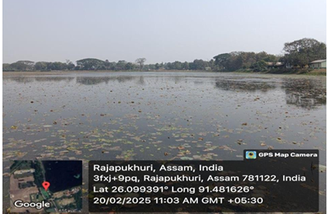

Figure 1: Geographical Positioning System (GPS) view showing the exact location of Rajapukhuri Pond, Rampur, Kamrup, Assam.
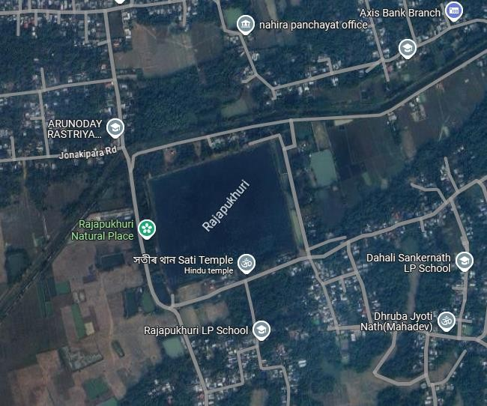

Figure 2: Satellite imagery depicting the spatial extent and surrounding landscape of Rajapukhuri Pond, Rampur, Kamrup, Assam.
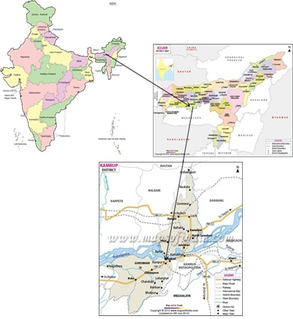

Figure 3: (A) Map of India showing the location of Assam; (B) Map of Assam highlighting Kamrup district; and (C) Map of Kamrup Rural District indicating the position of Rajapukhuri Pond.
2.2. Sample Collection:
A systematic and comprehensive investigation of the water quality of Rajapukhuri Pond was undertaken over a period of four months, from February 2025 to May 2025, with the objective of capturing seasonal variations and understanding the overall ecological health of the pond. This duration covered both pre-monsoon and early monsoon phases, enabling the assessment of natural fluctuations in the physico-chemical characteristics of the water.
Water sampling was carried out twice a month during the study period from multiple points across the pond to ensure representative coverage of the entire water body. Samples were collected in pre-cleaned 1,000 mL high-density polyethylene bottles by submerging them gently 10–15 cm below the water surface, keeping the mouth of the container against the direction of flow to avoid contamination by surface films and floating debris. To minimize diurnal variation, all sampling activities were conducted between 10:00 AM and 11:00 AM under similar weather conditions.

Table 1: Analytical methods employed for the determination of physico-chemical parameters of Rajapukhuri Pond.

Sl. NO | Water Quality arameters | Method of Analysis
1 | Temperature | Thermometric Method
2 | pH | Digital pH meter
3 | Free CO2 | Titrimetric method
4 | Dissolved Oxygen | Winkler’s Method
5 | Total Dissolved Solids | Digital TDS meter
6 | Electrical Conductivity | Digital EC meter

Before each sampling, the containers were thoroughly rinsed with deionized water and subsequently with pond water at the site. The collected samples were clearly labeled with date, time, and location, then transported to the departmental laboratory under controlled conditions. Upon arrival, the samples were refrigerated at 4°C to maintain their stability and prevent any alteration of physical and chemical characteristics prior to analysis.
In the laboratory, each parameter was analyzed following standard procedures recommended by APHA (2017) to ensure precision and reproducibility. The measured parameters included temperature, pH, free carbon dioxide, dissolved oxygen (DO), total dissolved solids (TDS), and electrical conductivity (EC) — all of which are crucial indicators of the pond’s water quality and ecological balance. The analytical methods used for each parameter are summarized in Table 1, which lists the instruments and techniques adopted for accurate quantification.
2.3. Physico-Chemical Analysis
The physico-chemical characteristics of the collected water samples were analyzed to assess the overall water quality and to understand seasonal variations during the study period. All analyses were carried out following the standard procedures recommended by APHA (2017) for the examination of water and wastewater. The parameters examined included temperature, pH, free carbon dioxide (CO₂), dissolved oxygen (DO), total dissolved solids (TDS), and electrical conductivity (EC).
Water temperature was measured in situ using a calibrated mercury thermometer. The pH of the samples was determined using a digital pH meter. Dissolved oxygen (DO) was estimated by the Winkler titrimetric method, while free carbon dioxide (CO₂) was determined using the titration method with standard sodium hydroxide solution and phenolphthalein indicator. Total dissolved solids (TDS) and electrical conductivity (EC) were measured using calibrated digital TDS and conductivity meters, respectively.
All instruments were properly calibrated before analysis to ensure accuracy and reliability of the measurements. The obtained values were recorded systematically and tabulated for subsequent analysis of seasonal trends and interrelationships among the measured parameters.
The analytical results were further compared with the drinking water quality standards prescribed by the Bureau of Indian Standards (BIS, 2012) and the World Health Organization (WHO, 2017) to evaluate the suitability of the pond water for ecological and domestic purposes.
2.4. Required Instrumentation
All laboratory analyses were performed in the Department of Zoology, D.K. College, Mirza, using calibrated instruments and standard laboratory glassware. The major instruments and apparatus used during the study are listed below:
- Mercury thermometer – for measurement of water temperature.
- Digital pH meter or pH strips – for determination of pH.
- Titration apparatus – including BOD bottles, conical flasks, pipettes, beakers, measuring cylinders, droppers, and a spirit lamp, for estimation of dissolved oxygen and free CO₂.
- Digital TDS and EC meters – for determination of total dissolved solids and electrical conductivity.
All instruments were cleaned and calibrated prior to use to ensure accuracy and reproducibility of results.

2.5. Determination of Dissolved Oxygen (DO) – Winkler’s Method
The concentration of dissolved oxygen in water samples was estimated by Winkler’s titrimetric method (APHA, 2017), based on oxidation–reduction reactions. In this method, dissolved oxygen oxidizes manganous ions under alkaline conditions to form manganese dioxide (MnO₂). This, in turn, reacts with potassium iodide to liberate iodine, which is titrated with standard sodium thiosulfate (Na₂S₂O₃) solution using starch as an indicator. The endpoint is indicated by the disappearance of the blue color.
Calculation:
$$\text{DO (mg/L)}=\frac{V×N×8×1000}{\text{mL of sample}}$$
Where:
- V = Volume of 0.01 N Na₂S₂O₃ used (mL)
- N = Normality of Na₂S₂O₃ (usually 0.01 N)
- 8 = Equivalent weight factor for oxygen
This equation for calculating dissolved oxygen concentration is based on the standard procedures described in APHA (2017). This method provides an accurate estimation of oxygen concentration, an essential indicator of the pond’s ability to support aquatic life.
2.6. Estimation of Free Carbon Dioxide (CO₂)
Free CO₂ in the water samples was determined by acid–base titration using phenolphthalein indicator and standard sodium hydroxide (NaOH) solution. The presence of free CO₂ renders water slightly acidic. During titration, CO₂ reacts with NaOH to form sodium bicarbonate, resulting in an increase in pH until a faint pink color appears at the endpoint (pH 8.3).
Procedure:
- Take 100 mL of the water sample in a clean conical flask.
- Add a few drops of phenolphthalein indicator.
- If the sample turns pink, free CO₂ is absent.
- If the sample remains colorless, free CO₂ is present.
- Titrate the colorless sample with 0.05 N NaOH until a faint pink color appears, indicating the endpoint.
Calculation:
$$\text{Free CO₂ (mg/L)}=\frac{V×N×44×1000}{\text{mL of sample}}$$
Where:
- V = Volume of 0.01 N NaOH used (mL)
- N = Normality of NaOH (usually 0.01 N)
- 44 = Molecular weight of CO₂
This method provides an estimation of the free carbon dioxide content, a key factor influencing the acidity and buffering capacity of the pond water (APHA, 2017).
2.6. Data Analysis
All recorded data were statistically analyzed to evaluate spatial and temporal variations in the measured parameters. The results were compared with the Bureau of Indian Standards (BIS, 2012) and World Health Organization (WHO, 2017) guidelines for water quality assessment to interpret the ecological condition of Rajapukhuri Pond.
3. Result and Discussion:
3.1 Temperature
During the study period, the surface water temperature of Rajapukhuri Pond exhibited distinct seasonal variation, ranging from 19.8°C to 24°C, with a mean value of 21.5°C (Table 2). The lowest temperature was recorded in February (19.8°C), while the highest was observed in May (24°C). This gradual rise in temperature, as depicted in Figure 4, reflects the natural climatic transition from the cooler pre-monsoon months to the onset of warmer early monsoon conditions.
Temperature plays a pivotal role in controlling various physicochemical and biological processes within aquatic ecosystems. It influences metabolic activities, enzymatic reactions, gas solubility, and reproductive cycles of aquatic organisms. A moderate increase in temperature generally promotes photosynthetic activity and planktonic growth, while excessive warming can reduce dissolved oxygen (DO) concentrations, thereby stressing aquatic fauna.
The observed temperature range suggests that Rajapukhuri Pond maintains a favorable thermal environment capable of supporting a balanced and diverse aquatic community. Similar seasonal warming trends have been reported by Deori and Baruah (2020) in Charan Beel and Patra et al. (2018) in Deepor Beel, where pre-monsoon temperature increases were found to significantly influence oxygen dynamics, nutrient availability, and algal proliferation.

Table 2: Monthly variation in surface water temperature of Rajapukhuri Pond recorded during February–May 2025. The temperature values show a gradual increase from winter to early monsoon months, reflecting the natural seasonal warming trend typical of freshwater ecosystems in Assam.

Month | Temperature
February | 19.8℃
March | 20℃
April | 22.2℃
May | 24℃

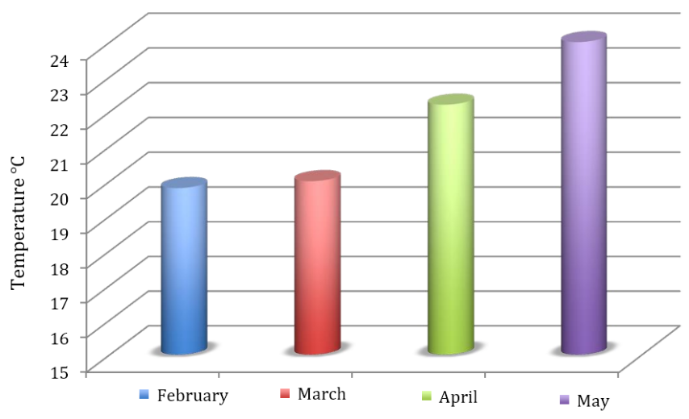

Figure 4. Graphical representation of the monthly variation in surface water temperature of Rajapukhuri Pond during the study period (February–May 2025). The figure illustrates a gradual rise in temperature from winter to pre-monsoon months, reflecting seasonal climatic influence on the pond ecosystem.
3.1. pH (Potential of Hydrogen)
The pH values of the pond water varied between 7.32 and 8.21, with an average of 7.38, indicating that the water is near-neutral with a slight tendency toward alkalinity. Such a range is considered ideal for most freshwater biota, as it maintains a balanced carbon dioxide–bicarbonate–carbonate equilibrium essential for photosynthetic processes.
Alkaline conditions often result from active photosynthesis by aquatic plants and phytoplankton, which consume carbon dioxide and thereby increase pH levels. High pH can also be associated with limited rainfall and reduced dilution during dry months. According to APHA (2017), water with pH values between 6.5 and 8.5 is suitable for aquatic life and safe for general ecological balance.
The observed pH stability throughout the study period indicates minimal anthropogenic interference. Studies by Sarmah et al. (2020) and Gupta (2009) similarly report slightly alkaline pH in natural ponds and beels of Assam, linked to photosynthetic carbon assimilation and low organic pollution.
3.3. Free Carbon Dioxide (CO₂)
Free CO₂ concentration, estimated using the titrimetric method, showed a consistent declining trend from 10.23 mg/L in February to 7.30 mg/L in May, as illustrated in Figure 5. The graphical representation clearly indicates a gradual decrease in CO₂ concentration during the study period, reflecting seasonal changes in the carbon dynamics of the pond ecosystem.
Free carbon dioxide is a key component of the aquatic carbon cycle and plays a crucial role in maintaining the acid–base balance of freshwater systems. Higher CO₂ concentrations during the cooler months (February–March) may be attributed to increased respiration of aquatic organisms and decomposition of organic matter, coupled with reduced photosynthetic uptake due to lower sunlight availability and lower productivity of primary producers. During this period, the relatively lower temperature limits photosynthetic activity of phytoplankton and aquatic macrophytes, allowing dissolved CO₂ to accumulate in the water.
As the season progresses toward the pre-monsoon period (April–May), rising temperature and increasing solar radiation enhance the photosynthetic activity of aquatic plants and phytoplankton. These organisms utilize dissolved carbon dioxide during photosynthesis, resulting in a progressive decline in CO₂ concentration in the water. In addition, increased biological productivity and improved atmospheric exchange during warmer months may further influence the carbon dioxide dynamics within the pond ecosystem.
A similar seasonal pattern has been reported in other freshwater bodies where higher photosynthetic activity during warmer periods leads to a reduction in free CO₂ levels. For example, Islam et al. (2014) observed a decline in CO₂ concentration in Deepor Beel during periods of enhanced photosynthesis. Comparable seasonal variations in carbon dioxide concentration have also been reported in freshwater ecosystems influenced by climatic and biological factors (Sarmah et al., 2020; Deori & Baruah, 2020). Although elevated CO₂ concentrations may sometimes contribute to water acidification and affect oxygen availability for aquatic organisms, the levels observed in Rajapukhuri Pond remained within acceptable ecological limits, indicating a balanced interaction between respiration, decomposition, and photosynthetic processes in the pond ecosystem.
Table 3. Variation in free CO₂ concentration of Rajapukhuri Pond
Month | Free CO₂ (mg/L)
February | 10.23 mg/L of CO₂ at NTP
March | 9.33 mg/L of CO₂ at NTP
April | 8.44 mg/L of CO₂ at NTP
May | 7.30 mg/L of CO₂ at NTP
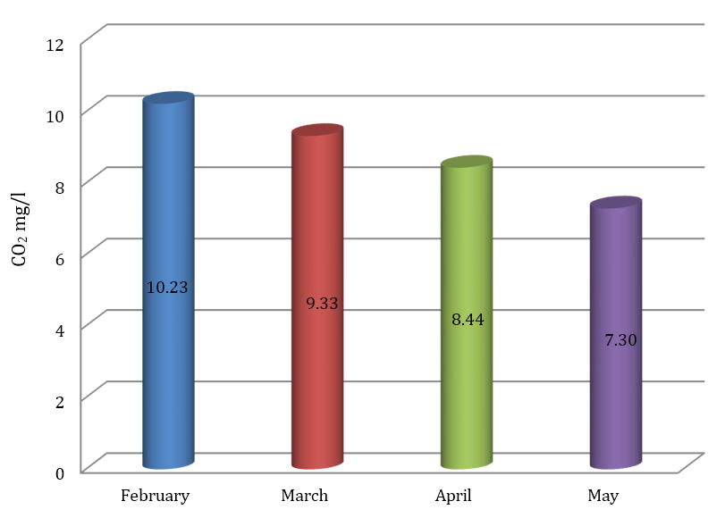

Figure 5. Graphical representation of the monthly variation in free CO₂ concentration in Rajapukhuri Pond during the study period (February–May 2025).

3.4. Dissolved Oxygen (DO)
The dissolved oxygen (DO) content of Rajapukhuri Pond exhibited noticeable seasonal variation during the study period, ranging from 6.19 mg/L to 8.74 mg/L (Table 4). The highest DO concentration (8.74 mg/L) was recorded in February, while the lowest (6.19 mg/L) was observed in May. This downward trend in DO levels across the months is illustrated in Figure 6, which clearly depicts the inverse relationship between rising temperature and declining oxygen availability in the water column.

Table 4. Monthly variation in dissolved oxygen (DO) concentration of Rajapukhuri Pond

Month | DO (mg/L)
February | 8.74 mg/L
March | 7.92 mg/L
April | 7.84 mg/L
May | 6.19 mg/L

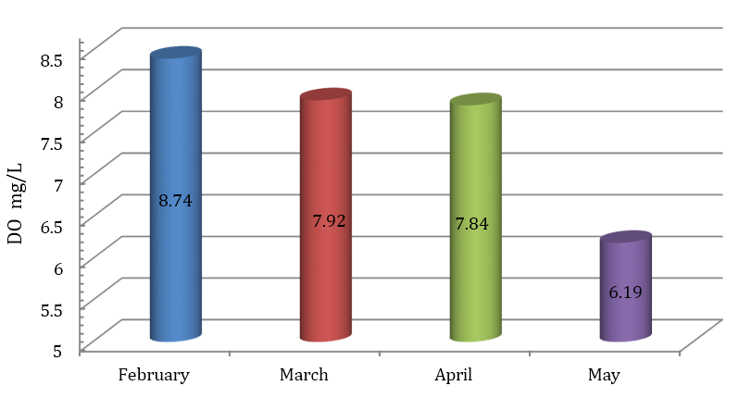

Figure 6. Graphical representation of monthly variation in dissolved oxygen (DO) concentration of Rajapukhuri Pond during February–May 2025.

During the cooler months, higher DO levels can be attributed to enhanced atmospheric diffusion, lower metabolic oxygen demand, and reduced microbial decomposition. As the season progressed toward summer, increased water temperature coupled with intensified microbial activities likely contributed to the gradual decline in DO concentration. This trend is consistent with the fundamental principle that oxygen solubility decreases with increasing temperature, influencing metabolic and ecological dynamics in aquatic systems.
Despite the seasonal decline, all recorded DO values remained above 6 mg/L, indicating that the pond maintained a healthy and supportive environment for aquatic organisms throughout the study period. According to Mahamuni and Khobragade (2020), DO concentrations between 5 and 8 mg/L characterize moderately productive water bodies with balanced ecological functioning. Furthermore, Rana and Jain (2017) reported that ponds maintaining DO levels above 6 mg/L support diverse and productive fish communities. The observed DO pattern in Rajapukhuri Pond therefore reflects a stable and ecologically favorable freshwater ecosystem.
3.5. Total Dissolved Solids (TDS)
The Total Dissolved Solids (TDS) concentration in Rajapukhuri Pond demonstrated a slight but consistent increase over the study period, ranging from 43 ppm in February to 47 ppm in May, with an average value of 44.7 ppm (Table 5). This gradual rise is depicted in Figure 7, which clearly illustrates the seasonal trend in dissolved solid content.

Table 5. Monthly variation in Total Dissolved Solids (TDS) concentration in Rajapukhuri Pond during the study period (February–May 2025).
Month | TDS (ppm)
February | 43 ppm
March | 44 ppm
April | 45 ppm
May | 47 ppm
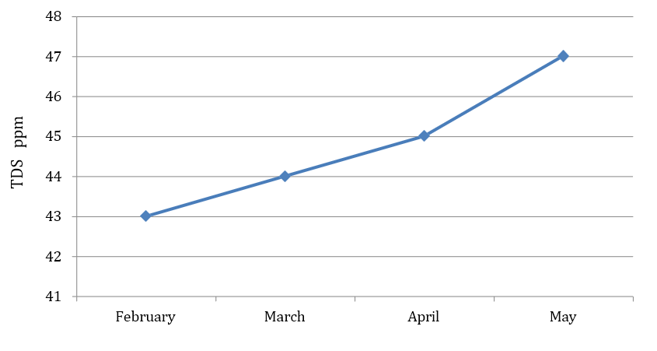

Figure 7. Monthly variation in Total Dissolved Solids (TDS) in Rajapukhuri Pond during February–May 2025.
The observed TDS levels indicate a low ionic concentration, suggesting minimal mineral input and limited anthropogenic influence in the pond ecosystem. Such low TDS values are characteristic of unpolluted freshwater systems, reflecting good water quality and supporting a balanced aquatic environment. TDS represents the total concentration of dissolved organic and inorganic substances, including salts, minerals, and ions. Elevated TDS levels can adversely affect aquatic organisms by interfering with osmoregulatory processes, reducing water clarity, and altering habitat conditions. However, the values recorded in Rajapukhuri Pond remain well below the permissible limit of 500 ppm recommended by the World Health Organization (WHO, 2011) for freshwater bodies, further indicating healthy water conditions.
Comparable observations were reported by Sargar and Thakare (2024) in freshwater ponds of Maharashtra, where low TDS levels were associated with high aquatic productivity and suitability for fish culture. The gradual increase observed in Rajapukhuri Pond toward summer may be attributed to evaporation and concentration effects, a common phenomenon in shallow water bodies subjected to rising temperatures. Overall, the TDS profile confirms that Rajapukhuri Pond maintains good water quality and stable ecological conditions, supporting sustained biological productivity.
3.6. Electrical Conductivity (EC)
The electrical conductivity (EC) of Rajapukhuri Pond exhibited a gradual increase over the study period, ranging from 86 μS/cm in February to 102 μS/cm in May, with a mean value of 91.5 μS/cm (Table 6). This progressive rise in conductivity is also illustrated in Figure 8, indicating seasonal variation in the concentration of dissolved ions in the pond water. Electrical conductivity serves as an indirect measure of the ionic and mineral content of water and is closely related to Total Dissolved Solids (TDS). The moderate EC values observed during the study indicate a low to moderate ionic concentration, which is characteristic of relatively unpolluted freshwater bodies with balanced mineral composition and limited anthropogenic disturbance.
The gradual increase in EC from February to May can be attributed to several seasonal factors. As temperature rises during the transition from winter to the pre-monsoon period, evaporation rates increase, leading to a concentration of dissolved salts and minerals in the water. Reduced water volume due to evaporation may further enhance the accumulation of ions such as bicarbonates, chlorides, and sulphates, thereby increasing electrical conductivity. In addition, increased biological activity and decomposition of organic matter during warmer months may contribute to the release of dissolved ions into the water column. Minor inputs from surrounding soil runoff and weathering of minerals in the catchment area may also influence the ionic composition of the pond water.
Similar seasonal increases in EC have been reported in freshwater ecosystems where higher temperatures and evaporation lead to concentration of dissolved ions. Studies conducted by Pathan (2019) and Mishra and Singh (2024) also observed comparable trends in reservoirs and ponds, where conductivity increased during warmer months due to enhanced mineral concentration and reduced dilution.
Despite the observed increase, the EC values recorded in Rajapukhuri Pond remain within the desirable range for freshwater ecosystems, indicating low salinity and minimal pollution stress. Such conditions are generally favorable for the growth of aquatic organisms and the maintenance of ecological stability. Therefore, the conductivity pattern observed in the present study suggests that Rajapukhuri Pond maintains a relatively stable ionic balance and suitable water quality for sustaining aquatic flora and fauna.
Table 6. Monthly variation in Electrical Conductivity (EC) of Rajapukhuri Pond during the study period (February–May 2025).
Month | Electrical Conductivity (EC)
February | 86
March | 88
April | 90
May | 102
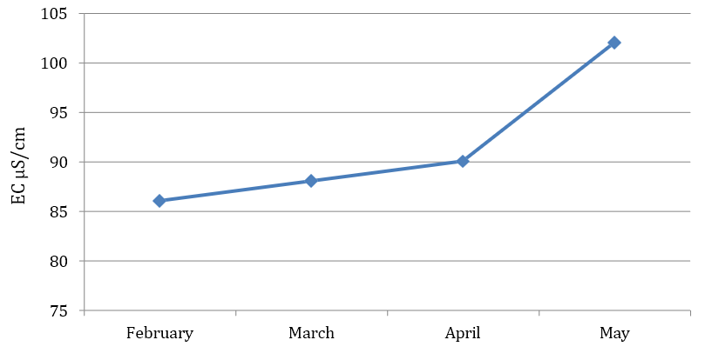

Figure 8. Monthly variation in Electrical Conductivity (EC) of Rajapukhuri Pond during February–May 2025.

3.7. Integrated Interpretation and Ecological Insights
An integrated assessment of the measured physico-chemical parameters indicates that Rajapukhuri Pond maintains a stable and ecologically balanced condition throughout the study period. The gradual rise in temperature accompanied by a corresponding decline in dissolved oxygen (DO) and free carbon dioxide (CO₂) reflects natural seasonal thermal and biological cycles typical of freshwater ecosystems. The slightly alkaline pH, combined with consistently low values of TDS and EC, suggests minimal anthropogenic influence and supports active photosynthetic and nutrient-cycling processes within the pond.
The relationship among the parameters highlights the dynamic equilibrium operating within the pond ecosystem:
- Temperature regulates metabolic activity and influences DO solubility;
- pH governs ion speciation and CO₂ buffering capacity;
- CO₂ and DO exhibit reciprocal trends driven by photosynthesis–respiration cycles;
- TDS and EC jointly reflect mineral content and ionic strength of the water.
Such balanced interactions characterize a self-sustaining, moderately productive freshwater system, in which physical, chemical, and biological components function harmoniously.
Comparison with other freshwater ecosystems in Assam—such as Deepor Beel (Islam et al., 2014), Charan Beel (Deori & Baruah, 2020), and the Dikhow River (Sarmah et al., 2020)—reveals similar seasonal trends but comparatively lower ionic and organic loads in Rajapukhuri Pond. This suggests that the pond remains relatively pristine and minimally disturbed. The low TDS and EC values, together with stable pH and sufficient DO concentrations, confirm that Rajapukhuri Pond provides an environment suitable for the sustenance of fish, phytoplankton, zooplankton, and aquatic macrophytes. Field observations of abundant aquatic vegetation and frequent bird presence further reinforce the pond’s high ecological value and balanced trophic dynamics. Overall, the absence of drastic fluctuations in water quality parameters suggests that natural regulatory processes predominate over human-induced disturbances. To preserve this favorable ecological condition, it is essential to protect the pond’s catchment area, restrict pollution inputs, and ensure sustainable community interaction with this water body.
4. Conclusion
The present study evaluated the seasonal variation of selected physico-chemical parameters of Rajapukhuri Pond in Rampur, Kamrup District, Assam. The results revealed that water temperature gradually increased from February to May, while dissolved oxygen and free carbon dioxide showed a decreasing trend during the same period. The pond water remained slightly alkaline, and the recorded values of total dissolved solids and electrical conductivity were relatively low throughout the study period. Dissolved oxygen concentrations consistently remained within the range suitable for aquatic organisms. Overall, the measured physico-chemical parameters indicate that Rajapukhuri Pond maintains good water quality and favorable ecological conditions for sustaining aquatic life. The seasonal variations observed in the parameters largely reflect natural environmental processes rather than significant anthropogenic disturbance. The findings of this study provide baseline information on the water quality status of Rajapukhuri Pond, which may be useful for future monitoring and management of similar freshwater ecosystems in the region.

COMPETING INTERESTS:
Authors have declared that they have no known competing financial interests OR non-financial interests OR personal relationships that could have appeared to influence the work reported in this paper.

Disclaimer (Artificial intelligence)

Author(s) hereby declare that NO generative AI technologies such as Large Language Models (ChatGPT, COPILOT, etc.) and text-to-image generators have been used during the writing or editing of this manuscript.

Reference:
Abdulazeez AM, Mohammed SA, Agada J, Saidu A, Adamu SU, Amira MK, Idujagi OS, Jamila MM, Winner L, Ransom UJ, Joseph IB. 2025. Comparative assessment of heavy metals concentration and water quality in treated water and raw water around Malali Water Works, Kaduna State, Nigeria. IRASS Journal of Multidisciplinary Studies. 2(1):35–40.

APHA. 2017. Standard Methods for the Examination of Water and Wastewater. 23rd ed. American Public Health Association, Washington, DC.

Biggs J, Williams P, Whitfield M, Nicolet P, Weatherby A. 2005. 15 years of pond assessment in Britain: Results and lessons learned from the work of Pond Conservation. Aquatic Conservation: Marine and Freshwater Ecosystems. 15(6):693–714.

BIS. 2012. Indian Standard Drinking Water Specification (IS 10500:2012). Bureau of Indian Standards, New Delhi.

Boyd CE. 1998. Water quality for pond aquaculture. Alabama Agricultural Experiment Station, Auburn University.

Carpenter SR, Caraco NF, Correll DL, Howarth RW, Sharpley AN, Smith VH. 1998. Nonpoint pollution of surface waters with phosphorus and nitrogen. Ecological Applications. 8(3):559–568.

Deori M, Baruah PK. 2020. An assessment of physico-chemical characteristics of Charan Beel, a freshwater wetland in Morigaon District, Assam, India. Applied Ecology and Environmental Sciences. 8(6):414–421. https://doi.org/10.12691/aees-8-6-13

Dixit AK, Pandey SK, Mehta R, Ahmad N, Gunjan, Pandey J. 2015. Study of physico-chemical parameters of different pond water of Bilaspur District, Chhattisgarh, India. Environmental Skeptics and Critics. 4(3):89–95.

Islam M, Motaleb A, Barman B. 2014. Studies on physico-chemical properties of water in some selected sites of Deepor Beel (Ramsar site), Assam, India. The Clarion. 3(2):25–32.

Kumar P, Prasad B, Pathak R. 2019. Assessment of water quality parameters of village ponds: A case study from Bihar, India. Journal of Water and Land Development. 40(1):73–78.

Kumar R, Madan A, Kumar S. 2023. Study of physico-chemical parameter and pond water quality analysis at Panipat, Haryana (India). World Journal of Pharmaceutical Research. 12(9):1020–1030. https://doi.org/10.20959/wjpr20239-28290

Mahamuni K, Khobragade A. 2020. Assessment of demand parameters of Nathsagar Reservoir at Paithan, Maharashtra. In: Recent Trends in Environment, Climate Change, Physical and Life Sciences. ISBN: 978-81-89140-22-9.

Mishra R, Singh RK. 2024. Analysis of water quality using physico-chemical parameters: Kori Dam in Bilaspur District, Chhattisgarh. Journal of Xi'an University of Architecture & Technology. 16(7). https://doi.org/10.37896/JXAT16.7/34408
Munni MA, Fardus Z, Mia MY, Afrin R. 2015. Assessment of pond water quality for fish culture: A case study of Santosh region in Tangail, Bangladesh. Journal of Environmental Science and Natural Resources. 6(2):157–162. https://doi.org/10.3329/jesnr.v6i2.22112

Randhir TO. 2012. Water for life and ecosystem sustainability. Available: https://www.researchgate.net/publication/228476948

Rana N, Jain S. 2017. Assessment of physico-chemical parameters of freshwater ponds of District Bijnor (U.P), India. Journal of Entomology and Zoology Studies. 5(4):524–528.

Roy R, Majumder M. 2022. Assessment of water quality trends in Deepor Beel, Assam, India. Environment, Development and Sustainability. https://doi.org/10.1007/s10668-021-02033-4

Sargaonkar A, Deshpande V. 2003. Development of an overall index of pollution for surface water based on a general classification scheme in Indian context. Environmental Monitoring and Assessment. 89:43–67.

Sargar GS, Thakare BG. 2024. Assessment of some selected physico-chemical parameters of water from Niwali Reservoir, Tahsil Jintur, Dist. Parbhani (M.S.), India. African Journal of Biomedical Research. 27(4S). https://doi.org/10.53555/AJBR.v27i4S.5004

Sarmah R, Dutta R, Bhagabati S, Nath D. 2020. Seasonal variation of water quality parameters of river Dikhow in Nagaland and Assam. International Journal of Chemical Studies. 8(5T). https://doi.org/10.22271/chemi.2020.v8.i5t.10502

Sharma P, Sarkar R, Deka JP, Koley S, Saha B. 2024. Assessing water quality of Deepor Beel, Assam, NE India, using water quality index: A case of Ramsar wetland. Arabian Journal of Geosciences. 17(20). https://doi.org/10.1007/s12517-023-11818-y

UNEP. 2023. Global Environment Outlook 7: Freshwater Quality and Ecosystem Health. United Nations Environment Programme, Nairobi.
Wang L, Zhang Q, Liu H, Zhao Y. 2024. Integrated assessment of freshwater ecosystem health using physicochemical indicators and water quality indices. Science of the Total Environment. 906:167112. https://doi.org/10.1016/j.scitotenv.2024.167112

WHO. 2017. Guidelines for Drinking-water Quality. 4th ed. World Health Organization, Geneva.
Zhang Y, Li J, Wang X, Chen H. 2023. Assessment of physicochemical parameters and water quality indices for sustainable freshwater management. Environmental Monitoring and Assessment. 195:1189. https://doi.org/10.1007/s10661-023-1189

