Original Research Article

Population dynamics of bud borer, Helicoverpa armigera on rose and its management under protected condition in Kashmir

.
ABSTRACT

Background: Rose cultivation has grown quickly in India in both protected and open-field settings, greatly boosting employment and revenue generation. A major challenge to sustainable rose cultivation under such controlled environments is that these structures inadvertently create favourable conditions for the accumulation and proliferation of insect pests, which can compromise both yield and quality.

Aims: Bud borer population and weather data, including temperature (minimum and maximum), minimum relative humidity, and maximum relative humidity, were correlated. The effectiveness of several compounds against bud borer on roses.
Study design: RCBD (Randomized Complete Block Design) was the method used in the experiment. The polyhouse, which was separated into three equal-sized blocks (14.6 m × 1.52 m), was used to plant the rose variety "Top secret." Eleven subplots, each measuring 1.11 m by 1.52 m, were created from each block. Five plants were cultivated at a suggested spacing of 35 cm by 25 cm in each plot.
Place and Duration of Study: The present investigation was carried out in the experimental block of the Division of Floriculture & Landscaping Architecture, SKUAST-K, Shalimar campus, Srinagar, from March 2022 to December 2022 under protected conditions.
Methodology: Ten rose plants were chosen at random to be observed in a polyhouse setting in order to document the seasonal occurrence of bud borer. Observations were made with a hand lens (10X). One day before the initial spray, the pre-count of bud borer on roses was taken. Post-count observations were made at 1, 3, 7, and 15 days following the spray. Three randomly chosen plants from each treatment were observed. At intervals of 14 days, a second round of spraying was carried out, and the same observations were made. A statistical analysis was performed on the recorded data.
Results: The peak bud borer incidence was observed in 29th SMW (0.3 bud borer/plant) at 21.4°C (minimum temperature), 34°C (maximum temperature), 65.5% (minimum RH) and 88% (maximum RH). Based on correlation studies, it was found that bud borer population was highly significantly and positively correlated with temperature (minimum and maximum), non-significantly and negatively correlated with minimum RH while highly significantly and negatively correlated with maximum RH. Regression analysis revealed 50 per cent variation in bud borer population on plants owing to weather parameters. Regarding bud borer, T₄ (Fipronil 5% SC @ 1ml/L) proved to be most efficient, followed by T₈ (Lecanicillium lecanii @ 5ml/L).
Conclusion: The peak incidence of bud borer was observed in July. Use of different newer molecules along with entomopathogens and botanicals and also use of biocontrol agents for the control of bud borer on rose.

Keywords: Rose, bud borer, seasonal incidence, protected condition.

1. INTRODUCTION

Since the rose is the symbol of love and the most demanding flower for welcoming anyone. So, it is very important to save and enhance the production of roses. Because of its aesthetic value, broad range of applications, and strong market demand, roses (Rosa spp.) are among the most significant ornamental crops cultivated globally and have a prominent position in the floriculture sector (Roman et al., 2025). Rose cultivation has grown quickly in India in both protected and open-field settings, greatly boosting employment and revenue generation (Anumala et al., 2021; Shahi et al., 2025). In temperate regions such as Kashmir, protected cultivation—particularly in polyhouses and greenhouses—has become increasingly popular, as it facilitates year-round production, enhances flower quality, and improves overall productivity. However, a major challenge to sustainable rose cultivation under such controlled environments is that these structures inadvertently create favourable conditions for the accumulation and proliferation of insect pests, which can compromise both yield and quality (Reddy et al., 2021; Shankar & Mukhtar, 2025; Grozea et al., 2025). The state's floriculture industry has grown significantly as a result of SKUAST-K's persistent efforts in partnership with the Government of Jammu & Kashmir. The cultivated area now stands at roughly 0.75 thousand hectares, and the annual production amounts to 0.42 thousand metric tonnes of loose flowers and 1.82 thousand metric tonnes of cut flowers (Sheikh et al., 2017).
The Bud borer, Helicoverpa armigera (Lepidoptera: Noctuidae) bore into the developing buds and feeds on petals inside them (Yadav et al., 2022; Patel et al., 2023). This prevents the buds from opening in infested buds, resulting in their drying. Partially damaged buds open into the deformed flowers. Peak incidence of Bud borer (10.06%) was reported during July (Prithivi et al., 2019).

2. material and methods

The present investigation was conducted on the rose cultivar ‘Top-Secret’ grown under protected conditions in a polyhouse at the Floriculture Experimental Field, Faculty of Horticulture (FOH), SKUAST-K, Shalimar Campus, Srinagar. The crop was planted at a spacing of 35 cm × 20 cm. Observations on the incidence of bud borer on rose were recorded at weekly intervals from March to December 2022. For this purpose, ten rose plants were randomly selected and examined regularly using a 10× hand lens. The influence of abiotic factors, namely maximum and minimum temperature and relative humidity, on bud borer population dynamics was also evaluated during the study period. Daily records of temperature (°C) and relative humidity (%) were obtained using a digital temperature and humidity meter. Simple correlation analyses were performed to determine the relationship between bud borer incidence and prevailing temperature and relative humidity under protected conditions in Kashmir.
The rose cultivar ‘Top Secret’ was grown under protected conditions in a polyhouse measuring 14.6 m × 6.0 m. The experimental area was divided into three equal blocks (14.6 m × 1.52 m), each constituting a replication. Further, each block was subdivided into eleven subplots of 1.11 m × 1.52 m. Each subplot represented a treatment and consisted of five rose plants maintained at the recommended spacing of 35 cm × 25 cm. In total, eleven treatments were evaluated with three replications, and the experiment was laid out in a Randomized Complete Block Design (RCBD). Pre-treatment observations on the incidence of bud borer on roses were recorded one day before the first spray. The treatments were applied using a hand-operated sprayer. Post-treatment observations were taken at 1, 3, 7, and 15 days after spraying. Data were collected from two randomly selected plants per treatment. A second spray was applied after a 14-day interval, and observations were recorded following the same schedule. The recorded data were subsequently subjected to appropriate statistical analysis.
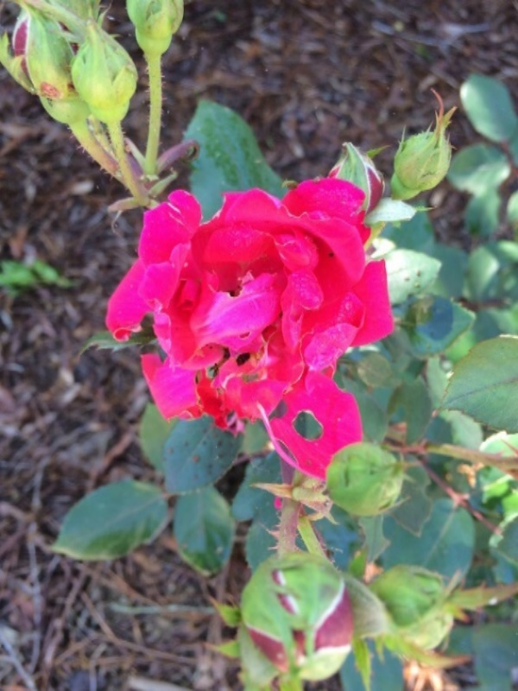
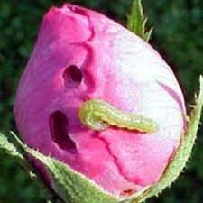
Use of yellow sticky traps
Whiteflies trapped on yellow sticky trap

Use of yellow sticky traps
Use of yellow sticky traps

PICture 1. Helicoverpa armigera on rose

3. results and discussion
The number of bud borer on rose plant ranged 0.05 to 0.3 bud borer/plant during the period of investigation (Table 1). There was no incidence of bud borer during 12th to 16th SMW (March- third week of April) followed by which the least incidence was recorded from 17th SMW (April) with 0.05 bud borer/plant, reaching up to the peak incidence (0.3 bud borer/plant) during 29th SMW (July) at a mean maximum temperature of 34°C. This was followed by the gradual decline in bud borer infestation level up to 35th SMW (September) with 0.1 bud borer/plant. Thereafter, no incidence was reported from 36th to 52nd SMW.
The number of bud borer on rose plant ranged 0.01 to 0.18 bud borer/plant The infestation was observed from April (0.01 bud borer/plant) followed by a steady increase and reached the peak in June (0.18 bud borer/plant) a mean maximum temperature of 31.2°C. Thereafter, the population declined up to September (0.10 bud borer/plant), following which no incidence of bud borer was recorded from October to December. The bud borer infestation was observed from 4th week of April (17th SMW) to 1st week of September (36th SMW). The maximum incidence of bud borer was recorded during 29th SMW (July) followed by the complete disappearance of pest from first week of September (36th SMW), which was almost in agreement with Prithvi Raj et al. (2019) who found the peak infestation of bud borer during the month of July and no incidence of the pest was recorded during the winter season.
Table 1. Treatment details (different molecules) against bud borer on rose under protected conditions.
T₁ | Spiromesifen 240% SC @0.4ml/L
T₂ | Fenazaquin 10% EC @0.4ml/L
T₃ | Abamectin 1.9% EC@0.5ml/L
T₄ | Fipronil 5%SC @ 1 ml/L
T₅ | Thiacloprid 21.7% SC @0.5ml/L
T₆ | Acetamiprid 20%SP@ 0.2g/L
T₇ | Thiamethoxam 25%WDG @ 0.3g/L
T₈ | Lecanicillium lecanii (1x10⁸ CFU’s/ml) @ 5ml/L
T₉ | Chlorfenpyr 10% SC @ 1ml/L
T₁₀ | Nimbecidine 0.03% @5ml/L
T₁₁ | Untreated control
The data presented in Table 2 revealed a highly significant positive correlation between bud borer on rose plant and minimum temperature (r = 0.363) and maximum temperature (r = 0.424). A negative and non-significant correlation was reported with minimum relative humidity (r = -0.263), whereas a negative and highly significant correlation was found with maximum relative humidity (r = -0.453). Further, 50 per cent variation was recorded in the bud borer plant population due to weather parameters. The bud borer incidence was found to be positively and significantly correlated with temperature (minimum and maximum) and recorded the peak (0.3 bud borer/plant) at a mean maximum temperature of 34°C, while a negative correlation of bud borer with
relative humidity was observed. The research findings are in congruence with Kapoor and Shankar (2019) who also reported a positive correlation of bud borer with temperature (minimum and maximum) and a negative correlation of bud borer with relative humidity. A possible reason of positive correlation of bud borer population with temperature is due to the overall effect of temperature on biological factors, including increased physiological responses and increased metabolic rates, leading to an increase in population size of the pest.

Fig-1: Seasonal incidence of bud borer on leaves and flowers in Rose under protected conditions during March 2022- December 2022
Table-2: Relationship between population of bud borer on rose and weather parameters (temperature, °C and relative humidity, %) under protected condition

Bud borer | Correlation coefficient values (r) |  |  |  | R² | Multiple Regression Equation
Bud borer | Temperature (°C) |  | Relative Humidity (%) |  | R² | Multiple Regression Equation
Bud borer | Minimum (X₁) | Maximum (X₂) | Minimum (X₃) | Maximum (X₄) | R² | Multiple Regression Equation
Number of bud borer/plant | 0.363* | 0.424* | -0.263 | -0.453** | 0.500 | Y= 0.166+0.006X1-0.002X2-0.005X3+0.002X4
Correlation is significant at the 0.05 level
** Correlation is significant at the 0.01 level
The data presented in Table 3 revealed that the number of bud borer recorded 1DBS, ranged 2.11 to 3.66 bud borer /leaf, exhibiting non-significant variation among different treatments.
At 1 DAS, T₄ (1.66 bud borer/plant) and T₄ (1.88 bud borer/plant) recorded the least number of bud borer followed by T₁₀ (2.22 bud borer/plant), T₈ (2.44bud borer/plant) and T₅ (2.66 bud borer/plant) which differ non-significantly, while T₁₀ (3.77 bud borer/plant) recorded the maximum number of bud borer among treatments, with untreated control (3.88 bud borer/plant).
At 3 DAS, T₆ and T₄ recorded the lowest number of bud borer (1.55 and 1.77 bud borer/plant, respectively) followed by T₇ (2.00 bud borer/plant) and T₅ (2.22 bud borer/plant) which were exhibiting a non-significant difference. T₁ (3.66 bud borer/plant) showed the least efficacy; however, it outperformed the control (4.11 bud borer/plant) significantly.
T₆ (1.44 bud borer/plant) showed its dominance over other treatments while T₂ (3.44 bud borer/plant) was found less efficient at 7DAS. However, all the treatments outperformed the control (4.66 bud borer/plant) significantly.
At 15 DAS, T₆ (1.33 bud borer/plant) recorded the lowest number of bud borer, followed by T₄ (1.55 bud borer/plant) and T₇ (1.77 bud borer/plant) while T₉ (3.22 bud borer/plant) recorded the maximum number of bud borer, hence showing the lowest efficacy among treatments. The untreated control recorded 5.00 bud borer/plant.
In second round of spray, at 1DAS, T₆ (1.22 bud borer/plant) and T₄ (1.44 bud borer/plant) recorded the lowest number of bud borer followed by T₈ (1.66 bud borer/plant) exhibiting non-significant variation with each other followed by T₇ (2.00 bud borer/plant) while T₁ (3.00 bud borer/plant) showed the least efficacy among all treatments. (Table 3).
Table 3: Comparative bio-efficacy of treatments against bud borer infesting rose plant
Treatments | Number of bud borer/plant (1st spray) |  |  |  |  | Number of bud borers/ plant (2nd spray) |  |  |  | Per cent protection
Treatments | 1DBS | 1DAS | 3DAS | 7DAS | 15DAS | 1DAS | 3DAS | 7DAS | 15DAS | Per cent protection
T₁: Spiromesifen 240%SC @0.4 ml/L | 3.77 (2.18)* | 3.66 (2.15) | 3.44 (2.11) | 3.22 (2.05) | 3.00 (2.00) | 3.00 (2.00) | 2.88 (1.97) | 2.11 (1.76) | 2.00 (1.73) | 64.66
T₂: Fenazaquin 10% EC @0.4 ml/L | 3.00 (2.00) | 2.88 (1.97) | 3.00 (2.00) | 3.44 (2.10) | 2.66 (1.91) | 2.77 (1.94) | 2.66 (1.89) | 1.89 (1.69) | 2.22 (1.79) | 60.77
T₃: Abamectin 1.9 % EC @ 0.5 ml/L | 3.55 (2.13) | 3.11 (2.01) | 3.11 (2.02) | 3.00 (2.00) | 2.44 (1.85) | 2.55 (1.88) | 2.33 (1.82) | 2.33 (1.82) | 2.44 (1.85) | 56.89
T₄: Fipronil 5% SC @ 1 ml/L | 3.33 (2.07) | 3.77 (2.18) | 1.77 (1.65) | 1.66 (1.62) | 1.55 (1.58) | 1.44 (1.56) | 1.22 (1.48) | 0.77 (1.32) | 0.44 (1.19) | 92.22
T₅: Thiacloprid 21.7 % SC @ 0.5 ml/L | 2.11 (1.76) | 2.66 (1.91) | 2.22 (1.78) | 2.66 (1.91) | 2.00 (1.73) | 2.11 (1.76) | 1.89 (1.69) | 1.44 (1.56) | 0.89 (1.36) | 84.27
T₆: Acetamiprid 20 % SP @ 0.2 g/L | 3.33 (2.07) | 1.88 (1.69) | 1.55 (1.59) | 1.44 (1.56) | 1.33 (1.52) | 1.22 (1.48) | 1.00 (1.41) | 0.55 (1.24) | 1.33 (1.28) | 76.50
T₇: Thiamethoxam 25% WDG @ 0.3 g/L | 3.55 (2.13) | 2.22 (1.79) | 2.00 (1.72) | 1.88 (1.69) | 1.77 (1.66) | 2.00 (1.73) | 1.44 (1.56) | 1.22 (1.48) | 1.55 (1.60) | 72.61
T₈: Lecanicillium lecanii @ 5ml/L | 2.77 (1.92) | 2.44 (1.85) | 2.44 (1.85) | 2.22 (1.79) | 2.33 (1.81) | 1.66 (1.62) | 1.66 (1.62) | 1.00 (1.41) | 0.66 (1.21) | 88.33
T₉: Chlorfenpyr 10 % SC @ 1ml/L | 3.33 (2.08) | 3.33 (2.07) | 2.66 (1.90) | 2.77 (1.93) | 3.22 (2.05) | 2.33 (1.82) | 3.11 (2.02) | 2.55 (1.88) | 1.77 (1.66) | 68.72
T₁₀: Nimbecidine 0.03 % @ 5 ml/L | 3.66 (2.15) | 1.88 (1.69) | 3.22 (2.05) | 2.33 (1.82) | 2.22 (1.78) | 2.33 (1.81) | 2.11 (1.75) | 1.66 (1.63) | 1.11 (1.44) | 80.38
T₁₁: Control | 3.33 (2.07) | 3.88 (2.21) | 4.11 (2.26) | 4.66 (2.38) | 5.00 (2.44) | 5.22 (2.48) | 5.44 (2.53) | 5.55 (2.56) | 5.66 (2.58) | -
C.D (p≤ 0.05) | NS | 0.32 | 0.32 | 0.28 | 0.32 | 0.32 | 0.34 | 0.25 | 0.30 | -
S.E(m) ± | 0.13 | 0.11 | 0.11 | 0.09 | 0.11 | 0.11 | 0.12 | 0.09 | 0.10 | -
C.V. | 10.90 | 9.42 | 9.72 | 8.63 | 10.07 | 10.09 | 11.06 | 8.80 | 10.66 | -
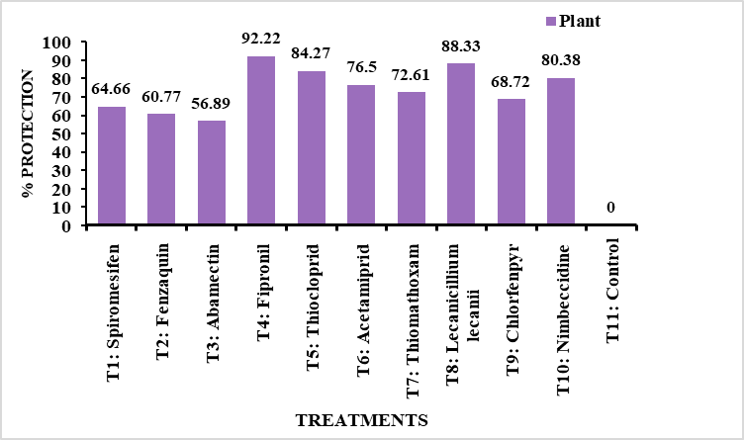
DBS- Day before spray, DAS- Days after spray and ( )* figures in parentheses are square root transformations and NS-Non-significant
Fig 2: Effect of different treatments against bud borer on plant of Rose (% protection)
At 3 DAS, T₆ (1.00 bud borer/plant) recorded the lowest number of bud borer followed by T₄ (1.22 bud borer/plant) followed by T₇ (1.44 bud borer/plant) and T₈ (1.66 bud borer/plant) exhibiting non-significant variation with each other. Lowest efficacy was shown by T₉ (3.11 bud borer/plant).
At 7 DAS, T₆ recorded the lowest number of bud borer (0.55 bud borer/plant) followed by T₄ (0.77 bud borer/plant), T₈ (1.00 bud borer/plant) and T₇ (1.22 bud borer/plant) which exhibit non-significant variation between each other. Lowest efficacy was shown by T₉ (2.55 bud borer/plant).
At 15 DAS, T₄ (0.44 bud borer/plant) showed its dominance over other treatments followed by T₈ (0.66 bud borer/plant), T₅ (0.89 bud borer/plant) and T₁₀ (1.11 bud borer/plant).
The maximum number of bud borer was recorded in T₃ (2.44 bud borer/plant) among the treatments. However, all the treatments outperformed the control (5.66 bud borer/plant) significantly. The current investigation revealed Fipronil 5% SC @ 1ml/L (T₄) as the most effective treatment in controlling bud borer on rose plants, which was followed by Lecanicillium lecanii @ 5ml/L (T₈) and Thiacloprid 21.7 % SC @ 0.5 ml/L (T₅). The research findings are in line with Meena and Raju (2014), who also found Fipronil was highly effective treatment against Helicoverpa armigera.
The per cent protection values in Table 3 revealed that the highest per cent protection was provided by T₄ (Fipronil 5% SC @ 1ml/L) i.e., 92.22 per cent, which was followed by T₈ [Lecanicillium lecanii (1×10⁸ CFUs/ml) @5ml/L] i.e., 88.33 per cent, T₅ (Thiacloprid 21.7 % SC @ 0.5 ml/L) i.e., 84.27 per cent followed by T₁₀ (Nimbecidine 0.03 % @ 5 ml/L) i.e., 80.38 per cent. The lowest protection was provided by T₃ (Abamectin 1.9 % EC @ 0.5 ml/l) i.e., 56.89 per cent. The data suggest the following decreasing order of efficacy of the applied treatments: T₄>T₈>T₅>T₁₀>T₆>T₇>T₉>T₁>T₂>T₃ (Fig. 2).

4. Conclusion

The following recommendations are suggested for bud borer control based on the findings of this investigation: July was the month with the highest bud borer occurrence. Therefore, before the pest population reaches its peak, it can be suppressed by employing management techniques. Using various molecules in conjunction with botanicals and entomopathogens improves the bud borer infestation. It is advisable to promote the use of biocontrol agents to control the pest population.

COMPETING INTERESTS:
Authors have declared that they have no known competing financial interests OR non-financial interests OR personal relationships that could have appeared to influence the work reported in this paper.

Disclaimer (Artificial intelligence)

Author(s) hereby declare that NO generative AI technologies such as Large Language Models (ChatGPT, COPILOT, etc.) and text-to-image generators have been used during the writing or editing of this manuscript.

References

Anumala, N. V. & Kumar, R. (2021). Floriculture sector in India: current status and export potential. The Journal of Horticultural Science and Biotechnology, 96(5): 673–680.
Kapoor, B. and Shankar, U., 2019. Seasonal incidence of Maruca vitrata Geyer and Helicoverpa armigera Hubner on black gram (Vigna mungo L. Hepper). Journal of Entomology and Zoology Studies 7(5): 1083-1087.
Prithiv Raj, V., Manzar, A., Ahmad, M. J., Nazki, I. T., Bhat, Z. A., Khan, I. and Magray, M. 2019. Seasonal incidence of major insect pests and mite on carnation under protected conditions in Kashmir. Journal of Experimental Zoology India 22(2): 1197-1202.
Sheikh, M. Q., Bhat, Z. A., Sidddique, M. A. A., Singh, K. P. & Saha, T. N. (2015). Present status and prospects of floriculture in Jammu and Kashmir. Journal of pharmacognosy and Phytochemistry, 13: 1-38.
Roman, G. M. S., Sestras, A. F., Stoian-Dod, R. L., Dan, C., Mircea, D. M., Boscaiu, M., & Sestras, R. E. (2025). Ornamental and Landscape Characteristics of Roses, Their Complexity, Contribution to the Overall Value of Cultivars, and Potential Applications of Use in Rose Breeding. Biology Bulletin, 52(2), 73.
Shahi, M., Badsar, M., & Shams, A. (2025). Factors Affecting Sustainable Production and Market Development of Damask Rose (Rosa damascene Mill.) in Iran: A Qualitative Analysis. Journal of Medicinal plants and By-products.
Yadav, S. P. S., Lahutiya, V., & Paudel, P. (2022). A review on the biology, ecology, and management tactics of Helicoverpa armigera (Lepidoptera: Noctuidae). Turkish Journal of Agriculture-Food Science and Technology, 10(12), 2467-2476.
Patel, R. S., Patel, K. A., Patil, K. S., & Toke, N. R. (2023). Biology and Management of Bud Borer (Helicoverpa armigera Hub.) on Rose in South Gujarat. Madras Agricultural Journal, 99(oct-dec), 1.
Reddy, S. E., Rana, S., Rana, A., & Kumar, R. (2021). Seasonal incidence and monitoring of Helicoverpa armigera Hübner on damask rose (Rosa× damascena Herrm.) by sex pheromone traps in western Himalaya (India). Journal of applied research on medicinal and aromatic plants, 20, 100270.
Shankar, U., & Mukhtar, Y. (2025). Pest management practices impact Helicoverpa armigera infestation and foraging behaviour of pollinators in sunflower. International Journal of Pest Management, 71(3), 385-394.
Grozea, I., Virteiu, A. M., Grozea, A., & Purice, D. (2025). Corn Pest Population Dynamics in Organic Systems Following Soybean: A Three-Year Study. Caraka Tani: Journal of Sustainable Agriculture, 40(4), 527-542.

