Original Research Article
Diversity of Swallowtail (Papilionidae) Butterflies of Saiden Community Forest, Ri Bhoi District, Meghalaya

Abstract,
Butterflies are ecologically significant bioindicators which are recognized for their sensitivity to environmental changes and habitat specifics. The present study assessed the diversity and relative abundance of Papilionidae in the Saiden Community Forest, Ri-Bhoi District, Meghalaya, from January to December 2021 with the objective to document the Papilionidae butterfly composition of the area. Field surveys were conducted using the Modified Pollard Walk method across three habitat types—Riverine Forest, Closed Canopy Forest, and Open Forest, the transect was laid at 1000m each with monthly sampling. A total of 15 species belonging to three genera (Papilio, Graphium, and Troides) were recorded. The genus Papilio was dominant (60%), followed by Graphium (23%) and Troides (17%). Among the species, Papilio helenus helenus (12.70%) and Troides helena (10.48%) were the most abundant, whereas Papilio clytia and Papilio demoleus demoleus (2.86% each) were the least. Four of the recorded species are protected under the Wildlife (Protection) Amendment Act, 2022, that includes Graphium aristeus anticrates, Papilio clytia, Troides aeacus, Troides helena. The findings underscore the ecological value of community-managed forests in sustaining swallowtail diversity and underline the need for monitoring and habitat conservation strategies to mitigate anthropogenic pressures. This study provides baseline data for future biodiversity assessments and conservation planning.
Keywords: Biodiversity, Community Forest, Conservation, Lepidoptera, Papilionidae.
- INTRODUCTION
Butterflies, belonging to the order Lepidoptera, represents a significant portion of global insect diversity which are recognized for their ecological importance and aesthetic appeal (Perveen & Khan, 2024). Comprising roughly 160,000 species globally, Lepidoptera, which includes both moths and butterflies, is one of the most readily identifiable insect orders (Baral et al., 2025). Of these, approximately 19,000 to 20,400 species are butterflies, distributed across nearly all continents except Antarctica (Theivaprakasham, 2020). These diurnal insects are particularly noted for their vibrant coloration and intricate wing patterns, making them easily distinguishable from other insect groups (Bibi et al., 2021). Their ubiquity and sensitivity to environmental shifts have led to their recognition as crucial bio-indicators, reflecting the health and stability of various ecosystems (Theivaprakasham, 2020). This sensitivity stems from their intricate life cycles, specific habitat requirements, and susceptibility to changes in temperature, precipitation, and host plant availability (Alarape et al., 2015; Thapa et al., 2023). Indeed, their role as pollinators further underscores their ecological significance, facilitating the reproduction of numerous plant species and contributing to overall biodiversity (Jose, 2024). Among the order Lepidoptera the family Papilionidae (Swallowtails) butterflies are widely regarded as some of the most striking members. Owing to their large size, vivid coloration, and commanding presence, they rank among the most recognizable butterfly groups worldwide. The Papilionidae family, commonly known as swallowtail butterflies, encompasses approximately 570 recognized species, making it a moderately diverse yet exceptionally prominent group within the order Lepidoptera (Zahiri et al., 2021). This family constitutes about 5% of the global butterfly fauna, and their conspicuous size and distinctive wing patterns often render them important bioindicators for assessing habitat health (Hu et al., 2023). Their diverse forms and distinctive features make them relatively easy to identify in the field. The family derives its name from the genus Papilio, a Latin term meaning “butterfly.” Linnaeus (1758) placed all known butterflies under the genus Papilio, forming the foundation of modern biological nomenclature based on Latin binomial names. Subsequent taxonomic revisions, however, restricted the use of this genus to specific swallowtail species. The genus Papilio comprises approximately 600 species worldwide (Nakae, 2021), of which about 96 species occur in the Indian subcontinent (Smetacek, 2025), indicating that India harbors nearly 14% of the global Papilio diversity. These butterflies are further distinguished by the presence of a forked osmeterium organ located at the base of the back of the head in their larval stage, a unique anatomical feature that aids in defense (Sidat & Bhatt, 2020). This family, commonly known as swallowtails, encompasses a wide range of species, many of which exhibit characteristic hindwing tails (Sidat & Bhatt, 2020). The study was conducted with the objective to document the Papilionidae butterfly species composition and to identify species of conservation importance based on their legal protection status.
2. MATERIALS AND METHODS
2.1: Study Area:
The study area is situated in Ri-Bhoi District of Meghalaya at approximately 25°52′20″ N latitude and 91°52′23″ E longitude, with an average elevation of about 565 m above mean sea level. The forest represents a tropical moist mixed deciduous ecosystem and forms part of a biodiversity-rich landscape. The hottest period of the year is Monsoon (June-September) here the temperature range between 33-35ᵒC, it is also the period with the maximum rainfall, The pre-monsoon season (March-May) and the retreating monsoon (October-November) are transitional period (Barthakur, 1986), while the winter (December-February) is characterized by cold weather. Despite being partially inhabited and subjected to cultivation, the forest continues to support considerable biological diversity; however, the ecosystem remains fragile as a result of ongoing deforestation. For the investigation of Papilio species, three distinct habitat types within the Saiden Community Forest were identified and selected: Riverine Forest, Closed Canopy Forest, and Open Forest.
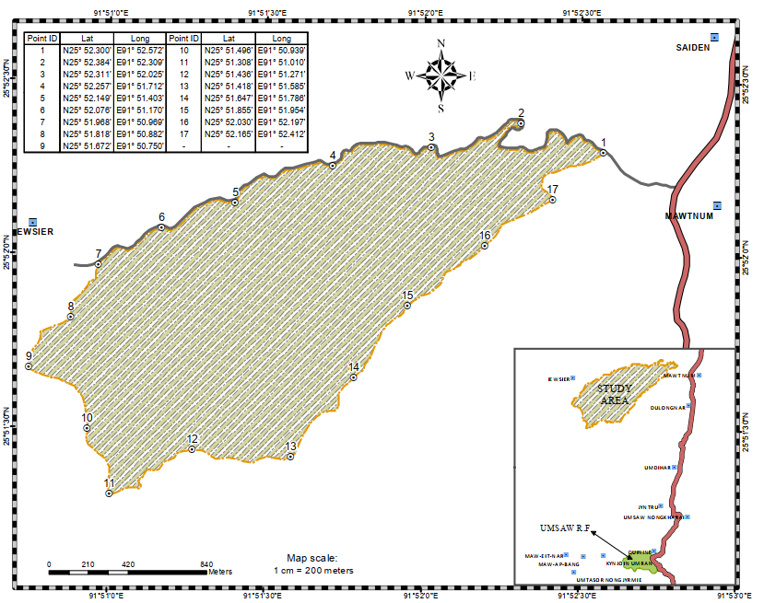
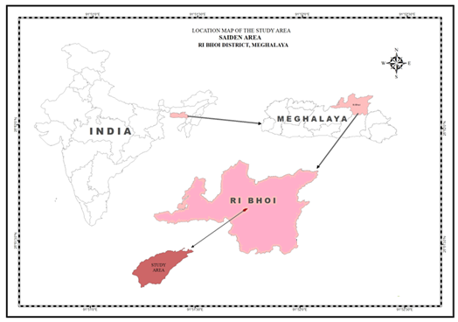
Fig 1: Map showing Saiden Community Forest, Meghalaya, India.
2.2: Survey and Data Collection:
A survey of Papilionidae butterflies in the Saiden Community Forest was conducted over a period of one year from January 2021 to December 2021. Three transects, measuring 1,000 m in length each were established across three distinct landscape types. Sampling was carried out once a month with each survey lasting for 2-3 days depending on prevailing weather conditions. Sampling was carried out during morning hours (07:00 am-12:00 noon) using the Modified Pollard Walk method (Pollard & Yates, 1993), in order to standardize observations. Within each transect, papilionid butterflies were recorded within a 10-m distance on either side of the observer ensuring uniform sampling effort and minimizing observational errors. Capture-and-release techniques with the help of a butterfly sweep net was also used for accurate identification of individuals that could not be reliably identified through photographic records alone. In addition, opportunistic surveys were also conducted at the end of each sampling session to increase the likelihood of detecting additional species. The sampling session in adjacent microhabitats such as forest edges, puddling sites, flowering patches, and shaded understory areas increases the probability of detecting less common, seasonal, or habitat-specialist species that might not be encountered during fixed transect walks. Species identification was done using standard identification keys of (Evans ,1932; Talbot, 1947; Haribal, 1992; Kehimkar, 2008).
3. RESULTS
During the study, a total of 15 species of swallowtail butterflies belonging to the family Papilionidae are recorded across three genera from the Saiden Community Forest (see Table 1). This finding reflects a considerable representation of papilionid diversity within the study area. Among the three genera recorded, the genus Papilio was observed to be the highest in number, accounting for 60% of the total species richness, the genus Graphium represented 23% of the total recorded species, while Troides was the least represented genus, contributing 17% to the overall composition (see Figure 2). Although Troides had fewer species, its presence is ecologically significant because members of this genus are often associated with specific host plant requirements. In terms of species-wise abundance, the species Papilio helenus helenus was observed as one of the most frequently encountered species under the genus Papilio, contributing 12.70% of the total observations. Within the genus Graphium, Graphium sarpedon accounted for 7.94%, indicating its moderate occurrence in the study area. Under the genus Troides, Troides helena was recorded at 10.48%, reflecting its notable presence despite the lower general representation. On the other hand, Papilio clytia and Papilio demoleus demoleus were the least recorded species, each contributing only 2.86% of the total individuals observed (see Table 1; Figure 4). Their lower abundance may be attributed to seasonal variation, limited host plant availability, or habitat preferences. The species accumulation curve illustrates the relationship between sampling effort (number of samples) and the cumulative number of Papilionidae species recorded in the Saiden Community Forest. At the initial stages of sampling (6 samples), no species were recorded, indicating low early detection. A sharp increase in species richness is observed between approximately 8 and 12 samples, where the number of recorded species rises rapidly from about 12 to 15. After 12 samples, the curve reaches a plateau at 15 species and remains stable despite further increases in sampling effort (up to 36 samples). The levelling off of the curve indicates that no new species were recorded beyond this point. This plateau suggests that the sampling effort was sufficient to capture most, if not all, of the Papilionidae species present in the study area during 2021. The overall nature of the curve demonstrates adequate sampling effort and the recorded total of 15 species is a reliable estimate of the actual papilionid species richness in the Saiden Community Forest for the study period (see Figure 3). Importantly, out of the 15 species recorded during the study period, four species are protected under the Wildlife (Protection) Amendment Act, 2022, these include Graphium aristeus anticrates, Papilio clytia, Troides aeacus, Troides helena. The occurrence of legally protected species within Saiden Community Forest underscores its conservation value and ecological importance.

Table 1: List of Papilionidae butterfly species recorded from Saiden Community Forest, 2021. C-Common, UC-Uncommon
Sl. No. | Common Name | Scientific Name | % of Abundance | Category | Status Under WPA
Family: Papilionidae
1 | Tailed Jay | Graphium agamemnon (Linnaeus) | 6.98 | C
2 | Chain swordtail | Graphium aristeus anticrates (Doubleday) | 3.49 | UC | Schedule II
3 | Common Jay | Graphium doson axion (Felder & Felder) | 4.76 | UC
4 | Common Bluebottle | Graphium sarpedon (Linnaeus) | 7.94 | C
5 | Common Peacock | Papilio bianor gladiator (Fruhstorfer) | 5.08 | C
6 | Common Mime | Papilio clytia (Linnaeus) | 2.86 | UC | Schedule II
7 | Lime Butterfly | Papilio demoleus demoleus (Linnaeus) | 2.86 | UC
8 | Red Helen | Papilio helenus helenus (Linnaeus) | 12.70 | C
9 | Continental Great Mormon | Papilio memnon agenor (form) (Linnaeus) | 11.43 | C
10 | Great Mormon | Papilio memnon alcanor (Linnaeus) | 4.76 | C
11 | Paris Peacock | Papilio paris paris (Linnaeus) | 7.30 | C
12 | Common Mormon | Papilio polytes romulus (Cramer) | 8.89 | C
13 | Spangle | Papilio protenor (Cramer) | 4.44 | UC
14 | Golden Birdwing | Troides aeacus (C. & R. Felder) | 6.03 | C | Schedule II
15 | Common Birdwing | Troides helena (C. & R. Felder) | 10.48 | C | Schedule II

Fig 2: Genus wise percentage composition of Papilionidae butterflies from Saiden Community Forest

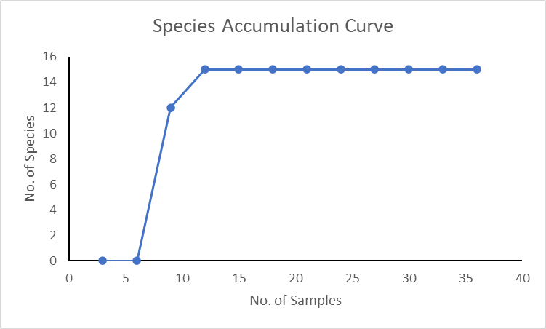
Fig 3: Species accumulation curve of Papilionidae butterfly in Saiden Community Forest
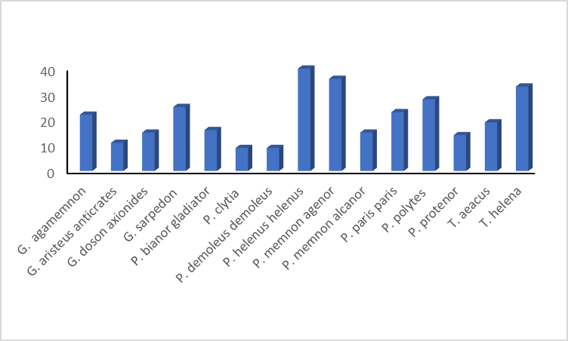
Fig 4: Species-wise Abundance of Papilionidae butterflies recorded from Saiden Community Forest
4. DISCUSSION

The present study highlights the ecological significance of Saiden Community Forest as a vital habitat for the family Papilionidae, documenting 15 species across three genera. The dominance of the genus Papilio (60%), followed by Graphium (23%) and Troides (17%), reflect a diverse assemblage of swallowtail butterflies typical of the northeastern Indian landscape. The recorded presence of high-frequency species such as P. helenus helenus (12.70%) and T. helena (10.48%) highlights the availability of suitable host plants and favorable microclimatic conditions within the community-managed forest (Deb et al., 2015). Conversely, the low abundance of species like P. clytia and P. demoleus demoleus (2.86% each) suggests potential sensitivity to habitat or seasonal fluctuations. The species accumulation curve for 2021 shows a rapid increase in the number of recorded species with increasing sampling effort during the initial phase of the survey. The sharp rise between 8 and 12 samples indicates that additional sampling substantially improved species detection. The curve subsequently reaches a plateau at 15 species, suggesting that further sampling did not yield any new species. This trend confirms that the sampling effort was adequate to reliably estimate the Papilionidae species richness in the study area. Significantly, the identification of four species protected under the Wildlife (Protection) Amendment Act, 2022, elevates the conservation status of this area. As community-managed forests often bridge the gap between human-modified landscapes and protected wilderness, the presence of these legally protected taxa heightens the urgent need for localized conservation strategies and long-term monitoring to mitigate anthropogenic pressures (Deb et al., 2015). These findings provide essential baseline data for future ecological research and the development of sustainable forest management practices in the region. Furthermore, according to the ecological status, the species were categorized as Common and Uncommon (see Table 1). This highlights the critical need for biodiversity conservation within the study area, as continued habitat degradation and anthropogenic pressures may lead to the extinction of these species if current trends persist (Deb et al., 2015). In view with the findings of the present study, several earlier investigations have reported higher butterfly (Papilionidae) diversity in moderately disturbed habitats compared to undisturbed areas (Spitzer et al., 1993). Similarly, urbanization has been shown to affect butterfly communities often leading to decline of species (Clark et al., 2007). Despite the ongoing deforestation and anthropogenic alterations, the area still supports a thriving diversity of Papilionids.
Butterflies are said to be excellent pollinators, as well as good indicators of environmental quality. These wonderful creatures with their vivid colours, markings and patterns are unique to each other. Their susceptibility to habitat patterns and fragmentation makes them particularly valuable in assessing anthropogenic disturbances within ecosystems, as changes in their abundance and diversity often correlate with broader environmental degradation (Kioko et al., 2020). Community forests, characterized by their varied forest types and often incorporating indigenous forest edges, play a crucial role in providing essential ecological requirements, thereby supporting a diverse Papilionidae community (Gaigher et al., 2023). Such habitats often harbor a significant proportion of regional flora and fauna, including numerous butterfly species. This underscores the necessity of these areas for maintaining arthropod biodiversity, particularly in regions facing rapid agricultural expansion and habitat fragmentation (Rozenberg et al., 2018).

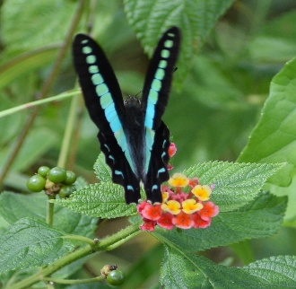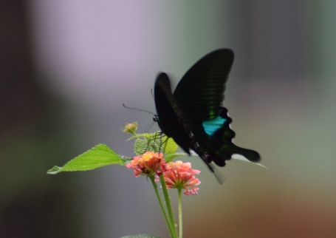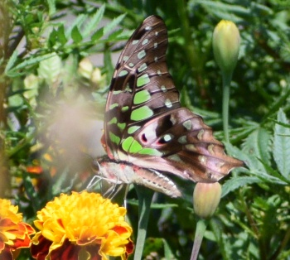
Graphium sarpedon Papilio paris paris Papilio agamemnon

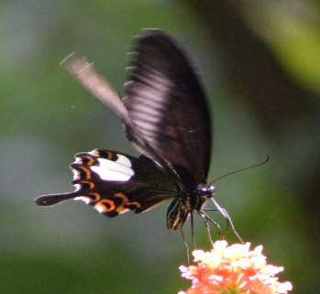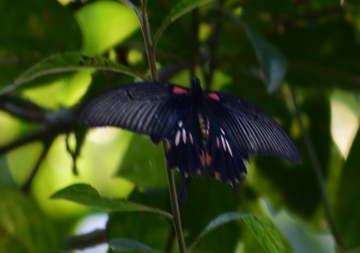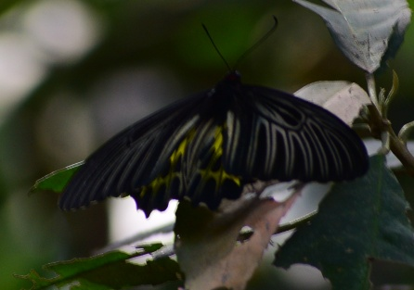
P. helenus helenus Papilio polytes romulus Troides helena

Fig 5: Photo-plates of few Papilionidae butterfly found in Saiden Community Forest

5. CONCLUSION

The investigation shows the ecological importance of Saiden Community Forest as a home for various types of swallowtail butterflies. The presence of multiple genera indicates differences in structure and resource availability in the landscape. Seasonal observations point out that the occurrence of species closely relates to favorable weather and habitat conditions. Finding legally protected species highlights the area's conservation value. The overall pattern of observations suggests a fairly stable butterfly community within the forest ecosystem. Good habitat management and less human disturbance will be key to maintaining this diversity. Ongoing long-term monitoring is recommended to track future changes and aid in informed conservation planning.

COMPETING INTERESTS DISCLAIMER:
Authors have declared that they have no known competing financial interests OR non-financial interests OR personal relationships that could have appeared to influence the work reported in this paper.

Disclaimer (Artificial intelligence)

Author(s) hereby declare that NO generative AI technologies such as Large Language Models (ChatGPT, COPILOT, etc.) and text-to-image generators have been used during the writing or editing of this manuscript.

REFERENCES

- Anonymous. The Wildlife (Protection) Act, 1972 (53 of 1972) as amended by the Wildlife (Protection) Amendment Act, 2002. Universal Law Publishing Co. Pvt. Ltd. 126pp. 2003
- Perveen, F., & Khan, A. (2024). Introductory Chapter: Lepidoptera Biodiversity and Conservation in the Twenty-First Century. In IntechOpen eBooks. IntechOpen.
- Baral, C., Baral, H. S., Inskipp, C., & Maharjan, R. (2025). Lepidoptera Diversity, Richness, and Distribution in Semi-Urban Farmland and other Habitats around Lumbini, Rupandehi. bioRxiv (Cold Spring Harbor Laboratory).
- Theivaprakasham, H. (2020). Identification of Indian butterflies using Deep Convolutional Neural Network. Journal of Asia-Pacific Entomology, 24(1), 329.
- Bibi, M., Bibi, S., Akhtar, N., Ullah, Z., Khan, M. F., & Qureshi, I. Z. (2021). Butterfly (Order: Lepidoptera) species Richness, diversity and distribution in different localities of Battagram, Pakistan. Saudi Journal of Biological Sciences, 29(3), 1853.
- Alarape, A. A., Omifolaji, J. K., & Mwansat, G. S. (2015). Butterfly Species Diversity and Abundance in University of Ibadan Botanical Garden, Nigeria. Open Journal of Ecology, 5(8), 352.
- Thapa, M. K., Saikia, M. K. & Saikia, P. K. (2023). Larval Hostplants’ Specificity of Butterflies in Garbhanga Reserve Forest (Proposed Wildlife Sanctuary) and Rani Reserve Forest, Kamrup, Assam, India. Asian Journal of Conservation Biology”. Vol. 12 No. 1, pp. 134–142
- Jose, A. (2024). Study of butterfly biodiversity in Dharam Tekri Chhindwara (M.P.). Journal of Entomology and Zoology Studies, 12(2), 105.
- Zahiri, R., Nazari, V., Rajaei, H., Wiemers, M., Fatahi, M., Seidel, M., Dalsgaard, T., & Husemann, M. (2021). An illustrated catalogue of the type specimens of Lepidoptera housed in the Zoological Museum Hamburg (ZMH): Part II. superfamily Papilionoidea. Evolutionary Systematics, 5(2),193.
- Hu, S., Cotton, A. M., Lamas, G., Duan, K., & Zhang, X. (2023). Checklist of Yunnan Papilionidae (Lepidoptera: Papilionoidea) with nomenclatural notes and descriptions of new subspecies. Zootaxa, 5362(1), 1.
- Linnaeus, C. (1758). Systema Naturae per regna tria naturae, secundum classes, ordines genera, species, cum characteribus, differentiis, synonymis, locis. 10th ed. Holmiae. 534 pp Moore, F. 1857. In Horsfield & Moore, Cat. Lep.Ills. E. India Co., 1: 22.
- Nakae, M. (2021). 世界のアゲハチョウ図説: Papilionidae of the world. Roppon-Ashi Entomological Books.
- Smetacek, P. (ed.). (2025). Synoptic Catalogue of the Butterflies of India. Second Edition. Butterfly Research Trust, Bhimtal.302pp
- Sidat, A., & Bhatt, U. (2020). Annotated checklist of butterflies of Ankleshwar & mdash; an industrial town in Gujarat, India. Check List, 16(4), 997.
- Barthakur M. (1986) Weather and climate of Northeast India, North East Geographer 18 (1-2):20-27.
- Pollard, E., Yates, T. J. Monitoring butterflies for ecology and conservation. The British Butterfly Monitoring Scheme. Chapman and Hall, London. 274pp. 1993.
- Evans, W.H. Identification of Indian Butterflies. 2nd Ed. Bombay Natural History Society. Bombay. 1932
- Talbot, G. (1947) The Fauna of British India, including Ceylon and Burma: Butterflies, Vol. 2. Taylor and Francis, London. 506pp.
- Haribal, M. The butterflies of Sikkim Himalaya and their natural history. Sikkim Nature Conservation Foundation, Gangtok, Sikkim, pp-217. 1992.
- Kehimkar, I. The Book of Indian Butterflies. Pub: BNHS, Bombay.2008
- Doubleday, (1846). Descriptions of new or imperfectly described Diurnal Lepidoptera. The Annals and Magazine Natural History, 17 (109): 22-26.
- Felder, C. and Felder, R. (1864). Species Lepidopterorum hucusque descriptae veliconibus expressae in seriem systematicum digestae. Pars prima. Papilionidae. Verhandlungen der kaiserlich-königlichen zoologisch-botanisch Gesellschaft in Wien 14(3): 289-378
- Felder, C. and Felder, R. (1865). Lepidoptera 1. Rhopalocera. Heft (2). Reise der Österreichischen Fregatte ‘Novara’, Zoologia, 2, 137–378, 26 pl. Carl Gerold’s Sohn, Vienna. (In German.).
- Fruhstorfer, H. (1902). Neue Lepidopteren aus dem Indo-Malayischen Gebiet Dt. Ent. Z. Iris, 15(1): 169-178.
- Cramer, P. (1775). Uitlandsche Kapellen (Papillons exotiques) Uitl. Kapellen 1 (1-7): 1- 132, pl. 1-84 (1775), (8): 133-155, pl. 85-96 (1776)
- Deb, M., Nautiyal, S., Sláma, P., Bhattacharjee, P. C., & Roychoudhury, S. (2015). Butterfly of Assam University Campus in Silchar: Can Academic Institutions Contribute to Conservation of Species Diversity in Northeastern Region of India? Acta Universitatis Agriculturae et Silviculturae Mendelianae Brunensis, 63(3), 731–739.
- Spitzer, K., V. Novotny, M. Tonner & J. Leps (1993). Habitat preferences, distribution and seasonality of the butterflies (Lepidoptera: Papilionoidea) in a montane tropical rain forest, Vietnam. Journal of Biogeography 20(1): 109–121
- Clark, P. J., Reed, J. M., & Chew, F. S. (2007). Effects of urbanization on butterfly species richness, guild structure, and rarity. Urban Ecosystems, 10(3), 321-337.
- Kioko, E., Musyoki, A., Luanga, A., Kioko, M., Mwangi, E., & Monda, L. (2020). Swallowtail butterflies (Lepidoptera: Papilionidae) species diversity and distribution in Africa: The Papilionidae collection at the National Museums of Kenya, Nairobi, Kenya. Biodiversity Data Journal, 8.
- Gaigher, R., Pryke, J. S., & Samways, M. J. (2023). Indigenous forest edges increase habitat complexity and refuge opportunities for grassland butterflies. Journal of Insect Conservation, 28(1), 27.
- Rozenberg, P., Mayeur, N., Nardin, M., Huard, F., Button, C., & Roques, A. (2018). Dendroecological analysis of the altitudinal shift of larch budmoth outbreaks with climate change in the french Alps. HAL (Le Centre Pour La Communication Scientifique Directe).

