First documentation of Hypogaeic Ant, Dorylus orientalis, predation on olive ridley turtle nests from the west coast of India with a note on eco-friendly mitigation in hatchery management.

ABSTRACT
The terrestrial developmental stage of sea turtles is highly vulnerable to multiple environmental and biological threats, including rising sea levels, elevated temperatures, and predation. Predation is one of the major factors reducing hatching and emergence success, thereby affecting population recruitment. During routine monitoring of protected nests in a hatchery on the west coast of India, severe infestations by hypogaeic ants were observed, resulting in damage to 35-50% of the relocated nests and causing 0% hatchling emergence in several cases, thereby compromising conservation efforts. The present study was undertaken to identify the ant species involved and to document its predatory behaviour on olive ridley turtle (Lepidochelys olivacea) eggs, with the objective of developing an effective management strategy to control the infestation. The ants were identified as Dorylus orientalis, which were found attacking protected nests and feeding on eggs during both early and late stages of incubation. The ants were also observed preying upon newly hatched hatchlings within the nest cavity. Neem cake, derived from the seeds of the native plant Azadirachta indica, was evaluated for its repellent properties. Application of neem cake to the nest at different stages of incubation effectively repelled the ants without causing mortality and ensured the successful emergence of hatchlings. The study provides the first direct record from India of predation on olive ridley turtle eggs by the hypogaeic ant Dorylus orientalis, demonstrating a simple and eco-friendly method for managing ant infestations in sea turtle hatcheries.

KEYWORDS: Predation, Conservation, Ecology, Ants, Sea turtle, Asia,

- INTRODUCTION
Hatchery management, as part of ex-situ conservation programs, is widely implemented to protect sea turtle nests from inundation, predation, and poaching. Relocation of eggs to protected hatcheries significantly reduces hatchling mortality caused by common predators such as feral dogs, sea birds, monitor lizards, and golden jackals. In addition to these well-known predators, carnivorous ants have also been reported to prey on sea turtle eggs and hatchlings. Fire ants, including Solenopsis geminata and Solenopsis invicta, are known to attack emerging hatchlings along the coasts of Florida and El Salvador (Craig et al., 2001, 2004). These ants were observed attacking in situ nests located near dune vegetation and were found to preferentially sting hatchlings rather than feeding on developing embryos within incubating eggs (Craig et al., 2001; James et al., 2007). Ant predation on turtle nests by species of the genus Dorylus was first reported from South Africa and Malaysia (George, 1970). Subsequent studies documented the predatory foraging behaviour of Dorylus laevigatus and Dorylus spininodis on green and leatherback turtle eggs in Malaysia and East Africa, where such infestations negatively affected emergence success (Morita et al., 2005; Maite et al., 2020).
India possesses an extensive and geomorphologically diverse coastline that supports several important sea turtle nesting habitats. The olive ridley turtle Lepidochelys olivacea (Eschscholtz, 1829) is one of the seven extant sea turtle species and nests sporadically along nearly 6000 km of India’s mainland east and west coasts. The species is classified as Vulnerable under the IUCN Red List and is listed under Schedule I of the Indian Wildlife (Protection) Act, 1972, providing it the highest level of legal protection in the country. The east coast of India, particularly the state of Odisha, supports one of the largest mass nesting (arribada) populations at Gahirmatha and Rushikulya. Female olive ridley turtles excavate pitcher-shaped nests in the sand using their hind flippers, deposit the eggs, and cover the nest before returning to the sea. On the Indian coast, the clutch size typically ranges from 75 to 135 eggs per nest, with an incubation period of approximately 45–60 days. Maharashtra state, on the west coast of India, has approximately 300km of coastline with olive ridley turtle nesting. Natural predators such as jackals, birds, hyenas, crabs, and feral dogs are known to prey on eggs and emerging hatchlings, often reducing hatchling survival (Satyaranjan and Hinrich, 2020). To minimise such losses, ex-situ hatchery management has been adopted at several nesting sites in India and all nesting sites in Maharashtra (Andrea and Nupur, 2018). The hatchery practice has achieved an average emergence success rate of 75% from nesting sites in Maharashtra.
Reports of ant depredation on turtle nests from India are limited, and information on the identity of the species involved and their management remains inadequate (Abhinay et al., 2016; Arun, 2018). The application of neem cake mixed with sand above the nest has been suggested as a possible control measure (Arun, 2018), but systematic evaluation is lacking. Persistent infestation by an unidentified ant species was observed at our study site on the west coast of India between 2014 and 2018. Approximately 35–50% of the incubating nests were affected each season, with infested nests showing only 0–10% hatchling emergence (Sumedha, unpublished data). The infestation appeared unpredictable and has recently been reported from additional nesting locations, indicating a potentially emerging threat to conservation programs. Control of such infestations is particularly challenging because the ants are hypogaeic and attack nests in large numbers from beneath the sand.
Azadirachta indica (commonly known as Neem in India) is a general insecticide used in horticulture practices. The use of the neem plant, Azadirachta indica, is predominant in integrated pest management in India and is native to the Indian subcontinent. It is not detrimental to the environment and is target-specific. The pesticidal constituents of neem tetranortriterpenoids (limonoids) are concentrated in the seed kernels and exert multi-targeted effects on insects; moreover, they are non-toxic to vertebrates. The cake's residual oil and limonoids, like azadirachtin, are used as an insect repellent (Rashmi, 2016).
To address this problem and develop an effective mitigation strategy, the present study was undertaken with the following objectives: (1) Identification of the ant species and assessment of its ecological role through literature; (2) Documentation of its foraging behaviour on turtle nests; (3) Application and effectiveness of selected Bioinsecticide; (4) Development of a standardized protocol for mitigation of ant infestation in hatchery management. Through this study, we aim to demonstrate how accurate identification of ant species can contribute to effective conservation management of olive ridley turtle nests. A controlled experimental study to evaluate the efficacy of the bioinsecticide on infested nests could not be conducted because the focal sea turtle species is listed under Schedule I of the Wildlife (Protection) Act, 1972, which restricts experimental manipulation.

2. MATERIAL AND METHODS
  - Study area
This study was done on two coastal sites in the Maharashtra state on the west coast of India, Wayangani -Vengurla beach (15° 52' N, 73° 36' E, hereafter site A) and Kolthare beach (17⁰ 38' N, 73° 7' E, hereafter site B) (Fig.1). These sandy beaches are high nesting sites (rookery) for solitary nesting olive ridley turtles with an average nest of 35 per nesting season per year. Both these sites are 2.5 km long, sandy with an estuary at one end and a rocky shore at the other side. Adjoining the sandy shore are plantations of casuarina and coconut with village settlements. The preliminary study for ant infestation was conducted during the nesting season of 2019 and 2020 on-site A, and the effectiveness of bioinsecticide and management practice in 2021 on both sites A and B.
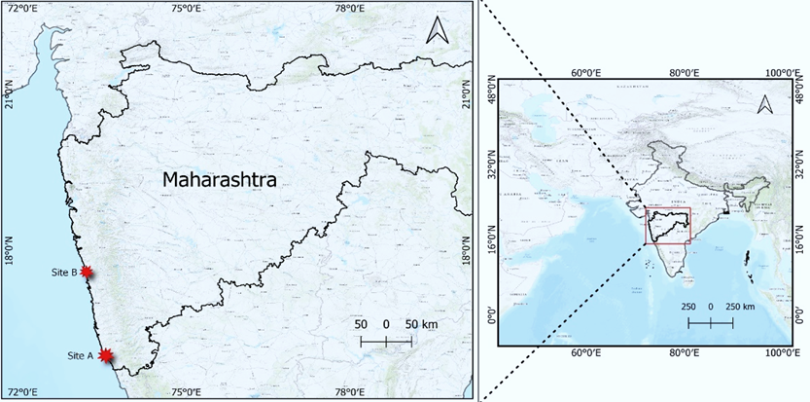

Fig. 1. The map of intervention study sites A and B on the west coast of India.

2.2 Ant sample collection
The infested nests were exhumed during the preliminary study to examine the hypogaeic ant activity. The ant specimens were collected live for species identification.
2.2.1 Preservation and identification of ant specimens
In the laboratory, the specimens were preserved in 80% ethanol and refrigerated. The samples were revived in a relaxation chamber containing a moisture pad made of two layers of tissue paper sheets wetted with distilled water. The specimens, after relaxation, were spread and photographed by a Magnus 7OT 0650 stereo zoom microscope. The post-processing of images was done using GIMP 2.10 and ImageJ. The ant species identified with key characters as described by Charles, T. B., in Fauna of British India (1903) and Barry, B., (1995).
2.3 Nesting data and temperature monitoring
The stages of development of the incubating eggs were estimated from the nesting data. The nest temperature was determined by using an indigenously developed temperature data logger with temperature sensors installed inside the nests. The sensors have an accuracy of ± 0.1 ºC (Sumedha and Sivakumar, 2023).
2.4 Hatchery management
2.4.1 Selection of bioinsecticide
The bioinsecticides used for the management were a) Neem powder (Np), b) Neem cake (Nc) and c) Neem cake + kerosene (Nc+K). The Np is made of dried leaves and bark of the tree, whereas Nc is the coarse residue that remains after neem oil is extracted from seeds. The Np was used in 2020 on-site A for infested and non-infested nests.

2.4.2 Application of bioinsecticides
2.4.2.1 Use of bioinsecticide during preliminary study
A trench of 1.5 feet was dug on all four sides of a nest having net fencing of 4 feet x 4 feet. The trench was then filled with three kg of Np intermittently mixed with sand. Based on the observations of 2019 and 2020, the ant management protocol was designed for the 2021 actual study.
2.4.2.2 Use of bioinsecticide during the actual study inside the hatchery
On site A, the perimeter of the hatchery (10 feet x 15 feet) was pre-treated with Np, whereas the hatchery on site B was not pretreated (Fig 3A). On both sites, after the first sign of infestation Nc was used instead of Np.
From the day of the first sign of infestation, all the subsequent relocated nests were pretreated by Nc for the prevention of infestation (Fig. 2A-B). In the case of infested nests inside the hatchery, two approaches were implemented for the use of Nc. The upper 0.5 feet of sand was removed, and we examined the nest for any sign of ants. 1) In case of nest infestation by ants, we noted the day of incubation of the nest, and then the eggs were removed carefully (without subjecting them to any rotational shock). We separated the damaged eggs from the undamaged eggs (Fig. 2C-E). The process of excavation and relocation of undamaged eggs was done swiftly to minimise the exposure of eggs to air, preventing desiccation (Fig 3B). 2) The infested nests were treated without relocating or excavating the eggs. This approach avoided any handling of the incubating eggs and was done on site B (Fig. 2F-H and Fig 3C).
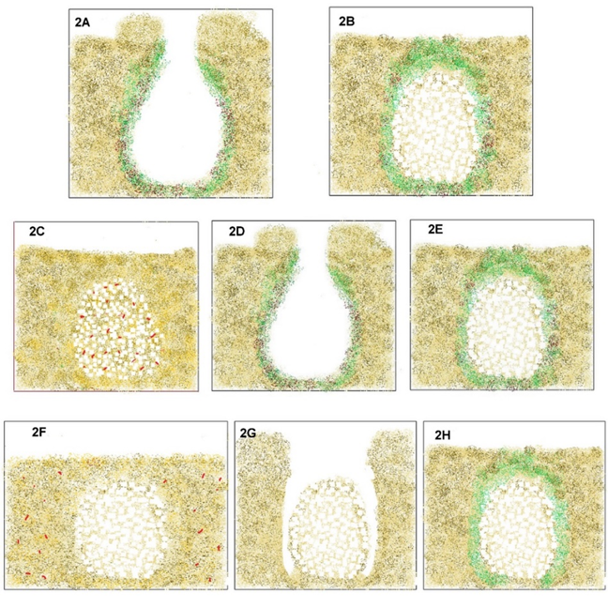

Fig. 2. The different methods of treatment of an infested nest. The pretreatment of the nest at the time of relocation is done by smearing the inner lining of dug out nest with a mixture of Nc and sand in a 1:1 ratio. The eggs are placed inside the pretreated nest, which is then closed by excavated sand (A-B). The nest top is then covered by a mixture of Nc and sand (1:1). The treatment procedure of the infested nests, which are excavated and relocated to another location pre-treated with Nc as described in A -B. Alternatively, the infested nest is treated on site without relocating (C-E). The eggs are excavated, and the inner lining of the nest is smeared with Nc and sand in a 1:1 ratio. Eggs are then placed in the nest, followed by steps in A-B. The infested nest is treated without excavating the eggs (F-H). The sand around the nest is removed without disturbing the eggs. A mixture of Nc and sand in a 1:1 ratio is then filled around the eggs, gradually closing the nest. (red dots are the ants, green is Nc, yellow and black are sand, white spots are eggs).

2.5 Exploratory study of the efficiency of Nc and kerosene on ants
A combination of kerosene sprinkled on Nc was used to see its efficacy in preventing infestation. This method was not directly used on the infested nest. We tested its effect on the sand with live ants. The sand containing live ants was placed inside the box with a lid. Then the mixture of Nc and kerosene was applied to the sand in a 1:4 proportion. The setup was placed in a dark shade for 30 minutes and then observed for any activity (Fig. 3D- E).
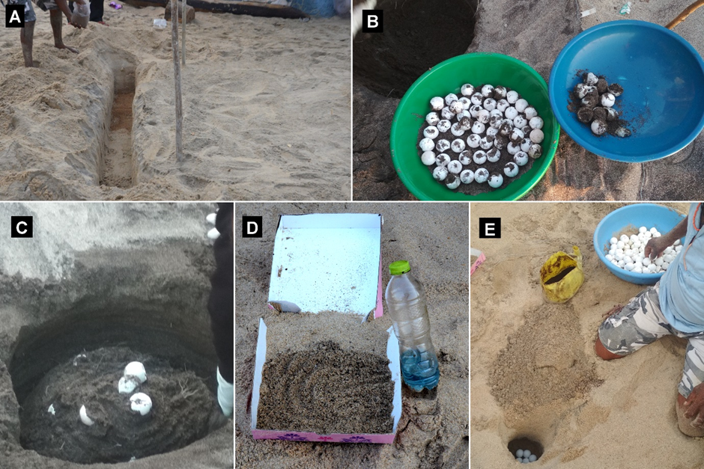

Fig. 3. Application of Np/Nc outside the nest/ hatchery by digging a trench of 1.5 feet in depth. The Np/Nc is intermittently layered with sand filling the trench. (B) Excavation of eggs from the infested nest and separating the damaged eggs. (C) Application of Nc around the nest without removing the eggs. The eggs are seen as a mound in the centre. (D) Testing the efficacy of Nc + kerosene on live active ants. (E) Relocation of the infested nest to another site. The nest is dug up, followed by treatment with Nc. The eggs are then placed in the treated nest.

3. RESULTS
  - Ant species identification
We identified the ant species predating on turtle eggs as Dorylus orientalis Westwood 1835, commonly called driver ant or Asian army ant. It belongs to the subfamily Dorylinae of the family Formicidae. The key identifying morphological characteristics of workers show antennae having nine segments, eyes absent, head rectangular. Pygidium was toothed and postpetiole, not separated from the next abdominal segment by a distinct impression. The occiput of the dorsal head region is deeply emarginated (Edward, 1964) (Fig. 4A-F).
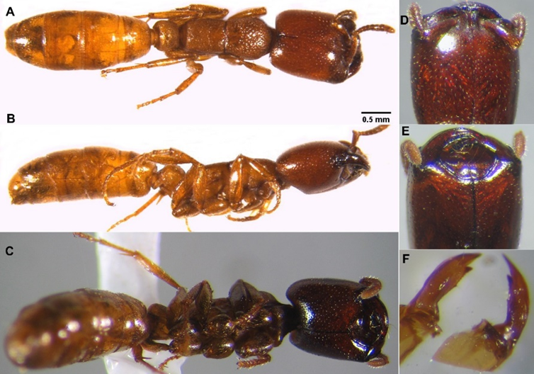

Fig. 4. The Asian army ant (Dorylus orientalis) (A) Dorsal view (B) lateral view (C) Ventral view (D) Dorsal view of the head (E) Ventral view of the head with strong cutting and piercing mandibles (F) Mandibles.

3.2 Behavioural observations of ants within infested nests.
The nest excavated for observation had the presence of huge numbers of army ants. The ants are seen active inside the nest when excavated during the daytime. But when exposed to direct light, the ants penetrated deep inside the nest. Small pits opening into tunnels were observed at the base of the nest about 1.5 feet deep. A few ants were seen escaping through these tunnels (Fig. 5D). We observed eggs with punctured holes in the shell (Fig. 5A). The infested nest that was examined had eggs in the advanced embryonic developmental stage (> 30 days of incubation) as well as the early developmental stage (< 10 days of incubation). During the infestation, we observed an absence of ants in the nest with eggs of mid-developmental stages, though they were present in the vicinity. The nests at early and late incubation stages infested by D. orientalis were completely damaged by ants with dead embryos, resulting in 0% emergence of hatchlings. On site B, a huge number of ants were seen on live hatchlings that had emerged from the nest, rendering it immobile (Fig. 5C).

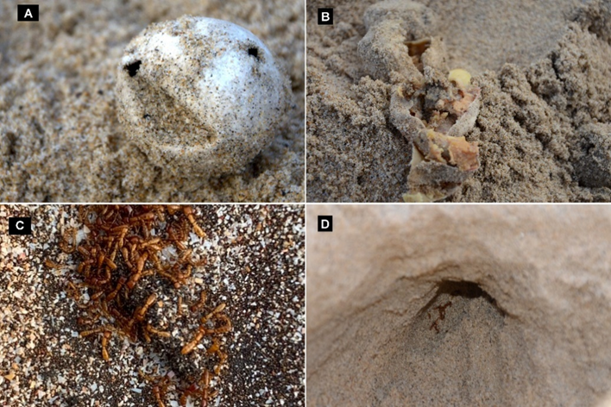

Fig. 5. Direct and indirect signs of D orientalis infestation (A) Holes punctured in the empty eggs. After the emergence of hatchlings, the eggs showing such holes show ant infestation (B) Ants feeding on the yolk of the egg (C) Ants on a live hatchling that has emerged from the nest (D) Ants seen escaping from the tunnels present at the base of the nest at a depth of 1.5 feet.
3.3 Temperature of infested nest
On-site A, the infestation of ants was first observed in the early month of March when the average incubation temperature recorded was 34ºC, whereas on-site B, the infestation appeared in late March when the average incubation temperature showed 33ºC (Fig. 6).

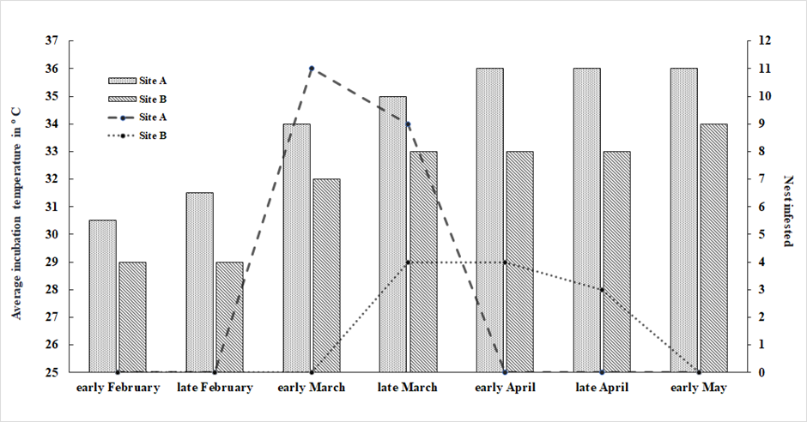
Fig. 6. The average incubation temperature of the nest and the infestation of the nest on sites A and B during the nesting period. The temporal variation in the incubation temperature between sites shows a corresponding variation in the ant infestation period. On both sites, the first sign of infestation was observed when the incubation temperature of the nests exceeded 33º C.

3.4 The efficacy of bioinsecticides
The use of Np on site A applied on the perimeter of the hatchery did not prevent the ant infestation in 2021, though it showed promising results in 2020. The infestation on site B was observed for the first time in 2021. The Nc, which replaced Np, was observed to be more effective in preventing the ant infestation in non–infested nests and driving away the ants from infested nests. The combination of kerosene and neem cake was found to be potent for D. orientalis. The excavation of the nests treated by Nc after the emergence of hatchlings showed the absence of live or dead ants or eggshells with punctured holes. Ant infestation and treatment outcomes were recorded at two hatchery sites (Site A and Site B) during the nesting season (Table 1). A total of 39 nests were protected at Site A and 35 nests at Site B. Ant infestation was observed in 21 nests at Site A and 11 nests at Site B, while 18 and 24 nests, respectively, remained free from infestation. Complete nest damage due to ants was recorded in three nests at Site A and seven nests at Site B.
At Site A, nine infested nests remained untreated, of which six showed hatchling emergence. Twelve nests that received pre-infestation treatment showed 100% emergence success. Eighteen nests treated after infestation also resulted in successful emergence in all treated nests.
At Site B, eleven nests were left untreated, of which only four showed emergence. Twenty nests that received pre-infestation treatment showed successful emergence in all cases. Four nests treated after infestation also showed successful emergence.
Overall, nests treated either before or after infestation showed higher emergence success compared to untreated nests, indicating the effectiveness of the treatment in preventing ant damage.
Table 1. The quantitative data of nesting, infestation, modes of treatment, and corresponding nests showing the emergence of hatchlings.
 | Site A | Site B
Total no of turtle nests protected in the hatchery | 39 | 35
No of nests infested by ants | 21 | 11
No of nests not infested by ants | 18 | 24
Nest completely damaged by ants | 03 | 07
Untreated nest | 09 | 11
Emergence from an untreated nest | 06 | 04
Pre-infestation treated nest | 12 | 20
Emergence from pre-infestation treated nest | 12 | 20
Post-infestation treated nest | 18 | 04
Emergence from the post-infestation treated nest | 18 | 04

3.5 Infestation pattern in relocated nests
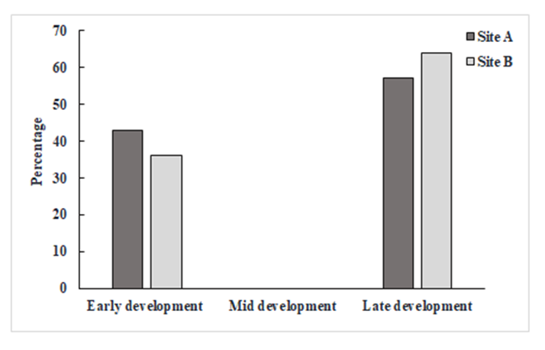
Ant infestation in relocated olive ridley nests was recorded during the 2021 nesting season, with attacks occurring at different stages of egg development. Infestation was observed during early, mid, and late incubation stages, as well as close to the hatching period. Several infested nests showed complete failure of emergence, with eggs either damaged or consumed by ants present within the nest chamber. Early-stage infestations resulted in the mortality of developing embryos, whereas late-stage infestations affected fully developed embryos and newly hatched hatchlings. These observations indicate that ant predation can occur throughout the incubation period and may significantly reduce emergence success in hatchery-protected nests (Fig 7).

Fig. 7. Occurrence of ant infestation during different incubation stages of the nest

4. DISCUSSION
The present study was undertaken to mitigate the impact of ant predation on turtle nests at an important olive ridley nesting site on the west coast of India. Identification of the ant species was a critical component of the study, as it enabled the development of an appropriate mitigation strategy. Considering the ecological role of the species in the study area, we evaluated non-toxic and environmentally safe control measures. We proposed both preventive and remedial approaches to manage nest infestation.
The ants responsible for nest depredation were identified as Dorylus orientalis, a hypogaeic species belonging to the genus Dorylus, which includes the well-known driver ants of Africa, with four species occurring in tropical Asia (Edward, 1964). Species of this genus form large colonies and are generalist predators. Historical reports of Dorylus species infesting turtle nests exist from South Africa and Malaysia, where heavy predation caused complete nest mortality (Humph, M. A. et al., 1965; George, 1975). Infestation of hawksbill turtle nests by Dorylus sp. in Malaysia has been reported at all stages of egg development, with punctured eggshells and ants attacking emerging hatchlings being typical signs of infestation (Eng-Heng and Hock-Chark, 1999; James et al., 2007). These observations are consistent with the present study, in which ants attacked eggs during early, mid, and late incubation stages and also preyed upon newly hatched hatchlings inside the nest. Although D. orientalis has a wide distribution across India, Myanmar, Sri Lanka, and Southeast Asia (Himender, 2008), its predatory behaviour on sea turtle nests has not previously been documented from India.
An increase in ant infestation in recent years may be related to ecological changes at the nesting site. A noticeable shift in the peak nesting season of olive ridley turtles from winter (December) to late winter–summer (February–March) has been recorded in the study area during the last decade (Sumedha and Sivakumar, 2023). This seasonal shift exposes nests to higher incubation temperatures, often exceeding 33 °C. In the present study, D. orientalis activity inside nests was observed mostly within the temperature range of 33–35 °C, with a marked decline at temperatures above 36 °C. Although the available data are insufficient to establish a strong correlation, elevated temperature and dry weather are known to increase ant activity and population size (Elangbam et al., 2022). Another possible explanation is the overlap between the turtle nesting season and the brooding period of D. orientalis, resulting in increased foraging activity. Similar synchrony between ant activity and turtle nesting has been reported for Solenopsis invicta and loggerhead turtles in Florida (Craig et al., 2004). Swarming of D. orientalis in northern India has been reported during late February following winter (Mithan, 1972), which corresponds with the nesting period observed in the present study.
The biology of hypogaeic ants is poorly understood, and information on colony structure, nesting sites, and foraging behaviour of D. orientalis is limited. Subterranean Dorylus species construct tunnels and long galleries in the soil, and their nest chambers are rarely observed. In the present study, ants entered and exited nests through underground tunnels, leaving little surface evidence, a behaviour similar to that reported for the army ant Labidus coecus infesting river turtle nests in Peru (M. da Costa et al., 2021) and D. laevigatus attacking turtle nests in Malaysia (Seh et al., 2023). Dorylus species are known to travel long distances from their permanent nest while foraging in large numbers, feeding on lipid-rich food during organized subterranean raids. Unlike D. laevigatus, which has been reported feeding on decaying eggs (Stefanie et al., 2002), D. orientalis in the present study attacked intact eggs and developing embryos, suggesting active predation rather than scavenging. Dead ants trapped in egg yolk, as reported for D. spininodis (Maite et al., 2020), were not observed in this study.
The preference of D. orientalis for advanced-stage eggs and hatchlings may be related to the availability of multiple nests concentrated within the hatchery, providing a rich and localized food source. Infestation of in-situ nests was not observed at the study site, as all nests were relocated to the hatchery, and the clustered arrangement may have facilitated ant foraging. The species is known to be omnivorous, feeding on insects, earthworms, plant material, and occasionally other ants such as Pheidole indica. Although considered an agricultural pest in several regions of India, Nepal, Myanmar, and Sri Lanka, the turtle nesting sites in Maharashtra lack major crop plants, suggesting that the presence of D. orientalis at these sites is primarily ecological rather than agricultural. The ants were observed scavenging on fish waste, fallen fruits, and other organic matter along the beach, indicating opportunistic feeding behaviour. As with other Dorylus species, their hypogaeic lifestyle may contribute to soil aeration and nutrient cycling, highlighting their ecological importance (Stefanie et al., 2002).
Management of D. orientalis in agriculture commonly involves chemical pesticides; however, such methods are unsuitable in turtle hatcheries due to ecological risks. In the study area, the organophosphate pesticide Phorate had previously been used but is now banned because of its environmental toxicity. Neem-based products have been reported as effective against D. orientalis in crop systems (Chandra et al., 2013; Badal et al., 2014), and therefore, neem cake was evaluated in the present study as a natural repellent. Application of neem cake to infested nests resulted in the successful emergence of hatchlings, indicating that the treatment effectively repelled ants without causing mortality. Although neem powder applied directly to nests protected at the individual nest level, it was less effective when used as a barrier around the hatchery. In contrast, neem cake applied as a pre-treatment around the hatchery boundary was more effective in preventing infestation. In areas with heavy ant presence, a defensive trench containing sand mixed with neem cake and a small quantity of kerosene, applied at least one meter away from the hatchery, acted as an effective barrier. However, kerosene should be used cautiously and only outside the hatchery area to avoid ecological harm. As a general hatchery management practice, pre-treatment of the hatchery with neem cake is recommended to prevent infestation.
This study provides the first direct evidence from India of predation on olive ridley turtle eggs by the native hypogaeic ant Dorylus orientalis. The findings highlight the importance of taxonomic identification in developing effective conservation strategies. In addition to documenting the predatory behaviour of the species, the study proposes a practical and eco-friendly management protocol that can be implemented in hatchery-based conservation programs. Application of the recommended pre-treatment during the 2022 and 2023 nesting seasons at the study site resulted in complete prevention of nest infestation, demonstrating the effectiveness of the proposed method.

5. CONCLUSION
This study provides the first confirmed record from India of predation on olive ridley turtle (Lepidochelys olivacea) eggs by the hypogaeic ant Dorylus orientalis. The infestation caused significant loss of eggs and hatchlings in hatchery nests, affecting emergence success and posing a challenge to ex-situ conservation efforts. Identification of the ant species enabled the development of an effective and eco-friendly mitigation strategy. Application of neem cake (Azadirachta indica) was found to repel ants without causing mortality and ensured successful hatchling emergence. Preventive treatment of the hatchery with neem cake proved effective in controlling infestation. The study highlights the importance of species identification and ecological understanding in developing safe and practical conservation management methods.

APPROVAL
The authors have taken permission from the Maharashtra State Forest Department to conduct the above research work (reference no: Desk-22(8)/WL/CR-88 (16-17)/34/2019 -20).

COMPETING INTERESTS DISCLAIMER:
Authors have declared that they have no known competing financial interests OR non-financial interests OR personal relationships that could have appeared to influence the work reported in this paper.

Disclaimer (Artificial intelligence)

Author(s) hereby declare that NO generative AI technologies such as Large Language Models (ChatGPT, COPILOT, etc.) and text-to-image generators have been used during the writing or editing of this manuscript.

REFERENCES
Abhinay, K., Mohan, U., Sumedha, A. K., 2016. Lesser-known natural threats to protected olive ridley nests in coastal Maharashtra. Indian Ocean Turtle Newsletter. 24, 6-7.

Anisur, R. A., Sunil, A., Naresh, D., 2013. Extent and potential use of bio-pesticides for crop protection in SAARC countries, in: Tayan, R. G., Abdul, k. A. (Eds.), Extent and potential use of bio-pesticides for crop protection in SAARC Countries. SAARC Agriculture Centre., Bangladesh, pp. 95-118.

Andrea, D. P., Nupur, K., 2018. The use of sea turtle hatcheries as an ex-situ conservation strategy in India. Indian Ocean Turtle Newsletter. 27, 18-29.

Arun, V., 2018. Student's Sea Turtle Conservation Network- Thirty years of sea turtle conservation on the Chennai coast. Indian Ocean Turtle Newsletter. 30, 2-5.

Badal, B., Utpal, B., Dwiban, P., 2014. Management of red ant, Dorylus orientalis Westwood (Hymenoptera: Formicidae) in potato. Journal of Entomological Research. 38, 265-267.

Barry, B., 1995. A new general catalogue of the ants of the world, first ed. Harvard University Press, Cambridge.

Chandra, K. D., Kamrul, H., Md Enayet, A. P., Md Harun O. R., Md Abdur, R. C., 2013. Development of Management Strategies against Red Ant (Dorylus Orientalis Westwood) of Potato. Universal Journal of Plant Science. 1, 74–77. https://doi.org/10.13189/ujps.2013.010303.

Charles T, B., 1903. Hymenoptera, Vol. II. Ants and Cuckoo-wasps, in: William, T. B. (Eds.), The fauna of British India, including Ceylon and Burma. Taylor and Francis., London, pp. 1-5.

Craig, R. A., Elizabeth, A. F., Kenneth, G. R., Daniel P. W., 2001. Effects of fire ants (Hymenoptera: Formicidae) on hatching turtles and prevalence of fire ants on sea turtle nesting beaches in Florida. Florida Entomologist. 84, 250-253.

Craig, R. A., Deborah, M. E., Ahjond, S. G., 2004. Red imported fire ant impacts on wildlife: A decade of research. American Midland Naturalist. 152, 88–103. https://doi.org/10.1674/0003-0031(2004)152 [0088: RIFAIO]2.0.CO;2.

Edward, O. W., 1964. The true army ants of the Indo-Australian area (Hymenoptera: Formicidae: Dorylinae). Pacific Insects. 6, 427-483.

Elangbam, B. D., Badal, B., Sudhansu B., 2022. Population dynamics of red ant Dorylus orientalis in potato grown under flood free/ prone conditions. Indian Journal of Entomology. 84, 942-946. DoI No.: 10.55446/IJE.2021.306.

Eng-Heng, C., Hock-Chark, L., 1999. Hawksbill turtles Eretmochelys imbricata, nesting on Redang island, Terengganu, Malaysia from 1993 to 1997. Chelonian Conservation and Biology. 3, 326-329.

George, R. H., 1970. Further studies on marine turtles in Tongaland III. Lammergeyer. 12, 7-25.

George, R. H., 1975. Further studies on marine turtles in Tongaland 8. Lammergeyer. 22, 9-18.

Himender, B., 2008. Altitudinal diversity of ants in Himalayan regions (Hymenoptera: Formicidae). Sociobiology. 52, 305-322.

Humph, M. A., John, H. B., Hennie, V. S., 1965. The marine turtles of Tongaland, Natal. Lammergeyer. 3, 10-40.

James, K. W., Lawrence, D. W., Chris, J., Holly, K., Stephanie, F., 2007. Predaceous ants, beach replenishment, and nest placement by sea turtles. Environmental Entomology. 36, 1084-1091.

Maite, I., Pierre, D. A., Olivia, S., Yves, B., Brendan, J. G., Adolfo, M., 2020. Cryptic massive nest colonisation by ants and termites in the world's largest leatherback turtle rookery. Ethology Ecology and Evolution. 32, 264–281. https://doi.org/10.1080/03949370.2020.1715487.

M, da Costa, R., J, M. Reintjes., D, Chen., Sean, O'D., 2021. Predation on nests of three species of Amazon River turtles (Podocnemis) by underground-foraging army ants (Labidus coecus). Insectes Sociaux. 68, 277–281. https://doi.org/10.1007/s00040-021-00814-8.

Mithan, L. R., 1972. Plant-pest status of root-eating ant, Dorylus orientalis, with notes on species, distribution, and habits (Insecta: Hymenoptera). Bombay Natural Historical Society. 72, 305–313.

Morita, M., Chan, E. H., Abu, H. A., 2005. Marauder ant (Pheidologeton affinis) predation of green turtle (Chelonia mydas) nests in Chagar Hutang, Redang Island and measures to protect the nests. Proceedings of the 2nd International Symposium on SEASTAR 2000 and Asian Bio-Blogging Science (The 6th SEASTAR2000 Workshop) 2005, 55-62.

Rashmi R., 2016. Neem Products, in: Omkar. (Eds.), Eco-friendly Pest Management for Food Security. Academic Press., Lucknow, pp. 545–562. https://doi.org/10.1016/C2014-0-04228-1.

Satyaranjan, B., Hinrich, K., 2020. Threats to the nests of Olive Ridley Turtles (Lepidochelys olivacea Eschschholtz, 1829) in the world’s largest sea turtle rookery at Gahirmatha, India: need for a solution. Herpetology Notes. 13, 435-442.

Seh, L. L., Jason, Y. S. G., Wei, Q. L., Sze, H. Y., 2023. Predatory ants invading sea turtle nests on the East Coast of Peninsular Malaysia. Insectes Sociaux. 70, 365 – 372. https://doi.org/10.1007/s00040-023-00925-4.

Stefanie, M. B., Andreas, W., K Eduard, L., Maryati, M., Ulrich, M., 2002. Foraging of a hypogaeic army ant: a long-neglected majority. Insectes Sociaux. 49, 133-141.

Sumedha, A. K., Sivakumar, K., 2023. Mitigating the Effects of a Shift in Nesting Season of Olive Ridley Turtles on the West Coast of India. IOSEA Marine Turtles. https://www.cms.int/iosea-turtles/es/node/23511/(accessed 6 August 2024)

