Evaluation of Functional and Textural Characteristics of Fish Mince Sausages Prepared Using Microbial Transglutaminase (MTGase)

Abstract
Microbial transglutaminase (MTGase) is widely used in food processing to improve the structural and functional properties of protein-based products through enzymatic cross-linking. The present study evaluated the influence of different concentrations of MTGase on the functional and textural characteristics of fish mince sausages prepared from Labeo rohita. Fish mince incorporated with varying levels (0, 0.5, 1.0 and 1.5%) of MTGase was processed into sausages and evaluated for functional properties such as water-holding capacity, cooking yield, and emulsion stability. Textural characteristics including gel strength and texture profile parameters were also determined. The results indicated statistically significant improvements (p < 0.05) in gel strength and water-holding capacity with increasing MTGase levels, with the optimal concentration producing sausages with superior structural integrity and desirable texture. These findings suggest that MTGase can be effectively utilized for the development of high-quality value-added fish products.

Graphical Abstract
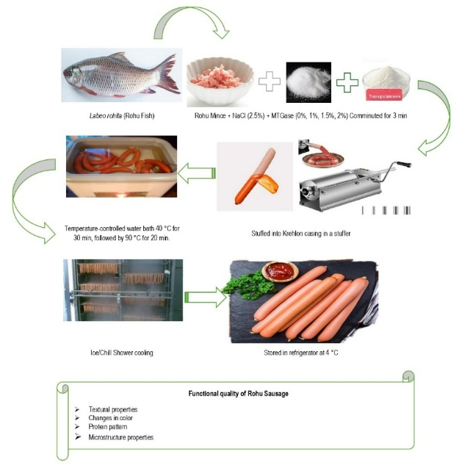

Keywords
Labeo rohita; color; gel strength; microstructure; microbial transglutaminase; mince; sausages; texture
1. Introduction
Fish production in India has reached new heights due to the promotion and expansion of aquaculture activities, contributing significantly to the national economy. During 2022–23, India’s total fish production (marine and inland) was reported at 175.45 lakh tonnes (Handbook on Fisheries Statistics, 2023). Indian major carps, viz., Labeo catla, Labeo rohita, and Cirrhinus mrigala, contributed approximately 57% of the total inland fish production during 2020–21. The disposal pattern of fish catch generally includes marketing as fresh fish, frozen products, cured products, canned products, or reduction into fish meal. Although a major portion of fish production in India is marketed in fresh form, the continuous increase in production has created challenges in efficient marketing and utilization. Therefore, diversification into value-added fresh and processed fish products is essential to enhance utilization and economic returns.
Technological advancements in fish processing, coupled with increasing demand among younger consumers for innovative and convenient products, have encouraged processors to develop diversified fish-based products with competitive taste and pricing. Many restructured fish products are prepared from fish mince or washed mince (surimi) mixed with salt to form a viscoelastic paste. Various functional ingredients such as starch, soy protein, whey protein, fat, microbial transglutaminase (MTGase), and hydrocolloids are incorporated to modify functional and textural properties and improve overall product quality (Makri, 2012; Park et al., 2013). The effectiveness of these additives depends on their interaction with specific fish muscle proteins and processing conditions (Moreno et al., 2008).
The gel-forming ability of myofibrillar proteins is a critical determinant of the functional and textural characteristics of fish products (Benjakul et al., 2003). Protein gel networks are stabilized by hydrogen bonds, hydrophobic interactions, and electrostatic forces (Foegeding et al., 1994). Differences in thermal stability of myofibrillar proteins between tropical and cold-water fish species may significantly influence gelation behavior during processing and storage (Howell et al., 1991). Freshwater fish, particularly Indian major carps, often exhibit limited unfolding of actomyosin at lower temperatures during thermal processing, which restricts effective cross-linking and gel network formation (Sankar and Ramachandran, 2002). Consequently, enhancement of gelation properties in carp mince remains a technological challenge.
Microbial transglutaminase (MTGase), commonly referred to as “meat glue,” is widely used in surimi and meat processing industries to improve gel strength and texture through protein polymerization via non-disulfide covalent bonds (Benjakul et al., 2008). MTGase catalyzes the formation of ε-(γ-glutamyl) lysine peptide bonds through an acyl-transfer reaction between the γ-carboxyamide group of glutamine residues and primary amines in proteins (Chanarat et al., 2012). The efficiency of MTGase in enhancing gel properties is influenced by enzyme concentration, fish species, fat content, and processing conditions (Asagami et al., 1995).
Recent studies have highlighted the role of microbial transglutaminase in improving the functional and rheological properties of protein-based food systems. MTGase catalyzes covalent cross-linking between glutamine and lysine residues of proteins, resulting in improved gel strength, texture, and water retention in muscle foods. Similar improvements in gel network formation and structural stability have been reported in surimi and protein-based emulsion gels when treated with MTGase (Walayat et al., 2022; Xu et al., 2023; Zhang & Chang, 2023). These findings demonstrate the growing interest in the application of MTGase for developing structured seafood products with enhanced quality characteristics.
Although MTGase has been applied in the development of fish sausages (Cavenaghi-Altemio et al., 2018), fish fingers (Aref et al., 2018), and other restructured fish products (Kunnath et al., 2013; Moreno et al., 2008; Cardoso et al., 2007; Ramírez et al., 2007; Téllez-Luis et al., 2002), limited information is available regarding its application in value-added products prepared from Indian major carp mince. Therefore, the present study aimed to evaluate the effect of different levels of MTGase on the functional and textural properties of sausages prepared from Labeo rohita mince.

2. Materials and Methods
2.1 Fish Samples and Ingredients
Fresh Indian major carp (Labeo rohita) with an average body weight of 1780 g were procured from a freshwater fish market in Dadar, Mumbai, India. The fish were transported to the market approximately 30–36 h post-harvest from farms under iced conditions at a fish-to-ice ratio of 1:2 (w/w). The samples were subsequently transported to the Department of Post-Harvest Technology, Central Institute of Fisheries Education (CIFE), Mumbai, India, maintaining the same fish-to-ice ratio.
Upon arrival, fish were washed, gutted, cleaned, and filleted under hygienic conditions. Fillets were kept on ice during preparation and analysis. Food-grade sodium chloride (NaCl) was procured from the local market. Industrial microbial transglutaminase (MTGase) was obtained from the Sasson Dock Cooperative Fisheries Society Surimi Processing Plant, Uran, Raigad, Maharashtra, India.
2.2 Preparation of Fish Mince and Sausages
Fish fillets were minced using a mechanical mincer (Baader 694, Lübeck, Germany) fitted with a 5 mm diameter plate. The mince was packed in polyethylene bags and kept surrounded by ice until further use.
Sausages were prepared following the method described by Lee (1984) with slight modifications. The mince was ground for 3 min in a mixer. Subsequently, 2.5% (w/w) NaCl was added and the mixture was comminuted for 3 min in a pre-cooled silent cutter. MTGase was incorporated at levels of 0.5%, 1.0%, and 1.5% (w/w), and the mixture was further comminuted for 3 min to obtain a homogeneous paste. The control treatment contained no MTGase.
The prepared paste was stuffed into Krehalon casings (2.5 cm diameter) and both ends were sealed. A two-step heating process was employed: setting at 40°C for 30 min followed by cooking at 90°C for 20 min in a temperature-controlled water bath (Strike 300, Steroglass, Perugia, Italy). The sausages were immediately cooled in iced water and stored at 4°C for 24 h prior to analysis.
2.3 Gel Strength Measurement
Sausage samples were equilibrated at 25°C for 2 h before analysis. After removing the casing, samples were cut into cylindrical pieces (2.5 cm length). Gel strength was measured using a Rheo Tex (Type SD-700, Sun Scientific Co. Ltd., Japan) equipped with a 5 mm diameter round-ended probe at a crosshead speed of 60 mm/min and a 2 kg load cell.
Breaking force (g) and deformation (mm) were recorded at rupture. Gel strength was calculated as:
Gel strength (g·cm) = Breaking force × Deformation
All measurements were performed in seven replicates.
2.4 Water Holding Capacity (WHC)
Water holding capacity was determined according to Verbeken et al. (2005). A 10 g sample was centrifuged at 12,000 × g for 30 min at 4°C. WHC was calculated as:
$$\text{WHC (\%)}=\frac{W_{2}}{W_{1}}×100$$
Where:
W₁ = Weight of sample before centrifugation (g)
W₂ = Weight of sample after centrifugation (g)

2.5 SDS–Polyacrylamide Gel Electrophoresis (SDS–PAGE)
Protein patterns were analyzed according to Laemmli (1970). Fish samples (3 g) were homogenized with 27 mL of 5% (w/v) SDS solution at 11,000 rpm for 1 min and incubated at 85°C for 1 h to solubilize proteins. The homogenate was centrifuged at 8000 × g for 20 min at 26–28°C (Eppendorf 5810R, Germany).
Protein concentration was determined using the Biuret method. Samples were mixed (1:1, v/v) with sample buffer (0.5 M Tris–HCl, pH 6.8, 4% SDS, 20% glycerol, 10% β-mercaptoethanol) and boiled for 3 min. Aliquots (5 μg protein) were loaded onto 10% resolving and 4% stacking gels. Electrophoresis was performed at 15 mA/gel using a Hoefer unit (Hoefer Inc., USA).
Gels were stained with 0.02% Coomassie Brilliant Blue R-250 and destained using methanol–acetic acid solution.
2.6 Colour Analysis
Colour parameters (L*, a*, b*) were measured using a Hunter LabScan XE colorimeter (Hunter Associates Laboratory, USA) with illuminant D65 and 10° observer angle. Samples (2.5 cm diameter × 3 cm height) were equilibrated at room temperature for 30 min before analysis.
Whiteness index was calculated according to Park (1995):
$$\text{Whiteness}=100-\sqrt{\left(100-L^{*})^{2}+a^{*2}+b^{*2}\right.}$$

2.7 Texture Profile Analysis (TPA)
Textural properties including hardness, cohesiveness, adhesiveness, and springiness were measured using a Texture Analyzer (TX-700, Lamy Rheology, France) equipped with a 50 mm cylindrical probe and 50 kg load cell.
Samples (2.5 cm diameter × 3 cm height) were compressed twice to 40% deformation at a crosshead speed of 1 mm/s with a 5 s interval between compressions. The force–time curves were recorded and textural parameters were calculated automatically by the instrument software.

2.8 Microstructure Analysis
Microstructure was examined using scanning electron microscopy (SEM) following Maqsood et al. (2012). Samples were cut into cubes (4 × 4 × 4 mm³) and fixed in 3% glutaraldehyde. After rinsing, samples were dehydrated through graded ethanol (50–100%), mounted on bronze stubs, and sputter-coated with gold.
Observations were performed using SEM (JEOL JSM-5800 LV, Tokyo, Japan) at 15 kV accelerating voltage.
2.9 Statistical Analysis
Data were analyzed using one-way analysis of variance (ANOVA) in SPSS version 22.0 (SPSS Inc., USA). Significant differences among means were determined using Duncan’s Multiple Range Test (DMRT) at a significance level of P < 0.05.
3. Results and Discussion
The functional properties, including gel strength and water holding capacity (WHC), of control and MTGase-treated sausages are presented in Table 1.
3.1 Gel Strength
MTGase significantly influenced (P < 0.05) the gel strength of fish mince sausages (Figure 1). The control sample exhibited a gel strength of 127.99 g·cm, whereas MTGase-treated samples showed values ranging from 260.78 to 380.20 g·cm. A progressive increase in gel strength was observed with increasing MTGase concentration (0.5–1.5%).
The enhancement in gel strength can be attributed to MTGase-induced protein cross-linking through ε-(γ-glutamyl) lysine covalent bonds, resulting in a stronger three-dimensional gel network (Motoki and Seguro, 1998). Such cross-linking stabilizes myosin molecules and protects gel-forming proteins from thermal denaturation during the setting process.
Similar improvements in gel strength with increasing MTGase concentration have been reported in restructured tuna steak (Ardiansyah and Sahubawa, 2020) and lizard fish mince gels (Benjakul et al., 2008). The increased number of covalent cross-links enhances structural stability, thereby increasing resistance to rupture. These findings confirm that MTGase effectively improves gel-forming ability in Labeo rohita mince.

3.2 Water Holding Capacity (WHC)
WHC differed significantly (P < 0.05) between control and MTGase-treated sausages (Table 1). Incorporation of MTGase improved WHC, indicating enhanced water retention within the gel matrix.
The improvement may be attributed to the formation of a denser and more organized protein network capable of entrapping water molecules (Han et al., 2009). Ramírez et al. (2007) also reported reduced expressible moisture in striped mullet mince gels containing MTGase. Similarly, Tammatinna et al. (2007) observed decreased moisture loss with increasing MTGase concentration.
However, Ardiansyah and Sahubawa (2020) reported no significant effect of MTGase on WHC in restructured tuna products, suggesting that species differences and muscle composition may influence enzyme efficiency. In the present study, MTGase effectively enhanced water retention in carp mince sausages.
3.3 Textural Characteristics
The addition of MTGase (0.5–1.5%) did not significantly influence (P > 0.05) most texture profile parameters (Table 2), although slight numerical increases in hardness were observed.
Hardness represents resistance to deformation during the first compression cycle. The marginal increase in hardness may be associated with MTGase-induced covalent cross-linking between protein polymers (Uresti et al., 2004). Similar non-significant changes in hardness were reported in restructured tuna steak (Ardiansyah and Sahubawa, 2020).
Cohesiveness and springiness showed slight improvement with MTGase addition, possibly due to enhanced protein–protein interactions forming a more elastic network (Andrés-Bello et al., 2011; Kunnath et al., 2013). Lower adhesiveness values were observed in MTGase-treated samples, indicating reduced surface stickiness and improved structural integrity (Moreno et al., 2008).
Overall, although instrumental texture parameters were not significantly altered, structural strengthening induced by MTGase contributed to improved gel stability.

3.4 Colour Characteristics
Colour parameters (L*, a*, b*, and whiteness index) are presented in Table 3. Whiteness differed significantly (P < 0.05) between control and MTGase-treated sausages but did not vary significantly among different MTGase levels.
Slight increases in L* and whiteness may be associated with protein denaturation and light scattering during heating. Benjakul et al. (2008) reported similar increases in L* values with increasing MTGase concentration in lizard fish mince.
Redness (a*) increased up to 1% MTGase incorporation, possibly due to pigment denaturation during thermal processing (Cavenaghi-Altemio et al., 2018). However, contrasting results were reported by Ardiansyah and Sahubawa (2020), where a* values decreased due to globin pigment denaturation.
Yellowness (b*) values showed a slight increase with higher MTGase levels, potentially due to the inherent color of enzyme preparation. Similar trends were reported by Canto et al. (2014). However, some studies observed no significant effect of MTGase on b* values (Kunnath et al., 2013; Ramírez et al., 2007). These variations indicate that muscle type and processing conditions play crucial roles in color development.

3.5 SDS–PAGE Pattern of Muscle Proteins
Protein profiles of sausages with varying MTGase levels are shown in Figure 2. Slight polymerization of myosin heavy chain (MHC) was observed in MTGase-treated samples, indicating effective cross-linking. MHC, a preferred substrate for MTGase, contributed to gel network formation during setting at 40°C (Chanarat and Benjakul, 2013).
The control sample exhibited a distinct MHC band with minimal polymerization. Bands around ~140 kDa and ~80 kDa corresponded to degraded MHC fragments and were not markedly altered among treatments (Cando et al., 2016). Actin (42 kDa) remained unchanged, consistent with reports that actin is not readily cross-linked by MTGase (Nakahara et al., 1999).
High-molecular-weight aggregates near the stacking gel suggested heat-induced protein aggregation (Téllez-Luis et al., 2002). These results confirm that MTGase enhances MHC polymerization, contributing to improved gel strength.
3.6 Microstructure
SEM micrographs (Figure 3) revealed structural differences between control and MTGase-treated samples. Control sausages exhibited a coarse gel matrix with large cavities, whereas MTGase-treated samples showed a more compact and homogeneous protein network with smaller voids.
The improved microstructure may be attributed to ε-(γ-glutamyl) lysine cross-linking induced by MTGase, leading to ordered aggregation of proteins during heating (Benjakul et al., 2008). Similar microstructural improvements were reported in mackerel mince gels (Chanarat and Benjakul, 2013).
Samples with higher gel strength and WHC demonstrated finer and more continuous networks, supporting the functional results. The presence of sarcoplasmic proteins was observed as dispersed patches within the gel matrix, which may interfere with gelation in unwashed mince systems.
Overall, MTGase incorporation significantly improved structural organization and network compactness in carp mince sausages.
4. Conclusion
The present study demonstrated the feasibility of utilizing microbial transglutaminase (MTGase) for the development of value-added sausages from Labeo rohita mince as a cost-effective alternative to conventional surimi-based products. Incorporation of MTGase significantly enhanced functional properties, particularly gel strength and water holding capacity, even in the presence of sarcoplasmic proteins.
Although instrumental texture parameters showed limited significant variation, microstructural analysis confirmed the formation of a finer and more homogeneous protein network in MTGase-treated samples. SDS–PAGE results indicated effective polymerization of myosin heavy chain without extensive protein degradation. Minor variations in color attributes were attributed to intrinsic pigments of the mince and the enzyme preparation.
Overall, MTGase incorporation improved structural integrity and gel quality of carp mince sausages. However, factors such as enzyme cost, availability, and raw material freshness may influence commercial application. Further studies focusing on optimization and alternative cross-linking strategies may enhance economic feasibility. Nevertheless, MTGase-treated carp mince products hold considerable potential as value-added fish products with promising market acceptability.

Research Content
The research work presented in this manuscript forms part of the original Ph.D. research.
Ethical Approval
Not applicable.
Conflict of Interest
The authors declare that there is no conflict of interest regarding the publication of this

COMPETING INTERESTS DISCLAIMER:
Authors have declared that they have no known competing financial interests OR non-financial interests OR personal relationships that could have appeared to influence the work reported in this paper.

Disclaimer (Artificial intelligence)

Author(s) hereby declare that NO generative AI technologies such as Large Language Models (ChatGPT, COPILOT, etc.) and text-to-image generators have been used during the writing or editing of this manuscript.

References
Andrés-Bello, A.P., García-Segovia, J.A., Ramírez, J. and Martínez-Monzó, J.: Production of cold-setting restructured fish products from gilthead sea bream (Sparus aurata) using microbial transglutaminase and regular and low-salt levels. CYTA–J. Food, 9(2): 121–125 (2011).
Ardiansyah, A. and Sahubawa, L.: Restructuring steak from flakes of yellowfin tuna meat using low-salt microbial transglutaminase (MTGase). IOP Conf. Ser.: Earth Environ. Sci., 404(1): 012073 (2020).
Aref, S., Morsy, N., Habibal, R.A. and Zayat, F.M.: Effect of transglutaminase enzyme, chitosan and rosemary extract on quality characteristics of ready-to-eat fish fingers from catfish (Clarias gariepinus) during frozen storage. EC Nutr., 13(11): 716–731 (2018).
Asagami, T., Ogiwara, M., Wakameda, A. and Noguchi, S.F.: Effect of microbial transglutaminase on the quality of frozen surimi from various fish species. Fish. Sci., 61(2): 267–272 (1995).
Benjakul, S., Phatcharat, S., Tammatinna, A., Visessanguan, W. and Kishimura, H.: Improvement of gelling properties of lizardfish mince as influenced by microbial transglutaminase and fish freshness. J. Food Sci., 73(6): 239–246 (2008).
Benjakul, S., Visessanguan, W., Thongkaew, C. and Tanaka, M.: Comparative study on physicochemical changes of muscle proteins from tropical fish during frozen storage. Food Res. Int., 36(8): 787–795 (2003).
Cando, D., Borderías, A.J. and Moreno, H.M.: Combined effect of amino acids and microbial transglutaminase on gelation of low-salt surimi under high-pressure processing. Innov. Food Sci. Emerg. Technol., 36: 10–17 (2016).
Canto, A.C., Lima, B.R.C., Suman, S.P., Lazaro, C.A., Monteiro, M.L.G., Conte-Junior, C.A., Freitas, M.Q., Cruz, A.G., Santos, E.B. and Silva, T.J.: Physico-chemical and sensory attributes of low-sodium restructured caiman steaks containing microbial transglutaminase. Meat Sci., 96(1): 623–632 (2014).
Cardoso, C., Mendes, R. and Nunes, M.L.: Effect of transglutaminase and carrageenan on restructured fish products containing dietary fibres. Int. J. Food Sci. Technol., 42(11): 1257–1264 (2007).
Cavenaghi-Altemio, A.D., Hashinokuti, A.A., Albuquerque, D.M. and Fonseca, G.G.: Transglutaminase addition increases quality and acceptability of sausages from mechanically separated hybrid sorubins meat. Emir. J. Food Agric., 30(11): 952–958 (2018).
Chanarat, S. and Benjakul, S.: Impact of microbial transglutaminase on gelling properties of Indian mackerel protein isolates. Food Chem., 136(2): 929–937 (2013).
Chanarat, S., Benjakul, S. and H-Kittikun, A.: Comparative study on protein cross-linking and gel-enhancing effect of microbial transglutaminase on surimi from different fish. J. Sci. Food Agric., 92(4): 844–852 (2012).
Foegeding, E.A., Gonzalez, C., Hamann, D.D. and Case, S.: Polyacrylamide gels as elastic models for food gels. Food Hydrocoll., 8(2): 125–134 (1994).
Gore, S. B., Balange, A. K., Katare, M. B., Mogalekar, H. S., Relekar, S. S., & Belsare, S. W. (2023). Functional and textural characteristics of fish mince sausages prepared using microbial transglutaminase.
Han, M., Zhang, Y., Fei, Y., Xu, X. and Zhou, G.: Effect of microbial transglutaminase on NMR relaxometry and microstructure of pork myofibrillar protein gel. Eur. Food Res. Technol., 228(4): 665–670 (2009).
Handbook on Fisheries Statistics: Department of Fisheries, Ministry of Fisheries, Animal Husbandry and Dairying, Government of India, New Delhi (2023).
Howell, B.K., Matthews, A.D. and Donnelly, A.P.: Thermal stability of fish myofibrils: A differential scanning calorimetric study. Int. J. Food Sci. Technol., 26(3): 283–295 (1991).
Kunnath, S., Lekshmi, M., Chouksey, M.K., Kannuchamy, N. and Gudipati, V.: Textural quality and oxidative stability of restructured pangasius mince mediated by transglutaminase. J. Food Sci. Technol., 52(1): 351–358 (2013).
Laemmli, U.K.: Cleavage of structural proteins during assembly of bacteriophage head. Nature, 227: 680–685 (1970).
Lanier, T.C.: Measurement of surimi composition and functional properties. In: Surimi Technology (Eds.: T.C. Lanier and C.M. Lee). Marcel Dekker Inc., New York, pp. 123–163 (1992).
Lee, C.M.: Surimi process technology. Food Technol., 38: 69–80 (1984).
Makri, M.: Chemical composition and sensory properties of fish burgers from gilthead sea bream (Sparus aurata). J. Anim. Vet. Adv., 11(18): 3327–3333 (2012).
Maqsood, S., Benjakul, S. and Balange, A.K.: Effect of tannic acid and kiam wood extract on lipid oxidation and texture of fish emulsion sausages during storage. Food Chem., 130(2): 408–416 (2012).
Moreno, H.M., Carballo, J. and Borderías, A.J.: Influence of alginate and microbial transglutaminase on restructured fish muscle at low temperature. J. Sci. Food Agric., 88(9): 1529–1536 (2008).
Motoki, M. and Seguro, K.: Transglutaminase and its use in food processing. Trends Food Sci. Technol., 9(5): 204–210 (1998).
Nakahara, C., Nozawa, H. and Seki, N.: Cross-linking of fish myofibrillar proteins by endogenous and microbial transglutaminases. Fish. Sci., 65(1): 138–144 (1999).
Ophart, C.E.: Virtual Chembook. Elmhurst College (2003).
Park, J.W.: Surimi gel colors as affected by moisture content and physical conditions. J. Food Sci., 60(1): 15–18 (1995).
Park, J.W., Ooizumi, T. and Hunt, A.L.: Ingredient technology for surimi and surimi seafood. In: Surimi and Surimi Seafood (Ed.: J.W. Park). CRC Press, Boca Raton, pp. 453–496 (2013).
Ramírez, J.A., Del Angel, A., Velazquez, G. and Vázquez, M.: Low-salt restructured fish products from Mexican flounder using microbial transglutaminase. Eur. Food Res. Technol., 223(3): 341–345 (2006).
Ramírez, J.A., Del Angel, A., Uresti, R.M., Velazquez, G. and Vázquez, M.: Low-salt restructured striped mullet products using microbial transglutaminase. Food Chem., 102(1): 243–249 (2007).
Sankar, T.V. and Ramachandran, A.: Rheological characteristics of surimi gels from Indian major carps. J. Sci. Food Agric., 82(9): 1021–1027 (2002).
Serdaroğlu, M.: Improving low-fat meatball characteristics by whey powder addition. Meat Sci., 72(1): 155–163 (2006).
Tammatinna, A., Benjakul, S., Visessanguan, W. and Tanaka, M.: Gelling properties of white shrimp (Penaeus vannamei) as influenced by MTGase. LWT–Food Sci. Technol., 40(9): 1489–1497 (2007).
Téllez-Luis, S.J., Uresti, R.M., Ramírez, J.A. and Vázquez, M.: Low-salt restructured fish products using microbial transglutaminase. J. Sci. Food Agric., 82(9): 953–959 (2002).
Uresti, R.M., Téllez-Luis, S.J., Ramírez, J.A. and Vázquez, M.: Low-salt fish products from silver carp using microbial transglutaminase. Food Chem., 86: 257–262 (2004).
Verbeken, D., Neirinck, N., Van der Meeren, P. and Dewettinck, K.: Influence of κ-carrageenan on gelation of salt-soluble meat proteins. Meat Sci., 70(1): 161–166 (2005).
Walayat, N., Liu, J., Nawaz, A., Aadil, R. M., López-Pedrouso, M., & Lorenzo, J. M. (2022). Role of food hydrocolloids as antioxidants along with modern processing techniques on surimi protein gel textural properties: Developments, limitations and future perspectives. Antioxidants, 11(3), 486.
Xu, Y., Sun, L., Zhuang, Y., Gu, Y., Cheng, G., Fan, X., & Liu, H. (2023). Protein-stabilized emulsion gels with improved emulsifying and gelling properties for the delivery of bioactive ingredients: A review. Foods, 12(14), 2703.
Zhang, Y., & Chang, S. K. (2023). Microbial transglutaminase cross-linking enhances the textural and rheological properties of surimi-like gels made from alkali-extracted protein isolate from catfish byproducts. Foods, 12(10), 2029.

Table 1: Functional properties of MTGase added sausages.
Parameter | Control | 0.5% MTGase | 1.0% MTGase | 1.5 % MTGase
Gel strength (g x cm) | 127.99±10.19ª | 260.78±14.18^{b} | 319.84±37.91^{c} | 380.20±40.03^{d}
WHC (%) | 64.40 ±2.21ª | 76.26±3.52^{b} | 77.89±2.91^{bc} | 81.39±0.90^{c}
Data (n=3) are expressed as mean (±SD). Different superscripts in the same row signify statistical difference (P<0.05).

Table 2: Textural characteristics of MTGase added sausages.
Parameter | Control | 0.5% MTGase | 1.0% MTGase | 1.5 % MTGase
Hardness (N) | 4.73±0.18ª | 4.24±0.21ª | 4.41±0.23ª | 4.88±0.85ª
Cohesiveness | 0.88±0.06ª | 0.93±0.05ª | 0.91±0.10ª | 0.90±0.03ª
Adhesiveness (J/m³) | 1.03±0.95ª | 0.60±0.46ª | 0.63±0.15ª | 0.63±0.15ª
Elasticity (mm) | 1.10±0.05ª | 1.09±0.08ª | 1.08±0.04ª | 1.06±0.01ª
Data (n=3) are expressed as mean (±SD). Different superscripts in the same row signify statistical difference (P<0.05)

Table 3: Colour characteristics of MTGase added sausages.
Parameter | Control | 0.5% MTGase | 1.0% MTGase | 1.5 % MTGase
Whiteness index | 64.98±0.40^{b} | 64.61±0.38^{b} | 63.24±0.22ª | 63.28±0.56ª
L | 67.35±0.44^{b} | 67.26±0.54^{b} | 66.33±0.29ª | 66.42±0.63ª
a* | 2.60±0.19ª | 2.98±0.19^{b} | 3.64±0.26^{c} | 2.98±0.16^{b}
b* | 12.40±0.14ª | 13.10±0.43^{b} | 14.28±0.64^{c} | 14.55±0.24^{c}
Data (n=5) are expressed as mean (±SD). Different superscripts in the same row signify statistical difference (P<0.05)

a
b
c
d0a
Fig. 1. Effect of different concentrations of microbial transglutaminase (MTGase) on the gel strength (g·cm) of sausage.
Bars represent mean gel strength values ± standard deviation (SD) obtained from replicate samples. Different superscript letters above the bars indicate statistically significant differences among treatments (p < 0.05).

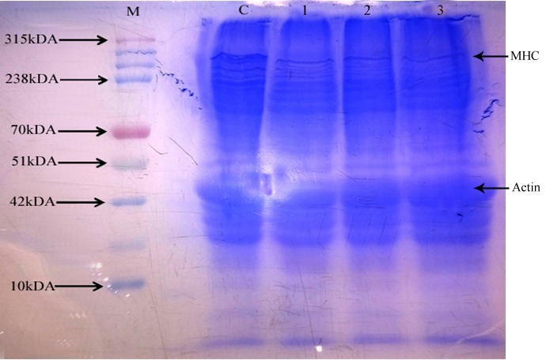
Fig. 2. SDS–PAGE patterns showing the effect of microbial transglutaminase (MTGase) on muscle protein profiles of sausages.
Lane M represents the molecular weight protein marker; Lane C represents the control sample without MTGase; Lane 1 represents sausage treated with 0.5% MTGase; Lane 2 represents sausage treated with 1% MTGase; and Lane 3 represents sausage treated with 1.5% MTGase.

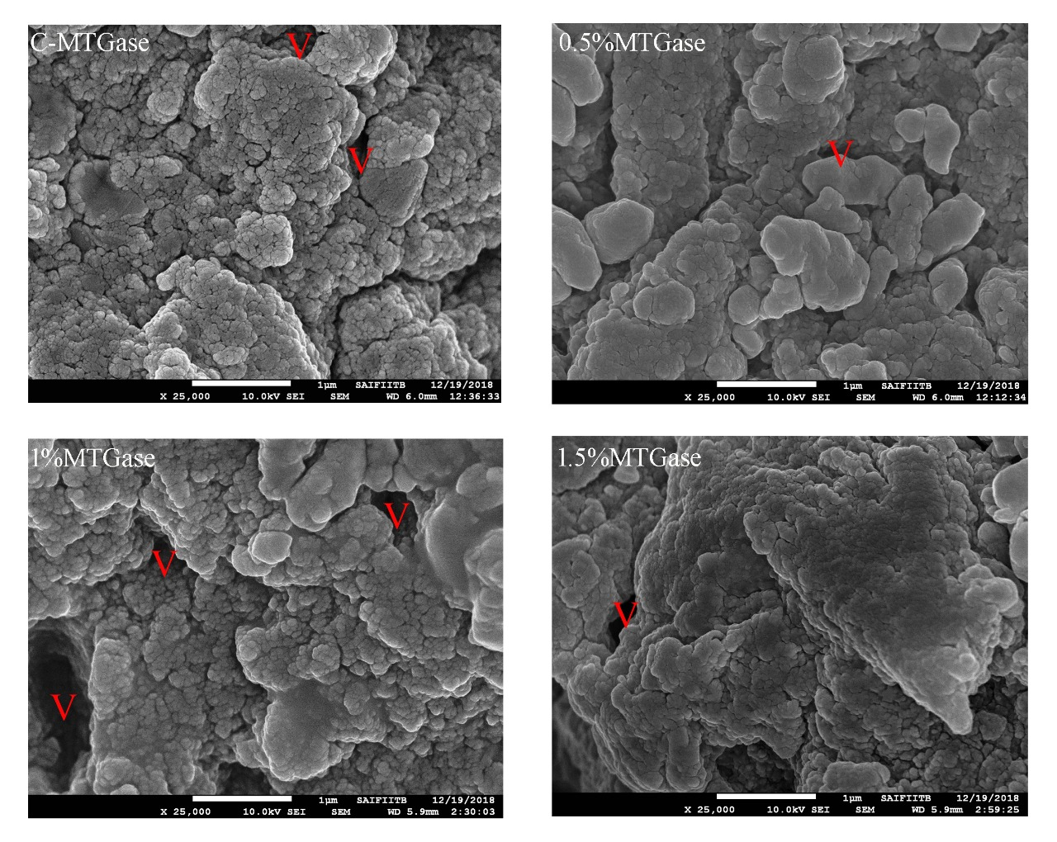

Fig. 3. Scanning Electron Microscopy (SEM) micrographs illustrating the microstructural characteristics of sausages treated with different concentrations of microbial transglutaminase (MTGase).
C-MTG represents the control sample without MTGase; 0.5% MTG represents sausage treated with 0.5% MTGase; 1% MTG represents sausage treated with 1% MTGase; and 1.5% MTG represents sausage treated with 1.5% MTGase. V indicates voids observed within the protein matrix structure.

