Evaluation of the Cytotoxic Potential of Lippia nodiflora (L.) Michx. Against Mouse Adenocarcinoma in Swiss albino Mice
ABSTRACT

Objective: Lippia nodiflora (L.) Michx. (Verbenaceae) has been used in indigenous medicine and claimed to possess a wide range of biological activities, including anticancer activity. The present study was designed to assess the in-vitro and in-vivo anticancer effect of Lippia nodiflora (L) Michx on the EAC cell line. Methods: EAC tumour-bearing mice were used to study anticancer activity. Monitoring the mean survival time and the impact on glycoproteins, antioxidant enzymes, and haematological and biochemical parameters were used to access the activity. Result: The in vitro cytotoxicity against EAC cell lines, the EELN was effective. At the studied dose levels (100, 200, and 300 mg/kg bw), EELN had a strong effect on recovering hemopoietic system and considerably (*P=0.05) extended the mean survival time. The liver marker enzymes and antioxidants were recovered on EELN administration. Results from the data generated were similar to those from animals given with standard medication 5-fluorouracil. Conclusion: The current study concluded that EELN has considerable increase in antioxidant system and inhibition of EAC growth in experimental animal.

Keywords: “Ethanol extract of Lippia nodiflora (L.) Michx” (EELN), “Ehrlich Ascites Carcinoma cell lines” (EAC), Increase in life span (ILS), Tumour growth response, Glycoproteins.

1. Introduction
Cancer continues to be a severe and clinically complex illness that places a heavy financial and social load on the human health care system. Millions of people worldwide are still impacted by the condition, which lowers their quality of life and is one of the main causes of death globally, despite recent improvements in diagnosis, prevention, and treatment [1]. Chemotherapy, radiotherapy, and surgery are the main cancer treatments accessible in modern medicine. Theoretically, it makes more sense to use chemopreventive drugs to intervene in the early stages of carcinogenesis rather than trying to use chemotherapeutic agents to remove fully grown cancers. Drug resistance and dose-limiting toxicities, which can negatively impact host cells, can cause the therapy to fail, and these medicines have a limited margin of safety [2]. Numerous alternative medicine systems that have developed over time and started in particular geographic locations are founded on conventional theories and philosophy. The Unani, Ayurvedic, Sidha, and Chinese medical systems which have their roots in the Arab, Indian, and Chinese cultures, respectively are the most popular of these. More than 700 distinct botanical extracts and a number of medication compositions that promise to treat and/or prevent a variety of illnesses, including cancer, have been identified by these medicinal systems [3]. It is well recognised that plants and plant-derived products are efficient and creative chemopreventive medicines for the treatment of cancer [4-6]. Plant-based anticancer medications make up over 60% of FDA-approved medications. Numerous natural plant extracts and phytochemicals have been shown to cause cancer cell types to undergo apoptosis [7, 8]. Currently, investigations show the following plant and their plant-derived substances are used to cure many pharmacological activities, including cancer. These plants are medicinally distributed in Asia, Africa, Europe, Australia, and South America. [9] Lippia nodiflora (L.) Michx. was therefore chosen for the study to assess its anticancer potential. An ethanol extract from Lippia nodiflora (L.) Michx (family Verbenaceae) was chosen, and it was tested for anticancer properties against EAC cell lines. According to reports, Lippia nodiflora (L.) Michx is an antiseptic, cardiovascular, antitussive, antioxidant, reproductive, gastro-intestinal, respiratory, antidiabetic, antimicrobial, antipyretic, anticancer, vermifuge, and anti-inflammatory substance. [10-11].
2. MATERIALS AND METHOD
2.1 Plant collection
The leaf of Lippia nodiflora (L) Michx was collected in the Thiruchirappali region of Tamilnadu and was identified using Ayuredic Pharmacopoeia of India [12]. Voucher specimens that were placed in the “Rapinat Herbarium at St. Joseph's College in Trichy were used to authenticate the selected plant material. The voucher specimen number is DK001.
2.2 Preparation of Ethanol Extract
Lippia nodiflora (L.) Michx plant material was collected and shade-dried. Using the cold extraction procedure, 250 g of dried plant material was steeped in ethanol for 48 hours. Filter paper was used to filter the solution, and the filtrate was then dried by rotary evaporation. For additional examination, the residue was gathered and kept in an airtight container. Furthermore, dried powder (EELN) and standard drug were formulated with saline for administration.[13]

2.3 Cell Line
The Amala Cancer Research Centre in Thrissur, India, provided the EAC (Ehrlich Ascites carcinoma) cell lines. The cells were inoculated intraperitoneally once every week at a dose of 1×10⁶cells/ml/mouse.[14].
2.4 Maintenance of EAC Cells
Weekly intraperitoneal passage was used to maintain the Ehrlich Ascites Carcinoma (EAC) cell line, which was gathered from the Amla Cancer Research Centre in Thrissur (1×10⁶ cells/mouse). For experimentation, cell viability was assessed via trypan blue assay and counted by haemocytometer, with a dose of 1×10⁶ EAC cells administered per mouse [15].
2.5 Experimental design
Biogen, located in Bangalore, provided the “healthy adult Swiss Albino mice of both sexes, weighing between 25 and 35 grams. Ten days before the trial, the animals were given time to get used to the lab environment. Standard cages made of polypropylene were utilized to house the animals. Each cage has enough room for six animals to prevent needless stress and death. In addition to being kept at 23 ± 2°C and 65 ± 5% humidity, the animals have been kept in the regular daylight cycle. Standard rat chow pellets from Sai Durga Foods and Feeds in Bangalore, India, were” used to feed the animals. After receiving the required committee approval, IAEC-International Animal Ethical Committee (Approval No: M.Phil/BC19/CPCSEA) all research was carried out in accordance with CCSEA guidelines.
Animals were divided into six groups of six mice (both sexes) each [16]
Group I: Normal Control
Group II: EAC cell line (1×10⁶ cells/mouse) (Disease Control)
Group III: EAC cell line (1×10⁶ cells/mouse) treated with 100 mg/kg bw. of EELN in saline orally
Group IV: EAC cell line (1×10⁶ cells/mouse) treated with 200 mg/kg bw. of EELN in saline orally
Group V: EAC cell line (1×10⁶ cells/mouse) treated with 300 mg/kg bw. of EELN in saline orally
Group VI: EAC cell line (1×10⁶ cells/mouse) treated with 5-fluorouracil (20 mg/kg bw) [17].
EELN - Ethanol Extract of Lippia nodiflora (L.) Michx.
EAC - Ehrlich Ascites Carcinoma
EELN administration began 24 hrs post-tumor inoculation and continued orally for 14 days. Animals “were sacrificed by cervical decapitation following the experimental periods, and the ascites fluid was gathered. After drawing blood, liver tissue was removed and cleaned in ice-cold saline.
2.6 Effect of EELN on survival time and Tumor growth response
The mean survival time (MST) and the percentage increase in longevity (ILS) were calculated [18]. Ascites fluid was used to measure the tumor volume, tumor cell count, and viable and non-viable cell counts” in order to evaluate the tumor growth response [19].
2.7 Hematological parameters
Erythrocytes (RBC), haemoglobin, and leucocytes (WBC) were counted from the whole blood [20].
2.8 Biochemical parameters
Serum and hepatic tissue were examined for a number of biochemical markers. Hepatic glycogen [22] and serum protein [21]. Hepatic glycoproteins such protein-bound hexoses [25], hexosamine [26], and fucose [27], as well as serum hepatic marker enzymes like AST, ALT, and ALP [23], LDH [24], and antioxidant parameters like LPO [28], GSH [29], GPX [30], SOD [31], and CAT [32] were examined in the liver tissue.
2.9 Statistical Analysis
Statistical analysis was performed using one-way analysis of variance (ANOVA), followed by Dunnett’s t-test for comparisons. Results are presented as mean ± SEM (n=6) and a P=0.05 was regarded as highly significant.
3. RESULTS
3.1 Effect of EELN on MST and Tumor response
Compared to the control, EELN administration resulted in a dose-dependent increase in life span (ILS) of 13.09% (100mg/kg bw), 35.55% (200mg/kg bw), and 59.05% (300mg/kg bw) in the tumor-bearing animals (Table 1). In EAC-bearing animals, EELN significantly inhibited tumor growth (Graph 1). The efficacy was demonstrated by a reduced tumor volume and a shift in cellular population, specifically a decrease in viable cells and an increase in non-viable cell counts.
3.2 Effect of EELN on Haematological parameters
Administration of the drug (EELN) reverted the elevated WBC counts back to normal (Graph 2) while also increasing the levels of haemoglobin and RBC.
3.3 Effect of EELN on Biochemical parameters
Elevated levels of tissue hepatic glycoprotein components (hexose, hexosamine, and fucose) (Graph 5) and serum hepatic marker enzymes (ALT, AST, ALP, and LDH) (Graphs 3 and 4) of EAC bearing mice were effectively restored by EELN. The liver antioxidant levels, including reduced glutathione, catalase, lipid peroxide (LPO), and superoxide dismutase (SOD) (Graph 6) was normalized on EELN administration.
4. DISCUSSION
Cancer is considered one of the deadliest diseases and the drugs used to treat cancer have been reported to produce severe tissue toxicity, accompanied by high cost. Plant extracts and chemicals have been a significant source of a number of anti-cancer drugs with practical applications. These consist of paclitaxel (taxol®), topotecan and irinotecan, vinblastine, vincristine, variants of camptothecin, etoposide, and epipodophyllotoxin. Based on their selective efficacy against molecular targets linked to cancer, several promising novel anticancer medicines are currently undergoing clinical development. is a common plant source that is botanically equivalent to it in this study. The ethanol extract of Lippia nodiflora (L.) Michx belonging to Verbenaceae family has been examined for its anticancer potential against EAC cell lines in swiss albino mice.
The fact that most anticancer medications have a brief half-life and cause serious side effects presents a substantial obstacle to extending the life span (survival) attained by cancer treatment. The lifespan of EAC-bearing mice was considerably extended 59.05% by the EELN. The primary source of nourishment for the quickly proliferating cancer cells is the ascites fluid [33]. In the ascitic fluid of tumour-bearing mice, EELN therapy decreased both the tumour volume and the proportion of viable cells. It's possible that the test medication caused cytotoxicity or prevented cellular migration and vascular permeability. As a result, the tumour's volume decreased throughout treatment (EELN).
Cancer chemotherapy frequently affects haematological parameters, including RBC, WBC, and haemoglobin levels. The cancer-bearing animal's enhanced immune response to the EAC injection led to lower haemoglobin and RBC levels and increased WBC levels. One factor contributing to the harmful consequences of cancer chemotherapy is the disturbance of haematological parameters in animals with tumours. In EAC-inoculated animals, the decreased haemoglobin is likely due to the oppressive effect of EAC on erythropoiesis, while the elevated WBC levels are attributed to an increased immune response [34 & 35]. In EAC-bearing mice, EELN markedly reduced the WBC count while increasing the erythrocyte count and haemoglobin level. This suggests that the haematological profile is changed by EELN to a more or less normal state.
The degree of malignancy is connected with the activity of liver marker enzymes (AST, ALT, and ALP), which can be utilized as a prognostic and diagnostic sign for cancer. Anaerobic glycolytic enzyme LDH is known to be a significant indicator of malignancy and the proliferation of cancer cells. There have been numerous findings linking higher LDH levels to cancer [36]. The increased serum hepatic marker enzyme was successfully reversed by administering the EELN at different dose levels, and regulation of LDH levels showed that the test medication successfully prevented the metastasis.
The elevated glycoprotein components (hexose, hexosamine, and fucose) in EAC-bearing animals suggest cellular damage [37]. EELN treatment preserve the plasma membrane's structural integrity, a mechanism that supports its potent anticancer effects.
Superoxide dismutase (SOD), lipid peroxide (LPO), reduced glutathione, and catalase were used to evaluate the antioxidant capability of EELN in the liver tissues of EAC-bearing mice. It was discovered that the tumour-bearing mice had significantly higher LPO levels. The liver's elevated levels of malondialdehyde (MDA) indicate increased lipid peroxidation, which damages tissue and impair antioxidant defences against the production of too many free radicals. The increased MDA levels returned to normal following EELN therapy. The test medication may decreased the production of free radicals, which in turn decreased membrane damage and LPO levels.
Compared to the normal control, the glutathione concentration in the tumour-bearing animals was less than half. The experimental animals' glutathione levels were higher after receiving EELN, which promotes the inhibition of the neoplastic process and lengthens the lifespan of the tumour-bearing animals. Glutathione deficiency and elevated hydroxyl radical generation are the main causes of decreased GPx function in tumour-bearing mice. The GPx level is restored with EELN therapy.
One of the most crucial enzymes in the enzymatic antioxidant defence system and the most sensitive enzyme indicator of liver damage is the metalloprotein superoxide dismutase (SOD). Because of mitochondrial depletion and Mn+ disintegration in the SOD system, SOD activity is reduced in tumour-inoculated animals [38]. The tumour-bearing mice's SOD levels were elevated after receiving an EELN therapy, suggesting that it may shield the mitochondria from oxidative damage.
All tissues contain the enzyme antioxidant catalase (CAT), although the liver and red blood cells have the highest levels of activity. The heme protein catalase is found in either microperoxisomes or peroxisomes. In order to shield the cell from oxidative damage brought on by H2O₂ and OH (hydroxyl radical), this enzyme catalyses the breakdown of H2O₂ into water and oxygen. CAT levels have been notably lower in the disease control group [39]. The scavenging of superoxide radicals during EELN treatment raised CAT levels; this could be explained by the catalase's increased activity as the ferrous group is reinstated. EELN potential as an inhibitor of tumour-induced intracellular oxidative stress was demonstrated by the reduction of lipid peroxidation and the rise in GSH, GPX, SOD, and CAT activities.
5. CONCLUSION
In conclusion, the data obtained from studies conducted against the EAC cell lines strongly suggest that EELN possesses considerable anticancer and antioxidant properties. The most effective dose of EELN was found to be 300mg/kg bw when compared to the conventional medication 5-fluorouracil (20mg/kg bw).
DISCLAIMER
Authers hereby declares that NO generative AI technologies such as Large Language Models (Chat GPT, COPILOT, etc) and text to image generators have been used during writing or editing of manuscripts.
ACKNOWLEDGEMENT
The authors thank the management of Srimad Andavan Arts and Science College for the infrastructure facilities and support provided in the Department of Biochemistry.
COMPETING INTERESTS
The authors declare no competing financial or non-financial interests that could have influenced the findings of this study.
REFERENCE
- Yeung-Leung Chenga, Shih-Chun Leea, Shinn-Zong Linb, Wen-Liang Changc, Yi-Lin Chenb, Nu-Man Tsaib, Yao-Chi Liud, Ching Tzaoa, Dah-Shyong Yud, Horng-Jyh Harne. (2005) Anti-proliferative activity of Bupleurum scrozonerifolium in A549 human lung cancer cells in vitro and in vivo. Cancer Letters 222, 183–193.
- Raju Senthil Kumar, Bala Subramanian Raj kapoor and Perumal Perumal (2011). In vitro and in vivo anticancer activity of Indigofera cassioides Rottl. Ex. DC. Asian Pacific Journal of Tropical Medicine, 379-385.
- Syed Kamil Mulla and Paramjyothi Swamy (2012). Anticancer activity of ethanol and polyphenol extracts of Portulaca quadrifida linn. on Human colon cancer cell lines. Int J Pharm Bio Sci. 3(3), 488 – 498
- Aruna K, Sivarama Krishnan VM (1990). Plant products as protective agents against cancer. Indian J Exp Biol. 28, 1008–11.
- Graham JG, Quinn ML, Fabricant DS, Fransworth NR (2000). Plants used against cancer: an extension of the work of Jonathan Hartwell. J Ethno pharmacol. 73, 347–77.
- Moongkarndi P, Kosem N, Luanratana O, Jongsomboonkusol S, Pongpan N (2004). Antiproliferative activity of Thai medicinal plant extracts on human breast adenocarcinoma cell line. Fitoterapia. 75:37, 5–7.
- Yoon Y, Kim YO, Jeon WK, Park HJ, Sung HJ (1999). Tanshinone IIA isolated from Salvia miltiorrhiza BUNGE induced apoptosis in HL60 human pre myelocytic leukemia cell line. J Ethno pharmacol. 68:121–7.
- Seo WG, Pae HO, Oh GS, Chai KY, Yun YG and Chung HT (2001). Ethyl acetate extract of the stem bark of Cudrania tricuspidata induces apoptosis in human leukemia HL-60 cells. Am J Chinese Med. 29:313–20.
- Ali Esmail Al-Snafi. Pharmacological and therapeutic effects of Lippia nodiflora (Phyla nodiflora) (2019). IOSR Journal of Pharmacy. 9(8), 15-25.
- Swamini Sharma, Deepak Pareek, Divya Jain and Dr. Subash Sahu (2025). Jalpippali (Lippia nodiflora Mich): A comprehensive review of ethnobotany, phytochemistry and pharmacology Journal of Medicinal Plants Studies. 13(6): 348-355.
- Kumaresan Thirupathy P, Asish Tulshkar and Vijaya C (2011). Neuropharmacological activity of Lippia nodifl ora Linn. Pharmacognosy Research, 3(3), 194-200.
- The Ayuredic Pharmacopoeia of India, Govt. of India. Ministry of Health and Family welfare Part-1, Volume5: 61-63
- Keerthana K, Deepa A, Shobana G, Jothi G, Sridharan G (2014). Preliminary phytochemical screening and in vitro antioxidant potential of euphorbia heterophylla l. Int j pharm pharm sci, 6(8), 549-553.
- Gothoskar SV, Ranadive KJ (1971). Anticancer screening of SAN-AB An extract of marking nut Semecarpus anacardium. Indian J Exp Biol. 9, 372-375.
- Sheeja KR, Kuttan G and Kuttan R (1997). Cytotoxic and antitumour activity of Berberin. Amala. Res Bull. Vol (17): 73-6.
- Sivasubramanian Rengaraju and Sridharan Gurunagarajan (2017). In vitro and In vivo anticancer activity of aqueous extract of hydnocarpus pentandra (buch. – ham.) Oken. Against Ehrlich Ascites Carcinoma cell lines. Int j pharm bio sci. 8(2): 964-972.
- Pavan Kumar Samudrala, Bibin Baby Augustine, Eshvendar Reddy Kasala, Lakshmi Narendra Bodduluru, Chandana Barua and Mangala Lahkar (2015). Evaluation of antitumor activity and antioxidant status of Alternanthera brasiliana against Ehrlich ascites carcinoma in Swiss albino mice. Pharmacognosy Research, 7(1), 66-73.
- Majumdar UK, Gupta M, and Maiti S (1997). Antitumor activity of Hygrophila spinosa on Ehrlich Ascites Carcinoma and Sacroma 180 induced mice. Indian J.Exp. Biol. 35, 473-477.
- Ramnath V, Kuttan G and Kuttan R (2002). Cytotoxic and Anti tumor effect of abrin on transplanted tumors in mice. Indian J. Physiol. Pharmacol. 46:69.
- Dacie JV, Lewis SM Practical hematology, 2nd ed., London: J and A Churchill, 1958; 38-48.
- Lowry OH, Rosebrough NJ, Farr AL and Randall RJ (1951). Protein measurement with Folin Phenol reagent, J. BiolChem.193, 265-275.
- Morales, L García-Rejón, M De La Higuera (1990). Influence of handling and/or anaesthesia on stress response in rainbow trout. Effects on liver primary metabolism. Comparative Biochemistry and Physiology Part A: Physiology. 95(1), 87-93.
- King J In: Practical Clinical Enzymology. Princeton MJ (Fol) Van D Nostrand Company, London, 1965; Page no 363.
- King J In: Practical Clinical Enzymology. Princeton MJ (Fol) Van D Nostrand Company, London, 1965; Page no 369.
- Niebes P (1972). Determination of enzyme and degradation in products of glycosaminoglycans metabolism in serum of healthy and varicose subjects. Clin Chim Acta. 42, 399-408.
- Wanger WO (1972). A more sensitive assay disseminating galactosamine and glucoseamine in mixtures. Anal. Biochem. 94, 394-396.
- Dishce Z, Hettles LB (1948). Spectrophotometric micro method for the determination of Fucose, J. Biol. Chem.175, 595-604.
- Ohkawa H, Ohishi N, and Yaki K (1979). Assay for lipid peroxides in animal tissues by thio-barbituric acid reaction. Anal Biochem. 95:351–358.
- Abirami J and Shobana G. Evaluation of Antiulcer Activity of Crateva Magna (Lour.) Dc in Wistar Albino Rats. Journal of Stress Physiology & Biochemistry, 19(3), 87-93.
- Rotruck JT, Pope AL, Ganther H, Swanson AB, Hafeman DG, Hoeksira WG and Selenium (1973). Biochemical role as a component of glutathione peroxidase. Science. 1790, 588-90.
- Misra HP and Fridovich I (1972). The role of superoxide anion in the autoxidation of epinephrine and a simple assay for SOD. J. BiolChem. 247, 3170-3175.
- Maehly AC and Chance B (1972). In methods of Biochemical analysis. New York, Inter science. 1:357.
- Sujata Maiti Choudhury, Malaya Gupta and Upal Kanti Majumder (2010). Antineoplastic activities of MT81 and its structural analogue in ehrlich ascites carcinoma-bearing swiss albino mice. Oxidative Medicine and Cellular Longevity, 3:1, 61-70.
- Farhadul Islam, Hasina Khatun, Soby Ghosh, MM Ali and JA Khanam (2012). Bioassay of Eucalyptus extracts for anticancer activity against Ehrlich ascites carcinoma (EAC) cells in Swiss albino mice. Asian Pac J Trop Biomed. 2(5): 394-398.
- Wafaa M Ibrahim, Sally MFoad and Ahmed Y Eltoukhy (2022). Biochemical study in Ehrlich carcinoma cells-bearing mice treated with arsenic trioxide and cisplatin, Advances in Environmental and Life Sciences. 1: 40-47.
- Helmy MH, El-Moneim NAA, El-Baki MMAA and El-Zoghby SM. Clinical value of serum lactate dehydrogenase, ceruloplasmin, Cathepsin-D and lipid bound Sialic acid in monitoring patients with Malignant lymphomas. Med.Sci.Res. 101:247-249.
- Sridharan G, Brindha P, JaiGanesh C, Sivasubramanian S (2011). Anti Tumor Potential of Premna integrifolia Linn Against Ehrlich Ascites Carcinoma Cell Lines. Pharmacologyonline, 2: 438-450
- Tahany Saleh Aldayel, Heba N. Gad El Hak, Mohamed S. Nafie, Raneem Saad, Heba M. A. Abdelrazek and Omnia E. Kilany (2023). Evaluation of antioxidant, anti‑inflammatory, anticancer activities and molecular docking of Moringa oleifera seed oil extract against experimental model of Ehrlich ascites carcinoma in Swiss female albino mice. BMC Complementary Medicine and Therapies. 23(457), 3-15.
- Sivakumar Ramalingam, Adithiya R, Anitha Joseph and Renuka Saravanan (2019). Anticancer activity of Ipomoea carnea on Ehrlich Ascites Carcinoma Bearing Mice. Indian Journal of Pharmaceutical Education and Research, 53(4); 703-709.

Groups | Mean Survival Time (days) | Increase Life span (ILS) (%)
Group II | 19.32±2.13 | 0.00
Group III | 21.85±1.17** | 13.09**
Group IV | 26.19±2.07** | 35.55**
Group V | 30.73±1.86** | 59.05**
Group VI | 34.2±2.26** | 77.01**
Table 1: Effect of EELN on MST and ILS
The Values indicate the mean ± SEM (n=6). **P=0.05 when compared to the values of group II with all groups III, IV, V & VI.

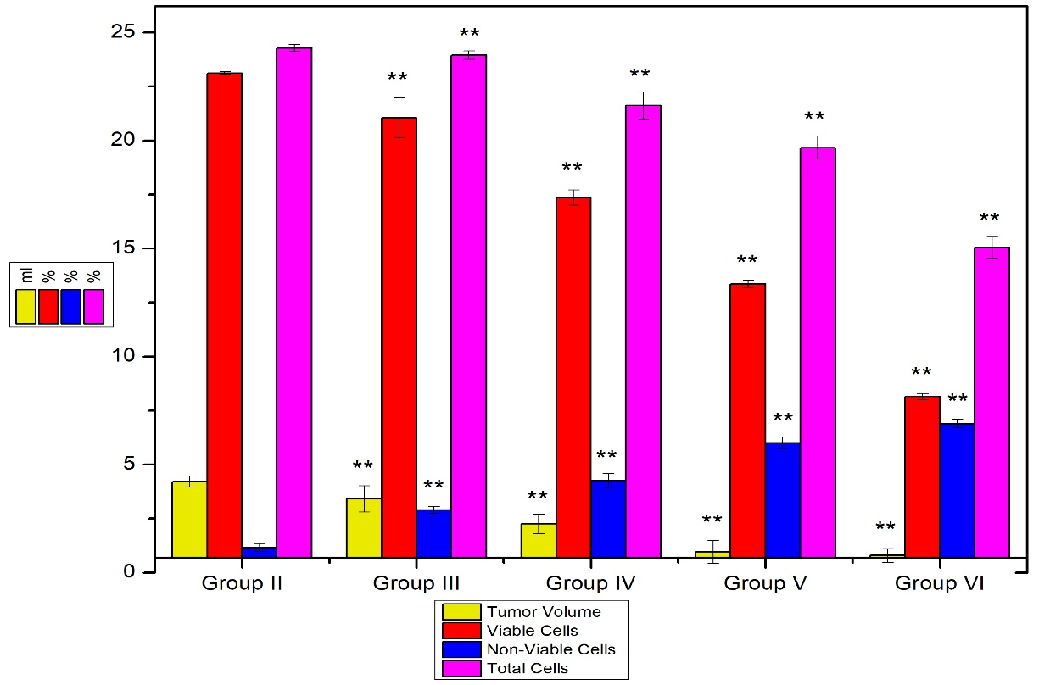
Graph 1: Effect of EELN on tumor growth
The Values indicate the mean ± SEM (n=6). **P=0.05 when compared to the values of group II with all groups III, IV, V & VI.

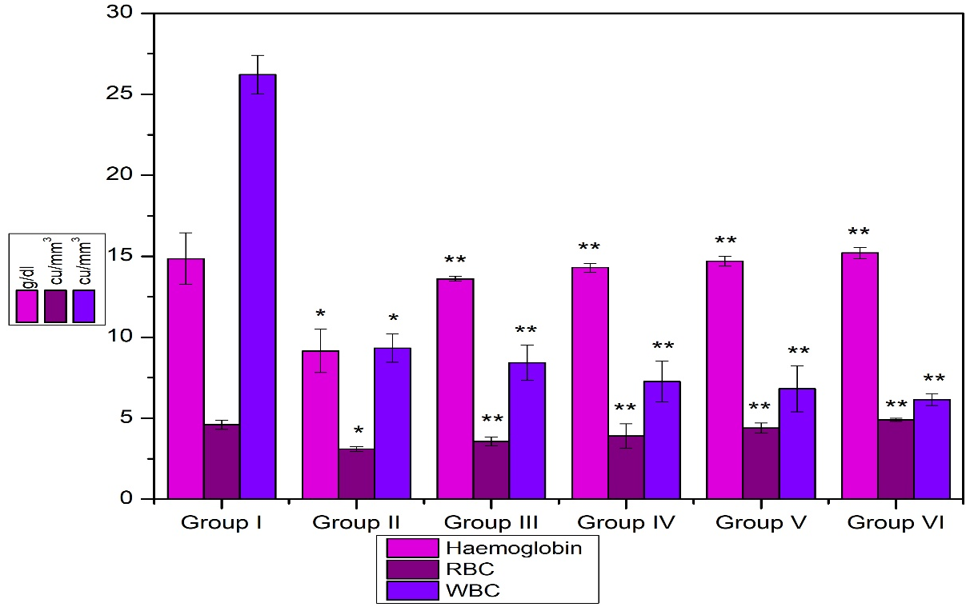
Graph 2: Effect of EELN on Haematological parameters
The Values indicate the mean ± SEM (n=6) *P=0.05 statistically significant when compared to group I. **P=0.05 statistically significant when compared to group II.
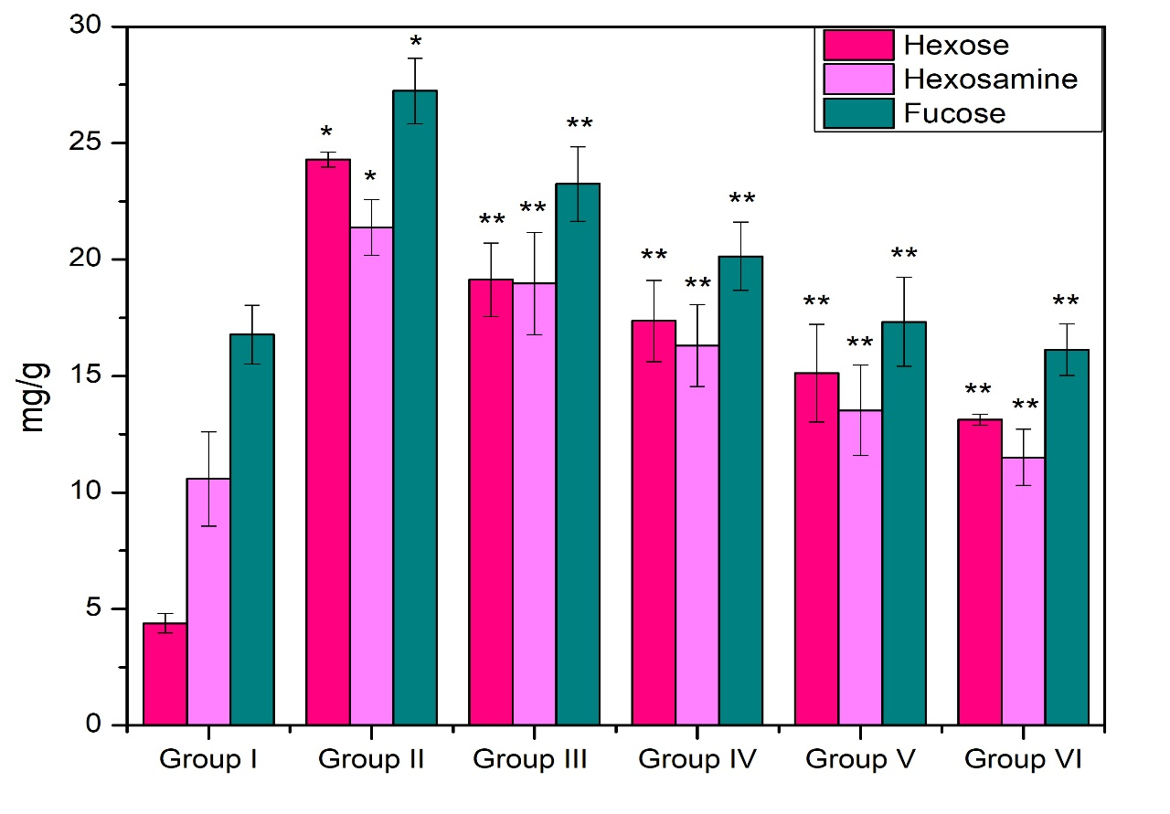
Graph 3: Effect of EELN on Hepatic Glycoproteins
Values are expressed as mean ± SEM (n=6) *P=0.05 statistically significant when compared to group I. **P=0.05 statistically significant when compared to group II.

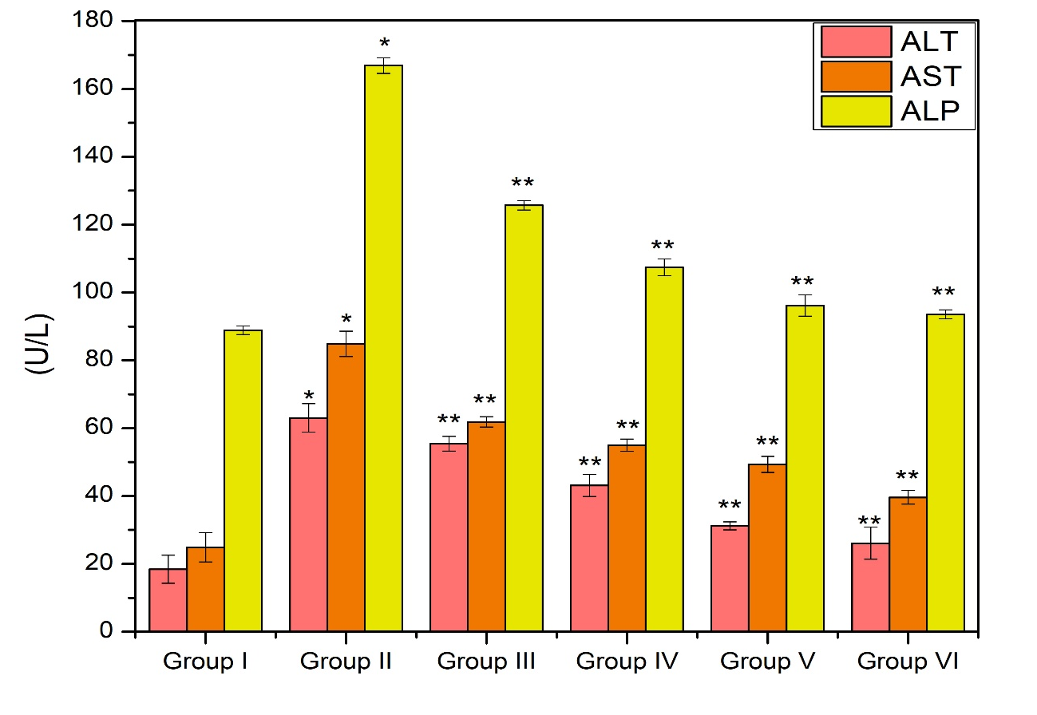
Graph 4: Effect of EELN on serum hepatic marker enzymes
Values are expressed as mean ± SEM (n=6) *P=0.05 statistically significant when compared to group I. **P=0.05 statistically significant when compared to group II.

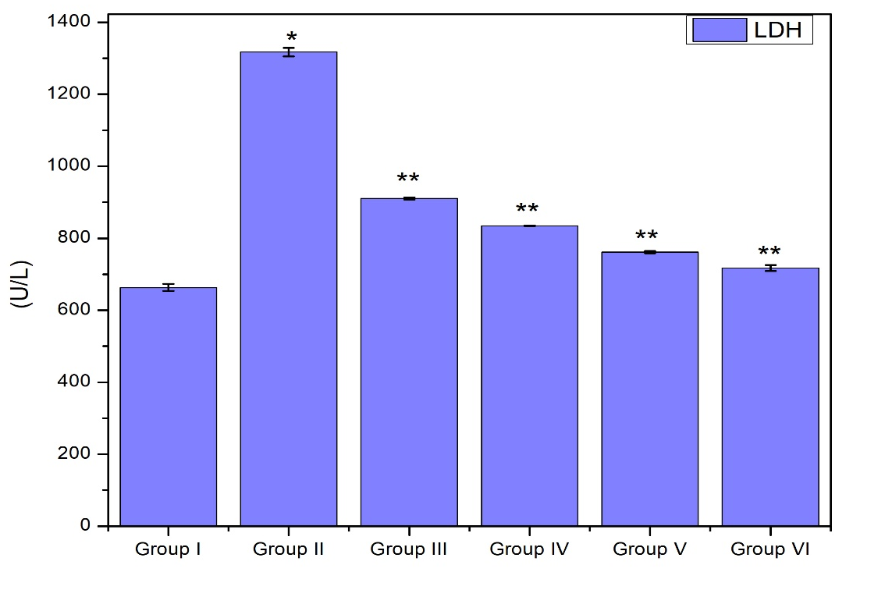
Graph 5: Effect of EELN on serum hepatic marker enzymes
Values are expressed as mean ± SEM (n=6) *P=0.05 statistically significant when compared to group I. **P=0.05 statistically significant when compared to group II.
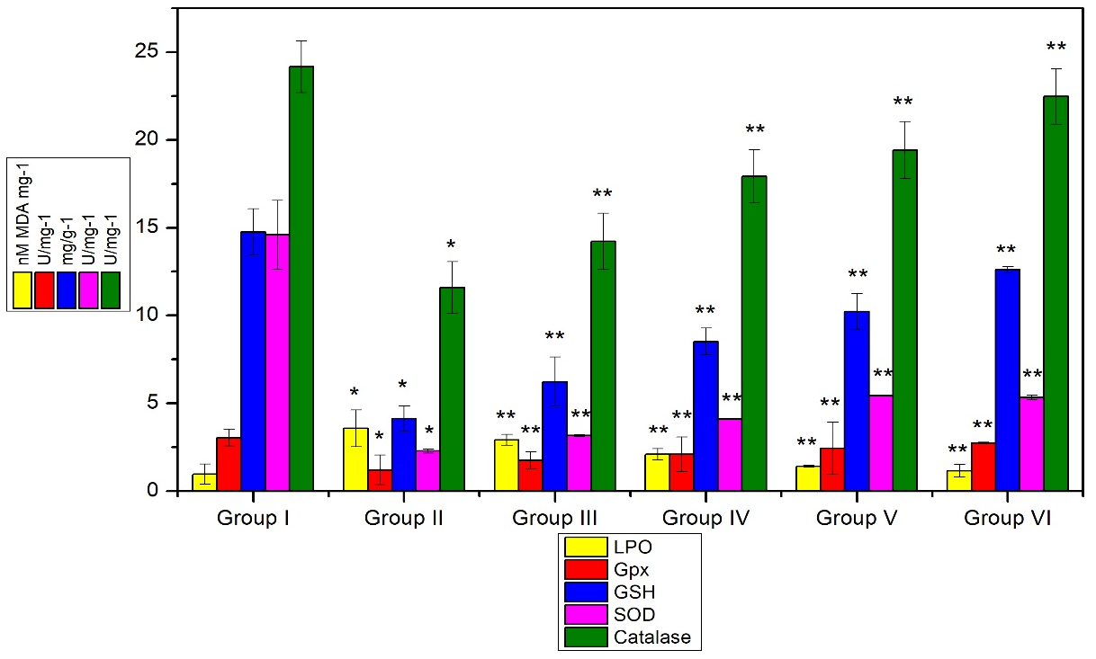

Graph 6: Effect of EELN on Enzymatic and Non-enzymatic Antioxidant Assays
Values are expressed as mean ± SEM (n=6), *P=0.05 stastically significant when compared to group I. **P=0.05 stastically significant when compared to group II.

