Original Research Article

Comparative Analysis of Interstitial Meiofaunal Diversity and Physico-Chemical Parameters in Estuarine and Sandy Beach Habitats along the Parangipettai Coast, India

Abstract
Meiofaunal communities play a critical ecological role in sedimentary ecosystems by mediating energy transfer between microbenthic producers and macrobenthic consumers. However, comparative data on interstitial assemblages from contrasting coastal habitats along the southeast Indian coast remain limited. The present study aimed to evaluate the diversity, composition, and density of interstitial meiofauna in relation to selected physico-chemical parameters at two contrasting habitats along the Parangipettai coast, southeast India—Vellar estuary (Station 1) and Puthupettai sandy beach (Station 2)—between October 2024 and March 2025. Triplicate sediment samples were collected monthly from each station. Surface sediments were processed using standard decantation and sieving techniques for meiofaunal extraction, and water quality parameters (temperature, salinity, pH, and dissolved oxygen) were recorded in situ. A total of 12 species representing 12 genera under three major taxonomic groups were identified. Nematodes dominated the assemblage (55%), followed by amphipods (25%), polychaetes (10%), and copepods (10%). Meiofaunal density was higher at Station 2 (≈1000 ind/m²) compared to Station 1 (≈820 ind/m²). Diversity indices indicated greater richness and evenness at Station 2 (S = 27; E′ = 0.48; H′ = 1.22) than at Station 1 (S = 25; E′ = 0.20; H′ = 1.05). The higher diversity and abundance at the sandy beach site suggest that relatively stable salinity regimes and improved oxygen availability promote structurally complex and evenly distributed meiofaunal communities. Overall, this study highlights habitat-specific variation in interstitial assemblages and underscores the importance of sandy beach systems in sustaining meiofaunal biodiversity along the Parangipettai coast.
Keywords: interstitial biodiversity, sediment ecology, nematode dominance, coastal habitats, southeast India

1. Introduction
Meiofauna (or meiobenthos) refers to a size-defined assemblage of microscopic, motile aquatic invertebrates that pass through a 500 μm sieve and are retained on meshes typically between 44–63 μm (Higgins and Thiel, 1998). This group includes permanent meiofauna that complete their entire life cycle within sediment interstices, as well as temporary meiofauna represented by juvenile stages of larger macrofaunal taxa (Coull and Bell, 1979). Occurring in both marine and freshwater systems, meiofaunal organisms inhabit interstitial spaces of sediments ranging from fine muds to coarse sands and are considered a distinct ecological unit linking microbial communities and macrobenthos (Piot et al., 2013).
Meiofauna are numerically dominant components of benthic ecosystems and play a central role in energy transfer, nutrient cycling, sediment stabilization, and bioturbation processes (Coull, 1999; Carman et al., 2000; Pinckney et al., 2003). Nematodes typically dominate meiofaunal assemblages, often accounting for more than 70–90% of total abundance in many marine habitats (Coull and Bell, 1979; Giere, 2009). Due to their short life cycles, high turnover rates, and sensitivity to environmental fluctuations, meiofaunal communities are widely recognized as effective bioindicators of ecological disturbance and habitat quality (Carman and Todaro, 1996; Schratzberger and Ingels, 2018).
Interstitial fauna inhabiting sandy beaches and estuarine sediments are especially influenced by environmental gradients such as salinity, dissolved oxygen, sediment grain size, and hydrodynamic forces (McLachlan and Brown, 2006; Giere, 2009). Grain size determines pore space availability and directly affects meiofaunal distribution and mobility, often leading to distinct zonation patterns within beach systems (Nybakken, 1997). Estuarine habitats, in contrast, experience fluctuating salinity regimes and organic matter inputs, creating dynamic ecological conditions that may shape meiofaunal structure differently from open sandy beaches.
Globally, extensive studies have documented meiofaunal biodiversity across intertidal, subtidal, and deep-sea environments (Coull et al., 1977; Giere, 2009). However, despite India’s extensive coastline and ecological heterogeneity, detailed and comparative studies on interstitial meiofaunal assemblages remain relatively limited, particularly along the southeast coast of India. The Parangipettai coast, located along the Bay of Bengal, represents a biologically productive region influenced by monsoonal freshwater influx through the Vellar estuary and dynamic sandy beach systems such as Puthupettai. These contrasting habitats provide a natural environmental gradient in terms of salinity stability, sediment texture, and hydrodynamic exposure, making them ideal for evaluating habitat-specific variation in meiofaunal communities.
Previous regional investigations have largely focused on macrofaunal diversity or general benthic ecology, with comparatively fewer studies quantifying interstitial meiofaunal diversity in relation to physico-chemical drivers. Furthermore, updated assessments incorporating diversity indices and density comparisons between estuarine and exposed beach habitats in this region are scarce. Addressing this gap is essential for understanding small-scale biodiversity patterns and for establishing baseline ecological data for future monitoring programs, particularly under increasing anthropogenic and climatic pressures along the southeast Indian coast. Recent global assessments have identified major knowledge gaps in meiofaunal ecology, including limited regional baseline datasets, insufficient integration of environmental drivers, and underrepresentation of tropical coastal systems in biodiversity assessments (Martínez et al., 2025). Addressing these priority research areas is essential for improving predictions of ecosystem functioning and resilience in sedimentary habitats.
Therefore, the present study aims to (i) assess the diversity and composition of interstitial meiofauna at two contrasting coastal habitats along the Parangipettai coast—Vellar estuary and Puthupettai sandy beach; (ii) quantify meiofaunal density using standardized sediment-based units; and (iii) examine the relationship between meiofaunal distribution and selected physico-chemical parameters. By comparing an estuarine system with a relatively open sandy beach environment, this study seeks to contribute region-specific insights into habitat-driven structuring of meiofaunal communities and to strengthen the baseline knowledge of coastal benthic biodiversity in southeast India.
- Material and Methods

Study area

The present study was conducted at two different stations along the southeast coast of India viz. Vellar estuary (Lat. 11.501148, Long 79.772144"), Pudhupettai beach (st. 2) (Lat 1515025, Long 79/7650458"), for a period of six months from October to March (Fig.1).

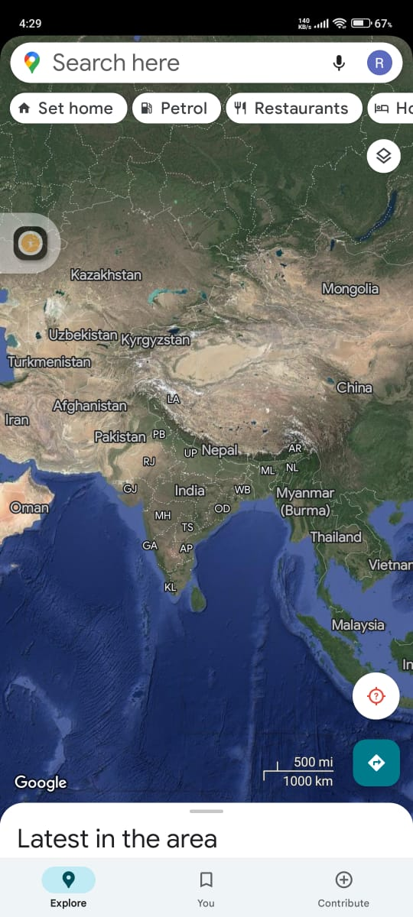
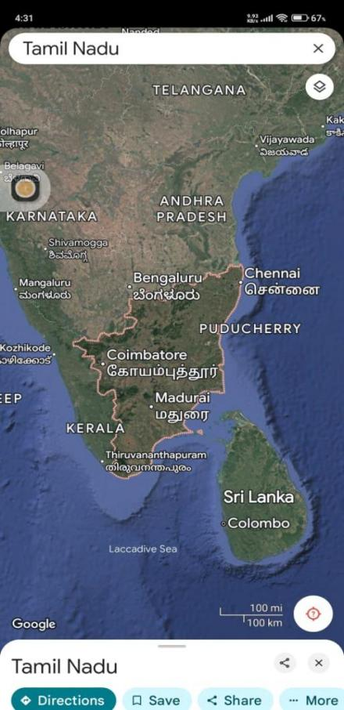
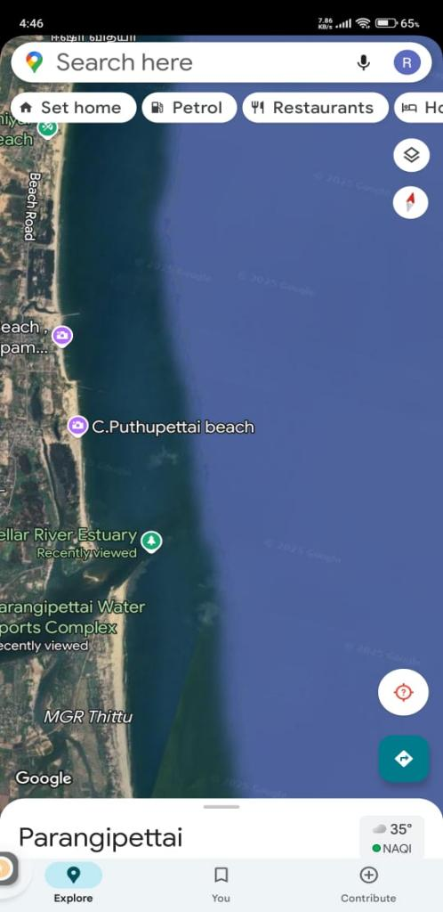

Fig.1. Map of samping station along the southest coast india

Station 1: Vellar Estuary
The Vellar estuary (11.501148° N, 79.772144° E) opens eastward into the Bay of Bengal and is influenced by freshwater inflow, tidal mixing, and anthropogenic inputs from adjacent agricultural fields, domestic settlements, and small-scale industries. The estuarine system experiences seasonal salinity fluctuations and variable organic matter loading. (Fig.2).

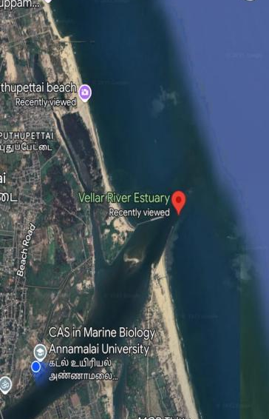

Fig.2. Sampling station of Vellar estuary (st.1)
Station 2: Puthupettai Beach
Puthupettai (11.515025° N, 79.765045° E) is an open sandy beach exposed to wave action and marine influence from the Bay of Bengal. Compared to the estuary, this site is characterized by relatively stable salinity regimes and well-sorted sandy sediments. (Fig.3).

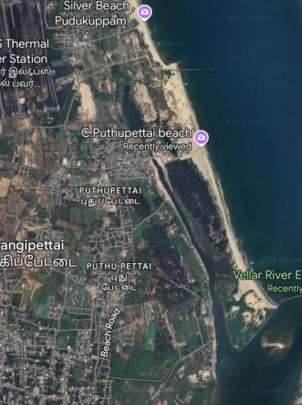

Fig.3. sampling station of Pudhupettai beach (st.2).

These two habitats were selected to evaluate meiofaunal variation across contrasting environmental gradients—estuarine (fluctuating, nutrient-influenced) versus exposed sandy beach (hydrodynamically active, marine-dominated).

2.2 Sample collection
The samples were collected October to March 2025 from two different stations such as Veller estuary (St.1), Pudhupettai beach (St.2). The sediment samples were collected using PVC corer (having an internal diameter of 10 cm and a length of 10 cm) (Platt and Warwick, 1983). Following collection, all samples were stored with a 10% formaldehyde solution and identified by staining them with Rose Bengal. Overnight, the samples were not disturbed in order to conduct both qualitative and quantitative examination.

2.3 Water and sediment analysis
Measurements of salinity (Refractometer, ATAGO, Japan), temperature (hand-held mercury thermometer), and pH (pH pen, model L1-120, Eutech Instrument, Singapore) were measured at each sampling event. Winkler's method was utilized to determine the dissolved oxygen (DO) in bottom water.

2.4 Meiofaunal Extraction and Identification
For meiofaunal examination, three replicate surface sediment samples were collected at each station using a PVC corer. The corer had an internal diameter of 10 cm and penetrated to a depth of 10 cm. Immediately after collection, samples were preserved in 10% buffered formaldehyde prepared with distilled water to prevent post-sampling biological degradation. Rose Bengal stain (0.5 g L⁻¹) was added to facilitate subsequent sorting of organisms. In the laboratory, meiofauna were extracted from sediment samples using standard decantation and sieving procedures. Each sediment sample was gently agitated with filtered seawater to suspend the organisms, and the supernatant was carefully decanted through a 45 µm mesh sieve, which served as the lower retention limit for meiofaunal organisms. A 500 µm mesh sieve was used as the upper limit to exclude macrofaunal components. The decantation process was repeated multiple times to ensure efficient separation of organisms from sediment particles. The retained fraction (45–500 µm size class) was transferred to labeled Petri dishes and examined under a stereo microscope. Organisms were sorted manually using fine needles and counted under magnification. Identification was carried out to the lowest possible taxonomic level using standard taxonomic keys and relevant literature. Major meiofaunal groups recorded included nematodes, harpacticoid copepods, amphipods, polychaetes, foraminiferans, and ostracods where present. All individuals were enumerated for each replicate sample. Meiofaunal abundance was standardized and expressed as individuals per 10 cm² (ind/10 cm²) based on the surface area of the corer. This area-based expression follows internationally accepted conventions for sediment-associated meiofaunal studies and ensures comparability with previous investigations. Quality control procedures included repeated microscopic verification of sorted specimens to minimize counting errors. Representative specimens were photographed and documented for taxonomic confirmation where necessary.
3.Results

3.1 Assessment of physio–chemical parameters of water (Vellar estuary)

During the six-month study period (October 2024–March 2025), the physico-chemical parameters at Station 1 (Vellar estuary) showed noticeable temporal variation.

pH: The minimum pH recorded was 7.5, while the maximum value reached 8.2 (Fig. 4). Monthly variation in pH was statistically significant (one-way ANOVA, p < 0.05).

Salinity: Salinity ranged from a minimum of 10.5 PSU to a maximum of 35.2 PSU (Fig. 5), reflecting freshwater influx and tidal mixing. Significant monthly variation was observed (ANOVA, p < 0.05).

Temperature: Water temperature ranged between 26°C and 28.2°C (Fig. 6). Monthly variation was not statistically significant (p > 0.05).

Dissolved Oxygen (DO): Dissolved oxygen ranged between 3.7 and 8.57 mg L⁻¹ (Fig. 7). Significant variation was observed among months (ANOVA, p < 0.05).

3.2 Assessment of physio–chemical parameters of water (Puthupettai beach)
At Station 2 (Puthupettai beach), physico-chemical parameters remained comparatively stable across months.
pH: The minimum pH recorded was 7.9 and the maximum was 8.3 (Fig. 8). Monthly variation was not statistically significant (p > 0.05).
Salinity: Salinity ranged from 30 to 36 PSU (Fig. 9). Compared to Station 1, salinity was significantly higher (independent t-test, p < 0.05) and showed less monthly fluctuation.
Temperature: Water temperature ranged between 24°C and 28°C (Fig. 10), with no significant monthly differences (p > 0.05).
Dissolved Oxygen: Dissolved oxygen values ranged from 5.8 to 6.5 mg L⁻¹ (Fig. 11). Compared to Station 1, DO was significantly more stable (p < 0.05).

Fig.4. pH of Vellar estuary (st.1)

Fig.5. Salinity level of velar estuary (st.1)

Fig.6. Temperature level of velar estuary (st.1).

Fig .7. Dissolved oxygen level of velar estuary (st.1)

Fig .8. pH level of puthupettai beach (st.2)

Fig.9. Salinity level of Puthupettai beach (st.2)

Fig 10. Temperature level of puthupettai beach (st.2)

Fig 11. Dissolved oxygen of puthupettai beach (st.2).

3.3 Species composition
A total of 12 species representing 12 genera across four major taxonomic groups were identified during the study period. The assemblage comprised:
- Nematodes: 8 species (8 genera)
- Copepods: 2 species (2 genera)
- Polychaetes: 1 species (1 genus)
- Amphipods: 1 species (1 genus)
Thus, the number of genera corresponds appropriately to the number of species identified. The overall meiofaunal community composition across both stations was dominated by nematodes (55%), followed by amphipods (25%), polychaetes (10%), and copepods (10%). Among the nematodes, Viscosia carnleyensis, Viscosia macramphida, and Anoplostoma viviparum were consistently recorded at both stations throughout the sampling period (Fig. 12–13). Two-way ANOVA indicated a significant effect of station on relative abundance of major taxa (p < 0.05), with nematodes significantly more abundant at Station 2.

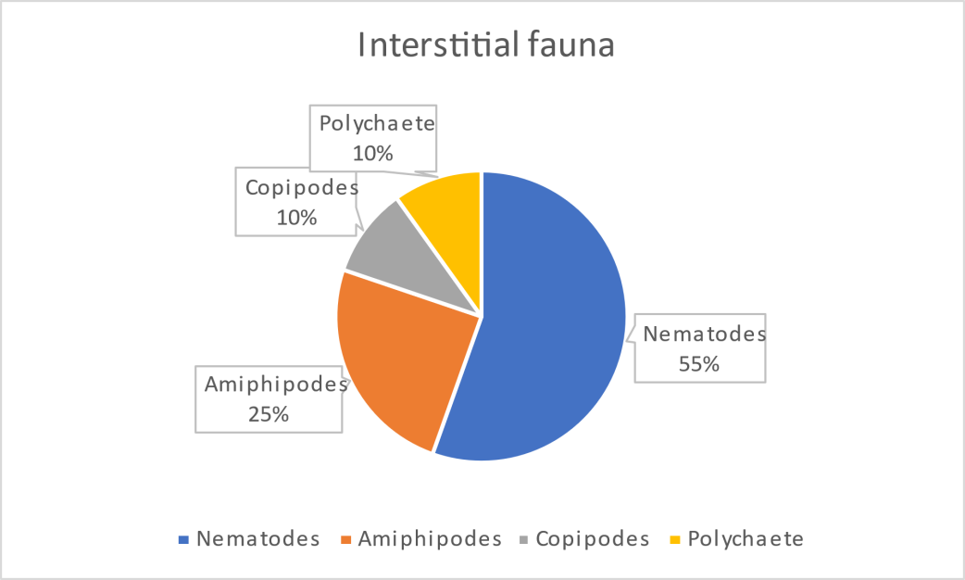

Fig.12. The Percentage composition of interstitial fauna in two stations

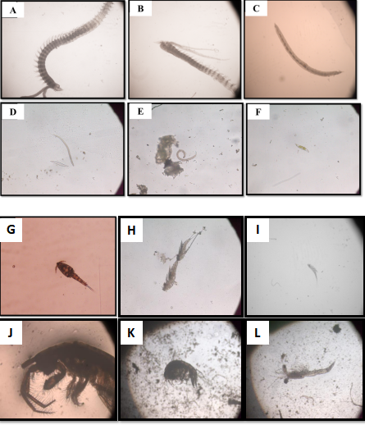

Fig.13. Dominant interstitial faunal from all the identified groups. (A.) Prionospio sp., (B). Magalona sp., (C) Pissionidens sp. (D). Viscosia carnleyensis(E). Viscosia marcramphida and (F).Anoplostoma viviparum(G). Paracalanus parvus, (H)Acartia sp. (I)Longipedi sp. (J.) Haplocheira sp.(K) Ampithoe sp.(L). Mysis larvae.

3.4 Species abundance and diversity
Meiofaunal abundance was standardized and expressed as individuals per 10 cm² (ind/10 cm²) based on the corer surface area. The previous volumetric expression (ind/10 m³) was corrected to align with internationally accepted sediment-based reporting standards.
Total abundance
Mean total abundance over the six-month period was:
- Station 2: ~1000 ind/10 cm²
- Station 1: ~820 ind/10 cm²
Independent sample t-tests confirmed that total abundance was significantly higher at Station 2 compared to Station 1 (p < 0.05).
Two-way ANOVA (Station × Month) revealed:
- Significant station effect (p < 0.05).
- Significant monthly variation (p < 0.05).
- Significant interaction effect (p < 0.05), indicating temporal patterns differed between habitats.

Taxon-specific abundance
Nematodes exhibited the highest abundance at both stations:
- Station 2: ~550 ind/10 cm²
- Station 1: ~451 ind/10 cm²
Amphipods were the second most abundant group:
- Station 2: ~250 ind/10 cm²
- Station 1: ~205 ind/10 cm²
Polychaetas and copepods showed comparatively lower abundance:
- Polychaetas: ~100 ind/10 cm² (Station 2); ~82 ind/10 cm² (Station 1)
- Copepods: ~100 ind/10 cm² (Station 2); ~82 ind/10 cm² (Station 1)
Monthly variation in abundance was significant for nematodes and amphipods (p < 0.05), but not for copepods (p > 0.05) (Fig.14).

Diversity indices
Diversity indices were calculated using monthly replicate data.
Station 2 exhibited higher diversity values than Station 1:
- Shannon index (H′): 1.22 (Station 2) vs. 1.05 (Station 1)
- Evenness (E′): 0.48 (Station 2) vs. 0.20 (Station 1)
Independent t-tests confirmed that Shannon diversity and evenness were significantly higher at Station 2 (p < 0.05). Species richness (S) corresponded to the total number of species recorded (12 species overall). Monthly richness did not differ significantly between stations (p > 0.05) (Fig.15).
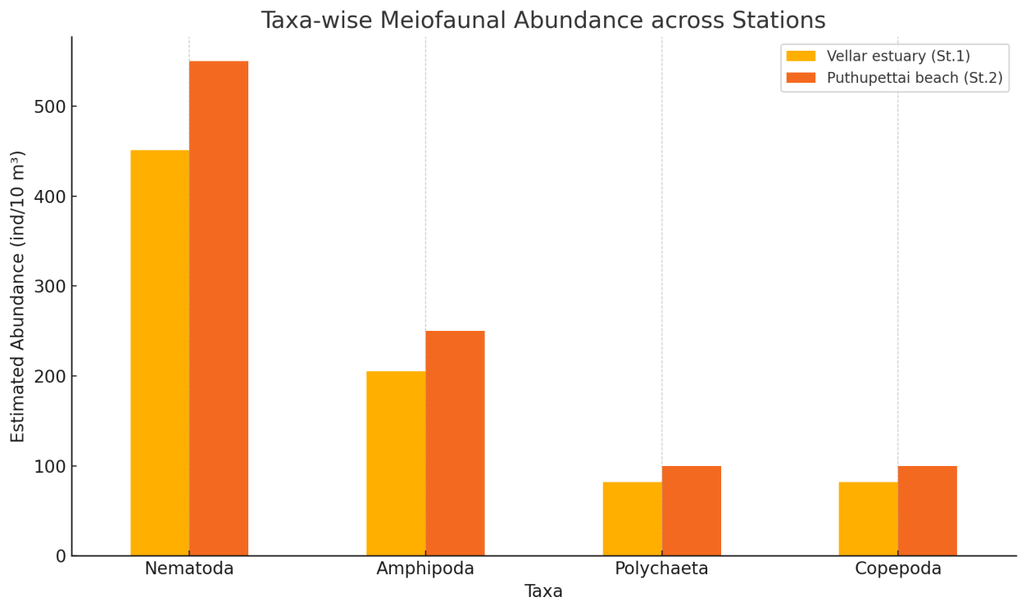
Fig. 14. Species abundance

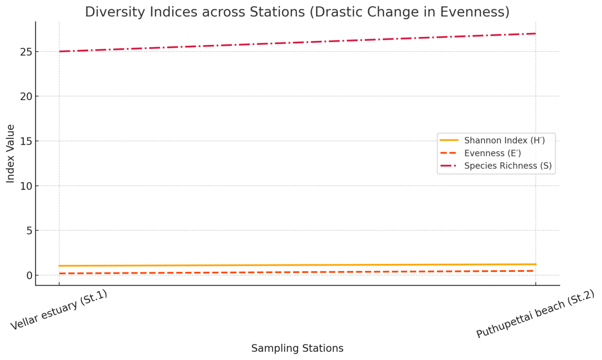

Fig. 15. Species diversity indices

4. Discussion
This study documents interstitial fauna composition and water quality patterns at two contrasting coastal habitats along the Parangipettai coast: an estuarine station (Station 1) and an open sandy beach station (Station 2). The physico-chemical ranges observed (pH ~7.5–8.3; temperature ~24–28.2°C; and variable dissolved oxygen and salinity ranges) are consistent with typical tropical coastal conditions where seasonal and local hydrological inputs influence estuarine waters more strongly than open beaches. In the present dataset, Station 1 exhibited a wide salinity range (10.5–35.2 ppt), reflecting freshwater influence and mixing, while Station 2 maintained higher and narrower salinity values (30–36 ppt), typical of more marine-dominated conditions. Such differences can substantially affect meiofaunal community structure, because osmoregulation constraints and habitat stability often favor different taxa in estuaries versus marine beaches.

4.1 Dominance of nematodes and functional significance
The observed dominance of nematodes (55%) aligns with extensive meiofaunal literature reporting nematodes as the most consistently abundant group across marine and estuarine sediments. Nematode dominance has been widely recorded in multiple environments and may span broad ranges in coastal sediments, reflecting their tolerance to environmental gradients and their ability to exploit diverse microbial and detrital resources (Carugati et al., 2015). The present finding, nematodes being the highest abundance group in both stations,supports the view that nematodes often form the structural “core” of meiofaunal assemblages, while other groups (e.g., copepods, polychaetes, amphipods) vary more with habitat conditions (Carugati et al., 2015).
Functionally, meiofauna contribute to sediment ecosystem processes through feeding, movement, and interactions with microbes. Meiofauna are known to facilitate biomineralization of organic matter and enhance nutrient regeneration, and they also serve as food for higher trophic levels, together supporting energy transfer and nutrient cycling in estuarine soft-bottom habitats (Coull, 1999). Emerging experimental evidence further demonstrates that meiofaunal grazing and bioturbation significantly influence sediment biogeochemical fluxes, including nitrogen and carbon cycling pathways in coastal sediments (Ballentine et al., 2024). Therefore, even modest shifts in community composition may influence sediment metabolism, nutrient fluxes, and food-web structure (Coull, 1999).

4.2 Habitat differences, abundance patterns, and oxygen–salinity context
Abundance and diversity were higher at Station 2 (Puthupettai beach) than Station 1 (Vellar estuary). This pattern can be interpreted in the context of habitat stability and stress gradients. Estuarine habitats often experience stronger fluctuations in salinity and organic inputs, which may favor tolerant taxa and increase dominance effects,consistent with the lower evenness observed at Station 1 (E′ = 0.20). Similar patterns linking meiofaunal community structure to salinity variability, oxygen gradients, and sediment organic content have been documented in recent coastal sediment studies, which demonstrate that environmental drivers strongly regulate diversity and dominance patterns across habitat types (Badri et al., 2025).Station 2 had higher evenness (E′ = 0.48), suggesting that individuals were more evenly distributed across taxa, which is commonly associated with more stable or less stressful environmental conditions (Coull, 1999).
Dissolved oxygen patterns are also ecologically relevant because many meiofauna occupy sediment–water interface layers where oxygen availability influences microbial food resources and animal respiration. Meiofaunal densities often shift with oxygen gradients and organic enrichment, and changes in DO can indirectly restructure communities by altering microbial biomass and sediment redox conditions; this fits broader benthic ecology understanding that sedimentary ecosystems are sensitive to stressors and that small-bodied communities can respond rapidly (Coull, 1999).

4.3 Grain size and interstitial habitat structure
A core ecological driver of interstitial fauna is sediment grain size, which determines pore-space availability and the physical limits on body size, movement, and dispersal. Classic work on marine sand interstitial fauna shows that species distribution in different sand biotopes is strongly dependent on ecological factors such as grain size, and that interstitial community structure is shaped by sediment characteristics (Swedmark, 1964). While the present study did not quantify grain-size distribution, the contrast between an estuarine mouth environment and a sandy beach suggests differences in sediment texture and hydrodynamic sorting. Such differences can contribute to the observed pattern of higher abundance and diversity at the beach station if pore spaces and oxygen diffusion are more favorable (Swedmark, 1964). Recent investigations of tropical sandy beaches confirm that sediment grain size, pore connectivity, and hydrodynamic exposure are key determinants of meiofaunal richness and evenness, often promoting higher diversity under stable marine conditions (Coppo et al., 2024).

4.4 Meiofauna as bioindicators and under-representation in monitoring
Meiofauna are increasingly highlighted as useful bioindicators because they combine fast generation times, direct sediment contact, and sensitivity to stressors such as pollution and eutrophication (Coull, 1999). Recent syntheses of sandy beach ecosystems emphasize that meiofaunal assemblages function as effective ecological sentinels due to their rapid response to environmental stress and their tight coupling with sediment processes, yet they remain underrepresented in coastal monitoring frameworks (Martínez et al., 2024). Importantly, recent synthesis of beach ecosystem research has shown that meiofauna remain substantially under-represented in ecological studies and ecosystem assessments of beaches, even though they are well suited as sentinels (Martínez et al., 2024). This supports the relevance of studies like the present one in strengthening baseline knowledge on meiofaunal communities and improving the scope of coastal monitoring and ecosystem health assessments (Martínez et al., 2024).

4.5 Comparison with regional and published observations
The community pattern in this study,nematode dominance with contributions from copepods, polychaetes, and amphipods,matches several published observations from coastal and estuarine systems. Multi-taxa meiofaunal compositions are frequently structured by salinity gradients and local sediment properties, and seasonal variation may further influence recruitment and abundance patterns (Coull, 1999; Swedmark, 1964). The higher diversity values at Station 2 (H′ = 1.22) relative to Station 1 (H′ = 1.05) support the conclusion that the beach site provided conditions that allowed more taxa to persist without strong dominance effects, consistent with the expectation that more stable marine conditions and favorable interstitial habitat structure promote higher evenness and diversity (Coull, 1999; Martínez et al., 2024).
Overall, the present study contributes site-specific baseline information for the Parangipettai region and supports the broader ecological understanding that interstitial fauna composition reflects a combination of habitat structure (pore space/grain size), water quality conditions (salinity and oxygen), and potential local disturbances (Swedmark, 1964; Coull, 1999; Martínez et al., 2024).

5. Conclusion
During the present study, the sediment and water samples were collected from two stations (Vellar estuary mouth and Puthupettai beach) for analysis of interstitial fauna diversity and physico-chemical parameters (water temperature, salinity, and pH). A total of 12 species and 18 genera belonging to four groups of interstitial fauna—polychaetes, nematodes, amphipods, and copepods—were recorded. Nematodes were the dominant group at both stations. Several taxa were common across stations, including nematodes (Viscosia carnleyensis, Viscosia marcramphida, Anoplostoma viviparum), polychaetes (Prionospio sp., Magelona sp., Pissionidens sp.), copepods (Paracalanus parvus, Acartia sp.), and amphipods (Haplocheira sp., Ampithoe sp.).
In conclusion, interstitial fauna—though often overlooked—play vital roles in marine ecosystems and caof ecosystem health. Continued research is necessary to better understand the diversity, distribution, and ecological functioning of these communities in tropical coastal systems.

Table 1: List of interstitial fauna identified during the study period.

Class | Genus | Species
Enoplida | Chromadoriata sp.
 | Viscosia | carnleyensis
 | Viscosia | marcramphida
 | Anoplostoma | viviparum
 | Polygastrophora | septembeelba
 | Sabatiera | falcifera
 | Sabatiera | jubata
 | Paramesonchium sp.
 | Metalinemoides | typicus
 | Theristus | pertenuis
Polycheate | Prionospio sp.  Magelona sp.  Sigambra sp.  Ampharete sp.  Cirratulus sp.  Glycera sp.  Poecilochaetus sp.  Spionidae sp.
Copepoda | Paracalanus | parvus
 | Acartia sp.
 | Miracia | efferata
 | Enterpina | acutifrons
 | Longipedi sp.
 | Macrsetella | gracilis
Amphipoda (Order) | Sammarogammarus sp.  Haplocheira sp.  Ampelisca sp.
Disclaimer (Artificial intelligence)
Author(s) hereby declare that NO generative AI technologies such as Large Language Models (ChatGPT, COPILOT, etc.) and text-to-image generators have been used during the writing or editing of this manuscript.

References
Ansari, A., Rivonkar, C.U. and Sangodkar, U.M.X., 2001. Population fluctuation and vertical distribution of meiofauna in a tropical mudflat at Mandovi estuary, west coast of India. Indian Journal of Marine Sciences, 30, 237–245.
Ansari, Z.A. and Parulekar, A.H., 1993. Distribution, abundance and ecology of the meiofauna in a tropical estuary along the west coast of India. Hydrobiologia, 262, 115–126.
Bongers, T., 1990. The maturity index: an ecological measure of environmental disturbance based on nematode species composition. Oecologia, 83, 14–19.
Carman, K.R. and Todaro, M.A., 1996. Influence of polycyclic aromatic hydrocarbons on the meiobenthic copepod community of a Louisiana salt marsh. Journal of Experimental Marine Biology and Ecology, 198(1), 37–54.
Carman, K.R., Fleeger, J.W. and Pomarico, S.M., 1997. Response of a benthic food web to hydrocarbon contamination. Limnology and Oceanography, 42(3), 561–571.
Carman, K.R., Fleeger, J.W. and Pomarico, S.M., 2000. Does historical exposure to hydrocarbon contamination alter the response of benthic communities to diesel contamination? Marine Environmental Research, 49(3), 255–278.
Carugati, L., Corinaldesi, C., Dell’Anno, A. and Danovaro, R., 2015. Metazoan meiofauna biodiversity: a neglected component of marine ecosystems. Marine Biodiversity, 45, 1–14.
Coull, B.C. and Bell, S.S., 1979. Perspectives of marine meiofaunal ecology. In: Livingston, R.J. (Ed.), Ecological Processes in Coastal and Marine Systems. Plenum Press, New York, pp. 189–216.
Coull, B.C., Ellison, R.L., Fleeger, J.W., Higgins, R.P., Hope, W.D., Hummon, W.D., Rieger, R.M., Sterrer, W.E., Thiel, H. and Tietjen, J.H., 1977. Quantitative estimates of the meiofauna from the deep sea off North Carolina, USA. Marine Biology, 39(3), 233–240.
Coull, B.C., 1999. Role of meiofauna in estuarine soft-bottom habitats. Australian Journal of Ecology, 24(4), 327–343.
Datta, R., Maity, P., Bhadury, P., Rizvi, A.N. and Raghunathan, C., 2022. An updated checklist of free-living marine nematodes from coastal India. Zootaxa, 5196(2), 151–196.
Funch, P., Nielsen, N.E.K., Graf, S. and Buttler, F., 2002. Marine meiofauna. Feltkursus i videregående zoologi på Molslaboratoriet, 119 pp.
Ganapati, P.N. and Rao, G.C., 1962. Ecology of the interstitial fauna inhabiting the sandy beaches of Waltair coast. Journal of the Marine Biological Association of India, 4, 44–57.
Harris, R.P., 1972. The distribution and ecology of the interstitial meiofauna of a sandy beach at Whitsand Bay, East Cornwall. Journal of the Marine Biological Association of the United Kingdom, 52(1), 1–18.
Higgins, R.P. and Thiel, H., 1998. Introduction to the Study of Meiofauna. Smithsonian Institution Press, Washington DC, 488 pp.
Kondalarao, B., 1983. Distribution of meiofauna in the Gautami–Godavari estuarine system, India. Mahasagar, 16, 25–34.
Kondalarao, B. and Ramanamurty, K.V., 1988. Ecology of intertidal meiofauna of the Kakinada Bay (Gautami–Godavari estuarine system), east coast of India. Indian Journal of Marine Sciences, 17, 185–190.
Kumar, A.T.A., Punniyamoorthy, R., Mariyappan, S., Swain, S. and Murugesan, P., 2022. Benthic meiofaunal diversity and distribution in Nagapattinam coastal waters, India. Indian Journal of Geo-Marine Sciences, 51(3), 238–246.
Mare, M.F., 1942. A study of a marine benthic community with special reference to the micro-organisms. Journal of the Marine Biological Association of the United Kingdom, 25, 517–554.
Mary, N. and Marmonier, P., 2000. First survey of interstitial fauna in New Caledonian rivers: influence of geological and geomorphological characteristics. Hydrobiologia, 418, 199–208.
Martínez, M.L., Defeo, O., Jaramillo, E. and McLachlan, A., 2024. Sandy beaches as ecosystems: overlooked biodiversity and ecosystem functioning. Estuarine, Coastal and Shelf Science, 298, 108594.
McLachlan, A., 1980. Exposed sandy beaches as semi-closed ecosystems. Marine Environmental Research, 4(1), 59–63.
Nybakken, J.W., 1997. Marine Biology: An Ecological Approach. 4th ed. Addison Wesley Longman, California.
Pinckney, J.L., Carman, K.R., Lumsden, S.E. and Hymel, S.N., 2003. Microalgal–meiofaunal trophic relationships in muddy intertidal estuarine sediments. Aquatic Microbial Ecology, 31(1), 99–108.
Piot, A., Nozais, C. and Archambault, P., 2013. Meiofauna affect the relationship between biodiversity and ecosystem functioning in benthic systems. Oikos, 122, 1359–1369.
Platt, H.M. and Warwick, R.M., 1980. The significance of free-living nematodes to the littoral ecosystem. In: Price, J.H., Irvine, D.E.G. and Farnham, W.F. (Eds.), The Shore Environment, Vol. 2. Academic Press, London, pp. 729–759.
Platt, H.M. and Warwick, R.M., 1983. Free-living Marine Nematodes. Part I: British Enoplids. Synopses of the British Fauna (New Series), No. 28. Cambridge University Press, Cambridge.
Rao, G.C., 1975. The interstitial fauna in the intertidal sands of Andaman and Nicobar group of islands. Journal of the Marine Biological Association of India, 17(2), 116–128.
Rizqydiani, M., Ismet, M.S. and Bengen, D.G., 2018. Diversity of meiofauna and its association with seagrass bed characteristics in Pramuka Island, Seribu Islands. IOP Conference Series: Earth and Environmental Science, 176, 012045.
Sarma, A.L.N. and Wilsanand, V., 1994. Littoral meiofauna of Bhitarkanika mangroves of river Mahanadi system, east coast of India. Indian Journal of Marine Sciences, 23, 44–49.
Steyaert, M., Deprez, T., Raes, M., Bezerra, T., Demesel, L., Derycke, S., Fonseca, G., Moens, T., Vanreusel, A. and Vincx, M., 2005. Electronic key to the free-living marine nematodes. Marine Biology Research, 1, 1–41.
Swedmark, B., 1964. The interstitial fauna of marine sand. Biological Reviews, 39(1), 1–42.
Thilagavathi, B., Das, B., Saravanakumar, A. and Raja, K., 2011. Benthic meiofaunal composition and community structure in the Sethukuda mangrove area and adjacent open sea, east coast of India. Ocean Science Journal, 46, 63–72.
Warwick, R.M., Platt, H.M. and Somerfield, P.J., 1998. Free-living Marine Nematodes. Part III: British Monhysterids. The Linnean Society of London and the Estuarine and Coastal Sciences Association.

