Original Research Article

Influence of Seasonal Fluctuations on Physicochemical Characteristics and Plankton Diversity of Nathsagar Reservoir, Maharashtra, India.

Abstract
The seasonal variation in water quality and plankton distribution was studied in the Nathsagar Reservoir, Maharashtra, India, to ascertain the role of physico-chemical parameters on plankton dynamics. Sampling was conducted at 10 sites (summer, winter, and monsoon) in 2022. Parameters such as temperature, pH, turbidity, dissolved oxygen, BOD/COD, TDS, electrical conductivity (EC), alkalinity (ALK), hardness, and major ions were tested according to standard methods. Correlations indicated positive associations among temperature, pH, turbidity, BOD, COD, and ions, and Cyanophyceae and Rotifera. In the studied water bodies, this implies that high temperatures, an alkaline environment, and organic enrichment have facilitated phytoplankton blooms and the development of a zooplankton community. By contrast, a significant positive correlation was found between dissolved oxygen and Bacillariophyceae, Cladocera, and Copepoda. The seasonal patterns indicate consistent plankton communities during winter, while pollution-tolerant taxa dominate in the monsoon and summer months. The study emphasises the influence of physicochemical factors on plankton distribution in Nathasagar Reservoir.
Keywords: Physicochemical parameters, Seasonal variation, Plankton diversity, Nathsagar Reservoir.
Introduction
Reservoir ecosystems are strongly influenced by seasonality, leading to major variations in chemistry and biology (Aware & Vishwanath, 2025). Plankton assemblage changes are quickly induced by temperature changes, as well as by nutrient availability, turbidity, and organic matter (the last variables are used to assess environmental quality in aquatic environments), making them suitable for monitoring the health of aquatic ecosystems (Negrete-García et al., 2024; Morán & Huete-Stauffer, 2018). Monsoon runoff, stable winter months, and higher summer temperatures are the most important factors that dictate water quality in tropical reservoirs and thereby control the composition and abundance of plankton communities.
Nathsagar Reservoir (Jayakwadi) is reportedly one of the major reservoirs in Maharashtra, and its potential uses include irrigation, fisheries, and a haven for migratory water birds (Jayakwadi Dam – Birds of Aurangabad, 2016). It is of ecological, social, and economic importance; however, few data are available on the seasonal impact on this reservoir's water quality (Vishwanath, 2025).
The physicochemical properties of water were interfering with the manipulation of the plankton assemblage. Phytoplankton, as primary producers, are influenced by changes in temperature and nutrient concentrations, and zooplankton, indirectly, depend on water chemistry and phytoplankton availability (Pandey & Kashyap, 2022; Sugumaran et al., 2020). Therefore, fluctuations in plankton abundance and composition are driven by interactions among physical, chemical, and biological processes under the natural conditions of the reservoir ecosystem (Neelgund & Kadadevaru, 2021). Shifts at one trophic level always affect the whole trophic web, emphasising the overall interdependence of aquatic ecosystems (Khan et al., 25).
Understanding seasonal relationships between plankton and water quality is crucial for evaluating ecosystem health and promoting sustainable conservation and management, especially amid growing anthropogenic impacts and climate variability. Observing plankton communities can provide valuable information on ecological responses to environmental change and on sustainable reservoir management (Annamalai et al., 2023; Das et al., 2024; Merkli et al., 2025).
Objectives of the Study
- To study the seasonal variation in physicochemical parameters of Nathsagar Reservoir at ten selected sites.
- To assess the Seasonal variability of phytoplankton and zooplankton populations.
- To study the correlation between physicochemical parameters and the plankton diversity in the reservoir.
2. Materials and Methods
2.1 Study Area:
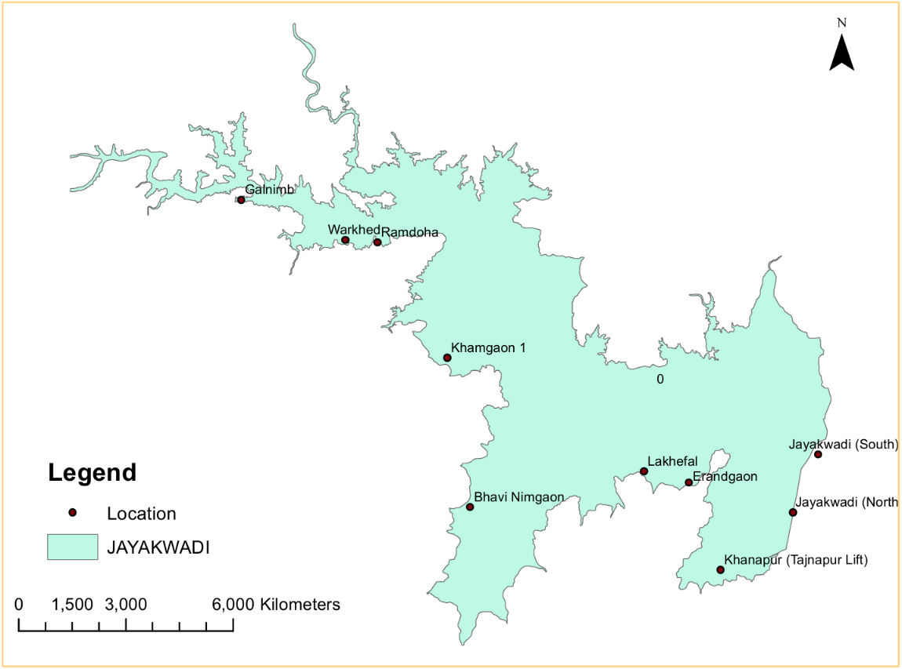
Figure 1. Study Area
Nathsagar Reservoir (Jayakwadi Dam) is located in Aurangabad district, Maharashtra, India (19°32′–19°38′ N; 75°15′–75°22′ E). It is one of the largest artificial reservoirs in the state and supports an important wetland ecosystem that supports fisheries, agriculture, and migratory waterbirds. Ten sampling sites were selected alongside Nathsagar reservoir, viz. Galnimb, Warkhed, Ramdoha, Khamgaon-1, Bhavi Nimgaon, Jayakwadi (South), Jayakwadi (North), Khanapur, Erandgaon, and Lakhefal.
2.2 Physicochemical Analysis
Water samples were collected seasonally from 10 selected sites in the Nathsagar Reservoir during the monsoon, winter, and summer seasons of 2022. Sampling was carried out during morning hours to minimise diurnal variation. Clean, pre-washed polyethene bottles were used for sample collection, and the bottles were rinsed with reservoir water prior to sampling. Samples were transported to the laboratory and analysed within 24 hours.
Physicochemical parameters were analysed following standard methods prescribed by the American Public Health Association (APHA, 2017). In situ measurements included water temperature, recorded with a calibrated thermometer; pH, measured with a portable digital pH meter; and electrical conductivity (EC), total dissolved solids (TDS), measured with a digital conductivity meter.
Laboratory analysis included chloride, alkalinity (titrimetric method), total hardness, bicarbonate, calcium, magnesium, biochemical oxygen demand (BOD, 5-day incubation method), and chemical oxygen demand (COD, dichromate reflux method). Dissolved oxygen (DO) was estimated using Winkler’s iodometric method. All glassware and instruments were properly cleaned and calibrated before analysis. Each parameter was analysed in triplicate to ensure accuracy and reliability, and the mean values were used for further interpretation. Results were expressed in standard units (mg/L or µS/cm), as recommended by APHA.
2.3 Plankton Diversity
Plankton samples were collected seasonally from all sampling sites by filtering 50 litres of reservoir water through a standard plankton net having a mesh size of 25 µm. The collected samples were immediately transferred to clean, labelled bottles and preserved in 4% formalin solution to prevent decomposition and maintain the structural integrity of organisms.
In the laboratory, plankton samples were thoroughly mixed and allowed to settle. Phytoplankton and zooplankton were identified up to species level using standard taxonomic keys and reference manuals (Prescott, 1962; Edmondson, 1959; Battish, 1992). Identification was confirmed by repeated microscopic examination.
Quantitative estimation of plankton was carried out using a Sedgwick–Rafter counting chamber under a compound microscope. For each sample, multiple counts were performed to minimise counting error, and the average value was considered for analysis. Plankton abundance was expressed as cells per litre (cells/L) for phytoplankton and individuals per litre (ind./L) for zooplankton.
Six dominant species from each plankton group were selected as representative bioindicators to evaluate seasonal and spatial variation. The abundance data were used to analyse seasonal trends, group-wise distribution, and ecological relationships between plankton communities and physicochemical parameters. Correlation analysis was performed to assess the influence of water quality variables on plankton distribution and abundance.
- Results:
3.1 Seasonal Trends of Water Parameters and Plankton Diversity
Seasonal variation in physicochemical parameters was evident across all sampling sites of Nathsagar Reservoir. Water temperature ranged from 30.6–32.4 °C during the monsoon, 23.4–25.1 °C during summer, and was moderate during winter. Turbidity was relatively higher during the monsoon (7.5–9.2 NTU) compared to the summer (5.0–6.5 NTU). The pH of the reservoir remained slightly alkaline throughout the study period, ranging from 7.34 to 8.70 in the monsoon and from 6.75 to 8.60 in summer. Elevated values of BOD (6.50–7.67 mg/L) and COD (41.0–46.9 mg/L) were recorded during monsoon, while comparatively lower values were observed during summer (BOD: 5.10–6.01 mg/L; COD: 31.0–36.9 mg/L). Total dissolved solids and electrical conductivity also showed higher values during monsoon (TDS: 497–589 mg/L; EC: 0.72–0.81 mS/cm) than summer (TDS: 397–489 mg/L; EC: 0.54–0.62 mS/cm). Dissolved oxygen ranged from 6.20–6.80 mg/L during the monsoon and increased during summer (7.60–8.20 mg/L), with maximum values observed during winter.

Figure 2. Seasonal variation in physicochemical parameters of Nathsagar Reservoir during Summer 2022.

Figure 3. Seasonal variation in physicochemical parameters of Nathsagar Reservoir during Monsoon 2022.

Figure 4. Seasonal variation in physicochemical parameters of Nathsagar Reservoir during Winter 2022.

3.4. Plankton Analysis:
Plankton communities exhibited pronounced seasonal variation across the reservoir. Phytoplankton abundance was highest during winter (2,800–4,400 cells/L), followed by summer (2,600–4,300 cells/L) and monsoon (2,100–3,600 cells/L). Cyanophyceae dominated during summer, showing peak densities across all sites, whereas winter exhibited a more balanced representation of Cyanophyceae, Chlorophyceae, and Bacillariophyceae. Zooplankton abundance also reached maximum values during winter (430–600 ind./L), followed by monsoon (360–570 ind./L), and comparatively lower values during summer (380–510 ind./L). Rotifera were dominant in summer, while Cladocera and Copepoda were more abundant in winter. These results indicate clear seasonal fluctuations in plankton communities across Nathsagar Reservoir.
- ZOOPLANKTON:
(Seasonal abundance – Ind/L)

Figure 5. Monsoon 2022 – Zooplankton.

Figure 6. Winter 2022 – Zooplankton.

Figure 7. Summer 2022 – Zooplankton

B) PHYTOPLANKTON
(Seasonal abundance – cells/L)

Figure 8. Monsoon 2022 – Phytoplankton

Figure 9 Winter 2022 – Phytoplankton.

Figure 10. Summer 2022 – Phytoplankton

4. Discussion
Naturally occurring seasonal variations in physicochemical parameters markedly affect the diversity and biomass of planktonic organisms in reservoirs. Although plankton diversity indeed peaked during wintry conditions, the highly nutrient-rich environment resulting from seasonal thawing of snow may have limited biodiversity inputs due to significant blurring with infusorial organisms, including predators and bivalves. These create photosynthesis-stimulating conditions, alongside a stable aquatic ecosystem.
Monsoon season runoff from the surrounding catchment areas increases water turbidity and organic matter input, further affecting water chemistry and plankton communities. BOD, COD, and turbidity are increasing in the reservoir due to runoff during rainfall that brings nutrients, sediments, and organic matter into the reservoir. These changes can change light penetration or nutrient availability, and thus phytoplankton productivity.
A predominance of Cyanophyae in summer implies nutrient-polluted conditions and warm temperatures that favour cyanobacteria species capable of forming blooms. Cyanobacterial blooms are often reported in eutrophic freshwater systems and can cause biodiversity loss through competitive exclusion of other phytoplankton taxa.
The relationship found between physicochemical parameters and plankton communities indicates the ecological significance of water quality variables in the present study. A positive correlation between temperature, pH, turbidity, alkalinity, and nutrient concentrations (except N :P) with Cyanophyceae and Rotifera suggests that these organisms thrive in environments characterized by greater nutrient and organic matter availability [30].
On the other hand, Bacillariophyceae, Cladocera, and Copepoda showed positive correlations with dissolved oxygen, indicating their dominance under well-oxygenated, relatively stable ecological conditions. Diatoms are favoured by high O2 levels and clear waters, while cladocerans and copepods generally prefer stable limnetic habitats with high food supply.
Seasonal turnover in these planktonic community structures also has important implications for reservoir fisheries and higher trophic levels. Plankton is the basis of the aquatic food web, and at one stage, it serves as the food for fish larvae and other aquatic fauna. Thus, changes in plankton abundance impact fish productivity and ecosystem stability.
The results of this study corroborate previous studies from tropical reservoirs, in which seasonal variation in hydrochemistry plays a key role in driving plankton distribution and community dynamics. These seasonal patterns have been observed in many freshwater ecosystems, where high plankton diversity is favoured in winter, and cyanobacterial dominance prevails during summer.
The results, in conclusion, demonstrate that physico-chemical variables regulate plankton diversity and seasonal ecological processes in Nathsagar Reservoir. It highlights the need for continuous monitoring of water quality and plankton communities to better manage and conserve reservoir ecosystems.
Seasonal Variation of Zooplankton
The seasonal patterns of community composition were clear across the reservoir's zooplankton communities. Total zooplankton abundance ranged from 360 to 570 individuals per litre during the monsoon season. The five most abundant groups were Rotifera, Cladocera, Copepoda, Protozoa, and Ostracoda. Due to their fast reproductive cycles and tolerance against environmental variation, rotifers dominate at times of high nutrient input.
Zooplankton samples indicated that the abundance of zooplankton increased substantially and reached winter values of 430–600 individuals per litre. Seasonal abundance peaks of these groups were observed in Cladocera and Copepoda. The higher prevalence of these groups could be due to favourable environmental conditions, such as moderate temperature, higher dissolved oxygen concentration, and better food availability.
Compared to these values, summer zooplankton abundance was relatively low (380–510 ind. litre−1). In this season, Rotifers were again the dominant organisms, likely due to their tolerance to higher temperatures and nutrient concentrations.
In general, the seasonal trend in zooplankton distribution is likely driven by physicochemical conditions and the availability of phytoplankton at a specific trophic level, but it also suggests that seasonal changes in some parameters affect macrophytes remarkably, particularly under environmental conditions.
Seasonal Variation of Phytoplankton
Communities of phytoplankton also exhibited sweeping seasonal variability. The abundance of total phytoplankton during the monsoon season ranged from 2100 to 3600 cells/L. Chlorophyceae and Cyanophyceae were dominant during this season.
The highest phytoplankton abundance was reported in winter (2800 to 4400 cells/L). Bacillariophyceae (diatoms) and Chlorophyceae were dominant; the presence of diatoms indicated that environmental conditions such as water transparency and dissolved oxygen levels have improved.
Phytoplankton abundance in summer ranged from 2600 to 4300 cells/L, with cyanophyceae dominant due to high temperatures and nutrient concentrations. Cyanobacterial dominance can indicate eutrophic conditions, which are common to tropical reservoirs in summer.

5. Conclusion
Seasonal changes in water quality have a big effect on plankton diversity in Nathsagar Reservoir. Winter has the most stable ecosystem, while summer shows more organic matter and more plankton blooms. These patterns could affect fish, waterbirds, and other higher levels in the food web.

Data Availability
Data are available within the article.

COMPETING INTERESTS DISCLAIMER:
Authors have declared that they have no known competing financial interests OR non-financial interests OR personal relationships that could have appeared to influence the work reported in this paper.

Disclaimer (Artificial intelligence)

Author(s) hereby declare that NO generative AI technologies such as Large Language Models (ChatGPT, COPILOT, etc.) and text-to-image generators have been used during the writing or editing of this manuscript.

References:
- APHA (2017). Standard Methods for the Examination of Water and Wastewater. 23rd Ed., American Public Health Association, Washington, DC.
- Wetzel, R.G. (2001). Limnology: Lake and River Ecosystems. 3rd Ed., Academic Press, San Diego.
- Odum, E.P. (1971). Fundamentals of Ecology. 3rd Ed., W.B. Saunders, Philadelphia.
- Pielou, E.C. (1966). The measurement of diversity in different types of biological collections. Journal of Theoretical Biology, 13: 131–144.
- Trivedy, R.K., & Goel, P.K. (1986). Chemical and Biological Methods for Water Pollution Studies. Environmental Publications, Karad, India.
- Prescott, G.W. (1962). Algae of the Western Great Lakes Area. Wm. C. Brown Co., Dubuque.
- Edmondson, W.T. (1959). Freshwater Biology. 2nd Ed., John Wiley & Sons, New York.
- Needham, J.G., & Needham, P.R. (1962). A Guide to the Study of Freshwater Biology. Holden-Day, San Francisco.
- Battish, S.K. (1992). Freshwater Zooplankton of India. Oxford & IBH, New Delhi.
- Ganapati, S.V. (1960). Ecology of the freshwater plankton. Hydrobiologia, 16: 257–269.
- Bais, V.S., & Agrawal, N.C. (1990). Seasonal variation of plankton in Sagar Lake, India. Journal of Freshwater Biology, 2: 49–54.
- Talling, J.F., & Lemoalle, J. (1998). Ecological Dynamics of Tropical Inland Waters. Cambridge University Press.
- Reynolds, C.S. (2006). The Ecology of Phytoplankton. Cambridge University Press.
- Vollenweider, R.A. (1968). Scientific Fundamentals of the Eutrophication of Lakes and Flowing Waters, with Particular Reference to Nitrogen and Phosphorus as Factors in Eutrophication.
- APHA (2005). Standard Methods for the Examination of Water and Wastewater. 21st Ed., APHA, Washington, DC.
- Aware, S., & Vishwanath, T. (2025). Seasonal dynamics of reservoir ecosystems. Journal of Aquatic Ecology, 40(1), 1–12.
- Negrete-García, G., López, M., & Ramírez, A. (2024). Plankton responses to environmental gradients in freshwater ecosystems. Ecological Indicators, 155, 110987.
- Morán, X. A. G., & Huete-Stauffer, T. M. (2018). Temperature sensitivities of microbial plankton net growth rates are seasonally coherent and linked to nutrient availability. Environmental Microbiology, 8, 1–10.
- Birds of Aurangabad. (2016). Jayakwadi Dam – Birds of Aurangabad.
- Neelgund, Y. F., & Kadadevaru, G. G. (2021). Seasonal plankton dynamics in reservoirs. Indian Journal of Ecology, 48(1), 123–130.
- Annamalai, S., Ramesh, K., & Kumar, P. (2023). Seasonal variation of plankton diversity in freshwater lakes. Water, 15(3), 456.
- Das, R., Sen, S., & Ghosh, A. (2024). Plankton as bioindicators of water quality. Frontiers in Environmental Science, 12, 100000.
- Jadhav, J., Mujumdar, M., Awale, M., Patil, R., & Kuchekar, S. (2026). Comparative assessment of soil quality in drought-prone and irrigated areas and estimation of soil quality index a novel approach. Discover Soil, 6, Article 12.
- Sobha Rani, S. (2018). Seasonal changes in water quality parameters of Malidevi estuary (Nellore) East Coast of Andhra Pradesh, India. Int J Current Innov Adv Res, 1(1), 1-6.
- Kurhe, Anil. (2013). Study of seasonal variations in physico-chemical parameters and nutrients in the water of the Bhatye estuary, Ratnagiri Central, West Coast of India. Journal of Environmental Sciences. Volume 3,. 1671-1677. 10.6088/ijes.2013030500035.
- SAWANT, D. R. S. (2019). INSIGHT TO THE HYDROLOGY OF RESERVOIRS FROM GADHINGLAJ TAHSIL. Lulu. com.
- Patil, S. R., Sawant, R. S., Kumbhar, D. S., & Jadhav, S. D. (2012). Hydrological Studies of Two Aquatic Ecosystems from Kagal Tahsil, Maharashtra. methods, 1, 2.

