Assessment of Feeding and Housing Management Practices Adopted by the Local Cattle Farmers from the Bastar Region of Chhattisgarh

Abstract

Livestock farming plays a vital role in the rural economy of Chhattisgarh State. This investigation was conducted to evaluate the existing feeding and housing management practices adopted by local cattle farmers of Bastar, Narayanpur and Dantewada districts from the Bastar Plateau zone of Chhattisgarh. The study revealed that all respondents adopted an extensive system of cattle farming, with feeding primarily dependent on grazing, crop residues, and grasses. Only 19.5% of respondents offer concentrate ratios, whereas very few supplied mineral mixtures to the animals. All the farmers constructed sheds for their animals using locally available low-cost materials, such as polypropylene or thatched roofs, and earthen flooring. Most of the sheds lack electricity, although cleanliness and ventilation facilities are maintained. The investigation highlights that the cattle farmers followed traditional low-input rearing with limited scientific management practices. Therefore, it reveals the urgent need for strengthened extension services and farmer,s training programme to promote scientific management practices among farmers.

Keywords: Bastar plateau, Grazing, Mineral mixture, Thatched roof, Ventilation, Human dwelling.

1. Introduction
Livestock rearing plays a significant role in the rural economy of Chhattisgarh, particularly in tribal-dominated districts such as Bastar. Cattle are an integral part of mixed crop-livestock farming systems, contributing to draught power, manure production, and livelihood security of small and marginal farmers (Parabex and Rahman, 2023). As per the 20th Livestock Census, Chhattisgarh has 99.05 lakh cattle, the highest in the state, and the Bastar plateau zone holds the 1st position in the state (DADH, 2019). Despite having a large local cattle population, the productivity of local cattle remains comparatively lower than in other parts of Chhattisgarh and India, mainly due to traditional management practices and limited adoption of scientific cattle management practices. Feeding management in rural areas of Chhattisgarh is largely dependent on grazing, crop residues, and locally available feed resources, with minimal use of balanced concentrate mixtures (Deoras et al. 2004). Similarly, housing structures are generally constructed from locally available materials without proper scientific design, often lacking adequate drainage and sanitation facilities (Ashokbabu et al. 2024). Cattle management practices are also influenced by socio-cultural beliefs and traditional practices followed in tribal regions where milking and milk utilization patterns are totally different from other geographical locations of the country (Singh et al., 2024). Cattle play a crucial role by providing draught power, manure and occasional income during emergencies (Bharat et al. 2019). Despite their importance, their production remains low due to low awareness of standard scientific practices and the unavailability of concentrated feed and fodder. Since cattle play a major livelihood asset for the farmers, improving cattle performance can directly enhance the socioeconomic profile of socially weak sections. Such an investigation is also necessary to bridge the development gap between tribal areas and the rest of the state (Verma et al. 2017). Therefore, a systematic analysis of feeding and housing management practices adopted by the local cattle farmers of Bastar, Narayanpur and Dantewada districts from the Bastar plateau zone of Chhattisgarh.
2. Materials and Methods
The present investigation was conducted in the Bastar Plateau zone of Chhattisgarh from July to December 2024. In the 1st stage, Bastar, Narayanpur and Dantewada were selected based on cattle population and accessibility of data collection, followed by two blocks from each district, , 3-4 villages from each block were randomly chosen, and data were gathered from 104 respondents across 32 villages. The respondents were selected based on the availability of cattle and a minimum of 5 years of experience in cattle farming. A well-structured, pre-tested, standardised questionnaire was designed for the collection information on feeding and housing management practices. Data of feeding management included the availability of fodder, concentrate ration, supplemental mineral mixture and common salt. Housing management practices were assessed by recording the location of the shed, type of floor and roof, cleanliness, ventilation and availability of electricity facilities. Primary information was gathered directly from the respondents through personal interview. The collected data were analysed using appropriate statistical methods, such as frequency and percentage, to assess the feeding and housing management practices followed by the cattle farmers of the surveyed area.
2.1 Agroecological distribution and cattle population
The investigation revealed that the studied cattle population distributed in the Bastar plateau zone of Chhattisgarh state. The highest population density was observed in Surajpur, Surguja, and Balrampur districts. The Bastar plateau zone are part of the Dandakaranya plateau within the Abujhmad hills and the Bailadila ranges which aligned with the Eastern Ghats system. The Bastar plateau is home to tribal communities such as Gond (including Maria and Muria sub-groups), Halba, Bhatra, Dhurwa and Dorla where, cattle are socio-economic and cultural heritage and primarily reared only for drought purpose. The majority of the cattle population consists of nondescript livestock genetic resource, with only a small percentage representing improved cattle breed. Bastar district (0.27 million) had the largest goat population, followed by Narayanpur district (0.19 million) and Dantewada (0.18 million), collectively totalling approximately 0.64 million cattle in the studied area.
3. Results and Discussion
3.1 Feeding management practices adopted by the local cattle farmers
The details of feeding management practices are depicted in Table 2.
3.1.1. Availability of fodder
The findings (Table 1) revealed that all the respondents (100%) practised an extensive system of rearing. In Bastar, farmers rear their animals mainly by grazing and feed their livestock a variety of fodder, including paddy, grasses, dry mahua, straw, and tree leaves. The majority, 76.9%, of respondents primarily rear on grazing (grass, tree leaves, and paddy), and around 23.1% on grazing and offer feed with a combination of paddy, grass, and mahua mix (Table 1). The cattle usually grazed for about 7-9 hours every day in natural grassland, forest and hilly areas. The grazing time changed depending on the season. This system reflects a low-input, low-output indigenous management approach and aligns with findings of the Chhattisgarh livestock development report (2021).
3.1.2. Concentrate ration, mineral mixture and common salt supplements
Feeding of concentrate ration was practiced by only 19.5% of farmers, whereas the rest of the farmers do not provide any type of grain to their animals. The study further revealed that 95.5% of respondents did not provide mineral mixture and common salt (92.5%) to their animals. This might be due to lack of unavailability or awareness about the importance of concentrate ration and mineral mixture among the farmers. The served area was predominated inhabited by tribal communities and small-scale farmers who have limited resources. Due to this resource constrains, they cannot afford concentrate feed and supplements to their animals. Additionally, there is a lack of awareness among these farmers about the importance of balanced feeding and mineral mixture. Because of economic limitations and insufficient knowledge, poor and traditional feeding practices were commonly followed in the studied area. This finding clearly indicates that cattle farmers depend entirely on grazing for cattle rearing. This finding was in contrast to the findings of Manohar et al. (2014), Saurav et al. (2023), Sumer et al. (2025) and Usha and Mahesh (2025).
3.1.3 Source of water
Since the studied area rich in natural water resources such as rivers and ponds but, farmers also provide ground water (4.81%) for their animals at home. The study reveals the ponds serves as the primary source of water for local cattle. The contrast finding was reported by Deb (2023) who found that the 48.33 percent of farmers supplied tap water. Sumer et al. (2025) also reported contrast finding that the 63.33% dairy farmer of Meghalaya used tap water for their animals. In addition, the respondents also provide cooked rice water (the leftover water from cooked rice) to their animals as a supplement source of nutrition and hydration.

Table 1. Feeding management practices adopted by the local cattle farmers
Variable | Parameters | Frequency (104) | Percentage
Source of fodder | Grazing (grasses, tree leaves and paddy) | 80 | 76.9%
Source of fodder | Grazing and a combination of paddy, grass, and mahua mix | 24 | 23.1%
Concentrate ration | Yes | 20 | 19.5%
Concentrate ration | No | 84 | 80.5%
Mineral mixture | Yes | 5 | 4.5%
Mineral mixture | No | 99 | 95.5%
Common salt | Yes | 8 | 7.5%
Common salt | No | 96 | 92.5%
Source of water | Community Pond | 99 | 95.19%
Source of water | Ground water | 4 | 4.81%

3.2 Housing management practices adopted by the local cattle farmers
The detailed description of housing management practices given in Table 2.
3.2.1. Location of shed
The investigation revealed that 100% of respondents constructed shed for their animals. The findings showed that 21% of farmers constructed animal sheds attached to their houses and 79% constructed separate sheds near their dwellings. Separating human dwellings from those of animals may reduce the transmission of diseases and improve sanitation. The finding was in line with that of Patel et al. (2013) in Western Maharashtra.
3.2.2. Type of roof
The majority (69%) of farmers covered their roof with tarpaulin sheets (Fig. 1), followed by earthen tiles/thatched roof (28%), and only 3% had concrete sheet roofing (Fig. 2). Similar finding was reported by Barman et al. (2023) who observed that indigenous cattle farmers adopted low-cost roofing materials. In contrast, Shreedhar et al (2017), Patel et al. (2017), Rathva et al. (2019) and Pilaniya et al. (2018) found that farmers preferred galvanised iron sheet roofs. Deb (2022) also stated that the 99.17 percent farmers of Tripura preferred corrugated GI sheet as roofing material.
3.2.2. Type of floor
Most of the respondents (73%) constructed an earthen floor in their shed, and 27% had a wooden floor (Fig. 1). The predominance of earthen flooring may be attributed to the low cost of construction. Similar findings were reported by Ashokbabu et al. (2024), who found that rural cattle farmers in Uttar Pradesh predominantly constructed kutcha (earthen) flooring due to economic limitations. Similarly, Saurav et al. (2024) observed that cattle farmers in North Bihar also preferred locally available flooring materials. However, contrasting findings have been documented in more developed dairy regions. Sinha et al. (2009) reported pucca (brick floor, cement) flooring adopted by farmers of dairy animals in Uttar Pradesh. Malsawmdawangliana and and Rahman (2016) reported 78.00 percent of respondents constructed wooden floor in cattle shed. Kumar et al (2017) and Shridhrer et al. (2017) also documented the same finding.
3.2.3. Cleaning and ventilation
The cleaning (83.5%) was practised once a day by scraping the dung from the floor surface. All surveyed sheds (100%) had windows to facilitate airflow, and regular cleaning practices were reported. Kumar et al. (2020) also reported adequate ventilation and regular cleaning practiced by the cattle farmer of north Gujarat.
3.2.4 Electricity and water facility
Only 15% of shelters had electricity, while 85% lacked electrical facilities. Contrary to the present findings, Saurav et al. (2023) documented that 91.11% of the dairy farmers had ensured proper lighting facilities in their cattle sheds. Similarly, only 15% farmer had facility of waterer within the shed, whereas 85% had lacking of it. In contrast, Singh et al. (2024) reported a higher adoption of free access water systems among dairy farmers.

Table 2. Housing Management Practices followed by the cattle farmers

Variable | Parameters | Frequency  (104) | Percentage
Location of shed | Attached to human dwelling | 22 | 21%%
Location of shed | Separate shed nearby their dwelling | 82 | 79%
Type of roof | Tarpaulin sheet | 72 | 69%
Type of roof | Earthen tiles/thatched roof | 29 | 28%
Type of roof | Concrete sheet | 3 | 3%
Type of floor | Earthen floor | 76 | 73%
Type of floor | Wooden floor | 28 | 27%
Cleanliness of house | Once in a day | 87 | 83.5%
Cleanliness of house | Dirty | 17 | 16.5%
Ventilation in house | Windows to facilitate airflow | 104 | 100%
Electricity | Yes | 16 | 15%
Electricity | No | 88 | 85%
Accessibility of clean drinking water | Yes | 16 | 15%
Accessibility of clean drinking water | No | 88 | 85%

Fig.2. Cattle shed constructed with wooden floor and and mix roofing material (tarpaulin, dried leaves and concrete sheet)

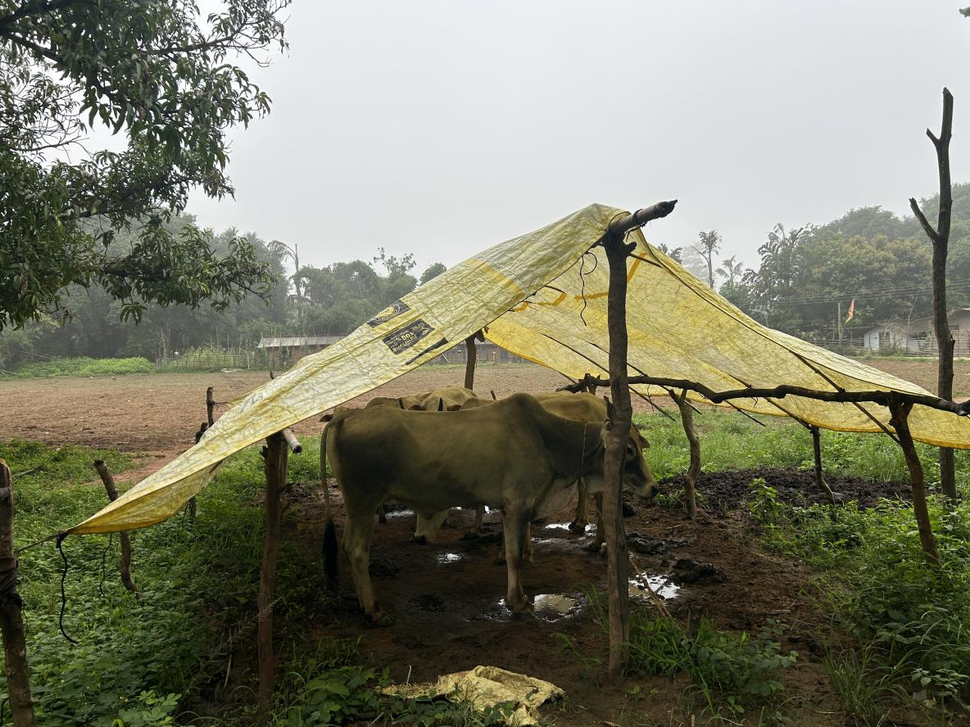

Fig. 1. Cattle Shed: Roofing material – Tarpaulin sheet, Floor - Earthen floor Conclusion
The study revealed that the local cattle farmers of the Bastar Plateau zone of Chhattisgarh follow their traditional practices and low-input systems of cattle farming. Feeding practices largely depend on natural grazing and crop residues, with limited use of balanced rations. Housing structures are generally constructed from locally available materials and lack scientific design, affecting hygiene and animal comfort. Overall, the findings indicate a considerable gap between recommended scientific practices and their field-level adoption. There is an urgent need to strengthen the extension services and improve farmer training programs to increase awareness and adopt scientific cattle rearing practices for the livelihood security of cattle farmers in the Bastar region.

Disclaimer (Artificial intelligence)
The author (s) hereby declare that Large Language Models and text-to-image generators like generative AI technologies have not been used during the preparation of this manuscript.

COMPETING INTERESTS DISCLAIMER:

Authors have declared that they have no known competing financial interests, non-financial interests, OR personal relationships that could have appeared to influence the work reported in this paper.References
Ashokbabu, C., Saratchandra, A., Harikrishna, C. and Srinivas Reddy, M. (2024). Study on
housing management practices followed by dairy farmers in Northern Telangana State
of India. Asian Journal of Dairy and Food Research, 43(1), 162–166.
Barman, B., Mohammad, A., E., G. C., Kisku, U., Lepcha, C. Y. and Yadav, P. (2023).
Assessment of the existing feeding and housing management practices of dairy animals
in Rajbanshi dairy farmers. Indian Journal of Animal Production and Management,
38(1–2), 45–52.
Bharat, G., Soni, A., and Das, P. K. (2019). Livestock production constraints in tribal districts
of Chhattisgarh. Indian Journal of Extension Education, 55(1), 45–51.
Chhattisgarh Livestock Development Report (2021). Department of Veterinary Services,
Government of Chhattisgarh.
Deb. Study on management practices, performance and welfare status of dairy cattle reared
under dairy cooperative societies in Tripura. M.V.Sc. Thesis. Imphal: CAU (Deemed
University); 2022.
Deoras, R., Nema, R.K., Tiwari, S.P. and Singh, M. (2004). Feeding and housing management
practices of dairy animals in Rajnandgaon district of Chhattisgarh plain. Indian
Journal of Animal Sciences, 90(6), 882-886.
Department of Animal Husbandry and Dairying (2019). 20th Livestock Census – All India
Report. Ministry of Fisheries, Animal Husbandry and Dairying, Government of India,
New Delhi.
Kumar R, Singh PK, Goyal RK, Singh H, Kumhar BL. Existing housing and feeding
management practices of buffaloes in Firozabad district of Uttar Pradesh, India.
International Journal of Current Microbiology and Applied Sciences. 2017;6(5):1831-
1838. doi:10.20546/ijcmas.2017.605.200.
Kumar, A., Upadhyay, V. K. and Singh, V. P. (2020). Existing dairy husbandry practices
followed by livestock owners in Farrukhabad district of Uttar Pradesh, India. Indian
Journal of Animal Production and Management, 38(1–2), 33–40.
Malsawmdawngliana R, Rahman S. Management practices followed by the dairy farmers of
Mizoram, India. Journal of Livestock Science. 2016;7: 220-225.
Manohar, D. S., Goswami, S. C. and Bais, B. (2014). Study on feeding management practices
of buffaloes in relation with selected traits of respondents in Jaipur district of Rajasthan,
India. Indian Journal of Animal Research, 48(2), 150–154.
https://doi.org/10.5958/j.0976-0555.48.2.032
Patel, N. B., Patel, J. B., Rao, T. K. S., Singh, R. R. and Modi, R. J. (2013). Housing
management practices of dairy animals in Patan district of North Gujarat region. Indian
Journal of Animal Production and Management, 43(2), 123–129.
Pilaniya, P., Desai, P. M. and Mordia, A. (2018). Existing housing management practices
followed by rural dairy animal owners in Sabar dairy milk shed of Gujarat, India. Indian
Journal of Animal Production and Management, 38(3–4), 175–181.
Prabex, S and Rahman, S. (2023). Socio-economic status and constraints faced by the
indigenous cattle farmers of Manipur. Indian Journal Animal Health (2023), 62(2):
364-370.https://doi.org/10.36062/ijah.2023.08323
Rathva AL, Sorathiya LM, Gadhavi DN, Patel NM. Farmstead planning of commercial dairy
farms in urban and peri-urban areas of South Gujarat. International Journal of
Agricultural Research. 2019;9(11):103-113.
doi:http://dx.doi.org/10.5455/ijlr.20190902075420.
Saurav, S. K., Chandran, V., Lepcha, C. Y., Chakravarty, R. and Ponnusamy, K. (2023).
Existing dairy management practices followed by cattle and buffalo owners of Northern
Bihar. Journal of Animal Research, 13(5), 839–846.
Singh, A.K., Upadhyay, P.K., Singh, D., Tewari, S., Kumar, V., Gupta, R. and Kumar, S.
(2024). Studies on different socio-economic profile of farmers and feeding
management practices of cattle in Hardoi district of Uttar Pradesh. International
Journal of Agricultural Extension and Social Development, 7(9S), 191–200.
Sreedhar S, Nagarjuna Reddy A, Sudhakar BV, Ramesh Babu P. Housing and other
managemental practices adopted by different categories of dairy farmers in Kadapa
district of Andhra Pradesh. International Journal of Livestock Research.
2017;7(11):191-199. doi:10.5455/ijlr.20170806111206.
Sinha, R. R. K., Dutt, T., Singh, R. R., Bhushan, B., Singh, M. and Kumar, S. (2009). Feeding
and housing management practices of dairy animals in Uttar Pradesh. Indian Journal
of Animal Sciences, 79(8), 829–833.
Sumer, E., Kalita, G., Goswami, R., Rahman, S., Ahmed, F. A., Chaudhary, J. K. and Pakyntein,
S. (2025). Housing and feeding management practices of crossbred dairy cattle in Khasi
and Jaintia Hill districts of Meghalaya. Indian Journal of Veterinary Sciences and
Animal Husbandry, 10(2S), 3687.
Verma, L. K., Gouri, M. D., Patil, V. M. and Guruprasad, R. (2017). Livelihood vulnerability
in tribal regions: A case study from South Chhattisgarh. Indian Journal of Social
Research, 58(3), 357–369.
Usha, S. and Mahesh, T. (2025). Housing and feeding management of Kangayam cattle in its
native breeding tract. International Journal of Veterinary Sciences and Animal
Husbandry, 10(5), 363–366.

.

