Effect of Double Queen System on the Development and Foraging Activities of Apis Mellifera Linn. Honey Bee Colonies

ABSTRACT
The two-queen system of colony management is based on the principle that honey production per unit number of bees increases as the population increases. Strong colonies not only produce more honey but they do it more efficiently than less populous colonies. Colony performance of A. mellifera under double queen system increased continuously throughout the spring season 2022. The maximum colony performance parameters viz., capped brood area (1236.35), pollen area (212.32) and honey area (4299.7) was observed in the T1 treatment and highest bee strength was observed in T2 treatment (8.82 bee-frames) followed by T1 treatment (8.79 bee-frames). The minimum colony performance parameters viz., capped brood area (563.43), pollen area (106.16), honey area (832.18) and bee strength (3.47 bee frames) was observed in the T8 treatment. The spring and autumn seasons of 2022 had the maximum foraging behaviour recorded between 1200 and 1300 hours in T1 treatment and the lowest foraging behaviour discovered between 1500 and 1600 hours. As regard to the foraging activity, the maximum number of incoming bees (107.02), outgoing bees (93.20) and nectar foragers (52.18) were recorded in T1 treatment and maximum number of pollen foragers’ (35.27) were recorded in T3 treatment. The minimum mean number of incoming bees (68.59), outgoing bees (50.31) and pollen foragers (16.09) were recorded in T8 treatment and minimum mean number of nectar foragers’ (28.01) were observed in T7 treatment.
Key words: Apis mellifera L., Two-queen system, Brood area, Pollen area, bee strength, foraging activity.
INTRODUCTION
Honey is the most significant product derived from apiculture and is consumed extensively across the world, conferring considerable economic importance on the industry (Almeida-Muradian et al., 2012). The global apiculture market is projected to register a Compound Annual Growth Rate (CAGR) of approximately 4.3 % between 2020 and 2025, with the Asia-Pacific region emerging as the dominant producer. India’s apiculture sector has experienced robust expansion, with the market size anticipated to reach approximately ₹33,128 million by 2024, reflecting an estimated CAGR of nearly 12 %. India also ranks among the leading exporters of natural honey, positioned sixth globally. During 2019–20, India’s recorded exports of natural honey amounted to 59,536.75 metric tonnes, valued at ₹633.82 crore, with the principal destinations being the United States of America, Saudi Arabia, Canada, and Qatar. The growing international demand for organic honey presents an opportunity to promote and standardise organic beekeeping practices, enhancing both market competitiveness and sustainability.
At the global level, honey production has exhibited sustained growth over recent decades, increasing from 771,144 tonnes in 1971 to 1,770,119 tonnes in 2020, corresponding to an average annual growth rate of approximately 1.79 % (FAO, 2020). In the 2021–22 period, India’s honey production reached an estimated 133,200 metric tonnes, elevating the country to second position worldwide, surpassed only by China, and marking a significant rise from its earlier ranking as eighth largest producer. These trends underscore the expanding role of apiculture in contributing to food systems, rural livelihoods, and international trade.
India is also one of the leading exporters of natural honey exporting 74,413.05 MT valued at USD 163.77 million in 2021-22 and USD 190.06 million in 2022-23. The domestic market, valued at ₹17.29-19.2 billion in 2020, is projected to grow at a 10% compound annual rate, reaching ₹30.6 billion by 2026. Within this context, the Union Territory of Jammu and Kashmir has emerged as an important centre for apiculture development, with the number of bee colonies increasing from 1.32 lakh in 2019 to 2.27 lakh in 2024-25 and honey output doubling from 13,062 to 27,092 quintals, positioning the region tenth in national honey production. Currently, 4,819 beekeepers 2,699 in Jammu and 2,120 in Kashmir are engaged in beekeeping activities, underscoring the region’s growing importance in promoting sustainable honey production and strengthening rural livelihoods (Anonymous, 2025).
Beekeeping represents a significant, sustainable, and environmentally sound practice that integrates elements of forestry, social forestry, and agricultural support activities. This multifaceted enterprise contributes to nutritional security, economic development, and ecological balance, while simultaneously generating employment and supplementary income for rural communities. Traditionally, beekeepers have prioritised honey extraction as the primary objective, often with limited emphasis on other valuable bee products such as beeswax, propolis, royal jelly, or pollen.
The production of honey is closely linked to colony strength and the frequency of honey harvests, with stronger colonies typically yielding higher outputs and more resilient production cycles (Neupane et al., 2012; Saini et al., 2018a, 2018b). Foraging behaviour constitutes one of the most distinctive and critical behaviours of the honey bee, Apis mellifera. Under normal colony conditions, worker bees transition to foraging tasks once they reach an age of approximately 21 days. At this stage, they undertake essential external activities, including the collection of nectar, pollen, water, and plant resins, which are vital for colony nutrition, hive construction, and overall productivity (Abou-Shaara, 2014). The efficiency and patterns of foraging behaviour therefore play a central role in determining both the quantity and quality of honey production, as well as the broader ecological contributions of beekeeping.
Experimentally, honey bee colonies can be maintained with multiple queens through specific management interventions designed to minimise aggression and prevent queen loss. One approach involves the use of queen excluders, which physically separate queens while allowing the colony to function cooperatively. Another technique is mandible ablation of egg-laying queens older than six months, enabling them to coexist within the same nest without initiating comb dominance or conflict (Human et al., 2013).
The two-queen system represents an intensive colony management strategy in which two queens simultaneously lay eggs within the same colony while remaining separated by a queen excluder. This approach has been associated with enhanced colony performance, particularly in terms of increased honey yields and other significant beekeeping advantages (Farrar, 1958; Moeller, 1976). An additional, though largely anecdotal, benefit of this system is the automatic requeening of colonies with young, vigorous queens when two-queen colonies are reverted to single-queen status under standard management practices (Banker, 1975). Collectively, these strategies demonstrate the potential of multi-queen management to optimise productivity and colony resilience in apiculture.
The double-queen system of colony management is based on the principle that the presence of two laying queens in a single colony leads to a significantly higher worker population. The increased brood production enhances colony strength, resulting in greater foraging intensity and more efficient exploitation of nectar resources during honey flow periods. Consequently, colonies maintained under a double-queen system tend to exhibit improved productivity and higher honey yields compared to single-queen colonies. Therefore, the present investigation was undertaken to evaluate the impact of the double-queen system on the performance of Apis mellifera Linnaeus.
MATERIALS AND METHODS
The investigation was undertaken at Apiary of Research and training Centre of pollinators, pollinizers and pollination management (RTCPPPM) Division of entomology, SKUAST-K Shalimar throughout the Spring-Autumn seasons, 2022. Twenty Four honeybee colonies of both single and double queen systems comprising of ten and twenty bee frame strength were maintained at apiary of Research and training Centre of pollinators, pollinizers and pollination management (RTCPPPM) SKUAST-K Shalimar, and were assessed for a number of colony growth indicators in the spring and autumn season 2022.Coexistence of Two- Queens was recorded at fortnightly intervals during the spring season 2022. Capped worker brood was measured in terms of capped brood area (cm²) using a frame-sized wire Grid (P. K. Chuneja, 1983). The measuring frame was apportioned well on the four bars of the experimental comb when placed on it. Bee strength (number of bee frames)was calculated by counting the bees on both faces of the comb and using a frame-sized wire grid, the colony's bee strength was calculated as the number of frames covered with bees. Honey store (g) for recording quality of Honey stored in combs, the area of ripe honey in a comb was measured with the help of measuring frame wire grid squares from each face of the every comb. The stored pollen (cm²) was recorded by using a frame-sized wire Grid from each face of the every comb. The total squares covering the pollen were counted.
Impact of double-queen system on the foraging activities of Apis mellifera L. was quantified by counting Number of bees going out of the hive per two minutes, as the bee foraging behaviour. Nectar foragers returning to the hive entrance were recorded per two minutes as the nectar foraging behaviour. Pollen foragers returning to the hive entrance were recorded per two minutes as the pollen foraging behaviour.
The experiment consisted of eight treatments designed to evaluate different configurations of single- and double-queen colony management systems under standardized colony strengths. Treatment T₁ comprised a double-queen colony in which the two queens were separated by a horizontal queen excluder and a shallow super in a twenty-frame strength colony, with an additional entrance provided to the upper brood chamber. Treatment T₂ was similar to T₁ in all respects, except that no additional entrance was provided to the upper brood chamber. In Treatment T₃, the two queens were maintained in the lower two brood chambers, separated by a horizontal queen excluder, within a twenty-frame strength colony, and an additional entrance was provided to the upper brood chamber. Treatment T₄ followed the same arrangement as T₃ but without an additional upper entrance. Treatment T₅ involved a more complex double-queen system in a twenty-frame strength colony, where the two queens were separated by a vertical queen excluder in the lowest chamber, while the upper two chambers were separated by a horizontal queen excluder. Treatment T₆ (control) consisted of a single-queen colony of twenty-frame strength managed under standard conditions. Treatment T₇ included a double-queen colony of ten-frame strength, with the queens separated by a vertical queen excluder, while Treatment T₈ (control) comprised a single-queen colony of ten-frame strength. Each treatment was replicated three times, resulting in a total of 24 colonies under observation. The experiment was laid out in a Randomized Block Design (RBD) to minimize experimental error and allow valid comparison among treatments.
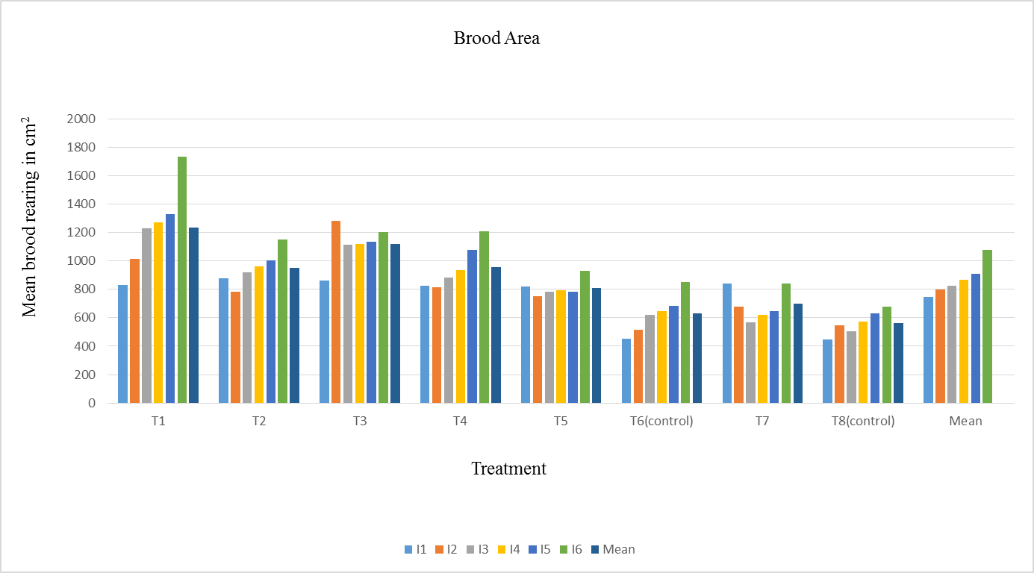
Results and discussion

Fig. 1: Effect of single and double queen system on worker brood area in A. mellifera colonies during different intervals

Table 1: Effect of single and double queen systems on the number of pollen foraging bees entering A. mellifera colonies during different fortnights at different times of the day
Treatment | I fortnight |  |  |  | IIfortnight |  |  |  | IIIfortnight
Treatment | t1 | t2 | t3 | S.Mean | t1 | t2 | t3 | S.Mean | t1 | t2 | t3 | S.Mean
T1 | 31.66 | 30.66 | 27 | 29.77 | 33 | 27.33 | 28.66 | 29.66 | 45.66 | 44.33 | 40 | 43.33
T2 | 24 | 22 | 23.33 | 23.11 | 22 | 17.66 | 19 | 19.55 | 36 | 31.66 | 31.33 | 33
T3 | 30 | 31.66 | 29.33 | 30.33 | 42.33 | 41.33 | 31.66 | 38.44 | 46.33 | 43.66 | 38.66 | 42.88
T4 | 25.33 | 26.33 | 21.66 | 24.44 | 32.66 | 21 | 22 | 25.22 | 40.66 | 38 | 29.66 | 36.11
T5 | 29 | 24.33 | 19 | 24.11 | 27.33 | 24.66 | 28.66 | 26.88 | 33.66 | 35 | 23.33 | 30.66
T6control | 24 | 19 | 19.33 | 20.77 | 27 | 26.33 | 24.33 | 25.88 | 31.33 | 25.66 | 24 | 27
T7 | 19.33 | 18.33 | 15.66 | 17.77 | 30.33 | 21.66 | 22.66 | 24.88 | 23.33 | 21.66 | 18.66 | 21.22
T8control | 15.33 | 14.66 | 14 | 14.66 | 20.66 | 15.33 | 15 | 17 | 24 | 17.33 | 16.66 | 19.33
MEAN |  |  |  | 23.12 |  |  |  | 25.94 |  |  |  | 31.69

Treatment | IVfortnight |  |  |  |  |  | V fortnight |  |  |  | VIfortnight |  |  |  | Mean
Treatment | t1 | t2 | t3 |  | S.Mean |  | t1 | t2 | t3 | S.Mean | t1 | t2 | t3 | S.Mean | Mean
T1 | 48.33 | 46.66 | 37.00 |  | 44.00 |  | 32.00 | 23.33 | 31.66 | 29.00 | 23.66 | 24.66 | 27.33 | 25.22 | 33.50
T2 | 33.66 | 36.66 | 30.00 |  | 33.44 |  | 25.33 | 18.33 | 22.66 | 22.11 | 17.33 | 15.33 | 18.33 | 17.00 | 24.70
T3 | 44.33 | 50.33 | 33.00 |  | 42.55 |  | 36.66 | 28.66 | 30.00 | 31.77 | 27.33 | 24.00 | 25.66 | 25.66 | 35.27
T4 | 38.00 | 36.66 | 33.66 |  | 36.11 |  | 21.33 | 18.33 | 20.33 | 20.00 | 20.66 | 16.66 | 13.33 | 16.88 | 26.46
T5 | 37.33 | 35.66 | 26.66 |  | 33.22 |  | 29.33 | 28.00 | 18.66 | 25.33 | 23.33 | 21.00 | 18.00 | 20.77 | 26.83
T6control | 28.33 | 27.66 | 24.00 |  | 26.66 |  | 26.00 | 19.00 | 16.66 | 20.55 | 24.00 | 17.66 | 13.66 | 18.44 | 23.22
T7 | 26.66 | 24.66 | 16.66 |  | 22.66 |  | 20.66 | 16.00 | 18.33 | 18.33 | 17.00 | 15.66 | 16.00 | 16.22 | 20.18
T8control | 22.66 | 21.66 | 18.00 |  | 20.77 |  | 13.33 | 12.66 | 14.33 | 13.44 | 14.66 | 10.00 | 9.33 | 11.33 | 16.09
MEAN |  |  |  |  | 32.43 |  |  |  |  | 22.56 |  |  |  | 18.94
 | C.D(p≤0.05)
 | Treatment |  |  | 1.61
 | Interval |  |  | 1.00
 | T×I |  |  | 2.84
 | T |  |  | 0.71
 | t×T |  |  | 2.01
 | t×I |  |  | 1.74
 | T×I×t |  |  | 4.92
*t1= (10:00 am) *t2= (12: 00 pm) *t3= (3:00 pm)
Table 2: Effect of single and double queen systems on the number of nectar foraging bees entering A. mellifera colonies during different fortnights at different times of the day
Treatment | I fortnight |  |  |  | IIfortnight |  |  |  | IIIfortnight
Treatment | t1 | t2 | t3 | S.Mean | t1 | t2 | t3 | S.Mean | t1 | t2 | t3 | S.Mean
T1 | 43 | 61.33 | 43.33 | 49.22 | 53.33 | 58.33 | 54.66 | 41.58 | 48.33 | 55.33 | 58.33 | 54
T2 | 35.66 | 37.33 | 30 | 34.33 | 41.33 | 44.33 | 31.66 | 29.33 | 39.33 | 42 | 38.66 | 40
T3 | 49.66 | 47 | 42.33 | 46.33 | 50 | 50.66 | 48.66 | 37.33 | 50.66 | 43 | 52.33 | 48.66
T4 | 32.66 | 40.66 | 32.33 | 3s5.22 | 37.33 | 38.33 | 38 | 28.41 | 38.66 | 40.33 | 39.33 | 39.44
T5 | 37 | 39 | 38.33 | 38.11 | 39.66 | 47.66 | 41.33 | 32.16 | 35.33 | 36.66 | 35 | 35.66
T6control | 32.33 | 36.33 | 32.66 | 33.77 | 38.66 | 40.33 | 36.66 | 28.91 | 32 | 34.33 | 31.33 | 32.55
T7 | 22 | 29.33 | 27 | 26.11 | 23.33 | 30 | 24.33 | 19.41 | 24.33 | 27.66 | 23.66 | 25.22
T8control | 27 | 30.33 | 27.33 | 28.22 | 22 | 31.33 | 30.33 | 20.91 | 21.33 | 29 | 25.66 | 25.33
MEAN |  |  |  | 36.41 |  |  |  | 39.68 |  |  |  | 37.61

Treatment | IVfortnight |  |  |  |  | V fortnight |  |  |  | VIfortnight |  |  |  | Mean
Treatment | t1 | t2 |  | t3 | S.Mean | t1 | t2 | t3 | S.Mean | t1 | t2 | t3 | S.Mean | Mean
T1 | 56.66 | 37.66 |  | 52 | 36.58 | 45.33 | 54.33 | 57 | 52.22 | 46.66 | 55.33 | 58.33 | 40.08 | 52.18
T2 | 36.66 | 47.33 |  | 52.66 | 34.16 | 43.66 | 39.66 | 43 | 42.11 | 36 | 48 | 46 | 32.5 | 40.74
T3 | 47.33 | 50 |  | 43 | 35.08 | 47.33 | 52.66 | 51 | 50.33 | 51.66 | 54.66 | 52 | 39.58 | 49.11
T4 | 32.66 | 37.33 |  | 35 | 26.25 | 36.33 | 42.33 | 39 | 39.22 | 37.66 | 49.66 | 40.33 | 31.91 | 38.22
T5 | 33.66 | 34.33 |  | 38 | 26.5 | 40.33 | 45.66 | 41 | 42.33 | 42.66 | 47.66 | 40.66 | 32.75 | 39.66
T6control | 30.66 | 39.66 |  | 31 | 25.33 | 37 | 49.33 | 41.66 | 42.66 | 33.33 | 50.33 | 38.66 | 30.58 | 37.01
T7 | 27.33 | 30.66 |  | 28.33 | 21.58 | 22 | 35 | 34 | 30.33 | 29.33 | 38.33 | 27.66 | 23.83 | 28.01
T8control | 23.66 | 30 |  | 26.33 | 20 | 27.33 | 34.66 | 32.66 | 31.55 | 32 | 39.33 | 36 | 26.83 | 29.24
MEAN |  |  |  |  | 37.58 |  |  |  | 41.34 |  |  |  | 43.01
 | C.D(p≤0.05)
 | Treatment |  | :  0.83
 | Interval |  | :  0.72
 | T×I |  | :  2.05
 | T |  | :  0.51
 | t×T |  | :  1.45
 | t×I |  | :  1.25
 | T×I×t |  | :  3.56
*t1= (10:00 am) *t2= (12: 00 pm) *t3= (3:00 pm)

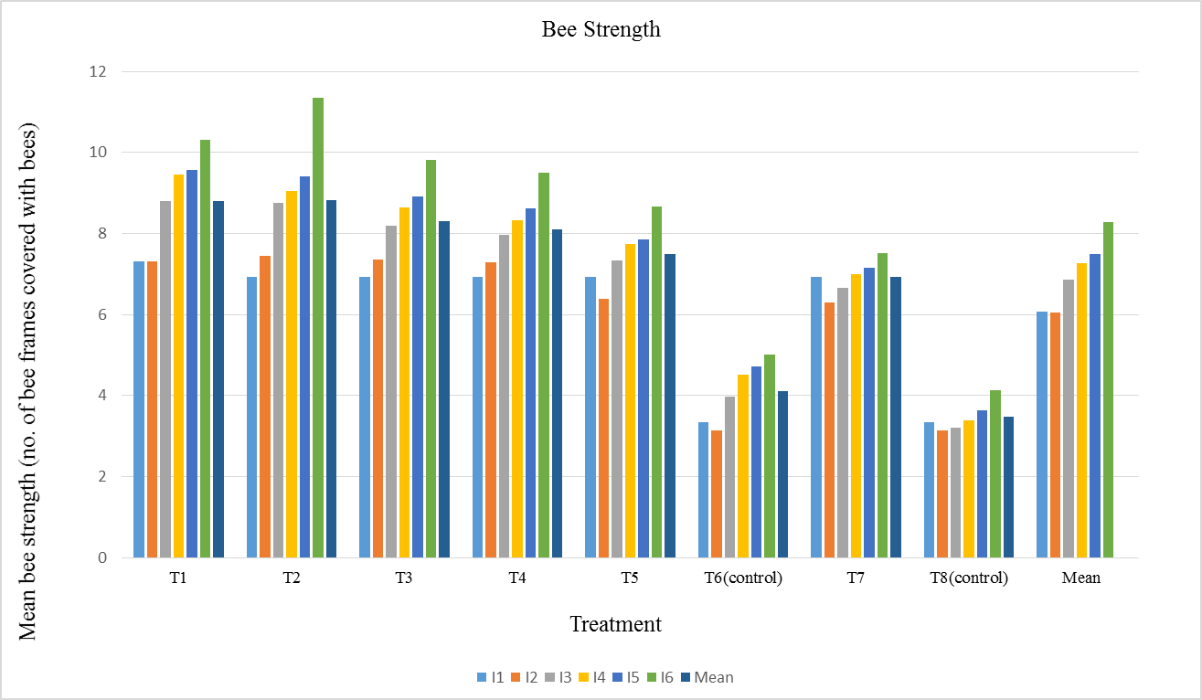
Fig. 2: Effect of single and double queen system on bee strength in A. mellifera colonies during different intervals
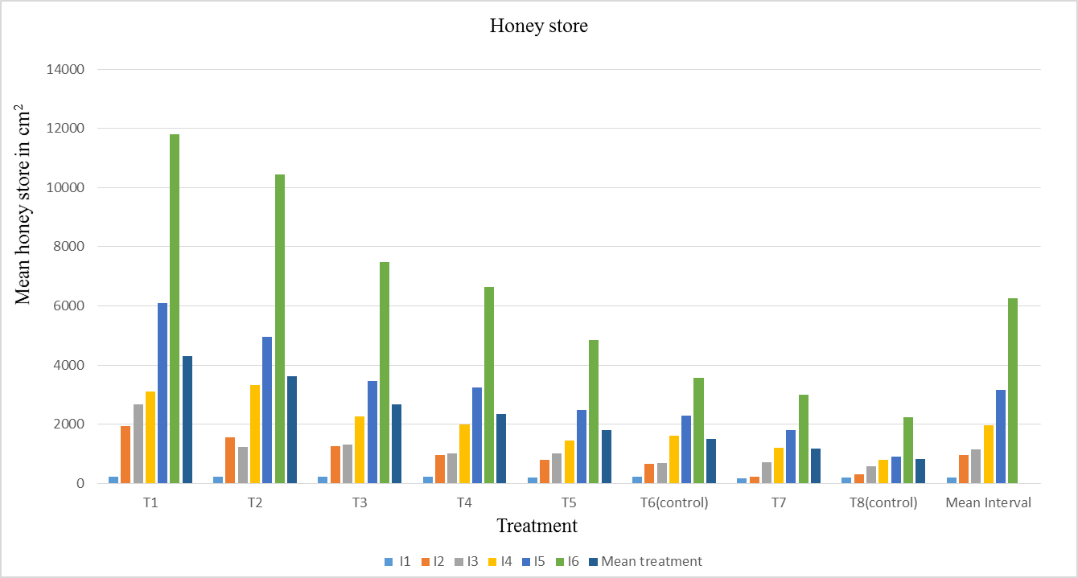
Fig. 3: Effect of single and double queen system on honey store in A.mellifera colonies during different intervals
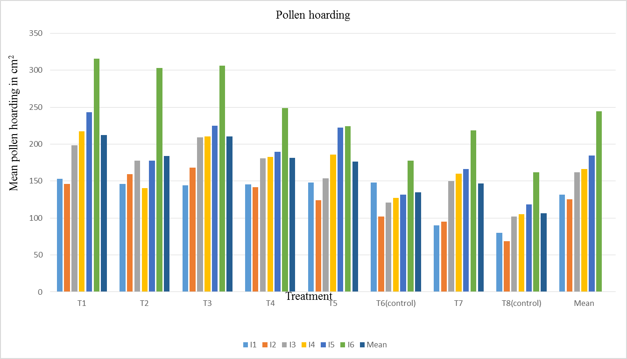
Fig. 4: Effect of single and double queen system on pollen loading in A.mellifera colonies during different intervals
The largest overall mean capped worker brood area was reported in treatment T1 (two queens separated by horizontal queen excluder and shallow super in twenty bee frame strength colony with additional entrance for upper brood chamber) as 1236.35 cm2, followed by the brood area of 1119.63 cm2 with treatment T3 (two queens separated by horizontal queen excluder in lower two chambers of twenty bee frame strength colony with additional entrance for the upper brood chamber). A significantly minimum mean capped brood area of 563.43 cm2 was recorded in T8 (Single queen in ten bee frame strength colony) (fig.1 and table 1 ). Data on bee strength revealed that, substantially, treatment T2 (two queens separated by horizontal queen excluder and shallow super in twenty bee frame 31 strength colony) yielded the highest overall mean bee frame strength as 8.82 bee frames, followed by the bee frame strength of 8.79 frames with treatment representing two queens separated by horizontal queen excluder and shallow super in twenty bee frame strength colony with additional entrance for upper brood chamber (T1); whereas, a significant minimum bee frame strength of 3.47 frames was recorded in treatment T8 (Single queen in ten bee frame strength colony) during the spring season, 2022 (fig. 2). Data on the honey area showed that, substantially, the treatment T1 (two queens separated by horizontal queen excluder and shallow super in twenty bee frame strength colony with additional entrance for upper brood chamber) produced the highest total mean honey store of 4.2kg, followed by the honey store of 3.6kg with treatment representing two queens separated by horizontal queen excluder and shallow super in twenty bee frame strength colony (T2); whereas, a significant minimum honey store of 0.8kg was recorded in T8 (single queen in ten bee frame strength colony) (fig.3). The maximum total mean pollen area was recorded in treatment T1 (two queens separated by horizontal queen excluder and shallow super in twenty bee frame strength colony with additional entrance for upper brood chamber) according to pollen area as 212.32 cm2, followed by the pollen area of 210.63 cm2 with treatment representing two queens separated by horizontal queen excluder in lower two chambers of twenty bee frame strength colony with additional entrance for the upper brood chamber (T3); whereas, a significant minimum pollen area of 106.16 cm2 was recorded in T8m (single queen in ten bee frame strength colony) (fig. 4and table 2). These findings are closely consistent with (Valle et al., 2004) who reported that average honey productivity/1,000 bees from double colonies was estimated to 1,022 g in double queen colonies and 902g in single queen colonies, indicating double-queen colonies have a 13% average productivity advantage compared to single-queen colonies. Also they evaluated the effect of two 32 queens/bee hive management system on colony population, honey production and profitability established 92 experimental colonies in the Mexican high plateau region. Their study revealed that colonies with two queens yielded 101.2% more honey than colonies with single queen (53.2± 2.4 vs 26.4± 1.8 kg, p< 0.01) and they also reported that the production cost per kg of honey was US 0.86 and US $1.07 for double and single queen colonies, respectively. They further reported that double queen colonies had 100% more bees and were 100% heavier than single queen colonies. So they recommended double queen system. The findings of the current analysis closely align with those of Rana and Goyal (1994). Maximum brood area, honey area, pollen area and number of frames were reported by the authors in May. Similar findings were reported by Mohapatra et al. (2012), who noted that May was the month with the highest bee population and honey reserves. The greatest brood area, pollen area, honey area and bee strength were recorded in May, according to Manzoor et al. (2019), whereas the minimum brood area, pollen area, honey area and bee strength were recorded in March. According to Taha et al. (2013), colony productivity of economic parameters is influenced by colony strength and stronger colonies produce more honey, pollen and brood than weaker colonies, which is consistent with the current findings. The findings are further supported by the work of Chaand et al. (2017), who noted a decline in colony developmental parameters at the end of May as a result of the onset of the floral dearth period while also observing a continuous increase in colony developmental parameters from March to May, including brood area, pollen area, honey area and bee strength. The results of present investigation are in concurrence with the finding of Wakjiraet al. (2020), who reported that double queen colonies produced 98.4% more honey than single queen colonies
Conclusion
The colony performance in terms of population size, brood rearing, honey store, pollen store, nectar foragers and pollen foragers was significantly influenced by double queen system. Between 1200 and 1300 hours, A. mellifera' s foraging activity peaked, and between 1500 and 1600 hours, it was at its lowest. Two-queen colonies can produce at least twice the amount of honey produced by single colonies. However the colony performance gets improved due to the increase in foraging activity of worker bees resulting in overall colony strength. Thus, it is concluded that the use of two-queen system, yields more honey, strengthens the colony and is financially profitable, compared to single queen conventional approach.

COMPETING INTERESTS:
Authors have declared that they have no known competing financial interests OR non-financial interests OR personal relationships that could have appeared to influence the work reported in this paper.
Disclaimer (Artificial intelligence)

Author(s) hereby declare that NO generative AI technologies such as Large Language Models (Chat GPT, COPILOT, etc.) and text-to-image generators have been used during the writing or editing of this manuscript.

REFERENCE
Abou-Shaara, H.F. 2014. The Foraging Behavior of Honey Bees, Apismellifera: A Review.VeterinarniMedicina,59:1-10.
Banker, R. 1975. Two-queen colony management. In Dadant and Sons (eds.) The hive and the honey bee. Dadant Hamilton, Illinois, USA: pp 404-410.
Chaand, D., Sharma, D., Ganai, S. A., Norboo, T. and Sharma, S. 2017. Effect of colony strength on colony build up and foraging activity of ApismelliferaL.Journal of Entomology and Zoology Studies, 5: 1369-73.
Farrar, C. L. 1958. Two-queen colony management for the production of honey. USDA, Agricultural Research Service; USA; No. ARS-33-48; 11 pp.
Human, H., Brodschneider, R., Dietemann, V., Dively, G., Ellis, J. D., Forsgren, E., Fries, I., Hatjina, F., Hu, F. L., Jaffé, R., Jensen, A. B., Köhler, A., Magyar, J. P., Özkýrým, A., Pirk, C. W. W., Rose, R., Strauss, U., Tanner, G., Tarpy, D. R., van der Steen, J. J. M., Vaudo, A., Vejsnaes, F., Wilde, J., Williams, G. R. and Zheng, H. Q. 2013. Miscellaneous standard methods for Apismellifera research. Journal of Apicultural Research52:1-53.
Manzoor, M., Sheikh, A. H. and Mathivanan, V. 2019. Evaluation of indigenous honey beeApiscerana-Srinagar (J&K) vs. Coimbatore (Tamil Nadu). Indian Journal of Entomology 81(3): 627-629.
Moeller, F. E. 1976. Two-queen system of honey bee colony management. Production Research Report, ARS, USDA; No. 161; 12 pp.
Mohapatra, L. N. and Satapathy, C. R. 2012. Studies on colony development in Apisceranaindica F. Indian Journal of Entomology 74: 102-103.
Neupane, K. R., Woyke, J. and Wilde, J. 2012. Effect of initial strength of honey bee colonies (Apismellifera) supered in different ways on maximizing honey production in Nepal. Journal of Apicultural Science, 56(2): 71–81.
Rana, B. S. and Goyal, N. P. 1994. Comparative brood rearing activity of Apismellifera and A. ceranaindica at Nauni (Solan), midhills of Himachal Pradesh, Indian Bee Journal56(1-2): 24-28.
Saini, S., Chaudhary, O. P. and Anoosha, V. 2018a. Apismellifera colony productivity and growth influenced by initial frame strength: Farmer’s perspective. The Indian Journal of Agricultural Sciences,88(10): 1618–1623.
Saini, S., Chaudhary, O. P. and Anoosha, V. 2018b. Relationship of population size and extraction frequency with honey production in Apismellifera colonies. Journal of Entomology & Zoology Studies, 6(3): 1374–1377.
Taha, E. K. A. and Al-Kahtani, S. N. 2013. Relationship between population size and productivity of honey bee colonies. Journal of Entomology, 10(3): 163–169.
Valle, A. G. G., Novoa, E. G., Benitez, A. C. and Rubio, J. A. Zozaya. 2004. The effect of using two honey bee (Apismellifera L.) Queens on colony population, honey production, and profitability in the Mexican high pleateau. Tec pecumex42(3):361-377.
Wakjira, K., Negera, T. and Kumsa, T. 2020. Two queen colonies in central highland conditions of Ethopia increase population size and Honey yield. Bee world97:109-113.

