Microwave-Assisted Green Synthesis of Terminalia chebula Mediated Silver Nanoparticles and Their Biological Applications

ABSTRACT
Green synthesis of nanoparticles using plant extracts has emerged as an economical, sustainable, and environmentally benign alternative to conventional physical and chemical methods. In the present study, silver nanoparticles (AgNPs) were synthesized using Terminalia chebula bark extract through a rapid microwave-assisted approach. The formation of nanoparticles was initially confirmed by a visible color change to brown, indicating the reduction of Ag⁺ ions. UV–Visible spectroscopy exhibited a characteristic surface plasmon resonance peak at 430 nm, confirming AgNP formation. FTIR analysis revealed the involvement of phytochemical constituents acting as reducing and stabilizing agents, while EDAX analysis confirmed elemental silver with a weight percentage of 53.43%. The biosynthesized nanoparticles demonstrated notable biological activities, including antibacterial activity against Staphylococcus aureus and antifungal efficacy against Candida albicans. In addition, cytotoxicity evaluated by MTT assay on the HeLa cervical cancer cell line showed a dose-dependent reduction in cell viability, with an IC₅₀ value of 55.20 µg/mL. These findings suggest that T. chebula–mediated AgNPs possess significant biomedical potential and may serve as promising candidates for antimicrobial and anticancer applications
Keywords: Terminalia chebula, silver nanoparticles, FTIR, Hela cancer cell line.

1.0 INTRODUCTION
Nanoscience is the interdisciplinary study, manipulation, and application of materials at the nanoscale (1–100 nm), where they exhibit unique physicochemical properties that differ markedly from their bulk counterparts¹. In recent years, green synthesis of metal nanoparticles has emerged as an environmentally sustainable and cost-effective alternative to traditional physical and chemical fabrication methods²˒³. Among these approaches, plant-mediated synthesis has gained particular attention, as plant extracts are rich in diverse bioactive compounds that can serve simultaneously as reducing and stabilizing agents during nanoparticle formation⁴˒⁹. Phytochemicals such as phenols, flavonoids, alkaloids, and proteins facilitate the reduction of metal ions into stable nanoparticles while often enhancing their biological functionality.
Biogenic synthesis of noble metal nanoparticles—including silver, gold, and platinum—using plant materials has been extensively reported, with applications spanning medicine, catalysis, environmental remediation, and nanobiotechnology⁵˒⁶. Silver nanoparticles (AgNPs), in particular, have attracted significant interest due to their potent antimicrobial, antioxidant, and anticancer properties, positioning them as promising candidates for diverse biomedical applications⁹. The enhanced biological activity of these nanoparticles is frequently attributed to the synergistic interactions between the metallic core and the plant-derived phytoconstituents capping the nanoparticles.
Terminalia chebula Retz., a member of the family Combretaceae, is an important medicinal plant widely distributed in India and other parts of South and Southeast Asia. It has been extensively used in Ayurvedic and traditional systems of medicine for the treatment of infections, inflammation, gastrointestinal disorders, and metabolic diseases¹⁰. The plant is rich in tannins, chebulagic acid, chebulinic acid, gallic acid, and other phenolic compounds that exhibit strong antioxidant and therapeutic properties¹⁰. These bioactive constituents make T. chebula an excellent candidate for green nanoparticle synthesis, as they can effectively mediate the reduction and stabilization of metal ions.
Previous studies have reported the successful synthesis of silver nanoparticles using different parts of T. chebula, demonstrating significant antimicrobial, catalytic, and anticancer activities¹¹–¹⁴. Such findings highlight the plant’s potential as a natural nanofactory for producing biologically active nanoparticles. Considering its rich phytochemical profile, medicinal importance, and availability, T. chebula was selected in the present study as a sustainable source for nanoparticle synthesis.
Cancer remains a major global health concern characterized by uncontrolled cell proliferation and resistance to apoptosis. The development of alternative therapeutic agents derived from natural resources has therefore attracted increasing research interest. Plant-mediated nanoparticles have shown promising cytotoxic effects against cancer cell lines due to their ability to induce oxidative stress and cellular damage selectively⁹˒¹³.
Therefore, the present study aims to synthesize silver nanoparticles using Terminalia chebula bark extract through a microwave-assisted green method and to evaluate their physicochemical characteristics along with their antioxidant, antimicrobial, and in vitro anticancer activities against the HeLa cancer cell line.
2.0 MATERIALS AND METHODS
Preparation of Terminalia chebula Bark Extract
The bark of Terminalia chebula was collected and thoroughly washed with distilled water to remove adhering impurities. The material was shade-dried at room temperature to preserve its bioactive constituents and then ground into a fine powder using a mechanical grinder. About 10 g of the powdered bark was mixed with 100 mL of methanol and kept for extraction for five days at room temperature with intermittent shaking to ensure efficient dissolution of phytochemicals. The mixture was subsequently filtered through Whatman No. 1 filter paper, and the clear filtrate was collected and stored at 4°C for further analysis.The total phenolic content of the extract was quantified using the modified Folin–Ciocalteu method.
2.2 Microwave-Assisted Synthesis of TCB-AgNPs
A 5 mM aqueous solution of silver nitrate (AgNO₃) was prepared (100 mL) and mixed with 1 mL of T. chebula bark extract in a clean beaker. The reaction mixture was subjected to microwave irradiation at 550 W for 10 minutes. A visible color change from colorless to dark brown indicated the formation of silver nanoparticles, confirming the reduction of Ag⁺ ions mediated by the plant extract.
2.3 Characterization of TCB-AgNPs
The synthesized nanoparticles were characterized using the following analytical techniques:
UV–Visible Spectroscopy to confirm nanoparticle formation through surface plasmon resonance (SPR).
Fourier Transform Infrared Spectroscopy (FTIR) to identify functional groups responsible for reduction and stabilization.
Energy Dispersive X-ray Analysis (EDAX) to determine elemental composition and confirm the presence of silver.
2.4 Evaluation of Biological Activities
2.4.1 Antioxidant Activity
The antioxidant potential of TCB-AgNPs was assessed using the DPPH (2,2-diphenyl-1-picrylhydrazyl) radical scavenging assay. The decrease in absorbance indicated the free radical scavenging ability of the synthesized nanoparticles.
2.4.2 Antimicrobial Activity
The antimicrobial activity was evaluated by the disc diffusion method against selected pathogens, namely Staphylococcus aureus and Candida albicans. The zones of inhibition were measured after incubation to determine antimicrobial efficacy.
2.5 MTT Cell Cytotoxicity Assay
2.5.1 Cell Culture
The HeLa (human cervical cancer) cell line was obtained from the National Centre for Cell Science (NCCS), Pune, India. Cells were cultured in Dulbecco’s Modified Eagle’s Medium (DMEM) supplemented with 10% fetal bovine serum (FBS) and 100 µg/mL penicillin–streptomycin. The cultures were maintained at 37°C in a humidified atmosphere containing 5% CO₂.
2.5.2 MTT Assay
The in vitro cytotoxicity of TCB-AgNPs was assessed using the MTT assay [3-(4,5-dimethylthiazol-2-yl)-2,5-diphenyl tetrazolium bromide]. HeLa cells were trypsinized, counted, and seeded into 96-well culture plates at a density of 1 × 10⁵ cells/mL, with 200 µL per well. Cells were incubated for 24–48 hours at 37°C in DMEM supplemented with 10% fetal bovine serum (FBS) and 1% antibiotic solution to permit cell attachment.
Following incubation, the medium was replaced with serum-free DMEM containing varying concentrations of TCB-AgNPs. Each concentration was tested in triplicate, and the cells were incubated for an additional 24 hours at 37°C in a humidified atmosphere containing 5% CO₂. Subsequently, 20 µL of MTT solution (5 mg/mL) was added to each well, and the plate was incubated for 2–4 hours until the formation of purple formazan crystals. The supernatant was carefully removed, and the wells were washed with 200 µL of 1× PBS.
Formazan crystals were solubilised by adding 100 µL of dimethyl sulfoxide (DMSO) to each well, followed by gentle shaking for 5 minutes. Absorbance was measured at 570 nm using a microplate reader. Cell viability percentages and IC₅₀ values were calculated using GraphPad Prism 6.0 software, providing quantitative measures of TCB-AgNP cytotoxicity.
3.0 RESULTS AND DISCUSSION
3.1 Determination of Total Phenolics
The present study demonstrates the successful green synthesis of silver nanoparticles using Terminalia chebula bark extract, which served as both a reducing and stabilizing agent. The high total phenolic content (148 mg/g tannic acid equivalent) confirms that the bark extract is rich in polyphenolic compounds, which are known to play a vital role in metal ion reduction and nanoparticle stabilization. Phenolic hydroxyl groups donate electrons to reduce Ag⁺ ions into Ag⁰, thereby facilitating nanoparticle formation. Similar observations have been reported in plant-mediated nanoparticle synthesis, where phenolic constituents significantly influenced reduction efficiency and particle stability (Iravani, 2011; Ahmed et al., 2016).
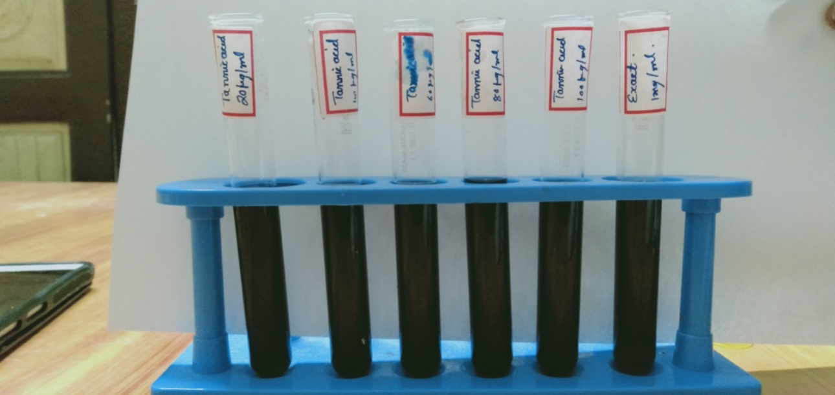
Fig. 1: Standard calibration curve for standard tannic acid and T. chebula bark extract
3.2 Visual Observation of TCB-AgNps
The rapid color change from pale yellow to dark brown during microwave irradiation provided preliminary evidence of nanoparticle formation due to surface plasmon resonance (SPR), a characteristic feature of silver nanoparticles. Microwave-assisted synthesis enhanced the reaction rate and ensured uniform nucleation, as reported in earlier studies describing microwave methods as rapid, energy-efficient, and capable of producing stable nanoparticles (Khan et al., 2019).
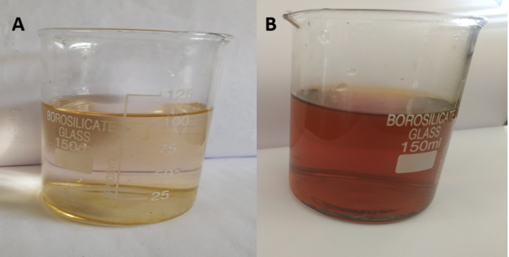
Fig. 2: Visual observation of formation of TCB-AgNps
3.3 UV-Visible spectrum of Silver Mediated Nanoparticle of T. chebula Bark Extract
The UV–Visible absorption peak observed at 430 nm further confirmed the formation of AgNPs, which falls within the typical SPR range (400–450 nm) reported for biologically synthesized silver nanoparticles (Song and Kim, 2009). This peak indicates nanoscale particle formation and agrees with previous reports on plant-extract-mediated AgNP synthesis
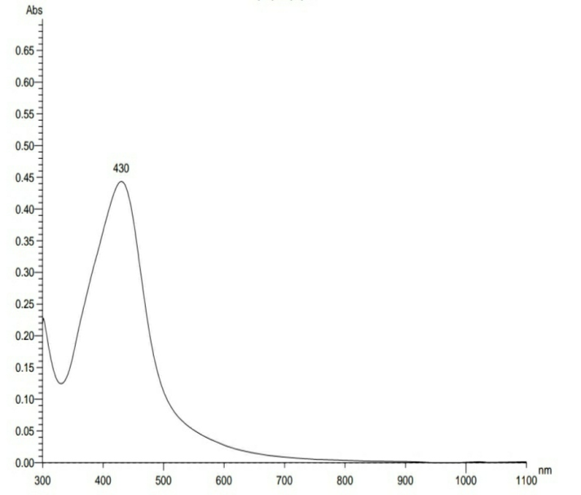
Fig. 3: UV-Visible spectrum of silver mediated nanoparticle of T. chebula bark extract
3.4 FTIR Analysis
FTIR analysis revealed the involvement of functional groups such as –OH, –C=O, and –C–O derived from phenolics, flavonoids, and tannins present in T. chebula. The disappearance or shift of certain peaks after nanoparticle synthesis suggests that these biomolecules actively participated in reduction and capping processes. Similar spectral changes have been attributed to phytochemical binding on nanoparticle surfaces, providing stability and preventing agglomeration (Mittal et al., 2013). 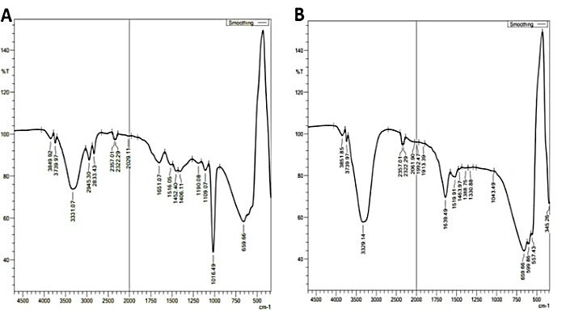
Fig. 4: FT-IR spectrum of T. chebula bark extract (A) and silver mediated nanoparticles of T. chebula bark extract (B)
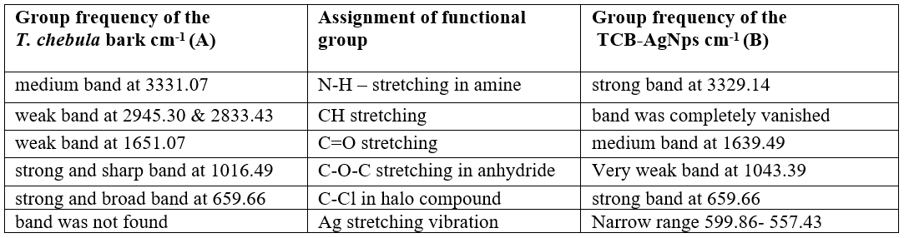
Table 1. FT-IR spectra of bark and silver mediated nanoparticles of T. chebula bark extract

3.5 Energy Dispersive X-ray Analysis of TCB-AgNps
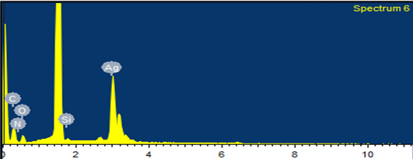
Fig. 5: EDAX spectrum of silver mediated nanoparticles of T. chebula bark
EDAX analysis confirmed the elemental composition of the synthesized nanoparticles, showing a strong silver signal with a weight percentage of 53.43%, validating the successful bioreduction of Ag⁺ ions. Comparable EDAX profiles have been documented in other green-synthesized AgNPs, confirming purity and metallic nature (Rajeshkumar and Bharath, 2017)
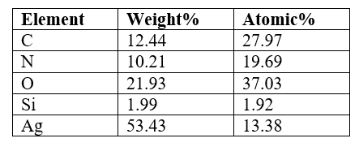
Table 2. Elemental composition of TCB-AgNps
3.6 Antibacterial Activity of TCB-AgNps
Biological activity studies revealed that TCB-AgNPs exhibited measurable antibacterial and antifungal activity against Staphylococcus aureus and Candida albicans. The antimicrobial action of AgNPs is widely attributed to their ability to disrupt microbial cell membranes, generate reactive oxygen species, and interfere with DNA replication (Morones et al., 2005). The observed inhibition zones support earlier findings that biologically synthesized AgNPs possess broad-spectrum antimicrobial properties due to synergistic effects between silver and plant phytochemicals.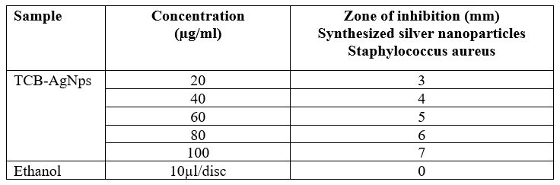
Table 3. Antibacterial activity of TCB-AgNps

3.7 Antifungal Activity
The table 4 shows the antifungal capability test of TCB-AgNps against the Candida albicans. The growth inhibitor activity against Candida albicans (3mm) at concentration 100µg/ml. The extract shows the higher activity in Candida albicans. The concentration from 20-100 µg/ml was varying to read the antifungal activity.
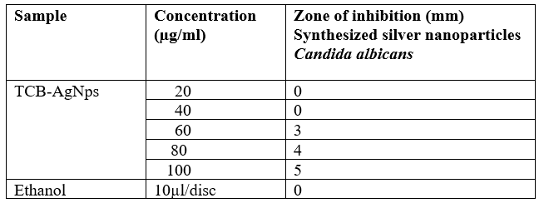
Table 4. Antifungal activity of TCB-AgNps

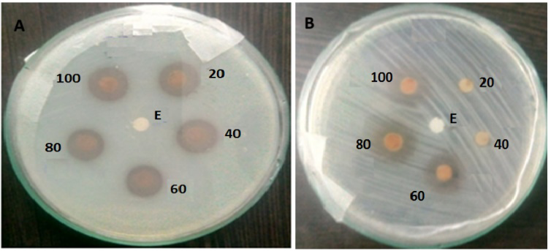
Fig. 6: Antibacterial activity of TCB-AgNps on Staphylococcus aureus (A) and Antifungal activity of TCB-AgNps on Candida albicans (B)
3.8 Antioxidant Activity of TCB-AgNps
The methanolic solution of DPPH were mixed to the 40µl of TCB-AgNps different concentration (20-100µg/ml). The DPPH solution (freshly prepared) was kept in the dark at 4ºC. 96% ethanol was added and shaken vigorous. After 5 min, measured spectrophotometrically at 517nm. The same amount of ethanol and DPPH were containing blank sample prepare. Each value was obtained by calculating the average of three experiments and data are presented as mean± SEM
(%) inhibition of DPPH activity = ((A-B)/A) x100
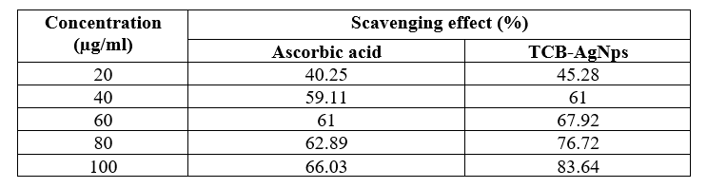
Table 5. Antioxidant activity of TCB-AgNps by DPPH activity

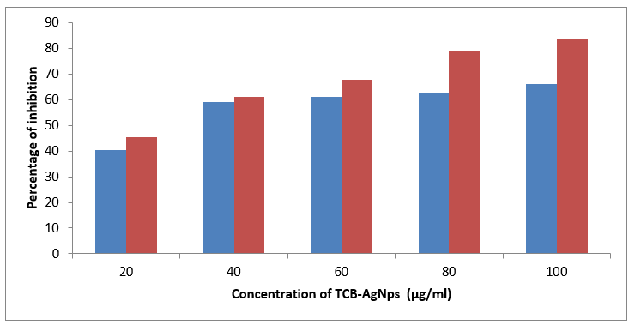
Fig. 7: Graphical representation of DPPH activity of TCB-AgNps
3.9 Anticancer Activity
In vitro cylotoxictiy, using Hela cells by 3-(4,5-dimethylthiazol-2-yl)-2,5-diphenyltetrazolium bromide (MTT) assay:
At 1μg/mL- 500μg/mL concentration of Ag mediated T. chebula bark shows the viability values which decreased from 99.47% to 46.88%. The cells showed reduction in viability with an increase in extract concentration.
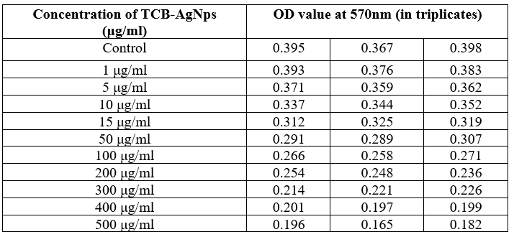
Table:6 Microplate reader values of Hela cells with TCB-AgNps at 570 nm

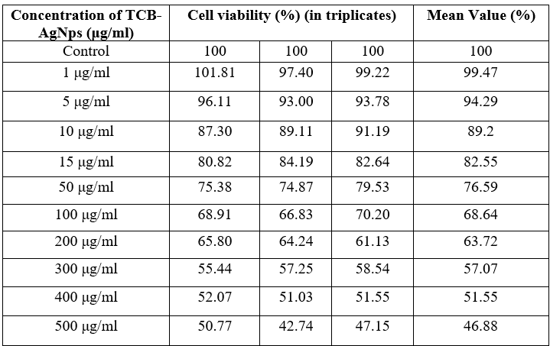
Table 7. Cell Viability of Hela cells with TCB-AgNps

Fig. 8: Cell Viability graphical representation of Hela cells with TCB-AgNps
The MTT assay is used to measure cellular metabolic activity as an indicator of cell viability, proliferation and cytotoxicity. The cytotoxic activity and % of cell viability of Ag mediated T. chebula bark against HELA cancer cell line was clearly evaluated with MTT test. The cells were exposed with varying concentrations of different Ag mediated T. chebula bark from 1µg/ml to 500µg/ml. As the concentration increases cell viability also good measuring factors that reflect the number of living cells cancer in a population. IC₅₀ is 55.20, a indicator of a substance’s in inhibiting a specific biochemical function. Cell lines' morphological changes with exposure with Ag mediated T. chebula bark were noted during the phase contrast microscope in the dose dependent manner shown in figure 9.
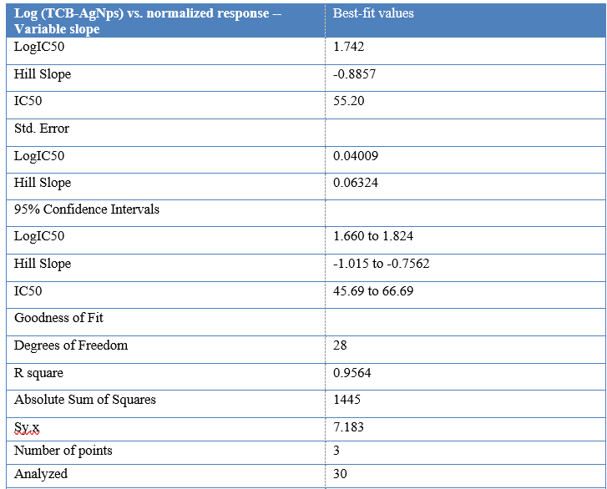
Table 8. IC₅₀ Value of TCB-AgNps

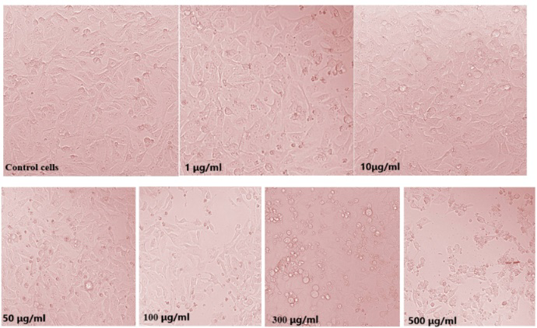
Fig. 9: Images of control cells and treated cells of Hela cancer cell line using TCB_AgNps
4.0 CONCLUSION
This study demonstrates a simple, rapid, and eco-friendly approach for the synthesis of silver nanoparticles using Terminalia chebula bark extract as a natural reducing and stabilizing agent. The microwave-assisted method enabled efficient nanoparticle formation, which was confirmed through spectroscopic and elemental analyses. The presence of phytochemical constituents, particularly phenolic compounds, played a crucial role in nanoparticle synthesis and stability. The biosynthesized TCB-AgNPs exhibited appreciable antioxidant, antimicrobial, and dose-dependent cytotoxic activities, indicating their potential as biofunctional nanomaterials. The combined effects of silver and plant-derived metabolites suggest a synergistic mechanism that enhances biological performance. Therefore, T. chebula–mediated AgNPs represent a promising, sustainable candidate for future applications in biomedical and pharmaceutical fields. Further investigations, including mechanistic and in vivo studies, are necessary to validate their therapeutic potential and safety..
Disclaimer (Artificial intelligence)

Author(s) hereby declare that NO generative AI technologies such as Large Language Models (ChatGPT, COPILOT, etc.) and text-to-image generators have been used during the writing or editing of this manuscript.

REFERENCES
- Kapoor A, Shankar P, Ali W. Green synthesis of metal nanoparticles for electronic textiles. Green Nanomaterials. 2020:81–97.
- Verma A, Gautam SP, Bansal KK, Prabhakar N, Rosenholm JM. Green nanotechnology: Advancement in phytoformulation research. Medicines. 2019;6(1):39.
- Ahmed S, Ahmad M, Swami BL, Ikram S. A review on plant extract-mediated synthesis of silver nanoparticles for antimicrobial applications. Journal of Advanced Research. 2016;7(1):17–28.
- Al-Radadi NS, Adam SIY. Green biosynthesis of Pt-nanoparticles from Anbara fruits: Toxic and protective effects on CCl₄-induced hepatotoxicity in Wistar rats. Arabian Journal of Chemistry. 2020;13(2):4386–4403.
- Al-Radadi NS. Artichoke (Cynara scolymus L.) mediated rapid synthesis of silver nanoparticles and their utilization in cancer treatment. Journal of Computational and Theoretical Nanoscience. 2018;15(6–7):1818–1829.
- Maître JL, et al. Three functions of cadherins in cell adhesion. Current Biology. 2013.
- Krushnam GS, et al. In vivo and molecular docking studies of Aegle marmelos fruit extract against isoproterenol-induced myocardial infarction in rats. Biomedicine & Pharmacotherapy. 2017.
- Zulfiqar Z, Khan RRM, Summer M, et al. Plant-mediated green synthesis of silver nanoparticles: Synthesis, characterization, biological applications and toxicological considerations. Biocatalysis and Agricultural Biotechnology. 2024;57:103121.
- Sultan MT, Anwar MJ, Imran M, et al. Phytochemical profile and pro-healthy properties of Terminalia chebula: A comprehensive review. International Journal of Food Properties. 2023;26(1):526–551.
- Edison JI, Sethuraman MG. Instant green synthesis of silver nanoparticles using Terminalia chebula fruit extract and evaluation of catalytic activity. Process Biochemistry. 2012;47(9):1351–1357.
- Espenti CS, Krishna Rao KSV, Madhusudana Rao K. Biosynthesis and characterization of silver nanoparticles using Terminalia chebula leaf extract and evaluation of antimicrobial potential. Materials Letters. 2016;174:129–133.
- Nandagopala S, Dhanalakshmi DP, Prakash P. Bioprospecting antibacterial and anticancer activities of silver nanoparticles synthesized using Terminalia chebula seed extract. International Journal of Pharmacy and Pharmaceutical Sciences. 2014;6(2):368–373.
- Kumar KM, Sinha M, Mandal BK, et al. Green synthesis of silver nanoparticles using Terminalia chebula extract and their antimicrobial studies. Spectrochimica Acta Part A: Molecular and Biomolecular Spectroscopy. 2012;91:228–233.
- Fajila K, Preethi AS, Anusuya R, Gayathri K, Annadurai S. In-vitro anticancer potential of Lantana camara using HeLa cell line. International Journal of Advanced Research. 2023;11:597–605.

