Seribiodiversity and Sustainable Sericulture: Integrating Forest Conservation and Rural Livelihood in India

Abstract
India stands out as the only country in the world producing all four commercially important varieties of natural silk mulberry, eri, tasar and muga each representing unique genetic and ecological diversity. The sericulture sector plays a crucial role in biodiversity conservation, livelihood generation, and sustainable rural development. Non-mulberry silks, dependent on forest ecosystems, link sericulture closely with forest biodiversity and tribal culture. Conserving seribiodiversity including silkworm races, host plants, and their habitats is vital for maintaining ecosystem balance and enhancing silk productivity. The study aims to examine how sericulture can integrate environmental conservation with socio-economic development by promoting biodiversity conservation, sustainable rural livelihoods, and inclusive economic growth. Sericulture aligns strongly with multiple Sustainable Development Goals (SDGs), promoting poverty reduction, gender equality, decent work and responsible production. Despite challenges such as genetic erosion, climate vulnerability, and limited market access, advancements in molecular breeding, eco-certification, and forest-based silk parks offer significant potential. By integrating environmental conservation with socio-economic growth, sericulture exemplifies a sustainable, eco-friendly rural enterprise that harmonizes biodiversity conservation with inclusive development. It is recommended that strengthening participatory forest management, adopting scientific breeding and conservation programs, and promoting eco-friendly and value-added silk production systems can collectively ensure ecological stability, climate resilience, and rural empowerment. Future efforts should focus on molecular characterization and conservation of silkworm genetic resources, promotion of eco-certification and sustainable silk production standards, and the establishment of forest-based silk parks integrating biodiversity conservation with rural enterprise.
Keywords: Seribiodiversity; Non-mulberry silk; Forest-based sericulture; Sustainable development; Rural livelihood; Biodiversity conservation.
Introduction
Sericulture is derived from the Latin word "Serio" or the Greek word "Sericos", implying "Silk" and "Culture,” and the English word signifying "Raising" refers to the "raising of silk creating living beings" with the end goal of acquiring silk from them. Thus, Sericulture is the activity of raising silkworms, including the composite action of raising and maintaining the nourishment plant of the silkworms, to form a protective covering called a cocoon and reeling/spinning of the cocoons to obtain the end product, silk (40, 42). Globally, sericulture is practised in over 60 countries, with China and India emerging as dominant leaders in production, technology and market influence. China remains the world’s largest producer of silk, contributing nearly 70–80% of global raw silk output, largely supported by extensive mulberry cultivation, advanced rearing technologies and a well-organised cocoon-to-fabric value chain. While countries such as Uzbekistan, Thailand, Vietnam, Brazil, and Japan also participate in silk production, their output is comparatively smaller, focusing mainly on mulberry or niche artisanal silk production (1, 2). The global silk industry plays a major socio-economic role, particularly in rural regions, generating millions of employment opportunities, especially for women and small-scale farmers, due to its labor-intensive nature (2). In recent years, changes in production dynamics have been observed: while traditional producers like China, Thailand and Brazil have experienced declines due to rising labor costs and in dustrial shifts, India, Uzbekistan and Vietnam have shown growth driven by government support, expanding domestic markets and interest in sustainable natural fibers (3). With increasing global demand for eco-friendly, biodegradable and ethically produced textiles, natural silk especially wild silks such as tasar and eri, is gaining renewed importance in luxury fashion, home textiles and biomedical applications. The global mulberry silk market alone was valued at over USD 6 billion in 2023 and is projected to expand significantly by 2030, indicating promising future opportunities.
India is the second largest silk producer globally, contributing around 15.5% of the world's raw silk production (1). Approximately 9.76 million people are employed in rural and semi-urban areas of the nation by the sericulture industry (39). This industry is a major source of foreign exchange earnings for the nation. India holds a unique position in the global sericulture industry as the only country producing all four commercially known types of natural silks, such as mulberry (Bombyx mori L.), Eri (Samia ricini Donovan), Tasar (Antheraea mylitta Drury) and Muga (Antheraea assamensis Helfer) (2,3). Each of these silk types represents distinct genetic resources and ecological adaptations, contributing to the remarkable seri biodiversity of the nation. The southern regions of India predominantly cultivate mulberry silkworms due to favorable climatic and agronomic conditions (4), while the north-eastern states, particularly Assam, serve as the natural habitat for eri, tasar and muga silkworms (5). Assam, in particular, is globally recognized for muga silk, known as the “golden silk” of India, produced exclusively by Antheraea assamensis (6).
Among commercially produced silks, four major types are recognised: mulberry, tasar, muga, and eri produced by Bombyxmori, Antheraea mylitta, Antheraea assamensis, and Samia ricini, respectively. Of these, tasar, muga, and eri are classified as non-mulberry or wild silks, collectively known in India as Vanya silk (41). The production of tasar and muga silks is intricately linked with forest ecosystems and traditional tribal communities, who rely on wild host plants and indigenous rearing practices. Consequently, biodiversity conservation, encompassing both silkworm genetic diversity and host plant resources, is essential to ensure the ecological resilience and long-term sustainability of the sector (7, 8).
Beyond its ecological significance, sericulture serves as an important agro-based, labor-intensive and eco-friendly rural enterprise, supporting the livelihoods of more than 10 million families across India (9, 10). A large proportion of these beneficiaries are women, highlighting the sector’s role in rural empowerment and inclusive economic growth (11, 12). Thus, the integration of biodiversity conservation with livelihood generation through sericulture represents a sustainable development model, balancing economic, ecological and social dimensions in rural India.
Seribiodiversity: Scope and Significance
Biodiversity, or biological diversity, refers to the variety and variability of all living organisms on Earth, encompassing the diversity within species (genetic diversity), between species and of ecosystems (13). It forms the foundation for ecosystem stability, resilience and productivity, ensuring the availability of resources essential for human survival and development. Biodiversity conservation is therefore integral to maintaining ecological balance, supporting ecosystem services and sustaining livelihoods dependent on biological resources (14).
Within this broad biological framework, seribiodiversity represents a specialized component of biodiversity associated with the silk-producing insects (silkworms) and their host plants (15). It encompasses the genetic, species and ecosystem-level diversity involved in sericulture. India stands out globally for its rich seribiodiversity, being the only country that produces all four major varieties of natural silk (2, 3). These species thrive in distinct ecological regions, reflecting the country’s wide range of climatic and environmental conditions conducive to sericulture (16).
The scope of seribiodiversity extends beyond silkworm species to include their wild relatives, host plant species, natural habitats, and associated microorganisms, which together form the ecological base for sustainable silk production. Wild silkworm species such as A. mylitta and A. assamensis are predominantly forest-dependent, while domesticated species like B. mori rely on agro-based systems (17). Conserving this diversity is vital for maintaining genetic resources, which are crucial for silkworm breeding, disease resistance, adaptability to climate change and enhancement of silk quality (18).
The significance of seribiodiversity extends to the socio-economic domain as well. Sericulture supports over 6.8 million rural households in India (9, 10), providing sustainable livelihoods, particularly for women and tribal communities (7). The integration of biodiversity conservation with rural livelihood generation makes sericulture an exemplary model of eco-friendly, inclusive, and sustainable rural development (19). By conserving the biological diversity of silkworms and their habitats, sericulture not only contributes to the ecological sustainability of forest and agro-ecosystems but also ensures economic resilience and cultural continuity among traditional silk-producing communities.
Table 1. Types of silk and their characteristics
Silk type | Silkworm Species | Host Plants | Major states
Mulberry silk | Bombyx mori | Mulberry | Karnataka, Andhra Pradesh, Tamil Nadu,
Eri Silk | Samia ricini | Tapioca/cassava, Papaya, Payam, Kessaru and Barkessuru | Assam, Meghalaya, Nagaland, Mizoram, Manipur, Arunachal Pradesh, Bihar, West Bengal, Odisha, Uttar Pradesh and Andhra Pradesh
Tropical Tasar Silk | Antheraea mylitta | Asan, Arjun and Sal | Bihar, Jharkhand, Madhya Pradesh, Chhattisgarh, Orissa and touching the fringes of West Bengal, Andhra Pradesh, Uttar Pradesh and Maharashtra
Temperate Tasar silk (Oak Tasar) | Antheraea proylei | Oak, Sidha and Wild Almond | Sub-Himalayan region of Jammu and Kashmir in the West to Manipur in the East covering Himachal Pradesh, Uttarkhand, Assam, Mizoram, Arunachal Pradesh and Nagaland
Muga silk | Antheraea assamensis | Som and Soalu | Assam (95%), Meghalaya, Nagaland, Manipur, Mizoram, Arunachal Pradesh and West Bengal

Figure 1. Silk Producing Regions of India
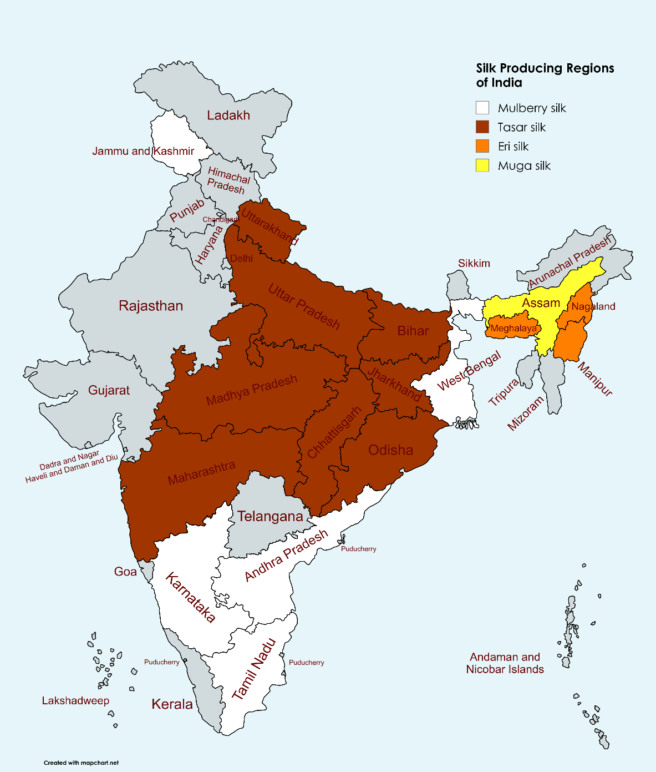
Diversity of silkworm eco races
Eri silkworm
The brick red or white coloured eri silk produced by Samia ricini. It is a domesticated multivoltine silkworm. It is widely grown in Assam and in Bihar, West Bengal, Manipur, Orissa, Tripura, Andhra Pradesh and some parts of Tamil Nadu (20). It has more than 1 species and 16 forms, variants or races (21).
Muga silkworm
The golden yellow muga silk is secreted by a semi domesticated multivoltine species called Antheraea assamensis. This species is widely distributed and cultured in Assam. It is endemic to Assam only and reared mostly in Brahmaputra valley (22). Some muga biotypes, like Halflong green, yellow mutant, Kukurapohia green and wild hibernating type, were collected from different areas (23).
Tasar silkworm
The brown coloured eco races extensively cultivated in in states of Bihar, MP, Orissa, Maharashtra, AP, Assam, Manipur, Meghalaya and Nagaland. The important species under the genus Antheraea includes the Tropical tasar (Antheraea mylitta) and Oak tasar (Antheraea proylei) (24). It has 22 forms or eco races in North eastern region of India (25).
Table 2. Distribution and Eco-Races of Non-Mulberry Silkworms
Silkworm type | Eco races | Major States
Eri silkworm | Borduar, Kokrajhar and Dhanubhanga | Lower Assam
Eri silkworm | Titabar | Upper Assam
Eri silkworm | Sille | Arunachal Pradesh
Eri silkworm | Nongpoh and Mendipathar | Meghalaya
Tasar silkworm | Andhra local | Andhra Pradesh
Tasar silkworm | Bhandara Local (Mulki) | Maharshtra
Tasar silkworm | Barhawra, Modia, Moonga and Daba | Bihar
Tasar silkworm | Belgaum Local | Karnataka
Tasar silkworm | Modal, Nalia, Sukinda, | Orissa
Tasar silkworm | Laria | Bihar and Madhya Pradesh
Tasar silkworm | Railey | Chattisgarh
Tasar silkworm | Tira | West Bengal
Muga silkworm | Halflong green and Kukurapohia green | Bhaktapara in lower Assam
Muga silkworm | Senchoa, Kamarbandha and Titabar | Upper Assam

Forest Biodiversity and Conservation of Vanya Silks
The productivity and sustainability of non-mulberry (vanya) silks such as tasar, eri and muga are intricately linked to the health and diversity of forest ecosystems (17). Unlike mulberry silkworms (Bombyx mori), which are domesticated and reared under controlled conditions, vanya silkworms are semi-domesticated or wild, relying heavily on naturally occurring forest vegetation for their survival and growth (26). Therefore, the forest biodiversity, particularly the availability and quality of host plant species, plays a decisive role in determining the success of vanya silk production (27).
Several native forest trees serve as primary host plants for these wild silkworms. For instance, Ailanthus excelsa (barkesseru) and Ailanthus grandis (Barpat) are vital for eri silkworms (Samia ricini), while Litsea polyantha (soalu) and Persea bombycina (som) constitute the major food plants for the muga silkworm (Antheraea assamensis). Similarly, Terminalia arjuna, Terminalia tomentosa and Shorea robusta are important for tasar silkworms (Antheraea mylitta). The abundance, phenological pattern and nutritional status of these host plants directly influence the growth, cocoon yield and silk quality of vanya silks (14).
However, rapid deforestation, land-use changes and habitat fragmentation have posed significant threats to the sustainability of forest-based sericulture. The conversion of forest lands into tea plantations, agricultural fields and industrial zones has resulted in the depletion of host plant resources and the degradation of natural habitats essential for wild silkworm populations. Such ecological disturbances not only reduce silkworm productivity but also endanger the genetic diversity of these economically important insect species (28).
Conservation of forest biodiversity is therefore crucial for maintaining the ecological foundation of vanya silk production. Strategies such as in-situ and ex-situ conservation of host plants, establishment of silkworm gene banks, habitat restoration and promotion of community-based forest management can significantly enhance the sustainability of this sector. Integrating sericulture with afforestation and agroforestry programmes can also ensure both livelihood security for tribal and rural communities and long-term conservation of forest biodiversity (29). Thus, protecting forest ecosystems is fundamental not only for preserving ecological balance but also for sustaining the heritage and economic viability of India’s vanya silk industry.
Figure 2. Flowchart linking sericulture to forest and community systems.
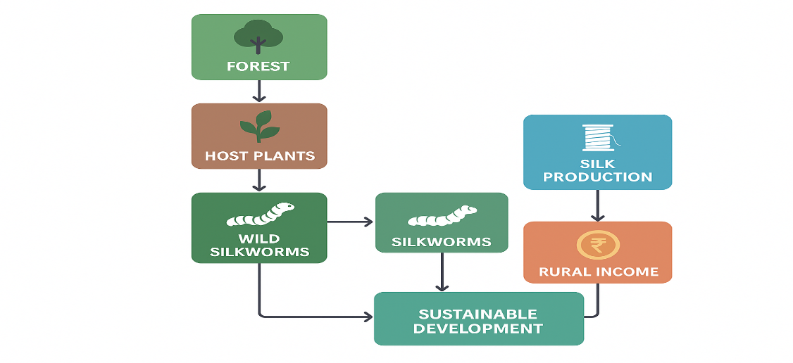
Ecological and Economic Value of Sericulture
Sericulture is an eco-friendly and sustainable activity that aligns well with ecological principles. It is non-polluting, renewable, and compatible with forest ecosystems. Mulberry and vanya silk plantations help in carbon sequestration, soil conservation, and improving biodiversity through agroforestry practices. These systems enhance soil fertility, prevent erosion, and contribute to a greener environment (30, 31, 32, 33).
Sericulture for Sustainable Development
Sericulture plays a vital role in advancing the goals of sustainable development by integrating environmental conservation with socio-economic progress. It directly contributes to several United Nations Sustainable Development Goals (SDGs), notably SDG 1 (No Poverty), SDG 5 (Gender Equality), SDG 8 (Decent Work and Economic Growth), SDG 12 (Responsible Consumption and Production), and SDG 15 (Life on Land) (34, 35, 38). Through its labor-intensive and eco-friendly nature, sericulture provides sustainable livelihoods, particularly for rural women and marginalized communities, thereby reducing poverty and promoting gender equity.
Environmentally, sericulture supports responsible production systems by utilizing renewable biological resources and minimizing ecological footprints. The integration of sericulture with carbon farming and agroforestry practices enhances its potential for climate change mitigation, carbon sequestration, and biodiversity restoration. Mulberry and vanya-based agroforestry systems not only contribute to soil fertility and microclimate regulation but also strengthen the resilience of rural ecosystems.
Figure 3. Sericulture and SDG’s
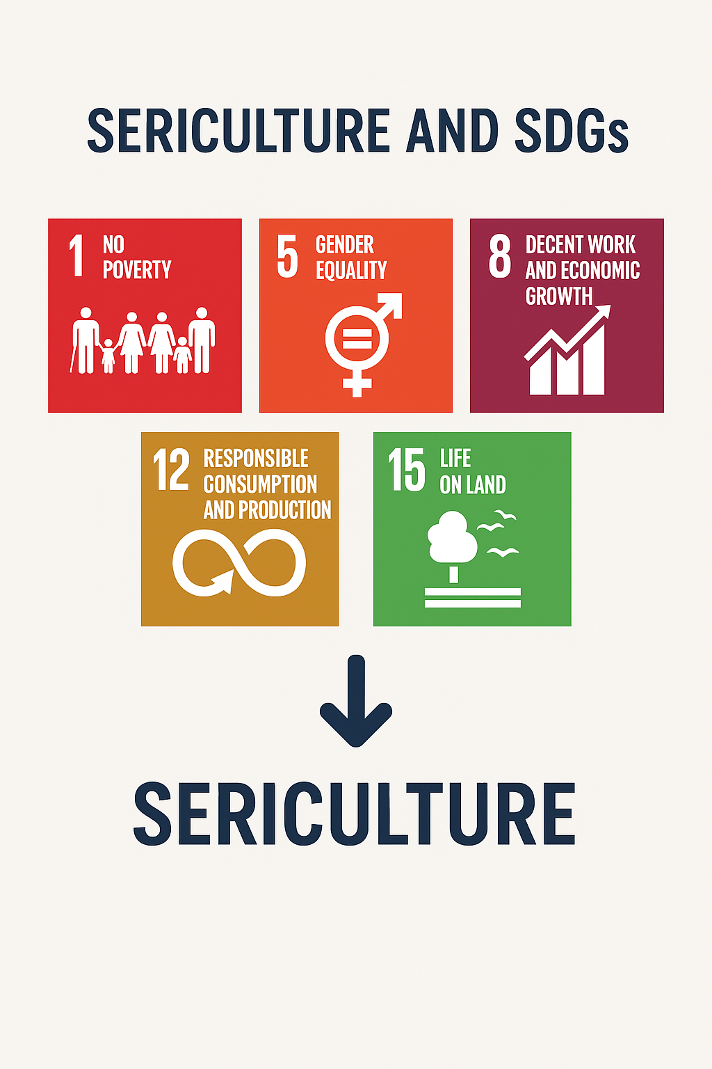

Policy Framework, Institutional Support and Community Participation in Sericulture
Sericulture development in India has been strongly influenced by supportive policy frameworks, institutional interventions and community-based participation, which together determine the sustainability of biodiversity-based silk production systems. National and state-level initiatives led by agencies such as the Central Silk Board (CSB), Ministry of Textiles, and state sericulture departments have played a pivotal role in conserving silkworm genetic resources, strengthening extension services and promoting livelihood-oriented sericulture models. Programmes focusing on bivoltine development, host plant improvement, silkworm seed production and capacity building have contributed to enhanced productivity while maintaining ecological integrity.
In the context of non-mulberry (vanya) sericulture, policy interventions assume greater significance because of the sector’s close linkage with forest ecosystems and tribal livelihoods. Government-supported schemes promoting Joint Forest Management (JFM), agroforestry and social forestry have enabled the integration of tasar, eri and muga silkworm rearing with forest conservation objectives. Such approaches not only reduce pressure on natural forests but also encourage the regeneration of host plant species, thereby strengthening ecological resilience. Community-based forest management has emerged as a particularly effective mechanism, wherein local stakeholders actively participate in protecting forest resources while deriving economic benefits through silk production.
Institutional support systems have also facilitated the establishment of silkworm germplasm banks, host plant nurseries and decentralized silkworm seed production units. These initiatives are crucial for conserving seribiodiversity and mitigating genetic erosion caused by habitat loss and climate variability. Furthermore, research institutions and universities have contributed through molecular characterization of silkworm races, development of climate-resilient host plants and disease management strategies, enhancing both productivity and sustainability.
Community participation remains central to the success of sericulture as a biodiversity-linked livelihood enterprise. Women’s self-help groups, farmer producer organizations and tribal cooperatives have increasingly been involved in cocoon production, reeling and value addition, thereby improving income security and social empowerment. Traditional ecological knowledge possessed by indigenous communities regarding host plant management, seasonal rearing practices and forest stewardship complements scientific interventions and enhances adaptive capacity.
Despite these advancements, gaps persist in policy coordination, market integration and technology dissemination, particularly in remote forest regions. Strengthening convergence among forestry, agriculture and rural development departments is essential to maximize the synergies between conservation and livelihood objectives. Future policy directions should emphasize inclusive governance, incentive-based conservation mechanisms and market-oriented interventions such as eco-labelling and geographical indications for vanya silks. By reinforcing institutional frameworks and community engagement, sericulture can emerge as a resilient, biodiversity-positive enterprise that simultaneously supports forest conservation and sustainable rural development.
Discussion
Sericulture in India represents a vital link between biodiversity conservation and sustainable rural livelihoods. Its diverse silkworm species and host plants reflect rich seribiodiversity that supports ecological balance and economic resilience. However, vanya silk production, being forest-dependent, faces challenges from deforestation, habitat loss and climate variability. While mulberry sericulture is agro-based and technology driven, vanya silk relies on tribal communities and traditional practices, requiring conservation focused approaches. Emerging tools such as molecular breeding, host plant improvement and eco-certification can enhance productivity and sustainability. Integrating sericulture with agroforestry and carbon farming further strengthens its role in climate change mitigation. As a gender inclusive, employment-intensive enterprise, sericulture aligns with key Sustainable Development Goals, especially poverty reduction and responsible production. Strengthened policy support, improved market access and research–community collaboration are essential to ensure sericulture’s long-term viability as an eco-friendly and economically sustainable rural development model.

Conclusion
Sericulture serves as an effective bridge between biodiversity conservation and sustainable livelihood development. By linking ecological preservation with rural income generation, it exemplifies a balanced model of environmental and socio-economic sustainability. The conservation of seribiodiversity including wild and domesticated silkworm species, host plants, and their habitats is essential for maintaining the ecological foundation of the silk industry. Strengthening participatory forest management, adopting scientific breeding and conservation programs, and promoting eco-friendly and value-added silk production systems can collectively ensure ecological stability, climate resilience, and rural empowerment. Thus, sericulture not only preserves the rich biological heritage of India but also contributes meaningfully to achieving long-term sustainable development goals.
Challenges and Future Prospects
Despite its vast potential, the sericulture sector faces several challenges that hinder its sustainable growth. These include the genetic erosion of wild silkworm populations, climate change impacts affecting host plant productivity, and restricted market access for rural producers. In addition, inadequate technological interventions and limited value addition constrain competitiveness in the global silk market. To overcome these limitations, future efforts should focus on molecular characterization and conservation of silkworm genetic resources, promotion of eco-certification and sustainable silk production standards, and the establishment of forest-based silk parks integrating biodiversity conservation with rural enterprise. Strengthening research–industry linkages, expanding market networks, and adopting climate-resilient practices will be crucial to ensure the long-term sustainability and global recognition of India’s sericulture sector.

COMPETING INTERESTS DISCLAIMER:
Authors have declared that they have no known competing financial interests OR non-financial interests OR personal relationships that could have appeared to influence the work reported in this paper.
References
- Popescu, A., Şerban, V., & Stanciu, M. (2025). Sustainability in Silk Production And Silk Textile Industry. Scientific Papers Series Management, Economic Engineering in Agriculture & Rural Development, 25(1).
- Dandin, S. B. (2025). Silk-a Global Textile. GAMANAM: Global Advances in Multidisciplinary Applications in Next-Gen And Modern Technologies, 1(1), 32-37.
- Rasuljonovich, K. R. (2025). The Development Strategies Ways of Silk Industry of The Republic of Uzbekistan. Imras, 8(2), 1-8.
- Central Silk Board (2023). Annual Report 2022–23. Government of India.
- Anitha, R. (2011). Indian silk industry in the global scenario. International Journal of Multidisciplinary management studies, 1(3), 100-110.
- Bukhari, R., & Kour, H. (2019). Background, current scenario and future challenges of the indian silk industry. Int. J. Curr. Microbiol. App. Sci, 8(5), 2448-2463. DOI: 10.20546/ijcmas.2019.805.289.
- Saini, P., Rohela, G. K., Kumar, J. S., Shabnam, A. A., & Kumar, A. (2023). Cultivation, utilization, and economic benefits of Mulberry. In The Mulberry Genome (pp. 13-56). Cham: Springer International Publishing. DOI: 10.1007/978-3-031-28478-6_2.
- Gogoi, B., & Goswami, B. C. (2016). Silkworm Biodiversity of Assam: Its Exploration and Development. Int. J. Interdiscip. Res. Sci. Soc. Cult, 2(1), 400-07.
- Goswami, D., Rabha, B., & Veer, V. (2016). Muga Silk-The Golden Thread of Assam. In Bioprospecting of Indigenous Bioresources of North-East India (pp. 279-294). Singapore: Springer Singapore. DOI: 10.1007/978-981-10-0620- 3_17.
- Vishaka, G. V., Rathore, M. S., Chandrashekharaiah, M., Nadaf, H. A., & Sinha, R. B. (2020). Tasar for tribes: A way of life. Journal of Entomology and Zoology Studies, 8(1), 374-377.
- Nath, S., & Modak, B. K. (2022). Tasar sericulture: an underutilized tool of poverty eradication among the tribals of Bankura district. In Indigenous People and Nature (pp. 437-463). Elsevier. DOI: 10.1016/B978-0-323-91603- 5.00014-2.
- Motamed, M. K. (2002). Socio-economic constraints in sericulture production-an analytical study (Doctoral dissertation, IARI, Division of Agricultural Extension, New Delhi).
- Ssemugenze, B., Esimu, J., Nagasha, J., & Wandui Masiga, C. (2021). Sericulture: Agro-based industry for sustainable socio-economic development: A review. DOI: 10.29322/IJSRP.11.09.2021.p11756.
- Kasi, E. (2013). Role of women in sericulture and community development: a study from a South Indian Village. Sage Open, 3(3), 2158244013502984. DOI: 10.1177/2158244013502984.
- Bukhari, R., Kour, H., & Aziz, A. (2019). Women and the Indian sericulture industry. International Journal of Current Microbiology and Applied Sciences, 8(05), 2319-7706. DOI: 10.20546/ijcmas.2019.805.101.
- DeLong Jr, D. C. (1996). Defining biodiversity. Wildlife society bulletin, 738-749.
- Mittermeier, R. A., Mittermeier, C. G., Brooks, T. M., Pilgrim, J. D., Konstant, W. R., Da Fonseca, G. A., & Kormos, C. (2003). Wilderness and biodiversity conservation. Proceedings of the National Academy of Sciences, 100(18), 10309-10313. DOI: 10.1073/pnas.1732458100.
- Tikader, A., & Kamble, C. (2010). Seri-biodiversity with reference to host plants in India. The Asian and Australian Journal of Plant Science and Biotechnology, 4(1), 1-11.
- Wani, M. Y., Ganie, N. A., Rather, R. A., Rani, S., & Bhat, Z. A. (2018). Seri biodiversity: An important approach for improving quality of life. Jr Ent Zoo Sty, 6(1), 100-105. DOI: 10.22271/j.ento.2018.6.1.1053.
- Ahmed, S. A., Singh, N. I., & Sarkar, C. R. (2015). Role of forest biodiversity in conservation of non-mulberry (vanya) silk in India. Munis Entomology & Zoology, 10(1), 342-357.
- Kamili, A. S., & Dar, Z. A. Conservation Strategies and Sustainable Use of Seri-Biodiversity with Special Emphasis on Mori-Silkworm (Bombyx mori L).
- Gangopadhyay, D., Ghosh, A., & Ray, M. (2019). Seribiodiversity and their role in Sustainable Development in India. International Journal of Plant and Environment, 5(04), 243-246. DOI: 10.18811/ijpen.v5i04.3.
- Kalita, H., Pathak, M., Ningthoujam, K., Sahoo, B. K., Boruah, S., & Sehgal, M. Eri Silkworm: A Potential Commercial Insect and Its Future Prospects. DOI: 10.54083/978-81-986377-3- 4_06.
- Swathiga, G., Manimegalai, S., & Arasakumar, E. (2022). Growth attributes of eco races of eri silkworm, Philosamia ricini Donovan in the Western Zone conditions of Tamil Nadu. Current Agriculture Research Journal, 10(3). DOI: 10.12944/CARJ.10.3.14.
- Tikader, A., Vijayan, K., & Saratchandra, B. (2013). Muga silkworm, Antheraea assamensis (Lepidoptera: Saturniidae)-an overview of distribution, biology and breeding. European Journal of Entomology, 110(2). DOI: 10.14411/eje.2013.096.
- Dandin, S. B., & Prabhu, N. (2022). Silkworm Biodiversity, Conservation, Threats, and Sustainable Utilization in Indian Subcontinent. In Biodiversity (pp. 157-192). CRC Press. DOI: 10.1201/9781003220398.
- Bambhaniya, K. C., Naik, M. M., & Ghetiya, L. V. (2017). Biology of tasar silkworm, Antheraea mylitta Drury under indoor conditions. Trends Biosci, 10(1), 126-131.
- Sharma, S. K., & Rai, M. M. (2015). Biodiversity and conservation of Tasar ecoraces. Int J Res Biosci Agric Technol, 2(7), 313-316.
- Shetty, K. K., Sathyanarayana, K., John, J. N., & Jose, I. (2007). Vanya silks of India-exploring new horizons. Black, Caspian Seas and Central Asia Silk Association (BACSA) www. bacsa-silk. org, 326.
- Barsagade, D. D., Tbakre, M. P., Meshram, H. M., Gathalkar, G. B., Gharade, S. A., & Thakre, R. P. (2012). Vanya tasar silkworm, Antheraea mylitta eco-race Bhandara, the local race and it's conservation strategy (Lepidoptera: Saturniidae). Journal of Science Information, 3, 17-23.
- Dewangan, S. K., Sahu, K. R., & Achari, K. V. (2011). Sericulture-A tool of eco-system checking through tribal. Journal of Environmental Research and Development, 6(1), 165-173.
- Attri, K., Vakayil, S., Shruthi, G., Parmar, S., Harika, K. R., Teja, K. S. S., & Panigrahi, C. K. (2024). Integrative approaches in sericulture from traditional practices to modern technologies sericulture and its contribution to biodiversity conservation. J Adv Biol Biotechnol, 27(8), 480-490. DOI: 10.9734/jabb/2024/v27i81160.
- Dhyani, S. K., Chauhan, D. S., Kumar, D., Kushwaha, V., & Lepcha, S. T. (1996). Sericulture-based agroforestry systems for hilly areas of north-east India. Agroforestry Systems, 34(3), 247-258. DOI: 10.1007/bf00046925.
- Rathore, M. S., & Srinivasulu, Y. (2018). Soil Carbon Sequestration in Temperate Conditions for Sustaining Sericulture. International Research Journal of Engineering and Technology (IRJET), 5(9), 96-101.
- Sujatha, G. S., Kumar, G. A., Teja, K. S. S., Devi, D. L., Vidya Madhuri, E., Panda, A., ... & Gautam, S. K. (2024). A comprehensive revie w of the effect and mitigation of climate change on sericulture. International Journal of Environment and Climate Change, 14(7), 776-788. DOI: 10.9734/ijecc/2024/v14i74317.
- Gangopadhyay, D. (2024). Sericulture-based agroforestry systems for livelihood and nutritional security in India: an overview. Sustainable Management and Conservation of Environmental Resources in India, 271-283. DOI: 10.1201/9781003469278.
- Grześkowiak, J., Łochyńska, M., & Frankowski, J. (2022). Sericulture in terms of sustainable development in agriculture. Problemy Ekorozwoju, 17(2), 210-217. DOI: 10.35784/pe.2022.2.23.
- Mushtaq, R., Qadiri, B., Lone, F. A., Raja, T. A., Singh, H., Ahmed, P., & Sharma, R. (2023). Role of sericulture in achieving sustainable development goals. Problemy Ekorozwoju, 18(1), 199-206. DOI: 10.35784/pe.2023.1.21.
- Pavithra, A., Rajashekar, J., Saikrishna, K., Shreya, B., Pramod Kumar, M., Thanuja, A. C., & Hariharan, S. (2024). The evolution of the sericulture industry in India: From tradition to modernity. Journal of Scientific Research and Reports, 30(9), 282–291.https://doi.org/10.9734/jsrr/2024/v30i92353
- Marak, M., Singha, T. A., & Saikia, D. (2024). Mechanization in Sericulture: An Overview. Journal of Advances in Biology & Biotechnology, 27(8), 820–825. https://doi.org/10.9734/jabb/2024/v27i81200
- Nath, I., Dutta, P. L., & Narzary, P. R. (2025). Muga Silk: A Review on its Structural, Physical, and Biomedical Significance. Journal of Experimental Agriculture International, 47(7), 850–863. https://doi.org/10.9734/jeai/2025/v47i73627
- Cappellozza, S., Casartelli, M., Sandrelli, F., Saviane, A., & Tettamanti, G. (2022). Silkworm and Silk: Traditional and Innovative Applications. Insects, 13(11), 1016. https://doi.org/10.3390/insects13111016

