Review Article

Neisseria meningitidis Infection: Biological Characteristics, Pathogenesis and Prevention Strategies

ABSTRACT

Neisseria meningitidis is a Gram-negative diplococcus that colonises the human nasopharynx and represents a significant cause of invasive bacterial disease worldwide. Although asymptomatic carriage of N. meningitidis is common in healthy individuals, the organism may occasionally invade the bloodstream and central nervous system, resulting in invasive meningococcal disease (IMD). The most frequent clinical manifestations of IMD include meningitis and meningococcal septicaemia, both of which are associated with rapid disease progression, high mortality rates, and substantial long-term morbidity among survivors. This review provides a comprehensive overview of Neisseria meningitidis as an important human pathogen. It summarises current knowledge regarding the microbiological characteristics, virulence determinants, and pathogenic mechanisms of the organism, as well as host immune responses involved in infection control. The review further examines patterns of asymptomatic carriage and modes of transmission, together with environmental and host-related factors that influence disease spread. In addition, the global epidemiology of meningococcal disease is discussed, highlighting regional variations in disease distribution. Clinical manifestations, diagnostic approaches, and laboratory identification methods are also reviewed. Current therapeutic strategies, including antimicrobial treatment and supportive care, are outlined alongside available vaccination programmes and public health interventions for disease prevention and control. By integrating findings from published scientific literature and public health sources, this review emphasises the continuing global health importance of Neisseria meningitidis. Sustained surveillance, effective vaccination strategies, and ongoing research are essential to reduce the burden of meningococcal disease worldwide.

Keywords: Neisseria meningitidis, Bacteria, Meningococcal Disease (IMD), Vaccines.

1.0 INTRODUCTION

Neisseria meningitidis (meningococcus) is a Gram-negative diplococcus and a major cause of bacterial meningitis and septicaemia worldwide. It grows on chocolate agar, soybean agar, and Mueller-Hinton agar. This organism causes meningitis, a serious bacterial disease characterized by fever, headache, nausea, neck and muscle pain. The organism is uniquely adapted to humans and commonly colonises the nasopharynx as part of the normal microbial flora. Asymptomatic carriage is frequent, particularly among adolescents and young adults, and plays a crucial role in the transmission and persistence of the bacterium within populations. Despite its frequent commensal existence, N. meningitidis has the capacity to invade host tissues and cause severe invasive meningococcal disease (IMD) (Nouri et al., 2026; Mikucki et al., 2022).

IMD is characterised primarily by meningitis, meningococcaemia, or a combination of both clinical conditions. The disease often progresses rapidly and may lead to severe complications or death within a short period of time, even with prompt medical intervention. When untreated, IMD mortality may exceed 50%, and mortality despite treatment remains high at 10% (Dubey et al., 2022). Survivors frequently experience long-term sequelae, including hearing impairment, neurological deficits, limb amputations, cognitive dysfunction, and psychological complications. The rapid progression and high case-fatality rate make meningococcal disease one of the most serious bacterial infections affecting humans.

Meningococcal disease remains an important global public health concern. The highest disease burden occurs in low- and middle-income countries, particularly within the African meningitis belt, where large-scale epidemics continue to occur (WHO, 2023). Nevertheless, sporadic cases and outbreaks are also reported in high-income regions such as Australia, Europe, and North America, especially among infants, adolescents, and young adults. Host susceptibility, environmental conditions, and behavioural factors all contribute to the epidemiology and transmission of the organism (Tzeng & Stephens, 2000).

Although effective vaccines targeting several meningococcal serogroups are available, Neisseria meningitidis continues to pose a significant health threat. The organism exhibits considerable genetic variability and possesses multiple mechanisms that facilitate immune evasion and persistent colonisation of the human host. Furthermore, asymptomatic carriers serve as important reservoirs for transmission, complicating disease control efforts.

This review provides a comprehensive overview of Neisseria meningitidis as an important human pathogen. It summarises current knowledge on the biological characteristics, pathogenic mechanisms, transmission dynamics, clinical manifestations, diagnostic approaches, and public health strategies for the prevention and control of meningococcal disease.

1.1 NATURE OF THE MICROBIAL PATHOGEN: CELLULAR STRUCTURE AND CLASSIFICATION

Neisseria meningitidis is a type of bacterium. It needs oxygen to live and does not create spores. It cannot move on its own and is classified as Gram-negative, which is something scientists use to group bacteria. Under a microscope, it looks like pairs of kidney bean-shaped cells. If someone is sick, these bacteria can often be found inside white blood cells called neutrophils. To figure out if a bacterial sample is N. meningitidis, labs test if it produces certain enzymes. N. meningitidis tests positive for both oxidase and catalase enzymes (CDC, 2022).
This bacterium is meticulous about where it grows. It needs special nutrient-rich environments, like chocolate agar, and likes an atmosphere with extra carbon dioxide (5–10%). This is because it is used to living in the back of human noses and throats. It does not live for long outside the human body, so it spreads from person to person (Heymann, 2021).

Neisseria meningitidis can result in meningitis, a dangerous infection of the membranes covering the brain and spinal cord. It is a severe sickness that can be life-threatening if not dealt with quickly. It is especially dangerous for babies, kids, and people with weak immune systems. Early symptoms of meningitis from Neisseria meningitidis can seem like the flu, such as fever, headache, and stiff neck. As the infection worsens, it can cause more serious problems like confusion, seizures, and even coma. One distinct sign is a rash that does not fade when touched. The bacteria are usually spread through close contact with someone who is carrying the bacteria, like coughing or kissing. It is less often transferred through sharing food or drinks. People can carry the bacteria in their nose or throat without getting sick, but they can still spread it to others.

Doctors usually use antibiotics to kill bacteria. Quickly dealing with antibiotics can help prevent serious problems and increase the chances of recovery. Also, vaccines are available to help protect against some types of Neisseria meningitidis. They are often recommended for teens, college students, and others who are at increased risk. Because Neisseria meningitidis can spread quickly, it is important to take steps to prevent infection. This includes regular handwashing, avoiding sharing personal items, and staying home when sick. If someone is exposed to Neisseria meningitidis, doctors may prescribe antibiotics to prevent them from getting sick. The bacteria have different serogroups (types) such as A, B, C, W, X, and Y. These group classifications are based on the bacterium's capsule. The disease's distribution may be different in various parts of the world. Meningitis outbreaks can happen anywhere, but they are more common in crowded places. Staying informed about the local risks can allow suitable safety measures to be taken.

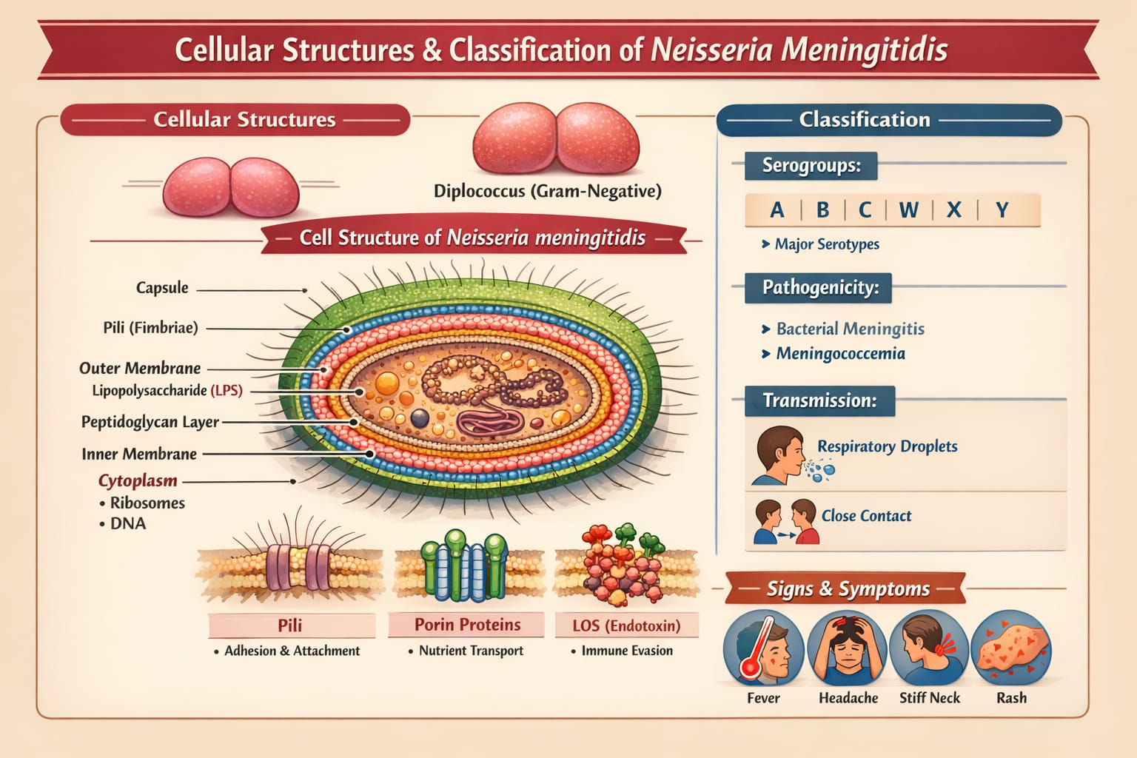

Fig 1: Detailed diagram for Cellular Structure Classification of Neisseria Meningitis

1.2 CAPSULAR DIVERSITY AND VIRULENCE MECHANISMS

One of the most important parts of Neisseria meningitidis is its polysaccharide capsule. It is the main thing that makes it dangerous. This capsule helps the bacteria avoid being eaten by immune cells and killed by the complement system, so it can live in the blood. (Brandtzaeg & van Deuren, 2012; Rouphael &Stephens, 2012). Because of differences in the capsule’s chemical makeup, Neisseria meningitidis is divided into at least twelve serogroups. Serogroups A, B, C, W, X, and Y are responsible for most of the severe infections we see around the world. (Tzeng &Stephens, 2000) The differences between the capsules are particularly important when we think about disease and how it spreads. For example, the serogroup B capsule does not cause a strong immune response because it looks a lot like molecules found in human nerve cells. This made it hard to make a vaccine. Instead of using the normal polysaccharide-based methods, scientists had to develop protein-based MenB vaccines using reverse vaccinology. (Stephens et al., 2007; Brandtzaeg & van Deuren, 2012).

1.3 THE ROLE OF THE POLYSACCHARIDE CAPSULE

The polysaccharide capsule is not just a general protective layer; it is a meticulously crafted shield that allows N. meningitidis to thrive in the hostile environment of the human bloodstream. Phagocytosis, the process by which immune cells engulf and destroy pathogens, is thwarted by the capsule's slippery surface and specific molecular structure. The complement system, a crucial part of the immune system that directly kills bacteria and promotes inflammation, is also rendered ineffective by the capsule's ability to interfere with the deposition of complement proteins on the bacterial surface (Brandtzaeg & van Deuren, 2012). By evading these key immune defences, N. meningitidis gains a critical advantage in establishing an infection.

2.0 GLOBAL IMPACT OF DIFFERENT SEROGROUPS

The distribution of N. meningitidis serogroups varies geographically, with some serogroups being more prevalent in certain regions than others. Serogroup A, for instance, has historically caused large epidemics in Africa's meningitis belt, while serogroup B is more common in Europe and North America. Serogroup C has been associated with outbreaks in various parts of the world, and the emergence of serogroups W and Y has led to increased disease incidence in recent years. These variations in serogroup prevalence have important implications for vaccine strategies, as vaccines need to be tailored to address the specific serogroups circulating in a given population. Regular surveillance and monitoring of serogroup distribution are essential for informing public health policies and ensuring effective disease prevention.

2.1 CHALLENGES AND INNOVATIONS IN VACCINE DEVELOPMENT

The poor immunogenicity of the serogroup B capsule presented a major challenge for vaccine developers. Traditional polysaccharide-based vaccines, which are effective for other serogroups, failed to elicit a strong and sustained immune response against serogroup B. This is because the capsule's structural similarity to human neural cell adhesion molecules leads to immune tolerance, where the body recognises the capsule as self and thus does not mount an immune attack. To overcome this obstacle, scientists turned to reverse vaccinology, a novel approach that involves analysing the bacterium's genome to identify potential protein antigens that can stimulate a protective immune response. This approach led to the development of MenB vaccines that contain a combination of recombinant proteins, providing a much-needed tool for preventing serogroup B meningococcal disease. The development of these vaccines represents a triumph of scientific innovation and has had a tremendous impact on public health.

2.2 OUTER MEMBRANE COMPONENTS AND IMMUNE EVASION

Neisseria meningitidis is not just dangerous because of its capsule. It also has a bunch of stuff on its outer membrane that helps it cause disease. Think of Type IV pili as tiny grappling hooks. They let the bacteria stick to the cells lining the nose and throat. This is important for forming little groups of bacteria, called microcolonies, which help them settle in (Caugant & Maiden, 2009). Then there are proteins like PorA, PorB, and Opa. These guys are like versatile tools. They help the bacteria stick to cells, get inside them, and even mess with the body's immune system (Rouphael & Stephens, 2012). LOS is like a nasty surprise hidden in the outer membrane. It is a type of endotoxin, and when the bacteria invade the body, LOS gets released into the blood. This causes a big, and often harmful, inflammatory reaction. This reaction is responsible for a lot of the symptoms you see in meningococcal septicemia, a severe blood infection (Stephens et al., 2007; Brandtzaeg & van Deuren, 2012).

Neisseria meningitidis is also good at changing its appearance. It uses tricks like phase variation and horizontal gene transfer to quickly switch the surface antigens it displays. This constant change makes it hard for the immune system to recognise and fight, allowing the bacteria to stick around longer and increasing the chance of outbreaks with particularly nasty strains (Caugant & Maiden, 2009). The bacteria change their look to avoid being detected by the body's defence mechanism. It is like the bacteria are playing hide and seek with the body system. So, it can stay in the system for a longer time. In the end, it leads to some aggressive strains, and the disease spreads faster.

3.0 PATHOGENESIS AND HOST INTERACTION: COLONISATION OF THE NASOPHARYNX

Meningococcal disease starts when the bacteria settle in the back of your nose and throat (the nasopharyngeal mucosa). The bacteria, called N. meningitidis, use tiny, hairlike structures called pili and other sticky molecules on their surface to latch onto the cells lining this area. This starts a period where many people carry the bacteria without even knowing it (Tzeng & Stephens, 2000; Caugant & Maiden, 2009). During this time, the body does not usually react strongly against the bacteria. It is like a truce, where neither side is really fighting. This could mean the body is tolerating the bacteria, or there is just a balance reached between the bacteria and your immune system. This carrying state can last for weeks or even months. It is important because this is how the bacteria spread from person to person (Christensen et al., 2010). But just because you have carried the bacteria before does not mean you are protected from it later. The body's defences that are triggered are usually specific to that exact type of bacteria and do not last exceedingly long (WHO, 2023). This means you can still catch meningococcal disease, even if you carried it before. To explain it more thoroughly:

The bacteria, like all living things, consist of different strains. Each strain has its own unique characteristics. When one strain of the bacteria enters your body, your system learns to fight that specific strain. It develops defences that are highly that are specifically aimed at disabling those strains (Schubert-Unkmeir, 2017).
This is why an immune system to one strain does not make you immune to other strains; it is like learning to defeat with one sword but not knowing how to defend against others. The immune system is not properly equipped to respond to the unfamiliar elements and distinctive features. After a period, the immune memory fades, leaving the individual susceptible to even the original strain again. Immunity is not always a lifetime thing. (Coureuil et al., 2017).

3.1 INVASION AND SYSTEMIC SPREAD

It is not very often that someone carrying the bacteria goes on to actually get sick with the invasive form of the disease. Whether that happens or not depends on things related to the bacteria itself and also things about the person carrying it. For example, if someone has a viral infection in their lungs, or if they smoke, or if they are exposed to polluted air, or even if the lining of their airways is damaged, it can make it easier for the bacteria to get into the bloodstream (Heymann, 2021).

Once the bacteria are in the blood, things can get serious pretty quickly. The N. meningitidis bacteria start multiplying fast and release a substance called LOS. This kicks off a whole chain reaction of inflammation in the body. Certain chemicals, like tumour necrosis factor-α and interleukins, cause the blood vessels to become leaky, which leads to low blood pressure, swelling in the tissues, and not enough blood flow to the organs. At the same time, the body's blood clotting system goes into overdrive, causing tiny clots to form throughout the body. This is called disseminated intravascular coagulation, and it can lead to tissue damage and even death (Stephens et al., 2007).

3.2 CENTRAL NERVOUS SYSTEM INVASION

Meningitis, caused by Neisseria meningitidis, happens when the bacteria get past the blood-brain barrier. They do this by messing with the cells lining the blood vessels in the brain and also through the body's own immune responses. (Schubert-Unkmeir, 2017; Coureuil et al., 2017). This leads to swelling of the meninges, the membranes around the brain and spinal cord, which then causes fluid buildup in the brain. The pressure inside the skull goes up, and brain cells get hurt. A lot of the long-term brain problems seen in people who survive meningitis come from all this damage. (Rouphael &Stephens, 2012). Whether or not someone gets really sick from meningitis has a lot to do with their immune system. People who are missing certain parts of their complement system, which is part of the immune system, are much more likely to get a severe infection. That shows how important the body's initial immune response is for keeping this type of infection under control. (CDC, 2022)

To go into more detail. When Neisseria meningitidis enters the bloodstream, it does not just passively drift into the brain. It actively interacts with the cells that form the blood-brain barrier. Think of these cells as gatekeepers. The bacteria can bind to these cells, tricking them or damaging them in a way that lets the bacteria sneak through. The immune system's involvement is a double-edged sword. On one hand, the immune system tries to fight off the infection. On the other hand, the immune response itself can cause inflammation that hurts the brain. The body sends immune cells to the meninges to fight the bacteria. These immune cells release chemicals that cause inflammation. While this inflammation is meant to kill the bacteria, it also damages the surrounding brain tissue.

Cerebral oedema, or swelling in the brain, is a dangerous consequence of this inflammation. As fluid builds up, it takes up space inside the skull. Since the skull is a fixed size, the extra fluid increases the pressure on the brain. This increased intracranial pressure puts a squeeze on brain cells, cutting off their blood supply. Brain cells need a constant supply of oxygen and nutrients to work properly, and when they do not get enough, they start to die. This neuronal injury can lead to a range of neurological problems. These problems can include things like seizures, hearing loss, learning disabilities, and even paralysis. The complement system is a group of proteins in the blood that work together to fight off infections. If someone is missing one or more of these proteins, their body is less able to kill the Neisseria meningitidis bacteria. This makes them much more likely to develop a serious case of meningitis. The CDC's statement really drives home the point that our innate immune defences are critical when it comes to warding off meningococcal infections.

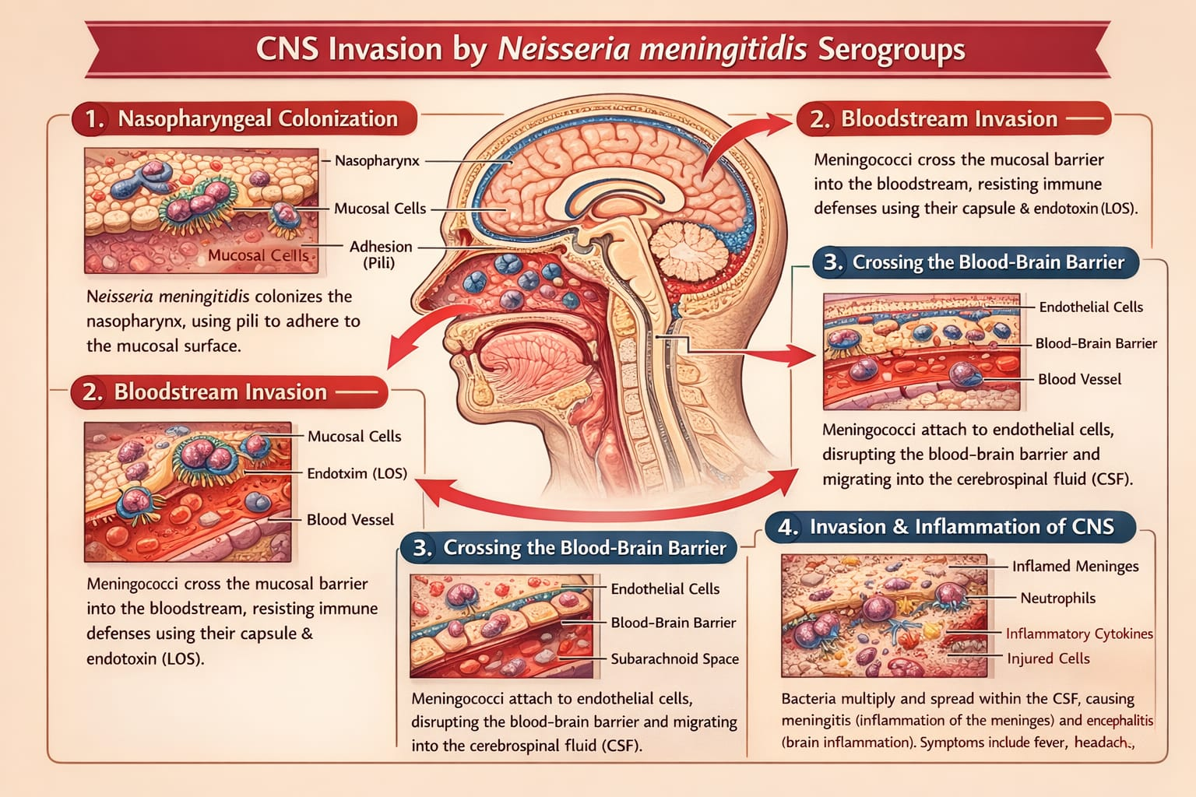

Fig 2: Detailed diagram to explain the central nervous system invasion by the Neisseria Meningitis.

4.0 TRANSMISSION AND ACQUISITION IN HUMANS

Neisseria meningitidis only spreads from person to person. It moves through tiny drops of liquid from the nose and throat when someone coughs or sneezes. It also spreads through close contact, like kissing or living close together with someone who has it (Heymann, 2021). Usually, you have to be around someone for a while to catch it. You probably won't get it just from a quick hello because the bacteria do not live long outside the body (CDC, 2022).

Many people carry the bacteria without getting sick. This is a big part of how the disease spreads. In rich countries, about 5% to 10% of people have it in their nose and throat. But for teenagers and young adults, that number goes up to 20% to 25% (WHO, 2023). These age groups are big spreaders because they often do not even know they have it. They might have no symptoms or just a mild infection. Things like where you live and your social life can also change how likely you are to get it. If you live in crowded conditions, are around smokers, do not have much money, or cannot easily see a doctor, you are more likely to get the bacteria and get sick (Tzeng & Stephens, 2000). It also matters what time of year it is. In places that get cold, there are more cases in the winter. In Africa, there are more cases during the dry season.

5.0 CLINICAL MANIFESTATIONS OF MENINGOCOCCAL DISEASE: MENINGOCOCCAL MENINGITIS
Early recognition of meningococcal disease is difficult because early symptoms are often nonspecific. Fever, headache, vomiting, and limb pain may appear before the classic signs of meningitis or septicemia, especially in children and adolescents (Thompson et al., 2006). Meningococcal meningitis happens when bacteria sneak into the brain and spinal cord, causing the protective layers around them (the meninges) to get inflamed. When this happens, people usually get a fever, a really bad headache, and a stiff neck. Bright lights might bother them, and they might feel sick to their stomachs, throwing up a lot. They could also get confused or have seizures. Little babies and small kids might not show the usual signs. They may just be cranky, not want to eat, seem tired, or have a soft spot on their head that sticks out more than usual (Heymann, 2021). Even though doctors have gotten better at treating it, meningococcal meningitis can still cause severe damage and even death. survivors often have long-term problems, like hearing loss, trouble learning, or problems moving (WHO, 2023).
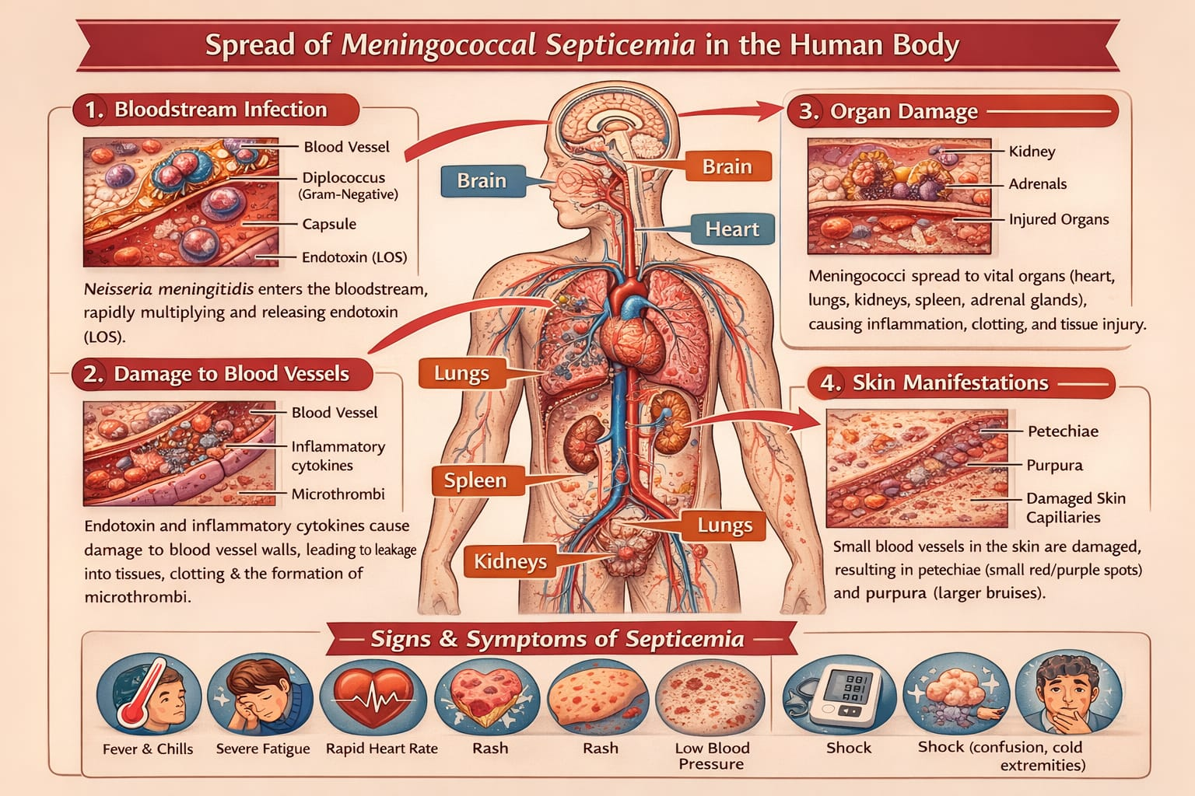

Fig 3: Detailed Explanation of how Meningococcal Septicaemia Spreads in the human body

5.1 MENINGOCOCCAL SEPTICEMIA

Meningococcal septicemia, also called meningococcemia, happens when bacteria quickly multiply in the bloodstream. This leads to widespread inflammation triggered by endotoxins (Rouphael &Stephens, 2012). When someone gets meningococcal septicemia, they might suddenly get a fever, chills, and muscle pain. Their blood pressure can drop, and they may develop a rash of small, non-blanching red or purple spots. Sometimes, the illness can worsen quickly, leading to septic shock, where multiple organs fail. In these serious situations, people can die within hours (Rouphael &Stephens, 2012). Even those who survive meningococcal septicemia can have long-term problems. These can include losing limbs, having bad scars on their skin, and experiencing ongoing issues with their organs. These complications show just how badly the disease can harm blood vessels (MacNeil et al., 2014).

6.0 DIAGNOSIS

Spotting invasive meningococcal disease quickly is super important because it can get bad fast and has a high chance of being fatal. Doctors usually check fluid from the spine and blood to make sure. A test called PCR has become a go-to because it is good at finding the bacteria’s DNA, even if antibiotics have already been given (CDC, 2022). Growing the bacteria in a lab is still needed to see which antibiotics work and to keep an eye on outbreaks.
Dealing with invasive meningococcal disease needs immediate action because it is so fast-moving and deadly. Getting it diagnosed right away and starting treatment immediately are key to helping patients survive. Treatment means hitting it hard with antibiotics, giving the patient all the support they need, and taking steps to keep it from spreading to others.

6.1 ANTIBIOTIC THERAPY

When someone is suspected of having invasive meningococcal disease (IMD), doctors should start antibiotic meds ASAP, even before lab tests come back. Usually, the go-to drugs are third-generation cephalosporins like ceftriaxone or cefotaxime. These are good because they fight a wide range of bacteria and get into the fluid around the brain and spinal cord really well (CDC,2022). Now, if you are in a place where the bacteria are not usually resistant to penicillin, you might use a high dose of penicillin through an IV. But you would only do that after the lab confirms the bacteria will respond to it. How long you stay on the antibiotics depends on how sick you are and how well you are responding to the meds, but it is usually about 5 to 7 days. Getting those antibiotics in early is super important because it can really lower the chances of dying or having long-term problems. That is why it is crucial for doctors to act fast when they see someone who might have IMD (Heymann, 2021).

Why is IMD so serious? IMD is a bacterial infection that can cause meningitis (inflammation of the membranes around the brain and spinal cord) and septicemia (blood poisoning). Both can be life-threatening, and even with treatment, they can lead to lasting disabilities. Why are third-generation cephalosporins usually the first choice? These antibiotics are broad-spectrum, meaning they are effective against many kinds of bacteria. They also cross the blood-brain barrier, which is important for treating meningitis. Ceftriaxone and cefotaxime are commonly used because they are reliable and easy to administer.

What about penicillin? Penicillin used to be the main treatment for IMD. However, the bacteria that cause IMD have become more resistant to penicillin in some areas. So, it is only used if the lab confirms that the specific bacteria causing the infection are susceptible to it.
Why is early treatment so important? IMD can progress very quickly. If the bacteria multiply and spread, they can cause serious damage to the brain, organs, and tissues. Starting antibiotics early can stop the infection in its tracks and prevent these complications. Long-term problems from IMD can include hearing loss, brain damage, learning disabilities, seizures, kidney damage, and amputations.

6.2 SUPPORTIVE AND INTENSIVE CARE

Looking after people with bad meningococcal disease is super important, especially when they have septicemia or septic shock. These patients usually need to go to the ICU so doctors and nurses can keep a close eye on them and deal with problems like low blood pressure, trouble breathing, and a condition called disseminated intravascular coagulation (DIC). To keep their organs working and make sure they are getting enough oxygen, they might need fluids, medicine to raise their blood pressure, and a breathing machine. When the disease causes meningitis (swelling around the brain and spinal cord), it is vital to handle any increased pressure inside the skull. This can be done by raising the head of the bed, using special medicines to reduce swelling, and carefully balancing the amount of fluid they receive. Doing all this helps stop further damage to the brain. (Rouphael &Stephens, 2012)

In more detail, meningococcal disease is no joke. It is a serious infection that can lead to septicemia (blood poisoning) and septic shock, where the body's response to an infection goes haywire, causing a dangerous drop in blood pressure and organ damage. When this happens, the body's organs do not get enough blood flow, and they can start to fail. That is why immediate and skilled care is essential. ICUs are specially equipped to provide this level of care. The staff there can continuously monitor vital signs like heart rate, blood pressure, and oxygen levels. They can also quickly respond to any changes or emergencies. Hypotension, or low blood pressure, is a frequent issue in these patients. If blood pressure drops too low, organs do not get the blood they need. Doctors use fluids to increase blood volume and medicines called vasopressors to constrict blood vessels, which raises blood pressure.

Respiratory failure is another common problem. The infection can damage the lungs, making it difficult for patients to breathe on their own. Mechanical ventilation, using a machine to help them breathe, might be necessary to ensure they get enough oxygen. DIC is a complex and dangerous condition where the body's blood clotting system goes into overdrive. This leads to small blood clots forming throughout the body, which can block blood flow to organs. At the same time, the body runs out of the things it needs to make clots, which increases the risk of bleeding. Managing DIC requires careful monitoring and treatment with blood products and medicines to restore the balance in the clotting system.

Meningitis, an inflammation of the membranes surrounding the brain and spinal cord, can cause increased pressure inside the skull (intracranial pressure). This increased pressure can damage the brain. Elevating the head of the bed helps to reduce this pressure. Osmotherapy involves using medicines like mannitol to draw fluid out of the brain tissue, which also lowers pressure. Careful fluid balance is crucial because too much fluid can worsen the swelling, while too little can lead to dehydration and further complications. So, they have to be constantly watched.

6.3 ADJUNCTIVE THERAPIES

Using steroids alongside antibiotics for bacterial meningitis, specifically when it's caused by meningococcal bacteria, is still something people argue about. Steroids might help lower the chance of nerve issues in some kinds of bacterial meningitis, but we do not have a lot of proof that they do much for meningococcal meningitis. Because of this, not everyone says you should use them, and usually, doctors decide based on what they think is best for the patient and what their hospital rules say (World Health Organization, 2023).

To go into a bit more depth, bacterial meningitis is a very bad infection that inflames the membranes around the brain and spinal cord. Meningococcal disease is a type of bacterial meningitis caused by Neisseria meningitidis bacteria, which can cause serious blood infections and long-term disabilities. Doctors and scientists have been doing research for years to discover how to treat it. Steroids, like dexamethasone, are sometimes used to try to calm down the body's response to the infection, which can cause swelling and damage to the brain. Some studies have suggested that steroids might reduce problems like hearing loss and nerve damage in kids with Haemophilus influenzae type b (Hib) meningitis.

But when it comes to meningococcal meningitis, the research is less detailed. Some studies have not found any real pluses to using steroids, and some have even suggested that they might not be helpful or could even cause harm in some situations. Because of the doubt, guidelines from groups like the World Health Organisation (WHO) usually say that using steroids for meningococcal meningitis should be up to the doctor. They will think about things like how sick the person is, if there are other health problems, and what the latest research says. Different hospitals might also have their own ways of doing things. The decision to use steroids is tricky, and doctors have to carefully balance the possible good things that could happen with the possible risks for each person who has meningococcal meningitis.

6.4 CHEMOPROPHYLAXIS FOR CLOSE CONTACTS

Because people can carry diseases without showing any symptoms and still spread them, it is a good idea to give preventive medication to those who have been near someone confirmed to have the disease. This helps stop more people from getting sick. Common medicines used include rifampicin, ciprofloxacin, or ceftriaxone. The choice depends on how old the person is, if they are pregnant, and which medicines are known to work well in that area (CDC, 2022).
Preventive treatment works best if it is given quickly after someone has been exposed to the disease. The faster they get the drugs, the better the chance of stopping the disease from spreading. For instance, diseases like meningitis or whooping cough can spread rapidly among people living in close quarters, such as college students in dormitories or family members in a household. In those situations, quick preventive meds can greatly reduce the chance of an outbreak.

It is really important to quickly identify and treat those close contacts. Public health departments usually have guidelines and resources to help with this, including recommendations on which drugs to use and how soon to administer them. They also keep an eye on local resistance patterns to make sure the chosen drugs are still useful. If a drug does not work well in a particular place because the bacteria or virus has become resistant to it, they will suggest another. The goal of preventive medication is not just to protect the immediate contacts but also to protect the broader community by limiting the disease's ability to spread. This is a standard public health strategy used for lots of communicable diseases, and it plays a vital part in controlling outbreaks and keeping people healthy.

7.0 PREVENTION AND PUBLIC HEALTH IMPLICATIONS: VACCINATION STRATEGIES

Vaccines are super important for stopping meningococcal disease, and they have really helped bring down the number of people getting sick from it all over the world. Right now, there are mainly two kinds of vaccines people use. Polymerase chain reaction (PCR) testing has become a valuable diagnostic tool for meningococcal disease, allowing rapid detection of bacterial DNA even after antibiotics have been started (Richardson et al., 2003; Diggle & Clarke, 2006). First, there are conjugate vaccines, and these go after serogroups A, C, W, and Y – they are called MenACWY vaccines for short.

Then, there are protein-based vaccines, which are made using fancy technology. These focus on serogroup B, so they are known as MenB vaccines (Maiden et al., 2002; Christensen et al., 2010). The conjugate vaccines are great because they get your body to make a strong defence against the disease, and that protection lasts a good while. Plus, they do something extra: they lower the number of germs hanging out in people's noses and throats. This is pretty cool because it helps protect even those who have not gotten the shot, leading to community-wide defence (Tzeng & Stephens, 2000). The MenB vaccines are also a big deal. Scientists made them using a clever method called reverse vaccinology. They aim for specific parts on the outside of the bacteria. In countries where lots of people have gotten these vaccines, there has been a big drop in serogroup B disease cases (Stephens et al., 2007). Molecular typing and genomic analysis are also important for outbreak investigation and surveillance, helping track transmission patterns and strain evolution (Diggle & Clarke, 2006).

8.0 AUSTRALIAN CONTEXT

In Australia, the National Immunisation Program (NIP) includes meningococcal vaccines. Babies and teenagers get routine shots for MenACWY. Also, when there are outbreaks or a lot of the disease in certain areas, there are unique vaccination drives with MenB (Australian Government Department of Health, 2023). Because of all this work, IMD cases have really gone down over the years. Even so, people still get it from time to time. To explain more, the NIP is like a master plan from the Aussie government to protect everyone from diseases that can be stopped with vaccines. Meningococcal disease is a big deal because it can cause serious infections like meningitis (inflammation of the brain and spinal cord) and septicemia (blood poisoning). These infections can be deadly or cause long-term problems.

The MenACWY vaccine protects against four common types of meningococcal disease: A, C, W, and Y. By giving this shot to babies and teens, the NIP hopes to keep these groups from getting sick and also stop the disease from spreading to others. The MenB vaccine is used when there is a spike in cases or when a certain area has a higher risk. Because MenB outbreaks can be very harmful, fast action with vaccines is needed to control them. The drop in IMD cases in Australia is mainly because of these vaccination programs. But, because sporadic cases still happen, health experts keep watching things closely and changing the vaccination plans as needed. They also keep an eye on the different types of meningococcal disease that are going around to make sure the vaccines are still the best ones to use.

8.1 OUTBREAK CONTROL AND SURVEILLANCE

Keeping a close watch on public health is super important so we can spot outbreaks early and jump into action fast. When we are able to quickly find out about these outbreaks, we can work to keep people healthy and stop diseases from spreading like wildfire. Disease tracking is a team effort, needing the help of laboratories, healthcare workers, and data experts. (Viner et al., 2012). To really get a handle on what is going on, we need to do a couple of things, such as confirming cases in the lab to know exactly what we are dealing with. It is also vital to understand exactly which type of bacteria or virus is causing the infections, as this makes the treatment a lot more targeted, and helps determine where it came from and how it's moving around. Also, by looking at the genetic code of the bugs causing trouble, we can learn a lot, we can watch how they change over time, and this further informs public health actions such as vaccine updates and strategic treatment options. This is what we call genomic surveillance. This may sound foreign, but in short, we get to see how diseases may evolve to cause problems in the future. With all this data in hand, health departments can see patterns that help them come up with plans to stop the spread of sickness.

When an outbreak happens, there are a few key things that we need to do right away. To protect as many people as possible, it includes getting vaccines out quickly. It is also very important to find and check on people who might have been near the sick people, this is called contact tracing, so that they do not infect anybody else without knowing. In some cases, giving medicine to people who have been exposed, known as chemoprophylaxis, can prevent them from getting sick. The World Health Organisation (WHO) has put out guidelines that explain how to do all these things, so countries around the globe can use them to handle outbreaks. (WHO, 2023)

8.2 CHALLENGES IN LOW-RESOURCE SETTINGS

Even though vaccinations have gotten better, meningococcal disease is still a big problem in poorer countries, causing a lot of sickness and death. One of the biggest issues is that not everyone can get the vaccines they need. Often, these areas do not have good hospitals or clinics, and when people do get sick, it takes too long to figure out what is wrong. This can make things a lot worse for patients. To really make a difference, we need a continuous global push to ensure that vaccines are available to everyone who needs them. We also need to keep a closer eye on who is getting sick and where, so we can respond quickly and efficiently. Improving the healthcare systems in these areas is also crucial, so people can get the right treatment as soon as possible. The African meningitis belt is one region that is particularly affected, so focusing our efforts there can have a huge. (World Health Organisation, 2023).

Imagine trying to protect your family from a serious illness when the nearest clinic is miles away and does not have enough vaccines. Now expand this picture to include entire communities facing similar challenges. Meningococcal disease can spread rapidly, and without prompt intervention, the consequences can be devastating. Children are especially vulnerable, and the loss of even one young life is a tragedy that can have lasting impacts on families and communities. Addressing this problem requires a multi-pronged approach. First, we need to ensure that vaccine supplies are sufficient and that they can reach even the most remote areas. This means investing in better transportation and storage systems to keep vaccines safe and potent. Next, healthcare workers need to be trained to recognise the symptoms of meningococcal disease and administer treatment quickly. Additionally, public awareness campaigns can help educate people about the importance of vaccination and early treatment.

The WHO plays a vital role in coordinating global efforts to combat meningococcal disease. By working with governments, non-profit organisations, and other stakeholders, the WHO can help to mobilise resources, share best practices, and track progress. Continuous research is also essential to develop updated vaccines and treatments that are even safer and more powerful. Ultimately, the fight against meningococcal disease in low-resource settings is a matter of social justice. Everyone, regardless of where they live or how much money they have, deserves the chance to live a healthy life. By working together, we can reduce the burden of this preventable disease and give more people the chance to reach their full potential. It is about ensuring a healthier future for vulnerable populations around the world, where access to basic healthcare is not a privilege but a right. This sustained effort requires not only medical interventions but also community engagement, policy changes, and long-term investment in health infrastructure.

9.0 FUTURE DIRECTIONS AND RESEARCH

Right now, a lot of research is going into Neisseria meningitidis, and scientists are trying to figure out how to stop and manage the disease better. One of the most important things they are trying to do is create vaccines that protect against many types of bacteria. They also want these vaccines to lower the number of people who carry the bacteria but do not show any signs of being sick. Scientists are also using new tools like genomics and molecular epidemiology to learn more about the different kinds of strains, how the disease spreads, and get better at predicting when outbreaks might happen (Stephens et al., 2007). Even though it is not a widespread issue yet, antimicrobial resistance is becoming a worry with meningococci. So, it is vital to keep an eye on how resistance is changing and to be careful about how we use antibiotics so we can keep treatments working well. Also, scientists are looking into how our genes and immune systems play a role in whether we get sick. This could give us ideas for new treatments and ways to prevent the disease in the future.

Vaccine Development Goals: The article mentions creating vaccines with broad protection. It could be useful to go into detail about what broad protection means. This could involve explaining the different serogroups of Neisseria meningitidis (A, B, C, W, X, Y) and why it is hard to make a single vaccine that works against all of them. It might also be good to talk about the methods scientists are using to try to make these vaccines, such as looking at the proteins and sugars on the surface of the bacteria. Asymptomatic Carriage Details: The text talks about reducing asymptomatic carriage. Expanding on this might mean explaining how people can carry the bacteria in their nose and throat without getting sick and how these people can unknowingly spread the bacteria to others. Talking about how common carriage is in different age groups (like teens and young adults) and the effect of carriage on herd immunity would be interesting.

Genomics and Molecular Epidemiology: The article brings up genomics and molecular epidemiology. It would be good to elaborate on how these tools work. For instance, explaining how scientists use DNA sequencing to identify different strains of bacteria, track how they are related to each other, and see how they spread during outbreaks. Mentioning specific methods like whole-genome sequencing and how they are used to understand the evolution of bacteria and their resistance to antibiotics could be added, too. Antimicrobial Resistance Concerns: The text mentions antimicrobial resistance. It might be helpful to list the antibiotics that are typically used to treat meningococcal disease (like penicillin, ceftriaxone) and talk about the mechanisms by which the bacteria become resistant to these drugs. The need for antibiotic surveillance to identify changing resistance patterns and to help guide treatment decisions could also be added.

Host Susceptibility and Immune Responses: The text mentions studying host genetic susceptibility and immune responses. One could go into more information about this by talking about the genes that might make people more at risk of getting the disease or having more severe symptoms. Also, explaining how the immune system fights off the bacteria (like through antibodies and complement) and how scientists are trying to boost these immune responses through vaccines and other treatments would be valuable. Broader Public Health Context: It will be good to put all of this research into a broader public health perspective. This could include talking about the global burden of meningococcal disease, the populations that are most at risk (like infants, adolescents, and people with certain medical conditions), and the importance of vaccination programs in preventing outbreaks and reducing the spread of the disease. Also, talking about the challenges related to vaccination in low-resource settings and efforts to improve access to vaccines worldwide is crucial.

10.0 CONCLUSION

Neisseria meningitidis is still a big health issue all over the world. What makes it tricky is that it can live in our noses without causing any trouble, but it also has the ability to suddenly cause very severe and deadly diseases. This Jekyll and Hyde nature of the bacteria, along with the many different types of it and the ways it avoids our immune systems, makes it hard to completely wipe out the disease. We have made progress. Better vaccines, antibiotics, and keeping a close watch on public health have lowered the number of cases of invasive meningococcal disease in many places, like Australia. Still, we cannot let our guard down. There are still individual cases, outbreaks, and a constant load of the disease in places without many resources. So, it is important to stay alert. Spotting the disease early, quick treatment, getting lots of people vaccinated, and having strong monitoring systems are still key to keeping meningococcal disease under control. To lower the burden of this terrible bug even more, we need to keep researching and working together worldwide.

10.1 UNDERSTANDING THE THREAT

Neisseria meningitidis, often called meningococcus, is a type of bacteria that can cause serious infections, including meningitis (inflammation of the membranes surrounding the brain and spinal cord) and bloodstream infections (septicemia). These infections can progress very quickly and, if not treated promptly, can lead to severe complications, such as brain damage, hearing loss, limb amputations, and even death.

10.2 WHY IT IS SO COMPLICATED

The bacterium's ability to live harmlessly in the nasopharynx (the back of the nose and throat) of some individuals, while causing severe disease in others, makes it a unique challenge. About 10% of the population might carry Neisseria meningitidis in their noses and throats without showing any symptoms. These people are called carriers. The bacteria can spread through close contact, like kissing, sharing utensils, or living in close quarters. Adding to the complexity, there are different serogroups (types) of Neisseria meningitidis, such as A, B, C, W, X, and Y. The distribution of these serogroups varies geographically, and they can cause outbreaks in different parts of the world.

10.3 SUCCESSES IN PREVENTION AND TREATMENT

Vaccination has been a major tool in reducing the incidence of meningococcal disease. Vaccines are available that protect against several of the most common serogroups. Antimicrobial therapy, particularly antibiotics, is used to treat meningococcal infections. Early diagnosis and prompt treatment are crucial for improving outcomes. Public health surveillance systems track cases of meningococcal disease, monitor trends, detect outbreaks, and guide prevention and control efforts.

10.4 LIMITATIONS AND CHALLENGES

Despite the progress made, meningococcal disease remains a concern for several reasons:
Sporadic Cases and Outbreaks: Even in regions with low overall incidence, sporadic cases and outbreaks can still occur, especially among adolescents and young adults. Disease Burden in Low-Resource Settings: Low-resource settings often experience a higher burden of meningococcal disease due to factors such as limited access to vaccines, healthcare, and sanitation. Genetic diversity: The high genetic diversity of Neisseria meningitidis and its ability to alter its surface structures (capsule switching) makes it difficult to develop broadly protective vaccines.
Emergence of new strains: Continuous surveillance is needed to detect and respond to the emergence of new strains of Neissaria meningitidis that may be more virulent or resistant to antibiotics.

10.5 THE WAY FORWARD

To further reduce the impact of meningococcal disease, the following measures are essential:
Continued research: More research is needed to understand the factors that contribute to meningococcal disease, develop new and improved vaccines, and improve diagnostic and treatment strategies. Global collaboration: International collaboration is essential for sharing information, coordinating surveillance efforts, and responding to outbreaks.
Improved access to vaccines: efforts are needed to improve access to vaccines worldwide, especially in low-resource settings. Strengthened surveillance systems: Robust surveillance systems are needed to track cases of meningococcal disease, monitor trends, detect outbreaks, and guide prevention and control efforts. By continuing to focus on these key areas, we can make important strides in further reducing the burden of this devastating pathogen.

CONSENT
It is not applicable.

ETHICAL APPROVAL
It is not applicable.

DISCLAIMER: ARTIFICIAL INTELLIGENCE
Artificial Intelligence (AI) ChatGPT was used for sourcing of relevant diagrams related to the detailed explanations during writing or editing of this manuscript.

REFERENCES

Australian Government Department of Health. (2023). Australian immunisation handbook: Meningococcal disease. Australian Government.

Centres for Disease Control and Prevention. (2022). Meningococcal disease: Clinical information. CDC.

Heymann, D. L. (2021). Control of communicable diseases manual (21st ed.). American Public Health Association.

MacNeil, J. R., Blain, A. E., Wang, X., & Cohn, A. C. (2014). Current epidemiology and trends in meningococcal disease. Clinical Infectious Diseases, 59(3), 409–417. https://doi.org/10.1093/cid/ciu386

Rouphael, N. G., & Stephens, D. S. (2012). Neisseria meningitidis: Biology, microbiology, and epidemiology. Methods in Molecular Biology, 799, 1–20. https://doi.org/10.1007/978-1-61779-346-2_1

Stephens, D. S., Greenwood, B., & Brandtzaeg, P. (2007). Epidemic meningitis, meningococcaemia, and Neisseria meningitidis. The Lancet, 369(9580), 2196–2210. https://doi.org/10.1016/S0140-6736(07)61016-2

Tzeng, Y. L., & Stephens, D. S. (2000). Epidemiology and pathogenesis of Neisseria meningitidis. Microbes and Infection, 2(6), 687–700. https://doi.org/10.1016/S1286-4579(00)00356-7

World Health Organization. (2023). Meningococcal meningitis. WHO.

Brandtzaeg, P., & van Deuren, M. (2012). Classification and pathogenesis of meningococcal infections. Methods in molecular biology (Clifton, N.J.), 799, 21–35. https://doi.org/10.1007/978-1-61779-346-2_2

Schubert-Unkmeir A. (2017). Molecular mechanisms involved in the interaction of Neisseria meningitidis with cells of the human blood-cerebrospinal fluid barrier. Pathogens and disease, 75(2), 10.1093/femspd/ftx023. https://doi.org/10.1093/femspd/ftx023

Coureuil, M., Lécuyer, H., Bourdoulous, S., & Nassif, X. (2017). A journey into the brain: insight into how bacterial pathogens cross blood-brain barriers. Nature reviews. Microbiology, 15(3), 149–159. https://doi.org/10.1038/nrmicro.2016.178

Christensen, H., May, M., Bowen, L., Hickman, M., & Trotter, C. L. (2010). Meningococcal carriage by age: a systematic review and meta-analysis. The Lancet. Infectious diseases, 10(12), 853–861. https://doi.org/10.1016/S1473-3099(10)70251-6

Caugant, D. A., & Maiden, M. C. (2009). Meningococcal carriage and disease--population biology and evolution. Vaccine, 27 Suppl 2(4), B64–B70. https://doi.org/10.1016/j.vaccine.2009.04.061

Thompson, M. J., Ninis, N., Perera, R., Mayon-White, R., Phillips, C., Bailey, L., Harnden, A., Mant, D., & Levin, M. (2006). Clinical recognition of meningococcal disease in children and adolescents. Lancet (London, England), 367(9508), 397–403. https://doi.org/10.1016/S0140-6736(06)67932-4

Viner, R. M., Booy, R., Johnson, H., Edmunds, W. J., Hudson, L., Bedford, H., Kaczmarski, E., Rajput, K., Ramsay, M., & Christie, D. (2012). Outcomes of invasive meningococcal serogroup B disease in children and adolescents (MOSAIC): a case-control study. The Lancet. Neurology, 11(9), 774–783. https://doi.org/10.1016/S1474-4422(12)70180-1

Richardson, D. C., Louie, L., Louie, M., & Simor, A. E. (2003). Evaluation of a rapid PCR assay for diagnosis of meningococcal meningitis. Journal of clinical microbiology, 41(8), 3851–3853. https://doi.org/10.1128/JCM.41.8.3851-3853.2003

Diggle, M. A., & Clarke, S. C. (2006). Molecular methods for the detection and characterisation of Neisseria meningitidis. Expert review of molecular diagnostics, 6(1), 79–87. https://doi.org/10.1586/14737159.6.1.79

Maiden, M. C., Stuart, J. M., & UK Meningococcal Carriage Group (2002). Carriage of serogroup C meningococci 1 year after meningococcal C conjugate polysaccharide vaccination. Lancet (London, England), 359(9320), 1829–1831. https://doi.org/10.1016/S0140-6736(02)08679-8

Ladhani, S. N., Andrews, N., Parikh, S. R., Campbell, H., White, J., Edelstein, M., Bai, X., Lucidarme, J., Borrow, R., & Ramsay, M. E. (2020). Vaccination of Infants with Meningococcal Group B Vaccine (4CMenB) in England. The New England journal of medicine, 382(4), 309–317. https://doi.org/10.1056/NEJMoa1901229

Australian Institute of Health and Welfare. (2022). Invasive meningococcal disease in Australia. AIHW.

World Health Organization. (2021). Defeating meningitis by 2030: Global roadmap. WHO.

Nouri, H. S., Fathi, N. A., & Dawood, I. T. (2026). Neisseria meningitides and Study of Epidemiology, Molecular Characteristics and Prevention of Meningococcal Infection. Al-Kitab Journal for Pure Sciences, 10(01), 35-53. https://doi.org/10.32441/kjps.10.01.p4

Mikucki, A., McCluskey, N. R., & Kahler, C. M. (2022). The host-pathogen interactions and epicellular lifestyle of Neisseria meningitidis. Frontiers in Cellular and Infection Microbiology, 12, 862935. https://doi.org/10.3389/fcimb.2022.862935

Dubey, H., Oster, P., Fazeli, M. S., Guedes, S., Serafini, P., Leung, L., & Amiche, A. (2022). Risk factors for contracting invasive meningococcal disease and related mortality: a systematic literature review and meta-analysis. International Journal of Infectious Diseases, 119, 1-9. https://doi.org/10.1016/j.ijid.2022.03.032

