Original Research Article
Growth and Physiological Responses of Anabas testudineus Fed Diets Supplemented with Citrus sinensis Peel

Abstract
The present study evaluated the effects of dietary supplementation with Citrus sinensis (sweet orange) peel on growth performance, biochemical composition, and haematological parameters of the freshwater fish Anabas testudineus. Experimental diets were formulated by incorporating dried C. sinensis peel at inclusion levels of 25%, 50%, and 75%, along with a control diet. Fish were reared under laboratory conditions for a period of 60 days. Growth performance, muscle biochemical constituents (protein, carbohydrate, and cholesterol), and haematological parameters (haemoglobin content and erythrocyte diameter) were assessed. Statistical analysis was performed using one-way ANOVA followed by Tukey’s HSD post-hoc test. The results indicated a significant (P < 0.05) improvement in growth, biochemical composition, and haematological indices in all treatment groups compared to the control, with the highest enhancement observed in the 75% inclusion group. The findings suggest that C. sinensis peel can serve as a promising natural feed additive to improve fish growth and physiological status, while also contributing to sustainable aquaculture through the utilization of agro-waste.

Keywords
Anabas testudineus; Citrus sinensis; phytobiotics ; growth performance; biochemical composition; haematological parameters; sustainable aquaculture,
1. INTRODUCTION
Aquaculture has emerged as the fastest-growing sector of global food production and is increasingly recognized for its role in ensuring food security and supplying high-quality animal protein. With capture fisheries reaching their production limits, aquaculture has become essential to meet the nutritional demands of a growing population (Subasinghe et al., 2009; Costello et al., 2020). However, the sustainability and profitability of aquaculture largely depend on feed efficiency, as feed accounts for nearly 50–60% of total production costs.
Fish meal has long been considered an ideal protein source in aquafeeds due to its superior nutritional quality and digestibility. Nevertheless, escalating prices, limited supply, and high demand have constrained its use, prompting the search for alternative feed ingredients (Tacon & Metian, 2015). In this context, plant-based feed resources and agro-industrial by-products have gained importance as cost-effective and sustainable substitutes. When properly formulated, these ingredients can support acceptable growth performance while reducing feed costs (Gatlin et al., 2007; Ahmadifar et al., 2021).
Alongside alternative protein sources, there has been a growing shift toward natural feed additives in aquaculture. The use of synthetic growth promoters and antibiotics has declined due to concerns related to antimicrobial resistance, environmental risks, and food safety (Francis et al., 2005). Consequently, phytobiotics—plant-derived bioactive compounds—have attracted significant attention as eco-friendly alternatives. These compounds are known to enhance growth, improve feed utilization, and modulate gut health, while also exhibiting antimicrobial and antioxidant properties (Hoseinifar et al., 2022; Reverter et al., 2021).
Fruit processing by-products, particularly citrus peels, represent a promising category of phytobiotics due to their wide availability and rich phytochemical composition. Citrus peels are abundant in flavonoids, phenolic compounds, essential oils, and vitamins, which contribute to their biological activities, including antimicrobial, antioxidant, and immunostimulatory effects (Kumar et al., 2020; Ahmadifar et al., 2021). Recent studies have demonstrated that dietary incorporation of citrus-derived products can enhance growth performance, digestive efficiency, and immune response in fish, supporting their application as functional feed additives in aquaculture systems (Van Hai, 2023).
Among citrus species, Citrus sinensis (sweet orange) is widely processed, generating large quantities of peel waste that remain underutilized. The peel contains higher concentrations of bioactive compounds than the edible portions, including flavonoids, phenolics, and essential oils such as limonene, which are known for their antimicrobial and antioxidant properties. These characteristics make orange peel a valuable candidate for incorporation into aquafeeds as a natural growth promoter and health enhancer.
Anabas testudineus (climbing perch) is a hardy, air-breathing freshwater fish widely cultured in South and Southeast Asia due to its adaptability and high market demand. Despite its commercial importance, limited research has been conducted on the use of citrus peel-derived phytobiotics in its diet. Therefore, the present study aimed to evaluate the effects of graded levels of Citrus sinensis peel extract on growth performance, muscle biochemical composition, and haematological parameters of A. testudineus.

2. Materials and Methods

2.1 Experimental fish and acclimatization
The freshwater air-breathing fish Anabas testudineus (climbing perch) was selected for the present study owing to its hardiness and high survival ability under laboratory conditions. Healthy fish of uniform size and apparent good health were collected from nearby freshwater sources. Upon collection, the fish were acclimatized to laboratory conditions in glass tanks containing dechlorinated tap water for a period of acclimation. During this period, fish were fed a basal diet and monitored regularly to ensure normal behaviour and health.
Following acclimatization, the fish were randomly distributed into four experimental tanks. Each tank contained five fish of medium size. The feeding trial was conducted for a period of 60 days, during which fish were fed twice daily. Mortality and any abnormal behaviour were recorded throughout the experimental period.

2.2 Experimental Diet Formulation
To evaluate the effects of Citrus sinensis peel meal as a partial replacement for fish meal, experimental diets were formulated with varying inclusion levels of citrus peel powder. C. sinensis peel meal was used as a test ingredient to replace fish meal at replacement levels of 25%, 50%, and 75%. All feed ingredients were finely ground and sieved to obtain a uniform particle size prior to diet preparation.
The formulated citrus peel-based diets were compared with a control diet to assess their effects on growth performance, nutrient utilization, biochemical composition, and haematological parameters of A. testudineus.

2.3 Preparation of Citrus sinensis peel-based diets
The experimental diets were prepared by incorporating Citrus sinensis peel powder into the basal feed at replacement levels of 25%, 50%, and 75%, where 12.5 g, 25 g, and 37.5 g of C. sinensis peel powder were mixed with 37.5 g, 25 g, and 12.5 g of powdered common feed, respectively. All ingredients were accurately weighed using an electronic balance, thoroughly mixed with warm water to form a homogeneous dough, manually pelletized, and sun-dried for five days to reduce moisture content and prevent spoilage; the dried pellets were stored in airtight containers until use. The basal diet was formulated using crushed maize (200 g), wheat bran (200 g), soybean meal (200 g), rice bran (200 g), groundnut oil cake (100 g), dried prawn (50 g), and maida (50 g), all of which were powdered, sieved, mixed uniformly, and processed into pellets using hot water, followed by sun-drying for five days and storage in separate containers. The feeding trial was conducted using four experimental tanks: Tank A received the control diet (common feed), Tank B received the 25% C. sinensis-supplemented diet, Tank C received the 50% C. sinensis-supplemented diet, and Tank D received the 75% C. sinensis-supplemented diet, with fish in all treatments being fed their respective diets twice daily throughout the experimental period.
2.4 Growth Performance
Growth performance was assessed by measuring the body weight of individual fish at the beginning and end of the experimental period. Weight gain was calculated to evaluate the effects of dietary treatments on growth.
2.5 Haematological Parameters
Measurement of erythrocyte diameter
Blood samples were collected from experimental fish by caudal vein puncture using sterile needles Blood smears were prepared on clean glass slides and air-dried. The smears were observed under a microscope using a 100× oil immersion objective lens. The diameter of erythrocytes per sample was measured using a micrometre, and the mean erythrocyte diameter was calculated
Determination of Haemoglobin Content
Haemoglobin concentration was measured using a haemoglobinometer. Blood samples were mixed with N/10 HCl, allowed to stand for colour development, diluted with distilled water, and matched against the comparator scale. The haemoglobin concentration was recorded at the lower meniscus and expressed as grams of haemoglobin per 100 mL of blood (g dL⁻¹).

2.6 Biochemical Analysis

Estimation of Protein
Muscle protein content was determined using the method described by Lowry et al. (1951) with slight modifications. Tissue samples were homogenized in cold buffer and treated with trichloroacetic acid (TCA) to precipitate proteins. The precipitated proteins were separated by centrifugation and re-dissolved in alkaline solution. The reaction with alkaline copper reagent followed by Folin–Ciocalteu reagent produced a blue-colored complex, and absorbance was measured spectrophotometrically. Protein concentration was calculated using bovine serum albumin as the standard. This method is widely used due to its high sensitivity and reliability for biological samples (Lowry et al., 1951; Tripathi et al., 2024) .

Estimation of Carbohydrate
Total carbohydrate content in muscle tissue was estimated by the Anthrone method as described by Yemm and Willis (1954). Homogenized samples were centrifuged, and the supernatant was subjected to acid hydrolysis followed by reaction with Anthrone reagent under heating conditions. The formation of a green-colored complex was measured using a colorimeter, and carbohydrate concentration was determined using a standard calibration curve. This method is commonly applied for carbohydrate estimation due to its simplicity and reproducibility in biological tissues (Yemm & Willis, 1954).

Estimation of Lipid
Total lipid content was estimated using a modified ferric chloride–sulphuric acid method. Tissue extracts were treated with ferric chloride reagent followed by concentrated sulphuric acid, resulting in color development proportional to lipid concentration. After incubation, absorbance was recorded using a colorimeter, and lipid levels were calculated against standard values. Colorimetric lipid estimation methods are widely used in biochemical studies due to their efficiency and suitability for tissue samples (Folch et al., 1957; recent adaptations in fish tissue analysis studies, 2023)

2.7 Statistical analysis
All experimental data were expressed as mean ± standard deviation (SD). Statistical analyses were performed using one-way analysis of variance (ANOVA) with the aid of SPSS software (Version 25.0, IBM Corp., USA). When significant differences were detected, Tukey’s honestly significant difference (HSD) post-hoc test was applied to compare treatment means. Differences among groups were considered statistically significant at a probability level of P < 0.05.
3. Results
The effects of dietary supplementation with Citrus sinensis peel on growth performance, biochemical composition, and haematological parameters of Anabas testudineus were evaluated over a two-month experimental period using one-way ANOVA followed by Tukey’s test. The results revealed noticeable variations in growth rate and biochemical and haematological indices among the experimental groups compared with the control. These variations were dependent on the concentration of C. sinensis incorporated into the diet.
Growth performance:
The growth performance of Anabas testudineus fed diets supplemented with different levels of Citrus sinensis peel is presented in Table 1. A significant increase (P < 0.05) in growth rate was observed in all treatment groups compared to the control.
The highest growth rate was recorded in the 75% inclusion group (40 ± 0.75), which was significantly higher than all other groups. The 50% (36.98 ± 0.60) and 25% (36 ± 0.58) treatment groups also showed improved growth compared to the control (31.8 ± 0.57), although no significant difference was observed between these two groups, as indicated by similar superscripts.
Statistical analysis using one-way ANOVA followed by Tukey’s HSD post-hoc test confirmed that the differences among treatment groups were significant (P < 0.05).
Table 1: Effect of Citrus sinensis diet supplement in growth of Anabas testudineus
Percentage of feed | Growth rate
Control | 31.8 ± 0.57ª
25% | 36 ± 0.58^{b}
50% | 36.98 ± 0.60^{b}
75% | 40 ± 0.75^{c}
ANOVA P<0.05, Mean±SD with different superscripts differ significantly between respective groups by Turkey’s post hoc test
Figure 1: Effect of Citrus sinensis diet supplement in the growth of Anabas testudineus
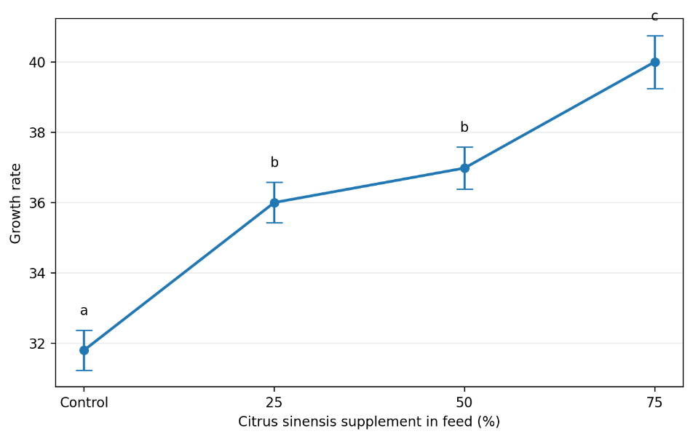
Protein content:
The total muscle protein content of Anabas testudineus fed diets supplemented with varying levels of Citrus sinensis peel is presented in Table 2. A significant increase (P < 0.05) in protein content was observed with increasing levels of dietary supplementation.
The highest protein content was recorded in the 75% inclusion group (23.8 ± 0.59), followed by the 50% (20.8 ± 0.59) and 25% (17.8 ± 0.59) groups, all of which were significantly higher than the control group (16.3 ± 0.58). Each treatment group differed significantly from one another, as indicated by distinct superscripts.
Statistical analysis using one-way ANOVA followed by Tukey’s HSD post-hoc test confirmed significant differences among all experimental groups (P < 0.05).
Table 2: Effect of Citrus sinensis in the total protein content of Anabas testudineus.
Percentage of feed | Experiment
Control | 16.3 ± 0.58ª
25% | 17.8 ± 0.59^{b}
50% | 20.8 ± 0.59^{c}
75% | 23.8 ± 0.59^{d}
ANOVA P<0.05, Mean±SD with different superscripts differ significantly between respective groups by Turkey’s post hoc test
Figure 2: Effect of Citrus sinensis in the total protein content of Anabas testudineus.
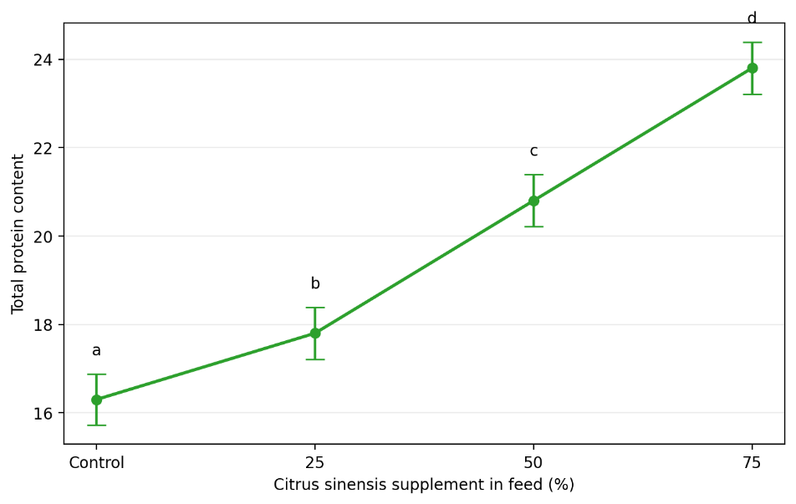
Cholesterol content:
The total cholesterol content of Anabas testudineus fed diets supplemented with varying levels of Citrus sinensis peel is presented in Table 3. A significant increase (P < 0.05) in cholesterol levels was observed across all treatment groups compared to the control.
The highest cholesterol content was recorded in the 75% inclusion group (9.7 ± 0.40), followed by the 50% (7.22 ± 0.36) and 25% (3.43 ± 0.50) groups. The control group exhibited the lowest value (2.08 ± 0.57). All experimental groups differed significantly from one another, as indicated by distinct superscripts.
Statistical analysis using one-way ANOVA followed by Tukey’s HSD post-hoc test confirmed that the differences among the groups were statistically significant (P < 0.05).
Table 3: Effect of Citrus sinensis in the total cholesterol content of Anabas testudineus.
Percentage of feed | Experiment
Control | 2.08 ± 0.57ª
25% | 3.43 ± 0.50b
50% | 7.22 ± 0.36^{c}
75% | 9.7 ± 0.40^{d}
ANOVA P<0.05, Mean±SD with different superscripts differ significantly between respective groups by Turkey’s post hoc test
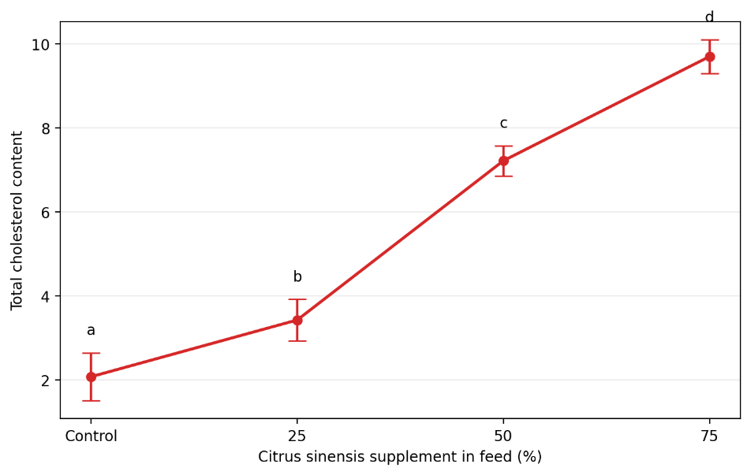
Carbohydrate content:
The total carbohydrate content of Anabas testudineus fed diets supplemented with different levels of Citrus sinensis peel is presented in Table 4. A significant increase (P < 0.05) in carbohydrate content was observed with increasing levels of dietary supplementation.
The highest carbohydrate content was recorded in the 75% inclusion group (22.4 ± 0.59), followed by the 50% (20.57 ± 0.59) and 25% (16.78 ± 0.40) groups, all of which were significantly higher than the control group (14.85 ± 0.49). Each treatment group differed significantly from one another, as indicated by distinct superscripts.
Statistical analysis using one-way ANOVA followed by Tukey’s HSD post-hoc test confirmed that the differences among the groups were statistically significant (P < 0.05).
Table 4: Effect of Citrus sinensis in the total Carbohydrate content of Anabas testudineus.
Percentage of feed | Experiment
Control | 14.85 ± 0.49ª
25% | 16.78 ± 0.4^{b}
50% | 20.57 ± 0.59^{c}
75% | 22.4 ± 0.59^{d}
ANOVA P<0.05, Mean±SD with different superscripts differ significantly between respective groups by Turkey’s post hoc test
Figure 3: Effect of Citrus sinensis in the total Carbohydrate content of Anabas testudineus.
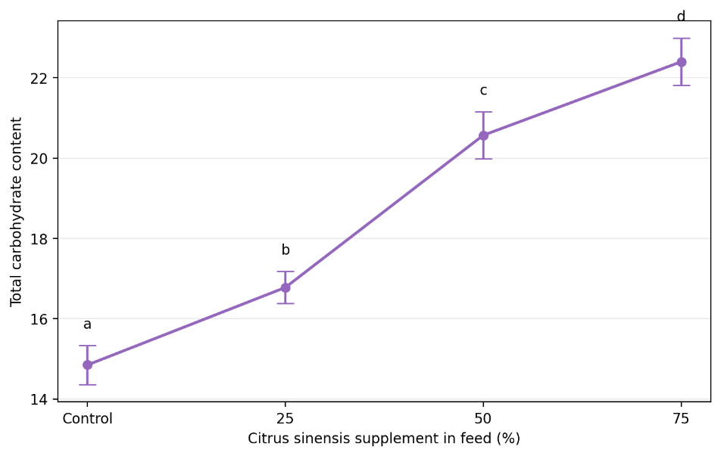
Haemoglobin content:
The haemoglobin content of Anabas testudineus fed diets supplemented with varying levels of Citrus sinensis peel is presented in Table 5. Significant differences (P < 0.05) were observed among the treatment groups.
The highest haemoglobin content was recorded in the 75% inclusion group (12.84 ± 0.53), followed by the 50% (12.26 ± 0.45) and control group (12.08 ± 0.38), while the lowest value was observed in the 25% group (12.00 ± 0.46). All groups differed significantly from one another, as indicated by distinct superscripts.
Statistical analysis using one-way ANOVA followed by Tukey’s HSD post-hoc test confirmed that the differences among treatment groups were statistically significant (P < 0.05).
Table 5: Haemoglobin content in Anabas testudineus at different concentration of Citrus sinensis.
Percentage of feed | Hemoglobin content
Control | 12.08 ± 0.38ª
25% | 12 ± 0.46^{b}
50% | 12.26 ± 0.45^{c}
75% | 12.84 ± 0.53^{d}
ANOVA P<0.05, Mean±SD with different superscripts differ significantly between respective groups by Turkey’s post hoc test
Figure 4: Haemoglobin content in Anabas testudineus at different concentration of Citrus sinensis
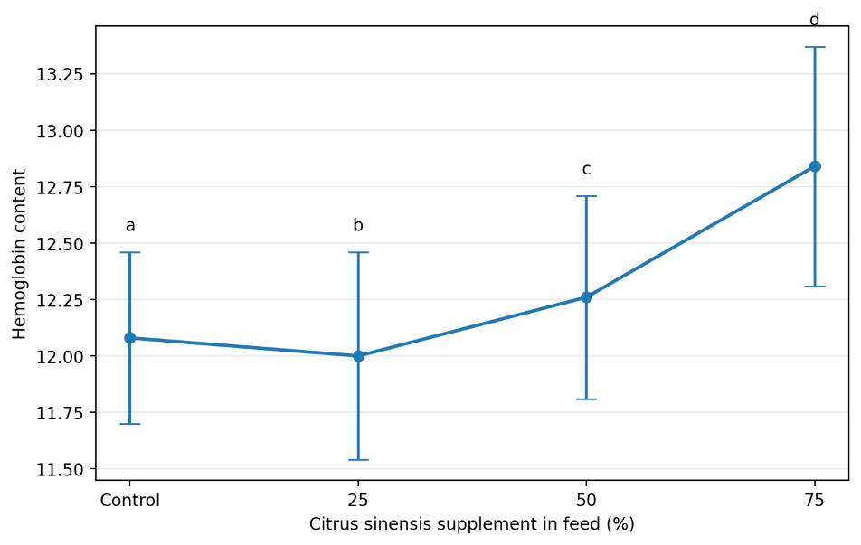
Red blood cell diameter:
The diameter of red blood cells (RBC) in Anabas testudineus fed diets supplemented with varying levels of Citrus sinensis peel is presented in Table 6. A significant increase (P < 0.05) in RBC diameter was observed with increasing levels of dietary supplementation.
The highest RBC diameter was recorded in the 75% inclusion group (3.8 ± 0.40), followed by the 50% (3.2 ± 0.40) and 25% (2.6 ± 0.48) groups, all of which were significantly higher than the control group (1.6 ± 0.48). Each treatment group differed significantly from one another, as indicated by distinct superscripts.
Statistical analysis using one-way ANOVA followed by Tukey’s HSD post-hoc test confirmed that the differences among the groups were statistically significant (P < 0.05).
Table 6: Diameter of RBC in Anabas testudineus at different concentration of Citrus sinensis feed.
Percentage of feed | Diameter of RBC
Control | 1.6 ± 0.48ª
25% | 2.6 ± 0.48^{b}
50% | 3.2 ± 0.4^{c}
75% | 3.8 ± 0.4^{d}
ANOVA P<0.05, Mean±SD with different superscripts differ significantly between respective groups by Turkey’s post hoc test
Figure 5: Diameter of RBC in Anabas testudineus at different concentration of Citrus sinensis feed.
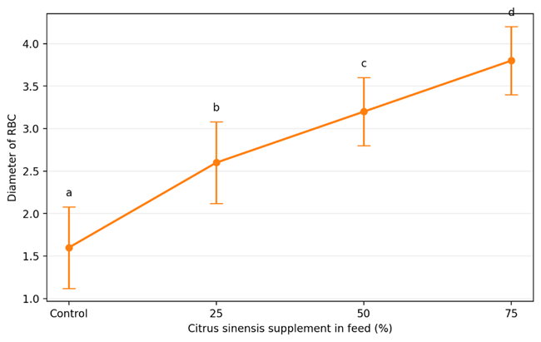

4. Discussion
The present study demonstrated that dietary supplementation of Citrus sinensis peel significantly improved growth performance, biochemical composition, and haematological parameters of Anabas testudineus, with effects being dose-dependent. The observed improvements may be attributed to the presence of bioactive compounds such as flavonoids, phenolics, and essential oils in citrus peel, which are known to enhance nutrient utilization and physiological functions in fish.
The significant increase in growth rate with increasing inclusion levels of C. sinensis peel indicates enhanced feed utilization and metabolic efficiency. The highest growth observed at 75% inclusion suggests that citrus peel supplementation positively influences digestive processes and nutrient absorption. Similar findings have been reported in fish fed phytobiotic-supplemented diets, where improved growth performance was associated with enhanced digestive enzyme activity and gut health (Hoseinifar et al., 2022; Van Hai, 2023). The presence of limonene and other bioactive compounds in citrus peel may stimulate appetite and improve feed conversion efficiency, thereby promoting growth.
Muscle protein content showed a significant increase with higher levels of dietary supplementation, indicating improved protein deposition and assimilation. This enhancement may be linked to the protein-sparing effect of phytobiotics, which optimize nutrient utilization and reduce protein catabolism. Previous studies have reported that plant-derived additives improve protein synthesis and retention in fish tissues, leading to better growth performance (Ahmadifar et al., 2021; Dawood et al., 2020). The progressive increase in protein content across treatments further supports the role of C. sinensis peel as a functional feed additive.
The increase in cholesterol levels observed in the present study may reflect enhanced lipid metabolism and energy availability rather than a negative physiological response. In fish, moderate increases in cholesterol are often associated with improved membrane stability and steroid synthesis. Similar trends have been reported in studies involving phytobiotic supplementation, where increased lipid fractions were linked to improved metabolic activity and physiological status (Reverter et al., 2021). However, the values remained within acceptable biological limits, suggesting no adverse effects on fish health.
Carbohydrate content also increased significantly with higher inclusion levels of C. sinensis peel, indicating improved energy storage and utilization. This may be attributed to enhanced digestive efficiency and carbohydrate metabolism stimulated by phytochemicals present in citrus peel. Flavonoids and phenolic compounds are known to influence carbohydrate metabolism by modulating enzyme activity and improving nutrient absorption (Kumar et al., 2020). The increase in carbohydrate levels may therefore contribute to the overall improvement in growth performance observed in this study.
Haematological parameters, particularly haemoglobin content and RBC diameter, showed significant improvement in response to dietary supplementation. The increase in haemoglobin levels suggests enhanced oxygen-carrying capacity and improved physiological status of the fish. Similarly, the increase in RBC diameter may indicate improved erythropoiesis and cellular health. These findings are consistent with previous studies demonstrating that phytobiotics enhance haematological parameters by stimulating immune function and improving overall fish health (Hoseinifar et al., 2022; Van Hai, 2023). The bioactive compounds in citrus peel, particularly antioxidants, may play a key role in protecting blood cells from oxidative stress and improving their functionality.
Overall, the results of the present study confirm that Citrus sinensis peel acts as an effective natural feed additive, enhancing growth, biochemical composition, and haematological health in Anabas testudineus. The observed improvements can be attributed to the synergistic effects of phytochemicals present in citrus peel, which enhance digestion, nutrient utilization, and physiological functions. These findings are in agreement with recent studies highlighting the potential of plant-based feed additives as sustainable alternatives to synthetic growth promoters in aquaculture.

5. Conclusion
The present study demonstrates that dietary supplementation of Citrus sinensis peel significantly enhances growth performance, biochemical composition, and haematological parameters of Anabas testudineus. The observed improvements were dose-dependent, with the highest inclusion level (75%) yielding the most pronounced effects in terms of growth rate, protein accumulation, and physiological health indicators.
The enhancement in growth and nutrient composition suggests improved feed utilization and metabolic efficiency, while the positive changes in haemoglobin content and RBC diameter indicate better physiological status and oxygen-carrying capacity. These effects can be attributed to the presence of bioactive compounds in citrus peel, which promote digestion, nutrient absorption, and overall fish health.
The findings highlight the potential of C. sinensis peel as a cost-effective, natural, and eco-friendly feed additive in aquaculture. Its utilization not only improves fish performance but also supports sustainable aquaculture practices through the valorization of agro-industrial waste.
Further studies are recommended to optimize inclusion levels under different culture conditions and to evaluate long-term effects on fish health and product quality.
REFERENCES
Ahmadifar, E., Dawood, M.A.O., Moghadam, M.S., Sheikhzadeh, N., Hoseinifar, S.H., Musthafa, M.S., & Van Doan, H. (2021). The use of plant-derived compounds in aquaculture: A review. Aquaculture Research, 52(7), 3024–3045.
Costello, C., Cao, L., Gelcich, S., Cisneros-Mata, M.Á., Free, C.M., Froehlich, H.E., Golden, C.D., Ishimura, G., Maier, J., Macadam-Somer, I., Mangin, T., Melnychuk, M.C., Miyahara, M., de Moor, C.L., Naylor, R., Nøstbakken, L., Ojea, E., O’Reilly, E., Parma, A.M., Plantinga, A.J., Thilsted, S.H., & Lubchenco, J. (2020). The future of food from the sea. Nature, 588, 95–100.
Dawood, M.A.O., Koshio, S., Esteban, M.Á., & El-Haroun, E.R. (2020). Beneficial roles of feed additives as immunostimulants in aquaculture: A review. Aquaculture, 500, 950–965.
Folch, J., Lees, M., & Sloane Stanley, G.H. (1957). A simple method for the isolation and purification of total lipids from animal tissues. Journal of Biological Chemistry, 226(1), 497–509.
Francis, G., Makkar, H.P.S., & Becker, K. (2005). Use of plant-derived products in aquaculture feeds. Aquaculture, 250(1–2), 3–16.
Gatlin, D.M., Barrows, F.T., Brown, P., Dabrowski, K., Gaylord, T.G., Hardy, R.W., Herman, E., Hu, G., Krogdahl, Å., Nelson, R., Overturf, K., Rust, M., Sealey, W., Skonberg, D., Souza, E.J., Stone, D., Wilson, R., & Wurtele, E. (2007). Expanding the utilization of sustainable plant products in aquafeeds. Aquaculture Research, 38(6), 551–579.
Hoseinifar, S.H., Sun, Y.Z., Wang, A., & Zhou, Z. (2022). Probiotics and phytobiotics in aquaculture: Impacts on growth, immunity, and gut microbiota. Aquaculture, 548, 737–755.
Kumar, N., Goel, N., & Saini, A. (2020). Nutritional and phytochemical potential of citrus peel: A review. Journal of Food Composition and Analysis, 89, 103–465.
Lowry, O.H., Rosebrough, N.J., Farr, A.L., & Randall, R.J. (1951). Protein measurement with the Folin–Ciocalteu reagent. Journal of Biological Chemistry, 193(1), 265–275.
Reverter, M., Bontemps, N., Lecchini, D., Banaigs, B., & Sasal, P. (2021). Use of plant extracts in fish aquaculture as an alternative to chemotherapy: Current status and future perspectives. Reviews in Aquaculture, 13(3), 1139–1159.
Subasinghe, R., Soto, D., & Jia, J. (2009). Global aquaculture and its role in sustainable development. Reviews in Aquaculture, 1(1), 2–9.
Tacon, A.G.J., & Metian, M. (2015). Feed matters: Satisfying the feed demand of aquaculture. Reviews in Fisheries Science & Aquaculture, 23(1), 1–10.
Van Hai, N. (2023). The use of medicinal plants as immunostimulants in aquaculture: A review. Aquaculture, 562, 738–756.
Yemm, E.W., & Willis, A.J. (1954). The estimation of carbohydrates in plant extracts by anthrone. Biochemical Journal, 57(3), 508–514.

