Original Research Article
Evaluating Water Quality Dynamics and Anthropogenic Influences in Rajapukhuri Pond, Rampur, Kamrup, Assam

ABSTRACT:
Rajapukhuri Pond, located in Rampur village of Kamrup District, Assam, is an important freshwater resource supporting local biodiversity and community needs. The present study evaluates the physico-chemical characteristics of the pond water and examines seasonal variations and anthropogenic influences on its water quality. Water samples were collected twice monthly from February to May 2025, covering pre-monsoon and early monsoon periods, and analyzed following standard APHA (2017) procedures. Key parameters assessed included temperature, pH, dissolved oxygen (DO), free carbon dioxide (CO₂), total dissolved solids (TDS), and electrical conductivity (EC). The results revealed a gradual seasonal increase in temperature (19.8–24.0°C) accompanied by a corresponding decline in DO and CO₂, reflecting natural limnological processes. The pond water remained slightly alkaline (pH 7.32–8.21), while DO concentrations (6.19–8.74 mg/L) consistently remained above levels required to support aquatic life. Low TDS (43–47 ppm) and EC (86–102 µS/cm) values indicated minimal mineralization and limited anthropogenic disturbance. Comparison with Bureau of Indian Standards (BIS) and World Health Organization (WHO) guidelines confirmed the suitability of the pond water for sustaining aquatic ecosystems. Overall, the study indicates that Rajapukhuri Pond maintains good ecological health and stable water quality conditions. Regular monitoring, protection of the catchment area, and community participation are recommended to ensure the long-term conservation and sustainable management of this freshwater ecosystem.

1. Introduction:
Water is one of the most essential natural resources for sustaining life on Earth. It plays a crucial role in maintaining ecological balance, supporting biodiversity, and fulfilling domestic, agricultural, and industrial needs. However, with rapid urbanization, industrialization, population growth, and unsustainable land-use practices, the quality of water resources has been deteriorating at an alarming rate. Contamination of water bodies from human activities has emerged as a major environmental challenge, posing serious threats to aquatic ecosystems and public health. The growing demand for water and the resulting stress on natural sources necessitates a detailed assessment of water quality. Ponds, lakes, rivers, and wetlands act as critical habitats that regulate hydrological cycles, sustain biodiversity, and provide livelihood opportunities to nearby communities. In rural and semi-urban regions, ponds are especially important as they serve multiple purposes—irrigation, fish culture, washing, bathing, and, in some cases, drinking. Maintaining their physico-chemical integrity is therefore vital for sustainable ecosystem functioning.
Among the numerous factors influencing water quality, physico-chemical parameters such as temperature, pH, dissolved oxygen (DO), biochemical oxygen demand (BOD), total dissolved solids (TDS), electrical conductivity (EC), and turbidity are widely recognized as key indicators of aquatic health. These parameters not only determine the suitability of water for various uses but also reflect the extent of pollution and the self-purification capacity of the water body. Seasonal variations, rainfall patterns, and anthropogenic discharges—including sewage inflow, agricultural runoff, and industrial effluents—further modulate these parameters. Thus, a systematic evaluation of these variables provides valuable insights into the ecological condition of aquatic systems.
In the context of Assam, numerous ponds, wetlands, and beels (oxbow lakes) serve as vital freshwater resources supporting biodiversity and local livelihoods. However, increasing encroachment, discharge of untreated waste, and conversion of catchment areas for agriculture or urban development have contributed to the gradual decline in water quality. The Rajapukhuri pond located in Rampur, Kamrup District, Assam, is one such important water body that caters to multiple community needs. Over time, it has been subjected to anthropogenic pressures, necessitating a scientific evaluation to determine its current water quality and ecological health.
Several studies in India and abroad have explored the physico-chemical characteristics of freshwater bodies, offering valuable insights into their ecological health, pollution dynamics, and management challenges. The study “Assessment of Water Quality Trends in Deepor Beel, Assam, India” by Roy and Majumder (2022) presented an extensive three-year evaluation of Deepor Beel, a Ramsar site in Assam, using the National Sanitation Foundation Water Quality Index (NSF WQI) and the Canadian Council of Ministers of Environment Water Quality Index (CCME WQI). Their findings indicated fair overall water quality (NSF WQI 55–76) that declined during the summer due to increased turbidity and eutrophication from nitrate and phosphate enrichment. A gradual annual deterioration was also noted, emphasizing the urgent need for effective wetland management.
Sargar and Thakare (2024) studied the physico-chemical parameters of the Niwali Reservoir in Maharashtra to assess its suitability for drinking, irrigation, and aquaculture. Seasonal variations were observed in temperature, pH, and DO, although most values remained within the permissible limits prescribed by Indian Standards (IS) and the World Health Organization (WHO). The study stressed the need for continuous monitoring to ensure long-term sustainability. Islam et al. (2014) examined the water quality of Deepor Beel at selected sites by analyzing temperature, DO, BOD, TDS, and turbidity. They found moderate pollution characterized by high turbidity and low DO levels, which were attributed to industrial encroachment and urban runoff. The study highlighted the necessity of conservation measures to protect this ecologically sensitive wetland. In Chhattisgarh, Mishra and Singh (2024) analyzed the water quality of Kori Dam, Bilaspur District, focusing on seasonal changes in temperature, pH, TDS, DO, BOD, and COD. The results showed relatively good water quality during the pre-monsoon season, which declined in the monsoon due to increased runoff and sedimentation, demonstrating the influence of climatic and anthropogenic factors on water chemistry. Rana et al. (2017) evaluated freshwater ponds in Bijnor District, Uttar Pradesh, analyzing parameters such as pH, DO, BOD, COD, hardness, and chloride content. Although most parameters exceeded WHO and BIS limits for drinking water, the ponds were found suitable for fish culture, indicating resilience in moderately polluted systems.
Sarmah et al. (2020) investigated seasonal variations in the Dikhow River, a tributary of the Brahmaputra, assessing parameters such as pH, DO, turbidity, hardness, and EC. The results showed that DO was lowest in winter and highest during the monsoon, while turbidity increased significantly during floods due to mining and other human activities. The study underscored the ecological vulnerability of the river to seasonal and anthropogenic impacts. Deori and Baruah (2020) studied Charan Beel in Morigaon District, Assam, and reported increased TDS, conductivity, and turbidity during the monsoon season, attributed to nutrient loading and sediment inflow from agricultural runoff. The beel exhibited signs of moderate eutrophication, calling for proper management to prevent further degradation. Kumar et al. (2023) conducted a detailed study on pond water quality in Panipat, Haryana, analyzing pH, EC, TDS, hardness, and major ions. The Water Quality Index ranged from 40.77 to 78.86, classifying most ponds as “poor” to “very poor.” The results suggested high mineralization and anthropogenic influence, reinforcing the need for regular monitoring. Murali et al. (2025) assessed the Manli River in Thrissur, Kerala, analyzing physical, chemical, and bacteriological parameters. While most chemical parameters remained within IS:10500–2012 limits, severe bacteriological contamination from coliform bacteria was observed downstream, particularly in urbanized and industrial regions. The study recommended improved waste management and infrastructure development. Dixit et al. (2015) analyzed pond water in 27 villages of Bilaspur District, Chhattisgarh, measuring pH, EC, TDS, temperature, salinity, and DO. The water was found to be slightly to strongly alkaline, with moderate TDS and DO levels supportive of aquatic life. Agricultural runoff and domestic waste were identified as primary factors influencing water chemistry. In Bangladesh, Munni et al. (2015) investigated pond water in Tangail to assess its suitability for fish culture. Parameters such as temperature, pH, DO, BOD, and EC were generally within acceptable limits, though fluctuating DO levels occasionally stressed aquatic organisms, indicating a need for better pond management.
Kakati et al. (2024) examined leachate pollution from the municipal dumping ground near Deepor Beel, finding extreme turbidity (up to 693 NTU), high BOD (458 mg/L), and heavy metal concentrations (arsenic, lead, nickel) far exceeding WHO and BIS limits. The study exposed the severe degradation of Deepor Beel due to unregulated waste disposal. Jain and Kumar (2021) conducted a limnological investigation of Akshar Vihar Pond in Bareilly, revealing significant seasonal variations in DO and hardness, with high COD and BOD values during post-monsoon seasons due to increased organic loading. The pond water remained “very hard” throughout the year, emphasizing the importance of routine monitoring.
Collectively, these studies demonstrate that freshwater bodies across diverse regions face similar challenges such as eutrophication, nutrient enrichment, sedimentation, and microbial contamination caused by human activities. Seasonal fluctuations further influence these parameters, affecting ecological balance and water usability. Insights from these investigations provide both methodological and conceptual frameworks for evaluating the water quality of the Rajapukhuri pond. By comparing the present findings with established standards and trends observed elsewhere, this study contributes to the growing body of knowledge on freshwater management and supports sustainable conservation practices in Assam and comparable ecological settings.
The present study aims to determine and analyze the physico-chemical parameters of Rajapukhuri Pond water during different seasons to understand the temporal variations in water quality. It further seeks to assess the overall water quality status using standard indices and to identify the major factors influencing its spatial and seasonal fluctuations. In addition to this, the study attempts to evaluate the interrelationships among various physico-chemical parameters through statistical correlation and multivariate analysis to identify the dominant controlling factors governing the pond’s water characteristics.
A critical aspect of the investigation involves examining the potential impact of anthropogenic activities and surrounding land-use patterns on the pond’s ecological health. The results are compared with national and international water quality standards such as those prescribed by the Bureau of Indian Standards (BIS) and the World Health Organization (WHO) to determine the suitability of the pond water for domestic, recreational, and aquatic life-supporting purposes. Through this integrated assessment, the study also seeks to provide scientific insights and practical recommendations for the sustainable management and conservation of Rajapukhuri Pond, contributing to a broader understanding of freshwater ecosystem health and environmental protection in the region.
2. Materials and Methods:
2.1. Study Area
The present study was conducted at Rajapukhuri, a large pond situated in Rampur village of Dahali, Bhagawatipara, in Kamrup district, Assam. The site holds both historical and ecological importance and is located approximately 31 km from Guwahati city, accessible via the main road. Geographically, the pond lies between 26.099146° N latitude and 91.482337° E longitude (Fig. 1). The pond is renowned for its expansive water spread and serves as an important freshwater body supporting the local community as well as the surrounding biodiversity.
Rajapukhuri Pond is surrounded by lush green vegetation, typical of the region, which contributes to its aesthetic appeal and ecological vitality. The surrounding habitat supports a rich diversity of resident and migratory birds, making it an attractive site for naturalists and bird watchers. The pond also sustains a variety of aquatic flora and fauna, including numerous fish and plant species that play a crucial role in maintaining the ecological balance of the area.
To illustrate the geographical context of the study site, Figure 1 presents the GPS view of Rajapukhuri, while Figure 2 shows the satellite image of the pond and its surrounding area. In addition, Figure 3 provides a series of maps for spatial reference: (A) the map of India, (B) the map of Assam state, and (C) the map of Kamrup Rural District, where Rajapukhuri is located. These visual representations aid in understanding the precise location and geographical setting of the pond within the broader regional framework.
The study area was selected for its ecological significance, accessibility, and representativeness of local pond ecosystems in Assam. Seasonal water sampling and analysis were carried out to examine variations in physico-chemical parameters and to assess water quality dynamics in relation to both environmental factors and anthropogenic influences.
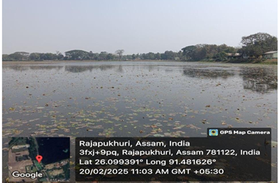

Figure 1: Geographical Positioning System (GPS) view showing the exact location of Rajapukhuri Pond, Rampur, Kamrup, Assam.
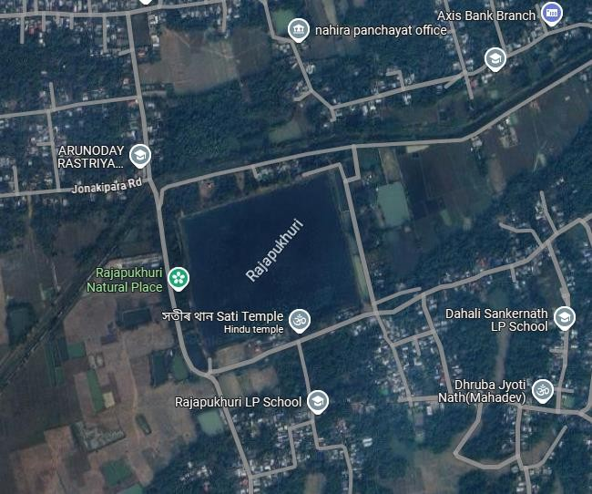

Figure 2: Satellite imagery depicting the spatial extent and surrounding landscape of Rajapukhuri Pond, Rampur, Kamrup, Assam.
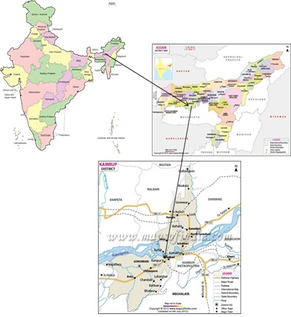

Figure 3: (A) Map of India showing the location of Assam; (B) Map of Assam highlighting Kamrup district; and (C) Map of Kamrup Rural District indicating the position of Rajapukhuri Pond.
2.2. Sample Collection:
A systematic and comprehensive investigation of the water quality of Rajapukhuri Pond was undertaken over a period of four months, from February 2025 to May 2025, with the objective of capturing seasonal variations and understanding the overall ecological health of the pond. This duration covered both pre-monsoon and early monsoon phases, enabling the assessment of natural fluctuations in the physico-chemical characteristics of the water.
Water sampling was carried out twice a month during the study period from multiple points across the pond to ensure representative coverage of the entire water body. Samples were collected in pre-cleaned 1,000 mL high-density polyethylene bottles by submerging them gently 10–15 cm below the water surface, keeping the mouth of the container against the direction of flow to avoid contamination by surface films and floating debris. To minimize diurnal variation, all sampling activities were conducted between 10:00 AM and 11:00 AM under similar weather conditions.

Table 1: Analytical methods employed for the determination of physico-chemical parameters of Rajapukhuri Pond.

Sl. NO | Water Quality arameters | Method of Analysis
1 | Temperature | Thermometric Method
2 | pH | Digital pH meter
3 | Free CO2 | Titrimetric method
4 | Dissolved Oxygen | Winkler’s Method
5 | Total Dissolved Solids | Digital TDS meter
6 | Electrical Conductivity | Digital EC meter

Before each sampling, the containers were thoroughly rinsed with deionized water and subsequently with pond water at the site. The collected samples were clearly labeled with date, time, and location, then transported to the departmental laboratory under controlled conditions. Upon arrival, the samples were refrigerated at 4°C to maintain their stability and prevent any alteration of physical and chemical characteristics prior to analysis.
In the laboratory, each parameter was analyzed following standard procedures recommended by APHA (2017) to ensure precision and reproducibility. The measured parameters included temperature, pH, free carbon dioxide, dissolved oxygen (DO), total dissolved solids (TDS), and electrical conductivity (EC) — all of which are crucial indicators of the pond’s water quality and ecological balance. The analytical methods used for each parameter are summarized in Table 1, which lists the instruments and techniques adopted for accurate quantification.
2.3. Physico-Chemical Analysis
The physico-chemical characteristics of the collected samples were analyzed to assess the overall water quality and to understand seasonal variations during the study period. The parameters examined included:
- Temperature
- pH
- Free Carbon Dioxide (CO₂)
- Dissolved Oxygen (DO)
- Total Dissolved Solids (TDS)
- Electrical Conductivity (EC)
The results obtained were meticulously recorded and tabulated for subsequent interpretation of trends and correlations among parameters.
2.4. Required Instrumentation
All laboratory analyses were performed in the Department of Zoology, D.K. College, Mirza, using calibrated instruments and standard laboratory glassware. The major instruments and apparatus used during the study are listed below:
- Mercury thermometer – for measurement of water temperature.
- Digital pH meter or pH strips – for determination of pH.
- Titration apparatus – including BOD bottles, conical flasks, pipettes, beakers, measuring cylinders, droppers, and a spirit lamp, for estimation of dissolved oxygen and free CO₂.
- Digital TDS and EC meters – for determination of total dissolved solids and electrical conductivity.
All instruments were cleaned and calibrated prior to use to ensure accuracy and reproducibility of results.

2.5. Determination of Dissolved Oxygen (DO) – Winkler’s Method
The concentration of dissolved oxygen in water samples was estimated by Winkler’s titrimetric method, based on oxidation–reduction reactions. In this method, dissolved oxygen oxidizes manganous ions under alkaline conditions to form manganese dioxide (MnO₂). This, in turn, reacts with potassium iodide to liberate iodine, which is titrated with standard sodium thiosulfate (Na₂S₂O₃) solution using starch as an indicator. The endpoint is indicated by the disappearance of the blue color.
Calculation:
$$\text{DO (mg/L)}=\frac{V×N×8×1000}{\text{mL of sample}}$$
Where:
- V = Volume of 0.01 N Na₂S₂O₃ used (mL)
- N = Normality of Na₂S₂O₃ (usually 0.01 N)
- 8 = Equivalent weight factor for oxygen
This method provides an accurate estimation of oxygen concentration, an essential indicator of the pond’s ability to support aquatic life.
2.6. Estimation of Free Carbon Dioxide (CO₂)
Free CO₂ in the water samples was determined by acid–base titration using phenolphthalein indicator and standard sodium hydroxide (NaOH) solution. The presence of free CO₂ renders water slightly acidic. During titration, CO₂ reacts with NaOH to form sodium bicarbonate, resulting in an increase in pH until a faint pink color appears at the endpoint (pH 8.3).
Procedure:
- Take 100 mL of the water sample in a clean conical flask.
- Add a few drops of phenolphthalein indicator.
- If the sample turns pink, free CO₂ is absent.
- If the sample remains colorless, free CO₂ is present.
- Titrate the colorless sample with 0.05 N NaOH until a faint pink color appears, indicating the endpoint.
Calculation:
$$\text{Free CO₂ (mg/L)}=\frac{V×N×44×1000}{\text{mL of sample}}$$
Where:
- V = Volume of 0.01 N NaOH used (mL)
- N = Normality of NaOH (usually 0.01 N)
- 44 = Molecular weight of CO₂
This method provides an estimation of the free carbon dioxide content, a key factor influencing the acidity and buffering capacity of the pond water.
2.6. Data Analysis
All recorded data were statistically analyzed to evaluate spatial and temporal variations in the measured parameters. The results were compared with the Bureau of Indian Standards (BIS, 2012) and World Health Organization (WHO, 2017) guidelines for water quality assessment to interpret the ecological condition of Rajapukhuri Pond.
3. Result and Discussion:
3.1 Temperature
During the study period, the surface water temperature of Rajapukhuri Pond exhibited distinct seasonal variation, ranging from 19.8°C to 24°C, with a mean value of 21.5°C (Table 2). The lowest temperature was recorded in February (19.8°C), while the highest was observed in May (24°C). This gradual rise in temperature, as depicted in Figure 4, reflects the natural climatic transition from the cooler pre-monsoon months to the onset of warmer early monsoon conditions.
Temperature plays a pivotal role in controlling various physicochemical and biological processes within aquatic ecosystems. It influences metabolic activities, enzymatic reactions, gas solubility, and reproductive cycles of aquatic organisms. A moderate increase in temperature generally promotes photosynthetic activity and planktonic growth, while excessive warming can reduce dissolved oxygen (DO) concentrations, thereby stressing aquatic fauna.
The observed temperature range suggests that Rajapukhuri Pond maintains a favorable thermal environment capable of supporting a balanced and diverse aquatic community. Similar seasonal warming trends have been reported by Deori and Baruah (2020) in Charan Beel and Patra et al. (2018) in Deepor Beel, where pre-monsoon temperature increases were found to significantly influence oxygen dynamics, nutrient availability, and algal proliferation.

Table 2: Monthly variation in surface water temperature of Rajapukhuri Pond recorded during February–May 2025. The temperature values show a gradual increase from winter to early monsoon months, reflecting the natural seasonal warming trend typical of freshwater ecosystems in Assam.

Month | Temperature
February | 19.8℃
March | 20℃
April | 22.2℃
May | 24℃

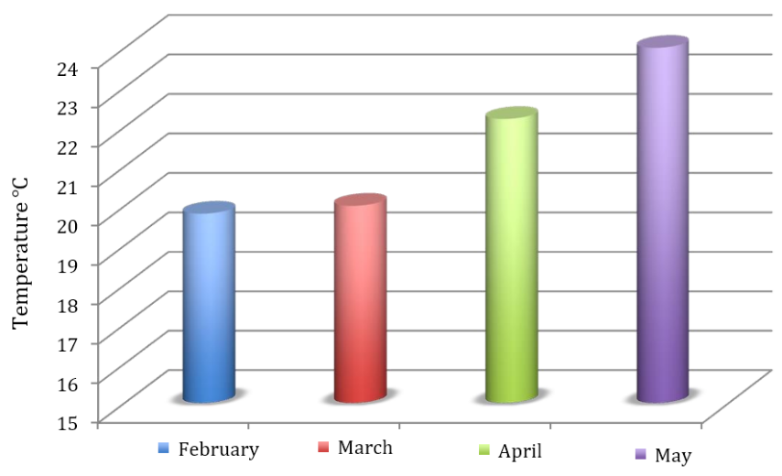

Figure 4. Graphical representation of the monthly variation in surface water temperature of Rajapukhuri Pond during the study period (February–May 2025). The figure illustrates a gradual rise in temperature from winter to pre-monsoon months, reflecting seasonal climatic influence on the pond ecosystem.
3.1. pH (Potential of Hydrogen)
The pH values of the pond water varied between 7.32 and 8.21, with an average of 7.38, indicating that the water is near-neutral with a slight tendency toward alkalinity. Such a range is considered ideal for most freshwater biota, as it maintains a balanced carbon dioxide–bicarbonate–carbonate equilibrium essential for photosynthetic processes.
Alkaline conditions often result from active photosynthesis by aquatic plants and phytoplankton, which consume carbon dioxide and thereby increase pH levels. High pH can also be associated with limited rainfall and reduced dilution during dry months. According to APHA (2017), water with pH values between 6.5 and 8.5 is suitable for aquatic life and safe for general ecological balance.
The observed pH stability throughout the study period indicates minimal anthropogenic interference. Studies by Sarmah et al. (2020) and Gupta (2009) similarly report slightly alkaline pH in natural ponds and beels of Assam, linked to photosynthetic carbon assimilation and low organic pollution.
3.3. Free Carbon Dioxide (CO₂)
Free CO₂ concentration, estimated using the titrimetric method, showed a consistent declining trend from 10.23 mg/L in February to 7.30 mg/L in May, as presented in Table 3. The gradual reduction in CO₂ levels across the four-month period is clearly illustrated in Figure 5, which highlights the seasonal shift in carbon dioxide dynamics within the pond ecosystem.
Table 3. Variation in free CO₂ concentration of Rajapukhuri Pond
Month | Free CO₂ (mg/L)
February | 10.23 mg/L of CO₂ at NTP
March | 9.33 mg/L of CO₂ at NTP
April | 8.44 mg/L of CO₂ at NTP
May | 7.30 mg/L of CO₂ at NTP

Free carbon dioxide is a key component of the aquatic carbon cycle and plays a crucial role in maintaining the acid–base balance of freshwater systems. Higher CO₂ concentrations during the cooler months (February–March) may be attributed to increased respiration and decomposition of organic matter, combined with reduced photosynthetic uptake due to lower sunlight availability and lower productivity of primary producers. As temperature and light intensity rise toward the pre-monsoon period, enhanced photosynthetic activity by phytoplankton and aquatic macrophytes utilizes more CO₂, resulting in a progressive decline in its concentration.
A similar seasonal pattern was reported by Islam et al. (2014) in Deepor Beel, where CO₂ levels decreased during periods of active photosynthesis. Although elevated CO₂ can cause acidification and interfere with oxygen absorption in fish, the levels observed in Rajapukhuri Pond remained within acceptable ecological limits, indicating a healthy balance between respiration and photosynthetic processes in the pond ecosystem.
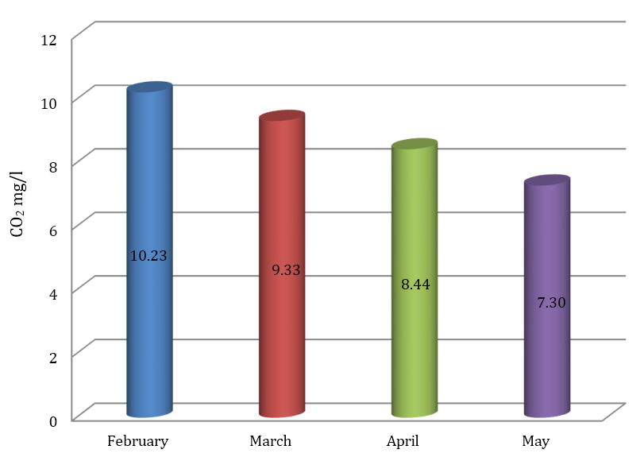

Figure 5.
Graphical representation of the monthly variation in free CO₂ concentration in Rajapukhuri Pond during the study period (February–May 2025).
3.4. Dissolved Oxygen (DO)
The dissolved oxygen (DO) content of Rajapukhuri Pond exhibited noticeable seasonal variation during the study period, ranging from 6.19 mg/L to 8.74 mg/L (Table 4). The highest DO concentration (8.74 mg/L) was recorded in February, while the lowest (6.19 mg/L) was observed in May. This downward trend in DO levels across the months is illustrated in Figure 6, which clearly depicts the inverse relationship between rising temperature and declining oxygen availability in the water column.

Table 4. Monthly variation in dissolved oxygen (DO) concentration of Rajapukhuri Pond

Month | DO (mg/L)
February | 8.74 mg/L
March | 7.92 mg/L
April | 7.84 mg/L
May | 6.19 mg/L

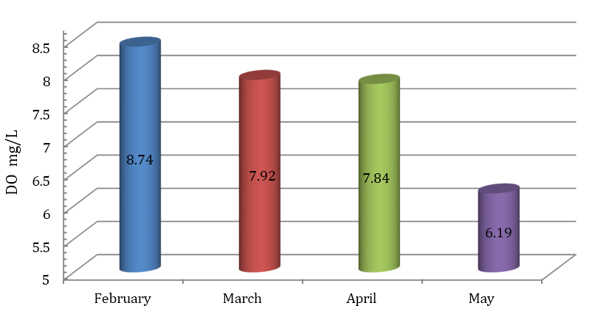

Figure 6. Graphical representation of monthly variation in dissolved oxygen (DO) concentration of Rajapukhuri Pond during February–May 2025.

During the cooler months, higher DO levels can be attributed to enhanced atmospheric diffusion, lower metabolic oxygen demand, and reduced microbial decomposition. As the season progressed toward summer, increased water temperature coupled with intensified microbial activities likely contributed to the gradual decline in DO concentration. This trend is consistent with the fundamental principle that oxygen solubility decreases with increasing temperature, influencing metabolic and ecological dynamics in aquatic systems.
Despite the seasonal decline, all recorded DO values remained above 6 mg/L, indicating that the pond maintained a healthy and supportive environment for aquatic organisms throughout the study period. According to Mahamuni and Khobragade (2020), DO concentrations between 5 and 8 mg/L characterize moderately productive water bodies with balanced ecological functioning. Furthermore, Rana and Jain (2017) reported that ponds maintaining DO levels above 6 mg/L support diverse and productive fish communities. The observed DO pattern in Rajapukhuri Pond therefore reflects a stable and ecologically favorable freshwater ecosystem.
3.5. Total Dissolved Solids (TDS)
The Total Dissolved Solids (TDS) concentration in Rajapukhuri Pond demonstrated a slight but consistent increase over the study period, ranging from 43 ppm in February to 47 ppm in May, with an average value of 44.7 ppm (Table 5). This gradual rise is depicted in Figure 7, which clearly illustrates the seasonal trend in dissolved solid content.

Table 5. Monthly variation in Total Dissolved Solids (TDS) concentration in Rajapukhuri Pond during the study period (February–May 2025).
Month | TDS (ppm)
February | 43 ppm
March | 44 ppm
April | 45 ppm
May | 47 ppm
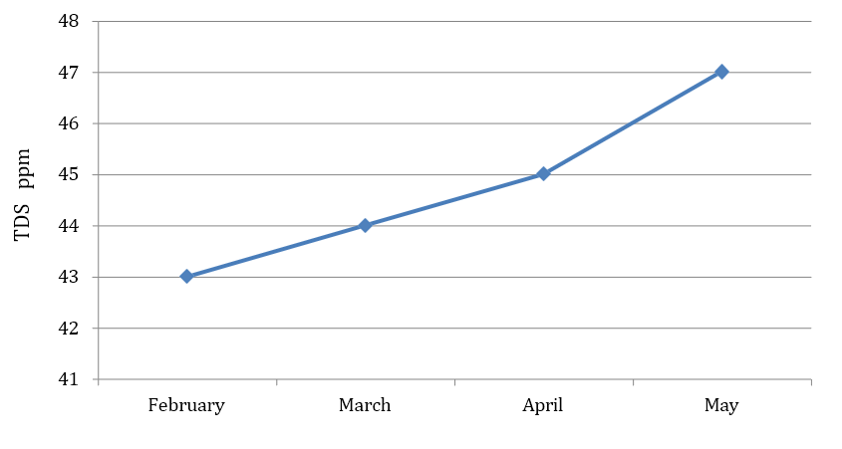

Figure 7. Monthly variation in Total Dissolved Solids (TDS) in Rajapukhuri Pond during February–May 2025.
The observed TDS levels indicate a low ionic concentration, suggesting minimal mineral input and limited anthropogenic influence in the pond ecosystem. Such low TDS values are characteristic of unpolluted freshwater systems, reflecting good water quality and supporting a balanced aquatic environment. TDS represents the total concentration of dissolved organic and inorganic substances, including salts, minerals, and ions. Elevated TDS levels can adversely affect aquatic organisms by interfering with osmoregulatory processes, reducing water clarity, and altering habitat conditions. However, the values recorded in Rajapukhuri Pond remain well below the permissible limit of 500 ppm recommended by the World Health Organization (WHO, 2011) for freshwater bodies, further indicating healthy water conditions.
Comparable observations were reported by Sargar and Thakare (2024) in freshwater ponds of Maharashtra, where low TDS levels were associated with high aquatic productivity and suitability for fish culture. The gradual increase observed in Rajapukhuri Pond toward summer may be attributed to evaporation and concentration effects, a common phenomenon in shallow water bodies subjected to rising temperatures. Overall, the TDS profile confirms that Rajapukhuri Pond maintains good water quality and stable ecological conditions, supporting sustained biological productivity.
3.6. Electrical Conductivity (EC)
The electrical conductivity (EC) of Rajapukhuri Pond exhibited a gradual increase over the study period, ranging from 86 μS/cm in February to 102 μS/cm in May, with a mean value of 91.5 μS/cm (Table 6). This progressive rise in conductivity is visually represented in Figure 8, reflecting seasonal concentration of dissolved ions as temperatures increased and evaporation intensified toward the early monsoon period.
Table 6. Monthly variation in Electrical Conductivity (EC) of Rajapukhuri Pond during the study period (February–May 2025).
Month | Electrical Conductivity (EC)
February | 86
March | 88
April | 90
May | 102
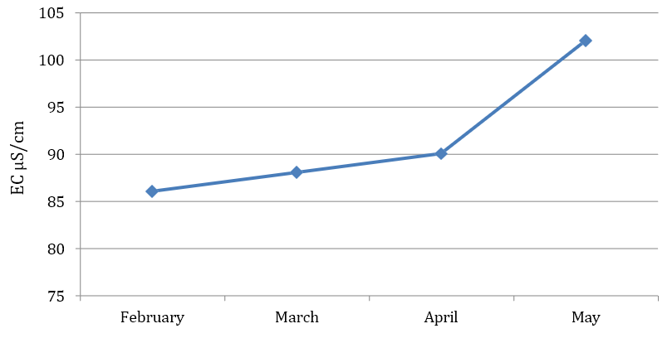

Figure 8. Monthly variation in Electrical Conductivity (EC) of Rajapukhuri Pond during February–May 2025.

Electrical conductivity serves as an indirect measure of the ionic and mineral content of water and is closely related to Total Dissolved Solids (TDS). The moderate EC values observed during the study indicate a low to moderate nutrient status, characteristic of healthy freshwater bodies with balanced ionic composition and limited anthropogenic input.
Low EC values typically suggest reduced inorganic loading, minimal runoff, and low pollution stress, while substantial increases may signal eutrophication or contamination. The observed EC values in Rajapukhuri Pond fall within the desirable range for freshwater ecosystems and are comparable to those reported by Pathan (2019) and Mishra & Singh (2024) in ecologically balanced, low-salinity water bodies supporting rich aquatic biodiversity. Overall, the EC trend supports the interpretation that Rajapukhuri Pond maintains good ecological stability and natural ionic equilibrium, further reinforcing its suitability for sustaining aquatic flora and fauna.
3.7. Integrated Interpretation and Ecological Insights
An integrated assessment of the measured physico-chemical parameters indicates that Rajapukhuri Pond maintains a stable and ecologically balanced condition throughout the study period. The gradual rise in temperature accompanied by a corresponding decline in dissolved oxygen (DO) and free carbon dioxide (CO₂) reflects natural seasonal thermal and biological cycles typical of freshwater ecosystems. The slightly alkaline pH, combined with consistently low values of TDS and EC, suggests minimal anthropogenic influence and supports active photosynthetic and nutrient-cycling processes within the pond.
The relationship among the parameters highlights the dynamic equilibrium operating within the pond ecosystem:
- Temperature regulates metabolic activity and influences DO solubility;
- pH governs ion speciation and CO₂ buffering capacity;
- CO₂ and DO exhibit reciprocal trends driven by photosynthesis–respiration cycles;
- TDS and EC jointly reflect mineral content and ionic strength of the water.
Such balanced interactions characterize a self-sustaining, moderately productive freshwater system, in which physical, chemical, and biological components function harmoniously.
Comparison with other freshwater ecosystems in Assam—such as Deepor Beel (Islam et al., 2014), Charan Beel (Deori & Baruah, 2020), and the Dikhow River (Sarmah et al., 2020)—reveals similar seasonal trends but comparatively lower ionic and organic loads in Rajapukhuri Pond. This suggests that the pond remains relatively pristine and minimally disturbed. The low TDS and EC values, together with stable pH and sufficient DO concentrations, confirm that Rajapukhuri Pond provides an environment suitable for the sustenance of fish, phytoplankton, zooplankton, and aquatic macrophytes. Field observations of abundant aquatic vegetation and frequent bird presence further reinforce the pond’s high ecological value and balanced trophic dynamics. Overall, the absence of drastic fluctuations in water quality parameters suggests that natural regulatory processes predominate over human-induced disturbances. To preserve this favorable ecological condition, it is essential to protect the pond’s catchment area, restrict pollution inputs, and ensure sustainable community interaction with this water body.
4. Conclusion
The present investigation provides a systematic evaluation of the physico-chemical characteristics of Rajapukhuri Pond, a historically important freshwater ecosystem in Rampur, Assam. The analysis of temperature, pH, dissolved oxygen, free carbon dioxide, total dissolved solids, and electrical conductivity over the study period indicates that the pond maintains stable and favorable water quality conditions with minimal anthropogenic disturbance. Seasonal variations observed in the parameters followed expected limnological trends, with increasing temperature from February to May accompanied by a gradual decline in dissolved oxygen and carbon dioxide levels. The slightly alkaline pH, low TDS, moderate EC, and consistently adequate dissolved oxygen concentrations suggest a low-mineral, unpolluted environment capable of sustaining aquatic biodiversity and ecological balance.
Although the pond presently exhibits good ecological health, sustained conservation measures are essential to preserve its integrity. Periodic long-term monitoring of physico-chemical and biological parameters, protection of the catchment area from runoff and waste disposal, controlled management of aquatic vegetation, and community-based conservation initiatives are recommended. Future studies incorporating multi-seasonal assessment, biological and microbial diversity analysis, sediment quality evaluation, nutrient cycling investigations, and GIS-based monitoring would provide a more comprehensive understanding of ecosystem dynamics and support long-term sustainable management of the pond.
CONSENT:
Not applicable.
Ethical approval
Not applicable.

COMPETING INTERESTS DISCLAIMER:
Authors have declared that they have no known competing financial interests OR non-financial interests OR personal relationships that could have appeared to influence the work reported in this paper.

Reference:
Abdulazeez AM, Mohammed SA, Agada J, Saidu A, Adamu SU, Amira MK, Idujagi OS, Jamila MM, Winner L, Ransom UJ, Joseph IB. 2025. Comparative assessment of heavy metals concentration and water quality in treated water and raw water around Malali Water Works, Kaduna State, Nigeria. IRASS Journal of Multidisciplinary Studies. 2(1):35–40.

Biggs J, Williams P, Whitfield M, Nicolet P, Weatherby A. 2005. 15 years of pond assessment in Britain: Results and lessons learned from the work of Pond Conservation. Aquatic Conservation: Marine and Freshwater Ecosystems. 15(6):693–714.

Boyd CE. 1998. Water quality for pond aquaculture. Alabama Agricultural Experiment Station, Auburn University.

Carpenter SR, Caraco NF, Correll DL, Howarth RW, Sharpley AN, Smith VH. 1998. Nonpoint pollution of surface waters with phosphorus and nitrogen. Ecological Applications. 8(3):559–568.

Deori M, Baruah PK. 2020. An assessment of physico-chemical characteristics of Charan Beel, a freshwater wetland in Morigaon District, Assam, India. Applied Ecology and Environmental Sciences. 8(6):414–421. https://doi.org/10.12691/aees-8-6-13

Dixit AK, Pandey SK, Mehta R, Ahmad N, Gunjan, Pandey J. 2015. Study of physico-chemical parameters of different pond water of Bilaspur District, Chhattisgarh, India. Environmental Skeptics and Critics. 4(3):89–95.

Islam M, Motaleb A, Barman B. 2014. Studies on physico-chemical properties of water in some selected sites of Deepor Beel (Ramsar site), Assam, India. The Clarion. 3(2):25–32.
Kumar P, Prasad B, Pathak R. 2019. Assessment of water quality parameters of village ponds: A case study from Bihar, India. Journal of Water and Land Development. 40(1):73–78.

Kumar R, Madan A, Kumar S. 2023. Study of physico-chemical parameter and pond water quality analysis at Panipat, Haryana (India). World Journal of Pharmaceutical Research. 12(9):1020–1030. https://doi.org/10.20959/wjpr20239-28290

Mahamuni K, Khobragade A. 2020. Assessment of demand parameters of Nathsagar Reservoir at Paithan, Maharashtra. In: Recent Trends in Environment, Climate Change, Physical and Life Sciences. ISBN: 978-81-89140-22-9.

Mishra R, Singh RK. 2024. Analysis of water quality using physico-chemical parameters: Kori Dam in Bilaspur District, Chhattisgarh. Journal of Xi'an University of Architecture & Technology. 16(7). https://doi.org/10.37896/JXAT16.7/34408

Munni MA, Fardus Z, Mia MY, Afrin R. 2015. Assessment of pond water quality for fish culture: A case study of Santosh region in Tangail, Bangladesh. Journal of Environmental Science and Natural Resources. 6(2):157–162. https://doi.org/10.3329/jesnr.v6i2.22112

Randhir TO. 2012. Water for life and ecosystem sustainability. Available:https://www.researchgate.net/publication/228476948

Rana N, Jain S. 2017. Assessment of physico-chemical parameters of freshwater ponds of District Bijnor (U.P), India. Journal of Entomology and Zoology Studies. 5(4):524–528.

Roy R, Majumder M. 2022. Assessment of water quality trends in Deepor Beel, Assam, India. Environment, Development and Sustainability. https://doi.org/10.1007/s10668-021-02033-4

Sargaonkar A, Deshpande V. 2003. Development of an overall index of pollution for surface water based on a general classification scheme in Indian context. Environmental Monitoring and Assessment. 89:43–67.
Sargar GS, Thakare BG. 2024. Assessment of some selected physico-chemical parameters of water from Niwali Reservoir, Tahsil Jintur, Dist. Parbhani (M.S.), India. African Journal of Biomedical Research. 27(4S). https://doi.org/10.53555/AJBR.v27i4S.5004

Sarmah R, Dutta R, Bhagabati S, Nath D. 2020. Seasonal variation of water quality parameters of river Dikhow in Nagaland and Assam. International Journal of Chemical Studies. 8(5T). https://doi.org/10.22271/chemi.2020.v8.i5t.10502

Sharma P, Sarkar R, Deka JP, Koley S, Saha B. 2024. Assessing water quality of Deepor Beel, Assam, NE India, using water quality index: A case of Ramsar wetland. Arabian Journal of Geosciences. 17(20). https://doi.org/10.1007/s12517-023-11818-y

