Effect of Double Queen System on the Development and Forging Activities of Apis Mellifera Linn. Honey Bee Colonies
ABSTRACT
The two-queen system of colony management is based on the principle that honey production per unit number of bees increases as the population increases. Strong colonies not only produce more honey but they do it more efficiently than less populous colonies. Colony performance of A. mellifera under double queen system increased continuously throughout the spring season 2022. The maximum colony performance parameters viz., capped brood area (1236.35), pollen area (212.32) and honey area (4299.7) was observed in the T1 treatment and highest bee strength was observed in T2 treatment (8.82 bee-frames) followed by T1 treatment (8.79 bee-frames). The minimum colony performance parameters viz., capped brood area (563.43), pollen area (106.16), honey area (832.18) and bee strength (3.47 bee frames) was observed in the T8 treatment. The spring and autumn seasons of 2022 had the maximum foraging behavior recorded between 1200 and 1300 hours in T1 treatment and the lowest foraging behavior discovered between 1500 and 1600 hours. As regard to the foraging activity, the maximum number of incoming bees (107.02), outgoing bees (93.20) and nectar foragers (52.18) were recorded in T1 treatment and maximum number of pollen foragers (35.27) were recorded in T3 treatment. The minimum mean number of incoming bees (68.59), outgoing bees (50.31) and pollen foragers (16.09) were recorded in T8 treatment and minimum mean number of nectar foragers (28.01) were observed in T7 treatment.
Key words: Apis mellifera L., Two-queen system, Brood area, Pollen area, Honey store, bee strength, foraging activity.
INTRODUCTION
Honey is the most important product from the apiary and is consumed globally, making it economically important (Almeida-Muradian et al., 2012).Globally apiculture market is estimated to register a Compounded Annual Growth Rate (CAGR) of 4.3% during the period 2020-25, with Asia-Pacific as the dominant producer. The Indian apiculture market size is expected to reach a value of Rs. 33,128.million by 2024, expanding at a CAGR of nearly 12%.India is the sixth major natural honey exporting country. During 2019-20, the recorded export of natural honey was 59,536.75 MT for Rs 633.82 crore. The major export destinations were the USA, Saudi Arab, Canada, and Qatar. The demand for organic honey in the international market could be leveraged for promoting organic beekeeping guidelines. Honey production in the World was 1,770,119 tonnes in 2020. The production of honey of World increased from 771,144 tonnes in 1971 to 1.77 million tonnes in 2020 growing at an average annual rate of 1.79 %.( Honey production in the World - knoema.com). The production of honey in India (2020-21) is 1, 25,000 metric tonnes. (National Bee Board Ministry of Agriculture and Farmers Welfare Government of India).
Beekeeping is a significant sustainable, and environmental sound activity involving integration of forestry, social forestry and Agricultural supporting activity since it provides nutritional, economic, and ecological balance, while providing employment and income Beekeepers are interested in extracting honey without focusing on other bee products. There is a clear connection between the production of honey and the strength of the workers and it is also well connected with honey extraction frequencies (Neupane et al., 2012; Saini et al., 2018a, 2018b). Foraging behaviour is one of the distinctive behaviours of honey bees, Apis mellifera. Under normal conditions, the forager honeybees are workers with an age of over 21 days, at which time they shift to perform tasks outside of the hive, including water, nectar, pollen or resin collection (Abou-Shaara 2014).
Experimentally, it is possible to maintain colonies with multiple queens by using queen excluders to avoid aggressive behavior and consequent queen losses, or by mandible ablation of egg laying queens older than six months so that they can cohabit the same nest (Human et al., 2013). The two-queen system is an intensive form of honey bee colony management in which two queens lay simultaneously in the same colony while separated by a queen excluder. This system has been responsible for increased honey production and other important beekeeping benefits (Farrar, 1958; Moeller, 1976). One benefit has been reported anecdotally to be the automatic requeening of colonies with young queens when two-queen colonies are returned to single queen status during normal two queen management (Banker, 1975).
The idea behind testing the double (two)-queen system of colony management in one colony is, therefore, based on the principle that two queens can build a strong population during the period of nectar flow to exploit the available resources efficiently and effectively. In other words, a higher worker population will result in higher production and productivity from more intensive foraging activity by worker bees. Keeping in view, the importance of double queen system, the present investigation was carried out on the Impact of Double Queen system on the performance of Apis mellifera Linnaeus,
MATERIALS AND METHODS
The investigation was undertaken at Apiary of Research and training Centre of pollinators, pollinizers and pollination management (RTCPPPM) SKUAST-K Shalimar throughout the Spring-Autumn seasons, 2022. Twenty Four honeybee colonies of both single and double queen systems comprising of twenty and ten bee frame strength were maintained at apiary of Research and training Centre of pollinators, pollinizers and pollination management (RTCPPPM) SKUAST-K Shalimar, and were assessed for a number of colony growth indicators in the spring and autumn season 2022. Coexistence of Two- Queens was recorded at fortnightly intervals during the spring season 2022. Capped worker brood was measured in terms of capped brood area (cm²) using a frame-sized wire Grid.. The measuring frame was apportioned well on the four bars of the experimental comb when placed on it. Bee strength (number of bee frames) was calculated by counting the bees on both faces of the comb and using a frame-sized wire grid, the colony's bee strength was calculated as the number of frames covered with bees. Honey store (g) for recording quality of Honey stored in combs, the area of ripe honey in a comb was measured with the help of measuring frame wire grid squares from each face of the every comb. The stored pollen (cm²) was recorded by using a frame-sized wire Grid from each face of the every comb. The total squares covering the pollen were counted.
Impact of double queen system on the forging activities of Apis mellifera Linn. Honey bee colonies: Number of bees going out of the hive per two minutes were recorded as the bee foraging behavior. Nectar foragers returning to the hive entrance were recorded per two minutes as the nectar foraging behavior. Pollen foragers returning to the hive entrance were recorded per two minutes as the pollen foraging behavior.

RESULTS AND DISCUSSION
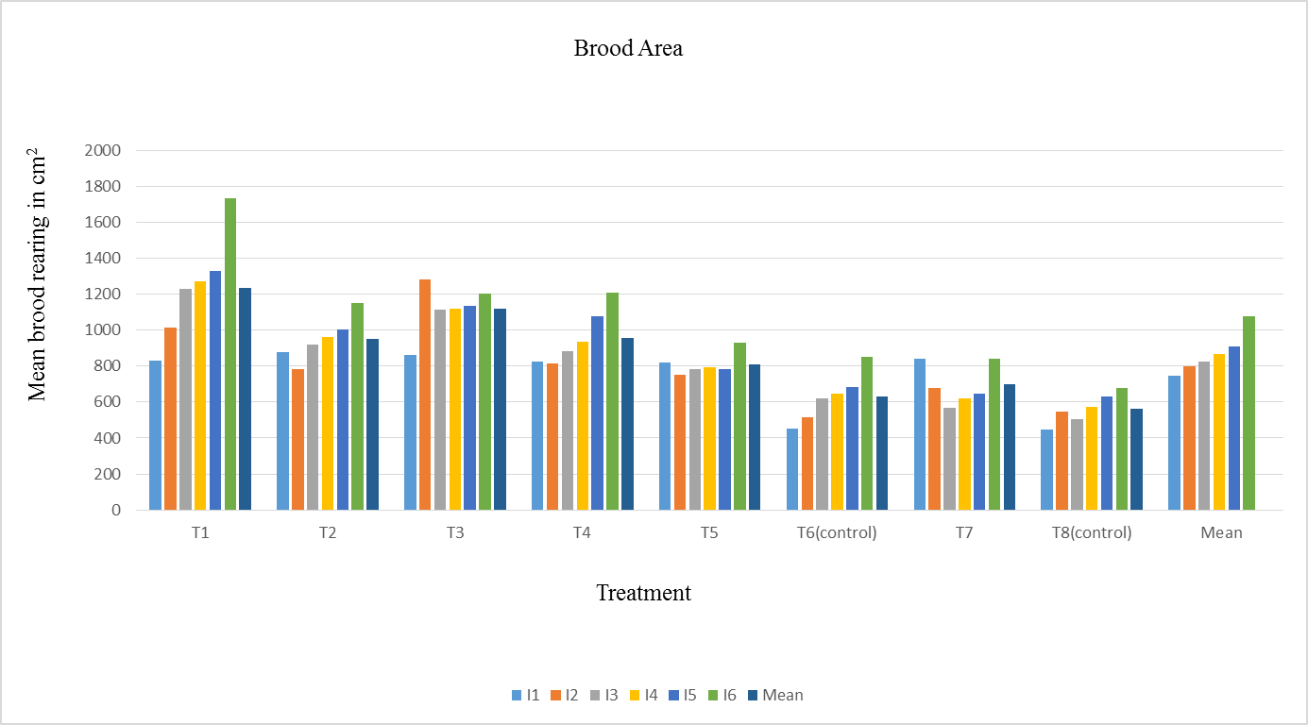
Fig. 1: Effect of single and double queen system on worker brood area in A. mellifera colonies during different intervals

Table 1: Effect of single and double queen systems on the number of pollen foraging bees entering A. mellifera colonies during different fortnights at different times of the day
Treatment | I fortnight |  |  |  | IIfortnight |  |  |  | IIIfortnight
Treatment | t1 | t2 | t3 | S.Mean | t1 | t2 | t3 | S.Mean | t1 | t2 | t3 | S.Mean
T1 | 31.66 | 30.66 | 27 | 29.77 | 33 | 27.33 | 28.66 | 29.66 | 45.66 | 44.33 | 40 | 43.33
T2 | 24 | 22 | 23.33 | 23.11 | 22 | 17.66 | 19 | 19.55 | 36 | 31.66 | 31.33 | 33
T3 | 30 | 31.66 | 29.33 | 30.33 | 42.33 | 41.33 | 31.66 | 38.44 | 46.33 | 43.66 | 38.66 | 42.88
T4 | 25.33 | 26.33 | 21.66 | 24.44 | 32.66 | 21 | 22 | 25.22 | 40.66 | 38 | 29.66 | 36.11
T5 | 29 | 24.33 | 19 | 24.11 | 27.33 | 24.66 | 28.66 | 26.88 | 33.66 | 35 | 23.33 | 30.66
T6control | 24 | 19 | 19.33 | 20.77 | 27 | 26.33 | 24.33 | 25.88 | 31.33 | 25.66 | 24 | 27
T7 | 19.33 | 18.33 | 15.66 | 17.77 | 30.33 | 21.66 | 22.66 | 24.88 | 23.33 | 21.66 | 18.66 | 21.22
T8control | 15.33 | 14.66 | 14 | 14.66 | 20.66 | 15.33 | 15 | 17 | 24 | 17.33 | 16.66 | 19.33
MEAN |  |  |  | 23.12 |  |  |  | 25.94 |  |  |  | 31.69

Treatment | IVfortnight |  |  |  |  |  | V fortnight |  |  |  | VIfortnight |  |  |  | Mean
Treatment | t1 | t2 | t3 |  | S.Mean |  | t1 | t2 | t3 | S.Mean | t1 | t2 | t3 | S.Mean | Mean
T1 | 48.33 | 46.66 | 37.00 |  | 44.00 |  | 32.00 | 23.33 | 31.66 | 29.00 | 23.66 | 24.66 | 27.33 | 25.22 | 33.50
T2 | 33.66 | 36.66 | 30.00 |  | 33.44 |  | 25.33 | 18.33 | 22.66 | 22.11 | 17.33 | 15.33 | 18.33 | 17.00 | 24.70
T3 | 44.33 | 50.33 | 33.00 |  | 42.55 |  | 36.66 | 28.66 | 30.00 | 31.77 | 27.33 | 24.00 | 25.66 | 25.66 | 35.27
T4 | 38.00 | 36.66 | 33.66 |  | 36.11 |  | 21.33 | 18.33 | 20.33 | 20.00 | 20.66 | 16.66 | 13.33 | 16.88 | 26.46
T5 | 37.33 | 35.66 | 26.66 |  | 33.22 |  | 29.33 | 28.00 | 18.66 | 25.33 | 23.33 | 21.00 | 18.00 | 20.77 | 26.83
T6control | 28.33 | 27.66 | 24.00 |  | 26.66 |  | 26.00 | 19.00 | 16.66 | 20.55 | 24.00 | 17.66 | 13.66 | 18.44 | 23.22
T7 | 26.66 | 24.66 | 16.66 |  | 22.66 |  | 20.66 | 16.00 | 18.33 | 18.33 | 17.00 | 15.66 | 16.00 | 16.22 | 20.18
T8control | 22.66 | 21.66 | 18.00 |  | 20.77 |  | 13.33 | 12.66 | 14.33 | 13.44 | 14.66 | 10.00 | 9.33 | 11.33 | 16.09
MEAN |  |  |  |  | 32.43 |  |  |  |  | 22.56 |  |  |  | 18.94
 | C.D(p≤0.05)
 | Treatment |  |  | 1.61
 | Interval |  |  | 1.00
 | T×I |  |  | 2.84
 | T |  |  | 0.71
 | t×T |  |  | 2.01
 | t×I |  |  | 1.74
 | T×I×t |  |  | 4.92
*t1= (10:00 am) *t2= (12: 00 pm) *t3= (3:00 pm)

Table 2: Effect of single and double queen systems on the number of nectar foraging bees entering A. mellifera colonies during different fortnights at different times of the day
Treatment | I fortnight |  |  |  | IIfortnight |  |  |  | IIIfortnight
Treatment | t1 | t2 | t3 | S.Mean | t1 | t2 | t3 | S.Mean | t1 | t2 | t3 | S.Mean
T1 | 43 | 61.33 | 43.33 | 49.22 | 53.33 | 58.33 | 54.66 | 41.58 | 48.33 | 55.33 | 58.33 | 54
T2 | 35.66 | 37.33 | 30 | 34.33 | 41.33 | 44.33 | 31.66 | 29.33 | 39.33 | 42 | 38.66 | 40
T3 | 49.66 | 47 | 42.33 | 46.33 | 50 | 50.66 | 48.66 | 37.33 | 50.66 | 43 | 52.33 | 48.66
T4 | 32.66 | 40.66 | 32.33 | 35.22 | 37.33 | 38.33 | 38 | 28.41 | 38.66 | 40.33 | 39.33 | 39.44
T5 | 37 | 39 | 38.33 | 38.11 | 39.66 | 47.66 | 41.33 | 32.16 | 35.33 | 36.66 | 35 | 35.66
T6control | 32.33 | 36.33 | 32.66 | 33.77 | 38.66 | 40.33 | 36.66 | 28.91 | 32 | 34.33 | 31.33 | 32.55
T7 | 22 | 29.33 | 27 | 26.11 | 23.33 | 30 | 24.33 | 19.41 | 24.33 | 27.66 | 23.66 | 25.22
T8control | 27 | 30.33 | 27.33 | 28.22 | 22 | 31.33 | 30.33 | 20.91 | 21.33 | 29 | 25.66 | 25.33
MEAN |  |  |  | 36.41 |  |  |  | 39.68 |  |  |  | 37.61

Treatment | IVfortnight |  |  |  |  | V fortnight |  |  |  | VIfortnight |  |  |  | Mean
Treatment | t1 | t2 |  | t3 | S.Mean | t1 | t2 | t3 | S.Mean | t1 | t2 | t3 | S.Mean | Mean
T1 | 56.66 | 37.66 |  | 52 | 36.58 | 45.33 | 54.33 | 57 | 52.22 | 46.66 | 55.33 | 58.33 | 40.08 | 52.18
T2 | 36.66 | 47.33 |  | 52.66 | 34.16 | 43.66 | 39.66 | 43 | 42.11 | 36 | 48 | 46 | 32.5 | 40.74
T3 | 47.33 | 50 |  | 43 | 35.08 | 47.33 | 52.66 | 51 | 50.33 | 51.66 | 54.66 | 52 | 39.58 | 49.11
T4 | 32.66 | 37.33 |  | 35 | 26.25 | 36.33 | 42.33 | 39 | 39.22 | 37.66 | 49.66 | 40.33 | 31.91 | 38.22
T5 | 33.66 | 34.33 |  | 38 | 26.5 | 40.33 | 45.66 | 41 | 42.33 | 42.66 | 47.66 | 40.66 | 32.75 | 39.66
T6control | 30.66 | 39.66 |  | 31 | 25.33 | 37 | 49.33 | 41.66 | 42.66 | 33.33 | 50.33 | 38.66 | 30.58 | 37.01
T7 | 27.33 | 30.66 |  | 28.33 | 21.58 | 22 | 35 | 34 | 30.33 | 29.33 | 38.33 | 27.66 | 23.83 | 28.01
T8control | 23.66 | 30 |  | 26.33 | 20 | 27.33 | 34.66 | 32.66 | 31.55 | 32 | 39.33 | 36 | 26.83 | 29.24
MEAN |  |  |  |  | 37.58 |  |  |  | 41.34 |  |  |  | 43.01
 | C.D(p≤0.05)
 | Treatment |  | :  0.83
 | Interval |  | :  0.72
 | T×I |  | :  2.05
 | T |  | :  0.51
 | t×T |  | :  1.45
 | t×I |  | :  1.25
 | T×I×t |  | :  3.56
*t1= (10:00 am) *t2= (12: 00 pm) *t3= (3:00 pm)

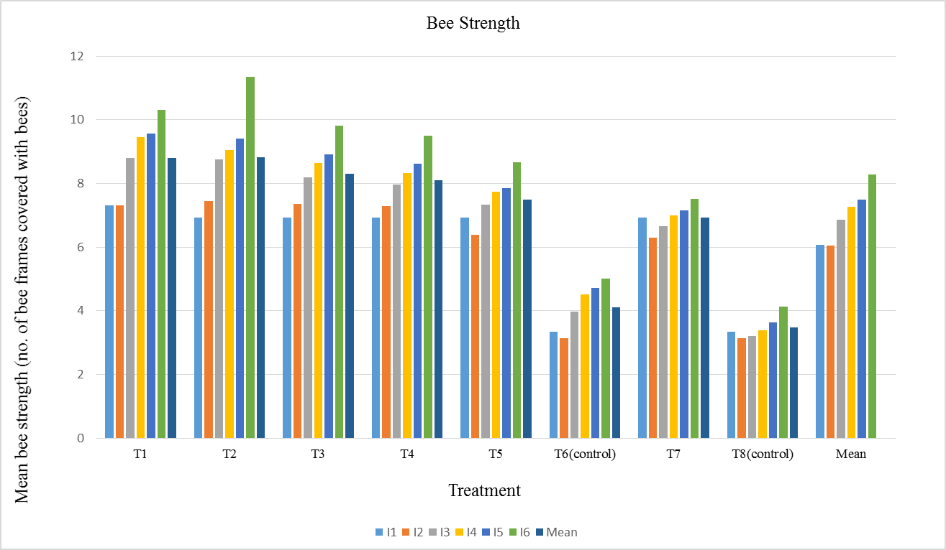
Fig. 2: Effect of single and double queen system on bee strength in A. mellifera colonies during different intervals
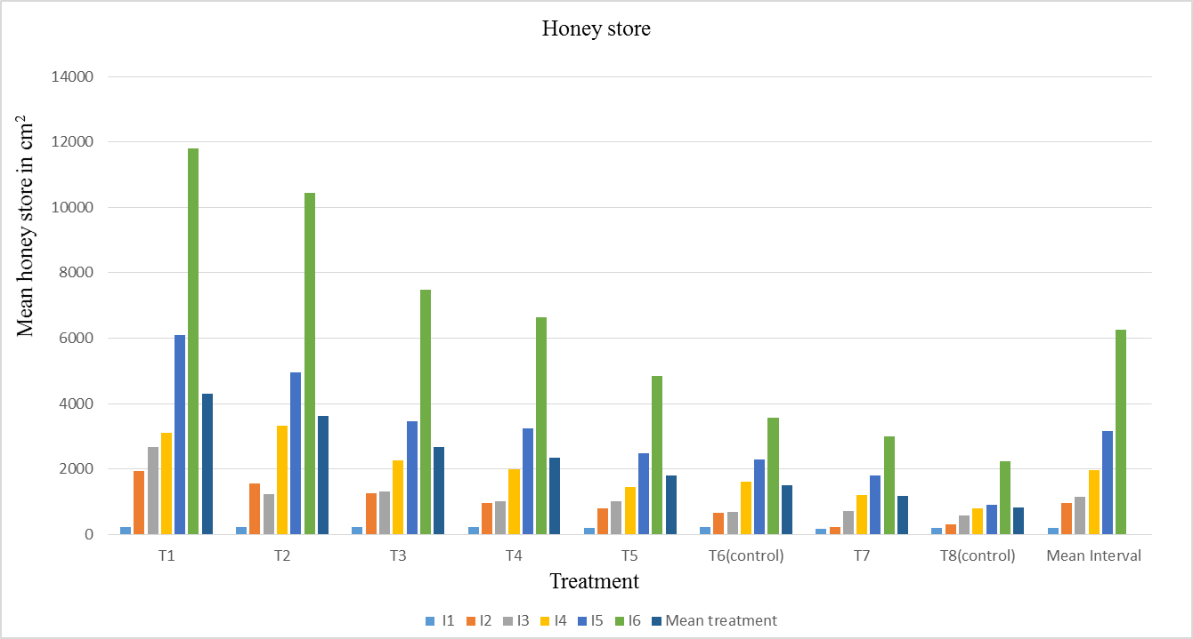
Fig. 3: Effect of single and double queen system on honey store in A.mellifera colonies during different intervals
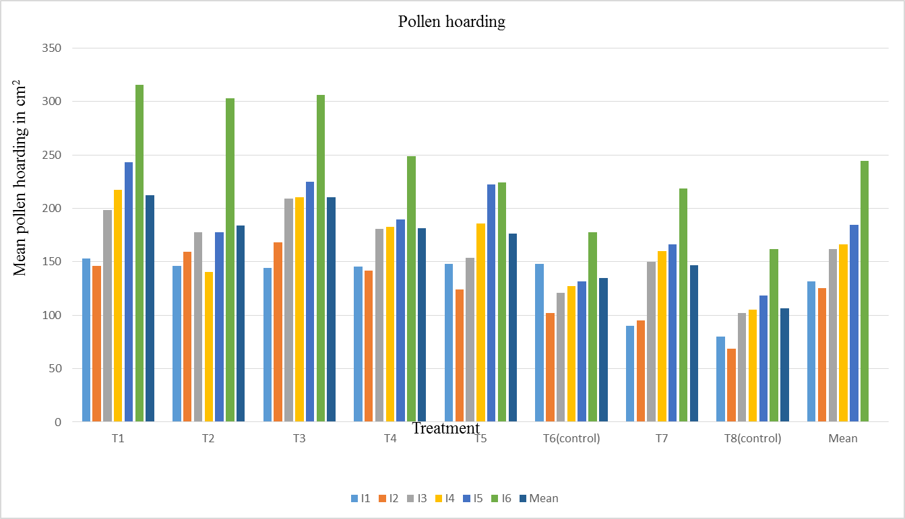
Fig. 4: Effect of single and double queen system on pollen loading in A.mellifera colonies during different intervals
The largest overall mean capped worker brood area was reported in treatment T1 (two queens separated by horizontal queen excluder and shallow super in twenty bee frame strength colony with additional entrance for upper brood chamber) as 1236.35 cm2, followed by the brood area of 1119.63 cm2 with treatment T3 (two queens separated by horizontal queen excluder in lower two chambers of twenty bee frame strength colony with additional entrance for the upper brood chamber). A significantly minimum mean capped brood area of 563.43 cm2 was recorded in T8 (Single queen in ten bee frame strength colony) (fig.1 and table 1 ). Data on bee strength revealed that, substantially, treatment T2 (two queens separated by horizontal queen excluder and shallow super in twenty bee frame 31 strength colony) yielded the highest overall mean bee frame strength as 8.82 bee frames, followed by the bee frame strength of 8.79 frames with treatment representing two queens separated by horizontal queen excluder and shallow super in twenty bee frame strength colony with additional entrance for upper brood chamber (T1); whereas, a significant minimum bee frame strength of 3.47 frames was recorded in treatment T8 (Single queen in ten bee frame strength colony) during the spring season, 2022 (fig. 2). Data on the honey area showed that, substantially, the treatment T1 (two queens separated by horizontal queen excluder and shallow super in twenty bee frame strength colony with additional entrance for upper brood chamber) produced the highest total mean honey store of 4.2kg, followed by the honey store of 3.6kg with treatment representing two queens separated by horizontal queen excluder and shallow super in twenty bee frame strength colony (T2); whereas, a significant minimum honey store of 0.8kg was recorded in T8 (single queen in ten bee frame strength colony) (fig.3). The maximum total mean pollen area was recorded in treatment T1 (two queens separated by horizontal queen excluder and shallow super in twenty bee frame strength colony with additional entrance for upper brood chamber) according to pollen area as 212.32 cm2, followed by the pollen area of 210.63 cm2 with treatment representing two queens separated by horizontal queen excluder in lower two chambers of twenty bee frame strength colony with additional entrance for the upper brood chamber (T3); whereas, a significant minimum pollen area of 106.16 cm2 was recorded in T8m (single queen in ten bee frame strength colony) (fig. 4and table 2). These findings are closely consistent with (Valle et al., 2004) who reported that average honey productivity/1,000 bees from double colonies was estimated to 1,022 g in double queen colonies and 902g in single queen colonies, indicating double-queen colonies have a 13% average productivity advantage compared to single-queen colonies. Also they evaluated the effect of two 32 queens/bee hive management system on colony population, honey production and profitability established 92 experimental colonies in the Mexican high plateau region. Their study revealed that colonies with two queens yielded 101.2% more honey than colonies with single queen (53.2± 2.4 vs 26.4± 1.8 kg, p< 0.01) and they also reported that the production cost per kg of honey was US 0.86 and US $1.07 for double and single queen colonies, respectively. They further reported that double queen colonies had 100% more bees and were 100% heavier than single queen colonies. So they recommended double queen system. The findings of the current analysis closely align with those of Rana and Goyal (1994). Maximum brood area, honey area, pollen area and number of frames were reported by the authors in May. Similar findings were reported by Mohapatra et al. (2012), who noted that May was the month with the highest bee population and honey reserves. The greatest brood area, pollen area, honey area and bee strength were recorded in May, according to Manzoor et al. (2019), whereas the minimum brood area, pollen area, honey area and bee strength were recorded in March. According to Taha et al. (2013), colony productivity of economic parameters is influenced by colony strength and stronger colonies produce more honey, pollen and brood than weaker colonies, which is consistent with the current findings. The findings are further supported by the work of Chaand et al. (2017), who noted a decline in colony developmental parameters at the end of May as a result of the onset of the floral dearth period while also observing a continuous increase in colony developmental parameters from March to May, including brood area, pollen area, honey area and bee strength. The results of present investigation are in concurrence with the finding of Wakjira et al. (2020), who reported that double queen colonies produced 98.4% more honey than single queen colonies
Conclusion
The colony performance in terms of population size, brood rearing, honey store, pollen store, nectar foragers and pollen foragers was significantly influenced by double queen system. Between 1200 and 1300 hours, A. mellifera' sforaging activity peaked, and between 1500 and 1600 hours, it was at its lowest. Two-queen colonies can produce at least twice the amount of honey produced by single colonies. Thus, it is concluded that the use of two-queen system, yields more honey and is financially profitable, compared to single queen conventional approach.

COMPETING INTERESTS DISCLAIMER:
Authors have declared that they have no known competing financial interests OR non-financial interests OR personal relationships that could have appeared to influence the work reported in this paper.

REFERENCE
Abou-Shaara, H.F. 2014. The Foraging Behavior of Honey Bees, Apismellifera: A Review.VeterinarniMedicina,59:1-10.
Banker, R. 1975. Two-queen colony management. In Dadant and Sons (eds.) The hive and the honey bee. Dadant Hamilton, Illinois, USA: pp 404-410.
Chaand, D., Sharma, D., Ganai, S. A., Norboo, T. and Sharma, S. 2017. Effect of colony strength on colony build up and foraging activity of Apismellifera L.Journal of Entomology and Zoology Studies, 5: 1369-73.
Farrar, C. L. 1958. Two-queen colony management for the production of honey. USDA, Agricultural Research Service; USA; No. ARS-33-48; 11 pp.
Human, H., Brodschneider, R., Dietemann, V., Dively, G., Ellis, J. D., Forsgren, E., Fries, I., Hatjina, F., Hu, F. L., Jaffé, R., Jensen, A. B., Köhler, A., Magyar, J. P., Özkýrým, A., Pirk, C. W. W., Rose, R., Strauss, U., Tanner, G., Tarpy, D. R., van der Steen, J. J. M., Vaudo, A., Vejsnaes, F., Wilde, J., Williams, G. R. and Zheng, H. Q. 2013. Miscellaneous standard methods for Apismellifera research. Journal of Apicultural Research52:1-53.
Manzoor, M., Sheikh, A. H. and Mathivanan, V. 2019. Evaluation of indigenous honey beeApiscerana-Srinagar (J&K) vs. Coimbatore (Tamil Nadu). Indian Journal of Entomology 81(3): 627-629.
Moeller, F. E. 1976. Two-queen system of honey bee colony management. Production Research Report, ARS, USDA; No. 161; 12 pp.
Mohapatra, L. N. and Satapathy, C. R. 2012. Studies on colony development in Apisceranaindica F. Indian Journal of Entomology 74: 102-103.
Neupane, K. R., Woyke, J. and Wilde, J. 2012. Effect of initial strength of honey bee colonies (Apismellifera) supered in different ways on maximizing honey production in Nepal. Journal of Apicultural Science, 56(2): 71–81.
Rana, B. S. and Goyal, N. P. 1994. Comparative brood rearing activity of Apismellifera and A. ceranaindica at Nauni (Solan), midhills of Himachal Pradesh, Indian Bee Journal56(1-2): 24-28.
Saini, S., Chaudhary, O. P. and Anoosha, V. 2018a. Apismellifera colony productivity and growth influenced by initial frame strength: Farmer’s perspective. The Indian Journal of Agricultural Sciences,88(10): 1618–1623.
Saini, S., Chaudhary, O. P. and Anoosha, V. 2018b. Relationship of population size and extraction frequency with honey production in Apismellifera colonies. Journal of Entomology & Zoology Studies, 6(3): 1374–1377.
Taha, E. K. A. and Al-Kahtani, S. N. 2013. Relationship between population size and productivity of honey bee colonies. Journal of Entomology, 10(3): 163–169.
Valle, A. G. G., Novoa, E. G., Benitez, A. C. and Rubio, J. A. Zozaya. 2004. The effect of using two honey bee (Apismellifera L.) Queens on colony population, honey production, and profitability in the Mexican high pleateau. Tec pecumex42(3):361-377.
Wakjira, K., Negera, T. and Kumsa, T. 2020. Two queen colonies in central highland conditions of Ethopia increase population size and Honey yield. Bee world97:109-113.

