Original Research Article
Integrative Taxonomic Confirmation of Coccinella septempunctata with Elytral Spot Variation from Berberis lycium in Himachal Pradesh, Northwestern Himalaya

ABSTRACT
Coccinella septempunctata, commonly called as the 7-spot ladybird beetle, belongs to the Order Coleoptera and Family Coccinellidae. It is a widely distributed species known for its predatory behaviour against agricultural pests like aphids. C. septempunctata is a highly beneficial biological control agent essential for sustainable agriculture and ecosystem balance. The present study provides morphological and molecular confirmation of C. septempunctata collected from the flowers of Berberis lycium, an important medicinal plant, in Himachal Pradesh, Northwestern Himalaya. Active pollen feeding behaviour of C. septempunctata was observed on B. lycium flowers, indicating that the plant serves as a seasonal nutritional resource to the species. During the study, three polymorphic forms were collected with elytral spot variation. Specimens were identified based on morphology and detailed examination of the genitalia. A 638bp fragment of the mtCOI gene was successfully amplified and sequenced from a representative morph and submitted to GenBank for accession number. This integration of morphological, molecular and ecological studies provides baseline data for polymorphism and floral association of C. septempunctata in the Northwestern Himalayan Region and contributes to regional DNA barcode database for ladybird beetles.
Keywords: Coccinella septempunctata, pollen feeding, Berberis lycium, integrative taxonomy, mtCOI barcoding

1. INTRODUCTION
The Order Coleoptera accounts for approximately 25% of all described species (Stork et al., 2015). The Family Coccinellidae, commonly called as ladybugs or ladybird beetles, is the largest family in the Superfamily Coccinelloidea, with almost 6000 species and 360 genera classified and described worldwide, including a diverse Indian fauna with about 550 species (Robertson et al., 2015; Kundoo & Khan, 2017; Poorani, 2019). The genus Coccinella belongs to the tribe Coccinellini within the subfamily Coccinellinae, originally established by Linnaeus in 1758. Coccinella septempunctata is a widely distributed species of the genus Coccinella with high phenotypic plasticity. It is a highly adaptable predatory ladybird beetle that inhabits diverse agricultural and grassland habitats and exhibits migratory and overwintering behaviours (Duan et al., 2021; Ricci et al., 2005; Maredia et al., 1992). It is an important biological pest control agent with variable voltinism and diapause period, making it efficient against aphids in late summer and autumn (Suleman, 2015; Ghosh et al., 2012; Sattar et al., 2008). Though it is euryphagous, it is not as widely polyphagous compared to other coccinellids and even feeds on pollen, moth eggs and bee powder (Triltsch, 2013). They act as accidental pollinators for different plants while searching for pollen, nectar and resting sites (Kamel et al., 2015; Stalažs & Dreimanis, 2016). C. septempunctata exhibits polymorphic forms that arise due to the aggregated effect of genetic variation, environmental factors and adaptive strategies (Bouanani et al., 2015). This population plasticity provides ecological resilience and broad adaptability in diverse environments without compromising species integrity (Hodek & Michaud, 2013). Morphological variation is not sufficient to categorise it as multiple species, as elytral spot size varies considerably among populations. The presence of polymorphic forms in coccinellid beetles can result in the misidentification of species, which can be resolved by studying male genitalia and siphonal structures along with external morphological studies. Male genitalia provide a more species-specific and distinctive feature for accurate species identification. It also becomes crucial to incorporate integrative taxonomic techniques, combining molecular tools with traditional taxonomy to resolve species boundaries (Marin et al., 2010). Mitochondrial COI-based DNA barcoding is used globally for species validation. The COI gene exhibits a relatively rapid rate of evolution, particularly at its third codon position, generating high variability among species, while remaining conserved within species (Hebert et al., 2003). Hence, it has become a widely accepted standardised marker for molecular characterisation of insects (Watanabe et al., 2024). In the present study, C. septempunctata was collected from flowers of Berberis lycium Royle from Himachal Pradesh. B. lycium is an important medicinal shrub of the region, which provides floral resources to many insects. There are limited integrated taxonomic studies from Himachal Pradesh, underscoring the need for regional validation of species identity using COI barcode data. The present paper discusses the integrative morphological and molecular confirmation of Coccinella septempunctata collected from B. lycium flowers in Himachal Pradesh, Northwestern Himalayan Region and documents its pollen feeding association.

2. METHODOLOGY
2.1 Sample collection
Adult specimens of Coccinella septempunctata were collected from the flowers of B. lycium from different locations in Himachal Pradesh. The collection was conducted during the flowering months of April and May, 2024. Beetles were collected using forceps and placed in glass vials. The samples for taxonomic studies were pinned, labelled and preserved in insect boxes. The samples for molecular analysis were stored in a -80°C ultra freezer in the laboratory.
2.2 Taxonomic studies
Samples were visualised under a stereomicroscope for morphological characterisation, followed by the extraction of the genitalia (Majerus & Kearns, 1989). The abdomen was detached and kept in 10% KOH solution overnight at room temperature for clearing and removal of extra tissues was done with the help of needles and camel brush. The genital structures were rinsed in distilled water, visualised and photographed using a Nikon digital camera attached to a stereomicroscope (SMZ1270). Species identification and morphological terminologies were based on relevant taxonomic literature (Poorani, 2023; Ślipiński et al., 2019).
2.3 Molecular Analysis
The genomic DNA was extracted from the leg and thorax region of the representative morph (M2) using the Dneasy blood and tissue kit from Qiagen, following standard protocols by manufacturers. The concentration and quality of extracted DNA were verified using the Nanodrop 2000c spectrophotometer. The extracted DNA was stored at -20°C for further use. The genomic DNA was used as a template in PCR to amplify the mitochondrial cytochrome oxidase I (mtCO1) gene region with Folmer primers, forward primer LCO 1490 5’- GGTCAACAAATCATAAAGATATTGG-3’ and reverse primer HCO 2198 5’- TAAACTTCAGGGTGACCAAAAAATCA-3’ (Folmer et al., 1994). The PCR amplification was achieved in VeritiPro Thermal Cycler by using a reaction volume of 25 µL following standard thermal cycling conditions. The amplified DNA was analysed with 1.5 agarose gel electrophoresis and visualised under UV and documented using Gel Proccd916 Zenith gel documentation system. The desired PCR product was purified using the Qiagen DNA purification kit. The sequencing was achieved with Big dye termination kit 3.1 by using forward LCO primer in ABI 3500xL Genetic analyser based on Sanger Sequencing. The Fast format files were subjected to BLAST search in NCBI to check the homology of sequences. The sequence was edited and aligned using Bioedit sequence alignment software, and submitted to GenBank for an accession number. The nucleotide content was calculated using MEGA12.

3. RESULTS AND DISCUSSION
During the flowering period, adult individuals of C. septempunctata were consistently observed on fully open flowers of B. lycium (Fig.1). Individuals remained on a single inflorescence for extended periods and were observed foraging on pollen from dehisced anthers, indicating that the plant served as a food resource for the species. Triltsch (1997) also observed the species feeding on pollen of different plants and identified pollen as one of the food remains in the gut dissection of C. septempunctata. A noticeable accumulation of yellow pollen grains was observed on the thoracic and leg region, suggesting potential incidental pollen transfer. During the present investigation, morphological variations were observed in Coccinella septempunctata. Three morphs (M1, M2, M3) of the species based on elytral variations were identified (Fig. 2a,2b,2c). Among these morphs, M1 was the most abundant and widespread form. Majumder et al. (2025) documented 6 morphs of the species from West Bengal, and Thamseer et al. (2022) documented 5 morphs.

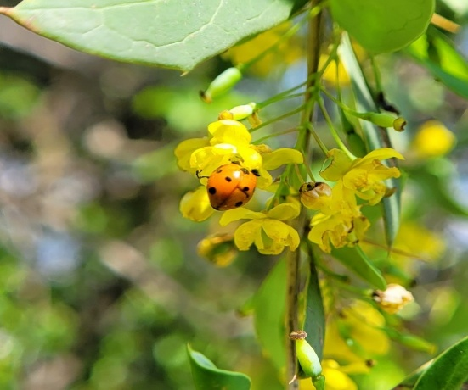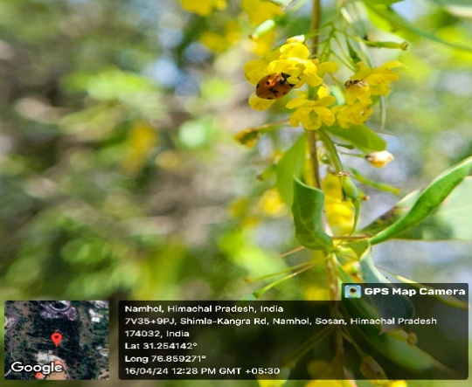
Fig 1. Adult Coccinella septempunctata visiting the flowers of Berberis lycium.

Morphological features
Coccinella septempunctata Linnaeus, 1758
1758. Coccinella septempunctata Linnaeus, Syst. Nat., 10th ed.: 365.
Material Examined: 3ex., 6.iv.24, Darlaghat (31.2359°N, 76.9271°E); 5ex., 11.iv.24, Rajgarh (30.8500°N, 77.2994°E); 3ex., 16.iv.24, Namhol (31.2541°N, 76.8592°E); 3ex., 20.iv.24, Dharamshala (32.2065°N, 76.3653°E); 4ex., 25.iv.24, Anni (31.4030°N, 77.4023°E); 4ex., 30.iv.19, Chail (30.9676°N, 77.1916°E); 4ex., 1.v.24 Taradevi (31.0490°N, 77.1480°E); 3ex., 2.v.25, Naldehra (31.1733°N, 77.2048°E); 3ex., 4.v.24, Theog (31.1270°N, 77.3430°E); 2ex., 5.v.24, Churag (31.3581°N, 77.1575°E) Coll. Monika Kaundal.
The body is roundly oval, strongly convex dorsally and nearly hemispherical. Body bright-red to orange-red, punctuated with 7 spots -three on each side of the elytra and one scutellar spot behind the thorax. Elytra is the hard wing casing, spots on the elytra can vary, giving a patched appearance. The head is black and triangular with spots on frons and antenna that is 11-segmented with a longer basal segment and nearly clubbed at apex. Eyes are small and finely faceted. Clypeus is short and truncated with robust mandibles. Pronotum is black in colour and densely punctuated, with white spots and a broad appearance. Scutellum is triangular, small, and brown-black (Fig.2d). Ventral surface is black with dark brown, short legs appearing to be three-segmented (pseudotetramerous). Similar observations were presented by Bhatnagar (2016).
Genitalia studies
Male genitalia: The tegmen is symmetrical with slender and elongated paramers that are curved inwards apically with fine setae on the dorsal side. Median lobe is elongate and tubular, and longer than the parameres. It is broad at the base and tapering gradually beyond the middle to the apex, ending in a triangular structure with a slightly ventral curve. Basal lobe is well developed and elongated. Trabes is short and thick. The siphonal capsule is thick, slender, curved and Y-shaped. It is thin near the apex and thick and bent towards the base. The distal end carries a sac-like structure (Fig. 2e, 2f). Similarly, Dhanapati et al. (2024) examined the male genitalia and siphonal structures in coccinellid beetles and emphasised the importance of male genitalia to mitigate misidentification issues in polymorphic forms. Singh and Malik (2018) also provided a taxonomic description of the male genitalia, noting a bulging and thick siphonal capsule. Female genitalia: Coxites is clubbed, elongate and tubular. The genital plate is broad with short setae at base and rounded apex. Spermatheca is semicircular and C-shaped. Bursa is membranous and well-developed (Fig. 2g). In a similar study by Kumar and Thakur (2025), the morphotaxonomy of C. septempunctata was studied, describing male and female genitalia as significant structures for species identification. Manoj et al. (2025) described the coxites as club handle-like with a prominent stylus. Similar findings were reported by El-Saeady et al. (2020), Ali et al. (2018), and Ashfaque (2013). All three morphs collected showed a similar structural arrangement of male and female genitalia.

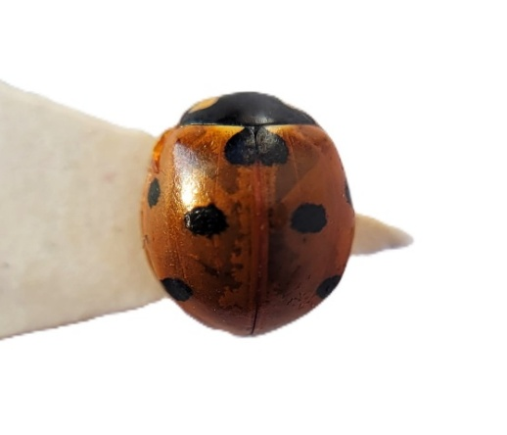
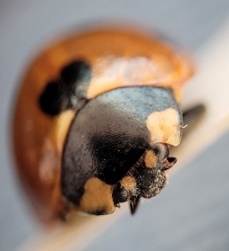
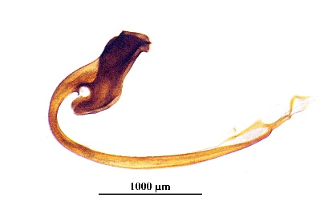
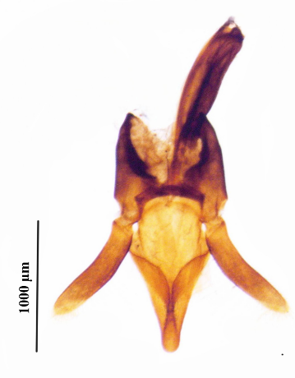
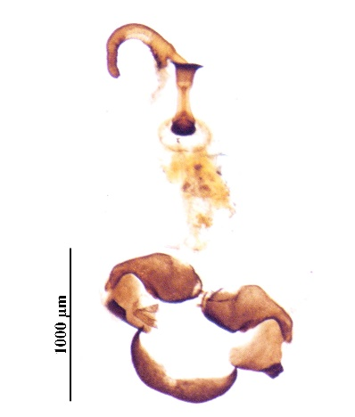
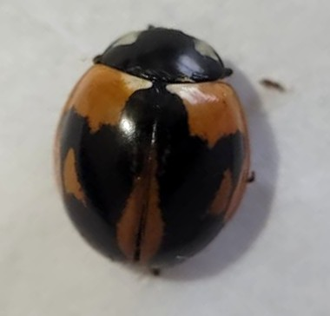
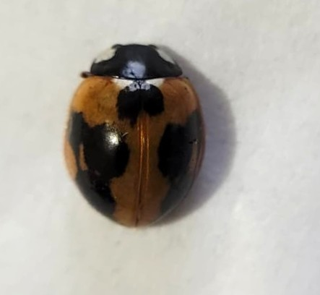
2e
2g
2a
2b
2c
2d
2f
M1
M2
M3

Fig 2. Coccinella septempunctata Linnaeus: 2a, 2b, 2c polymorphs (M1, M2, M3), 2d. head, 2e. tegmen ventral view, 2f. sipho, 2g. female genitalia with spermatheca.

Molecular identification and GenBank accession
The mitochondrial cytochrome oxidase subunit I (COI) gene was successfully amplified and sequenced from a representative morph (M2). The obtained sequence was edited, and a partial fragment of 638bp was submitted to the NCBI GenBank database under accession number PQ289165. BLAST analysis showed 99.22% sequence similarity with the already published sequence (OR185609) of C. septempunctata, available in the GenBank, confirming species identity. The final edited sequence exhibited a GC and AT content of 31.9% and 68.1%, respectively, indicating clear AT bias. Zhang et al. (2025) studied the mitochondrial genome of four dung beetles and observed a higher AT content commonly found in insect mitochondrial genomes. A similar high AT bias of 74.4% and 73.5% was observed in scarab beetles Dicronocephalus adamsi and Amphimallon sp., respectively (Guo et al., 2022).

4. CONCLUSION

The present study provides integrative morphological and molecular confirmation of Coccinella septempunctata collected from the flowering shrubs of Berberis lycium in Himachal Pradesh, a highly important medicinal plant of the Northwestern Himalayan region. The active pollen feeding behaviour of C. septempunctata was observed with significant visible pollen accumulation on adults, suggesting that B. lycium flowers serve as an important seasonal nutritional source to the species. During the collection, three polymorphic forms, based on elytral spot patterning, were identified on the plant, indicating phenotypic variation in the species. Taxonomic study of diagnostic features, including male and female genitalia, confirmed species identification, which was further corroborated by mitochondrial sequence analysis for a representative morph. All forms shared similarities in the male and female genitalia structures, confirming intraspecific phenotypic variation within the studied population

DISCLAIMER (ARTIFICIAL INTELLIGENCE)
The authors hereby declare that no generative AI technologies such as Language Models (ChatGPT, COPILOT, etc.) and text-to-image generators have been used during the writing or editing of this manuscript.

COMPETING INTERESTS DISCLAIMER:
Authors have declared that they have no known competing financial interests OR non-financial interests OR personal relationships that could have appeared to influence the work reported in this paper.

REFERENCES
Ali, M., Raza, G., Ali, S., Anjum, S. I., & Hussain, I. (2018). The Tribe Coccinellini Weise (Coleoptera: Coccinellidae) in Sindh, Pakistan. The Coleopterists Bulletin, 72(3), 629-638.
Ashfaque, M., Ullah, F., & Rafi, M. A. (2013). Genus Coccinella (Coccinellidae: Coleoptera) from Gilgit-Baltistan with two new records from Pakistan. Sarhad Journal of Agriculture, 29(2), 241-247.
Bhatnagar, P. S. (2016). A Study of Coccinellid (Insecta: Coleoptera: Coccinellidae) Fauna of Northern-Western Ghats. Records of the Zoological Survey of India, 71-82.
Bouanani, M. A., Magné, F., Lecompte, É., & Crouau-Roy, B. (2015). Development of 18 novel polymorphic microsatellites from Coccinella septempunctata and cross-species amplification in Coccinellidae species. Conservation Genetics Resources, 7(2), 445-449.
Dhanapati, G. K., Pal, S., & Rani, K. S. (2024). Exploring the diversity of coccinellid species: A comprehensive study on polymorphism and species-specific male genitalia identification. Entomon, 49(3), 435-444.
Duan, Y. J., He, H. G., Pu, D. Q., Yang, H., Chen, Q., & Lu, Q. C. (2021). Basic research status of Coccinella septempunctata. J. Biosaf, 30, 20-28.
El-Saeady, A. H. A., Hafez, S. F., Abied, M. K., & Bedewy, M. M. (2020). Taxonomical Revision of The Tribe Coccinellini (Coleoptera: Coccinellidae) In Egypt. Egyptian Academic Journal of Biological Sciences. A, Entomology, 13(4), 23-47.
Folmer, O., Black, M., Hoeh, W., Lutz, R. and Vrijenhoek. R. 1994. DNA primers for amplification of mitochondrial cytochrome C oxidase subunit I from diverse metazoan invertebrates. Molecular Marine Biology and Biotechnology, 3(5): 294-299.
Ghosh, S. K. R., & Chakraborty, K. (2012). Incidence and abundance of important predatory beetles with special reference to Coccinella septempunctata in sub-Himalayan region of north-east India. International Journal of Plant, Animal and Environmental Sciences, 2(3), 157-162.
Guo, S., Lin, X., & Song, N. (2022). Mitochondrial phylogenomics reveals deep relationships of scarab beetles (Coleoptera, Scarabaeidae). PLoS One, 17(12), e0278820.
Hebert, P. D., Cywinska, A., Ball, S. L., & DeWaard, J. R. (2003). Biological identifications through DNA barcodes. Proceedings of the Royal Society of London. Series B: Biological Sciences, 270(1512), 313-321.
Hodek, I., & Michaud, J. P. (2013). Why is Coccinella septempunctata so successful? (A point-of-view). EJE, 105(1), 1-12.
Kamel, S. M., Mahfouz, H. M., Blal, A. E. F. H., Said, M., & Mahmoud, M. F. (2015). Diversity of insect pollinators with reference to their impact on yield production of canola (Brassica napus L.) in Ismailia, Egypt. Pesticidi i fitomedicina, 30(3), 161-168.
Kumar, L., & Thakur, D.R. (2025). Morphotaxonomy with SEM description and life history trait of Coccinella septempunctata L. (Coleoptera: Coccinellidae). Journal of Diversity Studies, 4, 8-12
Kundoo, A. A., & Khan, A. A. (2017). Coccinellids as biological control agents of soft bodied insects: A review. Journal of Entomology and Zoology Studies, 5(5), 1362-1373.
Majerus, M., & Kearns, P. (1989). Ladybirds Naturalists Hand Books. Univ. of Cambridge. Richmond Publish. Co. Ltd., 963.
Majumder, T., Manna, A., Zaman, I., & Roy, K. (2025). Elytral polymorphism of Cheilomenes sexmaculata (Fabricius), Harmonia octomaculata (Fabricius), Coccinella septempunctata Linnaeus and Propylea dissecta (Mulsant) (Coleoptera: Coccinellidae) in the Gangetic Alluvial Plain Zone of West Bengal, India. Journal of Environmental Biology, 46(4), 589-603.
Manoj, V., Vidya, C. V., Ramesha, B., & Sreekumar, K. M. (2025). Taxonomic Studies of the Tribe Coccinellini (Coleoptera: Coccinellidae) of Kerala. Indian Journal of Entomology, 308-316.
Maredia, K. M., Gage, S. H., Landis, D. A., & Wirth, T. M. (1992). Ecological observations on predatory Coccinellidae (Coleoptera) in southwestern Michigan. The Great Lakes Entomologist, 25(4), 5.
Marin, J., Crouau‐Roy, B., Hemptinne, J. L., Lecompte, E., & Magro, A. (2010). Coccinella septempunctata (Coleoptera, Coccinellidae): a species complex?. Zoologica scripta, 39(6), 591-602.
Poorani, J. (2019). Coccinellidae of the Indian subcontinent. In Indian Insects (pp. 223-246). CRC Press
Poorani, J. (2023). An illustrated guide to lady beetles (Coleoptera: Coccinellidae) of the Indian Subcontinent. Part 1. Tribe Coccinellini. Zootaxa, 5332(1), 1-307.
Ricci, C., Ponti, L., & Pires, A. (2005). Migratory flight and pre-diapause feeding of Coccinella septempunctata (Coleoptera) adults in agricultural and mountain ecosystems of Central Italy. European Journal of Entomology, 102(3), 531.
Robertson, J. A., Ślipiński, A. D. A. M., Moulton, M., Shockley, F. W., Giorgi, A., Lord, N. P. et al. (2015). Phylogeny and classification of Cucujoidea and the recognition of a new superfamily C occinelloidea (C oleoptera: C ucujiformia). Systematic Entomology, 40(4), 745-778.
Sattar, M., Hamed, M., & Nadeem, S. (2008). Biology of Coccinella septempunctata Linn.(Coleoptera: Coccinellidae) and its predatory potential on cotton aphids, Aphis gossypii Glover (Hemiptera: Aphididae). Pakistan Journal of Zoology, 40(4).
Singh, V., & Malik, V. (2018). The Tribe Coccinellini (Coleoptera: Coccinellidae) From Haryana, India. Journal of Experimental Zoology India, 21(1).
Ślipiński, S. A., Li, J., & Pang, H. (2019). Ladybird Beetles of the Australo-Pacific Region: Coleoptera: Coccinellidae: Coccinellini. Csiro Publishing.
Stalažs, A., & Dreimanis, J. (2016). Composition of anthophilous insects in Prunus cerasus and Prunus domestica (Rosaceae) orchards in Latvia: preliminary notes on insect diversity. Zoology and Ecology, 26(2), 118-126.
Stork, N. E., McBroom, J., Gely, C., & Hamilton, A. J. (2015). New approaches narrow global species estimates for beetles, insects, and terrestrial arthropods. Proceedings of the National Academy of Sciences, 112(24), 7519-7523.
Suleman, N. (2015). Heterodynamic processes in C occinella septempunctata L.(C occinellidae: C oleoptera): a mini review. Entomological Science, 18(2), 141-146.
Thamseer, M. K., Yadav, S. S., Saini, R., & Rolania, K. (2022). Elytral Polymorphism in Seven Spotted Ladybird Beetle Coccinella septempunctata L. Indian Journal of Entomology, 683-686.
Triltsch, H. (1997). Gut contents in field sampled adults of Coccinella septempunctata (Col.: Coccinellidae). BioControl, 42(1), 125-131.
Triltsch, H. (2013). Food remains in the guts of Coccinella septempunctata (Coleoptera: Coccinellidae) adults and larvae. EJE, 96(4), 355-364.
Watanabe, S., Masamura, N., Satoh, S. Y., & Hirao, T. (2024). Evaluating the effectiveness of DNA barcoding for insect identification: a comprehensive review. Entomology Letters, 4(2-2024), 34-41.
Zhang, H., He, Q., Zhao, Z., Zhang, B., Zhou, J., Wang, C., et al. (2025). Mitochondrial genome comparison and phylogenetic analysis of four species of dung beetles (Coleoptera: Scarabaeidae: Scarabaeinae). Ecology and Evolution, 15(8), e71906.

