Original Research Article
Protein Alterations in the Alimentary Canal of Musca domestica Treated with Datura innoxia Seed Extract

ABSTRACT
Botanical insecticides are gaining attention as eco-friendly alternatives to synthetic pesticides. The present study investigates the effect of Datura innoxia seed extract on total protein content in different regions of the alimentary canal of Musca domestica (housefly), specifically the foregut, midgut, and hindgut. Quantitative protein estimation revealed a progressive reduction in protein levels in treated groups compared with the control. The hindgut showed the highest protein content in the control (66.02%), followed by the foregut (53.58%) and midgut (44.02%). However, after treatment with D. innoxia seed extract, protein levels decreased significantly across all gut regions, reaching 42.41%, 34.22%, and 25.11%, respectively, in later experimental groups. These biochemical alterations indicate severe metabolic disruption caused by the phytochemicals present in D. innoxia. The findings suggest that the seed extract interferes with protein metabolism, digestive enzyme activity, and tissue integrity in the alimentary canal of M. domestica, demonstrating its potential as a botanical insecticide.
Keywords: Musca domestica, Datura innoxia, Extract, Insecticide
1. Introduction
Houseflies (Musca domestica) are among the most common synanthropic insects and act as mechanical vectors of numerous pathogenic microorganisms. Their ability to transmit diseases such as typhoid, cholera, dysentery, and salmonellosis make them a major public health concern. Conventional chemical insecticides have been widely used to control housefly populations; however, their excessive use has led to environmental pollution, resistance development, and toxicity to non-target organisms. Botanical insecticides derived from plant secondary metabolites are emerging as effective and environmentally safe alternatives. Among these, Datura innoxia, a member of the Solanaceae family, is known for its rich content of biologically active compounds such as tropane alkaloids, including atropine and scopolamine. These compounds possess neurotoxic and insecticidal properties that can disrupt physiological and metabolic processes in insects (Abd El-Aziz, 2000).
In insects, proteins play essential roles in metabolism, enzyme synthesis, tissue structure, and energy regulation. Alterations in protein content often indicate physiological stress or toxicity. The digestive system of insects, consisting of the foregut, midgut, and hindgut, plays a crucial role in nutrient digestion and absorption. Any disruption in these tissues can lead to significant metabolic imbalance. The present study aims to investigate the biochemical impact of Datura innoxia seed extract on total protein content in different gut regions of Musca domestica. Understanding these alterations can help evaluate the insecticidal potential of plant-derived compounds and their mechanism of action (Bakr R F, 2007).
2. Materials and Methods
2.1 Collection of Experimental Insects
Adult houseflies (Musca domestica) were collected from local environments and maintained under laboratory conditions. The insects were reared in controlled temperature and humidity with access to standard food (Jyoti M. C., 2018: Jangam D. V., 2025).
2.2 Preparation of Plant Extract
Seeds of Datura innoxia were collected, washed, and dried. The dried seeds were powdered and subjected to solvent extraction to obtain the crude seed extract. The extract was concentrated and stored for experimental use (Upadhyay RK, 2011; Jangam D. V., 2025).
2.3 Experimental Design
Houseflies were divided into control and treatment groups. The treatment groups were exposed to different concentrations or exposure durations of Datura innoxia seed extract. After exposure, insects were dissected, and the alimentary canal was separated into Foregut (FG), Midgut (MG), Hindgut (HG) (Jangam D. V., 2025)
2.4 Protein Estimation
Total protein content was estimated using a standard biochemical method, such as the Lowry or Bradford assay. Tissue homogenates from each gut region were prepared and analysed spectrophotometrically. Protein values were calculated and expressed as percentage protein content (Lowery O.H., 1951).
2.5 Statistical Analysis
Results were tested by One-Way Analysis of Variance (ANOVA), then confirmed by Tukey’s test (means comparison) using Graph Pad software (3.6).
3. Results AND Discussion

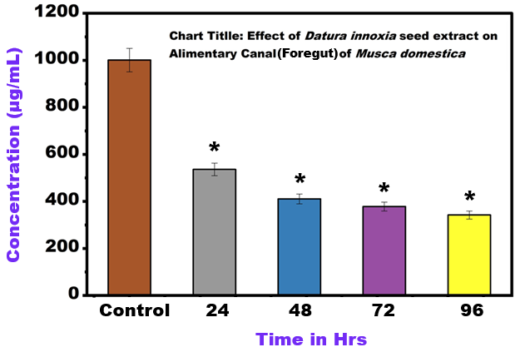
Fig. 1. Effect of Datura innoxia seed extract on the alimentary Canal (Foregut) of Musca domestica (Mean ± SE, Significant at *P < 0.001 compared with control)
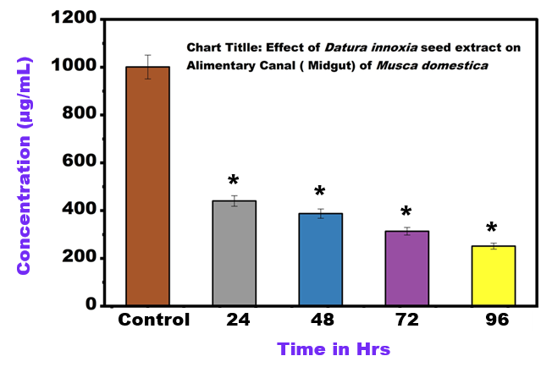
Fig. 2. Effect of Datura innoxia seed extract on the alimentary Canal (Midgut) of Musca domestica (Mean ± SE, Significant at *P < 0.001 compared with control)
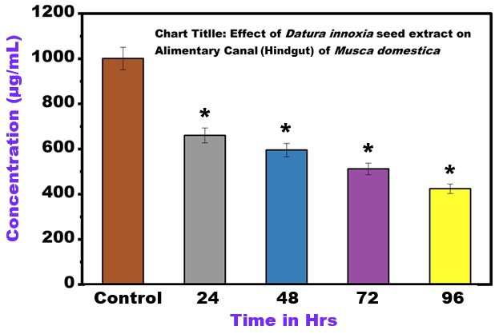
Fig. 3. Effect of Datura innoxia seed extract on the alimentary Canal (Hindgut) of Musca domestica (Mean ± SE, Significant at *P < 0.001 compared with control)
Based on the biological effects of plant extracts containing high levels of alkaloids like those found in Datura innoxia (primarily tropane alkaloids such as scopolamine and atropine), it is highly likely that the total protein content in the foregut of treated Musca domestica would be significantly decreased compared to the untreated control.
Table 1. Total Protein Content in Different Gut Region
Group | Hindgut (%) | Midgut (%) | Foregut (%)
Group 1 (Control) | 44.023 | 44.017 | 53.576
Group 2 | 59.530 | 38.716 | 41.043
Group 3 | 51.198 | 31.355 | 37.813
Group 4 | 42.417 | 25.119 | 34.218

The results clearly demonstrate a progressive decrease in protein content in all regions of the alimentary canal following treatment with Datura innoxia seed extract.
The hindgut showed the highest protein content in the control group (66.023%). The midgut exhibited the lowest protein level (44.017%) even in the control condition. Treatment resulted in a gradual decline in protein levels across all groups. In the final treatment group, protein levels dropped to 42.417% in hindgut, 25.119% in midgut, 34.218% in foregut these results indicate a strong inhibitory effect of the plant extract on protein metabolism (Table No.1).
4. Discussion
The foregut is the initial region of the digestive tract and plays an important role in food storage and transport. Exposure to Datura innoxia phytochemicals can directly affect epithelial cells of the foregut, leading to cellular damage and degradation of structural proteins. As a result, the total protein concentration decreases significantly (Fig. 1). The midgut is the primary site of digestion and nutrient absorption in insects. The decrease in midgut protein levels may be due to inhibition of digestive enzymes and disruption of protein synthesis pathways. The toxic components of Datura seeds interfere with metabolic processes, resulting in reduced enzyme production and tissue degeneration. The hindgut is responsible for water reabsorption and waste elimination. Protein depletion in this region suggests systemic metabolic stress caused by toxic compounds. The breakdown of epithelial cells and increased protein catabolism contribute to the observed decline in protein levels (Liang, J., 2025).
D. innoxia seeds are known to be rich in tropane alkaloids (e.g., scopolamine, atropine). These compounds are potent toxins that act primarily on the nervous system by interfering with acetylcholine receptors, which can lead to paralysis and death. The search results confirm the insecticidal potential of Datura species (including D. innoxia and related species like D. stramonium and D. metel) against various pests, including Musca domestica, often leading to high mortality, developmental abnormalities, and other toxic effects. The insect foregut is one of the first tissues to encounter the ingested toxic extract. The alkaloids and other phytochemicals can be rapidly absorbed or interact directly with the gut lining cells (epithelium). A significant decrease in total protein content in a tissue like the foregut can be attributed to several factors induced by the plant extract's toxicity. The stress induced by the toxins may trigger an elevated rate of protein breakdown (catabolism) to meet the energy demands for detoxification or repair mechanisms (Fatima, H, 2015).
The decrease in total protein content in the Musca domestica midgut treatment with Datura innoxia seed extract can be attributed to several factors related to the extract's toxic or anti-nutritional properties. The seeds of D. innoxia are rich in tropane alkaloids (e.g., scopolamine, atropine) and other phytochemicals like phenols and flavonoids, which possess insecticidal properties. These compounds can directly inhibit or denature key midgut digestive enzymes (like proteases, amylases, and lipases) in M. domestica. This interference severely limits the hydrolysis and absorption of dietary proteins and other nutrients, leading to a net decrease in tissue protein synthesis and accumulation. The toxic stress induced by the extract may lead to an increased rate of protein catabolism (breakdown) to meet the energy demands of the stressed organism or to eliminate damaged proteins. This shift in metabolism contributes to the overall reduction in measured total protein. Some components in the Datura extract may act as anti-feedants, significantly reducing the amount of food consumed by the Musca domestica larvae or adults. Reduced nutrient intake directly limits the raw materials needed for protein synthesis, leading to lower protein levels in the midgut tissue (Fig. 2). The observed decrease in total protein percentage highlights the anti-metabolic and toxic effects of the Datura innoxia seed extract, indicating its potential as a natural bio-insecticide by severely compromising the essential digestive and synthetic functions of the housefly's midgut (Janeh, M, 2017).
The toxic effect on cellular metabolism can disrupt key processes, including ribosomal activity and gene expression, leading to a substantial decrease in the de novo synthesis of new proteins. High concentrations of toxins can cause direct damage to the foregut epithelial cells. The resulting cellular damage, including necrosis or apoptosis, leads to the breakdown of cell structure and the subsequent loss or denaturation of intracellular proteins. The extract may inhibit digestive enzyme activity within the foregut or midgut, or damage the absorptive surface, thereby disrupting normal protein metabolism.
The hindgut primarily functions in water, salt, and nutrient reabsorption, as well as waste elimination. The decrease in protein content can be discussed through the following mechanisms. The seed extract of D. innoxia is rich in tropane alkaloids (e.g., scopolamine, atropine), which are potent neurotoxins and cellular poisons. As the toxins pass through the digestive tract, they induce histopathological damage to the hindgut epithelial cells. Damage to the cell membranes and organelles of the hindgut epithelium (vacuolization, necrosis) leads to the breakdown of structural proteins and enzymes, which are then either degraded or expelled with the faeces, resulting in a net loss of measurable protein in the tissue homogenate (Fig. 3) (Terra, W. R., 2023).
The toxic stress from the extract requires the insect to mobilise resources for detoxification and repair. This can lead to the catabolism (breakdown) of tissue proteins (including those in the hindgut) to provide amino acids for synthesising stress-response proteins or for energy. This metabolic shift reduces the total protein pool. If the midgut's digestive and absorption functions are severely compromised (as typically seen with Datura treatment), the availability of raw amino acids for de novo protein synthesis throughout the body, including the hindgut, is dramatically lowered. Although the hindgut is not the primary site of digestion, its integrity is essential for overall homeostasis. Severe disruption of the midgut (where most digestion/absorption occurs) by the extract leads to systemic starvation and malnutrition. The hindgut, like other tissues, reflects this systemic protein depletion, showing a reduced protein content as a secondary consequence of the primary poisoning in the midgut. The reduction in hindgut protein content confirms the generalised toxic effect of the D. innoxia extract on the entire alimentary canal of Musca domestica, further supporting its efficacy as a botanical insecticide.
D. innoxia seed extract causes a significant reduction in total protein content in the foregut, midgut, and hindgut of Musca domestica. Such biochemical alterations suggest severe physiological stress induced by the plant extract. The insecticidal activity of Datura innoxia is largely attributed to its tropane alkaloids, particularly atropine and scopolamine. These compounds disrupt normal nerve signalling and cellular metabolism. Additionally, plant secondary metabolites may act as anti-feedants, reducing food intake and causing nutrient deficiency in insects. Reduced protein synthesis, increased protein degradation, and tissue damage collectively contribute to the observed biochemical changes.
5. Conclusion
The present study clearly demonstrates that Datura innoxia seed extract significantly alters protein metabolism in the alimentary canal of Musca domestica. A progressive decrease in protein content was observed in the foregut, midgut, and hindgut following treatment. These findings indicate that the plant extract disrupts digestive physiology and cellular metabolism in houseflies. Therefore, Datura innoxia seed extract shows promising potential as a botanical insecticide for housefly control. Further investigations involving enzymatic assays, histopathological analysis, and molecular studies are recommended to better understand the mechanism of toxicity.

COMPETING INTERESTS DISCLAIMER:
Authors have declared that they have no known competing financial interests OR non-financial interests OR personal relationships that could have appeared to influence the work reported in this paper.

References
Abd El-Aziz HS (2000) Psychopathological studies on bacterial infection of cotton leaf worm, Spodoptera littoralis. M.Sc. Thesis. Fac.Sci.Ain Shams Univ., Egypt :144.
Bakr R F, Abdel Fattah HM and Mohamed EK (2007) Effect of chitin synthesis inhibitor, lufenuron on the development, haemolymph and antennal sensilla of Schistocerca gregaria (Forskal) (Orthoptera: Acrididae). African J. Biol. Sci., 3 (2): 35-43.
Baskar K, Ignacimuthu S, Jayakumar M (2015b) Toxic effects of Couroupi taguianensis against Spodoptera litura (Fabricius) (Lepidoptera: Noctuidae). Neotrop Entomol 44:84–91.
Baskar K, Muthu C, Ignacimuthu S (2015a) Bioefficacy of Atalantiamonophylla (L) Correa (Rutaceae) against Spodoptera litura Fabricius (Lepidoptera: Noctuidae). Entomol Ornithol Herpetol 4: 2.
Begum N, Sharma B and Pandey RS (2010) Evaluation of Insecticidal Efficacy of Calotropis Procera and Annona Squamosa Ethanol Extracts Against Musca Domestica. J Biofertil Biopestici 1:1.
Fatima, H., Khan, K., Zia, M., Ur-Rehman, T., Mirza, B., & Haq, I. U. (2015). Extraction optimization of medicinally important metabolites from Datura innoxia Mill.: an in vitro biological and phytochemical investigation. BMC complementary and alternative medicine, 15(1), 376.
Janeh, M., Osman, D. and Kambris, Z., 2017. Damage-induced cell regeneration in the midgut of Aedes albopictus mosquitoes. Scientific reports, 7(1), p.44594.
Jangam D. V., Patil S. D. (2025). Evaluation of insecticidal Properties of Datura innoxia Seed Extract Against Musca domestica larva (Diptera), Int. J Entomology Research, Vol 10, Issue 12, 2025, Pg no.189-192.
Jyoti M Chintalchere, Mudasir A Dar and Radhakrishna S Pandit (2018) Evaluation of Some Essential Oils against the larvae of House Fly, Musca domestica by Using Residual Film Method Adv Biotech & Micro 9(1): AIBM.MS.ID.555752.DOI: 10.19080/AIBM.2018.09.555752.
Liang, J., Xiao, F., Ojo, J., Chao, W. H., Ahmad, B., Alam, A., Chen, R. (2025). Insect resistance to insecticides: causes, mechanisms, and exploring potential solutions. Archives of Insect Biochemistry and Physiology, 118(2), e70045.
Lowry, O. H., Rosebrough, N. J., Farr, A. L., & Randall, R. J. (1951). Protein measurement with the Folin phenol reagent. Journal of Biological Chemistry, 193(1), 265–275.
Mahboubkar MM, Sendi JJ, Aliakbar A (2015) Effect of Artemisia annua L. essential oil on toxicity, enzyme activities, and energy reserves of cotton bollworm Helicoverpa armigera (Hübner) (Lepidoptera: Noctuidae). J Plant Prot Res 55:371– 377.
Senthilkumar N, Varma P, Gurusubramanian G (2009) Larvicidal and adulticidal activities of some medicinal plants against the malarial vector, Anopheles stephensi(Liston). Parasitol Res 104 (2): 237-244.
Seyoum E, Bateman RP, Charnley AK (2002) The effect of Metarhizium anisopliae var. acridum on haemolymph energy reserves and flight capability in the desert locust, Schistocerca gregaria. J. Appl. Entomol. 126 (2–3): 119–124.
Terra, W. R., Ferreira, C., & Silva, C. P. (2023). Overview of insect midgut function. In Molecular physiology and evolution of insect digestive systems (pp. 13-26). Cham: Springer International Publishing.
Upadhyay RK, Yadav N, Ahmad S (2011a) Toxic effects of solvent and aqueous extracts of Cassia alata against bio-molecules and enzymatic parameters of Callosobruchus chinensis L. (Coleoptera: Bruchidae). Adv Appl Sci Res 2:367–381.
Upadhyay RK, Yadav N, Ahmad S (2011b) Insecticidal potential of Capparis decidua on biochemical and enzymatic parameters of Tribolium castaneum (Herbst). Agric Environ 3:45–67.

