Original Research Article
Comparative Growth and Morphometric Assessment of Ducks reared under Semi-intensive of Management

Abstract:
In the rural conditions of Assam, duck rearing is an important component of the traditional farming system and plays a significant role in supporting the livelihood and nutritional security of farmers. Ducks are generally reared under semi-intensive or free-range management systems where they are allowed to scavenge in nearby water bodies such as ponds, wetlands and paddy fields during the day and are provided with limited supplementary feed in the evening. The region supports several indigenous as well as exotic duck varieties that are reared mainly for dual purposes, namely egg and meat production. Duck farming is often integrated with other agricultural activities, making it a vital part of the rural integrated farming system. Among the different duck breeds, Kuzi is an indigenous duck breed originating from Odisha that has shown good adaptability to village conditions. Khaki Campbell, an exotic breed, is widely known for its superior egg production potential. Crossbreeding between indigenous and exotic ducks is often practiced to combine desirable traits such as adaptability, disease resistance and improved productivity. The present study was conducted to evaluate the performance of Kuzi ducks, Khaki Campbell ducks and their crossbred (Kuzi × Khaki Campbell) under free-range rearing conditions in the Goalpara district of Assam. Important growth and productive parameters including weekly body weight up to 18 weeks of age, age at sexual maturity and different morphometric traits were assessed. These parameters provide valuable information on growth pattern, body conformation and productive potential of the breeds. The study indicated that the crossbred ducks performed comparatively better in terms of growth and productive traits than the pure breeds under the prevailing rearing conditions.Rural parts of Assam are home to different indigenous as well as exotic crossbred of ducks reared under mostly semi-intensive system of integrated system kept for both eggs and meat. Performance of an indigenous breed of duck from Odisha named Kuzi, Khaki Campbell and crossbred of Khaki Campbell and Kuzi under free range system of rearing in Goalpara district of Assam. The cross of the Kuzi and Khaki Campbell perform comparatively better in terms of growth and productive traits. The performance of indigenous Kuzi ducks, Khaki Campbell duck and Crossbred of Kuzi x Khaki Campbell (KC) under free range system conditions such as weekly body weight, age at sexual maturity and different morphometric parameters are considered in this study.
Keywords: crossbred, duck, indigenous, integrated, morphometric, semi-intensive.
Introduction:
India ranks second in the world in terms of duck population, with approximately 33.51 million ducks accounting for about 4.0% of the total poultry population of the country as reported in the 20th Livestock Census (2019). Duck farming plays an important role in the poultry sector, particularly in regions where abundant natural water resources and wetlands support scavenging-based production systems. The distribution of duck population in India is not uniform, with the highest concentration found in the Eastern region (64.5%), followed by the Northeastern region (16.02%) and the Southern region (12.60%). These areas provide favorable ecological conditions for duck rearing, such as paddy fields, ponds, marshy lands and riverine ecosystems that facilitate natural feeding and foraging behavior. It has been reported that indigenous ducks contribute about 91% of the total duck egg production in the country, while only about 9% is contributed by improved or exotic varieties (Gaur et al. 2010).
Most of the farmers in the rural and coastal region rear indigenous ducks for meat and egg production. According to the 20th Livestock Census (2019) conducted in India, Assam reported a duck population of approximately 6.6 million, making it to stand in second position in the country. Duck farming in Assam is particularly concentrated in areas with abundant water resources. The most commonly reared duck in Assam is the Pati duck, the first recognized native duck breed in the country (Islam et al., 2024). Other indigenous breeds like the Chara Chemballi, Khaki Campbell, Nagi (Nageswari) duck, Muscovy duck (Ceena Hah), Kerasia (Mukhi, 2019) and White Pekin ducks are also raised in these regions. Literatures on Kuzi which is an indigenous breeds of Odisha are available scanty (Padhi et al. 2022) with phenotypic and morphometric description (Padhi, 2010). Although various indigenous and improved duck varieties are reared in different parts of the country, scientific information on certain indigenous breeds remains limited. One such breed is the Kuzi duck of Odisha, for which only limited literature is available, mainly describing its phenotypic and morphometric characteristics (Padhi, 2010; Padhi et al., 2022). Despite the important contribution of ducks to the rural economy and livelihood of farmers, systematic research on the comparative performance of different duck breeds under field conditions is still limited. Studies focusing on growth performance, morphometric traits and production characteristics under semi-intensive management systems are particularly scarce. Therefore, the present study was undertaken to evaluate and compare the growth performance and morphometric traits of selected duck breeds reared under semi-intensive conditions up to a specific age. The findings of this study are expected to generate useful baseline information for breed improvement programmes and promote scientific duck farming practices in the region.
Materials and method:
The study was conducted in two districts of Assam namely Kamrup and Goalpara both under farm and field conditions. Three different breeds namely Khaki Campbell (KC), Kuzi and Cross (KC X Kuzi) were selected for the study from the mentioned districts. A total of 189 drakes and 214 ducks were selected for the study. The flocks were usually small and varied from 5-20 numbers of birds. The families were selected purposively keeping in mind the fact that no ducklings of exotic types were reared but only the native ducks, the houses having exotic or even seem to be crossbred ducks were not included in the survey and the adjacent houses from where the flocks can intermingle were also not taken into consideration.
Majority of the farmers’ rear the birds in houses made of locally available materials such as bamboo, thatch and do not construct any permanent structure. The birds are let loose in the morning in the water bodies and allow scavenging whole day and in the evening they are provided with leftover food from the kitchen or some supplementary feed.
In order to collect the relevant information, personal interview and on spot recording were done on prevalent duck husbandry practices and the morphometric and performance parameters. The morphometric traits of both the drake and duck were observed, identified and documented through visual observation like the plumage colour, shank colour, bill colour, feet colour, skin colour. The external morphological traits are evaluated based on the procedure mentioned by Cuesta (2008). The morphometric traits like body weight, bill length, bill width, head length, circumference, body length, chest circumference, wing length, wing span, femur length, tibia length are measured using measurement tape.
The statistical analysis was done and were expressed as mean ± standard error at P<0.05
Results and Discussion
The weekly body weight data recorded for both in all the three different breeds of ducks are presented in Table 1 up to 18 weeks of age. Weekly data recorded were analyzed and found that the crossbred body weight observed in the present study showed that the crosses recorded better body weight than the Kuzi and Khaki Campbell. These findings were in similarity to the significantly higher body weight that was observed in Crossbred of Kuzi x Khaki Campbell compared to Kuzi birds up to four weeks of age in agreement with the findings of Padhi and Sahoo (2011), Padhi et al. (2019). Whereas in another trial conducted by Padhi et.al. 2022, the body weight data recorded at 12, 16 and 20 week of age (growing period) in drakes and ducks of Kuzi breed. Similar results were found where significantly higher body weight than Crossbred of Kuzi x Khaki Campbell compared to Kuzi birds up to four weeks of age are mentioned in agreement with the findings of Padhi and Sahoo (2011), Padhi et al. (2019).

Table 1: Mean ± SE values of weekly body weight of duck under semi-intensive system of rearing

Age (weeks) | Khaki Campbell (KC) | Kuzi | Cross (KC X Kuzi)
1st | 87.50 ± 17.83 | 75.00 ± 21.62 | 72.50 ± 19.42
2nd | 190.00 ± 13.44 | 163. 46 ± 15.21 | 196.25 ± 9.72
3rd | 305.00 ± 32.91 | 325.00 ± 18.63 | 412.50 ± 123.77
4th | 582.00 ± 32.91 | 386.00 ± 32.91 | 749.50 ± 32.91
5th | 659.25 ± 23.75 | 570.00 ± 33.40 | 689.50 ± 37.64
6th | 739.00 ± 9.54 | 763.52 ± 74.42 | 780.00 ± 40.49
7th | 1030.00 ± 41.83 | 877.63 ± 75.07 | 1047.00 ± 16.85
8th | 1090.00 ± 69.88 | 717.50 ± 95.60 | 1141.25 ± 61.85
9th | 1020.00 ± 124.85 | 1167.00 ± 52.43 | 1186.25 ± 32.91
10th | 1220.50 ± 42.00 | 1170.25 ± 23.74 | 1246.25 ± 47.22
11th | 1365.00 ± 33.46 | 1301.00 ± 33.10 | 1390.00 ± 57.49
12th | 1405.00 ± 56.30 | 1428.00 ± 63.98 | 1530.75 ± 52.34
13th | 1575.00 ± 85.39 | 1525.00 ± 149.30 | 1675.00 ± 110.86
14th | 1611.00 ± 47.66 | 1711.00 ± 62.10 | 1738.00 ± 54.97
15th | 1681.25 ± 65.33 | 1750.00 ± 77.91 | 1850.00 ± 86.60
16 ^{th} | 1720.00 ± 35.76 | 1820.25 ± 56.76 | 1883.25 ± 47.86
17th | 1807.50 ± 48.66 | 1885.00 ± 63.54 | 1902.00 ± 51.85
18th | 1894.00 ± 59.04 | 1911.00 ± 35.75 | 1958.25 ± 52.63
Means bearing same superscripts in a row did not differ significantly.
Most of the indigenous ducks have multi-coloured plumage. The ducks mostly exhibit plumage colour of fawn, penciled, chocolate. The bill is yellow and the shake and toes remain are orange in the Kuzi varieties which resembles to the observation of Padhi, (2014). Flocks of Kuzi and crossbred of Khaki Campbell and Kuzi showed multi-coloured plumage. Similar results of multi-coloured plumage has also been described by Padhi et. al. (2023), Panda et. al. (2008) and Mishra et.al. (2009). The photographs of the flocks of Kuzi ducks are presented in Fig. 1 and that of Khak Campbell and Cross of Khaki Campbell and Kuzi are presented in Fig. 2 and 3, respectively.

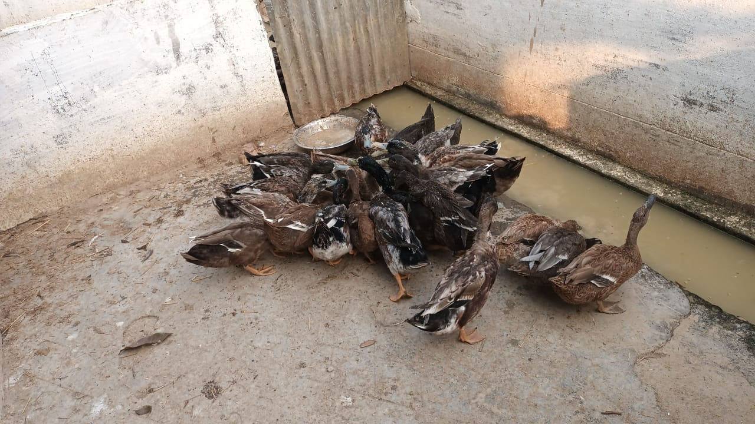
Figure 1: Flock of Kuzi
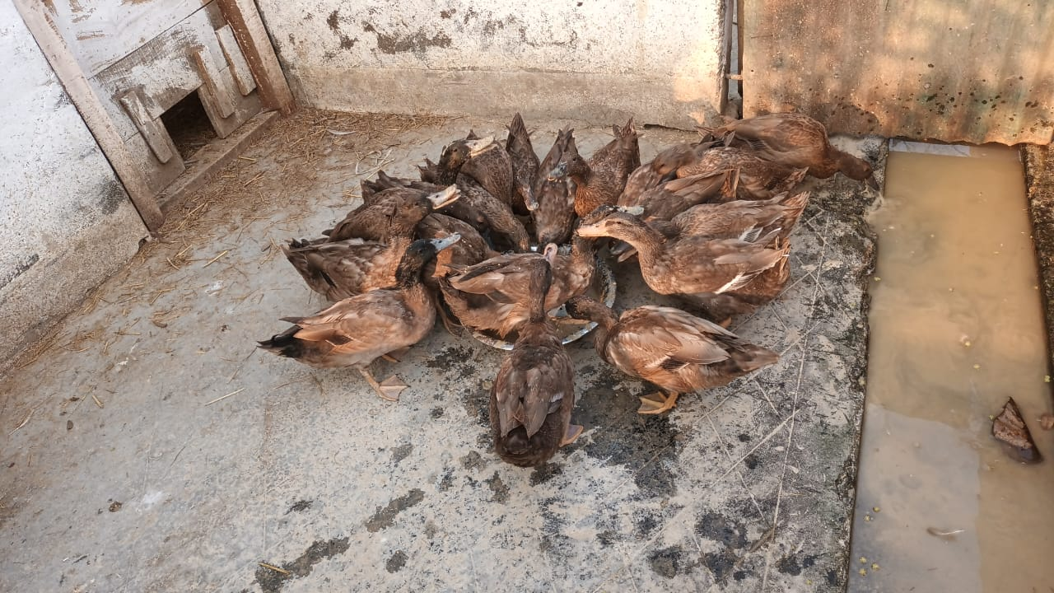
Figure 2: Flock of Khaki Campbell
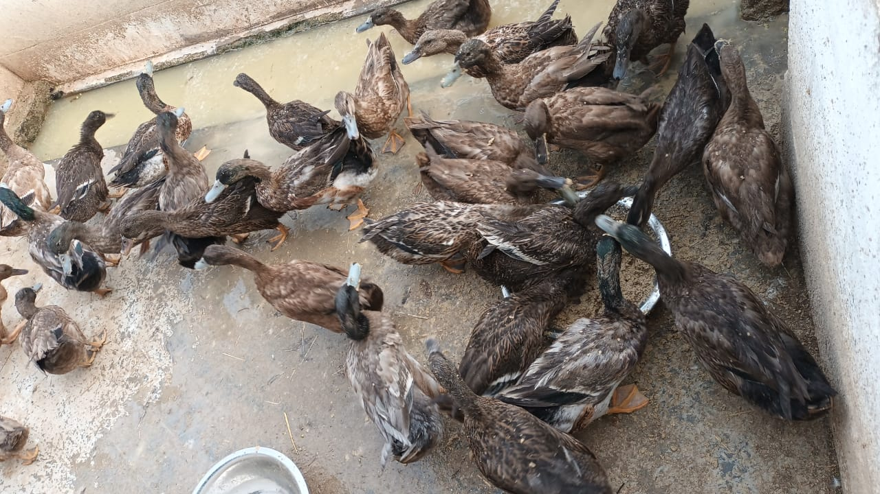
Figure 3: Cross of Khaki Campbell x Kuzi
From the present study, it revealed that the average morphometric parameters such as bill length, head length, bill width, bill circumference, neck length, body length, femur length, tibia length, keel length, wing length etc. have been recorded weekly up to 18th week of age and showed variable difference among the different breeds of duck taken under the study. Important conformation traits in respect to egg production are keel length, breast angle and shank length which are considered as good traits. From the present findings, it was found that the conformation traits like keel length, breast angle and shank length are comparatively higher in case f the crossbred birds. Similar findings were also showed in the findings of Padhi et al. (2009) and Padhi (2014).
Table 2: Mean ± SE values for morphometric traits of different breeds of duck under semi-intensive system of rearing
Parameters |  | Khaki Campbell (KC) | Kuzi | Cross (KC X Kuzi)
Bill length | Male | 5.5 ± 0.35 | 6.8 ± 0.26 | 5.5 ± 0.22
Bill length | Female | 6.3 ± 0.34 | 5.08 ± 0.10 | 6.2 ± 0.12
Head length | Male | 6.6 ± 0.43 | 7.8 ± 0.26 | 7.3 ± 0.20
Head length | Female | 7.5 ± 0.22 | 7.1 ± 0.19 | 6.6 ± 0.19
Bill diameter | Male | 8.4 ± 0.19 | 8.5 ± 0.22 | 8 ± 0.16
Bill diameter | Female | 7.5 ± 0.27 | 7.3 ± 0.3 | 8.02 ± 0.21
Bill width | Male | 5 ± 0.16 | 4.9 ± 0.19 | 4.5 ± 0.27
Bill width | Female | 4.8 ± 0.12 | 4.06 ± 0.12 | 4.2 ± 0.12
Head diameter | Male | 13.3 ± 0.30 | 13.8 ± 0.23 | 14.2 ± 0.25
Head diameter | Female | 12.8 ± 0.33 | 12.6 ± 0.30 | 13 ± 0.16
Neck length | Male | 19.9 ± 0.51 | 18.34 ± 0.29 | 21 ± 1.58
Neck length | Female | 22.6 ± 0.51 | 13.46 ± 0.45 | 20.5 ± 0.71
Body length | Male | 45.8 ± 0.86 | 42.6 ± 0.75 | 44.6 ± 1.21
Body length | Female | 45.4 ± 0.75 | 46 ± 0.38 | 42.8 ± 1.16
Femur length | Male | 8 ± 0.42 | 8.8 ± 0.34 | 8.5 ± 0.32
Femur length | Female | 7.7 ± 0.20 | 9.1 ± 0.07 | 7 ± 0.27
Tibia length | Male | 9.8 ± 0.41 | 9.34 ± 0.19 | 9.9 ± 0.33
Tibia length | Female | 8.4 ± 0.18=9 | 7.9 ± 0.25 | 9.54 ± 0.50
Meta Tarsal | Male | 5.3 ± 0.20 | 4.9 ± 0.12 | 5.78 ± 0.26
Meta Tarsal | Female | 5.2 ± 0.12 | 6.44 ± 0.17 | 5.7 ± 0.20
Digit | Male | 6.6 ± 0.19 | 8.6 ± 0.19 | 7.2 ±0.25
Digit | Female | 6.7 ± 0.12 | 6.48 ± 0.24 | 6.4 ± 0.29
Keel Length | Male | 7.1 ± 0.24 | 7.9 ± 0.33 | 8.2 ± 0.25
Keel Length | Female | 6.8 ± 0.25 | 6.3 ± 0.3 | 7.7 ± 0.20
Brest Angle | Male | 91.8 ± 0.45 | 92.6 ± 0.74 | 94.4 ± 0.51
Brest Angle | Female | 89.6 ± 0.51 | 92 ± 0.63 | 93 ± 0.63
Chest Circumference | Male | 30.4 ± 0.51 | 32.2 ± 0.66 | 33 ± 0.44
Chest Circumference | Female | 30.2 ± 0.58 | 31 ± 0.55 | 30.8 ± 0.37
Wing length | Male | 43 ± 1.14 | 32 ± 0.71 | 42.4 ± 0.68
Wing length | Female | 42 ± 0.89 | 30.2 ± 0.8 | 41.2 ± 0.49
Wing span | Male | 90. ± 1.96 | 91.4 ± 0.75 | 94.6 ± 1.03
Wing span | Female | 90.8 ± 1.83 | 90.8 ± 1.16 | 90.2 ± 1.88
Means bearing same superscripts in a row did not differ significantly.
The age at first egg or age at sexual maturity for Kuzi indigenous duck was found to be at 137 days whereas it was 126 days for the crossbred birds (KC X Kuzi). Padhi (2014) and Padi (2010) reported the age at sexual maturity for the indigenous duck of Odisha as 198 days whereas first egg was obtained at 101 days according to the findings of Padhi et.al.(2022). The eggs obtained from the different group of breeds of duck are shown in Table. 3 which showed that the eggs of the Kuzi, Kakhi Campbell and their cross ducks are of acceptable quality. These findings are in agreement with the results of Padhi et. al. (2022),

Table 3: Mean ± SE values for productive and egg quality traits of different breeds of duck under semi-intensive system of rearing
Parameters | Khaki Campbell (KC) | Kuzi | Cross (KC X Kuzi)
Age at sexual maturity (days) | 140 | 137 | 126
Body weight at sexual maturity (g) | 1888.00 | 1991.00 | 1958.25
First Egg weight (g) | 34.60 ± 12.67 | 41.80 ± 9.53 | 38.50 ± 10.84
Egg shape index | 74 ± 4.7 | 77 ± 6.84 | 77 ± 3.75
Yolk index | 0.43 ± 0.90 | 0.42 ± 1.16 | 0.40 ± 1.10
Albumen index | 0.092 ± 0.05 | 0.090 ± 0.02 | 0.086 ± 0.05
Shell thickness (mm) without membrane | 0.36 ± 0.04 | 0.34 ± 0.03 | 0.36 ± 0.07

Conclusion:
The present study compared the growth performance, morphometric traits and productive parameters of Khaki Campbell, Kuzi and their crossbred (KC × Kuzi) ducks reared under a semi-intensive management system under the present climatic condition of Assam. The findings revealed that the crossbred ducks generally exhibited superior growth performance compared to the pure breeds, as evidenced by comparatively higher body weights during most weeks of the rearing period up to 18 weeks of age. In addition, several important morphometric traits associated with productivity, such as keel length, breast angle and chest circumference, were observed to be comparatively higher in the crossbred birds, indicating better body conformation.
The crossbred ducks also attained sexual maturity earlier than the other breeds, which is a desirable trait for improving productivity in duck farming systems. Egg quality parameters among the three groups were found to be within acceptable ranges, suggesting that crossbreeding did not negatively affect egg characteristics.
Overall, the results of the study indicate that the crossbred KC × Kuzi ducks possess favorable growth and conformation traits under semi-intensive rearing conditions and may serve as a promising genetic resource for enhancing duck production in rural and semi-intensive farming systems of Assam. The findings provide useful baseline information for future breeding programmes and for promoting scientific duck farming practices in the region.

Conflict of interest:
The authors showed no conflict of interest for the research paper.

COMPETING INTERESTS DISCLAIMER:
Authors have declared that they have no known competing financial interests OR non-financial interests OR personal relationships that could have appeared to influence the work reported in this paper.

Reference:
Cuesta, M. L. (2008). Pictorial guidance for phenotypic characterization of chickens and ducks. FAO GCP/RAS/228/ GER Working Paper No. 15. FAO, Rome.

Gaur, U., Chaudhury, A., Tantia, M. S., Sharma, U., Javed, R., Sharma, A., Banerjee, P., Joshi, J. and Vijh, R. K. (2010). Genetic relationship among duck population of India. Indian Journal of Animal Science 80: 444–47.

Islam, R., Ali, A., Mahanta, J. D., Rahman, M., Rahman, M., Begum, K. ,Deka, P., Sarma, M., Saikia, A. and Sapcota, D. (2024)The Pati duck: first listed native duck breed in India. World’s Poultry Sci J. 1–16.

20th Livestock Census. (2019). Published by Department of Animal Husbandry, Dairying and Fisheries, Ministry of Agriculture, Government of India.

Mukhi,P. (2019) Speech of the Hon,ble Governor for the closing function of poultry expo at veterinary college field on 19th October, 2019.
https://rajbhavan.assam.gov.in/sites/default/files/public_utility/Speech%20for%20the%20 closing%20function%20of%20Poultry%20Expo%202019%20at%20Veterinary%20College%20Field%20on%2019th%20October%2C%202019.pdf

Mishra, P.K, Panda, N., Majhi, N., Mishra, S. C. and Dehuri, P. K. (2009). Characterization of one indigenous duck breed in Kalahandi district of Orissa. IV World Waterfowl Conference held at Thrissur, Kerala from 11 to 13 November. 535.

Panda, B.K, Padhi, M.K., Sahoo, S.K., Singh, D.P. and Kumar, S.(2008). Morphological and molecular characterisation of native chicken and ducks in Orissa and their conservation. CARI
Annual Report. 37–39.

Padhi, M.K., Panda, B.K. and Sahoo, S. K., (2009). Comparative performance of Khaki Campbell, Desi ducks and their crossbreds. Indian Veterinary Journal, 86, 942–945.
Padhi, M.K. (2010). Production benefits of the crossbreeding of indigenous and non-indigenous ducks-growing and laying period body weight and production performance. Tropical Animal Health and Production. 42: 1395–1403.

Padhi, M.K and Sahoo, S.K. (2011). Evaluation of native and Khaki Campbell ducks and their crosses. Indian Veterinary Journal. 88: 54–56.

Padhi, M. (2014). Evaluation of indigenous ducks of Odisha. World’s Poultry Science Journal 70: 617–26.

Padhi, M. K., Sahoo, S. K. and Giri, S.C. (2019). Study on performance evaluation and crossbreeding effects for juvenile body weights in duck. Indian Journal of Poultry Science 54: 5−8.

Padhi, M.K., Giri, S.C.,Sastry, K.V.H.,Sahoo, S.K., Bais, R.K.S., and Saxena, V.K.(2022) Genetic and phenotypic characterization of Kuzi ducks of Odisha and evaluation of carcass quality. Indian Journal of Animal Sciences 92 (2): 196–201.

Padhi, M. K., Giri, S.C. and Sahoo, S. K. (2023).Comparative performance of Kuzi Ducks (Anas platyrhynchos) and its crosses with Khaki Campbell with respect to growth, phenotypic parameters and carcass quality. Indian Journal of Animal Sciences. 93 (5): 523–527

