Original Research Article
Diversity and conservation status of Ichthyofauna in the river Rapti, Uttar Prdesh, India

ABSTRACT
The present study was carried out to know the Ichthyofaunal diversity of the river Rapti flowing through Shravasti, Balrampur and Siddharthnagar districts of Uttar Pradesh. The systematic survey of six sampling sites of the river was conducted once in a month for a period of one year from July 2024 to June 2025. The result of this study revealed the occurrence of 61 species belonging to 39 genera, 22 families and 9 orders. The order Cypriniformes was found as dominated order with 24 species (39.34%) followed by Siluriformes 18 species (29.50%), Perciformes 7 species (11.48%), Ophiocephaliformes 4 species (6.56%), Synbranchiformes 3 species (4.92%), Osteoglossiformes 2 species (3.28%), Clupeiformes 1 species (1.64%), Beloniformes 1 species (1.64 %) and Tetradontiformes with 1 species (1.64 %). According to IUCN red list most of them (54) are under Least Concern (LC), five species viz. Notopterus chitala, Ompok bimaculatus, Ompok pabda Hypophthalmichthys molitrix and Ailia coila, are recorded as under Near Threatened (NT) category and two species viz. Wallago attu and Bagarius bagarius are reported as under vulnerable (VU) category. The river Rapti and its fauna are under severe ecological degradation due to aquatic pollution, siltation, anthropogenic activities, illegal fishing approaches, introduction of exotic species of fishes and alien plant species. Thus, there is a need to taking up steps to maintain this valuable river and also to conserve its aquatic life. The present study will provide the base line data and may contribute as skeletal information for future studies of this river ecosystem. Author strongly recommends practical conservation action plan to prevent the Ichthyofauna of the river from extinction.

Keywords: Biodiversity, Ichthyofauna, River Rapti, Conservation status

- INTRODUCTION
Fishes are aquatic organism and a major group of vertebrates. The fish provides a protein-rich palatable diet and has been recognized as an excellent source of food for human beings since time immemorial. The flesh of fish contains high proportions of essential amino acids, fatty acids, especially omega-3 polyunsaturated fatty acids, vitamins, and minerals for the growth and development of the body as well as maintenance of health by preventing several nutritional deficiency ailments (Ali, 2024; Prakash, 2020a; Jain, 2017).
Biodiversity is the variability in the living forms on earth. It is one of the key components of our basic life support system. The diversity in fish fauna and fishery resources offer peerless scope for genetic and evolutionary studies (Bano & Serajuddin, 2016; Ali, 2025). Altogether 36,272 fish species have been reported from the world (Fricke et al., 2022), out of these 3,496 fish species were reported in different aquatic habitats of India contributing to 9.6% of the total fish diversity (Banerjee et al., 2022).
Water is a basic necessity for the survival of living organisms. India has enormous potential for aquatic resources these natural aquatic resources exist in the form of rivers, canals, lakes, ponds, and tanks that harbor a variety of fishes and other aquatic organisms. Rivers are the principal freshwater resources for living creatures. India is gifted with a river system comprising more than 20 major rivers with several tributaries (Kumar et al., 2005).
The river Rapti is a tributary of the Ghaghara River, flowing through Nepal and Uttar Pradesh, India. The river Rapti originated from the middle Himalayas of Nepal and enters eastern Uttar Pradesh at Chanda Pargana, east of Kundwa village in Bahraich district, then it flows through Bahraich, Shravasti, Balrampur, Siddharthnagar, Sant Kabir Nagar, and Gorakhpur districts before joining the Ghaghara River near Barhaj in theDeoria district.
Anthropogenic activities, urbanization, land reclamation, and industrialization enormously deteriorated the lotic and lentic water bodies. Unfortunately, the rivers are used as depositories for the disposal of domestic sewage, agricultural runoff, and industrial effluents, etc. They are non-degradable and often accumulate through trophic level causing a deleterious biological effect. Due to anthropogenic activities, pollution and climatic change, the freshwater habitat has recently become one of the most fragile habitats in the world (Pacheco et al., 2021). Water quality and biodiversity in freshwater ecosystems have been greatly impacted by anthropogenic activities such as land use changes, excessive sediment extraction, and chemical inputs (Mohd Izam et al., 2021).
Fish distribution and abundance in the different freshwater bodies of Uttar Pradesh have been evaluated by various authors (Ali, 2025; Prakash, 2021; Prakash, 2020a & 2020b; Sanjay and Prakash, 2020; Verma et. al., 2019; Jain, 2017; Patil and Gujar, 2015; Srivastava, 2013; Mishra et al., 2011and Serajuddin et. al., 2004).
The exclusive literature survey indicates that there is inadequate information is available on the pattern of fish diversity in the Rapti river. However, some authors have taken the initiative to explore the ichthyofaunal diversity of the river Rapti (Sah, 2025; Chaudhary, 2022; Sanjay and Prakash, 2020; Prakash et. al., 2020 and Verma et. al., 2019). There is a considerable knowledge gap on the fish diversity patterns in many riverine ecosystems of India, including in the case of river Rapti.
Keeping in mind that the present study was carried out to focus on the diversity, abundance, distribution, and richness of fish fauna at different sites of the river and also suggest proper management strategies for the conservation of the Ichthyofauna of the river Rapti.

- MATERIAL AND METHODS

Study area: The Rapti River is a tributary of the Ghaghara River, flowing through Nepal and Uttar Pradesh, India. The river Rapti originates in the Middle Himalayas of Nepal, south of a prominent east-west ridgeline, between the western Dhaulagiri Himalaya and the Mahabharat range, at an elevation of 3,048 meters. Initially, the river flows westward for nearly 100 km due to the Dundwa Range, a sub range of the Shiwalik hills. After bypassing this natural barrier, it resumes its southward course towards the Ganga Basin. The river has a length of about 600 km and enters eastern Uttar Pradesh at Chanda Pargana, east of Kundwa village in Bahraich district. It then flows through Bahraich, Shravasti, Balrampur, Siddharthnagar, Sant Kabirnagar, and Gorakhpur before joining the Ghaghara River near Barhaj in the Deoria district (Fig.1).
Collection of samples: Fish samples were collected from river Rapti flowing through, Shravasti, Balrampur and Siddharthnagar districts. Six different ghats (Table-1; Fig. 2) of the river were selected as sampling sites for collection of fishes, two from each district viz. Site-1 (Jhujhunia Ghat Bhawani Nagar, Shravasti), Site-2 (Andherpurwa Ghat Ikauna, Shravasti), Site-3 (Kodari Ghat Hasuwadol, Balrampur), Site-4 (Singarjot Ghat Mateiria Karma, Balrampur), Site-5 (Asnahra Ghat, Siddharthnagar) and Site 6 (Bitharia Ghat Baudihar, Siddharthnagar). Fish samples were collected from July, 2024 to June, 2025 on a monthly basis by local fisherman using hand nets, gill nets, cast nets, drag nets, scoop net including hooks and lines (Fig.3).
. The collected small sized fishes were directly placed in a wide mouth jar having 10% formalin solution. But larger specimens were preserved with incision on belly in the plastic containers. Fresh or preserved samples were identified up to species level. Identification of fish specimens was done by examining its shape, colour, scales, fins, fin formula, shape of mouth and other morphological characters with the help of standard taxonomic keys for fishes (Datta Munshi and Srivastava, 1988; Day, 1989; Talwar and Jhingran 1991; Menon, 1992; Srivastava, 2002; Jayaram, 2011). The conservation status of the fish species is based on IUCN (2024).

Table 1: Details of sampling sites of river Rapti
S. No. | Sampling Site | Locality | Geographical Location
1. | Site-1 | Jhunjhuniya Ghat, Bhawani Nagar, Shravasti | (27º41’N and 81º49’E)
2. | Site-2 | Andherpurwa Ghat, Ikauna Shravasti | (27º35’N and 81º57’E)
3. | Site-3 | Kodari Ghat, Balrampur | (27º49’N and 82º14’E)
4. | Site-4 | Singarjot Ghat, Mateiria Kerma, Balrampur | (27º31’N and 82º47’E)
5. | Site-5 | Asnahra Ghat, Siddharth Nagar | (27º21’N and 82º52’E )
6. | Site-6 | Bitharia Ghat, Baudihar, Siddharth Nagar | (27º19’N and 82º57’E)

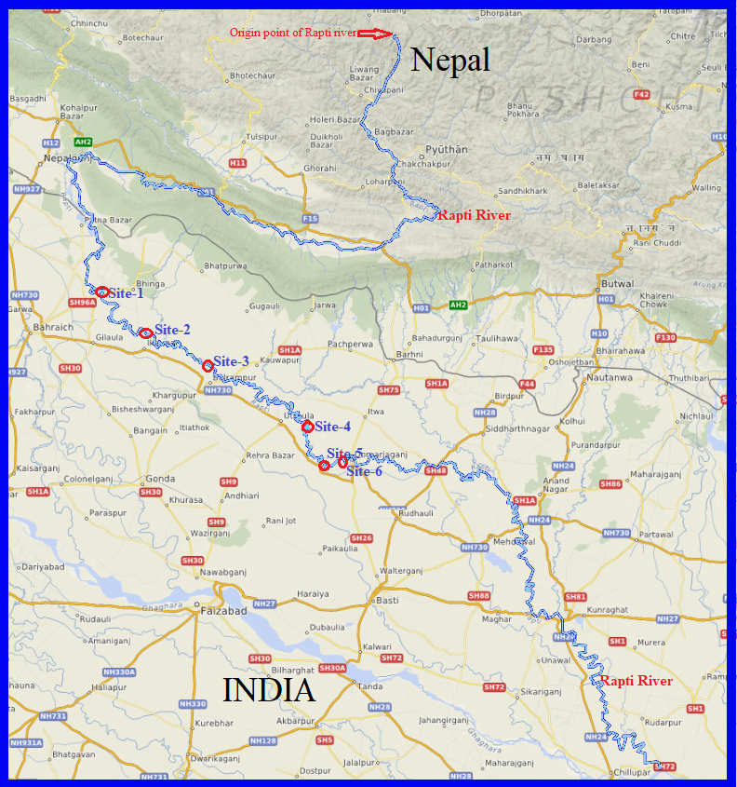
Figure 1: Map showing the origin & flow of river Rapti with Sampling Sites (Site 1-6)

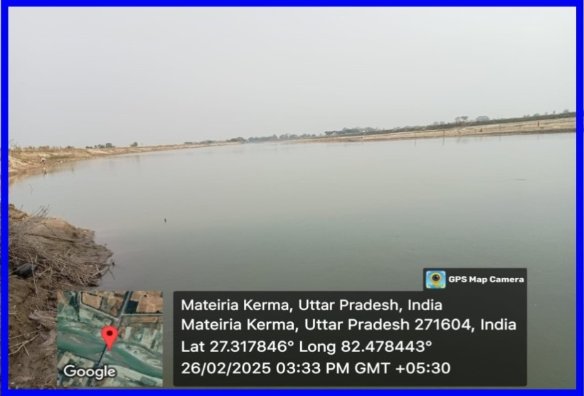
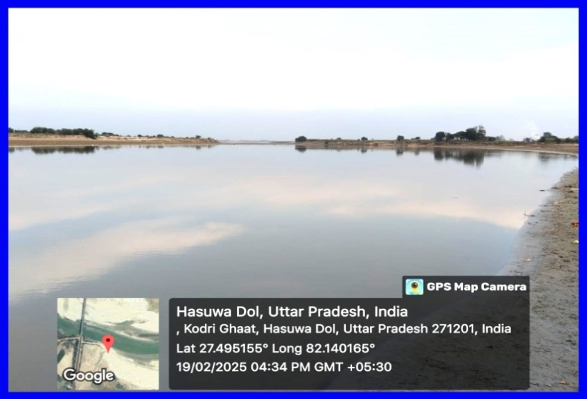
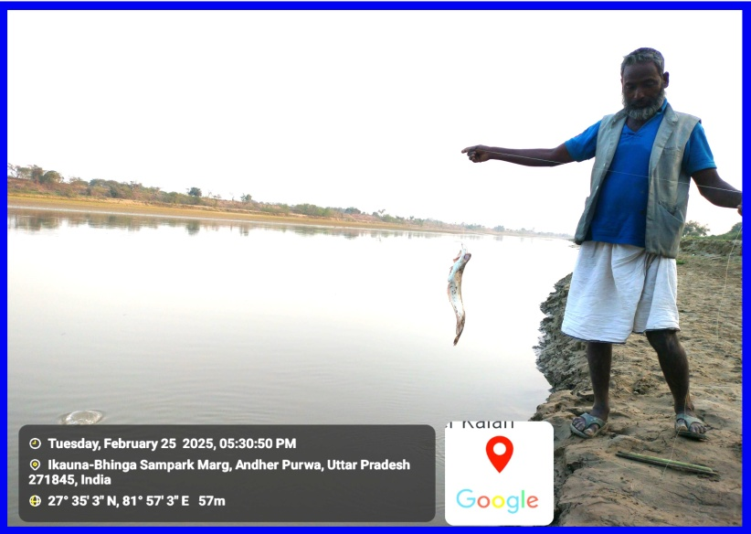
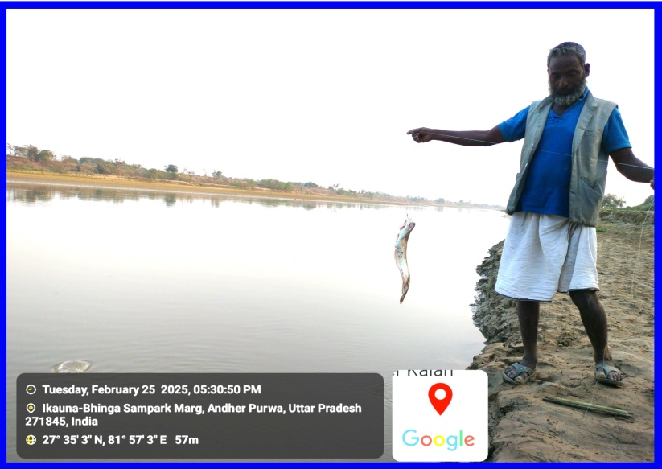
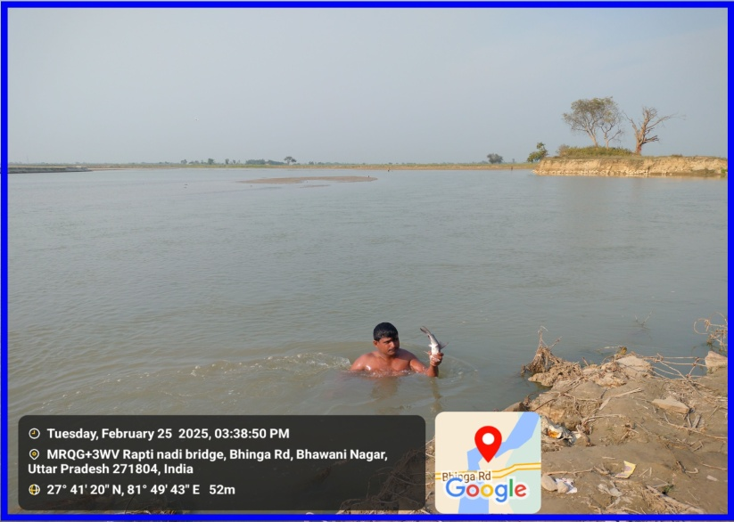
Site 1: Jhunjhunia Ghat, Shravasti Site 2: Andherpurwa Ghat, Shravasti

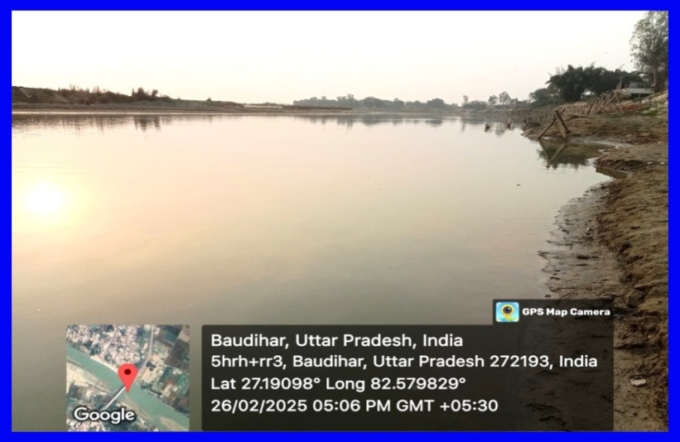
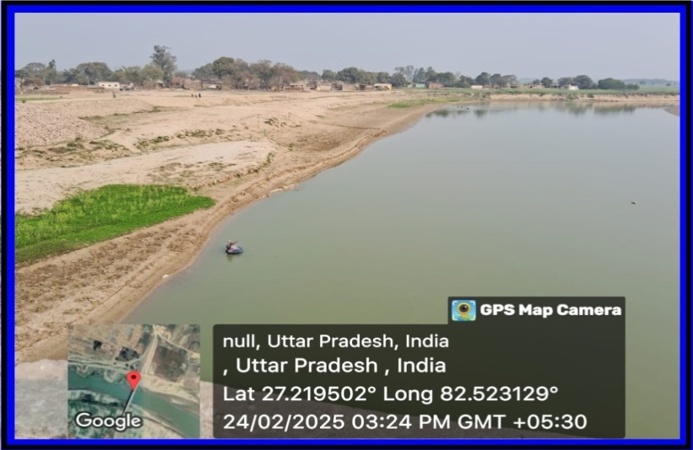
Site 3: Kodari Ghat, Balrampur Site 4: Singarjot Ghat Mateiria, Balrampur
Site 5: Asnahra Ghat, Siddharthnagar Site 6: Bithariya Ghat Baudihar, Siddharthnagar

Figure 2: Sampling Sites of river Rapti
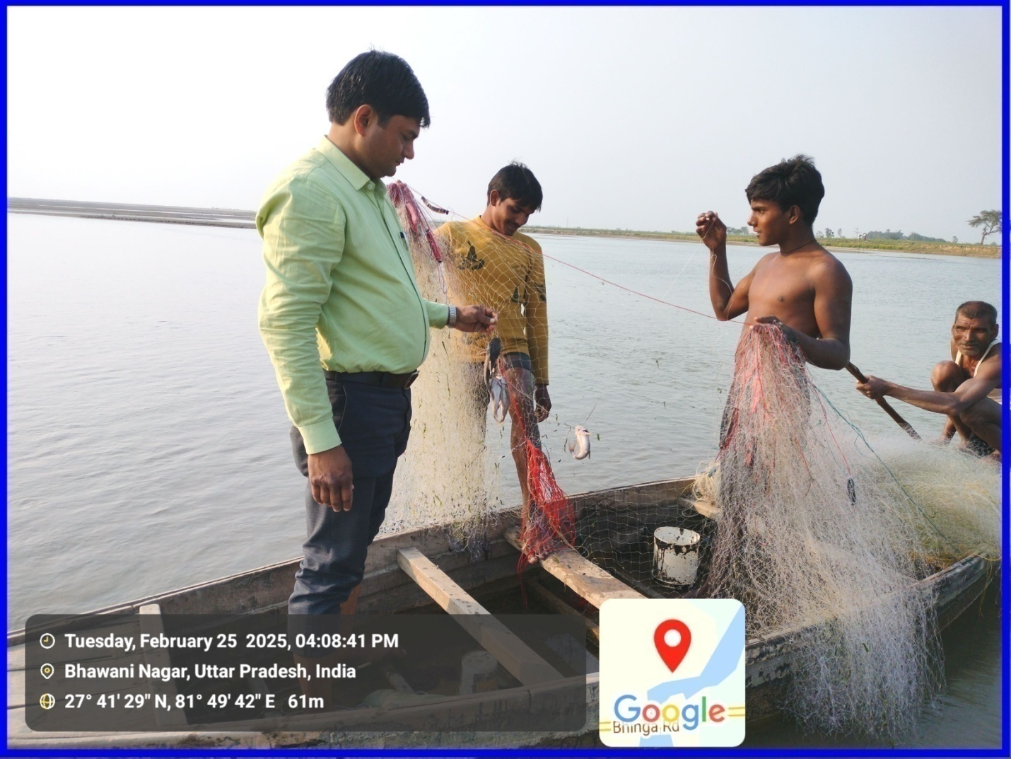
Figure 3: Collection of Fish species with the help of local fishermen at Jhunjhunia Ghat, river Rapti, Shravasti (U.P.)
- RESULT AND DISCUSSION
In the present study, a total of 61 fish species were collected from six sampling sites of the river Rapti belonging 39 genera, 22 families and 9 orders. All the identified fish species, their economic importance and IUCN conservation status are given in the table-2. Out of them the maximum 24 species were found to belong to order Cypriniformes (39.34%) followed by Siluriformes with 18 Species (29.50%), Perciformes with 7 species (11.48%), Ophiocephaliformes with 4 species (6.56%), Synbranchiformes with 3 species (4.92%), Osteoglossiformes with 2 species (3.28%), Clupeiformes with 1 species (1.64%), Belonifoemes with 1 species (1.64 %) and Tetradontiformes with 1 species (1.64 %) Table-3, Fig. 4 & 5. Fish species composition when grouped into families reveal that Cyprinidae constituting major share with 21 species (34.42%) followed by family Bagridae with 6 species (9.84 %); Ophiocephalidae with 4 species (6.56%); Cobitidae, Siluridae, Mastacembelidae and Sisoridae with 3 species each (4.91% share each); Notopteridae, Claridaeand Ambassidae with 2 species each (3.28 % share each) and remaining 11 families with 1 species comprises 1.63% each (Fig.5).
The number of fish species (61) recorded in the present study belonging to 39 genera, 22 families and 9 orders. Sanjay and Prakash(2020) were also reported 46 fish species in the same river that belonging to 30 genera, 19 families and 9 orders. Prakash (2021) was also studied ichthyofauna of the different waterbodies of Devipatan division and he reported a total of 58 fish species belonging 36 genera, 21 families and 9 orders. Ali (2025) was also reported a total 58 fish species, collected from five sampling sites of river Kuwano, Balrampur belonging to 36 genera, 20 families and 8 orders. Many researchers reported a strong dominance of fish fauna in different rivers, notable among them are Khesoh et.al. (2025) who reported a total of 37 fish species, belonging to 4 orders, 13 families, and 25 genera in the Milak and Tsurang river of Mokokchung district, Nagaland; Jaya et. al. (2024) reported 60 fish species in Gosthani estuaries, Bheemunipatnam, belonging 54 genera, 38 families and 20 orders; Saha et. al. (2024) reported of 29 fish species in Mora Dhanshri river Assam, belonging to 12 families and 05 orders; Mishra et. al. (2021) reported 69 fish species, in different water bodies of eastern Uttar Pradesh, belonging to 39 genera, 20 families and07 orders; Bano and Serajuddin (2016) reported 56 species in different sites of river Gomti at Lucknow, belonging to 41 genera, 21 families and 9 orders; Mishra et. al. (2011) reported 62 fish species at Ganga basin, belonging to 48 genera and 24 families.
A total 61 fish species reported in present study. Out of these, 33 species are commonly found and reported in almost all 6 sampling sites, whereas 9 species are moderate, 13 species are rare and 6 species are very rare in the river Rapti. Among these Labeo rohita, Catla catla, Puntius sarana, Bagarius bagarius, Notopterus notopterus, Wallago attu, Mystus spp., Channa spp. and Clarias spp. were frequently observed while some species of carps and catfishes were seen moderately and rare also. Sanjay and Prakash (2020) were also reported 46 fish species, out of which 13 were commonly found, 09 moderate, 18 rare and 06 very rare in the same river. Kanoujiya et. al. (2023) was reported 56 finfish species in the river Kuwano, out of which 48 were common and found abundantly, 4 were moderate and 4 were rarely found in the river.
The threat status of fish fauna of the river in the present study is as follows: most of them (54) are under Least Concern (LC), some (5) of them including Hypophthalmichthys molitrix, Notopterus chitala, Ompok bimaculatus, Ompok pabda and Ailia coila, are under Near Threatened (NT) category and few (02) of them including Bagarius bagarius and Wallago attu are under vulnerable (VU) category. Sanjay and Prakash (2020) were also reported 46 species of fishes in the same river. Out of which, 2 species comes under EN (endangered), 1 species under VU (vulnerable), 5 under NT (near threatened), 35 under LC (least concern) and 3 species are NE (not evaluated). Recently 58 fish species were reported by Ali (2025) in the river Kuwano, out of which 51 under least concern (LC), 5 under near threatened (NT) and 2 species are in vulnerable (VU) category. Kannaujiya et. al. (2023) also reported 56 fish species in the river Kuwano. Out of 56 species, 48 species belong to the least concern (LC), 2 species near threatened (NT), 2 species vulnerable (VU), 1 species endangered (EN) and 2 species were reported as not evaluated categories of the IUCN Red List. Considerable attention should be paid to conserve fish species comes under EN and NT categories.
In the present investigation a total 5 exotic fish species viz, Clarias gariepinus, Ctenopharyngodon idella, Hypopthalmichthys molitrix, Cyprinus carpio and Gudusia chapra were reported in the river Rapti. The migratory fishes viz, Bagarius bagarius, Ompak pabda and Wallago attu also reported in the river. The invasion of these exotic fishes in the river creates competition for food and habitat with native carps and indigenous fishes. The increasing appearance of exotic species in the river is alarming situation and major cause of devastation of the native fish biodiversity in freshwater ecosystems (Sarkar et.al, 2015; Kanoujiya et. al., 2023; Ali, 2025).

Fig. 4: Diagrammatic representation of percent contribution of fish species in each order

Fig. 5: Diagrammatic representation of total no. of fish species occurrence in each order

Table-2: Occurrence, economic importance and conservation status of Ichthyofauna of river Rapti, flowing through Shravasti, Balrampur and Siddharthnagar districts of Uttar Pradesh, India
S.N. |  | S.N. | Scientific Name | Common/ Local Name | Economic Importance | IUCN Status | Occurrence of Fish Species at Sampling Sites |  |  |  |  |  | Availability in the river
 |  |  |  |  |  |  | S-1 | S-2 | S-3 | S-4 | S-5 | S-6
 |  | S.N. | Order: Cypriniformes Family: Cyprinidae (Carp/ Minnows)
1 |  | 1 | Catla catla  (Hamilton, 1822) | Bhakur | FF | LC | +++ | +++ | ++ | ++ | ++ | +++ | Common
2 |  | 2 | Labeo rohita  (Hamilton, 1822) | Rohu | FF | LC | +++ | +++ | +++ | ++ | ++ | +++ | Common
3 |  | 3 | Labeo calbasu  (Hamilton, 1822) | Karaunchhar | FF | LC | ++ | + | + | - | ++ | + | Moderate
4 |  | 4 | Labeo bata  (Hamilton, 1822) | Bata | FF | LC | ++ | +++ | ++ | + | +++ | ++ | Common
5 |  | 5 | Labeo gonius  (Hamilton, 1822) | Kursi/Bata | FF | LC | + | + | + | - | + | - | Rare
6 |  | 6 | Labeo dero  (Hamilton, 1822) | Kalabans | FF | LC | + | - | + | - | + | + | Rare
7 |  | 7 | Cirrhinus mrigala  (Hamilton, 1822) | Naini | FF | LC | +++ | +++ | ++ | ++ | ++ | ++ | Common
8 |  | 8 | Cirrhinus reba  (Hamilton, 1822) | Raia | FF | LC | ++ | ++ | ++ | ++ | +++ | ++ | Common
9 |  | 9 | Cyprinus carpio  (Linnaeus, 1758) | Common carp/China carp | FF | LC | ++ | ++ | +++ | + | ++ | ++ | Common
10 |  | 10 | Ctenopheryngodon idella (Valenciennes, 1884) | Grass carp | FF | LC | ++ | ++ | ++ | + | ++ | +++ | Common
11 |  | 11 | Hypophthalmichthys molitrix (Valenciennes, 1884) | Silver carp | FF | NT | +++ | ++ | +++ | ++ | + | ++ | Common
12 |  | 12 | Puntius sophore  (Hamilton, 1822) | Sidhari | FF, OF | LC | ++ | ++ | ++ | ++ | +++ | +++ | Common
13 |  | 13 | Puntius ticto  (Hamilton, 1822) | Sidhari | FF, OF | LC | + | + | - | + | - | + | Rare
14 |  | 14 | Puntius sarana  (Hamilton, 1822) | Sidhari | FF, OF | LC | ++ | ++ | + | ++ | + | ++ | Common
15 |  | 15 | Puntius chola  (Hamilton, 1822) | Sidhari | FF, OF | LC | ++ | ++ | + | ++ | + | ++ | Common
16 |  | 16 | Rasbora daniconius  (Hamilton, 1822) | Dendua | FF, OF | LC | + | - | + | + | + | - | Rare
17 |  | 17 | Oxygaster bacaila  (Hamilton, 1822) | Chalhawa | FF, OF | LC | +++ | ++ | ++ | +++ | ++ | ++ | Common
18 |  | 18 | Amblypharyngodon mola (Hamilton, 1822) | Mola Carplet | FF, OF | LC | + | + | - | - | + | - | Rare
19 |  | 19 | Barilius bola (Hamilton, 1822) | Bola | FF | LC | - | - | + | - | + | - | Very Rare
20 |  | 20 | Osteobrama cotio  (Hamilton, 1822) | Gurda | FF | LC | + | + | - | + | - | - | Rare
21 |  | 21 | Esomus danricus  (Hamilton, 1822) | Dendu | FF, OF | LC | ++ | ++ | ++ | + | ++ | +++ | Common
 |  | Order: Cypriniformes Family: Cobitidae (True Loaches)
22 |  | 1 | Botia dario  (Hamilton, 1822) | Baggha | FF, OF | LC | + | - | + | - | - | + | Rare
23 |  | 2 | Botia lohachata (Chaudhury, 1922) | Bagha | FF, OF | LC | + | + | - | - | + | - | Rare
24 |  | 3 | Lepidocephalichtys guntea (Hamilton, 1822) | Nakti/ Naun | FF, OF | LC | ++ | ++ | + | ++ | + | ++ | Common
 |  | Order: ClupeiformesFamily: Clupeidae (Herrings/ Shads)
25 |  | 1 | Gudusia chapra  (Hamilton, 1822) | Suhia | FF | LC | +++ | ++ | ++ | ++ | + | ++ | Common
 |  | Order: Osteoglossiformes Family: Notopteridae (Featherbacks/ Knife Fishes)
26 |  | 1 | Notopterus chitala  (Hamilton, 1822) | Moya | FF, OF | NT | ++ | +++ | + | ++ | + | ++ | Common
27 |  | 2 | Notopterus notopterus  (Hamilton, 1822) | Patra | FF | LC | +++ | ++ | ++ | + | ++ | +++ | Common
 |  | Order: Siluriformes Family: Siluridae (Silurid Catfish)
28 |  | 1 | Wallago attu  (Bloch & Schneider, 1801) | Padhani | FF | VU | +++ | +++ | +++ | ++ | +++ | ++ | Common
29 |  | 2 | Ompak bimaculatous  (Bloch, 1794) | Jalkapoor | FF, OF | NT | +++ | ++ | ++ | +++ | ++ | +++ | Common
30 |  | 3 | Ompak pabda  (Hamilton, 1822) | Pabda | FF, OF | NT | + | + | - | - | + | - | Rare
 |  | Order: Siluriformes Family: Bagridae (Bagrid Catfish)
31 |  | 1 | Mystus tengra  (Hamilton, 1822) | Tengana | FF | LC | +++ | +++ | ++ | ++ | +++ | ++ | Common
32 |  | 2 | Mystus seenghala  (Sykes, 1839) | Dariai Tengara | FF | LC | +++ | ++ | +++ | ++ | +++ | ++ | Common
33 |  | 3 | Mystus cavasius  (Hamilton, 1822) | Tengara | FF, OF | LC | ++ | +++ | ++ | +++ | ++ | +++ | Common
34 |  | 4 | Mystus vittatus  (Bloch, 1794) | Tengara | FF, OF | LC | +++ | ++ | ++ | ++ | ++ | ++ | Common
35 |  | 5 | Mystus oar  (Hamilton, 1822) | Tengara | FF | LC | ++ | + | + | + | + | ++ | Moderate
36 |  | 6 | Rita rita  (Hamilton, 1822) | Hunna/ Rita | FF | LC | +++ | +++ | +++ | + | ++ | + | Common
 |  | Order: Siluriformes Family: Sisoridae (Sisorid Catfish)
37 |  | 1 | Bagarius bagarius  (Hamilton, 1822) | Ghhonch | FF | VU | +++ | ++ | ++ | ++ | ++ | ++ | Common
38 |  | 2 | Gangta cenia  (Hamilton, 1822) | Indian Gangta | FF, OF | LC | ++ | + | + | + | - | - | Rare
39 |  |  | Glyptothorax botius  (Hamilton, 1822) | Botius Catfish | FF. OF | LC | + | + | + | - | - | + | Rare
 |  | Order: Siluriformes Family: Pangasiidae (Shark Catfish)
40 |  | 2 | Pangasius pangasius (Hamilton, 1822) | Payas | FF | LC | +++ | +++ | ++ | ++ | ++ | +++ | Common
 |  | Order: Siluriformes Family: Claridae(Air breathing Catfish)
41 |  | 1 | Clarias batrachus (Linnaeus, 1758) | Mangur | FF, LF | LC | ++ | ++ | +++ | ++ | +++ | ++ | Common
42 |  | 2 | Clarias gariepinus  (Burchell, 1822) | African Catfish | FF | LC | ++ | +++ | ++ | ++ | ++ | +++ | Common
 |  | Order: Siluriformes Family: Heteropneustidae (Air sac Catfish)
43 |  | 1 | Heteropneustes fossilis (Bloch, 1794) | Singhi | FF, LF | LC | ++ | ++ | +++ | +++ | ++ | +++ | Common
 |  | Order: Siluriformes Family: Schilbeidae (African butter Catfish)
44 |  | 1 | Ailia coila (Hamilton, 1822) | Minti/Patasi | FF, OF | NT | + | + | - | - | + | - | Rare
 |  | Order: Siluriformes Family: Chacidae (Charcins)
45 |  | 1 | Chaca chaca (Hamilton, 1822) | Chakawa/ Angler Catfish | FF | LC | +++ | +++ | ++ | ++ | +++ | ++ | Common
 |  | Order: Ophiocephaliformes Family: Ophiocephalidae (Murrel/ Snakeheaded Fishes)
46 |  | 1 | Channa punctatus  (Bloch, 1793) | Girai | FF, LF | LC | ++ | +++ | +++ | +++ | ++ | ++ | Common
47 |  | 2 | Channa striatus  (Bloch, 1793) | Saur | FF | LC | +++ | ++ | ++ | +++ | +++ | +++ | Common
48 |  | 3 | Channa marulius  (Hamilton, 1822) | Saur | FF | LC | ++ | +++ | +++ | ++ | +++ | ++ | Common
49 |  | 4 | Channa gachua  (Hamilton, 1822) | Chargan | FF, LF | LC | - | ++ | + | - | - | + | Rare
 |  | Order: Perciformes Family:Ambassidae (Asiatic Glassfishes)
50 |  | 1 | Chanda nama  (Hamilton, 1822) | Chanda | OF | LC | ++ | ++ | + | ++ | + | + | Moderate
51 |  | 2 | Chanda ranga  (Hamilton, 1822) | Chanari | OF | LC | ++ | ++ | + | + | ++ | + | Moderate
 |  | Order: Perciformes Family:Anabantidae (Climbing Perches)
52 |  | 1 | Anabas testudineus  (Bloch, 1792) | Kawai | FF, LF | LC | +++ | +++ | +++ | ++ | ++ | ++ | Common
 |  | Order: Perciformes Family:Badidae (Blue Perches)
53 |  | 1 | Badis badis  (Hamilton, 1822) | Sumha | FF, LF | LC | +++ | ++ | ++ | +++ | ++ | ++ | Common
 | Order: Perciformes Family:Nandidae (Asian Leaf fishes)
54 |  | 1 | Nandus nandus  (Hamilton, 1822) | Dhebari | FF | LC | + | + | - | - | + | + | Rare
 |  | Order: Perciformes Family: Gobiidae (Gobies)
55 |  | 1 | Glossogobius giuris  (Hamilton, 1822) | Bulla | FF, OF | LC | + | - | + | + | - | - | Rare
 |  | Order: Perciformes Family: Osphronemidae (Gouramies)
56 |  | 1 | Colisa fasciatus  (Bloch & Schneider, 1801) | Khosti/ Khasuwa | OF, LF | LC | +++ | +++ | ++ | ++ | + | ++ | Common
 |  | Order: Synbranchiformes Family: Mastacembelidae (Spiny Eels)
57 |  | 1 | Mastacembelus armetus  (Lacepede, 1800) | Baam/ Bamla | FF | LC | +++ | ++ | ++ | ++ | +++ | ++ | Common
58 |  | 2 | Mastacembelus pancalus (Hamilton, 1822) | Baam | FF | LC | ++ | ++ | +++ | ++ | +++ | ++ | Common
59 |  | 3 | Mastacembelus aculeatus (Bloch, 1786) | Baam/ Bamla | FF | LC | +++ | ++ | +++ | ++ | +++ | ++ | Common
 |  | Order: Beloniformes Family: Belonidae (Needle Fish)
60 |  | 1 | Xenentodon cancila  (Hamilton, 1822) | Kawwa fish | FF, OF | LC | ++ | + | - | - | + | - | Rare
 | Order: Tetradontiformes Family: Tetradontidae
61 |  | 1 | Tetradon cutcutia (Hamilton, 1822) | Galfulani | OF | LC | + | + | - | - | + | - | Very Rare

Availability in the river: Common-39 Species; Moderate-04 Species; Rare-16 Species; Very Rare-02 Species
Abbreviations: FF= Food Fish; OF= Ornamental Fish; LF= Larvivorous Fish
LC= Least Concern; NT= Near Threatened; VU= Vulnerable

Table-3: Number and percentage composition of family, genus and species of each order of Ichthyofauna of river Rapti flowing through Shravasti, Balrampur and Siddharthnagar districts of Uttar Pradesh, India.
S.N. | Order | Family | Genus | Species | Percentage of Families in Order | Percentage of Genus in Order | Percentage of Species in Order
1 | Cypriniformes | 2 | 15 | 24 | 9.09 | 38.46 | 39.34
2 | Siluriformes | 8 | 12 | 18 | 36.36 | 30.77 | 29.50
3 | Perciformes | 6 | 6 | 7 | 27.27 | 15.38 | 11.48
4 | Ophiocephaliformes | 1 | 1 | 4 | 4.55 | 2.56 | 6.56
5 | Synbranchiformes | 1 | 1 | 3 | 4.55 | 2.56 | 4.92
6 | Osteoglossiformes | 1 | 1 | 2 | 4.55 | 2.56 | 3.28
7 | Clupeiformes | 1 | 1 | 1 | 4.55 | 2.56 | 1.64
8 | Beloniformes | 1 | 1 | 1 | 4.55 | 2.56 | 1.64
9 | Tetradontiformes | 1 | 1 | 1 | 4.55 | 2.56 | 1.64
Total |  | 22 | 39 | 61 | 100 | 100 | 100

Fig. 6: Diagrammatic representation of total no. of fish species occurrence in each family

- CONCLUSION
The Rapti River is a tributary of the Ghaghara River, flowing through Nepal and Uttar Pradesh, India. The richness of ichthyofaunal diversity in the river at present is considered to be satisfactory. But, the river and its fauna are approaching to under threat due to several anthropogenic activities such as illegal and overfishing, commercial exploitation, indiscriminate use of fertilizers and pesticides, habitat alteration and introduction of exotic species. It is suggested that the fishery authorities should investigate the fishing practices properly and to manage the fishery resources according to ecological principles. Fishing of small fishes during breeding season is a serious concern and it should be banned. There are few literatures are available about the Ichthyofaunal diversity of the river Rapti, so the present study will provide the baseline data on fish fauna of the river that would be beneficial for ichthyologists, fish culturist and researchers of fishery sector.

REFERENCES
- Ali, H. (2025). Ichthyofaunal diversity and their conservation status in river Kuwano, flowing through district Balrampur, Uttar Pradesh, India”. Uttar Pradesh Journal of Zoology 46 (5):191-205. https://doi.org/10.56557/upjoz/2025/v46i54835\
- Ali, H. (2024). Fish parasites and their impact on human health. Environment and Society 2023. pp 25-40.
- Banerjee, D.C., Raghunathan, A.N., Rizvi and Das, D. (2022) Animal discoveries 2021: New Species and New Records, Director, Zool. Surv. India, Kolkata, 232pp.
- Bano F., Serajuddin M. (2016). Biodiversity, Threat Status and Conservation Priority of Icthyo-fauna of River Gomti at Lucknow Region, India. Biodiversity Journal, 7(4):913-922.
- Chaudhari, Bhesh Raj (2022). Status of Fish Diversity in Lower West Rapti River, Banke. International Journal of Creative Research Thoughts 10 (10):427-433. http://dx.doi.org/10.2139/ssrn.4262895
- Datta Munshi, J., & Srivastava, S. (1988). Natural history of fishes and systematic of freshwater fishes of India. Narendra Publishing House.
- Day, F. (1989). The fauna of British India including Ceylon and Burma (Vol. 2). Taylor and Francis.
- Fricke, R., Eschmeyer, W.N. and Laan, R. V. (2022). Eschmeyer’s catalog of fishes: genera, species, The New Finfish Genetic Resource Discoveries from Indian Waters 297. Indian J. Plant Genet. Resour. 35(3): 293–297.
- IUCN (2024). IUCN Red List of Threatened Species. Available at https://www.iucnredlist.org/en
- Jain, S. (2017). Current status of ichthyofaunal diversity of various water sources of western Uttar Pradesh, India. International Journal of Fisheries and Aquatic Studies. 5(2): 473-478.
- Jaya, P., Rao, K. R., Surya, N., Rao, M. B., Balaji, M., & Ramakrishna, M. (2024). Annotated checklist of ichthyofaunal diversity in the freshwater tidal stretch along the Gosthani Estuary, Bheemunipatnam, East Coast of India. Uttar Pradesh Journal of Zoology 45(12): 89–101. https://doi.org/10.56557/upjoz/2024/v45i124108
- Jayaram, K. C. (2011). The freshwater fishes of Indian region (2nd ed.). Narendra Publication House.
- Kanoujiya, S., Sahu, A., Gautam, R. K., & Gorakh, S. S. (2023). An assessment of fish diversity of Kuwano river (A tributary of river Ghaghra), emerging threats and conservation perspectives. The Pharma Innovation Journal, 12(11), 275-285.
- Khesoh, V., Pulo, Z and Pankaj, P.P. (2025). Ichthyofaunal diversity and conservation status of the Tsurang and Milak Rivers of Mokokchung District, Nagaland. Journal of Applied and Natural Science 17(4): 1745 -1752. https://doi.org/10.31018/jans.v17i4.7005
- Kumar R,, Singh RD and Sharma KD. (2005) Water resources of India. Curr. Sci. 89: 794-811.
- Menon, A. G. K. (1992). The fauna of India and adjacent countries. Pisces 4 (Part-I). Homalopteridae. Zoological Survey of India.
- Mishra, S.K., Sarkar, U.K., Gupta, B.K., Trivedi, S.P., Dubey, V.K. and Pal, A., (2011). Pattern of freshwater fish diversity, threats and issues of fisheries management in an unexplored tributary of the Ganges basin, Northern India. Journal of Ecophysiology and Occupational Health, 11(3/4), pp.149.
- Mishra, S. P., Mishra, D. V., & Mishra, A. K. (2021). Diversity of freshwater fishes and their conservation status in Eastern Uttar Pradesh, India. International Journal for Modern Trends in Science and Technology, 7:69-77.
- Mohd Izam, N. A., Azman, S. N., Jonit, E., Sallehoddin, S. M. H., Khairul, D. C., Zainul Abidin, M. K., & Farinordin, F. A. (2021). Freshwater ecosystem: A short review of threats and mitigations in Malaysia. Gading Journal of Science and Technology, 4(1), 109-117.
- Pacheco, P., Mo, K., Dudley, N., Shapiro, A., Aguilar-Amuchastegui, N., Ling, P., Anderson, C., & Marx, A. (2021). Deforestation fronts: Drivers and responses in a changing world. WWF, Gland, Switzerland, 1-125.
- Patil, R. G. and Gujar, M. P. (2015). Ichthyofaunal diversity in Krishna River in Satara district, Maharashtra, India. International Journal of Researches in Biosciences, Agriculture and Technology. 3(2): 340-344.
- Prakash, S. (2020a). Fish diversity of Semara Taal, a wetland of district Siddharthnagar (U.P.), India. International Journal of Fisheries and Aquatic Research. 5(2):07-09.
- Prakash, S. (2020b). Conservation status of fishes reported from Semara Taal of District Siddharthnagar (U.P.). India. International Journal of Fauna and Biological Studies. 7(3): 21-24.
- Prakash, S. (2021). Present status of fish diversity of Davipatan Division of Uttar Pradesh, India. Intern. J. Zool. Invest. 7(2): 629-636. https://doi.org/10.33745/ijzi.2021.v07i02.047.
- Prakash S., Kumar A., Prakash S. and Mishra B.K. (2020). A Survey of fish fauna of Rapti river, Balrampur (U.P.) India. International Journal of Biological Innovations. 2 (1): 76-81.
- Sah, S. P. (2025). Fish diversity in relation to habitat of Rapti river, Chitwan.International Journal of Biological Innovations.7 (1): 66-73.
- Saha, A., Ahmed, S., Das, R., Bhattacharjee, S., Kashyap, S. C., Bhattacharjee, C., & Sur, S. (2024). A study on the freshwater fish diversity of Mora Dhansiri River, Assam,India. Uttar Pradesh Journal of Zoology, 45(6), 164–171. https://doi.org/10.56557/upjoz/2024/v45i63 963
- Sanjay, M.C. and Prakash, S. (2020) Ichthyofaunal diversity of Rapti River flowing through Shravasti and Balrampur districts of Uttar Pradesh (India). Bull Pure Appl Sci Zool. 39A(2): 272-280.
- Sarkar, U. K., Dubey, V. K., Pathak, A. K., & Mahapatra, B. K. (2015). Biodiversity of freshwater fishes in Uttar Pradesh: Regenerating status and reinforcing conservation efforts for sustainable management. In International Day for Biological Diversity: Biodiversity for Sustainable Development. Uttar Pradesh State Biodiversity Board, Lucknow. pp. 88-91.
- Serajuddin, M., Ali, R and Faridi, A.A.(2004). Freshwater fish diversity of Sant Ravidas Nagar, Bhadohi District of eastern Uttar Pradesh. India. J. Natural Conserv.16:413-422.
- Srivastava, P. K. (2013). Fish diversity and conservation perspectives of Gandak River, India. Our Nature, 11(1): 76-84.
- Srivastava, G. J. (2002). Fishes of U.P. and Bihar (9th ed.). Vishwavidalaya Prakashan.
- Talwar, P. K., & Jhingran, A. G. (1991). Inland fishes of India and adjacent countries (Vol. 1, Part 2, pp. 1158). Oxford and IBH Publishing Co. Pvt. Ltd.
- Verma D., Ahmad T., Bajpai S., Dixit V. K. and Singh U.B. (2019): Condition Factor of Fishes of Rapti River in Different Seasons at Balrampur, Uttar Pradesh, India. Int. J. Zool. Invest. 5 (2): 118-128.

