Isolation and Structural Elucidation of Mangiferin from Mangifera indica L. Bark and Evaluation of Its Antioxidant Activity and Preliminary Toxicity Using the Brine Shrimp Lethality Assay

ABSTRACT
Oxidative stress resulting from excessive production of reactive oxygen species (ROS) plays a critical role in the onset and progression of several chronic diseases, including cancer, diabetes mellitus, cardiovascular disorders, and neurodegenerative conditions. Natural antioxidants derived from medicinal plants are increasingly being explored as safer alternatives to synthetic antioxidants. In the present study, mangiferin, a bioactive C-glucosyl xanthone, was isolated and purified from the bark of Mangifera indica L. using Soxhlet extraction followed by silica gel column chromatography. The purity and identity of the isolated compound were confirmed through thin layer chromatography (TLC) and comprehensive spectroscopic and chromatographic characterization, including UV–Visible spectroscopy, FT-IR, HPLC, ¹H- and ¹³C-NMR, and GC–MS analyses. The antioxidant potential of purified mangiferin was evaluated using multiple in vitro assays, including DPPH, ABTS●⁺, hydroxyl radical, superoxide anion, hydrogen peroxide, nitric oxide scavenging, and ferric reducing antioxidant power (FRAP) assays. Mangiferin exhibited significant and concentration-dependent antioxidant activity across all assays, with IC₅₀ values comparable to those of the ascorbic acid. The strong radical scavenging and reducing abilities of mangiferin are attributed to its polyphenolic structure and efficient electron- and hydrogen-donating properties. In addition, the preliminary toxicity profile of mangiferin was assessed using the brine shrimp lethality assay (Artemia salina).The results indicated very low lethality of Artemia salina nauplii across the tested concentrations (25–500 µg/mL), with no mortality observed at 25 and 50 µg/mL and slight mortality at 100–500 µg/mL. The calculated LD₅₀ value of 1218.60 ± 0.87 µg/mL suggests very low toxicity. These findings support its potential application as a safe, natural antioxidant and a promising therapeutic lead for oxidative stress–related disorders.
Keywords: Mangiferin, Xanthone, Oxidative Stress, Natural Antioxidant, Mangifera indica L.

INTRODUCTION

Oxidative stress is a pathological condition that arises from an imbalance between the excessive generation of reactive oxygen species (ROS) and the capacity of the cellular antioxidant defense system to neutralize them. ROS, including superoxide anions, hydrogen peroxide, and hydroxyl radicals, are highly reactive molecules capable of inducing oxidative damage to vital cellular macromolecules such as nucleic acids, proteins, and lipids. Persistent oxidative stress disrupts cellular homeostasis, promotes genomic instability, alters signal transduction pathways, and accelerates cellular dysfunction, thereby playing a central role in the initiation and progression of numerous chronic and degenerative diseases (Reddy 2023). Accumulating evidence strongly implicates oxidative stress in the pathophysiology of cancer, diabetes mellitus, cardiovascular disorders, neurodegenerative diseases, diabetes, and other metabolic syndromes. Although endogenous enzymatic antioxidants (superoxide dismutase, catalase, glutathione peroxidase) and non-enzymatic antioxidants (glutathione, vitamins C and E) regulate ROS under normal physiological conditions, sustained or excessive radical production often overwhelms these defense mechanisms, highlighting the need for effective exogenous antioxidant sources (Leyane et al., 2022).

Medicinal plants constitute an invaluable reservoir of structurally diverse bioactive phytochemicals capable of mitigating oxidative stress through multiple mechanisms, including free radical scavenging, metal ion chelation, inhibition of pro-oxidant enzymes, and modulation of redox-sensitive signaling pathways (Tugen et al., 2025). Among these plants, Mangifera indica L. has gained considerable scientific attention due to its rich phytochemical profile and wide range of pharmacological activities. Mangiferin, a naturally occurring C-glucosyl xanthone predominantly distributed in the bark, leaves, and peels of Mangifera indica L., is recognized as one of the principal bioactive constituents responsible for its antioxidant, anti-inflammatory, antidiabetic, neuroprotective, and anticancer effects (Imran et al., 2017). Structurally, mangiferin possesses multiple hydroxyl groups and a xanthone backbone, which confer strong electron- and hydrogen-donating abilities, making it an efficient scavenger of reactive oxygen and nitrogen species. However, the biological activity of mangiferin is critically influenced by its purity, structural integrity, and physicochemical characteristics, which necessitate rigorous isolation and analytical validation.

Therefore, systematic isolation and purification of mangiferin from Mangifera indica L. bark are essential to obtain a chemically well-defined compound suitable for reproducible biological evaluation. Chromatographic techniques, particularly silica gel column chromatography coupled with thin layer chromatography, gives efficient separation of mangiferin from structurally related phytoconstituents and interfering matrix components. In addition, comprehensive structural and physicochemical characterization using advanced spectroscopic and chromatographic techniques including UV–Visible spectroscopy, Fourier-transform infrared spectroscopy (FT-IR), high-performance liquid chromatography (HPLC), nuclear magnetic resonance (¹H and ¹³C NMR), and mass spectrometry is indispensable for confirming compound identity, functional group composition, molecular framework, and chemical purity.

The brine shrimp lethality assay (BSLT) is a simple, rapid, and cost-effective bioassay commonly used for the preliminary assessment of the toxicity of natural and synthetic compounds. This assay employs the larvae of Artemia salina as a convenient invertebrate model for evaluating the biological effects of test substances. The toxicity of the compounds is determined by observing the mortality of brine shrimp nauplii after exposure to different concentrations of test compounds. The median lethal concentration (LD₅₀), as the concentration of test compound required to cause 50% mortality of the nauplii population, is calculated using regression analysis.

In this context, the present study aims to systematically isolate, purify, and characterize mangiferin from the bark of Mangifera indica L. using chromatographic and spectroscopic approaches, followed by a comprehensive evaluation of its antioxidant potential through multiple in vitro free radical scavenging and reducing power assays. In addition, the general toxicity profile of the isolated compound was assessed using the Brine Shrimp Lethality Assay employing Artemia salina nauplii to determine the LD₅₀ value. This integrated phytochemical and biological approach provides critical insights into the relationship between the structural integrity of mangiferin and its antioxidant efficacy, while also offering preliminary information regarding its safety profile, thereby supporting its potential application as a natural antioxidant and a promising therapeutic lead for oxidative stress–related disorders.

MATERIALS AND METHODS

Plant Material
The bark of Mangifera indica L. was collected from Mayiladuthurai District, Tamil Nadu, India. The plant material was authenticated by a botanist from the Department of Botany, Dharmapuram Gnanambigai Government Arts College (W), Tamil Nadu. A voucher specimen (DGGACW/BOT/125) was deposited for future reference.

Extraction of Mangifera indica L. Bark
The air-dried bark powder of Mangifera indica L. was subjected to exhaustive extraction using a Soxhlet apparatus with petroleum ether for 7 hours to remove fatty and non-polar constituents. The defatted residue was subsequently extracted using 95% ethanol for 3 hours in the same apparatus. After extraction, the ethanolic extract was concentrated and stored at 4 °C for further analysis, following the method described by Biswas et al., (2015).

Fractionation and Purification of Crude Extract
Fractionation of the crude ethanolic extract was carried out using column chromatography as described by Singh et al., (2012). A glass column was vertically packed with silica gel (60–120 µm), previously activated at 120 °C for 2 hours, using the slurry method with petroleum ether as the packing solvent. The column was gently tapped to ensure uniform packing and allowed to equilibrate before sample loading.
The ethanolic extract was adsorbed onto silica gel to form a free-flowing powder and carefully layered onto the top of the packed column. Elution was performed using a solvent system consisting of chloroform:acetone:formic acid (8:1.5:0.5), with fractions collected using solvents of increasing polarity. The collected fractions were concentrated by solvent evaporation, yielding mangiferin crystals, which were further purified by washing with acetone and ethanol to remove residual impurities.

Thin Layer Chromatography (TLC)
Thin layer chromatography was employed to monitor the separation and purity of the fractions. TLC Anexs were prepared by coating clean glass plates with an aqueous slurry of silica gel G, containing calcium carbonate or starch as a binder. The plates were activated by heating at 105 °C for 30 minutes and allowed to cool prior to use.
Samples were loaded approximately 1 cm from the base of the plate using capillary tubes. The developing chamber was pre-saturated with the solvent system chloroform:acetone:formic acid (8:1.5:0.5). The plates were developed until the solvent front reached approximately three-fourths of the plate height. After development, the plates were removed, air-dried, and heated at 60–120 °C. The presence of polyphenolic compounds was detected by exposing the plates to ammonia vapour, as described by Rasyid et al., (2020).
Characterization of Isolated Compound

UV and FT-IR Spectroscopic analysis

The collected sample was scanned in the wavelength ranging from 200-700nm using Perkin Elmer Spectrophotometer and the characteristic peaks were detected. FTIR analysis was performed using Perkin Elmer Spectrophotometer system, which was used to detect the characteristic peaks ranging from 400-4000 cm⁻¹ corresponding to their functional groups. The peak values of the UV and FTIR were recorded. Each and every analysis was repeated twice for the spectrum confirmation.

HPLC Analysis

HPLC was used to evaluate fractions using the (Paranthaman et al., 2012) method. A Shimadzu HPLC system (Class-VP V6.14 SP2, Japan) with a UV-visible detector and an autosampler (20 μL loop) was used for the analysis. Gradient elution with solvents A (water:acetic acid, 25:1 v/v) and B (methanol) was used to accomplish separation. At a flow rate of 1.0 mL/min, the percentage of solvent B was raised to 50% in 4 minutes and subsequently to 80% in 10 minutes. Detection was done at 280 nm, and each run lasted 25 minutes. Autochro software was used to capture and interpret chromatographic results.

NMR Spectroscopy

The NMR experiment was carried out in BRUKER-AMX400 MHz instrument with 5mg of purified compound in DMSO. Tetra Methyl Silane is used as the internal standard and chemical shifts are expressed in ppm. (Verpoorte et al., 2007).

Mass Spectrum Analysis

Mass spectrum analysis of sample was equipped with JEOL GC MATE-11 HR Mass spectrometer. The chromatography was fitted with DB 5 MS capillary column (30 m x 0.25 mm, film thickness 0.25 µm). The mass spectrometer was operated in the electron impact mode at 70ev. Ion source and transfer line temperature was kept at 250˚C. Mass spectra were recorded in the positive ion mode with a mass range from 100 to 1100 m/z. The detector transforms the number of molecules into an electrical signal and a computer or integrator translates this individual signal peaks into a graph.

Antioxidant Activity

DPPH Radical Scavenging Activity

The free radical scavenging activity of the isolated mangiferin was evaluated using the 1,1-diphenyl-2-picrylhydrazyl (DPPH) assay. A DPPH stock solution was prepared by dissolving 24 mg of DPPH in 100 mL of methanol. The solution was filtered and diluted with methanol to obtain a working solution with an absorbance of approximately 0.973 at 517 nm. For the assay, 3 mL of the DPPH working solution was mixed with 100 µL of mangiferin at concentrations ranging from 10 to 50 µg/mL. Ascorbic acid (10–50 µg/mL) served as the reference standard. The control contained 3 mL of DPPH solution and 100 µL of methanol. All reaction mixtures were incubated in the dark at room temperature for 30 min, and the absorbance was measured at 517 nm using a UV–Vis spectrophotometer (Baliyan et al., 2022).

ABTS●⁺ Radical Scavenging Activity
The ABTS●⁺ radical scavenging assay was performed according to the method described by (Rumpf et al., 2023), with slight modifications. The ABTS●⁺ radical cation was generated by reacting 7 mM ABTS with 2.45 mM potassium persulfate in ethanol:water (50:50, v/v) and incubating the mixture in the dark at 25 °C for 12–16 h. The resulting solution was diluted with 50% ethanol to obtain an absorbance of 0.700 ± 0.005 at 734 nm. For the assay, 2.5 mL of the diluted ABTS●⁺ solution was mixed with mangiferin at concentrations of 10–50 µg/mL. After incubation for 12 min, the absorbance was recorded at 734 nm. Ascorbic acid (10–50 µg/mL) was used as the standard antioxidant.

Hydroxyl Radical Scavenging Activity
The hydroxyl radical scavenging activity of mangiferin was determined following the method described by Chen et al., (2015). Briefly, 1 mL of mangiferin solution (10–50 µg/mL) was mixed with 1 mL of 9 mM FeSO₄ and 0.1 mL of 9 mM salicylic acid prepared in ethanol. The reaction was initiated by adding 1 mL of 9 mM H₂O₂, and the mixture was incubated at 37 ± 1 °C for 30 min. The absorbance was measured at 510 nm using a UV–Vis spectrophotometer. Ascorbic acid (10–50 µg/mL) was used as the positive control.

Hydrogen Peroxide (H₂O₂) Scavenging Activity
The hydrogen peroxide scavenging activity of mangiferin was evaluated using a modified method of Al-Amiery et al., (2015). A 2 mM H₂O₂ solution was prepared in 0.2 M phosphate buffer (pH 7.4). Various concentrations of mangiferin (10–50 µg/mL) were added to 2 mL of the H₂O₂ solution and incubated in the dark at room temperature for 30 min. The absorbance was measured at 230 nm against a blank containing phosphate buffer without H₂O₂. Ascorbic acid (10–50 µg/mL) was used as the standard. All experiments were performed in triplicate, and IC₅₀ values were calculated from the inhibition curves.

Nitric Oxide (NO) Radical Scavenging Assay
Nitric oxide scavenging activity was assessed using a modified method of Kurian et al., (2010). Briefly, 500 µL of mangiferin solutions (10–50 µg/mL) or distilled water (control) was mixed with 250 µL of sodium nitroprusside (10 mM) prepared in potassium phosphate buffer (pH 7.4). The reaction mixture was incubated at 37 °C for 120 min. After incubation, 250 µL of Griess reagent was added, and the absorbance was measured at 546 nm. Ascorbic acid (10–50 µg/mL) was used as the positive control.

Superoxide Radical Scavenging Assay
The superoxide anion scavenging activity of mangiferin was determined according to the method described by Liu et al., (2022), with minor modifications. Mangiferin solutions (10–50 µg/mL) were mixed with 3 mL of Tris–HCl buffer (50 mM, pH 8.2) and incubated at 25 °C for 20 min. The reaction was initiated by adding 0.3 mL of 3 mM pyrogallol, and the change in absorbance was monitored at 320 nm every 30 s for 5 min. The scavenging activity was calculated based on the inhibition of pyrogallol auto-oxidation. Ascorbic acid (10–50 µg/mL) served as the reference standard.

Reducing Power Assay
The reducing power of mangiferin was evaluated using the Ferric Reducing Antioxidant Power (FRAP) assay. Mangiferin solutions (10–50 µg/mL) were mixed with 2.5 mL of 0.2 M phosphate buffer (pH 6.6) and 2.5 mL of 1% potassium ferricyanide. The mixtures were incubated at 50 °C for 20 min, followed by the addition of 2.5 mL of 10% trichloroacetic acid. After centrifugation at 3,000 rpm for 10 min, 2.5 mL of the supernatant was mixed with 0.5 mL of 0.1% ferric chloride. The absorbance was measured at 700 nm. Ascorbic acid (10–50 µg/mL) was used as the standard. Increased absorbance indicated higher reducing power (Samarakoon, 2023).

Brine Shrimp Lethality Assay
The brine shrimp lethality assay was performed according to the method described by Suryawanshi et al., (2020) with some modifications. Brine shrimp (Artemia salina) eggs were purchased from a local pet store in Mayiladuthurai District, Tamil Nadu, India. Artificial seawater was prepared by dissolving 38 g of non-iodized sea salt in 1 L of distilled water, and the solution was filtered to obtain a clear medium. The brine shrimp eggs were incubated in a small hatching tank containing the prepared artificial seawater for 48 h under continuous illumination and aeration to facilitate hatching. After incubation, the hatched nauplii were collected carefully using a Pasteur pipette.
Mangiferin was dissolved in dimethyl sulfoxide (DMSO) to prepare the stock solution. Different concentrations of mangiferin (25, 50, 100, 250 and 500 µg/mL) were then prepared by diluting the stock solution with artificial seawater, ensuring that the final concentration of DMSO did not exceed 1.25% (v/v), as suggested by Dai and Mumper (2010). For each concentration, thirty nauplii were transferred into glass containers containing 25 mL of saline solution mixed with the respective concentration of the test sample. The samples were incubated at room temperature for 24 h. After incubation, the number of surviving nauplii was counted. Nauplii were considered dead when no internal or external movement was observed during 1 min of continuous observation. Saline solution alone served as the negative control, while potassium dichromate prepared at a concentration of 1 mg/mL in saline solution was used as the positive control. The percentage mortality of the nauplii was calculated using the following formula:
Mortality (%)=Initial number of live nauplii/ Number of dead nauplii ×100
The LD₅₀ value was calculated using the regression line equation obtained from the dose–response curve using MS-Excel for Mangiferin and control.

Statistical Analysis
All experiments were performed in triplicate (n=3), and the results were expressed as mean ± standard deviation (SD). Statistical significance among groups was analyzed using Student’s t-test. A p-value < 0.05 was considered statistically significant. IC₅₀ and LD₅₀ values were calculated using graphical regression analysis.

RESULTS AND DISCUSSION

Isolation, Purification and Characterization

Thin Layer Chromatography
The separated compound was analyzed by TLC and compared with standard quercetin and gallic acid (Fig. 1 and Table 1). The sample showed an Rf value of 0.65, which closely corresponds to the reported Rf value of mangiferin (0.66) by Rasyid et al., (2020). This close similarity confirms the identity of the isolated compound as mangiferin and indicates effective chromatographic separation. Furthermore, the distinct and single spot observed in the TLC analysis indicated the high purity of the isolated compound.
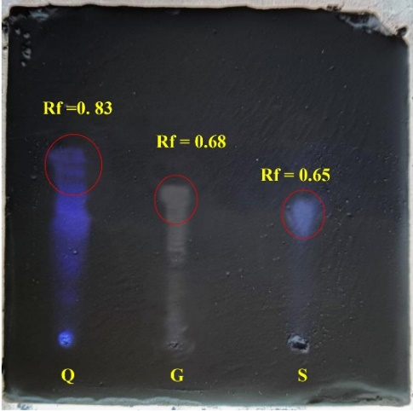
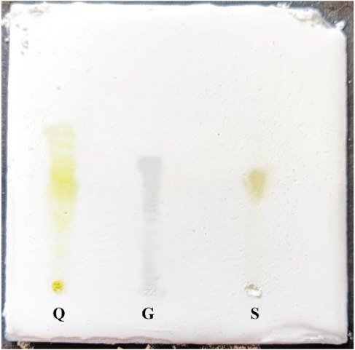

(A) (B)
Figure 1. Thin layer chromatography of the isolated compound (S) alongside standard quercetin (Q) and gallic acid (G) using chloroform:acetone:formic acid (8:1.5:0.5) as the mobile phase. (A) Chromatogram under visible light showing limited band visibility. (B) Chromatogram under UV illumination highlighting fluorescent bands used for Rf value determination and compound identification.

Table 1. Rf value of separated compound and standard compounds (quercetin and gallic acid) by TLC analysis
Flavonoid | Rf Value | Literature
Sample (S) | 3.9/6 = 0.65 | Rf = 0.66 indicated as mangiferin reported by Rasyid et al. (2020)
Quercetin (Q) | 5/6 = 0.83 | Standard compound
Gallic acid (G) | 4.1/6 = 0.68 | Standard compound

UV Spectrum analysis

The UV–Visible spectrum of the isolated compound is shown in Fig. 2. The analysis revealed characteristic absorption maxima (λmax) at 265, 311, and 363 nm, which are typical of polyphenolic xanthone glycosides. These absorption bands are attributed to π–π* transitions of the aromatic ring system and n–π* transitions associated with conjugated carbonyl and phenolic functional groups. The observed λmax values are in close agreement with previously reported UV spectral data for Mangiferin. Yehia et al., (2023) reported absorption maxima at 263, 315, and 364 nm for Mangiferin isolated from Mangifera indica L., which closely correspond to the values obtained in the present study. The minor variations in absorption maxima may be attributed to differences in solvent polarity or experimental conditions. The strong correlation between the observed UV absorption peaks and reported literature values confirms the presence of Mangiferin in the isolated compound and supports the successful purification of the target phytoconstituent.
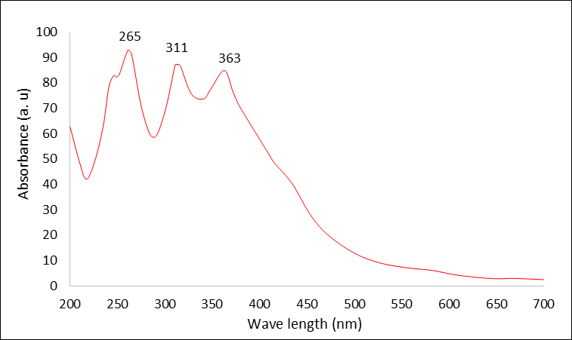
Fig. 2. UV Spectrum of isolated compound

FTIR Spectrum analysis

The FTIR spectrum of the isolated polyphenolic compound is presented in Fig. 3, and the corresponding functional group are summarized in Table 2. The spectrum exhibited a broad absorption band at 3436 cm⁻¹, which is characteristic of O–H stretching vibrations of phenolic hydroxyl groups, indicating the presence of hydrogen-bonded hydroxyl functionalities typical of polyphenolic compounds. A strong absorption peak observed at 1634 cm⁻¹ corresponds to the C=O stretching vibration, confirming the presence of a keto group within the xanthone nucleus. Additionally, the prominent peak at 1117 cm⁻¹ is attributed to C–O/C–C stretching vibrations associated with aromatic ring systems and glycosidic linkages, further supporting the polyphenolic nature of the isolated compound. These findings are in close agreed with earlier reports by Biswas et al., (2015), identified characteristic FTIR peaks for Mangiferin at 3367 cm⁻¹ (O–H stretching), 1670 cm⁻¹ (C=O stretching), and 1624.26 cm⁻¹ (C=C stretching). The slight shifts in peak positions may be attributed to differences in sample preparation, hydrogen bonding interactions, or instrumental conditions. The presence of phenolic hydroxyl groups, aromatic rings, and carbonyl functionalities confirmed by FTIR analysis strongly supports the successful isolation of Mangiferin and validates its characteristic aromatic and polyphenolic structure.

Fig. 3. FTIR Spectrum of isolated compound

Table. 2 FT-IR Peak Values and Functional Groups identified in the isolated compound

S. No. | Peak Values | Bonds | Functional groups
1 | 3436 | O–H stretch, H–bonded | Alcohols, Phenols
2 | 2028 | C-H stretch | Aliphatic
3 | 1634 | C=O | Keto
5 | 1270 | C–O stretch | Alcohols
6 | 1117 | C–O stretch | Aromatics
7 | 1021 | C–O stretch | Alcohols,
8 | 952 | =C–H bend | Alkenes
9 | 619 | –C ≡ C–H: C–H bend | Alkynes

HPLC Spectrum
The HPLC chromatogram of the isolated compound is presented in Fig. 4. The analysis revealed a prominent and well-resolved peak with a retention time of 4.75 minutes, indicating the presence of a single major compound in the isolated fraction. The observed retention time closely corresponds with earlier findings reported by Adin et al., (2023), who documented that Mangiferin isolated from Mangifera indica L. leaves eluted at an average retention time of 4.76 minutes under similar chromatographic conditions. The close agreement between the retention times strongly supports the successful isolation of Mangiferin from the bark extract. Furthermore, the appearance of a sharp and symmetrical peak suggests a high degree of purity of the isolated compound, with minimal interference from co-eluting impurities.
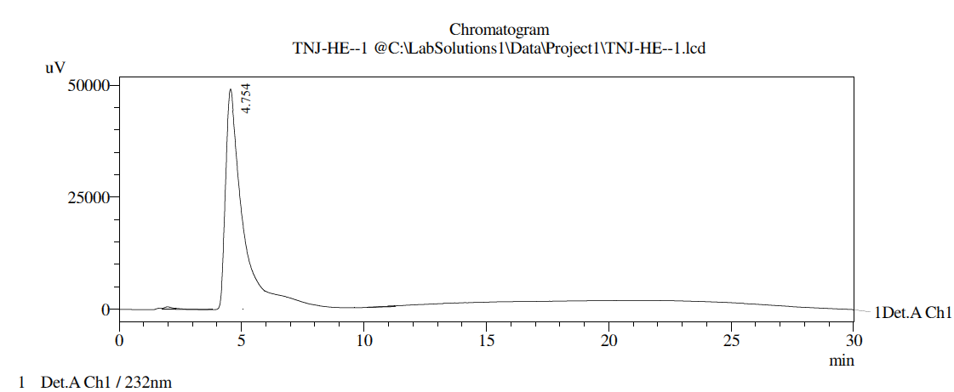

Fig. 4. HPLC Spectrum of isolated compound

NMR Spectrum of isolated compound

The ¹H-NMR spectrum of the isolated compound, recorded in DMSO at 400 MHz, is presented in Fig. 5. The spectrum displayed characteristic proton signals corresponding to aromatic rings, a xanthone (pyrone) nucleus, and glycosidic moieties, confirming the structural framework of Mangiferin. Proton signals observed in the range of δ 3.15–4.62 ppm were attributed to the sugar protons, including δ 3.15 (C-3′), 3.16 (C-4′), 3.17 (C-5′), 3.43 (C-6′), 3.61 and 4.01 (C-2′), and 4.62 ppm (C-1′), indicating the presence of a C-glucosyl unit.

The aromatic proton signals at δ 6.41 (H-4), 6.88 (H-5), and 7.43 ppm (H-8) correspond to the xanthone aromatic ring system. A downfield signal at δ 13.81 ppm was assigned to the phenolic hydroxyl proton (C-1–OH), which is characteristic of strong intramolecular hydrogen bonding commonly observed in xanthone derivatives.

The ¹³C-NMR spectrum of the isolated compound, shown in Fig. 6, further supported the structural identity of Mangiferin. Signals in the region of δ 61.39–81.53 ppm were assigned to the carbons of the glucosyl moiety, including δ 61.39 (C-6′), 70.32 (C-2′), 70.61 (C-4′), 73.12 (C-1′), 79.01 (C-3′), and 81.53 ppm (C-5′).

The aromatic and heterocyclic carbons of the xanthone core appeared between δ 93.28 and 163.78 ppm, with distinct signals at δ 93.28 (C-4), 101.19 (C-4b), 102.41 (C-5), 107.48 (C-2), 107.83 (C-8), 111.37 (C-8a), 143.88 (C-7-OH), 150.92 (C-6-OH), 154.63 (C-8b), 156.19 (C-4a), 161.67 (C-1-OH), and 163.78 ppm (C-3-OH). The signal at δ 176.03 ppm corresponds to the carbonyl carbon (C-9) of the xanthone moiety, confirming the presence of the keto functional group.

The obtained ¹H- and ¹³C-NMR spectral data are in excellent agreement with previously reported values for Mangiferin (Djemgou et al., 2010; Efendi et al., 2023). The NMR analysis conclusively confirms the structural identity of the isolated compound as Mangiferin, validating the effectiveness of the isolation and purification procedures employed in this study.

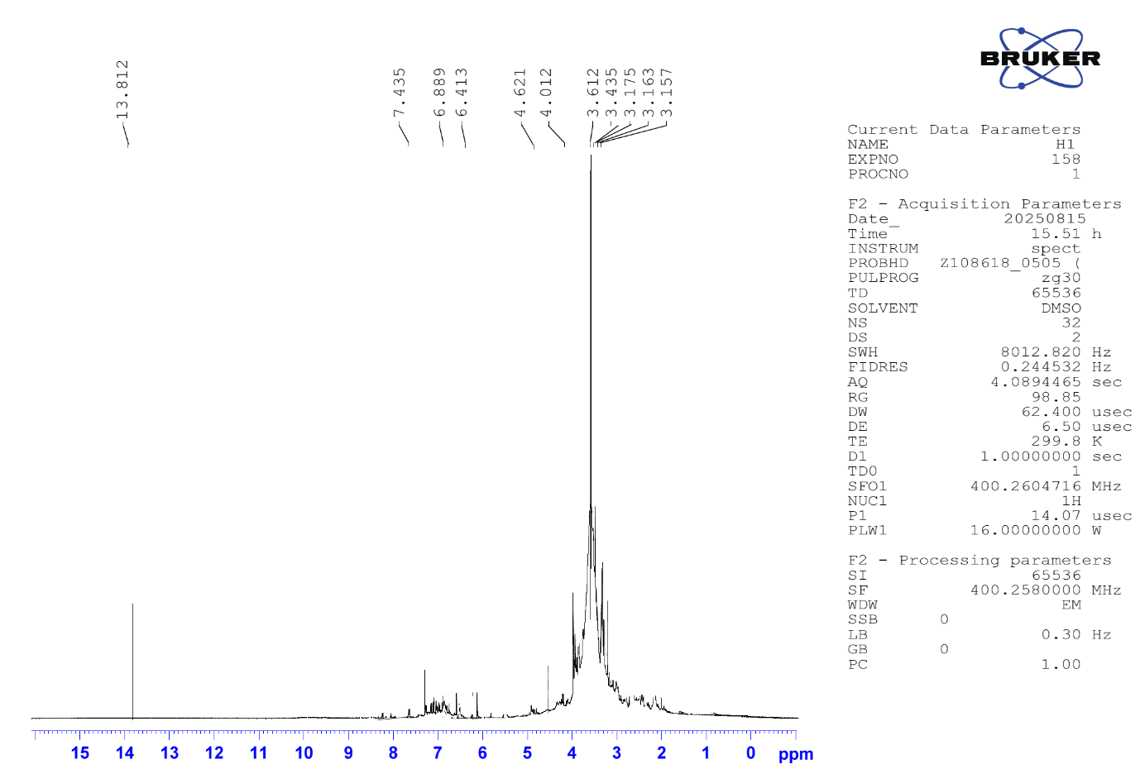
Fig. 5. Shows the ¹H-NMR Spectrum of isolated compound
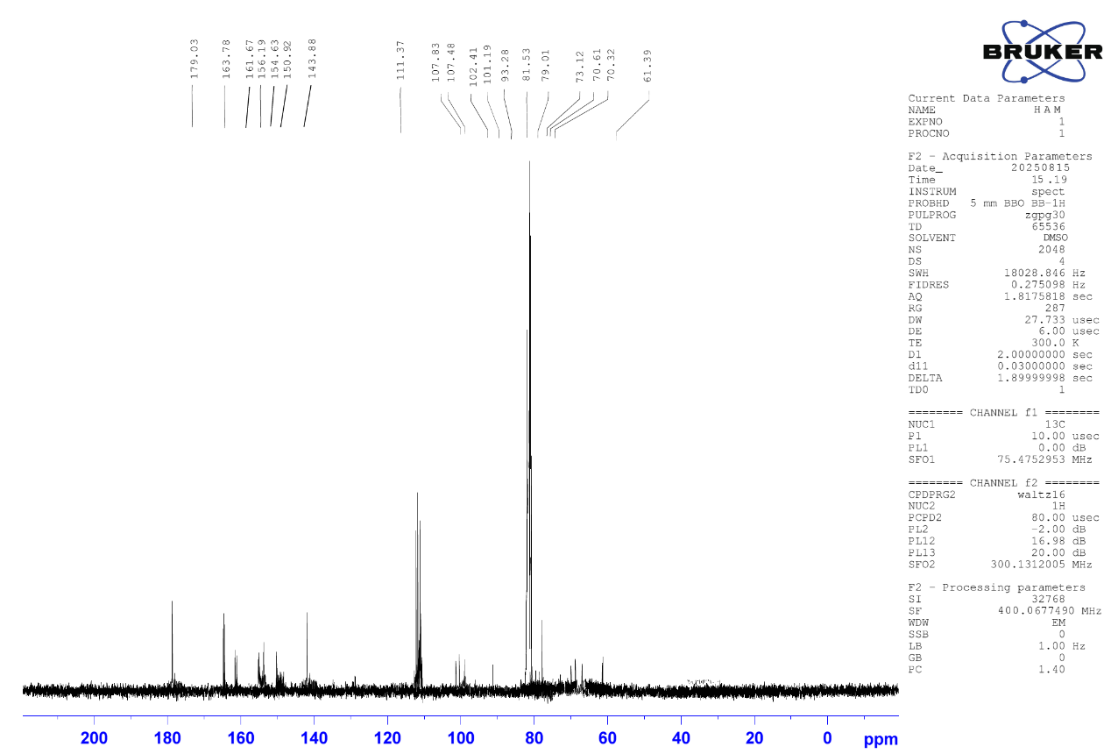

Fig. 6. Shows the ¹³C -NMR Spectrum

Mass Spectrum Isolated Mangiferin

The mass spectrum of the isolated compound (Fig. 7) elucidated a prominent molecular ion peak [M]⁺ at m/z 301.12, confirming the identity of the compound as Mangiferin. The corresponding molecular formula was deduced to be C₁₉H₁₈O₁₁, which is consistent with the reported chemical structure of Mangiferin. These findings are in close agreement with earlier studies by Cai et al., (2014), reported a molecular ion peak at m/z 301.10 for Mangiferin isolated from Mangifera indica L. The slight variation in the observed m/z value may be attributed to differences in instrumental resolution or experimental conditions. The mass spectral data provide strong support for the successful isolation and structural confirmation of Mangiferin.
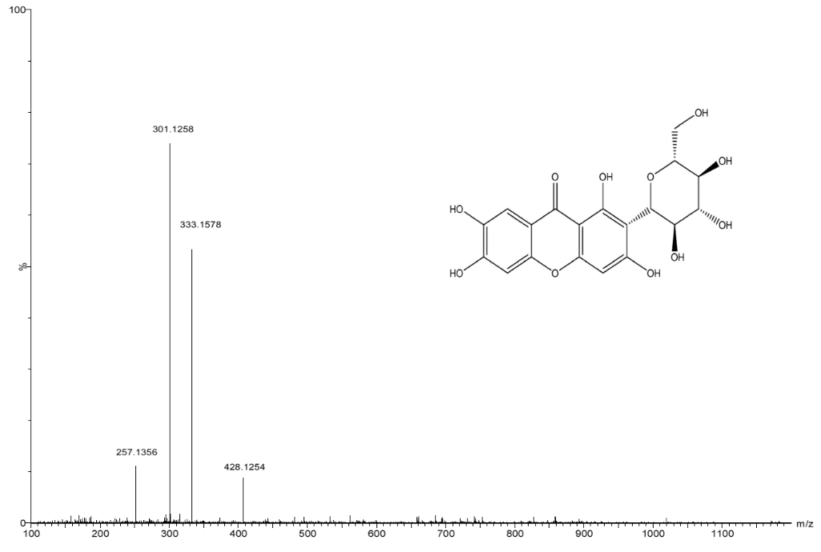

Fig. 7. Mass spectrum of isolated compound

The cumulative results from HPLC and spectroscopic analyses (UV–Vis, FTIR, NMR, and MS) confirmed the successful isolation and structural identity of Mangiferin from Mangifera indica L. bark with high purity. Characteristic functional groups, aromatic xanthone framework, glycosidic moiety, and molecular ion peak consistent with reported literature validated its polyphenolic nature.

Antioxidant Activity of Mangiferin from Mangifera indica L. Bark DPPH radical scavenging assay

The DPPH assay is a widely accepted method for assessing the in vitro antioxidant potential of natural compounds by measuring their ability to donate hydrogen atoms to the stable DPPH radical. Reduction of the deep violet DPPH radical to its non-radical form results in a colour change to pale yellow, which can be quantitatively monitored using UV–Visible spectroscopy (Gulcin et al., 2023).

In the present study, Mangiferin exhibited effective DPPH radical scavenging activity, as indicated by the visible colour change from violet to yellow. Mangiferin showed an IC₅₀ value of 36.6 µg/ml, which was comparable to that of the standard antioxidant ascorbic acid (31.15 µg/ml) (Fig. 8). A significant concentration-dependent increase in radical scavenging activity was observed, indicating that Mangiferin acts as an efficient hydrogen donor. These findings suggest that Mangiferin possesses strong antioxidant potential and contributes effectively to free radical neutralization under in vitro conditions.

Fig. 8. DPPH radical scavenging assay. Values are expressed as the mean ± S.D. (n=3). Different superscript indicate significant difference (p<0.05).

ABTS●⁺ Radical Scavenging Assay

The ABTS assay is a widely recognized method for evaluating antioxidant activity and is particularly useful for assessing the efficacy of both hydrophilic and lipophilic compounds. In this assay, ABTS●⁺ radicals are generated by the reaction of ABTS with potassium persulfate under dark conditions, producing a stable blue–green chromophore. The antioxidant capacity of test compounds is determined by their ability to reduce the ABTS●⁺ radical, which results in a decrease in absorbance at 734 nm (Ilyasov et al., 2020).
In the present study, Mangiferin exhibited strong ABTS●⁺ radical scavenging activity, as evidenced by the reduction of the blue–green chromophore to a colourless form. Mangiferin showed an IC₅₀ value of 35.64 µg/ml, which was comparable to that of the standard antioxidant ascorbic acid (30.40 µg/ml) (Fig. 9). A significant concentration-dependent increase in radical scavenging activity was observed, indicating Mangiferin’s effective electron-donating ability.

Fig. 9. ABTS●⁺ radical scavenging assay. Values are expressed as the mean ± S.D. (n=3). Different superscript indicate significant difference (p<0.05).

Hydroxyl radical scavenging potential

Hydroxyl radicals (OH•) are among the most reactive reactive oxygen species (ROS) and are capable of causing severe oxidative damage to cellular macromolecules. They disrupt protein structure by breaking disulfide bonds and initiate lipid peroxidation in cell membranes by attacking unsaturated fatty acids, leading to the formation of lipid peroxides. These processes alter membrane fluidity and permeability, impair cellular transport and signalling, and contribute to the development of various diseases (Chandimali et al., 2025).

In the present study, Mangiferin significantly inhibited hydroxyl radical-induced deoxyribose degradation, as evidenced by the reduced formation of the malondialdehyde–thiobarbituric acid (MDA–TBA) complex. Mangiferin exhibited an IC₅₀ value of 35.19 µg/ml, which was comparable to that of the standard antioxidant ascorbic acid (30.82 µg/ml) (Fig. 10). A clear dose-dependent increase in hydroxyl radical scavenging activity was observed, indicating the strong ability of Mangiferin to neutralize highly reactive hydroxyl radicals and protect biomolecules from oxidative damage.

Fig. 10. Hydroxyl radical scavenging assay. Values are expressed as the mean ± S.D. (n=3). Different superscript indicate significant difference (p<0.05).

Superoxide Scavenging Activity

Superoxide radicals (O₂•⁻) are highly reactive oxygen species that can be further converted into hydroxyl radicals (OH•), leading to extensive oxidative damage to DNA, proteins, lipids and other cellular components. Such oxidative stress plays a critical role in the progression of various diseases. Therefore, antioxidants capable of scavenging superoxide radicals are important in preventing cellular damage and disease progression.

In this assay, the superoxide radical scavenging activity of the test compound was evaluated based on its ability to inhibit the reduction of nitro blue tetrazolium (NBT) to purple-colored formazan in the presence of the PMS/NADH system (Jaun et al., 2021). In the present study, Mangiferin effectively scavenged superoxide radicals generated by the PMS/NADH system, resulting in a significant inhibition of NBT reduction. Mangiferin exhibited an IC₅₀ value of 33.81 µg/ml, which was slightly higher than that of the standard antioxidant ascorbic acid (29.47 µg/ml) (Fig. 11). A clear concentration-dependent increase in scavenging activity was observed, demonstrating Mangiferin’s effective superoxide radical neutralizing capacity.

Fig. 11. Superoxide anion assay. Values are expressed as the mean ± S.D. (n=3). Different superscript indicate significant difference (p<0.05).

Hydrogen Peroxide (H₂O₂) Radical Scavenging

Hydrogen peroxide (H₂O₂) is a byproduct of normal cellular metabolism and becomes harmful when produced in excess, leading to oxidative stress. Although H₂O₂ itself is relatively less reactive, it can be converted into highly reactive hydroxyl radicals (OH•) via Fenton’s reaction, resulting in severe damage to proteins, lipids, and cell membranes. Such oxidative damage disrupts membrane integrity, alters protein structure, and impairs cellular functions, thereby contributing to the development of various diseases, including cancer, diabetes mellitus, and cardiovascular conditions. Therefore, regulation of intracellular H₂O₂ levels is essential for maintaining cellular homeostasis. (Yu et al., 2024).

In the present study, Mangiferin exhibited strong hydrogen peroxide scavenging activity, as indicated by a significant decrease in absorbance due to the conversion of H₂O₂ into water and oxygen. Mangiferin showed an IC₅₀ value of 33.96 µg/ml, which was comparable to that of the standard antioxidant ascorbic acid (31.66 µg/ml) (Fig. 12). Both compounds demonstrated a concentration-dependent scavenging effect, indicating Mangiferin’s effective role in mitigating H₂O₂-mediated oxidative stress.

Fig. 12. Hydrogen peroxide radical scavenging assay. Values are expressed as the mean ± S.D. (n=3). Different superscript indicate significant difference (p<0.05).

Reducing Power Assay
The Ferric Reducing Antioxidant Power (FRAP) assay is a widely used analytical method for quantifying the antioxidant capacity of bioactive compounds. This assay is based on the reduction of ferric ions (Fe³⁺) to ferrous ions (Fe²⁺), leading to the formation of a coloured ferrous–tripyridyltriazine complex. The intensity of the developed colour, which directly proportional to the reducing potential of the test compound, is quantitatively measured using spectrophotometric analysis, ensuring high sensitivity and reproducibility (Benzie et al., 1999).
In the present study, Mangiferin exhibited a significant, concentration-dependent increase in reducing power, indicating its effective electron-donating capacity. Mangiferin showed an IC₅₀ value of 35.79 µg/ml, whereas the standard antioxidant ascorbic acid exhibited an IC₅₀ value of 31.76 µg/ml (Fig. 13). Although slightly lower than the standard, Mangiferin demonstrated strong ferric reducing ability, further confirming its potent antioxidant potential.

Fig. 13. Reducing power assay. Values are expressed as the mean ± S.D. (n=3). Different superscript indicate significant difference (p<0.05).

Nitric Oxide Scavenging Assay

The nitric oxide scavenging assay evaluates the ability of antioxidants to neutralize nitric oxide radicals generated from sodium nitroprusside in aqueous conditions. Nitric oxide readily reacts with oxygen to form nitrite ions, which can be quantified using the Griess reagent. Antioxidants inhibit nitrite formation by scavenging nitric oxide radicals, thereby reducing nitrosative stress associated with inflammation and various pathological conditions (Kumbhare et al., 2012). In the present study, Mangiferin significantly scavenged nitric oxide radicals, resulting in effective inhibition of nitrite formation. Mangiferin exhibited an IC₅₀ value of 43.60 µg/ml, which was slightly lower than that of the standard antioxidant ascorbic acid (47.03 µg/ml) (Fig. 14). A clear dose-dependent increase in nitric oxide scavenging activity was observed, indicating Mangiferin’s strong potential to mitigate nitric oxide–mediated oxidative and inflammatory damage.

Fig. 14. Nitric oxide radical scavenging. Values are expressed as the mean ± S.D. (n=3). Different superscript indicate significant difference (p<0.05).

Brine Shrimp Lethality Assay
The results of the brine shrimp lethality assay showed that mangiferin exhibited very low toxicity toward Artemia salina nauplii within the tested concentration range of 25–500 µg/mL. No mortality was observed at the lower concentrations of 25 and 50 µg/mL indicating that mangiferin is non-toxic at these levels. However a slight increase in mortality was observed at 100, 250, and 500 µg/mL suggesting a dose-dependent response with increasing concentration. Despite the gradual increase in mortality at higher concentrations the overall lethality remained relatively low indicating minimal toxicity of mangiferin toward brine shrimp nauplii. The negative control (artificial sea water) showed no mortality confirming that the experimental conditions did not affect the survival of the nauplii. In contrast the positive control Potassium dichromate (1 mg/mL) given 100% mortality demonstrating the sensitivity and reliability of the assay.The calculated LD₅₀ value of mangiferin was 1218.60 ± 0.87 µg/mL which is higher than the maximum tested concentration indicating very low toxicity toward brine shrimp nauplii. These findings suggest that mangiferin is relatively safe within the tested concentration range although a slight increase in mortality was observed when the dose increased.
Figure 15. Regression line equation obtained from the Brine Shrimp Lethality Assay (BSLT) for Mangiferin showing the relationship between concentration and percentage mortality of Artemia salina nauplii (n=3).
The present findings are consistent with previous reports indicating that mangiferin exhibits low toxicity in the brine shrimp lethality assay. A similar observation was reported by Ishaque et al., (2021), they isolated mangiferin from Dryopteris ramosa and evaluated its biological activities. In their study, mangiferin exhibited weak toxicity toward brine shrimp nauplii, with an LD₅₀ value of 969.77 ± 0.67 µg/mL, indicating relatively low lethality. These findings support the present study and suggest that mangiferin possesses low general toxicity in preliminary screening models.
CONCLUSION
The present study confirms that mangiferin isolated from Mangifera indica L. bark possesses strong antioxidant potential through efficient scavenging of reactive oxygen, nitrogen species and significant ferric reducing capacity. In addition, the brine shrimp lethality assay (Artemia salina) indicated very low toxicity with an LD₅₀ value of 1218.60 ± 0.87 µg/mL. These findings suggest that mangiferin exhibits potent antioxidant activity with minimal preliminary toxicity, supporting its potential as a natural antioxidant for managing oxidative stress–related disorders.

COMPETING INTERESTS DISCLAIMER:
Authors have declared that they have no known competing financial interests OR non-financial interests OR personal relationships that could have appeared to influence the work reported in this paper.

REFERENCES

Adin, S. N., Gupta, I., Aqil, M., Mujeeb, M., & Ahad, A. (2023). BBD driven optimization of extraction of therapeutically active xanthanoid mangiferin from Mangifera indica L. leaves and its antioxidant activity. Pharmacognosy research, 15(1).
Al-Amiery, A. A., Al-Majedy, Y. K., Kadhum, A. A. H., & Mohamad, A. B. (2015). Hydrogen Peroxide Scavenging Activity of Novel Coumarins Synthesized Using Different Approaches. PLOS ONE, 10(7), e0132175. https://doi.org/10.1371/journal.pone.0132175
Baliyan, S., Mukherjee, R., Priyadarshini, A., Vibhuti, A., Gupta, A., Pandey, R. P., & Chang, C.-M. (2022). Determination of Antioxidants by DPPH Radical Scavenging Activity and Quantitative Phytochemical Analysis of Ficus religiosa. Molecules, 27(4), 1326. https://doi.org/10.3390/molecules27041326
Benzie, I. F., & Strain, J. J. (1999). Ferric reducing/antioxidant power assay: direct measure of total antioxidant activity of biological fluids and modified version for simultaneous measurement of total antioxidant power and ascorbic acid concentration. Methods in enzymology, 299, 15–27. https://doi.org/10.1016/s0076-6879(99)99005-5
Biswas, T., Sen, A., Roy, R., Maji, S., & Maji, H. S. (2015). Isolation of mangiferin from flowering buds of Mangifera indica L and its evaluation of in vitro antibacterial activity. J Pharm Anal, 4(3), 49-56.
Cai, F., Sun, L., Gao, S., Zhan, Q., Wang, W., & Chen, W. (2014). An improved LC-MS/MS method for the determination of mangiferin in rat plasma and its application in nonlinear pharmacokinetics. Die Pharmazie-An International Journal of Pharmaceutical Sciences, 69(3), 168-172.
Chandimali, N., Bak, S.G., Park, E.H. Lim, H.J., Won, Y.S., Kim, E.K., Park, S.I., Lee, S.J. (2025). Free radicals and their impact on health and antioxidant defenses: a review. Cell Death Discov. 11, 19. https://doi.org/10.1038/s41420-024-02278-8
Chen, H., Diao, J., Li, Y., Chen, Q., Kong, B. (2015). The effectiveness of clove extracts in the inhibition of hydroxyl radical oxidation-induced structural and rheological changes in porcine myofibrillar protein. Meat Science, 111, 60-66. https://doi.org/10.1016/j.meatsci.2015.08.017
Dai, J., & Mumper, R. J. (2010). Plant phenolics: extraction, analysis and their antioxidant and anticancer properties. Molecules (Basel, Switzerland), 15(10), 7313–7352. https://doi.org/10.3390/molecules15107313
Gulcin, İ., & Alwasel, S. H. (2023). DPPH Radical Scavenging Assay. Processes, 11(8), 2248. https://doi.org/10.3390/pr11082248
Ilyasov, I. R., Beloborodov, V. L., Selivanova, I. A., & Terekhov, R. P. (2020). ABTS/PP Decolorization Assay of Antioxidant Capacity Reaction Pathways. International Journal of Molecular Sciences, 21(3), 1131. https://doi.org/10.3390/ijms21031131
Imran, M., Arshad, M. S., Butt, M. S., Kwon, J. H., Arshad, M. U., & Sultan, M. T. (2017). Mangiferin: a natural miracle bioactive compound against lifestyle related disorders. Lipids in health and disease, 16(1), 84. https://doi.org/10.1186/s12944-017-0449-y
Ishaque, M., Bibi, Y., Masood, S., Al Ayoubi, S., Qayyum, A., Nisa, S., & Ahmed, W. (2022). Xanthone C-glycosides isomers purified from Dryopteris ramosa (Hope) C. Chr. with bactericidal and cytotoxic prospects. Saudi journal of biological sciences, 29(2), 1191–1196. https://doi.org/10.1016/j.sjbs.2021.09.047
Juan, C. A., Pérez de la Lastra, J. M., Plou, F. J., & Pérez-Lebeña, E. (2021). The Chemistry of Reactive Oxygen Species (ROS) Revisited: Outlining Their Role in Biological Macromolecules (DNA, Lipids and Proteins) and Induced Pathologies. International journal of molecular sciences, 22(9), 4642. https://doi.org/10.3390/ijms22094642
Kumbhare, M. R., Guleha, V. Sivakumar, T. (2012). Estimation of total phenolic content, cytotoxicity and in–vitro antioxidant activity of stem bark of Moringa oleifera. Asian Pacific Journal of Tropical Disease, 2(2), 144-150, https://doi.org/10.1016/S2222-1808(12)60033-4
Kurian, G.A., Suryanarayanan, S., Raman, A. et al. (2010). Antioxidant effects of ethyl acetate extract of Desmodium gangeticum root on myocardial ischemia reperfusion injury in rat hearts. Chin Med 5, 3. https://doi.org/10.1186/1749-8546-5-3
Leyane, T. S., Jere, S. W., & Houreld, N. N. (2022). Oxidative Stress in Ageing and Chronic Degenerative Pathologies: Molecular Mechanisms Involved in Counteracting Oxidative Stress and Chronic Inflammation. International journal of molecular sciences, 23(13), 7273. https://doi.org/10.3390/ijms23137273​
Liu, F.-F., Li, Y.-Q., Sun, G.-J., Wang, C.-Y., Liang, Y., Zhao, X.-Z., He, J.-X., & Mo, H.-Z. (2022). Influence of ultrasound treatment on the physicochemical and antioxidant properties of mung bean protein hydrolysate. Ultrasonics Sonochemistry, 84, 105964. https://doi.org/10.1016/j.ultsonch.2022.105964
Paranthaman R, Praveen kumar P, Kumaravel S. (2012). GC-MS Analysis of Phytochemicals and Simultaneous Determination of Flavonoids in Amaranthus caudatus (Sirukeerai) by RP-HPLC. J Anal Bioanal Techniques 3:147.
Pratheepa, C., and C. Shibana. (2026). Synthesis and Characterization of Titanium Dioxide Nanoparticles from Ethanol Extracts of Portunus Pelagicus (Linnaeus, 1758) and Their Evaluation of Brine Shrimp Lethality Assay. UTTAR PRADESH JOURNAL OF ZOOLOGY 47 (1):51-62. https://doi.org/10.56557/upjoz/2026/v47i15436.
Rasyid, R., Mawaddah, S., & Rivai, H. (2020). Quantitative determination of mangiferin in methanol extract of Bacang Mango (Mangifera foetida L.) leaves by thin-layer chromatography densitometry. World J. Pharm. Pharm. Sci, 9, 1551-1560.
Reddy VP. (2023). Oxidative Stress in Health and Disease. Biomedicines, 11(11), 2925. https://doi.org/10.3390/biomedicines11112925
Rumpf, J., Burger, R., & Schulze, M. (2023). Statistical evaluation of DPPH, ABTS, FRAP, and Folin-Ciocalteu assays to assess the antioxidant capacity of lignins. International Journal of Biological Macromolecules, 233, 123470. https://doi.org/10.1016/j.ijbiomac.2023.123470
Samarakoon Dnaw & Samarakoon Dnaw. (2023). Advancing In vitro Antioxidant Activity Assessment: A Comprehensive Methodological Review and Improved Approaches for DPPH, FRAP and H2O2 Assays. Journal of Natural & Ayurvedic Medicine, 7(4), 1–7. https://doi.org/10.23880/jonam-16000431
Singh, S. K., Tiwari, R. M., Sinha, S. K., Danta, C. C., & Prasad, S. K. (2012). Antimicrobial evaluation of mangiferin and its synthesized analogues. Asian Pacific Journal of Tropical Biomedicine, 2(2), S884-S887.
Tüğen, A., & Buruleanu, C. L. (2025). The Role of Plant-Derived Bioactive Compounds in Mitigating Oxidative Stress. Foods (Basel, Switzerland), 15(1), 108. https://doi.org/10.3390/foods15010108
Verpoorte, K. C. (2007). The Pharmacology of Chinese Herbs. CRC Press, Boca Raton.
Wani TA, Bhat IA, Guleria K, Fayaz M, Anju T, Haritha K, Kumar A, Kaloo ZA. (2022). Phytochemicals: Diversity, Sources and Their Roles. Phytochemical Genomics. Springer, Singapore. https://doi.org/10.1007/978-981-19-5779-6
Yehia, R. S., & Altwaim, S. A. (2023). An insight into in vitro antioxidant, antimicrobial, cytotoxic, and apoptosis induction potential of mangiferin, a bioactive compound derived from Mangifera indica. Plants, 12(7), 1539.
Yu, Q., Li, W., Liang, M., Li, G., Wu, Z., Long, J., Yuan, C., Mei, W., & Xia, X. (2024). Preparation, Characterization, and Antioxidant Activities of Extracts from Amygdalus persica L. Flowers. Molecules, 29(3), 633. https://doi.org/10.3390/molecules29030633

