Comparative Effects of Vitamin C and Soy Protein Supplementation on Growth Performance and Cocoon Traits of Bombyx mori

Abstract
Silkworm nutrition plays a crucial role in determining larval growth, survival, and cocoon productivity in sericulture. The present study evaluated the effects of dietary supplementation of Vitamin C (ascorbic acid) and soy protein on the growth performance and cocoon parameters of the mulberry silkworm, Bombyx mori L. Fifth instar larvae were fed mulberry leaves fortified with graded concentrations (0.1%, 0.2%, 0.3%, and 0.4%) of Vitamin C and soy protein, while a control group received untreated leaves. Key biological and economic traits including larval weight, cocoon weight, pupal weight, shell weight, and shell ratio were recorded. Supplementation significantly improved larval growth and cocoon characteristics compared to the control. Among Vitamin C treatments, 0.2% concentration produced the maximum yield, indicating optimal physiological and metabolic support at this level. In contrast, 0.4% soy protein supplementation resulted in the highest cocoon productivity, suggesting enhanced protein availability for silk synthesis. The results highlight the importance of targeted nutritional fortification of mulberry leaves and demonstrate that Vitamin C and soy protein supplementation can serve as effective strategies for improving silkworm productivity and sustaining sericulture efficiency.

INTRODUCTION
Sericulture is an important agro-based industry that contributes significantly to rural employment, socioeconomic development, and the textile sector in many Asian countries. The industry provides livelihood opportunities to millions of small-scale farmers and plays a crucial role in sustaining rural economies through silk production and related activities. The productivity and profitability of sericulture largely depend on the growth performance, health status, and cocoon-producing efficiency of the mulberry silkworm, Bombyx mori L., which is the principal producer of commercial natural silk. Because silk production is directly linked to larval nutrition and physiological health, improving silkworm growth through nutritional interventions has become a major focus in sericulture research.
Silkworms are strictly monophagous insects that feed almost exclusively on mulberry (Morus alba) leaves. Consequently, the nutritional quality of mulberry foliage plays a decisive role in larval development, metabolic activity, silk gland function, and cocoon characteristics (Benchamin & Nagaraju, 1987; Ito, 1978). Any nutritional inadequacy during larval growth is immediately reflected in reduced larval Vigor, lower cocoon yield, poor shell ratio, and inferior silk quality. Variability in mulberry leaf composition due to environmental conditions, seasonal fluctuations, soil fertility, agronomic practices, and leaf maturity further influences silkworm performance, often leading to suboptimal growth and productivity.
Nutrition plays a central role in regulating insect growth, metabolism, energy utilization, and physiological stability. In Bombyx mori, this relationship is particularly important because silk production is a highly protein-intensive physiological process requiring efficient nutrient assimilation. Nutritional enrichment of mulberry leaves with proteins, amino acids, vitamins, and minerals has therefore been widely explored as a strategy to enhance larval growth, improve feed conversion efficiency, and increase cocoon productivity (Sengupta et al., 1972; Javed & Gondal, 2002; Etebari et al., 2005). Studies in insect nutritional ecology also emphasize that dietary protein availability strongly influences larval growth efficiency, tissue development, and silk gland maturation (Scriber & Slansky, 1981).
Silk fiber is composed predominantly of fibroin protein, accounting for approximately 70–75% of the total silk content, while sericin forms the outer coating of the cocoon filament. This high protein composition underscores the importance of adequate dietary protein and micronutrient availability during larval development, particularly during advanced larval stages when silk gland growth and fibroin synthesis are most active (Horie & Watanabe, 1980; Mondal et al., 2007). Fibroin biosynthesis depends heavily on amino acids such as glycine, alanine, and serine derived from dietary proteins, and variations in nutrient intake can directly influence cocoon weight, shell ratio, and overall silk quality.
Although mulberry leaves naturally supply essential nutrients required for silkworm growth, their composition varies widely depending on environmental and agronomic factors. Such variability can result in deficiencies of essential amino acids, vitamins, and micronutrients required for optimal larval growth and silk synthesis (Benchamin & Nagaraju, 1987; Ito & Tanaka, 1962). These limitations have encouraged the development of dietary supplementation strategies aimed at improving nutrient availability, stabilizing cocoon productivity, and enhancing silk yield. Several studies have demonstrated that enrichment of mulberry leaves with proteins, amino acids, vitamins, and other nutrients improves biological and commercial traits of silkworms, including growth rate, cocoon quality, shell weight, and silk productivity (Sree et al., 2024; Etebari et al., 2005).
Among micronutrients, Vitamin C (ascorbic acid) has received considerable attention due to its role in insect physiology. It functions as an antioxidant, enzyme cofactor, immune modulator, and regulator of oxidative stress. In silkworms, Vitamin C contributes to cellular integrity, digestive efficiency, and physiological stability during periods of rapid growth and intense metabolic activity. Early physiological studies demonstrated that ascorbic acid is indispensable for normal larval growth, silk gland development, and cocoon formation in Bombyx mori (Ito & Horie, 1962). Subsequent investigations confirmed that deficiency of Vitamin C adversely affects larval growth and cocoon production, whereas supplementation improves larval performance, feed utilization efficiency, and cocoon characteristics (Cappellozza et al., 2005; Etebari et al., 2004). The importance of Vitamin C becomes particularly evident during the fifth instar stage, when larvae exhibit accelerated feeding, rapid tissue growth, and intensive silk protein synthesis.
Protein supplementation represents another important nutritional approach to improving silkworm productivity. Proteins provide essential amino acids required for tissue growth, enzymatic functions, metabolic regulation, and silk protein synthesis. Adequate protein availability during larval development is essential for proper silk gland formation and efficient fibroin production (Horie & Watanabe, 1980; Ito, 1972). Soy protein, a plant-based protein source with a balanced amino acid composition, has been explored as a supplementary nutrient in silkworm diets. Protein-enriched mulberry leaves have been reported to enhance larval growth, cocoon weight, shell weight, and shell ratio by improving nitrogen availability and protein assimilation efficiency (Rao & Reddy, 2012; Ito, 1978). Such supplementation may be particularly beneficial under intensive rearing conditions or when mulberry leaf quality is suboptimal.
The fifth instar larval stage is considered the most critical phase in the life cycle of Bombyx mori, accounting for the majority of larval biomass accumulation and silk protein synthesis. Nutritional interventions during this stage can therefore have a profound impact on cocoon formation, shell ratio, and silk yield. While previous studies have independently evaluated the effects of vitamin supplementation or protein enrichment on silkworm growth and cocoon parameters, systematic experimental evaluations comparing the effects of Vitamin C and soy protein supplementation under controlled rearing conditions remain limited.
Therefore, the present study was undertaken to evaluate the effects of Vitamin C and graded levels of soy protein supplementation on the growth performance and cocoon parameters of the mulberry silkworm, Bombyx mori. By analyzing key biological and economic traits such as larval weight, cocoon weight, pupal weight, shell weight, and shell ratio, the study aims to identify optimal supplementation levels and provide scientifically validated nutritional strategies to enhance silkworm productivity and promote sustainable sericulture practices.

Materials and Methods
The experiment was conducted using healthy fifth instar larvae of the mulberry silkworm Bombyx mori L. obtained from a government-recognized sericulture centre. Rearing was carried out under controlled laboratory conditions maintaining a temperature of 25–27 °C, relative humidity of 70–85%, and a photoperiod of 12:12 h (light:dark). All rearing trays, foam pads, and appliances were disinfected prior to use with 2% bleaching powder solution to ensure hygienic conditions and to minimize disease incidence. Fresh mulberry (Morus alba) leaves of uniform maturity were collected daily from a well-maintained mulberry garden. The leaves were washed thoroughly in clean water to remove dust and contaminants and shade-dried before feeding to eliminate excess surface moisture. Vitamin C (ascorbic acid) and soy protein isolate were used as dietary supplements at graded concentrations of 0.1%, 0.2%, 0.3%, and 0.4%. Required quantities of each supplement were dissolved separately in sterile distilled water to prepare fresh solutions daily. The prepared solutions were sprayed uniformly on mulberry leaves using a fine mist sprayer, and the treated leaves were air-dried for approximately 10–15 minutes before feeding. Control larvae were provided untreated mulberry leaves. Each treatment consisted of three replicates with 50 larvae per replicate. Feeding was carried out twice daily at approximately 8:00 a.m. and 6:00 p.m. during the fifth instar stage. Uneaten leaves were removed before the subsequent feeding to prevent fermentation and microbial contamination. Standard rearing practices including bed cleaning, proper aeration, and monitoring of larval health were maintained throughout the experimental period.Biological and economic parameters including larval weight, cocoon weight, pupal weight, shell weight, and shell ratio were recorded. After spinning, cocoons were harvested, air-dried, and weighed using a precision electronic balance. Shell weight was recorded after removal of the pupae, and shell ratio was calculated as the percentage of shell weight relative to cocoon weight.
Results and Discussion
Nutritional supplementation plays a critical role in determining the growth performance and cocoon characteristics of Bombyx mori, particularly when mulberry leaves are fortified with additional macro- or micronutrients. As silkworm larvae depend almost entirely on mulberry leaves for their nutritional requirements, even minor variations in nutrient availability can significantly influence larval development, silk gland activity, and ultimately cocoon quality. In the present investigation, the effects of graded supplementation with vitamin C and soy protein (0.1%, 0.2%, 0.3%, and 0.4%) were evaluated to assess their relative efficacy in enhancing larval growth and silk productivity. Key parameters examined included larval weight, cocoon weight, pupal weight, shell weight, and shell ratio, all of which serve as reliable indicators of physiological health and commercial silk yield.
Table 1. Effect of soy protein supplementation on Bombyx mori
Soy Protein (%) | Larval Weight (g) | Cocoon Weight (g) | Pupal Weight (g) | Shell Weight (g) | Shell Ratio (%)
0 (Control) | 2.70 ± 0.07ᵉ | 1.40 ± 0.04ᵉ | 1.05 ± 0.03ᵉ | 0.35 ± 0.02ᵉ | 25.0 ± 0.5ᵉ
0.1 | 2.95 ± 0.08ᵈ | 1.50 ± 0.05ᵈ | 1.10 ± 0.04ᵈ | 0.39 ± 0.02ᵈ | 26.0 ± 0.6ᵈ
0.2 | 3.15 ± 0.09ᶜ | 1.60 ± 0.05ᶜ | 1.16 ± 0.04ᶜ | 0.44 ± 0.02ᶜ | 27.5 ± 0.6ᶜ
0.3 | 3.35 ± 0.10ᵇ | 1.72 ± 0.06ᵇ | 1.22 ± 0.04ᵇ | 0.50 ± 0.03ᵇ | 29.1 ± 0.7ᵇ
0.4 | 3.50 ± 0.10ᵃ | 1.80 ± 0.06ᵃ | 1.27 ± 0.04ᵃ | 0.55 ± 0.03ᵃ | 30.5 ± 0.7ᵃ

Values represent mean ± standard deviation (n = 3 replicates). Different superscript letters within a column indicate significant differences at p < 0.05 (Tukey’s HSD test).
Table 2. Effect of Vitamin C supplementation on Bombyx mori
Vitamin C (%) | Larval Weight (g) | Cocoon Weight (g) | Pupal Weight (g) | Shell Weight (g) | Shell Ratio (%)
0 (Control) | 2.70 ± 0.07ᶜ | 1.40 ± 0.04ᶜ | 1.05 ± 0.03ᶜ | 0.35 ± 0.02ᶜ | 25.0 ± 0.5ᶜ
0.1 | 2.85 ± 0.08ᵇ | 1.45 ± 0.05ᵇ | 1.08 ± 0.04ᵇ | 0.37 ± 0.02ᵇ | 25.6 ± 0.6ᵇ
0.2 | 3.05 ± 0.09ᵃ | 1.55 ± 0.05ᵃ | 1.13 ± 0.04ᵃ | 0.41 ± 0.02ᵃ | 26.8 ± 0.6ᵃ
0.3 | 2.95 ± 0.08ᵇ | 1.50 ± 0.05ᵇ | 1.10 ± 0.04ᵇ | 0.39 ± 0.02ᵇ | 26.3 ± 0.6ᵇ
0.4 | 2.85 ± 0.08ᵇ | 1.47 ± 0.05ᵇ | 1.08 ± 0.04ᵇ | 0.38 ± 0.02ᵇ | 26.0 ± 0.6ᵇ

Values represent mean ± standard deviation (n = 3 replicates). Different superscript letters within a column indicate significant differences at p < 0.05 (Tukey’s HSD test).

Vitamin C supplementation resulted in moderate improvements in larval growth and cocoon parameters. An increase in larval weight at lower supplementation levels indicates enhanced physiological performance, likely attributable to improved metabolic efficiency and nutrient assimilation. Among the concentrations tested, approximately 0.2% vitamin C produced the most favorable response, with noticeable increases in cocoon weight, pupal weight, shell weight, and shell ratio. These improvements suggest enhanced silk gland activity and more efficient cocoon formation.

Fig.1
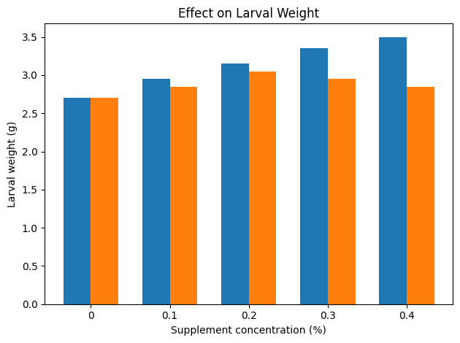

The positive effects of vitamin C may be attributed primarily to its function as an antioxidant and metabolic regulator. Silkworm larvae are particularly sensitive to oxidative stress, environmental fluctuations, and microbial challenges during rearing. Ascorbic acid helps neutralize reactive oxygen species generated during metabolic processes, thereby protecting cellular integrity and supporting physiological stability. This antioxidant function becomes especially important during the later larval instars, when metabolic activity and silk protein synthesis are at their peak.

Fig.2
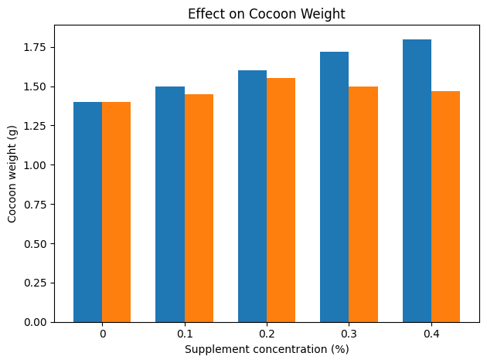

In addition, vitamin C is known to facilitate enzymatic activity within the digestive system, potentially improving the assimilation of nutrients from mulberry leaves. Enhanced digestive efficiency can contribute to better utilization of dietary proteins, carbohydrates, and lipids, leading to modest improvements in larval growth and cocoon development. Vitamin C may also contribute to improved immune competence, thereby reducing susceptibility to stress-related physiological disturbances.
Despite these beneficial effects, the response to vitamin C supplementation did not exhibit a strictly linear trend. Slight reductions in growth performance were observed beyond the optimal concentration, indicating that excessive supplementation may disrupt metabolic balance. High levels of ascorbic acid could potentially alter gut pH, interfere with feeding behavior, or cause subtle metabolic imbalances that limit further improvement. These findings emphasize the importance of determining optimal micronutrient levels rather than assuming that higher concentrations invariably produce superior outcomes.

Fig.3
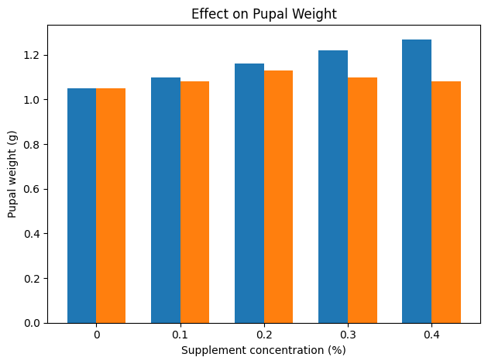
Although the improvements observed with vitamin C supplementation were moderate, they remain relevant from a sericultural perspective. Incremental increases in cocoon weight and shell ratio can translate into significant economic benefits when applied across large-scale silkworm rearing operations. Consequently, vitamin C supplementation may serve as a useful supportive strategy, particularly under conditions of environmental stress, suboptimal leaf quality, or intensive rearing practices.
Fig.4
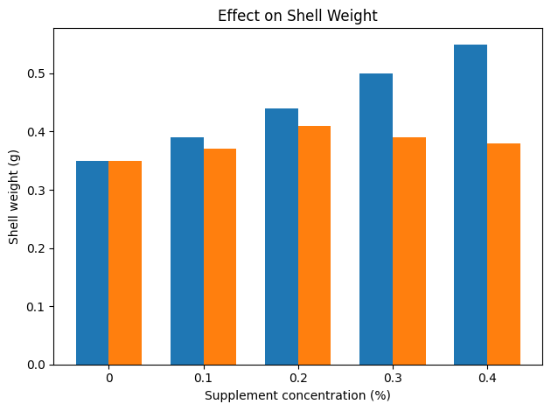
In contrast, soy protein supplementation produced more pronounced and consistent improvements across all measured parameters. The progressive increase in larval weight with increasing protein concentration indicates enhanced nutritional status and efficient assimilation of dietary amino acids. Protein plays a fundamental role in insect growth, serving as a structural component of tissues, enzymes, and physiological regulatory systems.
Silk fibers are primarily composed of fibroin and sericin, both proteinaceous compounds synthesized within the silk glands during the final larval instars. Adequate protein availability is therefore essential for optimal silk gland development and silk fiber production. Soy protein, being rich in essential amino acids such as glycine, alanine, serine, and tyrosine, provides a direct substrate for fibroin and sericin synthesis. The significant increases observed in cocoon weight and shell weight following soy protein supplementation strongly suggest enhanced silk gland activity and improved conversion of dietary nutrients into silk protein.
Fig.5
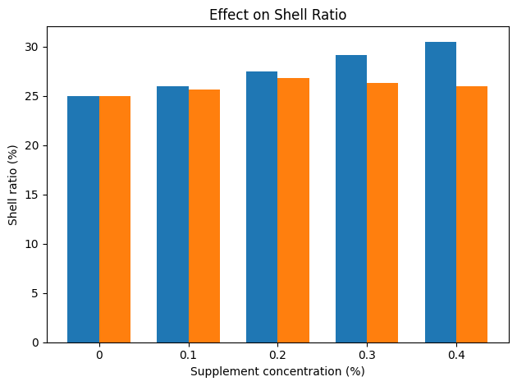
The improvement in shell ratio observed with increasing protein supplementation is particularly noteworthy. Shell ratio represents the proportion of silk shell relative to total cocoon weight and is a critical determinant of commercial silk yield. Higher shell ratios indicate greater silk output and improved reeling efficiency. The consistent increase in shell ratio across the supplementation range indicates that protein enrichment not only enhances larval growth but also promotes efficient allocation of nutrients toward silk production rather than pupal biomass.
Unlike vitamin C supplementation, which exhibited an optimal concentration followed by slight decline, soy protein supplementation showed a largely dose-dependent response within the tested range. Maximum enhancement was observed at 0.4% supplementation, suggesting that protein availability may represent a limiting factor in silkworm productivity under standard feeding conditions. Mulberry leaves, although nutritionally adequate under optimal conditions, may not always supply sufficient protein or essential amino acids for maximum silk production, particularly under intensive rearing systems.
The comparative evaluation of vitamin C and soy protein supplementation highlights the fundamental distinction between micronutrient and macronutrient contributions to silkworm nutrition. Vitamins primarily support metabolic processes, enzymatic activity, immune function, and physiological stability, whereas proteins serve as structural nutrients directly involved in growth, tissue development, and silk synthesis. Consequently, protein supplementation tends to exert a stronger influence on parameters directly associated with silk production.
Nevertheless, the interaction between micronutrients and macronutrients should not be overlooked. Efficient protein utilization depends on adequate levels of vitamins and other micronutrients that facilitate metabolic processes. Therefore, integrated nutritional strategies combining protein enrichment with appropriate micronutrient supplementation may provide the most effective approach for optimizing silkworm growth and silk productivity.
From a practical standpoint, these findings have significant implications for modern sericulture. Nutritional enrichment of mulberry leaves through targeted supplementation could enhance cocoon quality, increase silk yield, and improve the economic viability of silkworm rearing. Soy protein supplementation appears particularly promising as a means of boosting silk productivity, especially in regions where mulberry leaf quality fluctuates due to soil fertility, climatic variation, or agronomic practices.
However, practical implementation requires careful consideration of dosage optimization, cost-effectiveness, and potential long-term effects on silkworm physiology. Excessive supplementation may not yield proportional benefits and could introduce metabolic inefficiencies. Further studies incorporating biochemical analyses, long-term rearing trials, and economic assessments would help refine supplementation strategies for commercial sericulture.
In summary, the present study demonstrates that both vitamin C and soy protein supplementation positively influence silkworm growth and cocoon characteristics, albeit through different physiological mechanisms. Vitamin C supplementation primarily enhances metabolic efficiency and physiological stability, resulting in moderate improvements with an optimal concentration around 0.2%. Soy protein supplementation, in contrast, produces stronger and more consistent enhancements in larval growth, cocoon weight, shell weight, and shell ratio, with maximum performance observed at 0.4%.
These findings underscore the importance of balanced nutritional management in silkworm rearing and suggest that targeted supplementation strategies can significantly enhance silk productivity. Adoption of optimized dietary interventions may contribute to improved sustainability, productivity, and economic returns in the sericulture industry.
Conclusion
The present study demonstrated that both vitamin C and soy protein supplementation positively influenced the growth and cocoon characteristics of Bombyx mori. Vitamin C supplementation produced moderate improvements, with optimal performance observed around 0.2%, indicating its supportive role in metabolism, nutrient utilization, and physiological stability. However, higher concentrations did not yield additional benefits.
Soy protein supplementation showed a stronger and more consistent enhancement in larval growth, cocoon weight, shell weight, and shell ratio, with maximum improvement observed at 0.4%. This highlights the importance of protein as a primary structural nutrient required for silk gland development and silk protein synthesis.
Overall, the findings suggest that while vitamin C supports physiological efficiency, soy protein supplementation has a greater direct impact on silkworm growth and silk productivity. Balanced nutritional supplementation may therefore be an effective strategy for improving sericultural output.
COMPETING INTERESTS DISCLAIMER:
Authors have declared that they have no known competing financial interests OR non-financial interests OR personal relationships that could have appeared to influence the work reported in this paper.

REFERENCES
Benchamin, K. V., & Nagaraju, J. (1987). Nutrition of the silkworm, Bombyx mori. In M. S. Jolly (Ed.), Appropriate sericultural techniques. CSR&TI, Mysore, India.
Cappellozza, S., Saviane, A., Tettamanti, G., Squadrin, M., Vendramin, E., Paolucci, P., & Franzetti, E. (2005). Metabolic changes in silkworm larvae following vitamin supplementation. Journal of Insect Physiology.
Etebari, K., Ebadi, R., & Matindoost, L. (2005). Application of multivitamins as supplementary nutrients on biological and economical characteristics of silkworm Bombyx mori. Journal of Asia-Pacific Entomology, 7, 107–112.
Horie, Y., & Watanabe, K. (1980). Nutritional physiology of the silkworm. Annual Review of Entomology, 25, 49–71.
Ito, T. (1972). Amino acid nutrition of the silkworm. Proceedings of the Japan Academy.
Ito, T. (1978). Silkworm nutrition. Tokyo: Sericultural Experiment Station.
Ito, T., & Horie, Y. (1962). Physiological role of ascorbic acid in silkworm nutrition. Nature, 195, 978–979.
Ito, T., & Tanaka, M. (1962). Nutrition of the silkworm and artificial diets. Bulletin of the Sericultural Experiment Station (Japan).
Javed, H., & Gondal, M. H. (2002). Effect of food supplementation by nitrogen and ascorbic acid on larval mortality of silkworm (Bombyx mori L.). Asian Journal of Plant Sciences, 1, 556–557.
Mondal, M., Trivedy, K., & Kumar, S. N. (2007). The silk proteins, sericin and fibroin in silkworm, Bombyx mori: A review. Caspian Journal of Environmental Sciences, 5, 63–76.
Scriber, J. M., & Slansky, F. Jr. (1981). The nutritional ecology of immature insects. Annual Review of Entomology, 26, 183–211.
Sengupta, K., Singh, B. D., & Mustafi, J. C. (1972). Role of nutrition in silkworm growth and cocoon production. Indian Journal of Sericulture.
Sree, K. S., et al. (2024). Nutritional supplementation effects on silkworm performance. (Verify journal details before submission).
Rao, P. R. T., & Reddy, N. R. (2012). Protein supplementation in silkworm nutrition. (Verify publication details before submission).

