Original Research Article

Diversity of Interstitial Meiofauna and Physico-Chemical Characteristics of Coastal Waters along the Parangipettai Coast, Southeast India

Abstract
Meiofauna are microscopically small, motile organisms inhabiting interstitial spaces of aquatic sediments and are increasingly recognized as an ecological unit linking microbenthos and macrobenthos. This study examined the diversity and composition of interstitial fauna and measured key physico-chemical parameters of coastal waters at two stations along the Parangipettai coast, southeast India: Vellar estuary (Station 1) and Puthupettai beach (Station 2), during October 2024 to March 2025. Water quality parameters (pH, salinity, temperature, and dissolved oxygen) were recorded, and interstitial fauna were extracted from surface sediments using decantation and sieving methods. A total of 12 species belonging to 25 genera across 3 classes and 1 order were identified. Nematodes dominated the assemblage (55%), followed by amphipods (25%), polychaetes (10%), and copepods (10%). Meiofaunal abundance was higher at Station 2 (≈1000 ind/10 m³) than Station 1 (≈820 ind/10 m³). Diversity indices also showed higher richness and evenness at Station 2 (S = 27; E′ = 0.48; H′ = 1.22) than Station 1 (S = 25; E′ = 0.20; H′ = 1.05). The observed differences likely reflect habitat variation between estuarine and beach environments, including salinity range and dissolved oxygen conditions.
Keywords: meiofauna, interstitial fauna, nematodes, estuary, sandy beach, diversity indices, Parangipettai coast

1. Introduction
The term "meiofauna" denotes microscopically small, motile aquatic animals living mostly in and on soft substrates at all depths in the marine and fresh-water realm. Although originally restricted to small metazoans, ecological connections suggest that larger protozoans (ciliates), the newly settled larvae of many microbenthic animals (temporary meiofauna), and amoebozoans should also be included in the scope of meiofauna; this wider definition is used synonymously with meiobenthos in many contexts (Piot et al., 2013; Higgins and Thiel, 1998). Formally defined by sieve mesh sizes of between 44 and 500 mm, meiobenthos is increasingly considered an ecological unit of its own, and an important link between micro- and macro-benthos (Piot et al., 2013).
Several study disciplines, including ecology, evolutionary biology, and conservation biology, continue to emphasize the significance of measuring species richness in both terrestrial and marine ecosystems. Large macroscopic species have received more attention in spatial patterns of biodiversity than small-scale organisms, such as the vast majority of animal phyla represented in the polyphyletic group of meiofauna. According to body size, meiofauna are defined as animals that pass through a 500 μm mesh net and are caught by a 20 μm mesh net (Higgins and Thiel, 1998). Metazoan meiofauna, which comprise a range of parasitic species, are extensively found in all benthic habitats and ecosystems of the world's oceans. Meiofaunal animals inhabit all substrates, from muds to the coarsest shell gravels, and are the numerically dominant component of benthic metazoans in all marine systems, from intertidal beaches to the ocean bottom. Nematodes, which make up over 90% of the total meiofaunal abundance in benthic deep-sea ecosystems, dominate meiofaunal assemblages in many regions (Coull and Bell, 1979). Meiofauna are distinguished by their high diversity and abundance at the genus/species level or at the level of higher taxa, and because of their sensitivity to environmental changes, they are increasingly used in monitoring studies to evaluate environmental quality (Coull, 1999; Carman and Todaro, 1996). They are regarded as an appropriate model for investigation of species distribution and biodiversity patterns in marine environments because they serve as a functional link between macrofauna and microbial communities (Coull, 1999; Pinckney et al., 2003).
The term meiofauna loosely defines a group of organisms by their size that are larger than microfauna but smaller than macrofauna. In practice, the term usually includes organisms that can pass through a 1 mm mesh but are retained by a 45 µm mesh (Higgins and Thiel, 1998). The term meiobenthos was first coined by Molly Mare (1942), but organisms that fit into the modern meiofauna category have been studied since the 18th century.
Meiofaunal organisms are small animals (pass through a 500 mm sieve and are retained on a 0.063 or 0.045-mm sieve) found living in benthic zones of both freshwater and marine habitats and are considered numerically dominant metazoans (Coull and Bell, 1979; Higgins and Thiel, 1998). They occur from the splash zone on the beach to the deepest sediments in the sea, and are found on all types of sediments. Due to their taxonomic diversity and species richness, meiofauna represent an important but often neglected component of marine biodiversity. The presence of these interstitial organisms in the benthic zone is important since they serve as links to higher trophic levels in marine ecosystems. They play an important role in bioturbation and stimulation of bacterial metabolism in marine sediments, participate in biomineralization of organic matter, and act as a link between detritus and higher trophic levels in tropical habitats (Coull, 1999; Carman et al., 1997; Carman et al., 2000). They also exhibit high sensitivity to anthropogenic inputs, making them excellent sentinels of pollution (Carman and Todaro, 1996; Carman et al., 2000).
Interstitial fauna constituting a group of microscopic metazoans inhabiting intertidal sandy beaches of fresh and salt waters have received considerable attention in some parts of the world (Ganapati and Rao, 1962). It was not until the nineteen-twenties that biologists discovered this singular animal world which has since then been studied in the interstitial water in sand. Since the interstitial space is very small, its fauna is restricted to tiny organisms suited to a lacunar environment. Since the term meiofauna defines a size class but does not specify spatial location or how organisms move within the habitat, and since the interstitial space is a function of particle size, other terms have been used to refine the classification and indicate location (Nybakken, 1997).
Sand and related sediments found in lakes, rivers, springs, and the ocean are home to this sand microfauna, also known as interstitial fauna. The most diverse evolution of the interstitial fauna occurs in marine sediments. The marine sand microfauna includes species that are morphologically aberrant and occasionally represent whole new types of organization, but it also includes the majority of the invertebrate classes. The study of the interstitial fauna has produced discoveries that advanced systematic zoology and linked morphological organization to biology and environment (Swedmark, 1964).
Ecological investigations are ideally adapted to the interstitial environment (Swedmark, 1964). Typically, exposed sandy beaches have turbulent surf zones where wave energy is used to move sediment and water. It is commonly believed that the sea provides the majority of the food for benthic organisms on these beaches in the form of living and non-living organic particles, while surf zones carry carrion and detritus shoreward. It is suggested that sufficient quantities of inorganic nutrients are generated within many beaches to cause phytoplankton blooms in surf zones and that phytoplankton is a major food source for intertidal macrofauna. If the bulk of energy turnover occurs inside the surf zone, the beach may be considered only slightly subsidized and thus qualify as an ecosystem (McLachlan, 1980). Around the world, both freshwater and saltwater intertidal and subtidal sedimentary substrates support interstitial fauna and flora diversity, and major interstitial groupings have been found at depths up to 5000 m (Coull et al., 1977).
Interstitial organisms fall into two categories: newly arrived juveniles of macrofaunal species form temporary meiofauna, and organisms that live their entire lives in the sediment voids are permanent meiofauna (Coull and Bell, 1979; Higgins and Thiel, 1998). On a worldwide basis, the average biomass of meiofaunal organisms per square meter is between 1 and 2 g/m², with both numbers and biomass highest in intertidal areas and decreasing with depth; nematodes and harpacticoid copepods are typically the most abundant taxa (Coull and Bell, 1979).
The conditions affecting meiofauna differ from those affecting macrofauna in the same areas. A key factor influencing presence/absence and composition is grain size, because grain size determines the amount of interstitial space available for habitation and can act as a barrier to movement and dispersal. Meiofaunal organisms often show zonation based on grain size (Swedmark, 1964; Nybakken, 1997). Meiofauna can also occupy above-sediment habitats like rooted vegetation, moss, macroalgae fronds, sea ice, and animal structures (Funch et al., 2002). Benthic meiofauna influence primary production, nutrient cycling, and benthic metabolic processes, and their short generation times may contribute to rapid cycling of nutrients through meiobenthos (Carman et al., 1996; Carman et al., 1997; Carman et al., 2000; Pinckney et al., 2003; Coull, 1999).

- Material and Methods

Study area

The present study was conducted at two different stations along the southeast coast of India viz. Vellar estuary (Lat. 11.501148, Long 79.772144"), Pudhupettai beach (st. 2) (Lat 1515025, Long 79/7650458"), for a period of six months from October to March (Fig.1).

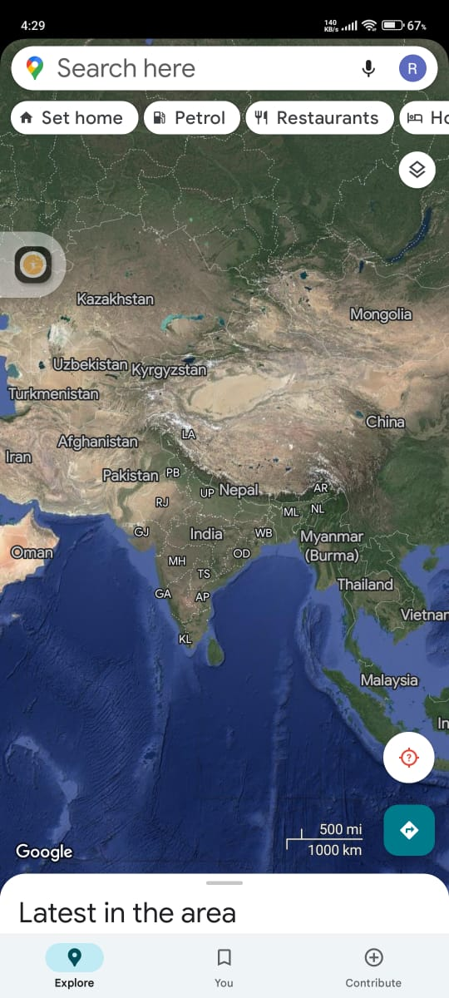
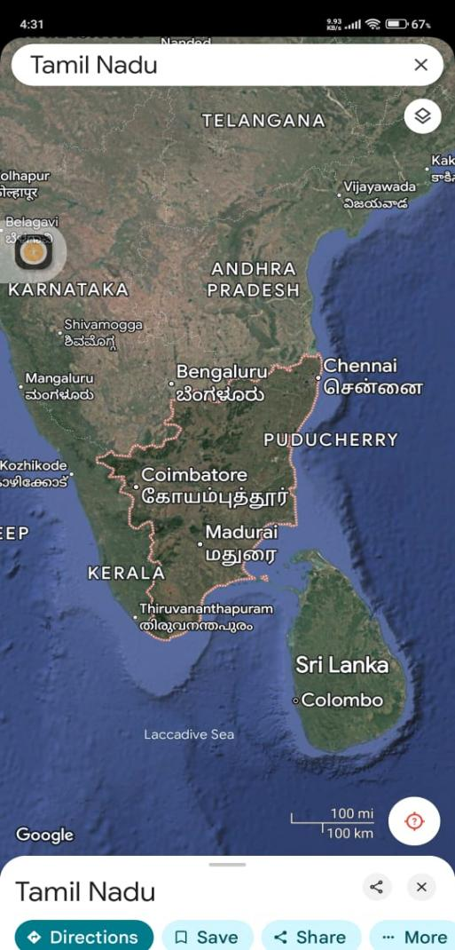
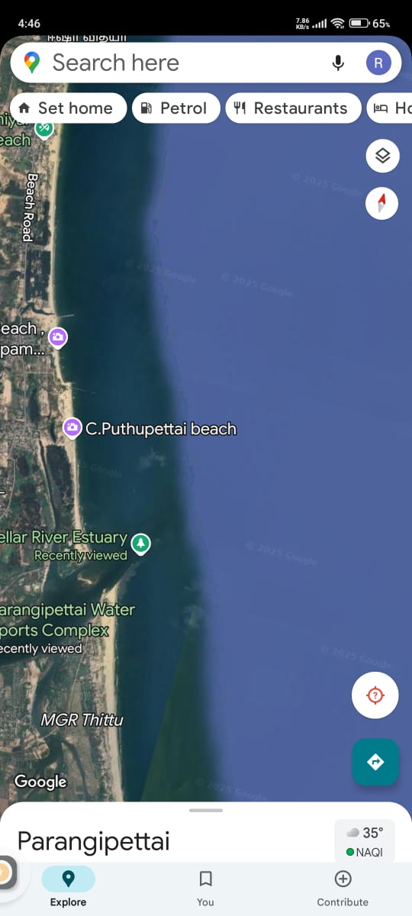

Fig.1. Map of samping station along the southest coast india

Station 1: Vellar Estuary
The Vellar estuary mouth flows eastward and empties into the Bay of Bengal. Parangipettai Vellar estuary is the mouth center and is busy with sandy beach activities using mechanized and non-mechanized boats. There are several inlets flowing directly into the estuary carrying waste from adjacent agricultural lands, domestic municipal, and distillery effluents (Fig.2).

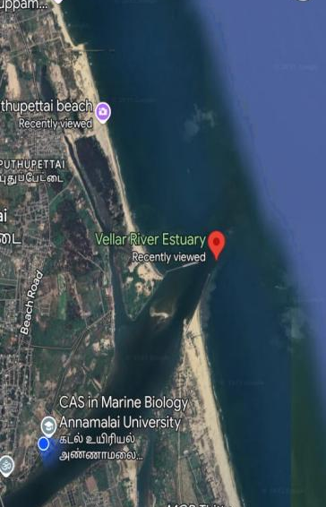

Fig.2. Sampling station of Vellar estuary (st.1)
Station 2: Puthupettai Beach
The Puthupettai beach flows eastward and empties into the Bay of Bengal. Puthupettai is the beach center and is busy with sandy beach meiofauna activities using mechanized and non-mechanized boats. There are several inlets flowing directly into the estuary carrying waste from adjacent agricultural lands, domestic municipal, and distillery effluents (Fig.3).

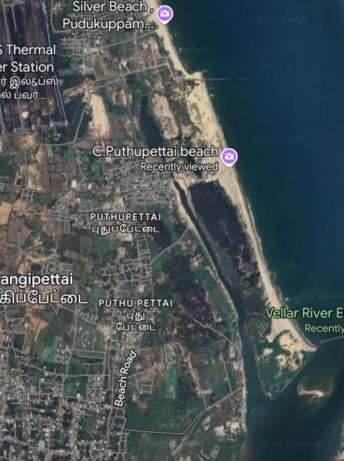

Fig.3. sampling station of Pudhupettai beach (st.2).

2.2 Sample collection
The samples were collected October to March 2025 from two different stations such as Veller estuary (St.1), Pudhupettai beach (St.2). The sediment samples were collected using PVC corer (having an internal diameter of 10 cm and a length of 10 cm) (Platt and Warwick, 1983). Following collection, all samples were stored with a 10% formaldehyde solution and identified by staining them with Rose Bengal. Overnight, the samples were not disturbed in order to conduct both qualitative and quantitative examination.

2.3 Water and sediment analysis
Measurements of salinity (Refractometer, ATAGO, Japan), temperature (hand-held mercury thermometer), and pH (pH pen, model L1-120, Eutech Instrument, Singapore) were measured at each sampling event. Winkler's method was utilized to determine the dissolved oxygen (DO) in bottom water.

2.4 Interstitial fauna analysis
Using a PVC corer, six surface three replicate sediment samples were gathered for faunal examination. The samples were brought to the lab right away after being fixed in 10% formaldehyde in distilled water. Through decantation over a 45 µm mesh screen, the interstitial fauna was separated from the sediment. Under a stereo microscope, the material that remained on the sieve was stained with Rose Bengal and identified to a potential taxonomic level. Using a sieve with a 0.040 mm mesh size, flotation and decantation were used to separate the metazoan meiofauna (foraminiferans, nematodes, harpacticoids, and ostracods) from the sediment. This method's efficiency more than the salt marsh's reported value. However, compared to other estuarine habitats, nematodes (107/cm2) displayed lower populations.
On an exposed sand beach at Whit sand Bay, East Convall, Harris (1972) investigated meiofauna and found that nematodes accounted for around half of the meiofauna, making them the dominant group; harpacticoid copepods ranked second in abundance, and tardigrades, gastrotrichs, turbellaria, and hydrozoans were also present (Harris, 1972). The richness and distribution of benthic meiofauna in the coastal waters of Nagapattinam were investigated by Tracy Austin Kumar et al. (2022), where offshore stations recorded higher species numbers post-monsoon and estuarine stations recorded lower densities (Kumar et al., 2022).
3.Results

3.1 Assessment of physio–chemical parameters of water (Vellar estuary)
pH: The minimum pH value (7.5) was recorded and maximum pH value (8.2) in station 1 (Fig.4).
Salinity: The minimum salinity concentration (10.5 ppt) was recorded and the maximum salinity concentration (35.2 ppt) was recorded in station 1 (Fig.5).
Temperature: The minimum water temperature (26°C) was recorded and the maximum temperature (28.2℃) was recorded in station 1 (Fig.6).
Dissolved oxygen (DO): Dissolved oxygen concentration ranged from 3.7 to 4.39 mg/l. The minimum dissolved oxygen concentration (4.28 mg/l) was recorded and the maximum (8.57 mg/l) was recorded in station 1 (Fig.7).

3.2 Assessment of physio–chemical parameters of water (Puthupettai beach)
pH: The minimum pH value (7.9) was recorded and maximum pH value (8.3) in station 2 (Fig.8).
Salinity: The minimum salinity concentration (30 ppt) was recorded and the maximum salinity concentration (36 ppt) was recorded in station 2 (Fig.9).
Temperature: The minimum water temperature (24°C) was recorded and the maximum temperature (28℃) was recorded in station 2 (Fig.10).
Dissolved oxygen: The minimum dissolved oxygen concentration (5.8 mg/l) was recorded and the maximum (6.5 mg/l) was recorded in station 2 (Fig.11).

Fig.4. pH of Vellar estuary (st.1)

Fig.5. Salinity level of velar estuary (st.1)

Fig.6. Temperature level of velar estuary (st.1).

Fig .7. Dissolved oxygen level of velar estuary (st.1)

Fig .8. pH level of puthupettai beach (st.2)

Fig.9. Salinity level of Puthupettai beach (st.2)

Fig 10. Temperature level of puthupettai beach (st.2)

Fig 11. Dissolved oxygen of puthupettai beach (st.2).

3.3 Species composition
A total of 12 species belonging to 25 genus and 3 class and 1 order were identified during the study period: nematodes with 10 genus and 8 species, polychaeta with 8 genus, amphipods with 3 genus, and copepods with 6 genus and 4 species. The overall meiofauna species composition was nematodes (55%), amphipods (25%), polychaeta (10%), and copepods (10%). Among the nematodes, Viscosia carnleyensis, Viscosia marcramphida, and Anoplostoma viviparum were common in the two stations (Fig.12–13).

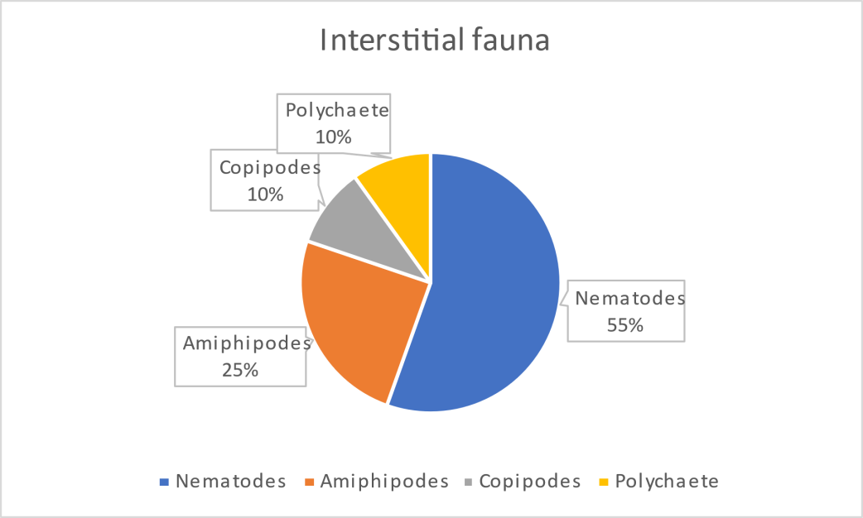

Fig.12. The Percentage composition of interstitial fauna in two stations

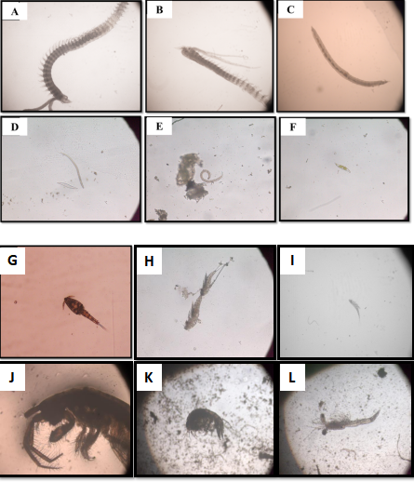

Fig.13. Dominant interstitial faunal from all the identified groups. (A.) Prionospio sp., (B). Magalona sp., (C) Pissionidens sp. (D). Viscosia carnleyensis(E). Viscosia marcramphida and (F).Anoplostoma viviparum(G). Paracalanus parvus, (H)Acartia sp. (I)Longipedi sp. (J.) Haplocheira sp.(K) Ampithoe sp.(L). Mysis larvae.

3.4 Species abundance and diversity
The abundance of meiofauna was high in Puthupettai beach (Station 2) with ~1000 ind/10 m³ and relatively lower in Vellar estuary (Station 1) with ~820 ind/10 m³. Nematodes exhibited the highest abundance at both stations (~550 ind/10 m³ at Station 2 and ~451 ind/10 m³ at Station 1). Copepods were the least abundant (~100 ind/10 m³ at Station 2 and ~82 ind/10 m³ at Station 1) (Fig.14).
Station 2 exhibited higher species richness (S = 27) and evenness (E′ = 0.48), while Station 1 showed lower evenness (E′ = 0.20) with moderate richness (S = 25). The Shannon Index values were higher at Station 2 (H′ = 1.22) than Station 1 (H′ = 1.05) (Fig.15).
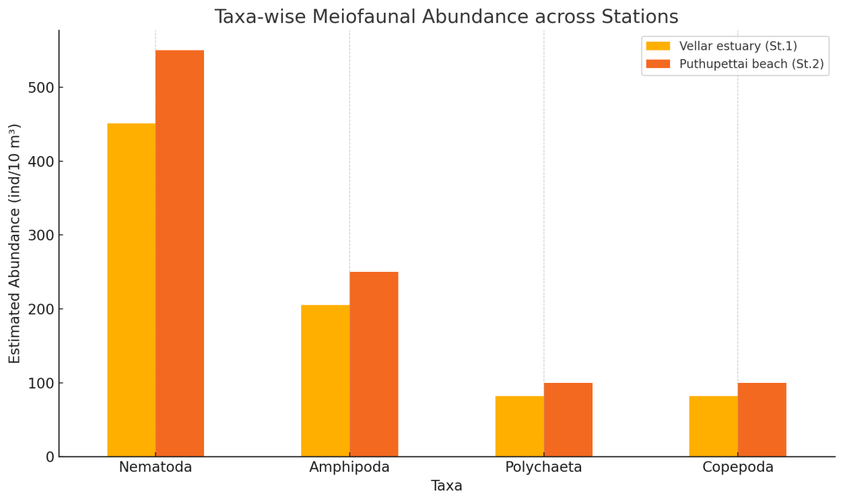
Fig. 14. Species abundance

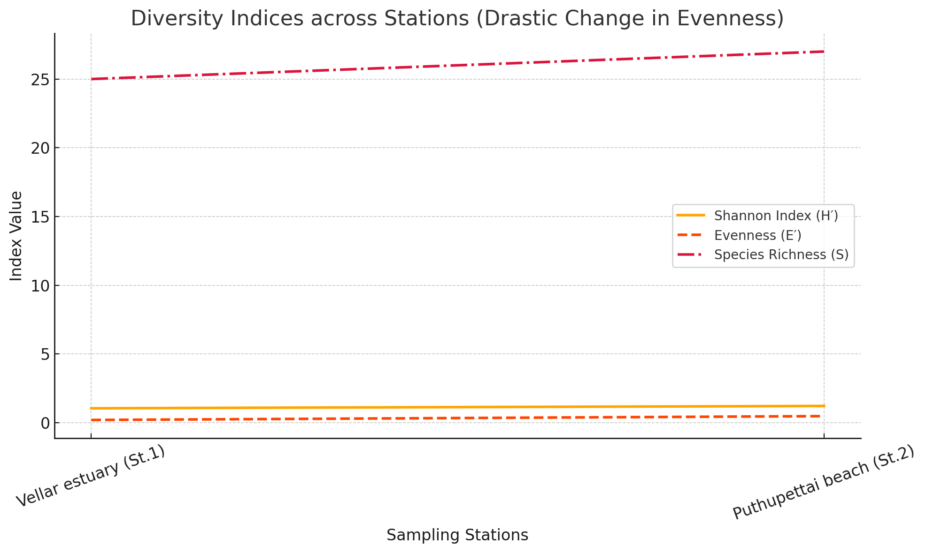

Fig. 15. Species diversity indices

4. Discussion
This study documents interstitial fauna composition and water quality patterns at two contrasting coastal habitats along the Parangipettai coast: an estuarine station (Station 1) and an open sandy beach station (Station 2). The physico-chemical ranges observed (pH ~7.5–8.3; temperature ~24–28.2°C; and variable dissolved oxygen and salinity ranges) are consistent with typical tropical coastal conditions where seasonal and local hydrological inputs influence estuarine waters more strongly than open beaches. In the present dataset, Station 1 exhibited a wide salinity range (10.5–35.2 ppt), reflecting freshwater influence and mixing, while Station 2 maintained higher and narrower salinity values (30–36 ppt), typical of more marine-dominated conditions. Such differences can substantially affect meiofaunal community structure, because osmoregulation constraints and habitat stability often favor different taxa in estuaries versus marine beaches.

4.1 Dominance of nematodes and functional significance
The observed dominance of nematodes (55%) aligns with extensive meiofaunal literature reporting nematodes as the most consistently abundant group across marine and estuarine sediments. Nematode dominance has been widely recorded in multiple environments and may span broad ranges in coastal sediments, reflecting their tolerance to environmental gradients and their ability to exploit diverse microbial and detrital resources (Carugati et al., 2015). The present finding, nematodes being the highest abundance group in both stations,supports the view that nematodes often form the structural “core” of meiofaunal assemblages, while other groups (e.g., copepods, polychaetes, amphipods) vary more with habitat conditions (Carugati et al., 2015).
Functionally, meiofauna contribute to sediment ecosystem processes through feeding, movement, and interactions with microbes. Meiofauna are known to facilitate biomineralization of organic matter and enhance nutrient regeneration, and they also serve as food for higher trophic levels, together supporting energy transfer and nutrient cycling in estuarine soft-bottom habitats (Coull, 1999). Therefore, even modest shifts in community composition may influence sediment metabolism, nutrient fluxes, and food-web structure (Coull, 1999).

4.2 Habitat differences, abundance patterns, and oxygen–salinity context
Abundance and diversity were higher at Station 2 (Puthupettai beach) than Station 1 (Vellar estuary). This pattern can be interpreted in the context of habitat stability and stress gradients. Estuarine habitats often experience stronger fluctuations in salinity and organic inputs, which may favor tolerant taxa and increase dominance effects,consistent with the lower evenness observed at Station 1 (E′ = 0.20). Station 2 had higher evenness (E′ = 0.48), suggesting that individuals were more evenly distributed across taxa, which is commonly associated with more stable or less stressful environmental conditions (Coull, 1999).
Dissolved oxygen patterns are also ecologically relevant because many meiofauna occupy sediment–water interface layers where oxygen availability influences microbial food resources and animal respiration. Meiofaunal densities often shift with oxygen gradients and organic enrichment, and changes in DO can indirectly restructure communities by altering microbial biomass and sediment redox conditions; this fits broader benthic ecology understanding that sedimentary ecosystems are sensitive to stressors and that small-bodied communities can respond rapidly (Coull, 1999).

4.3 Grain size and interstitial habitat structure
A core ecological driver of interstitial fauna is sediment grain size, which determines pore-space availability and the physical limits on body size, movement, and dispersal. Classic work on marine sand interstitial fauna shows that species distribution in different sand biotopes is strongly dependent on ecological factors such as grain size, and that interstitial community structure is shaped by sediment characteristics (Swedmark, 1964). While the present study did not quantify grain-size distribution, the contrast between an estuarine mouth environment and a sandy beach suggests differences in sediment texture and hydrodynamic sorting. Such differences can contribute to the observed pattern of higher abundance and diversity at the beach station if pore spaces and oxygen diffusion are more favorable (Swedmark, 1964).

4.4 Meiofauna as bioindicators and under-representation in monitoring
Meiofauna are increasingly highlighted as useful bioindicators because they combine fast generation times, direct sediment contact, and sensitivity to stressors such as pollution and eutrophication (Coull, 1999). Importantly, recent synthesis of beach ecosystem research has shown that meiofauna remain substantially under-represented in ecological studies and ecosystem assessments of beaches, even though they are well suited as sentinels (Martínez et al., 2024). This supports the relevance of studies like the present one in strengthening baseline knowledge on meiofaunal communities and improving the scope of coastal monitoring and ecosystem health assessments (Martínez et al., 2024).

4.5 Comparison with regional and published observations
The community pattern in this study,nematode dominance with contributions from copepods, polychaetes, and amphipods,matches several published observations from coastal and estuarine systems. Multi-taxa meiofaunal compositions are frequently structured by salinity gradients and local sediment properties, and seasonal variation may further influence recruitment and abundance patterns (Coull, 1999; Swedmark, 1964). The higher diversity values at Station 2 (H′ = 1.22) relative to Station 1 (H′ = 1.05) support the conclusion that the beach site provided conditions that allowed more taxa to persist without strong dominance effects, consistent with the expectation that more stable marine conditions and favorable interstitial habitat structure promote higher evenness and diversity (Coull, 1999; Martínez et al., 2024).
Overall, the present study contributes site-specific baseline information for the Parangipettai region and supports the broader ecological understanding that interstitial fauna composition reflects a combination of habitat structure (pore space/grain size), water quality conditions (salinity and oxygen), and potential local disturbances (Swedmark, 1964; Coull, 1999; Martínez et al., 2024).

5. Conclusion
During the present study, the sediment and water samples were collected from two stations (Vellar estuary mouth and Puthupettai beach) for analysis of interstitial fauna diversity and physico-chemical parameters (water temperature, salinity, and pH). A total of 12 species and 18 genera belonging to four groups of interstitial fauna—polychaetes, nematodes, amphipods, and copepods—were recorded. Nematodes were the dominant group at both stations. Several taxa were common across stations, including nematodes (Viscosia carnleyensis, Viscosia marcramphida, Anoplostoma viviparum), polychaetes (Prionospio sp., Magelona sp., Pissionidens sp.), copepods (Paracalanus parvus, Acartia sp.), and amphipods (Haplocheira sp., Ampithoe sp.).
In conclusion, interstitial fauna—though often overlooked—play vital roles in marine ecosystems and caof ecosystem health. Continued research is necessary to better understand the diversity, distribution, and ecological functioning of these communities in tropical coastal systems.

References
Ansari, A., Rivonkar, C.U. and Sangodkar, U.M.X., 2001. Population fluctuation and vertical distribution of meiofauna in a tropical mudflat at Mandovi estuary, west coast of India. Indian Journal of Marine Sciences, 30, 237–245.
Ansari, Z.A. and Parulekar, A.H., 1993. Distribution, abundance and ecology of the meiofauna in a tropical estuary along the west coast of India. Hydrobiologia, 262, 115–126.
Bongers, T., 1990. The maturity index: an ecological measure of environmental disturbance based on nematode species composition. Oecologia, 83, 14–19.
Carman, K.R. and Todaro, M.A., 1996. Influence of polycyclic aromatic hydrocarbons on the meiobenthic copepod community of a Louisiana salt marsh. Journal of Experimental Marine Biology and Ecology, 198(1), 37–54.
Carman, K.R., Fleeger, J.W. and Pomarico, S.M., 1997. Response of a benthic food web to hydrocarbon contamination. Limnology and Oceanography, 42(3), 561–571.
Carman, K.R., Fleeger, J.W. and Pomarico, S.M., 2000. Does historical exposure to hydrocarbon contamination alter the response of benthic communities to diesel contamination? Marine Environmental Research, 49(3), 255–278.
Carugati, L., Corinaldesi, C., Dell’Anno, A. and Danovaro, R., 2015. Metazoan meiofauna biodiversity: a neglected component of marine ecosystems. Marine Biodiversity, 45, 1–14.
Coull, B.C. and Bell, S.S., 1979. Perspectives of marine meiofaunal ecology. In: Livingston, R.J. (Ed.), Ecological Processes in Coastal and Marine Systems. Plenum Press, New York, pp. 189–216.
Coull, B.C., Ellison, R.L., Fleeger, J.W., Higgins, R.P., Hope, W.D., Hummon, W.D., Rieger, R.M., Sterrer, W.E., Thiel, H. and Tietjen, J.H., 1977. Quantitative estimates of the meiofauna from the deep sea off North Carolina, USA. Marine Biology, 39(3), 233–240.
Coull, B.C., 1999. Role of meiofauna in estuarine soft-bottom habitats. Australian Journal of Ecology, 24(4), 327–343.
Datta, R., Maity, P., Bhadury, P., Rizvi, A.N. and Raghunathan, C., 2022. An updated checklist of free-living marine nematodes from coastal India. Zootaxa, 5196(2), 151–196.
Funch, P., Nielsen, N.E.K., Graf, S. and Buttler, F., 2002. Marine meiofauna. Feltkursus i videregående zoologi på Molslaboratoriet, 119 pp.
Ganapati, P.N. and Rao, G.C., 1962. Ecology of the interstitial fauna inhabiting the sandy beaches of Waltair coast. Journal of the Marine Biological Association of India, 4, 44–57.
Harris, R.P., 1972. The distribution and ecology of the interstitial meiofauna of a sandy beach at Whitsand Bay, East Cornwall. Journal of the Marine Biological Association of the United Kingdom, 52(1), 1–18.
Higgins, R.P. and Thiel, H., 1998. Introduction to the Study of Meiofauna. Smithsonian Institution Press, Washington DC, 488 pp.
Kondalarao, B., 1983. Distribution of meiofauna in the Gautami–Godavari estuarine system, India. Mahasagar, 16, 25–34.
Kondalarao, B. and Ramanamurty, K.V., 1988. Ecology of intertidal meiofauna of the Kakinada Bay (Gautami–Godavari estuarine system), east coast of India. Indian Journal of Marine Sciences, 17, 185–190.
Kumar, A.T.A., Punniyamoorthy, R., Mariyappan, S., Swain, S. and Murugesan, P., 2022. Benthic meiofaunal diversity and distribution in Nagapattinam coastal waters, India. Indian Journal of Geo-Marine Sciences, 51(3), 238–246.
Mare, M.F., 1942. A study of a marine benthic community with special reference to the micro-organisms. Journal of the Marine Biological Association of the United Kingdom, 25, 517–554.
Mary, N. and Marmonier, P., 2000. First survey of interstitial fauna in New Caledonian rivers: influence of geological and geomorphological characteristics. Hydrobiologia, 418, 199–208.
Martínez, M.L., Defeo, O., Jaramillo, E. and McLachlan, A., 2024. Sandy beaches as ecosystems: overlooked biodiversity and ecosystem functioning. Estuarine, Coastal and Shelf Science, 298, 108594.
McLachlan, A., 1980. Exposed sandy beaches as semi-closed ecosystems. Marine Environmental Research, 4(1), 59–63.
Nybakken, J.W., 1997. Marine Biology: An Ecological Approach. 4th ed. Addison Wesley Longman, California.
Pinckney, J.L., Carman, K.R., Lumsden, S.E. and Hymel, S.N., 2003. Microalgal–meiofaunal trophic relationships in muddy intertidal estuarine sediments. Aquatic Microbial Ecology, 31(1), 99–108.
Piot, A., Nozais, C. and Archambault, P., 2013. Meiofauna affect the relationship between biodiversity and ecosystem functioning in benthic systems. Oikos, 122, 1359–1369.
Platt, H.M. and Warwick, R.M., 1980. The significance of free-living nematodes to the littoral ecosystem. In: Price, J.H., Irvine, D.E.G. and Farnham, W.F. (Eds.), The Shore Environment, Vol. 2. Academic Press, London, pp. 729–759.
Platt, H.M. and Warwick, R.M., 1983. Free-living Marine Nematodes. Part I: British Enoplids. Synopses of the British Fauna (New Series), No. 28. Cambridge University Press, Cambridge.
Rao, G.C., 1975. The interstitial fauna in the intertidal sands of Andaman and Nicobar group of islands. Journal of the Marine Biological Association of India, 17(2), 116–128.
Rizqydiani, M., Ismet, M.S. and Bengen, D.G., 2018. Diversity of meiofauna and its association with seagrass bed characteristics in Pramuka Island, Seribu Islands. IOP Conference Series: Earth and Environmental Science, 176, 012045.
Sarma, A.L.N. and Wilsanand, V., 1994. Littoral meiofauna of Bhitarkanika mangroves of river Mahanadi system, east coast of India. Indian Journal of Marine Sciences, 23, 44–49.
Steyaert, M., Deprez, T., Raes, M., Bezerra, T., Demesel, L., Derycke, S., Fonseca, G., Moens, T., Vanreusel, A. and Vincx, M., 2005. Electronic key to the free-living marine nematodes. Marine Biology Research, 1, 1–41.
Swedmark, B., 1964. The interstitial fauna of marine sand. Biological Reviews, 39(1), 1–42.
Thilagavathi, B., Das, B., Saravanakumar, A. and Raja, K., 2011. Benthic meiofaunal composition and community structure in the Sethukuda mangrove area and adjacent open sea, east coast of India. Ocean Science Journal, 46, 63–72.
Warwick, R.M., Platt, H.M. and Somerfield, P.J., 1998. Free-living Marine Nematodes. Part III: British Monhysterids. The Linnean Society of London and the Estuarine and Coastal Sciences Association.

