Assessment of Feeding and Housing Management practices adopted by the Local Cattle farmers from Bastar Region of Chhattisgarh

Abstract

Livestock farming plays a vital role in the rural economy of Chhattisgarh state. This investigation was conducted to evaluate the existing feeding and housing management practices followed by local cattle farmers of Bastar, Narayanpur and Dantewada district from the Bastar Plateau zone of Chhattisgarh. The study revealed that the all respondents followed extensive system of cattle farming, with feeding primarily dependent on grazing, crop residues and grasses. Only 19.5% of respondents offer concentrate ration whereas very few supplied mineral mixtures. All the farmers constructed shed to their animals using local available low-cost materials such as polyproline or thatched roof and earthen flooring. Most of the cattle shed lack of electricity, although cleanliness and ventilation facilities were maintained. The investigation highlights that the cattle farmers followed traditional, low input, limited scientific management practices and urgent need of extension services, farmers training to increase awareness among farmers to promote scientific cattle management and improve productivity.

Keywords: Bastar plateau, Grazing, Mineral mixture, thatched roof, ventilation, human dwelling.

1. Introduction
Livestock rearing plays a significant role in the rural economy of Chhattisgarh, particularly in tribal-dominated districts such as Bastar. Cattle are an integral part of mixed crop - livestock farming systems, contributing to draught power, manure production, and livelihood security of small and marginal farmers (Parabex and Rahman, 2023). As per the 20th Livestock Census, Chhattisgarh possesses 99.05 lakhs of cattle and with highest cattle heads the Bastar plateau zone holds the 1st position in the state (DADH, 2019). Despite adequate population size, productivity of local cattle remains comparatively low, mainly due to traditional management practices and limited adoption of scientific cattle farming. Feeding management in rural areas of Chhattisgarh is largely dependent on grazing, crop residues, and locally available feed resources, with minimal use of balanced concentrate mixtures (Deoras et al. 2004). Similarly, housing structures are generally constructed from locally available materials without proper scientific design, often lacking adequate drainage and sanitation facilities (Ashokbabu et al. 2024). Cattle management practices are also influenced by socio-cultural beliefs and traditional practices followed in tribal regions where milking and milk utilization patterns is totally different from other geographical location of the country. Cattle play a crucial role by providing draught power, manure and occasional income during emergencies (Bharat et al. 2019). Despite their importance, their production remains low due to low awareness of standerd scientific practices and unavailability of feed and fodder. Since cattle plays a major livelihood asset for the farmers, improving cattle performance can directly enhance socioeconomic profile of social weak sections. Such investigation is also necessary to bridge the development gap between tribal areas and the rest of the state (Verma et al. 2017). Therefore, a systematic analysis of feeding and housing management practices followed by local cattle farmers of Bastar plateau zone is essential to identify actual status of cattle farming in the studied area.

2. Materials and Methods
The present investigation was carried out in Bastar plateau zone of Chhattisgarh from July to December 2024. The breeding tract of local cattle of Bastar region is located at Latitude 19.0748° N and Longitude 81.9535° E. In the 1st stage, Bastar, Narayanpur and Dantewada were selected based on cattle population and accessibility of data collection followed by two blocks from each district total six blocks were randomly chosen. Additionally, 3-4 villages from each block were randomly chosen and finally data were gathered from 104 respondents from 32 villages. The respondents were selected on the basis of availability of cattle and minimum of five years of experience in cattle farming. A well-structured, pre-tested, standardized questionnaire were designed for collection of data. Primary information was gathered directly from the respondents. The collected data were analyzed using appropriate statistical methods such as frequency and percentage to assess the feeding and housing management practices followed by the cattle farmers of the surveyed area.

3. Results and Discussion

3.1 Feeding Management Practices Adopted by the Local Cattle Farmers
The findings (Table 1) revealed that all the respondents (100%) practiced extensive system of rearing. In Bastar, farmers rear their animals mainly by grazing and feed their livestock a variety of fodder, including paddy, grasses, dry mahua, straw, and tree leaves. The majority, 76.9%, of respondents primarily rear on grazing (grasses, tree leaves and paddy) and around 23.1% on grazing and offer feed with combination of paddy, grass, and mahua mix (Table 1). This system reflects a low-input, low-output indigenous management approach and aligns with findings of Chhattisgarh livestock development report (2021). Feeding of concentrate ration was practiced by only 19.5% of farmers whereas, rest of the farmers do not provide any type grains to their animals. The study further revealed that 95.5% of respondents did not provide mineral mixture and common salt (92.5%) to their animals. This finding clearly indicates that the cattle farmers totally depend on grazing for cattle rearing. This finding was in contrast of the finding of Manohar et al. (2014), Saurav et al. (2023), Sumer et al. (2025) and Usha and Mahesh (2025). The main source of water for animals of studied areas was pond.

Table 1. Feeding management practices followed by the local cattle farmers
Variable | Parameters | Frequency (104) | Percentage
Fodder | Grazing (grasses, tree leaves and paddy) | 80 | 76.9%
Fodder | Grazing and combination of paddy, grass, and mahua mix | 24 | 23.1%
Concentrate ration | Yes | 20 | 19.5%
Concentrate ration | No | 84 | 80.5%
Mineral mixture | Yes | 5 | 4.5%
Mineral mixture | No | 99 | 95.5%
Common salt | Yes | 8 | 7.5%
Common salt | No | 96 | 92.5%

3.2 Housing Management Practices Followed by the Local Cattle Farmers
The detailed description of housing management practices given in table 2. The investigation revealed that 100% of respondents constructed shed to their animals. The 21% of farmers constructed animal shed attached to their house and 79% constructed separate shed nearby their dwelling. Separate housing may reduce transmission of diseases and improve sanitation. The finding was in line with Patel et al. (2013) in Western Maharashtra. Majority (69%) of farmers covered their roof with tarpaulin sheets (Fig. 2) followed by earthen tiles/thatched roof (28%) and only 3% had concrete sheet roofing (Fig 1). Similar finding was reported by Barman et al. (2023) who observed that indigenous cattle farmers adopted low-cost roofing materials. In contrast, Pilaniya et al. (2018) found that in farmers preferred galvanized iron sheet roof. Most of the respondents (73%) constructed earthen floor in their shed and 27% had wooden floor (Fig. 1). The predominance of earthen flooring may be attributed to the low-cost of construction. Similar findings were reported by Ashokbabu et al. (2024) that the rural cattle farmer from Uttar Pradesh predominantly constructed kutcha (earthen) flooring due to economic limitations. Similarly, Saurav et al. (2024) observed that cattle farmers in North Bihar also preferred locally available flooring materials. However, contrast findings have been documented in more developed dairy regions. Sinha et al. (2009) reported pucca (brick floor, cement) flooring adopted by formers of dairy animals in Uttar Pradesh. The cleaning (83.5%) was practiced once in a day. All surveyed sheds (100%) had windows to facilitate airflow, and regular cleaning practices were reported. Kumar et al. (2020) also reported adequate ventilation and regular cleaning practiced by the cattle farmer of north Gujarat. Only 15% of shelters had electricity, while 85% lacked electrical facilities. Contrary to the present findings, Saurav et al. (2023) documented that 91.11% of the dairy farmers had ensured proper lighting facilities in their cattle sheds. Similarly, only 15% farmer had facility of waterer within the shed, whereas 85% had lacking of it. In contrast, Singh et al. (2024) reported a higher adoption of free access water systems among dairy farmers.

Table 2. Housing Management Practices followed by the cattle farmers

Variable | Parameters | Frequency  (104) | Percentage
Location of shed | Attached to human dwelling | 22 | 21%%
Location of shed | Separate shed nearby their dwelling | 82 | 79%
Type of roof | Tarpaulin sheet | 72 | 69%
Type of roof | Earthen tiles/thatched roof | 29 | 28%
Type of roof | Concrete sheet | 3 | 3%
Type of floor | Earthen floor | 76 | 73%
Type of floor | Wooden floor | 28 | 27%
Cleanliness of house | Once in a day | 87 | 83.5%
Cleanliness of house | Dirty | 17 | 16.5%
Ventilation in house | Windows to facilitate airflow | 104 | 100%
Electricity | Yes | 16 | 15%
Electricity | No | 88 | 85%
Accessibility of Clean drinking water | Yes | 16 | 15%
Accessibility of Clean drinking water | No | 88 | 85%

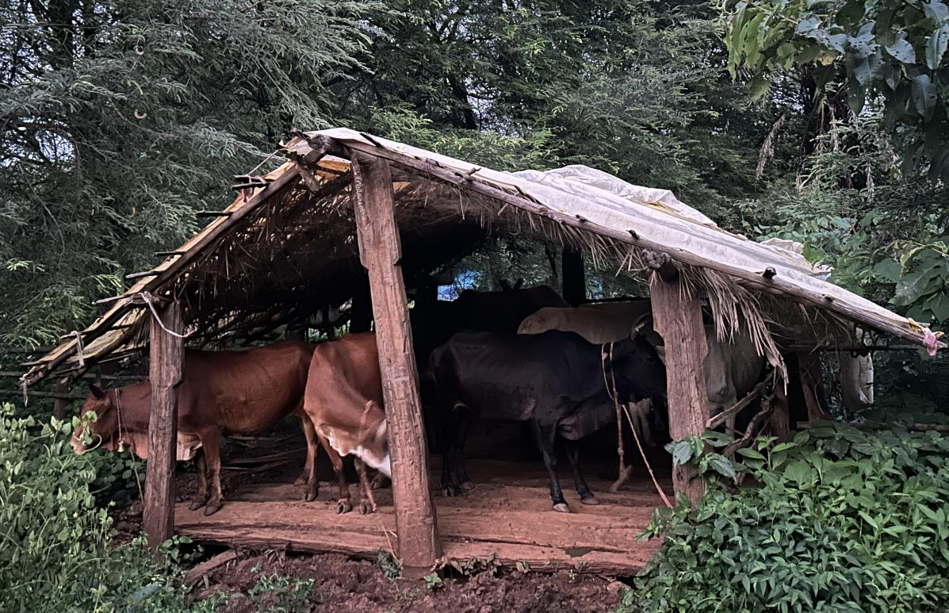

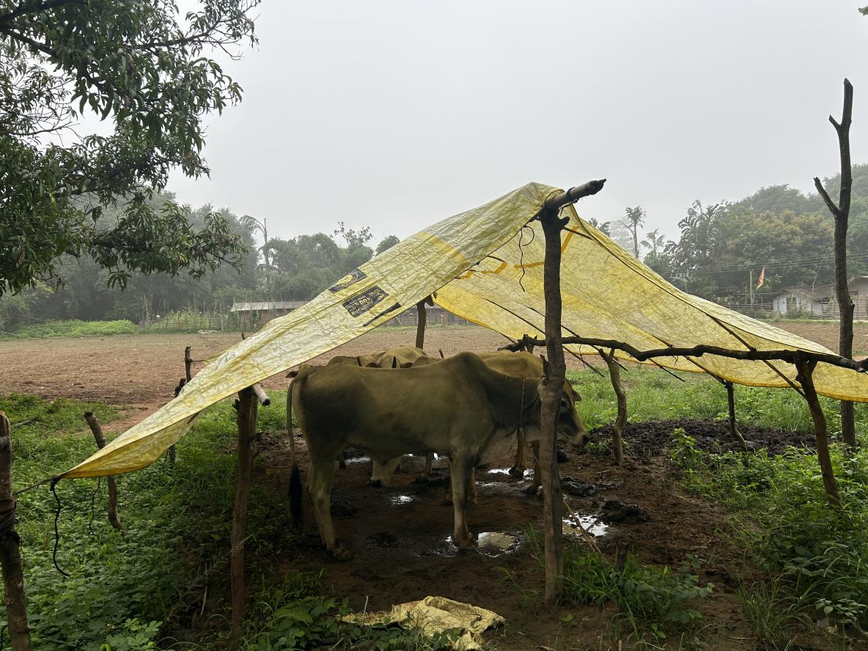
Fig.1. Cattle shed constructed with wooden floor and concrete sheet roof

Fig. 2. Cattle Shed: Roofing material – Tarpaulin sheet, Floor - Earthen floor

Conclusion
The study revealed that the local cattle farmers of the Bastar Plateau zone of Chhattisgarh following their traditional practices and low-input systems of cattle farming. Feeding practices largely depend on natural grazing and crop residues, with limited use of balanced rations. Housing structures are generally constructed from locally available materials and lack scientific design, affecting hygiene and animal comfort. Overall, the findings indicate a considerable gap between recommended scientific practices and their field-level adoption. Ther is an urgent need of strengthening the extension services and improving farmer training programs to increase awareness and adopt scientific cattle rearing practices for livelihood security of cattle farmers in the Bastar region.

Disclaimer (Artificial intelligence)
Author(s) hereby declares that Large Language Models and text to image generators like generative AI technologies have not been used during the preparation of this manuscript.

COMPETING INTERESTS DISCLAIMER:
Authors have declared that they have no known competing financial interests OR non-financial interests OR personal relationships that could have appeared to influence the work reported in this paper.

References
Ashokbabu, C., Saratchandra, A., Harikrishna, C. and Srinivas Reddy, M. (2024). Study on
housing management practices followed by dairy farmers in Northern Telangana State
of India. Asian Journal of Dairy and Food Research, 43(1), 162–166.
Barman, B., Mohammad, A., E., G. C., Kisku, U., Lepcha, C. Y. and Yadav, P. (2023).
Assessment of the existing feeding and housing management practices of dairy animals
in Rajbanshi dairy farmers. Indian Journal of Animal Production and Management,
38(1–2), 45–52.
Bharat, G., Soni, A., and Das, P. K. (2019). Livestock production constraints in tribal districts
of Chhattisgarh. Indian Journal of Extension Education, 55(1), 45–51.
Chhattisgarh Livestock Development Report (2021). Department of Veterinary Services,
Government of Chhattisgarh.
Deoras, R., Nema, R.K., Tiwari, S.P. and Singh, M. (2004). Feeding and housing management
practices of dairy animals in Rajnandgaon district of Chhattisgarh plain. Indian Journal
of Animal Sciences, 90(6), 882–886.
Department of Animal Husbandry and Dairying (2019). 20th Livestock Census – All India
Report. Ministry of Fisheries, Animal Husbandry and Dairying, Government of India,
New Delhi.
Kumar, A., Upadhyay, V. K. and Singh, V. P. (2020). Existing dairy husbandry practices
followed by livestock owners in Farrukhabad district of Uttar Pradesh, India. Indian
Journal of Animal Production and Management, 38(1–2), 33–40.
Manohar, D. S., Goswami, S. C. and Bais, B. (2014). Study on feeding management practices
of buffaloes in relation with selected traits of respondents in Jaipur district of Rajasthan,
India. Indian Journal of Animal Research, 48(2), 150–154.
https://doi.org/10.5958/j.0976-0555.48.2.032
Patel, N. B., Patel, J. B., Rao, T. K. S., Singh, R. R. and Modi, R. J. (2013). Housing
management practices of dairy animals in Patan district of North Gujarat region. Indian
Journal of Animal Production and Management, 43(2), 123–129.
Pilaniya, P., Desai, P. M. and Mordia, A. (2018). Existing housing management practices
followed by rural dairy animal owners in Sabar dairy milk shed of Gujarat, India. Indian
Journal of Animal Production and Management, 38(3–4), 175–181.
Prabex, S and Rahman, S. (2023). Socio-economic status and constraints faced by the
indigenous cattle farmers of Manipur. Indian Journal Animal Health (2023), 62(2):
364-370.https://doi.org/10.36062/ijah.2023.08323
Saurav, S. K., Chandran, V., Lepcha, C. Y., Chakravarty, R. and Ponnusamy, K. (2023).
Existing dairy management practices followed by cattle and buffalo owners of Northern
Bihar. Journal of Animal Research, 13(5), 839–846.
Singh, A.K., Upadhyay, P.K., Singh, D., Tewari, S., Kumar, V., Gupta, R. and Kumar, S.
(2024). Studies on different socio-economic profile of farmers and feeding
management practices of cattle in Hardoi district of Uttar Pradesh. International
Journal of Agricultural Extension and Social Development, 7(9S), 191–200.
Sinha, R. R. K., Dutt, T., Singh, R. R., Bhushan, B., Singh, M. and Kumar, S. (2009). Feeding
and housing management practices of dairy animals in Uttar Pradesh. Indian Journal
of Animal Sciences, 79(8), 829–833.
Sumer, E., Kalita, G., Goswami, R., Rahman, S., Ahmed, F. A., Chaudhary, J. K. and Pakyntein,
S. (2025). Housing and feeding management practices of crossbred dairy cattle in Khasi
and Jaintia Hill districts of Meghalaya. Indian Journal of Veterinary Sciences and
Animal Husbandry, 10(2S), 3687.
Verma, L. K., Gouri, M. D., Patil, V. M. and Guruprasad, R. (2017). Livelihood vulnerability
in tribal regions: A case study from South Chhattisgarh. Indian Journal of Social
Research, 58(3), 357–369.
Usha, S. and Mahesh, T. (2025). Housing and feeding management of Kangayam cattle in its
native breeding tract. International Journal of Veterinary Sciences and Animal
Husbandry, 10(5), 363–366.

.

