Original Research Article
IN-VITRO ANTICANCER ACTIVITY OF SILVER MEDIATED NANOPARTICLES OF TERMINALIA CHEBULA BARK IN HELA CANCER
CELL LINE

ABSTRACT
Sustainable production of nanoparticle employing extracts of plants is a simple, affordable, and ecologically friendly technique for generating nanoparticles. The key objective of microwave-assisted silver nanoparticle synthesis is to develop a new avenue for reducing the adverse effects of both physical as well as chemical processes. Brown coloration indicates the presence of AgNps mediated through Terminalia chebula bark extract. UV-VIS spectroscopy was employed to characterize the generated silver nanoparticles, and their corresponding peak intensity was obtained at 430 nm. FT-IR spectral studies revealed that the TC-AgNps were enriched with Phyto constituents. The silver weight percentage of 53.43% indicates the reduction of particles in nano size resulting from EDAX spectra. The silver nanoparticles synthesized have remarkable antibacterial properties against Staphylococcus aureus. Investigation has shown that Candida albicans possesses the highest antifungal zone of inhibition. Ag-mediated T.chebula bark has been administered to the HELA cancer cell line in different quantities, varying from 1µg/ml to 500µg/ml. As the concentration rises, cell viability also good assessing parameters that symbolize the number of living cell cancer in a population (IC₅₀) is 55.20.
Keywords: Terminalia chebula, silver nanoparticles, FTIR, Hela cancer cell line.

1.0 INTRODUCTION
Investigating, modifying, and designing matter, particles, and structures at the nanoscale is the focus of nanoscience. The range's atoms and molecules are one-millionth of a millimeter in dimension, where materials assess thermal, optical, electrical, and mechanical features. At the nanoscale, atoms and molecules build a massive structure¹. Metal nanoparticles (MNPs) can be synthesized using plant extracts. Key bioactive components derived via plants, notably alkaloids, phenols, flavonoids, proteins, and vitamins, serve as capping agents. These agents not only ensure the stability of the MNPs but also act as antioxidants with reducing properties, facilitating the reduction of metallic ions stepping into the appropriate nanoparticles ^{2,3}. Numerous studies have demonstrated the effective synthesis of noble metal nanoparticles (MNPs) like gold (Au), silver (Ag), platinum (Pt), and palladium (Pd) using natural resources such as plant seeds, peels, roots, and leaf extracts. These findings underscore the potential of noble MNPs as essential components in healthcare, manufacturing, and environmental sustainability, highlighting their revolutionary influence over a range of industries ^{5,6}. Cancer represents a critical challenge, marked by the uncontrolled proliferation of cells resulting from irreparable DNA damage and gene mutations that inhibit apoptotic signals. Various carcinomas, including those affecting the breast, ovaries, cervix, and lung, predominantly impact women, underscoring the urgent need for awareness, research, and effective treatment options ⁷. Human papillomavirus (HPV) is a dangerous infection that spreads through skin contact and is the primary cause of cervical cancer. To combat this serious health threat, it's crucial to address lifestyle factors such as inadequate physical movements and poor nutrition and unsafe sexual practices. By making healthier choices, we can considerably lower the chance of HPV and its associated health issues ⁸. Research suggests that AgNPs might inhibit cancer cell growth and viability in vivo and also in vitro. Plant-mediated silver nanoparticles are gaining popularity for good reason. They are cost-effective, environmentally friendly, highly efficient, and beneficial to human health. These advantages make them a great option in various applications ⁹. The richly colored, dried bark of Terminalia chebula, widely known as kuda bark, is a powerful remedy in traditional medicine. It effectively addresses a range of health concerns, including immune system disorders, infections, and skin conditions, making it a valuable asset for holistic healing⁹. Recent research highlights the considerable therapeutic potential of silver nanoparticles (AgNPs) synthesized using Terminalia chebula, which are also abundant in beneficial phytochemicals. These natural compounds not only enhance the efficacy of AgNPs but also suggest diverse applications in health and medicine^{11–14}. Experience the powerful benefits of bark extract from Terminalia chebula, a remarkable natural source rich in antioxidants, antibacterial properties, and phytochemicals for your health and wellness ¹⁵. The bark of Terminalia chebula has been ingeniously employed in the present study as both a capping and reducing agent in the fabrication of Ag nanoparticles. Notably, the therapeutic potential of these nanoparticles was rigorously evaluated for their antioxidant, antibacterial, and antifungal capabilities, along with their in vitro cytotoxic effects using the MTT assay on the HeLa cancer cell line. This innovative approach highlights the promising applications of TCB-Ag nanoparticles in medical treatments.
2.0 MATERIALS AND METHODS
2.1 Preparation of Terminalia chebula Bark Extract
The bark of Terminalia chebula offers significant potential for research and applications. After being carefully collected, the bark is dried in a shaded environment to preserve its beneficial properties. A fine powder is then produced from the dried bark, which serves as the foundation for further extraction. By using 100 ml of methanol as a solvent, we combine it with 10 g of the Terminalia chebula powder, enabling an efficient extraction process. This solution is incubated for five days to maximize the extraction of valuable compounds. The mixture is filtered through Whatman filter paper to collect the pure filtrate for in-depth examination. This meticulous approach ensures that we harness the full potential of Terminalia chebula for future studies and applications. Quantification of overall Phenolic Content was evaluated by utilizing modified Folin- Ciocalteu method in the Terminalia chebula bark extract.
2.2 Microwave Assisted Synthesis of TCB-AgNps
The 5 mM solution of 100 ml of AgNO₃ was taken and added with 1ml of T. chebula bark extract in a beaker. Then the added solution in the beaker was placed in microwave at 550W for 10minutes and after 10 minutes the solution changes from colorless to dark brown. This color change denotes the silver mediated nanoparticles of T. chebula bark extract.

2.3 Characterisation of TCB-AgNps
The UV-visible spectroscopy, FTIR, and EDAX, were utilized to analyze the characterisation of the synthesized TCB-Ag nanoparticles.
2.4 Potential Activity Determination
The antioxidant activity of TCB-AgNps was evaluated using the DPPH technique to assess its scavenging effect, along with its antimicrobial properties against selected pathogens. The disc diffusion approach was adopted to examine Staphylococcus aureus and Candida albicans.
2.5 MTT Cell Cytotoxicity Assay
2.5.1 Cell Culture
The NCCS in Pune provided the Hela (human cervical cancer) cell line. Cells were grown With DMEM (liquid media) along with 10% FBS (fetal bovine serum) and 100µg/ml penicillin and streptomycin, preserved at 37ºC in a condition having 5% Carbon di oxide.
2.5.2 MTT Test
Utilizing the MTT test procedure (3-(4,5-dimethylthiazol-2-yl)-2,5-diphenyl tetrazolium bromide) and Hela cells, we examined the cytotoxicity in vitro of TCB-AgNPs. Hela cells were trypsinized and collected in a tube. The cells of density of 1 × 10⁵ cells/ml (200 µL) were plated into a culture tissue plate. They were incubated for 24 to 48 hours at 37°C in DMEM media in addition with FBS (10%) and 1% antibiotic solution. After incubation, the substance was sterilized with FBS and administered in a serum-free medium containing DMEM with varying dosages. Every single sample were tested three times, and the cells endured another incubation phase for 24 hours at 37°C with 5% CO₂ in a moistened environment. Following the isolation period, MTT (20 µL of 5 mg/ml) were dropped into every cell and it was incubated for the following two to four hours using an inverted magnifying glass until the existence of purple precipitates was evident. Ultimately, the medium and MTT (220 µL) were sucked into wells were cleaned using 200 µL of 1X PBS. Additionally, DMSO of 100 microliters was included to dissolve the formazan crystals, and the plate was agitated for five minutes. Each well's absorbance was determined around 570 nm by microplate reader employing the Graph Pad Prism 6.0 program to evaluate the cell viability %. and IC50 value.
3.0 RESULTS AND DISCUSSION
3.1 Determination of Total Phenolics
Using modified Folin-Ciocalteu method total phenol contents in the Terminalia chebula bark were determined. A 1 ml aliquot of the Terminalia chebula bark extract (E) was mixed with 5 ml Folin-Ciocalteu reagent (previously diluted with water at 1:10 v/v) and 4 ml (75 g/l) of sodium carbonate. For the color development the tubes were vortexed for 15 seconds, and permit standing for 30miutes at 40ºC. Absorbance was then measured at 765 nm using the Hewlett Packard UV-VS spectrophotometer. Samples of Terminalia chebula bark extracts were evaluated at 0.1 mg/ml concentration as shown in figure 1. Overall phenolic content estimated as 148 mg/g tannic acid equivalent.
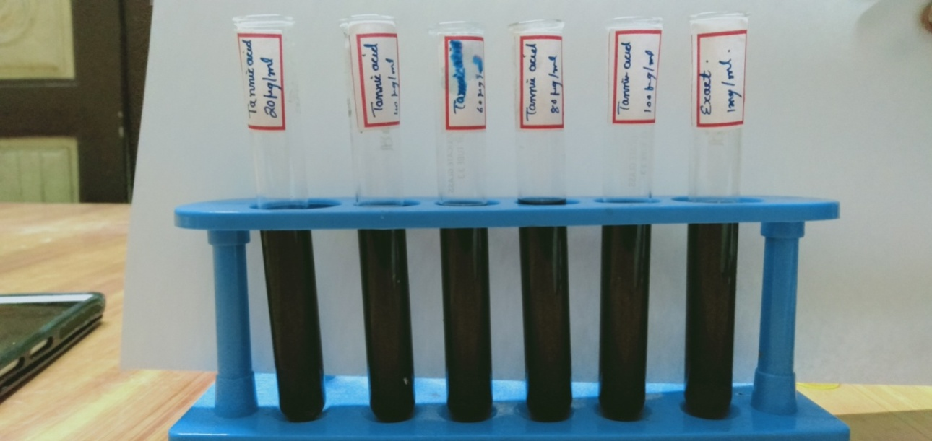
Fig. 1: Standard calibration curve for standard tannic acid and T. chebula bark extract
3.2 Visual Observation of TCB-AgNps
5mM AgNO₃ solution was added to 1ml of Terminalia chebula bark extract in a beaker and kept in microwave at 550W for 10minutes. This color changes denoted in the figure 2 A and B, from pale color to brown indicates the appearance of Ag mediated nanoparticles of T. chebula bark extract (TCB-AgNps).
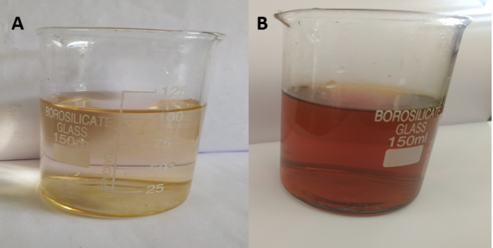
Fig. 2: Visual observation of formation of TCB-AgNps
3.3 UV-Visible spectrum of Silver Mediated Nanoparticle of T. chebula Bark Extract
The graph given in Fig. 3 indicates the absorption band peaks at 430nm respectively which proves the formation of TCB-AgNps in the solution turns reddish brown color.
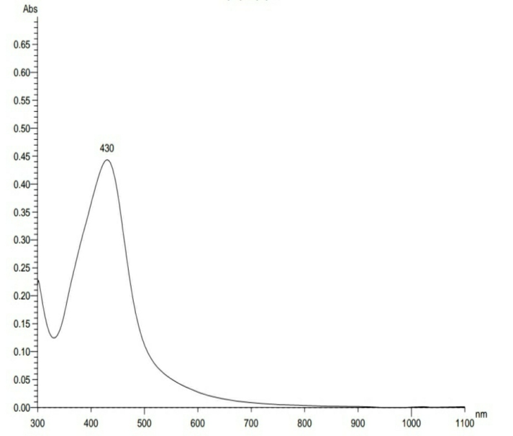
Fig. 3: UV-Visible spectrum of silver mediated nanoparticle of T. chebula bark extract
3.4 FTIR Analysis
Figure 4 shows the spectrum of FTIR of Terminalia chebula bark extract (A) and (B) indicates the spectrum of FTIR of TCB-AgNps. In the FTIR spectrum of bark extract shows some peaks, which were vanished in the FTIR spectra of synthesized silver nanoparticle. The removal of peaks caused by the presence of phytochemicals in the bark extract and involves a reduction of silver nanoparticle as displaced in Table 1.
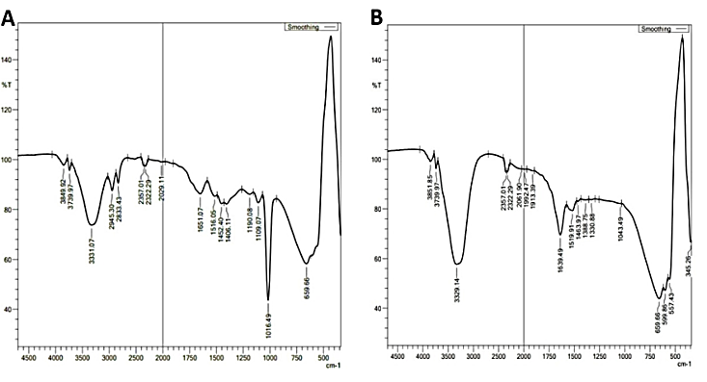
Fig. 4: FT-IR spectrum of T. chebula bark extract (A) and silver mediated nanoparticles of T. chebula bark extract (B)
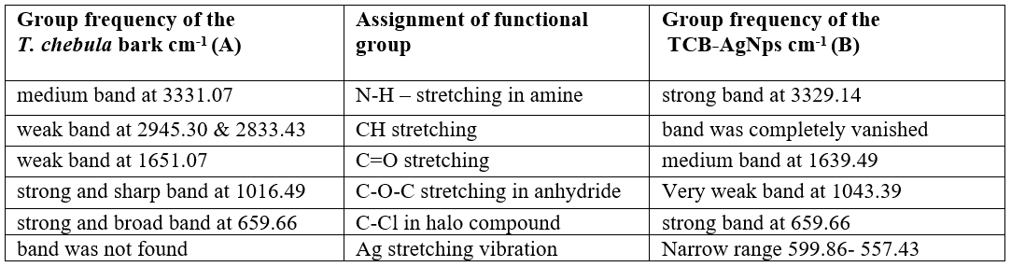
Table 1. FT-IR spectra of bark and silver mediated nanoparticles of T. chebula bark extract

3.5 Energy Dispersive X-ray Analysis of TCB-AgNps
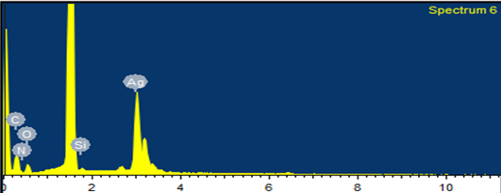
Fig. 5: EDAX spectrum of silver mediated nanoparticles of T. chebula bark
The elemental signal of silver mediated nanoparticles of T. chebula was verified by EDAX. A graph (figure 5) shows the no. of X-ray counts in the Y-axis and energy in KeV in the X-axis. The silver nanoparticles recorded by using EDAX spectrum. The silver weight percentage as 53.43% indicates the reduction of AgNps from the EDAX spectra (Table 2).

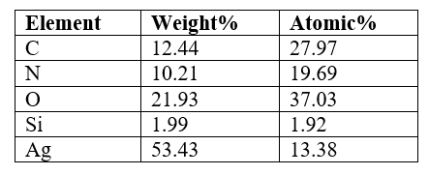
Table 2. Elemental composition of TCB-AgNps
3.6 Antibacterial Activity of TCB-AgNps
The result of the TCB-AgNps antibacterial activity was tested again pathogens by disk diffusion approach were represented in table 3. The extract showed growth inhibitor activity against Staphylococcus aureus(3mm) at concentration 100µg/ml the extracts show the antibacterial activity . The concentration from 20-100 µg/ml was varying to read the activity of antibacteria.
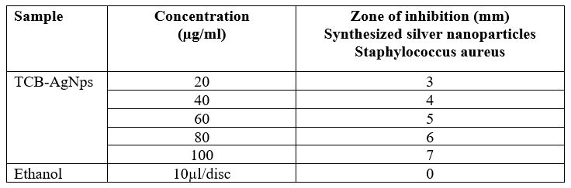
Table 3. Antibacterial activity of TCB-AgNps

3.7 Antifungal Activity
The table 4 shows the antifungal capability test of TCB-AgNps against the Candida albicans. The growth inhibitor activity against Candida albicans (3mm) at concentration 100µg/ml. The extract shows the higher activity in Candida albicans. The concentration from 20-100 µg/ml was varying to read the antifungal activity.
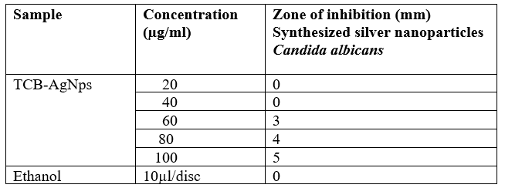
Table 4. Antifungal activity of TCB-AgNps

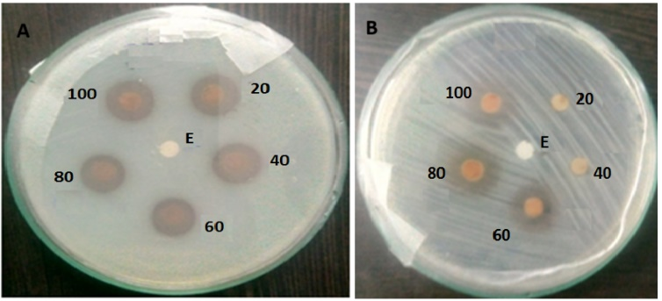
Fig. 6: Antibacterial activity of TCB-AgNps on Staphylococcus aureus (A) and Antifungal activity of TCB-AgNps on Candida albicans (B)
3.8 Antioxidant Activity of TCB-AgNps
The methanolic solution of DPPH were mixed to the 40µl of TCB-AgNps different concentration (20-100µg/ml). The DPPH solution (freshly prepared) was kept in the dark at 4ºC. 96% ethanol was added and shaken vigorous. After 5 min, measured spectrophotometrically at 517nm. The same amount of ethanol and DPPH were containing blank sample prepare. Each value was obtained by calculating the average of three experiments and data are presented as mean± SEM
(%) inhibition of DPPH activity = ((A-B)/A) x100
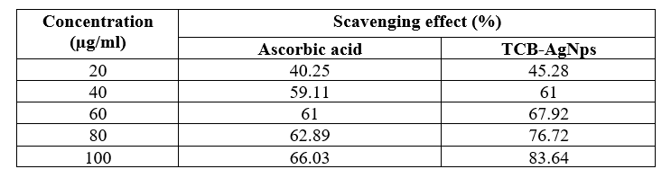
Table 5. Antioxidant activity of TCB-AgNps by DPPH activity

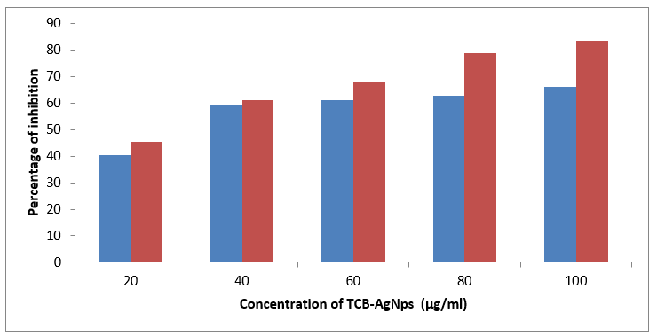
Fig. 7: Graphical representation of DPPH activity of TCB-AgNps
3.9 Anticancer Activity
In vitro cylotoxictiy, using Hela cells by 3-(4,5-dimethylthiazol-2-yl)-2,5-diphenyltetrazolium bromide (MTT) assay:
At 1μg/mL- 500μg/mL concentration of Ag mediated T. chebula bark shows the viability values which decreased from 99.47% to 46.88%. The cells showed reduction in viability with an increase in extract concentration.
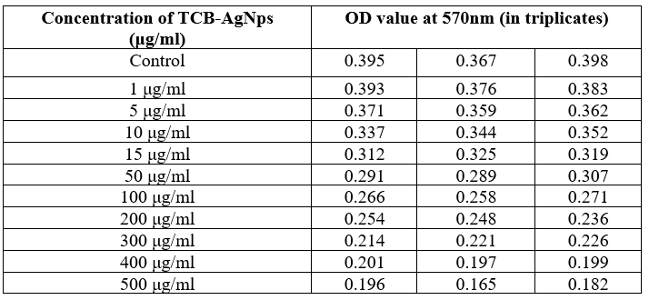
Table:6 Microplate reader values of Hela cells with TCB-AgNps at 570 nm

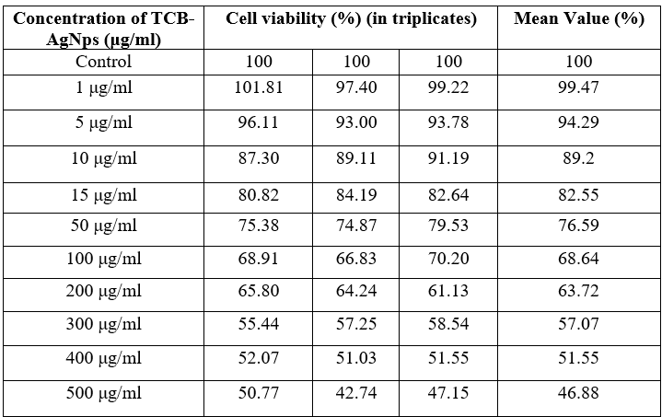
Table 7. Cell Viability of Hela cells with TCB-AgNps

Fig. 8: Cell Viability graphical representation of Hela cells with TCB-AgNps
The MTT assay is used to measure cellular metabolic activity as an indicator of cell viability, proliferation and cytotoxicity. The cytotoxic activity and % of cell viability of Ag mediated T. chebula bark against HELA cancer cell line was clearly evaluated with MTT test. The cells were exposed with varying concentrations of different Ag mediated T. chebula bark from 1µg/ml to 500µg/ml. As the concentration increases cell viability also good measuring factors that reflect the number of living cells cancer in a population. IC₅₀ is 55.20, a indicator of a substance’s in inhibiting a specific biochemical function. Cell lines' morphological changes with exposure with Ag mediated T. chebula bark were noted during the phase contrast microscope in the dose dependent manner shown in figure 9.
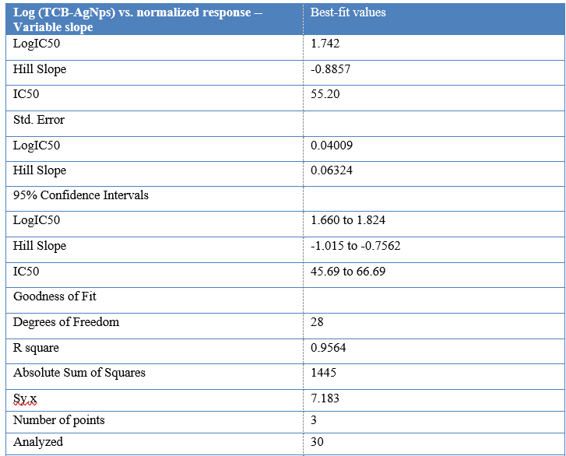
Table 8. IC₅₀ Value of TCB-AgNps

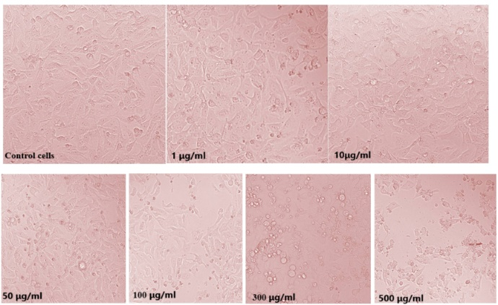
Fig. 9: Images of control cells and treated cells of Hela cancer cell line using TCB_AgNps
4.0 CONCLUSION
Herbal plants contain valuable bioactive secondary metabolites to treat various diseases and disorders. These herbs are readily available and cost effective than other sources. The present works reveal that the occurrence of brown color shown a presence of silver nanoparticles mediated Terminalia chebula bark extract. The silver nanoparticles synthesized were characterized using UV-VIS spectroscopy and the corresponding peak intensity obtained at 430nm. FT-IR spectral studies revealed that the functional groups present in T. chebula bark extract. The silver weight percentage as 53.43% indicates the reduction of silver nanoparticles from the EDAX spectra. The total phenolic content in a bark extract is 148mg/g. The scavenging activity reveals the good antioxidant activity. The extract showed growth inhibitor activity against Staphylococcus aureus(3mm) at concentration 100µg/ml the extracts shows the higher activity in Staphylococcus aureus. The growth inhibitor activity against Candida albicans(3mm) at concentration 100µg/ml the extracts shows the higher activity in Candida albicans. The cells were exposed with varying concentrations of different Ag mediated T. chebula bark from 1µg/ml to 500µg/ml. As the concentration increases cell viability also good measuring factors that reflect the number of living cells cancer in a population. IC₅₀ is 55.20, an indicator for the efficacy of a substance in inhibiting a specific biochemical function.

REFERENCES
1. http://www.emm-nano.org/what-is-nanoscience-nanotechnology/
2. Kapoor, A., Shankar, P. and Ali W., Green synthesis of metal nanoparticles for electronic textiles, Green Nanomater., 81–97 (2020).
3. Verma, A., Gautam, S.P., Bansal, K.K., Prabhakar, N. and Rosenholm J.M., Green nanotechnology: advancement in phytoformulation research, Medicines 6(1), 39 (2019).
4. Ahmed, S., Ahmad, M., Swami, B.L. and Ikram S., A review on plants extract mediated synthesis of silver nanoparticles for antimicrobial applications: a green expertise, J. Adv. Res., 7(1), 17–28 (2016).
5. Al-Radadi, N.S. and Adam S.I.Y., Green biosynthesis of Pt-nanoparticles from Anbara fruits: Toxic and protective effects on CCl4 induced hepatotoxicity in Wister rats, Arab. J. Chem., 13(2), 4386–4403 (2020).
6. Al-Radadi, N.S., Artichoke (Cynara scolymus L.), mediated rapid analysis of silver nanoparticles and their utilisation on the cancer cell treatments, J. Comput. Theor. Nanosci., 15(6–7), 1818–1829 (2018).
7. Maître, J.L. et al., Three functions of cadherins in cell adhesion, Curr. Biol., (2013).
8. Krushnam G.S., et al., In vivo and molecular docking studies using whole extract and phyto compounds of Aegle marmelos fruit protective effects against isoproterenol-induced myocardial infarction in rats, Biomed. Pharmacother. (2017).
9. Zulfiqar, Z., Mahmood Khan, R.R., Summer, M., Saeed, Z., Pervaiz, M., Rasheed, S., Shehzad, B., Kabir, F. and Ishaq, S., Plant-mediated green synthesis of silver nanoparticles: Synthesis, characterization, biological applications, and toxicological considerations: A review, Biocatal. Agric. Biotechnol., 57 (2024), 103121, ISSN 1878-8181, https://doi.org/10.1016/j.bcab.2024.103121.
10. Sultan, M.T., Anwar, M.J., Imran, M., Khalil, I., Saeed, F., Neelum, S. and Al Jbawi, E., Phytochemical profile and pro-healthy properties of Terminalia chebula: A comprehensive review. Int. J. Food Propert., 26(1), 526–551 (2023). https://doi.org/10.1080/10942912.2023.2166951.
11. Jebakumar Immanuel Edison and T., Sethuraman, M.G., Instant green synthesis of silver nanoparticles using Terminalia chebula fruit extract and evaluation of their catalytic activity on reduction of methylene blue. Process. Biochem. 47(9), 1351–1357 (2012).
12. Espenti, C.S., Krishna Rao, K.S.V. and Madhusudana Rao, K., Bio-synthesis and characterization of silver nanoparticles using Terminalia chebula leaf extract and evaluation of its antimicrobial potential, Mater. Lett. 174, 129–133 (2016).
13. Nandagopala, S., Ganesh Kumar, Dhanalakshmi, D.P. and Prakash, P., Bioprospecting the antibacterial and anticancer activities of silver nanoparticles synthesized using terminalia chebula seed extract, Int. J. Pharm. Pharm. Sci., 6(2), 368–373 (2014).
14. Kumar, K.M., Sinha, M., Mandal, B.K., Ghosh, A.R., Kumar, K.S., Reddy, P.S., Green synthesis of silver nanoparticles using Terminalia chebula extract at room temperature and their antimicrobial studies, Spectrochim. Acta Part A Mol. Biol. Mol. Spectrosc., 91, 228–233 (2012).
15. Fajila K., Preethi A.S., Anusuya R., Gayathri K. and Annadurai, S., In-vitro anti-cancer potential of whole plant of Lantana camara extract using Hela cells line, Int. J. Adv. Res., 11, 597–605 (2023) (ISSN 2320-5407).

