Review Article

Sensor-Based Technologies for Real-Time Monitoring and Precision Targeting of Insect Pests
Abstract:
Insect pests pose significant threats to agricultural production, causing substantial yield losses and economic damage worldwide. Conventional insect monitoring methods, such as manual scouting and trap-based sampling, are labor-intensive, time-consuming and often fail to provide timely and actionable information for effective pest management. Recent advancements in sensor technologies have paved the way for real-time, in-situ monitoring of insect pests, enabling precision targeting and site-specific control interventions. This review article explores the various types of sensors, including acoustic, optical and chemical sensors and their applications in detecting, identifying and quantifying insect pests. We discuss the design and implementation of wireless sensor networks for scalable and robust insect monitoring, along with data analytics approaches for automated pest detection and spatio-temporal modeling of pest population dynamics. Furthermore, we highlight the integration of sensor data into precision pest management systems, such as sensor-guided pesticide application technologies and intelligent pest control strategies. Real-world case studies demonstrating the efficacy of sensor-based pest management in diverse agricultural settings are presented.
Keywords: Insect Pests, Sensor Technologies, Real-Time Monitoring, Precision Pest Management, Wireless Sensor Networks
1. Introduction
1.1. The Need for Advanced Insect Pest Monitoring Solutions
Insect pests pose a significant threat to global agricultural production, causing substantial crop damage and yield losses. It is estimated that insect pests are responsible for 10-20% of total crop losses worldwide, amounting to billions of dollars in economic damage annually (Ejaz et al., 2025; Mansoor et al., 2025). Early detection and timely intervention are key factors in successful pest management. Identifying the presence and population dynamics of insect pests at the early stages of infestation allows farmers to take proactive measures, such as targeted pesticide applications or the deployment of biological control agents. However, current monitoring methods often fall short in providing the necessary temporal and spatial resolution required for effective decision-making. Manual scouting, which involves physically inspecting crops for signs of pest damage or presence, is labor-intensive, time-consuming and prone to human error. Trap-based sampling, another commonly used method, provides snapshots of pest populations at specific locations and times but fails to capture the dynamic nature of pest infestations across the entire field (Ray et al., 2025; Yin et al., 2025).
Furthermore, the limitations of traditional monitoring approaches hinder the implementation of precision agriculture practices. Precision agriculture aims to optimize crop management by tailoring inputs and interventions based on site-specific information. However, the lack of real-time, high-resolution data on pest populations hinders the ability to make informed decisions and apply targeted control measures (Molina-Rotger et al., 2023; Ray et al., 2025).
1.2. Drawbacks of Conventional Monitoring Approaches
Manual scouting is a labor-intensive process that requires trained personnel to physically inspect crops for signs of pest damage or presence. This method is time-consuming, especially in large-scale agricultural operations and may not provide a comprehensive assessment of pest populations across the entire field. Additionally, the accuracy of manual scouting is subject to human error and can vary depending on the expertise and experience of the scou t (Kiobia et al., 2023; Majdalawieh et al., 2025).
1.3. The Promise of Sensor-Based Technologies
Sensor-based technologies have emerged as a promising solution to address the limitations of conventional insect pest monitoring approaches. These technologies leverage advancements in sensors, wireless communication and data analytics to enable real-time, continuous monitoring of insect pests in agricultural settings (Rustia & Lin, 2023). This real-time data enables farmers to make informed decisions and respond promptly to pest outbreaks, minimizing the potential for crop damage and yield losses (Ray et al., 2025). Precision targeting not only improves the efficacy of pest control measures but also reduces the environmental impact by minimizing the use of broad-spectrum pesticides (Li et al., 2025). Integration of sensor data with other relevant information, such as weather data and crop growth models, can further enhance the accuracy and reliability of pest management recommendations (Ray et al., 2025).

2. Sensor Types and Their Applications in Insect Monitoring
The development of sensor technologies has opened up new possibilities for real-time, non-invasive monitoring of insect pests in agricultural systems. Various types of sensors, each with their unique capabilities and applications, have been explored for detecting, identifying and quantifying insect pests (Lima et al., 2020; Mansoor et al., 2025).

2.1. Acoustic Sensors:

Detecting Insect Sounds and Vibrations
By analyzing the spectral and temporal characteristics of these signals, researchers can identify and differentiate between different insect species and even estimate their population density (Symes et al., 2022). Similarly, acoustic sensors have been used to monitor stored product pests, such as the rice weevil and the red flour beetle, in grain storage facilities. By detecting the feeding and movement sounds of these pests, farmers can assess the level of infestation and make informed decisions regarding fumigation or other control strategies (Balingbing et al., 2024).

2.2. Optical Sensors:

Vision-Based Insect Recognition and Counting
Optical sensors, including cameras and imaging devices, have been widely explored for vision-based insect recognition and counting. These sensors capture high-resolution images or videos of insects, which are then processed using computer vision algorithms for automated pest identification and quantification. Optical sensors can operate in various wavelength ranges, including visible light, near-infrared and multispectral imaging, each offering unique advantages for insect detection (Kirkeby et al., 2021).
One common application of optical sensors is in the monitoring of greenhouse pests, such as whiteflies, thrips and aphids. These pests can cause significant damage to greenhouse crops and are often difficult to detect due to their small size and cryptic behavior. High-resolution cameras mounted on robotic systems or fixed structures can capture images of plants and detect the presence of pests based on their visual features, such as shape, size and color. Machine learning algorithms trained on large datasets of pest images can automatically classify and count the detected insects, providing real-time information on pest population dynamics (Venkateswara & Padmanabhan, 2025). Computer vision algorithms can analyze the captured images to identify and quantify pest damage, such as leaf defoliation or stem boring, providing valuable information for targeted pest management decisions (Khan et al., 2024).

2.3. Chemical Sensors:

Detecting Insect Pheromones and Volatiles
Chemical sensors, including gas sensors and electronic noses, have been explored for detecting insect pests based on their chemical signatures, such as pheromones and volatiles. Pheromones are chemical substances released by insects for communication and attraction, while volatiles are organic compounds emitted by plants in response to insect feeding or stress. By detecting these chemical cues, chemical sensors can provide valuable information on pest presence, activity and population dynamics (Arce et al., 2024). By monitoring the changes in pheromone or volatile concentrations over time, farmers can assess the level of pest infestation and make informed decisions regarding mating disruption or other control strategies (Arce et al., 2024). By installing chemical sensors in grain storage facilities, farmers can continuously monitor the air quality and detect the presence of pest-specific volatiles, enabling early detection of infestations and timely implementation of control measures (Badgujar et al., 2025).

2.4. Comparative Analysis of Sensor Performance and Suitability
When selecting sensors for insect pest monitoring, it is essential to consider their performance characteristics and suitability for specific applications. Each sensor type has its strengths and limitations and the choice of sensor depends on factors such as the target insect species, the crop system, the environmental conditions and the desired level of accuracy and resolution (Soussi et al., 2024).
Acoustic sensors offer high specificity in detecting and identifying insect pests based on their unique sound signatures. They are particularly suitable for monitoring wood-boring insects and stored product pests, where the sound of feeding and movement can be clearly distinguished from background noise (Mansoor et al., 2025; Soussi et al., 2024). However, acoustic sensors may have limited detection range and can be affected by environmental factors such as wind and rain (Mansoor et al., 2025). However, optical sensors may face challenges in detecting small or cryptic pests and can be affected by lighting conditions and occlusions (Kirkeby et al., 2021; Zhu et al., 2022).
Table 1: Comparative analysis of sensor technologies for insect pest monitoring
Sensor Type | Strengths | Limitations | Suitable Applications
Acoustic | High specificity, non-invasive | Limited detection range, affected by environmental noise | Wood-boring insects, stored product pests
Optical | High spatial resolution, automated counting | Limited detection of small or cryptic pests, affected by lighting conditions | Greenhouse pests, field crop pests, stored grain pests
Chemical | High sensitivity, early warning | Limited specificity, affected by environmental factors | Orchard pests, stored product pests, insect-borne diseases

3. Wireless Sensor Networks

Enabling Real-Time, In-Situ Monitoring
Wireless sensor networks (WSNs) have emerged as a powerful tool for real-time, in-situ monitoring of insect pests in agricultural systems (Potamitis et al., 2017; Rustia & Lin, 2023).

3.1. Designing Scalable and Robust Wireless Sensor Network Architectures
. Mesh topologies, on the other hand, allow sensor nodes to communicate with each other, enabling multi-hop data transmission and increased network coverage. Hybrid architectures combine the benefits of star and mesh topologies, providing a balance between simplicity and scalability (Centelles et al., 2021; Lv et al., 2024).
In addition to network topology, the selection of wireless communication protocols is crucial for reliable data transmission in challenging agricultural environments. Low-power wide-area network (LPWAN) technologies, such as LoRaWAN and SigFox, have gained popularity for their long-range communication capabilities and energy efficiency. These protocols enable sensor nodes to transmit data over distances of several kilometers, making them suitable for large-scale agricultural deployments. Other wireless technologies, such as ZigBee and Bluetooth Low Energy (BLE), offer short-range communication options for dense sensor networks and local data collection (Kumar, 2024; Mesías-Ruiz et al., 2023).

3.2. Optimizing Data Collection, Transmission and Storage Strategies
Efficient data collection, transmission and storage strategies are crucial for maximizing the utility of WSNs in insect pest monitoring (Yehoshua & Edan, 2023). These platforms offer scalable storage solutions, real-time data processing capabilities and advanced analytics tools for extracting insights from the collected data(Siddiqui, 2024). Cloud-based systems enable remote access to the monitoring data, facilitating timely decision-making and intervention by farmers and pest management experts.

3.3. Addressing Energy Efficiency and Network Lifetime Challenges
Energy efficiency is a critical consideration in the design and deployment of WSNs for insect pest monitoring. Sensor nodes are typically battery-powered and frequent battery replacements can be impractical and costly in large-scale agricultural deployments(Soussi et al., 2024; Taha et al., 2025). One approach to energy efficiency is the implementation of low-power communication protocols and duty cycling techniques. Sensor nodes can be programmed to enter sleep modes during periods of inactivity, reducing their power consumption. Duty cycling allows nodes to alternate between active and sleep states, enabling longer battery life while still maintaining adequate monitoring coverage (Soua & Minet, 2011). Solar energy harvesting has been widely explored for powering sensor nodes in outdoor agricultural environments, while thermal and vibration energy harvesting can be suitable for specific applications, such as monitoring stored grain or livestock facilities (Pandey, 2023).
Multi-hop routing protocols, such as low-energy adaptive clustering hierarchy (LEACH) and its variants, can be employed to distribute energy consumption across the network and minimize the energy burden on individual nodes(Abdolabadi, 2024; Elmonser et al., 2024). Adaptive network management techniques, such as dynamic node scheduling and load balancing, can further optimize resource utilization and prolong network lifetime.
4. Advances in Data Analytics for Insect Pest Detection and Quantification
The proliferation of sensor-based technologies for insect pest monitoring has led to the generation of vast amounts of data, presenting both opportunities and challenges for effective pest management. Advanced data analytics techniques, including machine learning and deep learning algorithms, have emerged as powerful tools for extracting actionable insights from the collected data. This section explores the recent advances in data analytics for automated insect pest detection, species classification and spatio-temporal modeling of pest population dynamics(Choi et al., 2023).

4.1. Machine Learning Algorithms for Automated Pest Identification
Machine learning algorithms have revolutionized the field of insect pest detection by enabling automated identification of pest species based on various data modalities, such as images, acoustic signals and chemical signatures. Supervised learning techniques, such as support vector machines (SVM), decision trees and random forests, have been widely applied for pest classification tasks. These algorithms learn from labeled training data, where each data instance is associated with a known pest species and build predictive models that can classify new, unseen data instances(Thenmozhi & Reddy, 2019). Domain expertise and knowledge of insect biology and behavior are often incorporated into the feature selection process to enhance the discriminatory power of the models(Fazzari et al., 2023).

4.2. Deep Learning Approaches for Species Classification and Counting
Deep learning, a subset of machine learning, has emerged as a powerful approach for insect pest classification and counting tasks. Deep learning algorithms, such as convolutional neural networks (CNNs) and recurrent neural networks (RNNs), have the ability to automatically learn hierarchical features from raw data, eliminating the need for manual feature engineering(Thenmozhi & Reddy, 2019). CNNs have been particularly successful in image-based pest classification, where they can learn discriminative visual features directly from pest images. Convolutional layers apply learned filters to the input image, capturing local patterns and features at different scales. Pooling layers reduce the spatial dimensions of the feature maps, providing translation invariance and reducing computational complexity(Hsieh et al., 2024). Transfer learning techniques, such as fine-tuning pre-trained CNN models, have been employed to leverage the knowledge learned from large-scale datasets in other domains (e.g., ImageNet) and adapt it to the specific task of pest classification (Shoaib et al., 2023). Data augmentation techniques, such as image rotation, scaling and flipping, are commonly used to increase the diversity of the training data and improve the robustness of the models.

4.3. Spatio-Temporal Modeling of Pest Population Dynamics and Dispersal Patterns
These methods consider the spatial autocorrelation and variability of pest populations, enabling the generation of high-resolution pest density maps(Sciarretta & Trematerra, 2014). Machine learning algorithms, such as support vector regression (SVR) and random forest regression, have also been applied to predict pest population dynamics, leveraging the complex interactions between pest populations and environmental factors(Singh et al., 2024). Machine learning techniques, such as Bayesian networks and artificial neural networks, have been employed to parameterize and calibrate dispersal models, improving their predictive accuracy (Mongare et al., 2023).

5. Precision Pest Management:

Integrating Sensor Data into Decision Support Systems
The integration of sensor-based monitoring data with decision support systems has paved the way for precision pest management approaches. Precision pest management involves the targeted application of control measures based on site-specific information, optimizing the use of resources while minimizing environmental impacts (Sharma & Shivandu, 2024).

5.1. Sensor-Guided, Site-Specific Pesticide Application Technologies
Precision spraying systems integrate sensor data with variable rate application technologies to deliver pesticides at the right place and the right time. These systems utilize GPS-enabled sprayers equipped with nozzle controllers that can adjust the application rate based on the real-time pest density information provided by the sensor network. The sprayers can also incorporate data on crop growth stage, weather conditions and other relevant factors to optimize the application parameters (Azghadi et al., 2025).

5.2. Automated Variable Rate Spraying and Intelligent Pest Control Strategies
Intelligent pest control strategies involve the use of machine learning algorithms to optimize the selection and timing of pesticide applications (Rayalu & Anuradha, 2024).. These algorithms can learn from historical data on pest population dynamics, weather patterns and the efficacy of different control measures to predict the optimal intervention strategies (Ray et al., 2025). Furthermore, the integration of weather data and crop growth models into the decision-making process can help farmers optimize the timing of pesticide applications to maximize their effectiveness and minimize drift and runoff (Olatinwo & Hoogenboom, 2013).
Sensor networks can provide real-time information on pest population dynamics and the spatial distribution of infestations (Adewusi et al., 2024). This information can be used to guide the timing and location of natural enemy releases, ensuring that the biological control agents are deployed when and where they are most needed. For example, sensors can detect the early stages of pest infestations, triggering the release of parasitoids or predators to prevent the buildup of pest populations (Mansoor et al., 2025; Subeesh & Mehta, 2021).

6. Real-World Implementations and Case Studies
The successful implementation of sensor-based technologies for insect pest monitoring has been demonstrated through various real-world applications and case studies. These examples showcase the practical feasibility, effectiveness and benefits of deploying sensor networks and precision pest management strategies in diverse agricultural settings (Bregaglio et al., 2025). This section presents three representative case studies, focusing on smart orchard pest management, sensor-based greenhouse whitefly detection and intelligent stored grain monitoring systems (Yuan et al., 2025).

6.1. Smart Orchard Pest Management:

Integrating Sensor Networks and Precision Spraying
A notable example of smart orchard pest management is the deployment of a wireless sensor network for real-time monitoring of codling moth populations in apple orchards. The sensor network consists of a grid of pheromone-baited traps equipped with optical sensors that detect the presence and number of adult moths (Sütő, 2022). The sprayers can adjust the application rate and droplet size to optimize coverage and minimize drift, reducing the overall pesticide use while maintaining effective pest control (Cubero et al., 2018).

6.2. Sensor-Based Greenhouse

Whitefly Detection and Suppression Strategies
Greenhouse production systems provide ideal conditions for the rapid growth and spread of insect pests, such as whiteflies, thrips and aphids. Among these pests, whiteflies are particularly challenging to control due to their high reproductive potential, resistance to insecticides and ability to transmit plant viruses (Niemann & Poehling, 2022). Sensor-based monitoring technologies have shown promise in detecting and suppressing whitefly infestations in greenhouses. The images are analyzed using computer vision algorithms to detect the presence and density of whitefly adults, nymphs and eggs (Kang et al., 2024). This integrated approach has significantly reduced the reliance on chemical insecticides, demonstrating enhanced whitefly suppression and improved crop health within controlled environments (Youssef, 2023).

6.3. Intelligent Stored Grain Monitoring Systems for Early Insect Infestation Detection
Early detection of insect infestations is critical for preventing the spread of damage and minimizing the need for fumigation treatments. Intelligent stored grain monitoring systems, integrating sensor technologies and data analytics, have emerged as powerful tools for proactive pest management in grain storage facilities (Labrot--Rhodes et al., 2025). The gas sensors detect the volatile organic compounds (VOCs) emitted by infested grain, providing an additional indicator of pest activity (Zhu et al., 2022). The real-time analysis of sensor data enables the early detection of insect activity, often before visual signs of infestation are apparent (Mansoor et al., 2025). The precise targeting of control measures based on the spatial distribution of infestations helps to minimize the use of pesticides and reduce the risk of resistance development in pest populations(Basavakiran et al., 2025). The platform integrates the sensor data with other relevant information, such as weather forecasts, crop phenology models and historical pest data, to generate actionable insights for pest management decisions(Balduque-Gil et al., 2023).

7. Emerging Trends and Future Research Directions
Nanoscale sensors and flexible electronics, energy harvesting technologies for self-powered sensor nodes and autonomous unmanned aerial vehicles for large-scale insect pest surveillance(Potamitis et al., 2017).

7.1. Nanoscale Sensors and Flexible Electronics for Enhanced Insect Monitoring
Nanoscale sensors can detect minute concentrations of insect pheromones, volatile organic compounds and other biomarkers, enabling the early detection of pest infestations and the monitoring of insect behavior at unprecedented levels of detail (Bohbot & Vernick, 2020). For example, the functionalization of carbon nanotubes with insect pheromone receptors has been explored for the creation of highly specific and sensitive pheromone sensors (Ferrier & Honeychurch, 2021).

7.2. Energy Harvesting Technologies for Self-Powered, Long-Lasting Sensor Nodes
Energy harvesting technologies, such as solar, thermal and piezoelectric energy harvesting, offer the potential to overcome these limitations by converting ambient energy sources into electrical energy to power the sensor nodes (Mahadasa et al., 2019). In agricultural settings, temperature differences between the soil, plants and air can be exploited for thermal energy harvesting (Yin et al., 2021). The movement of insects or the vibrations induced by wind or machinery can be harnessed to generate electrical energy (Petrauskas et al., 2023).

7.3. Autonomous Unmanned Aerial Vehicles for Large-Scale Insect Pest Surveillance
Autonomous unmanned aerial vehicles (UAVs), commonly known as drones, are emerging as powerful platforms for large-scale insect pest surveillance. UAVs equipped with high-resolution cameras, multispectral sensors and insect traps can cover vast areas of agricultural land quickly and efficiently, providing detailed spatial and temporal data on pest population dynamics and crop health (Potamitis et al., 2017). UAVs can also be used to deploy and retrieve pheromone traps in remote locations, providing a cost-effective means of sampling insect populations over large areas (Fahrentrapp et al., 2020).
The development of nanoscale sensors for insect pheromone detection represents a promising avenue for enhancing the performance and capabilities of insect pest monitoring systems (Gupta et al., 2024). The illustration highlights the potential of UAVs as versatile and efficient platforms for large-scale insect pest monitoring, providing farmers and pest management professionals with actionable information for timely and targeted interventions (Fahrentrapp et al., 2020).

8. Conclusion
Sensor-based technologies have revolutionized the field of insect pest monitoring, offering unprecedented opportunities for real-time, high-resolution and non-invasive surveillance of pest populations. The integration of various sensing modalities, wireless sensor networks and advanced data analytics has enabled the development of precision pest management strategies that optimize resource utilization, minimize environmental impacts and improve the efficiency and effectiveness of pest control interventions. Real-world implementations and case studies have demonstrated the tangible benefits of sensor-based pest monitoring systems in diverse agricultural settings, from orchards and greenhouses to stored grain facilities. As research progresses, emerging trends such as nanoscale sensors, energy harvesting technologies and autonomous UAVs promise to further enhance the capabilities and scalability of insect pest monitoring.

References
- Abdolabadi, H. (2024). An Information-Centric Approach to Enhance Network Lifetime in Water Quality Monitoring WSNs. Research Square (Research Square). https://doi.org/10.21203/rs.3.rs-4358089/v1
- Adewusi, A. O., Asuzu, O. F., Olorunsogo, T., Olorunsogo, T., Adaga, E. M., & Daraojimba, D. O. (2024). AI in precision agriculture: A review of technologies for sustainable farming practices [Review of AI in precision agriculture: A review of technologies for sustainable farming practices]. World Journal of Advanced Research and Reviews, 1, 2276. GSC Online Press. https://doi.org/10.30574/wjarr.2024.21.1.0314
- Arce, C. C. M., Mamin, M., Röder, G., Kanagendran, A., Degen, T., Défossez, E., Rasmann, S., Akiyama, T., Minami, K., Yoshikawa, G., Lopez‐Hilfiker, F. D., Cappellin, L., & Turlings, T. C. J. (2024). Odor-based real-time detection and identification of pests and diseases attacking crop plants. bioRxiv (Cold Spring Harbor Laboratory). https://doi.org/10.1101/2024.07.29.605549
- Azghadi, M. R., Olsen, A., Wood, J., Saleh, A., Calvert, B., Granshaw, T., Fillols, E., & Philippa, B. (2025). Precision robotic spot-spraying: Reducing herbicide use and enhancing environmental outcomes in sugarcane. Computers and Electronics in Agriculture, 235, 110365. https://doi.org/10.1016/j.compag.2025.110365
- Badgujar, C., Swaminathan, S., & Gerken, A. R. (2025). Electronic Nose for Agricultural Grain Pest Detection, Identification, and Monitoring: A Review [Review of Electronic Nose for Agricultural Grain Pest Detection, Identification, and Monitoring: A Review]. arXiv (Cornell University). Cornell University. https://doi.org/10.48550/arxiv.2505.01301
- Balduque-Gil, J., Lacueva-Pérez, F. J., Labata-Lezaun, G., Alonso, R., Ilarri, S., Sánchez‐Hernández, E., Martín‐Ramos, P., & Barriuso-Vargas, J. J. (2023). Big Data and Machine Learning to Improve European Grapevine Moth (Lobesia botrana) Predictions. Plants, 12(3), 633. https://doi.org/10.3390/plants12030633
- Balingbing, C., Kirchner, S., Siebald, H., Kaufmann, H.-H., Gummert, M., Hùng, N. V., & Hensel, O. (2024). Application of a multi-layer convolutional neural network model to classify major insect pests in stored rice detected by an acoustic device. Computers and Electronics in Agriculture, 225, 109297. https://doi.org/10.1016/j.compag.2024.109297
- Basavakiran, Bellibattalu, S. R., Gouli, S. Y., & GL, A. (2025). Emerging strategies in storage pest control: A review of current approaches and future prospects [Review of Emerging strategies in storage pest control: A review of current approaches and future prospects]. International Journal of Advanced Biochemistry Research, 9, 326. https://doi.org/10.33545/26174693.2025.v9.i3se.3974
- Bohbot, J. D., & Vernick, S. (2020). The Emergence of Insect Odorant Receptor-Based Biosensors [Review of The Emergence of Insect Odorant Receptor-Based Biosensors]. Biosensors, 10(3), 26. Multidisciplinary Digital Publishing Institute. https://doi.org/10.3390/bios10030026
- Bregaglio, S., Rossi, E., Ascari, L., Mongiano, G., Cavallo, E. D., Bajocco, S., Manici, L., Pepe, A. G., Bassi, C., Tiso, R., Pietrangeli, F., Cattaneo, G. M., Nigro, C., Gerardi, M., Bussotti, S., Sanchioni, A., Tognetti, D., Sandra, M., Lillo, I. D., … Bugiani, R. (2025). Releasing the octoPus, an open-source digital tool to promote Integrated Pest Management. Smart Agricultural Technology, 11, 101015. https://doi.org/10.1016/j.atech.2025.101015
- Centelles, R. P., Freitag, F., Meseguer, R., & Navarro, L. (2021). Beyond the Star of Stars: An Introduction to Multihop and Mesh for LoRa and LoRaWAN. IEEE Pervasive Computing, 20(2), 63. https://doi.org/10.1109/mprv.2021.3063443
- Choi, N. J., Ku, K. B., Mansoor, S., Chung, Y. S., & Tuan, T. T. (2023). A novel 3D insect detection and monitoring system in plants based on deep learning. Frontiers in Plant Science, 14. https://doi.org/10.3389/fpls.2023.1236154
- Cubero, S., López, S., Marco‐Noales, E., Alegre, V., Barbé, S., Aguilar, E., Navarro, I., Aleixos, N., & Blasco, J. (2018). Field robot to detect plants infected by Candidatus Liberibacter solanacearum in horticultural crops using multispectral computer vision. In Florence Research (University of Florence) (p. 255). University of Florence. http://hdl.handle.net/2158/1167851
- Ejaz, M. H., Bilal, M., Habib, U., Attique, M., & Chung, T.-S. (2025). Crop Pest Classification Using Deep Learning Techniques: A Review. https://doi.org/10.48550/ARXIV.2507.01494
- Elmonser, M., Alaerjan, A., Jabeur, R., Chikha, H. B., & Attia, R. (2024). Enhancing energy distribution through dynamic multi-hop for heterogeneous WSNs dedicated to IoT-enabled smart grids. Scientific Reports, 14(1). https://doi.org/10.1038/s41598-024-76492-w
- Fahrentrapp, J., Roosjen, P., Kooistra, L., Green, D. R., & Gregory, B. J. (2020). Autonomous UAV-Based Insect Monitoring (p. 137). https://doi.org/10.1201/9780429172410-9
- Fazzari, E., Carrara, F., Falchi, F., Stefanini, C., & Romano, D. (2023). Using AI to decode the behavioral responses of an insect to chemical stimuli: towards machine-animal computational technologies. International Journal of Machine Learning and Cybernetics, 15(5), 1985. https://doi.org/10.1007/s13042-023-02009-y
- Ferrier, D. C., & Honeychurch, K. C. (2021). Carbon Nanotube (CNT)-Based Biosensors [Review of Carbon Nanotube (CNT)-Based Biosensors]. Biosensors, 11(12), 486. Multidisciplinary Digital Publishing Institute. https://doi.org/10.3390/bios11120486
- Gupta, P., Chandak, R., Debnath, A., Traner, M., Watson, B. M., Huang, H., Derami, H. G., Baldi, H., Chakrabartty, S., Raman, B., & Singamaneni, S. (2024). Augmenting insect olfaction performance through nano-neuromodulation. Nature Nanotechnology, 19(5), 677. https://doi.org/10.1038/s41565-023-01592-z
- Hsieh, W. C., Bi, Z., Liu, J., Peng, B., Zhang, S., Pan, X., Xu, J., Wang, J., Chen, K., Yin, C. H., Feng, P., Wen, Y., Wang, T., Li, M., Ren, J., Niu, Q., Chen, S., & Liu, M. (2024). Deep Learning, Machine Learning -- Digital Signal and Image Processing: From Theory to Application. arXiv (Cornell University). https://doi.org/10.48550/arxiv.2410.20304
- Kang, R., Huang, J., Zhou, X., Ren, N., & Sun, S. (2024). Toward Real Scenery: A Lightweight Tomato Growth Inspection Algorithm for Leaf Disease Detection and Fruit Counting. Plant Phenomics, 6, 174. https://doi.org/10.34133/plantphenomics.0174
- Khan, A., Malebary, S. J., Dang, L. M., Binzagr, F., Song, H., & Moon, H. (2024). AI-Enabled Crop Management Framework for Pest Detection Using Visual Sensor Data. Plants, 13(5), 653. https://doi.org/10.3390/plants13050653
- Kiobia, D. O., Mwitta, C., Fue, K. G., Schmidt, J. M., Riley, D. G., & Rains, G. C. (2023). A Review of Successes and Impeding Challenges of IoT-Based Insect Pest Detection Systems for Estimating Agroecosystem Health and Productivity of Cotton [Review of A Review of Successes and Impeding Challenges of IoT-Based Insect Pest Detection Systems for Estimating Agroecosystem Health and Productivity of Cotton]. Sensors, 23(8), 4127. Multidisciplinary Digital Publishing Institute. https://doi.org/10.3390/s23084127
- Kirkeby, C., Rydhmer, K., Cook, S. M., Strand, A., Torrance, M. T., Swain, J. L., Prangsma, J. C., Johnen, A., Jensen, M., Brydegaard, M., & Græsbøll, K. (2021). Advances in automatic identification of flying insects using optical sensors and machine learning. Scientific Reports, 11(1), 1555. https://doi.org/10.1038/s41598-021-81005-0
- Kumar, R. (2024). Transforming Agriculture: Exploring Diverse Practices and Technological Innovations. arXiv (Cornell University). https://doi.org/10.48550/arxiv.2411.00643
- Labrot--Rhodes, L., Campo, É., & Poujaud, P. (2025). Review of monitoring systems for stored grains in a modified atmosphere [Review of Review of monitoring systems for stored grains in a modified atmosphere]. Heliyon, 11(3). Elsevier BV. https://doi.org/10.1016/j.heliyon.2025.e42347
- Li, W. J., Luo, Y., Jiang, P., Dong, X., Tang, K., Liang, Z., & Shi, Y. (2025). A sustainable crop protection through integrated technologies: UAV-based detection, real-time pesticide mixing and adaptive spraying. Scientific Reports, 15(1), 35748. https://doi.org/10.1038/s41598-025-19473-x
- Lima, M. C. F., Leandro, M. E. D. de A., Ubierna, C. V., Coronel, L. C. P., & Bazzo, C. O. G. (2020). Automatic Detection and Monitoring of Insect Pests—A Review. Agriculture, 10(5), 161. https://doi.org/10.3390/agriculture10050161
- Lv, H., Liu, L., Li, J., Xu, Y., & Sheng, Y. (2024). Design of Hybrid Topology Wireless Sensor Network Nodes Based on ZigBee Protocol. Electronics, 14(1), 115. https://doi.org/10.3390/electronics14010115
- Mahadasa, R., Goda, D. R., & Surarapu, P. (2019). Innovations in Energy Harvesting Technologies for Wireless Sensor Networks: Towards Self-Powered Systems. Asia Pacific Journal of Energy and Environment, 6(2), 101. https://doi.org/10.18034/apjee.v6i2.727
- Majdalawieh, M., Martins, C., Radi, M., Alaraj, M., & Khan, S. (2025). Precision agriculture in the age of AI: A systematic review of machine learning methods for crop disease detection. Smart Agricultural Technology, 12, 101491. https://doi.org/10.1016/j.atech.2025.101491
- Mansoor, S., Iqbal, S., Popescu, S. M., Kim, S. L., Mansoor, S., & Baek, J. (2025). Integration of smart sensors and IOT in precision agriculture: trends, challenges and future prospectives [Review of Integration of smart sensors and IOT in precision agriculture: trends, challenges and future prospectives]. Frontiers in Plant Science, 16. Frontiers Media. https://doi.org/10.3389/fpls.2025.1587869
- Mesías-Ruiz, G. A., Pérez‐Ortiz, M., Dorado, J., Castro, A. I. de, & Peña, J. M. (2023). Boosting precision crop protection towards agriculture 5.0 via machine learning and emerging technologies: A contextual review [Review of Boosting precision crop protection towards agriculture 5.0 via machine learning and emerging technologies: A contextual review]. Frontiers in Plant Science, 14. Frontiers Media. https://doi.org/10.3389/fpls.2023.1143326
- Molina-Rotger, M., Morán, A., Chueca, M. Á. M., & Alorda, B. (2023). Remote fruit fly detection using computer vision and machine learning-based electronic trap. Frontiers in Plant Science, 14. https://doi.org/10.3389/fpls.2023.1241576
- Mongare, R., Abdel‐Rahman, E. M., Mudereri, B. T., Kimathi, E., Onywere, S. M., & Tonnang, H. E. Z. (2023). Desert Locust (Schistocerca gregaria) Invasion Risk and Vegetation Damage in a Key Upsurge Area. Earth, 4(2), 187. https://doi.org/10.3390/earth4020010
- Niemann, J., & Poehling, H. (2022). Effect of narrow-banded blue LED device on host plant settlement by greenhouse whitefly and currant-lettuce aphid. Journal of Plant Diseases and Protection, 129(5), 1217. https://doi.org/10.1007/s41348-022-00622-7
- Olatinwo, R., & Hoogenboom, G. (2013). Weather-based Pest Forecasting for Efficient Crop Protection. In Elsevier eBooks (p. 59). Elsevier BV. https://doi.org/10.1016/b978-0-12-398529-3.00005-1
- Pandey, Y. K. (2023). Advancements in Energy-Harvesting Techniques for Agricultural Applications: A Review [Review of Advancements in Energy-Harvesting Techniques for Agricultural Applications: A Review]. International Journal for Research in Applied Science and Engineering Technology, 11(11), 890. International Journal for Research in Applied Science and Engineering Technology (IJRASET). https://doi.org/10.22214/ijraset.2023.56038
- Petrauskas, L., Haase, K., Schmidt, G., Hübler, A. C., Mannsfeld, S. C. B., Ellinger, F., & Kheradmand‐Boroujeni, B. (2023). Potential Application of Organic Electronics in Electrical Sensing of Insects and Integrated Pest Management towards Developing Ecofriendly Replacements for Chemical Insecticides. Advanced Science, 11(4). https://doi.org/10.1002/advs.202304849
- Potamitis, I., Eliopoulos, P. A., & Rigakis, I. (2017). Automated Remote Insect Surveillance at a Global Scale and the Internet of Things. Robotics, 6(3), 19. https://doi.org/10.3390/robotics6030019
- Ray, R. K., Chakravarty, S., Dash, S., Ghosh, A., Mohanty, S. N., Chirra, V. R. R., Ayouni, S., & Khan, M. (2025). Precision pest management in agriculture using Inception V3 and EfficientNet B4: A deep learning approach for crop protection. Information Processing in Agriculture. https://doi.org/10.1016/j.inpa.2025.09.005
- Rayalu, M. B., & Anuradha, S. (2024). The intersection of ecology and agriculture: Biological control as a tool for pest management. International Journal of Plant Pathology and Microbiology, 4(2), 46. https://doi.org/10.22271/27893065.2024.v4.i2a.92
- Rustia, D. J. A., & Lin, T. (2023). Intelligent Insect Monitoring Systems (p. 712). https://doi.org/10.1007/978-3-031-24861-0_152
- Sciarretta, A., & Trematerra, P. (2014). Geostatistical tools for the study of insect spatial distribution: practical implications in the integrated management of orchard and vineyard pests. Plant Protection Science, 50(2), 97. https://doi.org/10.17221/40/2013-pps
- Sharma, K., & Shivandu, S. K. (2024). Integrating artificial intelligence and Internet of Things (IoT) for enhanced crop monitoring and management in precision agriculture. Sensors International, 5, 100292. https://doi.org/10.1016/j.sintl.2024.100292
- Shoaib, M., Shah, B., El–Sappagh, S., Ali, A., Ullah, A., Alenezi, F., Gechev, T., Hussain, T., & Ali, F. (2023). An advanced deep learning models-based plant disease detection: A review of recent research [Review of An advanced deep learning models-based plant disease detection: A review of recent research]. Frontiers in Plant Science, 14. Frontiers Media. https://doi.org/10.3389/fpls.2023.1158933
- Siddiqui, S. T. (2024). Wireless Sensor Network for Smart Education: Design, Architecture and Implementation. International Journal for Research in Applied Science and Engineering Technology, 12(5), 4945. https://doi.org/10.22214/ijraset.2024.62672
- Singh, A. K., Yeasin, M., Paul, R. K., Paul, A. K., & Sarkar, A. (2024). Dynamic ensemble-based machine learning models for predicting pest populations. Frontiers in Applied Mathematics and Statistics, 10. https://doi.org/10.3389/fams.2024.1435517
- Soua, R., & Minet, P. (2011). A survey on energy efficient techniques in wireless sensor networks. 1. https://doi.org/10.1109/wmnc.2011.6097244
- Soussi, A., Zero, E., Sacile, R., Trinchero, D., & Fossa, M. (2024). Smart Sensors and Smart Data for Precision Agriculture: A Review [Review of Smart Sensors and Smart Data for Precision Agriculture: A Review]. Sensors, 24(8), 2647. Multidisciplinary Digital Publishing Institute. https://doi.org/10.3390/s24082647
- Subeesh, A., & Mehta, C. R. (2021). Automation and digitization of agriculture using artificial intelligence and internet of things. Artificial Intelligence in Agriculture, 5, 278. https://doi.org/10.1016/j.aiia.2021.11.004
- Sütő, J. (2022). Codling Moth Monitoring with Camera-Equipped Automated Traps: A Review [Review of Codling Moth Monitoring with Camera-Equipped Automated Traps: A Review]. Agriculture, 12(10), 1721. Multidisciplinary Digital Publishing Institute. https://doi.org/10.3390/agriculture12101721
- Symes, L. B., Madhusudhana, S., Martinson, S. J., Kernan, C. E., Hodge, K. B., Salisbury, D. P., Klinck, H., & Hofstede, H. M. ter. (2022). Estimation of katydid calling activity from soundscape recordings. Journal of Orthoptera Research, 31(2), 173. https://doi.org/10.3897/jor.31.73373
- Taha, M. F., Mao, H., Zhang, Z., Elmasry, G., Awad, M. A., Abdalla, A., Mousa, S., Elwakeel, A. E., & Elsherbiny, O. (2025). Emerging Technologies for Precision Crop Management Towards Agriculture 5.0: A Comprehensive Overview.
- Thenmozhi, K., & Reddy, U. S. (2019). Crop pest classification based on deep convolutional neural network and transfer learning. Computers and Electronics in Agriculture, 164, 104906. https://doi.org/10.1016/j.compag.2019.104906
- Venkateswara, S. M., & Padmanabhan, J. (2025). Deep learning based agricultural pest monitoring and classification. Scientific Reports, 15(1), 8684. https://doi.org/10.1038/s41598-025-92659-5
- Yehoshua, A., & Edan, Y. (2023). Mobile robots sampling algorithms for monitoring of insects populations in agricultural fields. arXiv (Cornell University). https://doi.org/10.48550/arxiv.2308.13806
- Yin, H., Cao, Y., Marelli, B., Zeng, X., Mason, A. J., & Cao, C. (2021). Soil Sensors and Plant Wearables for Smart and Precision Agriculture [Review of Soil Sensors and Plant Wearables for Smart and Precision Agriculture]. Advanced Materials, 33(20). https://doi.org/10.1002/adma.202007764
- Yin, J., Zhu, J., Chen, G., Jiang, L., Zhan, H., Deng, H., Long, Y., Lan, Y., Wu, B., & Xu, H. (2025). An Intelligent Field Monitoring System Based on Enhanced YOLO-RMD Architecture for Real-Time Rice Pest Detection and Management. Agriculture, 15(8), 798. https://doi.org/10.3390/agriculture15080798
- Youssef, A. S. B. (2023). Modern trends for the application of biological control and modern technologies in agricultural projects. Deleted Journal, 0. https://doi.org/10.21608/ijmae.2023.215953.1013
- Yuan, X., He, Z., & Huang, C. (2025). Design and Implementation of an Intelligent Pest Status Monitoring System for Farmland. Agronomy, 15(5), 1214. https://doi.org/10.3390/agronomy15051214
- Zhu, L., Ma, Q., Chen, J., & Zhao, G. (2022). Current progress on innovative pest detection techniques for stored cereal grains and thereof powders [Review of Current progress on innovative pest detection techniques for stored cereal grains and thereof powders]. Food Chemistry, 396, 133706. Elsevier BV. https://doi.org/10.1016/j.foodchem.2022.133706

Table 2: Comparative Analysis of Sensor Technologies for Insect Pest Monitoring
Sensor Type | Strengths | Limitations | Suitable Applications
Acoustic | High specificity, non-invasive | Limited detection range, affected by environmental noise | Wood-boring insects, stored product pests
Optical | High spatial resolution, automated counting | Limited detection of small or cryptic pests, affected by lighting conditions | Greenhouse pests, field crop pests, stored grain pests
Chemical | High sensitivity, early warning | Limited specificity, affected by environmental factors | Orchard pests, stored product pests, insect-borne diseases

Table 3: Wireless Sensor Network Topology Types
Topology Type | Features | Applications
Star | Simple, low-cost, single communication node | Small-scale networks, low-density sensor deployments
Mesh | Multi-hop data transmission, increased network coverage | Large-scale networks, wide-area monitoring
Hybrid | Combination of star and mesh, balances simplicity and scalability | Balanced large-scale network deployments

Table 4: Data Collection, Transmission, and Storage Strategies for WSNs
Strategy Type | Description | Advantages | Challenges
Efficient Data Collection | Optimized sampling methods for accurate data acquisition | Reduces data overload, improves reliability | Requires fine-tuning to balance power and accuracy
Low-Power Protocols | Use of energy-efficient protocols like LPWAN, ZigBee | Extends battery life, reduces cost | Limited range or throughput depending on protocol
Cloud-Based Storage | Storing data remotely for easy access and processing | Enables remote monitoring, real-time access | Data security and latency issues

Table 5: Energy Harvesting Technologies for WSNs
Energy Source | Description | Potential Applications
Solar Energy | Harvesting energy from sunlight to power sensors | Outdoor agricultural monitoring
Thermal Energy | Energy collected from temperature differences | Suitable for soil and crop sensors
Vibration Energy | Capturing energy from movement (e.g., insect vibrations) | Used for grain storage or livestock monitoring

Table 6: Machine Learning Techniques for Insect Pest Detection
Algorithm Type | Application | Advantage | Limitation
Support Vector Machines | Classifying pest species based on sensor data | High accuracy in classification tasks | Requires large labeled datasets
Convolutional Neural Networks (CNNs) | Image-based pest classification | Excellent for visual pest recognition | High computational resource requirements
Random Forests | Predicting pest population dynamics | Robust against overfitting, interpretable | May require tuning for optimal performance

Table 7: Real-World Case Studies of Sensor-Based Pest Monitoring
Case Study | Description | Technology Used | Results
Smart Orchard Pest Management | Monitoring codling moth populations in apple orchards | Pheromone-baited traps with optical sensors | Reduced pesticide use, effective control
Greenhouse Whitefly Detection | Detecting and controlling whitefly infestations in greenhouses | Camera-based optical sensors, machine learning | Significant decrease in whitefly population
Stored Grain Monitoring | Early detection of insect infestations in grain storage | Gas sensors, chemical sensors | Timely control measures, minimized pesticide use

Figure 1: Sensor Technologies for Insect Pest Monitoring Comparison
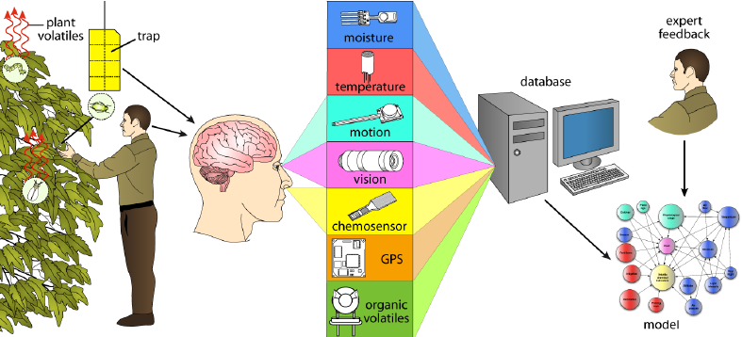
Figure 2: Machine Learning Algorithms for Pest Detection Performance
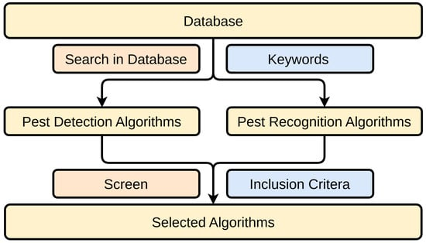
Figure 3: Wireless Sensor Network for Pest Monitoring
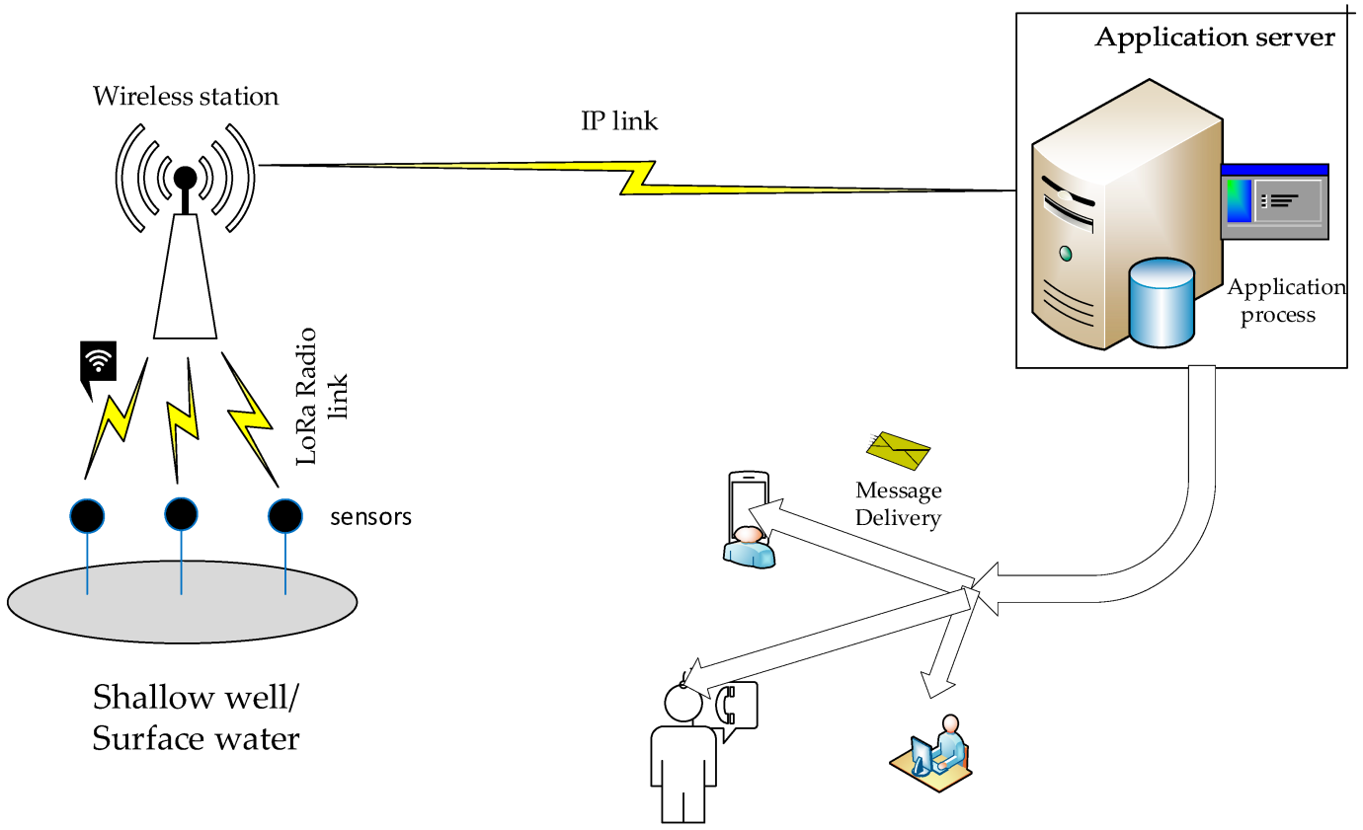
Figure 4: Energy Harvesting for Self-Powered Sensor Nodes
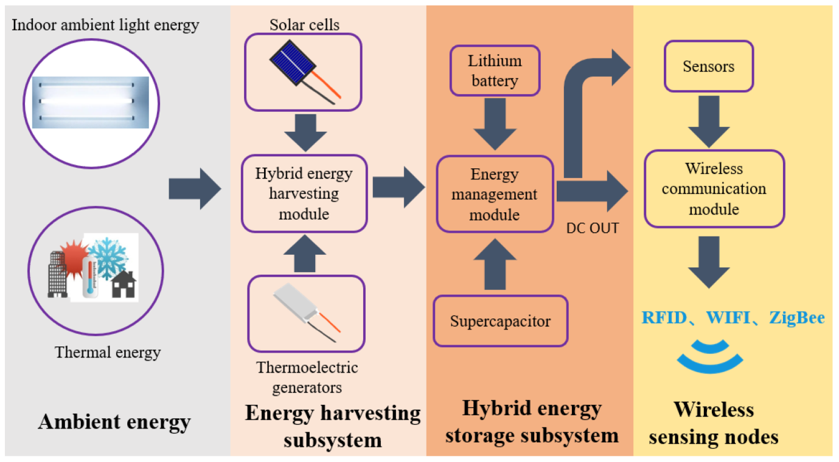
Figure 5: UAVs for Real-Time Pest Surveillance
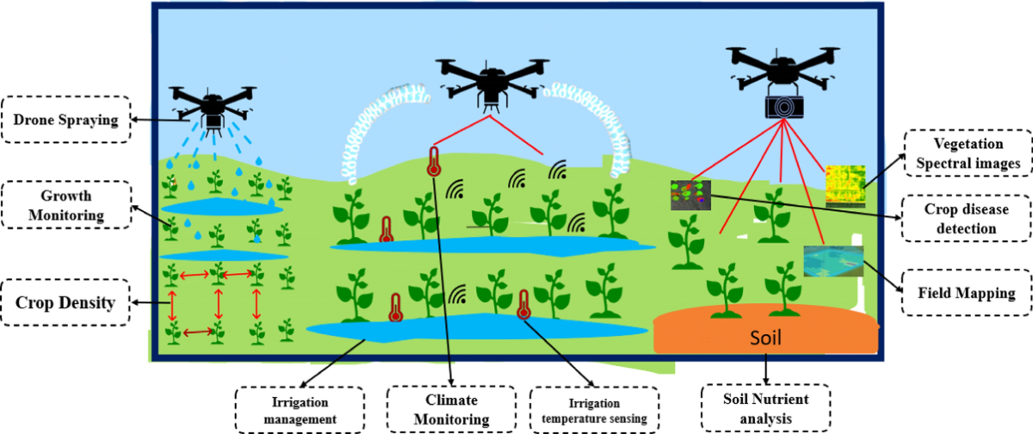
Figure 6: Sensor Data Integration in Pest Management Systems

