Original Research Article

Preliminary study on the biodiversity of mosquitoes (Insecta: Diptera) from Meghalaya with a checklist of some vector borne mosquito

.
ABSTRACT

This study investigates the presence and distribution of mosquito species in Mawsiatkhnam, with a focus on medically significant genera and their potential implications for public health. Data analysis reveals a notable prevalence of Culex and Aedes species, both of which are key vectors for arboviral diseases such as Japanese Encephalitis (JE) and filariasis. The ongoing risk of malaria is underscored by the identification of a diverse Anopheles population, with reports of malaria cases in the past decade. Conversely, the presence of Toxorhynchites, a genus known for its role in controlling mosquito populations, highlights a beneficial ecological factor. These findings emphasize the dual nature of the region’s mosquito ecology posing both a health risk due to vector-borne diseases and an ecological advantage through natural mosquito control mechanisms. This study underscores the importance of continued surveillance and vector management strategies to mitigate the impact of mosquito-borne diseases in the area.

Keywords: Mosquito, Biodiversity, Checklist, North East India, Meghalaya

1. INTRODUCTION

Mosquitoes are omnipresent group of insects (Foster and Walker, 2002; Blom et al., 2023) under family Culicidae and order Diptera (Rawal et al., 2024; Ghorbani et al., 2025) and are widely distributed across the temperate and tropical regions extending even to the Arctic (Harbach 2007, Bhattacharyya et.al 2014). They are crucially important in medical field as some species transmit various parasitic, viral, and bacterial diseases (Nebbak et al., 2022; Alyasiri and Jassum, 2025; Ghorbani et al., 2025). The Culicidae family has two main subfamilies: Anophelinae and Culicinae. Understanding their classification and morphology is vital for investigating and controlling mosquito-borne diseases (Wilkerson et al., 2015). Globally, over 3,539 known species belonging to 112 genera have been recorded (Fang, 2010; Harbach and Kitching, 2016; Harbach 2020; Konwar et al., 2021). India is part of the South-east Asian countries, falling under the Oriental Region (Gaston and Hudson 1994) known for its diverse culture, fauna, and flora. India along with Brazil, Indonesia, Malaysia and Thailand was considered as five top most countries in term of mosquito biodiversity (Foley et al. 2007). A total of 393 mosquito species belonging to 49 genera were identified and catalogue in India (Bhattacharyya et al., 2014). Northeast India is characterized by a high diversity of flora and fauna (Dash et al., 2008). It boasts a wide range of elevation, climate, and temperature, creating diverse habitats for mosquitoes. Weather affects the abundance, habitat suitability and distribution of the vector population (Dhanasekaran and Thangaraj, 2014). Besides, it affects the reproduction rates, survival of the vectors, disease spreading capacity, feeding and biting rates. Beyond the vectors themselves, weather also plays a role in the multiplication and survival of the disease-causing pathogens that infest inside the vector (Singh et al., 2023). Many workers, from Sen et al., 1973 to Dutta et al., 1992 have conducted surveys on mosquito occurrence, distribution, species composition, and identification. Nagpal and Sharma (1987) provided a clear picture of mosquito fauna in four Northeast States (Arunachal Pradesh, Assam, Meghalaya, and Mizoram), documenting 28 species under Anopheles along with 7 other genera. In 1994, Malhotra and Mahanta reported 130 mosquitos’ species from various sources in North East India. 40 years back, Das et al., 1984 surveyed on the mosquitoes of Meghalaya and record 40 species belonging to 6 genera. More recent surveys have documented a significant increase, identifying 94 species of mosquitoes from the state (Khan et al., 2013; Srivastava and Prasad 2015).
Meghalaya situated in the Northern part of India along with others seven North Eastern states with a geographical area of 22,429 sq. km with a population of 37, 72,452. The State lies within a Latitude of 25°02' N and Longitude of 92°50' E extends to the east/west along the international northern boundary of Bangladesh and to the north and eastern parts which is bounded by Assam. Administratively, Meghalaya is divided into twelve districts, viz., East Khasi Hills, West Khasi Hills, Ri Bhoi, South West Khasi Hills, West Jaintia Hills, East Jaintia Hills, West Garo Hills, South Garo Hills, East Garo Hills, North Garo Hills, South West Garo Hills and Eastern West Khasi Hills. Geographically, the State is made up of hilly-terrains, semi-hilly terrains and flood plains. Known for lush greenery and abundant rainfall, which are favorable for mosquito breeding. The overall climatic condition varies from hilly regions to the plains. The State abiotic records show conditions that vary from very humid and hot during monsoon to very cold and moderate in winter.
While over 90 species of mosquitoes have been identified in Meghalaya, many more are believed to exist but remain unknown due to their widespread dispersion and high numbers. This indicates a significant gap in the complete understanding of the region's mosquito fauna. The recent spread of various vector-borne diseases, primarily transmitted by mosquitoes belonging to the Culicidae family (Bamou et al., 2021; Gajda et al., 2023), poses a substantial public health concern across Meghalaya. This necessitates further investigation and thorough studies on these mosquitoes to understand their impact on public health. The goals of the current study were to review the mosquito fauna, generate entomological assessments of some vectors, and preparing a checklist on the vector borne disease mosquitoes within the surveyed region.

2. material and methods

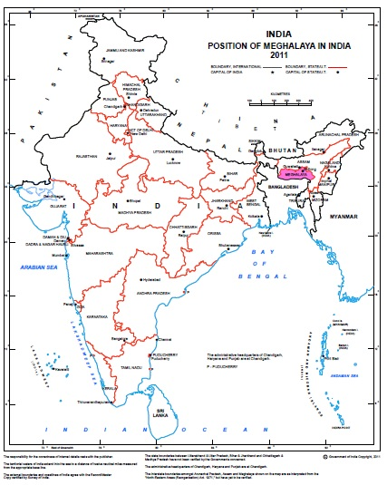
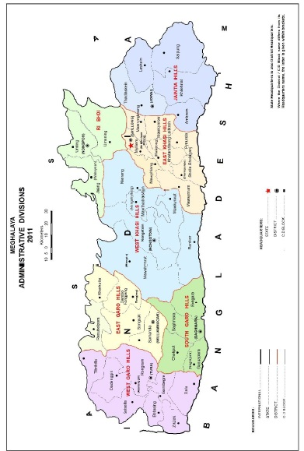
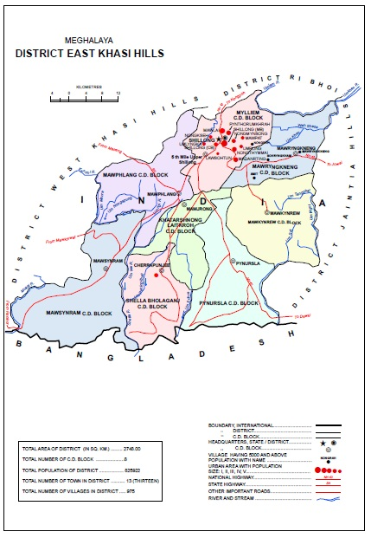
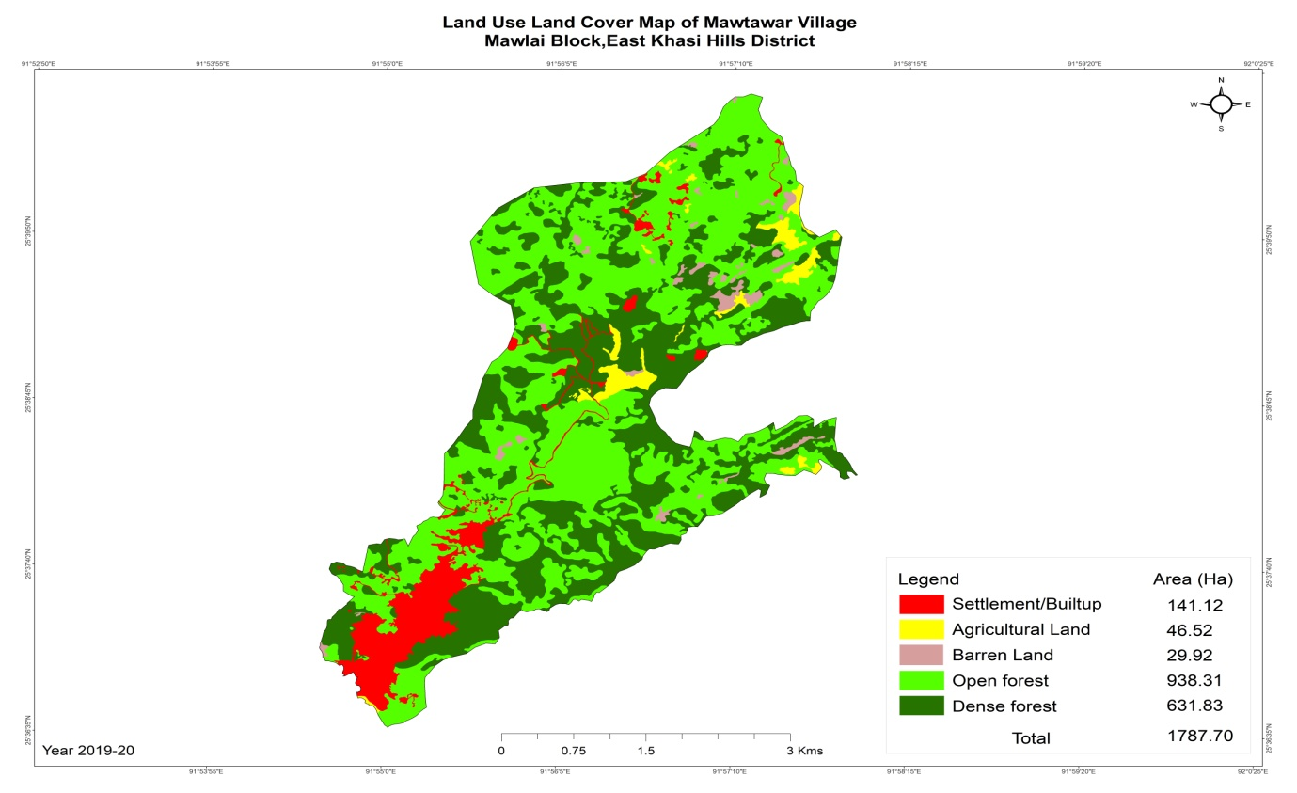

Source: Census of India 2011, Meghalaya, Series-18 Part Xii-A, District Census Handbook, East Khasi Hills, Village and Town Directory and Meghalaya Community Led Landscape Management Project: village report.
Figure 1. Study Area

2.1. Study site- The present study on the adult mosquito was conducted as part of a project by the Entomologist, Shillong and Nonstoin zone, State NCVBDC and students of St. Mary’s college 5th Semester, FYUP at Mawsiatkhnam, Nongkaa village which falls under Mylliem C & RD Block in East Khasi Hills District, bordering to Ri Bhoi District, Meghalaya. It is specifically noted as bordering the Ri Bhoi District which has reported malaria, dengue and Japanese encaphalitis cases. Cases of malaria and Japanese encephalitis had also been reported in Mawsiatkhnam. This geographic proximity could influence the mosquito species present due to the potential overlap of ecological zones. Mosquitoes, being highly mobile within their flight range, would not be confined by administrative boundaries, making the border region a potential hotspot for a mix of species found in both East Khasi Hills and Ri Bhoi's ecological environments. Mawsiatkhnam is covered in lush forests, with plentiful pines, sals and bamboo, along with other species like oak, birch, beech, and magnolia, contributing to the green and often misty landscape where its geographical area, topography, moderate and humid temperature characteristics provide ideal conditions for mosquito proliferation and mosquitoes breeding. This short survey is a crucial step in addressing the knowledge gaps regarding mosquito diversity and vector-borne diseases in Meghalaya, ultimately contributing to public health efforts in the state. The geographical and climatic conditions described for Mawsiatkhnam, Nongkaa village (lush forests, varied climate and abundant rainfall) indeed make it a suitable location for such entomological studies implying that a diverse and potentially high population of mosquitoes could be expected. Temperature and relative humidity were also recorded.

2.2. Adult Mosquito collection:
Methods employed for the collection of adult mosquitoes from the selected study sites is by hand catch using a mouth aspirator tube (Harbison et al., 2006; Tambwe et al., 2023) during evening hours 7:00 to 9:00 pm both for indoor and outdoor collection. This timeframe often coincides with peak mosquito activity, especially for many crepuscular (dusk/dawn active) or nocturnal species. For indoors, mosquito were collected from two cattle sheds which are excellent collection sites as they often attract zoophilic (animal-feeding) mosquito species, which can also bite humans. The outdoor collection was collected from resting sites such as vegetation, bamboo fencing, and the outside part of the house.
2.3. Identification of adult mosquitoes: The mosquito samples were identified up to species by the Entomologist and the internship students using literature and software for morphological characteristics. All mosquitoes samples were segregates, categories and identify based on the pictorial identification provided by WHO regional office for South East Asia (WHO, 2020).
2.4. Data analysis: Quantitative analyses of mosquito which was collected were expressed in density, abundance, species richness and species dominance. Margalef’s index were used to calculate species richness (Margalef, 1958) and Dominance of the species were calculated using Berger-Parker Dominance (Berger and Parker, 1970).
For density, the samples were calculated as Per Man Hour Density (PMHD) using the following formula:
PMHD= Total mosquitoes collected/ Number of collectors X time spent in hours.
Dominance of the samples were calculated using Berger-Parker Dominance Index formula: d=Nmax​/N
Where: Nmax​ = Number of individuals in the most abundant species and N = Total number of individuals in all species
Whereas species richness were calculated using Margalef Species Richness Index formula:
DMg​= (S−1)/ln(N)
Where: S = Total number of species, N = Total number of individuals in all species and ln = Natural logarithm
3. results and discussion
The majority of the mosquitoes collected across this study belonged to the genera Anopheles, Culex, Aedes, Mansonia and Toxorhynchites. During the survey, a total of 100 mosquito individuals from 5 genera and 24 species (Table 1) were identified, of which 100% were adult females.
Table 1: Relative Abundance of mosquitoes collected from study sites
Genera | Sl.No. | Species | No. of individuals | Relative Abundance
Anopheles | 1 | Anopheles annularis | 2 | 0.02
Anopheles | 2 | Anopheles barbirostris | 2 | 0.02
Anopheles | 3 | Anopheles barbumbrosus | 3 | 0.03
Anopheles | 4 | Anopheles crawfordi | 1 | 0.01
Anopheles | 5 | Anopheles dravidicus | 1 | 0.01
Anopheles | 6 | Anopheles hyrcanus | 4 | 0.04
Anopheles | 7 | Anopheles jamesii | 4 | 0.04
Anopheles | 8 | Anopheles kochi | 2 | 0.02
Anopheles | 9 | Anopheles koliensis | 4 | 0.04
Anopheles | 10 | Anopheles lesteri | 1 | 0.01
Anopheles | 11 | Anopheles maculatus | 6 | 0.06
Anopheles | 12 | Anopheles nigerrimus | 1 | 0.01
Anopheles | 13 | Anopheles pallidus | 2 | 0.02
Anopheles | 14 | Anopheles pseudojamesii | 2 | 0.02
Anopheles | 15 | Anopheles tessellatus | 1 | 0.01
Culex | 16 | Culex gelidus | 12 | 0.12
Culex | 17 | Culex pipiens | 8 | 0.08
Culex | 18 | Culex quinquifaciatus | 16 | 0.16
Culex | 19 | Culex tritaeniorhynchus | 1 | 0.01
Culex | 20 | Culex vishnui | 4 | 0.04
Aedes | 21 | Aedes aegypti | 3 | 0.03
Aedes | 22 | Aedes albopictus | 12 | 0.12
Mansonia | 23 | Mansonia uniformis | 1 | 0.01
Toxorhynchites | 24 | Toxorhynchites minimus | 7 | 0.07

Of all the mosquitoes samples collected, the abundance among the identified genera was found out that Culex is the most abundant genus overall, with a total of 41 individuals collected occupying almost half of the individuals with 41% from the total catch followed by Anopheles which is also highly represented, with a total of 36 individuals placing the second most abundance with 36% from the total catch. Aedes follows with 15 individuals (2 species) holding with a 15%. Meanwhile, Toxorhynchites has a notable presence with 7 individuals recording of 7% from the total samplings. Whereas Mansonia has the lowest representation with only 1 individual and occupying only 1% from the total catch (Fig 2).

Figure 2: Abundance of mosquitoes
Anopheles mosquitoes had the highest species richness among the collected samples, with a total of 15 species identified. Of these, nine species belonged to the sub-genus Cellia (Group A) and six to the sub-genus Anopheles (Group B). Following Anopheles, the Culex group showed five identified species, with four in the sub-genus culex and a single species in the sub-genus pipiens. Two common species, Ae. aegypti and Ae. albopictus, were identified within the Aedes group, both under the sub-genus stegomyia. Mansonia and Toxorhynchites occupied the lowest rank, with only a single species each, under the sub-genera mansonioides and toxorhynchites, respectively.
During the survey, the most predominant mosquito species was Cx. quinquifaciatus, which represented 16% of the total sample. This was followed by Cx. gelidus and Ae. albopictus, each accounting for 12%, and Cx. pipiens at 8%. The next most common species were Toxorhynchites (7%) and An. maculatus (6%). Cx. vishnui, An. koliensis, An. jamesii and An. hyrcanus represent 4 % each from the total catch. Ae. aegypti on the other hand occupying 3% of the total catch. Whereas An. annularis, An. barbirostris, An. kochi, An. pallidus, An. pseudojamesii represent 2% each and An. crawfordi, An. dravidicus, An. lesteri, An. nigerrimus, An. tessellatus, Cx. tritaeniorhynchus and Mansonia uniformis with 1% each from the total catch occupying the lowest amongst all.
Within the genus Anopheles, An. maculatus represented the highest proportion of the total catch, at 17% followed by An. hyrcanus, An. jamesii and An. koliensis with 11% each. An. barbumbrosis occupying 8% from the total Anopheles. Whereas, An. annularis, An. barbirostris, An. kochi, An. pallidus and An. pseudojamesii sharing 6% each from the Anopheles sampling. Among all the Anopheles species caught, the lowest percentage was 3%, which was shared by five species: An. crawfordi, An. dravidicus, An. lesteri, An. nigerrimus, and An. tessellatus (Fig. 3).

Figure 3: Anopheles species recorded from study sites
Among the Culex, Cx. quinquifaciatus dominating all species with 39% followed by Cx. gelidus and Cx. pipiens with 29% and 20% each from the total Culex catch. Cx. vishnui made up 10% of the total Culex catch, whereas Cx. tritaeniorhynchus was the least common species, representing only 2% (Fig. 4).

Figure 4: Culex species recorded from study sites
In the genus Aedes, Ae. albopictus was significantly more common than Ae. aegypti, representing 80% and 20% of the total catch, respectively (Fig. 5).

Figure 5: Aedes species recorded from study sites
Berger-Parker Dominance Index for each Genus showed that Mansonia and Toxorhynchus have the highest dominance (1.00) because each genus is represented by only one species, accounting for 100% of the individuals within that genus. Anopheles exhibits the lowest dominance (0.17) among the genera, suggesting a more even distribution of individuals among its various species (Table 2).
The Margalef Species Richness Index (Table 2) for this mosquito community is approximately 4.99. Margalef index gave the highest species richness to Anopheles (3.91) while Aedes (0.37) rank the least.
Table 2: Dominance and Richness of mosquitoes
Genera | Anopheles | Culex | Aedes | Mansonia | Toxorhynchites
Species | 15 | 5 | 2 | 1 | 1
Individuals | 36 | 41 | 15 | 1 | 1
Margalef | 3.907 | 1.077 | 0.3693 | 0 | 0
Berger-Parker | 0.1667 | 0.3902 | 0.8 | 1 | 1

On analysing the PMHD of the collected mosquito species, An. maculatus shows the highest PMHD, with a value close to 0.27 among Anopheles species followed by An. jamesii and An. hyrcanus having relatively high PMHD values, both around 0.18 and 0.19 (Fig 6).

Figure 6: PMHD of Anopheles
Among Culex species, Cx. quinquifasciatus has the highest PMHD by a significant margin, with a value close to 0.70 indicating a very high density of this species. The Japanese encephalitis vectors, Cx. vishnui shows a lower PMHD of around 0.18 and Cx. tritaeniorhynchus has the lowest PMHD with 0.1 during the collection (Fig 7).

Figure 7: PMHD of Culex
From the present studied a total of 11 species of mosquitoes were identified as an important medical insects being known and reported to transmit malaria, Japanese Encephalitis Virus, Lymphatic Filariasis (Bancroftian filariasis), West Nile Virus (WNV) & St. Louis Encephalitis virus (SLEV), Dengue, Chikungunya, Zika, and Yellow Fever (Table 3).
Table 3: Checklist of some important vector borne mosquitoes collected from study sites.
Sl.No. | Species | Disease
1 | Anopheles annularis | Malaria vector
2 | Anopheles jamesii | Malaria vector
3 | Anopheles hyrcanus group | Malaria, Lymphatic Filariasis, and Japanese Encephalitis Virus (JEV)
4 | Culex quinquifaciatus | Lymphatic Filariasis (Bancroftian filariasis), West Nile Virus (WNV) & St. Louis Encephalitis virus (SLEV)
5 | Culex gelidus | Japanese Encephalitis Virus (JEV)
6 | Culex pipiens | Japanese Encephalitis Virus (JEV)
7 | Culex vishnui | Japanese Encephalitis Virus (JEV)
8 | Culex tritaeniorhynchus | Japanese Encephalitis Virus (JEV)
9 | Aedes albopictus | Dengue, Chikungunya, Zika, and Yellow Fever
10 | Aedes aegypti. | Dengue, Chikungunya, Zika, and Yellow Fever
11 | Mansonia uniformis | Lymphatic Filariasis
4. Discussion:
Mosquitoes are important disease vectors. Their diversity and distribution determine the course of disease transmission and the ecological status of the native environment (Brugueras et al., 2020; Attaullah et al., 2023). Malaria and dengue are the two common diseases that are prevalent in the local public and the disease spread is associated with the abundance of mosquito vectors (L. AL-Eitan et al., 2024).
While Anopheles species are diverse, and An. maculatus is a known secondary vector in India (Baruah et al., 2024). Importance of An. maculatus in malaria transmission in northeastern India has been reported in parts of Assam and Meghalaya as early as the 1940s (Anderson and Viswanathan, 1941; Singh S. et al., 2012). The relative abundance of any single highly efficient malaria vector is not as overwhelmingly high as Cx. quinquifaciatus or Ae. albopictus. However, the sheer diversity of Anopheles species means a complex picture where multiple species could contribute to transmission.
The relative densities of various Anopheles species, indicating that An. maculatus, An. jamesii, and An. hyrcanus are the most prevalent in terms of man-hour density which is crucial for understanding the distribution and potential public health importance of different mosquito species in a given area. These species transmit malaria, Japanese encephalitis virus, and filariasis (Singh R. K. et. al., 2013, Mohanty et. al., 2024, Askari et. al., 2024).
The Margalef index of 4.99 suggests a relatively rich mosquito community given the sample size of 100 individuals and 24 species.
An. maculatus group are known to play important role in malaria transmission in the Oriental (Reid, 1968; Rao, 1984; Upatham et al., 1988) and the importance of An. maculatus in malaria transmission in northeastern India has been known for decades (Singh S. et al., 2012). Natural malaria infection was detected in parts of Assam and Meghalaya as early as the 1940s (Anderson and Viswanathan, 1941; Viswanathan et al., 1941). Plasmodium vivax was also reported in An. maculatus from Habiganj district of Bangladesh just across the Indo-Bangladesh border (Alam et al., 2010). Anopheles annularis is a widely distributed mosquito species and a known vector for malaria. It is considered a secondary vector in some regions of India, but can act as a primary vector in others, such as Assam, West Bengal, Andhra Pradesh, U.P and Odisha, and neighbouring countries like Sri Lanka, Nepal, and Myanmar (Singh R. K. et. al., 2013). Anopheles jamesii is often considered a non-malaria vector; recent studies have shown that An. jamesii can be a potential vector for malaria, specifically for Plasmodium vivax (Mohanty et. al., 2024). Its ability to transmit the parasite has been demonstrated in laboratory conditions, suggesting that it may be an emerging vector. Anopheles hyrcanus group is a group of closely related species that are medically significant. Members of this group are known to transmit malaria, Japanese Encephalitis Virus, and filariasis in various regions, particularly in Asia. They are a notable concern in parts of China, Iran, and other countries in the Oriental and Palaearctic regions (Fang et. al., 2017, Askari et. al., 2024).
Zoonotic virus transmission globally is largely due to mosquitoes of the Culex genus. Collectively, they play a significant role in the transmission of medically significant diseases such as Lymphatic Filariasis (Smuel et. al., 2004), West Nile virus and Japanese encephalitis virus (Madhav et. al., 2024). Cx. quinquifaciatus is the most abundant species, with 16 individuals (0.16 Relative Abundance), and is a known vector for Lymphatic Filariasis (Bancroftian filariasis), West Nile Virus (WNV) and St. Louis Encephalitis (SLEV) (Bartholomay et. al., 2011). While Cx. tritaeniorhynchus is often the primary vector for Japanese encephalitis Virus (JEV), it can also transmit Japanese Encephalitis Virus (JEV), particularly in urban settings (Kanojia. 2007). Its high abundance indicates a significant risk for the transmission of these diseases.
Cx. gelidus (12 individuals, 0.12 RA) which is a prominent vector of Japanese Encephalitis Virus (JEV), especially in India and Southeast Asia (Sudeep, 2014) and was observed to be the second most abundant after Cx. quinquefaciatus that points to a considerable risk of JEV transmission. The major vectors of Japanese encephalitis in India belong to Cx. vishnui group comprising of Cx. tritaeniorhynchus, Cx. vishnui and Cx. pseudovishnui (Samuel, 2000). The presence of Cx. pipiens, Cx. vishnui and Cx. tritaeniorhynchus also has a high risk for Japanese encephalitis (JE), a major primary vector in East Khasi Hills district of Meghalaya. Their presence, even in low numbers, warrants attention due to its high vectorial capacity.
Both Aedes species are important vectors for arboviruses like dengue, chikungunya, and Zika (Gómez et al., 2022; Ahebwa et al., 2023). The high density of Aedes albopictus suggests a greater potential for transmission of these diseases associated with this specific species.
Aedes vectors are highly prevalent in northeast India. Aedes albopictus (12 individuals, 0.12 Relative Abundance) has been reported as a vector of dengue in Northeast India like Assam, Arunachal Pradesh, Meghalaya and Nagaland (Chetri et. al, 2020). Aedes aegypti (3 individuals, 0.03 Relative Abundance) is the primary vector for Dengue, Chikungunya, Zika, and Yellow Fever (Chetri et. al, 2020; Cheong et. al., 2025). Although its abundance is lower than Aedes albopictus in this sample, its presence is extremely important given its high efficiency in transmitting these severe diseases.
Mansonia (1 individual, 0.01 Relative Abundance) are known vectors of Lymphatic filariasis (especially Brugia malayi and B. timori) and Ma. uniformis is a vector of both filariasis and Japanese encephalitis (Agrawal V.K., Sashindran V.K. 2006, Kanojia et. al., 2007). Their larvae attached to aquatic plants. Even a single individual suggests its presence in the area. M. uniformis is a recognized vector of filariasis or Japanese encephalitis.
The presence of Toxorhynchites is generally considered beneficial from a public health perspective. This genus is unique because adult Toxorhynchites mosquitoes do not feed on blood; they feed on nectar. They act as natural biological control agents, preying on the immature stages of pest and vector mosquitoes like Aedes and Culex (McAlister., 2017. Donald et. al., 2020; Sukupayo et. al, 2024). Their relative abundance of 0.07 (7%) is quite high for a predatory mosquito, which is a positive sign for natural mosquito control within the sampled area.
5. Conclusion
The data highlight a significant presence of medically important mosquito species, particularly from the Culex and Aedes genera, suggesting a substantial risk of arboviral diseases like Japanese encephalitis (Je) and filariasis. The diverse Anopheles population also indicates ongoing malaria risk as Mawsiatkhnam has reported malaria cases in the last 10 years. On a positive note, the presence of Toxorhynchites acts as a beneficial ecological factor.

Consent

Consent not applicable.

COMPETING INTERESTS DISCLAIMER:
Authors have declared that they have no known competing financial interests OR non-financial interests OR personal relationships that could have appeared to influence the work reported in this paper.

References

- Agrawal, V. K., & Sashindran, V. K. (2006). Lymphatic filariasis in India: Problems, challenges and new initiatives. Medical Journal of Armed Forces India, 62, 359–362. https://doi.org/10.1016/S0377-1237(06)80109-7
- Ahebwa, A., Hii, J., Neoh, K. B., & Chareonviriyaphap, T. (2023). Aedes aegypti and Aedes albopictus (Diptera: Culicidae) ecology, biology, behaviour, and implications on arbovirus transmission in Thailand: A review. One Health, 16, 100555. https://doi.org/10.1016/j.onehlt.2023.100555
- Al-Eitan, L., Alnemri, M., Ali, H., Alkhawaldeh, M., & Mihyar, A. (2024). Mosquito-borne diseases: Assessing risk and strategies to control their spread in the Middle East. Journal of Biosafety and Biosecurity, 6, 1–12. https://doi.org/10.1016/j.jobb.2023.12.003
- Alam, M. S., Khan, M. G. M., Choudhury, N., Deloer, S., Nazib, F., Bangali, A. M., & Haque, R. (2010). Prevalence of anopheline species and their Plasmodium infection status in epidemic-prone border areas of Bangladesh. Malaria Journal, 9, 15.
- Askari, F., Paksa, A., Shahabi, S., Saeedi, S., Sofizadeh, A., Vahedi, M., & Soltani, A. (2024). Population genetic structure and phylogenetic analysis of Anopheles hyrcanus (Diptera: Culicidae) inferred from nuclear ITS2 and mitochondrial COI gene sequences in northern Iran. BMC Infectious Diseases, 24, 724.
- Alyasiri, A. J., & Jassum, A. S. (2025). Mosquito-borne diseases: A review of the risks to humans in Iraq. Current Research in Interdisciplinary Studies, 4(2), 1–15. https://doi.org/10.58614/cris421
- Anderson, L. A. P., & Viswanathan, D. K. (1941). The Assam Medical Research Society, Shillong: A resume of its activities during 1931–41. Thacker Spink & Co.
- Attaullah, M., Gul, S., Bibi, D., Andaleeb, A., Ilahi, I., Siraj, M., Ahmad, M., Ullah, I., Ali, M., Ahmad, S., & Ullah, Z. (2023). Diversity, distribution and relative abundance of mosquito fauna (Diptera: Culicidae) of Malakand and Dir Lower, Pakistan. Brazilian Journal of Biology, 83, 2–9. https://doi.org/10.1590/1519-6984.247374
- Bamou, R., Mayi, M. P. A., Djiappi-Tchamen, B., Nana-Ndjangwo, S. M., Nchoutpouen, E., Cornel, A. J., Awono-Ambene, P., Parola, P., Tchuinkam, T., & Antonio-Nkondjio, C. (2021). An update on mosquito fauna and mosquito-borne diseases distribution in Cameroon. Parasites & Vectors, 14, 527. https://doi.org/10.1186/s13071-021-04950-9
- Bartholomay, L. C., Waterhouse, R. M., Mayhew, G. F., Campbell, C. L., Michel, K., Zou, Z., … Muskavitch, M. A. T. (2010). Pathogenomics of Culex quinquefasciatus and meta-analysis of infection responses to diverse pathogens. Science, 330(6000), 88–90. https://doi.org/10.1126/science.1193162
- Baruah, K., Hari, I., Viswan, K. A., & Srivastava, P. K. (2024). Distribution of malaria vectors in India: An update. Journal of Communicable Diseases, 56(1), 171–183. https://doi.org/10.24321/0019.5138.202423
- Berger, W. H., & Parker, F. L. (1970). Diversity of planktonic foraminifera in deep-sea sediments. Science, 168(3937), 1345–1347. https://doi.org/10.1126/science.168.3937.1345
- Bhattacharyya, D. R., Rajavel, A. R., Natarajan, R., Mohapatra, P. K., Jambulingam, P., & Mahanta, J. (2014). Faunal richness and checklist of Indian mosquitoes (Diptera: Culicidae). Check List, 10, 1342–1358.
- Blom, R., Schrama, M. J. J., Spitzen, J., Weller, B. F. M., van der Linden, A., Sikkema, R. S., Koopmans, M. P. G., & Koenraadt, C. J. M. (2023). Arbovirus persistence in north-western Europe: Are mosquitoes the only overwintering pathway? One Health, 16, 100467. https://doi.org/10.1016/j.onehlt.2022.100467
- Brugueras, S., Fernández-Martínez, B., Martínez-de la Puente, J., Figuerola, J., Porro, T. M., Rius, C., Larrauri, A., & Gómez-Barroso, D. (2020). Environmental drivers, climate change and emergent diseases transmitted by mosquitoes in southern Europe: A systematic review. Environmental Research, 191, 110038.
- Cheong, Y. L., Ghazali, S. M., Hashim, M. H. M., Ibrahim, M. K., Amran, A., Tiunh, T. Y., Lim, H. L., Cheah, Y. K., Gill, B. S., & Lim, K. H. (2025). Exploring 97 years of Aedes aegypti as a vector for dengue, yellow fever, Zika, and chikungunya: A scientometric analysis. JMIR Public Health and Surveillance, 14, e65844. https://doi.org/10.2196/65844
- Chetry, S., Patgiri, S. J., Bhattacharyya, D. R., Dutta, P., & Kumar, N. P. (2020). Incrimination of Aedes aegypti and Aedes albopictus as dengue virus vectors in Northeast India. Access Microbiology, 2(4). https://doi.org/10.1099/acmi.0.000101
- Das, S. C., Das, N. G., & Baruah, I. (1984). Mosquito survey in Meghalaya. Indian Journal of Public Health, 27(3), 147–150.
- Dash, A. P., Valecha, N., Anvikar, A. R., & Kumar, A. (2008). Malaria in India: Challenges and opportunities. Journal of Biosciences, 33(4), 583–592. https://doi.org/10.1007/s12038-008-0076-x
- Dhanasekaran, D., & Thangaraj, R. (2014). Microbial secondary metabolites as alternatives against insect vectors. Asian Pacific Journal of Tropical Disease, 4(4), 253–261.
- Donald, C. L., Siriyasatien, P., & Kohl, A. (2020). Toxorhynchites species: A review of current knowledge. Insects, 11(11), 747.
- Dutta, P., Bhattacharyya, D. R., Sharma, C. K., & Dutta, L. P. (1992). Anopheline fauna of Tirap district, Arunachal Pradesh with reference to malaria transmission. Indian Journal of Medical Research, 95, 245–249.
- Fang, J. (2010). Ecology: A world without mosquitoes. Nature, 466(7305), 432–434.
- Fang, Y., Shi, W., & Zhang, Y. (2017). Molecular phylogeny of Anopheles hyrcanus group based on ITS2 rDNA. Parasites & Vectors, 10(1). https://doi.org/10.1186/s13071-017-2351-x
- Foley, D. H., Rueda, L. M., & Wilkerson, R. C. (2007). Insight into global mosquito biogeography from country species records. Journal of Medical Entomology, 44(4), 554–567.
- Foster, W. A., & Walker, E. D. (2002). Mosquitoes (Culicidae). In Medical and veterinary entomology (pp. 204–256). Elsevier.
- Gajda, E., Krzowski, Ł., Kowalczuk, K., Pabin, A., & Maculewicz, E. (2023). Influence of mosquito-borne biological agents on health risks among soldiers. Annals of Agricultural and Environmental Medicine, 30(1), 2–8. https://doi.org/10.26444/aaem/155003
- Gaston, K. J., & Hudson, E. (1994). Regional patterns of diversity and estimates of global insect species richness. Biodiversity and Conservation, 3, 493–500.
- Ghorbani, A., Dekkiche, K., Ghorbani, A., & Garedaghi, Y. (2025). A review of mosquitoes (Diptera: Culicidae) and their biodiversity, medical and veterinary importance. Virology and Immunology Journal, 9(1). https://doi.org/10.23880/vij-16000355
- Gómez, M., Martinez, D., Muñoz, M., & Ramírez, J. D. (2022). Aedes aegypti and Aedes albopictus microbiome/virome. Parasites & Vectors, 15, 287. https://doi.org/10.1186/s13071-022-05401-9
- Harbach, R., & Kitching, I. (2015). The phylogeny of Anophelinae revisited: Inferences about the origin and classification of Anopheles (Diptera: Culicidae). Zoologica Scripta, 45, 1–13.
- Harbach, R. E. (2007). The Culicidae (Diptera): A review of taxonomy, classification and phylogeny. Zootaxa, 1668(1), 591–638.
- Harbach, R. E. (2020). Mosquito taxonomic inventory. http://mosquito-taxonomic-inventory.info (Accessed July 23, 2025).
- Harbison, J. E., Mathenge, E. M., Misiani, G. O., Mukabana, W. R., & Day, J. F. (2006). A simple method for sampling indoor-resting malaria mosquitoes Anopheles gambiae and Anopheles funestus (Diptera: Culicidae) in Africa. Journal of Medical Entomology, 43(3), 473–479.
- Kanojia, P. C. (2007). Ecological study on mosquito vectors of Japanese encephalitis virus in Bellary district, Karnataka. Indian Journal of Medical Research, 126, 152–157.
- Khan, S. A., Dutta, P., & Mahanta, J. (2013). Survey of new mosquito species of Meghalaya, India. Journal of Environmental Biology, 34, 191–195.
- Konwar, D., Bordoloi, R., Bordoloi, R., & Nath, N. (2021). Seasonal dynamics and abundance of mosquitoes in Sivasagar district of upper Assam, India with special reference to environmental factors. International Journal of Mosquito Research, 8(5), 28–36. https://doi.org/10.22271/23487941.2021.v8.i5a.560
- Madhav, M., Blasdell, K. R., Trewin, B., Paradkar, P. N., & López-Denman, A. J. (2024). Culex-transmitted diseases: Mechanisms, impact, and future control strategies using Wolbachia. Viruses, 16, 1134. https://doi.org/10.3390/v16071134
- Malhotra, P. R., & Mahanta, H. C. (1994). Check-list of mosquitoes of Northeast India (Diptera: Culicidae). Oriental Insects, 28, 125–149.
- Margalef, R. (1958). Information theory in ecology. General Systems, 3, 36–71.
- McAlister, E. (2017). The secret life of flies. Natural History Museum.
- Mohanty, A. K., Mazumdar, D., Govekar, A., D’Souza, C., Mohapatra, A., & Nina, P. B. (2024). Anopheles jamesii supports Plasmodium vivax sporogony under laboratory conditions. The American Journal of Tropical Medicine and Hygiene, 111(5), 984–987. https://doi.org/10.4269/ajtmh.24-0267
- Nagpal, B. N., & Sharma, V. P. (1987). Survey of mosquito fauna of northeastern region of India. Indian Journal of Malariology, 24, 143–149.
- Nebbak, A., Almeras, L., Parola, P., & Bitam, I. (2022). Mosquito vectors (Diptera: Culicidae) and mosquito-borne diseases in North Africa. Insects, 13, 962. https://doi.org/10.3390/insects13100962
- Rawal, D., Rajpurohit, A., Singh, S., Suthar, Y., & Dhaked, J. (2024). Molecular phylogenetics and evolution of mosquitoes. International Journal of Mosquito Research, 11(4), 115–119. https://doi.org/10.22271/23487941.2024.v11.i4b.793
- Rao, T. R. (1984). The anophelines of India. Malaria Research Centre, Indian Council of Medical Research.
- Reid, J. A. (1968). Anopheline mosquitoes of Malaya and Borneo. Institute for Medical Research.
- Samuel, P. P. (2000). Japanese encephalitis virus infection in mosquitoes and its epidemiological implications. ICMR Bulletin, 30.
- Samuel, P. P., Arunachalam, N., Hiriyan, J., Thenmozhi, V., Gajanana, A., & Satyanarayana, K. (2004). Host-feeding pattern of Culex quinquefasciatus and Mansonia annulifera. Journal of Medical Entomology, 41, 442–446. https://doi.org/10.1603/0022-2585-41.3.442
- Sen, A. K., John, V. M., Krishnan, K. S., & Rajagopal, R. (1973). Studies on malaria transmission in Tirap district, Arunachal Pradesh. Journal of Communicable Diseases, 5(2), 98–110.
- Singh, R. K., Haq, S., Kumar, G., & Dhiman, R. C. (2013). Bionomics and vectorial capacity of Anopheles annularis in India: A review. Journal of Communicable Diseases, 45(1–2), 1–16.
- Singh, V., Singh, N., & Swami, V. P. (2023). Diversity of mosquitoes in India: Status report. Journal of Emerging Technologies and Innovative Research, 10.
- Singha, S., Prakash, A., Yadav, R. N. S., Mohapatra, P. K., Sarma, N. P., Sarma, D. K., Mahanta, J., & Bhattacharyya, D. R. (2012). Anopheles (Cellia) maculatus group: Spatial distribution and molecular characterization. Acta Tropica, 124, 62–70. https://doi.org/10.1016/j.actatropica.2012.06.011
- Srivastava, A. K., & Prasad, S. B. (2015). Study of diversity and abundance of anopheline mosquitoes in Meghalaya, India. Austin Journal of Infectious Diseases, 2(1), 1016.
- Sudeep, A. B. (2014). Culex gelidus: An emerging mosquito vector with potential to transmit multiple viruses. Journal of Vector Borne Diseases, 51(4), 251–258.
- Sukupayo, P. R., Poudel, R. C., & Ghimire, T. R. (2024). Nature’s solution to Aedes vectors: Toxorhynchites as a biocontrol agent. Journal of Tropical Medicine, Article 3529261. https://doi.org/10.1155/2024/3529261
- Tambwe, M. M., Kibondo, U. A., Odufuwa, O. G., Moore, J., Mpelepele, A., Mashauri, R., Saddler, A., & Moore, S. J. (2023). Human landing catches as a measure of protective efficacy of spatial repellents. Parasites & Vectors, 16, 90. https://doi.org/10.1186/s13071-023-05685-5
- Upatham, E. S., Prasittisuk, C., Ratanatham, S., Green, C. A., Rojanasunan, W., Setakana, P., Theeraslip, N., Tremongkol, A., Viyanant, V., Pantuwatana, S., & Andre, R. G. (1988). Bionomics of Anopheles maculatus complex in Thailand. Southeast Asian Journal of Tropical Medicine and Public Health, 19, 259–269.
- Viswanathan, D. K., Das, S., & Oomen, A. V. (1941). Malaria-carrying anophelines in Assam. Journal of the Malaria Institute of India, 4, 297–306.
- World Health Organization. (2018). Pictorial identification key of important disease vectors in the WHO South-East Asia Region. WHO Regional Office for South-East Asia.
- Wilkerson, R. C., Linton, Y. M., Fonseca, D. M., Schultz, T. R., & Price, D. C. (2015). Making mosquito taxonomy useful: A stable classification of tribe Aedini. PLOS ONE, 10(7), e0133602. https://doi.org/10.1371/journal.pone.0133602

