Review Article
Conservation and management of the Asiatic lion (Panthera leo perisca ) in the landscape of Gir ,Gujarat: A review of in-situ strategies.

Abstract:

The lion is at the peak of the ecological pyramid and majorly affects the food chain by controlling the population of animals at the lower trophic levels. Gir National Park, India, is the only place in the world except Africa where a Asiatic lion(Panthera leo perisca) can be seen in its natural habitat due to its dry and deciduous forest. Asiatic lion(Panthera leo perisca) are confined to Gir, Gujarat, India and its is population started declining from 1936 to 1979 by almost 40% of the total population because of deadly diseases, habitat loss , fragmentation, poaching, and conflict with humans. The total number of lions in 1970 was reported to be around 177. This led to the threat of extinction of the lion species, so therefore, the project lion was launched for conservation in 1972, with the implementation of laws banning trophy hunting, poaching, relocating native humans to reduce human-lion conflict, protecting the boundaries of the national park to avoid exploitation and restricting human interaction, reducing anthropogenic activity, and the formation of a research and conservation centre. The project's purpose was to bring the dwindling lion population ,bringing it back from the brink of extinction in response to successful conservation efforts. Because of the efforts and implementation of Project Lion, the lion population currently stands at 674.

Keywords: Asiatic lion, Gir National Park, Project Lion, Population.
Introduction:

Gir National Park in India is the only place in the world except Africa where a lion can be seen in its natural habitat (Yadvendradev Jhala et al., 2019). Asiatic lions are confined in the Gir area of Gujarat in India in its traditional habitat without the interference of man. The area has a dry deciduous forest cover interspersed with moist mixed riverine valley forest patches along the perennial rivers and tropical thorn forest (Srivastav et al., 2011). Asiatic lions have tawny color tone with paler belly, while the abdomen and inner-side of the legs are white toned.
Males are significantly larger than females and have a distinct mane, whereas females lack one. The Asiatic lion differs from the African species in that it has a large belly fold. Male Asiatic lions also have ears that are clearly visible and a less substantial mane than African ones (Srivastav et al., 2011; Sharma et al., 2013; Shivaji et al., 2003). The Asiatic lion persists as one remaining population in and around Gir forest in the southwest part of Saurashtra region in the state of Gujarat, India (Singh et al., 2011).

While ex situ conservation is gaining momentum, protecting lions in their native habitats is essential for maintaining stable and self-sustaining populations. In situ conservation aims at increasing the population size of the majestic animal in their traditional habitats. Due to an increase in forest conservation, Gir has become dense and unfavorable with time (H. S. Singh, 2017; Banerjee & Jhala, 2012; Barnett et al., 2006)

The current work is an attempt to review the literature available on the in situ conservation of lions in the Gir National Park, and measures taken to bring about a change in the status of the declining number of lions.

Evolutionary history of lion population

The genus Panthera shared a common ancestry until the Pliocene epoch, after which lions developed distinct characteristics such as social group living and the presence of manes (Yamaguchi et al. 2004). Throughout their evolutionary history, lions have acquired a vast distribution range and have influenced the evolution of numerous sympatric species in Africa (Eisenberg 1981).

Panthera leo leo and Panthera leo persica, two separate subspecies of living lions, are known to have diverged recently, between 55,000 and 200,000 years ago. (O' Brien et al. 1987). There are currently two populations of free-ranging lions: P. l. leo in Africa and P. l. persica in India. The only remaining examples of the latter are discovered in India's Gir forest, whereas the former are currently only found in savannah settings in sub-Saharan Africa. (Nowell & Jackson, 1996).

Asiatic Lion: Habitat distribution and status
In the past, the Asiatic Lion's range was extensive, spanning from Syria through the Middle East to eastern India. (Kinnear, 1920; Joslin, 1973). In Saurashtra lions were found in Dhrangadhra, parts of Jasdan, Chotila, Alech hills, Barda hills, Girnar and Gir (Dalvi 1969). The lion population was fragmented at the start of the 20th century, and it eventually reduced to the Gir forest. (Dalvi, 1969). Lions have dispersed and established themselves outside the protected area (Singh, et . a l 2011) due to an increase in lion populations caused by an increase in density within Girl in recent years. The present population estimate is 674 lions, (Gujarat Forest Department census report 2005).

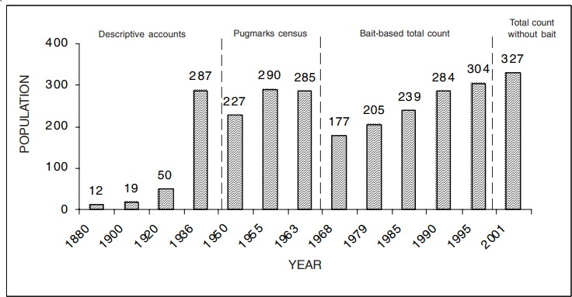Figure 1: Population number of Asiatic lions across 2 decades (Venkatraman, 2009)

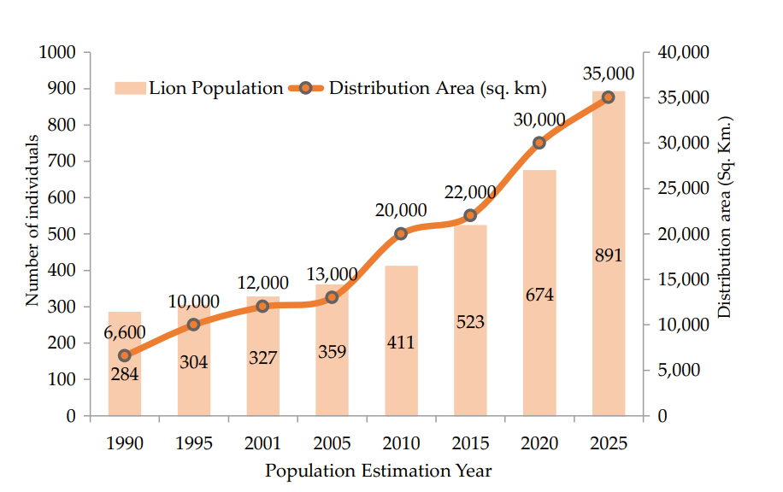
Figure . 2 Graph showing the lion population and distribution area of the Asiatic lions.(16 Lion population estimation -Dr. Mohan Ram et.al)

The Asiatic Lion population has fluctuated widely in the past and in recent years has shown a steady increase. According to the Gujarat Forest Department census, a total of 420 lions occur in Gir at an average density of 10 lions/100 km² (Meena et al. 2008). Males and females associate only during mating and do not rest or feed together.

The habitat of Gir is relatively denser than the open plains of the Serengeti thereby providing equal opportunities for hunting success for males and females as described in other comparable African Lion habitats such as Kruger National Park (Funston et al. 2001). The diet constituting small and medium wild prey as well as a vulnerable livestock prey-base is responsible for low lion group sizes and the loose bonding between male and female.

Statement of Purpose

The present review assessed the reasons for decline and conservation status of the animal in Gir, India. The population of Asiatic lions is on the decrease due to various reasons like loss of their natural habitat, Isolation and depletion of prey. The number of Asiatic lions in protected areas is seen to increase but in unprotected areas and natural habitats the number seems low. Earlier pugmarks, sightings, etc, were used as means to count the number of the animal.
However with advancement in technology radiometry is successfully used to track the number of individuals.
The lion population started declining from 1936 to 1979 by almost 40% of the total population reasons are encroachment, forest fires, natural disasters, grazing, the gathering of fuelwood, poaching, tourism, religious pilgrimage, diseases epidemics among lion population and unintentional lion fatalities due to human causes are all factors that pose a threat to the Gir PA and lion conservation. Agro-industrial developments and urban sprawl are currently causing an unprecedented shift in the traditional land-use patterns of the Gir terrain. In areas where humans predominate, lions have a wide range and will sometimes enter settlements at night in search of food. However, in order to avoid conflicts, they require specific daytime habitat patches (refuge sites). Most commonly, grasslands, Acacia patches, Prosopis Juli flora patches, and orchards define these patches. These vital habitat patches are mostly privately held and have a complicated land ownership structure; thus, they are likely to disappear quickly.

The number of Asian lions has increased from a few dozen to several hundred since it was on the verge of extinction. The largest stretches of dry deciduous forest, thorny forest, and savannah in Gujarat are found in the two hill systems of Gir and Girnar, where they live in remnant forest habitats. The Gir Sanctuary, Gir National Park, and Pania Sanctuary together with other protected areas make up the Gir Conservation Tract (GCA), which protects the Asiatic lion's primary habitat over a 20,000 km2 area of woodland. The Gir Conservation Area's satellite regions are protected by the other two wildlife refuges, Mitiyala and Girnar. A second sanctuary is being built nearby in the Barda forest to act as the Gir lions' primary residence.

In order to protect and maintain lions in their original natural territory the in situ conservation project was introduced in Gir,India. It involved the Gir sanctuary lion project, conservation of habitat along with maintenance of the forest area and ecosystem.
In-situ conservation of Asiatic lion over five decades

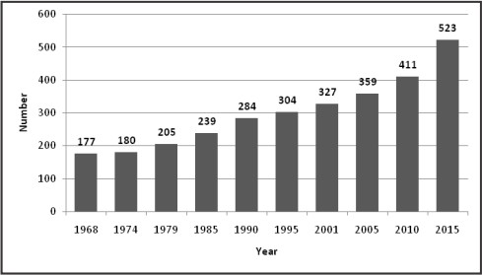
Figure 3: In-situ conservation of Asiatic lion over five decades (Singh, 2017)

Decade 1 Year 1966 to 1970: The Gir Forest operated in accordance with the Acharya Plan from 1956 to 1972, but from 1965 on, the focus moved to wildlife conservation. Following the establishment of the Gir Sanctuary, the Asiatic Lion Population Estimation was conducted in 1968 utilising visual counts by baiting, and 177 lions were documented (Dalvi,
1969).

Although the animal was absent from the Girnar range and the Mitiyala forests in this census,

17% of the overall lion population was discovered beyond the Gir forests. In order to conduct research and carry out Asian lion conservation efforts, Sasan established the Wildlife Division. Thus, in Sasan, the Gir Ecological Research Station was founded in 1969. The Gir Forest was managed by The Species Circle, Junagadh, with a focus on the preservation of the Asiatic Lion and other wildlife, beginning in 1970.

1971 to 1975: In 1972, the Gir Lion Sanctuary Project got under way. It planned to clear the sanctuary's boundaries, relocate the local Maldharis outside of it, and construct firelines and auxiliary roadways inside it. In 1972, the Gir Wildlife Division was split into the Gir West and East Divisions. In 1974, 180 lions were counted in the second estimate of the Asiatic lion population with a 2% increase over the first estimate.

Decade 2 (1975-1985): Habitat Conservation:

Year 1976–1980: Following the revision of the Acharya Plan, the management of the Gir forests was carried out in accordance with Joshi's Plan (1976–85), which completely altered the previous method of working with the forests to one based on the conservation of biodiversity and the enhancement of habitat. Joshi's working plan from 1976 placed a strong emphasis on improving and conserving wildlife and its environment. Lion population estimation was carried out in 1979 and recorded 205 lions (14% growth from previous estimate)

Year 1981 to 1985: In 1981, the Gir Nature Orientation Center was founded. The 1982 cyclone resulted in the uprooting of around 2.81 million trees. An estimate of the lion population was made in 1985, and 239 lions were found—a rise of 17% from the earlier estimate. Gir Maldharis were still being resettled; by 1986–1987, 592 Maldhari families had been relocated.

Decade 3 (1985-1995): Restoring the forest

The Drought Prone Area Scheme from 1986 to 1990. Program (DPAP) was restarted in 1986–

1987 and ran until 1994–1995. In 1989, Paniya Wildlife Sanctuary was declared across a 39.64
km2 region, expanding the Gir forest area. A 1990 estimate of the lion population revealed 284 lions, a 19% increase from the previous estimate.

Between 1991 and 1995, a plan for restoring degraded forests was put into action thanks to World Bank assistance. From 1991 to 1994, 440 acres of the social forestry divisions in Junagadh and Amreli were planted with trees. By using the bait count method, the Lion population was evaluated in 1995, and 304 lions were found (7% increase from the previous estimate).

Decade 4 (1995-2005): Biodiversity conservation

Year 1996 to 2000: The Gir forests were managed from 1996-2006 as per the Biodiversity Conservation Plan for Gir designed by Singh and Kamboj (1996). As per the prescription of the plan, Girnar and Mitiyala were eventually declared as Sanctuaries.
Year 2001 to 2005: A supplementary management plan was prepared by Pathak (2002) and the works were carried out as per the plan till 2006. The lion population estimation was carried out in 2001- Lion population doubled since 1968, with an estimate of 327 individuals (8% growth from previous estimate). A total of 271 lions were counted in Gir, 13 in Girnar, 20 in coastal areas, 16 in Mitiyala and Hippavadli zone and 7 in the villages near the Gir West.

The Asiatic Lions spread in areas outside Gir National Park and Wildlife Sanctuary to Girnar, Paniya and Mitiyala Wildlife Sanctuaries. Mitiyala Wildlife Sanctuary comprising of 2 area of
18.22 km was also notified in 2004 as a part of the Gir Protected Area Network. Asiatic lion population estimation was conducted in 2005 and recorded 359 lions (10% growth from previous estimate)

Decade 5 (2005-2015): Landscape conservation Year 2006 to 2010: The management of the

Gir forests was carried out as per the Supplementary Management Plan for Gir by Pathak in

2006, the plan focused on Wildlife Protection and Eco-Development activities. The unfortunate incidents of poaching of 7 lions occurred in 2007, the offenders were identified, arrested and convicted in the court of law. In order to strengthen conservation efforts and ensure long term safety of the wildlife of the area, the Gujarat State Lion Conservation Society (GSLCS) was constituted in 2007 and a new Task Force Division was set up in 2008. The Lion population estimation in 2010 recorded 411 lions (15% growth from previous estimate).

Year 2011 to 2015: In order to manage and conserve the 2 Asiatic Lions. The Management Plan by Meena and Kumar (2012) is to be implemented for the period from 2012 to 2022 with a focus on Landscape conservation approach through community participation.

SR no. | Area of Habitation | Cubs | Sub-Adults |  |  | Adult |  | Total
SR no. | Area of Habitation | Cubs | Male | Female | Unidentified | Male | Female | Total
1. | Gir national park and sanctuary and adjoining areas | 84 | 18 | 14 | 0 | 69 | 119 | 304
2. | Girnar Sanctuary | 11 | 1 | 2 | 0 | 5 | 14 | 33
3. | Mitiyala Sanctuary | 0 | 0 | 0 | 0 | 5 | 3 | 8
4. | Paniya Sanctuary | 0 | 1 | 1 | 0 | 2 | 7 | 11
5. | South Western Coast (Sutrapada-Kodinar-Una-Veraval) | 14 | 1 | 1 | 0 | 4 | 12 | 32
6. | South Eastern Coast (Rajula-Jafrabad-Nageshree) | 3 | 2 | 2 | 2 | 2 | 7 | 18
7. | Savarkunda, Liliya and its adjoining areas of Amreli | 24 | 7 | 7 | 7 | 11 | 24 | 80
8. | Bhavnagar District | 4 | 2 | 1 | 4 | 11 | 15 | 37
 | Total | 140 | 32 | 28 | 13 | 109 | 201 | 523

Table 1: Population of Asiatic lions in Gir National Park, Sanctuary and other areas of Asiatic lion Population Estimate-2015 (Singh, 2017).

Global efforts to preserve the final sanctuary for Asiatic lions began at the same time that forest officials started conserving the forest. To meet the demands of national policy, resource exploitation was prohibited, and residents of the protected region were relocated (Wildlife Protection Act).

However, the locals thought that restricting forest residents to the peripheries of protected areas by forbidding their entry inside the National Park was one of the most crucial measures. As a result, using the forest's resources has become more challenging, which has resulted in an
unspoken conflict between the forest and humans who live there. (Yadvendradev Jhala et al.,
2019 August.)

Year 2016-2020: Project Lion and relocation of Lion for conservation.

Project Lion, which was unveiled by Prime Minister Narendra Modi on August 15, 2020, aims to improve habitat by utilizing cutting-edge technologies for management and to address the problem of lion diseases. Improvements to habitat, the availability of more water sources, the formation of a task force for the Greater Gir region and a wildlife crime cell. "Lion ambulances a specialized veterinary institute and vaccination reserves, a GPS-based system for tracking vehicles, animals, and surveillance equipment, an automated sensor grid containing infrared heat sensors, magnetic sensors, and movement sensors.

Year 2020-2025
The lion population has grown by 70.36% over the last decade, from 523 in 2015 to 891 in 2025, while the distribution area has grown by 59.09%. Adult females grew from 260 to 330 (26.92%), boosting the population's reproductive potential. The current population estimate incorporates new satellite populations in Barda Wildlife Sanctuary, Jetpur and nearby areas, and Babra-Jasdan and adjoining areas, bringing the total number of Asiatic lions in satellite populations to 497 over nine satellite populations. The population in the corridor area was documented for the first time, with 22 individuals (16th Lion population estimation). (16th Lion population estimation)

Conclusion and Discussion.

There are approximately 670 Asiatic lions left in the Gir Forest of Western India, their last remaining natural habitat. There is a high possibility of extinction of the animal as its small sized population survives in a tiny patch of forest and a single disease epidemic or even a forest fire could wipe them out forever. (Gir Forest Dept census 2020).

The last population of free-ranging Asiatic lions has been steadily increasing in response to
successful conservation initiatives spanning five decades. With the increasing population size,

lions have expanded their range and move throughout the Greater Gir Landscape in Western

India.

Due to fatal diseases, habitat degradation and fragmentation, poaching, conflicts with humans, and other factors, the lion population began to decline between 1936 and 1979, dropping by about 40% of its original number. Around 177 lions were said to have existed in all in 1970. As a result, the lion species was in danger of going extinct and was declared Critically Endangered by the IUCN

In order to meet the demands of the national policy, prohibition of resource use and resettlement of people from the protected area were done (Wildlife Protection Act). This caused a conflict between the forest and its dwellers as they were restricted from entering the first area towards the fringes of the protected area.

In situ conservation maintains the natural habitat of the animal working towards increasing the number of the declining population of lions in their natural form. This was done in several steps that included protecting the lion's habitat, assessment of population and its monitoring, and reducing the animal man conflict faced. It also included mitigating laws in favor of conserving lion species at government level and educating the community from an early age about the same. The current review explores the conservation of lions in Gir national forest. Although a positive response has been received with the number of lions on the rise, stricter laws and policies along with the right management measures are required.

Through the in situ conservation project efforts were made to reduce the animal human conflict by relocating the humans inhabiting the lions natural territory. Radiometry and tagging proved
beneficial to count and track the increase in the population size. Introduction of prey species into the Gir forest was another attempt made to sustain the dying population. (ZSI)

Relocation to prevent extinction by reintroducing lion population in The Gujarat State Wildlife Department proposed new homes for lions in the Barda Wildlife Sanctuary and Bhavnagar Amreli Forest instead of Madhya Pradesh (MP), Kuno sanctuary. As a result, the Asiatic Lion's status was changed by the IUCN from Critically Endangered to Endangered, demonstrating the Asiatic Lion's success in conservation.

Although ex situ conservation (such as captive breeding programs in zoos and wildlife reserves) is increasing and plays an important role in preventing immediate extinction, it is essential to prioritize the conservation of lions within their natural range. Protecting lions in their native habitats ensures that they can maintain natural behaviors, ecological roles, and genetic diversity. In situ conservation helps sustain viable, self-reproducing populations, preserves ecosystem balance, and supports long-term species survival by addressing threats such as habitat loss, human–wildlife conflict, and poaching.
As of 2025, the Asiatic lion (Panthera leo persica) population in India has increased to 891 individuals, based on the 16th Lion Estimation released by the Gujarat Forest Department. This represents a 32% increase from the 2020 census (674 lions). The IUCN status of the Asiatic lion is listed as Vulnerable on the Red List of Threatened Species.
Over the last century the lion, classified as vulnerable in the IUCN Red List (Bauer et al. 2012) even national parks and protected areas cannot fully protect lions due to bushmeat hunting (Lindsey et al. 2013) and severe conflicts with humans on reserve borders (Woodroffe and Ginsberg 1998).
In Barda Wildlife Sanctuary, habitat enhancement projects are being implemented in newer lion habitats. A High-Tech Monitoring Unit was created in Sasan-Gir in 2019 to follow lions in real time using radio telemetry.

Disclaimer (Artificial intelligence)

Author(s) hereby declare that NO generative AI technologies such as Large Language Models (ChatGPT, COPILOT, etc.) and text-to-image generators have been used during the writing or editing of this manuscript.

References:

- IUCN. 2024. The IUCN Red List of Threatened Species. Version 2024-1.
- Mohan Ram, Ram Ratan Nala, Sanjay Kumar Srivastava, Jaipal Singh, Anirudh Partap Singh, (2026). Transformative trends: Population growth, social dynamics and range expansion of Asiatic Lions in Gujarat, India. Global Ecology and conservation. Volume 65.
- Shivaji, S., Kholkute, S. D., Verma, S. K., Gaur, A., Umapathy, G., Singh, A., and Singh, L. (2003). Conservation of wild animals by assisted reproduction and molecular marker technology. Indian journal of experimental biology, 41(7), 710-723.
- 16th Lion population estimation ,May 2025. Dr. Mohan Ram, Dr. Ram Ratan Nala.
- Bertola, L.D., Vermaat, M., Lesilau, F., Chege, M., Tumenta, P.N., Sogbohossou, E.A., Schaap, O.D., Bauer, H., Patterson, B.D., White, P.A., de Iongh, H.H., Laros, J. F.J. and Vrieling, K. 2022. Whole genome sequencing and the application of a SNP panel reveal primary evolutionary lineages and genomic variation in the lion (Panthera leo). BMC Genomics 23: 321. DOI: 10.1186/s12864-022-08510-y.
- Meena Venkataraman, D. W. Macdonald, (August 2023). Balancing conservation planning and mitigation: perspectives from a case study of the Asiatic lions. Front. Ecol. Evol., 08.
- Yadvendradev Jhala et al., 2019, Kausik Banerjee, Stotra Chakrabarti, Parabita Basu, Kartikeya Singh, (2019). “Asiatic Lion : Ecology and Economics and Politics of Conservation .” Frontiers in Ecology and Evolution.
- Singh A. P. (2017), “The Asiatic lion (panthera leo persica): 50 years journey for conservation of an endangered carnivore and its habitat in Gir protected area, Gujarat, India”. Indian forester, 143 (10) : 993-1003.
- Venkataraman M., David W. Macdonald, Robert A. Montgomery, “Managing Success; Asiatic lion conservation, interface problems and people’s perception in the Gir protected area”, (2014). Biological conservation. Volume 174, page no.120 – 126.
- Singh H.S, Luke Gibson, (2011). “A Conservation Success Story in the Otherwise dire megafauna extinction Crisis .The Asiatic on (Panthera leo persica) of Gir forest". Biological Conservation Volume 144, issue 5,. Page 1753-1757
- Meena, Y, V Jhala, R.Chellam, B. Pathak, (2011). “Implication of diet composition of

Asiatic lions for their conservation”. Journal of Zoology.
- Meena, V. (2008). “Reproductive strategy and behaviour of male Asiatic Lions.” Ph.D.Thesis (Submitted), Forest Research Institute University, lions to Dehradun, Uttarakhand, India.
- Mukherjee A, C K board, (2004), ”Integrated approach towards conservation of Gir National Park; the last refuge of Asiatic lion, India”. Biodiversity and conservation.
- Yamaguchi, N., A. Cooper, L. Werdelin & D.W. Macdonald (2004). Evolution of the mane and group-living in the lion Panthera leo: a review. Journal of Zoology, London.263: 329-342.
- O'Brien, S., J. Martenson, C. Packer, L. Herbst, V. de Voss, P. Jocelyn, J. Ott - V.
Meena, Y, V Jhala, R.Chellam, B. Pathak, (2011). “Implication of diet composition of Asiatic lions for their conservation”. Journal of Zoology.
- Chellam R. (1996). Lions of the Gir Forest. Wildlife Conservation, 40-43.
- Dalvi, M.K. (1969). Gir lion census 1968. Indian Foresters 95: 741-752.
- Jocelyn, D. & M. Bush, (1987).“Biochemical genetic variation in geographic isolates of African and Asiatic Lions.” National Geographic Research, page no. 114–124.
- Singh H.S. and Kamboj R.D. (1996). Biodiversity Conservation Plan for Gir (A Management Plan for Gir Sanctuary and National Park. Volume I (Pp 242) and Volume II (Pp 157). Gujarat state Forest Department, India.
- Singh H.S. and Gibson L. (2011). A conservation success story in the otherwise dire megafauna extinction crisis: The Asiatic lion (Panthera leo persica) of Gir forest. Biological Conservation, 144 (5).
- Nowell K. and Jackson P. (1996). "Panthera Leo". Wild Cats: Status Survey and conservation Action plan.Switzerland:IUCN/SSC cat specialist Group.
- Banerjee, K., & Jhala, Y. V. (2012). Demographic parameters of endangered Asiatic lions (Panthera leo persica) in Gir Forests, India. Journal of Mammalogy, 93(6), 1420-1430.
- Barnett, R., Yamaguchi, N., Barnes, I., & Cooper, A. (2006). Lost populations and preserving genetic diversity in the lion Panthera leo: Implications for its ex situ conservation. Conservation Genetics, 7(4), 507-514.
- Sharma, B. K., Kulshreshtha, S., Sharma, S., Singh, S., Jain, A., & Kulshreshtha, M. (2013). In situ and ex situ conservation: protected area network and zoos of Rajasthan. In Faunal Heritage of Rajasthan, India: Conservation and Management of Vertebrates (pp. 3-66). Cham: Springer International Publishing.
- O'Brien, S., J. Martenson, C. Packer, L. Herbst, V. de Voss, P. Jocelyn, J. Ott - V.

Venkatraman M. (2009).“Variation in social organisation of lions with particular reference to the Asiatic Lions Panthera leo persica (Carnivora: Felidae) of the Gir forest, India,” Journal of threatened taxa.(158-165).

