Antimicrobial Resistance Profiling of Selected Jejunal Bacterial Isolates from Commercially Slaughtered Broiler Chicken Against Growth-Promoting Antibiotics

Abstract
The use of growth promoting antibiotics (GPAs) in large scale poultry production pose significant risks to the intestinal microbial homeostasis in those chickens and contributes towards the development of resistance towards these antibiotics. This study investigated the antimicrobial susceptibility and resistance pattern of eight major GPAs - Oxytetracycline, Tetracycline, Vancomycin, streptomycin, enrofloxacin, tylosin, neomycin and gentamycin, against E. coli and Lactobacillus sp. isolated from the jejunum of commercially slaughtered broiler chickens. Agar well diffusion assay was carried out to evaluate the antibacterial sensitivity followed by resazurin-enhanced MIC assay for the determination of MIC, EC₅₀ and MBC. Non-linear regression analysis was carried out for curve analysis of concentration vs response. Freshly isolated bacteria from the jejunum showed a significant concentration-related response towards all antibiotics tested, except Tylosin, against E. coli and Lactobacillus sp. and the most effective antibiotics, Enrofloxacin and Oxytetracycline, showed a drastically low EC₅₀ value towards E. coli (0.038 ± 0 µg/µl and 46 ± 0 µg/µl, respectively) and Lactobacillus sp. (0.037 ± 0.00 µg/µl and 0.046 ± 0.00 µg/µl, respectively). In contrast, the inhibitory activity of tylosin was negligible and its EC₅₀ values were considerably higher, signifying innate and/or developed resistance. Lactobacillus sp. was highly sensitive to all GPAs, pointing to the unintended vulnerability of beneficial gut microbiome and dysbiosis. All concentration-response models demonstrated excellent goodness of fit and all p < 0.01, validating the concentration-dependent antimicrobial activity of GPAs against pathogenic and commensal jejunal bacteria, thus underscoring the warranted prudent use of antibiotic GPAs and the need for the development of sustainable alternatives to mitigate antimicrobial resistance in broiler raised regimes.
Keywords: Intestinal homeostasis, Jejunum, Broiler chicken, MIC, EC50, Poultry
1. Introduction

Concerning the global animal protein demand, in Poultry farming, Broiler Chicken (Gallus gallus domesticus) is primarily bred for their meat, reared under the intensive system fed with balanced diets based on species and age [1]. These broiler birds attain marketable size up to 2.2 to 2.5 Kg in 5 to 6 weeks due to their relatively short production cycle. These intensive rearing systems allow the broilers to grow to maximum size, but also raise the challenges, notably antimicrobial resistance, which is highly threatening the broiler health, productivity and food safety by the use of antibiotics [2-4]. Antimicrobial resistance (AMR) is the ability of microorganisms to withstand drugs that once inhibited or killed them, and is a global challenge that impacts both public and animal health that have originating from various sources, including antibiotics and antimicrobial usage (AMU) in animal production [5]. This rapid and modern system of broiler rearing is reported to utilize a number of growth-promoting antibiotics (GPAs) to encourage the growth of the broilers and maintain flock health [6-7]. These GPAs are feed additives administered regardless of the presence of diseases or other particulate pathogens [8-10]. Their mode of action involves gut microbiome modulation, reduction of immune-related energy expenditure, suppression of subclinical infections, etc. [11-12]. On the other hand, this selective pressure strengthens the emergence of multidrug-resistant strains such as E. coli, Salmonella, Staphylococcus aureus, and Enterococcus sp., many of which resist critical antibiotics including tetracycline, ciprofloxacin, ampicillin, and colistin [13-15]. These resistant pathogens pose risks not only to poultry health but also to public health through foodborne transmission, direct contact, and environmental dissemination [16-17]. The key determinant of broiler health and production efficiency was its gut microbiota, which plays vital roles in nutrient metabolism and mobilization [15], immune function modulation, and disease defense, and also affects intestinal morphology in broilers [19-22]. The microbial composition in the broiler gut changes throughout the life cycle due to bacterial replacement with the new bacterial taxa [23-24]. Frequent use of these GPAs resulted in microbial dysbiosis, notably reducing the beneficial microbial taxa, including Lactobacillus sp. [25] Therefore, this study primarily aimed to assess the antimicrobial resistance patterns associated with eight commonly used growth-promoting antibiotics in broiler chickens by evaluating the susceptibility of gut bacterial isolates through minimal inhibitory concentration (MIC) testing. The findings are expected to inform responsible antibiotic use and guide future strategies for sustainable poultry production.

2. Materials and Methods
2.1. Sample Collection and Preparation
The triplicate of jejunal samples were collected from the gastro intestinal tracts of fully grown freshly euthanized broiler chickens from a commercial slaughter facility near to the PG ad Research Department of Zoology, The American College, Madurai. The evisceration and jejunal isolation procedures were performed using stringent aseptic techniques to minimize the cross-contamination. Following the excision of the jejunal segment from the entire intestine, the excised tissue portion was immediately immersed in freshly prepared Phosphate -Buffer Saline (PBS) to minimize the stress and preserve the physiological pH stability of the microbes. Subsequently, the luminal digesta contents were meticulously and separately evacuated under sterile conditions. Both the digesta and the tissue were then immediately transported on ice to the laboratory for subsequent microbiological analysis.
2.2. Isolation of E. coli and Lactobacillus sp. isolates
The isolated jejunal digesta samples were serially diluted by ten-fold serial dilution using used for the isolation (PBS) to make aliquots at the optimal pH. Then the dilutions were plates in MacConkey Agar and MRS Agar for presumptive isolation of E. coli and Lactobacillus sp. and the plates were incubated for 24 hours at 37⁰C. Following the incubation period, pure cultures were established and their identifications were confirmed by morphological and biochemical characterization assays. The pure isolates were cryopreserved at -80⁰C for subsequent antimicrobial analysis and long-term storage.
2.3. Preparation of Antibiotic formulates
Eight growth promoting Antibiotics- Oxytetracycline (OT), Tetracycline (TC), Vancomycin (VM), Streptomycin (SM), Enrofloxacin (EF), Tylosin (TY), Neomycin (NM) and Gentamycin (GM) were procured from the authorized veterinary medical suppliers for the antimicrobial testing. Stock Concentrations and working Concentrations of each antibiotic were carefully prepared using sterile double distilled water in accordance to the manufacturer’s instructions.
2.4. Antibacterial Susceptibility testing against gut isolates
Before MIC assay, All the eight antibiotics at various concentrations were subjected to the antibacterial susceptibility testing against E. coli and Lactobacillus sp. using the agar well diffusion method. The Mueller - Hinton agar (MHA) plates were uniformly inoculated with each pure isolates using sterile cotton swabs and standard 6mm wells were made using sterile corkborer and each well was filled with the respective antibiotic concentration. The inoculated plates were incubated 37°C for 18-24 hours. Followed by the incubation, the Zone of Inhibition (ZOI) around each well were measured in millimetres using digital vernier caliper.
2.5. Quantitative evaluation of bacterial viability by Resazurin-Enhanced MIC assay
For the MIC assay, the concentrations were formulated based on the least concentration of each antibiotic which showed the bacterial inhibition in well diffusion Assay. MIC assay was performed in 96 -well microtiter plates by the broth microdilution method. Each well was inoculated with 100 µL of specific concentration and the equal amount of standard bacterial inoculum was added and incubated at 37°C for 18-24 hours. After the turbidity measurement, 30 μl of 0.015% resazurin solution was added to each well and the plates were incubated for an additional 2–4 hours at 37°C to allow for colorimetric development. Following incubation, absorbance was measured at 570 nm to evaluate bacterial viability based on resazurin reduction. For determining minimal bactericidal concentration (MBC), Post-MIC concentrations were streaked onto the agar plates in triplicate to ensure reproducibility and accuracy of results.
2.6. Data Processing and Statistical analysis
All statistical analysis were conducted using OriginPro 2025b (64-bit) SR1 version 10.2.5.234.
All the concentrations of each antibiotic against E. coli and Lactobacillus sp. were plotted against the Zone of Inhibition data to illustrate the relative efficacy of each antibiotic across experimental conditions. For the MIC interpretation, the obtained inhibition values were normalized initially using base-10 logarithmic transformation (Log₁₀) to improve the data distribution and the transformed data plotted and subjected to the nonlinear curve fit regression analysis to detect the Concentration-response relationship, enabling the estimation of half-maximal inhibitory concentration (EC₅₀), Hill slope (p), R² for each antibiotic against the two bacterial isolates. The significance of the drug effect was analysed by analysis of variance (ANOVA).
3. Results
3.1 Antibacterial susceptibility
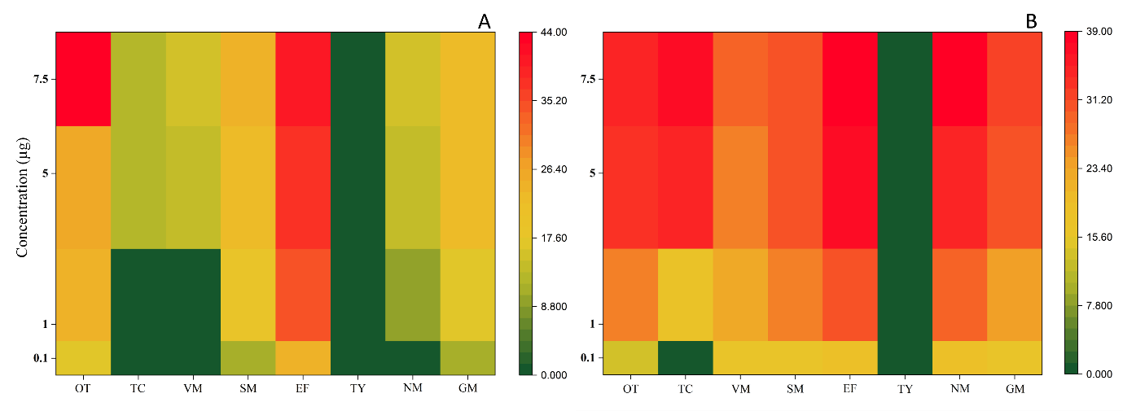
Figure.1 showed the results of the antibacterial susceptibility of the E. coli and Lactobacillus sp. against the different growth promoting antibiotics. Of the 8 different antibiotics were tested against these isolates, all the antibiotics shows significant susceptibility in all tested concentration except tylosin. Against E. coli, Enrofloxacin yielded the highest efficiency overall, by producing 24 mm zone at 0.1µg, and gradually increased to 40 mm in the maximum concentration (7.5µg). Similarly, Oxytetracycline also showed the gradual increase in inhibition ranging from 17 mm to 44 mm at tested concentrations. In contrast, Streptomycin,
Figure 1. Antibacterial susceptibility profiles of A) E. coli spp. and B) Lactobacillus spp. against eight antibiotics (OT, TC, VM, SM, EF, TY, NM, and GM) across increasing concentrations (0.1–7.5 µg). Colour gradients indicate the magnitude of inhibition, with green representing minimal inhibition and red representing strong inhibition, highlighting antibiotic-specific and dose-dependent variations in inhibitory response.
Tetracycline, Vancomycin, and Neomycin showed pattern of inhibition and their efficacy sharply increased at 5µg and higher concentrations. Alternatively, against Lactobacillus spp. all the antibiotics were exhibited very strong inhibition at low concentration (1µg) and showed gradual increase in inhibition with increased concentrations. Enrofloxacin and Neomycin revealed its highest potency (39 mm), while Oxytetracycline, Streptomycin, Gentamycin, and Vancomycin demonstrated consistent, dose-dependent antimicrobial action against the

Table 1. Nonlinear regression parameters obtained from the four-parameter logistic (4PL) model fitted to the Concentration–Response data of Selected Growth promoting Antibiotics against Escherichia coli spp. isolated from broiler chicken gut
 |  |  | Escherichia coli spp.
GPAs | MIC A1(%) | MIC A2(%) | Hill slope (p) | EC50 ± SE | EC90 ± SE | R² | p<0.01
Oxytetracycline | 28.53 | 82.88 | 0.0014 | 0.046±0.00 | 0.096±0.01 | 0.99 | *
Tetracycline | 32.63 | 89.72 | 0.01495 | 2.967±0.28 | 7.085±1.46 | 0.93 | *
Vancomycin | 41.2 | 93.7 | 0.00849 | 2.953±0.17 | 5.110±0.58 | 0.97 | *
Streptomycin | 37.95 | 100 | 0.01985 | 0.053±0.00 | 0.099±0.01 | 0.97 | *
Enrofloxacin | 50.71 | 100 | 8.69E-05 | 0.038±0.00 | 0.105±0.00 | 0.99 | *
Tylosin | 47.21 | 96.29 | 0.00869 | 10.790±0.42 | 15.850±1.32 | 0.96 | *
Neomycin | 28.31 | 100 | 0.00327 | 0.626±0.02 | 1.029±0.09 | 0.98 | *
Gentamycin | 35.53 | 100 | 7.65E-04 | 0.063±0.00 | 0.098±0.00 | 0.99 | *
Note:EC50 values expressed in μg/μl, R²=1 means perfect fit, * Statistically significant
Table 2. Nonlinear regression parameters obtained from the four-parameter logistic (4PL) model fitted to the Concentration–Response data of Selected Growth promoting Antibiotics against Lactobacillus spp. isolated from broiler chicken gut
 |  |  | Lactobacillus spp.
GPAs | MIC A1(%) | MIC A2(%) | Hill slope (p) | EC50 ± SE | EC90 ± SE | R² | p<0.01
Oxytetracycline | 35.2 | 86.21 | 0.00358 | 0.046±0.00 | 0.159±0.03 | 0.97 | *
Tetracycline | 44.33 | 91.71 | 6.85E-04 | 0.469±0.02 | 1.091±0.09 | 0.99 | *
Vancomycin | 42.66 | 82.25 | 2.97E-04 | 0.055±0.00 | 0.149±0.01 | 0.99 | *
Streptomycin | 28.53 | 79.1 | 0.00114 | 0.043±0.00 | 0.122±0.01 | 0.98 | *
Enrofloxacin | 38.4 | 90.45 | 9.09E-04 | 0.037±0.00 | 0.101±0.01 | 0.98 | *
Tylosin | 30.85 | 61.24 | 0.00105 | 6.201±0.17 | 9.134±0.45 | 0.99 | *
Neomycin | 32.72 | 78.79 | 0.01236 | 0.092±0.00 | 0.199±0.44 | 0.97 | *
Gentamycin | 42.58 | 88.44 | 0.00591 | 0.063±0.00 | 0.101±0.00 | 0.98 | *

Note: EC50 values expressed in μg/μl, R²=1 means perfect fit, * Statistically significant.
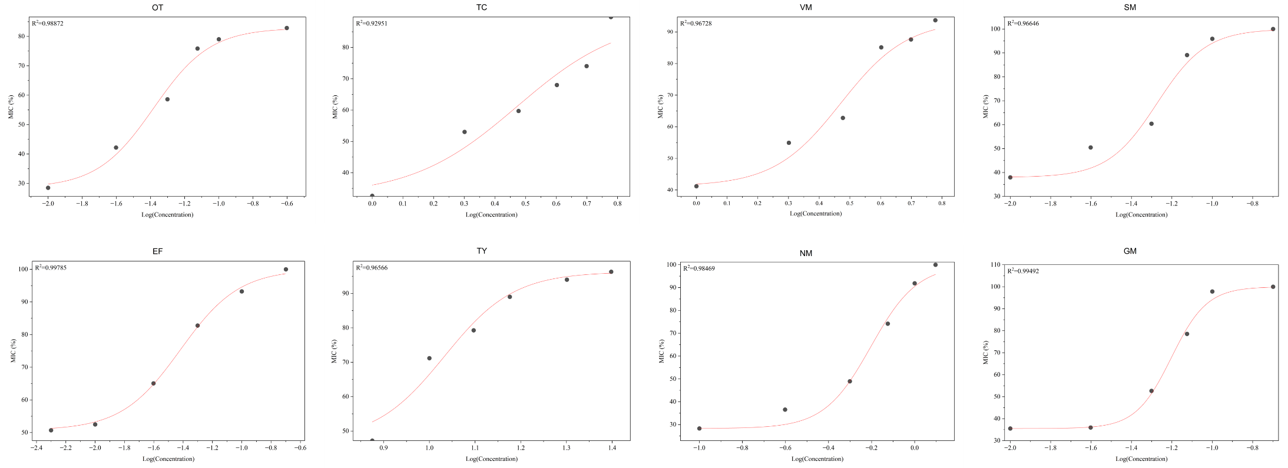
Graph. 1. Dose-Response curves of eight growth promoting antibiotics against the E. coli spp. showing the Concentration-dependent inhibition over the experimental period. Data represents the Slope (p) of the all fitted curves. (OT-Oxytetracycline, TC-Tetracycline, VM-Vancomycin, SM-Streptomycin, EF-Enrofloxacin, TY-Tylosin, NM-Neomycin, GM-Gentamycin)

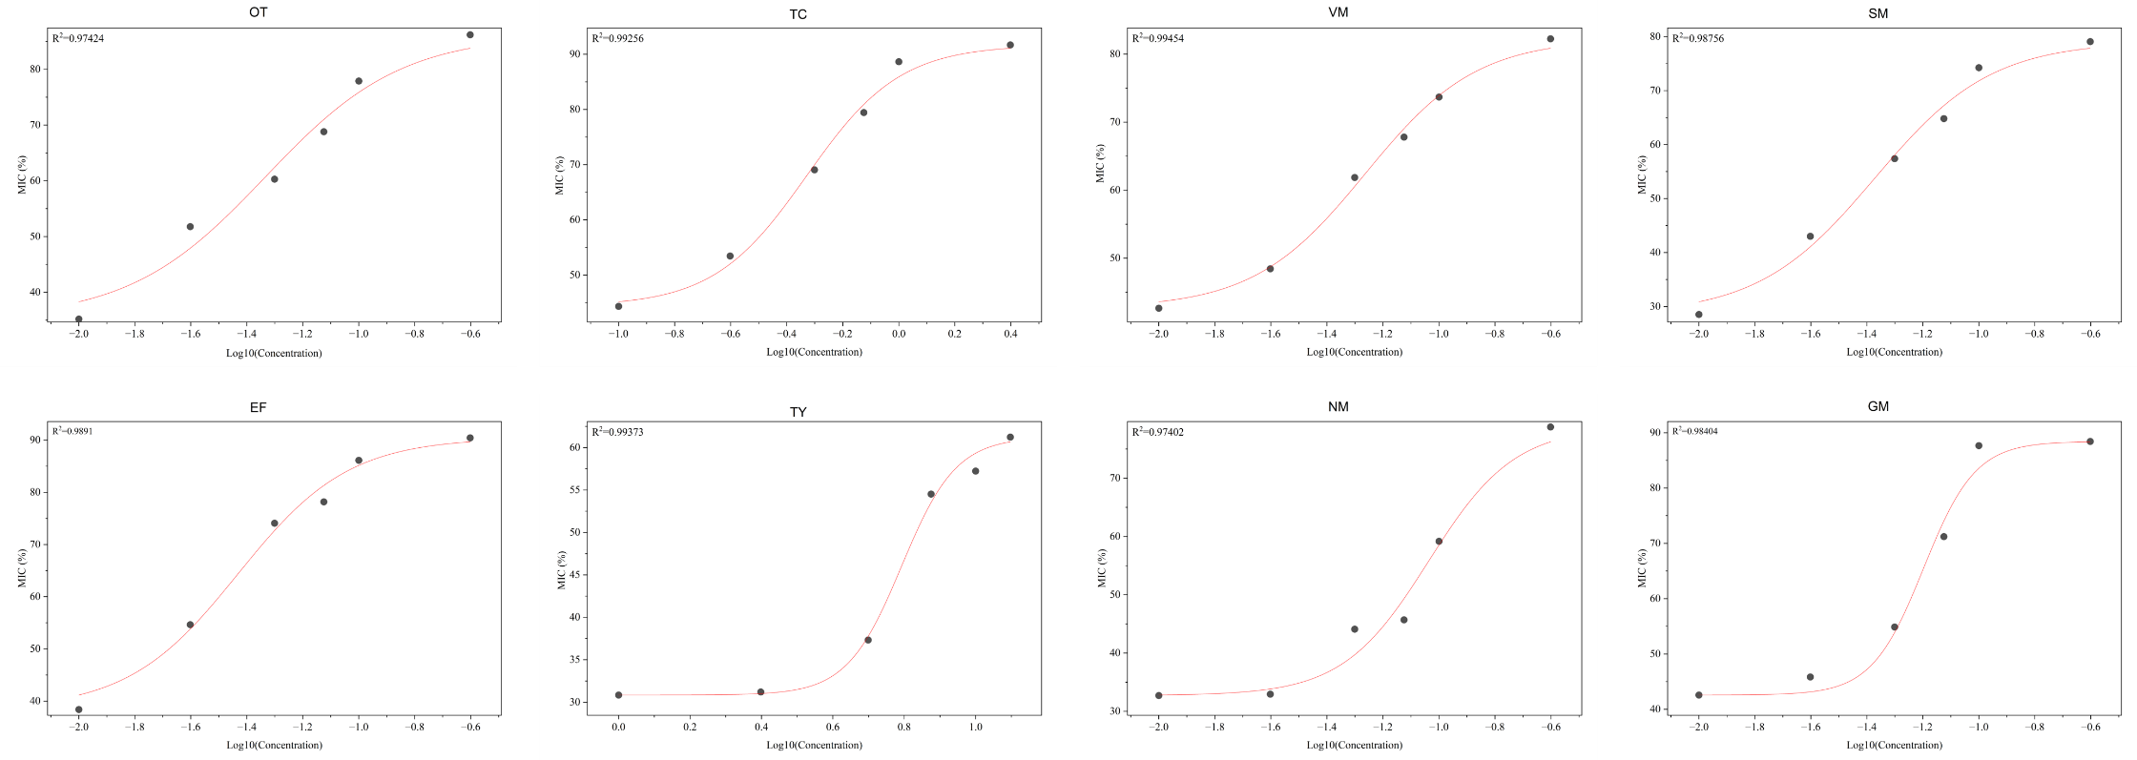
Graph. 2. Dose-Response curves of eight growth promoting antibiotics against the Lactobacillus spp. showing the Concentration-dependent inhibition over the experimental period. Data represents the Slope (p) of the all fitted curves. (OT-Oxytetracycline, TC-Tetracycline, VM-Vancomycin, SM-Streptomycin, EF-Enrofloxacin, TY-Tylosin, NM-Neomycin, GM-Gentamycin)

lactobacillus sp. Notably Tylosin demonstrated no effect and inhibitory activity in all tested concentrations against both the gut isolates.
3.2 Minimal Inhibitory Concentrations (MIC)
Table .1 and Table .2 showed the comparative analysis of the dose-response curves, quantified by the 50% effective concentration (EC50) revealed significant variability in the antimicrobial potency among the eight tested antibiotics against the two gut isolates. The MIC results against E. coli revealed the effective concentration required to kill the 50% bacterial population (EC50±SE) was reported to be 0.041±0µg/µl (OT), 2.967±0.28 µg/µl (TC), 2.953±0.17 µg/µl (VM), 0.053±0 µg/µl (SM), 0.038±0 µg/µl (EF), 10.790±0.42 µg/µl (TY), 0.626±0.02 µg/µl (NM), and 0.063±0 µg/µl (GM) respectively. Similarly, against the Lactobacillus sp. EC50 values reported from 0.046±0 µg/µl (OT), 0.469±0.02 µg/µl (TC), 0.055±0 µg/µl (VM), 0.043±0 µg/µl (SM), 0.037±0 µg/µl (EF), 6.201±0.17 µg/µl (TY), 0.092±0 µg/µl (NM), and 0.063±0 µg/µl (GM) respectively. The inflection points of the sigmoid curves, were influenced by the tested concentrations of the all-tested antibiotics confirmed the measured EC50 values as a strong parameter for quantifying the antibiotics’ potency in this non-linear regression model. Table 1. and Table .2 also indicated that obtained steepness values (hill slope) of sigmoid curves of all tested antibiotics also confirmed the significant transitions from the lower efficacy to the higher efficacy with all tested concentrations. All the growth curve fits were successfully fitted and demonstrated an excellent coefficient of determination (R²) values ranged from 0.93 to 0.99 and all the fits were highly statistically significant (p<0.01), supported the sturdiness of the parameter estimates.
3.3 Minimal Bactericidal Concentrations (MBC)
The MBC assay results were revealed the varied inhibitory concentrations among the eight growth promoting antibiotics against the E. coli and Lactobacillus sp. Oxytetracycline and tetracycline showed clear concentration - dependant reduction at all tested concentrations, whereas Enrofloxacin and Neomycin also showed visible growth reduction with the increasing concentrations. Gentamycin and Vancomycin demonstrated the antibacterial activity only in their highest concentrations. Streptomycin demonstrated the gradual inhibition, but permitted the growth at higher concentrations. Unlike other antibiotics, Tylosin demonstrated ineffectiveness by permitting the bacterial growth at all tested concentrations of all the antibiotics.
4. Discussion
The primary objective of this study was to test and evaluated the antimicrobial susceptibility and potency of the eight growth promoting antibiotics against E. coli and Lactobacillus sp. from the commercially slaughtered broiler chicken. A clear, potent antibacterial activity demonstrated by all tested antibiotics against the gut isolates was the most significant finding of this present study. Similarly, there was a significant substantial variability in their inhibitory potency against two tested bacteria comply with the studies of [26]. Comparing the data sets, Enrofloxacin (EF), consistently showed the higher efficacy against both bacteria, whereas Tylosin had no effects on either bacterium. The susceptibility profiles confirming that enrofloxacin was the most potent antibiotic among the all-tested antibiotics against the E. coli and Lactobacillus sp. Among the tested isolates, enrofloxacin demonstrated maximum efficiency, producing significant zone of inhibition (24 mm) even at the lowest concentration (0.1 µg) against E. coli and demonstrated significant increase with the increased concentration ranges. These findings were highly aligned with the recent studies of [27-28], stated that fluoroquinolones exhibit high and sustained efficacy against the both bacteria -by targets the enzyme systems of DNA replication [8]. The results of MIC detection showed the marginally different EC50 values of enrofloxacin against E. coli and Lactobacillus sp. affirms the non-selective nature of the antibiotic in the intestinal environment, provides the evidence for the sustainable substantial targets effects to the beneficial commensals like Lactobacillus sp. MIC results revealed oxytetracycline also established a strong antibacterial and dose dependent bacteriostatic effects against both bacteria, coincides with studies of [21,29-30], reasoned increasing consistent change in the tetracycline resistant due to the excessive dependence of these antibiotics in commercially intensive farming systems. Based on the results, a conspicuous finding was the non-existence of the antimicrobial activity of the tylosin against the both gut inhabitants in the in vitro conditions, clearly suggest either intrinsic resistant mechanism of tested bacteria or the increased level of procured resistance of these isolates against Tylosin. Our results indicates that the high EC50 values of Tylosin against the E. coli brings out that macrolides like Tylosin exhibit very poor efficacy against gram-negative bacteria like E. coli due to the hydrophobicity and membrane permeability, coincides with the findings of the [31]. Contrastingly, the Streptomycin, Tetracycline, Vancomycin, and Neomycin followed a “threshold effect” means they revealed the bacteriostatic effects only in the higher concentrations may potentially leads to the resistant strain selection rather than the elimination when the lower concentrations were repeatedly administrated. An important concern highlighted in the in our results is the high sensitivity of the lactobacillus spp. against the all- tested GPAs. This outcome may arise from the resistant stillness of the Lactobacillus sp. in the broiler gut and these commensals were considered as “beneficial residents” and they may have not evolved equivalent degrees of multidrug resistance like the other gut bacteria. Additionally, the same results were achieved by the [32] stating Lactobacillus sp. lacks the threshold resistance and this high level of inhibition may be attributed due to the initial responding behaviour of the Lactobacillus sp. in the gut against any oral antibiotic administration. furthermore, an important concern highlighted in the in our results is the high sensitivity of the lactobacillus sp. against the all-tested GPAs. Our findings clearly illustrates that this kind of sensitivity pattern demand high concern, because these species are very crucial for the short chain fatty acid production and the maintenance of lower intestinal pH [24, 33] and may leads to the dysbiosis, if it not systemically monitored. While provides significant quantitative data on antimicrobial susceptibility, our study has certain limitations including the In vitro nature of the investigation, number of gut isolates tested, and the high reliance of the phenotypic susceptibility testing. In spite of these limitations, our study acts as a critical baseline for understanding the concentration-dependent effects of growth-promoting antibiotics and emphasize the significant risk of collateral damage to the beneficial bacteria in the broiler gut. The findings of our study also stress some important futuristic aspects like In vitro models to In vivo trials, integrating Molecular and Metagenomic analysis and targeted alternatives to the GPA to reduce the usage of the growth promoting antibiotics and control the emergence the antimicrobial resistance in the broiler chicken production.
5. Conclusion
This investigation statistically tested and proved that antimicrobial susceptibility dynamics of eight growth-promoting antibiotics against E. coli and the Lactobacillus sp. isolated from the intestine of the broiler chicken and the high coefficient of determination and the statistical significance (p<0.01), validated the reliability of the EC50 values in explaining the antibacterial potency among the all-tested concentrations. The results suggested that Enrofloxacin and Oxytetracycline showed the maximum antibacterial efficacy against the selected bacteria in In vitro, whereas tylosin demonstrated a complete resistance contrastingly. This results clearly illustrates that the regular administration of minimal concentrations of these antibiotics can leads to the non-selection and dysbiosis of the other beneficial bacterial targets and may this phenomenon replicated in vivo environment and over usage of these broad spectral antibiotics may potentially disrupt the intestinal microbial homeostasis leading to depletion of the native beneficial bacteria, secondary infections and ultimately reduce the nutrition absorption in the processing in the broiler chicken.
8. Declaration of AI use
Authors hereby declares that NO generative AI technologies such as Large Language Models (ChatGPT, COPILOT, etc) and text-to-image generators have been used during writing or editing of this manuscript.
9. Competing interests
Authors have declared that no competing interests exist.
References
- Tona, G. O. (2018). Current and Future Improvements in Livestock. Animal husbandry and nutrition, 147.
- Meluzzi, A., & Sirri, F. (2009). Welfare of broiler chickens. Italian Journal of Animal Science, 8(sup1), 161-173.
- Apalowo, O. O., Ekunseitan, D. A., & Fasina, Y. O. (2024). Impact of heat stress on broiler chicken production. Poultry, 3(2), 107-128.
- Chattopadhyay, M. K. (2014). Use of antibiotics as feed additives: a burning question. Frontiers in microbiology, 5, 334.
- Gaonkar, P. P., & Huber, L. (2025). Addressing antimicrobial resistance in United States poultry: the critical need for environmental surveillance. Journal of the American Veterinary Medical Association, 263(12), 1481-1489.
- Graham, D. W., Bergeron, G., Bourassa, M. W., Dickson, J., Gomes, F., Howe, A., ... & Wittum, T. E. (2019). Complexities in understanding antimicrobial resistance across domesticated animal, human, and environmental systems. Annals of the New York Academy of Sciences, 1441(1), 17-30.
- Butaye, P., Devriese, L. A., & Haesebrouck, F. (2003). Antimicrobial growth promoters used in animal feed: effects of less well-known antibiotics on gram-positive bacteria. Clinical microbiology reviews, 16(2), 175-188.
- Gupta, C. L., Blum, S. E., Kattusamy, K., Daniel, T., Druyan, S., Shapira, R., ... & Cytryn, E. (2021). Longitudinal study on the effects of growth-promoting and therapeutic antibiotics on the dynamics of chicken cloacal and litter microbiomes and resistomes. Microbiome, 9(1), 178.
- Salaheen, S., Kim, S. W., Haley, B. J., Van Kessel, J. A. S., & Biswas, D. (2017). Alternative growth promoters modulate broiler gut microbiome and enhance body weight gain. Frontiers in microbiology, 8, 2088.
- Mehdi, Y., Létourneau-Montminy, M. P., Gaucher, M. L., Chorfi, Y., Suresh, G., Rouissi, T., ... & Godbout, S. (2018). Use of antibiotics in broiler production: Global impacts and alternatives. Animal nutrition, 4(2), 170-178.
- Miyakawa, M. E. F., Casanova, N. A., & Kogut, M. H. (2024). How did antibiotic growth promoters increase growth and feed efficiency in poultry? Poultry science, 103(2), 103278.
- Paul, S. S., Rama Rao, S. V., Hegde, N., Williams, N. J., Chatterjee, R. N., Raju, M. V. L. N., ... & Gargi, M. (2022). Effects of dietary antimicrobial growth promoters on performance parameters and abundance and diversity of broiler chicken gut microbiome and selection of antibiotic resistance genes. Frontiers in microbiology, 13, 905050.
- Akbar, A., & Anal, A. K. (2013). Prevalence and antibiogram study of Salmonella and Staphylococcus aureus in poultry meat. Asian Pacific journal of tropical biomedicine, 3(2), 163-168.
- Roy, M., Islam, O., Rahman, M. A., Misty, S. S., Kurmi, R., Islam, M. A., ... & Islam, M. S. (2025). Prevalence and antimicrobial resistance patterns of Escherichia coli isolated from broiler chickens in Sylhet district of Bangladesh. Veterinary Medicine and Science, 11(5), e70576.
- Brower, C. H., Mandal, S., Hayer, S., Sran, M., Zehra, A., Patel, S. J., ... & Laxminarayan, R. (2017). The prevalence of extended-spectrum beta-lactamase-producing multidrug-resistant Escherichia coli in poultry chickens and variation according to farming practices in Punjab, India. Environmental health perspectives, 125(7), 077015.
- Christodoulou, M. K., & CHRISTODOULOU, M. K. (2023). Comparison of antimicrobial resistance in Escherichia coli strains isolated from swine, poultry, and farm workers in the respective livestock farming units in Greece. Cureus, 15(12).
- Soro, K. D., Kagambega, A., Nikiema, M. M., Sawadogo, A., Bouda, S. C., Compaore, K. M., ... & BARRO, N. (2024). Characteristics of poultry farms and use of antibiotics in Peri-urban farms in Burkina Faso. Int J Curr Microbiol App Sci, 13, 231-247.
- Forder, R. E. A., Howarth, G. S., Tivey, D. R., & Hughes, R. J. (2007). Bacterial modulation of small intestinal goblet cells and mucin composition during early posthatch development of poultry. Poultry science, 86(11), 2396-2403.
- Kwak, M. J., Park, M. Y., Choi, Y. S., Cho, J., Pathiraja, D., Kim, J., ... & Whang, K. Y. (2021). Dietary sophorolipid accelerates growth by modulation of gut microbiota population and intestinal environments in broiler chickens. Journal of Animal Science and Biotechnology, 12(1), 81.
- Perić, D., Šefer, D., Barea, R., Radulović, S., Jovanović, D., Grdović, S., & Marković, R. (2025). Organic trace minerals as an innovative nutritional solution for advancement of production performance and intestinal microbiota in piglets. Scientific journal" Meat Technology", 66(3), 182-189.
- Xu, Y., Chen, K., Huang, Y., Yan, Y., Zhang, W., Tian, J., ... & Nie, Q. (2025). Fecal microbiota transplantation improves growth performance of chickens by increasing the intestinal Lactobacillus and glutamine. Poultry Science, 105243.
- Lu, J., Idris, U., Harmon, B., Hofacre, C., Maurer, J. J., & Lee, M. D. (2003). Diversity and succession of the intestinal bacterial community of the maturing broiler chicken. Applied and environmental microbiology, 69(11), 6816-6824.
- Stamilla, A., Ruiz-Ruiz, S., Artacho, A., Pons, J., Messina, A., Lucia Randazzo, C., ... & Moya, A. (2021). Analysis of the microbial intestinal tract in broiler chickens during the rearing period. Biology, 10(9), 942.
- Coelho-Rocha, N. D., de Jesus, L. C. L., Barroso, F. A. L., da Silva, T. F., Ferreira, E., Gonçalves, J. E., ... & Azevedo, V. A. D. C. (2023). Evaluation of probiotic properties of novel Brazilian Lactiplantibacillus plantarum strains. Probiotics and Antimicrobial Proteins, 15(1), 160-174.
- Aruwa, C. E., Pillay, C., Nyaga, M. M., & Sabiu, S. (2021). Poultry gut health–microbiome functions, environmental impacts, microbiome engineering and advancements in characterization technologies. Journal of Animal Science and Biotechnology, 12(1), 119.
- Ma, B., Wang, D., Mei, X., Lei, C., Li, C., & Wang, H. (2023). Effect of enrofloxacin on the microbiome, metabolome, and abundance of antibiotic resistance genes in the chicken cecum. Microbiology spectrum, 11(2), e04795-22.
- Fletcher, S. (2015). Understanding the contribution of environmental factors in the spread of antimicrobial resistance. Environmental health and preventive medicine, 20(4), 243-252.
- Nicholds, J. A., French, D., Parker, D., & O'Kane, P. (2024). Antimicrobial Therapy in Poultry. Antimicrobial Therapy in Veterinary Medicine, 697-719.
- Untari, T., Herawati, O., Anggita, M., Asmara, W., Wahyuni, A. E. T. H., & Wibowo, M. H. (2021). The effect of antibiotic growth promoters (AGP) on antibiotic resistance and the digestive system of broiler chicken in Sleman, Yogyakarta. In BIO Web of Conferences (Vol. 33, p. 04005). EDP Sciences.
- Kerek, Á., Szabó, Á., Barnácz, F., Csirmaz, B., Kovács, L., & Jerzsele, Á. (2025). Antimicrobial Susceptibility Profiles of Commensal Enterococcus spp. Isolates from Turkeys in Hungarian Poultry Farms Between 2022 and 2023. Antibiotics, 14(4), 331.
- Hamed, F., & Isa, J. K. (2024). Isolation of Lactobacillus spp. from Healthy Infants' Feces and Study of their Antibiotic Susceptibility. Wasit Journal for Pure sciences, 3(3), 208-215.
- Mosa, M. I., Salem, H. M., Hassan, M., El-Saied, M. A., Bastamy, M. A., & Amer, M. M. (2025). The effect of infectious bursal disease virus infection on gut microbiota of broiler chicken and the role of prebiotics and probiotics on correction of gut dysbiosis using analysis of 16s rrna gene sequencing. Bulgarian Journal of Veterinary Medicine, 28(3).

