Original Research Article
Prevalence of Microplastics in Coastal Waters at Veraval, Saurashtra Coast, Gujarat, India.

ABSTRACT
The prevalence of microplastics in coastal water, Veraval at the Saurashtra coast off Gujarat, India, was studied. The sampling was carried out in Gujarat, focusing on the coastal areas of Veraval coast, a part of Saurashtra coastal region. Two sampling stations were established at each location to ensure diverse data collection and account for potential spatial variations in microplastic intensity. Monthly sample was collected from Oct. 2020 to Mar. 2021 through using OBM boat with 2-3 knot speed. The average microplastic abundance in coastal water at stations 1 and 2 was 0.132 ± 0.018 no./m³ and 0.071 ± 0.014 no./m³, respectively. Fiber-shaped and size fractions of microplastics ranging from 2000 μm to 4000 μm were dominant in both coastal water stations. Black and red microplastics were identified abundantly at both coastal water sampling stations. Fishing and related activities, riverine flow, and tourism contributed to the abundance and widespread distribution of microplastics in coastal water. This finding reveals the presence of microplastic contamination in the coastal water of Veraval, which necessitates scientific regulation and management by enforcing comprehensive waste management strategies.
Keywords: Microplastic, coastal water, microplastic pollution, Plastic, Saurashtra coast.
1. Introduction
Marine ecosystems, ranging from coastal habitats to the deep sea, sustain rich biodiversity, regulate climate, and support human livelihoods. However, escalating plastic pollution, driven by excessive use and poor waste management, has become the dominant marine debris, persisting for centuries due to its extremely slow degradation and posing a serious threat to ecosystem health and sustainability (Peng et al., 2018). Driven by their versatility and low cost, plastics have expanded rapidly, with global production rising from 1.5 million tonnes to 400.3 million tonnes in 2022 (Plastic Europe, 2023) and projected to approach 1 billion tonnes by 2050 (Lusher et al., 2017).
Microplastics in coastal waters are categorized by their origin, size, and shape (Thompson et al., 2004). Microplastics are classified as primary or secondary based on origin. Microplastics are categorized as primary, deliberately manufactured particles used in cosmetics and industry, and secondary, formed by the breakdown of larger plastics through UV radiation and mechanical abrasion. Further differentiated by size (micro- and nanoplastics) and shape (fragments, beads, fibers, films, and foams). This classification helps identify their sources, environmental distribution, and ecological impacts, supporting effective mitigation strategies (Thompson et al., 2004; Kershaw et al., 2019).
Numerous studies have reported the presence of microplastics in freshwater (Peng et al., 2018; Di and Wang, 2018), brackish water, and marine water (Abidli et al., 2017). Microscopic plastics are now ubiquitous across global marine environments, occurring from beaches and surface waters to the deep-sea floor (Ashton et al., 2010; Lusher et al., 2017). Additionally, microplastics have been reported in the coastal waters of India (Gurjar et al., 2022), estuarine waters (Ramesh et al., 2022), and beach sediments (Sunitha et al., 2021). The presence of microplastics has been reported across various levels of the marine food chain viz., zooplankton (Collignon et al., 2012), mussels (Karlsson, 2017), bivalves (Li et al., 2015), crustaceans (Daniel et al., 2020), fishes (Karlsson, 2017), marine mammals (Nelms et al., 2019), whales (Besseling et al., 2015), dolphins (Nelms et al., 2019), sea birds (Provencher et al., 2018), and sea turtles (Ocean Conservancy, 2016), highlighted the need of comprehensive study.
Gujarat is a leading coastal state of India with an extensive ~2,300 km Arabian Sea coastline that supports rich marine biodiversity and key fisheries and tourism activities. Plastic pollution research has underrepresented the extent of microplastic pollution on the Gujarat coast, as only a few studies (Vidyasakar et al., 2021; Rabari et al., 2022) have delved into this critical issue. In this context, the study aims to assess microplastic pollution in coastal waters by quantifying its spatial-temporal distribution and physical characteristics, thereby supporting effective coastal waste management strategies.
2. MATERIALS AND METHODS
2.1. Sampling sites
The sampling was carried out in Gujarat, focusing on the coastal areas of the Veraval coast, which were chosen for their importance in regional marine habitats. Veraval, a prominent fishing harbour, large-scale fishing activities, and riverine activity were selected to provide a comprehensive overview of microplastic pollution at spatial and temporal scales in coastal waters (CWs). Two sampling stations were established at each location to ensure diverse data collection and account for potential spatial variations in microplastic intensity. The monthly sample was collected by using of OBM boat with 2-3 knot small speed, sampling period spanned from October 2020 to March 2021, a timeframe chosen to capture seasonal variations and assess the impact of both monsoon and post-monsoon conditions on plastic debris distribution. Coastal water samples were collected from Veraval, viz., Station 1-CWs (Bhidbhanjan) (20.89411°N, 70.37650°E) and Station 2-CWs (Triveni) (20.879165°N, 70.405367°E), respectively (Fig. 1).
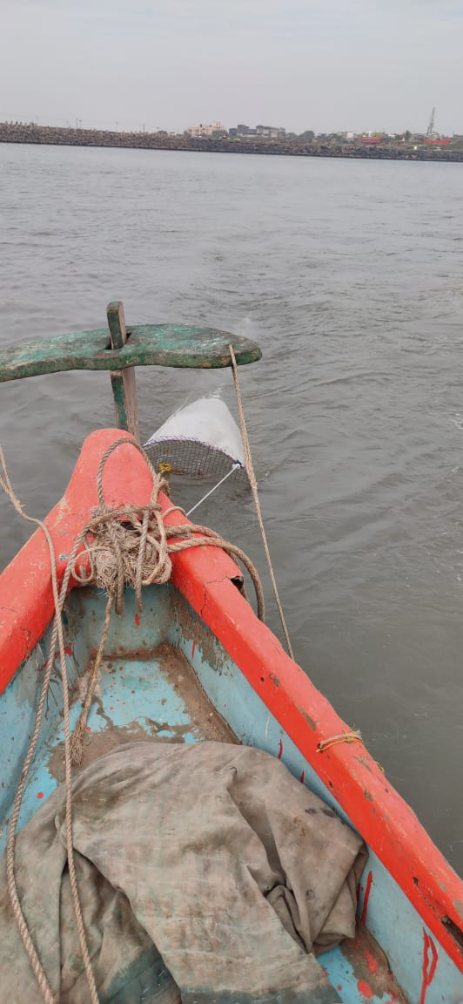 | 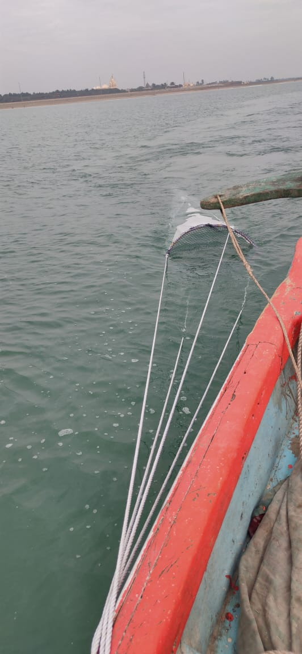
Fig. 1 Sampling images of A. Station 1-CWs (Bhidbhanjan) and B. Station 2-CWs (Triveni).
2.2. Microplastic sampling and extraction from coastal waters
Water samples were collected in triplicate using a plankton net of 50 μm mesh size. The plankton net was deployed from an outboard motorized boat (OBM) with an overall length (OAL) of 10-20 feet, operating at a minimal speed to avoid damaging the net and minimizing surfing impact. Samples were correctly collected and transported to the laboratory for further analysis. In the laboratory, the samples were treated with 30% hydrogen peroxide (H₂O₂) at room temperature in the dark for 24 hours to digest organic matter. The treated samples were diluted with distilled water and filtered through a cellulose nitrate membrane filter paper (0.45 μm, 47 mm, Whatman) through a vacuum filtration pump unit (Axiva made). The filter papers were placed in clean Petri dishes and examined visually using a LEICA stereoscopic microscope equipped with a digital camera (Wang et al., 2017) for the presence of microplastic particles.
2.3. Physical characteristics of microplastics
Microplastic particles were counted, and their physical characteristics, size, shape, and colour were assessed for each identified particle. Particles were classified according to shape into various categories, such as fibers, fragments, films, pellets, and foams (Kershaw et al., 2019). The colours of the microplastics were visually identified and noted. Additionally, particles were categorized into five size ranges: <500 μm, 501-1000 μm, 1001-2000 μm, 2001-4000 μm, and 4001-5000 μm for the size distribution of microplastics.
2.4. Statistical analysis
The statistical analysis assessed spatial-temporal variations in microplastic abundance in coastal water (Gregory, 2009;) using the Analysis of Variance (ANOVA) in Microsoft Excel with statistical significance (p-value: <0.05). Spatial variation was analyzed by comparing microplastic abundance between different sampling sites along the coastline, while temporal variation was assessed by evaluating data collected over different seasons or periods.
3. Results and Discussion
3.1. Microplastic analysis: coastal water
3.1.1. Microplastic abundance
The monthly variation in microplastic abundance (mean ± SD, no/m³) from coastal waters at Stations 1 and 2 is given in Table 1. The abundance of microplastics from coastal water samples at stations 1 and 2 ranged between 0.106 to 0.150 no/m³ and 0.056 to 0.093 no/m³, respectively. The average microplastic abundance was 0.132 no/m³ at Station 1 and 0.071 no/m³ at Station 2. The highest abundance was recorded at Station 1 in November 2020 (0.150 no/m³) and Station 2 in October 2020 (0.093 no/m³). The lowest values were noted at Station 1 in March 2021 (0.106 no/m³) and Station 2 in January 2021 (0.056 no/m³). Station 1 consistently showed higher microplastic pollution levels compared to Station 2. Statistical analysis indicated significant differences (P < 0.05) in microplastic abundance across different months and between the stations.
3.1.2 Physical characteristics of microplastics
The shape, size, and colour composition of microplastics in coastal waters at stations 1 and 2 were illustrated in Fig. 2. Microplastics were categorized into four distinct shapes, viz., fiber, fragment, film, and foam. Fibers were the most prevalent at both stations, followed by fragments, films, and foams. The size distribution of microplastics was classified into five ranges: <500 μm, 501-1000 μm, 1001-2000 μm, 2001-4000 μm, and 4001-5000 μm. At Station 1, the predominant size range was 2000-4000 μm, and at Station 2, the most common size range was 1000-2000 μm. Seven colours of microplastics were recorded: black, red, blue, white, transparent, green, and yellow. Black colour microplastics were most common at station 1, while red microplastics were predominant at station 2.
3.1.3. Coastal water
Table 1 Monthly Variations (mean ± SD) of microplastic abundance (no/m³) from coastal water at Veraval coast
Months SamplStation |  | October | November | December | January | February | March
Coastal water | ^{S1} | ^{0.148 ± 0.038} | ^{0.150 ± 0.021} | ^{0.142 ± 0.009} | ^{0.133 ± 0.031} | ^{0.112 ± 0.030} | ^{0.106 ± 0.013}
Coastal water | ^{S2} | ^{0.093 ± 0.013} | ^{0.080 ± 0.007} | ^{0.058 ± 0.008} | ^{0.056 ± 0.015} | ^{0.068 ± 0.009} | ^{0.070 ± 0.006}

Our findings indicate that the coastal waters of the Veraval coast are significantly impacted by microplastic pollution, with Station 1 exhibiting higher levels of contamination than Station 2. The elevated microplastic concentrations at Station 1 are likely attributable to the intense fishing activities in the area. Marine litter from maritime sources, such as the fishing and aquaculture industries, contributes to this pollution (Jambeck et al., 2015). Plastic materials used in boat construction (such as painting and antifouling coatings), maintenance, fishing gear (including nets, trawls, dredges, traps, floats, lures, hooks, and lines), fish hold insulation, and fish crates all contribute to the microplastic load observed at Station 1 (FAO, 2016). The highest recorded microplastic abundance at Station 1 was 0.150 no/m³, consistent with similar findings of 0.15 no/m³ reported for surface waters in the northwestern Mediterranean (De Lucia et al., 2014).
Fig. 2 Physical characteristics of microplastics in the collected sample from coastal water: A) Shape composition, B) Size composition & C) Colour composition.
The abundance of microplastics at Station 2 was lower compared to Station 1, primarily due to the influence of tourism and riverine flow. Land-based sources of microplastics include unprotected landfills and dumps near coastal areas or riverine systems, public litter, and extreme shoreline events such as storms (Allsopp et al., 2006). At Station 2, the peak microplastic concentration was recorded at 0.093 no/m³ in October during the post-monsoon period. The microplastic levels at Station 2 are influenced by riverine flow and tourism. Similar trends have been observed on the Chennai coast, where coastal flooding has led to a three-fold increase in microplastic abundance attributed to riverine transport (Veerasingam et al., 2016). Additionally, increased microplastic loads inshore reflect terrestrial runoff contributions and particles' re-suspension from sediments following storm events (Lattin et al., 2004).
A. Fiber | B. Fragments
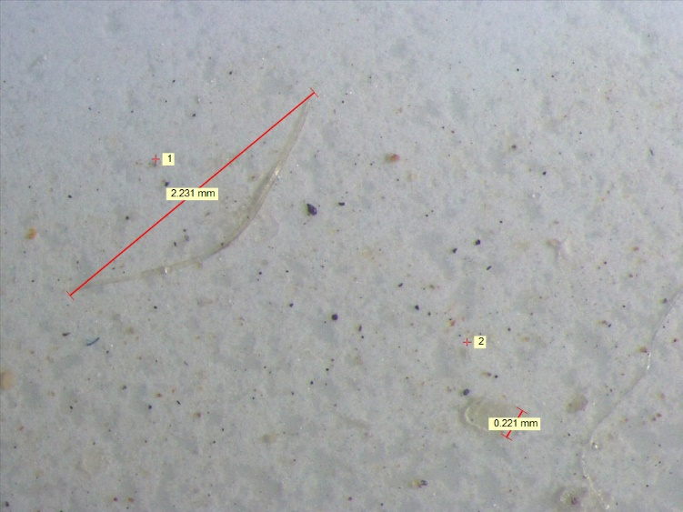 | 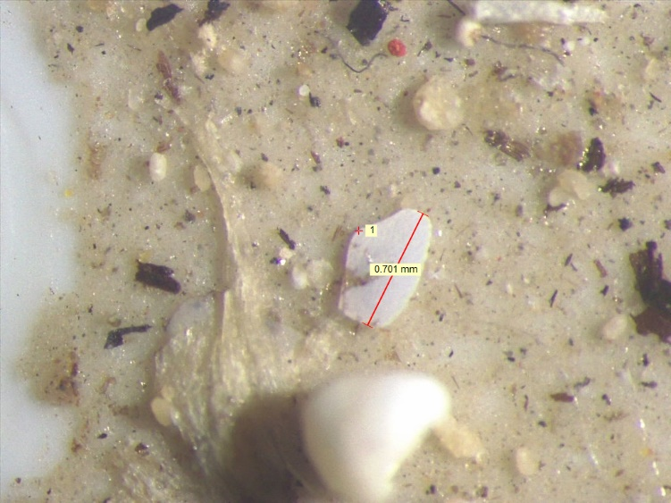
C. Film | D. Foam
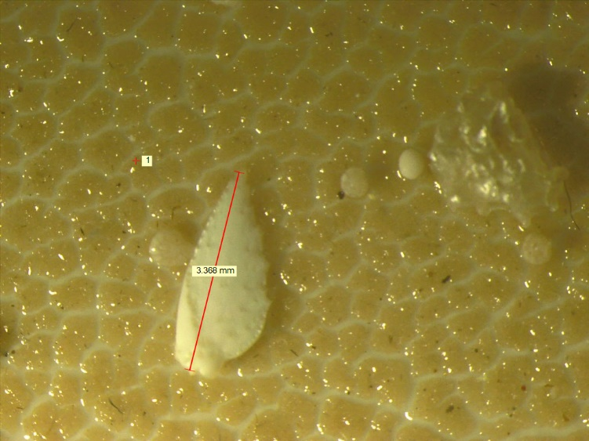 | 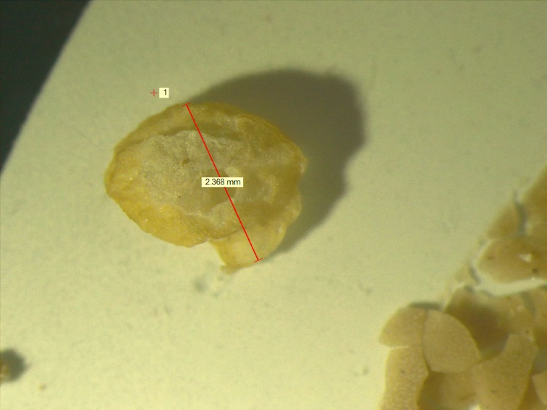

Fig. 3 Photographs of different shapes, sizes, and colors of microplastics
The fiber-shaped microplastics were the most prevalent at both coastal stations. Fibers and granules are among the most common forms of plastic debris found in oceans globally (Eriksen et al., 2014; Lusher et al., 2017). Fishing activities are a significant source of fiber and filament-shaped microplastics (Kershaw et al., 2019). Fragment-shaped microplastics arise from biological fragmentation, photodegradation, chemical weathering, and the fragmentation of larger plastic items (Andrady et al., 2011; Cole et al., 2011; Duis and Coors, 2016). In this study, the predominant size range of microplastics was 2001 μm - 4000 μm. Thompson et al. (2004) noted that particles < 20 μm are more likely to be ingested by small invertebrates, and filter-feeding organisms and fish can have significant detrimental effects like intestinal blockage, nutritional deficiencies, and increased mortality (Wessel et al., 2016). The dominant colours of microplastics observed were red and black. The colour of microplastics is crucial in their ingestion by marine organisms, as coloured microplastics can attract predators by resembling their prey (Retama et al., 2016).
4. Conclusions
Our study elucidates the pervasive impact of microplastics on coastal waters, revealing significant variations in shape, size, and colour. The findings indicate that microplastic abundance is notably higher at Station 1 compared to Station 2 in coastal waters. At Station 1, key contributors to this elevated microplastic load include fishing activities, harbour operations, and fisheries-related businesses. Seasonal variations also affect microplastic abundance, with post-monsoon months (October-December) showing increased levels at Station 2 compared to other periods (January-March). Plastic pollution significantly threatens aquatic environments and organisms, necessitating ongoing monitoring and management. Enhanced understanding of the impacts of microplastics on marine ecosystems and human health should be prioritized to address this growing environmental concern effectively. Regular beach clean-up initiatives should be enforced in coastal areas to remove accumulated microplastics and prevent their further dispersal. Improving wastewater treatment processes to capture microplastics before they reach marine waters is also critical. Public awareness campaigns can educate communities about the impact of plastic pollution and encourage responsible behavior. Research and monitoring programs should be strengthened to better understand the microplastic distribution and impact, enabling targeted intervention strategies. Collaborative efforts between governments, industries, and local communities are vital for effectively addressing this environmental challenge.
Disclaimer (Artificial intelligence)
Option 1:
Author(s) hereby declare that NO generative AI technologies such as Large Language Models (ChatGPT, COPILOT, etc.) and text-to-image generators have been used during the writing or editing of this manuscript.

References
- Abidli, S., Toumi, H., Lahbib, Y., & Trigui El Menif, N. (2017). The first evaluation of microplastics in sediments from the complex lagoon-channel of Bizerte (Northern Tunisia). Water, Air, & Soil Pollution, 228, 1-10. https://doi.org/10.1007/s11270-017-3439-9
- Allsopp, M., Santillo, D., & Johnston, P. (2006). Environmental and human health concerns in the processing of electrical and electronic waste. UK: Greenpeace Research Laboratories, Department of Biological Sciences, University of Exeter, Exeter.
- Andrady, A. L. (2011). Microplastics in the marine environment. Marine pollution bulletin, 62(8), 1596-1605. https://doi.org/10.1016/j.marpolbul.2011.05.030
- Ashton, K., Holmes, L., & Turner, A. (2010). Association of metals with plastic production pellets in the marine environment. Marine pollution bulletin, 60(11), 2050-2055. https://doi.org/10.1016/j.marpolbul.2010.07.014
- Besseling, E., Foekema, E. M., Van Franeker, J. A., Leopold, M. F., Kühn, S., Rebolledo, E. B., & Koelmans, A. A. (2015). Microplastic in a macro filter feeder: humpback whale Megaptera novaeangliae. Marine pollution bulletin, 95(1), 248-252. https://doi.org/10.1016/j.marpolbul.2015.04.007
- Cole, M., Lindeque, P., Halsband, C., & Galloway, T. S. (2011). Microplastics as contaminants in the marine environment: a review. Marine pollution bulletin, 62(12), 2588-2597. https://doi.org/10.1016/j.marpolbul.2011.09.025
- Collignon, A., Hecq, J. H., Glagani, F., Voisin, P., Collard, F., & Goffart, A. (2012). Neustonic microplastic and zooplankton in the North Western Mediterranean Sea. Marine pollution bulletin, 64(4), 861-864.
- Conservancy, O. (2016). 30th Anniversary International Coastal Cleanup. www.oceanconservancy.org
- Daniel, D. B. Ashraf, P. M., & Thomas, S. N. (2020). Abundance, characteristics and seasonal variation of microplastics in Indian white shrimps (Fenneropenaeus indicus) from coastal waters off Cochin, Kerala, India. Science of the Total Environment, 737, 139839. https://doi.org/10.1016/j.scitotenv.2020.139839
- De Lucia, G. A., Caliani, I., Marra, S., Camedda, A., Coppa, S., Alcaro, L., & Matiddi, M. (2014). Amount and distribution of neustonic micro-plastic off the western Sardinian coast (Central-Western Mediterranean Sea). Marine environmental research, 100, 10-16. https://doi.org/10.1016/j.marenvres.2014.03.017
- Di, M., & Wang, J. (2018). Microplastics in surface waters and sediments of the Three Gorges Reservoir, China. Science of the Total Environment, 616, 1620-1627. https://doi.org/10.1016/j.scitotenv.2017.10.150
- Duis, K., & Coors, A. (2016). Microplastics in the aquatic and terrestrial environment: sources (with a specific focus on personal care products), fate and effects. Environmental Sciences Europe, 28(1), 2. . https://doi.org/10.1186/s12302-015-0069-y
- Eriksen, M., Lebreton, L. C., Carson, H. S., Thiel, M., Moore, C. J., Borerro, J. C., & Reisser, J. (2014). Plastic pollution in the world's oceans: more than 5 trillion plastic pieces weighing over 250,000 tons afloat at sea. PloS one, 9(12), e111913. https://doi.org/10.1371/journal.pone.0111913
- FAO. (2016). Fisheries and Aquaculture topics. Fish capture technology. Topics Fact Sheets. In: FAO Fisheries and Aquaculture Department. Available at http://www.fao.org/fishery/technology/capture/en.
- Gregory, M. R. (2009). Environmental Implications of Plastic Debris in Marine Settings—entanglement, ingestion, smothering, hangers-on, and alien invasions. Philosophical Transactions of the Royal Society B, 364(1526), 2013-2025.
- Gurjar, U. R., Xavier, K. M., Shukla, S. P., Jaiswar, A. K., Deshmukhe, G., & Nayak, B. B. (2022). Microplastic pollution in coastal ecosystem off Mumbai coast, India. Chemosphere, 288, 132484. https://doi.org/10.1016/j.chemosphere.2021.132484
- Jambeck, J. R., Geyer, R., Wilcox, C., Siegler, T. R., Perryman, M., Andrady, A., & Law, K. L. (2015). Plastic waste inputs from land into the ocean. science, 347(6223), 768-771. https://doi.org/10.1126/science.1260352
- Karlsson, T. M., Vethaak, A. D., Almroth, B. C., Ariese, F., van Velzen, M., Hassellöv, M., & Leslie, H. A. (2017). Screening for microplastics in sediment, water, marine invertebrates and fish: Method development and microplastic accumulation. Marine pollution bulletin, 122(1-2), 403-408. https://doi.org/10.1016/j.marpolbul.2017.06.081
- Kershaw, P. J., Turra, A., & Galgani, F. (2019). Guidelines for the monitoring and assessment of plastic litter and microplastics in the ocean.
- Lattin, G. L., Moore, C. J., Zellers, A. F., Moore, S. L., & Weisberg, S. B. (2004). A comparison of neustonic plastic and zooplankton at different depths near the southern California shore. Marine pollution bulletin, 49(4), 291-294. https://doi.org/10.1016/j.marpolbul.2004.01.020
- Li, J., Yang, D., Li, L., Jabeen, K., & Shi, H. (2015). Microplastics in commercial bivalves from China. Environmental pollution, 207, 190-195. https://doi.org/10.1016/j.envpol.2015.09.018
- Lusher, A., Hollman, P., & Mendoza-Hill, J. (2017). Microplastics in fisheries and aquaculture: status of knowledge on their occurrence and implications for aquatic organisms and food safety. FAO Fisheries and Aquaculture Technical Paper. No. 615. Rome, Italy.
- Nelms, S. E., Barnett, J., Brownlow, A., Davison, N. J., Deaville, R., Galloway, T. S., & Godley, B. J. (2019). Microplastics in marine mammals stranded around the British coast: ubiquitous but transitory?. Scientific Reports, 9(1), 1075. https://doi.org/10.1016/j.trac.2018.10.020
- Nelms, S. E., et al. (2019). Microplastics in marine mammals stranded around the British coast: ubiquitous but transitory ?. Scientific Reports, 9(1), 1075. https://doi.org/10.1038/s41598-018-37428-3
- Peng, G., Xu, P., Zhu, B., Bai, M., & Li, D. (2018). Microplastics in freshwater river sediments in Shanghai, China: a case study of risk assessment in mega-cities. Environmental Pollution, 234, 448-456. https://doi.org/10.1016/j.envpol.2017.11.034
- PLASTICS EUROPE. Plastics-the Facts, 2023. Accessible from https://plasticseurope.org/knowledge-hub/plastics-the-fast-facts-2023/
- Provencher, J. F., Vermaire, J. C., Avery-Gomm, S., Braune, B. M., & Mallory, M. L. (2018). Garbage in guano? Microplastic debris found in faecal precursors of seabirds known to ingest plastics. Science of the Total Environment, 644, 1477-1484. https://doi.org/10.1016/j.scitotenv.2018.07.101
- Rabari, V., Patel, K., Patel, H., & Trivedi, J. (2022).Quantitative assessment of microplastic in sandy beaches of Gujarat state, India. Marine Pollution Bulletin, 181, 113925. https://doi.org/10.1016/j.marpolbul.2022.113925
- Ramesh, S., & Nagalakshmi, R. (2022). Influence of COVID-19 on microplastics pollution in coastal water and sediment of Chennai, India. In Advances in Construction Management: Select Proceedings of ACMM 2021. Singapore: Springer Nature Singapore, pp. 547-563.https://doi.org/10.1007/978-981-16-5839-6_47
- Retama, I., Jonathan, M. P., Shruti, V. C., Velumani, S., Sarkar, S. K., Roy, P. D., & Rodríguez-Espinosa, P. F. (2016). Microplastics in tourist beaches of Huatulco Bay, Pacific coast of southern Mexico. Marine Pollution Bulletin, 113(1-2), 530-535.
- Sunitha, T. G., Monisha, V., Sivanesan, S., Vasanthy, M., Prabhakaran, M., Omine, K., & Darchen, A. (2021). Micro-plastic pollution along the Bay of Bengal coastal stretch of Tamil Nadu, South India. Science of the Total Environment, 756, 144073. https://doi.org/10.1016/j.scitotenv.2020.144073
- Thompson, R. C., Olsen, Y., Mitchell, R. P., Davis, A., Rowland, S. J., John, A. W., & Russell, A. E. (2004). Lost at sea: where is all the plastic?. Science, 304(5672), 838-838. https://doi.org/10.1126/science.1094559
- Veerasingam, S. Mugilarasan, M., Venkatachalapathy, R., & Vethamony, P. (2016). Influence of 2015 flood on the distribution and occurrence of microplastic pellets along the Chennai coast, India. Marine pollution bulletin, 109(1), 196-204. https://doi.org/10.1016/j.marpolbul.2016.05.082
- Vidyasakar, A., Krishnakumar, S., Kumar, K. S., Neelavannan, K., Anbalagan, S., Kasilingam, K., & Magesh, N. S. (2021). Microplastic contamination in edible sea salt from the largest salt-producing states of India. Marine Pollution Bulletin, 171, 112728. https://doi.org/10.1016/j.marpolbul.2021.112728
- Wang, W., Ndungu, A. W., Li, Z., & Wang, J. (2017). Microplastics pollution in inland freshwaters of China: A case study in urban surface waters of Wuhan, China. Science of the Total Environment, 575, 1369-1374. https://doi.org/10.1016/j.scitotenv.2016.09.213
- Wessel, C. C., Lockridge, G. R., Battiste, D., & Cebrian, J. (2016). Abundance and characteristics of microplastics in beach sediments: insights into microplastic accumulation in northern Gulf of Mexico estuaries. Marine Pollution Bulletin, 109(1), 178-183. https://doi.org/10.1016/j.marpolbul.2016.06.002

