IMPACT OF CUO NANOPARTICLES ON SURVIVABILITY OF EARTHWORM PERIONYX SANSIBARICUS [MICHAELSEN]

ABSTRACT
Engineered copper oxide nanoparticles (CuO NPs) are increasingly released into terrestrial environments through industrial discharge, agrochemicals, biosolid amendments, and waste streams, raising concerns regarding their potential impacts on soil biota. Earthworms constitute ecologically significant detritivores that are widely utilized as bioindicators in terrestrial ecotoxicology. This study assessed the chronic toxicity of CuO nanoparticles to Perionyx sansibaricus, a tropical epigeic earthworm of ecological and vermicomposting importance, under a standardized 28-day artificial soil exposure. Test concentrations included 0, 200, 400, 600, 800, and 1000 mg CuO kg⁻¹ dry soil. The present work deals with the impact of different concentrations of copper NPs on the survivability of earthworm Perionyx sansibaricus. Survivability rates decreased significantly with increasing concentration of CuO NPs. The average survivability was 87.25%,62%,52%,38.34% and 19.25% for doses 200, 400, 600, 800 and 1000 mg kg⁻¹ respectively. A significant, dose-dependent and duration dependent toxicity of cuo nanoparticles on Perionyx sansibaricus was observed. Given the widespread agricultural use of CuO-based products, the study emphasizes the need for stricter environmental monitoring, responsible usage, and safe disposal practices to mitigate unintended harm to non-target soil organisms such as earthworms. The assessment of ecological danger and the management of CuO NPs utilized in diverse fields will benefit greatly from this study.

Keywords: CuO Nanoparticles, Earthworms, Biological effect, Toxicity, Perionyx sansibaricus
1. INTRODUCTION
There is an increased use of Engineered nanomaterials (ENMs) in different fields like agricultural, medical, industrial and consumer products because of their distinctive physical and chemical characteristics observed at nanoscale (Klaine et al., 2008; Maurer-Jones et al., 2013). As a principal group of commercial metal-based nanomaterials, copper oxide nanoparticles (CuO NPs) are steadily used in agriculture, sensors, and semiconductors, while they also serve as powerful antibacterial and catalytic agents (Kahru & Dubourguier, 2010; Azam et al., 2012).
The extensive use of copper oxide nanoparticles is raising concern for its inevitable environmental release.
Because of their increasing production and use in commercial formulations, there is a greater chance that they will be released into the environment, particularly into soil systems. CuO NPs enter soil through direct agricultural application, industrial effluents, landfill leachate from nano-enabled goods, air deposition from manufacturing emissions, and land spreading of sewage sludge and biosolids containing nano-residues. Numerous processes, such as aggregation, dissolution to Cu2+ ions, adsorption to clay minerals and organic matter, and redox-mediated transformations, influence the mobility, permanence, and bioavailability of CuO NPs in soil. The fact that both released Cu2+ and nanoparticle-specific effects result in oxidative stress, enzyme inhibition, microbial community alterations, and toxicity to soil invertebrates raises questions about long-term soil health and trophic transfer (Keller et al., 2013; Dimkpa et al., 2012; Tourinho et al., 2012; Wang et al., 2012). Industrial emissions, dust sedimentation, and wastewater reuse are among the potential release pathways that present serious concerns to the health of aquatic and soil organisms (Nowack & Bucheli, 2007; Gottschalk et al., 2009).
Soils are major sinks for engineered nanomaterials (ENMs) because of their intricate heterogeneity and reactive surface chemistry facilitate the entrapment and physicochemical transformation of particle pollutants (Cornelis et al., 2014; Tourinho et al., 2012). ENMs undergoes series of physicochemical and biological interactions that transforms their fate, toxicity and bioavailability after being added to soils. These transformations include aggregation, dissolution, surface oxidation, sulfidation, organic matter binding, and cation exchange processes (Lowry et al., 2012; Auffan et al., 2009). CuO NPs partially dissolve and release Cu²⁺ ions, which are harmful to microbes and terrestrial species (Adeleye et al., 2016; Ivask et al., 2014).
Earthworms are major players involved in soil decomposition influencing microbial activity, soil structure, organic matter turnover, and nutrient mineralization (Lavelle et al., 2006). In terrestrial ecotoxicology earthworms are frequently used as model organisms because of their ecological significance and susceptibility to soil pollutants. Perionyx sansibaricus is of ecological and vermicultural relevance in South Asian agroecosystems, functioning as an epigeic detritivore occupying organic-rich layers and compost substrates (Suthar, 2008). Despite the extensive use of Eisenia fetida in standardized toxicity experiments and nano-ecotoxicological literature, comparably few research have explored tropical species or species important to vermitechnology and compost-based waste processing.
CuO NPs are more ecotoxic than bulk CuO or dissolved Cu salts, as shown in various studies using soil invertebrate models, indicating specific mechanisms of action for nanoparticles (Kang et al., 2012; Koelmans et al., 2015). However, considering the known toxicity of ionic copper, dissolution continues to be a significant confounding factor. Integrating nanoparticle and ionic routes into risk assessment frameworks is a crucial priority of the science (Petersen & Henry, 2012; Kahru & Ivask, 2013).

Despite the growing body of research on CuO NP toxicity in temperate model species there is little information available regarding P. sansibaricus. Nanoparticle pollution may have unintended environmental effects because tropical earthworms have an ecological function in vermicomposting, nutrient cycling, and organic waste degradation. Additionally, the physicochemical factors (pH, clay content, organic percentage) of tropical and temperate soils differ, which may influence bioavailability and nano-soil interactions. Global risk assessment frameworks that prioritize taxonomic and regional representativeness are in line with filling up data shortages for tropical taxa (Amorim et al., 2017).
2. MATERIAL AND METHODS
Test Soil
The OECD test guideline 207 (1984) was followed in the preparation of artificial soil. pH of the soil was measured using a pH meter. Organic carbon was estimated following Walkley & Black (1934) whereas Kjeldahl method (1883) was used for the estimation of Nitrogen. Estimation of potassium and phosphorous content of soil were determined following Misra (1973). Oven drying method was used for the determination of moisture content of soil (Joshi et al., 2010).
Test Compound
CuO nanoparticles (< 50nm particle size) were purchased from Sigma Aldrich (product no.544868-25G). Scanning electron microscopy (SEM) was done to confirm the particle size of CuO NPs, X-ray Diffraction (XRD) was done to determine the crystalline structure of the nps and Energy Dispersive X-ray Spectroscopy (EDS) was used for the elemental analysis of CuO.NPs. SEM images of CuO NPs were obtained from Birla Institute of Technology, Mesra, Ranchi using ZEISS microscopy (Fig.1) with the SEM operated in brightfield mode at 200KX.

Test Organisms
Hand sorting method (Srivastava et al., 2003) was employed for collection of adult Perionyx sansibaricus from organically rich garbage sites at Morhabadi, Ranchi. Identification of the worms was done by Zoological Survey of India, HQ, Kolkata. Acclimatization of earthworms was done in the laboratory for a period of three weeks prior to start of experiment. 10 individuals were added to each experimental pot containing 1 kg soil samples.

Experimental design
Each experimental pot contained 1kg of artificial soil. To each pot containing artificial soil powdered CuO NPs was mixed at different concentrations (200 mg, 400 mg, 600 mg, 800 mg and 1000 mg). Ten mature clitellate worms after gut evacuation were inoculated to each pot. The effect of nanoparticles on earthworm mortality was investigated at different durations of exposure (7 d, 14 d, 21 d, and 28 d). For proper ventilation and exchange of gases the lid was perforated. A control was set up having only 1 kg of artificial soil with no CuO nanoparticle. Moisture content was maintained in experimental pots by spraying water at regular intervals. Three replicates of each concentration were set up. To avoid alteration in soil properties no organic food was added during the entire experimental period (Wu et al., 2020).
At fixed duration the number of surviving earthworms in each experimental pot was counted. Earthworms which responded to mechanical stimuli were considered alive (Anshu et al., 2020).

3. RESULTS AND DISCUSSION

Test Soil Characteristic: The mean values of the physicochemical characteristics of the artificial soil used in the experiment are summarized in Table 1.
Table 1. Physico-chemical characteristics of artificial soil (Mean ± SD).
Parameters | Mean Value
pH | 6.33 ± 0.40
Moisture Level (%) | 51.67 ± 3.51
Organic Carbon (%) | 5.89 ± 0.39
Nitrogen (%) | 0.34 ± 0.05
C/N ratio | 17.31 ± 2.00
Phosphorous (%) | 0.34 ± 0.16
Potassium (%) | 1.34 ± 0.10

Characteristic of Nanoparticles:
Fig.1 shows the Scanning electron microscope (SEM) image of CuO NPs. It revealed that the CuO nanoparticles predominantly exhibited a rod-shaped morphology and confirmed the particle size i.e less than 50 nm. The XRD pattern of CuO nanoparticles exhibited sharp and intense diffraction peaks, indicating a high degree of crystallinity and purity. Peak broadening observed in the diffraction pattern suggests the nanoscale nature of the particles, with an estimated particle size of less than 50 nm. The XRD pattern of CuO nanoparticles represented as intensity versus 2θ (Fig. 2). The EDS spectrum displayed distinct peaks corresponding to copper and oxygen, confirming the elemental composition and purity of the synthesized nanoparticles (Fig.3).

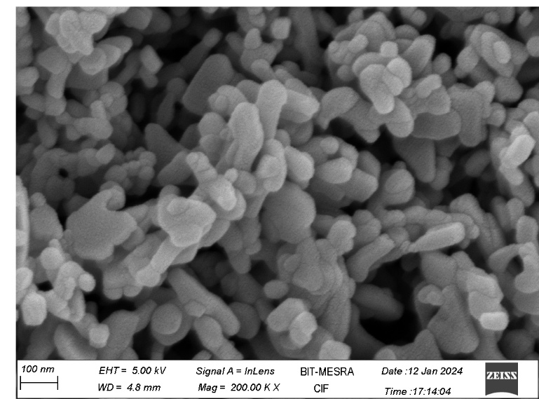
Fig.1. Scanning electron microscope (SEM) image of CuO NPs.
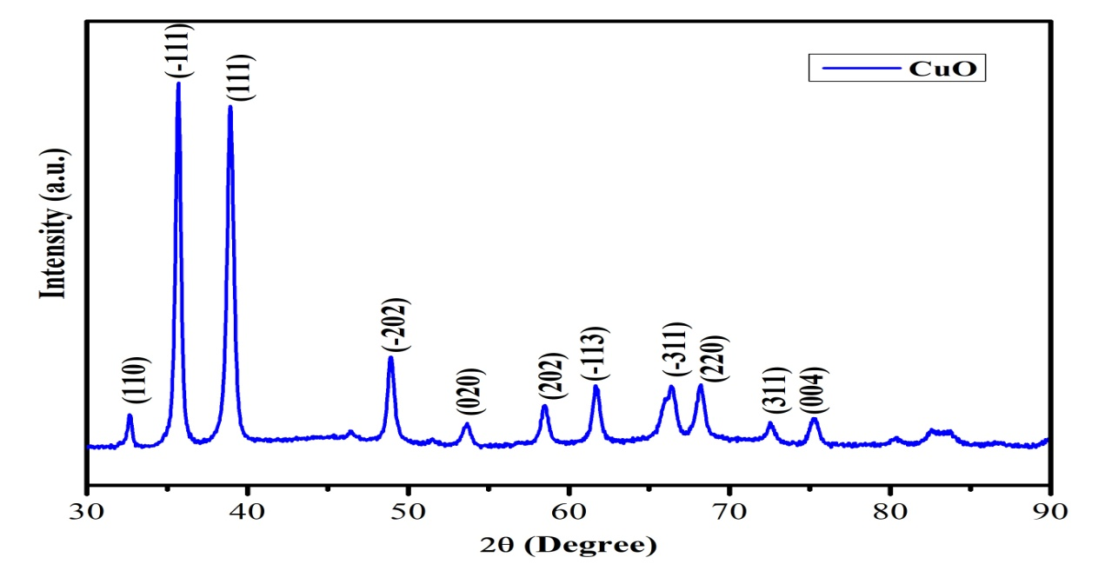
Fig. 2. XRD pattern of CuO Np showing intensity vs 2θ.
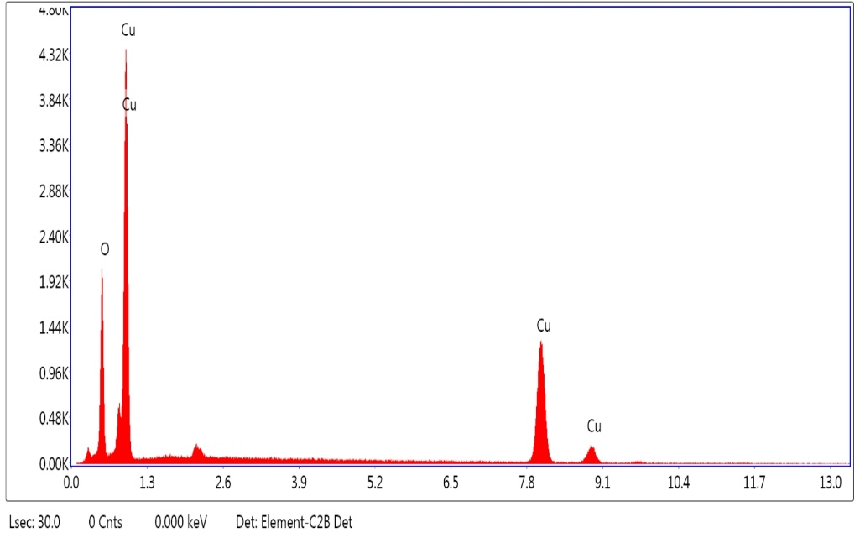
Fig.3. EDS spectrum of CuO NPs showing the presence of copper and oxygen.
Survivability of earthworms exposed to CuO NPs: The impact of different concentrations of CuO NPs on the survivability of earthworms at different durations have been shown on Fig. 4. Survivability rates were maximum for control groups while mortality increased significantly with increasing concentration of CuO NPs. The average survivability was 87.25%,62%,52%,38.34% and 19.25% for doses 200, 400, 600, 800 and 1000 mg kg⁻¹.

Fig. 4. Impact of different concentration of CuO NPs on survival of Perionyx sansibaricus for different durations.

The mean value of worm survivability differs significantly among different cconcentrations of CuO NPs (F = 43.66; df = 5,15; p < 0.001) as well as at different durations of exposure (F = 14.27; df =5,15; p < 0.001) (Table 2) when the survivability was analysed by a two-way ANOVA.

Table 2: A two-way ANOVA test among survivability of Perionyx sansibaricus exposed to different concentration of CuO NPs for different duration.

Source of variation | Sum of Square | Degree of freedom | Mean square | Variation ratio F | Significance
Different doses | 18160.27 | 5 | 3632.05 | 43.66 | p < 0.001
Different duration | 3562.12 | 3 | 1187.37 | 14.27 | p < 0.001
Residual | 1247.83 | 15 | 83.19

4. DISCUSSION
The present study demonstrates a significant decrease in the survivability of earthworms that is both dose and duration-dependent illustrating the ecotoxicological impact of copper oxide (CuO) nanoparticles in soil environments. The survivability of earthworm provides a suitable measure for estimating the stress in terrestrial invertebrates caused by nanoparticles, as illustrated by the increased mortality rates associated with higher concentrations of nanoparticles and prolonged exposure (Gomes et al., 2015; Shoults-Wilson et al., 2011, Baxla et al., 2025, Kachhap et al., 2025).
The impact of metal or metal oxide nanoparticles in other earthworm species also showed similar effects. Exposure of CuO nanoparticles in Eisenia fetida significantly affected growth, survival, and cocoon production (Bicho et al., 2022), whereas Baxla et al., (2025) also reported significant reduction in survivability, growth and reproduction in Drawida willsi exposed to CuO Nps. Kachhap et al., (2025) reported significant reduction in survivability in earthworm Perionyx sansibaricus exposed to Aluminium oxide NPs. Mosleh et al., (2023) reported adverse effects in Lumbricus terrestris exposed to metal-based nanoparticles, including decreased viability and phagocytic activity. Exposure to heavy metals such as Pb and Cd caused genotoxic effects in Perionyx excavatus (Das & Gupta, 2021), whereas Cu nanoparticles and CuSO₄ caused immunotoxic reactions in Metaphire posthuma (Gautam et al., 2017). These findings are in conformity with our findings and authenticate the general sensitivity of earthworms to nanoparticle contamination in soil.
Earthworms showed a higher survival rate at lower concentrations of CuO nanoparticles, during the initial phase of exposure, indicating the activation of immediate physiological defense mechanisms like metal-binding proteins, mucus production, and antioxidant enzymes (Scott-Fordsmand et al., 2014). However, with increasing concentrations and longer duration of exposure, mortality increased indicating inability of these protective mechanisms for extended nanoparticle exposure. Studies showing concentration and duration related mortality patterns in Eisenia fetida and Lumbricus rubellus when exposed to CuO nanoparticles reveals the constancy of these detrimental effects across species (Hu et al., 2012; Lahive et al., 2017).
One of the major contributors to toxicity is the release of copper ions (Cu²⁺) from CuO nanoparticles. Even the low solubility of CuO NPs is sufficient to increase the quantity of accessible copper via soil pore water which interferes and alters membrane integrity, earthworm ion regulation and enzyme activity (Jośko & Oleszczuk, 2013; Unrine et al., 2010).
Because earthworms play a significant role in terrestrial ecosystems, their declining survival rate affects several factors, including nutrient cycling, soil structure, aeration, and the breakdown of organic matter (Edwards & Bohlen, 1996). CuO nanoparticle shows different degree of impacts on different earthworm species according to their susceptibility. Community composition may be altered by CuO nanoparticle contamination, leading to long-term ecological imbalance (Lahive et al., 2017).
However, the present study is the first to evaluate CuO NP toxicity in Perionyx sansibaricus, a dominant species present in organically rich garbage sites. Given its ecological importance, abundance, and sensitivity, P. sansibaricus could serve as a valuable model organism and bioindicator for nanoparticle pollution in tropical soil environments.
4. CONCLUSION
This study provides clear evidence of the toxic effects of copper oxide (CuO) nanoparticles on the earthworm Perionyx sansibaricus, with a particular focus on its survivability when exposed to different concentrations for different durations. A significant, dose-dependent and time dependent toxicity of cuo nanoparticles on Perionyx sansibaricus was observed. While lower concentrations exhibited limited toxicity, higher concentrations resulted in severe adverse effects, including complete mortality. These findings underscore the potential ecological risks posed by CuO nanoparticle contamination in soil ecosystems. Given the widespread agricultural use of CuO-based products, the study emphasizes the need for stricter environmental monitoring, responsible usage, and safe disposal practices to mitigate unintended harm to non-target soil organisms such as earthworms. The assessment of ecological danger and the management of CuO NPs utilized in diverse fields will benefit greatly from this study.

COMPETING INTRESTS
Authors declare that they have no competing interests.

DISCLAIMER (ARTIFICIAL INTELLIGENCE)

Author(s) hereby declare that NO generative AI technologies have been used during the writing or editing of this manuscript.

REFERENCES
Adeleye, A. S., Conway, J. R., Garner, K., Huang, Y. & Keller, A. A. (2016). Engineered nanomaterials for environmental applications: Implications for bioavailability and toxicity. Environmental Science & Technology, 50(2), 1081–1094. https://doi.org/10.1021/acs.est.5b04510
Amorim, M. J. B., Pinto, F., Santos, M. A. & Bebianno, M. J. (2017). Assessing nanomaterial effects on tropical soil invertebrates: Challenges and perspectives. Environmental Toxicology and Chemistry, 36(11), 2995–3005.
Auffan, M., Rose, J., Bottero, J.Y., Lowry, G. V., Jolivet, J.P. & Wiesner, M. R. (2009). Towards a definition of inorganic nanoparticles from an environmental, health and safety perspective. Nature Nanotechnology, 4, 634–641.
Azam, A., Ahmed, A. S., Oves, M., Khan, M. S. & Memic, A. (2012). Antimicrobial activity of metal oxide nanoparticles against Gram-positive and Gram-negative bacteria: A review. International Journal of Nanomedicine, 7, 6003–6033.
Baxla, N.S., Subarna, S., Mandal, S. K., Srivastava, R., Singh, S. & Sinha, M. P. (2025). Concentration dependent effect of CuO nanoparticles on survival, biomass and reproduction in Drawida willsi (Michaelsen). Uttar Pradesh Journal of Zoology, 46(11), 67-73.
Cornelis, G., Hund-Rinke, K., Kuhlbusch, T., Peters, R., Nowack, B., Smulders, S. & Hund-Rinke, K. (2014). Review of soil exposure scenarios for engineered nanoparticles. Environmental Toxicology and Chemistry, 33(10), 2123–2135.
Dimkpa, C.O., Calder, A., Britt, D.W., McLean, J.E. & Anderson, A.J. (2012). Responses of a soil bacterium, Pseudomonas chlororaphis, to CuO nanoparticles and Cu ions: Toxicity, oxidative stress, and metal speciation. Environmental Science & Technology, 46, 12112–12120.
Edwards, C. A. & Bohlen, P. J. (1996). Biology and Ecology of Earthworms (3rd ed.). Chapman & Hall, London.
Gomes, S. I. L., Hansen, D., Scott-Fordsmand, J. J. & Amorim, M. J. B. (2013). Effects of CuO nanoparticles and CuCl₂ on earthworms (Eisenia fetida): Survival, reproduction and avoidance behavior. Environmental Toxicology and Chemistry, 32, 2644–2651.
Gomes, S. I. L., Scott-Fordsmand, J. J. & Amorim, M. J. B. (2015). Cellular energy allocation to assess sub-lethal toxicity of CuO nanoparticles on earthworms. Environmental Pollution, 206, 336–342.
Gottschalk, F., Sonderer, T., Scholz, R. W. & Nowack, B. (2009). Modeled environmental concentrations of engineered nanomaterials (TiO₂, ZnO, Ag, CNT, fullerenes) for different regions. Environmental Science & Technology, 43(24), 9216–9222.
Hu, C. W., Li, M., Cui, Y. B., Li, D. S., Chen, J. & Yang, L. Y. (2012). Toxicological effects of TiO₂ and CuO nanoparticles in soil on earthworm Eisenia fetida. Soil Biology and Biochemistry, 48, 36–42.
Ivask, A., Bondarenko, O., Käkinen, A., Kurvet, I., Kahru, A. & Lofts, S. (2014). Toxicity of metal oxide nanoparticles to Eisenia fetida: Bioavailability, particle size, and dissolution effects. Environmental Toxicology and Chemistry, 33(11), 2496–2505.
Joshi, N., Dabral, M. & Maikhuri, K. R. (2010). Density, biomass and species richness of earthworms in agroecosystems of Garhwal, Himalaya, India. Tropical Natural History, 10(2), 171-179.
Jośko, I. & Oleszczuk, P. (2013). Influence of soil type and environmental conditions on ZnO and CuO nanoparticle toxicity. Environmental Science and Pollution Research, 20, 257–265.
Kachhap, S., Mandal, S. K., Srivastava, R. & Sinha, M. P. (2025). Survivability of the earthworm Perionyx sansibaricus (Michaelsen) in soil contaminated with Aluminium oxide Nanoparticles. Uttar Pradesh Journal of Zoology, 46(4), 342-347.
Kahru, A. & Dubourguier, H. C. (2010). From ecotoxicology of nanoparticles to nanoecotoxicology. Toxicology, 269, 105–119.
Kang, S., Pinault, M., Pfefferle, L. D. & Elimelech, M. (2012). Single-walled carbon nanotubes exhibit strong antimicrobial activity. Langmuir, 24(13), 6409–6413.
Keller, A.A., McFerran, S., Lazareva, A., & Suh, S. (2013). Global life cycle releases of engineered nanomaterials. Journal of Nanoparticle Research, 15, 1692.
Kjeldahl, J. (1883). New method for determination of nitrogen. Chemical News, 48:101-102.
Klaine, S. J., Alvarez, P. J., Batley, G. E., Fernandes, T. F., Handy, R. D., Lyon, D. Y., Mahendra, S., et al. (2008). Nanomaterials in the environment: Behavior, fate, bioavailability, and effects. Environmental Toxicology and Chemistry, 27(9), 1825–1851.
Koelmans, A. A., Gottschalk, F., Sun, T. & Nowack, B. (2015). Nanomaterials in the environment: Behavior, fate, bioavailability, and effects. Environmental Science & Technology, 49(9), 5257–5268.
Lahive, E., Jurkschat, K., Shaw, B. J., Handy, R. D., Spurgeon, D. J., Svendsen, C. & Mosselmans, J. F. W. (2017). Toxicity of cerium oxide and copper oxide nanoparticles to the earthworm Lumbricus rubellus. Environmental Toxicology and Chemistry, 36, 190–199.
Lavelle, P., Decaëns, T., Aubert, M., Barot, S., Blouin, M., Bureau, F., Margerie, P., et al. (2006). Soil invertebrates and ecosystem services. European Journal of Soil Biology, 42, S3–S15.
Lowry, G. V., Gregory, K. B., Apte, S. C. & Lead, J. R. (2012). Transformations of nanomaterials in the environment. Environmental Science & Technology, 46(13), 6893–6899.
Maurer-Jones, M. A., Gunsolus, I. L., Murphy, C. J. & Haynes, C. L. (2013). Toxicity of engineered nanoparticles in the environment. Analytical Chemistry, 85, 3036–3049.
Misra, R. (1973). Ecology workbook. Oxford and IBH Publishing Co.
Nowack, B. & Bucheli, T. D. (2007). Occurrence, behavior and effects of nanoparticles in the environment. Environmental Pollution, 150, 5–22.
OECD (2008). OECD Guidelines for the Testing of Chemicals, Section 222: Earthworm Reproduction Test (Eisenia fetida/Eisenia andrei). Organisation for Economic Co-operation and Development, Paris.
Petersen, E. J. & Henry, T. B. (2012). Incorporating nanomaterial characterization into environmental risk assessments. Environmental Toxicology and Chemistry, 31, 2595–2603.
Scott-Fordsmand, J. J., Krogh, P. H. & Johansen, A. (2008). Effects of copper nanoparticles on earthworm reproduction. Environmental Toxicology and Chemistry, 27(11), 2142–2147.
Scott-Fordsmand, J. J., Krogh, P. H., Schaefer, M. & Johansen, A. (2014). The toxicity testing of double-walled nanotubes-contaminated food to Eisenia veneta earthworms. Ecotoxicology and Environmental Safety, 99, 9–15.
Srivastava, R., Kumar, M., Choudhary, A. K. & Sinha, M. P. (2003). Earthworm diversity in Jharkhand state. Nature Environment and Pollution Technology., 2(3), 357-362.
Suthar, S. (2008). Vermicomposting of agricultural residues using Perionyx sansibaricus. Bioresource Technology, 99, 1673–1678.
Tourinho, P. S., van Gestel, C. A., Morgan, A. J., Kille, P. & Loureiro, S. (2012). Metal-based nanoparticles in soil: Fate, behavior, and effects on terrestrial invertebrates. Environmental Toxicology and Chemistry, 31, 1679–1692.
Unrine, J. M., Tsyusko, O. V., Hunyadi, S. E., Judy, J. D. & Bertsch, P. M. (2010). Effects of particle size on chemical speciation and bioavailability of copper to earthworms (Eisenia fetida) exposed to Cu nanoparticles. Journal of Environmental Quality, 39, 1942–1953.
Walkley, A. & Black, I. A. (1934). Determination of Organic carbon in soil. Soil Science,37,29-38.
Wang, Z., Li, J., Zhao, J. & Xing, B. (2012). Toxicity and internalization of CuO nanoparticles to soil invertebrates. Environmental Science & Technology, 46, 12068–12076.

