Original Research Article
ICHTHYODIVERSITY OF SICHI RIVER, UNDER KOYU CIRCLE, LOWER SIANG DISTRICT, ARUNACHAL PRADESH, INDIA

ABSTRACT
A survey and documentation of ichthyofaunal diversity were undertaken from April 2024 to December 2025 in the Sichi river, located within the Koyu circle of Lower Siang district, Arunachal Pradesh, India. With the help of local fishermen, specimens were sampled randomly along the length of the river at various times using locally available fishing gear and techniques. A total of 36 species of fish were recorded, belonging to 14 families, 5 orders, and 30 genera. According to the IUCN conservation categories, among the 36 species, 1 species comes under the category of Endangered (EN), 3 species are under the Vulnerable (VU) category, 5 species are under the Near Threatened (NT) category, 1 species is under the Data Deficient (DD) category and the remaining 5 species are under the Not Evaluated (NE) category. Under The Wild Life (Protection) Amendment Act (WPAA, 2022), one species, Cyprinion semiplotum, is listed under the Scheduled-I. The study also revealed that most of the fish species recorded from the river have high food value, recreational/sport fishing value, and ornamental value. Furthermore, the study also revealed that the fish population in the river has declined alarmingly over the past decade, highlighting the urgent need for appropriate conservation measures.
Key words: Arunachal Pradesh, Ichthyodiversity, Koyu Circle, Sichi river,
- INTRODUCTION
Arunachal Pradesh, a part of the eastern Himalaya, is situated on the extreme northeastern tip of the Union of India, lying between 26˚ 28′ to 29˚30′ north latitude and 90˚ 31′ to 97˚ 30′ East longitude, covering an area of 83,743 sq. km. The state has a well-defined drainage system with numerous rivers and rivulets forming diverse and potential habitats for rich ichthyofaunal resources. The major drainage systems of the state comprise the Kameng, the Subansiri, the Lohit, the Siang and the Tirap.
The eastern Himalayan region of India has been identified as one of the 18th mega biodiversity hotspot areas of the world by Myers et al. (2000). The region is endowed with rich floral and faunal genetic diversity with a high degree of endemism. Moreover, the biodiversity of the region is also highly threatened. Kottelat (1989) observed that the high diversity of the region is attributed to the recent geological history and the Himalayan orogeny, which played an important role in the speciation and evolution of groups inhabiting mountain streams. The lotic and lentic water bodies of the northeastern region of India harbor rich ichthyofaunal diversity. Sen (2000) recorded a total of 267 fish species from Assam and its neighboring states. Vishwanath et al. (2007) reported 396 different fish species from the region. Sarkar & Pooniah (2000), in a separate study, reported a total of 186 species from the region, of which 62 species were identified as endemic to this region, while 53 species were identified as ornamental valued fish. Vishwanath (2021) also conducted an extensive study on the freshwater fishes of the eastern Himalayas and recorded 512 fish species under 128 genera and 40 families. While reviewing the ichthyofaunal diversity and distribution of northeast India, Sarma et al. (2022) also recorded 512 fish species from the NE region.
Many studies have been conducted on the ichthyofaunal diversity of Arunachal Pradesh. The first comprehensive attempt to study the ichthyofaunal diversity of Arunachal Pradesh was made by Nath & Dey (2000), who reported a total of 131 fish species from the state. While compiling the checklist of ichthyofauna of Arunachal Pradesh, Bagra et al. (2009) reported a total of 216 fish species, and Gurumayum et al. (2016) reported a massive 259 species of fishes from the water bodies of the state. Darshan et al. (2019) listed a total of 213 species based on field surveys and available literature. Kosygin et al. (2024), while compiling the systematic checklist of fishes of India, reported a total of 272 fish species from the state of Arunachal Pradesh, Including 47 endemic fish species from the state. Besides these, much work has been done on ichthyofaunal bioresources of rivers of Arunachal Pradesh, viz. Datta & Barman (1985) recorded 28 species from the Namdapha National Park, Tirap; Sen (1999) surveyed and reported a total of 52 fish species from Subansiri, East and West Siang districts; Tamang et al.(2007) recorded 47 species from the Sinkhi river. Bagra & Das (2010) reported a total of 44 fish species from the Siyom river of the West Siang district. Das et al.(2015) reported 82 species from the river Siang; Sinha & Tamang (2015) reported 121 species of fish from East Siang district; Taro & Kadu (2018) reported 21 fish species from the Sille river of East Siang; Loyi et al. (2018) reported a total of 38 species of fish from Tengapani Rivers Namsai; Gurumayum (2021) recorded 75 fish species from the Poma river; Satpathy (2021) reported 26 species from the Subansisri river of Upper Subansisri district; Sinha (2022) recorded 47 fish species from water bodies of Anjaw district; Taro et al.(2022) reported a 37 different fish species from Senkhi stream at Itanagar; Tayeng et al.(2025) recorded a total of 54 species from the Sirum river of East Siang district.
Despite such extensive research work on the ichthyofaunal bioresources of the state, there are still numerous lotic and lentic water bodies remain unexplored in the context of scientific investigation and documentation of available fish species. The Sichi river is one of such lentic water body endowed with a high fish species diversity, where no scientific exploration and documentation have been conducted to date. The present study is being undertaken to fill this research gap by compiling of a complete checklist of fishes of Arunachal Pradesh so that the generated database on the fishery resources of the river may be utilized by the various stakeholders, researchers and planners in designing an effective sustainable biodiversity conservation strategy.
- MATERIALS AND METHODS

  - Study area
The present study was carried out in Sichi river (Figure 1) of Koyu circle, Lower Siang district of Arunachal Pradesh. The river Sichi is one of the main lentic water bodies of Upper Ramle Banggo under Koyu circle, and it is also one of the major tributaries of the Singen river of Lower Siang district of Arunachal Pradesh. The river originates near the northern side of Kadu village, Lower Siang district and the southern part of Leparada district of Arunachal Pradesh. From its origin point, it runs in a slightly eastward direction and then curves southwards towards Rotte village after traversing hilly terrain and ultimately gives off its contents into the Singen river. The shape of the river was a narrow and shallow type in the upper and middle zones, whereas it opens wider in the lower zone. The riparian zone of the Sichi River is well covered with vegetation. No village or human settlement is recorded on both banks of the river. However, lots of agriculture and horticulture activities were seen on the left bank of the river. In recent years, lots of illegal logging has also been reported from the upper catchment area of the river.
To investigate the ichthyofaunal diversity of the Sichi river, a random sampling was conducted along the Sichi river (Figure 2) from April 2024 to December 2025. Sampling of fish was made using locally available fishing gear and techniques viz. cast net, gill net, hooks, Lipum, Hibok, Takom, Riib dinam etc. The collected fish specimens were directly put into 5-8% formalin, and then it was transported to the laboratory at the Department of Zoology, Jawaharlal Nehru College, Pasighat. The fish specimens were properly sorted and identified using standard literature (Talwar & Jhingran 1991; Jayaram 1999; Nath & Dey 2000; Kottelat 2001; Jayaram 2006; Darshan et al. 2019, Vishwanath 2021). All the sorted and identified fish specimens were preserved in 10% formalin, labeled, registered, and deposited in the Jawaharlal Nehru College Museum of Fishes (JNCMF), Department of Zoology, Jawaharlal Nehru College, Pasighat, for future reference. The conservation status of each species was confirmed following the IUCN Red List of Threatened Species Version 2024-2 (https:// www.iucnredlist.org). All the recorded fish species were also compared with the Scheduled list as per (WPAA, 2022).The latest valid scientific names, families, and orders of the fish species were confirmed following Eschmeyer’s Catalogue of Fishes (Fricke et al. 2025).Each representative fish species was photographed for future photographic documentation.

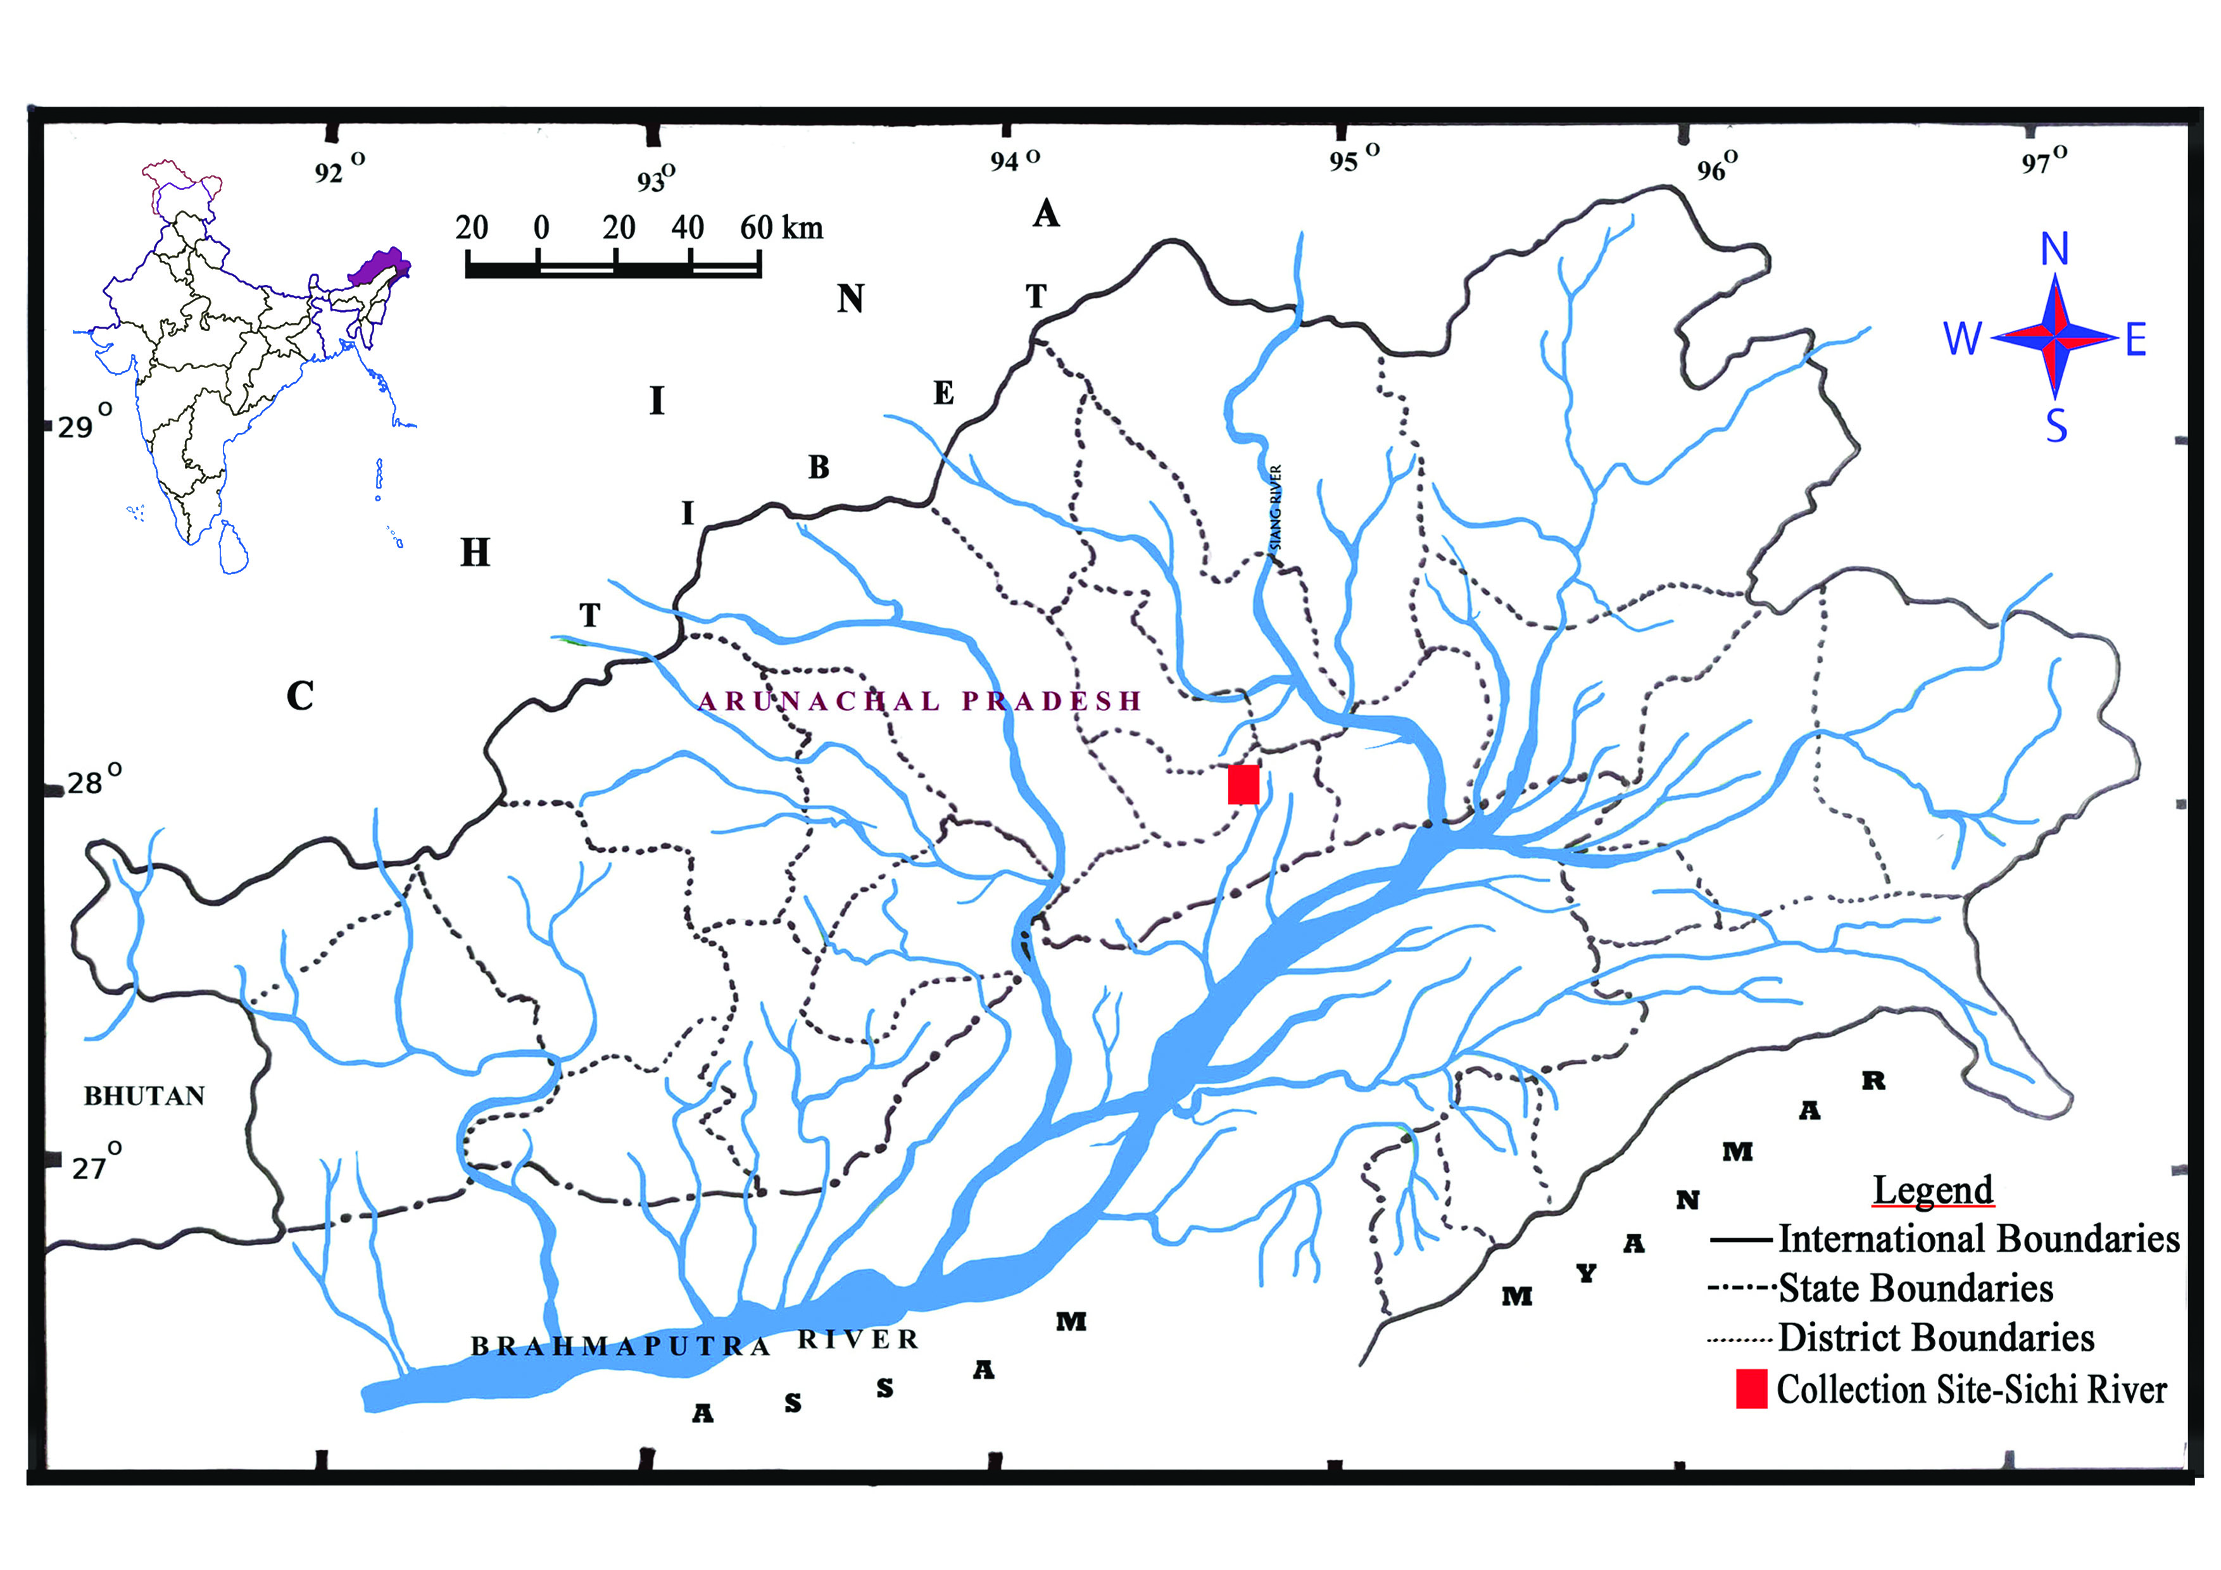

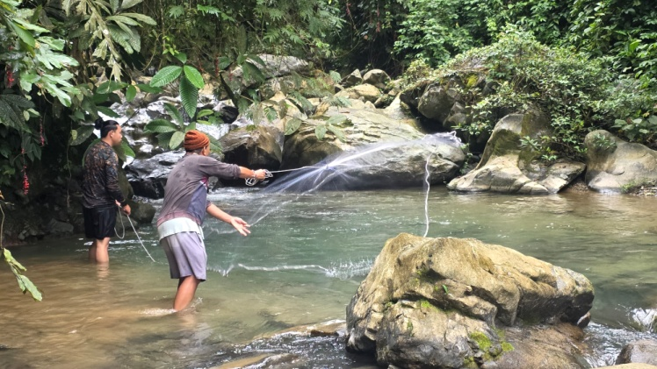
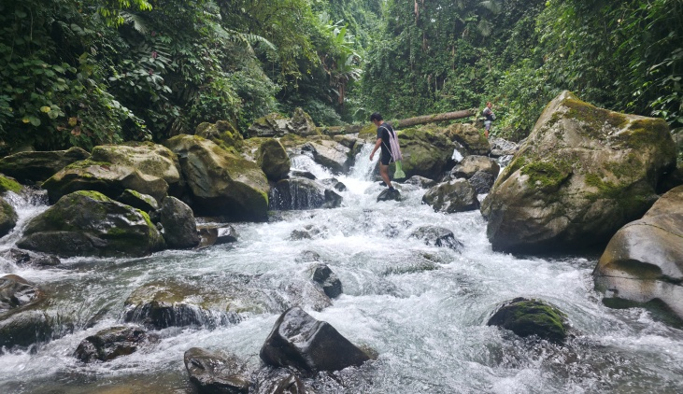
Figure1. Map Showing study area, Sichi river under Koyu Circle, Lower Siang District, Arunachal Pradesh

Figure 2. Fish sampling at Sichi river, Koyu Circle, Lower Siang District, Arunachal Pradesh

RESULT and DISCUSSION

A total of 36 fish species were recorded, belonging to 14 families and 5 orders and under 30 genera, from the Sichi river of Upper Ramle Banggo, Lower Siang District, Arunachal Pradesh, India (Table 1). The order Cypriniformes represents the highest diversity with 24 species across 6 families representing the order. The order Siluriformes was represented by 8 species in 4 families and Perciformes was represented by 2 families with 1 species each. Anguiliformes and Synbranchiformes were represented by a single species under a single family and a single genus. Among the families, Cyprinidae was found to be the dominant group, represented by 13 species, followed by Danionidae with 5 species and followed by Sisoridae with 4 species. Bagridae, Balitoridae and Nemacheilidae were represented by 2 species each. However, the families Anguillidae, Botiidae, Cobitidae, Siluriade, Amblyceptidae, Badidae, Channidae and Mastacembelidae were represented by a single species each. Most of the fishes of the Sichi river (21 species) are under the conservation category of Least Concern (LC) as per the assessment criteria of the International Union for Conservation of Nature and Natural Resources (IUCN) (Table 1). Among them, only one species falls under the Endangered (EN) category, three species are under the Vulnerable (VU) category, five species are under the Near Threatened (NT) category, one species is under the Data deficient (DD) category, whereas the remaining five species are under the Not Evaluated (NE) category. The study also shows that the river is home to one of the listed Scheduled–I protected freshwater fish Cyprinion semiplotum (WPAA, 2022). The present study also revealed 29 fish species recorded from the river are of high ornamental value.
Table 1. List of fishes of Sichi river and their Order, Family, Scientific name and IUCN status.

Sl.no | Order | Family | Scientific name | IUCN Status
1 | Anguilliformes | Anguillidae | Anguilla bengalensis (Gray) | NT
2 | Cypriniformes | Danionidae | Opsarius barna (Hamilton)* | LC
3 |  |  | Opsarius bendelisis(Hamilton) * | LC
4 |  |  | Devario aequipinnatus (McClelland) * | LC
5 |  |  | Devario devario (Hamilton) * | LC
6 |  |  | Danio dangila (Hamilton) * | LC
7 |  | Cyprinidae | Puntius chola (Hamilton) * | LC
8 |  |  | Puntius sophore (Hamilton) * | LC
9 |  |  | Cyprinion semiplotum (McClelland) * | VU
10 |  |  | Tariqilabeo latius (Hamilton) * | LC
11 |  |  | Chagunius chagunio Hamilton | LC
12 |  |  | Garra gotyla (Gray) * | LC
13 |  |  | Garra annandalei Hora* | NE
14 |  |  | Garra lissorhynchus(McClelland) * | LC
15 |  |  | Garra arupi Nebeshwar, Vishwanath & Das* | NE
16 |  |  | Labeo pangusia (Hamilton) | NT
17 |  |  | Neolissochilus hexagonolepis (McClelland) | NT
18 |  |  | Tor putitora (Hamilton) | EN
19 |  |  | Schizothorax richardsonii (Gray) | VU
20 |  | Balitoridae | Balitora brucei Gray* | NT
21 |  |  | Paracanthocobitis botia (Hamilton) * | LC
22 |  | Nemacheilidae | Aborichthys elongatus Hora* | LC
23 |  |  | Mustura daral Rameshori,Chinglemba, Darshan & Vishwanath* | NE
24 |  | Botiidae | Botia rostrata Gunther * | VU
25 |  | Cobitidae | Lepidocephalichthys guntea (Hamilton) * | LC
26 | Siluriformes | Bagridae | Batasio fasciolatus Ng * | LC
27 |  |  | Olyra longicaudata McClelland * | LC
28 |  | Siluridae | Pterocryptis gangelica Peters | DD
29 |  | Amblycepitidae | Amblyceps apangi Nath& Dey* | LC
30 |  | Sisoridae | Glyptothorax cavia (Hamilton) * | LC
31 |  |  | Pseudochenis sulcatus (McClelland) * | LC
32 |  |  | Exostoma tenuicaudatum Tamang, Sinha & Gurumayum * | NE
33 |  |  | Ompok Pabo(Hamilton) * | NT
34 | Perciformes | Badidae | Badis singenensis Geetakumari & Kadu * | NE
35 |  | Channidae | Channa gachua (Hamilton) * | LC
36 | Synbranchiformes | Mastacembelidae | Mastacembelus armatus (Lacepede) (Hamilton) * | LC
EN: Endangered; VU: Vulnerable; NT: Near Threatened; LC: Least Concern; DD: Data Deficient; NE : Not Evaluated
* indicates the ornamental value fish species reported from the Sichi river
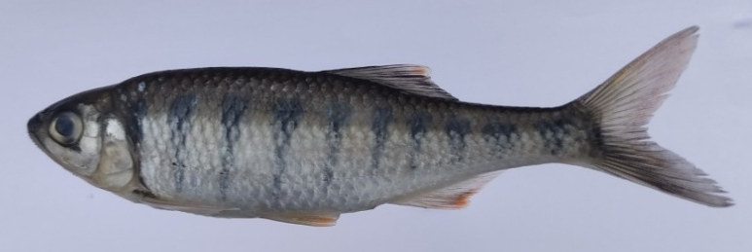
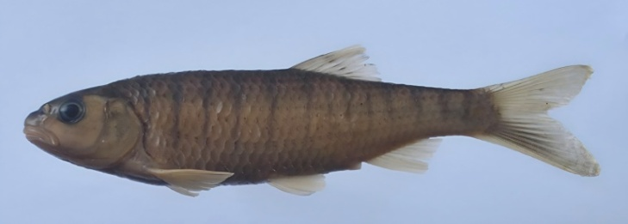

i.Opsarius barna
ii. Opsarius bendelisis
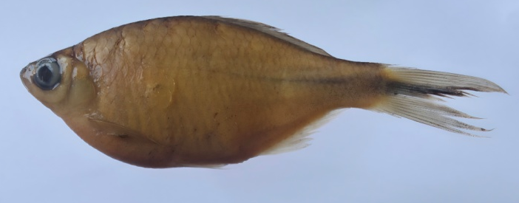
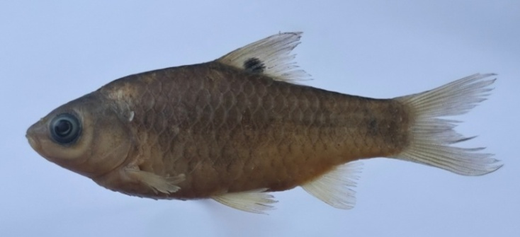

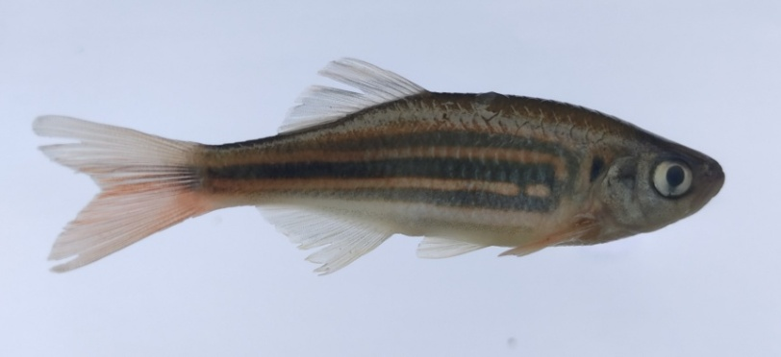
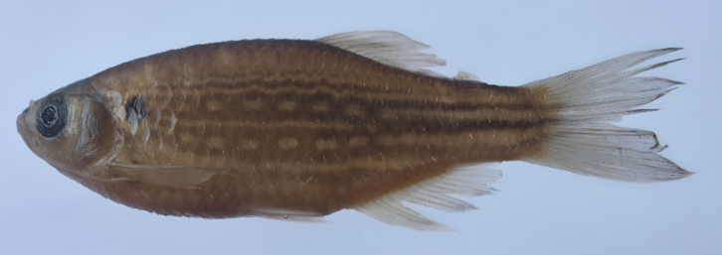
iv. Puntius chola
iii. Devario devario

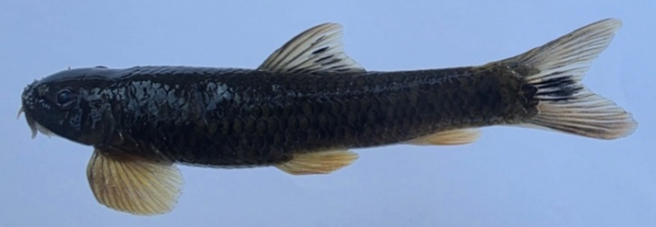
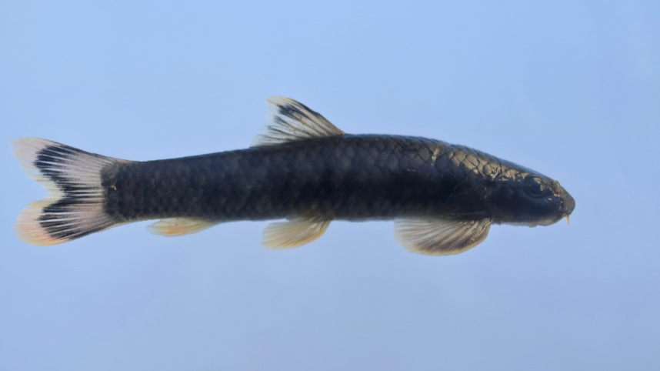
vi. Danio dangila
v. Devario aequipinnatus

viii. Garra arupi
vii. Garra lissorhynchus
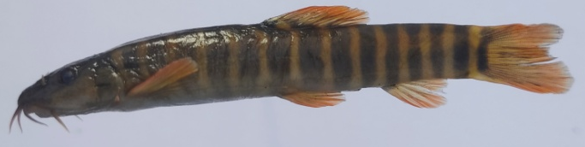
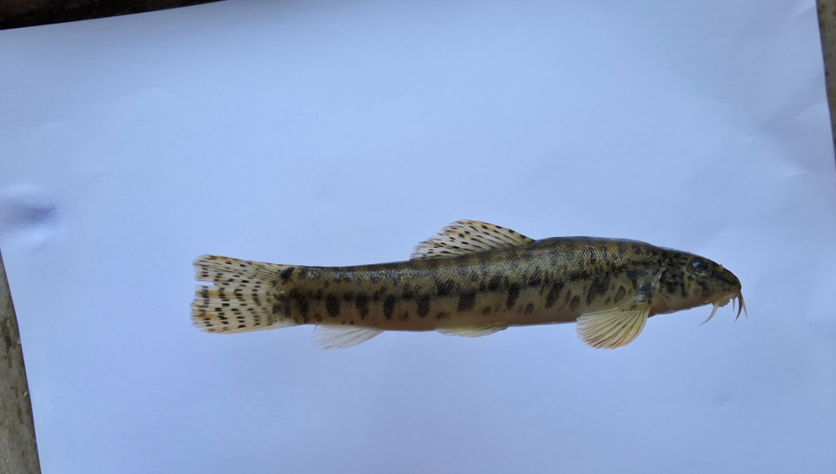

x. Paracanthocobitis botia
ix. Mustura daral
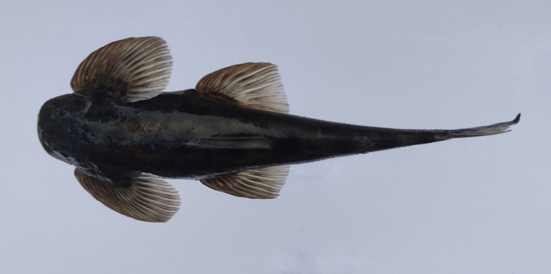
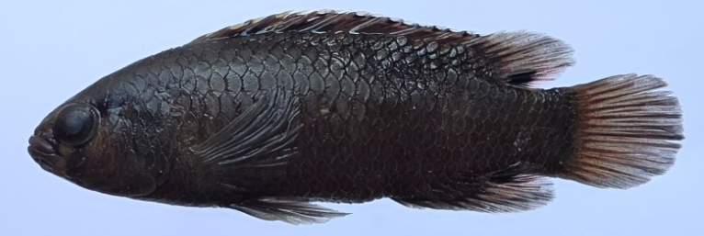

xii. Balitora brucei
xi. Badis singenensis
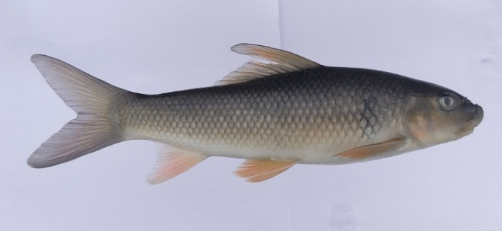
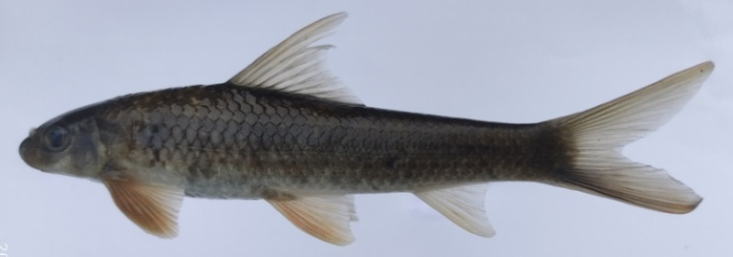

xiii. Tariqilabeo latius
xiv. Labeo pangusia
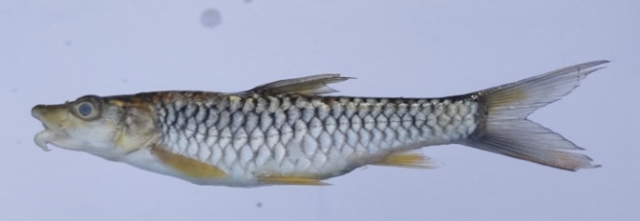
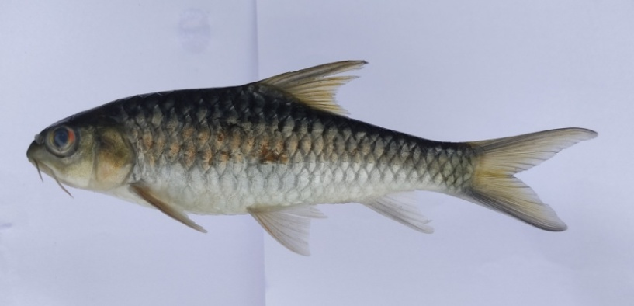

xv. Neolissochilus hexagonolepis
xvi. Tor putitora
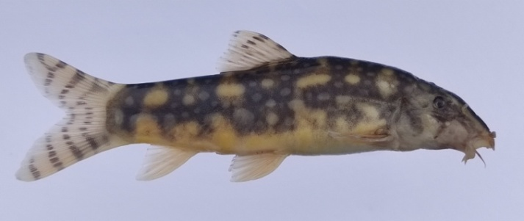
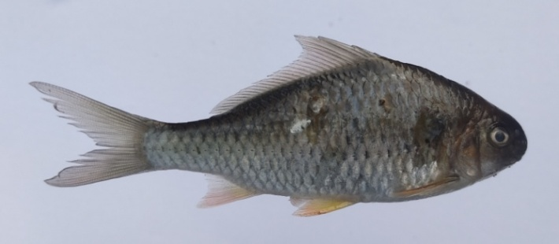

xviii. Botia rostrata
xvii. Cyprinion semiplotum
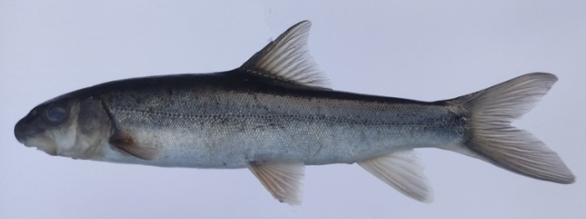
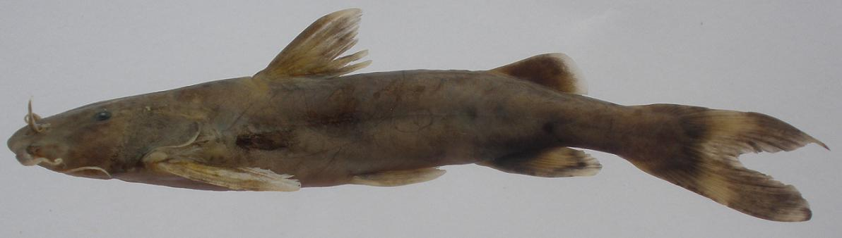

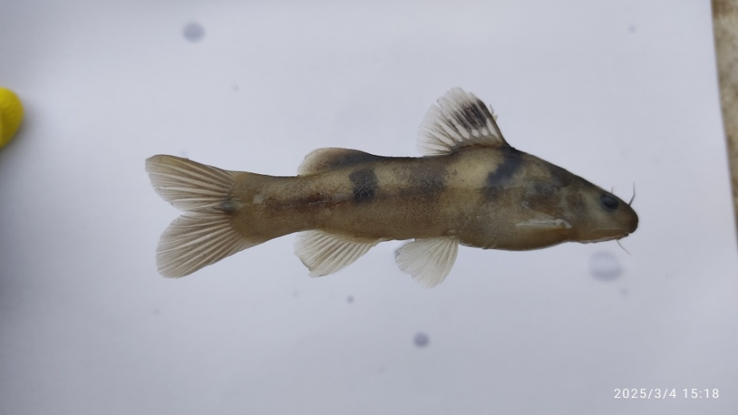
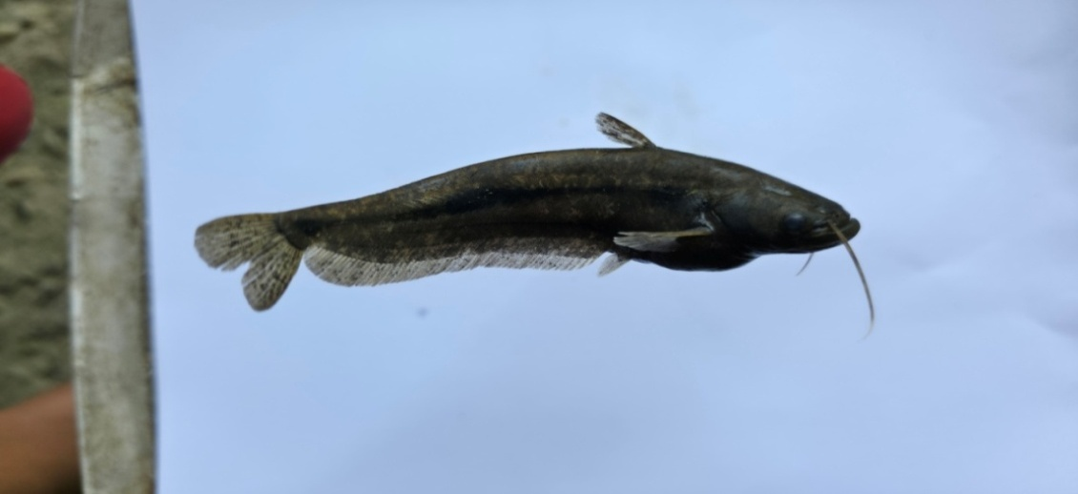
xix. Glyptothorax cavia
xx. Schizothorax richardsonii

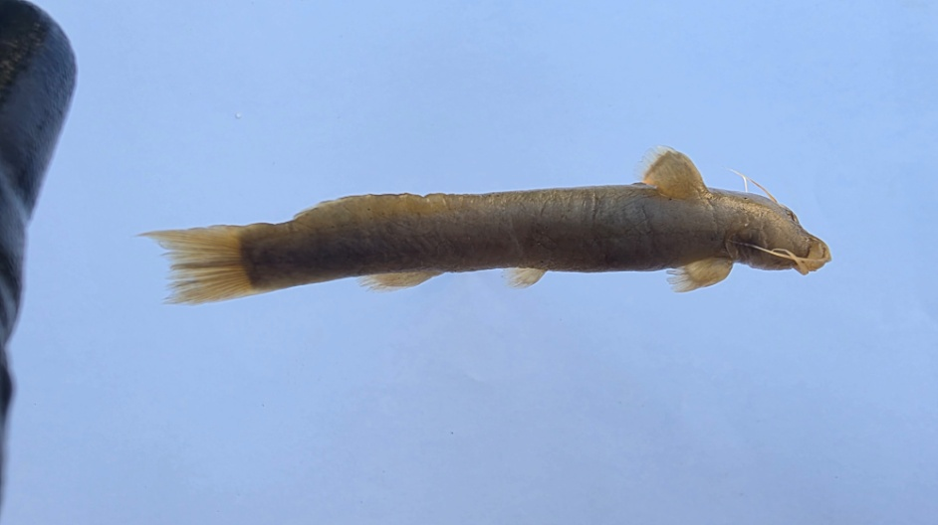
xxi. Ompok pabo
xxii. Batasio fasciolatus
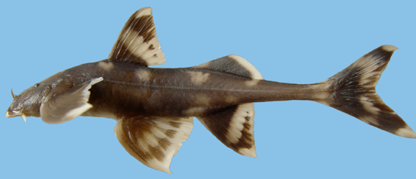

xxiv. Pseudecheneis sulcata
xxiii. Amblyceps apangi

Figure 3. Photographs of some of the important food, game fish and ornamental fish species recorded from Sichi river.
The results of the present study of the ichthyofaunal diversity of the Sichi river revealed a total of 36 fish species under 30 genera, 14 families and 5 orders. The order Cypriniformes represents the highest diversity with 24 species, followed by Siluriformes with 8 species and Perciformes with 2 species. The orders Anguiliformes and Synbranchiformes were represented by a single species each. Among the families, Cyprinidae was found to be the dominant group, represented by 13 species, which are followed by Danionidae with 5 species and Sisoridae with 4 species. Balitoridae, Bagridae and Nemacheilidae were represented by 2 species each. However, Anguillidae, Botiidae, Cobitidae, Siluriade, Amblyceptidae, Badidae, Channidae and Mastacembelidae were represented by 1 species each.
The maximum recorded fishes (21 species) of the Sichi river are under the Least Concern (LC) conservation category as per the assessment criteria of the International Union for Conservation of Nature and Natural Resources (IUCN). Among them, only one species, Tor putitora, falls under the Endangered (EN) category, whereas three species, viz. C.semiplotum, S.richardsonii and B.rostrata are under the Vulnerable (VU) category. The 4 species, namely A.bengalensis, L.pangusia, N.hexagonolepis, O.pabo and B.brucei, fall under the category of Near Threatened (NT). Only one species (P.gangelica) is under the category of Data Deficient (DD), whereas the remaining 5 species, such as G.annandalei, G.arupi, M.daral, E.tenuicaudatum and B.singenensis are in the category of Not Evaluated (NE). Kumari & Sonowal (2023) recorded a total of 23 fish species from the Namchik river in Changlang district of Arunachal Pradesh and reported two species under the Endangered category. However, it seems they had mistakenly placed Crocssochelius latius under the IUCN Endangered category. The most common species distributed in the study area were T.latius, N.hexagonolepis & G.gotyla. Similarly, the rare species of the river were B.brucei and E. tenuicaudatum. Whereas species like S.richardsonii, L.pangusia and E.tenuicaudatum were encountered only in the upper reaches of the river at higher altitudes. A. bengalensis was encountered in a deep shallow/pool types with rocky substrate. Species like B.singenensis, B.fasciolatus, P.botia, P.sophore, P.chola, O.barna, and D.devario were encountered in the lower portion of the river near the confluence area of the Singen River. The Assamese kingfish, Cyprinion semiplotum, is the only fish species that comes under the category of the Scheduled-I list of protected animals as per WPAA, 2022. Despite being a Scheduled-I protected animal, Cyprinion semiplotum has been extracted from the rivers by local tribals due to its high food value. A rigorous awareness campaign is necessary in the study area to educate the local population regarding IUCN conservation status, CITES status and the status of Scheduled animals under the Wild Life (Protection) Amendment Act, 2022 for better conservation of important bioresources of the region. Nanda (2016), reported 45 fish species from the river Pachin and the family cyprinidae was found to be the dominant group. Similarly, Das & Anku (2020) reported 17 fish species from the Swkhe stream of Ziro valley. Interestingly, Channa was recorded as the most dominant genus in their study, whereas, the present study shows only one species of Channa was recorded from the Sichi river. While studying the ichthyodiversity of Kangsabati reservoir in West Bengal, Bera et al. (2014) recorded a total of 39 species of commercially important fish, of which six species were under the threatened category whereas one species was under the vulnerable category.
Most of the fish species recorded from the river have an economic value such as food, recreational value and ornamental value. Fishes like Tariqilabeo latius, Garra Gotyla, Labeo pangusia, Cyprinion semiplotum and Mastacembelus armatus have good food value, while some of the fish species, viz. Tor putitora and Neolissochilus hexagonolepis are especially preferred for recreational fishing/angling activities. The study also revealed that most of the reported fish species from the Sichi river are beautifully coloured and have the potential to be included in an ornamental fish list. Out of 36 recorded fish species, a total of 29 have ornamental value fish. Abujam et al. (2021) also recorded a total of 52 ornamental fish species under 6 orders and 15 families while studying the trade potential of indigenous ornamental fishes of Arunachal Pradesh. Despite rich ichthyofaunal bioresources, the fishery resources of the river have never been explored, perhaps due to its remoteness or inaccessibility, except for limited work has been done on the Singen river such as Geetakumari & Kadu (2011) describing a new species, Badis singenensis from the Singen river; Kadu & Das (2011) recorded Conta conta from the Singen River for the first time in the state. Sarma et al. (2022) stress the need for exploration of fish fauna of the major river systems of North East India at regular intervals to build a comparable database that might be utilized by the stakeholders, researchers, planning and management. The present study generated a fish checklist database of 37 fish species and is the first ever scientific exploration and documentation of fishes from the Sichi river. The generated data will be helpful in planning strategies for biodiversity conservation measures.
The present study also revealed that the fish population in the Sichi River has been gradually decreasing over the last few years, according to information gathered from local people of Kadu, Rote and Koyu villages under Koyu circle. This rapid decline in the fish population of the river might be due to over-exploitation of fishery resources and engagement in illegal and destructive fishing methods such as electrofishing and dynamiting in the river. Apart from these, illegal logging activities were also reported from the upper riparian reaches of the Sichi river. In view of these illegal activities and to control the rapid decline of fish populations in the river, local bodies and administration issued prohibitory orders agaisnt illegal fishing and hunting within their jurisdiction for conservation.
- CONCLUSION
Despite various exploratory works conducted on the documentation of fishes from lotic and lentic water bodies of Arunachal Pradesh, there are still a number of unexplored important rivers and rivulets in the state. Sichi is one of those unexplored rivers in the context of scientific documentation of fishery resources. The present exploratory investigation reveals that the river is endowed with rich ichthyofaunal diversity with a total of 36 fish species. Most of the recorded species have high food value and are valued as recreational/sport fish. Further, the present study also reveals that the river is endowed with a high diversity of ornamental fish species. If tapped properly, it could be a source of employment generation and earnings for educated unemployed local youths of Lower Siang district. However, from the present study, it is also a shown that, though the river harbours high species diversity, the fish population of the river has been declining rapidly in recent decades. Therefore, a proper conservation strategy is needed in this direction to maintain the diversity and population of fish in the river.
DISCLAIMER (aRTIFICIAL INTELEGENCE)

Author is hereby declare that no generative AI technologies such as Large Language Models (ChatGPT, COPILOT, etc) and text-to-image generators have been used during witting or editing of this manuscript.

ACKNOWLEDGEMENT
The author is grateful to the Director, Higher & Technical Education, Itanagar Govt. of Arunachal Pradesh for funding this research work under Research Funding Scheme for Govt. college teacher, DHTE and also to the Department of Zoology, Jawaharlal Nehru College Pasighat for providing research facility.
Competing interests
Author has declared that there is no competing interests exist.

Authors’ Contributions
As a sole author everything was done by the author. The author read and approved the final manuscript.

REFERENCES

- Abujam, S., Tamang, L., Nimasow, G. & Das, D.N. (2021). Trade Potential of Indigenous Ornamental Fishes of Arunachal Pradesh, India. Asian Fisheries Science 34:312–325. https://doi.org/10.33997/j.afs.2021.34.4.004
- Bagra, K., Kadu, K., Nebeshwar, K., Laskar, B.A., Sarkar, U.K. & Das, D.N. (2009). Ichthyological survey and review of the checklist of fish fauna of Arunachal Pradesh, India. Check List. 5(2):330-350. https://doi.org/10.15560/5.2.330.
- Bagra, K. & Das, D.N. (2010). Fish diversity of Siyom river of Arunachal Pradesh, India: A Case Study. Our nature, 8:164-169. https://doi.org/10.3126/on.v8i81.4324
- Bera, A., Bhattacharya, M., Patra, B. C., & Sar, U. K. (2014). Ichthyofaunal diversity and water quality in the Kangsabati Reservoir, West Bengal, India. Advances in Zoology, 2014: 1-8.http://dx.doi.org/10.1155/2014/674313
- Das, B.K.,Boruah, P., & Kar, D. (2015). Fish diversity and drainage analysis of River Siang, East Siang district of Arunachal Pradesh. Bioscience Discovery, 6(1-1) Special 16-20. https://biosciencediscovery.com

- Das, K., & Anku, T. (2020). Ichthyofaunal study of Swkhestream, Ziro valley, Lower Subansiri, Arunachal Pradesh. International Journal of Global Science Research, 7(2): 1344-1352. https://doi.org /10.26540/ijgsr.v7.i2.2020.157.
- Darshan, A., Abujam, S. & Das, D.N. (2019). Biodiversity of fishes in Arunachal Himalayas. Systematic, Classification and Taxonomic identification. Academic press. 270 p. https://www.elsevier.com/books/biodiversity-of-fishes-in-arunachal-himalaya/singh/978-0-12-815556-1.
- Datta, A.K. & Barman, R.P. (1985). Fauna of Namdapha, Arunachal Pradesh (Pisces). Rec. Zool. Surv. India,8 (1-4): 275-284.
- Fricke, R., Eschmeyer, W.N. & Van der Laan, R. (eds.) (2025). Eschmeyer’s Catalog of Fishes: genera, species, references.http://researcharchive.calacademy.org/research/ichthyology/catalog/ fshcatmain.asp. Accessed on 04.02.2026.
- Geetakumari, K. & Kadu, K. (2011). Badis singenensis, a new species (Teleostei: Badidae) from Singen river, Arunachal Pradesh, Northeast India. Journal of Threatened Taxa, 3(9): 2085-2089. https://doi.org/10.11609/JoTT.o2531.2085-9.
- Gurumayum, S.D, Kosygin, L. & Tamang, L. (2016). Ichthyofaunal diversity of Arunachal Pradesh, India: A part of Himalaya biodiversity hotspot. International journal of fisheries and aquatic Studies, 4(2): 337-346. https://www.fisheriesjournal.com/archives/2016/vol4issue2/PartE/4-1-71.pdf
- Gurumayum, S.D. (2021). A preliminary report on fish diversity of Poma river and its tributaries, Arunachal Pradesh, India. International Journal of Fisheries and Aquatic Studies 2021; 9(2): 158-162. https://doi.org/10.22271/fish.2021.v9.i2c.2437
- IUCN (2025). The IUCN Red List of Threatened Species. Version 2024-2. https://www.iucnredlist.org>. Accessed on 13.iii.2025.
- Jayaram, K.C. (1999). The freshwater fishes of Indian region. Narendra Publishing House, New Delhi. xv +385, pl.11.
- Jayaram, K.C. (2006). Catfishes of India. Narendra Publishing House, New Delhi. xxvii+551p. pl.18.
- Kadu,K. & Das, D.N. (2011). New record of freshwater erithistid catfish Conta conta (Hamilton, 1822) (Teleostei: Erethistidae) from Arunachal Pradesh (Biodiversity hotspot), India.The Bioscan,6(3):413-416. https://thebioscan.com/index.php/pub/article/view/1852.
- Kosygin, L., Mohapatra, A., Bineesh, K.K.,Sharma, I., Jadhav, S.S., & Khynriam, D. (2024). Fauna of IndiaChecklist: Pisces. Version 1.0. Zoological Survey India. https://doi.org/10.26515/Fauna/1/2023/Choradata:Pisces
- Kottelat,M. (1989). Zoogeography of the fishes from IndoChinese inland waters with an annoted checklist. Bulletine Zoologish Museum, 12(1):1-54.
- Kottelat, M. (2001) Fishes of Laos. Cambodia. Wildlife Heritage Trust, Publication.198 p.
- Kumari, K. & Sonowal, M. (2023). Ichthyofaunal Diversity Assessment and Formulating Framework Module for Conservational Strategies of Namchik River, Changlang,Arunachal Pradesh. Spectrum: Science and Technology, 10:13-24. https://doi.org/10.54290/spect/2023.v10.1.0003
- Loyi, R., Chowtang, N.L., Tamang, L. & Das, D.N. (2018). Ichthyo-faunal diversity of Tengapani River, Namsai, Arunachal Pradesh, India. International Journal of Fisheries & Aquatic Studies. 6(5): 83-90.
- Myers, N., Mittermeir, R.A., Da Fonseca, G.A.B. & Kent, J. (2000) Biodiversity Hotspot for conservation priorities. Nature, 403: 853-858.
- Nanda, P. (2016). Fish Diversity of River Pachin, Eastern Himalaya. International Research Journal of biological science. 5(7):20-25. www.isca.in, www.isca.me
- Nath, P. & Dey, S. C. (2000). Fish and Fisheries of North Eastern India (Arunachal Pradesh), Narendra Publishing House, Dehli. xviii+ 217 p.
- Sarkar, U.K., & Ponniah, A.G. (2000). Evaluation of North East Indian fishes for their potential as cultivable, sport and ornamental fishes along with their conservational and endemic status, pp. 11-30. InIn A.G. Ponniah and U.K. Sarkar (Eds), Fish biodiversity of North East India, NBFGR, NAPT, publication 2, 228p.
- Sarma, K., Das, R., Bharali, R.C. & Sarma, D. (2022). A review on ichthyofaunal diversity and distribution of North East India. Indian Journal of Plant Genetic resources. 35(3):298-300.
https://doi.10.5958/0976-1926.2022.00086.9
- Satpathy, S., Sivakumar, K. & Johnson, J.A. (2021). Fish communities and associated habitat variables in the upper Subansiri River of Arunachal Pradesh, eastern Himalaya, India. Journal of Threatened Taxa 13(1): 17477–17486. https://doi.org/10.11609/jott.5503.13.1.17477-17486
- Sen, N. (1999). On a collection of fishes from Subansiri and Siang districts of Arunachal Pradesh. Rec. Zool. Surv. India, 97(1):141-144. https://doi.org/10.26515/rzsi/v97/i1/1999/160261
- Sen, N. (2000). Occurrence, distribution and status of diversified fish fauna of North Esat India, pp. 31-48. In A.G. Ponniah and U.K. Sarkar (Eds), Fish biodiversity of north east India, NBFGR, NAPT, publication 2, 228p.
- Sinha, B. & Tamang, L. (2015). Ichthyofauna of East Siang district, Arunachal Pradesh, India. Rec. zool. Surv. India : 115(Part-3) : 241-253. https://10.26515/rzsi/v115/i3/2015/120709
- Sinha, B., (2022). Notes on the ichthyofaunal diversity of Anjaw district in eastern ArunachalPradesh, India. Bulletin of Arunachal Forest Research.36 (1&2), 1–13: 202. http://sfribulletin.org.in/vol-36-issue-1&2-2022/
- Talwar, P.K., & Jhingran, A.G. (1991). Inland fishes of India and adjacent countries. Oxford and IBH, New Delhi.
- Tamang, L., Chaudhry, S. & Choudhury, D. (2007): Ichthyofaunal contribution to the state and comparison of habitat contiguity on taxonomic diversity in Senkhi stream, Arunachal Pradesh, India, Bombay Natural History Society, 104 (2): 170-177.
- Taro, K., & Kadu, K. (2018).Fish diversity of Sille River, East Siang, Arunachal Pradesh, India. Journal of Survey in Fisheries Science.5(10:16-19. https://doi.org/10.53555/byacdc40
- Taro, K., Tamang, L. & Das, D.N. (2022). Ichthyofaunal diversity of Senkhi stream, Itanagar, Arunachal Pradesh: a comparative status between 2004–05 and 2018–19. Journal of Threatened Taxa 14(7): 21356–21367. https://doi.org/10.11609/jott.5738.14.7.21356-21367
- Tayeng, O., Wangchu, L. & Das, D.N. (2025). A preliminary study of fish diversity in Sirum River of East Siang District, Arunachal Pradesh, India. Journal of Threatened Taxa 17(11): 27960–27969. https://doi.org/10.11609/jott.9814.17.11.27960-27969
- Vishwanath, W., Lakra, W.S. & Sarkar, U.K. (2007). Fishes of North East India. National Bureau of Fish Genetic Resources publication, Luknow, 290 p.
- Vishwanath, W. (2021). Freshwater Fishes of Eastern Himalayas. Academic Press. 411p
- .WPAA (2022). Ministry of Law and Justice. The Wild Life (Protection) Amendment Act, 2022 (No. 18 of 2022). Government of India.

