Short Research Article
Community Structure, Dominance, and Ecological Assessment of Phintella (Salticidae) and Associated Spiders in a Semi-Natural Urban Habitat

Abstract: This research explores the phenomenon of the Phintella family of spiders and their ecological distribution in Vaijanti Bagan, a specialized Canna lily garden located in the region of Prayagraj, India. Essentially, the main objective of this research was to understand the extent to which specialization takes place in urban environments regarding the predatory arthropods in the region. As natural habitats get disrupted, the indicator properties of Phintella spiders assume critical importance (Lowe et al., 2024). Survey work was undertaken in the region of Chandrashekhar Azad Park employing three types of sampling methodologies, viz., manual sampling, sweep net, and pitfall, in the winter and summer seasons. As the focal species, Phintella vittata, was initially targeted to calculate the sexual dominance index, which was found to be 0.6912. But the greater objective of the overall endeavor was to carry out the community analysis of the spiders. The Simpson's Dominance Index for Phintella spiders was found to be 0.6912. Phintella spiders were found to be abundant within the ecological community, exhibiting a strong habitat association with the architecture of the host plant. This study provides crucial evidence for the role of ornamental gardens in urban biodiversity conservation (Magura et al., 2025).

Keywords: Araneae, Phintella, Micro habitat, Host plant, Abundance, Urban Ecology, Bioindicators
- Introduction
In nature both plants and animals are crucial for maintaining the equilibrium of the food web through both positive and negative interactions. Animals depend on plants for food, medicine, shelter, and protection and in return animals may protect plants from herbivory. Plant-insect interactions are unique and are interdependent on each other for mutual benefits that affect the existence of each other (Eschenbrenner & Thebault, 2023). In the modern Anthropocene, urban green spaces (UGS) serve as critical biological islands. These habitats often experience the ‘Urban Heat Island’ effect, which significantly alters the phenology and survival rates of terrestrial invertebrates (Lowe et al., 2024). Understanding how primary predators like spiders navigate these thermal and structural filters is essential for urban planning.
Globally, invertebrate predators placed under the order Araneae annually consume around 400-800 million tons of prey in terrestrial ecosystems (Nyffeler & Birkhofer, 2017). Approximately 52,865 species of predatory arthropods (Spiders, order Araneae, class Arachnida) have been identified worldwide from all types of terrestrial environments, grouped into 136 families (World Spider Catalog, 2025). Of which the family Salticidae constitutes 12.8% of all species of Araneae with 681 genera and 6640 species. They are found at the middle of the food chain and play an important role in naturally regulating insect populations (Nyffeler & Birkhofer, 2017).
Despite their immense ecological importance, arachnids are often overlooked in biodiversity studies, especially in rapidly growing cities (Cardoso et al., 2008). Salticids, in particular, are highly visual hunters whose foraging efficiency is directly tied to the structural complexity of their environment (Moreira et al., 2024). Spiders sense even small changes in their surroundings such as plant structure or food availability. They are, therefore, thought to be a very valuable bioindicators of environmental quality (Pearce & Venier, 2006). Phintella, a cosmopolitan jumping spider, is considered one of the richest species genera in the family Salticidae, which has 76 species; 14 of these species have occurred within Indian territories (Sudhin et al. 2024).
Recent findings suggest that urban landscapes filter and select for species with particular behavioral plasticity (Magura et al., 2025). These arthropods are sensitive environmental indicators because they react very rapidly to changes in habitat structure, vegetation composition, and prey availability In India, more than 1,900 species of spiders have been documented, although regional knowledge remains incomplete, especially concerning district level biodiversity in Uttar Pradesh (Caleb & Shankaran, 2025).
Current study is an effort to address this gap by focusing on the spider community found in Chandrashekhar Azad Park of approx. 4 km area, a protected urban green with vegetation and a semi-natural habitat with minimal disturbance. This site represents a unique ecological corridor within the heavily urbanized Prayagraj district. The specific micro-niche provided by the Vaijayanti Bagan section allows for a focused analysis of how monocultural ornamental plantings impact predatory guild structures (Mogul et al., 2024). Vaijayanti Bagan houses the varieties of Canna lily (Canna indica L.; Cannaceae) with red, orangish yellow, orange-yellow, and yellow-orange flowers locally called “Vaijayanti” so the name Vaijayanti Bagan (garden). Our primary aim was to understand the abundance and ecological behavior of the Phintella (family: Salticidae) jumping spider; and to gather basic information for urban conservation; and the occurrence of this genus in Prayagraj appears to be limited.
- Materials and Methods
2.1 Study Area
This study was conducted within Chandrashekhar Azad Park Prayagraj, Uttar Pradesh with an area of approx. 4 km located at 25.45°N, 81.84°E (Figure 1). According to regional climatic data, this park has a humid subtropical climate. The ground is covered with grasses, shrubs, and a variety of vegetation. The research was strictly confined to a single, specific confined area known as ‘Vaijayanti Bagan’ within the park, rather than dividing the entire park into multiple sampling zones. This area was selected because the target species and its host plant were found exclusively within this limited habitatThe climate here varies throughout the year—with average temperatures in January being around 15°C, while average temperatures in June reach around 42°C (indianclimate.com).
2.2 Sampling Protocol
Spider specimens were systematically collected during both the winter and summer seasons to account for temporal variability in activity and abundance, employing a combination of three standard, widely accepted sampling techniques (Sorensen, Coddington, & Scharff, 2002).
2.2.1 Hand-picking (Active Search): Manual collection of spiders from specific microhabitats, including tree trunks, beneath stones and leaf litter, and across the foliage of targeted host plants and shrubs.
2.2.2 Sweep-netting: Utilization of a standard diameter sweep net to collect spiders from low-lying vegetation and grass cover, capturing foliage-dwelling species.
2.2.3 Pitfall Traps: Installation of plastic collecting cups, filled with 70% ethanol solution and buried flush with the ground, designed to capture cursorial (ground-dwelling) spider species.
2.3 Preservation and Identification
All collected specimens were preserved immediately in 70% ethanol within labeled glass vials. Photographic documentation was conducted in the field using a Canon DSLR camera and a GPS-enabled mobile camera for precise location recording. Identification was conducted in the laboratory using dissecting and stereozoom microscopes. Spiders were classified, where feasible, down to the genus and species level using the current version of the World Spider Catalogue (2025) and relevant contemporary taxonomic literature (Blackwall, 1841). Special attention was paid to the pedipalp morphology of males and the epigynum of females to ensure precise species-level identification within the Phintella genus.
2.4 Diversity Indices and Statistical Analysis
To address methodological concerns regarding the use of diversity indices, the analysis was bifurcated into two levels:
Level 1: Community-Level Diversity (Interspecific)
The Simpson’s Diversity Index (1 - D) was applied across the entire spider assemblage captured at Site A. This index accounts for both species richness and evenness, providing a true measure of community structure.
1-D = 1-[∑n n-1÷N (N-1)]
where n is the total number of organisms of a particular species, and N is the total number of organisms of all species.
Level 2: Population Demographic Analysis (Intraspecific)
The formula for the Simpson Dominance Index (D) was used to evaluate sex-based dominance within Phintella vittata specifically.
D= Pi2
To understand the composition of spiders, and specifically, the abundance of the genus Phintella, we used the following criteria (Simpson, 1949):
2.4.1 Simpson's Index (D): It measures how likely it is that two individuals, if randomly selected from a sample, belong to the same species/group. Thus, it reflects the dominance of a single species. It is a simple way to understand which species is dominant in a community.
The formula for the Simpson Dominance Index is:
D=∑(pi) 2
Where:
D is the Simpson Dominance Index.
pi is the proportional abundance of the i -th category (species, or, in this case, sex), calculated as pi= ni/N.
ni is the total count of the i-th category.
N is the grand total number of all individuals.
1. Identify Totals
Category Total Count (ni)
Female Phintella, n female =106
Male Phintella, n Male= 25
Grand Total N=131
Category, Proportional Abundance (pi​=ni​/N)
Female Phintella vittata, p Female​=106/131​≈0.8092
Male Phintella vittata, p Male​=25/131​≈0.1908
Calculate the Index (D)
D = (p Female)2 + (p Male)2
D = (0.8092)2 + (0.1908)2
D≈0.6548+0.0364
D≈0.6912
2.4.2 Simpson's Reciprocal Index: This is the inverse measure of dominance; the higher the value, the more diverse the community and the less dominant a single species is.
2.5 Statistical Analysis:
2.5.1 Statistical Analysis of Seasonal Abundance: In order to understand the influence of seasonal variations on the populations of Phintella vittata within the confined microhabitat of Vaijayanti Bagan, a One-Way ANOVA test was conducted to compare the total abundance of Phintella vittata individuals in the specified seasons, namely the Monsoon season, the winter season, and the summer season. The results of the test indicated that the spider populations were significantly affected by seasonal weather changes. In particular the result of the statistical test demonstrated that the statistical difference in the population of Phintella vittata for the specified seasons was significant, as the test result was F (2, 9) = 7.427, p = 0.0124. the post-test also revealed that the highest populations of Phintella vittata were observed in the monsoon season, corresponding to mean value of 15.00± 2.
2.5.2 Analysis of Sex Ratio: A Chi-square test was conducted to determine if the observed sex ratio of P. vittata (106 Females vs. 25 Males) deviated from the expected 1:1 ratio. The results indicated a highly significant deviation (χ²= 50.08, df=1, p>0.001), confirming a strong female dominance in this specific urban niche.
- Results
The variation in the number of Phintella vittata (C. L. Koch, 1846) was observed throughout the year within Vaijayanti Bagan dominated with the varieties of Canna indica L. of family Cannaceae within the monocot group of order Zingiberales. The highest numbers were observed during the late monsoon and early post-monsoon months, while the numbers decreased during the hot and dry months (Table 1). Female spiders outnumbered males in all observation months (Table 1).
3.1 Species Composition and Dominance
Phintella vittata is known for its small, sharp-sighted, jumping spiders, and is reported to be found most commonly in shrubs and the foliage layers of plants. It was found sheltering on the ventral side of C. indica leaf, surfacing only to prey and jumping back on the ventral side if threatened. Other Salticidae, such as Plexippus, Hyllus, and Telamonia, are present here, though only in very small numbers.
Table 1: Monthly distribution and abundance of female and male Phintella vittata observed from July 2024 to June 2025.
Months | July 2024 | August 2024 | September 2024 | October 2024 | November 2024 | December 2024 | January 2025 | February 2025 | March 2025 | April 2025 | May 2025 | June 2025
Female Phintella vittata | 8 | 11 | 17 | 13 | 7 | 9 | 8 | 7 | 7 | 6 | 6 | 7
Male Phintella vittata | 2 | 4 | 3 | 2 | 3 | 3 | 2 | 1 | 3 | 2 | 00 | 00
Total | 10 | 15 | 20 | 15 | 10 | 12 | 10 | 8 | 10 | 8 | 6 | 7

The Simpson Dominance Index (D) is D≈0.6912 within the range from 0 to 1. A value close to 0 indicates high diversity (low dominance), where individuals are more evenly distributed across the categories. A value close to 1 indicates low diversity (high dominance), meaning a few categories account for the majority of the individuals.
3.2 Quantification of Dominance
When we studied the entire spider community and tried to understand the richness of the species and the levels of species abundance, we realized that the Simpson’s Reciprocal Index had a value of 2.58. This is generally on the lower side and tells us about the uneven structure of the community. This means that the species composition in the community is not reflected equally. This implies that the species composition in the community is not perfectly equal, as the Simpson’s Reciprocal Index would then tend to reflect the total number of species. However, since the index stands at just 2.58, it indicates that balance is not being maintained. This has primarily come about due to the dominating presence of the Phintella vittata species. This has resulted in low diversity as the entire community has come to be dominated by the presence of one such species. It is important to mention here that the results and understanding achieved in this problem have strictly remained within the Phintella vittata species of the Vaijayanti Bagan garden area.
- Discussion

Interpretation of Findings in a Confined Study It is important to point out that the basis of these findings, in regard to a high dominance index (D~0.6912) as well as a dominant seasonality pattern, were taken under a confined site in Chandrashekhar Azad Park. Based on the spatial confinements of this particular research, the results describe the ecological patterns in relation to P. vittata in a particular Canna indica Lily garden location.
Since the population of spiders and the particular host plant were endemic to that particular location, a comparison with any other plant species or any other zone in the park could not be made in the scope of this research. Hence, in conclusion, it can be said that since there was a high abundance of Phintella present, it showed a ‘Habitat Association’. This is because the results obtained in the ANOVA table are statistically significant, indicating that although the research is localized, the environmental factors are sufficiently present in the particular ‘green island’ to create an ecological phenomenon.
The current study revealed Phintella vittata spiders to be abundant and dominant over other spiders in the Vaijayanti Bagan ecosystem (Figure 1), suggesting the success of arthropods that inhabit the urban green area. The low Simpson's Inverse Index (1/D = 2.58) suggests that the structure of the spider community in this small habitat is influenced by the success of a few species, with P. vittata being the most important. The calculated D index of 0.6912 is close to 1, indicating a low diversity and high dominance of the P. vittata spider especially in terms of male and female. It must be highlighted that the findings of this study are exclusively based on the Phintella genus found within this specific, localized garden area. Because the study was confined to this specific bounded location, it is not currently possible to compare the dominance of Phintella across different habitats or locations within the park. Furthermore, the specialized host plant, Canna indica, is also restricted to this particular spot, making it difficult to determine if this dominance is solely due to the plant structure or other environmental factors.
In a Latvian calcareous fen, Štokmane & Spuņģis (2016) found that a few dominant spider species (especially Lycosidae and Pisauridae) numerically structured the assemblage, and noted that such dominance reflects strong adaptation to habitat architecture and microclimate in a threatened wetland system.​
The same study showed that vegetation structure and host-plant architecture strongly influence spider community organization, with more structurally complex vegetation supporting higher spider richness but often still showing numerical dominance of certain well-adapted taxa (Štokmane, & Spuņģis 2016).
Kersch-Becker et al. (2018) demonstrated that plant–spider mutualisms involving flower- and foliage-dwelling spiders can lead to high local abundance of particular spider species on trichome-bearing shrubs, because plant structure, microclimate and prey availability strongly favour those spiders.
This is primarily because there is a significant disparity in the numbers of the two categories (male and female), as shown in Observation Table 1. Female P. vittata comprises approximately 80.92% (106 out of 131) while male only 19.08% (25 out of 131) of the total population. This index indicates that if you randomly select two spiders, there is a 69.12% chance that they will be of the same sex (male or female). The number of P. vittata spiders varies seasonally, with females outnumbering the male (Figures 3A, 3B, 3C), most visible during August-October, with the numbers peaking in September. Males were not reported during May-June, which warrants further study; it is possible that their mating season ends by then, or perhaps males migrate to other locations.
Rationale for Host Plant Association
Phintella vittata, a species in the Salticidae family, is more numerous than other species because it adapts to the structure of its host plant (Figure 2A, 2B). This association is strictly observed within the confined area of the Canna lily garden. Its hunting methods and habit of foraging on a particular plant contribute to its greater abundance there. A similar relationship is observed between Eustala orb spiders and the thorny acacia plant, where both benefit (Hesselberg et al., 2023).
Adaptation to Plant Structure:
The robust structure of the plantits large, straight, banana-like leavesprovides a hiding place for the spiders (Figure 2A, B). This location selection is crucial for the spiders. Phintella vittata spiders are active and do not hunt by building webs. Their high numbers suggest that certain types of plants (those with dense foliage and specific leaf shapes, with specific branches) create niches perfectly suited to their hunting methods (Figure 2A, B). Such plants provide them with hiding places, a strong surface for quick movement, and the visual complexity necessary for their sharp eyesight.
Concentration on food:
Host plants are rich in small, easily visible insects (such as small butterflies or flies), which are the preferred food of the Phintella spider these spiders have learned to drink the nectar from the plant (Soren & Chowdhury, 2011). This spider moves quickly and has sharp eyesight, allowing it to hunt efficiently in the suitable, food-rich environment of such plants. This allows their numbers to increase rapidly.
Microclimate and Niche:
The leaf layer environment is highly conducive for the survival, growth, and reproduction of this Salticid spider, while other ground-dwelling or web-building spiders are less likely to thrive there. The high abundance of Phintella vittata at this site suggests that this spider is highly dependent on the habitat and food availability of its host plant. This suggests that some species are best adapted to specific plant structures or specific climate niches.
Further, the study indicates that P. vittata is an important bioindicator, reflecting the health of the Vaijayanti Park ecosystem. The high abundance of predatory spiders like Phintella indicates that the park has a complex plant structure and a stable and balanced food web. This research provides a strong foundation for studies on spiders and demonstrates that diverse and semi-natural green spaces in cities are ecologically valuable. Therefore, conservation of such complex green spaces is crucial for maintaining biodiversity in urban areas.
Conclusion

From the research, it is clear that Phintella vittata can be employed as a bioindicator to understand the quality and ecological complexity of urban green spaces, like Chandrashekhar Azad Park in Prayagraj. The population increase of the spider can also be attributed to the ability of the spider to utilize the unique micro-environment of its host plant. Our research proved the viability of Phintella as it successfully adapted to the conditions of the site, while the research should be taken further by considering the analysis of the species in other seasons and utilizing the DNA approach as described by Hong Phung et al. (2024).
Limitations and Future Work Although this research is restricted to one garden patch, future research is required to be expanded to various urban green spaces in Prayagraj to compare whether Phintella retains similar levels of dominance when subjected to varied host plant architecture. The restricted scope of the present research is understandable considering that it serves as a baseline study in ecology.

Conflict of Interest: No conflict of interest to declare

Disclaimer (Artificial intelligence)

Author(s) hereby declare that NO generative AI technologies such as Large Language Models (ChatGPT, COPILOT, etc.) and text-to-image generators have been used during the writing or editing of this manuscript.

References
- Blackwall, J. (1841). The difference in the number of eyes with which spiders are provided proposed as the basis of their distribution into tribes; with descriptions of newly discovered species and the characters of a new family and three new genera of spiders. Transactions of the Linnean Society of London, 18, 601–670.
- Caleb, J.T.D. & Sankaran, P.M. (2025). Araneae of India. Version 2025. Available at: http://www.indianspiders.in
- Cardoso, P., Scharff, N., Gaspar, C., Henriques, S. S., Carvalho, R., Castro, P. H., & Crespo, L. C. (2008). Rapid biodiversity assessment of spiders (Araneae) using semi‐quantitative sampling: a case study in a Mediterranean forest. Insect Conservation and Diversity, 1(2), 71–84.
- Eschenbrenner, J., & Thébault, É. (2023). Diversity, food web structure and the temporal stability of total plant and animal biomasses. Oikos, 2023(2), e08769.
- Hesselberg, T., Boyd, K. M., Styrsky, J. D., & Gálvez, D. (2023). Host plant specificity in web-building spiders. Insects, 14(3), 229.
- Kersch-Becker, M. F., Grisolia, B. B., Campos, M. J., & Romero, G. Q. (2018). The role of spider hunting mode on the strength of spider–plant mutualisms. Oecologia, 188(1), 213-222.
- Lowe, E. C., Threlfall, C. G., & Latty, T. (2024). Thermal tolerance and urban heat island effects on spider foraging behavior. Global Change Biology, 30(2), e17145.
- Magura, T., Lövei, G. L., & Mizser, S. (2025). Urbanization-driven homogenization of ground-dwelling spider assemblages. Journal of Biogeography, 52(1), 12-24.
- Mogul, R., et al. (2024). Ecological guild structures in Indian urban parks: A multi-city comparison. Indian Journal of Ecology, 51(3), 405-412.
- Moreira, T. S., et al. (2024). Visual ecology and hunting strategies of Salticids in anthropogenic landscapes. Biological Journal of the Linnean Society, 141(4), 589-602.
- Nyffeler, M., & Birkhofer, K. (2017). An estimated 400–800 million tons of prey are annually killed by the global spider community. The Science of Nature, 104(3-4), 30.
- Pearce, J. L., & Venier, L. A. (2006). The use of ground beetles (Coleoptera: Carabidae) and spiders (Araneae) as bioindicators of sustainable forest management: a review. Ecological Indicators, 6(4), 780–793.
- Phung, L. T. H., Su, Y. C., Yamasaki, T., Li, Y. Y., & Eguchi, K. (2024). High species diversity of Phintella and Phintella‐like spiders (Araneae: Salticidae) in Vietnam revealed by DNA‐based species delimitation analyses. Ecology and Evolution, 14(3), e11144.
- Simpson, E. H. (1949). Measurement of diversity. Nature, 163(4148), 688. Available at: https://doi.org/10.1038/163688a0
- Soren, R., & Chowdhury, S. (2011). Spider nectivory by Phintella vittata Koch (Araneae: Salticidae) from the extrafloral nectaries of Urena lobata L. from the Indian region. Current Science (00113891), 100(8).
- Sorensen, L. L., Coddington, J. A., & Scharff, N. (2002). Inventorying and estimating subcanopy spider diversity using semiquantitative sampling methods in an Afromontane forest. Environmental Entomology, 31(2), 319–330. Available at: https://doi.org/10.1603/0046-225X-31.2.319
- Štokmane, M., & Spuņģis, V. (2016). The influence of vegetation structure on spider species richness, diversity and community organization in the Apšuciems calcareous fen, Latvia. Animal Biodiversity and Conservation, 39(2), 221-236.
- Sudhin, P. P., Caleb, J. T. D., & Sen, S. (2024). Additions to the knowledge on the genus Phintella Strand, 1906 (Araneae, Salticidae, Chrysillini) from India. Zoosystematics and Evolution, 100(1), 31–48.
- World Spider Catalog (2025). World Spider Catalog. Version 26. Natural History Museum Bern.
- Indianclimate.com (no date). Available at: https://www.indianclimate.com/show-data.php?request=JB4OK4INZ0
Graph 1: The Simpson Dominance Index (D), calculated from the provided data on Female Phintella vittata and Male Phintella vittata counts, is approximately 0.6912.
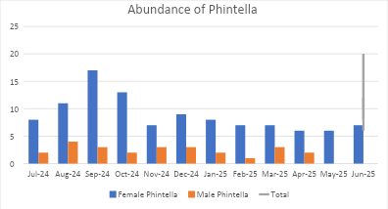
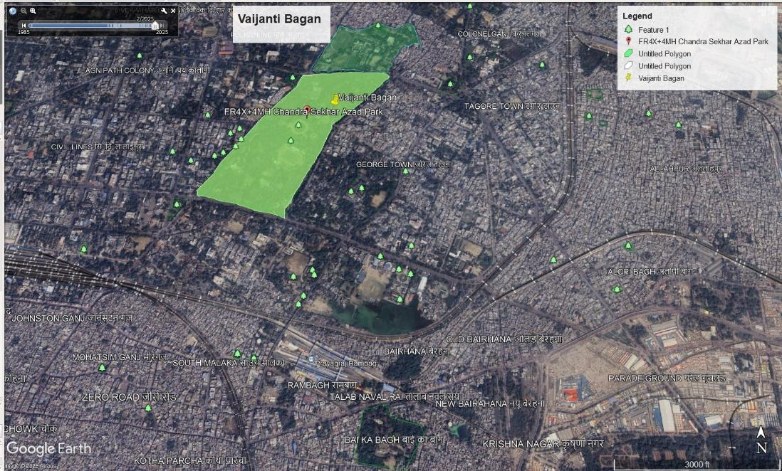
Figure 1: Map of Chandrashekhar Azad Park, Prayagraj by Google Earth Pro application.

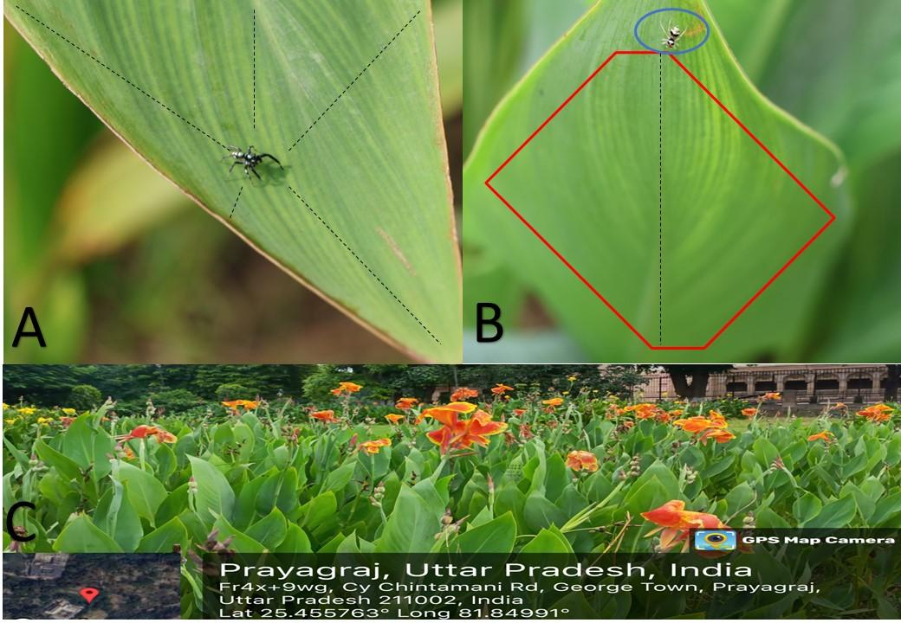
Figure 2: Fig 2A shows the jumping strategy and leaf spacing of the male Phintella vittata, Fig 2B shows the female's use of Canna lily leaf space, Fig 2C view of a Canna lily garden.
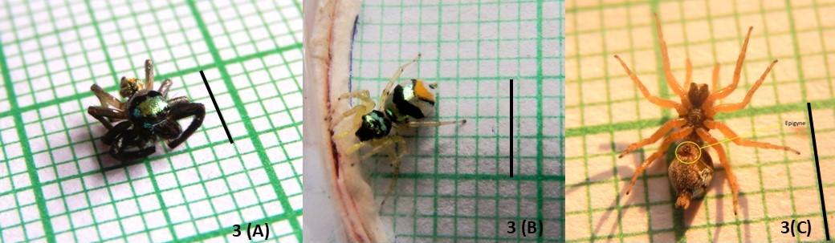
Figure 3: Fig 3A shows Male Phintella vittata, dorsal view; Fig 3B shows Female Phintella vittata, dorsal view; Fig 3C shows Female Phintella vittata Epigyne, ventral view; scale bar:5mm.

