Original Research Article

COI Gene-Based-Molecular Identification of Invasive Craspedacusta sowerbii Lankester, 1880 (Hydrozoa, Limnomedusa) Freshwater Jellyfish in Arga-Parvati wetlands, Gonda district, Uttar Pradesh, India
ABSTRACT
Species level identification of freshwater jellyfish remains challenging because of their fragile morphology, short-lived medusae and cryptic polyp stages. Hence, combining morphological taxonomy with molecular tools such as DNA barcoding using mitochondrial Cytochrome C Oxidase subunit I (COI) gene sequences provides an accurate and reliable approach for confirming species identity. This study reports the first molecularly confirmed occurrence of the freshwater jellyfish Craspedacusta sowerbii (Lankester, 1880) from northern India, recorded in the Arga-Parvati wetland complex of Gonda District, Uttar Pradesh. Species identification was achieved through an integrative approach combining morphological and molecular analyses. Morphologically, the medusa displayed a flattened hemispherical bell (mean diameter 15 ± 1.8 mm), four simple radial canals with corresponding pouch like gonads and 200 marginal tentacles bearing birhopaloid nematocysts. Molecular characterization using the mitochondrial Cytochrome C Oxidase subunit I (COI) gene (709 bp) confirmed 100% similarity with the Chinese isolate (KF510026.1) and 95% with the German isolate (FJ423619.1), indicating low genetic divergence and suggesting a globally conserved lineage. Phylogenetic analysis clustered the Indian isolate with C. sowerbii populations from China, Germany and Morocco with strong bootstrap support (86–100%), affirming its invasive potential. Physico-chemical analysis revealed warm (38 °C), slightly alkaline (pH 7.7-7.9) and phosphate-enriched (0.141-0.147 ppm) conditions characteristic of eutrophic systems. The proliferation and decay of Eichhornia crassipes (water hyacinth) likely enhanced phosphate release and organic load, stimulating algal and zooplankton productivity that favored jellyfish blooms. The findings demonstrate a trophic link between eutrophication and jellyfish proliferation and emphasize C. sowerbii as an indicator of nutrient enrichment while underscoring the need for wetland nutrient and macrophyte management.
Keywords: Invasive Hydrozoan, Peach blossom jellyfish, Medusa, Wetland eutrophication
INTRODUCTION
The phylogenetic analysis conducted in this thesis revealed a global distribution of only a few haplotypes that indicates an efficient spread of certain haplotypes originating from China. One haplotype was newly detected and seems to be restricted to Europe at the present stage. Surprisingly, sex of medusae was associated with haplotype in both species, suggesting that sex of medusae is rather genetically defined by the maternal polyp line and not by environmental factors (Schachtl, 2019’ Gophen & Shealtiel, 2012). Freshwater jellyfish belong to the family Olindiidae, which falls under the phylum Cnidaria and the class Hydrozoa. This family comprises a fascinating but understudied group of medusae that often display remarkable bloom phenomena in lentic ecosystems (Dumont, 1994; Bouillon and Boero, 2000a). Globally, about 20 freshwater jellyfish species have been reported across six genera, inhabiting lakes, reservoirs and ponds. In India, four genera i.e. Limnocnida, Craspedacusta, Mansariella and Keralika have been documented which indicates the wide biogeographic distribution of freshwater medusae (Jankowski, 2001).
The genus Craspedacusta was first described by Lankester in 1880 and currently includes around 11 recognized species among which Craspedacusta sowerbii (Lankester, 1880) is the most widespread occurring on all continents except Antarctica. This species is also known as the peach blossom jellyfish and is believed to have originated from the Yangtze River system in China and later spread globally through the aquarium trade, aquatic plant transport and ballast water movement (Fritz et al., 2009; Winata et al., 2024). Within the genus, C. sowerbii and C. kiatingi are recognized as invasive taxa capable of establishing in novel freshwater habitats and altering native ecological dynamics (Thorp and Covich, 2009; Zhang et al., 2009).
The life cycle of C. sowerbii is metagenetic and comprises an alternation between a sexually reproductive medusa stage and an asexually reproducing polyp stage. Polyps can transform into resting chitin covered cysts called podocysts which enable survival under unfavorable conditions and facilitating passive dispersal (Marchessaux et al., 2022). Blooms of this species are often episodic and are influenced by temperature as well as eutrophication and nutrient enrichment particularly phosphate and nitrate concentrations which promote medusa formation (Spadinger and Maier, 1999; Lucas et al 2012).
Ecologically C. sowerbii are often associated with elevated water temperature together with high nutrient concentrations and eutrophic conditions that favor zooplankton abundance serving as prey for the medusae (Gießler et al., 2023). Such blooms can alter local food web structures by predating on micro and meso zooplankton thereby leading to potential cascading effects on primary producers and fish recruitment. They may also reduce water clarity while modifying energy flow pathways impacting the ecological balance of freshwater systems. Moreover, jellyfish blooms can serve as bioindicators of ecosystem imbalance caused by eutrophication and climate change (Smith and Alexander, 2008; Richardson et al., 2009).
In India, reports of C. sowerbii have been sporadic, mainly from Kerala, whereas systematic molecular documentation and studies on the causes and potential consequences of jellyfish blooms remain limited (Sreeram et al., 2025). Northern India with its extensive network of floodplain wetlands and reservoirs remains largely unexplored for such occurrences. During a biodiversity assessment survey, a bloom of freshwater jellyfish was observed within the Arga-Parvati Bird Sanctuary in Gonda District, Uttar Pradesh, India. The sanctuary managed by the Forest Department of Uttar Pradesh forms an ecologically significant floodplain system that supports rich aquatic biodiversity. The survey undertaken under an institutional project guided by ICAR-Central Inland Fisheries Research Institute (ICAR-CIFRI) at Barrackpore, West Bengal aimed to document aquatic fauna and evaluate wetland ecosystem health. The unexpected appearance of jellyfish medusae led to a detailed scientific investigation to determine their taxonomic identity and ecological relevance.
Species level identification of freshwater jellyfish remains challenging because of their fragile morphology, short-lived medusae and cryptic polyp stages. Hence, combining morphological taxonomy with molecular tools such as DNA barcoding using mitochondrial Cytochrome C Oxidase subunit I (COI) gene sequences provides an accurate and reliable approach for confirming species identity (Hebert et al., 2003). This integrative methodology is particularly important for identifying invasive or cryptic species, tracking dispersal pathways and understanding evolutionary relationships among global populations. The present study was therefore undertaken to identify the freshwater jellyfish species recorded during the survey through morphological and genetic analyses, determine the source of the blooms and evaluate their potential impact on the lake ecosystem while suggesting management strategies to control C. sowerbii proliferation. This study was initiated due to the extensive growth of water hyacinth observed in the Arga-Parvati Protected Wetland, which was considered a potential factor contributing to the jellyfish bloom.
2. MATERIALS AND METHODS
2.1. Sampling:
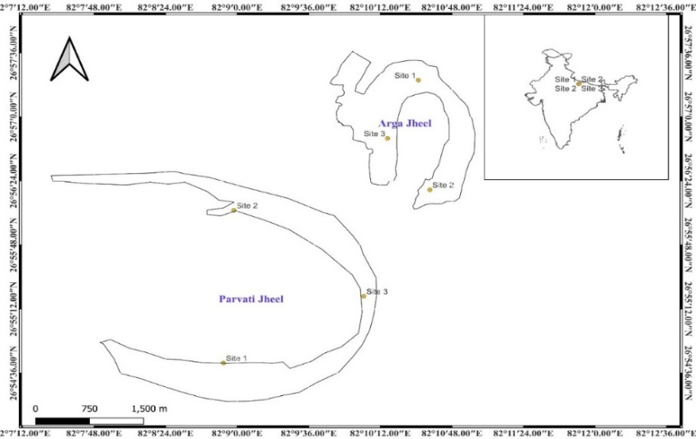
The present study was a part of biodiversity assessment of the Arga-Parvati Protected Wetland, Forest Department, Uttar Pradesh, India (Fig. 1). Four sampling sites were selected in each wetland and their geographic coordinates were recorded using a Garmin eTrex 32x (±3mm) handheld GPS (Table 1) and seasonal sampling was planned. During the sampling in the month of April 2022, some unusual creatures were reported from the Arga-Parvati wetlands in huge abundance. The total 40 number of specimens were collected in glass water bottle and preserved in the 95% alcohol. After reaching in the biology lab of the Prayagraj Regional Centre of ICAR-Central Inland Fisheries Research Institute, classical taxonomy was done using published literature of Bouillon and Boero, 2000a, 2000b; Kramp, 1950 and identified as C. sowerbii. The Stereo zoom microscopes (Leica, Model DMIL LED: S/N 510624) is used to take photographs and to perform morphological studies.

Fig. 1. Map of Arga-Parvati wetlands, Gonda district, Uttar Pradesh

Table 1. GPS coordinates of sampling sites in Arga-Parvati wetlands, Gonda district, Uttar Pradesh, India.
Site No. | Latitude (N) | Longitude (E)
1 | 26°56'30.9" | 82°10'51.9"
2 | 26°57'17.1" | 82°10'35.8"
3 | 26°57'00.8" | 82°10'09.3"
4 | 26°57'24.0" | 82°10'36.3"

2.2. Estimation of available phosphate concentration in wetland water:
Water samples were collected from four fixed sites in the Arga-Parvati wetlands during the bloom period. Surface water was taken in clean polyethylene bottles and analysed in the laboratory for phosphate concentration. Available phosphorus was measured by the stannous chloride colorimetric method using a UV-Vis spectrophotometer at 690 nm and results were expressed in mg L⁻¹ (ppm). Duplicate readings were averaged to ensure precision.
2.3. DNA isolation and PCR amplification:
The collected specimens preserved in absolute ethanol (95%) were transported to the Institute laboratory in Prayagraj, Uttar Pradesh for DNA isolation process. The DNA isolation was carried out using the protocol described by Sambrook and Russell (2001). This is the universal method for extracting high quality DNA from biological specimens. The isolated DNA was then processed with a set of restriction enzymes in a digestion reaction. Gel electrophoresis was performed using a 1% agarose gel and the DNA bands were visualized using a Gel Doc system to evaluate the quality and quantity of the extracted DNA.
The partial mitochondrial Cytochrome C Oxidase subunit I (COI) gene is a widely used in molecular biology to identify species and distinguish between different taxa of animals (Hebert et al., 2003). To amplify this gene, polymerase chain reaction (PCR) was performed using the forward primer: LCOjf (5’-GGTCAACAAATCATAAAGATATTGGAAC-3’) and reverse primer: HCO2198 (5’-TAAACTTCAGGGTGACCAAAAAATCA-3’) primer sets, as described by Dawson, 2005 and Folmer et al. 1994, respectively. The reaction mixture for PCR was prepared with various component to amplify a specific DNA sequence. The 50 μl mixture contained 5 μl of 10× PCR buffer, 1 μl of 50 mM MgCl₂, 1 μl of 10 mM dNTPs (Sigma, USA), 1 μl of 10 pmol per primer and 100 ng of extracted genomic DNA and 1 U Taq DNA polymerase (Sigma, USA).
For the amplification of the target DNA, the PCR was performed with an initial denaturation at 95 °C for 2 minutes, followed by 35 cycles of denaturation at 94 °C for 30 seconds, annealing at 51 °C for 60 seconds and extension at 72 °C for 90 seconds, with a final extension step at 72 °C for 7 minutes. These conditions were optimized to ensure the accurate and precise amplification of the target fragment. To visualize the DNA fragments in the amplified product, gel electrophoresis was performed on 1.8% agarose gels. The amplified product was subsequently sequenced in both the forward and reverse directions using the Applied Biosystems ABI 373xl capillary sequencer (Applied Biosystems, Foster City, CA).
2.4. Sequence analysis:
The DNA sequences were edited and aligned using BioEdit 7.0.5.2 software (Hall, 1999). The sequences were confirmed for accuracy by comparing them to (NCBI) GenBank reference sequences using the Basic Local Alignment Search Tool (BLAST).
The phylogenetic relationships among the organisms were analyzed using MEGA XI (Tamura et al., 2021) to gain a deeper understanding of their evolutionary history. A Maximum Likelihood (ML) tree was constructed based on the verified DNA sequences and closely related species retrieved from the NCBI.

- RESULTS
3.1. Systematics:
Phylum: Cnidaria
Class: Hydrozoa
Order: Limnomedusa
Family: Olindidae
Genus: Craspedacusta Lankester, 1880
Species: Craspedacusta sowerbii Lankester, 1880
3.2. Observation physico-chemical parameters of wetland water:
The surface water temperature in both wetlands was 38 °C, while the pH values were 7.9 in the Arga wetland and 7.7 in the Parvati wetland, indicating slightly alkaline conditions. Dissolved oxygen levels averaged 3.0 mg L⁻¹ in Arga and 3.2 mg L⁻¹ in Parvati, reflecting moderate oxygen availability. The mean available phosphate concentration were 0.141 ppm in Arga and 0.147 ppm in Parvati.
3.3. Taxonomic characters:
The medusa exhibits distinct morphological features that aid in its identification (Fig.2). An umbrella of the Medusa was flatter than hemispherical with a mean bell diameter of 15 mm. Four simple radial canals in the medusa with four pouch like gonads facing towards these canals. Quadrangular manubrium within the center of the sub umbrella joined together to form a lip. The gastrovascular cavity of the organism is composed of five whitish canals with four placed radially and one traversing from dorsal to ventral direction. The velum has several tentacles of differing lengths positioned around it in a pattern of three to seven short tentacles between longer ones. In total, there are 220 no. of tentacles present. Closed tubular statocysts present in the velum with their number nearly matching that of the marginal tentacles. The medusa is whitish in colour and translucent with milky-white/gonad (Fig 3). A group of nematocysts from the marginal tentacles called birhopaloids with a coiled shaft visible under the microscope at 40x magnification.
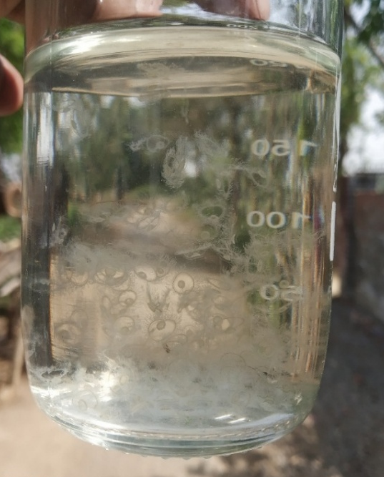

Fig. 2. Specimens of C. sowerbii collected from Arga wetlands

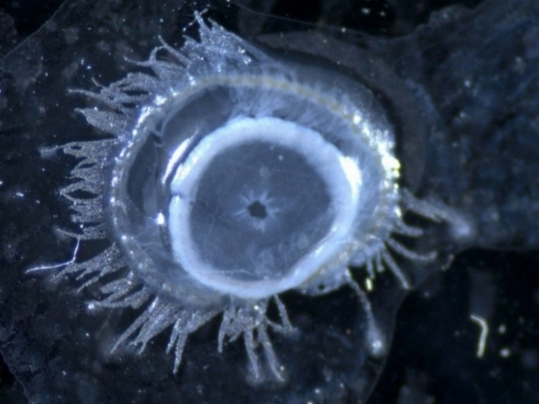

Fig. 3. Microscopic view of a juvenile jellyfish (Medusa)-Anterior view
  - Molecular identification of C. sowerbii:
The mitochondrial Cytochrome c oxidase I (COI) gene was used in this study for the precise identification of jellyfish species. A 709 bp COI sequence of C. sowerbii was generated (Fig. 4), which showed 100% similarity with the C. sowerbii sequence (KF510026.1) from China, according to the BLAST-N analysis. Phylogenetic analysis revealed that all C. sowerbii samples clustered together, with a bootstrap support of 100%. The specimen from this study showed the close genetic affinity with the Chinese C. sowerbii (KF510026.1), as illustrated in Fig. 5. The C. sowerbii sample from the present study is indicated by the shaded triangle. The verified DNA sequence has been submitted to GenBank under the accession number OP120942.

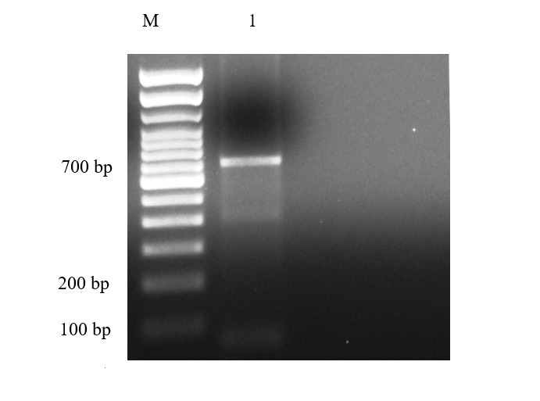

Fig. 4. Agarose gel electrophoresis showing PCR amplified product

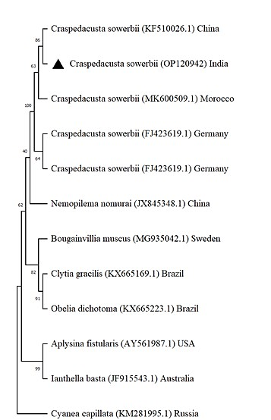

Fig. 5. Phylogenetic tree of C. sowerbii and related cnidarian species

Nei model and Maximum Likelihood (ML) are very powerful tools in phylogenetic studies and this method has been used to construct the tree based on the mitochondrial cytochrome c oxidase subunit 1 (CO1) gene. The tree is expected to provide valuable insights into the evolutionary relationships among organisms, as well as providing data for further research.
  - Phylogenetic analysis:
The phylogenetic tree based on the mitochondrial cytochrome c oxidase subunit I (COI) gene clearly demonstrates the evolutionary relationship of C. sowerbii from the Arga-Parvati wetlands in India (Accession No. OP120942) with other global populations. The Indian isolate, represented by a solid triangle, formed a well supported clade with C. sowerbii sequences from China (KF510026.1), Morocco (MK600509.1) and Germany (FJ423619.1). This clustering pattern, supported by high bootstrap values (86–100%), indicates very low genetic divergence among geographically distant populations, suggesting a common ancestral origin and the strong invasive potential of this species. The high degree of genetic similarity between the Indian and Chinese isolates (100% identity) points to a possible recent introduction event or a shared lineage that has remained conserved across regions.
The branching of Craspedacusta species as a distinct monophyletic group confirms the taxonomic accuracy of the molecular identification. Other hydrozoan and scyphozoan species such as Nemopilema nomurai (China), Bougainvillia muscus (Sweden), Clytia gracilis (Brazil) and Obelia dichotoma (Brazil) formed separate clusters, serving as outgroups and reinforcing the genetic distinctiveness of C. sowerbii within the family Olindiidae. The moderate bootstrap values (40-64%) among these lineages reflect expected divergence across different genera of the class Hydrozoa.
The close genetic affinity between the Indian and East Asian C. sowerbii populations suggests possible east-west dispersal pathways. Such dispersal could be facilitated by passive transport of dormant podocysts through migratory waterfowl along Asian flyways or by attachment to aquatic vegetation such as E. crassipes (water hyacinth).
DISCUSSION
The phylogenetic analysis of the mitochondrial Cytochrome C Oxidase subunit I (COI) gene revealed 100% sequence similarity between the C. sowerbii isolate from the Arga-Parvati wetlands (Accession No. OP120942) and the Chinese isolate (KF510026.1), while showing 95% similarity with the German isolate (FJ423619.1). This high degree of genetic resemblance confirms a close evolutionary relationship and indicates minimal regional divergence. The Indian isolate clustered with sequences from Germany, China and Morocco (MK600509.1) with strong bootstrap support (86-100%), forming a well-supported monophyletic clade within the family Olindiidae. These results mark one of the first molecularly validated records of C. sowerbii from northern India. The observed genetic similarity suggests a recent introduction or a conserved global lineage maintained through natural or anthropogenic dispersal routes. Earlier studies by Dumont (1994) proposed that C. sowerbii may spread through migratory birds that inadvertently transport dormant podocysts across continents, while Kramp (1950) suggested passive dispersal via floating macrophytes such as E. crassipes (water hyacinth). The low genetic variability across distant populations highlights a stable mitochondrial genome and strong invasive adaptability (Fritz et al., 2009; Zhang et al., 2009; Morpurgo et al., 2020). Overall, the phylogenetic evidence confirms the taxonomic distinctness of C. sowerbii and underscores its global dispersal capability across freshwater ecosystems (Lucas et al., 2012; Tamura et al., 2021).
The extensive proliferation of E. crassipes observed during the present study indicates severe eutrophication and poor wetland management in the Arga-Parvati system. The decomposition of this invasive macrophyte significantly alters nutrient dynamics by releasing large amounts of phosphorus and organic matter into the water column. As demonstrated by Masifwa et al. (2004), decaying E. crassipes releases peak phosphorus concentrations within the first ten days under hypoxic conditions, accompanied by reduced dissolved oxygen and pH. This process enhances microbial decomposition and fosters algal and phytoplankton blooms. The elevated phosphorus levels recorded in the present study, 0.141 ppm in Arga and 0.147 ppm in Parvati, confirm active nutrient enrichment that promotes primary productivity and sustains zooplankton populations. Zooplanktonic copepods and cladocerans, which serve as the preferred prey of C. sowerbii medusae (Meunier et al., 2020; Morpurgo et al., 2020), thrive in these conditions. Phosphorus-rich phytoplankton further enhance copepod growth and reproduction strengthening the trophic linkage between eutrophication and jellyfish proliferation. The slightly alkaline pH (7.7-7.9) and moderate dissolved oxygen levels (3.0-3.2 mg L⁻¹) indicate buffered aquatic conditions favourable for photosynthetic activity, microbial respiration and polyp attachment. Collectively, these parameters illustrate how E. crassipes decomposition drives phosphate enrichment, increases prey abundance and indirectly fuels C. sowerbii blooms, demonstrating the cascading ecological effects of anthropogenic nutrient loading on freshwater ecosystems (Lüskow et al., 2023).
These findings collectively describe a warm, shallow and nutrient-enriched aquatic environment favorable for the activation and growth of C. sowerbii. The recorded water temperature of 38 °C in both wetlands lies within the optimal thermal range for the transformation of polyps into medusae (Marchessaux et al., 2022). The shallow mean depth of 1.2 m and limited water exchange promote solar heating, thermal stratification and organic matter accumulation, conditions that facilitate the reactivation of dormant podocysts into active stages (Dumont, 1994). The interaction between E. crassipes proliferation, phosphate enrichment and C. sowerbii bloom dynamics can be explained as a trophic cascade, the decay of E. crassipes releases phosphate and organic matter, stimulating phytoplankton growth; this bloom increases populations of copepods and cladocerans, which serve as prey for C. sowerbii medusae, thereby promoting jellyfish bloom formation (Pitt et al., 2009).
Both wetlands characterized by elevated phosphate and dissolved oxygen levels, likely support high planktonic productivity. The Parvati wetland with its higher ionic load and nitrogen enrichment, indicates a more advanced stage of eutrophication compared to Arga. Despite these differences, both systems exhibit poor hydrological flushing and strong nutrient retention, creating favourable conditions for C. sowerbii proliferation (Schachtl et al., 2023). While the present findings demonstrate a clear association between phosphate enrichment and jellyfish occurrence, further quantitative studies are required to establish the causal link between phosphorus dynamics and bloom intensity.
Ecologically, the proliferation of C. sowerbii in these wetlands presents a significant threat to freshwater food-web stability. Both its polyp and medusa stages actively feed on zooplankton, thereby reducing grazing pressure on phytoplankton and promoting algal dominance (Jankowski et al., 2005). The medusae also prey on juvenile fish and macroinvertebrates, potentially disrupting fish recruitment and altering community structure (Smith and Alexander, 2008). Contact with water containing C. sowerbii was reported to cause itching and mild skin irritation, indicating the presence of proteolytic and cytolytic compounds capable of inducing localized inflammatory reactions (Purcell et al., 2001; Casafús et al., 2024). The observed bloom reflects ecological imbalance resulting from nutrient enrichment and macrophyte decomposition, conditions that strongly favor jellyfish proliferation. Sustained ecosystem monitoring and effective management of nutrient inputs are crucial to mitigate bloom recurrence and maintain the ecological health of these freshwater wetlands (Zhu et al., 2020).

Conclusion
The present investigation provides the first molecularly confirmed record of C. sowerbii from northern India and it establishes its presence in the Arga-Parvati wetland system of Uttar Pradesh. Morphological examination supported by COI gene sequencing verified 100% similarity with the Chinese isolate (KF510026.1) and 95% with the German isolate (FJ423619.1) and this finding signifies either a recent introduction or a conserved global lineage. The results reveal a clear ecological linkage between eutrophication, invasive macrophyte decomposition and jellyfish bloom formation. Elevated temperature, high phosphate concentration, and increased organic matter resulting from E. crassipes decay created ideal environmental conditions for medusa proliferation. The trophic cascade involving nutrient enrichment, phytoplankton productivity and zooplankton abundance facilitated bloom development. This study demonstrates that anthropogenic nutrient loading and poor hydrological management enhance the likelihood of C. sowerbii establishment and recurrence. Continuous ecological surveillance, nutrient load reduction, and macrophyte control are therefore essential for preserving wetland ecosystem stability and preventing the future spread of this invasive hydrozoan species in Indian freshwater habitats.

REFERENCES
Bouillon, J., & Boero, F. (2000a). Synopsis of the families and genera of the Hydromedusae of the world, with a list of the worldwide species. Thalassia Salentina, 24, 47–296.
Bouillon, J., & Boero, F. (2000b). The Hydrozoa: A new classification in the light of old knowledge. Thalassia Salentina, 24(1), 1–45.
Casafús, M. G., Gritti, M. A., Miranda, C., Guimarães, P., Montalto, L., & Peichoto, M. E. (2025). Freshwater jellyfish in northeastern Argentina: A risk to human health. Transactions of the Royal Society of Tropical Medicine and Hygiene, 119(1), 48–57.
Dawson, M. N. (2005). Incipient speciation of Catostylus mosaicus (Scyphozoa: Rhizostomeae: Catostylidae), comparative phylogeography and biogeography in south-east Australia. Journal of Biogeography, 32(3), 515–533.
Dumont, H. J. (1994). The distribution and ecology of the fresh and brackish-water medusae of the world. In H. J. Dumont, J. Green, & H. Masundire (Eds.), Studies on the ecology of tropical zooplankton (pp. 1–12). Springer Netherlands.
Folmer, O., Black, M., Hoeh, W., Lutz, R., & Vrijenhoek, R. (1994). DNA primers for amplification of mitochondrial cytochrome c oxidase subunit I from diverse metazoan invertebrates. Molecular Marine Biology and Biotechnology, 3, 294–299.
Fritz, G. B., Pfannkuchen, M., Reuner, A., Schill, R. O., & Brümmer, F. (2009). Craspedacusta sowerbii Lankester, 1880 population dispersal analysis using COI and ITS sequences. Journal of Limnology, 68, 46–52.
Gießler, S., Strauss, T., Schachtl, K., Jankowski, T., Klotz, R., & Stibor, H. (2023). Trophic positions of polyp and medusa stages of the freshwater jellyfish Craspedacusta sowerbii based on stable isotope analysis. Biology, 12(6), 814.
Hall, T. A. (1999). BioEdit: A user-friendly biological sequence alignment editor and analysis program for Windows 95/98/NT. Nucleic Acids Symposium Series, 41, 95–98.
Hebert, P. D. N., Ratnasingham, S., & deWaard, J. R. (2003). Barcoding animal life: Cytochrome c oxidase subunit 1 divergences among closely related species. Proceedings of the Royal Society B: Biological Sciences, 270, S96–S99.
Jankowski, T. (2001). The freshwater medusae of the world: A taxonomic and systematic literature study with remarks on other inland water jellyfish. Hydrobiologia, 462(1), 91–113.
Jankowski, T., Strauss, T., & Ratte, H. T. (2005). Trophic interactions of the freshwater jellyfish Craspedacusta sowerbii. Journal of Plankton Research, 27(8), 811–823.
Kramp, P. L. (1950). Freshwater medusae in China. Proceedings of the Zoological Society of London, 120(1), 165–184.
Lankester, E. R. (1880). On Limnocodium (Craspedacustes) sowerbii, a new trachomedusa inhabiting fresh water. Journal of Cell Science, 2(79), 351–371.
Lucas, C. H., Graham, W. M., & Widmer, C. (2012). Jellyfish life histories: Role of polyps in forming and maintaining scyphomedusa populations. Advances in Marine Biology, 63, 133–196.
Lüskow, F., Boersma, M., López-González, P. J., & Pakhomov, E. A. (2023). Genetic variability, biomass parameters, elemental composition and energy content of the non-indigenous hydromedusa Craspedacusta sowerbii in North America. Journal of Plankton Research, 45(1), 82–98.
Marchessaux, G., Lüskow, F., Bejean, M., & Pakhomov, E. A. (2022). Increasing temperature facilitates polyp spreading and medusa appearance of the invasive hydrozoan Craspedacusta sowerbii. Biology, 11(8), 1100.
Masifwa, W. F., Okello, W., & Ochieng, H. (2004). Phosphorus release from decomposing water hyacinth and effects of decomposition on water quality. Uganda Journal of Agricultural Sciences, 9(1), 389–395.
Meunier, C. L., Herstoff, E. M., Geisen, C., & Boersma, M. (2020). A matter of time and proportion: The availability of phosphorus-rich phytoplankton influences growth and behavior of copepod nauplii. Journal of Plankton Research, 42(5), 530–538.
Morpurgo, M., Schuchert, P., Vorhauser, S., & Alber, R. (2020). Occurrence of two distinct lineages of the freshwater jellyfish Craspedacusta sowerbii (Hydrozoa: Limnomedusae) in Italy. Journal of Limnology, 80(1).
Pitt, K. A., Welsh, D. T., & Condon, R. H. (2009). Influence of jellyfish blooms on carbon, nitrogen and phosphorus cycling and plankton production. Hydrobiologia, 616(1), 133–149.
Purcell, J. E., Graham, W. M., & Dumont, H. J. (2001). Jellyfish blooms: Ecological and societal importance. Springer Netherlands.
Richardson, A. J., Bakun, A., Hays, G. C., & Gibbons, M. J. (2009). The jellyfish joyride: Causes, consequences and management responses to a more gelatinous future. Trends in Ecology & Evolution, 24(6), 312–322.
Sambrook, J., & Russell, D. W. (2001). Molecular cloning: A laboratory manual (3rd ed.). Cold Spring Harbor Laboratory Press.
Schachtl, K., Gießler, S., & Stibor, H. (2023). The invasive freshwater jellyfish Craspedacusta sowerbii: A new vector for vertical nutrient transport within lakes? Fundamental and Applied Limnology, 196(3–4), 205–216.
Smith, A. S., & Alexander, J. E., Jr. (2008). Potential effects of the freshwater jellyfish Craspedacusta sowerbii on zooplankton community abundance. Journal of Plankton Research, 30(12), 1323–1327.
Spadinger, R., & Maier, G. (1999). Prey selection and diel feeding of the freshwater jellyfish Craspedacusta sowerbii. Freshwater Biology, 41(3), 567–573.
Sreeram, M. P., Prasad, R., Sreekumar, K. M., Raju, A. K., Augustina, T. A. X., Lüskow, F., & Saravanan, R. (2025). Post-flooding blooms of the non-indigenous freshwater jellyfish Craspedacusta sowerbii Lankester, 1880 in Kollam District of Kerala, India. Journal of Plankton Research, 47(1).
Tamura, K., Stecher, G., & Kumar, S. (2021). MEGA11: Molecular evolutionary genetics analysis version 11. Molecular Biology and Evolution, 38(7), 3022–3027.
Thorp, J. H., & Covich, A. P. (2009). Ecology and classification of North American freshwater invertebrates. Academic Press.
Winata, K., Zhu, J. A., Hanselman, K. M., Zerbe, E., Langguth, J., Folino-Rorem, N., & Cartwright, P. (2024). Life cycle transitions in the freshwater jellyfish Craspedacusta sowerbii. Biology, 13(12), 1069.
Zhang, L. Q., Wang, G. T., Yao, W. J., Li, W. X., & Gao, Q. (2009). Molecular systematics of medusae in the genus Craspedacusta (Cnidaria: Hydrozoa: Limnomedusae) in China with reference to species identity. Journal of Plankton Research, 31(5), 563–570.
Zhu, K., Wu, Y., Li, C., Xu, J., & Zhang, M. (2020). Ecosystem-based restoration to mitigate eutrophication: A case study in a shallow lake. Water, 12(8), 2141.

Schachtl, K. (2019). Genetic characterization and ecological effects of the invasive freshwater jellyfish Craspedacusta sowerbii (Doctoral dissertation, lmu).
Gophen, M., & Shealtiel, L. (2012). Record of the alien species Craspedacusta sowerbyi Lankester, 1880 (Cnidaria: Limnomedusae) in Lake Kinneret catchment area. BioInvasions Records, 1, 29-31.

