A faunistic survey and morphometric analysis of termite species from Jorhat and Golaghat districts of Assam

ABSTRACT

To understand the incidence of different termite species in four habitats (forest, agriculture, rural and urban sites), a systematic GPS based study was carried out during 2020-2021 and 2021-2022 in two selected districts of Assam. The study revealed the presence of eight different termite species across diverse habitats in both districts. Among these 8 species, five species belonged to the Macrotermitinae subfamily, while the remaining 3 species belonged to Nasutitermitinae, Kalotermitinae and Amitermitinae subfamilies. The genus Odontotermes was found to be predominant, comprising four species viz., Odontotermes obesus (Rambur), O. feae (Wasmann), O. parvidens (Holmg. and Holmg.) and O. kapuri (Roonwal and Chhotani). The other 4 species belonged to different genera and these were Microtermes mycophagous (Desneux), Trinervitermes biformis (Wasmann), Neotermes buxensis (Roonwal and Sen-sarma) and Speculitermes chadaensis (Chatterjee and Thapa). Four different feeding groups of termites were observed among which soil, litter and fungus feeder were dominantly found. Among eight species, O. obesus and O. feae were dominantly distributed in different habitats of both the district. Morphometric studies indicated that O. feae was larger than rest of the seven species.

Keywords: Termite species, incidence; habitats and feeding group

1. INTRODUCTION

Termites are eusocial insects, live in colonies composed of individuals developed from more than one generation, representing cooperative care and showing reproductive division of the labour. At large termites are considered as ecosystem engineers, because of various anthropogenic activities, many species are of late reported to be major pests of many agricultural, horticultural and urban landscapes. Termites are widely distributed throughout the tropical and subtropical regions of the world except for Antarctica, with the highest diversity found in tropical forests (Eggleton, 2000). By the early 1970’s approximately 1900 living and fossil species of termites had been described (Lee and Wood, 1971) and a constant flow of descriptions is still continuing. The world living and fossil termites recognized 3,106 termite species which were classified into 12 important families (Krishna et al., 2013). In Asia, about 435 species of termites have been reported abundantly distributed in mild tropical and subtropical habitats indicating their moisture loving behaviour to build various mound architect (Krishna et al., 2013). The Indian termite fauna consists of 320 species of 53 genera and 8 families (Aiswarya et al., 2025). Termite nests consist of two main integral parts viz., inanimate and animate. The animate represents all the inhabiting termites inside the nest while inanimate is the entire nest constructed by the termites (Bignell et al., 2010). The structure of the termite nest classified into three main categories viz., subterranean (below ground), epigeal (above the soil surface) and arboreal nest (above the ground attached with large trees and connected to the ground via shelter tubes) (Noirot and Darlington, 2000). Epigeal nests protrude above the soil surface are termed as mounds made out of earth and mud (Bignell et al., 2010). The subtropical climatic condition of Assam provides congenial environment for proliferation of a variety of termite species (Bhattacharyya et al., 2007; Bhattacharyya et al., 2014; Kathbaruah et al., 2025). However, information about their incidence in various ecosystem and habitats are practically scanty. Considering all facts, the present study unravelled the information about existence of termite species along with their right taxonomic identity in different habitats in Assam.

2. material and methods

The study was carried out in Jorhat and Golaghat district of Assam and in each district four different habitats (forest, agriculture, rural and urban sites) were selected. Each habitat was completely different to each other and the location of the study area was delineated through Geographic Positioning System.

List 1 : The details of the study sites are tabulated below
Habitat | District |  | Geographic coordinates
Habitat | Jorhat | Golaghat | Jorhat | Golaghat
Forest | Hoollongapar Gibbon  Wildlife Sanctuary | Nambor Wildlife Sanctuary | 26°40' N  94°19' E | 26°52' N  93°96' E
Agriculture | Instruction Cum Research Farm &  Horticulture Experimental Farm, ,Assam Agricultural University, Jorhat | Sugarcane, Medicinal and Aromatic Plants Research Station, Assam Agricultural University, Buralikson | 26°72′ N  94°19′ E | 26°31' N  93°58' E
Rural | Maharichuk, Majuli river island | Kachamari village | 26°57′ N  94°10′ E | 26°53′ N  93°98′ E
Urban | Dholajan village | Kacharihat village | 26°65′ N  94°12′ E | 26°51′ N  94°01′ E

Transect and quadrate methods were followed for termites sampling as given by Jones et al. (2005). At three months interval in each selected habitat of both the districts. Transect method was carried out in 100 m long and 2 m wide transect line, which was divided into 20 contiguous sections each (2m x 5m) which were numbered sequentially. Samples were collected in each section for 30 minutes by two persons. In each section, different microhabitats were searched for termite accumulations. All the mounds encountered, carton runways and sheeting on vegetation up to a height of 2 m above ground level were taken into consideration. Quadrate method was followed in 10 m x 10 m randomly selected plot which was divided into 4 sub sections, each having 25 square meter which were marked randomly and in those sections termites were sampled by following the methodology mentioned in case of transect method. The samples were then brought to the Soil Arthropod Pests Laboratory, Department of Entomology, Assam Agricultural University (AAU), Jorhat. Collected soil debris were then placed in a tray and separation was performed with the help of a brush. Termites which were extracted then preserved in 80 per cent ethanol in 20 ml glass bottles. The preserved specimens were labelled carefully and later identified using a key compiled by Zoological Survey of India (ZSI), sourcebooks and other compendia and further confirmed by Dr. C. M. Kalleshwaraswamy, Professor, Department of Entomology, University of Agricultural and Horticultural Sciences, Shivamogga, India. The species were identified through proper measurements of morphological characters viz., head (postmentum, labrum and mandible), eyes, antennae, pronotum, mesonotum, metanotum, legs, rostrum (in nasuti), cerci and wings etc. Generally, soldiers were selected for measurements of morphological traits but in some cases where soldiers were unable to collect, winged alate and workers were compared with keys for identification. Measurements of the different parts were taken using Stereozoom Microscope (Model: Zeiss Stemi 2000-C) and Scanning Electron Microscope (Model: JSM 6390LV) in Soil Arthropod Laboratory, Department of Entomology, AAU and the Department of Physics, Tezpur University, Assam respectively.
3. results and discussion

Sampling and identification of the species along with their feeding status:
Studies were conducted for two consecutive years (2020-21 and 2021-22) at four different habitats in the Jorhat and Golaghat district of Assam. Sampling in different habitats revealed eight species of termites from both districts. Among the 8 different species, 5 species were belonged to Macrotermitinae subfamily (Table 1) (Fig. 1), whereas other 3 species belonged to Nasutitermitinae, Kalotermitinae and Amitermitinae subfamily respectively (Table 1) (Fig. 2). The genus Odontotermes were found dominant and consisted of four species: Odontotermes obesus (Rambur), O. feae (Wasmann), O. parvidens (Holmg. and Holmg.), and O. kapuri (Roonwal and Chhotani). The remaining 4 species were belonged to different genera and these were Microtermes mycophagous (Desneux), Trinervitermes biformis (Wasmann), Neotermes buxensis (Roonwal and Sen-sarma) and Speculitermes chadaensis (Chatterjee and Thapa). The present findings are in accordance with the study by Anantharaju et al. (2014), who reported ten species of termites from Northeastern Puducherry: Hypotermes obscuriceps, Macrotermes convulsionarius, Odontotermes anamallensis, O. brunneus, O. globicola, Microcerotermes fletcheri, Microtermes obesi, Trinervitermes biformis, Coptotermes heimi, and Neotermes assmuthi. The feeding status of the identified species revealed that termites belonging to the Macrotermitinae and Amitermitinae subfamilies were generally subterranean soil, wood, litter and fungus feeders. While the T. biformis and N. buxensis were arboreal, soil and grass feeder and wood dweller termites (Table 1). Detailed ecology of these species were also described by Roonwal and Chhotani (1989). It was also observed that among 8 species only two (O. obesus and O. feae) were prolific mound builders and dominantly distributed in all habitats of Jorhat and Golaghat districts.

Morphometric study of the termites belonging to Macrotermitinae subfamily:
The diagnostic characters to measure the different structures of the head, mandibles and mouth parts were determined by following the standard keys given by Roonwal and Chhotani (1989) and Chhotani (1997). Most of the termite species were identified with soldier morphometric characters (Fig. 3 & 4). But S. chadaensis and N. buxensis were identified based on morphometric characters of workers and imagos. Morphometric measurements of termite species under Macrotermitinae, Nasutitermitinae, Kalotermitinae and Amitermitinae subfamily are presented in the Table 2. Morphometric study revealed that among the soldier termites under Macrotermitinae subfamily highest total body length (TBL) was observed in case of O. feae (9.48 ± 0.40 mm) followed by O. parvidens (8.28 ± 0.23 mm), M. mycophagous (8.41± 0.22 mm), O. obesus (7.77 ± 0.38 mm) and O. kapuri (5.63 ± 0.41 mm). However, the length of the head (LH) and length of the head with the mandibles (LH+LM) was more in case of O. parvidens (2.80 ± 0.21 mm) & (4.14 ± 0.27 mm) followed by O. feae (2.54 ± 0.23 mm) & (3.93 ± 0.34 mm), O. obesus (1.80 ± 0.22 mm) & (2.66 ± 0.27 mm), O. kapuri (1.71 ± 0.19 mm) & (2.54 ± 0.25 mm) and M. mycophagous (1.15 ± 0.18 mm) & (1.73 ± 0.27 mm) respectively. Considering width of the head (WH) O. feae registered highest width length (2.14 ± 0.19 mm) followed by O. parvidens (1.92 ± 0.32 mm), O. obesus (1.31 ± 0.28 mm) O. kapuri (1.17 ± 0.23 mm) and M. mycophagous (0.86 ± 0.23 mm). Head index (HI) measurement indicated that O. feae registered highest head index (0.85 ± 0.13 mm) followed by M. mycophagous (0.77 ± 0.25 mm), O. obesus (0.74 ± 0.18 mm), O. kapuri (0.69 ± 0.17 mm) and O. parvidens (0.69 ± 0.12 mm). Length of the labrum (LL) was bigger in case of O. parvidens (0.55 ± 0.19 mm) than four of the soldier termites viz., O. kapuri (0.47 ± 0.16 mm), O. obesus (0.40 ± 0.19 mm), O. feae (0.37 ± 0.20 mm) and M. mycophagous, (0.35 ± 0.17 mm) but the width of the labrum (WH) (0.41 ± 0.12 mm) was lesser than the O. feae (0.58 ± 0.12 mm). Width of the labrum registered in O. kapuri, O. obesus, and M. mycophagous were 0.36 ± 0.10, 0.31 ± 0.08 and 0.28 ± 0.07 mm respectively. Length of the left mandible (LLM) was higher in case of O. feae (1.39 ± 0.15 mm), than O. parvidens (1.34 ± 0.09 mm), O. obesus (0.86 ± 0.28 mm), O. kapuri (0.82 ± 0.16 mm), and M. mycophagous (0.51 ± 0.17 mm). Among all the species head mandibular length index (HMLI) was more in case of O. feae (0.55 ± 0.05 mm) than M. mycophagous (0.51 ± 0.17 mm), O. obesus (0.49 ± 0.19 mm), O. kapuri (0.49 ± 0.11 mm) and O. parvidens (0.48 ± 0.04 mm). Measurement of tooth region in the left mandible revealed that O. parvidens exhibited higher left mandibular tooth distance (LMTD) and left mandibular tooth Index (LMTI) (0.81 ± 0.27 & 0.61 ± 0.18 mm) than O. feae (0.72 ± 0.18 & 0.52 ± 0.13 mm), O. obesus (0.39 ± 0.08 & 0.51 ± 0.25 mm) and O. kapuri (0.26 ± 0.04 & 0.33 ± 0.07 mm) respectively. Length of postmentum (LPo) and width of postmentum (WPo) were comparatively higher in case of O. parvidens (1.56 ± 0.25 & 0.84 ± 0.32 mm) than O. feae (1.48 ± 0.22 & 0.79 ± 0.11 mm), O. kapuri (0.93 ± 0.34 & 0.62 ± 0.21 mm), O. obesus (0.89 ± 0.31 & 0.52 ± 0.24 mm), and M. mycophagous (0.50 ± 0.18 & 0.34 ± 0.10 mm). Length and width of the pronotum (LP) and (WP) were higher in case of O. feae (1.06 ± 0.18 & 1.57 ± 0.26 mm) than O. parvidens (0.89 ± 0.30 & 1.53 ± 0.28 mm), O. kapuri (0.73 ± 0.14 & 1.29 ± 0.11 mm), O. obesus (0.64 ± 0.21 & 1.03 ± 0.17 mm) and M. mycophagous (0.36 ± 0.10 & 0.58 ± 0.15 mm). Pronotum index (PI) was comparatively larger in case of O. feae (0.70 ± 0.20 mm) followed by M. mycophagous (0.65 ± 0.28 mm) O. obesus (0.64 ± 0.23 mm), O. parvidens (0.61 ± 0.25 mm) and O. kapuri (0.57 ± 0.13). Numbers of antennal segments (NAS) were same in case of O. feae and O. kapuri (17 numbers), as such in O. obesus and O. parvidens (16 numbers) whereas M. mycophagous exhibited 14 numbers of antennal segments (NAS) (Table 2) (Fig. 4 & 5). Of late Saha et al. (2016) described the subterranean termite genus Odontotermes from Chhattisgarh, India, providing annotated checklist and a revised key. They identified eight different species of Odontotermes, six species were new records from the state and the species were O. assmuthi (Holmgren), O. feae (Wasmann), O. globicola (Wasmann) O. gurdaspurensis (Holmgren & Holmgren), O. horai (Roonwal & Chhotani), O. horni (Wasmann), O. latiguloides (Roonwal & Verma) and O. obesus (Rambur). In another taxonomic study Farkhanda and Akhtar (2006) described the soldier caste of O. parvidens. The detailed taxonomic treatment of the soldier caste of O. parvidens showed significant variation in different morphometric parameters within the samples collected from various localities of Lahore, Pakistan. The present taxonomic study of these soldier termites under the Macrotermitinae subfamily revealed that O. feae was comparatively bigger than O. parvidens, M. mycophagous, O. obesus and O. kapuri.
Morphometric study of T. biformis (soldier), S. chadaensis (worker) and N. buxensis (imago):
Observation on the morphometric study of three termite species namely., T. biformis (soldier), S. chadaensis (worker) and N. buxensis (imago) under the subfamilies Nasutitermitinae, Apiculitermitinae and Kalotermitinae respectively revealed that imago individuals of N. buxensis recorded highest total body length (7.72 ± 0.31 mm) followed by soldier individuals of T. biformis (5.42 ± 0.37 mm) and worker individuals of S. chadaensis (4.41 ± 0.42 mm) (Table 2) (Fig. 5). N. buxensis imagoes registered a total body length with the length of the wings were 9.18 ± 0.11 mm. T. biformis soldiers recorded higher length of the head (1.35 ± 0.29 mm) compared to S. chadaensis workers (1.16 ± 0.26 mm) and N. buxensis imagoes (1.15 ± 0.22 mm). The measurement of head with the mandibles in S. chadaensis workers was 2.22 ± 0.27 mm lengths. Being a nauste termite T. biformis did not have mandibles; instead, these were replaced by rostrum while the imagoes of N. buxensis had rudimentary mandibles. The measurement of head length with the rostrum in T. biformis were 2.17 ± 0.31 mm. The measurement of width of the head and head index revealed that N. buxensis imagoes recorded comparatively higher width of the head and head index (1.32 ± 0.25 & 1.15 ± 0.27 mm) than S. chadaensis workers (1.25 ± 0.20 & 1.07 ± 0.36 mm) and T. biformis soldiers (0.93 ± 0.25 & 0.69 ± 0.18 mm). Length and width of the labrum in case of N. buxensis imagoes and S. chadaensis workers were 0.48 ± 0.16 & 0.59 ± 0.21 mm and 0.17 ± 0.06 & 0.21 ± 0.11 respectively. Workers of S. chadaensis identified through the presence of mid dorsal spot situated dorsally on the head portion and the diameter of this spot was 0.15 ± 0.03 mm. Imagoes of N. buxensis had well developed compound and simple eyes but S. chadaensis workers had only a pair of compound eyes but devoid of simple eyes. Diameter of compound eyes recorded in case of N. buxensis imagoes and S. chadaensis workers were 0.62 ± 0.19 mm and 0.24 ± 0.11 mm respectively. Diameter of lateral ocellus and eye ocellus distance were 0.19 ± 0.07 mm and 0.11 ± 0.05 mm respectively. Length of the rostrum and head rostral length index of T. biformis soldiers were 0.82 ± 0.14 and 0.61 ± 0.18 respectively. Length of the left mandible, head mandibular length index, left mandibular tooth distance and left mandibular tooth index of S. chadaensis workers were 0.53 ± 0.19, 0.47 ± 0.13, 0.12 ± 0.03 and 0.25 ± 0.09 mm respectively. Length and width of postmentum in case of N. buxensis imagoes (0.83 ± 0.09 & 1.35 ± 0.27 mm) were comparatively more than S. chadaensis workers (0.41 ± 0.07 & 0.73 ± 0.26 mm) and T. biformis soldiers (0.21 ± 0.03 & 0.34 ± 0.09 mm). Length of fore and hind wings of N. buxensis imagoes were 1.03 ± 0.27 and 1.45 ± 0.34 mm respectively. Pronotum index were comparatively higher in case of T. biformis soldiers (0.62 ± 0.03 mm) than N. buxensis imagoes (0.61 ± 0.07 mm) and S. chadaensis workers (0.56 ± 0.05 mm). Number of antennal segments was more in case of N. buxensis imagoes (17 numbers) than S. chadaensis workers (14 numbers) and T. biformis soldiers (12 numbers) (Table 2) (Fig. 6). During 2016 more or less a similar kind of study was conducted by Amina et al. (2016), they also described that S. chadaensis exhibited a dark brown head capsule, while the post-clypeus and labrum were paler than the head capsule. The antennae thorax and abdomen were pale brown and translucent. The body and head were densely and sparsely hairy.

4. Conclusion

The present study clearly indicates the occurrence of eight species of termites viz., Odontotermes obesus, O. feae, O. parvidens, and O. kapuri, Microtermes mycophagous, Trinervitermes biformis, Neotermes buxensis and Speculitermes chadaensis in the Jorhat and Golaghat districts of Assam. Among these O. obesus and O. feae, were prolific mound builders and were dominantly distributed across various habitats. Morphometric studies of all identified species exhibited a range of sizes, however; taxonomic details revealed that O. feae was comparatively larger than the other termite species. Considering above information, it is evident that a rigorous GPS based survey covering all districts of Assam is required to identify the termite fauna which might unravel many more new records. For accurate species descriptions, both conventional taxonomy and recent molecular techniques should be employed. Moreover, termite management in the "North East" region, particularly under organic cultivation is really a big challenge (Pujari et al., 2013) and hence efforts must be made to explore potential botanicals, entomopathogenic nematodes and entomogenous fungi (Bhattacharyya et al., 2023; Bhagawati et al., 2017; Devi et al., 2023; Devi et al., 2025; Sarmah, 2023; Bhairavi et al., 2021). For mound building termites, mechanical elimination is an effective technique for managing termite populations. Digging the termitarium and killing the queen along with the complementary forms after locating the royal chamber is one of the effective methods of managing mound building termites (Mishra et al., 2019).

Competing Interests
Authors have declared that they have no known competing financial interests or non-financial interests or personal relationships that could have appeared to influence the work reported in this paper.

Disclaimer (Artificial intelligence)

Author(s) hereby declares that NO generative AI technologies such as Large Language Models (ChatGPT, COPILOT, etc.) and text-to-image generators have been used during the writing or editing of this manuscript.

REFERENCES:

Aiswarya, P. M., Honey, S., & Sudhikumar, A. V. (2025). Termites (Blattodea: Isoptera) of India: An updated checklist. Acta Zoológica Lilloana, 69(1), 77–158. https://doi.org/10.30550/j.azl/2013
Amina, P., Rajmohana, K., Bhavana, K. V., & Rabeeha, P. (2016). New records of termite species from Kerala (Isoptera: Termitidae). Journal of Threatened Taxa, 8(11), 9334–9338.
Anantharaju, T., Kaur, G., Gajlakshmi, S., & Abbasi, S. A. (2014). Sampling and identification of termites in Northeastern Puducherry. Journal of Entomology and Zoological Studies, 2(3), 225–230.
Bhagawati, S., Bhattacharyya, B., Mishra, H., & Gogoi, D. (2017). Chemical management of termites (Odontotermes obesus) in preserved setts of sugarcane (Saccharum officinarum). Journal of Entomology and Zoology Studies, 5(1), 856–859.
Bhairavi, K. S., Bhattacharyya, B., Devi, G., Bhagawati, S., Das, P. P. G., Devi, E. B., et al. (2021). Evaluation of two native entomopathogenic nematodes against Odontotermes obesus (Rambur) (Isoptera: Termitidae) and Agrotis ipsilon (Hufnagel) (Lepidoptera: Noctuidae). Egyptian Journal of Biological Pest Control, 31, 111.
Bhattacharyya, B., Baruah, A. A. L. H., Bhuyan, U., & Das, P. (2007). Management of termites in preserved setts of sugarcane in Assam. Pesticide Research Journal, 19(1), 45–46.
Bhattacharyya, B., Gogoi, I., Das, P. P. G., & Kalita, B. (2023). Management of agricultural insect pests for sustainable agriculture and environment. In M. Farooq, N. Gogoi, & M. Pisante (Eds.), Sustainable Agriculture and the Environment (pp. 161–193). United States: Academic Press, Elsevier. ISBN: 978-0-323-90500-8.
Bhattacharyya, B., Mishra, H., Gogoi, D., & Bhagawati, S. (2014). Management of termite in preserved setts of sugarcane (Saccharum officinarum) with microbes. Current Advances in Agricultural Sciences, 6(2), 176–179.
Bignell, D. E., Roisin, Y., & Lo, N. (2010). Biology of termites: A modern synthesis. Dordrecht: Springer.
Chhotani, O. B. (1997). Fauna of Indian and adjacent countries: Isoptera (Termites). Calcutta: Zoological Survey of India.
Pujari, D., Bhattacharyya, B., & Das, M. (2013). Insect pest management in organic agriculture. International Journal of Plant Protection, 6(2), 467–472.
Devi, G., Bhattacharyya, B., Bhattacharjee, S., Bathari, M., & Pathak, S. (2025). Field and multi-locational study on efficacy of native entomopathogenic nematodes (Heterorhabditis bacteriophora Poinar) against termite (Odontotermes obesus Rambur) in Assam, India. International Journal of Plant & Soil Science, 37(11), 536–547.
Devi, G., Bhattacharyya, B., Bora, D., & Gogoi, M. (2023). Field pathogenicity and persistence of entomopathogenic nematode, Heterorhabditis bacteriophora infecting termite (Odontotermes obesus Rambur) in tea plantation. Journal of Entomological Research, 47, 844–848.
Eggleton, P. (2000). Global patterns of termite diversity. In T. Abe, D. E. Bignell, & M. Higashi (Eds.), Termites: Evolution, sociality, symbiosis, ecology (pp. 25–51). Dordrecht, Netherlands: Kluwer Academic Publishers.
Farkhanda, M., & Akhtar, M. S. (2006). Morphometric analysis of population samples of soldier caste of Odontotermes parvidens Holmgren and Holmgren (Isoptera: Termitidae: Macrotermitinae). Journal of Research (Science), 17(3), 207–218.
Jones, D. T., Verkerk, R. H. J., & Eggleton, P. (2005). Methods in ecology: Insect sampling in forest ecosystems. In S. R. Leather (Ed.), Insect sampling in forest ecosystems (pp. 221–253). Oxford, U.K.: Blackwell Publishing.
Kathbaruah, S., Bhattacharyya, B., & Bhairavi, K. S. (2025). Properties of termite mounds and its impact on crop growth: A review. Biotica Research Today, 7(1), 28–32.
Krishna, K., Grimaldi, D. A., Krishna, V., & Engel, M. S. (2013). Treatise on the Isoptera of the world. Bulletin of the American Museum of Natural History, 377(7), 1–200.
Lee, K. E., & Wood, T. G. (1971). Termites and soils. London: Academic Press.
Mishra, H., Bhattacharyya, B., Bhagawati, S., Gogoi, D., & Bhattacharjee, S. (2019). Suppression of termite attack in tea ecosystem with biopesticides. Indian Journal of Entomology, 81(4), 685–687.
Noirot, C., & Darlington, J. P. E. C. (2000). Termite nests: Architecture, regulation and defence. In T. Abe, D. E. Bignell, & M. Higashi (Eds.), Termites: Evolution, sociality, symbioses, ecology (pp. 121–139). Springer.
Roonwal, M. L., & Chhotani, O. B. (1989). Fauna of Indian and adjacent countries: Isoptera (Termites). Calcutta: Zoological Survey of India, 1, 89–100, 120.
Saha, N., Mazumdar, P. C., Basak, J., Raha, A., Majumder, A., & Chandra, K. (2016). Subterranean termite genus Odontotermes (Blattaria: Isoptera: Termitidae) from Chhattisgarh, India with its annotated checklist and revised key. Journal of Threatened Taxa, 8(3), 8602–8610.
Sarmah, K., Bhattacharyya, B., & Das, P. P. G. (2023). Bioefficacy of green chemistry insecticides against termite Odontotermes obesus Rambur and red ant Dorylus orientalis Westwood. Pesticide Research Journal, 35(1), 90–95.

Table 1. Termite species identified from different habitats of Assam

Subfamily | Species | Feeding status | Mound/non mound builders
Macrotermitinae | Odontotermes obesus (Rambur) | Subterranean, soil and wood feeder | Mound builders
 | O. feae (Wasmann) | Subterranean, soil and wood feeder | Mound builders
 | O. parvidens (Holmg. and Holmg.) | Subterranean, soil and wood feeder | Non mound builders
 | O. kapuri (Roonwal and Chhotani) | Subterranean, soil and wood feeder | Non mound builders
 | Microtermes mycophagous (Desneux) | Subterranean, litter and fungus feeder | Non mound builders
Nasutitermitinae | Trinervitermes biformis (Wasmann) | Arboreal, soil and grass feeder | Non mound builders
Kalotermitinae | Neotermes buxensis (Roonwal and Sen-sarma) | Wood dweller | Non mound builders
Amitermitinae | Speculitermes chadaensis (Chatterjee and Thapa) | Subterranean, litter and fungus feeder | Non mound builders

Table 2. Morphometric characters of eight species of termites under subfamily Macrotermitinae, Nasutitermitinae, Kalotermitinae and Amitermitinae (Mean ± SD)
Morphometric traits | O. obesus | O. feae | O. parvidens | O. kapuri | M. mycophagous | T. biformis | S. chadaensis (worker) | N. buxensis (imago)
Total body length (TBL) | 7.77 ± 0.38  (7.21 - 8.83) | 9.48 ± 0.40  (9.09 -10.14) | 8.28 ± 0.23  (8.06 -8.90) | 5.63 ± 0.41  (5.10 - 6.05) | 8.41± 0.22  (8.17 - 9.15) | 5.42 ± 0.37  (5.02 - 5.85) | 4.41 ± 0.42  (3.21 - 5.21 ) | 7.72 ± 0.31  (7.21 - 8.32)
TBL with wings | - | - | - | - | - | - | - | 9.18 ± 0.11  (9.00 - 9.38)
Length of the head (LH) | 1.80 ± 0.22  (1.34 - 2.12) | 2.54 ± 0.23  (2.14 - 2.89) | 2.80 ± 0.21  (2.30 - 3.18) | 1.71 ± 0.19  (1.32 - 1.98) | 1.15 ± 0.18  (0.85 - 1.56) | 1.35 ± 0.29  (1.05 - 1.98) | 1.16 ± 0.26  (0.69 - 1.75) | 1.15 ± 0.22  (0.69 - 1.52)
Length of the head with mandibles (LH + LM) | 2.66 ± 0.27  (2.34 - 3.23) | 3.93 ± 0.34  (3.43 - 4.59) | 4.14 ± 0.27  (3.53 - 4.6) | 2.54 ± 0.25  (2.18 - 3.04) | 1.73 ± 0.27  (1.26 - 2.21) | - | 2.22 ± 0.27  (1.68 - 2.81) | -
Length of the head with rostrum | - | - | - | - | - | 2.17 ± 0.31  (1.70 - 2.75) | - | -
Width of the head (WH) | 1.31 ± 0.28  (1.03 - 1.9) | 2.14 ± 0.19  (1.67 - 2.43) | 1.92 ± 0.32  (1.45 - 2.74) | 1.17 ± 0.23  (0.89 - 1.69) | 0.86 ± 0.23  (0.34 - 1.19) | 0.93 ± 0.25  (0.56 - 1.43) | 1.25 ± 0.20  (0.95 - 1.78) | 1.32 ± 0.25  (1.05 - 1.97)
Head index  (HI) (WH /LH) | 0.74 ± 0.18  (0.51 - 1.15) | 0.85 ± 0.13  (0.63 - 1.00) | 0.69 ± 0.12  (0.51 - 0.95) | 0.69 ± 0.17  (0.47 - 1.17) | 0.77 ± 0.25  (0.22 - 1.21) | 0.69 ± 0.18  (0.42 - 1.19) | 1.07 ± 0.36  (0.32 -1.75) | 1.15 ± 0.27  (0.59 -1.65)
Length of the labrum  (LL) | 0.40 ± 0.19  (0.12 - 0.75) | 0.37 ± 0.20  (0.14 - 0.68) | 0.55 ± 0.19  (0.32 - 0.92) | 0.47 ± 0.16  (0.21 - 0.73) | 0.35 ± 0.17  (0.10 - 0.70) | - | 0.17 ± 0.06  (0.09 - 0.29) | 0.48 ± 0.16  (0.30 - 0.89)
Width of the labrum  (WL) | 0.31 ± 0.08  (0.17 - 0.51) | 0.58 ± 0.12  (0.34 - 0.76) | 0.41 ± 0.12  (0.22 - 0.58) | 0.36 ± 0.10  (0.21 - 0.57) | 0.28 ± 0.07  (0.12 - 0.41) | - | 0.21 ± 0.11  (0.09 - 0.59) | 0.59 ± 0.21  (0.14 - 1.07)
Diameter of mid dorsal spot | - | - | - | - | - | - | 0.15 ± 0.03  (0.09 - 0.20) | -
Diameter of compound eye | - | - | - | - | - | - | 0.24 ± 0.11  (0.14 - 0.59) | 0.62 ± 0.19  (0.27 - 1.10)
Diameter of lateral ocellus | - | - | - | - | - | - | - | 0.19 ± 0.07  (0.09 - 0.38)
Eye ocellus distance | - | - | - | - | - | - | - | 0.11 ± 0.05  (0.01 - 0.31)
Length of the rostrum | - | - | - | - | - | 0.82 ± 0.14  (0.53 - 1.00) | - | -
Head rostral index | - | - | - | - | - | 0.61 ± 0.18  (0.25 - 1.06) | - | -
Length of the left mandible (LLM) | 0.86 ± 0.28  (0.46 - 1.38) | 1.39 ± 0.15  (1.21 - 1.72) | 1.34 ± 0.09  (1.17 - 1.52) | 0.82 ± 0.16  (0.59 - 1.16) | 0.57 ± 0.18  (0.32 - 0.98) | - | 0.53 ± 0.19  (0.24 - 1.04) | -
Head mandibular length index (HMLI) (LLM/LH) | 0.49 ± 0.19  (0.24 - 0.81) | 0.55 ± 0.05  (0.44 - 0.64) | 0.48 ± 0.04  (0.42 - 0.53) | 0.49 ± 0.11  (0.34 - 0.66) | 0.51 ± 0.17  (0.26 - 1.02) | - | 0.47 ± 0.13  (0.32 - 0.79) | -
Left mandibular tooth distance (LMTD) | 0.39 ± 0.08  (0.21 - 0.56) | 0.72 ± 0.18  (0.51 - 1.15) | 0.81 ± 0.27  (0.46 - 1.54) | 0.26 ± 0.04  (0.17 - 0.32) | - | - | 0.12 ± 0.03  (0.09 - 0.27) | -
Left mandibular tooth index LMTI (LMTD/LLM) | 0.51 ± 0.25  (0.23 - 1.22) | 0.52 ± 0.13  (0.32 - 0.80) | 0.61 ± 0.18  (0.33 - 1.06) | 0.33 ± 0.07  (0.22 - 0.45) | - | - | 0.25 ± 0.09  (0.14 - 0.72) | -
Length of postmentum (LPo) | 0.89 ± 0.31  (0.41 - 1.52) | 1.48 ± 0.22  (1.14 - 1.89) | 1.56 ± 0.25  (1.09 - 1.96) | 0.93 ± 0.34  (0.44 - 1.56) | 0.50 ± 0.18  (0.34 - 1.05) | - | - | -
Width of postmentum (WPo) | 0.52 ± 0.24  (0.27 - 1.19) | 0.79 ± 0.11  (0.63 - 0.98) | 0.84 ± 0.32  (0.41 - 1.52) | 0.62 ± 0.21  (0.37 - 1.15) | 0.34 ± 0.10  (0.23 - 0.67) | - | - | -
Length of the pronotum (LP) | 0.64 ± 0.21  (0.40 - 1.24) | 1.06 ± 0.18  (0.52 - 1.25) | 0.89 ± 0.30  (0.54 - 1.51) | 0.73 ± 0.14  (0.36 - 0.98) | 0.36 ± 0.10  (0.25 - 0.69) | 0.21 ± 0.03  (0.11 - 0.59) | 0.41 ± 0.07  (0.19 - 0.54) | 0.83 ± 0.09  (0.34 - 1.05)
Width of the pronotum (WP) | 1.03 ± 0.17  (0.49 - 1.25) | 1.57 ± 0.26  (1.00 - 1.96) | 1.53 ± 0.28  (1.05 - 2.00) | 1.29 ± 0.11  (1.10 - 1.50) | 0.58 ± 0.15  (0.40 - 0.95) | 0.34 ± 0.09  (0.16 - 0.58) | 0.73 ± 0.26  (0.21 - 0.95) | 1.35 ± 0.27  (1.02 - 1.67)
Length of the fore wing | - | - | - | - | - | - | - | 1.03 ± 0.21  (0.56-1.32)
Length of the hind wing | - | - | - | - | - | - | - | 1.45 ± 0.34  (1.06-1.90)
Pronotum index PI  (LP / WP) | 0.64 ± 0.23  (0.38 - 1.18) | 0.70 ± 0.20  (0.31 - 1.21) | 0.61 ± 0.25  (0.32 - 1.20) | 0.57 ± 0.13  (0.30 - 0.82) | 0.65 ± 0.28  (0.34 - 1.53) | 0.62 ± 0.03  (0.35 - 0.72) | 0.56 ± 0.05  (0.39 - 0.78) | 0.61 ± 0.07  (0.39-0.81)
NAS (Number of Antennal Segment) | 16 | 17 | 16 | 17 | 14 | 12 | 14 | 17

*Mean of 30 observations
*Data in parenthesis are in range

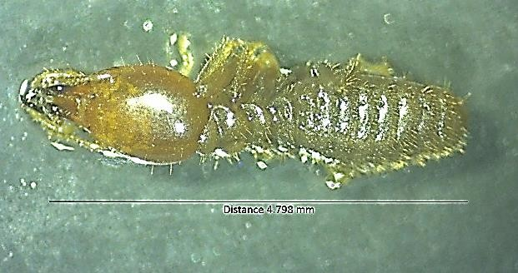
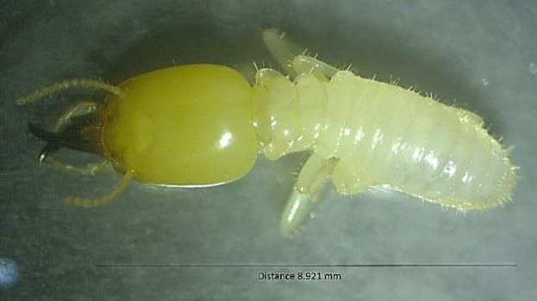
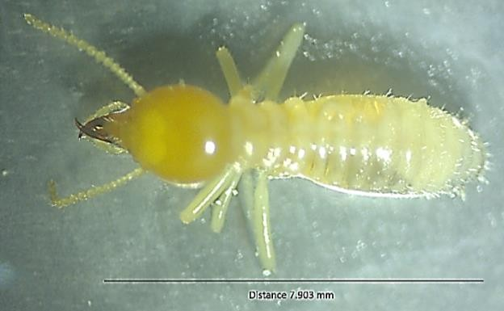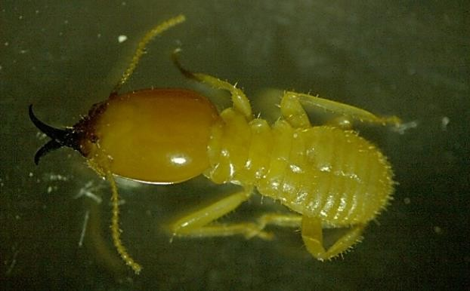

a. Odontotermes obesus | b. Odontotermes feae
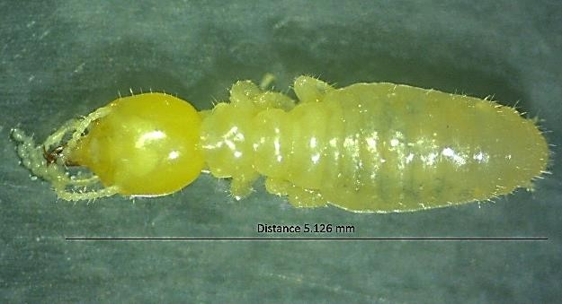  c. Odontotermes parvidens | d. Odontotermes kapuri
e. Microtermes mycophagous
Fig. 1. Different termite species (a-e) belonging to Macrotermitinae subfamily

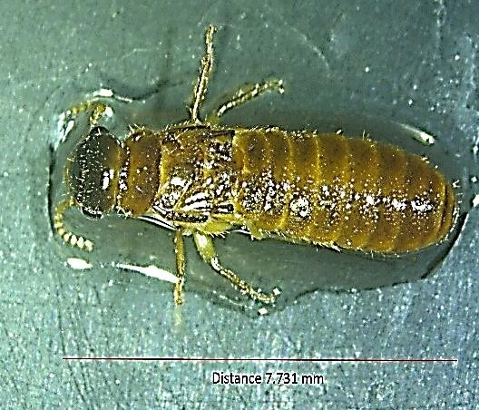
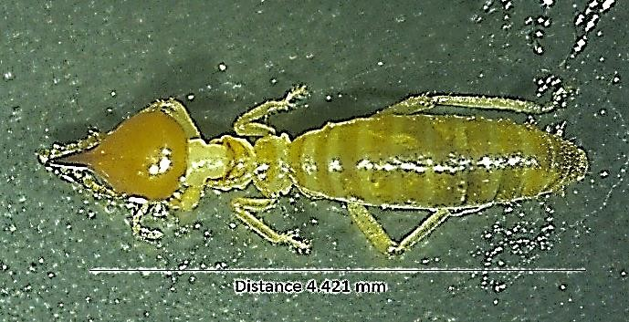

a. Trinervitermes biformis
b. Neotermes buxensis
c. Speculitermes chadaensis

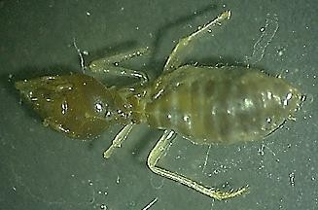
Fig. 2. Termite species belonging to Nasutitermitinae (a), Kalotermitinae (b) and Amitermitinae (c) subfamily

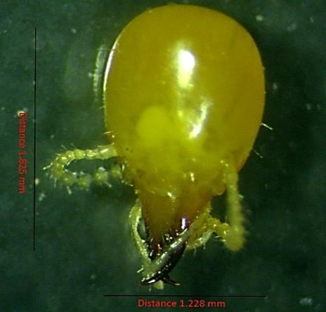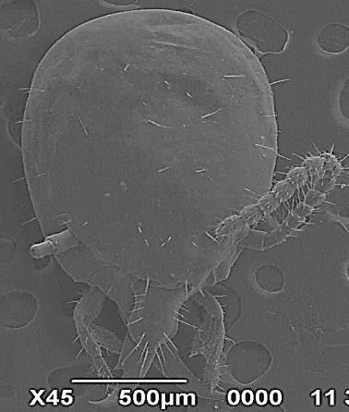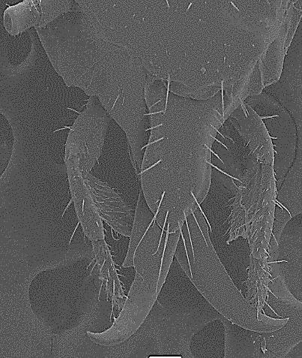

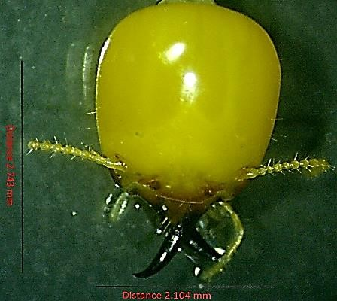
a. Stereo zoom and scanning electron microscopy of mandible of O. obesus
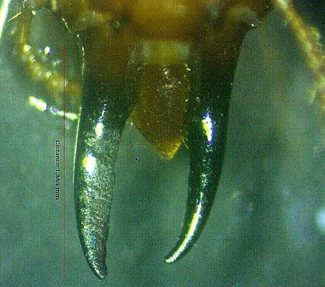
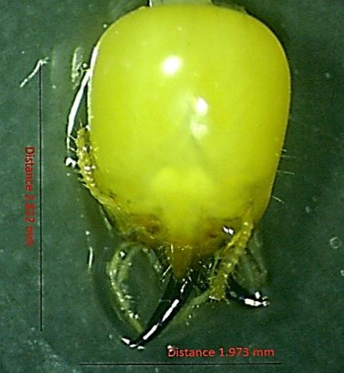
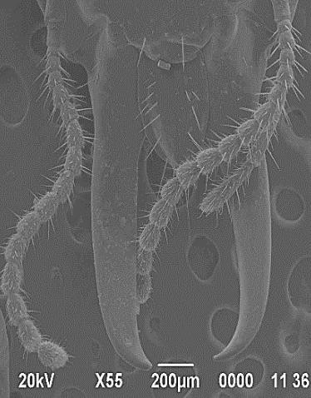
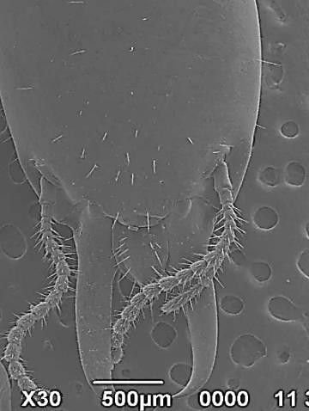
b. Stereo zoom microscopy of mandible of O. feae
c. Stereozoom and scanning electron microscopy of mandible of O. parvidens
Fig. 3. Stereo zoom and scanning electron microscopy of mandible of different termite species (a-c)

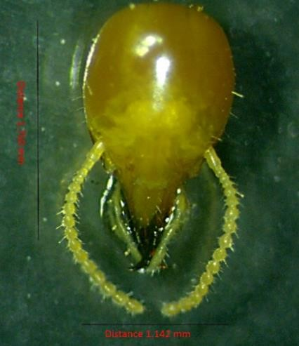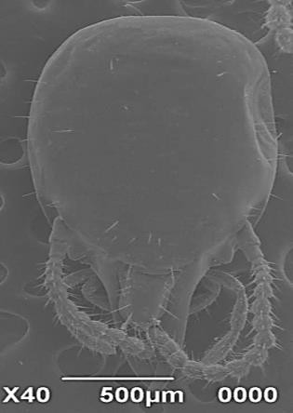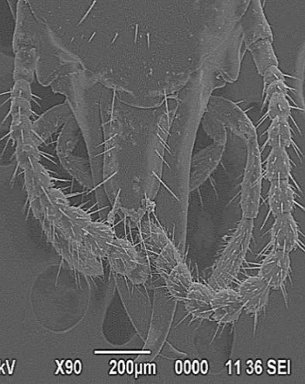

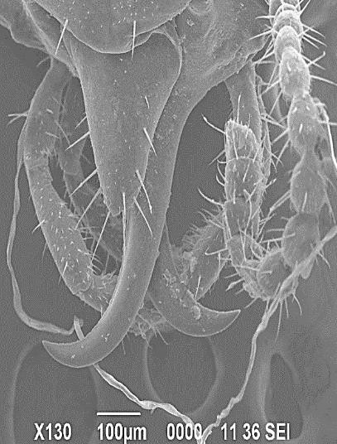
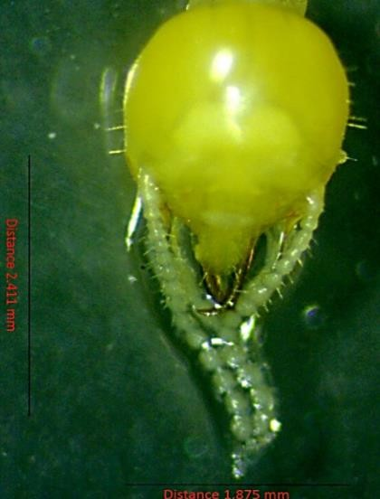
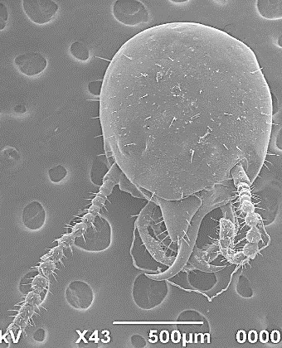
a. Stereo zoom and scanning electron microscopy of mandible of O. kapuri
b. Stereozoom and scanning electron microscopy of mandible of M. mycophagous
Fig. 4. Stereo zoom and scanning electron microscopy of mandible of O. kapuri and M. mycophagous (a & b)

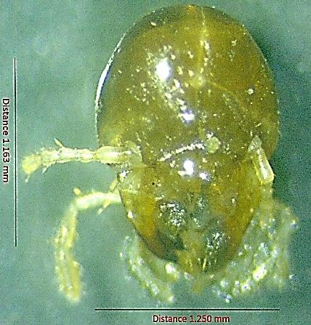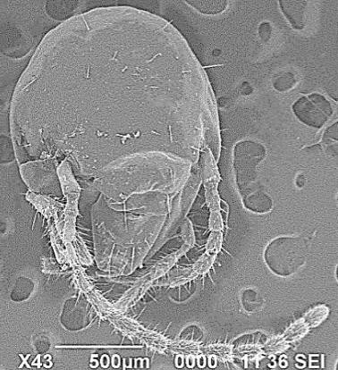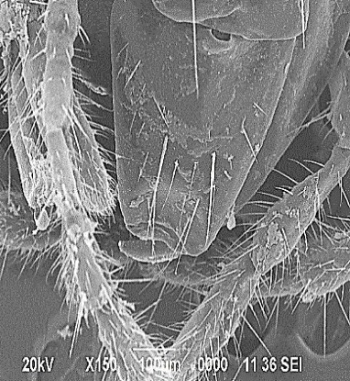

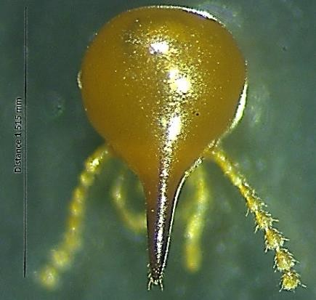
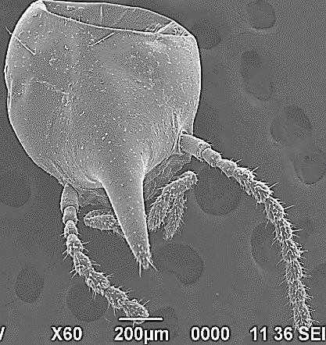
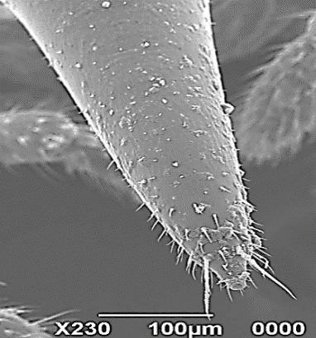
a. Stereo zoom and scanning electron microscopy of mandible of S. chadaensis
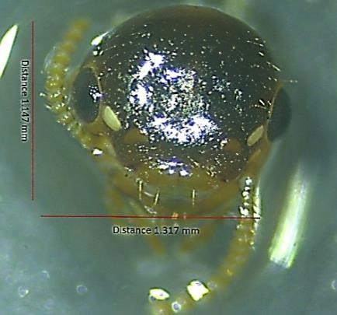
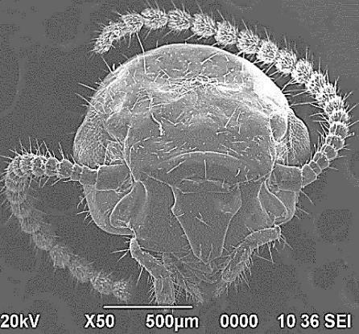
b. Stereo zoom and scanning electron microscopy of mandible of T. biformis
c. Stereozoom and scanning electron microscopy of mandible of N. buxensis
Fig. 5. Stereo zoom and scanning electron microscopy of mandible of different termite species (a-c)

