Butterfly (Lepidoptera) Diversity and Community Structure in Kohka, Adjacent to Turia Gate, Pench National Park, Madhya Pradesh, India

ABSTRACT
Butterflies are an important model group in understanding ecology particularly biodiversity status and habitat health of a particular region. A scientific exercise was undertaken to explore butterfly diversity and abundance in Kohka, an adjoining area of Turia gate, Pench National Park, Madhya Pradesh, India, in December, 2025. A total of 69 butterfly species belonging to 48 genera and five families (Nymphalidae, Papilionidae, Pieridae, Lycaenidae and Hesperiidae) were recorded during this study, of which eight species are protected under the Wildlife (Protection) Act of India, 1972. Of the total, 38.14% were very common, 24.78% were common, 33.92% were not rare, and 3.16% were rare. Nymphalidae was dominant with 54.66% of total butterflies, 43.48% of total recorded species and 39.58% of total recorded genera. The high values of Shannon-Weiner index (H'=3.86), Simpson's index of diversity (D=0.97), Pielou’s evenness index (J′=0.91) and Margalef's Richness index (d=10.72) indicates high butterfly diversity with, high abundance and evenness in the study area. The butterflies found with high occurrence frequency were Euploea core, Parantica aglea, Junonia iphita, Symphaedra nais, Melanitis leda, Ypthima baldus, Pareronia hippia, Eurema hecabe, Catopsilia Pomona, Pieris canidia, Papilio polytes, and Pachliopta aristolochiae. The information from this survey-based study will facilitate the assessment of the habitat quality or ecosystem health of the area surrounding the National Park, thus aiding in the development of necessary conservation strategies for butterflies and their habitat, if necessary.
Key words: Butterfly diversity and abundance, conservation strategies, habitat health, Kohka, Nymphalidae.

1. INTRODUCTION
Butterflies, the miraculous insects, belonging to the order Lepidoptera, are easily recognized by their radiant colours and subtle flickering movements. They are one of the best taxonomically and ecologically studied groups of insects, owing to their importance in terrestrial community structure and ecosystems (Pahari et al., 2018). They play a crucial role in maintaining the stability of food webs as herbivores (Rusman et al., 2016), pollinators (Mukherjee et al., 2015) host of parasitoids (Van-Nouhuys & Hanski, 2002), prey of predators (Rusman et al., 2016). The loss of butterfly diversity and abundance adversely affects ecosystem functioning (Altermatt & Pearse, 2011). Butterflies are highly sensitive to habitat fragmentation, changes in microclimate (Fordyce, 2003), and vegetation structure (Koh, 2007), as their diversity is positively correlated with plant diversity (Padhye et al., 2006). As indicator taxa in terms of habitat quality (Ramana, 2010) and anthropogenic disturbance (Kocher & Williams, 2000), they are one of the most suitable tools for biodiversity studies and for adopting conservation initiatives, if necessary. Hence, monitoring frameworks for Lepidoptera (butterflies and moths) are crucial for assessing the environmental effects on biodiversity as these insects are highly sensitive to habitat alteration and climate change (Harpke et al., 2025; Lang et al., 2019).
More than 18,000 species of butterflies have been documented throughout the world (Larsen et al., 2011); with about 1311 species from India (Varshney & Smetacek, 2015), out of which 107 Papilionids, 109 Pierids, 521 Nymphalids, 443 Lycaenids and 321 Hesperiids (Kehimkar, 2008). Approximately, 200 species were recorded from Odisha, 285 species from Southern India and 334 species from Western Ghats, 351 species from Peninsular India, and about 177 species from Madhya Pradesh and Chhattisgarh (Palei & Rath, 2014; Chandra et al., 2007). In recent times, butterflies of different protected areas of India have been documented by several authors (Santhosh et al., 2025; Paunikar & Sharma, 2022; Virani, 2020; Islam et al., 2022); a few of these studies are from Madhya Pradesh (Tiple & Khurad, 2009; Tiple, 2012; Sharma & Radhakrishnan, 2005, 2006; Chandrakar et al., 2007; Harsh et al., 2015; Gajbe, 2016; Bhowate & Kumar, 2020¹, 2020²).
Over last few decades, habitat fragmentation and degradation due to anthropogenic activities and climatic changes are becoming a major cause of threat to Indian fauna (Harsh et al., 2015) Moreover, anthropogenic influences and habitat alteration cause migration or local extinction of butterfly species (Mennechez et al., 2003; Clark et al., 2007). Hence, systematic survey-based studies on butterfly diversity and abundance in locations adjacent to the protected areas would help to assess the biodiversity status and habitat health of those areas.
The exact status of butterflies in Kohka, in the vicinity of Turia gate, Pench National Park of Madhya Pradesh have not previously been considered. In this context, an effort has been made to study the species richness, evenness and abundance of the butterfly fauna in this area which will help in understanding the ecology of this area and also in determining whether anthropogenic activities, such as tourism pressure and hotel or resort construction, have an adverse impact on the butterfly community.
2. MATERIALS AND METHODS
2.1 Study area
The study was conducted in Kohka, an adjoining area of Turia gate, Pench National Park, Madhya Pradesh, India. The study area lies between 21.73997°N, 79.33778°E and 21.73427°N, 79.35821°E, covering a total area of 4 km (Fig. 1). The area is covered by tropical dry deciduous type forest, grasslands, open lands and agriculture lands (Fig. 2). The study area experiences a subtropical climate, with summer temperatures ranging between 28°C and 45°C. Monsoon remains active until September. Temperature remains cool and pleasant from October to June. During these months, temperature ranges between 10°C and 28°C, occasionally the temperature even goes down to 5°C.
2.2 Survey technique:
Data collection was carried out over eight days in December 2025, during favorable weather conditions, specifically from 08:00 am to 01:00 pm and 03:00 pm to 05:30 pm, using a walk/count method (Pollard, 1997) with necessary modifications. The entire 4 km survey path was covered by 8 transects, each measuring 500 m, which were surveyed daily. The pace was slow but constant, covering each transect in about an hour. All butterflies on the line and within 5 m on each side were recorded, along with their respective number of species. Butterflies were primarily identified at the site by observation, but in difficult cases, they were photographed and identified using a standard field guide (Kunte et al., 2014; Kehimkar, 2016; Dey et al., 2017). No specimens were collected during the surveys. All common English and scientific names were used in accordance with Varshney and Smetacek (2015) guidelines.
2.3 Statistical data Analysis
Species occurrence analysis was carried out by Microsoft Excel Program with using the following formulas. Statistical analyses of alpha diversity indices were carried out by Microsoft Excel 2019 software. Shannon-Weiner diversity index (Shannon & Weaver, 1963), Simpson index of Dominance (Simpson, 1964) and Pielou’s Evenness index (Mulder et al., 2004), Margalef’s Index for Richness (Margalef, 1958) were calculated. To represent species richness and evenness a rank abundance curve was prepared (Whittaker, 1965).
Shannon-Weiner diversity index (H’) = - Σ pi ln pi
Shannon H_{max}= Log₁ (N)
Dominance index (D_{BP})= N_{max}/N (Berger and Parker, 1970)
Simpson’s diversity index (Ds)= Σ^{S}_{i-1}[ni (ni-1)/N(N-1)]
Simpson's index of diversity (D)= 1-Σ^{S}_{i-1}[ni (ni-1)/N(N-1)]
Simpson's reciprocal index (Dr)= 1/ Σ^{S}_{i} pi²
Pielou’s evenness index (J′)= H′/ln Nt
Relative abundance (RA) = ni/N (Bisht et al., 2004)
Margalef’s Richness Index (d) = [(Nt-1) / ln(N)]
Here, pi is the proportion of the i^{th} species in the butterfly community. N is the number of individuals present in a butterfly fauna. ni is the number of individuals of i^{th} species. N_{max} is the number of individuals in most abundant species. Nt is total number of all species
The frequency of occurrence of each species was calculated based on the number of occasions the species was recorded during the surveys. The butterflies, recorded from the survey site, were categorized into four different classes on the basis of their prevalence, namely VC (very common; RA>3.5), C (common; RA>1.5-3.5), NR (not rare; RA>0.5 to 1.5), R (rare; RA≤0.5) to indicate the rarest to the most common butterfly species(Agase et al., 2022) and denoted in Table 1 as status.
3. RESULTS
A total number of 69 butterfly species belonging to 48 genera and 5 different families were recorded from the study site (Table 1). Among the 69 butterfly species, 30 of them belonged to family Nymphalidae, 15 to the family Pieridae, 8 to the family Papilionidae, 12 and 4 to the families Lycaenidae and Hesperiidae respectively. While considering the relative abundance of the observed butterfly species of the study site, Baronet (Symphaedra nais; RA: 5.80) was found to be the most abundant butterfly species, followed by Common Mormon (Papilio polytes; RA: 5.62), Common Grass Yelllow (Eurema hecabe; RA: 5.45), Chocolate Pansy (Junonia iphita; RA: 4.92), Common Evening Brown (Melanitis leda; RA: 4.57), Indian Wanderer (Pareronia hippia; RA: 4.39). A total of 2, 8, and 19 butterfly species had relative abundances ranging from 4 to 3, 3 to 2, and 2 to 1, respectively, while the remaining species had a relative abundance of less than 1.
The population status of butterflies in the study area indicates that the maximum number of butterflies was recorded within the family Nymphalidae (54.66%), followed by Pieridae (23.02%), Papilionidae (13.18%), Lycaenidae (7.73%) and Hesperiidae (1.41%) (Fig. 3).
Results of the genus proportion analysis of the surveyed butterfly community showed that the maximum number of genera were recorded from the family Nymphalidae (39.58%), followed by the families Lycaenidae and Pieridae, which comprised 22.92% each, Hesperiidae (8.33%), and Papilionidae (6.25%). Additionally, the analysis of species proportion revealed that 43.48% of the total butterfly species belonged to the family Nymphalidae, followed by Lycaenidae (22.92%), Pieridae (21.74%), Papilionidae (11.59%), and Hesperiidae (5.80%) (Fig. 4).
Out of 30 observed nymphalid species, the Baronet (Symphaedra nais) was found to be the most abundant, followed by the Chocolate Pansy (Junonia iphita), while the Blue Pansy (Junonia orithya) and Great Eggfly (Hypolimnas bolina) were the least abundant. Within the family Pieridae, the Common Grass Yellow (Eurema hecabe) was recorded in the highest numbers, whereas the Common Albatross (Appias albina) was recorded in the lowest. For the family Papilionidae, the Common Mormon (Papilio polytes) was counted in the maximum numbers, whereas the Spot Swordtail (Graphium nomius) was counted in the minimum. Among the Lycaenidae family, the Plains Cupid (Chilades pandava) recorded the highest count, while the Grass Jewel (Chilades trochylus) recorded the lowest. Within the Hesperiidae family, Small Branded-Swift (Pelopidas mathias) and Common Redeye (Matapa aria) showed maximum abundance, while whereas Tricolour Pied Flat (Coladenia indrani) and Malabar Spotted Flat (Celaenorrhinus ambareesa) were the least abundant (Table 1).
The genus Junonia of the family Nymphalidae was found to be the dominant one, represented by six species, namely: J. atlites, J. almana, J. lemonias, J. hierta, J. orithya, J. iphita, followed by the genera Mycalesis and Ypthima of the Nymphalidae family, and Papilio and Graphium of the Papilionidae family, all of which comprised of three species. Danaus and Hypolimnas of the Nymphalidae family, and Ixias, Eurema, Catopsilia, and Appias of the Pieridae family, along with Pachliopta of the Papilionidae family and Chilades of the Lycaenidae family, each comprised two species (Fig. 5). The remaining 35 genera were composed of only 1 species each. The species-genus ratio observed in this study was 1.437.
Based on the value of butterfly relative dominance in the study area, 38.14% of the total counted butterflies was categorized as very common, 24.78% as common, 33.92% as not rare, and 3.16% as rare (Fig. 6).
All the recorded species are widely distributed in India; however, eight species observed at the study site are listed in the Indian Wildlife (Protection) Act, 1972 (Anonymous, 2006) (Table 1). Among these butterfly species, Danaid Eggfly (Hypolimnas misippus) belonged to Schedule I. Common Baron (Euthalia aconthea), Common Gull (Cepora nerissa), Common Albatross (Appias albina), Crimson Rose (Pachliopta hector), Common Pierrot (Castalius rosimon) and Angled Pierrot (Caleta decidia) belonged to Schedule II, while Striped Albatross (Appias libythea) belonged to Schedule IV (Table 1).
The Shannon diversity index (H') value of 3.86 indicates high species richness within the butterfly community at the sampled site (Table 2). The Simpson’s index (Ds) value was observed near 0, suggesting the persistence of high species abundance within the studied butterfly community. A Simpson’s index of diversity (D=1-Ds) of 0.97 indicates a well-balanced butterfly community with high species richness and evenness. The value of Pielou’s evenness index (J'=0.91) was close to 1, suggesting that the butterfly species in the surveyed community were evenly distributed. A Margalef’s Richness index value of 10.72 indicates exceptionally high species richness in the studied butterfly community, similarly, the Simpson’s reciprocal index value of 38.35 suggests good species diversity. The low Dominance Index value (D_{BP}=0.06) indicates that no single butterfly species dominates the community Thus, the diversity indices reflect that the butterfly community is highly diverse, with high species richness, high abundance, and high evenness.
The Shannon diversity index (H') values of the recorded five butterfly families ranged from 1.26 to 3.14 (Table 3). In this case, family Nymphalidae had the highest value as maximum number of species were recorded from this family, followed by family Lycaenidae (2.42), Pieridae (2.27), Papilionidae (1.71) whereas the least value was observed from the Hesperiidae family. The highest value of Shannon H_{max} was obtained from the family Nymphalidae (3.40), followed by Pieridae (2.71), Lycaenidae (2.49), Papilionidae (2.08), Hesperiidae (1.39). The values of Pielou’s evenness index (J') determine whether the species in a community are evenly distributed or not. This value was found to be highest in case of Lycaenidae (0.97) and lowest in case of Papilionidae (0.82). Simpson's index of diversity (D) revealed the species richness and evenness in the community. Its value was recorded to be higher for family Nymphalidae (0.95), followed by Lycaenidae (0.93), Hesperiidae (0.89), Pieridae (0.87). Again, the value of Simpson’s reciprocal index (Dr) indicated the presence of higher butterfly diversity from the family Nymphalidae (20.12). Family-wise values of the Dominance Index (D_{BP}) revealed that Baronet (Symphaedra nais) was the dominant species within Nymphalidae (D_{BP}=0.11), Common Grass Yellow (Eurema hecabe) within Pieridae (D_{BP}=0.24), Common Mormon (Papilio polytes) within Papilionidae (D_{BP}=0.43), and Plains Cupid (Chilades pandava) within Lycaenidae (D_{BP}=0.14); meanwhile, Small Branded-Swift (Pelopidas mathias) and Common Redeye (Matapa aria) were co-dominant in Hesperiidae (D_{BP}=0.38).
The Whittaker plot’s curve depicted a steep inclination up to the first ten butterfly species that were recorded at the study site (Fig. 7). These ten butterfly species occurred in high abundance and with less evenness in comparison to the remaining species. Species rank ten onwards the abundance of the observed butterfly species were found to decrease accordingly along with increased evenness among the sampled species of the study areas.
Analysis of the family-wise rank abundance curve indicated that the family Lycaenidae had the highest evenness, followed by Nymphalidae, Hesperiidae, and Pieridae, while Papilionidae showed the lowest (Fig. 8).
4. DISCUSSION
A comprehensive assessment of the key taxa of a region is a prerequisite before the implementation of conservation management plans. The current study provides a baseline data on butterfly diversity and abundance within Kohka region, situated near the Turia gate of Pench National Park, Madhya Pradesh. This central state of India hosts 174 species of butterflies belonging to 100 genera under eight families (Chandra et al., 2007). During the course of study 69 species of butterflies referable to 48 genera, belonging to five families were recorded. This number contributes to the existing tally of 59 butterfly species reported by Harsh et al. (2015) from the Kanha-Pench corridor. A good assemblage of butterfly species obtained from the study site is likely due to the presence of a diverse array of floral species and a healthy habitat. Butterfly surveys-based studies in diverse locations of Madhya Pradesh demonstrated varied patterns of species diversity and abundance, often correlated with landscape patterns, vegetation diversity and density, and urbanization levels (Mukherjee et al., 2015; Ockinger & Smith, 2009; Mutmainnah & Santosa, 2019). A total number of 49 species of butterflies were reported from Amarkantak Biosphere Reserve (Rani & Kashyap, 2024), 66 species from Tropical Forest Research Institute, Jabalpur (Tiple, 2012), 59 butterfly species from Kanha-Pench corridor (Harsh et al., 2015), 38 species from Chhindwara district (Bhowate & Kumar, 2020²), 35 species from Betul district (Bhowate & Kumar, 2020¹) and 35 species from Narmada Nagar town (Keshre & Upadhya, 2023).
The present study recorded the most species and individuals from the Nymphalidae family, perhaps due to their varied morphological attributes, polyphagous nature, and strong flight (Majumder et al., 2012). The dominance of the Nymphalids, as revealed by the present study, is similar to those observed in other parts of the country (Mutmainnah & Santosa, 2019; Bhowate & Kumar, 2020¹, 2020²; Harsh et al., 2015; Paunikar & Sharma, 2022; Islam et al., 2022; Santhosh et al., 2025). Following Nymphalidae, the family Pieridae had the maximum number of species and individuals, which was in agreement with findings by Bhowate and Kumar (2020¹, 2020²) at Betul district and Chhindwara district, Harsh et al. (2015) at Kanha-Pench corridor and Sharma (2024) at Barkatullah University campus. The high abundance and diversity of Pieridae might be due to the area having less canopy cover and more flowering plants, as they are attracted to sunlight and have a great affinity for flowers. A few earlier studies have shown that the Lycaenidae is the second most abundant and diverse family after Nymphalidae (Flora et al., 2020; Pahade, 2024). In the current study, a smaller number of Lycaenids were counted because the studied region has fewer human habitations; however, they are typically found in large numbers near human settlements in semi-arid regions (Mali et al., 2014). Very few species of Hesperiidae were recorded, likely owing to their shade-loving nature and host-plant specificity (Priyamvada & Mohapatra, 2016). A similar finding was reported by Deokar and Shukla (2015) conducted in Kolamarka Conservation Reserve, Central India, and Bhowate and Kumar (2020¹, 2020²) in Betul district and Chhindwara district, Madhya Pradesh.
The counting of butterflies of different species showed that Common Grass Yellow was found to be one of the dominant species of the study area, which is consistent with the observations of Keshre and Upadhya (2023) from Narmada Nagar town, Harsh et al. (2015) from Kanha-Pench corridor, and Bhowate and Kumar (2020¹) from Betul district; a similar type of vegetation might be the cause of their great assemblage.
The study area falls within a Tropical Dry Deciduous Forest and is comprised of large trees such as Tectona grandis, Madhuca indica, Diospyros melanoxylon, Terminalia tomentosa, Buchanania lanzan, Lagerstroemia parviflora, Miliusa velutina and Lannea coromandelica, and bamboo (Dendrocalamus strictus) (Tiple & Deokar, 2024). This region, along with grassland, open scrub jungle dominated by Lantana camara, agricultural fields, open lands, and wetlands, provides an ideal habitat for a large assemblage of butterfly species. Anthropogenic activities, such as tourism pressure and urbanization, are causing habitat degradation, facilitating the spread of the exotic species Lantana camara, which provides an important source of nectar for several butterfly species (Raju & Reddy, 1995). The presence of wetlands favors a high abundance of few species, such as Catopsilia pomona and Eurema hecabe, which were observed mud-puddling in wet soil depressions near the water body (Prajapati & Prajapati, 2013).
In the study area, 38.14% of the butterfly species were found to be very common and 3.16% rare, supporting the findings of Flora et al. (2020) from Jabalpur City, Bhowate and Kumar (2020²) from Chhindwara district, Madhya Pradesh.
The occurrence of a highly diverse butterfly community (H'=3.86) in the study site can be explained by the availability of a wide range of host and nectar plants favorable to many butterfly species, along with an ideal canopy cover that allows appropriate sunlight to reach the ground.
Listing butterfly species in accordance with the Wild life Protection Act, 1972, is necessary to provide appropriate and adequate legal protection to Indian butterflies as well as to assess the floral diversity and habitat quality (Kunte, 2000). A total of eight species is listed in this Act, indicating that the study area possesses a considerable number of legally protected butterflies, which reflects its vegetation richness. The current results emphasize the need for the long-term conservation of butterflies to prevent regional extinction and protect them from anthropogenic disturbances (Watson et al., 2014; Maxwell et al., 2020).

5. CONCLUSION
Butterflies are a good indicator of habitat quality and environmental health, so it is essential to conserve them along with their habitats all over the world. Because of widespread habitat destruction due to increasing needs of the growing human population, many native butterflies are fast disappearing and their survival is now threatened. In this scenario, systematic surveys are required to assess the present ecological status of these species, specifically by determining their community structure and the level of anthropogenic disturbance affecting them. If needed, thoughtful conservation measures should be adopted, which will create a healthy habitat for butterfly conservation. It is evident from the present investigation that the butterfly community in the study area is highly diverse. Host and nectar plant availability, habitat health, and related factors contribute to the stability of the butterfly community, particularly in terms of species richness and abundance. The present study is not conclusive; therefore, long-term systematic survey-based studies in other areas are recommended for the future.

DISCLAIMER (ARTIFICIAL INTELLIGENCE)
Authors hereby declare that NO generative AI technologies such as Large Language Models (ChatGPT, COPILOT, etc.) and text-to-image generators have been used during the writing or editing of this manuscript.

COMPETING INTERESTS
Authors have declared that no competing interests exist.

REFERENCES
Agase, D. M., Markam, M. S., Kothe, T. S., Bisen, M. K., & Kamleshiya, P. (2022). Butterfly diversity of Gangulpara, Balaghat, Madhya Pradesh. Journal of Entomology and Zoology Studies, 10(5), 361-367.
Altermatt, F., & Pearse, I. S. (2011). Similarity and specialization of the larval versus adult diet of European butterflies and moths. American Naturalist, 178, 372-382.
Anonymous. (2006). The Wildlife (Protection) Act 1972. Dehradun: Natraj Publishers.
Berger, W. H., & Parker, F. L. (1970). Diversity of planktonic foraminifera in deep sea sediments. Science, 168, 1345-1347.
Bhowate, S., & Kumar, P. (2020¹). Species diversity, relative abundance and status of butterflies of Betul district, Madhya Pradesh. Journal of Entomology and Zoology Studies, 8(3), 1054-1057.
Bhowate, S., & Kumar, P. (2020²). Diversity and abundance of butterfly fauna of Chhindwara district, Madhya Pradesh. International Journal of Entomology Research, 5(6), 121-124.
Chandrakar, M., Palekar, S., & Chandrakar, S. (2007). Butterfly Fauna of Melghat Region, Maharashtra. Zoos’ Print Journal, 22(7), 2762-2764.
Clark, P. J., Reed, J. M., & Chew, F. S. (2007). Effects of urbanization on butterfly species richness, guild structure, and rarity. Urban Ecosystems, 10(3), 321–37. https://doi.org/10.1007/s11252-007-0029-4.
Deokar, A., & Shukla, P. N. (2015). A preliminary survey of butterfly diversity in Kolamarka Conservation Reserve, Central India. International Journal of Advanced Research, 3(8), 12-17.
Dey, P. K., Payra, A., & Mondal, K. A. (2017). Study on butterfly diversity Singur, West Bengal, India. e-planet, 15(1), 73-77.
Flora, J. S., Tiple, A. D., Sengupta, A., & Padwad, S. V.. (2020). Butterfly (Lepidoptera: Rhopalocera) fauna of Jabalpur City, Madhya Pradesh, India. Journal of Threatened Taxa, 12(11), 16607–16613.
Fordyce, J. A., & Nice, C. C. (2003). Variation in butterfly egg adhesion: Adaptation to level host plant senescence characteristics? Ecology Letters, 6, 23-27.
Gajbe, P. U. (2016). Diversity of Butterflies in Karhandla Region of Umred-Karhandla Wildlife Sanctuary, Maharashtra, India. Journal on New Biological Reports, 5(1) 35 – 40.
Harpke, A., Kühn, E., Schmitt, T., Settele, J., & Musche, M. (2025). ﻿The Grassland Butterfly Index for Germany. Nature Conservation, 59, 313-334.
Harsh, S., Jena, J., Sharma, T., & Sarkar, P. K. (2015). Diversity of butterflies and their habitat association in four different habitat types in Kanha-Pench corridor, Madhya Pradesh, India. International Journal of Advanced Research, 3(1), 779-785.
Islam, N., Chhetri, T., Borkataki, U., Basumatary, S., & Rahman, M. (2022). Abundance and diversity of butterflies in Raimona National Park of Assam, India. International Journal of Entomology Research, 7(2): 54-62.
Kehimkar, I. (2008). The Book of Indian Butterflies. Mumbai: Bombay natural History Society and Oxford University Press.
Kehimkar, I. (2016). Butterflies of India. Bombay Natural History Society. Mumbai: Oxford University Press.
Keshre, V., & Upadhya, V. (2023). Preliminary studies on butterfly fauna of Narmada Nagar town, Dist. Khandwa M.P. Journal of Entomology and Zoology Studies, 11(1), 149-153.
Kocher, S. D., & Williams, E. H. (2000). The diversity and abundance of North American butterflies vary with habitat disturbance and geography. Journal of Biogeography, 27(4), 785–794. http://doi.org/10.1046/j.1365-2699.2000.00454.x
Koh, L. P. (2007). Impacts of land use change on South-east Asian forest butterflies: a review. Journal of Applied Ecology, 44, 703-713.
Kunte, K. (2000). Butterflies of Peninsular India. Indian Academy of Sciences. Bangalore: Universities Press.
Kunte, K., Zhang, W., Tenger-Trolander, A., Palmer, D. H, Martin, A., Reed, R. D., Mullen, S. P., & Kronforst, M. R. (2014). Double sex is a mimicry supergene. Nature, 507, 229-232.
Lang, A., Kallhardt, F., Lee, M. S., Loos, J., Molander. M. A., Muntean, I., Pettersson, L. B., Rakosy, L., Stefanescu, C., & Messean, A. (2019). Monitoring environmental effects on farmland Lepidoptera: Does necessary sampling effort vary between different bio-geographic regions in Europe? Ecological Indicators, 791-800.
Larsen, T. H., Escobar, F., & Armbrecht, I. (2011). Insects of the tropical andes: diversity patterns, processes and global change. In S. K. Herzog, R. Martínez, P.M. Jorgensen & H. Tiessen (Eds.), Climate Change and Biodiversity in the Tropical Andes (pp. 228–244). Brazil: Inter-American Institute for Global Change Research (IAI) and Scientific Committee on Problems of the Environment.
Margalef, R. (1958). Temporal succession and spatial heterogeneity in phytoplankton. Perspectives in Marine Biology (Série B. Colloques), 27, 323-349.
Majumder, J., Lodh, R., & Agarwala, B. K. (2012). Variation in butterfly diversity and unique species richness along different habitats in Trishna Wildlife Sanctuary, Tripura, northeast India. Check List, 8(3), 432-436.
Mali, M. S., Khokhariya, B. P. & Dabgar, Y. B. (2014). Biotic interrelationship of plants and butterflies in surrounding of Gandhinagar, Gujarat. International Journal of Scientific Research, 3(4), 420-422.
Maxwell, S. L., Cazalis, V., Dudley, N., Hoffmann, M., Rodrigues, A. S., Stolton, S., & Watson, J. E. (2020). Area-based conservation in the twenty-first century. Nature, 586, 217–22. https://doi.org/10.1038/ s41586-020-2773-z
Mennechez, G., Schtickzelle, N., & Baguette, M. (2003). Metapopulation dynamics of the bog fritillary between a continuous and a highly fragmented butterfly: comparison of demographic parameters and dispersal landscape. Landscape Ecology, 18, 279- 291.
Mukherjee, S., Banerjee, S., Saha, G. K., Basu, P. & Aditya G. (2015). Butterfly diversity in Kolkata, India: An appraisal for conservation management. Journal of Asia-Pacific Biodiversity, 8(3), 210–221. https://doi.org/10.1016/j.japb.2015.08.001
Mulder, C. P. H., Bazeley-White, E., Dimitrakopoulos, P. G., Hector, A., SchererLorenzen, M., & Schmid, B. (2004). Species evenness and productivity in experimental plant communities. Oikos, 107, 50–63.
Mutmainnah, A. R., & Santosa, Y. (2019). Impact of oil palm plantation on the butterfly diversity: a Case study in KGP & CNG, Ketapang, West Kalimantan. IoP Conf. Series: Earth and Environmental Science, 336, 012032.
Ockinger, E., Dannestam, A., & Smith, H. G. (2009). The importance of fragmentation and habitat quality of urban grasslands for butterfly diversity. Landscape and Urban Planning, 93, 31-37.
Padhye, A. D., Dahanukar, N., Paingaonkar, M., Deshpande, M., & Deshpande, D. (2006). Season andlandscape wise distribution of butterflies in Tamhini, Northern Western Ghats, India. Zoos’ Print, 21(3), 2175-2181.
Pahade, P. (2024). Study of butterfly biodiversity in Dharam Tekri Chhindwara (M.P.). Journal of Entomology and Zoology Studies, 12(2), 105-110.
Pahari, P. R., Mishra, N. P., Sahoo, A., & Bhattacharya, T. (2018). A study on the butterfly diversity of Haldia industrial belt and adjacent rural area in Purba Medinipur District, West Bengal, India. News, 97, 207–224.
Palei, N. C., & Rath, B. P. (2014). Butterflies diversity of Sunabeda Wildlife Sanctuary, Odisha, India. Journal of Entomology and Zoology Studies, 2(2), 39-44.
Paunikar, S. D., & Sharma, G. (2022). Butterfly species diversity and distribution in protected forest areas of North-West Himalaya of India. Biological Forum – An International Journal, 14(4), 1004-1015.
Pollard, E. A. (1997). Method for assessing changes in the abundance of butterflies. Biology Conservation, 12, 115-134.
Prajapati, S. H., & Prajapati, R. P. (2013). Classified guilds in avian community with respect to food and feeding Beahviour. Indian Journal of Science and Technology, 1(2), 1-7.
Priyamvada, & Mohapatra, A. K. (2016). A preliminary study on diversity of butterflies (Lepidoptera: Macrolepidoptera) in Regional Institute of Education campus, Bhubaneswar, Odisha, India. Journal of Entomology and Zoology Studies, 4(2), 489-496.
Raju, A. J. S., & Reddy, C. S. (1995): Flower color shifts and pollination in Lantana camera L. Verbenaceae. Journal of Palaeosciences, 31, 275-289.
Ramana, S. P. V. (2010). Biodiversity and Conservation of Butterflies in the Eastern Ghats. The Ecoscan, 4(1), 59-67.
Rani, R., & Kashyap, H. (2024). A Study on butterfly diversity and abundance in Vicinity of Indira Gandhi National Tribal University campus, Amarkantak (MP)India. International Journal of Entomology Research, 9(4), 19-26.
Rusman, R., Atmowidi, T., & Peggie, D. (2016). Butterflies (Lepidoptera: Papilionoidea) of Mount Sago, West Sumatra: Diversity and Flower Preference. Hayati Journal of Biosciences, 23(3), 132–7. https://doi.org/10.1016/j.hjb.2016.12.001
Santhosh, S., Gopi-Krishna, V., Amulya, G. K., Sheily, S., Nithesh, M., & Basavarajappa, S. (2025). Butterfly diversity in Nagarahole (Rajiv Gandhi) National Park of Karnataka, India: an updated checklist. Journal of Threatened Taxa, 17(10): 27611–27636.
Shannon, C. E., & Weaver W. (1963). The Mathematical Theory of Communication. Urbana: The University of Illinois Press.
Sharma, R. (2024). Diversity and abundance of butterflies at Barkatullah University campus, Madhya Pradesh, India. International Journal of Entomology Research, 9(8), 226-229.
Sharma, R. M., & Radhakrishnan, C. (2005). Insecta: Lepidoptera (Rhopalocera and Grypocera). Fauna of Pench National Park. Zoological Survey of India. Conservation Area Series, 20, 251-274.
Sharma, R. M., & Radhakrishnan, C. (2006). Insecta: Lepidoptera (Rhopalocera and Grypocera). Fauna of Tadoba Andhari Tiger Reserve. Zoological Survey of India, Conservation Area Series, 25, 255-277.
Simpson, G. G. (1964). Species density in North American recent mammals. Systematic Zoology, 3, 57–73.
Tiple, A. D. (2012). Butterfly species diversity, relative abundance and status in Tropical Forest Research Institute, Jabalpur, Madhya Pradesh, Central India. Journal of Threatened Taxa, 4(7), 2713-2717.
Tiple, A. D., & Deokar, A. R. (2024). Butterfly (Lepidoptera: Rhopalocera) fauna of Pench Tiger Reserve, Nagpur, Maharashtra, Central India. Bionotes, 26(1), 44-60.
Tiple, A. D., & Khurad, A. M. (2009). Butterfly species diversity, habitats and seasonal distribution in and around Nagpur City, Central India. World Journal of Zoology, 4(3), 153-162.
Van-Nouhuys, S., & Hanski, I. (2002). Colonization rates and distances of a host butterfly and two specific parasitoids in a fragmented landscape. Journal of Animal Ecology, 71(4), 639–50. https://doi.org/10.1046/j.1365-2656.2002.00627.x
Varshney, R. K., & Smetacek, P. (2015). A Synoptic Catalogue of the Butterflies of India. Butterfly Research Centre. New Delhi: Bhimtal and Indinov Publishing.
Virani, R. S. (2020). Diversity of Butterflies in Tipeshwar Wildlife Sanctuary of Maharashtra, India. Bioscience Biotechnology Research Communication, 3, 1390-1402.
Whitaker, R. H. (1965). Dominance and diversity in land plant communities: numerical relations of species express the importance of competition in community function and evolution. Science, 147(3655), 250-260.

Table 1: Checklist of butterfly species along with their family, relative abundance, occurrence frequency, status and WPA Schedule recorded in the study site.
Sl. No. | Family | Common Name | Scientific name | Relative Abundance (RA) | Occurrence frequency (%) | Status | WPA  Schedule
1 | Nymphalidae | Plain Tiger | Danaus chrysippus | 0.70 | 50 | NR
2 |  | Striped Tiger | Danaus genutia | 1.93 | 75 | C
3 |  | Common Crow | Euploea core | 3.87 | 100 | VC
4 |  | Glassy Tiger | Parantica aglea | 3.51 | 100 | VC
5 |  | Common Nawab | Polyura athamas | 1.23 | 25 | NR
6 |  | Blue Tiger | Tirumala limniace | 2.28 | 75 | C
7 |  | Grey Pansy | Junonia atlites | 2.11 | 75 | C
8 |  | Peacock Pansy | Junonia almana | 2.46 | 75 | C
9 |  | Lemon Pansy | Junonia lemonias | 1.23 | 62.5 | NR
10 |  | Yellow Pansy | Junonia hierta | 0.70 | 25 | NR
11 |  | Blue Pansy | Junonia orithya | 0.18 | 12.5 | R
12 |  | Chocolate Pansy | Junonia iphita | 4.92 | 100 | VC
13 |  | Baronet | Symphaedra nais | 5.80 | 100 | VC
14 |  | Common Baron | Euthalia aconthea | 1.05 | 37.5 | NR | Schedule II
15 |  | Common Sailer | Neptis hylas | 1.23 | 50 | NR
16 |  | Great Eggfly | Hypolimnas bolina | 0.18 | 12.5 | R
17 |  | Danaid Eggfly | Hypolimnas misippus | 0.53 | 25 | NR | Schedule I
18 |  | Common Leopard | Phalanta phalantha | 1.23 | 37.5 | NR
19 |  | Long-branded Bushbrown | Mycalesis visala | 1.41 | 50 | NR
20 |  | Dark-branded Bushbrown | Mycalesis mineus | 1.41 | 75 | NR
21 |  | Common Bushbrown | Mycalesis perseus | 2.46 | 75 | C
22 |  | Tawny Coster | Acraea terpsicore | 1.05 | 37.5 | NR
23 |  | Common Sergeant | Athyma perius | 0.70 | 37.5 | NR
24 |  | Common Evening Brown | Melanitis leda | 4.57 | 100 | VC
25 |  | Common Three-ring | Ypthima asterope | 1.23 | 25 | NR
26 |  | Common Four-ring | Ypthima huebneri | 1.58 | 50 | C
27 |  | Common Five-ring | Ypthima baldus | 2.28 | 100 | C
28 |  | Painted Lady | Vanessa cardui | 1.23 | 50 | NR
29 |  | Commander | Moduza procris | 0.88 | 50 | NR
30 |  | Common Palmfly | Elymnias hypermnestra | 0.70 | 37.5 | NR
31 | Pieridae | Indian Jezebel | Delias eucharis | 0.70 | 37.5 | NR
32 |  | Large Salmon Arab | Colotis fausta | 0.35 | 25 | R
33 |  | Indian Wanderer | Pareronia hippia | 4.39 | 100 | VC
34 |  | Common Gull | Cepora nerissa | 2.28 | 75 | C | Schedule II
35 |  | White Orange-tip | Ixias marianne | 0.35 | 12.5 | R
36 |  | Yellow Orange-tip | Ixias pyrene | 0.35 | 12.5 | R
37 |  | Orange Tip | Anthocharis cardamines | 0.88 | 25 | NR
38 |  | Common Grass Yellow | Eurema hecabe | 5.45 | 100 | VC
39 |  | Spotless Grass Yellow | Eurema laeta | 0.35 | 25 | R
40 |  | Lemon Emigrant | Catopsilia pomona | 2.99 | 100 | C
41 |  | Mottled Emigrant | Catopsilia pyranthe | 1.23 | 37.5 | NR
42 |  | Asian Cabbage White | Pieris canidia | 1.93 | 100 | C
43 |  | Common Albatross | Appias albina | 0.18 | 12.5 | R | Schedule II
44 |  | Striped Albatross | Appias libythea | 0.53 | 12.5 | NR | Schedule IV
45 |  | Pioneer | Belenois aurota | 1.05 | 25 | NR
46 | Papilionidae | Lime | Papilio demoleus | 0.70 | 25 | NR
47 |  | Common Mime | Papilio clytia | 0.70 | 25 | NR
48 |  | Common Mormon | Papilio polytes | 5.62 | 100 | VC
49 |  | Common Rose | Pachliopta aristolochiae | 2.46 | 100 | C
50 |  | Crimson Rose | Pachliopta hector | 1.05 | 62.5 | NR | Schedule II
51 |  | Common Jay | Graphium doson | 1.05 | 50 | NR
52 |  | Spot Swordtail | Graphium nomius | 0.35 | 25 | R
53 |  | Tailed Jay | Graphium agamemnon | 1.23 | 50 | NR
54 | Lycaenidae | Tiny Grass Blue | Zizula hylax | 0.70 | 12.5 | NR
55 |  | Monkey Puzzle | Rathinda amor | 0.35 | 25 | R
56 |  | Grass Jewel | Chilades trochylus | 0.18 | 12.5 | R
57 |  | Plains Cupid | Chilades pandava | 1.05 | 37.5 | NR
58 |  | Common Cerulean | Jamides celeno | 0.53 | 12.5 | NR
59 |  | Forget-me-not | Catochrysops strabo | 0.70 | 25 | NR
60 |  | Lesser Grass Blue | Zizina otis | 0.53 | 12.5 | NR
61 |  | Common Pierrot | Castalius rosimon | 0.88 | 62.5 | NR | Schedule II
62 |  | Angled Pierrot | Caleta decidia | 0.70 | 25 | NR | Schedule II
63 |  | Dark Grass Blue | Zizeeria karsandra | 0.70 | 12.5 | NR
64 |  | Zebra Blue | Leptotes plinius | 0.70 | 50 | NR
65 |  | Common Silverline | Cigaritis vulcanus | 0.70 | 50 | NR
66 | Hesperiidae | Small Branded-Swift | Pelopidas mathias | 0.53 | 25 | NR
67 |  | Common Redeye | Matapa aria | 0.53 | 25 | NR
68 |  | Tricolour Pied Flat | Coladenia indrani | 0.18 | 12.5 | R
69 |  | Malabar Spotted Flat | Celaenorrhinus ambareesa | 0.18 | 12.5 | R
VC (very common; RA>3.5), C (common; RA>1.5-3.5), NR (not rare; RA>0.5 to 1.5), R (rare; RA≤0.5) to indicate the rarest to the most common butterfly species (Agase et al., 2022).
WPA- Species enlisted in Indian Wildlife Protection Act, 1972.

Table 2: Values of different biodiversity indices of butterfly population of the study area
Shannon diversity index (H') | Pielou’s evenness index (J′) | Simpson's index (Ds) | Simpson's index of diversity (D) | Margalef's Richness index  (d) | Simpson's reciprocal index (Dr) | Dominance index (D_{BP})
3.86 | 0.91 | 0.03 | 0.97 | 10.72 | 38.35 | 0.06

Table 3: Values of different biodiversity indices of butterfly population of the study area
Family | Shannon diversity index (H') | Shannon H_{max} | Pielou’s evenness index (J′) | Simpson's index (Ds) | Simpson's index of diversity (D) | Simpson's reciprocal index (Dr) | Dominance index (D_{BP})
Nymphalidae | 3.14 | 3.40 | 0.92 | 0.05 | 0.95 | 20.12 | 0.11
Pieridae | 2.27 | 2.71 | 0.84 | 0.13 | 0.87 | 7.79 | 0.24
Papilionidae | 1.71 | 2.08 | 0.82 | 0.23 | 0.77 | 4.26 | 0.43
Lycaenidae | 2.42 | 2.49 | 0.97 | 0.07 | 0.93 | 13.91 | 0.14
Hesperiidae | 1.26 | 1.39 | 0.91 | 0.21 | 0.89 | 4.67 | 0.38

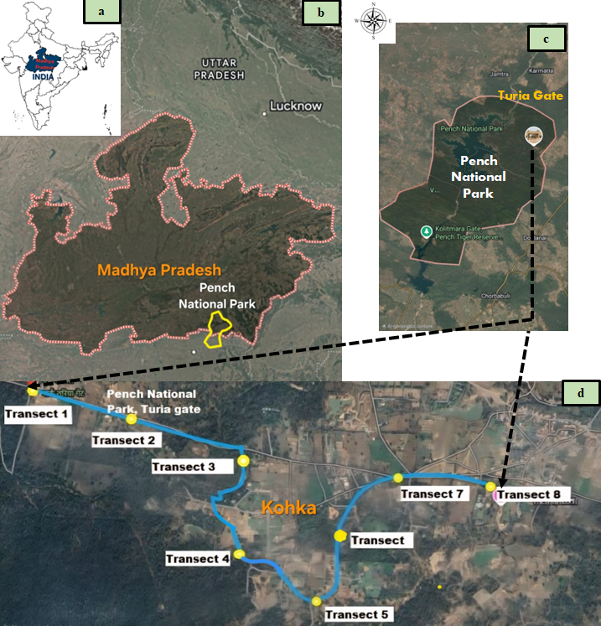
Fig. 1. Map of India (a), and satellite image of Madhya Pradesh (b), Pench National Park (c), and study area (d).
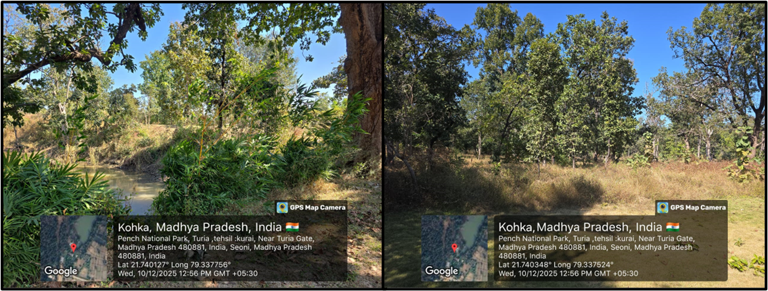
Fig. 2. Photographs of the study area that consists of herbs, shrubs and trees
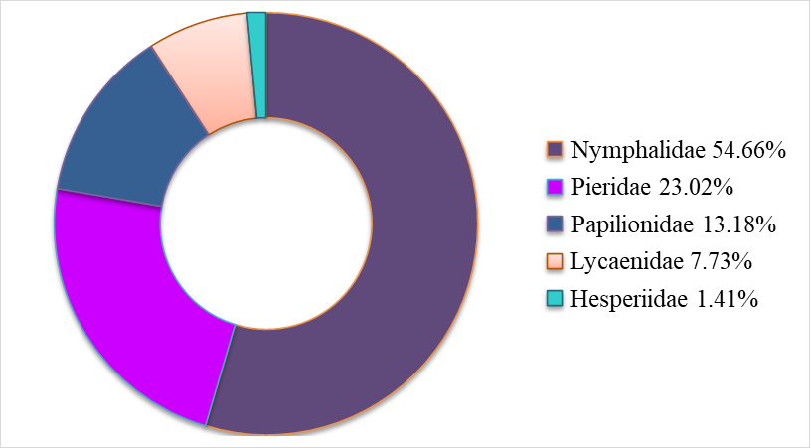
Fig. 3. Percentage composition of five families of butterflies in the study area
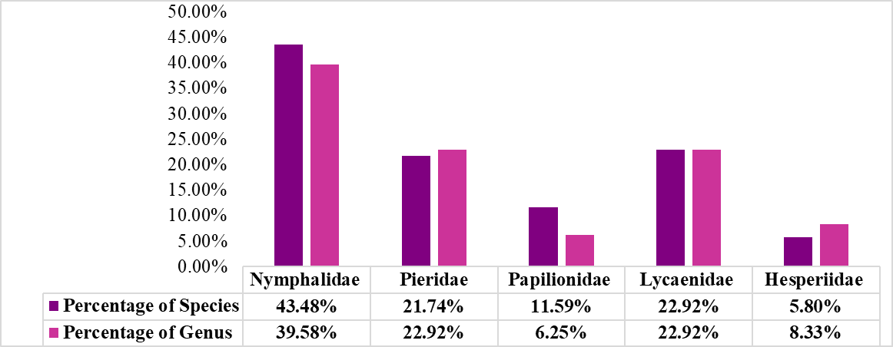
Fig. 4. Genus to species proportion of butterflies of five families.
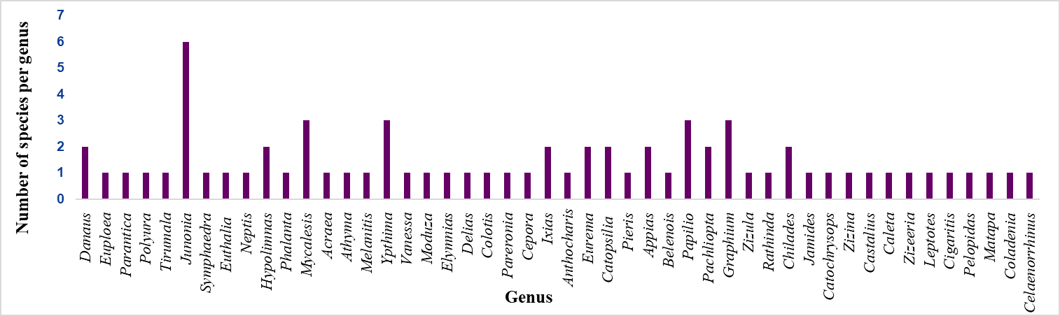
Fig. 5. Species richness of the recorded butterfly genera of the study site.
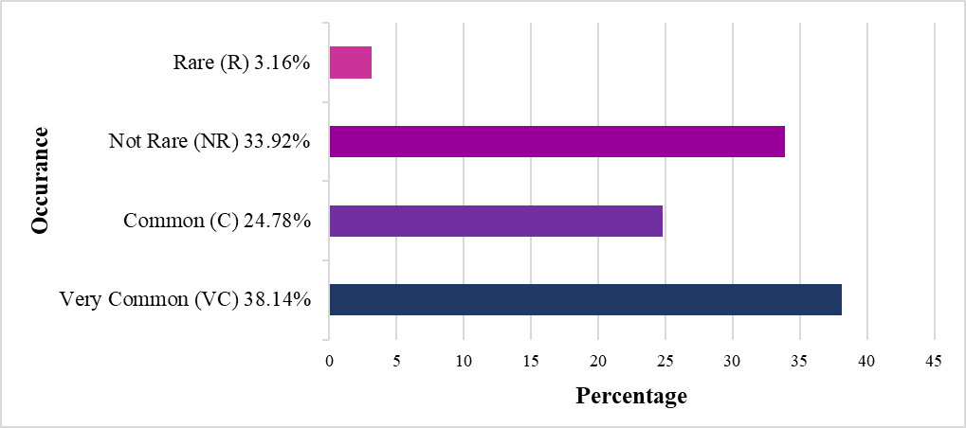
Fig. 6. Occurrence of different butterfly species in the study area
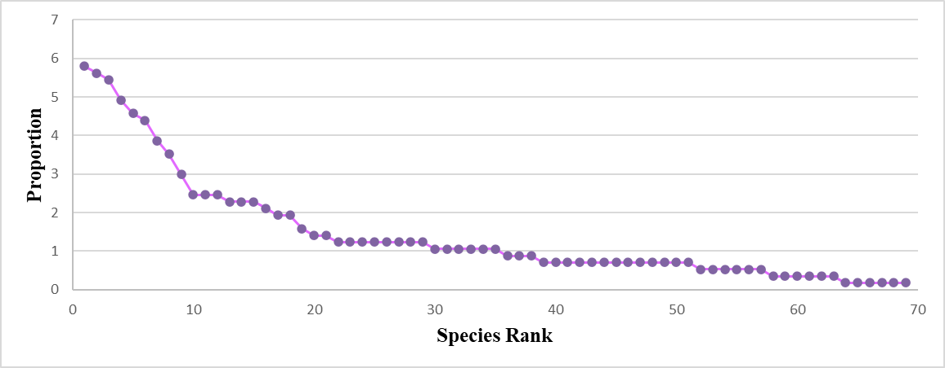
Fig. 7. Rank abundance curve of 69 species of butterfly in the study area
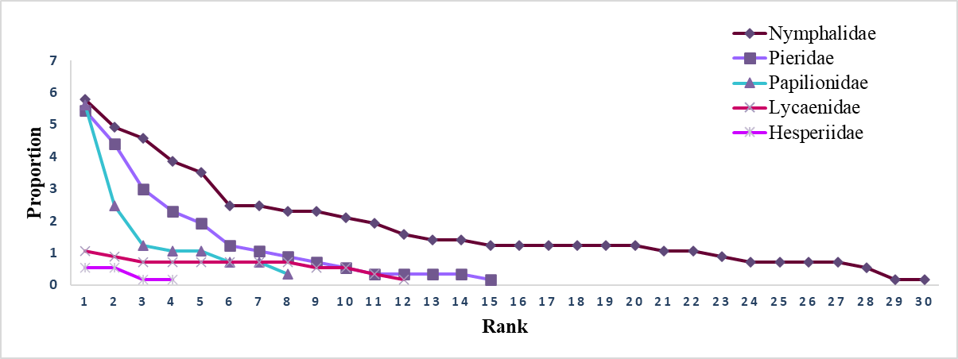
Fig. 8. Rank abundance curve of five families of butterfly in the study area.
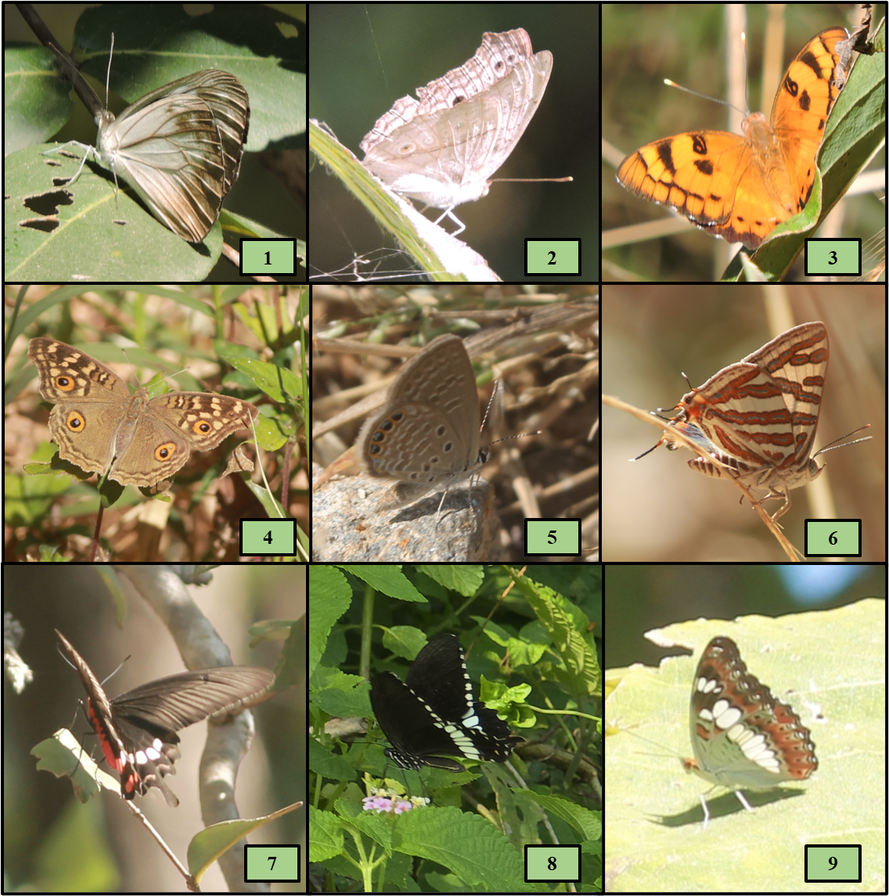
Fig. 9. Photographs of different butterfly species recorded in the study area
1) Pareronia hippia, 2) Junonia atlites, 3) Symphaedra nais, 4) Junonia lemonias, 5) Chilades trochilus, 6) Cigaritis vulcanus, 7) Pachliopta aristolochiae, 8) Papilio polytes, 9) Moduza procris

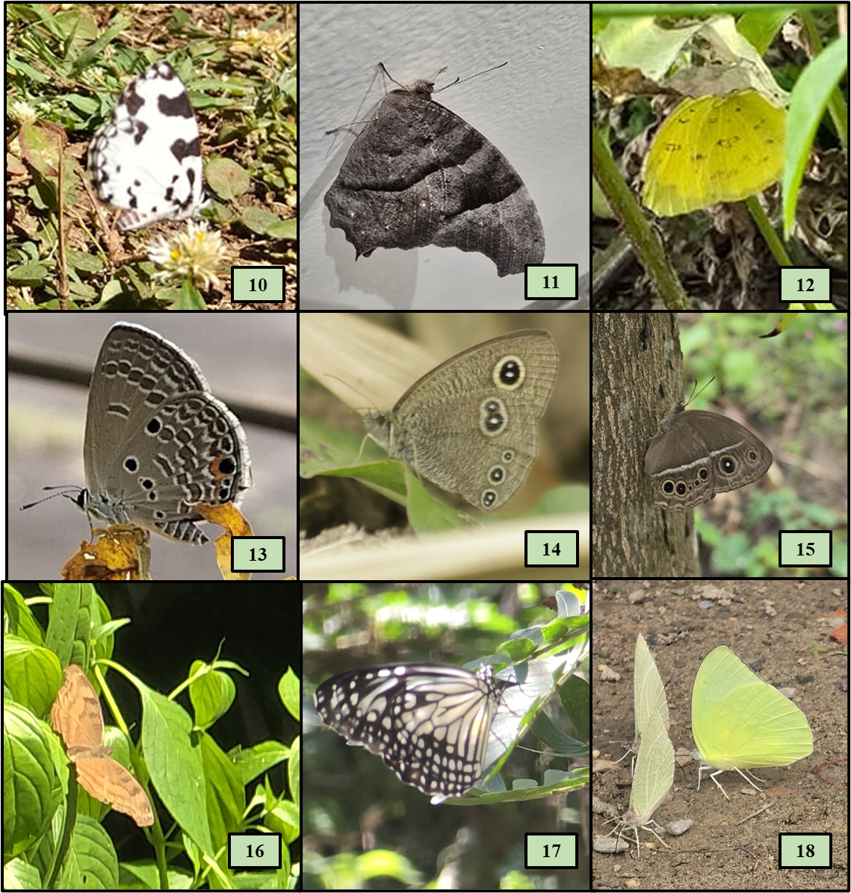
Fig 10. Photographs of different butterfly species recorded in the study area
10) Caleta decidia, 11) Melanitis leda, 12) Eurema hecabe, 13) Chilades pandava, 14) Ypthima baldus, 15) Mycalesis mineus, 16) Junonia iphita, 17) Parantica aglea, 18) Catopsilia pyranthe

