GEOCHEMICAL ASSESSMENT AND SPATIAL VARIABILITY OF HEAVY METALS IN URBAN MECHANIC-WORKSHOP SOILS IN ASABA, SOUTHERN NIGERIA

ABSTRACT
Automobile repair activities in urban environments contribute significantly to heavy metal accumulation in surface soils, yet detailed geochemical evidence remains limited for many cities in southern Nigeria. This study investigated the concentration levels and spatial distribution of cadmium (Cd), chromium (Cr), lead (Pb), iron (Fe), nickel (Ni), and zinc (Zn) in soils from selected automobile mechanic workshops in Asaba, Delta State. Composite surface soil samples (0–15 cm) were collected from four active workshop locations and a control site within Dennis Osadebay University. Samples were digested using a nitric–perchloric acid mixture and analysed using atomic absorption spectrophotometry (AAS). Mean metal concentrations in workshop soils ranged from 5.34–9.01 mg/kg for Cd, 5.32–10.36 mg/kg for Cr, 21.81–52.11 mg/kg for Pb, 23.17–31.85 mg/kg for Fe, 6.80–14.37 mg/kg for Ni, and 18.06–24.46 mg/kg for Zn, compared with substantially lower values at the control site. Cadmium concentrations at all workshop locations exceeded WHO and NESREA guideline limits, while lead exceeded permissible levels at the Mami Market site. Although Cr, Ni, and Zn remained within regulatory thresholds, their enrichment above background levels indicates continuous anthropogenic input. The findings highlight progressive modification of urban soil geochemistry due to automobile repair activities and underscore the need for improved waste management and routine environmental monitoring in mechanic-workshop environments.
Keywords: Heavy metal contamination, Geochemical baseline, Automobile workshops, Spatial variation, Asaba metropolis, Atomic absorption spectrophotometry (AAS)
Introduction
Trace metals occur naturally in soils as constituents of parent geological materials; however, their concentration and distribution within urban environments are increasingly shaped by anthropogenic activities rather than natural processes (Ali et al., 2019). Rapid urban expansion, increased vehicular density, and the growth of informal commercial and industrial operations have substantially modified soil geochemistry in many developing regions, where environmental regulation and waste control remain limited (Konadu et al., 2023; Madukasi & Agbazue, 2024). Urban soils therefore function as long-term sinks for potentially toxic metals, creating pathways for human exposure through direct soil contact, resuspended dust, and secondary contamination of water and food systems (Onadje & Akalusi, 2024; Iwegbue & Bassey, 2024).
Automobile repair and maintenance activities represent an important yet often under-regulated source of heavy-metal enrichment in urban soils. Informal mechanic workshops generate diverse waste streams, including spent engine oil, used lubricants, battery components, metal scraps, brake linings, and tyre debris, which are commonly discharged directly onto surrounding soils (Amaechi & Onwuka, 2021; Vincent et al., 2022). Continuous deposition of these materials over time promotes the accumulation of metals such as cadmium, lead, zinc, nickel, and chromium in surface soils, frequently at concentrations exceeding background levels (Ajeh et al., 2022; Duru et al., 2024). The extent and spatial pattern of contamination are strongly influenced by factors such as workshop density, duration of operation, traffic intensity, and local land-use pressure, resulting in marked site-to-site variability in metal distribution within urban landscapes (Akpan et al., 2023; Majabi et al., 2023).
This aim of this study is to examine the levels and spatial patterns of selected heavy metals (Cd, Cr, Pb, Fe, Ni, and Zn) in surface soils associated with automobile mechanic workshops in Asaba, southern Nigeria. The specific objectives were to determine the extent of metal enrichment relative to background conditions, evaluate differences in contamination across workshop locations, and assess measured concentrations against WHO and NESREA soil quality guidelines to identify areas of potential environmental concern arising from automobile repair activities.
Materials and Methods
Study Area
This study was conducted in Asaba, the capital city of Delta State, southern Nigeria, located at approximately 6.198° N latitude and 6.732° E longitude along the western bank of the River Niger. Asaba lies within the Niger Delta region and is directly opposite Onitsha across the river. The area is underlain predominantly by the Ogwashi–Asaba Formation and the Benin Formation, consisting of interbedded sands, sandy clays, lateritic horizons, and lignite layers. These geological units form shallow, unconfined aquifers that are widely exploited for domestic water supply and are particularly susceptible to surface-derived contamination.
The city experiences a tropical climate characterised by distinct wet and dry seasons. Rainfall occurs mainly between April and November, with peak precipitation around September, while relative humidity remains high throughout most of the year. Automobile repair activities in Asaba are largely informal and widely distributed along major roads, including Anwai Road, Okpanam Road, Ibusa Road, and the Mami Market axis. Most workshops operate without structured waste-management systems, resulting in direct discharge of used engine oil, metal scraps, batteries, tyres, and other vehicular residues onto surrounding soils. For this study, four active mechanic-workshop locations and one control site within Dennis Osadebay University campus were selected, georeferenced using a andheld Global Positioning System (GPS), and confirmed through field reconnaissance.
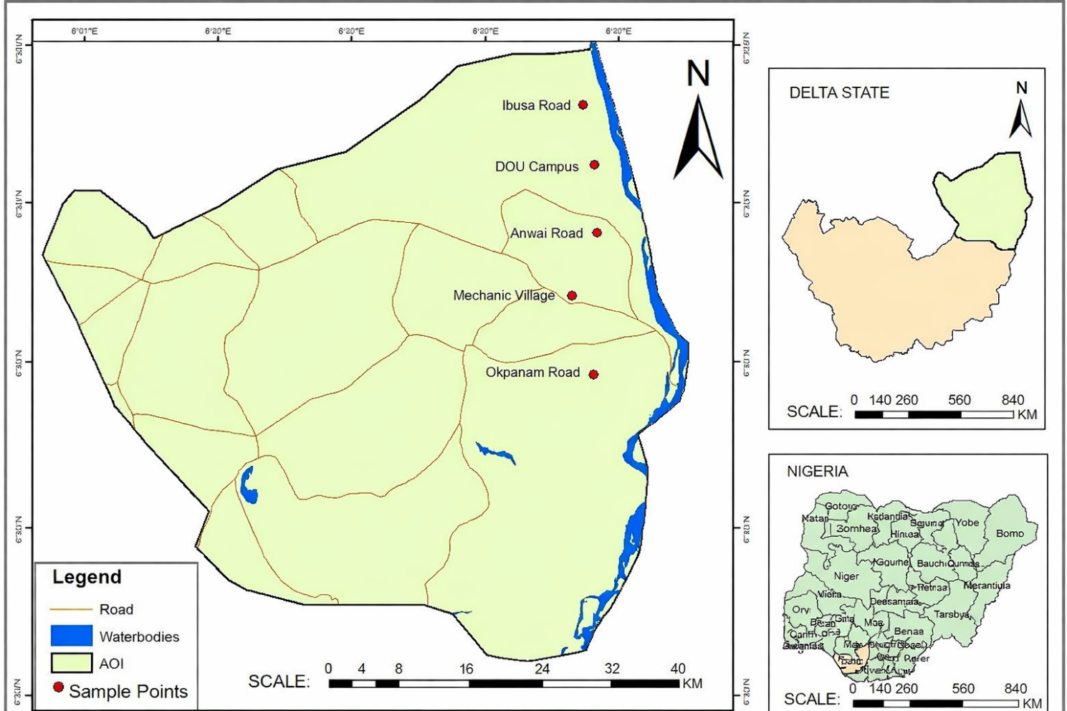
Figure 1: Map showing the study area
Table 1: Geographic Coordinates of Selected Automobile workshops in Asaba
Site | Latitude (°N) | Longitude (°E) | Description
Anwai Road | 6.21578 | 6.70269 | Low-traffic roads with low-intensity auto-mechanic activities.
Okpanam Road | 6.2135 | 6.7130 | It holds a significant amount of traffic, business activity, and a large number of automobile-related industries.
Ibusa Road | 6.2080 | 6.7000 | It is a transitional area between the peri-urban periphery and the urban centre.
Mechanic Village (Mami Market) | 6.2140 | 6.7030 | A major road with lots of commercial activities alongside sales of automobile spare parts and workshops.
DOU Campus | 6.2544 | 6.7030 | It is relatively free of industrial operations, heavy traffic, and vehicle workshop activities.

Sample collection and preparation
Surface soil samples were collected from each automobile workshop site following standard environmental sampling procedures. At each location, soil was obtained from four randomly selected points within the workshop area at a depth of 0–15 cm, representing the zone most affected by anthropogenic inputs. The individual samples were combined to form a composite sample for each site in order to minimise local heterogeneity. Control soil samples were collected using the same procedure from an area within Dennis Osadebay University campus that is free from mechanical activities, heavy traffic, and industrial influence. All samples were placed in clean, labelled polyethylene containers and transported to the laboratory for analysis.

Sample Preparation and Acid Digestion
In the laboratory, soil samples were air-dried at ambient temperature (22–26 °C) to constant weight, gently disaggregated using a porcelain mortar and pestle, and passed through a 2 mm stainless-steel sieve to remove debris and coarse materials. One gram of each prepared soil sample was accurately weighed into acid-washed digestion vessels. Pre-digestion was carried out by adding 10 mL of concentrated nitric acid (HNO₃) to each sample, followed by gentle heating on a hot plate to reduce organic matter content. The residues obtained were further digested using a mixed acid solution consisting of nitric acid and perchloric acid (HNO₃:HClO₄, 3:1 v/v). The digestion mixtures were allowed to stand briefly at room temperature before heating at approximately 150 °C until clear solutions were obtained and perchloric acid fumes had completely dissipated. After cooling, the digests were filtered through Whatman No. 1 filter paper into 50 mL volumetric flasks and made up to volume with deionised water. The resulting solutions were stored in pre-cleaned plastic bottles prior to instrumental analysis.

Heavy Metal Determination
Concentrations of cadmium (Cd), chromium (Cr), lead (Pb), iron (Fe), nickel (Ni), and zinc (Zn) in the digested soil solutions were determined using atomic absorption spectrophotometry (AAS). Instrument calibration was performed using analytical-grade standard solutions prepared from certified stock standards. Quality assurance procedures included reagent blanks and duplicate analyses to ensure analytical reliability. The instrument was operated in accordance with the manufacturer’s specifications, and metal concentrations were expressed in milligrams per kilogram (mg/kg) of dry soil.

Data Analysis
Analytical results were presented as mean values ± standard deviation. Statistical analysis was performed using Microsoft Excel (2016) and SPSS software (version 23). One-way analysis of variance (ANOVA) was applied to assess differences in metal concentrations among sampling locations, with statistical significance evaluated at p < 0.05.
Results

Table 1 presents the mean concentrations of the heavy metals, in mg/Kg, found in selected automobile workshops in Asaba, including the control. The heavy metals examined in this study include Cd, Cr, Pb, Fe, Ni and Zn. These metals were determined and analysed from the sediment samples of the four selected automobile workshops.
Table 2: Mean Concentrations (mg/Kg) of the Heavy Metals in the four selected Automobile workshops and Control. Values are expressed as mean ± standard deviation (n = 4)
Parameters | Anwai Road | Okpanam Road | Ibusa Road | Maimi Market | Control DOU | WHO (mg/kg) | NESREA  (mg/kg)
Cd | 5.34±0.15 | 8.95±0.11 | 5.42±0.14 | 9.01±0.15 | 2.15±0.05 | 3.00 | 3.00
Cr | 9.44±0.36 | 5.32±0.17 | 6.11±0.75 | 10.36±0.01 | 1.94±0.01 | 100 | 100
Pb | 21.81±0.17 | 24.01±0.02 | 22.00±0.01 | 52.11±0.12 | 1.27±0.11 | 50 | 164
Fe | 25.05±0.04 | 27.35±0.02 | 23.17±0.06 | 31.85±0.15 | 6.49±0.25 | 30,000 | NS
Ni | 6.80±0.22 | 9.15±0.12 | 7.13±0.01 | 14.37±0.43 | 2.31±0.01 | 35 | 70
Zn | 19.54±0.15 | 19.77±0.03 | 18.06±0.05 | 24.46±0.12 | 3.72±0.05 | 90 | 421
Source: Researchers field work, 2025.
NESREA STANDARDS: National Environmental Standards and Regulations Enforcement Agency, 2011.
Key: Cadmium (Cd), Chromium (Cr), Lead (Pb), Iron (Fe), Nickel (Ni), Zinc (Zn), and NS (Not Specified).

Cadmium levels across the selected workshops soils ranged from 5.34 ± 0.15 mg/kg to 9.01 ± 0.15 mg/kg at Anwai Road and Maimi Market respectively while the control site had the least value of 2.15 ± 0.05 mg/kg. The values of soils across the selected all exceeded both the WHO and NESREA standards of (3 mg/kg).
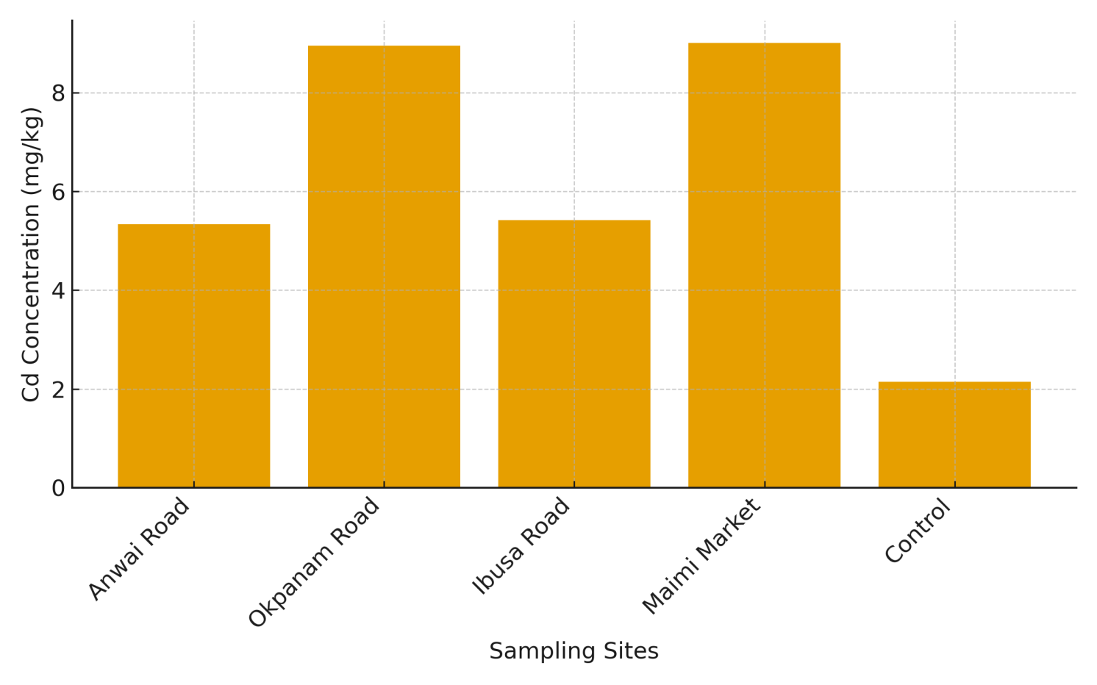
Figure 1: Mean cadmium (Cd) concentrations (mg/kg) across the five sampling sites (Anwai Road, Okpanam Road, Ibusa Road, Maimi Market, and the Control site). Values represent mean concentrations of Cd indicating elevated levels at Okpanam Road and Maimi Market compared to the control.

Chromium levels had values between 5.32 ± 0.17 mg/kg (Okpanam Road) and 10.36 ± 0.01 mg/kg (Maimi Market), while the control site had a value of 1.94 ± 0.01 mg/kg. However, all values recorded were clearly below the below regulatory limits (100 mg/kg).

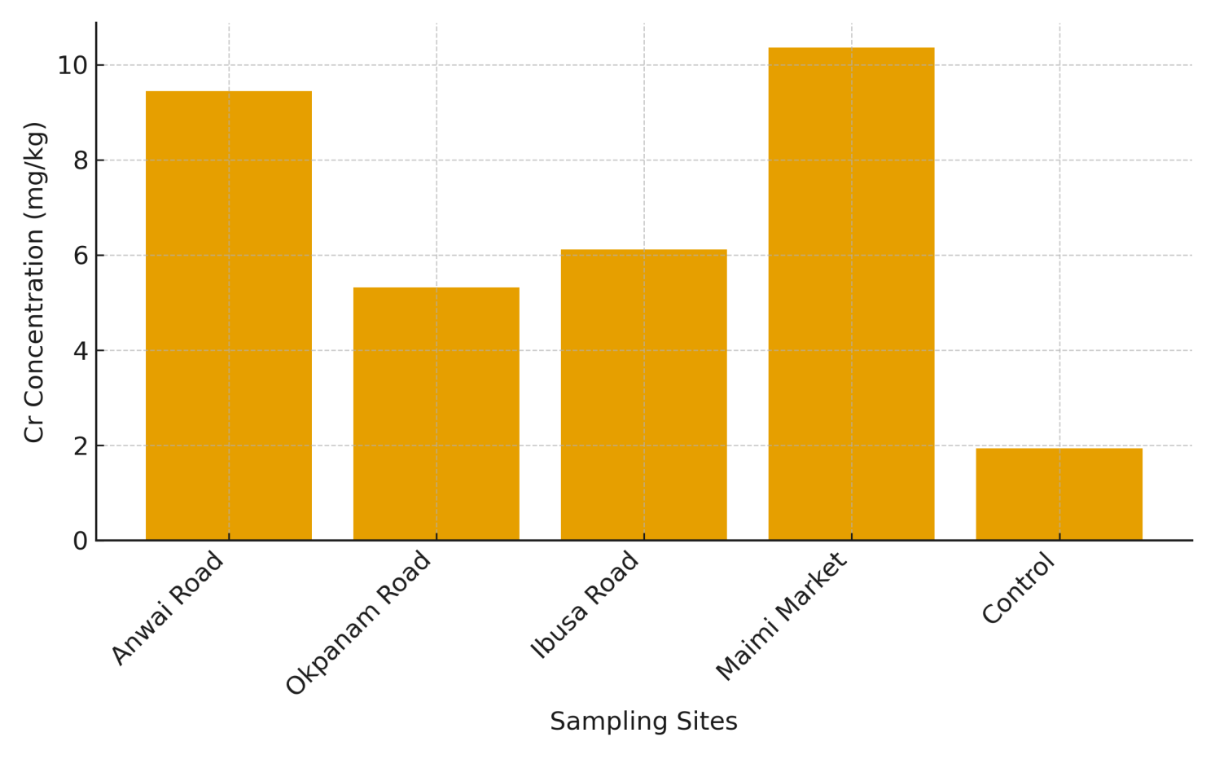
Figure 2: Mean chromium (Cr) concentrations (mg/kg) in soils collected from the selected automobile workshops and control site. Cr levels were highest at Maimi Market and lowest at the control site.

The concentration of Lead (Pb) were highest in all the stations with Maimi market having the highest amount of 52.11 ± 0.12 mg/kg exceeding the WHO permissible limit of 50 mg/kg. Values of Lead for the other workshops ranged 21.81–24.01 mg/kg. However, the control site at the University campus had only 1.27 ± 0.11 mg/kg.

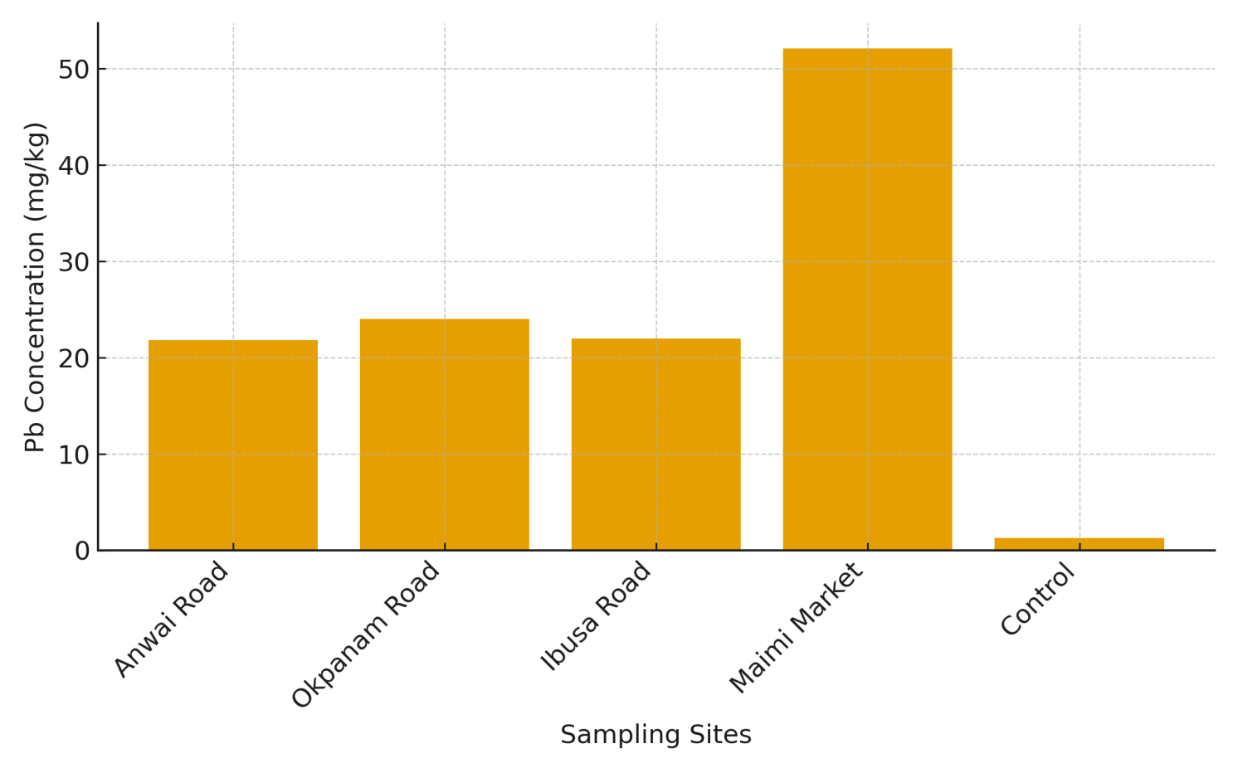

Figure 3: Mean lead (Pb) concentrations (mg/kg) across sampling locations. Pb levels were substantially higher in Maimi Market soils compared to other sites, reflecting significant anthropogenic contamination.

The concentration of Iron (Fe) followed a similar spatial pattern, with values ranging from 23.17–31.85 mg/kg, and 6.49 ± 0.25 mg/kg at the control site. Fe is not strictly restricted under NESREA, but its elevated abundance suggests long-term accumulation from rusting processes, automobile engine parts, and metallic debris.

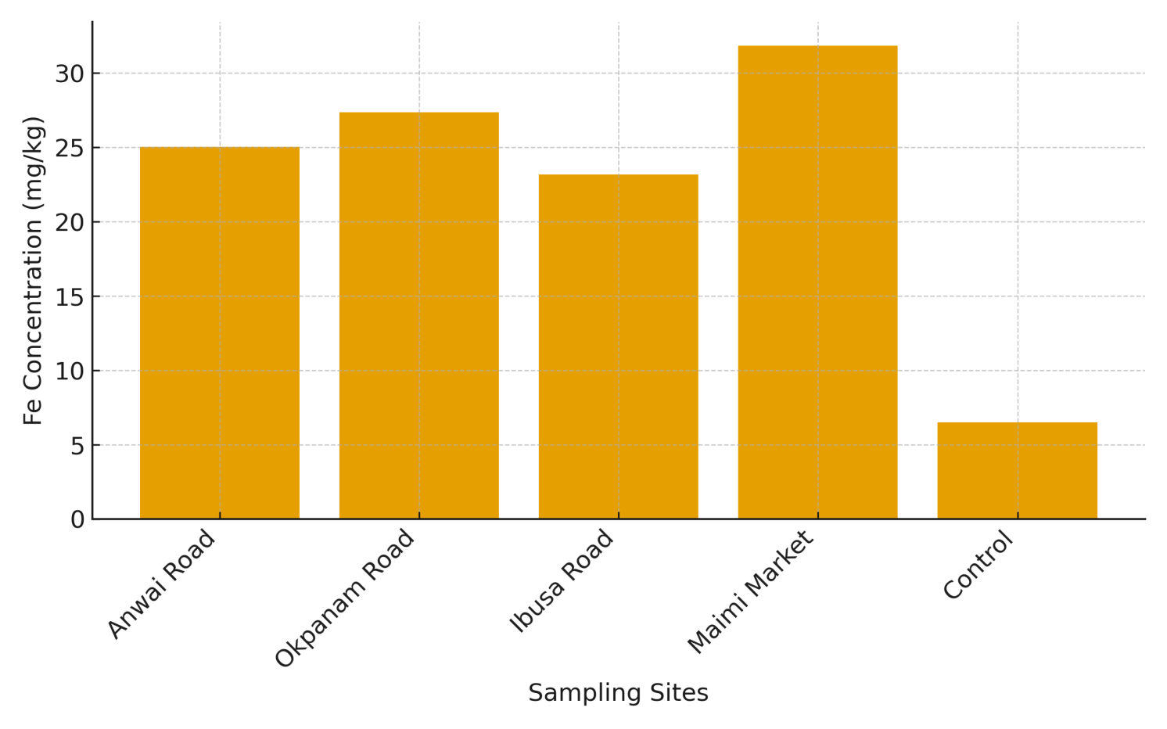
Figure 4: Mean iron (Fe) concentrations (mg/kg) in soil samples from the four automobile workshops and control. Fe concentrations peaked at Maimi Market, with the lowest levels recorded at the control site.
Nickel (Ni) values were between 6.80 ± 0.22 to 14.37 ± 0.43 mg/kg. The control site again had the least value of 2.31 ± 0.01 mg/kg. All values recorded were below the permissible limits of 35 mg/kg and 70 mg/kg stipulated by WHO and NESREA respectively.
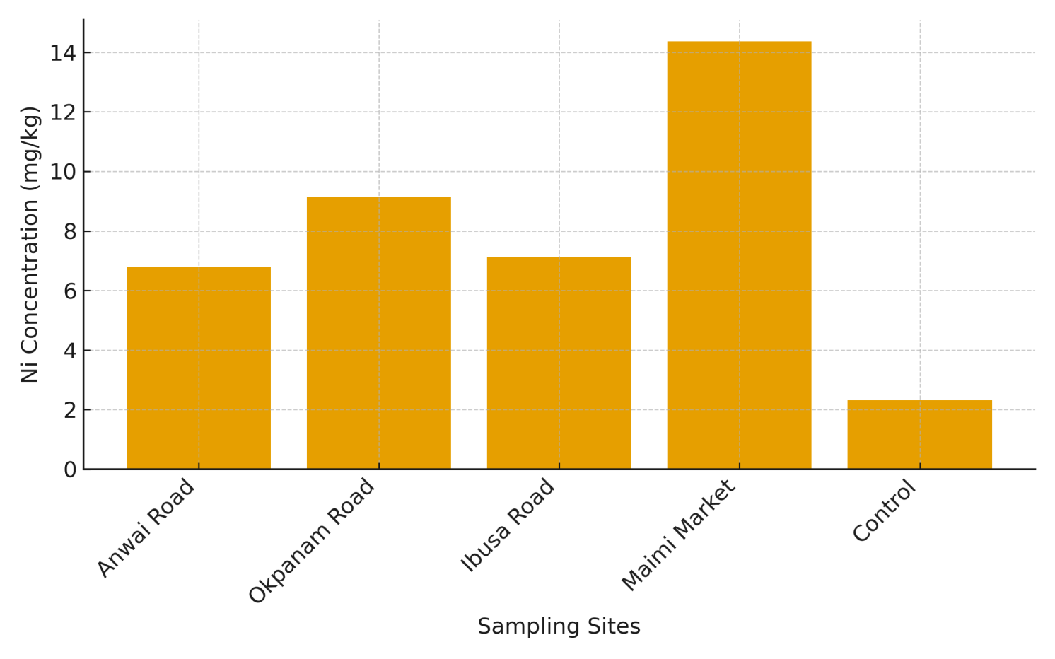
Figure 5: Mean nickel (Ni) concentrations (mg/kg) across the study locations. Similar to other metals, Ni levels were elevated at Maimi Market compared with the control, suggesting deposition from mechanical activities.
The concentrations of Zinc (Zn) recorded from all the selected sites were below the WHO (90 mg/kg) and NESREA (421 mg/kg) limits with values ranging from 18.06–24.46 mg/kg as compared to 3.72 ± 0.05 mg/kg at the control site.
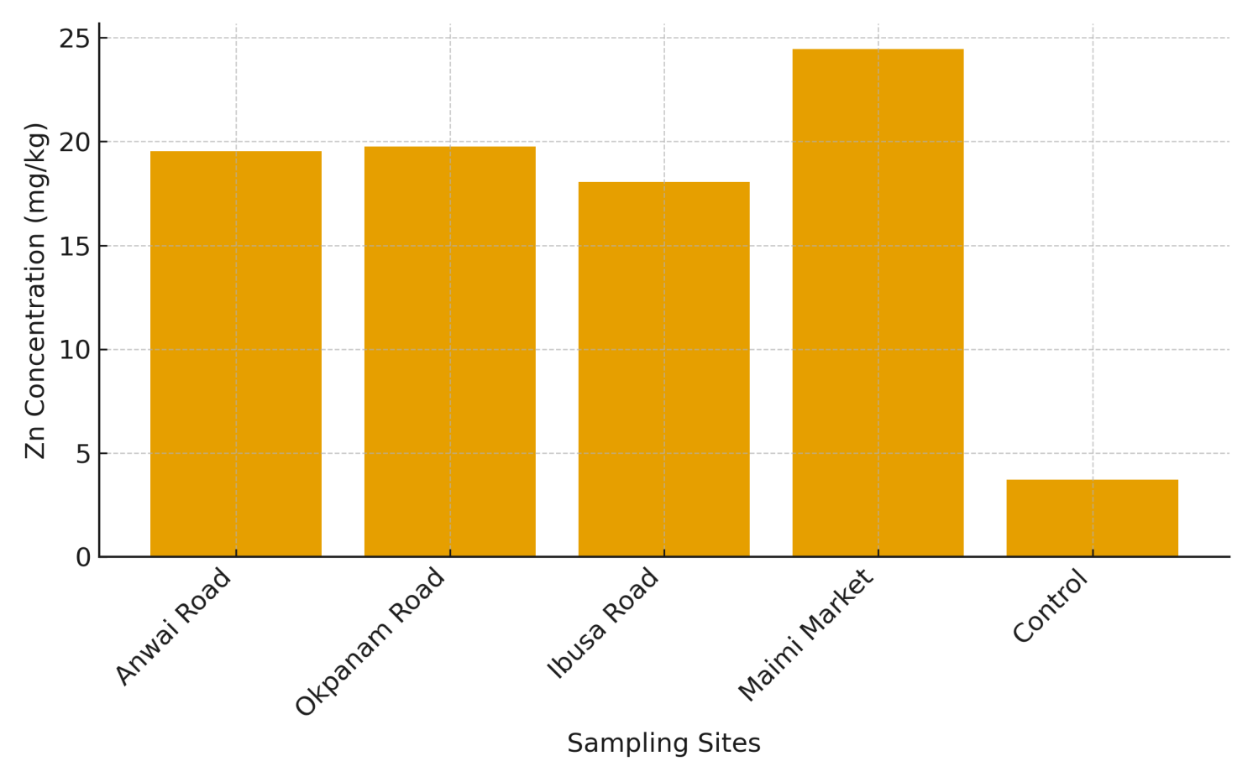

Figure 6: Mean zinc (Zn) concentrations (mg/kg) from soils at the various workshop sites and control. Zn concentrations were highest at Maimi Market, while the control site showed the lowest values.

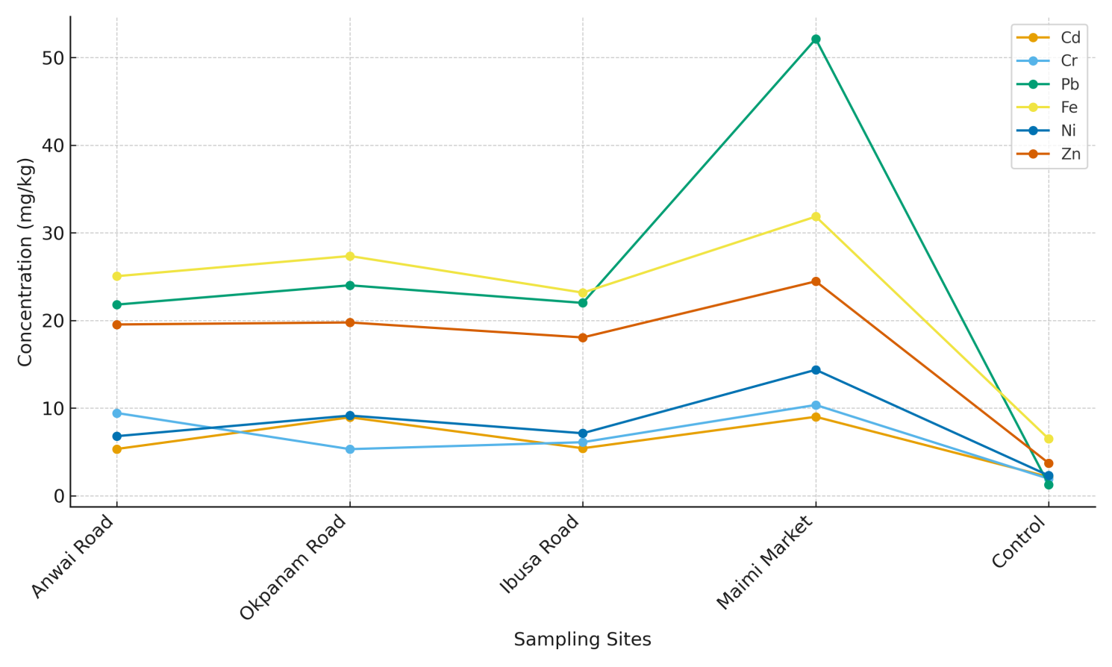
Figure 7: Mean heavy metal concentrations across sampling sites, showing spatial differences in Cd, Cr, Pb, Fe, Ni, and Zn levels among the automobile workshop areas and the control site.

Discussion
The results of this study demonstrate clear enrichment of heavy metals in surface soils surrounding automobile workshops in Asaba relative to the control site, confirming the strong influence of anthropogenic activities on urban soil quality. Elevated concentrations across all workshop locations indicate sustained metal inputs associated with mechanical operations, vehicular maintenance, and poor waste-handling practices. The observed contamination pattern, with highest metal levels at Maimi Market, reflects differences in workshop density, traffic flow, and intensity of commercial activities.
Cadmium emerged as a metal of particular concern, with concentrations exceeding WHO and NESREA guideline values at all workshop sites. Similar levels of Cd enrichment have been reported in soils around automobile workshops in Awka, Benin City, Nsukka, and Uyo, where inputs were linked to battery disposal, lubricants, plastic stabilisers, and metal plating residues (Amaechi & Onwuka, 2021; Ajeh et al., 2022; Duru et al., 2024). The persistence of Cd in soils and its potential mobility under acidic conditions heighten the risk of environmental and human exposure.
Lead concentrations were notably elevated at Maimi Market, exceeding the WHO guideline value, and were substantially higher than those recorded at other sites. This enrichment is consistent with previous studies that associate Pb accumulation in workshop soils with lead-acid batteries, metal parts, paints, and historical use of leaded petrol (Akpan et al., 2023; Mohammed et al., 2025). Lead contamination is of concern due to its neurotoxic effects, particularly for children and occupationally exposed populations (Iwegbue et al., 2024).
Chromium, nickel, and zinc concentrations remained below regulatory thresholds but were markedly higher than background levels. These metals are commonly derived from brake linings, tyre wear, welding activities, and corrosion of vehicle components, and their accumulation indicates ongoing anthropogenic input despite regulatory compliance (Majabi et al., 2023; Daniel et al., 2025). Zinc, in particular, serves as a reliable tracer of traffic and workshop activities even when present at moderate concentrations.
Iron exhibited significant enrichment across workshop sites compared to the control, reflecting both natural soil composition and contributions from corroded metallic materials and engine components. Similar patterns have been widely documented in mechanic-workshop environments, where Fe is often used as a reference element in contamination assessments (Ololade, 2014; Elemile et al., 2021).
The spatial contamination gradient observed in this study highlights the cumulative effects of prolonged mechanical activities and inadequate waste management on urban soil quality. Although most metals remain within regulatory limits, continued accumulation may pose long-term risks through dust resuspension, direct contact, and potential leaching into shallow groundwater systems, particularly in areas underlain by permeable soils such as Asaba.
Conclusion
This study demonstrates that soils surrounding automobile workshops in Asaba are significantly enriched with heavy metals compared to background conditions. Cadmium contamination exceeded regulatory limits across all workshop sites, while lead concentrations at Maimi Market surpassed recommended guidelines, identifying this location as a major contamination hotspot. Although chromium, nickel, and zinc remained within permissible limits, their elevated levels indicate ongoing geochemical alteration driven by vehicular repair activities and poor waste handling. The observed spatial contamination gradient underscores the influence of workshop density and land-use pressure on soil quality. Strengthening waste-management practices, introducing containment measures, and implementing routine environmental monitoring are essential to prevent further degradation of urban soils in Asaba.
Disclaimer (Artificial intelligence)

Author(s) hereby declare that NO generative AI technologies such as Large Language Models (ChatGPT, COPILOT, etc.) and text-to-image generators have been used during the writing or editing of this manuscript.

Reference
Akpan, J. O., Essien, U. C., & Udo, A. E. (2023). Assessment of toxic metals in auto-mechanic workshop soils in Modakeke, Nigeria. Journal of Environmental Chemistry and Ecotoxicology, 15(3), 71–82. https://doi.org/10.5897/JECE2023.0510
Ali, H., Khan, E., & Ilahi, I. (2019). Environmental chemistry and ecotoxicology of hazardous heavy metals: Environmental persistence, toxicity, and bioaccumulation. Journal of Chemistry, 2019, 6730305. https://doi.org/10.1155/2019/6730305
Amaechi, M., & Onwuka, S. U. (2021). Determination of heavy metal concentrations in soils of automobile workshops in Awka, Anambra State, Nigeria. International Journal of Environment and Pollution Research, 9(3), 18–32.
Daniel, E. I., Ikenna, A. I., & George, O. (2025). Soil heavy metal contamination around auto-mechanic workshops in Uyo metropolis and associated health risks. Environmental Health Perspectives Nigeria, 12(1), 44–59.
Duru, C. E., Nwankwo, C., & Madu, C. N. (2024). Heavy metals in auto-mechanic soils and human health implications in Nsukka, Nigeria. Heliyon, 10(2), e25524. https://doi.org/10.1016/j.heliyon.2024.e25524
Elemile, O. O., Uthman, B. A., & Kolawole, A. N. (2021). Metal pollution index and contamination trend of Fe and associated metals around industrial mechanic clusters in Nigeria. Environmental Challenges, 5, 100299. https://doi.org/10.1016/j.envc.2021.100299
Iwegbue, C. M. A., & Bassey, F. I. (2024). Lead exposure in urban roadside and mechanical-cluster soils: Public health implications in Southern Nigeria. Environmental Science and Pollution Research, 31(4), 5123–5135. https://doi.org/10.1007/s11356-023-26697-8
Konadu, F. N., Asare-Donkor, N. K., & Bentum, J. K. (2023). Human health risk assessment of potentially toxic elements in soils around automobile mechanic workshops in Ghana. Toxicology Reports, 10, 1278–1289.
Madukasi, E. I., & Agbazue, O. (2024). Evaluation of physicochemical parameters and heavy metal levels in soils from automobile workshops in Nnewi, Nigeria. Journal of Applied Sciences and Environmental Management, 28(9), 2729–2736. https://doi.org/10.4314/jasem.v28i9.16
Majabi, O. A., Hassan, S., & Jimoh, A. (2023). Zinc distribution in soils affected by vehicular wear and auto-mechanic activities in Okene, Nigeria. Scientific African, 19, e01572. https://doi.org/10.1016/j.sciaf.2023.e01572
Mohammed, S. B., John, F. A., & Aliyu, M. (2025). Public health risks of heavy metals in urban mechanic-village soils of Yola, Northeast Nigeria. Journal of Environmental Toxicology and Public Health, 10(1), 20–33.
National Environmental Standards and Regulations Enforcement Agency. (2011). National environmental (soil quality) regulations. Federal Republic of Nigeria.
Ololade, I. A. (2014). Assessment of heavy metal contamination in automobile workshop soils in Ikare Akoko, Southwestern Nigeria. Environmental Monitoring and Assessment, 186(12), 8741–8749. https://doi.org/10.1007/s10661-014-4040-8
Onadje, F.O. & Akalusi, K.E. (2024): Analyses of Transaminases and Phosphatases Levels in the Lead (Pb) Exposed fish, Clarias gariepinus: Implications of environmental contaminant. Faculty of Natural and Applied Sciences Journal of Applied Biological Sciences. Vol. 2 (1). 79-89. ISSN: 3027-0685
Vincent, F., Manu, J. M., Chessed, G., Vandi, P., Francis, S., & Norah, S. (2022). Assessment of heavy metals in soil and groundwater near automobile workshops in Yola and Jimeta, Nigeria. Journal of Applied Sciences and Environmental Management, 26(11), 1749–1755.

