Original Research Article
First report on moth (Insecta: Lepidoptera) diversity at Pench Tiger Reserve, Maharashtra

.
ABSTRACT

Moths (Insecta: Lepidoptera) are an important group of insects that play important roles in terrestrial ecosystems, contributing to pollination, herbivory and serving as prey for various predators. For many protected areas in India, moth documentation is incomplete or poor. Pench Tiger Reserve is one of the important tiger reserves in central India, located across the two states, Maharashtra and Madhya Pradesh. The present study aimed to document the baseline data on moth diversity in Pench Tiger Reserve in Maharashtra. In the study period from June 2020 to May 2023, 92 moth species from 19 families and 11 superfamilies were recorded from four locations, representing taxonomic diversity in the protected area. Erebidae (21%) and Crambidae (15%) were dominant families, followed by Noctuidae (13%), Geometridae (11%), Limacodidae (9%), and Sphingidae (7%). The most species-rich group was Noctuoidea, which was followed by Pyraloidea; the least represented groups were Cossoidea and Tineoidea. The presence of diverse moth species supports the presence of a stable ecosystem. The study also emphasizes how crucial protected forest ecosystems are to preserve ecological balance and insect biodiversity. The current study supports conservation management plans for India's protected forest ecosystems and adds to regional biodiversity databases.

Keywords: Lepidoptera, Moth, Pench Tiger Reserve, Maharashtra, Insecta

1. INTRODUCTION

In class Insecta, Lepidoptera is the second largest and most diverse order (Benton, 1995). Moths are a very diverse group of organisms within Lepidoptera, and they are very important to balance the ecosystem. Moths are insects that live in a variety of places and are holometabolous, nocturnal, and phytophagous insects. People know about them because of their size, dark colour, good looks and their life-cycle connection to plants (Kristensen, 2007). Moths are found in many places around the world, including plains, deserts, forests, valleys, and mountains (Gurule et al., 2011). Moths are important for the ecosystem because they pollinate flowers and are food for other animals. Biological studies can use them as bioindicators because they are sensitive to changes in their habitat. Moth larvae are pests that can harm many types of crops, vegetables, and forests. They can also help keep weeds in check (Shah and Mitra, 2015; Uniyal et al., 2016; Shubhalaxmi, 2018). Due to their ecological visibility, moths in tropical regions are underexplored (Kristensen et al., 2007). Most studies of moth diversity are conducted in biodiversity hotspots, whereas protected areas remain unexplored (Shubhalaxmi et al., 2011; Gurule & Nikam, 2013).
Tiger reserves are important protected areas in India that also support insect diversity through their vegetation, host plant availability, and low anthropogenic activity. The study aimed to identify moth species in the Pench Tiger Reserve, one of India's key protected areas for tiger conservation in Maharashtra. The present investigation helps in baseline data, diversity documentation for long-term monitoring and conservation planning in Pench Tiger Reserve, Maharashtra.

2. Materials and methods

2.1 Study area:
Pench Tiger Reserve is an important tiger reserve located in Maharashtra and Madhya Pradesh in central India. The main aim of the Pench Tiger Reserve is to protect the natural ecosystem, especially for tiger conservation. The survey was conducted between June 2020 and May 2023 in the Pench Tiger Reserve, Maharashtra, at four different locations: Amaltas Tourism Complex, Sillari (21°34'33.51"N and 79°17'16.03"E); Tiger Top Rest House, Totaladoh (21°39'14.59"N and 79°13'35.50"E); Irrigation Department Rest House, Totaladoh (21°39'14.59"N and 79°13'35.50"E); and Kolitmara Tourism Complex, Kolitmara (21°33'9.02"N and 79°10'38.07"E). Due to restrictions under the Wildlife Protection Act rules and regulations, neither the light trap method nor any other methods that could disturb the reserve were used. Specimens were not collected due to permission issues; only photographic records were documented, using a random sampling method. With the help of the collected photographs, the species were analysed and identified (Hampson, 1892; Gurule et al., 2010, 2011a, 2011b, 2013a, 2013b; Shubhalaxmi, 2018).

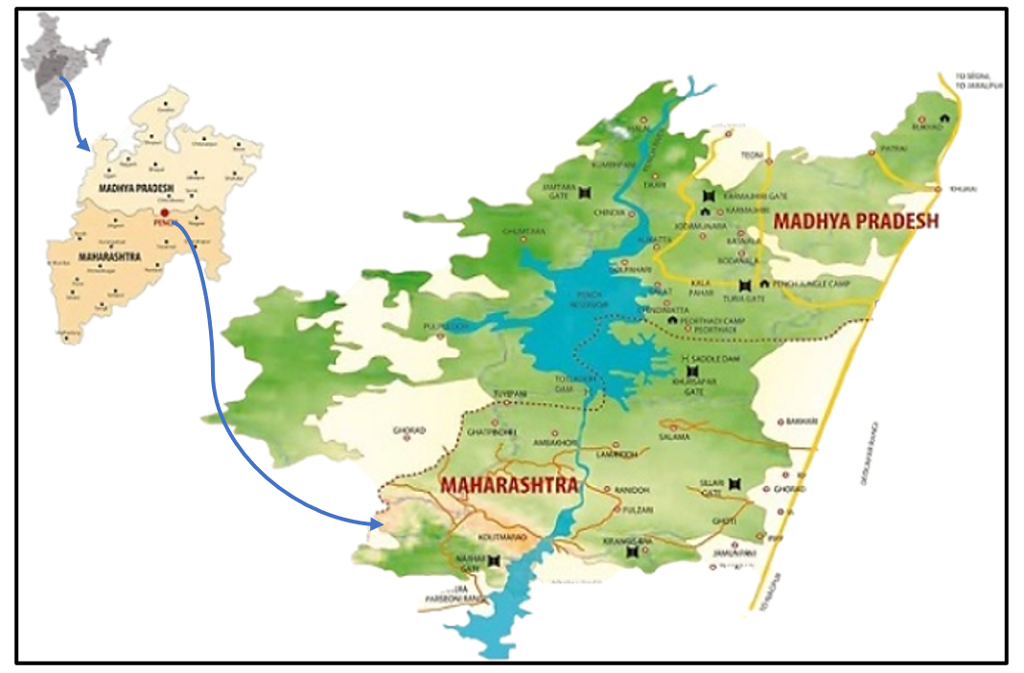
Fig.1. Pench tiger reserve, Maharashtra: The moth diversity observation site.

3. results and discussion

A total of 92 moth species were recorded from the Pench Tiger Reserve, belonging to 19 different families and 11 superfamilies, indicating high taxonomic diversity in the Pench Tiger Reserve (Table No. 1). Erebidae was the most common family (21%), followed by families like Crambidae (15%), Noctuidae (13%), Geometridae (11%), Limacodidae (9%), Sphingidae (7%), Eupterotidae (3%), Pyralidae (3%), Notodontidae (3%), Saturniidae (2%), Nolidae (2%), Uraniidae (2%), Thyrididae (2%), Bombycidae (1%), Cossidae (1%), Hyblaeidae (1%), Pterophoridae (1%), Tineidae (1%), and Tortricidae (1%). At the study site, only one species from each of the families Bombycidae, Cossidae, Hyblaeidae, Pterophoridae, Tineidae, and Tortricidae was found, indicating these families are rare in the area (Graphs 2 and 3). A superfamily-level analysis showed that Cossoidea and Tineoidea were the least common groups, while Noctuoidea and Pyraloidea were the most diverse superfamilies (Graph 1). The prevalence of Erebidae and Noctuidae signifies considerable ecological adaptability and an extensive range of host plants.
Bombycidae (Ganisa postica), Cossidae (Xyleutes persona), Hyblaeidae (Hyblaea puera), Pterophoridae (Emmelina monodactyla), Tineidae (Edosa sp.), and Tortricidae (Anticrates sp.) families were less abundant. The presence of diverse moth species indicates that the diverse Pench tiger reserve provides microhabitats, such as dense forest, shrub vegetation, and grassland patches.

Fig. 2. Superfamily-wise number of moth species in Pench Tiger Reserve, Maharashtra.

Fig. 3. Family-wise number of moth species in Pench Tiger Reserve, Maharashtra.
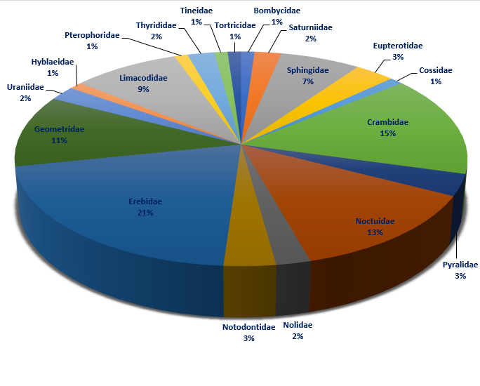
Fig. 4. % of moth species in different families at Pench Tiger Reserve, Maharashtra

Table 1. Checklist of moths recorded in Pench Tiger Reserve, Maharashtra

Superfamily | Family | Scientific Name of the species
Bombycoidea | Bombycidae | - Ganisa postica (Walker, 1855)
Bombycoidea | Saturniidae | - Actias selene (Hübner, 1807)
Bombycoidea | Saturniidae | - Antheraea paphia (Linnaeus, 1758)
Bombycoidea | Sphingidae | - Acherontia styx (Westwood, 1844)
Bombycoidea | Sphingidae | - Daphnis nerii (Linnaeus, 1758)
Bombycoidea | Sphingidae | - Hippotion celerio (Linnaeus, 1758)
Bombycoidea | Sphingidae | - Agrius convolvuli (Linnaeus, 1758)
Bombycoidea | Sphingidae | - Marumba dyras (Walker, 1856)
Bombycoidea | Sphingidae | - Dolbina inexacta (Walker, 1856)
Bombycoidea | Eupterotidae | - Eupterote mollifera (Walker, 1865)
Bombycoidea | Eupterotidae | - Eupterote undata (Blanchard,1844)
Bombycoidea | Eupterotidae | - Eupterote gardneri (Bryk, 1950)
Cossoidea | Cossidae | - Xyleutes persona (Le Guillou, 1841)
Pyraloidea | Crambidae | - Spoladea recurvalis (Fabricius, 1775)
Pyraloidea | Crambidae | - Maruca vitrata (Fabricius, 1787)
Pyraloidea | Crambidae | - Sameodes cancellalis (Zeller, 1852)
Pyraloidea | Crambidae | - Rehimena phrynealis (Walker, 1859)
Pyraloidea | Crambidae | - Paliga ochrealis (Moore,1886)
Pyraloidea | Crambidae | - Nymphicula blandialis (Walker, 1855)
Pyraloidea | Crambidae | - Pramadea lunalis (Guenée, 1854)
Pyraloidea | Crambidae | - Omiodes indicata (Fabricius, 1775)
Pyraloidea | Crambidae | - Nausinoe geometralis (Guenée, 1854)
Pyraloidea | Crambidae | - Syngamia falsidicalis (Walker, 1859)
Pyraloidea | Crambidae | - Pyrausta panopealis (Walker, 1859)
Pyraloidea | Crambidae | - Patania balteata (Fabricius, 1798)
Pyraloidea | Crambidae | - Palpita vitrealis (Rossi,1794)
Pyraloidea | Crambidae | - Glycythyma chrysorycta (Meyrick, 1884)
Pyraloidea | Pyralidae | - Locastra muscosalis (Walker,1859)
Pyraloidea | Pyralidae | - Autocharis fessalis (Swinhoe, 1886)
Pyraloidea | Pyralidae | - Endotricha sp.
Noctuoidea | Noctuidae | - Chrysodeixis eriosoma (Doubleday, 1843)
Noctuoidea | Noctuidae | - Xanthodes albago (Fabricius, 1794)
Noctuoidea | Noctuidae | - Chasmina judicata (Walker, 1858)
Noctuoidea | Noctuidae | - Maliattha quadripartita (Walker, 1865)
Noctuoidea | Noctuidae | - Hypena laceratalis (Walker,1859)
Noctuoidea | Noctuidae | - Hypocala deflorata (Fabricius, 1794)
Noctuoidea | Noctuidae | - Helicoverpa armigera (Hübner, 1805)
Noctuoidea | Noctuidae | - Condica dolorosa (Walker, 1865)
Noctuoidea | Noctuidae | - Mocis undata (Fabricius, 1775)
Noctuoidea | Noctuidae | - Bamra mundata (Walker, 1858)
Noctuoidea | Noctuidae | - Enispa rosellus (Hampson, 1893)
Noctuoidea | Noctuidae | - Eustrotia marginata (Walker, 1866)
Noctuoidea | Nolidae | - Pardoxia graellsi (Feisthamel, 1837)
Noctuoidea | Nolidae | - Nola analis (Wileman & West, 1928)
Noctuoidea | Notodontidae | - Netria spp. (Walker, 1855)
Noctuoidea | Notodontidae | - Syntypistis perdix (Moore, 1879)
Noctuoidea | Notodontidae | - Antheua servula (Drury ,1773)
Noctuoidea | Erebidae | - Bastilla simillima (Guenee, 1852)
Noctuoidea | Erebidae | - Ataboruza divisa (Walker, 1862)
Noctuoidea | Erebidae | - Trigonodes hyppasia (Cramer, 1779)
Noctuoidea | Erebidae | - Aloa lactinea (Cramer, 1777)
Noctuoidea | Erebidae | - Rajendra biguttata (Walker, 1855)
Noctuoidea | Erebidae | - Erebus macrops (Linnaeus, 1770)
Noctuoidea | Erebidae | - Fodina stola (Guenée, 1852)
Noctuoidea | Erebidae | - Ericeia inangulata (Guenée, 1852)
Noctuoidea | Erebidae | - Creatonotos transiens (Walker, 1855)
Noctuoidea | Erebidae | - Spilarctia sp.
Noctuoidea | Erebidae | - Aegocera bimacula (Walker, 1854)
Noctuoidea | Erebidae | - Episparis liturata (Fabricius,1787)
Noctuoidea | Erebidae | - Pericyma SP.
Noctuoidea | Erebidae | - Miltochrista rubricosa (Moore, 1878)
Noctuoidea | Erebidae | - Nepita conferta (Walker, 1854)
Noctuoidea | Erebidae | - Amata passalis (Fabricius, 1781)
Noctuoidea | Erebidae | - Utetheisa pulchella (Linnaeus, 1758)
Noctuoidea | Erebidae | - Lymantria grandis (Walker, 1855)
Noctuoidea | Erebidae | - Nodaria externalis (Guenée, 1854)
Geometroidea | Geometridae | - Chiasmia hebesata (Walker, 1861)
Geometroidea | Geometridae | - Chiasmia Eleonora (Cramer, 1780)
Geometroidea | Geometridae | - Scopula cuneilinea (Walker,1863)
Geometroidea | Geometridae | - Pingasa chlora (Stoll, 1782)
Geometroidea | Geometridae | - Thalassodes dissita (Walker, 1861)
Geometroidea | Geometridae | - Traminda mundissima (Walker, 1861)
Geometroidea | Geometridae | - Hyposidra talaca (Walker, 1860)
Geometroidea | Geometridae | - Boarmiini-genera spp. (Duponchel, 1845)
Geometroidea | Geometridae | - Gymnoscelis deleta (Hampson, 1891)
Geometroidea | Geometridae | - Astygisa hollowayi (Stüning & Walia,2009)
Geometroidea | Uraniidae | - Micronia aculeata (Guenée, 1857)
Geometroidea | Uraniidae | - Phazaca theclata (Guenée, 1857)
Hyblaeoidea | Hyblaeidae | - Hyblaea puera (Cramer, 1777)
Zygaenoidea | Limacodidae | - Altha subnotata (Walker, 1865)
Zygaenoidea | Limacodidae | - Altha nivea (Walker, 1862)
Zygaenoidea | Limacodidae | - Cheromettia apicata (Moore, 1879)
Zygaenoidea | Limacodidae | - Cania spp.
Zygaenoidea | Limacodidae | - Parasa lepida (Cramer, 1799)
Zygaenoidea | Limacodidae | - Miresa argentifera (Walker, 1855).
Zygaenoidea | Limacodidae | - Thosea sp.1
Zygaenoidea | Limacodidae | - Thosea sp.2
Pterophoroidea | Pterophoridae | - Emmelina monodactyla (Linnaeus, 1758)
Thyridoidea | Thyrididae | - Rhodoneura spp.
Thyridoidea | Thyrididae | - Hypolamprus spp.
Tineoidea | Tineidae | - Edosa sp.
Tortricoidea | Tortricidae | - Anticrates spp. Nr. eulima (Meyrick, 1905)

In the present investigation, in Pench Tiger Reserve, 92 moth species belonging to 19 families and 11 superfamilies were recorded, indicating significant lepidopteran diversity in the protected area. Dominance of Erebidae, followed by Crambidae, Noctuidae, and Geometridae was observed in several studies. Gurule and Nikam (2013) reported Erebidae and Noctuidae as dominant families in Northern Maharashtra, similar to the present investigation. The Noctuoidea family was dominant in protected areas of Uttarakhand (2016), supporting that tropical and subtropical forest supports Erebidae and Noctuidae families. Similar finding was reported by Pawar et al. (2021). Crambidae and Erebidae were dominant families in Navi Mumbai. In the Western Ghats, Shubhalaxmi et al. (2011) reported rich moth biodiversity.
Actias selene (Hübner, 1807) is widely distributed across South and Southeast Asia, according to Gurule and Nikam (2013b). The presence of large-sized moth like Actias selene, Acherontia styx, and Daphnis nerii is indictor of mature vegetation and stable forest ecosystem. Kathirvelu et al. (2019) also documented these species from semi-natural environments in Tamil Nadu, demonstrating their broad ecological range and dependence on intact vegetation. The existence of Sphingidae species indicates high habitat quality, which further encourages the availability of host plants for the larvae and nectar plants. Shah and Mitra (2015) reported that the presence of the moth is dependent on vegetation and agriculture in the surrounding area. The moth species Helicoverpa armigera is an important pest species in agriculture and was recorded in the present study, shows link between agriculture and forest. Recent studies of Chandra and Nema (2007) and Singh et al. (2014) suggested that protected areas support more diversity of moths as compared to disturbed areas in their recent checklist study.
Pench Tiger Reserve is important role in protecting insect biodiversity. Moths are indicator to habitat disturbance and can be used as bioindicators in Pench Tiger Reserve similar suggestion was given by Uniyal et al. (2016), suggest moth can be used for health monitoring of the ecosystem. An overall comparison with earlier Indian moth research indicates that Pench Tiger Reserve maintains an ecologically significant moth variety comparable to other biodiversity-rich locations in India. Therefore, the current study provides important baseline data for moth diversity in central India, where few studies have been conducted. The use of molecular techniques, long-term monitoring, and seasonal sampling may enhance the documentation of moth diversity in this region.

4. Conclusion

The study highlights the ecological richness of Pench Tiger Reserve by documenting 92 moth species from 19 families and 11 superfamilies. Stable populations are supported by dominant families such as Erebidae and Noctuidae, which reveal a variety of host plants and habitats. Different ecological niches are indicated by the presence of both common and rare species. Furthermore, agriculturally significant pests show connections with agro-ecosystems, whereas large sensitive species indicate high habitat quality. The importance of the reserve for conservation, particularly for insect biodiversity, is confirmed by these findings. Positioning moth diversity as a bioindicator for ecosystem health, the study provides baseline data for central Indian moths and recommends long-term monitoring and molecular techniques for improved comprehension and conservation efforts.

Plate 1: 92 moth species

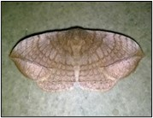 | 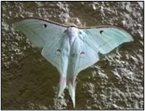 | 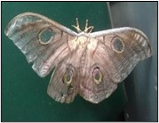 | 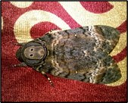 | 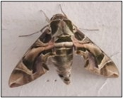 | 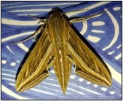 | 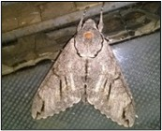
1. Ganisa postica  (Walker, 1855) | 2. Actias selene  (Hübner, 1807) | 3. Antheraea paphia (Linnaeus, 1758) | 4. Acherontia styx (Westwood, 1844) | 5. Daphnis nerii  (Linnaeus, 1758) | 6. Hippotion celerio  (Linnaeus, 1758) | 7. Agrius convolvuli  (Linnaeus, 1758)
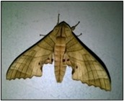 | 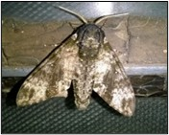 | 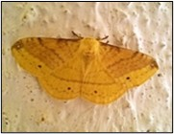 | 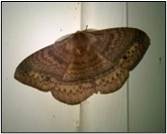 | 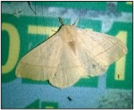 | 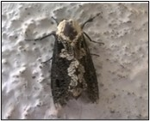 | 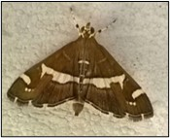
8. Marumba dyras  (Walker, 1856) | 9. Dolbina inexacta  (Walker, 1856) | 10. Eupterote mollifera (Walker, 1865) | 11. Eupterote undata  (Blanchard,1844) | 12. Eupterote gardneri  (Bryk, 1950) | 13. Xyleutes persona  (Le Guillou, 1841) | 14. Spoladea recurvalis  (Fabricius, 1775)
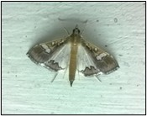 | 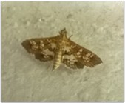 | 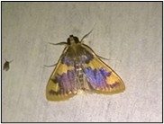 | 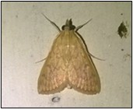 | 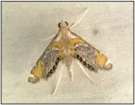 | 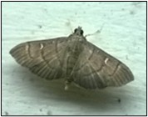 | 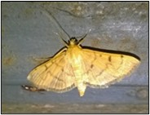
15. Maruca vitrata  (Fabricius, 1787) | 16. Sameodes cancellalis (Zeller, 1852) | 17. Rehimena phrynealis  (Walker, 1859) | 18. Paliga ochrealis (Moore,1886) | 19. Nymphicula blandialis  (Walker, 1855) | 20. Pramadea lunalis (Guenée, 1854) | 21.Omiodes indicata  (Fabricius, 1775)
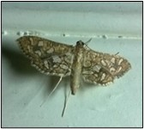 | 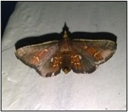 | 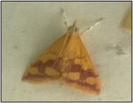 | 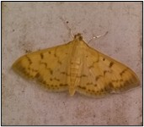 | 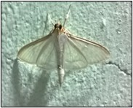 | 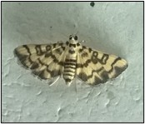 | 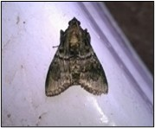
22. Nausinoe geometralis (Guenée, 1854) | 23. Syngamia falsidicalis (Walker, 1859) | 24. Pyrausta panopealis (Walker, 1859) | 25. Patania balteata (Fabricius, 1798) | 26. Palpita vitrealis (Rossi,1794) | 27. Glycythyma schrysorycta  (Meyrick, 1884) | 28. Locastra muscosalis  (Walker,1859)
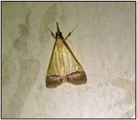 | 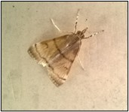 | 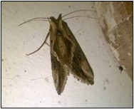 | 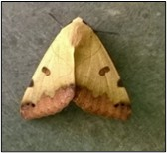 | 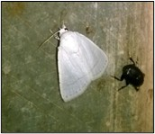 | 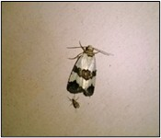 | 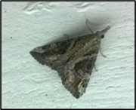
29. Autocharis fessalis (Swinhoe, 1886) | 30. Endotricha Sp. | 31. Chrysodeixis eriosoma (Doubleday, 1843) | 32. Xanthodes albago  (Fabricius, 1794) | 33. Chasmina judicata (Walker, 1858) | 34. Maliattha quadripartita  (Walker, 1865) | 35. Hypena laceratalis  (Walker,1859)
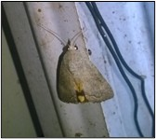 | 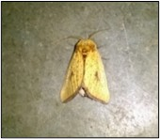 | 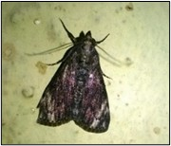 | 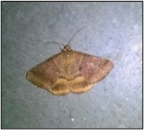 | 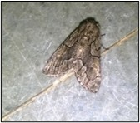 | 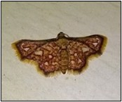 | 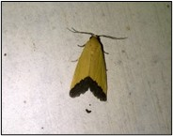
36. Hypocala deflorata  (Fabricius, 1794) | 37. Helicoverpa armigera (Hübner, 1805) | 38. Condica dolorosa (Walker, 1865) | 39. Mocis undata  (Fabricius, 1775) | 40. Bamra mundata  (Walker, 1858) | 41. Enispa rosellus (Hampson, 1893) | 42. Eustrotia marginata (Walker, 1866)
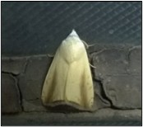 | 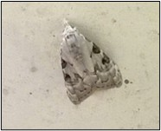 | 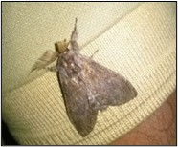 | 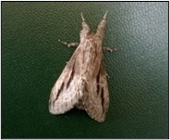 | 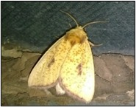 | 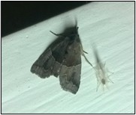 | 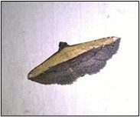
43.. Pardoxia graellsi (Feisthamel, 1837) | 44. Nola analis  (Wileman & West, 1928) | 45. Netria spp.  (Walker, 1855) | 46. Syntypistis perdix  (Moore, 1879) | 47. Antheua servula  (Drury,1773) | 48. Bastilla simillima (Guenee, 1852) | 49. Ataboruza divisa  (Walker, 1862)
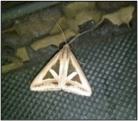 | 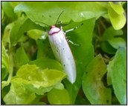 | 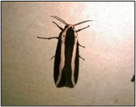 | 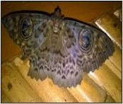 | 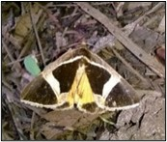 | 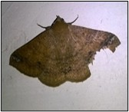 | 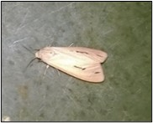
50. Trigonodes hyppasia  (Cramer, 1779) | 51. Aloa lactinea  (Cramer, 1777) | 52. Rajendra biguttata  (Walker, 1855) | 53. Erebus macrops (Linnaeus, 1770) | 54. Fodina stola  (Guenée, 1852) | 55. Ericeia inangulata (Guenée, 1852) | 56. Creatonotos transiens  (sWalker, 1855)
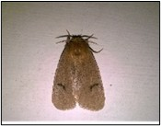 | 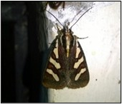 | 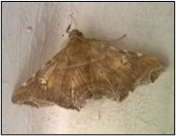 | 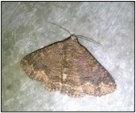 | 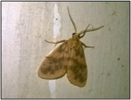 | 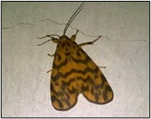 | 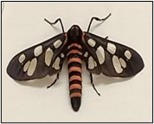
57. Spilarctia sp. | 58. Aegocera bimacula (Walker, 1854) | 60. Episparis liturata (Fabricus,1787) | 60. Pericyma sp. | 61. Miltochrista rubricosa  (Moore, 1878) | 62. Nepita conferta  (Walker, 1854) | 63. Amata passalis  (Fabricius, 1781)
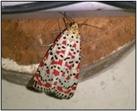 | 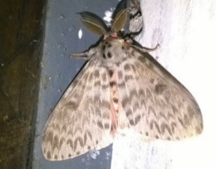 | 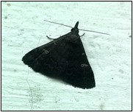 | 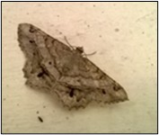 | 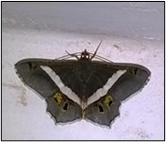 | 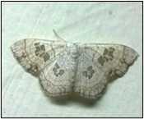 | 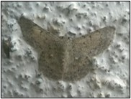
64. Utetheisa pulchella (Linnaeus, 1758) | 65. Lymantria grandis  (Walker, 1855) | 66. Nodaria externalis  (Guenée, 1854) | 67. Chiasmia hebesata (Walker, 1861) | 68. Chiasmia Eleonora (Cramer, 1780) | 69. Scopula cuneilinea (Walker,1863) | 70. Pingasa chlora  (Stoll, 1782)
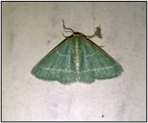 | 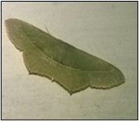 | 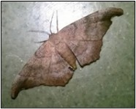 | 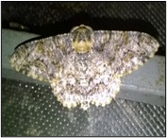 | 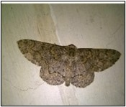 | 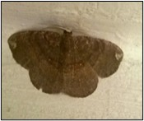 | 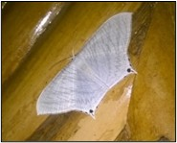
71. Thalassodes dissita (Walker, 1861) | 72. Traminda mundissima (Walker, 1861) | 73. Hyposidra talaca  (Walker, 1860) | 74. Boarmiini-genera spp. | 75. Gymnoscelis deleta (Hampson, 1891) | 76. Astygisa hollowayi (Stüning & Walia, 2009) | 77. Micronia aculeata  (Guenée, 1857)
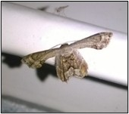 | 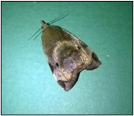 | 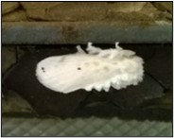 | 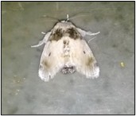 | 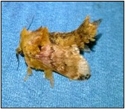 | 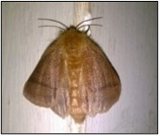 | 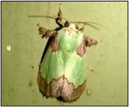
78. Phazaca theclata  (Guenée, 1857) | 79. Hyblaea puera (Cramer, 1777) | 80 Altha subnotata (Walker, 1865) | 81. Altha nivea  (Walker, 1862) | 82. Cheromettia apicata  (Moore, 1879) | 83. Cania sp. | 84. Parasa lepida  (Cramer, 1799)
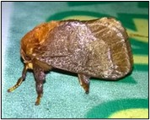 | 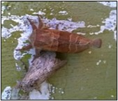 | 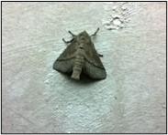 | 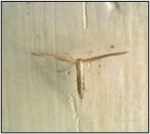 | 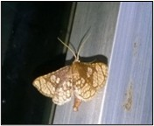 | 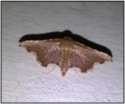 | 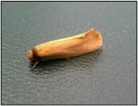
85. Miresa argentifera (Walker, 1855). | 86. Thosea spp.  (Walker, 1855) | 87. Thosea spp. 2 | 88. Emmelina monodactyla  (Linnaeus, 1758) | 89. Rhodoneura spp. | 90. Hypolamprus sp. | 91. Edosa sp.  (Walker, 1886)
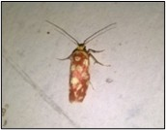
92. Anticrates spp. Nr. eulima
(Meyrick, 1905)

References

- Benton, T. G. (1995). Biodiversity and biogeography of Henderson Island's insects. Biological journal of the Linnean Society, 56(1-2), 245-259.
- Chandra, K., & Nema, D. K. (2007). Faunal diversity of moths in Madhya Pradesh. Zoological Survey of India Records.
- Gurule, S. A., & Nikam, S. M. (2011b). Inventory of lepidopterous insects in survey for moth diversity. Flora, 17(1pp), 165-174.
- Gurule, S. A., & Nikam, S. M. (2013). The moths (Lepidoptera: Heterocera) of northern Maharashtra: A preliminary checklist. Journal of Threatened Taxa, 5(12), 4693–4713.
- Gurule, S. A., Nikam, S. M., & Borse, V. B. (2011a). Faunastic studies on macro moth (Lepidoptera: Noctuoidea) from North Maharashtra. In Proceedings of International conference on Biodiversity and its Conservation (pp. 1-16).
- Gurule, S. A., Nikam, S. M., Kharat, A. J., & Gangurde, J. H. (2010). Check-list of owlet and underwing moth (Lepidoptera: Noctuidae) from Nashik district, (MS) India, Flora & Fauna an Int. Jour. Biol. Sci., 16(2): 295-304.
- Gurule, S.A. (2013a). Taxonomic study of Moths (Lepidoptera: Heterocera) from north Maharashtra, India. Ph.D. thesis submitted to Savitribai Phule Pune University, Pune, 250 pp. https://shodhganga.inflibnet.ac.in/handle/10603/98571.
- Hampson, G.F. (1892). The Fauna of British India including Ceylon and Burma, Moths - volume 1. Taylor and Francis, London, 527pp.
- Kathirvelu, C., Ayyasamy, R., & Karthikeyan, M. (2019). Preliminary checklist of moths (Lepidoptera: Glossata) of Annamalai Nagar, Tamil Nadu. Journal of Applied and Natural Science, 11(2).
- Kristensen, N. P., Scoble, M. J., & Karsholt, O. (2007). Lepidoptera phylogeny and systematics: The state of inventorying moth and butterfly diversity. Zootaxa, 1668(1), 699–747.
- Pawar, P. R., Supnekar, S. P., Meshram, L. N., Pawar, N. B., & Rokade, A. G. (2021). Checklist of moth fauna (Lepidoptera: Heterocera) from Panvel, Navi Mumbai, Maharashtra, West Coast of India. Uttar Pradesh Journal of Zoology, 42(13), 11-21.
- Maharashtra, West Coast of India. Uttar Pradesh Journal of Zoology, 42(13), 11–21.
- Shah, S. K., & Mitra, B. (2015). Moth (Insecta: Lepidoptera) fauna and their insect predators associated with tea gardens and surrounding ecosystems in Northern West Bengal, India. Journal of Zoology Studies, 2(6), 1–5.
- Shubhalaxmi, V. (2018). Birdwing field guide to Indian moths. Birdwing Publishers.
- Shubhalaxmi, V., Kendrick, R., Vaidya, A., Kalagi, N., & Bhagwat, A. (2011). Inventory of moth fauna of the Western Ghats, India. Journal of Threatened Taxa.
- Singh, N., Ahmad, J., & Joshi, R. (2014). Diversity of moth fauna in North India. Journal of Entomology and Zoology Studies.
- Uniyal, V. P., Dey, P., & Sanyal, A. K. (2016). Diversity of moths Lepidoptera: Heterocera) and their potential role as a conservation tool in different protected areas of Uttarakhand. Wildlife Institute of India, Dehradun (DST Project Completion Report), 117.

