Original Research Article
ICHTHYODIVERSITY OF SICHI RIVER, UNDER KOYU CIRCLE, LOWER SIANG DISTRICT, ARUNACHAL PARDESH, INDIA

ABSTRACT
A survey and documentation on ichthyofaunal diversity was undertaken from April 2024 to December 2025 in the Sichi river, under the Koyu circle of Lower Siang district, Arunachal Pradesh, India. With the help of local fishermen, sampling of specimens was done along the length of the river randomly from time to time using available local fishing gear and techniques. A total of 36 species of fish were recorded, belonging to 14 families and 5 orders, and 30 genera, respectively. As per the IUCN conservation category, out of 36 species, 1 species comes under the category of Endangered (EN), 3 species are under the Vulnerable (VU) category, 5 species are under the Near Threatened (NT) category, 1 species is under the Data Deficient (DD) category and the remaining 5 species are under the Not Evaluated (NE) category. The study also revealed that most of the fish species recorded from the river are of high food value, recreational/sport fishing value, and ornamental value. The present study also revealed the fish population of the river has been declining alarmingly in last the decade, which warrants proper conservation measures in this direction.
Key words: ichthyodiversity, Sichi river, Arunachal Pradesh
- INTRODUCTION
Arunachal Pradesh, a part of the eastern Himalaya, is situated on the extreme north-eastern tip of the union of India, lying between 26˚ 28′ to 29˚30′ north latitude and 90˚ 31′ to 97˚ 30′ East longitude, covering an area of 83,743 sq. km. The state has a well defined drainage system with numerous rivers and rivulets forming diverse and potential habitats for rich ichthyofaunal resources. The major drainage systems of the state comprise the Kameng, the Subansiri, the Lohit, the Siang and the Tirap.
The eastern Himalayan region of India has been identified as one of the 18th mega biodiversity hotspot areas of the world by Myers et al. (2000). The region is endowed with rich floral and faunal genetic diversity with a high degree of endemism. Moreover, the biodiversity of the region is also highly threatened. Kottelat (1989) observed that the high diversity of the region is attributed to the recent geological history and the Himalayan orogeny, which played an important role in the speciation and evolution of groups inhabiting mountain streams. The lotic and lentic water bodies of the northeastern region of India harbor rich ichthyofaunal diversity. Sen (2000) recorded a total of 267 fish species from Assam and its neighboring states. Vishwanath et al. (2007) reported 396 different fish species from the region. Sarkar and Pooniah (2000), in a separate study, reported a total of 186 species from the region, of which 62 species were identified as endemic to this region, while 53 species were identified as ornamental valued fish. Vishwanath (2021) also conducted an extensive study on the freshwater fishes of the eastern Himalayas and recorded 512 fish species under 128 genera and 40 families. While reviewing the ichthyofaunal diversity and distribution of northeast India, Sarma et al. (2022) also recorded 512 fish species from the NE region.
Many studies have been done on the ichthyofaunal diversity of Arunachal Pradesh. The first comprehensive attempt at the study of ichthyofaunal diversity of Arunachal Pradesh was done by Nath & Dey (2000), where they reported a total of 131 fish species from the state. While compiling the checklist of ichthyofauna of Arunachal Pradesh, Bagra et al. (2009) reported a total of 216 fish species, and Gurumayum et al. (2016) reported a massive 259 species of fishes from water bodies of the state. Darshan et al. (2019) listed a total of 213 species based on field surveys and available literature. Besides these, lots of work was done on ichthyofaunal bioresources of rivers of Arunachal Pradesh, viz. Datta & Barman (1985) recorded 28 species from the Namdhapha National Park, Tirap; Sen (1999) surveyed & reported a total of 52 fish species from Subansiri, East and West Siang district; Tamang et al.(2007) recorded 47 species from the Sinkhi river. Bagra & Das (2010) reported a total of 44 fish species from the Siyom river of the West Siang district. Das et al.(2015) reported 82 species from river Siang; Sinha & Tamang (2015) reported 121 species of fish from East Siang district; Taro & Kadu (2018) reported 21 fish species from Sille river of East Siang; Loyi et al. (2018) reported a total of 38 species of fish from Tengapani Rivers Namsai; Gurumayum (2021) recorded 75 fish species from the Poma river; Satpathy (2021) reported 26 species from the Subansisri river of Upper Subansisri district; Sinha (2022) recorded 47 fish species from water bodies of Anjaw district; Taro et al.(2022) reported a 37 different fish species Senkhi stream at Itanagar; Tayeng et al.(2025) recorded a total of 54 species from Sirum river of East Siang district.
Despite such extensive research work on the ichthyofaunal bioresources of the state, there are still numerous lotic and lentic water bodies that are yet to be explored in the context of scientific exploration and documentation of available fish species. The Sichi river is one of such lentic water bodies which is endowed with a high diversity of fish species, where no scientific exploration and documentation has been done till today. The present study is being undertaken to fill up the research gap in the compiling of a complete checklist of fishes of Arunachal Pradesh so that the generated database on fishery resources of the river may be utilized by the various stakeholders, researchers, planning and management, and in designing an effective sustainable biodiversity conservation strategy.
- MATERIALS AND METHODS
The river Sichi (Figure 1) is one of the main tributaries of the Singen river of the Upper Ramle Bango area in Lower Siang district of Arunachal Pradesh, which ultimately drain off its contents into mighty Brahmaputra. It originated near the southern part of Leparada district of Arunachal Pradesh. No village or human settlement is recorded on both banks of the river. However, lots of agricultural and horticultural activities were seen on left bank of the river. In recent years, lots of illegal logging has also been reported from the upper catchment area of the river.
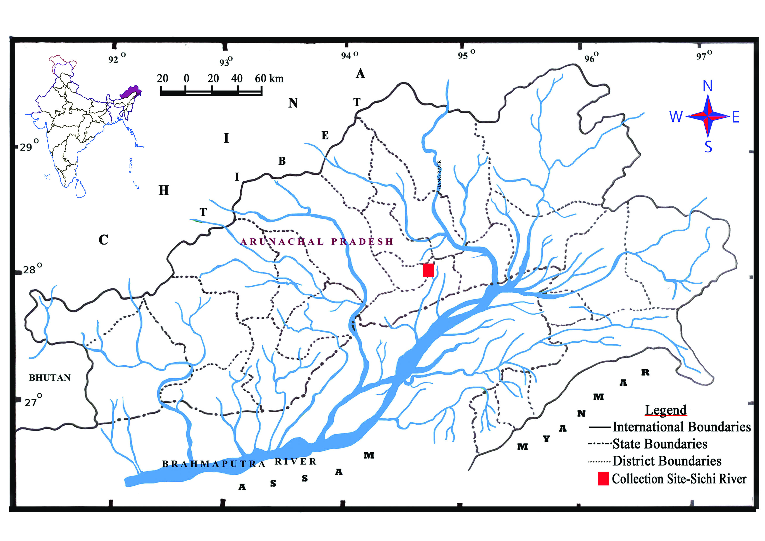
To investigate the ichthyofaunal diversity of the Sichi river, a random sampling was conducted along the Sichi river (Figure 2) from April 2024 to December 2025. Sampling of fish was made using locally available fishing gear and techniques viz. cast net, gill net, hooks, Lipum, Hibok, Takom, Riib dinam etc. The collected fish specimens were directly put into 5-8% formalin, and then it was transported to the laboratory at the Department of Zoology, Jawaharlal Nehru College, Pasighat. The fish specimens were properly sorted and identified using standard literature (Talwar & Jhingran 1991; Jayaram 1999; Nath & Dey 2000; Kottelat 2001; Jayaram 2006; Darshan et al. 2019, Vishwanath 2021). All the sorted and identified fish specimens were preserved in 10% formalin, labelled, registered, and deposited in the Jawaharlal Nehru College Museum of Fishes (JNCMF), Department of Zoology, Jawaharlal Nehru College, Pasighat, for future reference. The conservation status of each species was confirmed following the IUCN Red List of Threatened Species Version 2024-2 (https:// www.iucnredlist.org). The latest valid scientific names, families, and orders of the fish species were confirmed following Eschmeyer’s Catalogue of Fishes (Fricke et al. 2025).Each representative fish species was photographed for future photographic documentation.

Figure1. Map Showing study area (Sichi river)
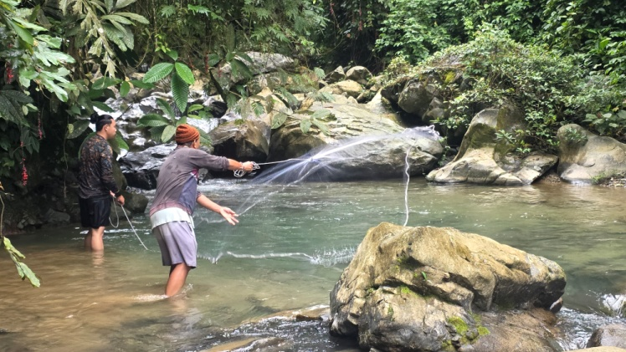
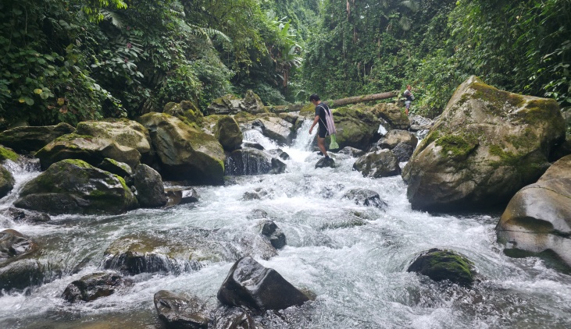

Figure 2. View of sampling site, Sichi river

- RESULT
A total of 36 fish species were recorded, which belong to 14 families and 5 orders and under 30 genera, from the Sichi river of Upper Ramle Banggo, Lower Siang District, Arunachal Pradesh, India (Table 1). The order Cypriniformes represents the highest diversity with 24 species, with 6 families representing the order. While the order Siluriformes was represented by 8 species in 4 families and Perciformes was represented by 2 families with 1 species each. Anguiliformes and Synbranchiformes were represented by a single species under a single family and a single genus. Among the families, Cyprinidae was found to be the dominant group, represented by 13 species, followed by Danionidae with 5 species and followed by Sisoridae with 4 species. Bagridae, Balitoridae and Nemacheilidae were represented by 2 species each. However, the families Anguillidae, Batiidae, Cobitidae, Siluriade, Amblyceptidae, Badidae, Channidae and Mastacembelidae were represented by single species each. Most of the fishes of the Sichi river (21 species) are under the conservation category of Least Concerned (LC) as per the assessment criteria of the International Union for Conservation of Nature and Natural Resources (IUCN) (Table 1). Among them, only one species comes under the Endangered (EN) category, three species are under the Vulnerable (VU) category, five species are under the Near Threatened (NT) category, one species is under the Data deficient (DD) category, whereas the remaining five species are under the Not Evaluated (NE) category. The present study also revealed 29 fish species recorded from the river are of high ornamental value.

Table 1. Systematic checklist of fishes of Sichi river, Upper Ramle Banggo,Lower Siang District, Arunachal Pradesh India.
Sl.no | Order | Family | Scientific name | IUCN Status
1 | Anguilliformes | Anguillidae | Anguilla bengalensis (Gray) | NT
2 | Cypriniformes | Danionidae | Opsarius barna (Hamilton)* | LC
3 |  |  | Opsarius bendelisis(Hamilton) * | LC
4 |  |  | Devario aequipinnatus (McClelland) * | LC
5 |  |  | Devario devario (Hamilton) * | LC
6 |  |  | Danio dangila (Hamilton) * | LC
7 |  | Cyprinidae | Puntius chola (Hamilton) * | LC
8 |  |  | Puntius sophore (Hamilton) * | LC
9 |  |  | Cyprinion semiplotum (McClelland) * | VU
10 |  |  | Tariqilabeo latius (Hamilton) * | LC
11 |  |  | Chagunius chagunio Hamilton | LC
12 |  |  | Garra gotyla (Gray) * | LC
13 |  |  | Garra annandalei Hora* | NE
14 |  |  | Garra lissorhynchus(McClelland) * | LC
15 |  |  | Garra arupii Nebeshwar, Vishwanath & Das* | NE
16 |  |  | Labeo pangusia (Hamilton) | NT
17 |  |  | Neolissochilus hexagonolepis (McClelland) | NT
18 |  |  | Tor putitora (Hamilton) | EN
19 |  |  | Schizothorax richardsonii (Gray) | VU
20 |  | Balitoridae | Balitora brucei Gray* | NT
21 |  |  | Paracanthocobitis botia (Hamilton) * | LC
22 |  | Nemacheilidae | Aborichthys elongatus Hora* | LC
23 |  |  | Mustura daral Rameshori,Chinglemba, Darshan & Vishwanath* | NE
24 |  | Batiidae | Botia rostrata Gunther * | VU
25 |  | Cobitidae | Lepidocephalichthys guntea (Hamilton) * | LC
26 | Siluriformes | Bagridae | Batasio fasciolatus Ng * | LC
27 |  |  | Olyra longicaudata McClelland * | LC
28 |  | Siluridae | Pterocryptis gangelica Peters | DD
29 |  | Amblycepitidae | Amblyceps apangi Nath& Dey* | LC
30 |  | Sisoridae | Glyptothorax cavia (Hamilton) * | LC
31 |  |  | Pseudochenis sulcatus (McClelland) * | LC
32 |  |  | Exostoma tenuicaudatum Tamang, Sinha & Gurumayum * | NE
33 |  |  | Ompok pabo(Hamilton) * | NT
34 | Perciformes | Badidae | Badis singenensis Geetakumari &Kadu (Hamilton) * | NE
35 |  | Channidae | Channa gachua (Hamilton) (Hamilton) * | LC
36 | Synbranchiformes | Mastacembelidae | Mastacembelus armatus (Lacepede) (Hamilton) * | LC
EN: Endangered; VU: Vulnerable; NT: Near Threatened; LC: Least Concerned; DD: Data Deficient; NE : Not Evaluated
* indicates the ornamental fish species reported from the Sichi river

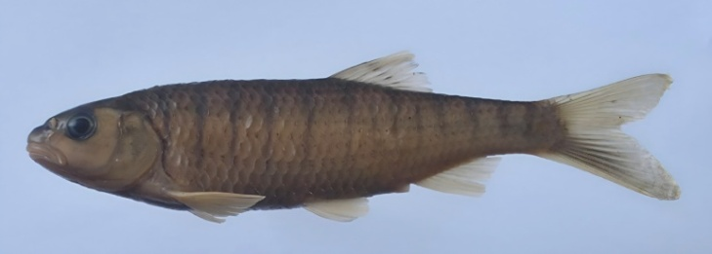
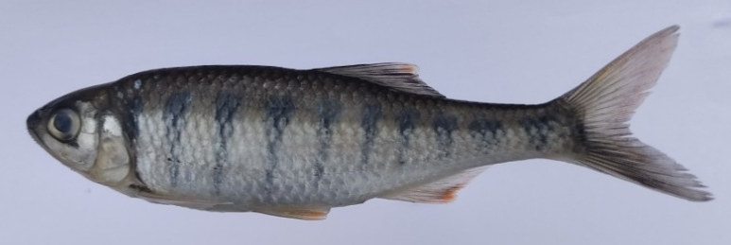

ii. Opsarius bendelisis
i.Opsarius barna
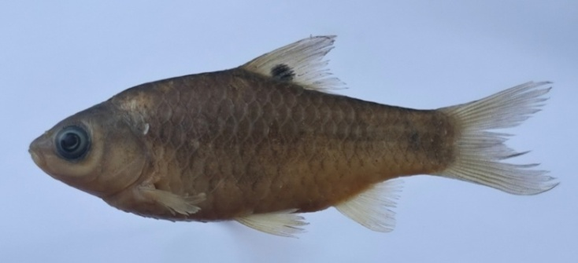
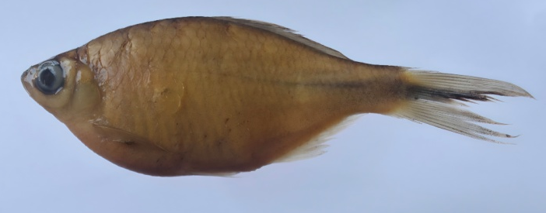

iv. Puntius chola
iii. Devario devario
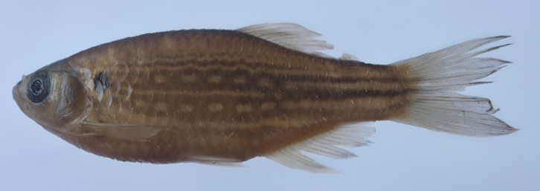
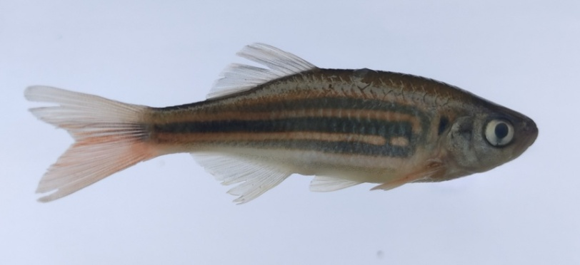

vi. Danio dangila
v. Devario aequipinnatus
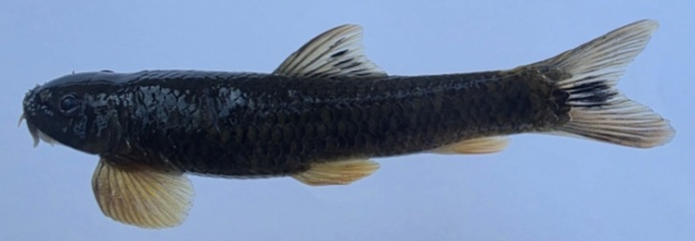
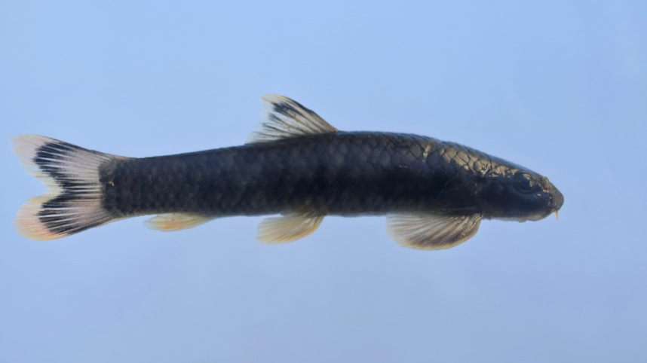

viii. Garra arupi
vii. Garra lissorhynchus

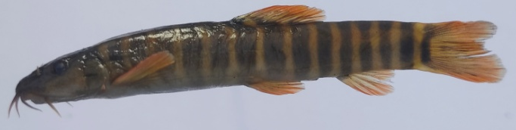
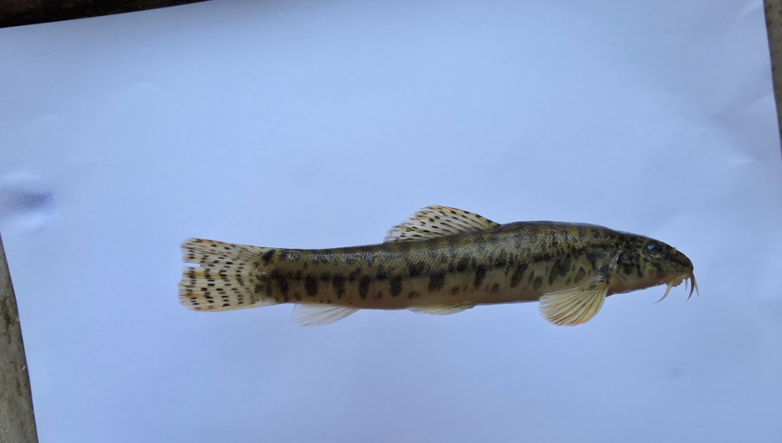
x. Paracanthocobitis botia
ix. Mustura daral
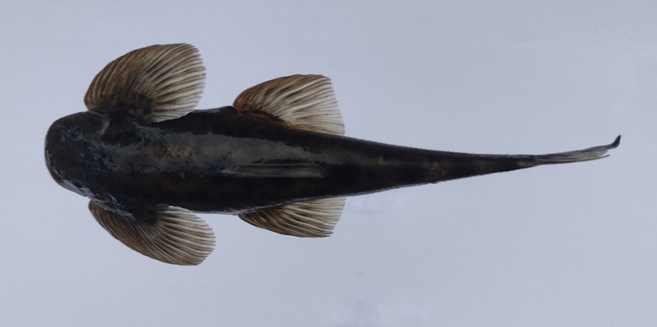
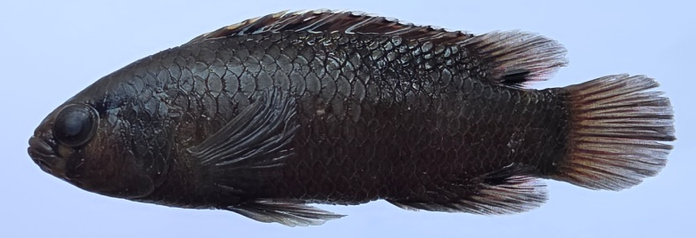

xii. Balitora brucei
xi. Badis singenensis

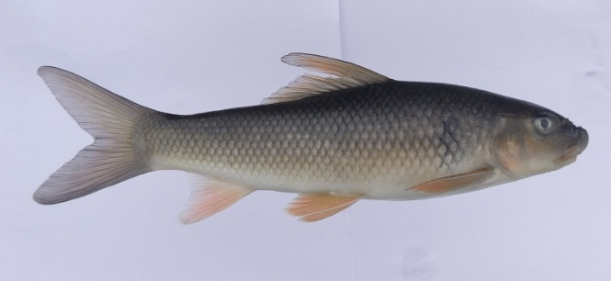
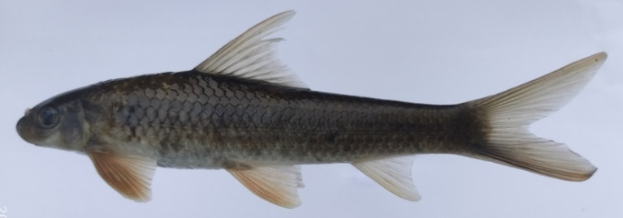

xiv. Labeo pangusia
xiii. Tarilabeo latius
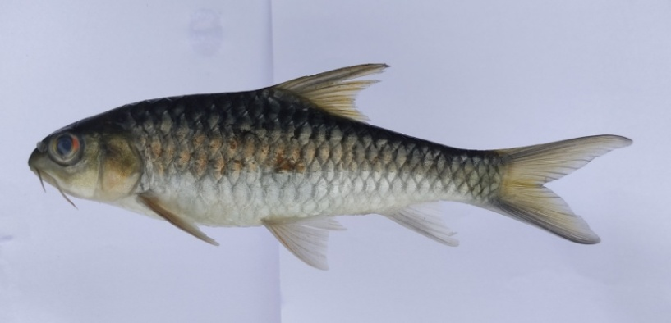
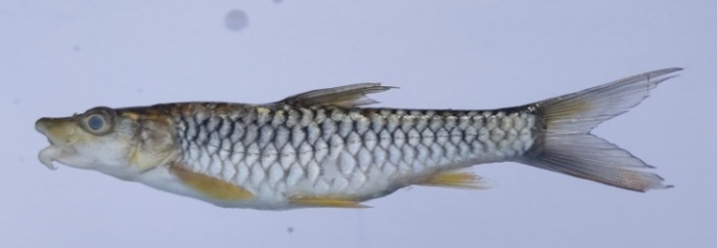

xvi. Tor putitora
xv. Neolissochilus hexagonolepis
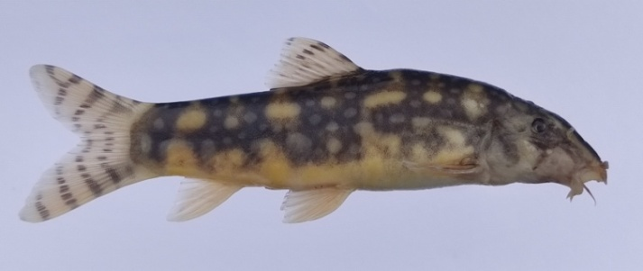
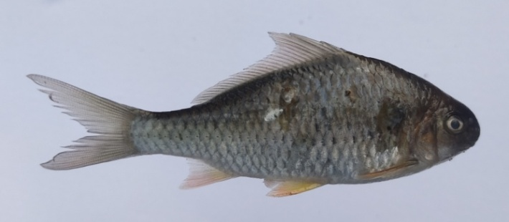

xviii. Botia rostrata
xvii. Cyprinion semiplotum
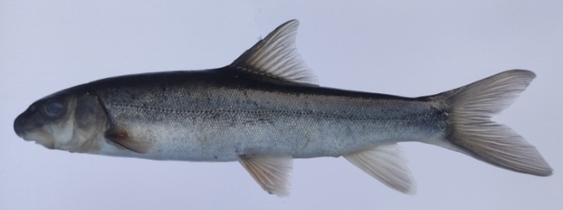
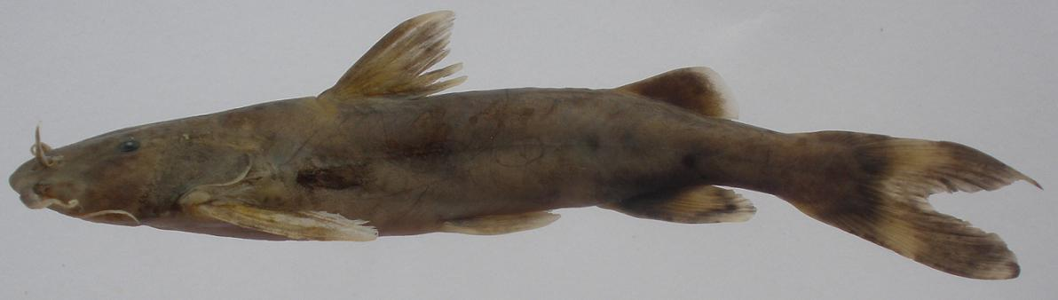

xx. Schizothorax richardsonii
xix. Glyptothorax cavia
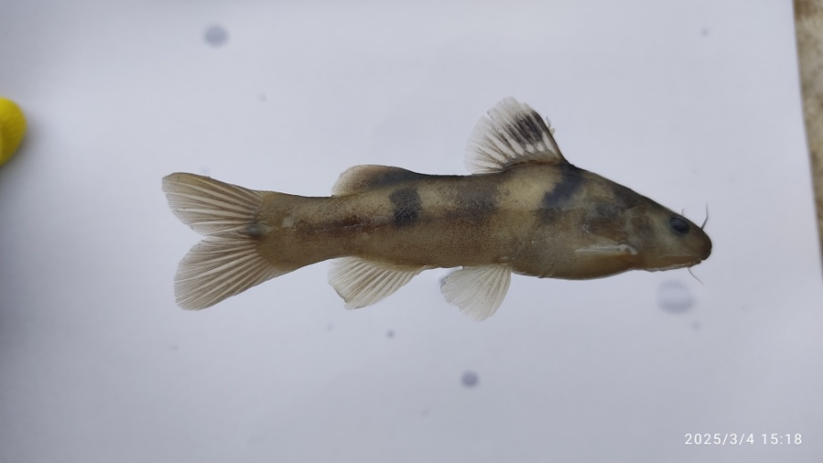
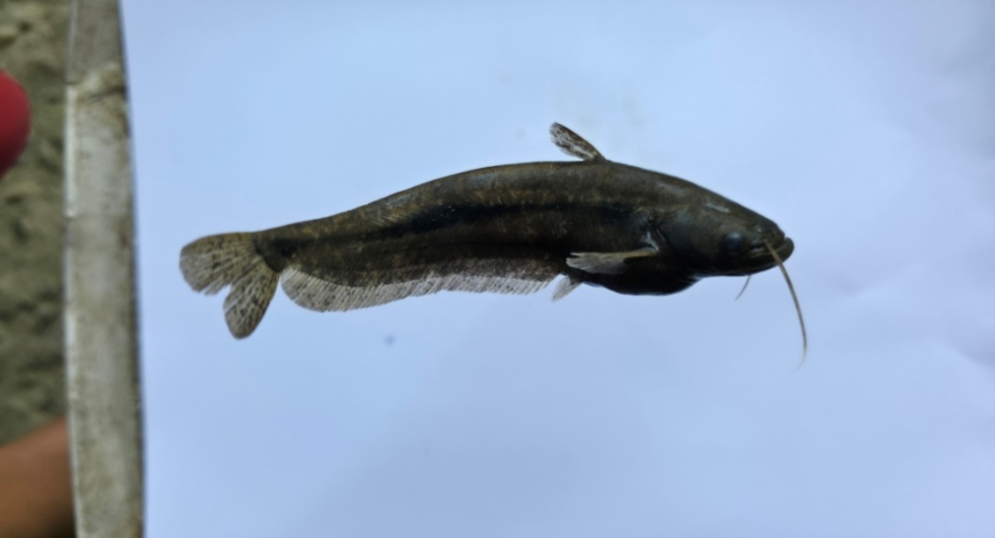

xxi. Ompok pabo
xxii. Batasio fasciolatus
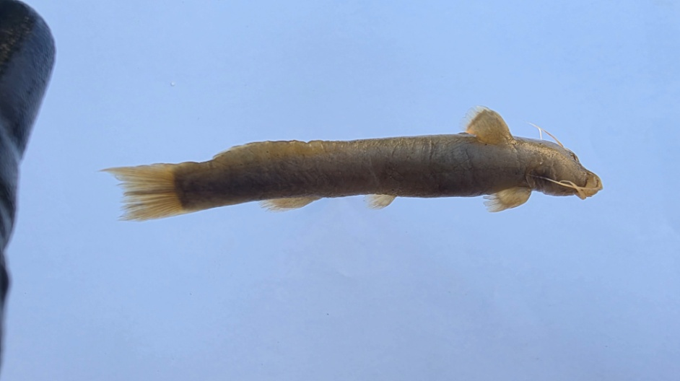
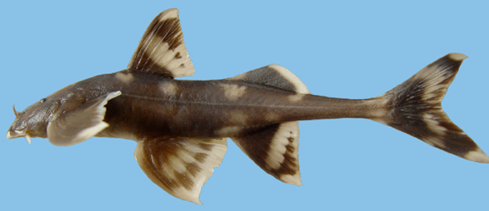

xxiii. Amblyceps apangi
xxiv. Pseudecheneis sulcata

Figure 3. Photographs of important food, game, and ornamental fish species recorded from the Sichi River.
- DISCUSSION
The results of the present study of the ichthyofaunal diversity of the Sichi river revealed a total of 36 fish species under 30 genera, 14 families and 5 orders. The order Cypriniformes represents the highest diversity with 24 species, followed by Siluriformes with 8 species and Perciformes with 2 species. While the orders Anguiliformes and Synbranchiformes were represented by a single species each. Among the families, Cyprinidae was found to be the dominant group, represented by 13 species, which are followed by Danionidae with 5 species and Sisoridae with 4 species. Balitoridae, Bagridae and Nemacheilidae were represented by 2 species. However, Anguillidae, Batiidae, Cobitidae, Siluriade, Amblyciptidae, Badidae, Channidae and Mastacembelidae were represented by 1 species each.
The maximum recorded fishes (21 species) of the Sichi river are under the Least Concerned (LC) conservation category as per the assessment criteria of the International Union for Conservation of Nature and Natural Resources (IUCN). Among them, only one species, Tor putitora, comes under the Endangered (EN) category, whereas three species, viz. C.semiplotum, S.richardsonii & B.rostrata are under the Vulnerable (VU) category. The 4 species, namely A.bengalensis, L.pangusia, N.hexagonolepis, O.pabo and B.brucei, fall under the category of Near Threatened (NT). Only one species (P. gangelica) is under the category of Data Deficient (DD), whereas the remaining 5 species, such as G.annandalei, G.arupii,M.daral, E. tenuicaudatum & B.singenensis are in the category of Not Evaluated (NE). The most common species distributed in the study area were T.latius, A.hexagonolepis & G.gotyla. Similarly, the rare species of the river were B.brucei and E. tenuicaudatum. Whereas species like S.richardsonii, L.pangusea & E.tenuicaudatum were encountered only in the upper reaches of the river at higher altitudes. A. bengalensis was encountered in a deep shallow/pool type with rocky substrate. Species like B.singenensis, B.fasciolatus, P.botia, P.sophore, P.chola, O.barna, and D.devario were encountered from the lower portion of the river near the confluence area of River Singen/Hingen.
Most of the fish species recorded from the river have an economic value as food, recreational value and ornamental value. Fishes like Tariqilabeo latius, Garra Gotyla, Labeo pangusia, Cyprinion semiplotum and Mastacembelus armatus have good food value, while some of the fish species, viz. Tor putitora and Neolissochilus hexagonolepis are exceptionally preferred for recreational fishing/angling activities. The study also revealed that most of the reported fish species from the Sichi river are beautifully coloured and have the potential to be included in an ornamental fish list. Out of 36 recorded fish species, a total of 29 of them are ornamental value fish. Abujam et al. (2021) also recorded a total of 52 ornamental fish species under 6 orders and 15 families while studying the trade potential of indigenous ornamental fishes of Arunachal Pradesh. Despite rich ichthyofaunal bioresources, the fishery resources of the river have never been explored maybe because of its remoteness or inaccessibility, except a little work has been done on the Singen river such as Geetakumari & Kadu (2011) describing a new species, Badis singenensis from Singen river; Kadu & Das (2011) recorded Conta conta from Singen River for the first time from state.
The present study also revealed that the fish population in the Sichi River has been gradually decreasing in the last few years, as per information gathered from local people of Kadu, Rote & Koyu villages under Koyu circle. This rapid decline of the fish population of the river might be due to over exploitation of fishery resources and engagement in illegal and destructive fishing such as electrofishing and dynamiting in the river. Apart from these, illegal logging activities were also reported from the upper riparian reaches of the Sichi river. Keeping in view such illegal activities and to control the rapid decline of fish populations in the river, local bodies and administration issued prohibitory orders for illegal fishing and hunting in their jurisdiction for conservation.
- CONCLUSION
Despite various exploratory works done on the documentation of fishes from lotic and lentic water bodies of Arunachal Pradesh, there are still a number of unexplored important rivers and rivulets in the state. Sichi is one among those unexplored rivers in the context of scientific documentation of fishery resources. The present study reveals that the river is endowed with rich ichthyofaunal diversity (36 species). Sarma et al. (2022) also emphasize the exploration of fish fauna of the major river systems of North East India at regular intervals to build a comparable database that might be utilized by the stakeholders, researchers, planning and management. It is also revealed from the present study that the river has a rich potential in fishes of ornamental, recreational/sport and food value. From the present study, it is also evident that though the river harbours high species diversity, the fish population of the river has been declining rapidly in recent decades. Maintaining fish diversity is important because it is not easy to identify the aquatic ecosystem sustainability of every species (Das et al. 2015). So, a proper conservation strategy is needed in this direction to maintain the diversity and population of fish in the river.
DISCLAIMER (aRTIFICIAL INTELEGENCE)

Author is hereby declare that no generative AI technologies such as Large Language Models (ChatGPT, COPILOT, etc) and text-to-image generators have been used during witting or editing of this manuscript.

REFERENCES

Abujam, S., Tamang, L., Nimasow, G. & Das, D.N. (2021). Trade Potential of Indigenous Ornamental Fishes of Arunachal Pradesh, India. Asian Fisheries Science 34:312–325. https://doi.org/10.33997/j.afs.2021.34.4.004
Bagra, K., Kadu, K., Nebeshwar, K., Laskar, B.A., Sarkar, U.K. & Das, D.N. (2009). Ichthyological survey and review of the checklist of fish fauna of Arunachal Pradesh, India. Check List. 5(2):330-350. https://doi.org/10.15560/5.2.330.
Bagra, K. & Das, D.N. (2010). Fish diversity of Siyom river of Arunachal Pradesh, India: A Case Study. Our nature, 8:164-169. https://doi.org/10.3126/on.v8i81.4324
Das, B.K., Boruah, P., & Kar, D. (2015). Icthyofaunal Diversity of Siang River in Arunachal Pradesh, India. Proceedings of the Zoological Society. 70:52-60. https://doi.org/10.1007/s12595-05-0155-6
Darshan, A., Abujam, S. & Das, D.N. (2019). Biodiversity of fishes in Arunachal Himalayas. Systematic, Classification and Taxonomic identification. Academic press. 270 p. https://www.elsevier.com/books/biodiversity-of-fishes-in-arunachal-himalaya/singh/978-0-12-815556-1.
Datta, A.K. & Barman, R.P. (1985). Fauna of Namdapha, Arunachal Pradesh (Pisces). Rec. Zool. Surv. India,8 (1-4): 275-284.
Fricke, R., Eschmeyer, W.N. & Van der Laan, R. (eds.) (2025). Eschmeyer’s Catalog of Fishes: genera, species, references.http://researcharchive.calacademy.org/research/ichthyology/catalog/ fshcatmain.asp. Accessed on 04.02.2026.
Geetakumari, K. & Kadu, K. (2011). Badis singenensis, a new species (Teleostei: Badidae) from Singen river, Arunachal Pradesh, Northeast India. Journal of Threatened Taxa, 3(9): 2085-2089. https://doi.org/10.11609/JoTT.o2531.2085-9.
Gurumayum, S.D, Kosygin, L. & Tamang, L. (2016). Ichthyofaunal diversity of Arunachal Pradesh, India: A part of Himalaya biodiversity hotspot. International journal of fisheries and aquatic Studies, 4(2): 337-346. https://www.fisheriesjournal.com/archives/2016/vol4issue2/PartE/4-1-71.pdf
Gurumayum, S.D. (2021). A preliminary report on fish diversity of Poma river and its tributaries, Arunachal Pradesh, India. International Journal of Fisheries and Aquatic Studies 2021; 9(2): 158-162. https://doi.org/10.22271/fish.2021.v9.i2c.2437
IUCN (2025). The IUCN Red List of Threatened Species. Version 2024-2. https://www.iucnredlist.org>. Accessed on 13.iii.2025.
Jayaram, K.C. (1981). The freshwater fishes of India, Pakistan, Bangladesh, Burma and Sri Lanka- A handbook, Calcutta, Zoological Survey of India. Xxii+175 p.
Jayaram, K.C. (1999). The freshwater fishes of Indian region. Narendra Publishing House, New Delhi. xv +385, pl.11.
Jayaram, K.C. (2006). Catfishes of India. Narendra Publishing House, New Delhi. xxvii+551p. pl.18.
Kadu, K. & Das, D.N. (2011). New record of freshwater erithistid catfish Conta conta (Hamilton, 1822) (Teleostei: Erethistidae) from Arunachal Pradesh (Biodiversity hotspot), India. The Bioscan, 6(3): 413-416. https://thebioscan.com/index.php/pub/article/view/1852.
Kottelat,M. (1989). Zoogeography of the fishes from IndoChinese inland waters with an annoted checklist. Bulletine Zoologish Museum, 12(1):1-54.
Kottelat, M. (2001) Fishes of Laos. Cambodia. Wildlife Heritage Trust, Publication.198 p.

Loyi, R., Chowtang, N.L., Tamang, L. & Das, D.N. (2018). Ichthyo-faunal diversity of Tengapani River, Namsai, Arunachal Pradesh, India. International Journal of Fisheries & Aquatic Studies. 6(5): 83-90.
Myers, N., Mittermeir, R.A., Da Fonseca, G.A.B. & Kent, J. (2000) Biodiversity Hotspot forconservation priorities. Nature, 403: 853-858.
Nath, P. & Dey, S. C. (2000). Fish and Fisheries of North Eastern India (Arunachal Pradesh), Narendra Publishing House, Dehli. xviii+ 217 p.
Sarkar, U.K., & Ponniah, A.G. (2000). Evaluation of North East Indian fishes for their potential as cultivable, sport and ornamental fishes along with their conservational and endemic status, pp. 11-30. InIn A.G. Ponniah and U.K. Sarkar (Eds), Fish biodiversity of North East India, NBFGR, NAPT, publication 2, 228p.
Sarma, K., Das, R., Bharali, R.C. & Sarma, D. (2022). A review on ichthyofaunal diversity and distribution of North East India. Indian Journal of Plant Genetic resources. 35(3):298-300. https://doi.10.5958/0976-1926.2022.00086.9
Satpathy, S., Sivakumar, K. & Johnson, J.A. (2021). Fish communities and associated habitat variables in the upper Subansiri River of Arunachal Pradesh, eastern Himalaya, India. Journal of Threatened Taxa 13(1): 17477–17486. https://doi.org/10.11609/jott.5503.13.1.17477-17486
Sen, N. (1999). On a collection of fishes from Subansiri and Siang districts of Arunachal Pradesh. Rec. Zool. Surv. India, 97(1):141-144. https://doi.org/10.26515/rzsi/v97/i1/1999/160261
Sen, N. (2000). Occurrence, distribution and status of diversified fish fauna of North Esat India, pp. 31-48. In A.G. Ponniah and U.K. Sarkar (Eds), Fish biodiversity of north east India, NBFGR, NAPT, publication 2, 228p.
Sinha, B. & Tamang, L. (2015). Ichthyofauna of East Siang district, Arunachal Pradesh, India. Rec. zool. Surv. India : 115(Part-3) : 241-253. https://10.26515/rzsi/v115/i3/2015/120709
Sinha, B., (2022). Notes on the ichthyofaunal diversity of Anjaw district in eastern Arunachal
Pradesh, India. Bulletin of Arunachal Forest Research.36 (1&2), 1–13: 202.
http://sfribulletin.org.in/vol-36-issue-1&2-2022/
Talwar, P.K., & Jhingran, A.G. (1991). Inland fishes of India and adjacent countries. Oxford and IBH, New Delhi.
Tamang, L., Chaudhry, S. & Choudhury, D. (2007): Ichthyofaunal contribution to the state and comparison of habitat contiguity on taxonomic diversity in Senkhi stream, Arunachal Pradesh, India, Bombay Natural History Society, 104 (2): 170-177.
Taro, K., & Kadu, K. (2018).Fish diversity of Sille River, East Siang, Arunachal Pradesh, India. Journal of Survey in Fisheries Science.5(10:16-19. https://doi.org/10.53555/byacdc40
Taro, K., Tamang, L. & Das, D.N. (2022). Ichthyofaunal diversity of Senkhi stream, Itanagar, Arunachal Pradesh: a comparative status between 2004–05 and 2018–19. Journal of Threatened Taxa 14(7): 21356–21367. https://doi.org/10.11609/jott.5738.14.7.21356-21367
Tayeng, O., Wangchu, L. & Das, D.N. (2025). A preliminary study of fish diversity in Sirum River of East Siang District, Arunachal Pradesh, India. Journal of Threatened Taxa 17(11): 27960–27969. https://doi.org/10.11609/jott.9814.17.11.27960-27969
Vishwanath, W., Lakra, W.S. & Sarkar, U.K. (2007). Fishes of North East India. National Bureau of Fish Genetic Resources publication, Luknow, 290 p.
Vishwanath, W. (2021). Freshwater Fishes of Eastern Himalayas. Academic Press. 411p

