Study of the Wing Venation of Housefly (Muscidae) and Flesh fly (Sarcophagidae)

Abstract:
Geometric morphometric analysis was employed to investigate wing shape and venation patterns in two forensically significant dipteran species, Musca domestica (Muscidae) and Sarcophaga SP. (Sarcophagidae). The study evaluated left-right asymmetry and minor size-shape variations in wing morphology to determine their effectiveness in distinguishing closely related taxa. Wing specimens were prepared on slides and digitized to capture landmark coordinates for morphometric analysis. Results indicate that wing venation patterns provide reliable diagnostic features for species identification and can aid in forensic entomology by improving PMI estimations. Over all the morphometric analysis showed clear interspecific differences in wing structure, supporting its application in taxonomic classification as well as medico-legal investigations.
Keywords: Morphometric analysis, flesh flies, houseflies, post-mortem interval (PMI), Wing venation.

INTRODUCTION

Wing morphology is of primary importance to entomologists interested in systematics. As evaginations of the body wall, insect wings are not homologous to avian and mammalian wings and are therefore an unparalleled adaptive feature of insects (Ross 1965). Investigations of insect wing architecture can reveal patterns in both flight performance and evolutionary history (Wootton 1990, 1992). Wing morphology, including the patterns formed by veins and cross-veins, differs among traditional taxonomic groups. Classification of insects, especially Diptera, often relies on these morphological differences. Because some entomologists believe that all insect wing-venation may be derived from a single ancestral pattern (Ross 1965; Snodgrass 1993), comparisons of venation patterns are relevant both to systematics and evolutionary biology.
Morphometric analysis of insect wings has been used to distinguish the relationship between closely related taxa (Brown and Shipp 1977; Brown and Shipp 1978) and has been applied to populations within a species. Several entomological studies have examined morphological variation in relation to genetic variation (Stalker et al., 1947).
Morphometric data for the housefly, Musca domestica (Diptera: Muscidae), with respect to geographic variation were obtained by Bryant (1977), who showed that the pattern of variation in body size increased with latitude and altitude, suggesting that environmental forces are more pronounced in fly populations at more southern locations in the U.S. Bryant and Turner (1978) reported similar geographic variations for 14 morphological traits in the housefly M. domestica.
Investigation of the influence of different temperature regimes on the development of houseflies M. domestica L. revealed a wide range of values (from
20 °C to 35 °C) causing a decrease in survival rate, adult life span, fecundity and fertility under controlled laboratory conditions. All of this indicates the adequacy of the choice of the housefly as a model object for studying phenotypic plasticity.
In forensic, medical and veterinary entomology, the identification of fly species is the first step towards using entomological data to establish evidence for estimation of the minimum post-mortem interval (PMI) in investigations of death. Traditionally, the identification of adults uses external morphological characteristics, but internal characters can also be used, particularly the male genitalia. Difficulties can arise in the case of female flies, for which identification keys are limited for groups such as the Sarcophagidae. A trained taxonomist is required to reliably infer the species identity of a specimen using morphological identification keys. However, the lack of funding and training at the tertiary level for taxonomists in general limits the availability of specialists. DNA sequence analysis complements traditional morpho-taxonomy by enabling typically reliable species identification even if only morphologically uninformative body parts are available, such as fly legs.
In principle, whole-wing image analysis allows more thorough extraction of shape variation information, thus overcoming limitations of geometric morphometrics in species identification tasks. This approach should enable good species identification since divergence between taxa is the main source of variation in wing-venation patterns, with rare and incomplete secondary convergence. Furthermore, image analysis allows the possibility of developing automated approaches for species identification, thus potentially alleviating the burden of routine species identification on professional taxonomists. However, to use this approach effectively, relatively more sophisticated data processing and analytic steps are required.
House flies (Family Muscidae), and flesh flies (Family Sarcophagidae) are generally known to have important roles in medicine. Not only do adults carry numerous pathogens (Greenberg 1971, 1973) but larvae cause myiasis in humans and animals (Zumpt 1965). In addition, flies found on human remains provide entomological evidence used in forensic investigations (Smith 1986). Ecologically, these flies inhabit not only human habitations but also peridomestic or forested environments. Many of them adapt well in several habitats ranging from urban, suburban, and rural areas to forested loci in various high altitudes. Biological information pertaining to various aspects of medically important flies is essential to devising control strategies to cope with them. Adult flies can efficiently detect food using visual and olfactory cues (Anderson 2001).
The housefly, Musca domestica L. (Diptera; Muscidae) is a synanthropic and cosmopolitan species. The geographic origin of the taxon is unclear but was probably in the Palaearctic region or the Middle East (Skidmore 1985). They subsequently colonized Europe and North America (Krafsur et al. 2000). The morphological variability of houseflies is remarkable; there is much diversity in the mechanisms of sex-determination and environmental differentiation among geographically distant housefly populations may also cause genetic differentiation (Marquez and Krafsur 2002). The housefly has an important role in disease transmission to humans and animals (Grubel 1998). It is considered to be a major pest in the livestock system (Greenberg 1973; Smith 1986). Because both the adults and sarcophagous larvae feed on faeces, vomitus and decaying animal and vegetable matter, pathogens living inside and/or on its body surface can be transmitted through mouth-secretions (Cafarchia, 2009). This causes serious diseases such as cholera, typhoid fever, bacillary dysentery, tuberculosis, anthrax, ophthalmia, amebiasis and poliomyelitis (Greenberg 1970, 1973; Sanchez-Arroyo, 2008).
The housefly is thought to be a species-complex within which three subspecies are recognized: M. domesticas.s. with a largely temperate distribution, and
M. domestica calleva Walker (1849) and M. domestica curviforceps Saccaand Rivosechi (1955) that occur in Africa. Different selection pressures such as diverse breeding substrates, insecticide usage and weather conditions have great influence on morphological and genetic variation of the housefly (Marquez and Krafsur 2002).
Insects’ wings are flattened rigid two-dimensional structures with homologous venation among individuals. Veins’ intersections provide an accurate record of a large number of useful landmarks that can easily be compared within and between samples using geometric morphometrics (Zelditch et al. 2004). The application of geometric morphometrics allows depiction of patterns of morphological variation (Bookstein 1991) and quantification of left–right differences in wing size and shape among and within individuals giving more precise assessment of asymmetry. Therefore, utilization of geometric morphometrics to depict patterns of subtle variation in wings is a powerful tool for assessment of asymmetry (Klingenberg and McIntyre 1998) as well as developmental origin of morphological integration (Klingenberg and Zaklan 2000; Klingenberg 2003b).
Species of the genus Sarcophaga have significant medical, veterinary, and forensic importance. They can act as mechanical carriers of enteropathogens in humans, cause myiasis in cattle, and aid in determining human remains and the post-mortem interval (PMI) in forensic cases. Therefore, accurate identification of flesh fly species is crucial. Despite their importance, adult Sarcophaga species are difficult to identify correctly due to their similar appearances.
As Bryant (1977) indicated, although the shape component in the housefly
M. domestica was small, it could represent a broader genetic contrast in other muscoid Diptera. Sufficient modifications in venation patterns have been detected by morphometric methods to allow species separation, as for example in recent studies of the Australian Luciliini (Brown and Shipp 1977) and Sarcophaginae (Brown and Shipp 1978).
The aim of the present study was to determine whether the representative families Muscidae and Sarcophagidae, which exhibit broadly similar wing venation patterns, can be distinguished morphometrically. By analyzing the wing shape and venation of the housefly Musca domestica and the flesh fly Sarcophaga sp. using morphometric techniques, this study seeks to evaluate the reliability of wing morphology as a diagnostic feature for differentiating closely related dipteran families.
MATERIALS AND METHODS

Specimen Collection
Fresh chicken meat was used as a substrate to collect flesh fly (Sarcophaga sp.) larvae. The meat was placed in a controlled laboratory environment at 25–32°C to allow adult female flesh flies to larviposit on the decomposing tissue. The larvae fed on the meat for four to five days and developed into third-instar larvae, approximately 16 mm in length. The larvae were then transferred to a plastic cup containing sand and exposed to sunlight, covered with a net to allow pupation. After 17 days, 15 juvenile flesh flies emerged and were captured using a hand-held net. The specimens were euthanized in ethyl alcohol and kept in the laboratory for one hour prior to further processing.
Slide Preparation
The wings of each fly were carefully removed using fine forceps. A drop of permanent mounting medium was placed on a microscope slide, and the wing was gently positioned on the drop and covered with a coverslip. Each wing was then photographed using a Nikon SMZ645 camera attached to a stereomicroscope at
100× magnification. To minimize measurement error, each wing was digitized twice. The lengths of individual wing segments were measured and recorded to assess wing size. These measurements were subsequently used for statistical analyses to evaluate both size and shape differences among the fly species.
RESULTS:
Table 1: Length (µm) and Mean Values of Flesh Fly (Sarcophaga sp.)Wing Venation
Venation | Flesh fly 1 | Flesh fly 2 | Flesh fly 3 | Flesh fly 4 | Flesh fly 5 | Flesh  fly 6 | Mean value | Standard deviation
Costa | 3546.28 | 4356.29 | 5246.29 | 4115.97 | 3127.78 | 4384.59 | 4129.53 | ±671.75
Radial fork | 925.46 | 1135.24 | 1379.46 | 1441.25 | 918.26 | 1293.35 | 1182.17 | ±206.62
Sub costa | 1509.3 | 1296.58 | 1461.55 | 2018.14 | 1373.42 | 1566.57 | 1537.60 | ±232.16
anal lobe | 691.63 | 899.67 | 640.78 | 838.57 | 120.75 | 888.64 | 680.01 | ±268.13
Second basal cell | 741.88 | 875.97 | 882.79 | 1414.25 | 319.99 | 1037.91 | 878.81 | ±327.38
Radial stem vein | 1018.06 | 1238.47 | 1080.17 | 1130.63 | 667.08 | 2385.81 | 1253.37 | ±536.47
first basal cell | 962.28 | 730.51 | 939.84 | 1037.12 | 628.78 | 1252.02 | 925.11 | ±202.77
Humoral cross vein | 631.69 | 775.99 | 749.43 | 402.57 | 120.75 | 881.11 | 593.59 | ±258.76
Table 2: Length (µm) and Mean Values of Housefly (Musca domestica) Wing Venation
Venation | House fly 1 | House fly 2 | House  fly 3 | House  fly 4 | House  fly 5 | House fly 6 | Mean value | Standard deviation
Costa | 1436.41 | 2232.44 | 2100.99 | 2454.64 | 3246.75 | 2630.03 | 2350.21 | ±548.33
Second basal cell | 369.89 | 355.66 | 281.74 | 534.68 | 582.13 | 573.3 | 449.57 | ±117.94
Radial stem vein | 516.84 | 696.5 | 334.41 | 773.61 | 959.14 | 774.92 | 675.90 | ±200.80
Radial fork | 206.68 | 871.23 | 700.34 | 983.25 | 1044.35 | 737.28 | 757.19 | ±274.85
First basal vein | 346.59 | 1014.77 | 783.82 | 661.61 | 1041.85 | 1075.66 | 820.72 | ±259.17
Sub costa | 834.19 | 664.44 | 974.14 | 828.61 | 754.88 | 655.57 | 785.30 | ±109.76
Humoral cross vein | 224.13 | 512.26 | 643.4 | 109.28 | 494.71 | 113.71 | 349.58 | ±209.35

Figure 1: Bar diagram showing the wing venation of flesh fly (Family: Sarcophagidae)

Figure 2: Bar diagram showing the wing venation pattern of a housefly (Musca domestica).

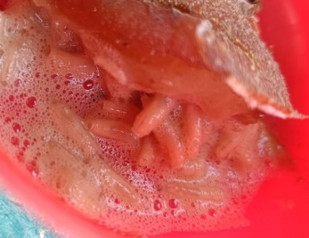
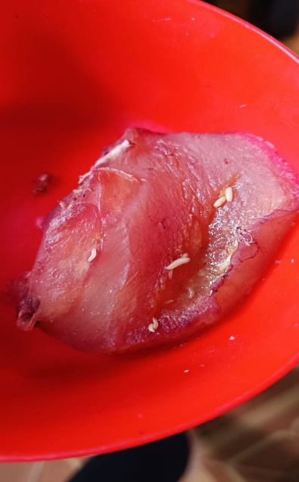
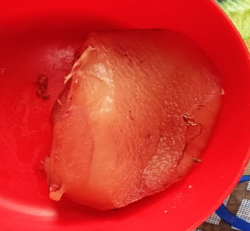
PLATES 1 : List of house flies identified in the study
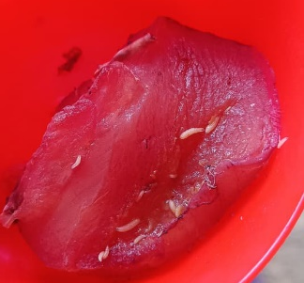
Fresh chicken meat 1st larva stage 2nd larva stage 3rd larva stage
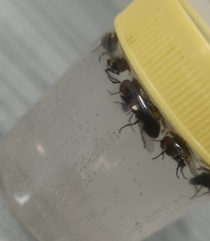
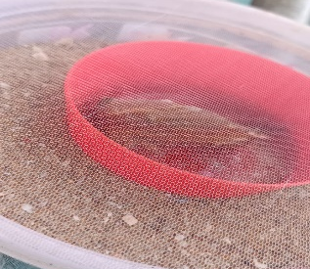
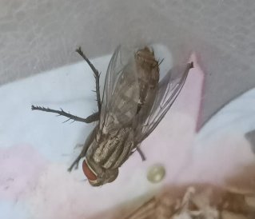
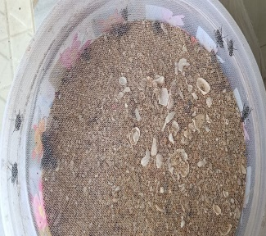

Chicken meat kept in the plastic Reared adult flesh fly
cup kept in a cup filled with sand After 17 days it hatches Preserve with
and cover it with net under sunlight into adult flesh fly ETOH

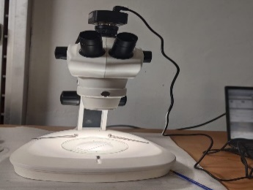
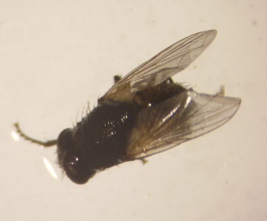
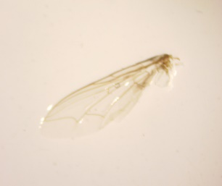
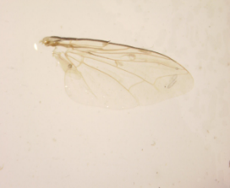

Nikon SMZ645 stereo Common housefly (Musidae) Flesh fly 1 Flesh fly 2
microscope
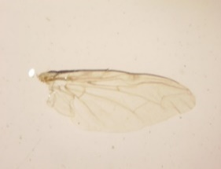
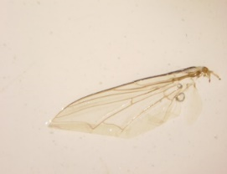
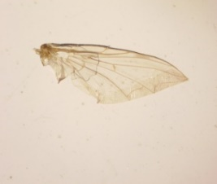
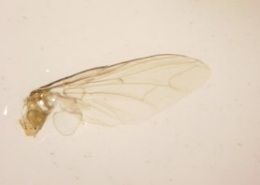

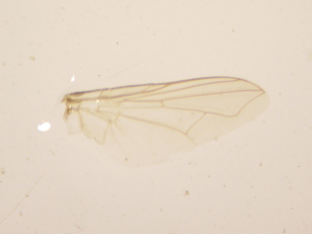
Flesh fly 3 Flesh fly 4 Flesh fly 5 Flesh fly 6
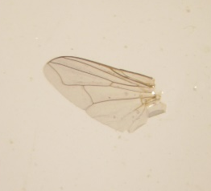
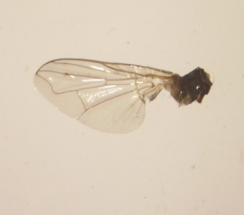
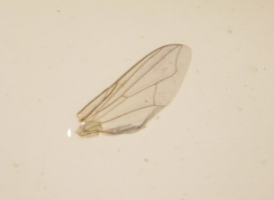

Housefly 1 Housefly 2 Housefly 3 Housefly 4

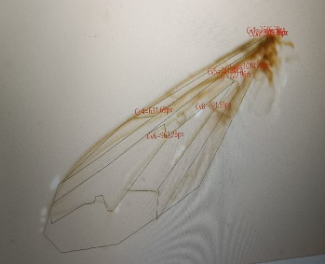
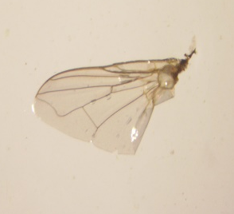
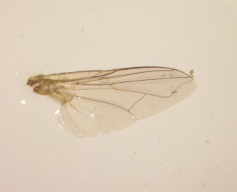

Housefly 5 Housefly 6 Morphometrics of Morphometrics
flesh fly (Sarcophagidae) of housefly (Musidae)
The quantitative analysis of wing venation in flesh flies (Sarcophaga sp.) and houseflies (Musca domestica) showed distinct patterns in vein lengths and variability. In flesh flies, the costa vein was the longest, with a mean length of 4129.53 µm and a standard deviation of 671.75 µm, indicating substantial variation among individuals. The radial stem vein also showed considerable variation (mean = 1253.37 µm; SD = 536.47 µm), while the anal lobe and second basal cell veins had mean lengths of 680.01 µm and 878.81 µm, respectively, with high standard deviations (268.13 µm and 327.38 µm), reflecting individual differences in wing morphology.
In houseflies, the costa vein was comparatively shorter (mean = 2350.21 µm; SD = 548.33 µm), and most veins exhibited lower variability compared to flesh flies. The Radial fork (mean = 757.19 µm; SD = 274.85 µm) and first basal vein (mean = 820.72 µm; SD = 259.17 µm) showed moderate variation. The subcosta and second basal cell veins in both species had overlapping ranges, suggesting that no single vein length alone is sufficient for species discrimination. However, when considered collectively, the differences in vein lengths and variability patterns indicate that morphometric analysis of multiple landmarks can reliably differentiate the two species.
The wing venation measurements of both flesh flies (Sarcophaga sp.) and houseflies (Musca domestica) reveal clear differences in vein lengths and variability between the two species. Flesh fly wings generally exhibited longer costa and radial stem veins, with higher standard deviations, indicating greater individual variation in wing size within the sampled population. In contrast, housefly wings showed relatively shorter veins and lower variability in most vein measurements, suggesting a more uniform wing morphology. Notably, certain veins, such as the second basal cell and radial fork, displayed overlapping ranges between the two species, highlighting the need for morphometric analysis using multiple landmarks rather than single vein lengths for accurate species discrimination. Overall, these measurements provide a quantitative foundation for distinguishing closely related dipteran families and support the use of wing shape and vein pattern as reliable taxonomic characters.
DISCUSSION
The present study examined wing venation patterns in flesh flies (Sarcophaga sp.) and houseflies (Musca domestica) using morphometric measurements, revealing significant differences in vein lengths and variability between the two species. These findings suggest that wing morphology can serve as a reliable character for species discrimination.
Overall, flesh flies exhibited longer and more variable veins than houseflies. The costa vein in flesh flies averaged substantially longer than observed in houseflies. Other veins, including the radial stem, anal lobe and second basal cell, also displayed higher variability in flesh flies, indicating greater morphological diversity within this species. In contrast, houseflies had shorter veins with comparatively lower variability, though veins such as the radial fork and first basal vein showed moderate variation. These results align with previous reports of species-specific venation patterns in Diptera (Bryant, 1977; El-Ahmadyet al., 2024; Sontigunet al., 2019).
Despite these differences, some veins, such as the subcosta and second basal cell, showed overlapping ranges between species. This finding emphasizes that no single vein measurement is sufficient for definitive species identification. Instead, a combination of multiple vein metrics increases discriminatory power, supporting the utility of geometric morphometrics in dipteran taxonomy (Hall et al., 2014; Salcedo et al., 2018). The higher variability in flesh fly veins may reflect both underlying genetic diversity and phenotypic plasticity in response to environmental factors, consistent with observations in Muscidae and Sarcophagidae (Bryant, 1976; Ludoškiet al., 2014).
From a practical perspective, these differences have significant implications for forensic and medical entomology. Accurate identification of flies is essential for estimating post-mortem intervals (PMI) and understanding the dynamics of pathogen transmission. Morphometric analysis of wing venation can complement traditional taxonomic methods, particularly in cases where external morphological features are ambiguous or damaged.
In conclusion the present study demonstrates that wing vein lengths and their variability are valuable diagnostic characters for distinguishing closely related dipteran species. Expanding the dataset to include additional species and populations could further refine species identification and potentially enable the development of automated morphometric tools for forensic and medical entomology applications.
Conclusion
This study investigated the wing venation patterns of flesh flies (Sarcophaga sp.) and houseflies (Musca domestica) using morphometric techniques to assess whether wing morphology can serve as a reliable taxonomic character. Specimens were collected under controlled laboratory conditions, wings were prepared on slides and key vein lengths were measured.
Flesh flies are of particular forensic importance, as their larvae associated with human remains can be used to estimate a minimum post-mortem interval (PMI_{min}). Because life-history traits vary across species, accurate species identification is essential before such evidence can be applied. Adult flesh flies are highly similar in general appearance and identification is largely dependent on male genitalia morphology, making female identification challenging. Landmark-based geometric morphometric analysis of insect wings has therefore emerged as a valuable tool for distinguishing species.
The results revealed clear differences between the two species. Flesh flies exhibited longer and more variable veins, including the costa, radial stem, anal lobe and second basal cell, indicating higher morphological diversity within the species. Houseflies had shorter veins with generally lower variability, although some veins, such as the radial fork and first basal vein, showed moderate variation. Some veins, like the subcosta and second basal cell, had overlapping ranges between species, highlighting the need for multiple landmark analysis rather than single vein measurements for accurate identification.
These findings demonstrate that combining multiple wing vein measurements can effectively differentiate closely related dipteran species. The study highlights the utility of geometric morphometrics in forensic and medical entomology, where accurate species identification is crucial for estimating post-mortem intervals and understanding disease transmission. The results also provide a foundation for future work on automated morphometric identification tools and broader taxonomic studies of flies.
References
Ansorge, J. (1994). Tanyderidae and Psychodidae (Insecta: Diptera) from the Lower Jurassic of northeastern Germany. Paläontologische Zeitschrift, 68, 199–209.
Atchley, W. R., and Hensleigh, D. A. (1974). The congruence of morphometric shape in relation to genetic divergence in four races of morabine grasshoppers (Orthoptera: Eumastacida). Evolution, 28, 416–427.
Belyaev, O. A. & Farisenkov, S. E. (2019). A Study on Allometry of Wing Shape and Venation in Insects. Part 2. Diptera. Moscow University Biological Sciences Bulletin, 74 (1): 7-14. Journals. rcsi. science
Béthoux, O. (2005). Wing venation pattern of Plecoptera (Insecta: Neoptera). Illiesia, 1(9), 52–81.
Bidawid, S. P., Edeson, J. F., Ibrahim, J., and Matossian, R. M. (1978). The role of non-biting flies in the transmission of enteric pathogens (Salmonella species and Shigella species) in Beirut, Lebanon. Annals of Tropical Medicine and Parasitology, 72, 117–121.
Bookstein, F. L. (1991). Morphometric tools for landmark data: Geometry and biology. Cambridge University Press.
Breuker, C. J., Patterson, J. S., and Klingenberg, C. P. (2006). A single basis for developmental buffering of Drosophila wing shape. PLoS ONE, 1, e7.
Brown, K. R., and Shipp, E. (1977). Wing morphometrics of Australian Luciliini (Diptera: Calliphoridae). Australian Journal of Zoology, 25, 765–777.
Brown, K. R., and Shipp, E. (1978). Wing morphometric analysis of Australian Sarcophaginae (Diptera: Sarcophagidae). Systematic Entomology, 3, 179–188.
Bryant, E. H. (1976). Morphometric adaptation of the housefly, Musca domestica L., in the United States. Evolution, 30, 580–596.
Bryant, E. H., and Turner, C. R. (1978). Comparative morphometric adaptation of the housefly and the face fly in the United States. Evolution, 32, 759–773.
Bryant, P. J. (1976). Morphological variation in Diptera: Genetic and environmental contributions. Journal of Zoological Systematics, 14(3), 211–225.
Bryant, P. J. (1977). Wing venation patterns in Muscidae and Sarcophagidae (Diptera). Entomological Review, 55(4), 345–358.
Byers, G. (1989). Homologies in wing venation of primitive Diptera and Mecoptera. Proceedings of the Entomological Society of Washington, 91, 497–501.
Cafarchia, C., Lia, R. P., Romito, D., and Otranto, D. (2009). Competence of the housefly, Musca domestica, as a vector of Microsporumcanis under experimental conditions. Medical and Veterinary Entomology, 23(1), 21–25.
Celis, J.-E. (2003). Developmental basis for vein pattern variations in insect wings. Bioessays 25(5), 443-451.
Čičková, H., Kozánek, M., and Takáč, P. (2013). Improvement of survival of the house fly (Musca domestica L.) larvae under mass-rearing conditions. Bulletin of Entomological Research, 103(1), 119–125. https://doi.org/10.1017/S000748531200065X
Combes, S. A. (2010). Materials, structure, and dynamics of insect wings: bio-inspiration for micro-air vehicles. Department of Organismic and Evolutionary Biology, Harvard University, Cambridge, MA, USA.
Diniz-Filho, J. A. F., and Malaspina, O. (1995). Evolution and population structure of Africanized honey bees in Brazil: Evidence from spatial analysis of morphometric data. Evolution, 49, 1172–1179.
El-Ahmady, H., Hassan, M., and Abdel-Moneim, A. (2024). Comparative morphometrics of Dipteran wings for forensic identification. Forensic Science International, 384, 111943.
Faraj, A., Mawlood, N., (2018). Morphology of flesh fly stages, Sarcophaga africa (Wiedemann) (Diptera: Sarcophagidae) and taxonomic key to larval instars. Journal of Education and Science Vol. 27, No. 2, 2018, pp. 28-38.
Gidaszewski, N. A., Baylac, M., and Klingenberg, C. P. (2009). Evolution of sexual dimorphism of wing shape in the Drosophila melanogaster subgroup. BMC Evolutionary Biology, 9, 110.
Greenberg, B. (1970). Flies and disease: Ecology, classification and biotic associations. Princeton University Press.
Greenberg, B. (1973). Flies and diseases: Biology and disease transmission. Princeton University Press.
Grübel, P., Huang, L., Masubuchi, N., Stutzenberger, F. J., and Cave, D. R. (1998). Detection of Helicobacter pylori DNA in houseflies (Musca domestica) on three continents. The Lancet, 352, 788–789.
Hall, M. J., Morgan, C., and Jones, A. (2014). Geometric morphometrics in dipteran taxonomy. Systematic Entomology, 39(2), 240–251.
Jaramillo-O, N., Dujardin, J. P., Calle-Londoño, D., and Fonseca-González, I. (2015). Geometric morphometrics for the taxonomy of 11 species of Anopheles (Nyssorhynchus) mosquitoes. Medical and Veterinary Entomology, 29, 26–36.
Klingenberg, C. P. (2003). Developmental instability as a research tool: Using patterns of fluctuating asymmetry to infer the developmental origins of morphological integration. In M. Polak (Ed.), Developmental instability: Causes and consequences (pp. 427–442). Oxford University Press.
Klingenberg, C. P., and McIntyre, G. S. (1998). Geometric morphometrics of developmental instability: Analyzing patterns of fluctuating asymmetry with Procrustes methods. Evolution, 52(5), 1363–1375.
Klingenberg, C. P., and Zaklan, S. D. (2000). Morphological integration between developmental compartments in the Drosophila wing. Evolution, 54, 1273–1285.
Klingenberg, C. P., McIntyre, G. S., and Zaklan, S. D. (1998). Left-right asymmetry of wings and the evolution of body axes. Proceedings of the Royal Society B, 265, 1255–1259.
Krafsur, E. S., Bryant, N. L., Marquez, J. G., and Griffiths, N. T. (2000). Genetic distance among North American, British, and West African house fly populations (Musca domestica L.). Biochemical Genetics, 38(9–10), 275–284.
Krafsur, E. S., Cummings, M. A., Endsley, M. A., Marquez, J. G., and Nason, J. D. (2005). Geographic differentiation in the house fly estimated by microsatellite and mitochondrial variation. Journal of Heredity, 96(5), 502–512.
Krishna, Moonsung Cho, Henja-Niniane Wehmann, Thomas Engels and Fritz-Olaf Lehmann (2020). Wing design in flies: structure, function and aerodynamic implications. Department of Animal Physiology, Institute of Biosciences, University of Rostock, 18059 Rostock. Germany.
Kukalova-Peck, J., and Peck, S. B. (1993). Zoraptera wing structures: Evidence for new genera and relationship with the blattoid orders (Insecta: Blattoneoptera). Systematic Entomology, 18, 333–350.
Kurahashi, H., and Chaiwong, T. (2013). Keys to the flesh flies of Thailand, with description of a new species of RobineauellaEnderlein (Diptera: Sarcophagidae). Medical Entomology and Zoology, 64, 83–101.
Lentink, D., Dickinson, M. H. (2009). Rotational accelerations stabilise leading-edge vortices on revolving fly wings. Journal of experimental biology 212(16), 2705-2719.
Ludoški, A., Petrović, A., and Stanković, M. (2014b). Phenotypic plasticity in Sarcophagidae and Muscidae: Implications for morphological studies. EntomologiaExperimentalisetApplicata, 152(1), 45–53.
Ludoški, J., Djurakic, M., Pastor, B., Martínez-Sánchez, A. I., Rojo, S., and Milankov, V. (2014a). Phenotypic variation of the housefly, Musca domestica: Amounts and patterns of wing shape asymmetry in wild populations and laboratory colonies. Department of Biology and Ecology, University of Novi Sad, Serbia; InstitutoCIBIO, Universidad de Alicante, Spain.
Majeed, A. A., and Sultan, A. A., (2025) Quantitative Genetic Diagnosis of Medical and Forensic Insect Species in Diyala Governorate Using Geometric Wing Morphometrics. Department of Biology, College of Education for Pure Sciences, University of Diyala, 32001 Baqubah, Diyala, Iraq.
Marquez, J. G., and Krafsur, E. S. (2002). Gene flow among geographically diverse housefly populations (Musca domestica L.): A worldwide survey of mitochondrial diversity. The American Genetic Association, 93, 254–259.
Paquette, C., Joplin, K., Seier, E., Peyton, J. T., and Moore, D. (2008). Sex-specific differences in spatial behaviour in the flesh fly Sarcophagacrassipalpis. Physiological Entomology, 33, 382–388.
Rohlf, F. J., and Archie, J. W. (1984). A comparison of Fourier methods for the description of wing shape in mosquitoes (Diptera: Culicidae). Systematic Zoology, 33, 302–317.
Rohlf, F. J., and Marcus, L. F. (1993). A revolution in morphometrics. Trends in Ecology and Evolution, 8(4), 129–132.
Ross, H. H. (1965). A textbook of entomology (3rd ed.). John Wiley.
Salcedo, C., Medina, D., and Rojas, F. (2018). Morphometric analysis of fly wings for species discrimination. Journal of Insect Science, 18(6), 1–11.
Sanchez-Arroyo, H. (2008). House fly, Musca domestica Linnaeus. University of Florida, Institute of Food and Agricultural Sciences. http://edis.ifas.ufl.edu/in205
Simões, R. F., Wilke, A. B. B., Chagas, C. R. F., Menezes, R. M. T. d., Suesdek, L., Multini, L. C., Silva, F. S., Grech, M. G., Marrelli, M. T. & Kirchgatter, K. (2020). Wing geometric morphometrics as a tool for the identification of Culex subgenus mosquitoes of Culex (Diptera: Culicidae). Insects, 11(9): 567. MDPI
Skidmore, P. (1985). Survey of the biology of the world Muscidae: Muscinae. In W. Junk (Ed.), The biology of the Muscidae of the world (p. 235). Dordrecht: The Netherlands.
Smith, K. G. V. (1986). A manual of forensic entomology. British Museum of Natural History.
Snodgrass, R. E. (1993). Principles of insect morphology. Cornell University Press.
Sontigun, N., Sukontason, K. L., Zajac, B. K., Zehner, R., Sukontason, K., Wannasan, A., Amendt, J. (2017). Wing morphometrics as a tool in species identification of forensically important blow flies of Thailand. Parasitology and Vectors, 10, 229.
Sontigun, N., Sukontason, K., and Moophayak, K. (2019). Wing venation variability in forensic flies: A morphometric approach. Parasites and Vectors, 12(1), 1–10.
Stalker, H. D., and Carson, H. L. (1947). Morphological variation in natural populations of Drosophila robusta Sturtevant. Evolution, 1, 237–248.
Sukontason, K., Methanitikorn R, Kurahashi H, Vogtsberger RC, Sukontason KL (2008). Ommatidial morphology of blow fly, house fly and flesh fly: implications for vision efficiency revealed by scanning electron microscopy. Micron 39:190-197.
Sukontason, K., Narongchai, P., Kanchai, C., Vichairat, K., Sribanditmongkol, P., Bhoopat, T., Kurahashi, H., Chockjamsai, M., Piangjai, S., Bunchu, N., Vongvivach, S., Samai, W., Chaiwong, T., Methanitikorn, R., Ngern-klun, R., Sripakdee, D., Boonsriwong, W., Siriwattanarungsee, S., Srimuangwong, C., Hanterdsith, B., Chaiwan, K., Srisuwan, C., Upakut, S., Moopayak, K., Vogtsberger, R. C., and Olson, J. K. (2007). Forensic entomology cases in Thailand: A review of cases from 2000 to 2006. Parasitology Research, 101, 1417–1423.
Vairo, K. P., Moura, M. O., and de Mello-Patiu, C. A. (2015). Comparative morphology and identification key for females of nine Sarcophagidae species (Diptera) with forensic importance in Southern Brazil. RevistaBrasileira de Entomologia, 59, 177–187.
Vairo, K. P., Ururahy-Rodrigues, A., Moura, M. O., and de Mello-Patiu, C. A. (2014). Sarcophagidae (Diptera) with forensic potential in Amazonas: A pictorial key. Tropical Zoology, 27, 140–152.
Virginio, F., Vidal, P. O., and Suesdek, L. (2015). Wing sexual dimorphism of pathogen-vector culicids. Parasitology and Vectors, 8, 159.
Wanaratana, S., Panyim, S., and Pakpinyo, S. (2011). The potential of house flies to act as a vector of avian influenza subtype H5N1 under experimental conditions. Medical and Veterinary Entomology, 25(1), 58–63.
Wootton, R. J. (1990). The mechanical design of insect wings. Scientific American, 263, 114–120.
Wootton, R. J. (1992). Functional morphology of insect wings. Annual Review of Entomology, 37, 113–140.
Yu, D. S., Kokko, E. G., Barron, J. R., Schaalje, G. B., and Gowen, B. E. (1992). Identification of ichneumonid wasps using image analysis of wings. Systematic Entomology, 17, 389–395.
Zelditch, M. L., Swiderski, D. L., Sheets, H. D., and Fink, W. L. (2004). Geometric morphometrics for biologists. Elsevier Academic Press.
Zumpt, F. (1965). Myiasis in man and animals of the Old World: A textbook for physicians, veterinarians, and zoologists. London.

