Clinical and welfare insights from a cow pox outbreak in Sahiwal cattle and handlers from Jammu and Kashmir, India

Abstract
Sahiwal cow breed is considered as a hardy breed with superior tolerance to summer stress and better disease resistance. Present study reports an outbreak of cow pox at Narsingh Gaushala in Udhampur district of Jammu and Kashmir (UT). In a group of 17 Sahiwal cattle, 7 lactating Sahiwal cattle and 3 calves were affected with cowpox. It was also observed that the morbidity was as high as 70% in lactating cattle followed by suckling calves at 42.85%. No mortality was observed in the farm. Suckling calves showed lesions after 9 days of outbreak in lactating cow. Cowpox lesions were prominent and clearly visible on teats, udder of lactating animals whereas lesions on face and muzzle were seen in suckling calves. Various stages of pox lesions like papules, pustules, erythema, vesicles and scabs were observed in animals. Affected animals showed elevated temperature and heart rate. Handlers and milkers in the farm mainly showed lesions on hands in the form of papules and pustules. All affected Sahiwal cattle and calves were treated with Inj. Enrofloxacin @ 5mg/kg O.D. for 5 days followed by Inj. Meloxicam @ 0.5mg/kg B.I.D. for 2 days as supportive therapy. Teat dipping with betadine-glycerin two times a day was also done. All affected animals recovered within 12-14 days of treatment.
Key words: Cowpox, Sahiwal, edema, lymphadenopathy and erythema

Running title: Cowpox outbreak in Sahiwal cattle at Jammu, Gaushala

INTRODUCTION
India has the world’s most diverse cattle genetic resource along with a considerable size of indigenous cattle population. These native cattle breeds are very hardy and adopt well to extreme climatic conditions in addition to being disease resistance and economical. Cowpox is a benign skin disease which is contagious in nature and its lesions are mostly seen on udder and teats of animal (Radostitis et al., 2000). Cowpox virus is related to the family of Poxviridae, Chordopox virinae subfamily and genus Orthopox virus (Delhon, 2022). Cow pox virus has been reported in various wild animals as well as domestic animals like cattle, cats, dogs, horses (Becker et al.,2009). The pustular local cowpox lesions are found in the muzzle, teats or scrotum, udder of affected animal and in case of systemic disease, whole body gets covered in pocks (Delhon, 2022). Pox lesions on udder and teat in animals can act as attributing factor to clinical mastitis, which causes economic loss by decrease in milk production, reduced cost of animal or loss of quarter (Kahrs 2002; Sharma et al., 2020). The incubation period of cowpox virus lasts around 3-7 days (Delhon, 2022). Human cowpox is a zoonotic infection which is rare but can be severe as humans suffer from hemorrhagic pustule on hand along with edema, lymphadenopathy and erythema (Baxby et al., 1994). Humans may also develop the infection by contact with infected animals, rodents or cats (Fenner 1996; Essbauer and Meyer,2007; Vogel et al., 2012). Pox virus can enter through skin contact and scars (Ferrier et al., 2017; Schwarzer et al., 2013). Indigenous breeds are considered more resistant and less susceptible to udder diseases as compared to exotic breeds like Holstein-Friesian, Jersey (Sharma et al., 2020). This is the first case report from Udhampur district of Jammu and Kashmir with an outbreak of cowpox in Sahiwal cattle, calves and milkers.
MATERIALS AND METHODS
A disease outbreak case in Sahiwal Cattle was reported by a farmer’s farm Narsingh Gaushala, Khoon, Udhampur to the Division of Veterinary Medicine, R.S. Pura. Animals showed history of fever and red painful papulo-pustular eruptions on udder and teats. Cows were reluctant to milking and suckling by the calves due to pain. In addition, milkers/handlers were also seen to develop lesions on hands and fingers. Narsingh Gaushala, Udhampur is exclusively maintaining only Sahiwal breed in the farm without the introduction of other breeds. The affected Sahiwal cattle farm was visited and affected animals were clinically examined for distributions of lesions on udder and teats. A survey questionnaire was developed to collect history on the feeding schedule, change in feed intake, recent visit of animals to infected farms, introduction of new or infected animals, milk production, change in milk production after cow pox infection, change in milk quality, milk pH, welfare indicators and overall body score of animals. Mastitis screening was also done with California mastitis test (CMT). All physiological parameters of affected cows and calves were recorded every day twice till the recovery. Major physiological parameters recorded included temperature, heart rate, respiration rate etc. Suckling calves who had developed lesions of cow pox at farm were also examined. All infected young calves were also sperated from other healthy calves with no lesions. Milkers/handlers with lesions on hands and fingers were advised not to do milking of healthy animals.

RESULTS AND DISCUSSION

A total of seventeen Sahiwal cattle (10 lactating cows and 7 calves) were maintained at Narsingh Gaushala, Udhampur. Out of these, ten animals showed typical clinical signs of cowpox, including fever, papulo-pustular lesions on the teats (Pic.1), udder, and muzzle (Table 1). Morbidity was recorded at 70 % among lactating cows and 42.85 % among calves, with no mortality observed during the outbreak. The overall herd morbidity was 58.82 %. Recovery was achieved in all affected animals within 12–14 days following prompt treatment and isolation.

Table 1. Morbidity and Recovery Pattern in Affected Sahiwal Cattle and Calves
Animal Category | Total Animals | Affected (No.) | Morbidity (%) | Mortality (%) | Average Recovery Time (days)
Lactating cows | 10 | 7 | 70.00 | 0.00 | 12.5 ± 0.5
Calves | 7 | 3 | 42.85 | 0.00 | 13.0 ± 0.7
Total | 17 | 10 | 58.82 | 0.00 | 12.7 ± 0.6

During the acute phase of the infection, affected cows exhibited a noticeable rise in body temperature (40.3 °C), heart rate (82 beats/min), and respiration rate (40 breaths/min), indicating systemic stress and discomfort. Gradual normalization of these parameters was observed from day 10 onwards (Table 2).

Table 2. Changes in Physiological Parameters during Infection
Parameter | Normal Range (Sahiwal) | Day 1 of Outbreak | Peak Infection (Day 3–4) | Recovery (Day 10–12)
Temperature (°C) | 38.5 ± 0.5 | 39.6 ± 0.3 | 40.3 ± 0.2 | 38.7 ± 0.4
Heart Rate (beats/min) | 55–65 | 72 ± 3 | 82 ± 2 | 60 ± 2
Respiration Rate (breaths/min) | 20–30 | 32 ± 2 | 40 ± 2 | 26 ± 1

A sharp decline in milk yield by approximately 37 % was recorded during infection, accompanied by swelling and pain in the udder and teats, causing reluctance to milking. After recovery, milk yield nearly returned to normal levels (Table 3; Figure 1).

Table 3. Effect of Cowpox on Milk Yield and Udder Health
Parameter | Pre-Outbreak | During Infection | Post-Recovery
Average Milk Yield (L/day/cow) | 10.2 ± 0.8 | 6.4 ± 0.6 | 9.8 ± 0.7
Teat Lesion Score (1–5) | 0 | 4.0 ± 0.3 | 0.5 ± 0.1
Udder Swelling Score (1–5) | 0 | 3.5 ± 0.4 | 0.3 ± 0.1

Mastitis Screening using California Mastitis Test (CMT) was done to evaluate any subclinical and clinical mastitis associated with cowpox lesions. Out of seven affected cows 71.42% showed positive reaction for mild to moderate mastitis, while three healthy cows were CMT negative. CMT results showed higher reactivity in quarters with active pox lesions, indicating inflammation or secondary bacterial invasion due to teat skin compromise

Table 4. Mastitis Screening using California Mastitis Test (CMT)
Group | Total Tested | CMT Positive (No) | %
Affected | 7 | 5 | 71.42
Healthy | 3 | 0 | 0.00
Total | 10 | 5 | 50.00

Table 5. Welfare indicators in cow pox infection
Welfare Indicator | Normal Behaviour | During Outbreak | After Recovery
Grooming | Normal | Reduced | Normal
Lying Time | 8-10 h/day | 5-6h/day (Reduced) | 8-10 h/day
Interaction | Interactive | Isolated Behaviour | Interactive
Alertness | Active/Alert | Dull | Active/ Alert
Pain score | 0 | High | 0

Welfare indicators like body score and feed intake were also observed (Table.5). Stress and pain during cow pox reduced appetite and body condition. Physiological and welfare parameters revealed that body condition and feed intake were significantly reduced during the infection period. Behavioural observations confirmed marked discomfort, reduced grooming, isolation and altered lying behaviour among infected cows. These findings collectively highlighted animal welfare compromise during the active phase of cow pox

Human involvement and lesions in milkers
Two milkers and one handler at the Narsingh Gaushala also developed pustular and popular lesions (Pic.2 and Pic.3) on their hands and fingers approximately 5-7 days after handling infected animals. The lesions were painful, erythematous and nodular with occasional mild edema. In some cases, lesions showed central umbilication and crust formation. The affected person reported mild fever, local pain and lymphadenopathy in axillary region. Supportive therapy with topical povidone-iodine and oral antihistamines was advised and all human cases recovered completely within 12-14 days without scarring. No secondary bacterial infection was observed during healing

DISCUSSION

The present outbreak of cowpox in a closed Sahiwal herd emphasizes the zoonotic and welfare implications of poxvirus infections even in disease-resistant indigenous breeds. Morbidity of 58.82 % in the herd was relatively higher than that reported by Bhardwaj (2012) 46.39 %, suggesting that confined housing and cold climatic stress may predispose animals to infection. The absence of mortality and rapid recovery (12–14 days) reflected effective management, early diagnosis, and prompt therapeutic intervention.

The rise in temperature and heart rate during the infection indicated a systemic inflammatory response, consistent with findings of Schatzmayr et al., (2000) and Delhon (2022). Welfare indicators such as reduced feed intake, reluctance to milking, and visible discomfort underline the compromised welfare state during infection. Animal welfare scoring based on behaviour, udder lesions, and milk output can therefore serve as practical monitoring tools during such outbreaks.

The 37 % decline in milk yield highlights the economic significance of cowpox even in hardy indigenous breeds. Temporary reduction in lactation and udder lesions also increased handling stress among milkers, a factor further complicated by zoonotic transmission evidenced by hand lesions on milkers and handlers.
The observed increased milk pH is in agreement with subclinical mastitis pattern, further supported by positive CMT reactions. Behavioural and welfare observations substantiated the physiological stress response, reinforcing that clinical cowpox can transiently compromise animal well being. Monitoring these indicators provide a simple yet effective welfare assessment tool for field veterinarians. From an epidemiological perspective, winter occurrence and proximity to rodent populations point towards rodent reservoirs as a possible source of viral transmission, corroborating reports by Marennikova et al., (1984) and Essbauer and Meyer (2007). Preventive strategies should thus include improved rodent control, personal protective equipment for milkers, regular teat disinfection, and isolation of affected animals.
Human infection in the present outbreak was restricted to three individuals who exhibited classical self-limiting cow pox lesions on the hands and fingers. The papulo pastular lesions with mild fever was similar to the symptoms described by Baxy et al. (1984) and Vogel et al. (2012). Complete recovery within 12-14 days without scarring indicated a mild local form of zoonotic infection. This emphasizes the importance of personal protective equipment (PPE), especially gloves and disinfectant hand washes for workers handling infected animals. The incident underlines the one health perspective linking animal welfare, zoonotic risk and occupational safety. Overall, this case study underscores that even resilient indigenous cattle breeds such as Sahiwal can experience welfare and productivity losses during cowpox outbreaks. Incorporating welfare-based management, prompt treatment, and biosecurity measures is crucial to reduce both animal suffering and economic loss in future incidences.

Figure 1. Line graph showing changes in temperature and heart rate of affected cows during infection and recovery phases.

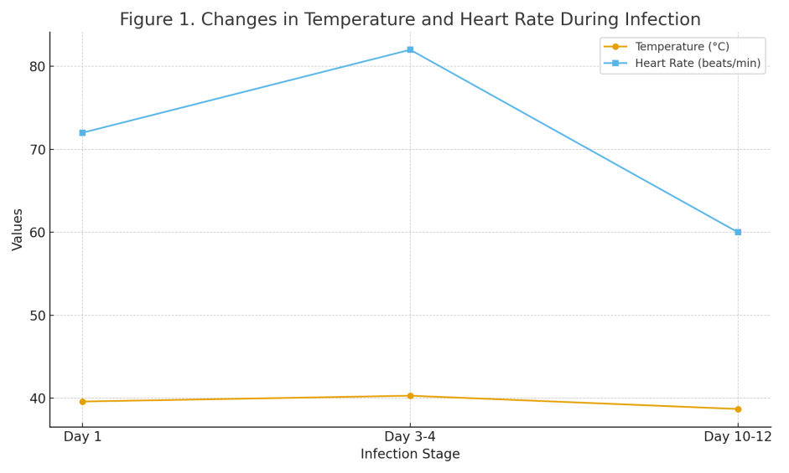

Figure 2. Bar graph illustrating variation in milk yield (pre-outbreak, infection, and recovery stages).

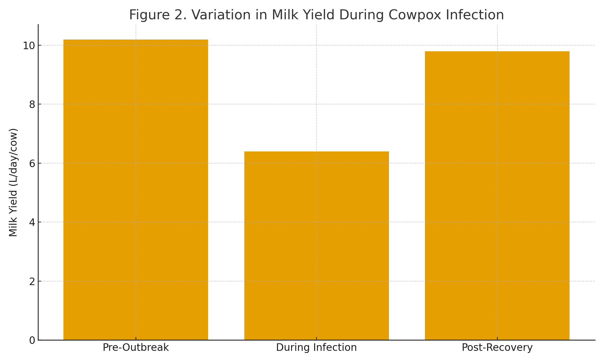

Figure 3. Pie chart representing distribution of lesion sites in affected animals

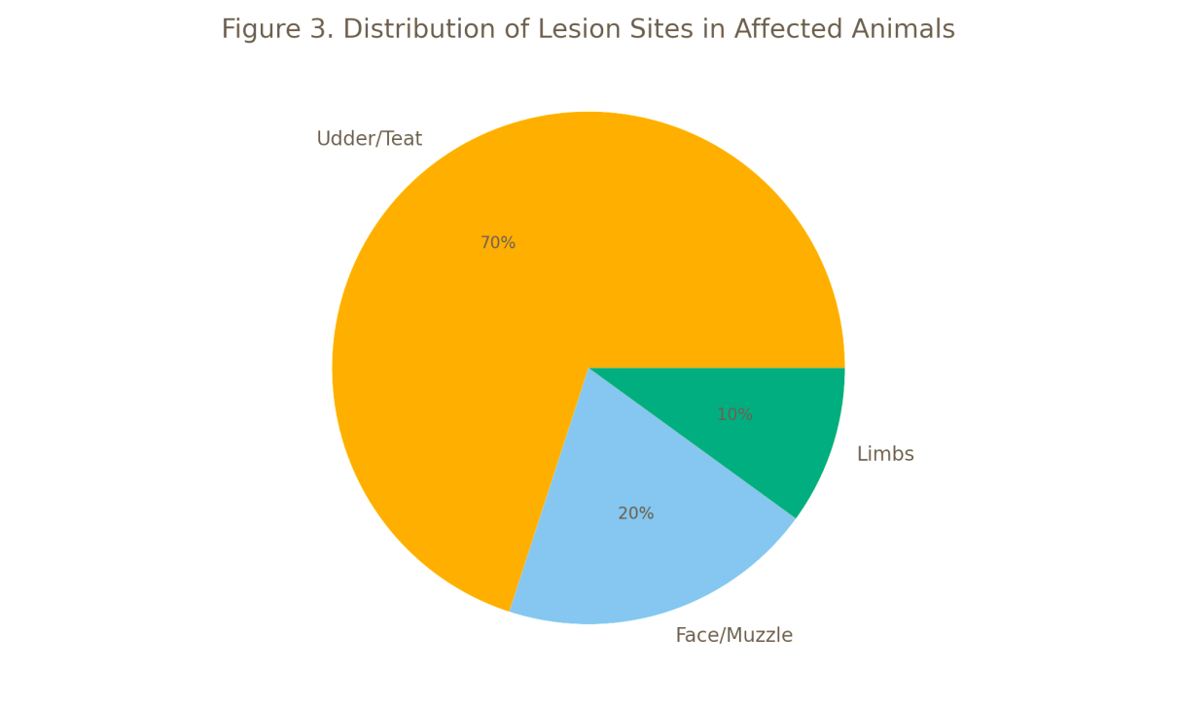

Conflict of interest: Authors have no conflict of interest.
Data availability declaration: All data included is part of original research on clinical outbreak.

REFERENCES
Baxby, D., Bennett, M., & Getty, B. (1994). Human cowpox 1969–93: a review based on 54 cases. British Journal of Dermatology, 131(5), 598-607.
Becker, C., Kurth, A., Hessler, F., Kramp, H., Gokel, M., Hoffmann, R. & Nitsche, A. (2009). Cowpox virus infection in pet rat owners: not always immediately recognized. Deutsches Ärzteblatt International, 106(19), 329.
Bhardwaj, R. K. (2012). An Outbreak of Cowpox in Dairy Farms of Jammu. Indian Veterinary Journal, 89(8), 143.
Delhon, G. (2022). Poxviridae. Veterinary Microbiology, 522-532.
Essbauer, S., and H. Meyer. 2007. Genus Orthopoxvirus: Cowpox virus, p. 75. A. A. Mercer, A. Schmidt, and O. Weber (eds.), Poxviruses. Birkhäuser Basel, Boston.
Ferrier, A., G. Frenois-Veyrat, E. Schvoerer, S. Henard, F. Jarjaval, I. Drouet, H. Timera, L. Boutin, E. Mosca, C. Peyrefitte, and O. Ferraris. 2021. Fatal Cowpox Virus Infection in Human Fetus, France, 2017. Emerg Infect Dis 27:2570-2577.
Fenner F 1996. Poxvirus. In BN Fields, Fields Virology, Lippincott-Raven Publishers, Philadelphia, p. 2673-2695.
Kahrs, R. F. (2001). Viral diseases of cattle (pp. viii+-324).
Marennikova, S. S., Shelukhina, E. M., & Efremova, E. V. (1984). New outlook on the biology of cowpox virus. Acta virologica, 28(5), 437-444.
Radostits, O. M., Gay, C. C., Blood, D. C., & Hinchcliff, K. W. (2000). Veterinary Medicine: A textbook of the Diseases of Cattle, Sheep, Pigs, Goats and Horses, 9th. London, UK: WB sounders.
Schwarzer, H., A. Kurth, M. Hermel, and N. Plange. 2013. Severe ulcerative keratitis in ocular cowpox infection. Graef Arch Clin Exp 251:1451-1452.
Schatzmayr, H. G., Lemos, E. R. S. D., Mazur, C., Schubach, A., Majerowicz, S., Rozental, T., ... & Barth, O. M. (2000). Detection of poxvirus in cattle associated with human cases in the State of Rio de Janeiro: preliminary report. Memórias do Instituto Oswaldo Cruz, 95, 625-627.
Sharma, S., Gupta, D. K., & Bansal, B. K. (2020). Udder and teat skin lesions in bovines. International Journal of Livestock Research, 10, 1-14.
Shchelkunov, S. N., Marennikova, S. S., & Moyer, R. W. (2006). Orthopoxviruses pathogenic for humans. Springer Science & Business Media.
Vogel, S., Sárdy, M., Glos, K., Korting, H. C., Ruzicka, T., & Wollenberg, A. (2012). The Munich outbreak of cutaneous cowpox infection: transmission by infected pet rats. Acta dermato-venereologica, 92(2), 126-131.

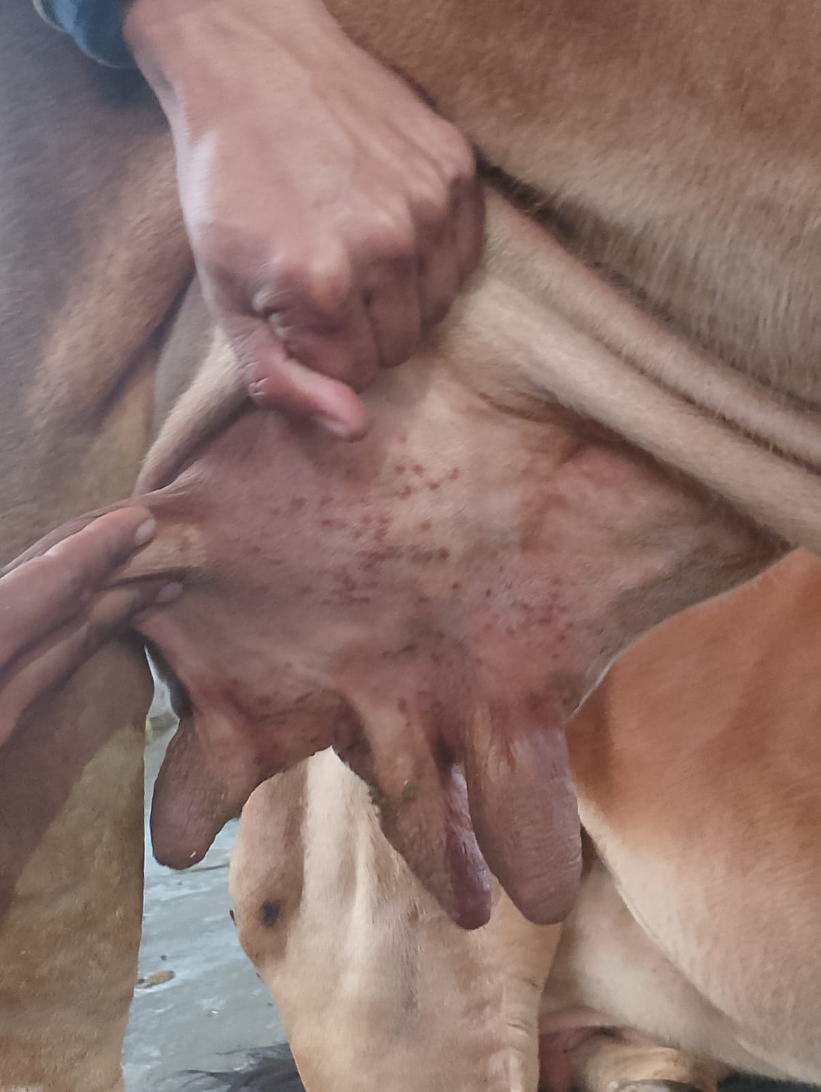
Pic.1 Teat pox lesions on udder of Sahiwal cow.

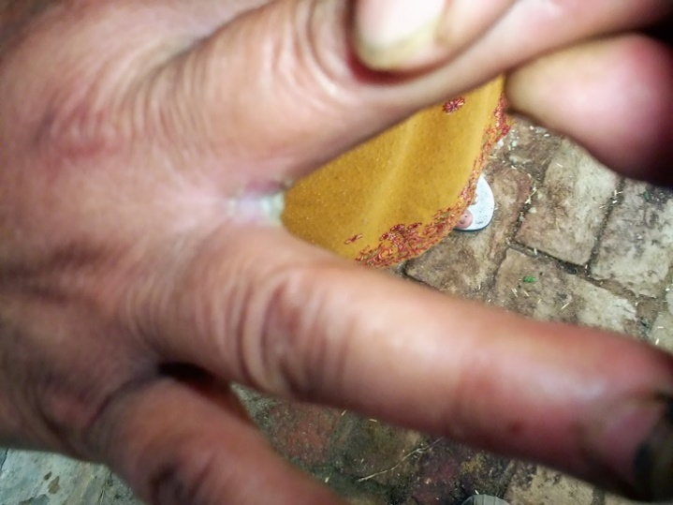
Pic.2 Cow Pox lesions on Milker’s Hand

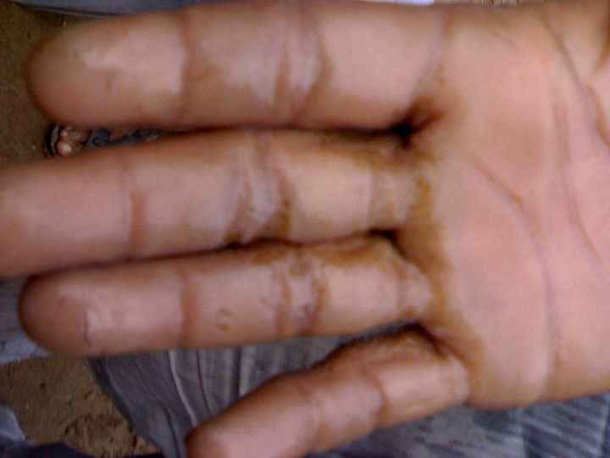
Pic.3 Cow Pox lesions on Handlers Hand

