Original Research Article
New Distribution Record and Range Extension of Humerana humeralis (Boulenger, 1887) in Meghalaya, India with Morphometric and Habitat Insights

Abstract
The present study reports the first-ever confirmed distribution record of Humerana humeralis from Nongkhyllem Wildlife Sanctuary and Reserved Forest of Meghalaya, northeastern India, thereby extending the known range of the species within the eastern Himalayan biogeographic region. This record fills an important distributional gap between earlier reports from Assam, Arunachal Pradesh, and adjoining Bangladesh. Detailed morphometric measurements were taken from adult specimens, revealing pronounced sexual dimorphism, with males exhibiting larger snout–vent length, head dimensions, tympanum size, and limb proportions compared to females. These measurements are largely congruent with previously published descriptions, confirming the taxonomic identity of the species while also highlighting minor regional variation. Habitat use further indicates that the species primarily occupies perennial streams, marshy pools, and forest-edge wetlands, preferably in semi-evergreen forest, emphasizing its dependence on stable aquatic and riparian microhabitats. The present record underscores the conservation significance of Nongkhyllem Wildlife Sanctuary, and its adjacent reserved forest highlights the need for habitat protection for the conservation of amphibian diversity in this landscape.

Keywords: Humeral Frog, Humerana humeralis, Nongkhyllem Wildlife Sanctuary, Nongkhyllem Reserved Forest, amphibian distribution.

INTRODUCTION
Humerana humeralis (Boulenger, 1887), commonly known as the Humeral Frog, is a species of Ranidae that is extensively found throughout South and Southeast Asia, covering a significant area of the Indo-Burma biogeographic region. In addition to India, they are known to distribute in Bangladesh (Frost, 2008; Al-Razi et al., 2014a,b), Nepal (Schleich and Kastle, 2002; Frost, 2008), Bhutan (Frost, 2008) and Myanmar (Boulenger, 1887, 1890; Frost, 2008), extending further east into Thailand, Laos, Cambodia, Vietnam, and southern China, as well as certain regions of the Malay Peninsula (Inger and Stuebing, 2005; Frost, 2024).

Within the Indian subcontinent, this species is primarily documented in northeastern India, specifically in the states of Assam (Hussain et al., 2007; Purkayastha, 2012; Chetia et al., 2014; Neog, 2016), Arunachal Pradesh (Hussain et al., 2007; Roy et al., 2018), Nagaland (Ao et al., 2003), Manipur (Ningombam and Bordoloi, 2007) and West Bengal (Deuti et al., 2017; Sen et al., 2022). Few studies reported its frequent presence in the Brahmaputra valley and the surrounding hill ranges, where the climatic conditions support a consistent availability of freshwater (Pawar and Birand, 2001; Sengupta et al., 2010). However, its distribution in Meghalaya state of northeast India was not reported. Hence, an initiative was undertaken to investigate amphibians distribution in and around the Nongkhyllem Wildlife Sanctuary of Meghalaya, aiming to establish their distribution, abundance, and habitat utilization pattern.

MATHODOLOGY
As amphibians inhabit both terrestrial/arboreal and aquatic environments, the survey encompassed both types of habitats. The survey was carried out along forest trails that included all habitat types (semi-evergreen, evergreen, shrub, deciduous, riverine, grassland), and the number of individuals was documented in relation to these habitats. Existing forest trails were explored during the evening hours. Two methods were employed for this purpose: (i) Visual Encounter Survey: This method involved searching for amphibians while walking along the forest trail during the evening hours (15:00 to 22:00) (Crump and Scott, 1994; Heyer et al., 1994; Naniwadekar and Vasudevan, 2014), and (ii) Active Search: In this method, amphibians were actively sought in various microhabitats, including epiphytes, beneath loose bark and logs, under leaf litter, root buttresses, overhead canopies, under rocks, in tree holes, puddles, springs, and along streambeds, considering the vegetation outside the designated forest trails. Along with this, the standard method for morphometric measurements was followed using digital vernier calipers with an accuracy level to the nearest 0.1 mm that adheres to establish the anuran morphology (Dubois, 1974; Watters et al., 2016). Measurements were typically taken from adult specimens, with males and females measured separately due to the significant sexual size dimorphism, a characteristic commonly observed in Ranid frogs (Shine, 1979).

STUDY AREA
The Nongkhyllem Wildlife Sanctuary (NWLS) and its adjacent Nongkhyllem Reserved Forest (NRF) are situated in the Ri-Bhoi district of Meghalaya (Fig. 1), collectively forming an ecologically important forested area that spans approximately 88 km². This region is positioned between 25°50′30″–26°00′00″ N and 91°40′00″–91°47′00″ E, with elevations varying from 300 to 900 m above sea level. The landscape is marked by rolling hills, ridges, and perennial streams, which create favourable habitats for a diverse array of wildlife, especially amphibians. The climate in this area is classified as humid subtropical, with annual rainfall ranging from 2000 to 4000 mm and moderate seasonal temperature fluctuations. The predominant vegetation consists of tropical evergreen and semi-evergreen forests, featuring species such as Shorea robusta, Schima wallichii, and Castanopsis sp., along with a variety of bamboos, orchids, and ferns. The sanctuary and the reserved forest are home to a rich diversity of fauna, including the Western Hoolock Gibbon, clouded leopard, barking deer, hornbills, and amphibian genera like Polypedates, Amolops, and Microhyla. In spite of growing human-induced pressures, NWLS and NRF continue to play a vital role in biodiversity conservation and ecological connectivity within the region.

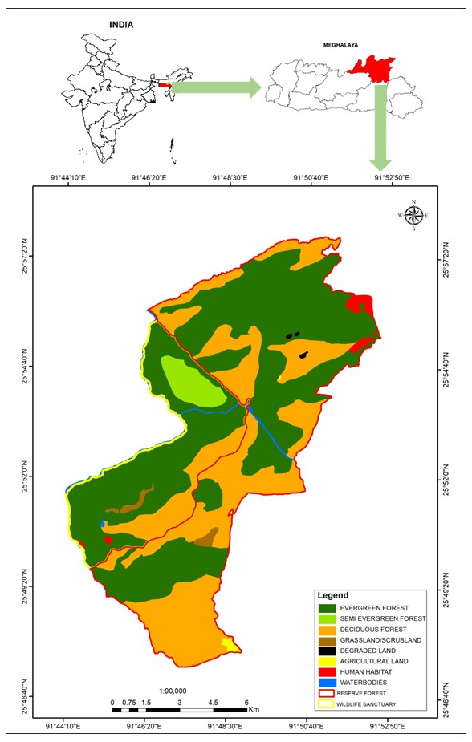

Figure 1: Nongkhyllem Wildlife Sanctuary and Reserved Forest in Meghalaya, India (Source: Meghalaya Forests and Environment Department)

RESULTS
Distribution and abundance
The study found seven adults with H. humeralis, of which two were males, while the remaining five were adult females. Based on their morphometric character (Fig. 2), their distribution is reported for the first time in Meghalaya state of northeast India. Details of their morphometric characters, abundance, and habitat use in Nongkhyllem Wildlife Sanctuary and Reserved Forest are described below. However, all the sightings were recorded between 199 – 597 m altitude and reported during the rainy season (May-August).

Morphological characteristics
The morphometric evaluation of H. humeralis revealed distinct sexual dimorphism, with males consistently exhibiting larger and more robust body parameters than females (Table 1). The average snout–vent length (SVL) was 46.41 mm, with males achieving a mean SVL of 58.8 mm (ranging from 55.3 to 62.3 mm), while females averaged 41.46 mm (ranging from 32.4 to 50.5 mm). Likewise, the axilla–groin distance (AG) was greater in males (9.40 mm; 8.3–10.5 mm) compared to females (6.70 mm; 5.2–7.6 mm), indicating a relatively longer trunk in males.

Head measurements indicate significant differences between the sexes. The mean head length (HL) was 5.25 mm (ranging from 4.0 to 6.5 mm) in males and 3.10 mm (ranging from 1.5 to 5.3 mm) in females, while head width (HW) measured 3.85 mm (ranging from 2.3 to 5.4 mm) in males and 1.98 mm (ranging from 0.8 to 3.0 mm) in females. The average snout length (SL) was 4.35 mm (ranging from 4.1 to 4.6 mm) in males, surpassing that of females (2.66 mm; ranging from 2.1 to 3.6 mm). Additionally, head depth at the nostril (HDN) and at the angle of the jaw (HD) were also greater in males, measuring 3.95 mm (ranging from 2.3 to 5.6 mm) and 6.35 mm (ranging from 4.2 to 8.5 mm), respectively, compared to 1.56 mm (ranging from 0.6 to 3.1 mm) and 3.98 mm (ranging from 2.7 to 6.1 mm) in females.

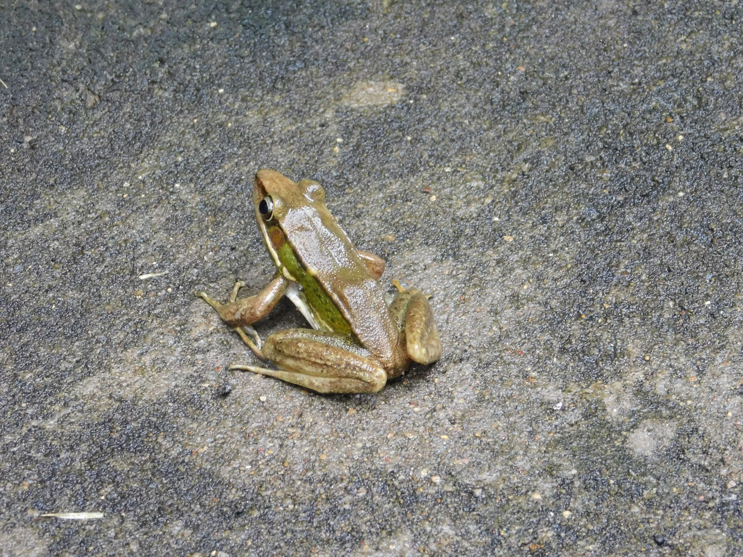 | 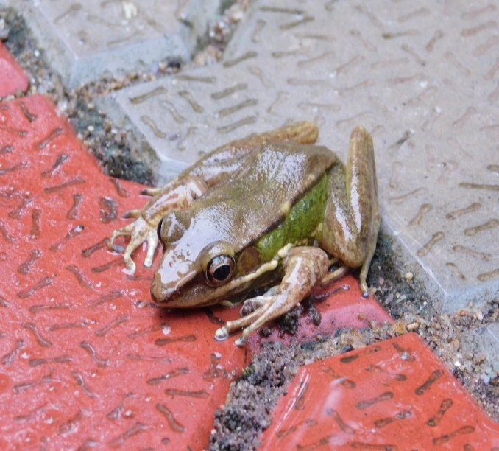
- Male | - Female
Fig 2: Humerana humeralis reported first time from Nongkhyllem Wildlife Sanctuary and Reserved Forest of Meghalaya, India

Cranial and facial distances further highlighted sexual dimorphism. The eye-to-nostril distance (EN) measured 5.50 mm (ranging from 3.2 to 7.8 mm) in males and 4.94 mm (ranging from 2.6 to 6.3 mm) in females, while the nostril-to-snout distance (NS) was 6.60 mm (ranging from 5.2 to 8.0 mm) in males and 3.74 mm (ranging from 2.5 to 4.7 mm) in females. The average eye diameter (ED) was 5.25 mm (ranging from 4.0 to 6.5 mm) in males and 2.88 mm (ranging from 1.6 to 3.8 mm) in females. The internarial space (INS) measured 5.45 mm (ranging from 5.3 to 5.6 mm) in males and 3.14 mm (ranging from 2.4 to 4.4 mm) in females, while the interorbital space (IOS) was 5.90 mm (ranging from 4.3 to 7.5 mm) in males and 2.60 mm (ranging from 1.7 to 3.2 mm) in females.

The distances between the anterior and posterior corners of the eyes were greater in males, with the inter-anterior eye (IAE) measured 5.75 mm (ranging from 5.0 to 6.5 mm) and the inter-posterior eye (IPE) measured 7.45 mm (ranging from 6.3 to 8.6 mm), in contrast to 4.30 mm (ranging from 3.6 to 4.8 mm) and 3.96 mm (ranging from 2.8 to 5.2 mm) in females. The width of the upper eyelid (UE) was also larger in males at 7.30 mm (ranging from 6.3 to 8.3 mm) compared to females at 5.72 mm (ranging from 4.2 to 7.5 mm). Measurements related to the mandible, including the distance from the mandible to the nostril (MN), the mandible to the front of the eye (MAE), and the mandible to the back of the eye (MPE), were consistently larger in males, measuring 8.90 mm, 11.75 mm, and 10.40 mm respectively, compared to females at 6.72 mm, 8.14 mm, and 6.62 mm respectively.

Tympanic and ocular structures were found to be developed in males. The distance from the eye to the tympanum (TE) was 9.40 mm (ranging from 8.3 to 10.5 mm) in males and 5.48 mm (ranging from 3.2 to 7.5 mm) in females. The horizontal diameter of the tympanum (HTYD) measured 6.65 mm (ranging from 6.2 to 7.1 mm) in males and 4.08 mm (ranging from 2.5 to 5.3 mm) in females, while the vertical diameter of the tympanum (VTYD) was 6.40 mm (ranging from 5.3 to 7.5 mm) in males and 3.82 mm (ranging from 2.7 to 5.0 mm) in females.

Table 1: Morphometric measurements for Humerana humeralis found in Nongkhyllem Wildlife Sanctuary and Reserved Forest of Meghalaya, India
Parameter | Present study |  | Previous studies
Parameter | Male | Female | NE India (Hussain et al., 2007) | Bangladesh (Al-Razi et al., 2014)
Snout–vent length (SVL) | 58.8 (55.3–62.3) | 41.46 (32.4–50.5) | 57.5–75.7 | 43.25
Axilla–groin (AG) | 9.40 (8.3–10.5) | 6.70 (5.2–7.6) | -- | --
Head length (HL) | 5.25 (4.0–6.5) | 3.10 (1.5–5.3) | 19.55–24.35 | 14.50
Head width (HW) | 3.85 (2.3–5.4) | 1.98 (0.8–3.0) | 17.60–24.15 | 13.35
Snout length (SL) | 4.35 (4.1–4.6) | 2.66 (2.1–3.6) | -- | --
Eye diameter (ED) | 5.25 (4.0–6.5) | 2.88 (1.6–3.8) | 5.70–8.70 | 4.85
Interorbital space (IOS) | 5.90 (4.3–7.5) | 2.60 (1.7–3.2) | -- | --
Tympanum diameter (HTYD) | 6.65 (6.2–7.1) | 4.08 (2.5–5.3) | 4.65–6.00 | 3.80
Forelimb length (FL) | 8.40 (7.3–9.5) | 5.88 (4.5–6.5) | 35.4–46.35 | --
Hand length (HAND) | 7.70 (6.8–8.6) | 4.64 (3.1–5.3) | -- | --
Hind limb length (HLL) | 9.40 (8.5–10.3) | 6.96 (5.1–9.2) | 98.8–133.5 | --
Tibia length (TBL) | 8.60 (7.4–9.8) | 6.22 (4.8–8.5) | 29.3–39.7 | --
Tibia width (TBW) | 3.45 (3.1–3.8) | 1.46 (0.6–2.3) | -- | --
Inner metacarpal tubercle (IMC) | 3.95 (3.8–4.1) | 2.70 (1.5–3.8) | 3.10–4.20 | --
Inner metatarsal tubercle (IMT) | 2.95 (2.7–3.2) | 1.50 (0.8–2.1) | 2.60–3.75 | --
Toe IV length (T4) | 5.95 (4.5–7.4) | 3.22 (2.3–4.5) | Longest toe reported | --

Appendicular measurements suggest that males possess longer and more robust limbs. The average forelimb length (FL) was 8.40 mm (ranging from 7.3 to 9.5 mm) in males and 5.88 mm (ranging from 4.5 to 6.5 mm) in females, while hand length (HAND) measured 7.70 mm (ranging from 6.8 to 8.6 mm) in males and 4.64 mm (ranging from 3.1 to 5.3 mm) in females. Individual finger lengths were consistently larger in males: the first finger (F1) measured 9.40 mm (ranging from 8.6 to 10.2 mm) compared to 6.74 mm (ranging from 5.2 to 7.4 mm) in females; the second finger (F2) measured 7.25 mm (ranging from 6.5 to 8.0 mm) versus 3.90 mm (ranging from 1.2 to 5.6 mm); the third finger (F3) measured 9.05 mm (ranging from 8.6 to 9.5 mm) compared to 5.54 mm (ranging from 3.2 to 7.4 mm); and the fourth finger (F4) measured 7.75 mm (ranging from 7.5 to 8.0 mm) versus 5.64 mm (ranging from 4.3 to 6.3 mm). The inner metacarpal tubercle (IMC) measured 3.95 mm (ranging from 3.8 to 4.1 mm) in males and 2.70 mm (ranging from 1.5 to 3.8 mm) in females, while the outer metacarpal tubercle (OMC) measured 10.25 mm (ranging from 9.1 to 11.3 mm) in males and 6.16 mm (ranging from 3.2 to 10.5 mm) in females.

The dimensions of the hind limbs exhibited a comparable trend. In males, the hind limb length (HLL) was recorded at 9.40 mm (ranging from 8.5 to 10.3 mm), while in females it measured 6.96 mm (with a range of 5.1 to 9.2 mm). The average tibia length (TBL) for males was 8.60 mm (7.4–9.8 mm), in contrast to 6.22 mm (4.8–8.5 mm) in females. Additionally, tibia width (TBW) was noted at 3.45 mm (3.1–3.8 mm) for males and 1.46 mm (0.6–2.3 mm) for females. Males also exhibited more pronounced supranumerary tubercles on their hands and feet, averaging 116.40 mm (111.3–121.5 mm), compared to 94.32 mm (78.6–108.2 mm) in females.

Toe measurements further illustrated sexual dimorphism. The lengths of the first to fifth toes in males were 7.05 mm (T1), 7.55 mm (T2), 7.45 mm (T3), 5.95 mm (T4), and 6.65 mm (T5), whereas in females, these measurements were 5.20 mm, 4.66 mm, 4.00 mm, 3.22 mm, and 5.16 mm, respectively. The maximum width of the disc on the fourth toe (T4D) was 5.80 mm (5.1–6.5 mm) in males, while in females it was 3.14 mm (1.6–4.7 mm). The inner metatarsal tubercle (IMT) measured 2.95 mm (2.7–3.2 mm) in males and 1.50 mm (0.8–2.1 mm) in females.

The analysis of morphometric data distinctly reveals that H. humeralis displays significant sexual dimorphism, with males exhibiting larger body sizes, broader heads, well-developed tympanic structures, and longer limbs and digits compared to females. These characteristics are possibly associated with reproductive behaviour and ecological adaptations.

Habitat use pattern
Out of the total seven sightings, H. humeralis was observed utilizing the Evergreen forest (EVG) at a rate of 57.1%, followed by the Semi-evergreen forest (SEVG) at 42.9%. However, no individual was recorded in Deciduous Forest (DF), Wetlands/Water Bodies (WB), or Agricultural land (AG). This pattern of habitat utilization suggests a significant association with intact evergreen and semi-evergreen forest ecosystems, underscoring the species' dependence. Further, their habitat selectivity pattern also demonstrated a significantly positive selectivity value of 36.38%, indicating an active preference for Semi-evergreen forest (Fig. 3). In contrast, all other habitats exhibited negative selectivity values, implying a tendency to avoid them. Deciduous forest (DF) recorded the most pronounced negative selectivity at –31.63, highlighting a clear avoidance of disturbed habitats. Evergreen forest (EVG) at –1.29, grasslands (GL) at –0.99, water bodies (WB) at –1.01, and agricultural land (AG) at –0.43, suggesting a low to moderate level of avoidance. Overall, the finding indicates that H. humeralis is a habitat specialist with a strong preference for semi-evergreen forests and a limited tolerance for degraded or non-forest habitats.

Fig. 3: Habitat selectivity patterns of Humerana humeralis in Nongkhyllem Wildlife Sanctuary and Reserved Forest of Meghalaya, India
EVG: Evergreen Forest, SEVG: Semi-evergreen Forest, DF: Deciduous Forest,
GL: Grassland, AG: Agricultural land, WB: Water bodies

DISCUSSION
Humerana humeralis is confined to northeastern India, with verified sightings exclusively from states that are either within or neighboring the Indo-Burma and Eastern Himalayan areas. This broad distribution indicates a considerable level of ecological adaptability, allowing the species to thrive in various climatic conditions, ranging from humid tropical lowlands to subtropical hill forests. Although they are regarded as locally abundant in several states, especially in Assam state of India, their distribution is reported to be sporadic in fragmented forest areas, particularly where freshwater habitats have been modified or degraded (Stuart et al., 2008; Rowley et al., 2010). The present distribution record of H. humeralis from Nongkhyllem is perhaps the first ever record of its distribution from Meghalaya state of India, likely due to having rolling plains, gentle hills, and a system of perennial streams and ponds that align with the lentic and lotic microhabitats favoured by them. In terms of altitude, H. humeralis has been recorded from near sea level to about 1,200–1,500 meters above sea level, although most observations are concentrated in low- to mid-elevation areas (IUCN SSC Amphibian Specialist Group, 2020). Within this altitude range, its population density can fluctuate significantly based on habitat quality, hydrological conditions, and human-induced disturbances.

Morphometric and habitat assessments from Nongkhyllem align with earlier published data from northeast India and Bangladesh, suggesting that local populations exhibit the same set of diagnostic traits (sturdy limbs, well-formed tympanum, and enlarged toe discs), although absolute size may differ regionally. Such size discrepancies have been documented before and are likely indicative of geographic and sampling variations rather than taxonomic distinctions.

The present morphometric study of H. humeralis offers crucial insights for identifying species, evaluating sexual dimorphism, with males consistently larger and more robust than females across the majority of morphometric measurements. This trend is well established in Ranid frogs and is typically linked to reproductive behavior, territoriality, and mating strategies (Duellman and Trueb, 1994; Wells, 2007). In H. humeralis, morphometric measurements have been extensively utilized to differentiate it from related species within the genus Humerana and other Ranid taxa, as well as to assess geographic variation throughout its extensive distributional range (Chanda, 2002; Dinesh et al., 2020). The most frequently reported measurement is snout–vent length (SVL), which acts as an indicator of overall body size. In H. humeralis, adult SVL typically varies from moderate to large, with females generally achieving larger body sizes compared to males (Chanda, 2002; Sengupta et al., 2010). Limb measurements, especially tibia length and foot length, hold ecological significance as they indicate adaptations for movement in semi-aquatic and stream-associated environments (Inger, 1966; Emerson, 1978). Head dimensions, such as head length, head width, snout length, and eye diameter, are critical diagnostic features and may exhibit slight variation among populations living in different environmental contexts. This variation has been linked to ecological factors, including the availability of prey and the structure of microhabitats (van Bocxlaer et al., 2010). Overall, morphometric data enhance both taxonomic clarity and ecological understanding of H. humeralis populations throughout its distribution.

On a larger scale, the morphometric differences observed among populations may indicate local environmental factors, such as altitude, hydrology, and habitat structure. This variation highlights the necessity of integrating morphometric data into ecological and conservation research, especially when evaluating population health and adaptive capacity in evolving environments (van Bocxlaer et al., 2010; Watters et al., 2016). The morphometric characteristics of H. humeralis are intricately associated with its semi-aquatic behaviour. The relatively elongated hind limbs and well-formed feet enhance its swimming and jumping abilities along the edges of streams, while the moderate dimensions of the head and snout align with a general insectivorous feeding habit (Inger, 1966; Emerson, 1978). The presence of sexual dimorphism, where females achieve a greater snout-vent length (SVL), is likely connected to higher fecundity, a trend commonly observed in anuran species (Shine, 1979).

As the species inhabits both primary evergreen and semi-evergreen forests, as well as secondary and regenerating forests, indicating a certain level of tolerance to moderate habitat disturbance (Pawar and Birand, 2001; Sengupta et al., 2010). They exhibit a strong ecological affinity for freshwater-dependent environments, particularly those associated with lotic and lentic systems. This species is most commonly found in riparian forest with stream edges, riverbanks, forest pools, ponds, marshes, and temporary rain-fed water bodies (Inger, 1966; Chanda, 2002). These habitats are essential for breeding, larval development, and adult foraging. Hence, they were commonly found in shaded stream corridors and damp forest floors, where individuals are frequently seen resting among leaf litter, beneath vegetation cover, or on low shrubs near water bodies. Occasionally, they are also found in human-altered environments, such as agricultural fields, tea plantations, roadside ditches, and village ponds, as long as sufficient moisture and breeding sites are present. However, their breeding success and population density in these habitats may be lower than in undisturbed forest ecosystems, primarily due to water pollution, agrochemical runoff, and changes to natural hydrology (Stuart et al., 2008; Dinesh et al., 2020).

Conclusion
From a conservation standpoint, the occurrence of H. humeralis in the well-protected Nongkhyllem Wildlife Sanctuary is promising; however, ongoing threats in Nongkhyllem Reserve Forest, such as land-use changes in the adjacent landscape and proposed ecotourism initiatives, could impact the hydrology, and evergreen and semi-evergreen forests are crucial for breeding. Therefore, it is advisable to continue monitoring their population sizes, breeding locations, and habitat quality to ensure their long-term survival.

Disclaimer (Artificial Intelligence)
Authors hereby declare that no generative AI technologies such as Large Language Models (ChatGPT, COPILOT, etc.) and text-to-image generators have been used during the writing or editing of this manuscript.

References
Al Razi, H., Baki, M. A., & Alam, S. M. I. (2014a). Record of Humerana humeralis (Boulenger, 1887) from Rangpur District of north-western Bangladesh. Bangladesh Journal of Zoology, 42(2): 277–282.
Al-Razi, H., Rahman, M. M., & Howlader, M. S. A. (2014b). First record of Humerana humeralis from Bangladesh with notes on external morphology. Journal of Threatened Taxa, 6(7): 6025–6029. https://doi.org/10.11609/JoTT.o3565.6025-6029
Ao, J. M., Bordoloi, S., & Ohler, A. (2003). Amphibian fauna of Nagaland with nineteen new records from the state including five new records for India. Zoo’s Print Journal, 18(6): 1117–1125.
Boulenger, G. A. (1887). An account of the batrachians obtained in Burma by M. L. Fea of the Genova Civic Museum. Annali del Museo Civico di Storia Naturale di Genova, Series 2, 5: 418–424.
Boulenger, G. A. (1890). The fauna of British India, including Ceylon and Burma: Reptilia and Batrachia. Taylor and Francis, London.
Chanda, S. K. (2002). Handbook of Indian amphibians. Zoological Survey of India, Kolkata.
Chetia, M., Sharma, D. K., & Sengupta, S. (2014). Amphibian diversity of wetlands of Bongaigaon District of Assam with a note on the morphometric characters of Duttaphrynus melanostictus. International Journal of Research Studies in Biosciences, 2(6): 26–32.
Crump, M. L., & Scott, N. J. Jr. (1994). Visual encounter surveys. In: W. R. Heyer, M. A. Donnelly, R. W. McDiarmid, L. A. C. Hayek, & M. S. Foster (Eds.), Measuring and monitoring biological diversity: Standard methods for amphibians. Smithsonian Institution Press, Washington DC, pp. 84–92.
Deuti, K., Ray, S., Bag, P., & Dey, S. K. (2017). Amphibians of the Duars area of northern West Bengal. Records of the Zoological Survey of India, 117(3): 221–241. https://doi.org/10.26515/rzsi/v117/i3/2017/120966
Dinesh, K. P., Radhakrishnan, C., Channakeshavamurthy, B. H., Deepak, P., & Kulkarni, N. U. (2020). A checklist of amphibians of India with IUCN conservation status. Zoological Survey of India, Kolkata.
Dubois, A. (1974). Diagnostic characters and taxonomy in amphibians. Journal of Herpetology, 8(3): 213–241.
Duellman, W. E., & Trueb, L. (1994). Biology of amphibians. Johns Hopkins University Press, Baltimore.
Emerson, S. B. (1978). Allometry and jumping in frogs: Helping the twain to meet. Evolution, 32(3): 551–564. https://doi.org/10.2307/2407722
Frost, D. R. (2008). Amphibian species of the world: An online reference, Version 5.2. American Museum of Natural History, New York, USA.
Frost, D. R. (2024). Amphibian species of the world: An online reference. American Museum of Natural History, New York, USA.
Heyer, W. R., Donnelly, M. A., McDiarmid, R. W., Hayek, L. A. C., & Foster, M. S. (Eds.). (1994). Measuring and monitoring biological diversity: Standard methods for amphibians. Smithsonian Institution Press, Washington DC.
Hussain, B., Bordoloi, S., Ohler, A., & Sengupta, S. (2007). Rana humeralis—a new record for India with notes on morphology. Zoo’s Print Journal, 22(4): 2659–2662.
Inger, R. F. (1966). Adaptations of amphibians to stream environments. Fieldiana: Zoology, 52: 1–402.
Inger, R. F., & Stuebing, R. B. (2005). A field guide to the frogs of Borneo. Natural History Publications (Borneo), Kota Kinabalu.
IUCN SSC Amphibian Specialist Group. (2020). Humerana humeralis. The IUCN Red List of Threatened Species. Version 2020. https://doi.org/10.2305/IUCN.UK.2020-3.RLTS.T58638A14799367.en
Naniwadekar, R., & Vasudevan, K. (2014). Patterns of amphibian diversity and distribution in the Western Ghats of India. Current Science, 107(3): 430–439.
Neog, N. (2016). Anuran diversity in and around historic Joysagar Tank of Sivasagar District, Assam. Journal of Entomology and Zoology Studies, 4(5): 512–515.
Ningombam, B., & Bordoloi, S. (2007). Amphibian fauna of Loktak Lake, Manipur, India, with ten new records for the State. Zoo’s Print Journal, 22: 2688–2690.
Pawar, S. S., & Birand, A. C. (2001). A survey of amphibians, reptiles, and birds in Northeast India. CERC Technical Report 6: 1–50.
Purkayastha, J. (2012). Showcasing urban herpetofauna: A conservational effort through community participation. Final report submitted to the Rufford Foundation.
Rowley, J. J. L., Brown, R. M., Bain, R. H., Kusrini, M. D., Inger, R. F., Stuart, B. L., Wogan, G. O. U., Thy, N., Chan-ard, T., Trung, C. T., Diesmos, A. C., Iskandar, D. T., Lau, M. W. N., Ming, L. T., Makchai, S., Truong, N. Q., & Phimmachak, S. (2010). Impacts of habitat loss on amphibians in Southeast Asia. Biodiversity and Conservation, 19: 3057–3075. https://doi.org/10.1007/s10531-010-9872-3
Roy, J. K., Begum, R. H., & Ahmed, M. F. (2018). Amphibians of the Dibang River Basin, Arunachal Pradesh: an annotated checklist with distribution records. Journal of Threatened Taxa, 10(15): 12940–12952. https://doi.org/10.11609/jott.4249.10.15.12940-12952
Schleich, H. H., & Kästle, W. (2002). Amphibians and reptiles of Nepal. A.R.G. Gantner Verlag, Ruggell, Liechtenstein. Pp. 1201.
Sen, A., Mukherjee, A., & Das, N. (2022). A survey on premating and mating behaviour of Humerana humeralis Boulenger, 1887. EC Veterinary Science, 7(2): 20–26.
Sengupta, S., Hussain, A., Choudhury, N. K., Gogoi, K., Ahmed, M. F., & Choudhury, N. K. (2010). Amphibian fauna of northeastern India. Records of the Zoological Survey of India, Occasional Paper 296: 1–111.
Shine, R. (1979). Sexual selection and sexual dimorphism in the Amphibia. Copeia, 1979(2): 297–306. https://doi.org/10.2307/1443801
Stuart, S. N., Hoffmann, M., Chanson, J. S., Cox, N. A., Berridge, R. J., Ramani, P., & Young, B. E. (2008). Threatened amphibians of the world. Lynx Edicions, Barcelona.
van Bocxlaer, I., Loader, S. P., Roelants, K., Biju, S. D., Menegon, M., & Bossuyt, F. (2010). Gradual adaptation toward a range-expansion phenotype initiated the global radiation of toads. Science, 327(5966): 679–682. https://doi.org/10.1126/science.1182858
Watters, J. L., Cummings, S. T., Flanagan, R. L., & Siler, C. D. (2016). Review of morphometric measurements used in anuran studies. Herpetological Review, 47(4): 521–532.
Wells, K. D. (2007). The ecology and behavior of amphibians. University of Chicago Press, Chicago. https://doi.org/10.7208/chicago/9780226893334.001.0001

