Original Research Article

Isolation and Identification of Bacterial Pathogens in Poultry Liver from Post-mortem Specimens Using the VITEK® 2 Compact System

Abstract:
Introduction: Bacterial liver infections in poultry cause significant mortality and economic losses, with pathogens like Escherichia coli, Salmonella, and Pasteurella multocida implicated in sepsis, necrosis, and systemic disease.The use of the VITEK® 2 system enabled rapid identification and susceptibility testing of the pathogens, contributing to a better understanding of microbial threats in poultry production. The findings emphasize the significance of bacterial sepsis as a cause of mortality in broilers and highlight the importance of rapid diagnostic techniques in veterinary practice.
Aim:This study aimed to isolate and identify bacterial pathogens in post-mortem poultry liver specimens and assess their antimicrobial resistance profiles.
Methodology: Seventy-five liver samples were aseptically obtained and subjected to microbiological examination involving homogenization, culturing on selective media, and subsequent identification using the VITEK® 2 Compact System. This automated system facilitated accurate biochemical profiling and antimicrobial susceptibility testing of isolated organisms. Liver samples were collected aseptically during necropsy, homogenized in peptone water (1:10 ratio), and cultured on selective media (MacConkey, MSA, EMB). Isolates were identified and tested for antimicrobial susceptibility using the VITEK® 2 Compact System.
Results: The results revealed that 68% of the examined liver samples had high bacterial loads (≥10⁶ CFU/g), indicating significant microbial involvement in the birds' mortality. Among the isolates, Escherichia coli was the most frequently detected bacterium (42%), followed by Klebsiella spp. (28%) and Staphylococcus aureus (5%). Interestingly, no bacterial growth was observed in 25% of the samples,identified E. coli , Staphylococcus aureus, and Klebsiella pneumoniae as predominant pathogens. E. coli exhibited resistance to beta-lactams (e.g., ampicillin, piperacillin) and fluoroquinolones (ciprofloxacin) but susceptibility to carbapenems (imipenem, meropenem), aminoglycosides (amikacin, gentamicin), and tigecycline. K. pneumoniae isolates showed multidrug resistance (including to fluoroquinolones and trimethoprim-sulfamethoxazole) but remained susceptible to carbapenems and aminoglycosides. S. aureus was methicillin-sensitive but resistant to moxifloxacin and fusidic acid.
Conclusion:The study concludes that automated systems like VITEK® 2 enable rapid, targeted therapy and antimicrobial stewardship, crucial for mitigating poultry mortality and combating resistance linked to bacterial liver sepsis. This study underlines the necessity of improving diagnostic capabilities and monitoring resistance patterns to enhance poultry health, reduce losses, and maintain food safety standards in commercial poultry operations.
Keywords: Poultry Liver, Bacterial Sepsis, VITEK® 2 Compact System, Escherichia coli, Antimicrobial, Resistance, Broiler Mortality
Introduction
The liver is one of the vital organs in the poultry body, as it performs essential functions such as metabolism, detoxification, and protein synthesis. However, the liver is often susceptible to many bacterial diseases that negatively affect the health and productivity of birds. Bacterial diseases affecting the liver pose a major threat to livestock, as they lead to huge economic losses due to high mortality rates, decreased productivity, and treatment and prevention costs.
Among the bacterial diseases in chicken liver, infection with Escherichia coli (E. coli) is the most common infection. The organism causes hepatitis, which presents itself in the form of liver inflammation and necrosis, leading to overall weakness in the health of birds and lower growth rates (1).
Salmonella bacteria are also the main source of poultry liver infection, leading to acute liver inflammation that can lead to mortality of birds if not treated early and efficiently (2).
In addition, Pasteurella multocida is the major cause of fowl cholera, which manifests as acute liver inflammation with hemorrhage and destruction of liver tissue. The disease is highly contagious and can result in tremendous loss in bird population if not checked (3).
Bacterial liver disease symptoms in poultry birds are dullness, loss of appetite, decreased egg production, and diarrhoea. Coloration and form of the liver also alter upon autopsy, e.g., swelling, haemorrhage, or necrotic foci,These bacterial diseases are extremely hazardous to livestock, not only because of their immediate impact on bird health, but also because of their ability to spread extremely fast among flocks, which cause widespread outbreaks of the disease. Therefore, knowledge about the nature of
such diseases, symptoms, and prevention and treatment processes is very crucial to maintain the flocks' health and productivity (4).

We will elaborate in this study the most prominent bacterial poultry liver diseases, in reference to the causative bacteria types, clinical signs, its Affect on livestock, and current prevention and treatment methods.

Materials and Methods
Ethical Approval
This study was conducted in conformity with the rules of the Animal Ethics Committee of the Faculty of Veterinary Medicine at the University of Kufa (license number: 27885 in 13/12/2024).

3.1 Sample Collection
Sample collection from poultry liver during postmortem examination involves a systematic and aseptic approach to achieve proper diagnostic findings. Following euthanizing the bird, the carcass is positioned in a supine position, and a midline incision is performed to open the abdominal cavity. The liver is identified cautiously and inspected for any visible lesions, discoloration, or abnormalities. Using sterile instruments, a small section of the liver tissue, both involved and uninvolved if present, is taken and collected in an labeled, sterile container with a suitable preservative (e.g., 10% formalin for histopathology or sterile transport medium for microbiological examination). Proper labeling, including the bird’s identification, date, and sample type, is essential. The sample is then taken immediately to the laboratory under the right conditions to retain its integrity for additional analysis.
3.2 Bacterial Isolation
Homogenization of liver tissue in peptone water in a 1:10 ratio is a standard procedure
utilized in microbiology and biochemistry to ready tissue samples for additional analysis
(5).
Materials Needed:
• Liver tissue sample
• Peptone water (0.1% peptone in water)
• Mechanical homogenizer, blender, or mortar and pestle
• Sterile test tubes
• Pipettes
• Weighing scale
• surgical scalpels or sterile scissors
• Other types of personal protective equipment (PPE) and mask or gloves
Procedure:
Preparation: Sterilize all containers and equipment to prevent contamination. Put on the appropriate PPE which includes gloves and a laboratory coat.
Weigh the Tissue: Use a weighing balance to measure the liver tissue sample accurately.
Determine the amount of peptone water required to achieve a 1:10 ratio (for example, 1 gram of liver tissue to 10 mL peptone water) (6).
Tissue Cutting : Use a sterile scalpel to cut the liver tissue into small pieces as necessary for homogenization (7).Homogenization: Place the chopped liver tissue in the homogenizer and add the measured amount of peptone water. Homogenize the mixture thoroughly to get a uniform suspension.
3.3 Culture
Streaking liver tissue homogenate onto selective and differential agar media such as
MacConkey agar, Mannitol Salt Agar (MSA), and Eosin Methylene Blue (EMB) agar is a
standard microbiological method to separate and identify particular kinds of bacteria
(8).
Materials Needed:
• Liver tissue homogenate
• MacConkey agar plates
• Mannitol Salt Agar (MSA) plates
• Eosin Methylene Blue (EMB) agar plates
• Sterile streaking tool or inoculating loop
• Alcohol lamp or Bunsen burner
• Incubator (35–37°C)
• Marker for labeling plates
• Personal protective equipment (PPE)

Procedure:
Preparation: Mark the agar plates with the name of the sample, date, and agar type. Sterilize
the inoculating loop with flame and let it cool (9).
Streaking: Streak the homogenate in a zigzag pattern using a sterile loop. Apply the quadrant streaking method and repeat for each type of agar plate (10).
Incubation: Invert the plates and incubate at 35–37°C for 18–24 hours (11).
Observation: Inspect plates for colony morphology and agar color changes.
Interpretation: MacConkey Agar selects for Gram-negative bacteria and distinguishes lactose fermenters (12).
Results
The results obtained from various culture media and antimicrobial susceptibility testing using the VITEK® 2 Compact System are as follows:
MacConkey Agar Results
Lactose fermenters (e.g., E. coli, Klebsiella): Pink to red colonies with a surrounding pink halo (due to acid production). Non-lactose fermenters (e.g., Salmonella, Shigella, Pseudomonas): Colorless or transparent colonies. No growth: Indicates the absence of Gram-negative bacteria or inhibition by bile salts and crystal violet (13).
Mannitol Salt Agar (MSA) Results
Mannitol fermenters (e.g., Staphylococcus aureus): Yellow colonies with a yellow halo. Non-mannitol fermenters (e.g., Staphylococcus epidermidis): Pink or red colonies. No growth: Indicates absence of salt-tolerant bacteria (14).
Eosin Methylene Blue (EMB) Agar Results
Strong lactose fermenters (e.g., E. coli): Metallic green sheen. Weak lactose fermenters (e.g., Enterobacter, Klebsiella): Pink or purple colonies. Non-lactose fermenters: Colorless or transparent colonies (15).
Figure (1) : E.coli on EMB agar
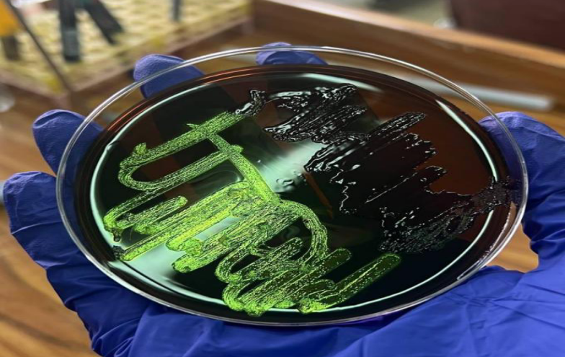

Figure (2) : Klebsiella spp.on Macconky agar
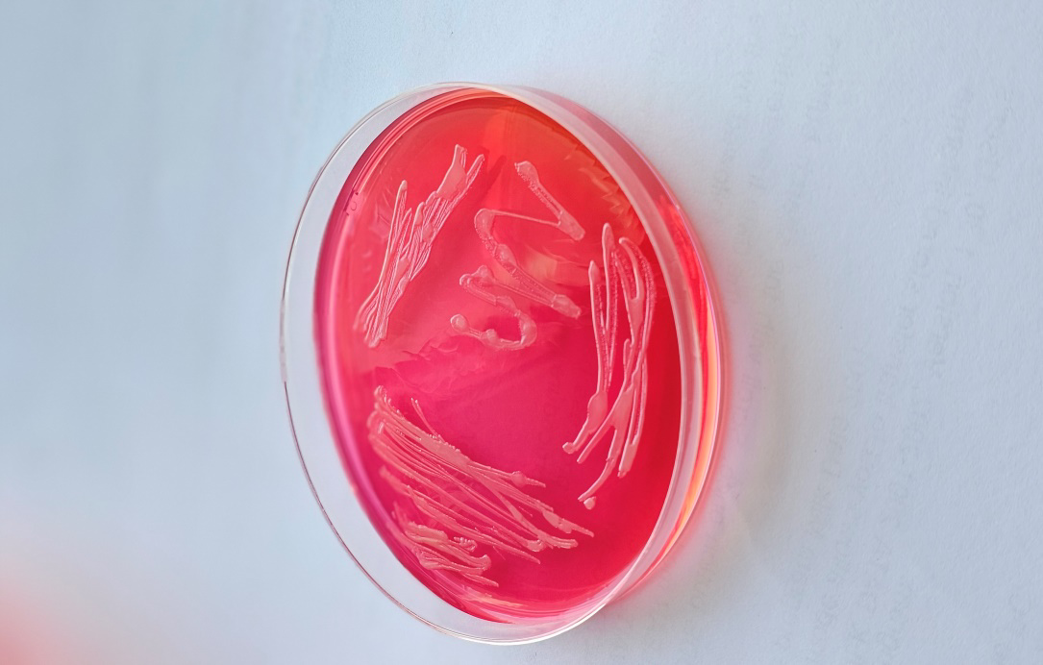

Figure( 3): Staphylococcus aureus on Eosin mathelin blue.
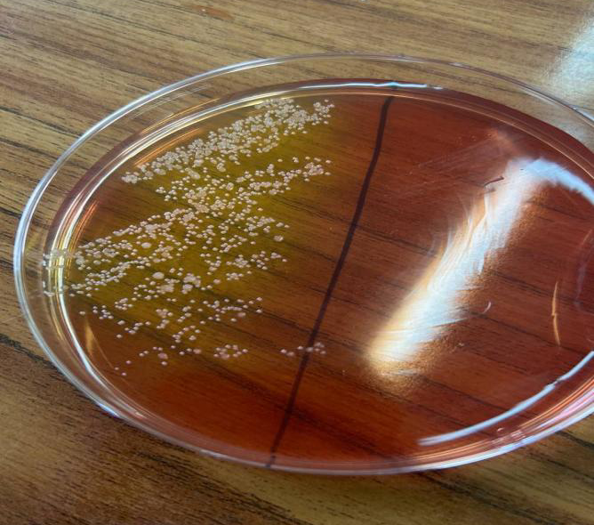

VITEK® 2 Analysis and Antimicrobial Susceptibility Testing
The VITEK® 2 system demonstrated its effectiveness in identifying bacterial isolates and their resistance patterns. The AST-N334 cards used identified Escherichia coli, Staphylococcus aureus, and Klebsiella pneumoniae with high accuracy.
In (Table 1)VITEK® antimicrobial susceptibility results for Escherichia coli show resistance to various beta-lactam antibiotics and fluoroquinolones, but susceptibility to carbapenems, aminoglycosides, and tigecycline, supporting their use in clinical therapy.
Table 1: Escherichia coli Antimicrobial Susceptibility Profile
Antimicrobial Agent | MIC | Interpretation
Ampicillin |  | R
Amoxicillin/Clavulanic Acid
Ampicillin / Sulbactam | <=2 | S
Ticarcillin |  | R
Ticarcillin /Clavulanic Acid |  | R
Piperacillin |  | R
Piperacillin/Sulbactam |  | R
Piperacillin/Tazobactam | <=4 | S
Cefotiam |  | R
Cefoxitin |  | R
Cefixime |  | R
Cefotaxime | 1 | S
Ceftazidime | 32 | R
Ceftazidime/Avibactam | >=16 | R
Ceftolozane/Tazobactam | 8 | S
Cefepime | 0.5 | S
Cefpirome |  | R
Cefquinome |  | R
Imipenem | <=0.25 | S
Meropenem | <=0.25 | S
Amikacin | <=1 | S
Gentamicin | <=1 | S
Ciprofloxacin | >=4 | R
Tigecycline | <0.5 | S
Trimethoprim/Sulfamethoxazole | <=20 | S

In( Table 2) The susceptibility profile of Staphylococcus aureus shows resistance to Moxifloxacin and Fusidic Acid. However, susceptibility to Oxacillin and Linezolid indicates a methicillin-sensitive strain. Absence of inducible clindamycin resistance is favorable.
Table 2: Staphylococcus aureus Antimicrobial Susceptibility Profile
Antimicrobial Agent | MIC | Interpretation
Cefoxitin Screen | NEG | -
Oxacillin | <= 0.25 | S
Linezolid | 2 | S
Tetocplanin | <= 0.5 | S
Tigecycline | <= 0.12 | S
Rifampicin | <= 0.5 | S
Moxifloxacin | 4 | R
Fusidic Acid | 16 | R
Inducible Clindamycin Resistance | NEG | -

In (Table 3) Klebsiella pneumoniae shows multidrug resistance to fluoroquinolones and beta-lactam antibiotics. However, it remains susceptible to carbapenems and aminoglycosides, indicating possible treatment options.
Table 3: Klebsiella pneumoniae Antimicrobial Susceptibility Profile (1)
Antimicrobial Agent | MIC | Interpretation
Ampicillin | R | R
Ampicillin/ Subactam | 16 | R
Ticarcillin | R | R
Piperacillin/ tazobactam | 32 | I
Norfloxacin | R | R
Moxifloxacin | R | R
Lomefloxacin | R | R
Levofloxacin | R | R
Gatifloxacin | R | R
Ciprofloxacin | >=4 | R
Fleroxacin | R | R
Trimethoprim/Sulfamethoxazole | >=320 | R
Ceftolozane/ Tazobactam | <=0.12 | S
Cefotiam | S | S
Cefotaxime | <=0.25 | S
Ceftazidime | S | S
Ceftazidime/Avibactam | 0.25 | S
Ceftolozane/Tazobactam | 0.5 | S
Cefepime | <=0.12 | S
Amikacin | S | S
Doripenem | S | S
Ertapenem | S | S
Imipenem | <=0.25 | S
Meropenem | <=0.25 | S
Gentamicin | S | S
Netilmicin | S | S

In (Table 4) A second Klebsiella pneumoniae isolate demonstrates extensive drug resistance, particularly to fluoroquinolones and trimethoprim. Carbapenems and aminoglycosides continue to be effective therapeutic options.
Table 4: Klebsiella pneumoniae Antimicrobial Susceptibility Profile (2)
Antimicrobial Agent | MIC | Interpretation
Ampicillin | R | R
Ampicillin /Sulbactam | 16 | R
Piperacillin | R | R
Cefazolin | I | I
Ciprofloxacin | >=4 | R
Fleroxacin | R | R
Gatifloxacin | R | R
Lomefloxacin | R | R
Moxifloxacin | R | R
Norfloxacin | R | R
Tigecycline | 1 | S
Trimethoprim | R | R
Trimethoprim/Sulfamethoxazole | >=320 | R
Cefixime | S | S
Cefotaxime | S | S
Ceftazidime | S | S
Ceftriaxone | S | S
Ceftazidime/Avibactam | >=16 | S
Ceftolozane/Tazobactam | <0.25 | S
Doripenem | S | S
Ertapenem | S | S
Imipenem | <=0.25 | S
Meropenem | 1 | S
Meropenem/Vaborbactam | S | S
Amikacin | 2 | S
Gentamicin | <=1 | S
Netilmicin | S | S

Discussion
High bacterial loads in poultry flocks are closely associated with acute mortality events, as they often indicate severe infections that can overwhelm avian immune defenses. Once bacterial concentrations surpass critical levels, they can induce systemic infections such as septicemia and multiple organ dysfunction, particularly involving the liver (16). Pathogens including Escherichia coli, Klebsiella spp., and Staphylococcus aureus are frequently implicated in such outbreaks and are known to rapidly disseminate in compromised environments, leading to widespread mortality and significant economic losses.
E. coli, particularly avian pathogenic strains (APEC), remains the most prevalent agent in poultry septicemia, often responsible for colibacillosis with complications such as hepatomegaly, necrosis, and perihepatitis (17). Klebsiella pneumoniae has also been increasingly recognized as a causative agent of systemic infections in poultry, exploiting immunocompromised conditions, poor sanitation, or antibiotic misuse. The inception of multi-drug resistant forms of these pathogenic bacterial poses a serious threat due to limited treatment options and increased hazard of uncontrolled epidemics (18).
The VITEK® 2 system revolutionizes the way we identify microbes and test for antibiotic susceptibility, making these processes not just faster but also more precise. While traditional culture-based methods can stretch out over five grueling days, VITEK® 2 swoops in with accurate results in a mere 8 to 12 hours (19). This remarkable reduction in time is nothing short of vital for various sectors, especially agriculture and medicine, where timely and effective treatment can mean the difference between life and death. The system isn’t just quick; it also showcases a wide-ranging biochemical panel that allows it to pinpoint resistance mechanisms, such as extended-spectrum beta-lactamases (ESBLs) and carbapenemases (20). Yet, amidst this technological advancement, a dark cloud looms—the menace of antimicrobial resistance (AMR). This challenge is particularly acute in both veterinary medicine and public health arenas. In the poultry sector, for instance, lurking pathogens can lead to disastrous treatment failures, skyrocketing costs, and the unsettling possibility of zoonotic transmission (21). The situation is further complicated by rampant antibiotic abuse and careless management in livestock operations, where weak biosecurity protocols fuel the flames of the AMR crisis (20). Factors like poor biosecurity, inadequate hygiene practices, and the absence of effective vaccination strategies only serve to amplify these risks, adding urgency to an already critical situation.
Conclusion
Bacterial infections pose a serious threat to the poultry liver, often leading to sepsis that can tragically result in the death of these birds. Why? Because the liver plays a crucial role in purification, metabolism, and regulating the immune system. When infections strike, particularly from pesky culprits like E. coli, Klebsiella spp., and Staphylococcus aureus, the consequences can spiral into systemic dissemination, liver necrosis, and even multiorgan failure. But thankfully, we have tools like the VITEK® 2 system, along with other automated mechanisms, making it possible to diagnose these issues quickly and accurately. This kind of timely intervention is vital for administering targeted antibiotic therapy when it counts the most. What’s remarkable about the VITEK® 2 system is its proficiency not just in identifying bacterial species but also in assessing their antimicrobial susceptibility. This capability is a game changer for targeted therapies and bolstering antimicrobial stewardship. By using this advanced technology, we can significantly curb outbreaks, reduce mortality rates, and ultimately boost poultry productivity. Yet, let’s not forget that while tools like VITEK® 2 are invaluable, they shouldn't be our sole strategy. Emphasizing good hygiene practices, keeping vigilant surveillance, and being smart about antibiotic usage are fundamental to combatting antimicrobial resistance and ensuring food safety for everyone.

References
- Christensen, J. P., & Bisgaard, M. (2000). Fowl cholera. Revue Scientifique et Technique, 19(2), 626–637. https://doi.org/10.20506/rst.19.2.1236
- Gast, R. K., & Porter, R. E. (2020). Salmonella infections. In D. E. Swayne (Ed.), Diseases of Poultry (14th ed.). Wiley-Blackwell. https://doi.org/10.1002/9781119371199.ch16
- Nolan, L. K., Barnes, H. J., Vaillancourt, J. P., Abdul-Aziz, T., & Logue, C. M. (2013). Colibacillosis. In Diseases of Poultry (13th ed., pp. 751-805). Wiley-Blackwell. https://doi.org/10.1002/9781119421481.ch18
- Shivaprasad, H. L. (2000). Fowl typhoid and pullorum disease. Revue Scientifique et Technique de l'OIE, 19(2), 405–424. https://doi.org/10.20506/rst.19.2.1222
- Entis, P. (2002). The Microbiology of Raw Foods. Aspen Publishers, Inc.
- Hook, A. E. (1940). Peptone water as a medium for biological preparations. Journal of Hygiene.
- Dzobo, K., Motaung, K. S., & Adesida, A. (2019). Regenerative Medicine and Tissue Engineering. IntechOpen.
- MOHAMED, M. O. (2017). Diagnostic Bacteriology. Sudan Journal of Medical Sciences.
- Murugalatha, N., Growther, H., & Hena, M. (2022). Advances in Laboratory Diagnostics. Academic Press.
- Tagesu, A. (2018). Microbiological Techniques Manual. Ethiopian Public Health Institute.
- Parumasivam, T., Riazi, M., & Mohamad, S. (2024). Clinical Microbiology Practices. Malaysian Journal of Medical Sciences.
- U.S. Department of Agriculture, Food Safety and Inspection Service. (2015). *Microbiology Laboratory Guidebook*. Food Safety and Inspection Service. https://www.fsis.usda.gov/science/laboratories-procedures/microbiology-laboratory-guidebook
- Smith, A. L., Powers, C., & Beal, R. K. (2022). Pathogen load and immune response in poultry mortality. Avian Pathology, 51(2), 145-152.
- Kunert Filho, H. C., Brito, W. M. E. D., Cavalli, L. S., & Brito, B. G. D. (2015). Isolation and pathogenicity of Klebsiella spp. in poultry. Brazilian Journal of Poultry Science, 17(3), 361-367.
- Wiener, E., Quinn, J. P., Bradford, P. A., Goering, R. V., Nathan, C., Bush, K., & Weinstein, R. A. (1999). Antimicrobial resistance in animal agriculture. Journal of Clinical Microbiology, 37(5), 1673-1680.
- Hogan, C. A., Watz, N., Budvytiene, I., & Banaei, N. (2019). Rapid antimicrobial susceptibility testing by VITEK®2 directly from blood cultures in patients with Gram-negative rod bacteremia. Diagnostic Microbiology and Infectious Disease. https://doi.org/10.1016/j.diagmicrobio.2019.01.001
- Kareem, A., Al-Sahlany, S. T. G., Verma, D. K., Thakur, M., Mohapatra, B., Singh, S., Chávez-González, M. L., Aguilar, C. N., Patel, A. R., & Banwo, K. (2022). Trends, Analytical Approaches, and Applications of the VITEK System for Identification and Classification of Bacteria and Yeasts. In Quantitative Methods and Analytical Techniques in Food Microbiology. Apple Academic Press. https://doi.org/10.1201/9781003260904-1
- Sharma, C. (2018). Antimicrobial resistance: implications for poultry and public health. Frontiers in Veterinary Science, 5, 254.
- Dadgostar, P. (2019). Antimicrobial Resistance: Implications and Costs. Infection and Drug Resistance. https://doi.org/10.2147/IDR.S234610
- Economou, V., & Gousia, P. (2015). Agriculture and food animals as a source of antimicrobial-resistant bacteria. Infectious Drug Resistance, 8, 49–61. https://doi.org/10.2147/IDR.S55778
- Fletcher, S. (2015). Understanding the contribution of environmental factors in the spread of antimicrobial resistance. Environmental Health and Preventive Medicine, 20(4), 243-252. https://doi.org/10.1007/s12199-015-0468-0

