Original Research Article
Effect of Essential Oil Supplementation on Gut Morphological Parameters of Japanese Quails Assessed by Histopathological Examination

ABSTRACT
The present study was conducted to evaluate the effect of dietary supplementation of essential oil on growth performance, nutrient utilization of japanese quail birds. A total of two hundred (200), a day-old Japanese quail chicks were taken and divided randomly into five different treatment groups (T₁, T ₂, T3, T₄ and T₅) and every group was having four replicates having ten chicks in each. Diets were prepared by addition of cinnamon and peppermint essential oils in different concentrations, treatment group T₁-basal or control diet for 35 days, T₂-basal diet supplemented with cinnamon essential oil @500 ppm, T₃-basal diet supplemented with peppermint essential oil @500 ppm, T₄-basal diet supplemented with combination of cinnamon and peppermint essential oil @250 ppm each, T₅ -Basal diet supplemented with combination of cinnamon and peppermint essential oil @ 500 ppm each. Gut histological parameters were found to be improved in all essential oil supplemented groups. Villus height (μm) was found higher (p<0.05) in essential oil supplemented groups than control. Crypt depth (μm) was found higher (p<0.05) in T2 and T3 group than control. It was concluded that dietary supplementation of cinnamon oil (@500ppm), peppermint oil (@500ppm) and combination of cinnamon and peppermint oil (@250 ppm each) significantly (p<0.05) improved gut morphological parameters, without adversely affecting blood biochemical parameters in Japanese quail birds.
Keywords: Cinnamon essential oil; Coturnix coturnix japonica; Crypt depth; Growth performance; Gut morphology; Japanese quail; Nutrient utilization; Peppermint essential oil; Phytogenic feed additive; Villus height.

1. INTRODUCTION
The total poultry population in India was recorded at 851.81 million according to the 20th Livestock Census (2019), reflecting an increase of 16.8% over the previous census, backyard poultry constituted 317.07 million, showing a substantial growth of 45.8%, while commercial poultry accounted for 534.07 million, with an increase of 4.5% over the 19th Livestock Census (2012) (DAHD, 2019). The livestock sector plays a vital role in the Indian economy, contributing approximately 28.49% of agricultural GDP and 4.9% of the national GDP (Basic Animal Husbandry Statistics, 2019). Among livestock sub-sectors, the poultry industry is the most organized and scientifically advanced, and has emerged as the fastest-growing segment of Indian agriculture. Despite its rapid growth, the poultry industry faces significant challenges, particularly the rising cost of feed, which constitutes nearly 80% of the total production cost, thereby increasing the overall cost of meat and eggs. This has encouraged researchers to explore natural and cost-effective feed additives that can enhance growth performance and nutrient utilization in poultry. In recent years, alternative poultry species such as Japanese quails, ducks, guinea fowls, and turkeys have gained attention due to their economic viability and adaptability. Among these, Japanese quail (Coturnix coturnix japonica) has emerged as a promising alternative poultry species due to its rapid growth rate, short generation interval, early sexual maturity, low feed requirement, disease resistance, and minimal space requirement. The species originated in East Asia and has been associated with human civilization since the 12th century. Japanese quails were introduced in India at the Central Avian Research Institute (CARI), Izatnagar in 1974. Owing to their quick growth, Japanese quails are well suited as table birds and are capable of laying approximately 230 eggs per year. Quail meat is considered nutritionally superior, being low in fat, high in protein, and rich in vitamins, essential amino acids, and unsaturated fatty acids (Owen et al., 2013). The physicochemical properties of quail meat are comparable to chicken meat (Marareni and Mnisi, 2020). For several decades, antibiotic growth promoters (AGPs) have been widely used in poultry diets to improve growth performance and feed efficiency (Roura et al., 1992). However, growing concerns regarding antibiotic resistance and drug residues in animal products have led to strict regulations on their use. The World Health Organization (WHO) has recommended the gradual withdrawal of antibiotics from animal feeds and their replacement with safer alternatives (Bywater, 2005). This has intensified research into natural feed additives, particularly phytogenic compounds. Essential oils, derived from herbs and medicinal plants, have gained considerable attention as potential alternatives to AGPs due to their antimicrobial, antioxidant, immunomodulatory, and digestive stimulant properties (Rašković et al., 2015). India, being rich in medicinal plants, offers immense potential for the use of essential oils in poultry nutrition. Studies have demonstrated that essential oils can improve growth performance, gut health, and nutrient utilization in poultry and may also help in controlling enteric pathogens (Jerzsele et al., 2012; Peng et al., 2016). Peppermint (Mentha piperita) essential oil is rich in menthol and polyphenolic compounds, which exhibit strong antioxidant, antimicrobial, and immune-enhancing properties (Schuhmacher et al., 2003). Similarly, cinnamon (Cinnamomum spp.) essential oil, rich in cinnamaldehyde, possesses potent antibacterial and digestive stimulant properties (Chang et al., 2001; Giordani et al., 2006). Despite the documented benefits of essential oils in broilers, limited information is available on their effects on growth performance and nutrient utilization in Japanese quails under Indian conditions. Therefore, the present study entitled Effect of Dietary Supplementation of Essential Oils on gut morphological parameters of Japanese Quails was undertaken to evaluate the potential of cinnamon and peppermint essential oils as natural growth promoters and to assess their impact on gut morphological performance in Japanese quail production systems.
2. MATERIALS AND METHODS
2.1 Ethical approval
The present study was carried out in total of two hundred (200) japanese quail birds of the College of Veterinary & Animal Sciences, SVPUAT, Meerut - 250110, Uttar Pradesh, India. The duration of research experiment was March, 2024 to April, 2024 (Approximate). The protocol of research experiment was approved by Institute Animal Ethics Committee (IAEC) of College of Veterinary & Animal Sciences, SVPUAT, Meerut - 250110, Uttar Pradesh, India. (Registration no. 2058/GO/Re/SL/19/CPCSEA), Funding Source / Proposed Funding Source with complete address : University fund for MVSC students, SVPUAT, Meerut-250110, UP, India
2.2 Histological examination of Intestinal tract
Samples for histological analysis of the segments jejunum of the small intestine were immediately taken, after sacrifice, from four chickens for each replicate at every feed change for a total of 20 birds. Three cm length-portions of each segment were collected during the trial at 35 day. A total of 20 samples were analyzed for morphometric analysis due to different treatments of chicks.
Table. 1 Steps Followed for Tissue Processing for Histopathological Examination.
Steps | Chemicals | Time
- Fixation | Formalin (10%)  (Neutral buffered formalin) | 72 hours
- Dehydration | 50% alcohol  70% alcohol  80% alcohol  Absolute alcohol I  Absolute alcohol II  Acetone I  Acetone II | 1 hour  1 hour  1 hour  1 hour  1 hour  1 hour  1 hour
- Clearing | Benzene I  Benzene II | 45 minutes  45 minutes
- Infiltration | Paraffin I at 62°C  Paraffin II at 62°C | 3 hours  3 hours

2.3 Block Preparation
i. Collection and Identification
The sample tissues were cut into 4-5 mm size before fixation. Tissue identification mark was made by proper coding on the collection bottle
ii. Fixation
Fixation was carried out in 10% Neutral buffered formalin with least 10 times volume of sample for 72 hours.
iii. Washing
After fixation, the tissues was cut into small pieces and kept in tissue capsule along with identification marks written with pencil on small paper and then washed under running tap water for 2-3 hours to remove the residual formalin.
iv. Dehydration, Clearing and impregnation
Our aim was to imbibe tissue with paraffin; this cannot be done directly because paraffin is not mixable with water of tissue. Dehydration is done in stages, first the tissue is immersed in ascending grade of alcohol which replaces water of tissue (dehydration). For clearing benzene was used and impregnated in paraffin.
v. Embedding
The process of embedding enables specimens too small and/or too delicate to the surrounded with some suitable material example paraffin that will support them on all sides with firmness but without producing any injurious effect on the specimen the embedded tissue may then be section into sufficiently thin slices without distortion.

vi. Block making
It was done with the help of L- moulds, small amount of molten wax is poured in to the rectangular space made by combining two L- moulds. Immediately the tissue is placed with proper orientation then finally the space in the mould is filled with molten.
vii. Section cutting
Done by using semi-automatic microtome machine. Before actual tissue sectioning the tissue block was trimmed to remove extra wax and to expose the tissue. Block is fixed to microtome with block holder and the 24-26µ thick sections are cut to reach the tissue properly. Then with the help of new blade 4-5µ thick sections were made. The ribbon of properly cut sections were taken to water bath from where it is taken on glass slides.
viii. Stannin - the process for stanning was followed by given table
Table .2 Procedure of Haematoxyline and Eosine Stanning
Steps | Chemicals | Time
- Deparaffinization | Xylene I  Xylene II | 15 minutes  10 minutes
- Rehydration | Absolute alcohol I  90% alcohol  80% alcohol  70% alcohol  Tap water | 1 minutes  1 minutes  1 minutes  1 minutes  1 minutes
- Staining | Haematoxylin  Tap water  Acid alcohol  Tap water  Ammonia water  Eosin  Tap water | 10 minutes  1 minutes  1 minutes  1 minutes  1 minutes  5 minutes  1 minutes
- Dehydration | 50% alcohol  70% alcohol  90% alcohol  Absolute Alcohol II  Air dry | 1 minutes  1 minutes  1 minutes  1 minutes
- Clearing | Xylene III  Xylene IV | 10 minutes  10 minutes
- Mounting | DPX | Overnight
ix. Measure
The intestinal morphometric variables, villus height, crypt depth, epithelial thickness and villus height: crypt depth ratio was evaluated in the jejunum (Langhout et al., 1999). On day 35, 4 birds from each treatment were killed by decapitation, then, 3 cm lengths of jejunum (midpoint of jejunum) were removed for gut morphological measurements. Intestinal samples from each section were immersed in formaldehyde, before fixation in bouin’s solution and paraffin embedding. Histological examinations were carried out according to the method of (Iji et al., 2001). Paraffin sections at 6 μm thickness were made from each sample, stained with hematoxylin and eosin, and examined by light microscopy. Villus height, crypt depth, were analyzed from each preparation. The length of the intestinal villi and the depth of the intestinal crypt were measured with linear scaled graticule. The number of goblet cells/μm2 area of the villus and crypts was measured by 25 squared graticule.
2.4 Statistical Analysis
Data obtained was subjected to analysis by completely randomized design with the simple analysis of variance technique (Snedecor and Cochran, 1994) using Statistical Package for the Social Sciences (SPSS, 2011). Homogenous subsets have been separated by using Duncan’s multiple range test described by (Duncan, 1955). Differences among treatments were considered to as significant when p≤0.05.

3. RESULTS
The objective of this study was to determine the effect of dietary supplementation of cinnamon and peppermint essential oil on gut morphology traits of Japanese quail birds. An experiment was conducted for a period of five weeks. For this purpose, two hundred (200), day old Japanese quail chicks were taken and divided randomly into five different treatment groups (T₁, T ₂, T₃, T₄ and T₅) and every group was having four replicates having ten chicks in each. T₁ represented control group (basal diet only) and T ₂, T₃, T₄ and T₅ corresponded to other treatment groups. Diets were prepared by addition of cinnamon and peppermint essential oils in different concentrations, treatment group T₁-basal or control diet for 35 days, T₂-basal diet supplemented with cinnamon essential oil @500 ppm, T₃-basal diet supplemented with peppermint essential oil @500 ppm, T₄-basal diet supplemented with combination of cinnamon and peppermint essential oil @250 ppm each, T₅ -Basal diet supplemented with combination of cinnamon and peppermint essential oil @ 500 ppm each.
The gut histological evaluation of quail birds of all the five groups measured at last 5th week 35 days trial is given in Table 3 & Figure 1. The following intestinal content morphometric variables, i.e. villus height, crypt depth, villus height: crypt depth ratio were evaluated in the jejunum analysis, in basal diet control (T1), basal diet supplemented with cinnamon essential oil @500ppm (T2), basal diet supplemented with peppermint essential oil @500ppm (T3), basal diet supplemented with combination of cinnamon and peppermint essential oil @250 ppm (T4) and basal diet supplemented with combination of cinnamon and peppermint essential oil @500 ppm (T5) were found to be 840, 873.75, 870, 853.25, 865.75, & 107.87, 118.10, 116.43, 110.68, 107.58 & 7.79, 7.40, 7.48, 7.71, 8.05, respectively. Gut histological parameters were found significantly (p<0.05) higher in all essential oil supplemented groups. Villus height (μm) was found significantly (p<0.05) higher in essential oil supplemented groups than control. Crypt depth (μm) was found significantly (p<0.05) higher in T2 and T3 group than control.
Table 3: Histological examination of intestinal tract (jejunum) at 5 weeks of age fed with different level of essential oil in Japanese quail bird
Treatment | Villus height  (μm) | Crypt depth  (μm) | Villus: Crypt depth Ratio
T₁ | 840.00ª | 107.87ª | 7.79ª
T₂ | 873.75^{c} | 118.10^{b} | 7.40^{d}
T₃ | 870.00^{c} | 116.43^{b} | 7.48^{db}
T₄ | 853.25^{b} | 110.68ª | 7.71^{bc}
T₅ | 865.75^{c} | 107.58ª | 8.05ª
SEM | 2.47 | 0.99 | 0.07
P VALUE | <0.01 | <0.01 | <0.01

Means bearing different superscript in a column differ significantly (p<0.05).

Figure 1: Tissue Processing for Histopathological Examination of intestinal tract (jejunum) and block preparation

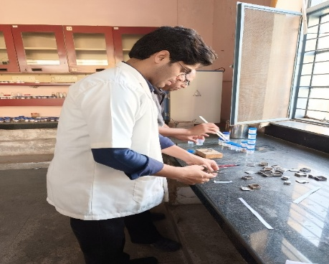

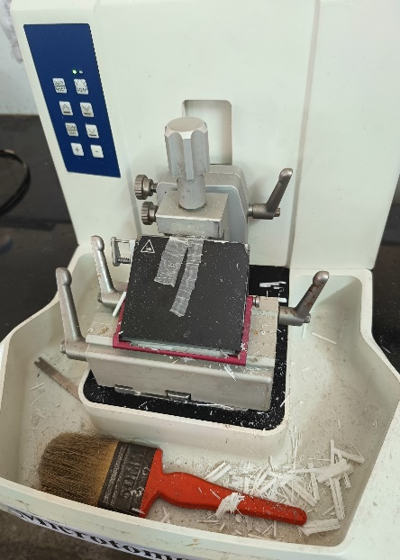

Figure 2: Histological examination of intestinal tract (jejunum) after treatments
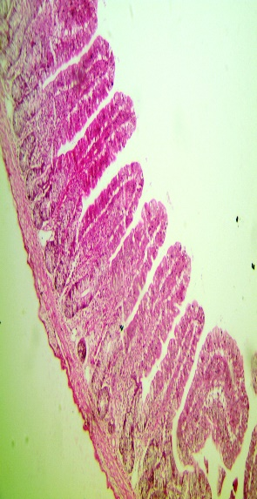
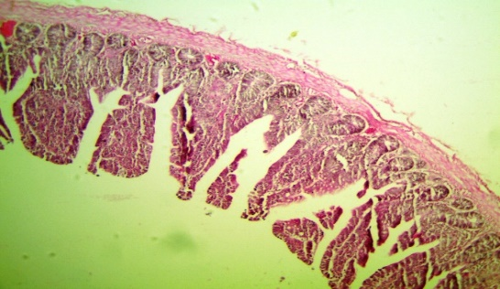
Treatment (T2)

Treatment (T₁)

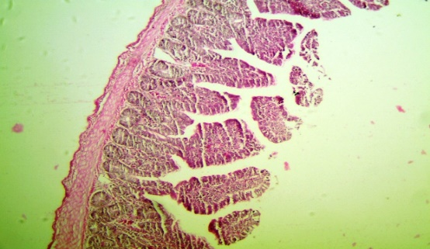
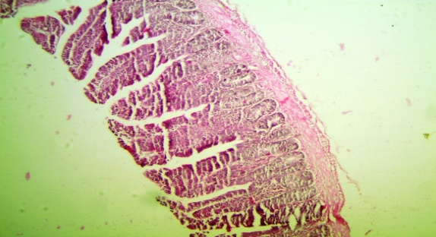
Treatment (T4)

Treatment (T3)

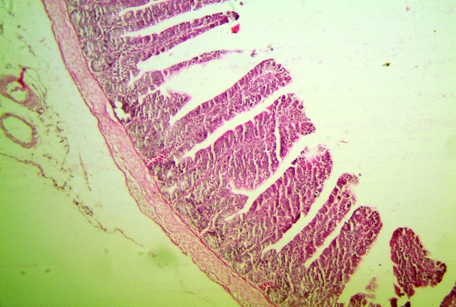
Treatment (T5)

4. DISCUSSION
The discussion on determining the effect of dietary supplementation of cinnamon and peppermint essential oil on growth performance, gut microflora, immune response, blood biochemicals and carcass quality traits of Japanese quail birds is given below.

Gut health and gut histology

In cecum contents, the E. coli (cfu/g) count was significantly decreased in essential oil supplemented groups in current experiment. Gut histological parameters were found to be improved in all essential oil supplemented groups. Villus height (μm) was found higher (p<0.05) in essential oil supplemented groups than control. Crypt depth (μm) was found higher (p<0.05) in T₂ and T₃ group than control. Similar to our study, Kürekci et al. (2021) found that essential oil supplementation (palmarosa, lemon myrtle, α-tops) altered intestinal morphology in Japanese quails, with palmarosa oil increasing villus height and oleic acid content, enhancing gut health. Basil and peppermint essential oils (BEO, PEO) reduced E. coli and fungi, increased lactobacilli in quail, with breed-specific effects, brown line had more lactobacilli, golden line had higher dressing percentage (Abbas et al., 2021). Thyme extract supplementation boosted beneficial lactobacillus bacteria and reduced harmful coliforms in Japanese quail intestines, outperforming antibiotic virginiamycin, promoting a healthier gut microbiome (Mehdipour et al., 2013). Dietary oregano essential oil (OEO) at 150 mg/kg enhanced Japanese quail intestinal histomorphology (Herve et al., 2019). In contrary to our study, dietary inclusion of 5 culinary herbs (thyme, marjoram, rosemary, oregano, yarrow) or their essential oils showed no significant impact on broiler intestinal microflora, including lactic acid bacteria and pathogens (Cross et al., 2007). Thyme essential oil (TEO) supplementation significantly (p<0.05) enhanced beneficial Lactobacillus spp. and reduced harmful E. coli populations in Japanese quail ileum, promoting a healthier gut microbiome (Khaksar et al., 2012). Herbal essential oil mixture and antibiotic supplementation improved quail growth performance, feed conversion ratio, and intestinal mucosal development (goblet cell size and number), with no impact on carcass yield (Cabuk et al., 2014). Thyme and savory essential oils improve quail intestinal absorption, effectively (Dehghani et al., 2018).
5. CONCLUSION
The effect of dietary supplementation of cinnamon and peppermint essential oil on growth performance, gut microflora, immune response, blood biochemicals and carcass quality traits of Japanese quail birds may be concluded as: Dietary supplementation of cinnamon oil (@500ppm), peppermint oil (@500ppm) and combination of cinnamon and peppermint oil (@250 ppm each) significantly (p<0.05) improved growth performance, immune response, gut morphological parameters and reduced harmful gut microflora in Japanese quail birds.
DISCLAIMER (ARTIFICIAL INTELLIGENCE)
All Authors hereby declare that no generative Artificial Intelligence (AI) technologies were used such as Large Language Models (ChatGPT, COPILOT, etc.) and different text-to-image generators have been used during writing and editing this whole article’s manuscript.

REFERENCES
Abbas, R. J., AlShaheen, S. A., & Majeed, T. I. (2021). Effect of Different Levels of Basil and Peppermint an Essential Oils on Productive and Physiological Performance of Two Lines of Growing Quail (Coturnix Coturnix Japonica). Biochemical & Cellular Archives, 21(1), 140.
Basic Animal Husbandry Statistics (BAHS), Livestock Statistics (2019), Department of Animal Husbandry and Dairying. http://dahd.nic.in.
Bywater, R. J. (2005). Identification and surveillance of antimicrobial resistance dissemination in animal production. Poultry science, 84(4), 644-648.
Cabuk, M. E. T. I. N., Eratak, S., Alcicek, A. H. M. E. T., & Tuglu, I. (2014). Effect of herbal essential oil mixture on intestinal mucosal development, growth performance, and weights of internal organs of quails. Journal of Essential Oil Bearing Plants, 17(4), 599-606.
Chang, S. T., Chen, P. F., and Chang, S. C. (2001). Antibacterial activity of leaf essential oils and their constituents from Cinnamomum osmophloeum. Journal of ethnopharmacology, 77(1), 123-127.
Cross, D. E., McDevitt, R. M., Hillman, K., and Acamovic, T. (2007). The effect of herbs and their associated essential oils on performance, dietary digestibility and gut microflora in chickens from 7 to 28 days of age. British poultry science, 48(4), 496-506.
Cross, D. E., Svoboda, K., McDevitt, R. M., and Acamovic, T. (2003). The performance of chickens fed diets with and without thyme oil and enzymes. British Poultry Science, 44(S1), 18-19.
Dehghani, N., Afsharmanesh, M., Salarmoini, M., Ebrahimnejad, H., and Bitaraf, A. (2018). Effect of pennyroyal, savory and thyme essential oils on Japanese quail physiology. Heliyon, 4(10).
Department of Animal Husbandry and Dairying. (2019). 20th Livestock Census – 2019: All India report. Ministry of Fisheries, Animal Husbandry and Dairying, Government of India. https://dahd.nic.in
Giordani, R., Regli, P., Kaloustian, J., and Portugal, H. (2006). Potentiation of antifungal activity of amphotericin B by essential oil from Cinnamomum cassia. Phytotherapy Research: An International Journal Devoted to Pharmacological and Toxicological Evaluation of Natural Product Derivatives, 20(1), 58-61.
Herve, T., Raphaël, K. J., Ferdinand, N., Victor Herman, N., Willy Marvel, N. M., Cyril D’Alex, T., & Laurine Vitrice, F. T. (2019). Effects of ginger (Zingiber officinale, Roscoe) essential oil on growth and laying performances, serum metabolites, and egg yolk antioxidant and cholesterol status in laying Japanese quail. Journal of veterinary medicine, 2019(1), 7857504.
Jerzsele, A., Szeker, K., Csizinszky, R., Gere, E., Jakab, C., Mallo, J. J., and Galfi, P. (2012). Efficacy of protected sodium butyrate, a protected blend of essential oils, their combination, and Bacillus amyloliquefaciens spore suspension against artificially induced necrotic enteritis in broilers. Poultry Science, 91(4), 837-843.
Khaksar, V., Van Krimpen, M., Hashemipour, H., and Pilevar, M. (2012). Effects of thyme essential oil on performance, some blood parameters and ileal microflora of Japanese quail. The Journal of Poultry Science, 49(2), 106-110.
Kürekci, C., Özsoy, B., Hassan, E., Özkan, H., Gundoğdu, A., Özsoy, Ş. Y., & Yakan, A. (2021). Effect of essential oil supplementation to diet on meat quality, fatty acid composition, performance parameters and intestinal microbiota of Japanese quails. Journal of Animal Physiology and Animal Nutrition, 105(5), 927-937.
Langhout, D. J., Schutte, J. B., De Jong, J., Sloetjes, H., Verstegen, W. A., and Tamminga, S. (2000). Effect of viscosity on digestion of nutrients in conventional and germ-free chicks. British Journal of Nutrition, 83(5), 533-540.
Langhout, D. J., Schutte, J. B., Van Leeuwen, P., Wiebenga, J., and Tamminga, S. (1999). Effect of dietary high-and low-methylated citrus pectin on the activity of the ileal microflora and morphology of the small intestinal wall of broiler chicks. British poultry science, 40(3), 340-347.
Langhout, P. (2000). New additives for broiler chickens. 22-27.
Lee, K. W., Everts, H., and Beynen, A. C. (2004). Essential oils in broiler nutrition. International Journal of Poultry Science , 3(12), 738-752. Iji, P. A., Saki, A. A., and Tivey, D. R. (2001). Intestinal structure and function of broiler chickens on diets supplemented with a mannan oligosaccharide. Journal of the Science of Food and Agriculture, 81(12), 1186-1192.
Marareni, M., and Mnisi, C. M. (2020). Growth performance, serum biochemistry and meat quality traits of Jumbo quails fed with mopane worm (Imbrasia belina) meal-containing diets. Veterinary and Animal Science, 10, 100141.
Mehdipour, Z., Afsharmanesh, M., and Sami, M. (2014). Effects of supplemental thyme extract (Thymus vulgaris L.) on growth performance, intestinal microbial populations, and meat quality in Japanese quails. Comparative Clinical Pathology, 23, 1503-1508.
Owen, O. J., and Dike, U. A. (2013). Japanese Quail (Coturnix coturnix japonica) husbandry: a means of increasing animal protein base in developing countries. Journal of Environmental Issues and Agriculture in Developing Countries (JEIADC), 5(1), 1-4.
Peng, Q. Y., Li, J. D., Li, Z., Duan, Z. Y., and Wu, Y. P. (2016). Effects of dietary supplementation with oregano essential oil on growth performance, carcass traits and jejunal morphology in broiler chickens. Animal feed science and technology, 214, 148-153.
Rašković, A., Pavlović, N., Kvrgić, M., Sudji, J., Mitić, G., Čapo, I., and Mikov, M. (2015). Effects of pharmaceutical formulations containing thyme on carbon tetrachloride-induced liver injury in rats. BMC complementary and alternative medicine, 15, 1-11.
Roura, E., Homedes, J., and Klasing, K. C. (1992). Prevention of immunologic stress contributes to the growth-permitting ability of dietary antibiotics in chicks. The Journal of nutrition, 122(12), 2383-2390.
Schuhmacher, A., Reichling, J., and Schnitzler, P. J. P. V. (2003). Virucidal effect of peppermint oil on the enveloped viruses herpes simplex virus type 1 and type 2 in vitro. Phytomedicine, 10(6-7), 504-510.

