Original Research Article

Studies on the physical and chemical parameters of Visapur Dam, Maharashtra, India

Abstract:

A study was conducted over two years on the freshwater ecosystem of Visapur Dam in Ahilyanagar, Maharashtra. We examined various physico-chemical parameters at three different sites within the dam. Throughout the study period, the water quality parameters showed significant variations. The pH levels ranged from 6.97 to 8.27, while water temperature fluctuated considerably between 22.3°C and 33.0°C, likely due to seasonal changes. Turbidity levels remained relatively moderate, ranging from 11.4 to 16.2 NTU. Notable changes were observed in Total Dissolved Solids (TDS) and salinity, with TDS varying between 95.7 and 156.7 mg/L and salinity ranging from 67.5 to 111.2 mg/L. Other key water quality indicators also varied during the study. Total hardness ranged from 183.3 to 320 mg/L, and total alkalinity fluctuated between 102.7 and 187.7 mg/L. Dissolved oxygen levels, crucial for aquatic life, varied significantly from 4.6 to 6.4 mg/L. Chloride concentrations ranged from 21.1 to 32.8 mg/L. Such studies are important as freshwater zooplankton diversity, distribution and abundance are influenced by physicochemical conditions. Seasonal changes, anthropogenic activities, or natural processes may change water conditions affecting their presence. Thus, it becomes important to study the prevailing environmental conditions and understand how they affect the zooplankton in natural as well as artificial aquatic environments. This may help in generating favourable conditions for the survival and growth of organisms, such as zooplankton and fish, in such kind of aquatic habitats.

Key words: conservation, environment, eutrophication, freshwater, zooplankton

- INTRODUCTION
The presence of zooplankton in an ecosystem is influenced by environmental conditions, as the abiotic and biotic factors (Kolar and Rahel, 1993; Bhalsing and Pokale, 2025). Zooplankton flourish when environmental conditions are favourable, with each species having distinct requirements. Changes in physicochemical, biological, or microbiological conditions can modify their diversity and distribution, sometimes resulting in local extinction (Zhang et al., 2022). Factors like climate change, pollution, and habitat destruction can adversely change ecosystem equilibrium (Weiskopf et al., 2020), resulting in altered ecosystem structure and function. Investigating environmental parameters is crucial for ecosystem health and productivity (Engdaw et al., 2025). Factors like temperature, pH, dissolved oxygen, and salinity determine water's suitability for aquatic life (Banerjee et al., 2022; Roy and Saikia, 2023; Khushboo, 2025). Such research ensures conditions remain favourable for aquatic organisms and aids in understanding biotic-abiotic interactions. Unwanted parameter changes may indicate contamination due to human activities. Zooplankton communities can indicate impacts of eutrophication, acidification, global warming, and UV radiation (Annabi-Trabelsi et al., 2022; Zhang et al., 2022).
Environmental monitoring in water bodies helps optimize growth and prevent diseases in economically significant organisms as fish, crustaceans. Regular monitoring detects stress signs that can affect species diversity and thus abundance. Understanding environmental conditions aids in protecting endangered species and monitoring algal blooms (Peng et al., 2024), invasive species (Pastorino et al., 2025; Chang et al., 2025), and pollution (Artiola and Brusseau, 2019). Zooplankton presence is influenced by physical, chemical, geographical, biological, and ecological factors (Vanjare et al., 2010, 2023; Vanjare and Pai, 2013; Padhye et al., 2023; Tung et al., 2025), which together affect their assemblages and seasonal distribution (Hulyal and Kaliwal, 2008).
The foremost ecological research on freshwater zooplankton occurred in Calcutta, followed by studies across India and Maharashtra (Battish, 1992; Dhanapathi, 1975, 2000 etc). Phytoplankton and bacteria depend on required chemical factors for development. Zooplankton feed on these organisms before being consumed by fish, supporting aquaculture. Carps feed exclusively on zooplankton during larval and juvenile stages.
The present study at a manmade reservoir in Ahilyanagar district (2022-24) examines physical and chemical variations. While this reservoir has been studied for zooplankton, sponges, fish, and birds (Pandhakar et al., 2014), no long-term zooplankton studies exist, prompting our two-year investigation.
- MATERIAL AND METHODS
The study was conducted at the Visapur dam, near Shrigonda, now Ahilyanagar (18.8035565°N 74.5827484°E). Visapur Dam is an earthfill dam on the Hanga River covering 385 sq. km. Built during British rule (1896-1927), it provides irrigation as part of the Kukdi water shed project supplying water to Shrigonda district. Three stations were selected based on human interference, pollution status, and accessibility. The stations were monitored for environmental parameters from October 2022 to September 2024. Monthly water samples were collected and analysed following standard methods (APHA, 1991) and instrument specifications.
Environmental parameters of water, including pH, temperature, TDS, salinity, hardness, turbidity, chloride, total alkalinity, and dissolved oxygen, were measured at all stations using standard multiparameter meters (Eutech, Hanna) and kits (Aquasol, Hanna). Readings were taken on-station and noted immediately. The pH, Temperature (in °C), Total dissolved solids (TDS) and salinity were measured using PCS Testr 35 Multiparameter (Eutech Instruments), with results in ppm. Turbidity was measured using a turbidity meter. Dissolved oxygen (DO) was measured during zooplankton collection using the Dissolved Oxygen meter (Hanna, India), with readings in mg/L. Total Hardness, Chlorides and Total alkalinity were measured using a handheld colorimeter (Hanna, India).
Environmental data and correlation studies were analysed from the study area using software and websites such as PAST software and Microsoft Excel. The results are expressed in graphs, plots and tables.

- RESULT AND DISCUSSION
The environmental parameters were studied over two years from September 2022-August 2024. Water parameters including pH, Temperature, Salinity, TDS, turbidity, hardness, alkalinity, chloride and Dissolved Oxygen were analysed.
The water quality parameters showed significant variations during the study. The pH levels ranged from 6.97 to 8.27, while water temperature varied between 22.3°C to 33.0°C. Turbidity levels ranged from 11.4 to 16.2 NTU. Total Dissolved Solids varied between 95.7 and 156.7 mg/L and salinity between 67.5 and 111.2 mg/L. Total hardness ranged from 183.3 to 320 mg/L, total alkalinity between 102.7 and 187.7 mg/L, and dissolved oxygen from 4.6 to 6.4 mg/L. Chloride concentrations ranged from 21.1 to 32.8 mg/L.
These variations suggest influences of seasonal changes and environmental factors over the study period. The water chemistry showed similar patterns across both years, with seasonal changes affecting the environmental parameters. All physico-chemical parameters of Visapur dam were within permissible limits set by regulatory authorities and aligned with other studies in Maharashtra and India. The water is non-polluted and suitable for domestic, agricultural and industrial purposes if maintained properly. The results indicate improved water conditions in both waterbodies and highlight the need for habitat conservation.

3.1 pH (Fig. 1, 2)
During the monsoon season (i.e June-September) for both years similar highest pH results were observed, with Station 1 averaging 8.16, station 2 at 7.88, and station 3 at 7.78. The high pH values during monsoon months may be due to increased water volume leading to dilution effects (rains), and changes in plant photosynthetic activity. Summer months (March-May) exhibited the lowest pH values, with station 1 averaging 7.57, Station 2 at 7.18, and Station 3 at 7.15. The month of March recorded the lowest overall monthly average (7.07 across all stations), while December time showed the highest (8.20). The decline in pH during the summer could be associated with an increased decomposition rate, reduced water levels, and higher water temperatures affecting the chemical chemistry. Winter season (October-February) demonstrates intermediate pH values, with averages of 7.85, 7.96, and 7.87 for the three stations 1, 2, and 3 respectively.
pH determines the acidity or alkalinity of water and further influences aquatic plant and animal life in all waterbodies. Most freshwater organisms live and survive within a pH range of 6.5-8.5 in tropical setting. If it becomes too low (i.e. acidic) or too high (i.e. alkaline), it may cause issues/damage to fish, plankton, as well as other aquatic organisms by affecting their metabolism, growth and reproduction and thus their survival. Water pH also maintains the solubility and availability of nutrients and those of toxic substances (as metals become more soluble and toxic in lower pH). Drastic changes in pH can indicate environmental pollution or chemical imbalance, making it an important parameter in assessing water quality and ecosystem health as was done in the present study. Aquatic organisms such as fish and zooplankton are affected by pH because most of their metabolic activities are dependent on standard minute temperature changes (Manikam et al., 2015).
All the studied pH measurements fall within or very close to the acceptable range for freshwater aquatic ecosystems. The neutral (near 7) pH conditions in the study suggest healthy aquatic environments at all the three stations, concluding that it may be suitable for supporting diverse freshwater organisms, like the zooplankton as is evident from the present study. The slight alkalinity observed during winter months is typical for many freshwater systems as in seen in most Indian studies.

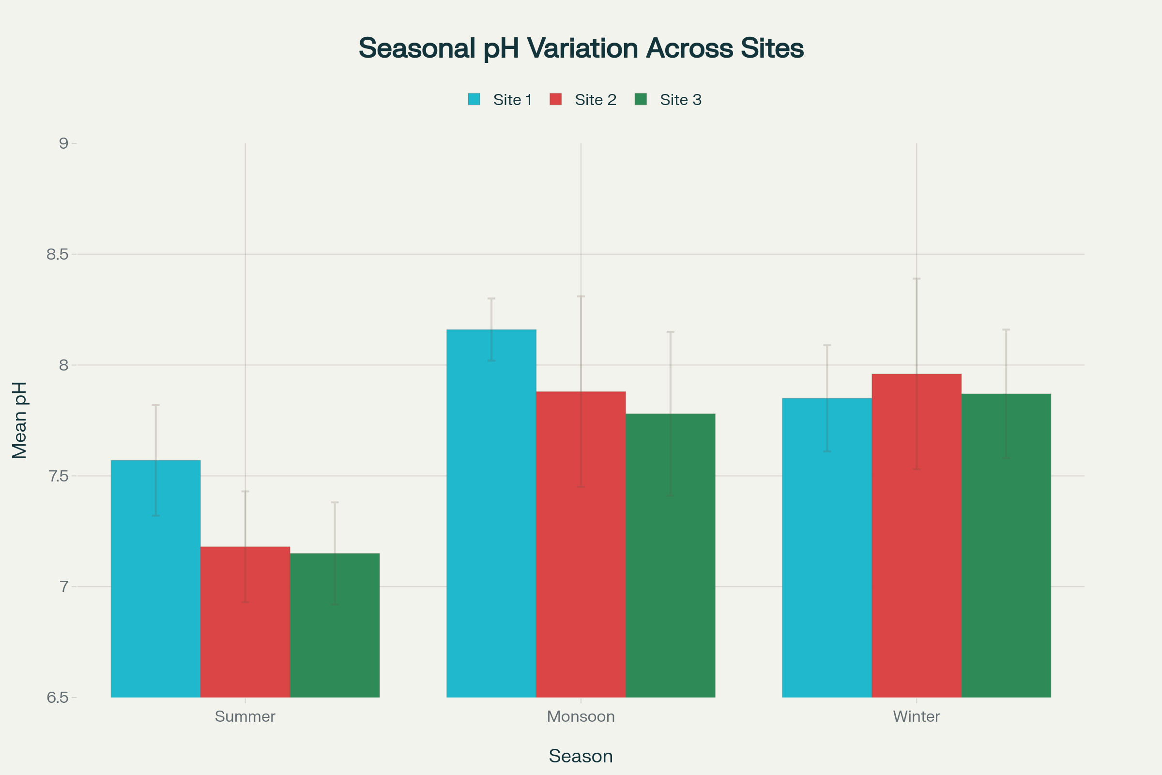
Fig 1: Seasonal comparison of mean pH values across three stations

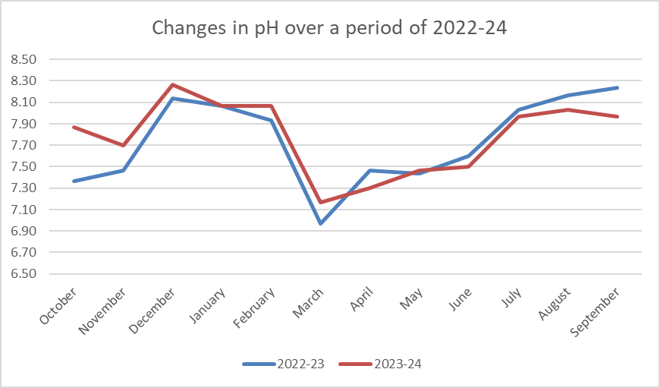

Fig 2: Monthly changes in the pH over the period of two years
3.2 Temperature (Fig. 2,3)

The temperature data shows remarkable similarity across stations with seasonal patterns for both years, aligning with (sub)tropical conditions in India and other countries (Arora and Mehra, 2009; Vanjare et al., 2017). Highest temperatures occurred in summer and lower in winter months, following India's typical pattern. All stations showed similar temperature readings without significant differences. Station 1 shows a mean temperature of 26.55°C (range: 22.0-33.0°C), station 2 averages 26.48°C (range: 22.6-33.0°C), and Station 3 averaged 26.64°C (range: 22.3-33.1°C). Unlike pH levels which varied significantly, temperature remained consistent across stations, indicating evenly mixed water at the study site.
Temporal and Seasonal Patterns
Temperature shows distinct seasonal variation among measured parameters. Summer months (March-May) recorded highest temperatures, with Station 1 averaging 31.0°C, station 2 at 30.9°C, and Station 3 at 30.7°C. April and May showed peak temperatures, with monthly averages of 32.25-32.35°C. Winter months (October-February) had lowest temperatures, with station 1 averaging 23.91°C, station 2 at 23.74°C, and station 3 at 24.10°C, with November recording the lowest at 22.72°C. Monsoon season (June-Sept) showed intermediate temperatures, averaging 26.5°C (station 1), 26.6°C (station 2), and 26.8°C (station 3), representing a rapid decline due to rain cloud cover and precipitation. The data shows three thermal regimes: summer (March to May) with high temperatures and moderate variability (SD: 2.0-2.5°C), winter (October-February) with least variability (SD: 1.1-1.6°C) and coolest conditions, and monsoon months (June-September) with moderate temperatures and similar variability to summer (SD: 2.6°C). The summer peak occurred in pre-monsoon months (April-May), while winter minimum occurred in post-monsoon and early winter (November-December), aligning with regional climate patterns in Maharashtra and India (Dhembare, 2011; Bansode, 2023).
Water temperatures ranged from 22.0°C (Station 1, October- 23) to 33.1°C (Station 3, May- 23). The 11°C range represents typical seasonal variation for freshwater systems in tropical/subtropical regions like Maharashtra (Dhembare, 2011; Bansode, 2023). These temperatures support diverse freshwater biota, including zooplankton and invertebrates. Summer temperatures of 30-33°C may be high for sensitive species, while winter temperatures of 22-24°C remain tolerable for most tropical organisms. Temperature influences metabolism, growth, and reproduction of aquatic invertebrates. It affects dissolved oxygen levels, impacting aquatic life presence. Species survive within specific temperature ranges, and sudden changes can cause stress or mortality. Temperature controls water chemistry, nutrient solubility, and seasonal differences, affecting oxygen and nutrient distribution. It regulates algal growth and biological productivity, making it crucial for maintaining ecological balance in tropical freshwater habitats. Temperature impacts all metabolic and physiological activities, including feeding, reproduction, movement, and distribution of aquatic invertebrate animals (Manikam et al., 2015).

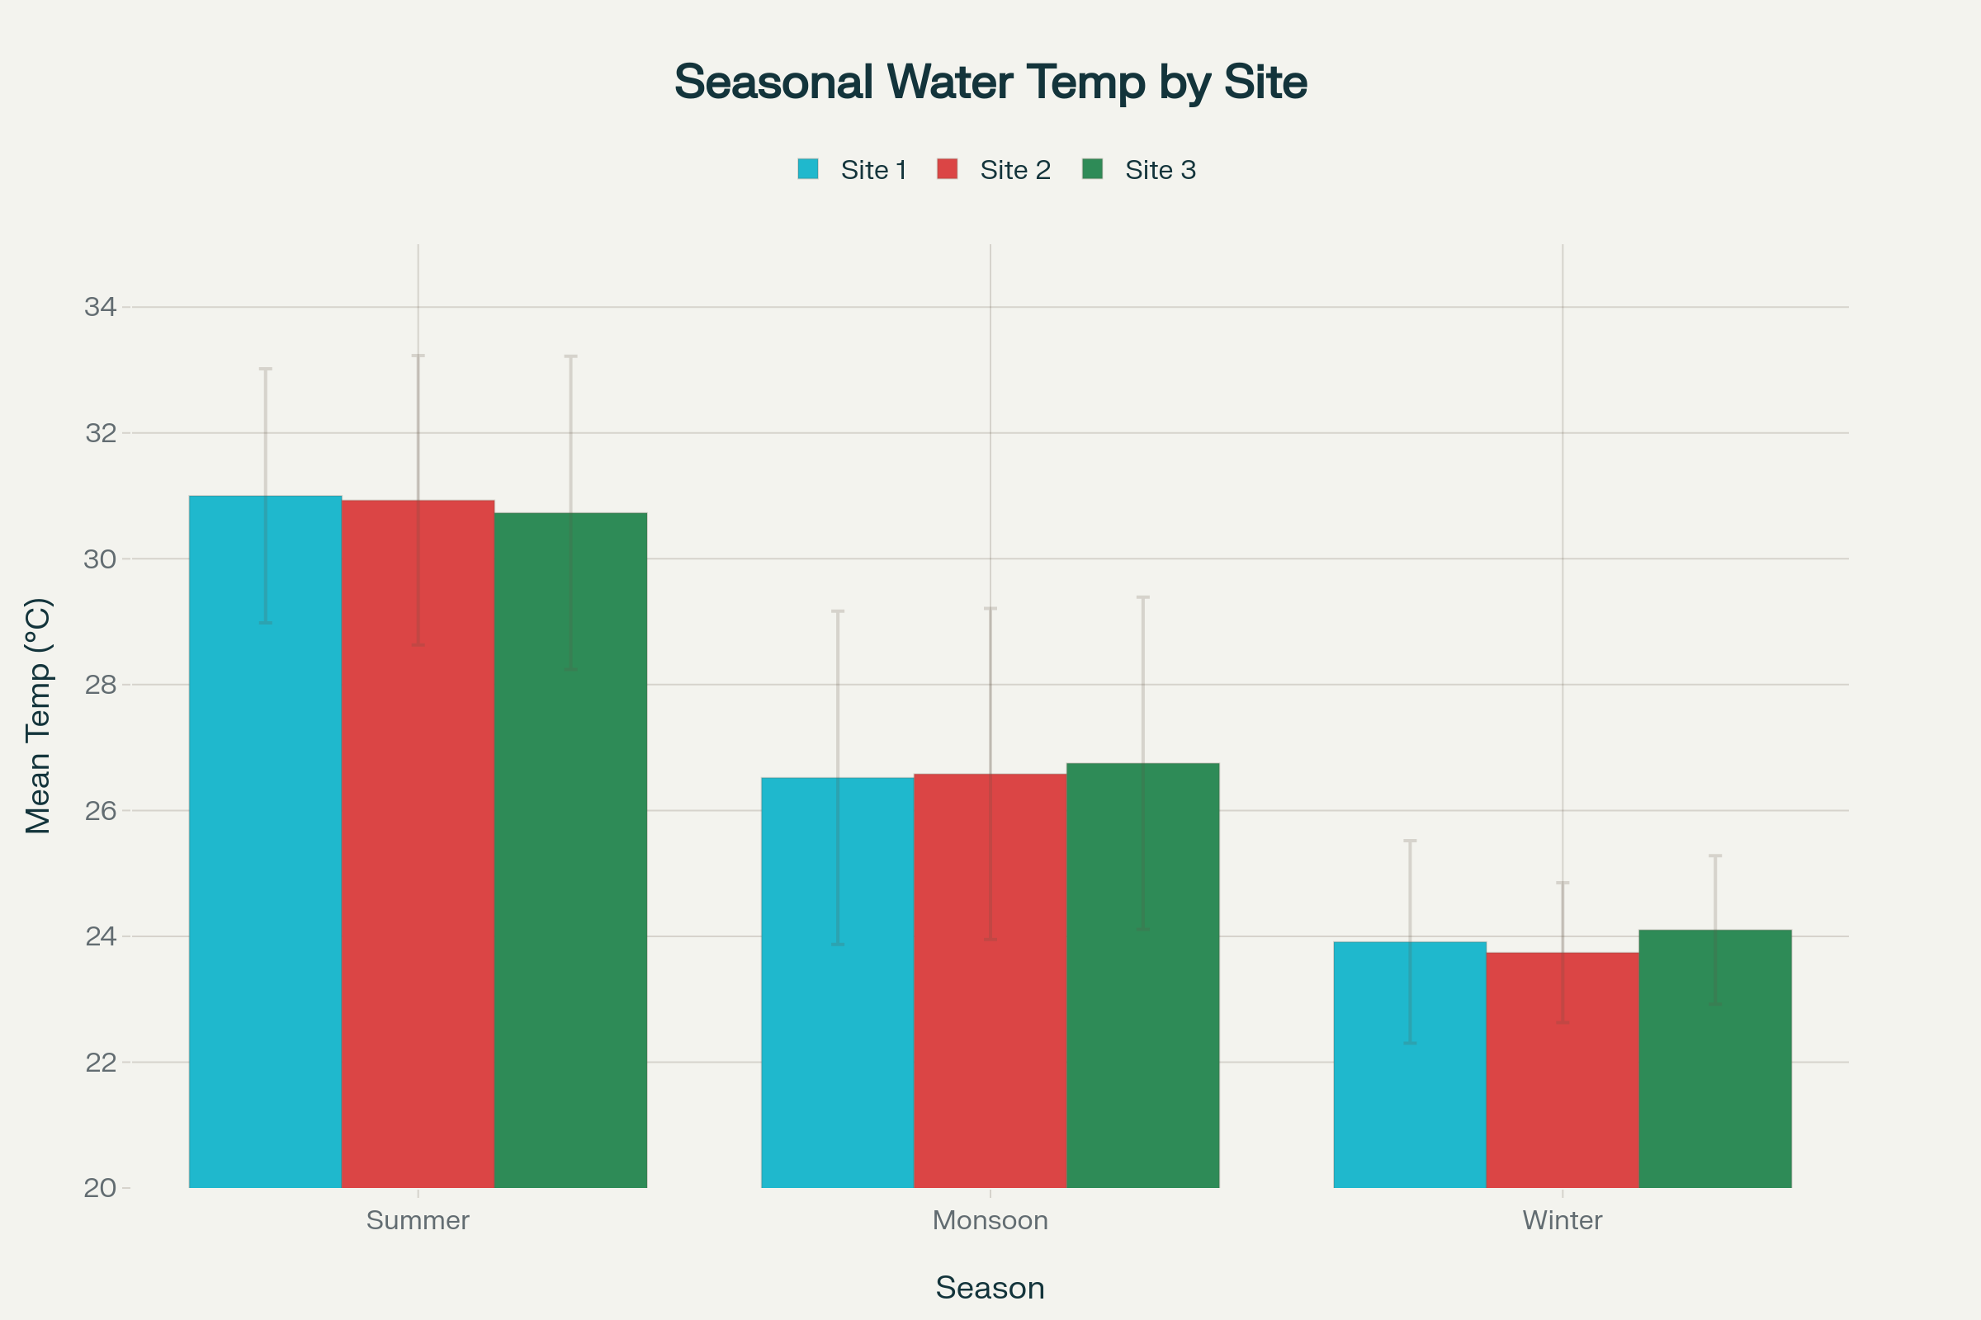
Fig 3: Seasonal comparison of mean water temperature across three stations

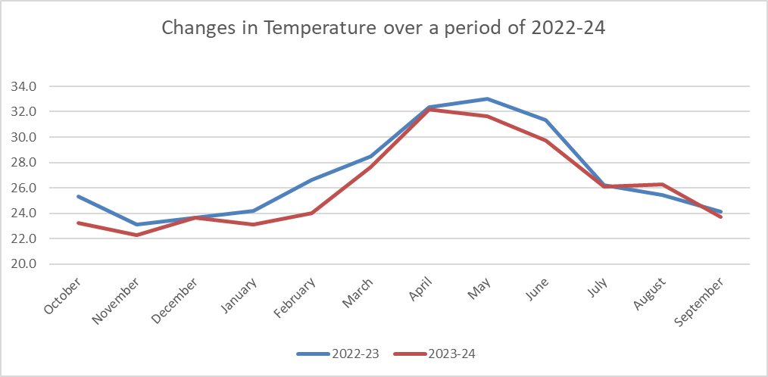

Fig 4: Monthly changes in the temperature over the period of two years

3.3 Turbidity (Fig. 5,6)
Turbidity represents water clarity and indicates suspended sediment in freshwater systems. All stations showed similar turbidity values. Station 1 shows a mean turbidity of 13.54 NTU (range: 11.2-16.2 NTU), station 2 averages 13.4 NTU (range: 11.3-16.2 NTU), and station 3 gave an average of 13.2 NTU (range: 11.6-16.5 NTU). The values suggest consistent water clarity throughout the stations, as the dam is mostly rain fed. This indicates similar suspended sediment concentration at all locations. Temporal and Seasonal Patterns Turbidity shows seasonal variation, though less pronounced than temperature patterns. Monsoon months (June-September) show highest turbidity values, with Station 1 averaging 14.98 NTU, Station 2 at 14.60 NTU, and Station 3 at 14.44 NTU, due to increased runoff and soil erosion. Winter months (October-February) display lowest turbidity, with Station 1 averaging 12.10 NTU, Station 2 at 12.34 NTU, and Station 3 at 12.32 NTU. Summer months (March-May) show intermediate values, with Station 1 averaging 14.03 NTU, Station 2 at 13.67 NTU, and Station 3 at 13.18 NTU. July recorded the highest monthly average (15.57 NTU). Seasonal Thermal-Turbidity Relationships Turbidity and temperature show inverse seasonal relationships. Peak temperatures occurred in summer (March-May), while peak turbidity occurred during monsoon (June-July). Summer has high temperatures but lower precipitation, resulting in lower turbidity. Monsoon brings increased precipitation and sediment transport, raising turbidity despite lower temperatures. This inverse pattern is typical of monsoon-influenced systems and affects ecosystem parameters.
Measured turbidity values (11.2-16.5 NTU) fall within acceptable ranges for freshwater systems. Values below 5 NTU indicate clear water, while values above 40 NTU suggest decreased water clarity. The range of 11.2-16.5 NTU indicates moderately turbid water, typical for subtropical freshwater systems subject to monsoons and seasonal sediment mobilization. This turbidity level supports diverse aquatic life, though it suggests moderate suspended sediment and reduced light penetration compared to clear water systems. In winter, clearer water allows more light penetration, enhancing photosynthesis. The consistent turbidity patterns across stations, with strong seasonal cycles, suggest turbidity is primarily controlled by meteorological inputs rather than station-specific features. This affects zooplankton ecology, as turbidity impacts light availability, phytoplankton productivity and zooplankton community structure. Winter's reduced turbidity enables increased light penetration and photosynthetic activity, supporting higher zooplankton populations through increased food availability.

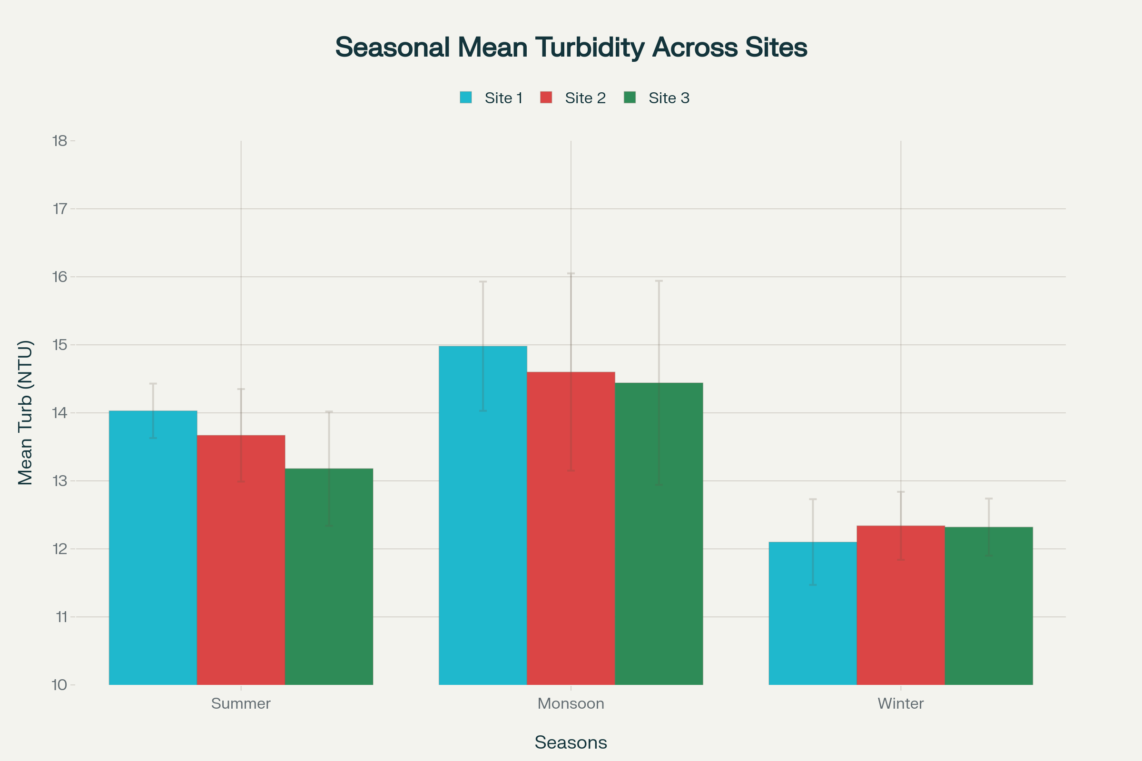

Fig 5: Seasonal comparison of mean water turbidity across all three stations.

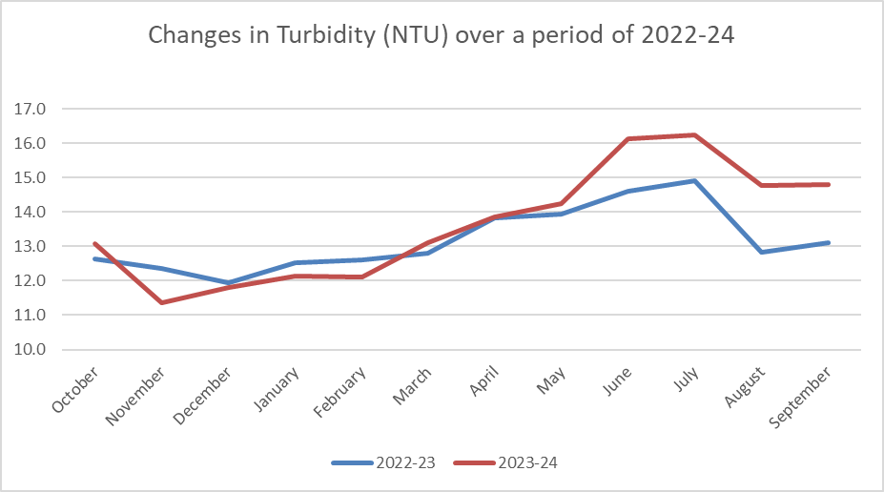

Fig 6: Monthly changes in the turbidity over the period of two years

3.4 Total dissolved solids (TDS) (Fig. 7,8)
TDS is the concentration of inorganic salts and dissolved organic matter in water and indicates water mineralization and quality. The parameter relates directly to water's electrical conductivity (EC). The three stations show similar TDS values with some differences. Station 1 has a mean TDS of 127.33 mg/L (range: 90-160 mg/L). Station 2 averages 125.13 mg/L (range: 90-152 mg/L), and station 3 averages 130.25 mg/L (range: 100-160 mg/L). Station 3's higher TDS values suggest different hydrogeochemical characteristics or inputs maintaining high mineralization. TDS showed clear seasonal variation regulated by monsoon patterns. Summer months (March-May) show highest concentrations across stations: Station 1 at 150.33 mg/L, Station 2 at 140.67 mg/L, and Station 3 at 142.00 mg/L, reflecting evaporative concentration during the dry season. Monsoon months (June-September) show lower TDS values: Station 1 at 105.25 mg/L, Station 2 at 106.13 mg/L, and Station 3 at 114.50 mg/L. July recorded the lowest monthly average (102 mg/L), a &gt;40% reduction from May's peak (154 mg/L). Winter months show intermediate TDS values, with stations averaging 131.2-135.8 mg/L. The seasonal pattern remains consistent across both years, showing monsoon rainfall's influence. The summer to monsoon TDS reduction of 40-50 mg/L occurs due to: 1) summer evaporative concentration, 2) monsoon rainfall dilution, 3) reduced mineral mixing during high flow, and 4) varying seasonal groundwater inputs.
The consistent TDS patterns across stations show that mineral inputs are primarily controlled by monsoon driven hydrological forces rather than local geology. All measured TDS values (range: 90-160 mg/L) fall within acceptable limits for freshwater systems. The WHO guideline recommends TDS levels below 1000 mg/L for potable water. The observed values indicate moderately mineralized freshwater, typical of (sub)tropical reservoirs in monsoon regions. These TDS concentrations support diverse aquatic life, with values of 100-150 mg/L indicating good water quality. The seasonal reduction to ~100-115 mg/L during monsoon represents freshwater input exceeding mineralization processes.

.
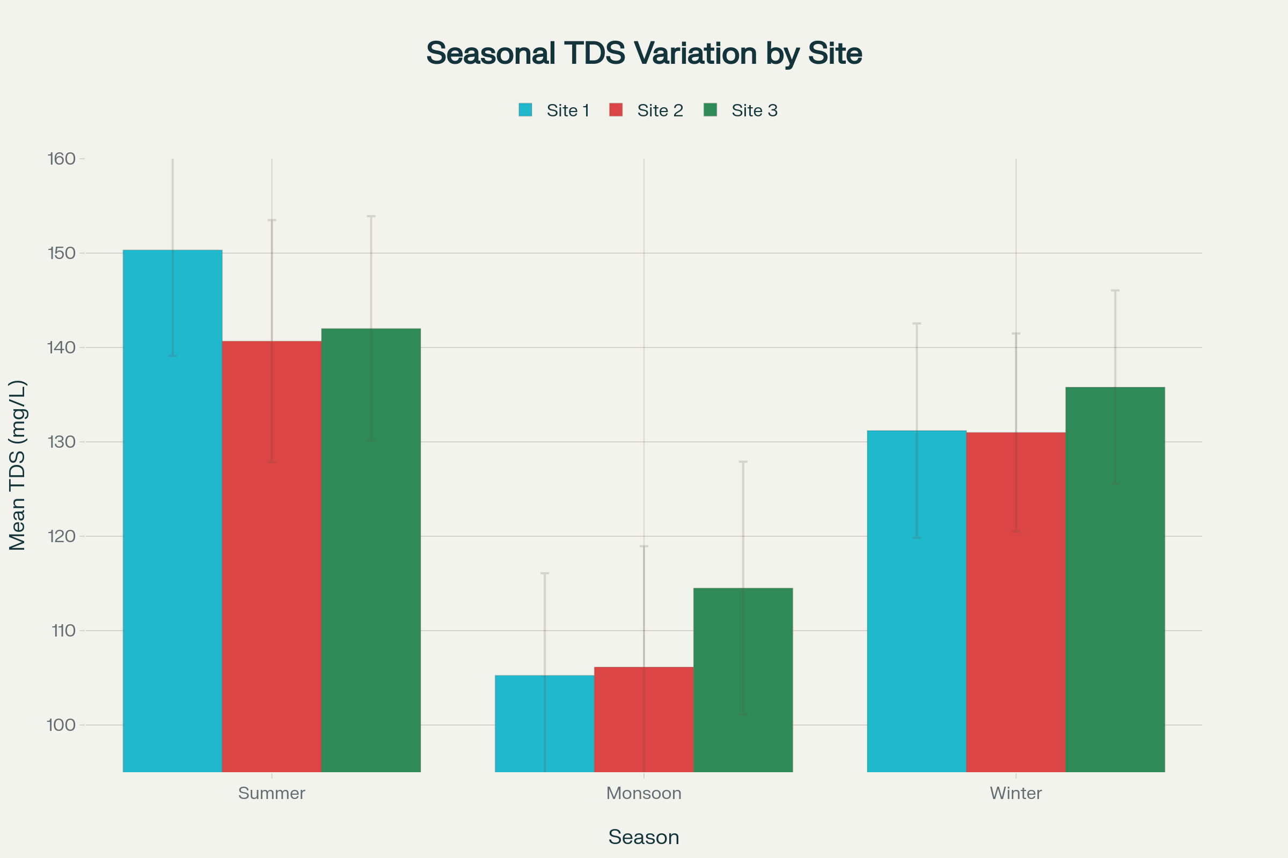
Fig 7: Seasonal comparison of mean TDS concentrations across three stations

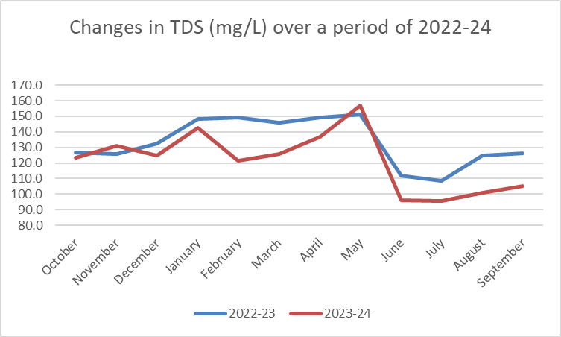
Fig 8: Monthly changes in the TDS for the period of two years

3.5 Salinity (Fig. 9,10)
Salinity represents the concentration of dissolved salt ions in freshwater and plays a key role in maintaining balance in aquatic habitats. In freshwater bodies, salinity is usually lower than marine habitats, and small changes can affect aquatic organisms' survival. Many freshwater organisms are adapted to narrow salinity ranges. Increases in salinity from pollution, evaporation, or saltwater intrusion may cause stress or death of organisms. Salinity influences organisms' osmotic balance and impacts aquatic life distribution. Monitoring salinity is essential for understanding water quality and ecosystem functioning. Salinity values are lower for both years and determine the presence of freshwater/brackish species. The data showed seasonal patterns driven by monsoon cycles, with maximum values in summer. All three stations show similar salinity values. Station 1 shows a mean salinity of 90.46 mg/L (range: 64-114 PSU). Station 2 averages 88.96 PSU (range: 64-108 PSU), and Station 3 averages 92.33 PSU (range: 71-114 PSU).
Salinity shows pronounced seasonal variation controlled by monsoon cycles. Summer months (March-May) have the highest salinity across stations: Station 1 averages 106.83 PSU, Station 2 at 99.83 PSU, and Station 3 at 100.83 PSU, reflecting evaporative concentration during the dry season. Monsoon months (June-September) show lower salinity, with Station 1 averaging 74.88 PSU, Station 2 at 75.38 PSU, and Station 3 at 81.00 PSU. July recorded the lowest monthly average (72.17 PSU), a 34% reduction from May's peak (109.67 PSU). Winter months (October-February) show intermediate values, with Station 1 averaging 93.10 PSU, Station 2 at 93.30 PSU, and Station 3 at 96.30 PSU. The pattern remains consistent across monitoring years. The inverse relationship between salinity and monsoon rainfall shows three phases: Summer (March-May) with maximum salt concentration (mean ~100-107 PSU), Monsoon (June-September) with minimum values (mean ~75-81 PSU), and Winter (October-February) with intermediate levels (mean ~93-96 PSU). The 34-35% reduction from summer to monsoon peaks demonstrates the monsoon system's impact on water chemistry, consistent with evaporative concentration in dry seasons and freshwater dilution during precipitation.

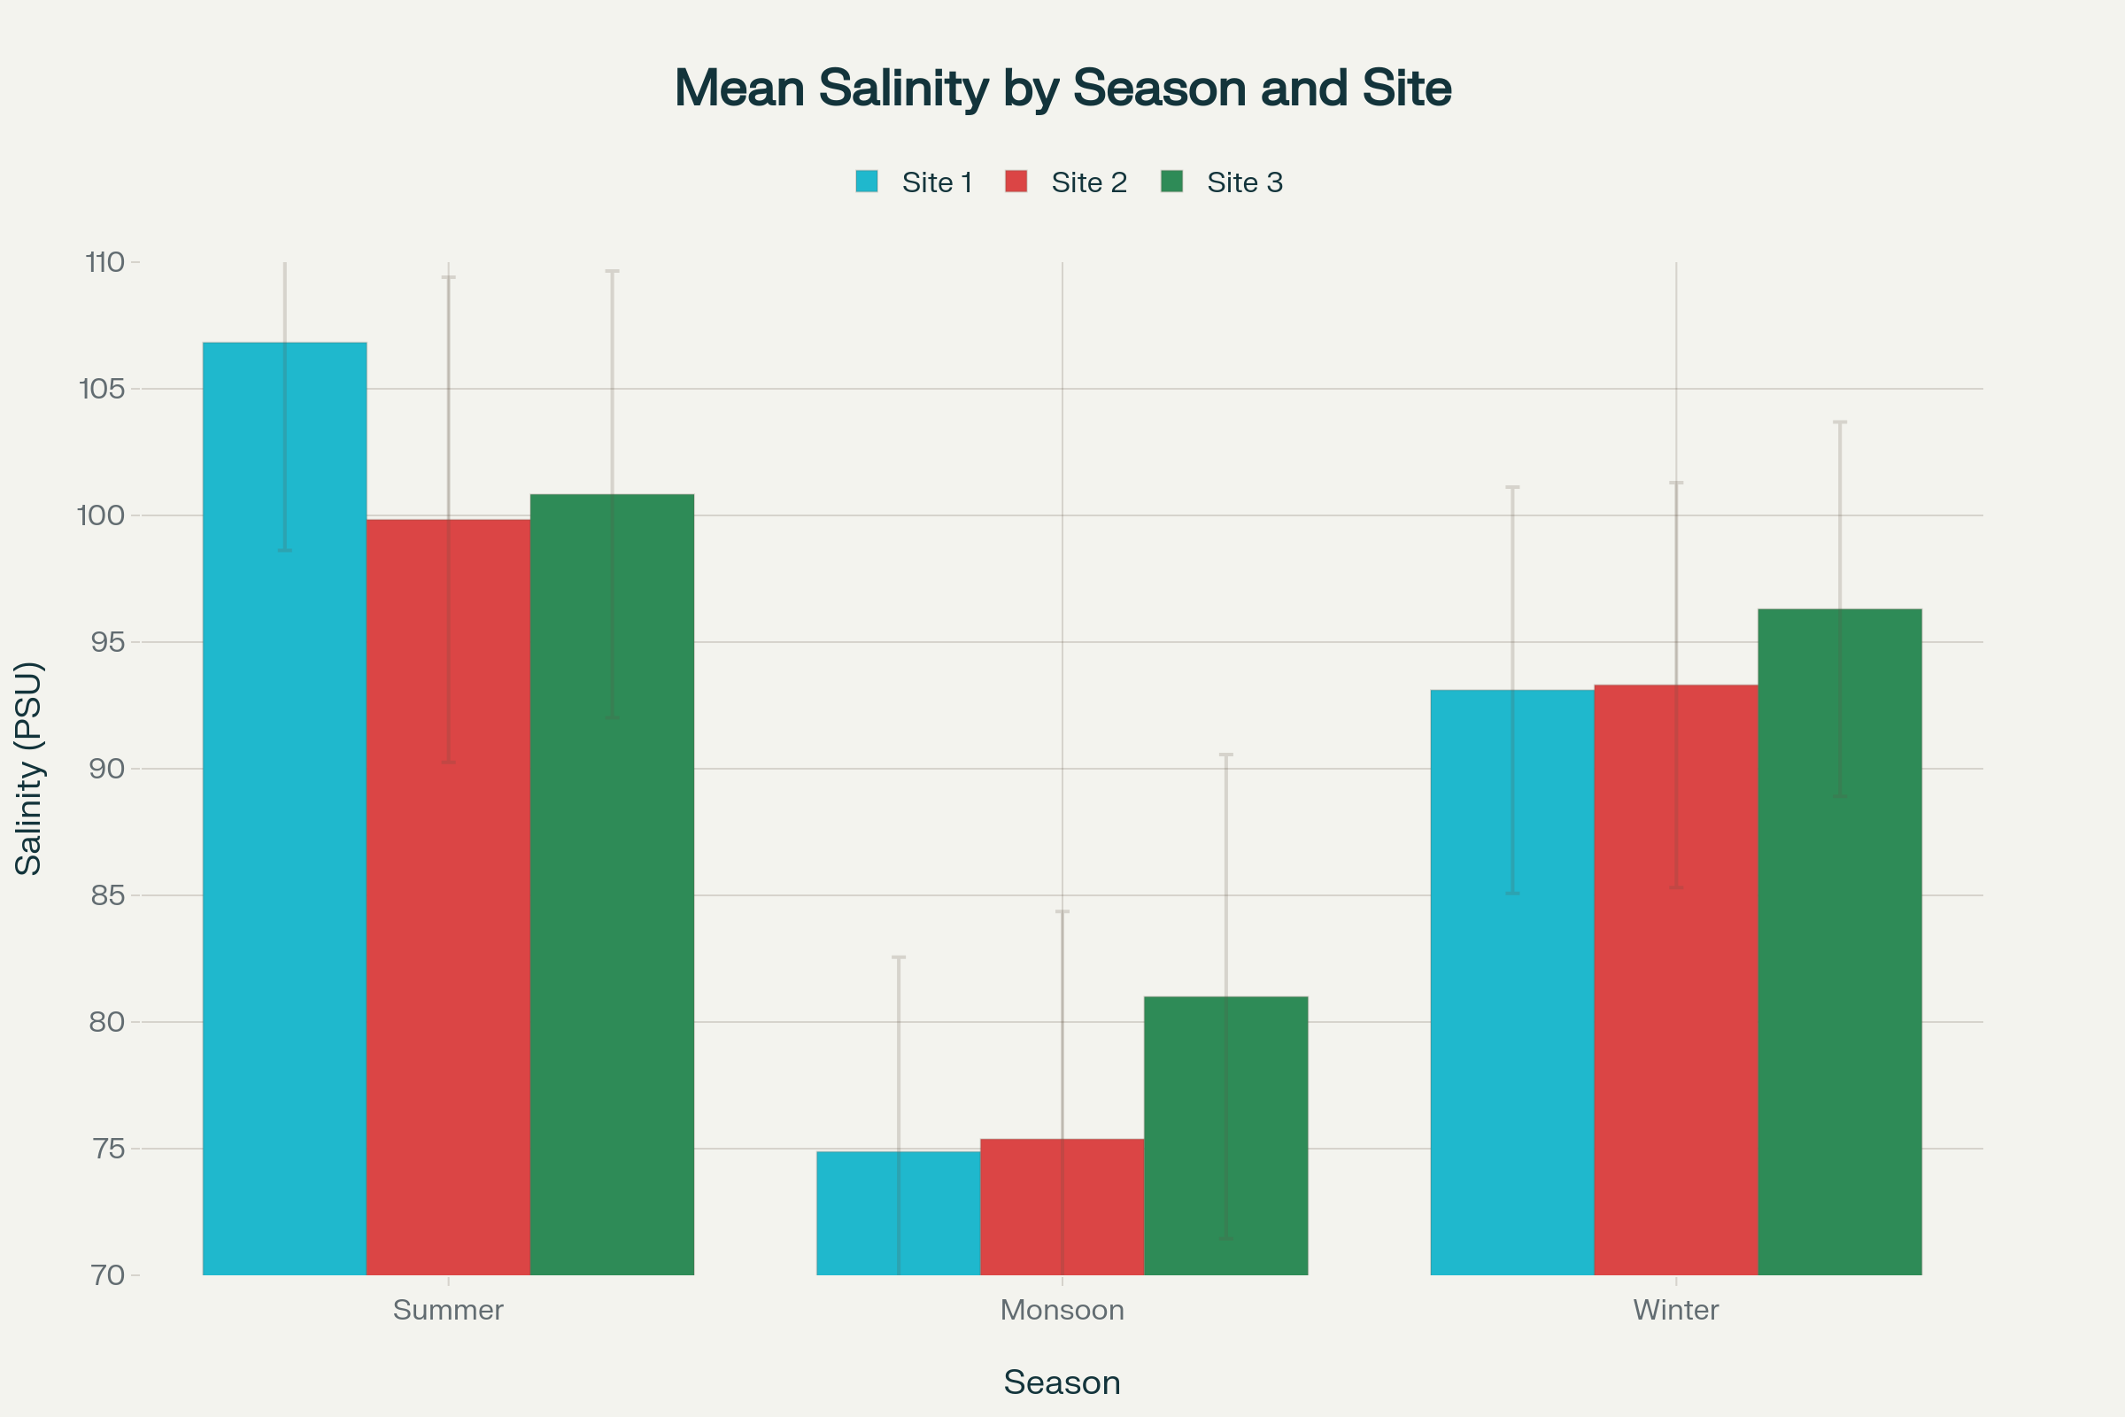
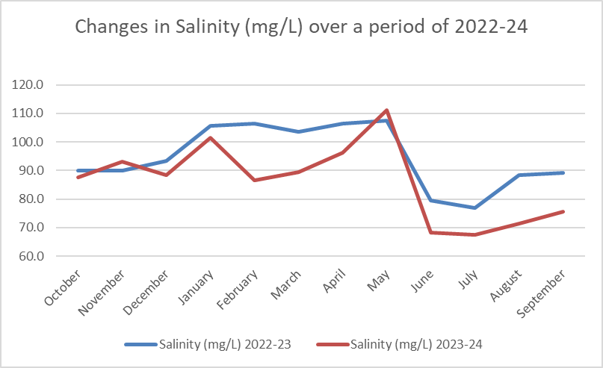
Fig 9: Seasonal comparison of mean salinity across three stations

Fig 10: Monthly changes in the Salinity over the period of two years

3.6 Hardness (Fig. 11,12)

Water hardness represents the concentration of dissolved calcium and magnesium ions and indicates water quality. The data show seasonal patterns driven by monsoon hydrology. All three stations exhibit "Hard" water conditions per WHO classification (150-300 mg/L as CaCO₃). Station 1 shows a mean hardness of 250.00 mg/L (range: 180-320 mg/L). Station 2 averages 246.09 mg/L (range: 180-300 mg/L), and Station 3 averages 253.91 mg/L (range: 190-340 mg/L). All values exceed WHO guideline of &lt;150 mg/L, indicating consistently hard water requiring potential treatment. Water hardness shows seasonal variation controlled by monsoon cycles, similar to TDS, salinity, and temperature patterns. Summer months (March-May) show highest hardness concentrations, reflecting low water volume. Monsoon months (June-September) display lower hardness due to freshwater dilution. Winter months show intermediate values. May recorded the highest monthly average (306.67 mg/L), while July showed the lowest (185.00 mg/L), a 39% reduction. Year-to-year comparison showed Station 1 increased by 5.7%, Station 2 remained stable (-0.9%), and Station 3 increased by 7.3%. The seasonal hardness cycle reflects three phases: Summer Concentration (March-May) with maximum dissolved minerals (~288-290 mg/L), Monsoon Dilution (June-September) reducing hardness by 24-28% (~208-220 mg/L), and Winter Transition (October-February) with intermediate values (~251-261 mg/L). The synchrony across stations and consistent "Hard" classification suggests hardness is primarily controlled by monsoon cycles rather than station-specific factors. The seasonal patterns across both monitoring years indicate stable long-term trends.

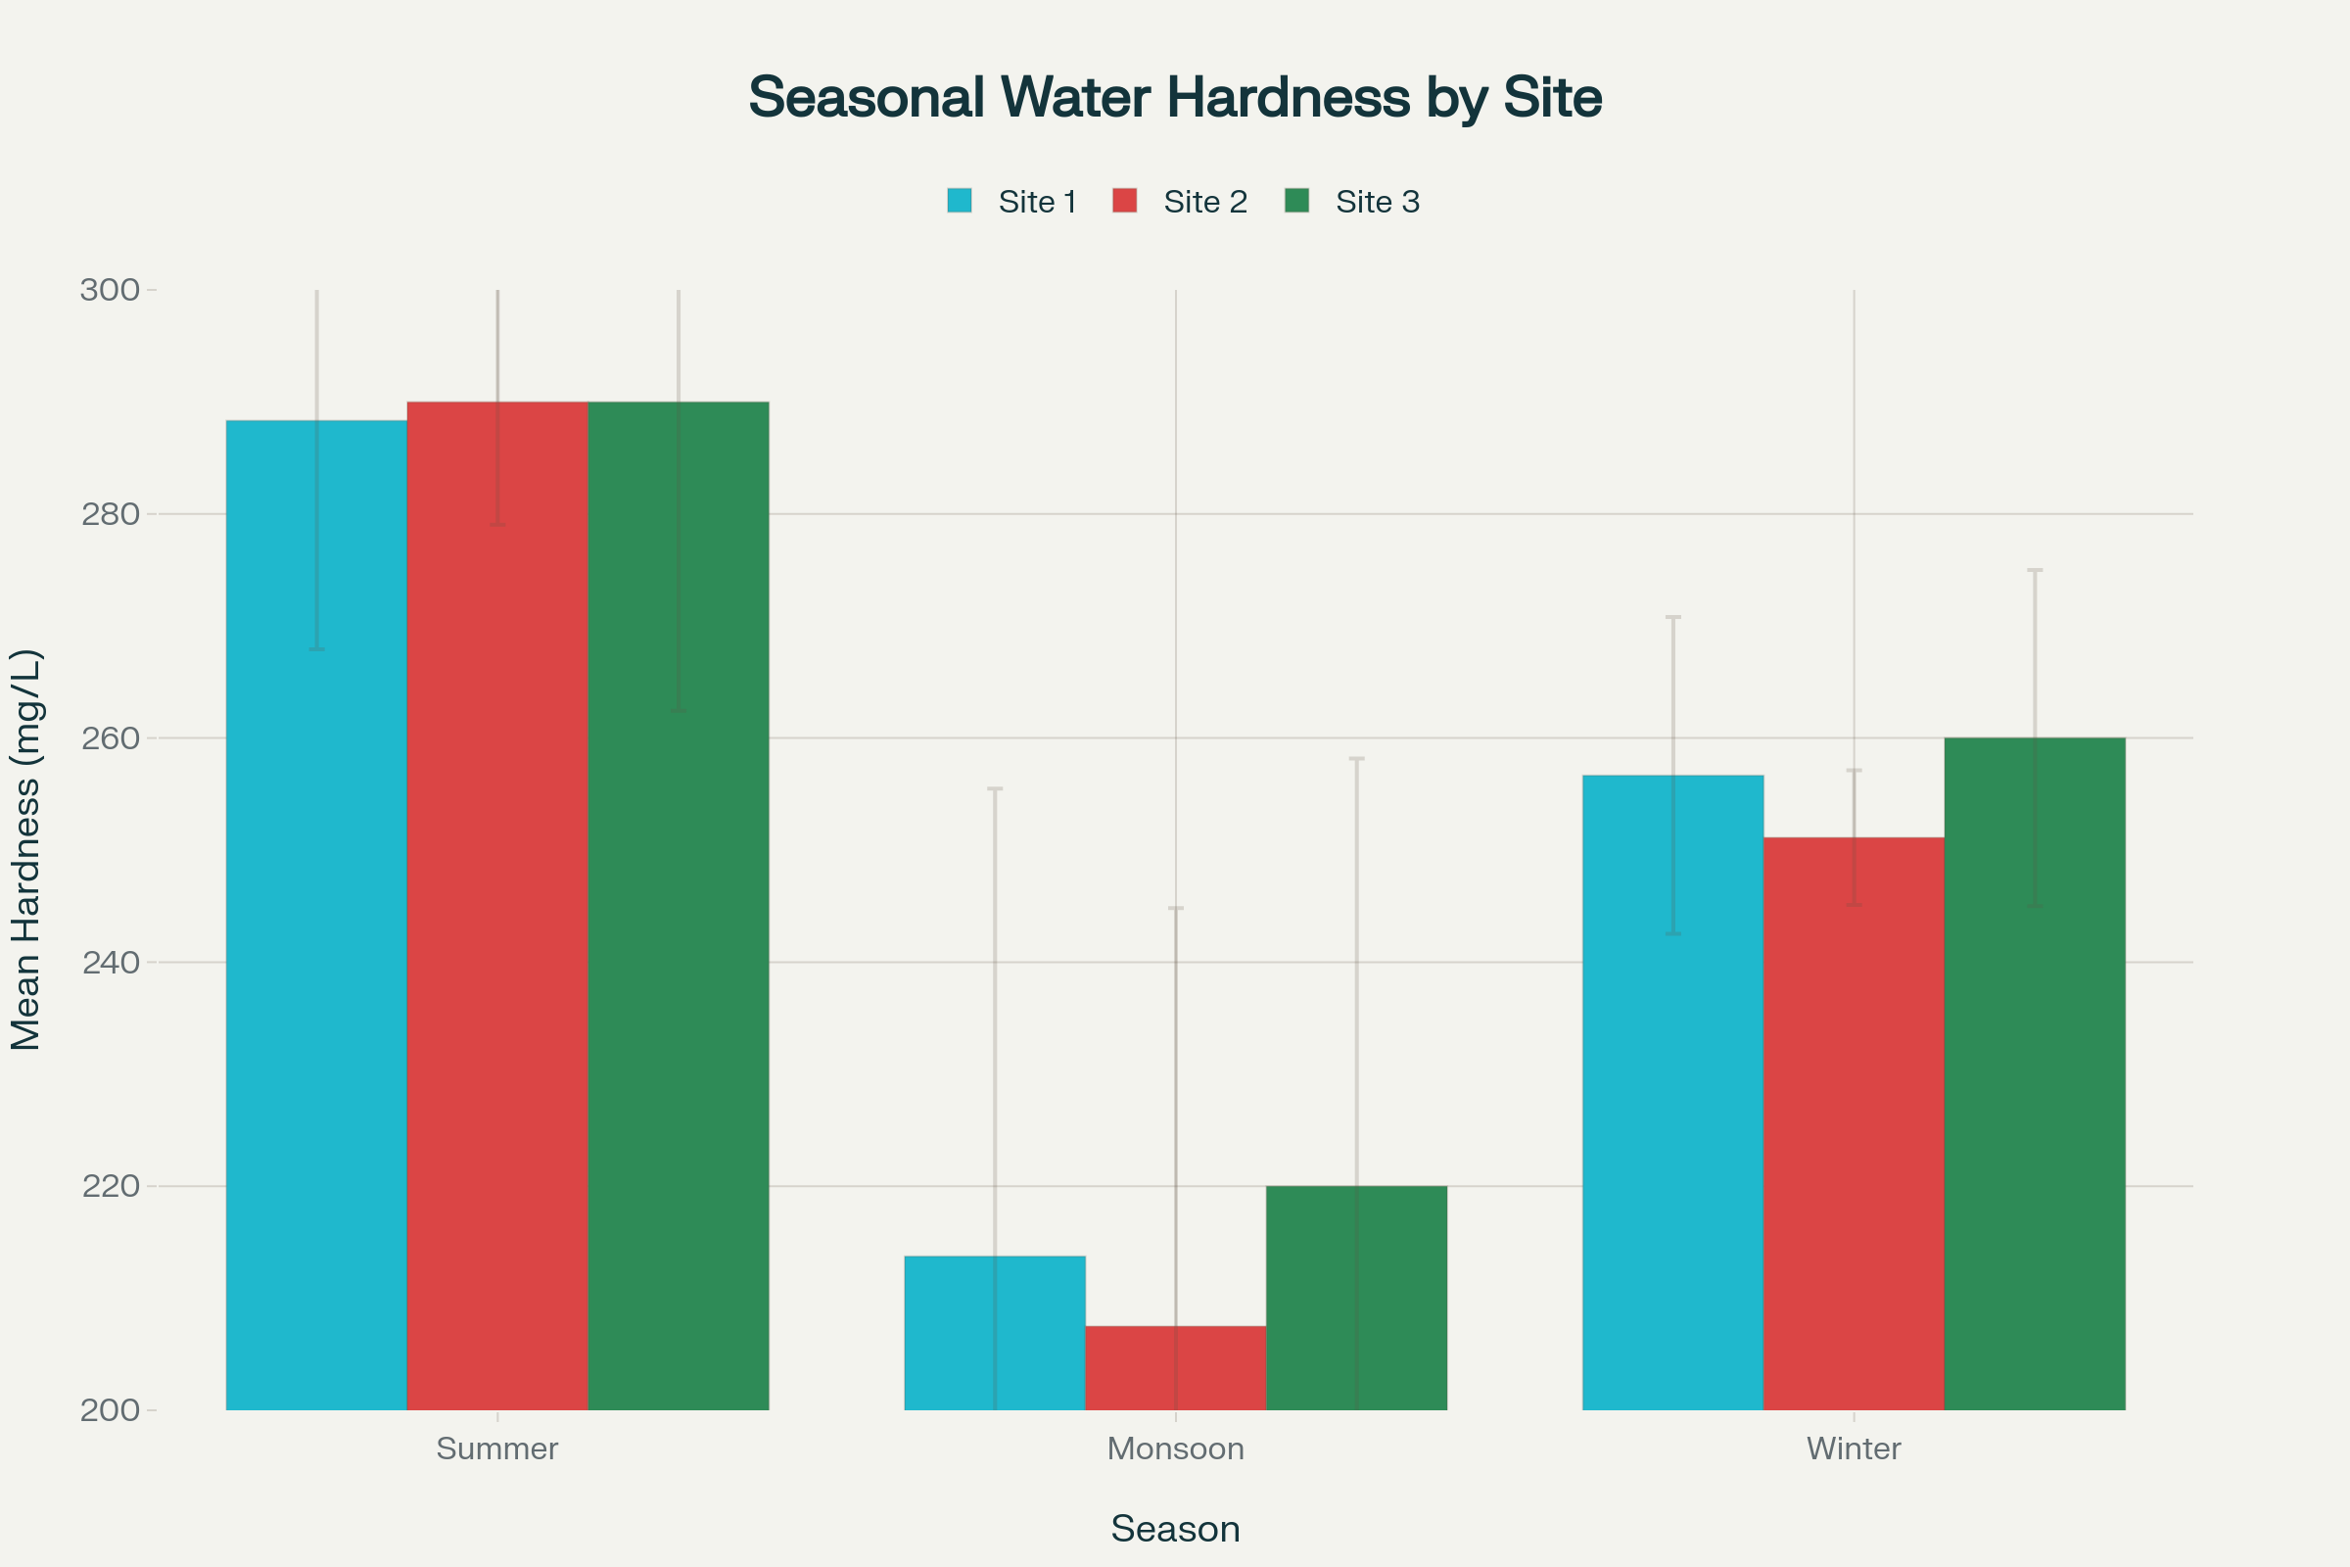

Fig 11: Seasonal comparison of mean water hardness across three stations

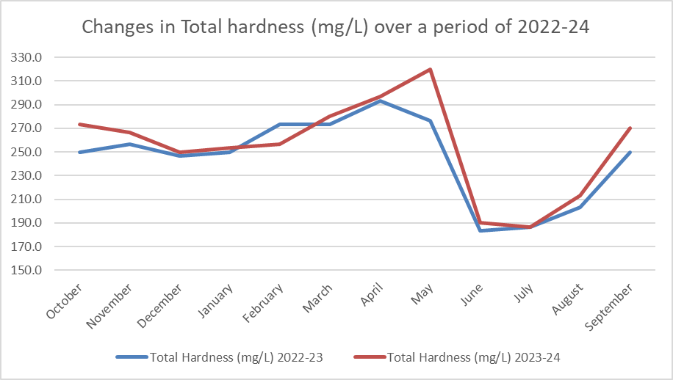

Fig 12: Monthly changes in the total hardness over the period of two years

3.7 Alkalinity (Fig. 13,14)

Water alkalinity represents the capacity to neutralize acids, determined by bicarbonate, carbonate, and hydroxide ions. It is critical for water quality and aquatic ecosystem health. All stations show "Moderate" alkalinity (WHO: 50-200 mg/L as CaCO₃). Station 1 shows mean alkalinity of 146.04 mg/L (100-190 mg/L range). Station 2 averages 141.29 mg/L (100-188 mg/L), and Station 3 averages 139.71 mg/L (100-185 mg/L). All values fall within the moderate range, indicating balanced water chemistry across stations. Water alkalinity varies seasonally with the monsoon cycle, following patterns in hardness, TDS, and mineralization parameters. Summer months show highest alkalinity due to low water volume, while monsoon months show lower values from rainfall dilution. Winter months display intermediate values. May recorded the highest monthly average (181.83 mg/L), while August showed the lowest (110.83 mg/L). The seasonal cycle reflects: Summer Phase (March-May): Low precipitation causes maximum alkalinity (mean ~156-171 mg/L). Monsoon Phase (June-September): Heavy precipitation dilutes alkalinity by 23-28% (mean ~120-124 mg/L). Winter Phase (October-February): Declining precipitation yields intermediate values (mean ~145-149 mg/L). All stations maintain ideal moderate alkalinity, with strong synchrony indicating control by monsoon cycles rather than local factors. Station 1's elevation suggests geological differences requiring investigation. An 8-10% alkalinity increase across stations from 2022-24 warrants monitoring for long-term changes.

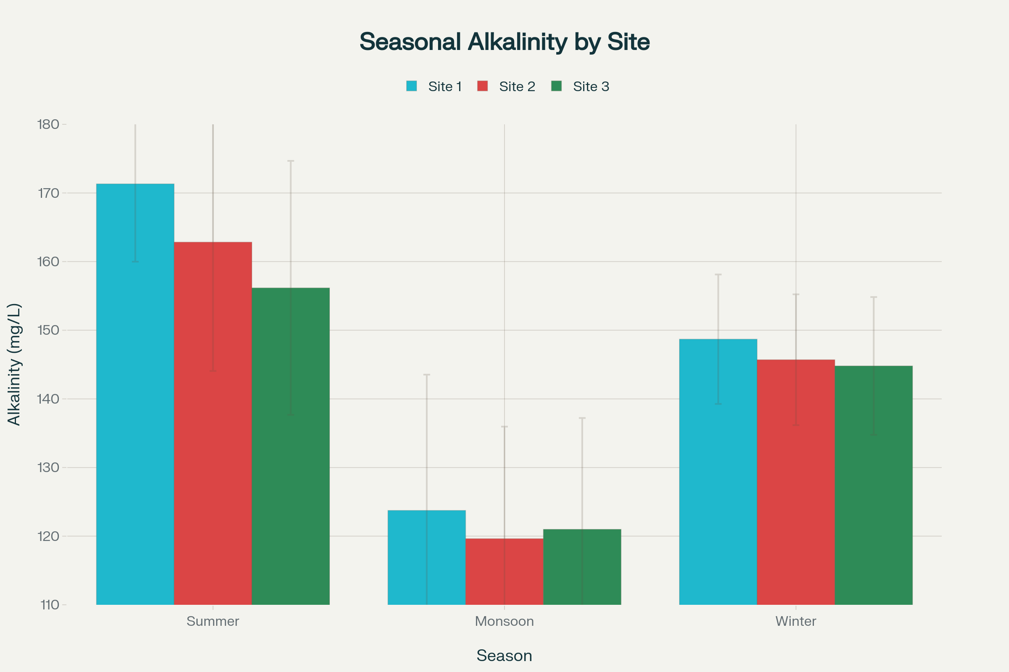
Fig 13: Seasonal comparison of mean water alkalinity across three stations
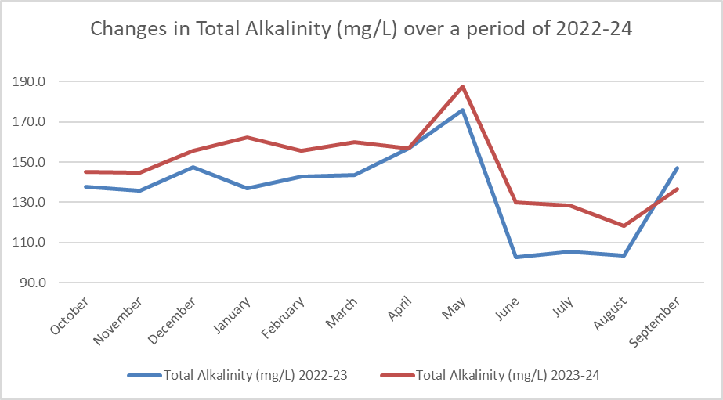
Fig 14: Monthly changes in the alkalinity over the period of two years

3.8 Dissolved Oxygen (Fig. 15,16)
Dissolved oxygen (DO) is essential for the survival of aquatic organisms, as it supports respiration in zooplankton, fish, other living organisms. Adequate levels indicate good water quality and a well thriving, healthy ecosystem. Lower oxygen levels can cause stress or death of aquatic organisms, while higher levels may also be harmful and/or lethal. DO also influences decomposition, nutrient cycling, and organic matter breakdown in these habitats. Factors like temperature, salinity, and pollution affect oxygen concentration (ex. warmer or polluted water holds less oxygen). Hence, maintaining proper DO levels is of utmost importance for sustaining aquatic biodiversity and ecosystem functioning.
Dissolved oxygen is a critical parameter for aquatic ecosystem health, affecting survival and distribution of aquatic organisms. The data reveal concerning patterns of oxygen stress during summer months. The three stations show similar DO concentrations with no significant differences (ANOVA: F = 0.218, p = 0.805). Station 1 shows a mean DO of 5.296 mg/L (range: 4.2-6.9 mg/L), Station 2 averages 5.288 mg/L (range: 4.5-6.2 mg/L), and Station 3 averages 5.383 mg/L (range: 4.8-6.3 mg/L). Station 3 has the highest mean DO, lowest variability (CV = 7.34%), and fewest sub-threshold measurements (3 below 5 mg/L), while Station 1 shows the lowest mean DO, highest variability (CV = 13.64%), and most measurements below 5 mg/L (9 measurements).
Dissolved oxygen shows a reversed seasonal pattern compared to temperature, TDS, salinity, hardness, and alkalinity. Monsoon months have the lowest DO concentrations, driven by cooler temperatures and enhanced water aeration during high flow. Summer months display the lowest DO concentrations due to high temperatures and thermal stratification reducing oxygen solubility. Winter months show intermediate DO values. August recorded the highest monthly average (5.883 mg/L), while May showed the lowest (4.650 mg/L)—a 20.8% reduction. This represents a 30% higher DO during monsoon compared to summer at Station 1. May represents the worst period for oxygen availability, combining highest temperatures (~33°C), maximum solute concentration, lowest dilution and highest metabolic demand (Table 1). All stations show low DO during March-May (mean 4.47-5.05 mg/L), creating potential oxygen stress for sensitive aquatic populations. The inverse relationship reflects physicochemical principles, as oxygen is more soluble in cool water (Mallekh and Lagardere, 2002). DO values were higher in winter and rainy seasons compared to summer. Lower summer values may result from sewage and agricultural waste inputs. The temperature-DO relationship creates a system where summer represents a critical bottleneck for oxygen-dependent aquatic life, particularly for essential zooplankton communities.

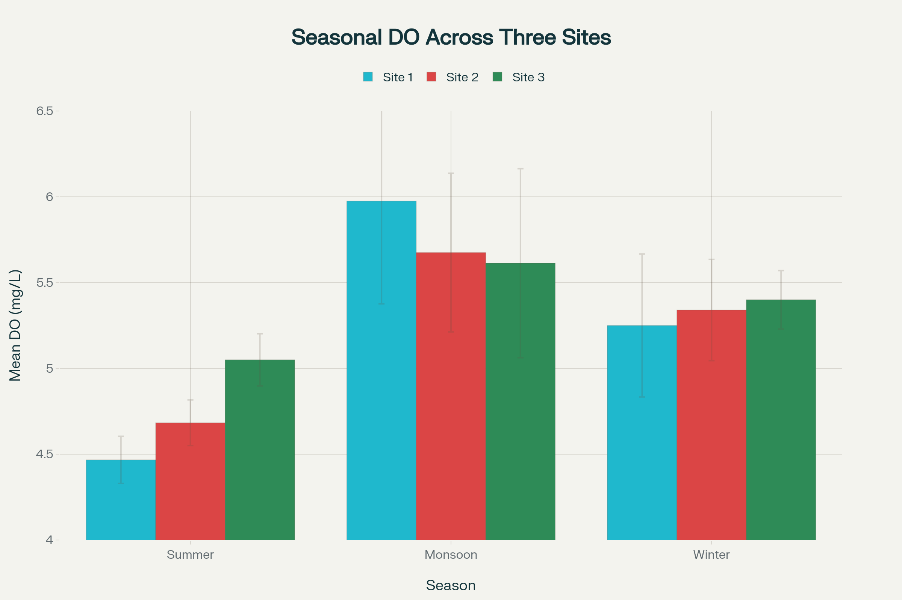
Fig 15: Seasonal comparison of mean dissolved oxygen across three stations
.
Parameter | Summer | Monsoon | Difference
Temperature | ~31°C | ~26°C | -5°C (16% lower)
Dissolved Oxygen | 4.7 mg/L | 5.8 mg/L | +1.1 mg/L (23% higher)

Table1: Table indicating the inverse Temperature and Oxygen relation
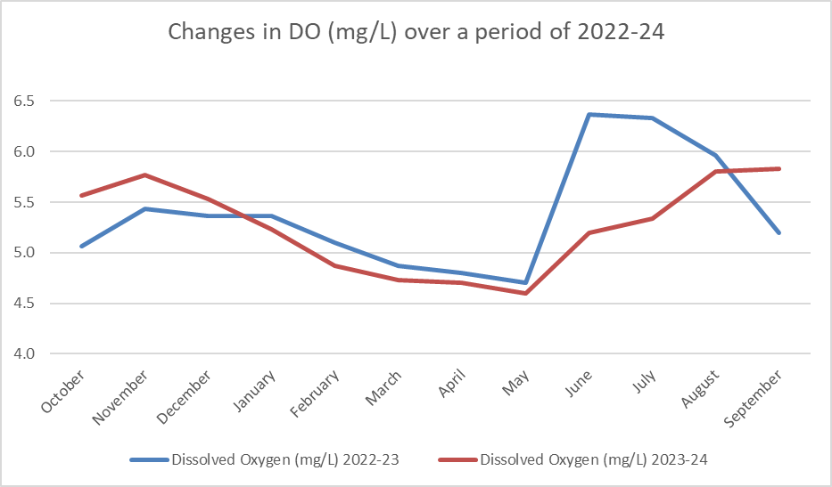

Fig 16: Monthly changes in the dissolved Oxygen over the period of two years

3.9 Chlorides (Fig 17,18)

Chlorides are important indicators of water salinity and potential contamination. Chlorides are naturally occurring ions that help maintain osmotic balance and are essential for normal physiological functions of aquatic organisms. Excessive chloride levels from agricultural runoff, sewage, or industrial waste can harm aquatic life and indicate pollution. High chloride concentrations may alter water's ionic composition, affecting sensitive species. Monitoring chloride levels is important for assessing water quality and protecting freshwater ecosystems. Hardness of freshwater is due to dissolved calcium and magnesium ions, essential for maintaining healthy functions in aquatic organisms. Moderate hardness (61–120 mg/L as CaCO₃) benefits most freshwater species, helps bone development and maintains reproductive health. Hardness lessens metal toxicity and stabilizes pH, making environments more resilient. However, levels >180 mg/L may harm organism sensitive to high mineral content. Monitoring total hardness helps maintain conditions that support freshwater ecosystems. The data reveal a good freshwater system with strong seasonal patterns. All measured values (20.0-33.4 mg/L) fall below the WHO guideline of 250 mg/L, indicating excellent freshwater quality without saline intrusion or contamination. These levels are typical of pristine freshwater systems.
Chloride concentrations show seasonal variation following the pattern of other dissolved ions and inverse to dissolved oxygen. Summer months (March-May) show the highest chloride concentrations from evaporation, while monsoon months (June-September) display the lowest due to freshwater input. Winter months (October-February) show intermediate concentrations. May recorded the highest monthly average (32.20 mg/L), while August showed the lowest (21.97 mg/L). The 26% reduction from summer to monsoon (30 mg/L to 23.5 mg/L) reflects hydrological processes (Table 2). This seasonal signature indicates a well-functioning hydrological cycle between precipitation and solute concentration. The combination of low chloride, freshwater signature, and predictable patterns indicates chlorides are not a water quality concern, but serve as tracers of hydrological processes and evidence of a pristine ecosystem supporting aquatic biodiversity.

.
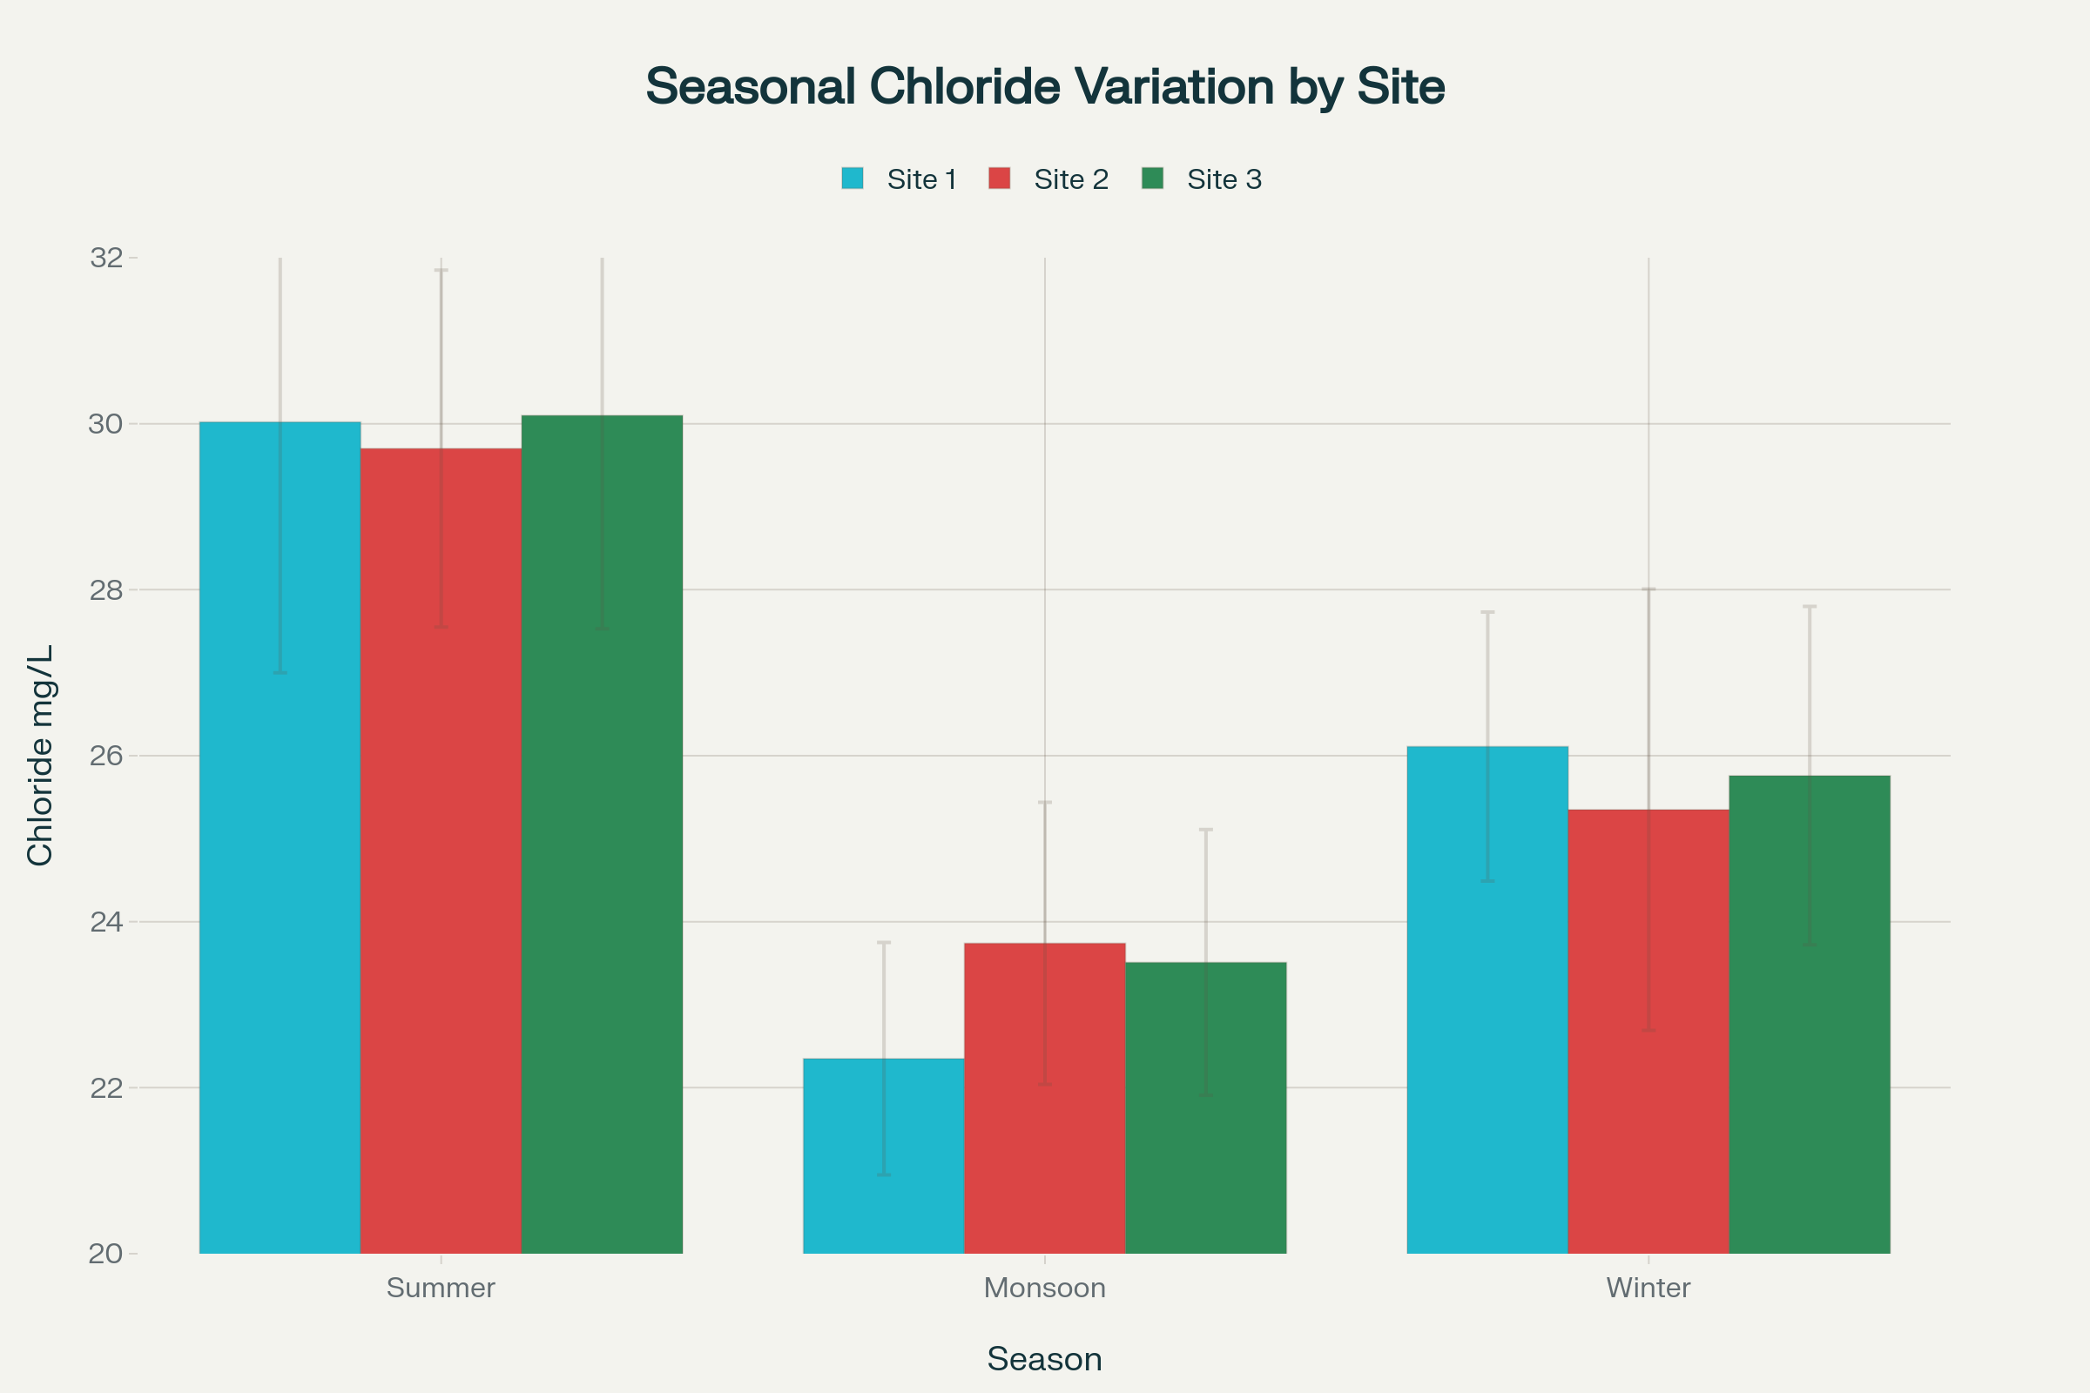
Fig 17: Seasonal comparison of mean chloride concentrations across three stations

Season | Process | Effect
Summer | Evaporation + Low water volume | Chloride concentration increases to 30 mg/L
Monsoon | Heavy rainfall + Large water volume increase | Chloride diluted to 23.5 mg/L (44% drop)
Winter | Declining rainfall + Stable water levels | Chloride intermediate at 25.5 mg/L
Table 2: The process and effect leading to chloride reduction
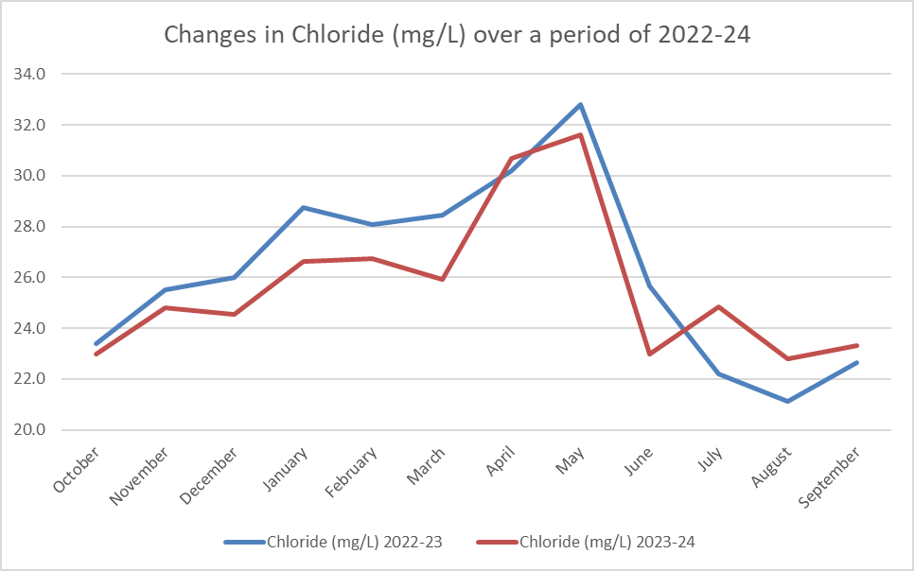
Fig 18: Monthly changes in the chloride over the period of two years

- CONCLUSIONS

The water quality parameters exhibited significant variations over the two-year study period. The pH levels ranged from slightly acidic to alkaline, spanning from 6.97 to 8.27. Water temperature also showed considerable variation, fluctuating between 22.3°C and 33.0°C, reflecting seasonal changes. Turbidity levels remained relatively moderate, ranging from 11.4 to 16.2 NTU. Total Dissolved Solids (TDS) and salinity displayed notable changes, with TDS varying between 95.7 and 156.7 mg/L and salinity ranging from 67.5 to 111.2 mg/L. Other key water quality indicators also varied during the study period. Total hardness ranged from 183.3 to 320 mg/L, while total alkalinity fluctuated between 102.7 and 187.7 mg/L. Dissolved oxygen levels, essential for aquatic life, varied significantly from 4.6 to 6.4 mg/L. Chloride concentrations ranged from 21.1 to 32.8 mg/L.
These fluctuations in water quality parameters suggest the influence of various environmental factors, potentially including seasonal changes, anthropogenic activities, or natural processes affecting the water body over the two-year period. Species diversity and abundance in reservoirs are influenced by physical and chemical factors such as temperature, pH, dissolved oxygen, and nutrient levels, among others (Fathibi et al., 2017; Jamwal et al., 2025). Additionally, chemicals responsible for eutrophication, such as nitrates and phosphates, also impact the diversity and abundance of zooplankton (Arora and Mehra, 2009). Changes in any of the standard prevailing parameters may indicate contamination or pollution from human activities, whether industrial, agricultural, or domestic. It is crucial to study these parameters to ensure favourable conditions for the survival and growth of aquatic organisms, such as zooplankton and fish, in these habitats.
The conservation of plants and animals is becoming increasingly important, especially in light of recent industrial and social development. We are losing our forests and water bodies on a large scale due to road construction, industries, and other factors. Habitats are being destroyed, and ecosystems are collapsing. In light of the above study, we can conclude that such artificial habitats may become a refuge for many flora and fauna in the future.

REFERENCES

- Annabi-Trabelsi, N., Guermazi, W., Leignel, V., Al-Enezi, Y., Karam, Q., Ali, M., & Belmonte, G. (2022). Effects of Eutrophication on Plankton abundance and composition in the Gulf of Gabès (Mediterranean Sea, Tunisia). Water. 14 (14): 2230.
- Arora, J., & Mehra, N. K. (2009). Seasonal dynamics of zooplankton in a shallow eutrophic, man-made hyposaline lake in Delhi (India): role of environmental factors. Hydrobiologia. 626 (1): 27-40.
- Artiola, J. F., & Brusseau, M. L. (2019). The role of environmental monitoring in pollution science. In Environmental and pollution science (pp. 149-162). Academic Press.
- Banerjee, D., Chatterjee, S., & Nath, S. (2022). Aquatic physicochemical parameters and their possible impact on freshwater bodies. Applied Ecology and Environmental Sciences. 10 (6): 360-367.
- Bansode, S. G. (2023). Study of Freshwater Zooplanktons in Nira River Around Akluj Dist. Solapur Maharashtra State, India. Biomedical Journal of Scientific & Technical Research. 52(3): 43805-43809.
- Battish, S K (1992) Freshwater Zooplankton of India. Oxford and IBH Publishing Co. Pvt. Ltd., New Delhi, 233 pp.
- Bhalsing, D. G., & Pokale, S. N. (2025c). Studies on certain physico-chemical parameters of Visapur Dam, Maharashtra, India. International Journal of Biology Sciences. 7(10): 53-55

- Chang, H., Ye, T., Xie, Z., & Liu, X. (2025). Application of Environmental DNA in Aquatic Ecosystem Monitoring: Opportunities, Challenges and Prospects. Water. 17 (5): 661.
- Dhembare, A. J. (2011). Diversity and its indices in zooplankton with physico-chemical properties of Mula Dam Water Ahmednagar, Maharashtra, India. European Journal of Experimental Biology. 1 (4): 98-103.
- Dhanapathi, M. V. S. S. S. (1975). Rotifers from Andhra Pradesh, India. Zoological Journal of the Linnean Society. 57(1): 85-94.
- Dhanapati M. V. S. S. (2000). Taxonomic notes on the Rotifera. Indian Association of Aquatic Biologists, Hyderabad. 15 (1&2): 6-15.
- Engdaw, F., Kifle, D., & Fetahi, T. (2025). Water quality parameters influence temporal dynamics of zooplankton community structure in a tropical highland lake, Lake Tana, Ethiopia. Marine Pollution Bulletin. 218: 118239.
- Fathibi, K., Aneesh, E. M., & Sudhikumar, A. V. (2017). Indian fresh water zooplankton: a review. International Journal of Recent Scientific Research. 8: 20999-21015.
- Hulyal, S. B., & Kaliwal, B. B. (2008). Water quality assessment of Almatti Reservoir of Bijapur (Karnataka State, India) with special reference to zooplankton. Environmental monitoring and assessment. 139 (1): 299-306.
- Jamwal, N., & Sharma, A. (2025). Environmental drivers of zooplankton diversity and composition of Pargwal Wetland, Jammu & Kashmir, India. Journal of Threatened Taxa. 17 (8): 27333-27345
- Khushboo (2025). Impact of Temperature, pH, Turbidity, and Dissolved Oxygen on Water Quality Parameters. International Journal of Innovative Research in Technology. 11 (11): 3942-3948.
- Kolar, C. S., & Rahel, F. J. (1993). Interaction of a biotic factor (predator presence) and an abiotic factor (low oxygen) as an influence on benthic invertebrate communities. Oecologia. 95 (2): 210-219.
- Mallekh, R., & Lagardere, J. P. (2002). Effect of temperature and dissolved oxygen concentration on the metabolic rate of the turbot and the relationship between metabolic scope and feeding demand. Journal of Fish Biology. 60 (5): 1105-1115
- Manickam, N., Bhavan, P. S., Santhanam, P., Bhuvaneswari, R., Muralisankar, T., Srinivasan, V., ... & Karthik, M. (2018). Impact of seasonal changes in zooplankton biodiversity in Ukkadam Lake, Coimbatore, Tamil Nadu, India, and potential future implications of climate change. The Journal of Basic and Applied Zoology. 79(1): 15.
- Pandarkar A.K, Pawar B.A & Shendge A.N (2014). Zooplankton diversity of Visapur reservoir in Ahmednagar district, Maharashtra. Journal of Experimental Zoology, India.17 (1): 327-329
- Pastorino, P., Esposito, G., Prearo, M., & Sonne, C. (2025). The role of invasive alien species as bioindicators for environmental pollution. Current Opinion in Environmental Science & Health. 100620.
- Peng, Y., Zhang, W., Yang, X., Zhang, Z., Zhu, G., & Zhou, S. (2024). Current status and prospects of algal bloom early warning technologies: A Review. Journal of Environmental Management. 349: 119510.
- Roy, S., & Saikia, S. K. (2023). Characterization of Some Physico-Chemical Parameters of Water Bodies Inhabited by Small Indigenous Fish Species (SIFs): A Case Study. European Journal of Aquatic Sciences. 2 (3): 1-7.
- Tung, N. T., Giang, H. T., Tu, P. Т. С., Vy, T. T., Hieu, N. T., & Lien, N. T. К. (2025). Zooplankton species diversity in Dau Tieng Lake, Vietnam. Aquaculture, Aquarium, Conservation & Legislation. 18 (2): 712-724.
- Vanjare, A. I., Padhye, S. M., & Pai, K. (2010). Zooplankton from a polluted river, Mula (India), with record of Brachionus rubens (Ehrenberg, 1838) epizoic on Moina macrocopa (Straus, 1820). Opuscula Zoologica Budapestensis. 41 (1): 89-92.
- Vanjare, A., & Pai, K. (2013). Ecology of freshwater Rotifera in a seasonal pond of the University of Pune (Maharashtra, India). Applied Ecology and Environmental Research. 11 (4): 525-539.
- Vanjare, A. I., Panikar, C. A. V. N., & Padhye, S. M. (2017). Species richness estimate of freshwater rotifers (Animalia: Rotifera) of western Maharashtra, India with comments on their distribution. Current Science. 112(4): 695-698.
- Vanjare, A. I., Shinde, Y. S., & Padhye, S. M. (2023). Faunistic overview of the freshwater zooplankton from the urban riverine habitats of Pune, India. Journal of Threatened Taxa. 15 (9): 23879-23888.
- Weiskopf, S. R., Rubenstein, M. A., Crozier, L. G., Gaichas, S., Griffis, R., Halofsky, J. E., ... & Whyte, K. P. (2020). Climate change effects on biodiversity, ecosystems, ecosystem services, and natural resource management in the United States. Science of the Total Environment. 733: 137782.

- Zhang, Z., Shi, Z., Yu, Z., Zhou, K., Lin, J., Wu, J., & Mu, J. (2022). Spatio-temporal variations of zooplankton and correlations with environmental parameters around Tiaowei Island, Fujian, China. International Journal of Environmental Research and Public Health. 19 (19): 12731.

