Diversity of Aquatic Macrophytes and Water Quality Assessment of Joysagar Tank of Sivasagar District, Assam, India

ABSTRACT

The present study documents the diversity of aquatic macrophytes and evaluates key water quality parameters in Joysagar Tank, Sivasagar district. The primary objective of this research was to inventory the aquatic macrophyte species and assess important water quality indicators, including pH, dissolved oxygen, and temperature, in order to generate baseline information on the ecological condition of the tank.
A total of 54 macrophyte species belonging to 45 genera were recorded during the study period. The dominant families were poaceae representing 10 species. This is followed by Polygonaceae and Asteraceae (6 species). The findings reveal a diverse assemblage of macrophytes, with species such as Eclipta prostrata, Eichhornia crassipes, Kyllinga brevifolia and Colocasia esculenta being particularly prominent. Overall, the measured water quality parameters remained within stable ranges, suggesting a functioning aquatic ecosystem. The characteristics of tank hydrology is regulated by the physico- chemical properties of water. Results show that increasing temperature value and rain water is favorable for growth and development of macrophytes. Lower turbidity enhances light availability, improves photosynthesis and generally indicates better water quality which support the healthy growth and development of macrophytes. Hydrogen ion concentration of water is considered as one of the important factors regulating aquatic ecosystem. Nevertheless, the study also identifies emerging concerns, including eutrophication and persistent human-induced disturbances, which pose significant threats to the long-term sustainability of the tank. In Joysagar Tank, various anthropogenic activities—such as the disposal of solid waste and plastics, discharge of restaurant waste, and recreational boating—have contributed to the degradation of the tank’s ecosystem. Although Joysagar Tank supports rich biodiversity, it is increasingly facing environmental challenges due to human interference. Therefore, the implementation of effective pollution-control measures, along with enhanced public awareness and community participation, is essential for the conservation and sustainable management of the tank’s ecosystem.

Keywords: Aquatic Macrophytes; Joysgar tank; Macrophytes; physio-chemical parameter; wetland

1.INTRODUCTION

Limnology is the scientific study of inland water systems and is widely regarded as a subfield of environmental science and ecology [1]. It shares strong connections with aquatic ecology and hydrobiology, disciplines that examine aquatic organisms in relation to their physical and hydrological environments [2]. Although freshwater science is often used interchangeably with limnology, this is inaccurate, as limnology also encompasses the study of saline inland water bodies, such as salt lakes [3].
Biological diversity describes the range and variability of living organisms across different levels, including species, habitats, and ecosystems. This diversity arises from multiple environments—terrestrial, marine, and freshwater—and the complex ecological interactions they support (Gopal, [4]). Historically, wetlands were considered low-value landscapes in social and economic development, frequently drained or altered for agricultural and urban use [5,6]. Over time, however, their ecological significance has become widely recognized. Wetlands are now understood to be among the most biologically rich and productive ecosystems globally, serving as transition zones between aquatic and terrestrial environments [7].
These ecosystems play a vital role in supporting human well-being by offering essential services such as water purification, food resources, raw materials, flood regulation, erosion prevention, and the preservation of biodiversity [8].
Aquatic macrophytes constitute an important group of plants that inhabit freshwater ecosystems, including lakes, rivers, wetlands, and ponds. These plants are typically large and easily observable, and they are distinguished by their capacity to grow in aquatic or semi-aquatic conditions. Aquatic macrophytes may remain permanently or temporarily submerged, float freely on the water surface, or emerge above the surface while remaining rooted in saturated substrates. They are large, visible plants adapted to moist and aquatic conditions and include a wide range of plant groups such as angiosperms, ferns, mosses, liverworts, and certain freshwater macroalgae [9]. Owing to their high abundance and species richness, aquatic macrophytes play a crucial ecological role by providing an important source of food and fodder within aquatic ecosystems. Many aquatic macrophytes exhibit wide geographical distribution due to their highly efficient reproductive strategies and strong dispersal abilities [10,11,12]. Across different growth forms, population expansion occurs mainly through vegetative propagation using rhizomes, overwintering buds, and fragmented plant parts. These propagules can be transported over long distances by wind, animals, and human activities. Some species, particularly helophytes, demonstrate exceptional colonization potential as they combine rapid vegetative growth with prolific seed production, with seeds readily dispersed by wind [11,13]. Aquatic macrophytes strongly influence both the structure and functioning of freshwater ecosystems. However, several pressures on inland water bodies—such as eutrophication, climate change, and the introduction of non-native species—pose serious threats to these ecosystems. These disturbances often result in reduced macrophyte diversity and promote the spread of invasive species at the expense of native flora.
As primary producers, aquatic macrophytes play a central role in biogeochemical cycles and food webs within lentic freshwater systems. Owing to their diverse functional roles, macrophytes form an integral component of many freshwater ecosystems. They contribute to ecosystem stability by providing shelter for macroinvertebrates, serving as habitats for zooplankton, and offering feeding, breeding, and refuge areas for littoral fish communities. In addition, macrophytes influence nutrient and contaminant cycling, help stabilize sediments, reduce shoreline erosion, and limit sediment resuspension.
Aquatic macrophytes are also valuable indicators of water quality and have the capacity to accumulate heavy metals. Furthermore, they help regulate water quality through the release of various organic and inorganic compounds [14].
Climatic conditions play a crucial role in determining water quality and availability, which in turn influence aquatic biodiversity [15]. Adverse environmental factors, including climate variability and deterioration of water quality, can restrict the distribution and species richness of ecological communities. Even minor changes in environmental conditions may exert substantial effects on aquatic ecosystems. Therefore, identifying the key environmental factors that shape aquatic communities across different spatial and temporal scales is essential for understanding ecosystem dynamics and supporting effective management and conservation strategies.
The present study is therefore undertaken to investigate diversity of aquatic macrophytes of Joysagar tank. The Joysagar tank is situated in Sivasagar District, Assam, which is located at the North- East part of India. It is considered as the largest man- made tank in Asia. The water levels in this tank remain consistent throughout all season, this is supported by the fact that the tank is fed by underground water source [16,17]. The tank’s water level is fourteen feet higher from the ground level. Diverse floras are found in this tank. The study is also conducted on the physico- chemical properties of waterbody of Joysagar tank.The primary objective of the present study is to address existing knowledge gaps regarding aquatic macrophytes in Joysagar Tank, a comparatively understudied ecosystem of Assam. By documenting macrophyte diversity alongside an assessment of water quality, this research aims to present a comprehensive evaluation of the ecological condition and functional status of the beel.
A systematic survey of aquatic macrophytes combined with water quality analysis is essential for recording the biodiversity of this tank, assessing its ecological health, and understanding the interactions between aquatic vegetation and physicochemical characteristics of the water. As effective bioindicators, macrophytes provide valuable information on the environmental status of the tank, while key water quality parameters—such as pH, dissolved oxygen, and turbidity—offer insights into its ability to sustain aquatic organisms. At the same time, it identifies major threats, including eutrophication and anthropogenic disturbances, that pose risks to its long-term ecological integrity. By generating essential baseline data, this research contributes to future conservation planning and highlights the necessity of sustainable management strategies to safeguard both the ecological and economic functions of the tank.

2. MATERIAL AND METHODS

2.1 Study Area

The study area comprises the historic Joysagar Tank, the largest man-made tank in Asia, located in Sivasagar District of Assam. The tank lies approximately 5 km from Sivasagar town and is situated adjacent to Joy Dol. Geographically, Joysagar Tank extends between 26°56′97″ N and 26°57′32″ N latitude and 94°37′38″ E and 94°37′54″ E longitude. The tank was constructed during the reign of Swargadeo Rudra Singha (1696–1714 AD) in memory of his mother, Joymoti Konwari. To the north of the tank lies the well-known Rupohi Pothar, while Kaloogaon is located to the south. Salaguri lies to the east of the tank, and the historic town of Rangpur Nagar (present-day Joysagar) is situated to the west. The water level of Joysagar Tank is approximately fourteen feet higher than the surrounding ground level. The tank supports a rich diversity of flora and fauna, reflecting its ecological significance. One of its notable characteristics is the relative stability of its water level throughout the year; even during the dry season, the water level does not decline appreciably. Joysagar Tank is also one of the most prominent tourist attractions in Sivasagar and receives a large number of visitors annually. During the winter months, the tank serves as an important habitat for numerous migratory bird species, making birdwatching a popular activity during this period. Joysagar tank was selected as the study site because of its distinctive ecological characteristics and the growing intensity of anthropogenic pressures acting upon it. The tank maintains relatively stable water levels throughout the year, although seasonal hydrological variations influence the distribution and abundance of aquatic species. To obtain a representative assessment of the ecological condition of the tank, sampling locations were systematically established across different zones of the tank.

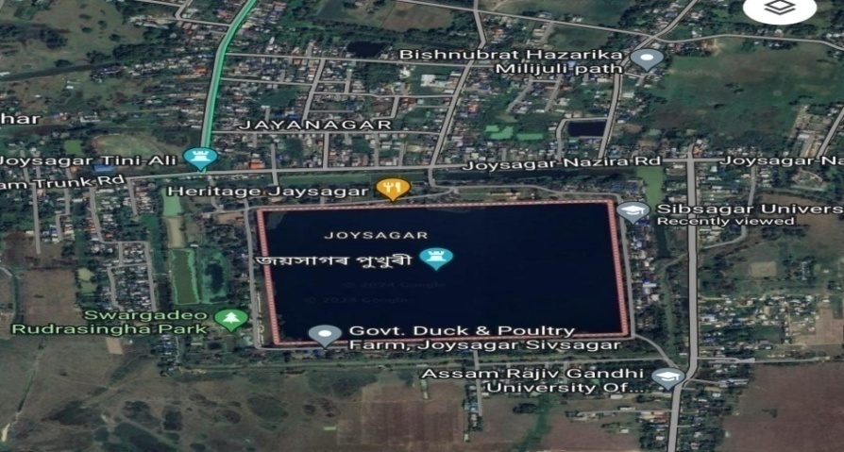

Fig. 1. Map showing Joysagar tank of Sivasagar District, Assam (Source: Google earth)
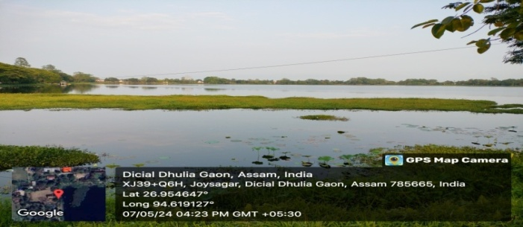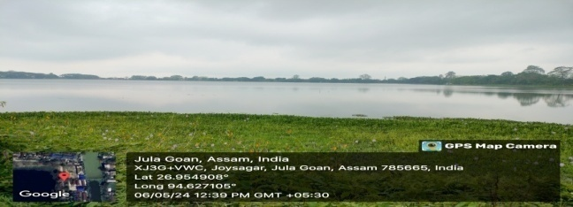

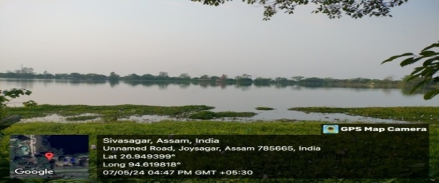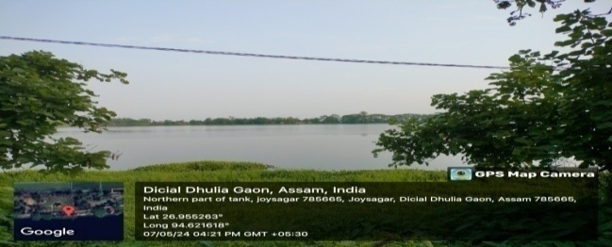

Fig 2: Various Study sites of Joysagar Tank, Sivasagar

2.2 Sample collection

Aquatic macrophyte samples were collected from multiple locations within Joysagar tank using a random sampling approach to ensure representative coverage of the wetland. Collected plant specimens were identified with the help of standard regional floristic references, including Flora of Assam (Volumes I–V).
Simultaneously, water samples were obtained from the same sites for the analysis of physicochemical parameters. Water was collected in pre-sterilized containers and promptly transported to the laboratory to prevent contamination and ensure accurate analysis.

Aquatic macrophytes in Joysagar tank were sampled using a systematic transect method to ensure representative coverage of the wetland. Five transects, each 100 m in length, were laid perpendicular to the shoreline so as to encompass a broad range of habitat types, including submerged, emergent, and floating vegetation zones.Along each transect, 1 m² quadrats were placed at 10 m intervals, resulting in a total of 50 sampling plots. This sampling design provided comprehensive spatial coverage and enabled a reliable assessment of macrophyte species composition, distribution, and abundance across the wetland.

2.3 Water Quality Analysis

Water quality in Joysagar tank was assessed by analyzing several physicochemical parameters following standard procedures recommended by the U.S. Environmental Protection Agency [18].
Water temperature was measured in situ at each sampling location using a calibrated thermometer, as temperature is a key factor influencing chemical reactions and biological processes in aquatic ecosystems. The pH of the water was determined using a portable digital pH meter that was standardized prior to measurement to ensure accuracy. Dissolved oxygen and free carbon dioxide concentrations were estimated using standard titrimetric methods, which are widely recognized for their reliability in freshwater quality assessment.
Additional physicochemical parameters were analyzed under laboratory conditions following established standard methodologies. These parameters included total dissolved solids (TDS), turbidity, iron, calcium, magnesium, total hardness, total alkalinity, chloride, total arsenic, nitrate, fluoride, and residual chlorine. The assessment of these parameters provided a comprehensive understanding of the chemical characteristics of the water and aided in identifying potential sources of contamination. All analyses were performed in accordance with recognized standard protocols to ensure accuracy, precision, and reproducibility of the results.
All data were collected on a seasonal basis to capture temporal variations in water quality. The resulting dataset was analyzed to evaluate the overall ecological health of the tank.

3. RESULTS

The present study documented a total of 54 macrophyte species belonging to 45 genera and 28 families across the study sites. Among these, Poaceae emerged as the most dominant family with 10 species. This was followed by Polygonaceae and Asteraceae, each represented by 6 species. Apiaceae and Onagraceae contributed 3 species each, while Rubiaceae, Elatinaceae, Amaranthaceae, Araceae, and Cyperaceae were represented by 2 species each. The remaining families—namely Pontederiaceae, Convolvulaceae, Salviniaceae, Nymphaeaceae, Oxalidaceae, Commelinaceae, Cleomaceae, Dryopteridaceae, Linderniaceae, Pteridaceae, Trapaceae, Lentibulariaceae, Alismataceae, Stratiotaceae, Lamiaceae, Euphorbiaceae, and Caryophyllaceae—were represented by a single species each. Details of the aquatic macrophytes identified from the sampled waterways of Joysagar Tank are summarized in Table 1 Density of Eclipta prostrata is highest among the all-study site. Density value was highest in case of Nymphaea alba, Eichhornia crassipes, Kyllinga brevifolia and Colocasia esculenta in both seasons. They are tolerent to the seasonal variation and their dispersion and siurvival were not affected by the changes of seasons.

Table 1. List of aquatic macrophytes found in Joysagar Tank, Sivasagar District

Sl. No. | Scientific Name | Family | Growth Habit | Common Name
1 | Sagittaria subulata | Alismataceae | Emergent | Dwarf arrowhead
2 | Alternanthera philoxeroides | Amaranthaceae | Emergent / Floating | Alligator weed
3 | Amaranthus viridis | Amaranthaceae | Emergent | Slender amaranth
4 | Centella asiatica | Apiaceae | Emergent | Indian pennywort
5 | Oenanthe javanica | Apiaceae | Emergent | Water dropwort
6 | Pimpinella peregrina | Apiaceae | Emergent | Wild anise
7 | Colocasia esculenta | Araceae | Emergent | Taro / Elephant ear
8 | Pistia stratiotes | Araceae | Free-floating | Water lettuce
9 | Ageratum conyzoides | Asteraceae | Emergent | Billy goat weed
10 | Eclipta prostrata | Asteraceae | Emergent | False daisy
11 | Enhydra fluctuans | Asteraceae | Emergent | Water cress
12 | Erechtites hieraciifolius | Asteraceae | Emergent | American burnweed
13 | Gymnocoronis latifolia | Asteraceae | Emergent | Senegal tea plant
14 | Mikania cordata | Asteraceae | Emergent climber | Mile-a-minute weed
15 | Drymaria cordata | Caryophyllaceae | Emergent | Tropical chickweed
16 | Cleoserrata speciosa | Cleomaceae | Emergent | Spider flower
17 | Commelina diffusa | Commelinaceae | Emergent | Spreading dayflower
18 | Ipomoea aquatica | Convolvulaceae | Emergent / Floating | Water spinach
19 | Cyperus compactus | Cyperaceae | Emergent | Flatsedge
20 | Cyperus difformis | Cyperaceae | Emergent | Variable flatsedge
21 | Diplazium esculentum | Dryopteridaceae | Emergent | Vegetable fern
22 | Elatine hexandra | Elatinaceae | Submerged | Six-stamen waterwort
23 | Elatine sp. | Elatinaceae | Submerged | Waterwort
24 | Euphorbia hirta | Euphorbiaceae | Emergent | Asthma weed
25 | Leonurus sibiricus | Lamiaceae | Emergent | Siberian motherwort
26 | Utricularia aurea | Lentibulariaceae | Free-floating (submerged) | Golden bladderwort
27 | Lindernia crustacea | Linderniaceae | Emergent | False pimpernel
28 | Nymphaea alba | Nymphaeaceae | Rooted floating | White water lily
29 | Ludwigia adscendens | Onagraceae | Floating / Emergent | Floating primrose-willow
30 | Ludwigia palustris | Onagraceae | Emergent | Marsh seedbox
31 | Ludwigia peploides | Onagraceae | Floating | Creeping water primrose
32 | Oxalis corniculata | Oxalidaceae | Emergent | Creeping wood sorrel
33 | Axonopus compressus | Poaceae | Emergent | Carpet grass
34 | Scirpus lateriflorus | Poaceae | Emergent | Bulrush
35 | Kyllinga brevifolia | Poaceae | Emergent | Green kyllinga
36 | Leersia hexandra | Poaceae | Emergent | Southern cutgrass
37 | Hygroryza aristata | Poaceae | Floating grass | Asian floating rice
38 | Hymenachne acutigluma | Poaceae | Emergent | West Indian marsh grass
39 | Oplismenus hirtellus | Poaceae | Emergent | Basket grass
40 | Oryza rufipogon | Poaceae | Emergent | Wild rice
41 | Panicum hemitomon | Poaceae | Emergent | Maidencane
42 | Vetiveria zizanioides | Poaceae | Emergent | Vetiver grass
43 | Eichhornia crassipes | Pontederiaceae | Free-floating | Water hyacinth
44 | Persicaria glabra | Polygonaceae | Emergent | Smooth smartweed
45 | Persicaria lapathifolia | Polygonaceae | Emergent | Pale smartweed
46 | Persicaria hydropiper | Polygonaceae | Emergent | Water pepper
47 | Persicaria odorata | Polygonaceae | Emergent | Vietnamese coriander
48 | Persicaria orientalis | Polygonaceae | Emergent | Prince’s feather
49 | Pteris biaurita | Pteridaceae | Emergent (fern) | Ladder brake
50 | Oldenlandia corymbosa | Rubiaceae | Emergent | Diamond flower
51 | Oldenlandia diffusa | Rubiaceae | Emergent | Snake needle grass
52 | Salvinia natans | Salviniaceae | Free-floating (fern) | Floating fern
53 | Stratiotes aloides | Stratiotaceae | Submerged / Floating | Water soldier
54 | Trapa natans | Trapaceae | Rooted floating | Water chestnut

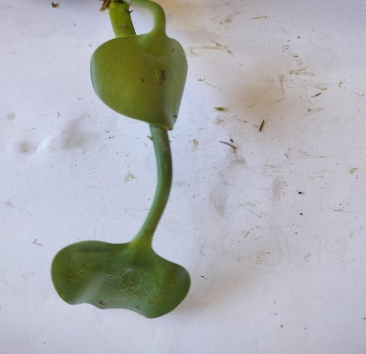  Eichhornia crassipes | 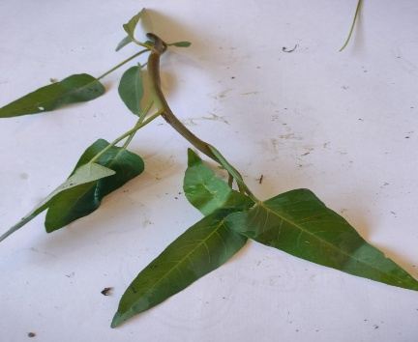  Ipomoea aquatica | 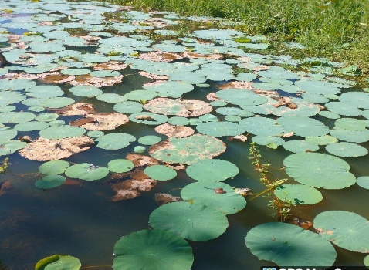  Nymphaea
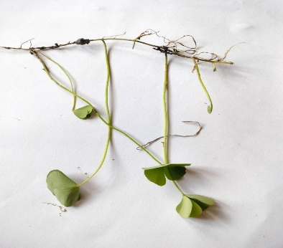  Oxalis Corniculata | 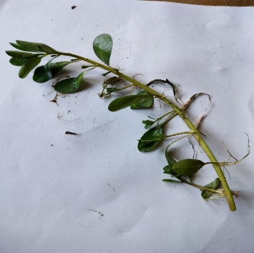  Ludwigia palustris | 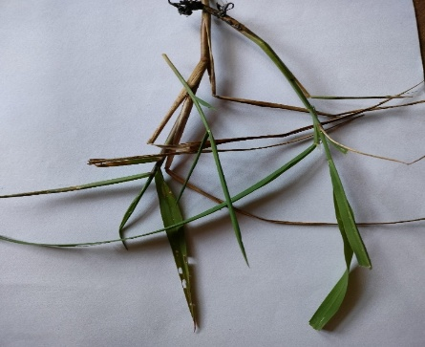  Eleusine indica
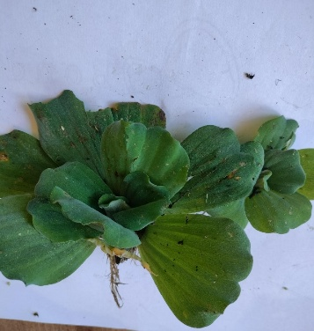  Pistia stratiotes | 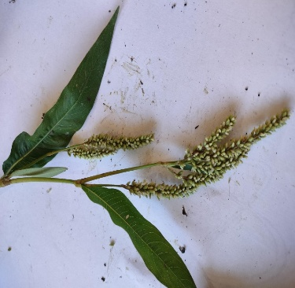  Persicaria lapathifolia | 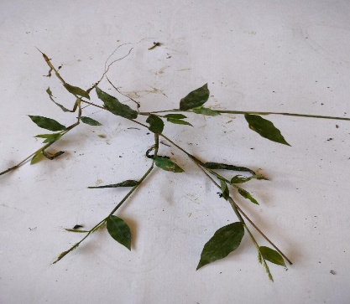  Oplismenus hirtellus
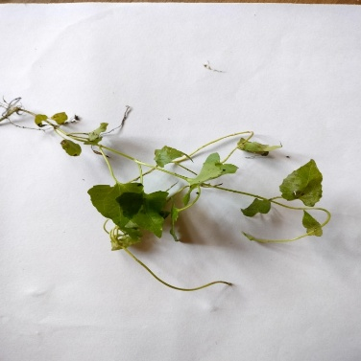  Mikania cordata | 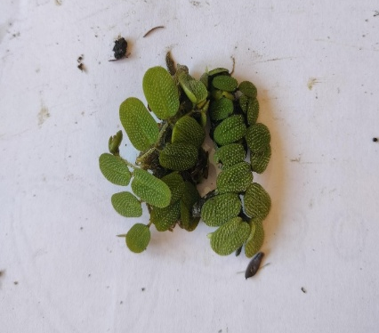  Salvinia natan | 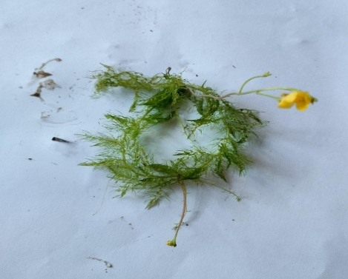  Utricularia aurea
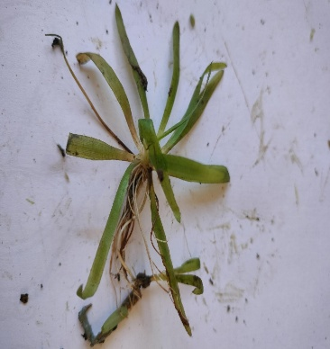  Sagittaria subulata | 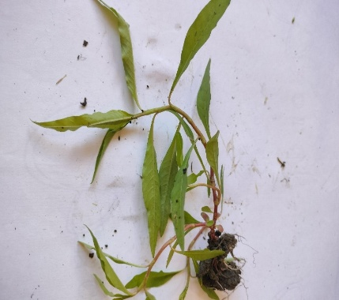  Persicaria sp. | 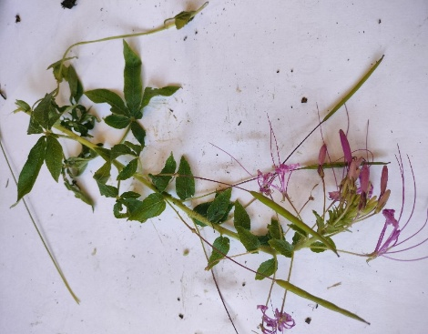  Cleoserrata speciosa

Plate 1: Images of aquatic macrophytes of Joysagar Tank.

3.1 Physico-chemical Analysis of Water
The assessment of physico-chemical characteristics is essential for evaluating the overall water quality of aquatic ecosystems. These parameters offer valuable insights into the environmental conditions that govern biological productivity and maintain ecological balance. Moreover, variations in physico-chemical properties are closely linked to the distribution, abundance, and diversity of aquatic organisms inhabiting a water body.
Higher temperature and increased rainfall during the summer season promote the growth and development of aquatic macrophytes. In contrast, turbidity levels tend to increase during the winter season, which can limit light penetration and thereby inhibit macrophyte growth and productivity. Elevated concentrations of total dissolved solids (TDS) are also commonly observed during the summer months. The pH of the water is generally higher in winter, which may contribute to a decline in macrophyte species diversity and richness. Similarly, alkalinity values are elevated during the winter season, corresponding with seasonal patterns in macrophyte vegetation dynamics. Increased water hardness during winter indicates higher concentrations of calcium and magnesium ions, which may exert adverse effects on the growth and distribution of aquatic macrophyte populations. In the present investigation, the measured physico-chemical parameters of Joysagar Tank are presented in Table 2 and were analyzed to evaluate the suitability of the habitat for aquatic life. The observed values of the assessed parameters indicate that the water quality of Joysagar Tank remains within permissible and favorable ranges, thereby supporting the growth, survival, and reproductive processes of aquatic organisms. Overall, the findings suggest that Joysagar Tank offers a stable and conducive aquatic environment capable of sustaining diverse biological communities.

Table 2: Water sample analysis result of Joysagar tank
Sl No | Parameter | Concentration
 | pH Value | 6-7.8
 | Air Temperature | 16.8- 32 ℃
 | Water Temperature | 19-34 ℃
 | Turbidity | 4-34 NTU
 | Dissolved oxygen | 1-6.8 mg/l
 | TDS (Total Dissolved Solids) | 82-92 mg/l
 | Iron | 0.26-0.49 mg/l
 | Total Hardness | 50-64 mg/l
 | Calcium | 11.22 -12.02mg/l
 | Magnesium | 4.89-8.78 mg/l
 | Nitrate | 0 mg/l
 | Total Arsenic | 0 mg/l
 | Fluoride | 0.02-0.06 mg/l
 | Residual Chlorine | 0 mg/l
 | Sulphate | 1.6-2.54 mg/l
 | Total Alkalinity | 45-66 mg/l
 | Chloride | 4.5-9.92 mg/l

Fig. 3. Graphical presentation of the water quality parameters based of Joysagar Tank

4. DISCUSSION

The survey documented 54 macrophyte species belonging to 45 genera and 28 families, reflecting favorable water quality conditions, efficient nutrient cycling, and the availability of suitable habitats for aquatic organisms. These macrophytes play an important role in sediment stabilization, biodiversity maintenance, and overall ecosystem functioning. Water quality assessment was carried out using selected physicochemical parameters, including salinity, dissolved oxygen (DO), turbidity, pH, iron, arsenic, fluoride, nitrite, calcium, magnesium and temperature. Water temperature was recorded using a digital thermometer, while pH was measured in situ with a portable pH meter. Observations indicated that the water remained moderately clear for most of the year. The pH values varied between 6.0 and 7.8, largely influenced by aquatic vegetation and the surrounding basin soil characteristics. Dissolved oxygen concentrations ranged from 1 to 6.8 mg/l, which is adequate to sustain aquatic organisms, including fish and aquatic insects. Total alkalinity values fluctuated between 45-66 mg/l, indicating temporal variations in water hardness and buffering capacity. Notably, nitrite and arsenic were absent from all analyzed water samples, highlighting the good quality and safety of the water.
Aquatic macrophyte diversity plays a crucial role in understanding the structure and functioning of freshwater ecosystems. Macrophytes contribute significantly to nutrient cycling, habitat complexity, primary productivity, and the overall ecological balance of wetlands and other aquatic systems. Consequently, numerous studies have emphasized the importance of documenting macrophyte diversity in relation to environmental conditions.
Chibsa et al. [19] investigated the distribution and diversity of aquatic macrophytes in relation to selected physicochemical parameters of the Ketar River. Their study recorded sixteen macrophyte species belonging to fourteen families, of which eleven species were emergent, three were rooted with floating leaves, and two were free-floating. Sharma and Dwivedi [20] documented a high diversity of aquatic macrophytes from the Govardhan Sagar water body.A comprehensive regional-scale assessment was conducted in four blocks of Purba Medinipur District, where sixty-seven aquatic macrophyte species belonging to fifty-four genera and thirty-two families were recorded. Growth-form analysis revealed that 40% of species were emergent, 34% marginal, 18% floating, and 8% submerged [21]. In Assam, assessment of the ecological status of wetlands in the Rudrasagar Wetland and documented forty-three macrophyte species, including emergent, floating, submerged, and rooted floating-leaf forms [22]. Saikia [23] recorded sixty-two macrophyte species under thirty families from wetlands of the Hojai subdivision, including both annual and perennial species.Further contributions include the work of Dutta et al. [24], who documented sixty-eight macrophyte species belonging to forty-nine genera and twenty-eight families from Kalpa Beel, with Cyperaceae emerging as the dominant family. Recent investigations of wetlands in Assam and adjacent regions have primarily emphasized the assessment of water quality parameters and aquatic macrophyte diversity. Studies conducted in Kapla Beel reported that dominant macrophytes such as Eichhornia crassipes exhibited high productivity, showing positive correlations with temperature, pH, and turbidity, while displaying a negative relationship with dissolved oxygen (DO) [25]. In Sambalpur, macrophyte diversity was found to be negatively correlated with most physicochemical variables, suggesting the influence of anthropogenic disturbances on wetland health [26]. Similarly, studies assessing wetlands of Sivasagar employed physicochemical characteristics and macroinvertebrate diversity as bioindicators to evaluate water quality and pollution status [27]. Research from the Disangmukh wetland revealed positive associations between macrophyte diversity and parameters such as DO, oxidation–reduction potential (ORP), and total dissolved solids (TDS) (Durlov & Sahariah, 2022). Collectively, these findings underscore the importance of integrating water quality monitoring with biodiversity assessments for the effective management and conservation of wetland ecosystems [28].

5. CONCLUSION
The present study provides valuable insights into the ecological status and biodiversity of one of the important freshwater wetlands of Assam. The recorded aquatic macrophytes revealed a rich and diverse assemblage of species, representing different growth forms such as emergent, submerged, floating, and rooted floating-leaved plants. This diversity reflects the structural complexity of the wetland and highlights the crucial role of macrophytes in maintaining ecological balance, nutrient cycling, sediment stabilization, and providing habitat for a wide range of aquatic organisms. The assessment of physicochemical water quality parameters indicated that Joysagar Tank generally maintains conditions conducive to supporting aquatic life. Parameters such as temperature, pH, dissolved oxygen, turbidity, and alkalinity remained within permissible limits for freshwater ecosystems, suggesting moderate to good water quality. Seasonal variations observed in certain parameters, particularly turbidity and dissolved oxygen, were largely influenced by monsoonal runoff, organic matter input, and biological activity within the tank. The absence or negligible levels of toxic contaminants further indicate that the water body is relatively safe for ecological functions and limited human use.Overall, the combined evaluation of macrophyte diversity and water quality parameters demonstrates that Joysagar Tank functions as a biologically productive and ecologically significant wetland. However, increasing anthropogenic pressures, such as the disposal of solid waste and plastics, discharge of restaurant waste, and recreational boating—have contributed to the degradation of the tank’s ecosystem. Nutrient enrichment, and seasonal disturbances may pose potential threats to its long-term health. Regular monitoring of aquatic vegetation and water quality, along with appropriate conservation and management measures, is therefore essential to preserve the ecological integrity of Joysagar Tank. The baseline information generated through this study will be valuable for future ecological assessments, conservation planning, and sustainable management of freshwater wetlands in the Sivasagar district and comparable regions of Assam.

DISCLAIMER (ARTIFICIAL INTELLIGENCE)

Grammarly was used to review and improve the grammatical accuracy, clarity, and readability of the manuscript. Semantic Scholar was utilized to identify and access relevant scholarly articles and research papers for reference and literature support.
Details of AI tools used:
- Grammarly
- Semantic Scholar

COMPETING INTERESTS
The authors declare that they have no known competing financial or personal interests that could have appeared to influence the work reported in this paper. All authors have read and approved the final manuscript and agree to its submission and publication.

REFERANCES

1. Talling JF. The developmental history of inland-water science. Freshwater Reviews. 2008;1 (2):119-141.

2. Bertoni R. Limnology of rivers and lakes. Limnology, in Encyclopedia of Life Support Systems (EOLSS), Developed under the Auspices of the UNESCO; 2011.

3. Williams WD. The largest, highest, and lowest lakes of the world: saline lakes. Internationale Vereinigung für theoretische und angewandte Limnologie: Verhandlungen. 1996;26(1):61-79.

4. Gopal B. Biodiversity in wetlands. The Wetlands Handbook. 2009; 2:65-95.

5. Assessment ME. Ecosystems and human well-being: Wetlands and water. World Resources Institute; 2005.

6. Maltby E. 1 The Changing Wetland Paradigm. The Wetlands Handbook. 2009; 1.

7. Xu T, Weng B, Yan D, Wang K, Li X, Bi W, Liu Y. Wetlands of international importance: Status, threats, and future protection. International Journal of Environmental Research and Public Health. 2019;16(10):1818.

8. Sullivan CA, Fisher DE. Managing wetlands: Integrating natural and human processes according to law. Hydrological Sciences Journal. 2011;56(8):1640-1655.

9. Chambers PA, Lacoul P, Murphy KJ, Thomaz SM. Global diversity of aquatic macrophytes in freshwater. Hydrobiologia. 2007;595(1), 9–26.

10.Sculthorpe CD. The biology of aquatic vascular plants. Edward Arnold Publishers Ltd. London, UK. 1967

11.Barrat-Segretain MH. Sttrategies of reproduction, dispersion, and competition in river plants. A review Vegetation. 1996; 123: 13-37.

12.Santamaria L. Why are most aquatic plants widely distributed? Dispersal, clonal growth and small- scale heterogeneity in stressful environment. Acta Oecologia. 2002; 23:137-154.

13.Wetzel RG. Limnology, lake and river ecosystems. Third Edition. Academic Press (ISBN 0-12-744760-1), 2001

14.Chung IH, Jeng SS.Bulletin of the Institute of zoology, Academy of Science. 1974; 13:68-73.

15. Boyd CE, Tucker CS. Pond aquaculture water quality management. Kluwer, MA. 1998

16. Baruah SL. A comprehensive history of Assam, Munshiram Monuharlal Publishers Pvt. Ltd., New Delhi. 1985

17. Borpujari HK. The comprehensive history of Assam. Publication Board Assam, Guwahati, Assam, India. III. 1992

18. U.S. Environmental protection agency. Factsheets on Water Quality Parameters; 2023

19. Chibsa Y, Mengistou S, Kifle D. Distribution and diversity of macrophytes in relation to some physico – chemical factors in the Ketar river, Ziway Catchment, Ethiopia.2021

20.Sharma P, Dwivedi HS. Diversity of aquatic macrophytes of Govardhan Sagar water body at Ujjain (MP), India. International Journal of Advanced Research in Biological Sciences. 2016; 3(8) :2016.

21. Bhanja A, Sinha N, Mandal B, Payra P. Diversity of aquatic macrophytes in four blocks of Purba Medinipur District, West Bengal, India. IND. J. Pure App. Biosci. 2023; 11 (1): 1-8.

22. Dutta U. Ecological status of wetlands of Rudrasagar area in Sivasagar district, Assam. INFLIBNET Center, Publ. Guwahati University. 2005

23. Saikia M. Aquatic macrophytes of the wetlands of Hojai sub division, Nagaon district of Assam, India. G.J.B.H.S. 2013; 2(3):141-145
.
24. Dutta T, Deka U, Rabha PK. Diversity of aquatic macrophytes of Kalpa beel of Barpeta district, Assam, India. Annals of Biological Research. 2014, 5(12):4

25. Deka U, Borthakur U, Phukan S. Ecological productivity studies of the dominant aquatic macrophytes in Kapla Beel, Assam north east India. Ecology Environment and Conservation 2022; S182–S188. Available: https://doi.org/10.53550/eec.2022.v28i04s.027

26. Badra R, Panda J, Sahoo S. A study on water quality and macrophyte diversity in three wetlands of Sambalpur District, Odisha from Ecosystem Management Perspective. Ecology Environment and Conservation.2022;1395–1403. Available: https://doi.org/10.53550/eec.202 2.v28i03.042

27. Devi P. Assessment of water quality and overall biodiversity of certain wetlands of Sivasagar urban area. International Journal of Health Sciences. 2022; 3363–3371. Available: https://doi.org/10.53730/ijhs.v6n s1.5352

28. Lahon D, Sahariah D. Physico-chemical properties of water and its impactson the species diversity of aquatic plants at Disangmukh Wetland of Assam, India. Ecology Environment and Conservation. 2022;203–207. Available: https://doi.org/10.53550/eec.202 2.v28i01.026

