Cytotoxicity of cypermethrin on air breathing catfish Heteropneustes fossilis on tissue level (special emphasis on gill tissues)
Abstract
Use of Pyrethroid pesticide has increased several times for better production of crops. Of these pesticides cypermethrin has increased immensely due to their biodegradability and low toxicity in nature. To evaluate the toxic effects of these pesticides on Heteropneustes fossilis, the fishes were exposed to 1.0 μg / L cypermethrin for 24 h. All the fishes were sampled at the end of 24 h experiment. Gill tissues of Heteropneustes fossilis were examined histologically after exposure to lethal concentrations (1.0 μg / L) of cypermethrin for 24 h. Controlled condition was maintained. Severe necrosis, hypertrophy of the secondary gill lamella and edematous separation of the epithelial cells due to cypermethrin treatment is seen. Pillar cell system (PCS) remained relatively unaffected in treated fish; but haemorrhage in the primary gill lamella at the base of secondary gill lamella were found in treated fish. The main aim of this article is to evaluate the cytotoxic effects of cypermethrin on fish tissues specially for gill tissues.
Key words: Pesticide, Cypermethrin, H.fossilis, gill tissue, toxic effects.

Introduction
Human population has increased day by day and seems to be reached 8.5 billion within 2030. For such enhanced increase in population, food production should be reached increasingly more and more. For better food production purposes pesticide consumption has been increased recently than previous years.
For last two decades increased use of synthetic pesticides is observed for huge production of crops. But an alarming situation is now a great concern due to persistent nature of such pesticides, their effects on environment and human health and their biomagnification properties by which they enter into food chain. To mitigate such problems recently evolved pyrethroid pesticide is now a days plays important role due to their biodegradability nature and low toxicity to birds and mammals (Moore and Waring 2001). For last few years several pyrethroid pesticides had been used in agricultural fields to combat insect pests (Parashar et al., 2001 and Wardhaugh, 2005). Of these pesticides Cypermethrin is widely used in agricultural field to control pests (Nath et al. 2024). Like many other pesticides, cypermethrin is highly toxic to fish 96h LC50 being 0.67 μg/L for Heteropneustes fossilis (Saha and Kaviraj,2003), 2.60 μg/L for Cyprinus carpio (Saha and Kaviraj, 2008) and 2.0 μg/L for Atlantic salmon Salmo salar (Smith and Stratton, 1986). The embryos (48 h LC50- 0.909 μg /L) and larvae (96 h LC50- 0.809 μg / L) of common carp are even more sensitive to cypermethrin (Aydin et al., 2005). Pyrethroids is lipophilic in nature and attract many non-polar components in gill and thus adsorbed in gill tissue (Smith and Straton, 1986) and thereby causing respiratory distress. The main objective of this bioassay was to determine the lethal effects of cypermethrin on gill tissues of Heteropneustes fossilis.
Methods
Bioassay methods
Adult acclimatized specimens of H. fossilis (mean length 15.20 ± 0.5 cm and mean weight 20.10 ± 0.4 g) were stocked in 15L glass aquaria each containing 3L of water. The fishes were exposed to 1.0 μg / L cypermethrin for 24 h. All the fishes were sampled at the end of 24 h experiment. Gill tissues were cut off with a clean scissor, washed in saline solution to remove the adhering mucus and were fixed in Zenker acetic. Fixed gill tissues were decalcified using 5 % HNO₃ in 70 % alcohol (Datta Munshi 1959). The tissues were then cleaned and dehydrated through graded alcohol, washed in Xylene and embedded in paraffin. 5 μ thick sections of the tissue were cut in microtome from the paraffin blocks of the tissues and were stained in eosin and Delafield haematoxylene following the standard procedure for light microscopy (Bradbury 1969).
Result
Severe pathological changes were observed in gill tissues of H. fossilis exposed to cypermethrin (1.0 µg /L) for 24 h. Effects of cypermethrin on gill tissues of H. fossilis have been presented in Plate 1. The control fish showed a normal structure of gill with primary and secondary gill lamellae. The secondary lamellae showed regular arrangement of epithelial cells separated by pillar cells. In between the secondary lamellae, the primary lamellae are lined by a thick stratified epithelium, mucous cells and blood capillaries. Cypermethrin treatment caused severe necrosis and hypertrophy of the secondary gill lamellae. Epithelial cell linings showed edematous separation and were lifted off from the secondary lamellae thereby almost obliterating the water space in between the secondary lamellae. Stratified epithelial layer of the primary gill lamellae also underwent necrosis and haemorrhage was detected in the primary gill lamellae at the base of the secondary lamellae.
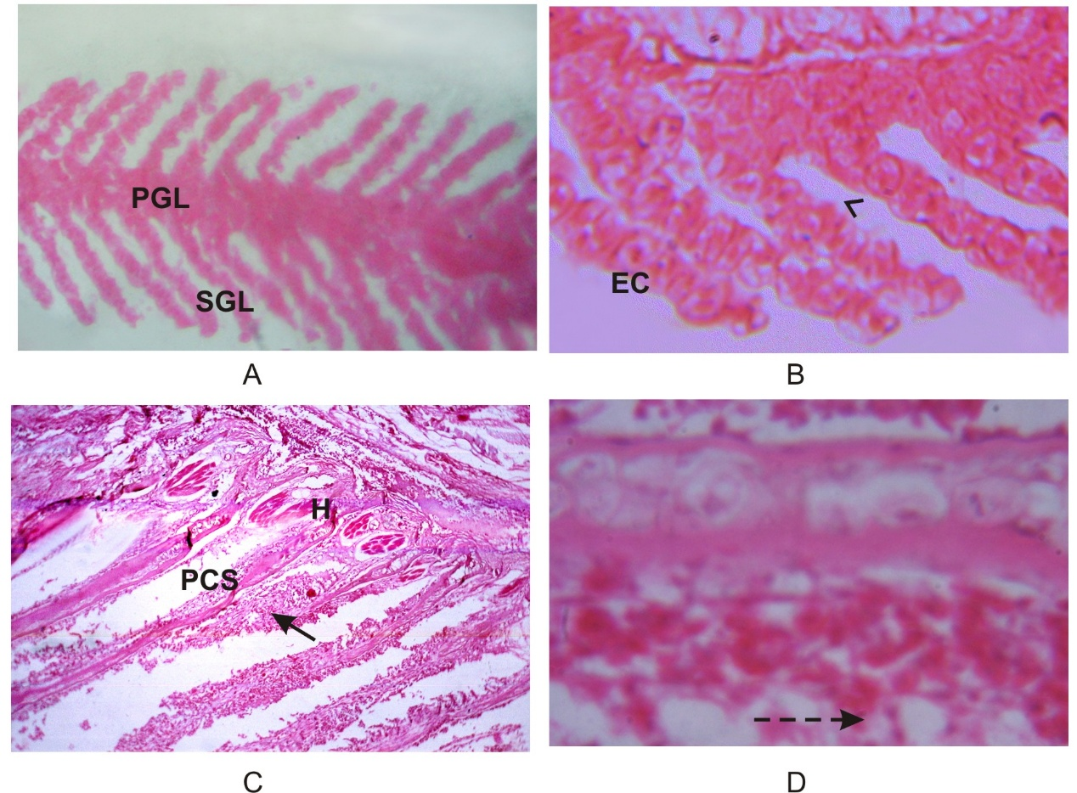

Plate 1. Photomicrograph showing structure of gill lamella of control (A and B) and cypermethrin treated (C and D) fish. Note normal primary gill lamella (PGL) and secondary gill lamella (SGL) of control of fish in A (H and E X 100) and normal epithelial cell (EC) in the secondary gill lamella and normal water space (arrow head) between two secondary gill lamellae of control fish in B (H and E X 400). Severe necrosis and hypertrophy of the secondary gill lamella (arrow) and edematous separation of the epithelial cells (broken arrow) due to cypermethrin treatment is seen respectively in C (H and E X 400). Pillar cell system (PCS) remained relatively unaffected in treated fish; but haemorrhage (H) in the primary gill lamella at the base of secondary gill lamella were found in treated fish.

Discussion
Histopathological alterations in fish gills are efficient indicators of water quality, because these tissues are vulnerable to pollutants in water due to their large surface area and external location. Gills perform numerous functions, such as excretion of nitrogenous waste products and acid–base balance. Functional impairment of gills thus causes the health of fish. Several types of lesions are observed in fish when exposed to a toxicant. Erkmen et al. (2000) reported the lifting of epithelial layer from gill lamellae, necrosis and degeneration of secondary lamellae, shortening of secondary lamellae and club shaped lamellae in the gills of Lebistes reticulates exposed to cypermethrin. Liquefaction, breakage of gill lamella and hypertrophy of mucous cells observed in the gills of Anabas testudineus when exposed to cypermethrin (Jha et al. 2020). Gill lesions, epithelial lifting, desquamation, necrosis, hyperplasia, gill lamellar degeneration, hyperplasia of epithelial cell, fusion and curling of secondary lamellae, hemorrhage and fusion were observed in Anabas testudineus when exposed to cypermethrin (Akter et al. 2024). In Clarias gariepinus when exposed to cypermethrin showed epithelial hypertrophy and hyperplasia, epithelial lifting, odema, fusion of secondary lamellae, necrosis and desquamation in the gill tissue (Velmurugan et asl. 2009). Aneurism, epithelial necrosis, secondary lamellae showing fusion and lifting of epithelium due to deltamethrin treatment have been reported in many species of fish (Cengiz and Unlu 2002 and 2003). Cyprinus carpio exposed to deltamethrin also showed desquamation and necrosis (Cengiz and Unlu 2006). Many other toxicants produce effects on gills of fish similar to pyrethroid pesticides. Alazemi et al. (1996) showed degenerative effects in the gill epithelium of Gnathonemus petersii exposed to atrazine. Epithelial hypertrophy and hyperplasia, fusion of secondary lamellae, necrosis, lifting of epithelium, oedema between the epithelium and blood capillaries has been reported in Pimephales promelas exposed to chlorine dioxide. (Yonkos et al. 2000). Fusion of secondary lamellae and oedamatous separation of the primary and secondary lamellae leading to sloughing at the tip, alteration of pillar cells and expanded blood spaces have been observed in Clarias geriepinus exposed to glyphosphate (Olurin et al. 2006). Hyperplasia and oedamatous separation of epithelial layers of the secondary gill lamellae as observed in the present investigation resumes these effects. Richmonds and Dutta (1989) divided the commonly reported gill lesions into two groups-(1) the direct deletorius effects of the irritants and (2) the defense responses of fish. Epithelial necrosis, desquamation of gill epithelium lifting up of the epithelium and lamellar fusion are direct responses inducd by cypermethrin. Increase in thickness of epithelial layers and fusion of adjacent secondary lamellae as a result of hyperplasia decrease distance between water and blood (Cardoso et al. 1996) there by inhibiting the respiratory, secretory and excretory functions of the gills. It also lowers circulation at the gills, widen the blood spaces and contract the pillar cells (Fanta et al. 2003). Haemorrhage and sloughing of branchial arteries at the opercula end of the primary lamellae can disrupt the circulation of deoxygenated blood via the branchial arteries into the secondary lamellae in a direction opposite to that of water flow. As a result, oxygen uptake is hampered. This can cause asphyxiation, tissue necrosis and finally death of the fish.
References
- Akter S., Al-Mamun Md. A., Hossain Md. S., Hossain A., Rahman Md. Z., Khalil S., M., I., Alam M.M. M. (2024). Ecotoxicological effects of cypermethrin on indigenous perch (Anabas testudineus). Heliyon. 10: (4). 29. e25723. https://doi.org/10.1016/j.heliyon.2024.e25723
- Alazemi B. M., Lewis J. W. and Andrews E. B. (1996). Gill damage in the freshwater fish Gnathonemus petersii (family: Mormyridae) exposed to selected pollutants: an ultrastructural study. Environmental Science and Technology. 17 (3): 225–238.
- Aydin R., Köprücü K., Dörücü M., Köprücü S. and Pala M. (2005). Acute toxicity of synthetic pyrethroid cypermethrin on the common carp (Cyprinus carpio L) embryos and larvae. Aquaculture International. 13 (5): 451 – 458.
- Bradbury S. (1969). Hewer’s text book of Histology for medical students. London William Heinemann, Medical book Ltd. Ninth edition. August, pp. 429.
- Cardoso E. L., Chiarini-Garcia H., Frreira R. M. A. and Poli C. R. (1996). Morphological changes in the gills of Lophiosilurus alexandri exposed to un-ionized ammonia. Journal of Fish Biology. 49: 778-787.
- Cengiz E. I.and Unlu E. (2002). Histopathological changes in the gills of mosquitofish, Gambusia affinis exposed to endosulfan. Bulletin of Environmental Contamination and Toxicology. 68 (2): 290–296.
- Cengiz E. I. and Unlu E. (2003). Histopathology of gills in mosquitofish, Gambusia affinis after long-term exposure to sublethal concentrations of malathion. Journal of Environmental Science Health. B. 38 (5):581–589.
- Cengiz E. I. and Unlu E. (2006). Sub-lethal effects of commercial deltamethrin on the structure of the gill, liver and gut tissues of mosquitofish, Gambusia affinis: A microscopic study. Environmental Toxicology and Pharmacology. 21(3): 246-253.
- Datta Munshi J. (1959). Studies on the structure of the gills in certain freshwater Teleosts. In: Exploring respiration in Air-breathing fishes, 60 / 90, 1. 2-38.
- Erkmen B., Caliskan M., Yerli S.V. (2000). Histopathological effects of cyphenothrin on the gills of Lebistes reticulatus. Veterinary and Human Toxicology. 42 (1): 5–7.
- Fanta E., Saint Anna Rios F., Romao S., Vianna A. and Fieiberger S. (2003). Histopathology of the fish Corydoras paleatus contaminated with sublethal levels of organophosphorus in water and food. Ecotoxicology and Environmental Safety. 54: 119-130.
- Jha A. K. Anupama, Mishra K. C. (2020). Impacts of cypermethrin on histopathology of liver and gills of fresh water fish Anabas testudineus. Uttar Pradesh Journal of Zoology. 41(11):56-60.
- Moore A. and Waring C. P. (2001). The effects of a synthetic pyrethroid pesticide on some aspects of reproduction in Atlantic salmon (Salmo salar L.). Aquatic Toxicology. 52: 1-12.
- Nath, U., Puzari, A., and Jamir, T. (2024). Toxicological assessment of synthetic pesticides on physiology of Phaseolus vulgaris L. and Pisum sativum L. along with their correlation to health hazards: a case study in south-west Nagaland, India. J. Saudi Soc. Agric. Sci. 23, 300–311. doi: 10.1016/j.jssas.2024.01.001.
- Olurin K. B.1., Olojo E. A. A, Mbaka G. O. and Akindele A. T. (2006). Histopathological responses of the gill and liver tissues of Clarias gariepinus fingerlings to the herbicide, glyphosate. African Journal of Biotechnology. 5(24): 2480-2487.
- Parashar B. D., Gupta G. P., Rao Y. V. S. and Rao K. M. (2001). Control of the buffalo fly Haematobia irritans exigua in India, using the pydfrethroids deltamethrin and fenvalerate. Medical and Veterinary Entomology. 15 (3): 346.
- Richmonds C. and Dutta H. M. (1989). Histopathological changes induced by malathion in the gills of Bluegill Lepomis macrochirus. Bulletin of Environmental Contamination and Toxicology. 43: 123–130.
- Saha S. and Kaviraj A. (2003). Acute toxicity of synthetic pyrethroid cypermethrin to freshwater catfish Heteropneustis fossilis (Bloch). Intrernational Journal of Toxicology. 22: 325–328.
- Saha S. and Kaviraj A. (2008). Acute toxicity of synthetic pyrethroid cypermethrin to some freshwater organisms. Bulletin of Environmental Contamination and Toxicology. 80: 49–52.
- Smith T. M. and Stratton G. W. (1986). Effects of synthetic pyrethroid insecticides on non target organisms. Residue Reviews. 97: 93-120.
- Velmurugan B., Mathews T.. and Cengiz E. I. (2009). Histopathological effects of cypermethrin on gill, liver and kidney of fresh water fish Clarias gariepinus (Burchell, 1822), and recovery after exposure. Environmental Technology. 30 (13): 1453 – 1460. https://doi.org/10.1080/09593330903207194

Wardhaugh K. G. (2005). Insecticidal activity of synthetic pyrethroids, organophosphates, insect growth regulators, and other livestock parasiticides: an Australian perspective. Environmental toxicology and chemistry. 24 (4): 789-796.
- Yonkos L. T., Fisher D. J., Wright D. A. and Kane A. S. (2000). Pathology of fathead minnows (Pimephales promelas) exposed to chlorine dioxide and chlorite. Marine Environmental Research. 50 (1–5): 267–271.

