Comparative study of survival and growth performance of penaeus vannamei (Boone, 1931) with probiotic supplementation at higher salinities

ABSTRACT

Probiotics are considered as one of the most significant components of shrimp aquaculture due to its several beneficial effects such as disease prevention, water quality maintenance, and growth performance. Present research work was designed to compare the performance of Penaeus vannamei at different hypersaline condition under probiotics supplementation. A 60 days experiment trial was carried out at higher salinities (45, 50, 55 and 60 ppt) with probiotic. All the important water quality parameters such as total ammonia nitrogen, nitrite, total hardness, total alkalinity, pH etc. was found to be in optimum range after few weeks in all treatments and control but the effect was better in control (45 ppt) and T-1 (50 ppt). The growth performance of P. vannamei was found better in control and T-1 compared to the rest of the treatments. FCR was found to be significantly lower in control compared to T-3. A similar trend was observed with survival percentage. Average body weight gain, protein efficiency ratio, feed efficiency ratio and specific growth ratio was found better in control and lowest in T-3 (60 ppt). Hence it can be concluded that 45 and 50 ppt with probiotics is most suitable for culture as compared to other higher salinities.

Keywords: - P. vannamei, Higher salinity, probiotics, growth performance & survival

1. INTRODUCTION

Aquaculture is considered one of the fastest growing foods producing sector and presently contributing around 47% of world total food fish production (FAO, 2018). Indian aquaculture is undergoing rapid developments towards achieving the goal of blue revolution and holding the second rank in the world aquaculture, with the production of 5,066 thousand tonnes in 2016 (FAO, 2018). The current pace of aquaculture is evident due to extensive transformations happening within the industry, mainly due to the adoption of an advanced strategy of water quality, feed and disease management. It further opens the scope of vertical expansion and shows the hope to provide nutritional security to rapidly growing populations all around the world. Shrimp farming is the key player which has changed the face of aquaculture around the globe. Indian shrimp aquaculture industry has undergone remarkable transformations during the last 10 years and same is reflected in export performance which is 65% of total seafood export in the country during 2016-17 (Ayan, 2017). The total export shrimp contributes approximately. 34,484 metric tons (US$ 3726.36 million) in 2016-17 more than half of the total marine product export of the country. Out of the total shrimp export from the country during 2016-17 Litopenaeus vannamei contributes about 28.46 % (quantity) and approx. 50% contribute values wise the total export of Litopenaeus vannamei alone contribute approx. 329766 metric tons (MPEDA, 2017).
Among all the species of shrimp, Litopenaeus vannamei represent over 90% of shrimp culture in the western hemisphere and presently it is the most commonly cultured shrimp in Central and South American countries, China, India and Thailand (Frias-Espericueta et al., 2001; McGraw et al., 2002; Saoud et al., 2003). The natural distribution of this species is mainly in brackish water area where annual rainfall and evaporation cycles expose the species to wide seasonal variations in temperature and salinity. The ability of L. vannamei to withstand such an extensive range of salinity is utilized by aquaculturist and it is being cultured at salinty ranging from 0 ppt to 35 ppt.

The plethora of problems associated with P.monodon such as WSSV outbreak, lack of SPF seed, international market demand etc. has compelled the Indian government to allow the culture of exotic shrimp L. vannamei in 2009 after reviewing the results of the pilot project by Coastal Aquaculture Authority (CAA). At present L. vannamei occupied a major part of India and being cultured in freshwater, brackish water and inland saline water. In India, L. vannamei culture is going on at very low salinities (~0-2 ppt) in Godavari and Krishna districts of Andhra Pradesh and Thanjavur district of Tamil Nadu and very high salinities (50-60 ppt) in Tamil Nadu and Gujarat (CIBA, 2017).

India has a total brackish water area of 1.24 million ha and only 20% of it is being utilized. After West Bengal, Gujarat has the second largest area of brackish water land. In Gujarat, shrimp farming is gaining momentum day by day. Presently, approximately 15,000 ha are being used for brackish water shrimp culture and it is expected to grow further. In Gujarat, the major shrimp farming areas are Valsad, Navsari, Surat and Bharuch, of which Surat is taking lead in brackish water aquaculture. Bhavnagar, Amreli and Jamnagar of Saurashtra coast recently catch attention and found suitable for shrimp culture.

Global warming has emerged as a serious problem all around the world. It is further predicted that global warming and a consequent increase in water temperature could impact aquaculture significantly. Exceeding temperature beyond optimal range has a direct impact on salinity due to increased evaporation. Salinity change is highly correlated with many other water parameters such as pH, dissolved oxygen, alkalinity, hardness, nitrite TAN etc. These water quality parameters directly affect growth and survival of organism especially in stressful hyperosmotic environment and further prone to bacterial attack such as Vibrio alginolyticus, V. harveyi etc. Many parts of Gujarat and Tamilnadu faces sever salinity rise which reaches up to 60 ppt during extreme summer. Increase salinities of water negatively harms to shrimp growth performance and survival by osmoregulatory stress, reduced feed intake and feed utilization, increased metabolic and energy demand, molting and physiological disturbances, deterioration of water quality, increased disease susceptibility and oxidative stress.

The strategic use of probiotics in the culture of Pacific white shrimp (Litopenaeus vannamei) under elevated salinity regimes has gained growing attention within the scientific community due to its relevance in addressing stress-driven limitations in modern aquaculture. Exposure to high-salinity environments places substantial osmoregulatory and metabolic demands on shrimp, frequently resulting in impaired growth performance, weakened immune competence, and heightened vulnerability to pathogenic microorganisms. Probiotic intervention represents an effective biological approach to counteract these challenges by stabilizing intestinal microbial communities, enhancing digestive efficiency, optimizing nutrient assimilation, and reinforcing innate defense mechanisms. Scientifically, evaluating probiotic–host–environment interactions under hypersaline conditions provides critical insights into the adaptive physiological responses and microbial dynamics that underpin stress resilience in crustaceans. Furthermore, this line of research supports the advancement of environmentally responsible, antibiotic-free health management strategies, in alignment with global objectives for sustainable aquaculture intensification. Collectively, probiotic application in high-salinity shrimp culture systems contributes not only to a deeper understanding of stress biology in L. vannamei but also to the development of robust, science-based solutions for resilient and sustainable shrimp production.

Probiotics are being applied extensively in shrimp farming to control the outbreak of disease. Several farmers are using probiotics at higher salinity too. But whether probiotics show their beneficial effects at higher salinity (especially >40 ppt) or not is still under the scanner. Therefore, the aim of the present study is to compare the performance of probiotics on water quality, growth performance and survival of L. vannamei stocked at higher salinities.
With this background information, present research work was designed to compare the performance of probiotics on water quality, growth performance and survival of L. vannamei stocked at higher salinities.

2. Materials and methods

The experiment was conducted for 60 days to compare the growth performance and survival of Litopenaeus vannamei at higher salinities with probiotic. The materials used and methodology adopted for present research work is described as following.
Experimental Site
The experiment was conducted at Ratnakar Aquaculture farm, Rajula, District Amreli, Gujarat. Water used for the culture was collected from the creek and brine water was collected from salt pan located at Victor village, Rajula. The laboratory work was carried out in the farm laboratory. The microbiology work was performed at Regional Research Centre, ICAR- Central Institute of Fisheries Technology, Veraval, Gujarat.
Experimental Animals
Litopenaeus vannamei Post-larvae-12 (PL-12) was procured from “West Coast Frozen Food Pvt Ltd.” Shrimp Hatchery Division, Kotda (20o 41’ N, 70o 50’) (Ta. Kodinar, Dist: Gir-Somnath). PL were acclimatized and stocked in the pond and grown up to 2.5 to 2.9 gm. Shrimps of average size 2.9-3.0 gm. were transferred into the tank with different salinities (according to treatment) for acclimatization for 10 days before the start of research. Only healthy and active shrimps of average size 3-3.1 gm were stocked in the experimental tank with stocking density 45 nos per tank.
Experimental setup
The experiment was carried out in square plastic tank of 1000 litre capacity. The experiment was set up following a completely randomized design. The experiment included one control and three treatment groups in triplicates following Completely Randomized Design (CRD) such as 45 ppt salinity to rear shrimps with probiotic supplementation (control), 50 ppt salinity to rear shrimp with probiotic supplementation (T-1), 55 ppt salinity to rear shrimp with probiotic supplementation (T-3), 60 ppt salinity to rear shrimp with probiotic supplementation (T-3). Experimental tanks were washed with potassium permanganate solution (5 ppm) and sun-dried before the start of the experiment. All the tanks were half filled (around 500 litters) with water of desired salinity by mixing creek water and brine (Helm and Bourne, 2004). Tank water was further disinfected by bleaching powder @ 60 ppm and then supplied with 4 air stone-hoses type of diffuser system connected to 2 HP blowers for vigorous aeration. Aeration was provided throughout the experimental duration except during feeding and sampling. Zero water exchange system (with intermittent water addition of desired salinity to maintain water volume in all tank) were followed during the whole experimental period of 60 days.

Experimental Diet and Feeding
Animals were fed at the rate of 5 % of their body weight during the experiment with commercially available feed (CP) having crude protein 35%, crude fat 5%, fiber 4%, and moisture 11%). Feeding frequency was four times a day similar to actual shrimp farm at 07:00 PM (morning), 11:00 PM, 3:00 AM (afternoon) and 7:00 AM (evening). Feed Probiotic (Bacillus spp) was incorporated into the feed along with binder @ 10gm/ kg. The same probiotic added feed was used in all treatments and control.

Physico-chemical Parameters of water
Different water quality parameters such as dissolved oxygen, salinity, pH and temperature were measured at regular intervals. Total hardness, total alkalinity, total ammonia nitrogen (TAN) and nitrite were measured weekly following standard protocol. The concentration of dissolved oxygen was determined weekly using the Winkler titration method and expressed as mg/l. The salinity of water was measured using refractometer (Atago, Ltd, Japan) and expressed in ppt. pH and temperature were measures by using pH meter and thermometer (Hanna, Portugal). Total ammonia concentration was measured weekly by using spectrophotometer at a wave length of 640 nm following Phenate method (APHA, 1998) and compared with the standard graph. The concentration of ammonia was expressed in mg/l. Nitrite level of water was measured as per Phenate method (APHA, 1998) at 543 nm using a spectrophotometer and it was compared with the standard graph of nitrite nitrogen concentration. The concentration of nitrite was expressed in mg/l. Total alkalinity was measured using a standard titration method and it was expressed in mg/l. Total hardness was measured using a standard titration method and it was expressed in mg/l.

Growth Parameters

Randomly 30% of shrimp in every tank were sampled fortnightly for the collection of data required for estimation of growth parameters. The weight of animal was measured by using electronic balance. The utmost care was taken while sampling to minimize stress on the animal. Following growth parameters were estimated.
$Average body weight =\frac{ Total body weight of shrimp }{Number of shrimp}$  Mean weight increment = Final average body weight – Initial average body weight | (1)
SGR (specific growth rate) as a percentage was calculated using the formula given below.  $$SGR =\frac{ {Log}_{e}(Final weight)-{Log}_{e }(Initial weight) }{Number of days}x100$$ | (2)
Food conversion ratio (FCR) is the weight of the food consumed divided by the body weight gain, all over a specified period of time. The FCR (Food Conversation Ratio) was calculated using the following formula: | (3)
$$FCR =\frac{Amount of feed given (g) }{Body weight gain\left(Wet weight\right)(g)}$$ | (4)
The feed efficiency ratio was calculated using the following formula | (5)
$$FER =\frac{ Body weight gain \left(wet weight\right)\left(g\right)}{ Feed given \left(Dry weight\right)\left(g\right)}$$ | (6)
3. results AND DISCUSSION

Sixty days experiment was carried out to compare the growth performance and survival of L. vannamei cultured at different higher salinity (45, 50, 55 and 60 ppt) with probiotics. Parameters observed and other results obtained during the experimental period along with discussion are presented following.

Physico-chemical Parameters
Water quality parameters were measured at regular intervals and presented comprehensively in table no. 1 (control and T-1) and table no. 2 (T-2 and T3). Temperature plays a critical role in shrimp physiology and affects final growth performance hence monitored regularly. Temperature observed during the experiment was found in the range of 19.76±0.304ºC to 25.46±0.128ºC. A decrease in temperature during the experimental period was observed in all tanks. Observations are presented in table 1 & 2 and graphically illustrated in fig. 1. The mean value of temperature in control, T-1, T-2 and T-3 was found to be 22.38±0.165 ºC, 21.74±0.281 ºC, 21.93±0.276 ºC and 21.88±0.341 ºC respectively. The range of pH recorded during the experiment was 7.4±0.057 to 8.2±0.057. Values of pH recorded throughout the experiment and presented in table 2 and 3 and graphically illustrated in fig.2. The mean value of pH in control, T-1, T-2 and T-3 were found to be 7.85±0.044, 7.77±0.039, 7.70±0.041 and 7.65±0.041 respectively. Total hardness was estimated weakly and presented in table no. 1 and 2. It is also graphically represented in figure 3. The range of the total hardness during the experiment was 8816.70±60.644 to 14717±948.338 mg/l. The mean value of total hardness in control, T-1, T-2 and T-3 were found to be 9768.18±105.454, 10642.52±553.564, 10642.52±553.564 and 13284.11±414.327 respectively. Total alkalinity was estimated weekly during the experiments and presented in table 1 and 2 and illustrated graphically in fig. 4. The range of the total alkalinity during the experiment was 130.7.637±1.666 to 266.67±19.220 mg/l. The mean value of total alkalinity in control, T-1, T-2 and T-3 were found to be 170.18±2.601, 193.14±15.910, 209.44±4.446 and 233.88±11.654 respectively. Total Ammonia Nitrogen was estimated weekly and observations are presented in table no. 1 and 2 and the same is illustrated graphically in fig. 5. The range of the total ammonia nitrogen during the experiment was 0.10±0.000 to 0.40±0.100 mg/l. The mean value of total ammonia nitrogen in control, T-1, T-2 and T-3 were found to be 0.20±0.002, 0.22±0.002, 0.23±0.001 and 0.20±0.002 respectively. Nitrite was estimated weekly during the experimental period and observations are presented in table no. 2 and 3 and the same is illustrated graphically in fig. 6. The range of the nitrite during the experiment was 0.05±0.000 to 0.20±0.043 mg/l. The mean value of nitrite in control, T-1, T-2 and T-3 were found to be 0.10±0.003, 0.11±0.003, 0.11±0.004 and 0.10±0.004 respectively. A constant dissolve oxygen level of 5.00±0.00 to 6.00±0.00 mg/l is maintained during the experimental period in all the tanks. It was observed routinely and aerations were adjusted accordingly to maintain the optimum level. Constant salinity in each tank according to treatment and control (45, 50, 55 and 60 ppt) was maintained throughout the experimental period. It was precisely monitored, and actions were executed in case of any fluctuations observed.

Table 1 Physico chemical parameters of water observed during the experiment in control and T-1
 | DOC | Sampling | Temperature  (oC) | pH | Total Alkalinity (ppm) | Total Hardness  (ppm) | TAN  (ppm) | Nitrite  (ppm)
Control | 1 | S1 | 25.46±0.128 | 8.20±0.057 | 130.00±7.637 | 9816.70±250.355 | 0.30±0.000 | 0.15±0.000
Control | 8 | S2 | 24.61±0.176 | 8.03±0.033 | 136.67±1.666 | 10080.00±117.898 | 0.23±0.008 | 0.13±0.004
Control | 15 | S3 | 23.72±0.073 | 7.90±0.152 | 151.67±1.666 | 10627.00±57.831 | 0.26±0.001 | 0.13±0.005
Control | 23 | S4 | 22.87±0.058 | 7.86±0.033 | 188.33±1.666 | 12320.00±251.661 | 0.23±0.007 | 0.13±0.006
Control | 30 | S5 | 22.16±0.123 | 7.80±0.152 | 185.00±2.886 | 8816.70±60.64468 | 0.16±0.001 | 0.07±0.008
Control | 38 | S6 | 21.49±0.187 | 7.76±0.033 | 185.00±2.886 | 9120.00±0.000 | 0.30±0.000 | 0.15±0.001
Control | 45 | S7 | 20.98±0.268 | 7.76±0.033 | 183.33±1.666 | 9153.30±33.333 | 0.16±0.003 | 0.08±0.004
Control | 52 | S8 | 20.28±0.220 | 7.76±0.033 | 188.33±1.666 | 8890.00±142.244 | 0.10±0.000 | 0.05±0.002
Control | 60 | S9 | 19.84±0.249 | 7.66±0.033 | 183.33±1.666 | 9090.00±35.118 | 0.13±0.002 | 0.06±0.001
T-1 | 1 | S1 | 25.10±0.204 | 8.16±0.066 | 148.33±15.898 | 10850.00±281.484 | 0.30±0.000 | 0.15±0.000
T-1 | 8 | S2 | 24.18±0.226 | 7.86±0.033 | 155.00±15.000 | 10880.00±216.564 | 0.33±0.004 | 0.15±0.003
T-1 | 15 | S3 | 23.31±0.251 | 7.86±0.033 | 161.67±14.240 | 11783.00±178.916 | 0.23±0.003 | 0.11±0.005
T-1 | 23 | S4 | 22.60±0.175 | 7.76±0.033 | 221.67±39.826 | 12483.00±319.392 | 0.23±0.009 | 0.11±0.006
T-1 | 30 | S5 | 22.03±0.300 | 7.70±0.057 | 211.67±14.240 | 9856.70±144.952 | 0.30±0.000 | 0.15±0.006
T-1 | 38 | S6 | 21.19±0.388 | 7.73±0.033 | 226.67±15.898 | 10120.00±109.697 | 0.30±0.002 | 0.15±0.002
T-1 | 45 | S7 | 20.64±0.313 | 7.73±0.033 | 215.00±10.408 | 9746.98±318.180 | 0.13±0.001 | 0.07±0.003
T-1 | 52 | S8 | 20.09±0.376 | 7.63±0.033 | 183.33±7.264 | 9880.00±381.095 | 0.13±0.001 | 0.05±0.004
T-1 | 60 | S9 | 19.89±0.293 | 7.50±0.000 | 215.00±10.408 | 10183.00±31.797 | 0.10±0.000 | 0.05±0.002
*Values are presented as mean ± SE.

Table 2 Physico chemical parameters of water observed during the experiment in T-2 and T-3
 | DOC | Sampling | Temperature  (ºC) | pH | Total  Alkalinity (ppm) | Total Hardness (ppm) | TAN  (ppm) | Nitrite  (ppm)
T-2 | 1 | S1 | 24.85±0.190 | 8.06±0.033 | 153.33±1.666 | 11813.00±57.831 | 0.30±0.000 | 0.15±0.000
T-2 | 8 | S2 | 23.80±0.113 | 7.86±0.033 | 170.00±5.773 | 13050.00±1185.430 | 0.40±0.005 | 0.20±0.004
T-2 | 15 | S3 | 23.20±0.254 | 7.80±0.057 | 183.33±6.009 | 12590.00±35.118 | 0.26±0.001 | 0.13±0.004
T-2 | 23 | S4 | 22.54±0.187 | 7.70±0.057 | 238.33±4.409 | 13280.00±88.881 | 0.23±0.000 | 0.13±0.006
T-2 | 30 | S5 | 21.79±0.269 | 7.73±0.033 | 226.67±3.333 | 10883.00±31.797 | 0.23±0.001 | 0.11±0.008
T-2 | 38 | S6 | 21.08±0.390 | 7.73±0.033 | 223.33±3.333 | 10850.00±35.118 | 0.26±0.001 | 0.13±0.005
T-2 | 45 | S7 | 20.20±0.378 | 7.56±0.033 | 223.33±3.333 | 13047.00±466.917 | 0.13±0.001 | 0.07±0.002
T-2 | 52 | S8 | 20.04±0.386 | 7.50±0.000 | 243.33±8.819 | 11080.00±135.031 | 0.13±0.002 | 0.08±0.001
T-2 | 60 | S9 | 19.85±0.319 | 7.43±0.066 | 223.33±3.333 | 11017.00±115.662 | 0.13±0.001 | 0.07±0.004
T-3 | 1 | S1 | 24.30±0.000 | 8.06±0.033 | 175.00±2.886 | 14717.00±948.338 | 0.30±0.000 | 0.15±0.000
T-3 | 8 | S2 | 24.09±0.353 | 7.80±0.000 | 193.33±6.666 | 13117.00±349.301 | 0.33±0.004 | 0.16±0.005
T-3 | 15 | S3 | 23.17±0.303 | 7.76±0.033 | 198.33±14.813 | 13783.00±331.679 | 0.30±0.000 | 0.15±0.004
T-3 | 23 | S4 | 22.42±0.353 | 7.73±0.033 | 266.67±19.220 | 14520.00±624.500 | 0.26±0.008 | 0.13±0.007
T-3 | 30 | S5 | 21.69±0.378 | 7.63±0.033 | 248.33±14.240 | 11917.00±354.511 | 0.23±0.002 | 0.11±0.009
T-3 | 38 | S6 | 20.98±0.477 | 7.63±0.033 | 248.33±14.240 | 11850.00±321.299 | 0.10±0.000 | 0.05±0.005
T-3 | 45 | S7 | 20.47±0.465 | 7.46±0.233 | 248.33±14.240 | 14683.00±68.394 | 0.13±0.001 | 0.07±0.002
T-3 | 52 | S8 | 20.03±0.433 | 7.40±0.057 | 263.33±16.914 | 12750.00±316.596 | 0.10±0.000 | 0.05±0.006
T-3 | 60 | S9 | 19.76±0.304 | 7.40±0.057 | 263.33±1.666 | 12220.00±0.000 | 0.13±0.002 | 0.08±0.004

*Values are presented as mean ± SE

Fig. 1 Trend line of temperature variation in control and treatments during the experiment
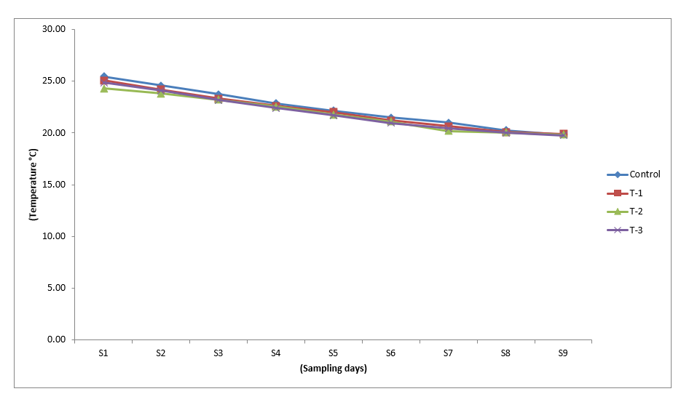
Fig. 2 Trend line of pH variation in control and treatments during the experiment
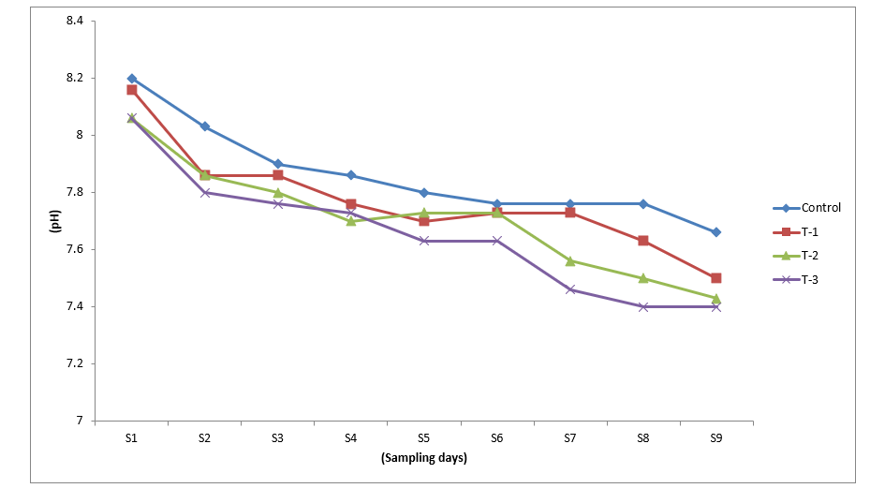

Fig. 3 Trend line of total hardness variation in control and treatments during the experiment
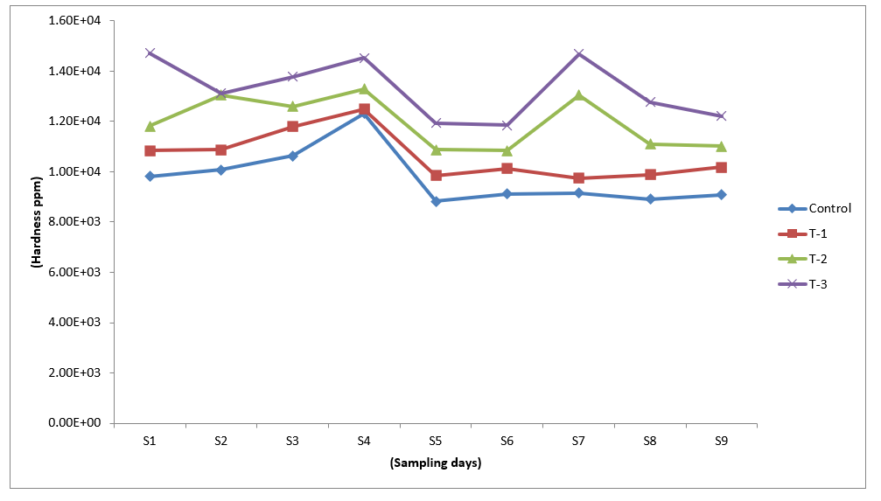

Fig. 4 Trend line of total alkalinity variation in control and treatments during the experiment

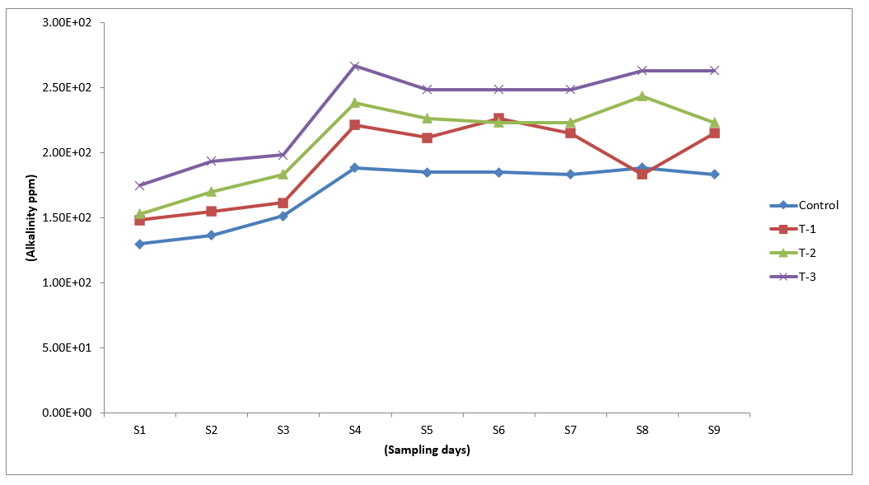

Fig. 5 Trend line of TAN variation in control and treatments during the experiment
t
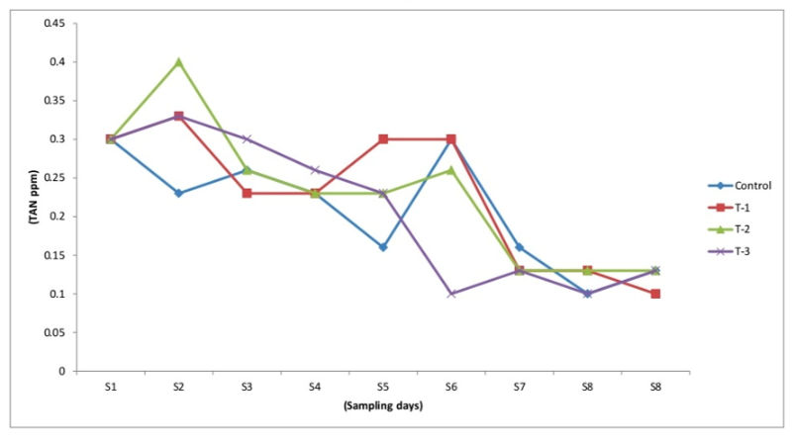

Fig. 6 Trend line of nitrite variation in control and treatments during the experiment
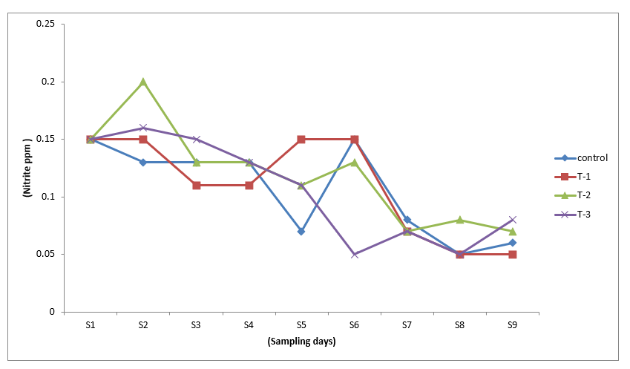
Temperature is one of the most critical parameters in aquaculture systems affecting animal physiology as well as hydrological parameters. Hence it has a direct role on growth performance of the animal. In present experiment, temperature is found to decrease from start (25.46±0.128 ºC) to the end (19.76±0.304 ºC) due to the onset of winter. The optimal range of temperature for this species is between 30 and 34 ºC. At 20°C or lower growth virtually stops (Ravichandran et al., 2012). Similar trends were observed here as the growth performance was poor towards the end of the experiment due to a decrease in temperature. There was no significant difference (P>0.05) in temperature between different treatments and control on different days of sampling except first sampling. pH is also considered as one of the important parameters which affects the physiology as well as soil water chemistry. pH in the range of 7.5-8.5 is considered as the most suitable for aquaculture. Stable day night pH with fluctuation not more than 0.5 is considered the most appropriate for shrimp farming (Ravichandran, 2012; Saraswathy, 2016). In the present study except for few occasions pH was reported in the above said range. Mean pH value in all the treatments and control was between 7.5-8.0. Further the pattern of fluctuation in pH during the experimental period was found to be almost similar in all the treatments and control (fig. 2). As the decrease in temperature also corresponds to a decrease in pH. Hence in the present experiment, a clear decrease in pH was observed from the beginning towards the end. Hardness is important for shrimp aquaculture as it has a direct effect on moulting. Hardness and salinity are positively correlated. A similar trend is observed in the present experiment (fig. 3) as the mean total hardness was minimum in control and found to increase from T1 to T3. A significant difference (P<0.05) was observed between different treatments and control during most of the sampling day (fig. 3). Alkalinity is an important hydrological parameter in aquaculture and a range of 80-200 mg/l is considered as most suitable for shrimp aquaculture (Ching et al., 2007). Mean total alkalinity observed in the present experiment was found to be 170.18±2.601, 193.14±15.910, 209.44±4.446 and 233.88±11.654 for control, T-1, T-2 and T-3 respectively. Hence an increase in total alkalinity is observed along with salinity (fig. 4). A similar finding was reported by (Maica et al., 2014) as they observed an increase in the alkalinity and the concentration of total suspended solids, nitrite and phosphate in L. vannamei super-intensive system along with an increase in salinity. A sudden increase in total alkalinity between S3 and S4 was observed due to the addition of water to top up the evaporation loss in each tank. A significant difference (P<0.05) was observed in total alkalinity between different treatments and control on most of the sampling days (fig. 4). TAN concentration is critical for shrimp aquaculture and known to affect it significantly. Most of the efforts in shrimp farm are invested towards minimizing the level of TAN in water. TAN concentrations below 0.1 ppm are recommended in shrimp culture (CIBA, 2017). Here TAN level was found to be in the range of 0.10±0.000 to 0.40±0.100 mg/l. The mean value of total ammonia nitrogen in control, T-1, T-2 and T-3 were found to be 0.20±0.002, 0.22±0.002, 0.23±0.001 and 0.20±0.002 respectively. It is reported that the shrimp can tolerate the increased level of total ammonia nitrogen at higher salinity (Kır, M. and Öz, O., 2015). Hence here it can be further concluded that the growth observed even at higher TAN level was due to the same. The lower level of TAN was found in control which may be due to the better action of probiotics applied. Kim et al. (2005) reported that Bacillus strain has got potential to reduce TAN through nitrification and denitrification. The present study also indicates that TAN level decreased along with culture period which may be due to the better action of probiotic after acclimatization at higher salinity. Nitrite level < 1 mg/l (Ravichandran et al., 2012) is recommended for shrimp farming. Here nitrite level is reported below 1 ppm in all treatments and control. Here the decrease in the level of nitrite was observed from beginning till the end which may be due to better action of probiotic. Dissolved oxygen is critical for aquaculture and level of 4.5 ppm or more is recommended for shrimp aquaculture (Ravichandran et al., 2012). A level of 5.00 to 6.00 mg/l was maintained throughout the experimental period in all the tanks.
Growth Performance
The present study showed better growth performance and yield in control as compared to treatments (T1, T2 and T3). Control showed higher growth performance (ABWG) compared to treatments. Higher PER, FER, SGR, survival and lowest FCR were found in control compared to other treatments. Detailed result related to growth performance was presented in the following section. Average body weight gain (ABWG) of L.vannamei reared under control and treatments is presented in table-3 and fig 7. L.vannamei showed the highest average body weight gain in control (3.96±0.439gm) and minimum in T-3 (2.57±0.001gm). Poor growth of shrimp in T3 as compared to control may be attributed due to high saline water, as reported by Zhu et al., (2004) where they observed poor growth performance of L. vannamei juveniles at higher salinities. This result is in agreement with the finding of several researchers (Menz and Blake, 1980; Pante, 1990; Bray et al., 1994; Somocha et al., 1998; and McGraw et al., 2002). Survival of L. vannamei reared under control and treatment is presented in table-3, figure 8. Survival of L. vannamei at the end of the experiment was maximum in control (86.66±0.000) and lowest in the T-3 (63.70±0.000). In the present study maximum survival rate was 86.66% in the control and minimum was 63.70% in T-3. FCR of L. vannamei observed in control and treatments are presented in table-3 and fig. 9. Lowest FCR was found in control (1.95±0.327) whereas, maximum in T-3 (12.39±2.806). It may be due to low salinity and the effect of probiotics which provide a conducive environment for the better growth of the organisms. Our finding was supported by the report of improved FCR by use of gut probiotic in the culture of P.monodon by Shailender et al. (2012). SGR of L. vannamei observed in control and treatments are presented in table-3 and fig. 10. A significant difference was observed among different treatments of L. vannamei. The highest SGR recorded was in control (1.50±0.114) and the lowest in T-3 (0.9864±0.058). FER of L. vannamei observed in control and treatments are presented in table-3 and fig. 11. It was observed that FER is maximum (0.53±0.084) in control whereas minimum in T-3 (0.09±0.024). During the present experiment there was significant different (P<0.05) observed in T-2 and T-3 as compared to control. PER of L. vannamei observed in control and treatments are presented in table-3 and fig. 12. The value of PER among the treatments and control were significantly different with T2 and T3 respectively. The highest value was observed in the control (0.04±0.004) and minimum in the T-3 (0.02±0.000). In the present study, PER was maximum (0.04) in control and minimum (0.02) in T-3 (60 ppt). The decreasing trends of PER among the treatments compared to control may be due to stressful condition at higher salinities. In this present experiment significant (P<0.05) different was observed in T-2 and T-3 as compared to control.
Table 3. Growth performance and survival of L. vannamei

 | FCR | PER | FER | SGR | ABWG | Survival
Control | 1.95±0.327 | 0.04±0.004 | 0.53±0.084 | 1.50±0.114 | 3.96±0.439 | 86.66±0.000
T1 | 2.35±0.684 | 0.03±0.003 | 0.51±0.153 | 1.38±0.113 | 3.71±0.344 | 81.48±0.000
T2 | 6.34±1.798 | 0.02±0.000 | 0.18±0.040 | 1.06±0.092 | 2.63±0.066 | 70.37±0.000
T3 | 12.39±2.806 | 0.02±0.000 | 0.09±0.024 | 0.98±0.058 | 2.57±0.001 | 63.70±0.000

Values are presented as mean ± SE

Fig. 7 Average body weight gain during the culture period

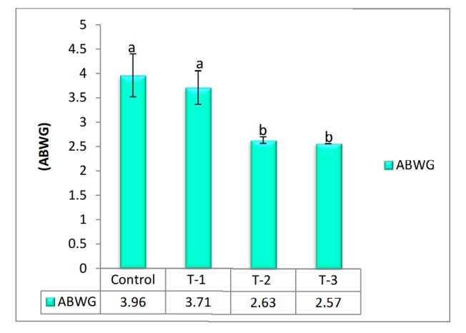

Fig. 8 Survival during the culture period
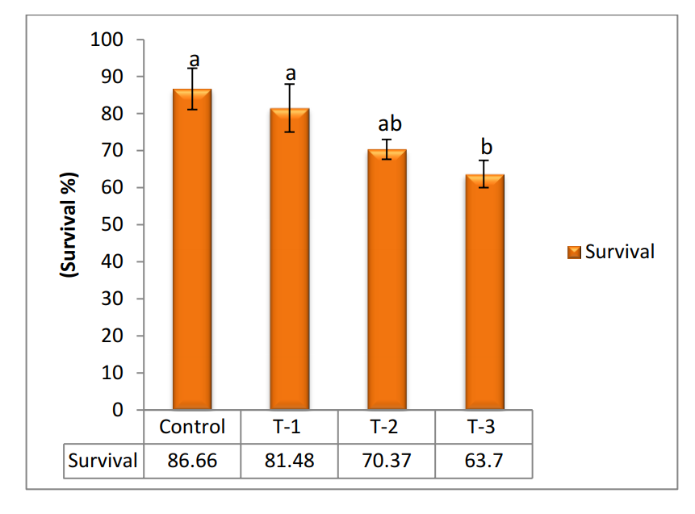
Fig. 9 Food Conversion Ratio during the culture period
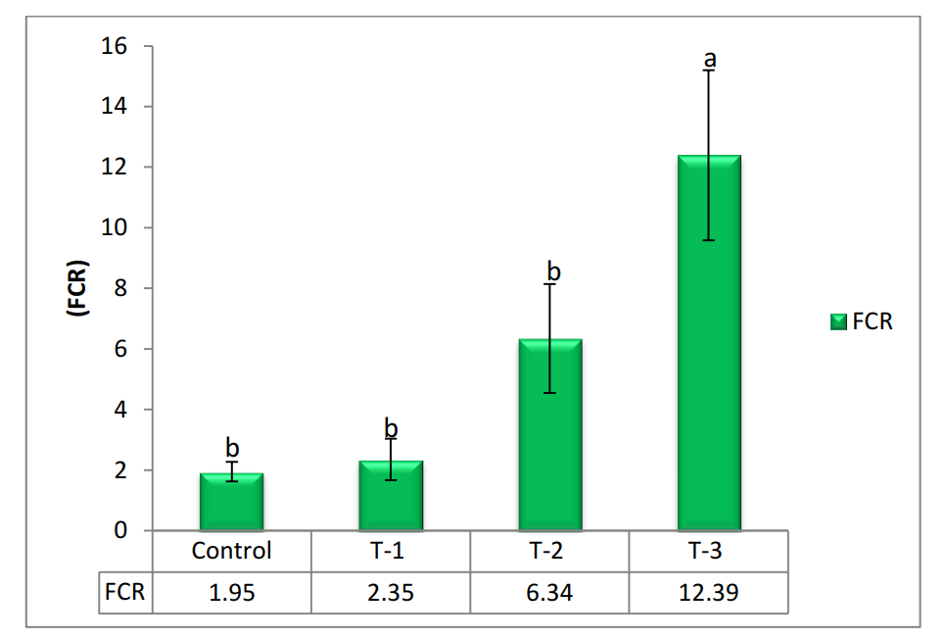

Fig. 10 Specific Growth Rate during the culture period
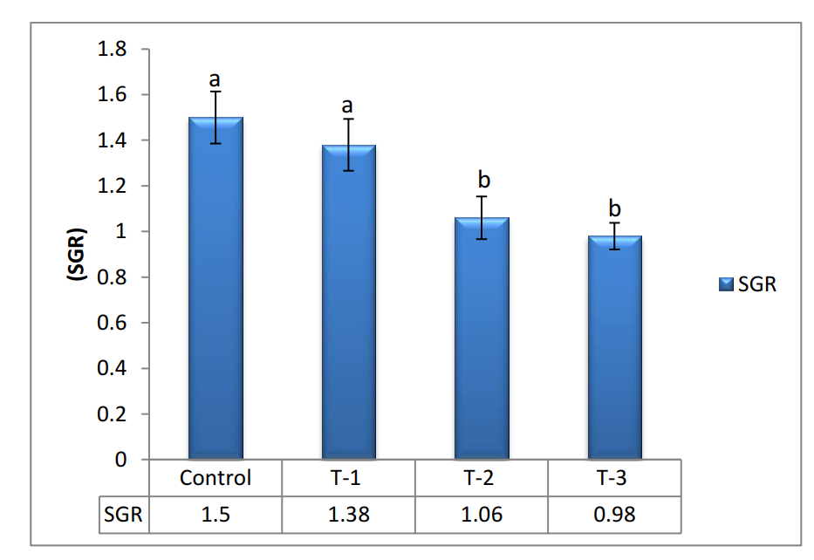

Fig. 11 Feed Efficiency Ratio during the culture period.
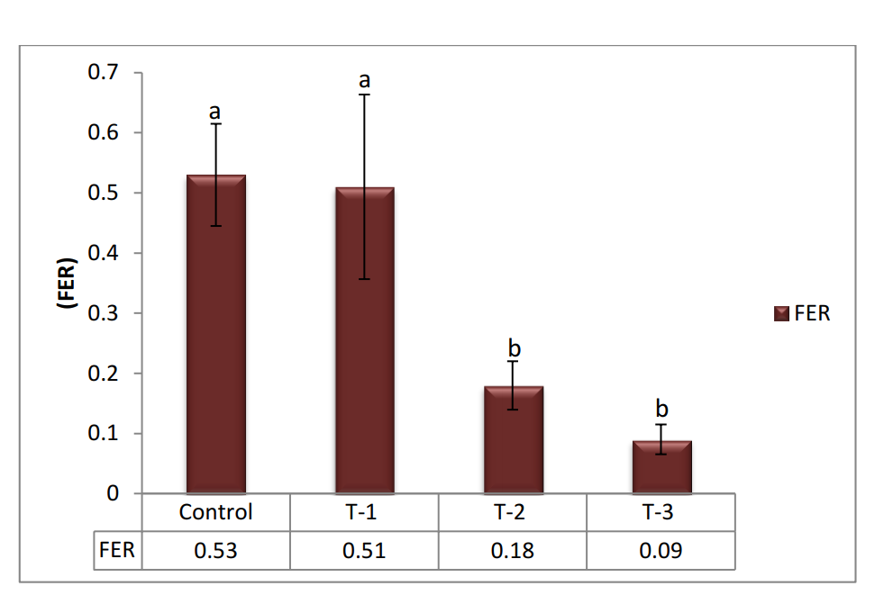

Fig. 12 Protein Efficiency Ratio during the culture period.

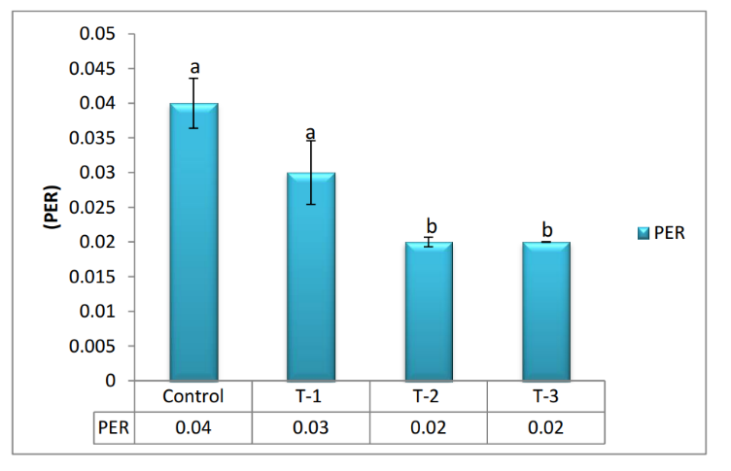
According to Bray et al. (1994), Litopenaeus vannamei achieves maximum growth when reared at salinity levels lower than its isosmotic threshold. The optimal salinity for growth varies among aquatic species and is closely linked to their ability to regulate internal osmotic pressure. Species exhibiting a stronger hyper-osmoregulatory capacity generally perform better under reduced salinity conditions, while those with weaker hyper-osmoregulatory ability tend to show improved growth at elevated salinity levels. Findings from the present investigation revealed that the growth response of L. vannamei in Treatment 1 did not differ significantly from that of the control group, indicating comparable performance. The survival report of high mortality in T3 and T4 was in agreement with the finding of Zhu et al. (2004) as they demonstrated that a high Na/K ratio in seawater resulted in poor survival of L.vannamei and same was supported by the finding of Perez-Velazquez et al., (2007) and Ponce-Palafox et al., (1997) i.e. if salinity increase survival rate is decrease. Here significant different (P<0.05) was observed in T-3 compared with control. FCR may be good due to low salinity and the effect of probiotics which provide a conducive environment for the better growth of the organisms. Our finding was supported by the report of improved FCR by use of gut probiotic in the culture of P.monodon by Shailender et al. (2012). In present study SGR reported was maximum and minimum in control and in T3 respectively. The obtained results may be due to inclusive effects of probiotic and salinity. Kumar et al., (2013) reported that the use of B. subtilis as feed probiotics in shrimps improved growth performance. According to Yan et al., (2007), SGR decreases with increase in salinity. The highest Protein efficiency ratio and feed efficiency ratio were observed decreases with increase in salinity.
Growth performance of Litopenaeus vannamei cultured under hypersaline conditions (45–60 ppt) was markedly affected by both salinity level and probiotic supplementation. Shrimp reared at 45 and 50 ppt with probiotic inclusion demonstrated significantly superior final body weight, weight gain, and specific growth rate (SGR), accompanied by a lower feed conversion ratio (FCR), when compared with individuals maintained at 55 and 60 ppt.
The decline in growth at elevated salinities is largely associated with increased energetic costs of osmoregulation, which reallocates metabolic energy away from tissue accretion and growth processes (Castille & Lawrence, 1981). Notably, the enhanced growth performance observed in probiotic-fed shrimp indicates that probiotics can partially counteract salinity-induced physiological stress. Probiotic strains, particularly those belonging to Bacillus spp., are reported to enhance digestive enzyme secretion, improve intestinal microbial balance, and increase nutrient absorption efficiency, collectively contributing to improved growth under stressful rearing environments (Hai, 2015; Zokaeifar et al., 2012).
Furthermore, the significantly improved FCR recorded in probiotic-treated shrimp at 45–50 ppt suggests more efficient feed utilization and reduced metabolic wastage under hypersaline stress. Comparable improvements in growth and feed efficiency following probiotic supplementation have been reported in L. vannamei cultured under environmentally challenging or sub-optimal conditions (Wang, 2007).
Survival Performance
Survival of L. vannamei was significantly influenced by salinity gradient as well as probiotic administration. Maximum survival was achieved in probiotic-supplemented groups maintained at 45 ppt, followed by those at 50 ppt, whereas survival declined sharply at 55 and 60 ppt, particularly in non-supplemented control treatments. Salinity levels exceeding the optimal physiological range are known to impose severe osmotic stress, suppress immune competence, and enhance vulnerability to opportunistic pathogens, ultimately resulting in increased mortality (Lin & Chen, 2003; Ponce-Palafox et al., 1997).
The improved survival observed in probiotic-treated shrimp under high salinity conditions indicates enhanced stress resistance and health status. These beneficial effects may be attributed to the immunostimulatory properties of probiotics, including activation of nonspecific immune responses, inhibition of pathogenic bacteria such as Vibrio spp. through competitive exclusion, and stabilization of rearing water quality via microbial bioremediation processes (Verschuere et al., 2000; Balcázar et al., 2006).
Relationship between Probiotic Supplementation, Growth, and Survival under High Salinity
A clear positive association was observed between probiotic supplementation and improved growth performance and survival of L. vannamei under hypersaline conditions (45–60 ppt). Although increasing salinity exerted a negative influence on shrimp physiological performance, probiotic inclusion effectively moderated these adverse effects, particularly at moderately high salinities (45–50 ppt). This response suggests that probiotics enhance the adaptive capacity of shrimp by supporting gut integrity, minimizing oxidative and osmotic stress, and strengthening immune defenses under salinity stress.
However, the reduction in growth and survival beyond 50 ppt, even in probiotic-treated groups, indicates that the protective effects of probiotics are limited under extreme salinity exposure. Nevertheless, probiotic supplementation noticeably broadened the salinity tolerance range of L. vannamei, thereby improving its culture potential in hypersaline environments. Similar observations have been reported in earlier studies, emphasizing that probiotics primarily function as stress-mitigating agents rather than complete stress eliminators (Irianto & Austin, 2002; Hai, 2015).
Overall Implications
The present findings clearly demonstrate that probiotic supplementation is an effective nutritional strategy for enhancing growth performance and survival of L. vannamei under hypersaline culture conditions. Probiotics significantly improved shrimp performance at 45–50 ppt by alleviating salinity-induced stress, while extremely high salinity levels (≥55 ppt) remained physiologically challenging despite probiotic intervention. These results hold significant practical relevance for the development of sustainable shrimp farming practices in inland saline and coastal hypersaline aquaculture systems where salinity management poses a major constraint.

4. Conclusion
The present study demonstrates that probiotic supplementation plays a critical role in enhancing growth performance and survival of Litopenaeus vannamei cultured under hypersaline conditions. Shrimp reared at moderate hyper salinity (45–50 ppt) with probiotic inclusion exhibited superior growth, improved feed utilization, and higher survival compared to those maintained at higher salinities without probiotic support. These improvements indicate that probiotics effectively mitigate the physiological stress associated with elevated salinity by enhancing nutrient utilization efficiency, strengthening immune responses, and improving overall stress tolerance.
Although L. vannamei is known for its wide salinity tolerance, extreme salinity levels (≥55 ppt) negatively affected growth and survival, even in probiotic-treated groups, suggesting inherent physiological limitations under severe osmotic stress. Nevertheless, probiotic supplementation significantly extended the functional salinity tolerance range of shrimp, making culture at moderate hypersaline conditions more feasible.
Overall, the findings highlight probiotics as a sustainable and practical intervention for improving shrimp performance in inland saline and coastal aquaculture systems where salinity fluctuations pose major challenges. Incorporation of probiotics into shrimp feeding and management strategies can enhance productivity and resilience under hypersaline environments, contributing to the long-term sustainability of shrimp aquaculture.

AcknowledgEments

The authors express gratitude to the Hon’ble Vice-Chancellor, Kamdhenu University (KU), Gandhinagar, Gujarat, India; Director of Research, KU, Gandhinagar; Dean, Fisheries KU, Gandhinagar for their unwavering support, motivation, and funding for the research work.

Competing interests
Authors have declared that no competing interests exist.

Authors’ Contributions

Author A conceived and led the study, carried out data collection, statistical analysis, interpretation of results, and prepared the manuscript. Author B coordinated the research activities, supervised the experimental design, and ensured the timely execution of the project. Author C performed statistical analyses and assisted in the experiment and sampling procedures. Author D assisted with experimental procedures as per the study design. Author E supported the research through literature review, data entry, and assistance during experimental setup. All authors reviewed and approved the final manuscript. All authors read and approved the final manuscript.”

Disclaimer (Artificial intelligence)

Author(s) hereby declare that NO generative AI technologies such as Large Language Models (ChatGPT, COPILOT, etc.) and text-to-image generators have been used during the writing or editing of this manuscript.

References

- Apha (1998). Standard methods for the examination of water and waste water, 20th edition.
  - American public health association, Washington DC.
- Ayan, P., Puja, J.,vidhyasagar ,L. and Mradul , M., 2017. [Internet]. Indian Shrimp Industry- A Primer. Available fom: www.careratings.com
- Balcázar, J. L., De Blas, I., Ruiz-Zarzuela, I., Cunningham, D., Vendrell, D., & Múzquiz, J. L. (2006). The role of probiotics in aquaculture. Veterinary microbiology, 114(3-4), 173-186.
- Bray, W. A., Lawrence, A. L., and Leung-Trujillo, J. R. (1994). The effect of salinity on growth and survival of Penaeus vannamei, with observations on the interaction of IHHN virus and salinity. Aquaculture, 122(2-3), 133-146.
- Castille, F. L., & Lawrence, A. L. (1981). The effect of salinity on growth and survival of penaeid shrimp. Journal of the World Mariculture Society, 12, 259–271.
- Ching, C.A. (2007). Water alkalinity in the cultivation of arine shrimp. Boletines Nicovita 3:1-3.
- CIBA (2017). Annual report 2016-17. Central Institute of Brackishwater Aquaculture, Chennai, Tamilnadu, India pp. 208.
- Irianto, A., & Austin, B. (2002). Probiotics in aquaculture. Journal of Fish Diseases, 25, 633–642.
- FAO (2018). The State of World Fisheries and Aquaculture 2016. In brief. Contributing to food security and nutrition for all. Rome.
- Frias-Espericueta, M. G., Voltolina, D., and Osuna-Lopez, J. I. (2001). Acute toxicity of cadmium, mercury, and lead to whiteleg shrimp (Litopenaeus vannamei) postlarvae. Bulletin of Environmental Contamination and Toxicology, 67(4), 580-586.
- Hai, N. V. (2015). The use of probiotics in aquaculture. Journal of Applied Microbiology, 119, 917–935.
- Helm, M. M. and Bourne, N. (2004). Hatchery culture of bivalves: a practical manual. FAO fisheries technical paper.471: 31- 129.
- Kim, J. K., Park, K. J., Cho, K. S., Nam, S. W., Park, T. J., and Bajpai, R. (2005). Aerobic nitrification–denitrification by heterotrophic Bacillus strains. Bioresource Technology, 96(17), 1897-1906.
- Kır, M., and Öz, O. (2015). Effects of salinity on acute toxicity of ammonia and oxygen consumption rates in common prawn, Palaemon serratus (Pennat, 1777). Journal of the World Aquaculture Society, 46(1), 76-82.
- Kumar, P. N. J., Jyothsna, R. S., Reddy, M. H., and Sreevani, S. (2013). Effect of Bacillus subtilis and Lactobacillus rhamnosus incorporated probiotic diet on growth pattern and enzymes in Penaeus vannamei. International Journal of Life Sciences Pharmaceutical sciences review and research, 3(4), 6-11.
- Lin, Y. C., & Chen, J. C. (2003). Acute toxicity of ammonia on Litopenaeus vannamei at different salinity levels. Aquaculture, 218, 239–248.
- Maicá, P. F., Borba, M. R. D., Martins, T. G., and Wasielesky Junior, W. (2014). Effect of salinity on performance and body composition of Pacific white shrimp juveniles reared in a super-intensive system. Revista Brasileira de Zootecnia, 43(7), 343-350.
- MPEDA (2017). Marine Product Export Development authority, ministry of commerce India.
- McGraw, W. J., Davis, D. A., Teichert‐Coddington, D., and Rouse, D. B. (2002). Acclimation of Litopenaeus vannamei postlarvae to low salinity: influence of age, salinity endpoint, and rate of salinity reduction. Journal of the World Aquaculture Society, 33(1), 78-84.
- Menz, A., and Blake, B. F. (1980). Experiments on the growth of Penaeus vannamei Boone. Journal of Experimental Marine Biology and Ecology, 48(2), 99-111.
- Pante, M.J.R., (1990). Influence of environmental stress on the heritability of molting frequency and growth rate of the penaeid shrimp, Penaeus vannamei. University of Houston-Clear lake, Houston, TX, USA, M.Sc. Thesis.
- Perez-Velazquez, M., Gonzalez-Felix, L.M., Jaimes-Bustamente, F., Martinez-Cordova and Trujillo-Villalba, R.L. (2007).Investigation of the Effects of Salinity and Dietary Protein Level on Growth and Survival of Pacific White Shrimp, Litopenaeus vannamei. Journal of the world aquaculture society, 38(4).
- Ponce-Palafox, J., Martinez-Palacios, C. A. and Ross, L. G. (1997). The effects of salinity and temperature on the growth and survival rates of juvenile white shrimp, Penaeus vannamei, Boone, 1931. Aquaculture, 157(1-2), 107-115.
- Ravichandran, P. (2012). Overview of Litopenaeus vannamei culture practice and importance of Govt. regulation measures. Management of emerging diseases of shrimp with special reference to Pacific white shrimp, Litopenaeus vannamei.
- Samocha, T. M., Guajardo, H., Lawrence, A. L., Castille, F. L., Speed, M., McKee, D. A., and Page, K. I. (1998). A simple stress test for Penaeus vannamei postlarvae. Aquaculture, 165(3-4), 233-242.
- Saoud, I. P., Davis, D. A., and Rouse, D. B. (2003). Suitability studies of inland well waters for Litopenaeus vannamei culture. Aquaculture, 217(1-4), 373-383.
- Saraswathy, R., Kumararaja, P., Lalitha, N., Muralidhar M., and Alavandi, S.V. (2016) Soil and water quality management for shrimp farming.(CIBA) Extension series no -53. Pamphlets 102.
- Shailender, M., Suresh Babu, Ch., Srikanth, B., Bangarraju, P., Siva Krishna, G., and Jayagopal, P. (2012). Effect of probiotics on growth and survival of Penaeus monodon (Fabricius, 1798) post larvae infected with swollen hindgut syndrome (SHG) with better management practices. Journal of Pharmacy and Biological Sciences, 3(4), 33-40.
- Verschuere, L., Rombaut, G., Sorgeloos, P., & Verstraete, W. (2000). Probiotic bacteria as biological control agents in aquaculture. Microbiology and molecular biology reviews, 64(4), 655-671.
- Wang, Y. B. (2007). Effect of probiotics on growth performance and digestive enzyme activity of shrimp. Aquaculture, 269, 259–264.
- Yan, B., Wang, X., and Cao, M. (2007). Effects of salinity and temperature on survival, growth, and energy budget of juvenile Litopenaeus vannamei. Journal of Shellfish Research, 26(1), 141-146.
- Zhu, C., S. Dong, F. Wang and G. Huang. (2004). Effects of Na/K ratio in seawater on growth and energy budget of juvenile Litopenaeus vannamei. Aquaculture 234:485–496.
- Zokaeifar, H., Balcázar, J. L., Saad, C. R., Kamarudin, M. S., Sijam, K., Arshad, A., & Nejat, N. (2012). Effects of Bacillus subtilis on the growth performance, digestive enzymes, immune gene expression and disease resistance of white shrimp, Litopenaeus vannamei. Fish & shellfish immunology, 33(4), 683-689.

