Biological control potential of Cheilomenes sulphurea (Coleoptera: Coccinellidae) against Aphids on Cashew trees in Korhogo, Côte d’Ivoire

Abstract
Cashew (Anacardium occidentale L.) cultivation, belonging to the family Anacardiacea, represents one of the main economic activities for farmers in the central and northern regions of Côte d’Ivoire. However, despite the numerous advantages associated with cashew production, the crop faces considerable challenges due to the combined effects of several factors, notably aphid infestations. The primary objective of this study is to propose improved mechanisms for controlling aphids on cashew trees through an environmentally friendly biological control approach that also safeguards producers' health. For the biological study, plastic pots with volumes of 300 ml and 10 ml were used as rearing environments for adult and larval lady beetles, respectively. To assess predation, lady beetles were starved for 24 hours before the introduction of aphids. Statistical analyses revealed a significant difference (p = 0.0346) between the two consumption stages of the lady beetles. On the one hand, the study demonstrated that predation by Cheilomenes sulphurea against Aphis gossypii and Toxoptera aurantii aphids was remarkable. Indeed, lady beetles exhibited voracity at all developmental stages, with the highest predation observed in fourth-instar larvae, regardless of aphid species provided. On the other hand, no significant difference was observed in aphid consumption by adult lady beetles according to sex. Furthermore, the study showed that C. sulphurea exhibited virtually no feeding preference between A. gossypii and T. aurantii across all developmental stages.
Keywords : cashew, lady beetle, aphid, evaluation, predation, biological control, Lataha.
- Introduction
Cashew (Anacardium occidentale L.) is cultivated in more than 32 countries worldwide. Production is concentrated in four main regions: Southeast Asia, West Africa, East Africa, and Brazil (Wonni et al., 2017). Cashew was introduced in Côte d’Ivoire before independence in 1960. The initial objective of this crop was to combat desert encroachment and protect soils already degraded by erosion, particularly in the northern part of the country (Coulibaly et al., 2023). Over the past three decades, cashew nut has become the leading export product from northern Côte d’Ivoire (Mory et al., 2025). For the past ten years, Côte d’Ivoire has been the world’s largest producer. Thanks to its contribution to the national economy, cashew nut represents a source of hope for the savanna regions (Fondjo et al., 2025). The cashew cultivation area was estimated at 16,685 ha in 2013, 29,582 ha in 2014, and 38,483 ha in 2015 (Koné et al., 2025). The cashew sector represents an important source of income in rural areas, engaging more than 350,000 producers and supporting approximately 2.5 million people (Ouattara, 2017). Several products such as alcohol, oil, flour, and medicinal derivatives are obtained from the fruit, shell, kernel, leaves, bark, and cashew apple. The wood is used as fuel or for timber production (N’gomory, 2020). However, despite these advantages, cashew cultivation faces major challenges due to the combined effects of several factors, particularly insect pest attacks (Coulibaly et al., 2023). The cashew sector is confronted with potential phytosanitary problems (mainly insect pests) that could negatively affect national production. A preliminary study was conducted in cashew-producing areas to inventory harmful insects affecting cashew trees and assess their impact (Konaté et al., 2020). Producers mainly rely on chemical control to protect their crops against these pests. Nevertheless, chemical control is not always effective and can be difficult to implement in a regulatory context that is constantly evolving (Philippe et al., 2023). Among the insects infesting cashew trees, aphids are among the most damaging, causing yield losses of up to 70%. Unfortunately, very limited data exist on the damage caused by aphids to cashew at the national level (Kouadio et al., 2017). Therefore, the main objective of this study is to propose improved mechanisms for controlling aphids on cashew trees through biological control using lady beetles. The specific theme of the study is: “Evaluation of the predation of lady beetles, Cheilomenes sulphurea (Coleoptera: Coccinellidae), as biological control agents against aphids on cashew trees.” Specifically, the study aims to :
- Measure the voracity of lady beetles at different developmental stages ;
- Assess the feeding preferences of lady beetles at different developmental stages.
- Materials and Methods
  - Study Site
The study was conducted in the Korhogo Department, located in northern Côte d’Ivoire between 8°26′–10°27′ N and 5°17′–6°19′ W (N9.45374, W5.63324), covering an area of 12,500 km² (Figure 4). Fieldwork took place at the CNRA Fruit Research Station in Lataha, situated 22 km north of Korhogo. The Station encompasses 40 ha and is positioned at 9°34′ N, 5°34′ W, at an elevation of 350 m. The mean annual rainfall averages 1,400 mm in wet years and 1,000 mm in dry years. Soils are ferrallitic, typically derived from granite formations (Djaha, 2018).
  - Biological Material
The biological material consisted of Cheilomenes sulphurea (Figure 1). Colonies of Aphis gossypii and Toxoptera aurantii (aphids) (Figure 2) were used as a food source for rearing both adults and larvae of Cheilomenes sulphurea. Regarding plant material, in addition to cashew (Anacardium occidentale) seedlings, Commelina benghalensis plants were used as a food source for the aphids and as a substrate for oviposition.
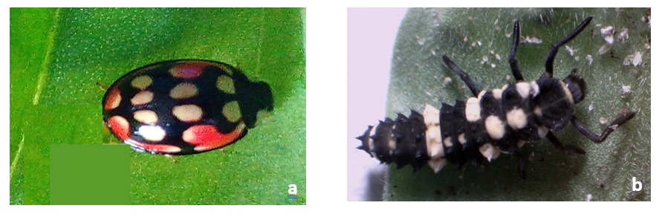

Figure 1 : Lady beetle C.sulphurea
a : Adulte b. larval stage 4
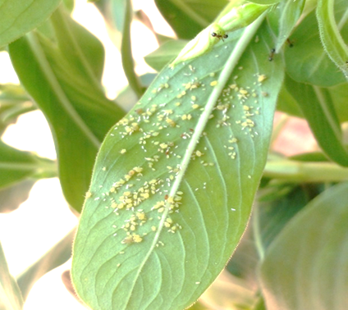

Figure 2 : Aphid colony
2.3 Technical Materials
The technical materials employed in this study included the following: a soft pig-bristle brush, which was used for the careful handling of lady beetle larvae; plastic containers of 300 mL and 10 mL capacity, serving respectively as rearing environments for adult and larval stages of lady beetles; an organza-type muslin with a mesh size of 0.02 mm, employed to cover the rearing containers; a handheld magnifying lens with a plastic handle and a compound optical microscope, which were utilized to observe lady beetle eggs and larvae and to quantify aphid populations during voracity assays; and thermometers, which were used to monitor the ambient laboratory temperature and to maintain experimental conditions at 25 °C.
2.4 Experimental Design of the Biological Control Mechanism
This experimental design consisted of employing natural enemies of aphids against the target populations. A sample of 20 lady beetles was used to evaluate their effectiveness in the elimination of aphids (Table 1). Adult lady beetles were collected from the natural environment of the study station. In addition to adult specimens, fourth-instar lady beetle larvae were also included in the experiments. The study focused on two aphid species previously identified in cashew orchards at the study site : Toxoptera aurantii and Aphis gossypii.
Table 1. Experimental design of the biological control mechanism
Type of lady beetle | Number fed with Aphis gossypii | Number fed with Toxoptera aurantii | Total
Adult | 5 | 5 | 10
Larva | 5 | 5 | 10
Total |  |  | 20

2.5 Voracity Test
To conduct the voracity test, adult lady beetles were starved for 24 hours prior to the introduction of aphids. Following this period, aphids were placed into 400 mL vials containing the starved lady beetles. The vials were hermetically sealed with organza-type muslin (mesh size 0.02 mm) and lightly sprayed with water to maintain suitable microclimatic conditions. The vials were then kept in an open area for 24 hours.
After 24 hours, the number of aphids not consumed by the predators was counted under a magnifying lens. The number of missing aphids was considered to represent prey consumption by the lady beetles. For larval stages, the experiment consisted of providing continuous daily feeding, as larvae are fragile and vulnerable when deprived of food. In this case, aphids were supplied to the fourth-instar lady beetle larvae without prior starvation, within 400 mL vials. The vials were similarly maintained in an open area for 24 hours.
After 24 hours, the number of aphids not consumed was again recorded under a magnifying lens, and the number of missing aphids was taken as an indicator of prey consumption.
The ambient temperature of the study area was maintained at 25 °C, and consumption was also measured according to the sex of the lady beetles.
Table 2 : Presents the number of aphids provided to the lady beetles.

 |  | Daily ration
 |  | Number of Aphis gossypii | Number of Toxoptera aurantii | Daily total
EXPERIENCE 1 | Adult | 10 | 10 | 20
EXPERIENCE 1 | Larva | 10 | 10 | 20
EXPERIENCE 2 | Adult | 50 | 50 | 100
EXPERIENCE 2 | Larva | 50 | 50 | 100
EXPERIENCE 3 | Adult | 100 | 100 | 200
EXPERIENCE 3 | Larva | 100 | 100 | 200
EXPERIENCE 4 | Adult | 200 | 200 | 400
EXPERIENCE 4 | Larva | 200 | 200 | 400
EXPERIENCE 4 | Adult | 400 | 400 | 800
EXPERIENCE 4 | Larva | 400 | 400 | 800
Total |  |  |  | 3040

2.6 Data Analysis
Quantitative data on the mechanisms of biological control were first subjected to descriptive analysis. Means, standard deviations, and coefficients of variation were calculated for all quantitative traits. The evaluation of biological control focused on two parameters: predator voracity and feeding preferences. Predator voracity was assessed as a function of several factors, including species, sex, and developmental stage, while feeding preference was inferred from the prey offered during the voracity tests.
Pairwise correlations among traits were analyzed using Pearson’s correlation test at a 5% significance level. All statistical analyses were performed using the software Excel Statistica (ANOVA).

- Results
3.1 Mean Consumption of Aphids (Aphis gossypii and Toxoptera aurantii) by Lady Beetles
Lady beetle larvae consumed significantly more A. gossypii aphids (135.76 ± 24.89) compared to adult beetles (77.76 ± 9.59). Statistical analysis revealed a significant difference between the two developmental stages (p = 0.0346) (Figure 3).
Similarly, for T. aurantii, larval consumption (127.2 ± 24.01) was higher than that of adults (62.2 ± 7.62). Statistical analysis again indicated a significant difference between the two stages (p = 0.0129) (Figure 4).
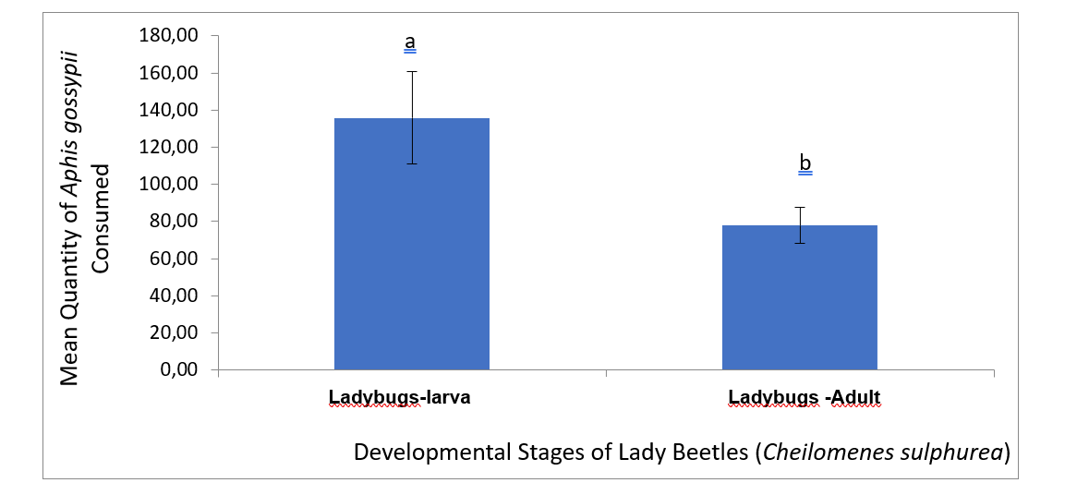
P= 0.0346
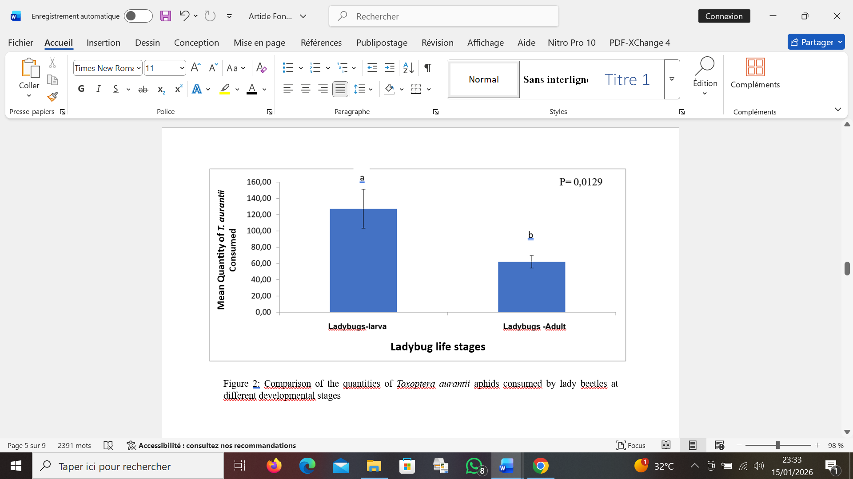
Figure 3 : Comparison of the quantities of Aphis gossypii aphids consumed by lady beetles at different developmental stages.

Figure 4 : Comparison of the quantities of Toxoptera aurantii aphids consumed by lady beetles at different developmental stages
3.2 Average consumption of aphids (A. gossypii and T. aurantii) according to the sex of lady beetles
Male lady beetles (80.08 ± 10.51) consumed more aphids than female lady beetles (71.68 ± 9.28). However, statistical analyses revealed no significant difference (p = 0.5521) between sexes (Figure 5).

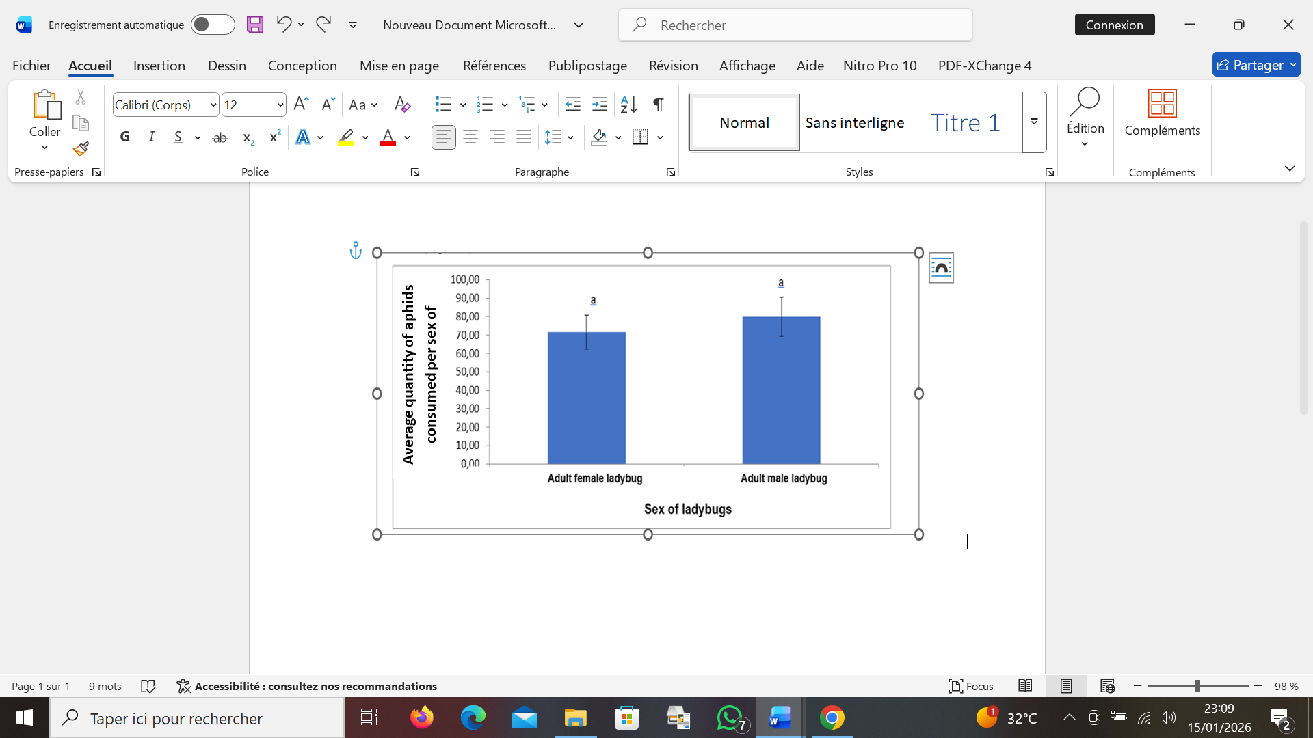

Figure 5 : Comparison of Aphis gossypii aphid consumption by male and female lady beetles

3.3 Comparison of Aphis gossypii and Toxoptera aurantii aphid consumption by adult lady beetles
The quantities of Aphis gossypii consumed within 24 hours by adult lady beetles were 77.76 ± 9.59, whereas the consumption of Toxoptera aurantii by other adult lady beetles was 62.2 ± 7.62 over the same period (Figure 6). Statistical analysis showed no significant difference (p = 0.2102) between the two aphid species.
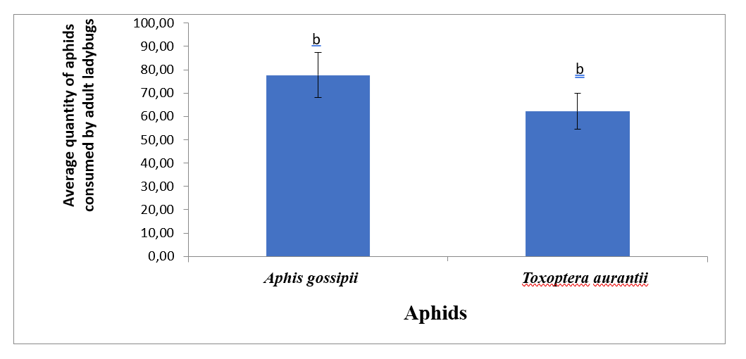
Figure 6 : Comparison of Aphis gossypii and Toxoptera aurantii aphid consumption by adult lady beetles

- DISCUSSION
This study highlighted the importance of biological control in cashew (Anacardium occidentale) cultivation within production areas of Côte d’Ivoire. Both adult and larval stages of Cheilomenes sulphurea (Coleoptera: Coccinellidae) generally feed on aphids. The predatory activity of lady beetles on aphids has been reported by several authors, including Agarwal and Neelkamal (2010). According to these authors, in addition to lady beetles, other insects such as ants and wasps also exhibit potential as biological control agents. It is further important to note that interactions exist between predator and prey populations. In 2023, Eric, in the framework of his doctoral research, observed that the dynamics of aphid populations and their interactions with natural enemies promote the abundance of beneficial organisms, particularly lady beetles. It is further important to note that interactions exist between predator and prey populations. In 2015, Lounes and collaborators observed that the availability of aphids enabled Coccinella septempunctata to complete its entire biological cycle. In contrast, the cycle of Hippodamia variegata was disrupted due to food scarcity. A sharp decline in apterous aphid populations was noted from early May, after which only alate individuals persisted. In 2021, Noémie and co-authors reported similar findings. According to their study, lady beetles exert effective control over aphid populations ; however, since they appear to leave apple orchards in July, later aphid populations tend to increase in their absence.Subsequently, in 2022, Berryman and Kindlmann reaffirmed that among predators specialized to varying degrees on aphids, both larval and adult stages of lady beetles are the most formidable. Agarwal et al., (2007) had already documented the impact of predatory ant species nesting in agroecosystems on the larval stages of two major lepidopteran pests, the diamondback moth (Plutella xylostella) and the black cutworm (Agrotis ipsilon), in cauliflower fields in Uttar Pradesh, India. Field observations revealed that six ant species, with Pheidole sp. being the most significant, attacked the damaging larval stages of both pests. Baiting experiments with larvae of these pests, randomly placed on the soil surface, demonstrated strong retrieval activity by Pheidole sp. Furthermore, larval density studies of the two pests in cauliflower crops located 1-5 m from Pheidole sp. nests confirmed the intensity of ant predation. Our findings revealed that aphid consumption by lady beetle larvae was markedly higher than that of adults, regardless of the aphid species provided. This difference can be attributed to the developmental process of lady beetles during the larval stage. Larvae undergo four successive molts, increasing in size until reaching the fourth instar, which represents the final larval stage. At this stage used in the present experiment larvae consume large quantities of aphids both to sustain their immediate nutritional needs and to accumulate reserves for the pupal phase of development, during which lady beetles remain immobile and dormant for several days. Our results are consistent with those of Michel et al. (2017), who demonstrated that an adult lady beetle can consume approximately 100 aphids per day, whereas a larva may consume up to 600. These authors further confirmed that lady beetles feed on aphids at all developmental stages. Sex-related differences in voracity were also observed in Cheilomenes sulphurea, with males exhibiting higher consumption rates than females. This difference may be explained by the greater activity and mobility of adult males within the experimental vials, which increases their contact with aphids, whereas females tend to remain more static. Overall, our results indicate that this biological control method against aphids is effective. Similar conclusions have been drawn by other authors. For instance, Adama et al. (2023), in their work on the role of Oecophylla longinoda ants in the management of mango pests, reported that the presence of these ants drastically reduced pest populations. In Senegal, further studies conducted by Salimata in 2024 within the framework of integrated management against Tephritidae demonstrated that the presence of the same red ants, Oecophylla longinoda (Hymenoptera: Formicidae), in mango orchards reduced damage caused by Tephritidae. This reduction was achieved through predation on adults (rare), third-instar larvae (more frequent), and by the repellent effect of “pheromones” left by the ants. Regarding Fopius arisanus (Hymenoptera: Braconidae), this species is a micro-wasp and an ovi-pupal parasitoid. Its known hosts belong mainly to the genus Bactrocera. Studies by N’dépo et al. (2020) showed that releases of Fopius arisanus in mango orchards led to a decrease in Bactrocera dorsalis populations. Similarly, the use of the fungi Metarhizium anisopliae and Metarhizium acridum proved effective in controlling Bactrocera dorsalis (Diop, 2020). Our results are consistent with those of Adama et al. (2023), who reported that predators such as lady beetles do not exhibit marked prey selection, indicating that their capacity to discriminate between prey types is limited.

- CONCLUSION
The study conducted at the National Center for Agronomic Research of Lataha (CNRA) focused on evaluating the predatory activity of Cheilomenes sulphurea (Coleoptera: Coccinellidae) as a biological control agent against aphids on cashew trees. The findings revealed, on the one hand, that predation by C. sulphurea on Aphis gossypii and Toxoptera aurantii was quite remarkable. Indeed, lady beetles exhibited voracity at all developmental stages, with the fourth larval instar showing the highest level of consumption, regardless of the aphid species provided. However, no significant difference was observed in aphid consumption between adult males and females.
On the other hand, the study showed that C. sulphurea displayed virtually no marked food preference between A. gossypii and T. aurantii across all developmental stages. Nevertheless, consumption of A. gossypii was slightly higher than that of T. aurantii, though the difference was not statistically significant.
Authors’ contributions
This work was carried out in collaboration among all authors. All authors read and approved the final manuscript.
Disclaimer (Artificial intelligence)

Author(s) hereby declare that NO generative AI technologies such as Large Language Models (ChatGPT, COPILOT, etc.) and text-to-image generators have been used during the writing or editing of this manuscript.

References
- Adama C., Magloire Y. M., Ossey R. N., Abi N., Dabe D. & Djata S. 2023. Comparaison de différentes techniques utilisées pour évaluer l’abondance des fourmis oecophylles (Oecophylla longinoda) dans les vergers manguiers du nord de la côte d’ivoire. Rev. Ivoir. Sci. Technol., 42 132 – 141
- Agarwal V.M. & Rastogi N., 2010. Ants as dominant insect visitors of the extrafloral nectaries of sponge gourd plant, Luffa cylindrica (L.) (Cucurbitaceae). Asian Myrmecology.Vol 3 45-54
- Agarwal V.M., Rastogi N. & Raju S.V.S 2007. Impact of predatory ants on two lepidopteran insect pests in Indian cauliflower agroecosystems. Journal of Applied Entomology. Vol 131, Issue7 Pages 493-500
- Berryman, A. A., & Kindlmann, P., 2022. Population systems. In Insect Ecology. https://doi.org/10.1016/b978-0-323-85673-7.00013-7
- Coulibaly A., Akmel M. S., Aka A. C., 2023 Développement Des Cultures De Rente Et Implications Socio-Environnementales Dans Le Département De Dabou , Revue Internationale de Recherches Multidisciplinaires et Actuelles : Vol. 11 n°1 1-10
- Diop, M. N. 2020. L’importance de l’innovation agroalimentaire en Afrique : Cas de la mangue au Sénégal. Université du Québec à Chicoutimi.65p
- Djaha A. J. B., N’da H.A., Koffi K.E., Adopo A.N. et Ake S., 2018. Diversité morphologique des accessions d’anacardier (Anacardium occidentale L.) introduits en Côte d’Ivoire, Rev. Ivoir. Sci. Technol. 23 : 244–258.

- Éric S., 2023. Modélisation de la dynamique du contrôle biologique des pucerons des céréales par les auxiliaires de culture. Thèse de Doctorat, Université de Lorraine, Belgique. 252pp.

- Fondjo B. B., SORO., Ouattara G. M. 2, N’depo O. R. and Yatty K., J. 2025. Sanitary Quality Improvement of Cashew Nuts through Orchard Rehabilitation in Daloa, Côte d’Ivoire : A Case Study of Anacardium occidentale L. World Journal of Advanced Research and Reviews 27(03), 615–624
- Konate L.M., Kouame F.N., Abo K., Ipou Ipou J., Soro S., Traore K. &Kone D. 2020. Adventices des vergers de l'anacardier en Côte d'Ivoire. Agronomie Africaine Journal
- Vol. 32 Nº3 277 - 295
- Koné F. N., Kouamé F. N., and Dhédé P. E. K. 2025. Essor de l’anacarde et sécurité alimentaire dans le département d’Odienné : Défis et perspectives. International Journal of Innovation and Scientific Research Vol. 78 Nº 1. pp. 14-29

- Kouadio D. K., Koffi E. K., Bleu G., D., Konan L. K., Kagninbébin V. O. & Mamadou D., 2017. Évaluation des dégâts de Analeptes trifasciata (Coleoptera : Cerambycidae) sur les anacardiers dans les régions du Béré et de l’Iffou (Côte d’Ivoire). Journal of Applied Biosciences 112 : 10969-1097

- Lounes S., Jean Louis H. & Alexandra M., 2015. Partage des ressources trophiques chez les coccinelles Bull. Soc. zool. Fr., 140 (1) : 5-23.
- Michel de L. & Aurélie M., 2017. Stratégies optimales d’introduction de coccinelles pour lutter contre des pucerons ravageurs de cultures. 27p.

- Noémie G. L., Mirella A., Gérald C., 2021. Le contrôle des pucerons par les coccinelles sous filets d’exclusion dans un verger de pommiers en régie biologique au Québec. 4p
- N’Dépo, O. R., Tano, D. K. C., Hala, N., Adopo, N. A., & Kouassi, K. P., 2020. Piégeage des Mouches des Fruits (Diptera : Tephritidae) à base d’extraits de Ocimum Basilicum L. (Lamiaceae) : Cas de Bactrocera dorsalis, principal ravageur de mangues en Côte d’Ivoire. European Scientific Journal, 16, 1857-7881.
- Ouattara G. M., 2017. Les déterminants de l’adoption de certaines bonnes pratiques culturales avant récolte de la noix de cajou en Côte d’Ivoire. Journal of Economics and Finance (IOSR-JEF), 8(3), pp 08-15.
- Philippe L., Angel A., Laurence B., Benjamin G.& Soungari S., 2023. Analyse de la chaîne de valeur de l’anacardier en Côte d’Ivoire. 172p

- Mory L., K., Souleymane D., Nakpalo S., 2025. Caractérisation des adventices problématiques des vergers de l’anacardier (Anacardium occidentale L.) dans deux zones agroécologiques (zone soudano-guinéenne et la zone soudanienne) de Côte d’Ivoire. ESJ Natural/Life/Medical Sciences. Vol.21, No.33 pp108-125
- N’gomory K. F., 2020 : l’essor de la culture de l’anacarde et sécurité alimentaire dans la sous-préfecture d’Odienné, 210p.
- Salimata D., 2024. Efficacité de la lutte intégrée contre les mouches de fruits des vergers de manguiers (Mangifera indica L.) en Casamance (Sénégal). Mémoire de Master. Université Assane Seck de Ziguinchor. Sénégal. 53
- Wonni I, Sereme D, Ouedraogo I, Kassankagno A., & Dao I., 2017. Diseases of Cashew Nut Plants (Anacardium Occidentale L.) in Burkina Faso. Advances in Plants & Agricul- ture Research 6 (3) : 00216.

