Isolation Characterization, and Antimicrobial potential of Marine Actinomycetes Associated Barnacles from southern India.
Abstract
Marine environments represent an underexplored reservoir of bioactive microorganisms with significant pharmaceutical potential. The present study aimed to isolate and characterize actinomycetes associated with marine barnacles collected from chinnavilai Beach, Kannyakumari District ,TamilNadu, India,and evaluate their antimicrobial activity against selected pathogens .A total of 17 actinomycetes strain were isolated using selective actinomycetes isolation medium , of which four morphologically distinct isolates(BAR1-BAR4)were selected for detailed investigation.The isolates were characterized based on macroscopic and micromorphological features, including aerial and substrate mycelium, pigmentation, and spore chain morphology. Antimicrobial screening using the agar plug
Revealed that the isolates exhibited varying degrees of inhibitory activity against clinical important pathogens, with isolate BAR2showing pronounced activity, particularly against
Methicillin-resistant staphylococcus aureus (MRSA),along with notable inhibition of Actinetobacter baumannii and klesiella pneumonia. The findings demonstrate that marine barnacle associated actinomycetes are a promising source of potent antimicrobial agents and highlight their potential role in the discovery of novel secondary metabolites to combat multi drug resistant bacterial infections.
Keywords: Actinomycetes; Barnacles; Marine; Secondary metabolites; Antimicrobial;Pathogen
- Introduction
Actinomycetes are responsible for the discovery of valuable secondary metabolites, making them the most economically and biotechnologically important prokaryotes. (Attimardet al., 2012). They are active members of the marine microbial community and are found in a variety of marine ecosystems. Actinomycetes are the most extensively distributed group of microorganisms in nature, primarily found in marine environments. It contributed about 70% of the sources. Biologically active metabolites produced by actinomycetes are being employed in human medicine. Multidrug-resistant microorganisms are a significant cost burden in the development of novel antibiotics (Brown and Wright, 2016). Numerous valuable bioactive compounds have been discovered through screening for novel bioactive compounds. The genetic and metabolic diversity of marine actinomycetes suggests that the marine environment is an untapped source of bioactive metabolites. The majority of antibiotics target the function of bacteria. Natural products from marine sources have interesting biomedical and biotechnological applications. Methicillin-resistant Staphylococcus aureus (MRSA)is the most commonly identified antibiotic-resistant pathogen (Kavanagahet al.,2017). Actinomycetes are active compounds found in marine microbial communities. These microbes thrive in the sediment of mangroves, which make them a promising source of new organisms (Hong et al., 2009). Staphylococcus aureus is a significant pathogen that is becoming more important as antibiotic resistance increases (Lowry, 1998). Actinomycetes are capable of producing bioactive substances, including antibiotics, that can effectively combat phytopathogenic fungi. (Crawford et al.,1993). The diversity of life in the terrestrial environment is extraordinary, with a high level of biodiversity (Donia and Hamann 2003). Actinomycetes are a rich source of bioactive substances(Vining, 1992). The pharmaceutical industry is facing a serious challenge due to the lack of effective antimicrobial agents and the increasing prevalence of infection immunity and multi-drug resistance(Bharatnagar and Kim, 2010). Actinomycetes were inoculated using submerged fermentation to produce bioactive compounds on a large scale (Romankovaet al., 1971). Actinobacteria is a major phylum of bacteria (Hong, 2010). Barnacles are the oldest phylum having a fossil record (Hentschelet al., 2012). Barnacles are abundant in tropical reefs (Schmitt et al., 2012).Currently, numerous scientists worldwide are attempting to identify new drugs that originate from plants and microorganisms (Masiet al.,2017).The use of microbial plant stimulants is a vital method of sustainable agriculture that The soil minerals soluble microflora transforms complex and insoluble forms of minerals into simple nutrients (Hakim et al.2016) The objective of this study is to discover marine actinomycetes present in barnacles and investigate their antimicrobial properties by analyzing antibiotic production of selected strains.
Oceans cover over 70 percent of our planet's surface, and marine life is the source of all life on Earth. Experts believe that the biological richness in some marine ecosystems like coral reefs and the deep sea floor is greater than that of tropical rainforests. It is concluded that because the environmental conditions, in the sea are so different from those on land, marine Actinomycetes may create a variety of bioactive substances based on their differences in features from their terrestrial counterparts (Imada et al., 2007).
Rare strains offer a substitute source for the identification of new secondary metabolites when researchers have used up all of the easily isolable products of common species. Marine actinomycetes are known for being excellent suppliers of antibiotics, but they also produce other substances that are vital to medicine. It is believed that lateral gene transfer is a partial source of the gene clusters responsible for the medications
(Bentley et al., 2002)
Marine actinomycetes are abundant in species and widely inhabit sediments, seawater, aquatic organisms, present, these actinomycetes are mainly separated from the marine invertebrates especially sponges, corals as well as brown algae. It is presently estimated that only 1% of microbes can be separated using traditional culturing techniques, making the potential for this field more compelling (Janet al.,2010, Subramani, R.; Aalbersberget al.,2010). However, emerging technologies provide us with the tools to determine overall microbial diversity. The Ribosomal Database Project (RDP) classification of 16S rRNA sequences of marine organism-associated actinomycetes in 2014, revealed 136 genera within the subclass of Acidimicrobidae, Actinobacteridae, and Rubrobacteridea, of which Streptomyces, Micromonospora, Microbacterium, and Nocardiopsis were abundant (Valliappanet al.,2014). In addition, rare actinomycetes including Actinoalloteichus, Agromyces, Agrococcus, Amycolatopsis, Nonomuraea, Phycicoccus, Saccharothrix, and Serinicoccus were discovered from these marine organisms (Valliappanet al.,2014).
Marine actinomycetes serve as a vital source of secondary metabolite include antibiotics and natural products like tetracycline and streptomycin, they play major role in clinical treatments for significant diseases such pathogenic bacterial infection. Antibiotic has lead to sharp increase in variety and number of drug resistant bacteria notably multidrug resistant in clinicial setting posing a grave threat to the human survival (pan et al.,2025).Marine actinobacteria have reported involved in various task like organic material transformations and mineralization process(Gobalakrishanan et al.,2018).Actinomycetes are derived group of bacteria comprising of the several genera , they and they are gram positive micro organisms most similar fungi,and structurally filamentous. Wide variety of secondary metabolites actinomycetes well establish in manufacturing many biotechnological important compounds actinomycetes especially strains belongs to genus streptomyces have considered great reservoir of the antimicrobial and antibiotic components (Adeyemo et al.,2020). Jagannathan et al. (2021) deliberated the secondary metabolite produced by actinomycetes species abundant sources of antibiotics, anti tumor agents and anti fungals. The actinomycetes derived medicine are in circulation as current treatment but actinomycetes are being explored as the potential source of the new compound to combat multidrug resistant in pathogenic bacteria, Actinomycetesas potential to solve the environmental concern is another area of the recent investigation utility in bio remediation of the pesticides, toxic metals and biofouling, some other application including biofuels,detergentsand food preservatives novel products begin to develop for diverse applied research purpose .pseudonocardia sp VUK-10 ,a novel strain having antimicrobial properties was isolated from mangrove sediment actinomycetes strain PMA2 and PNA6 isolated from the sediment sample of thandavarayan Tamilnadu were extracted for secondary metabolites using ethyl acetate. fourtyfive and fourty compoundswere detected after GCMS analysis among these compounds cinnamic acid was obtained which was a notable anti microbial agent (Manoharan et al.,2020)
Mondal and Thomas( 2022) made an attempt isolate Actinomycetes from marine sediments in their terms of ability to produce several novel bioactive compounds. A total of the 16 different actinomycetes isolates,2 isolate demonstrate in vitro antibacterial activity against Aeromonas hydrophila and vibrio parahemolyticus,among them only one isolate was found to have the potent antibacterial activity, and hence for futher analysis this isolate was designated as the Beijerinickia fluminensis V1T01,The bioactive components obtained were extracted and later subjected to fourier transform infrared spectroscopy and gas chromatography-mass spectroscopy analyses for identification of active antibacterial molecule.Dhani et.al.,(2025) showed that 32 marine soil samples were collected from Tyre City Beach Lebanon in differtent seasons. A tatol of 10actinomycetes species were identified and characterized depending on their microscopic images.All isolates displayed significant antimicrobial activities against the tested indicator microorganisms.all 10 isolates of marine actinomycetes exhibits antifungal in cross streak test against candida albicans,Aspergillus niger,Aspergillus flavus.optimum conditionused to enhance the production of the antimicrobial secondary metabolite against Bacillus cereus were tested for three isolates kocuria rosea,micrococcus luteus streptomyces longisporoflavus.

2. Materials and methods
2.1 Sample collection
Barnacle samples were collected from Chinnavilai Beach (Kanyakumari District), Tamil Nadu, India,and stored at -20ºC.Then, the barnacles were pre-treated and further used for actinomycetes isolation
2.2 Isolation of actinomycetes
Barnacle samples were safely collected, and 1g of the sample was serially diluted in sterile distilled water and spread over the AIM. The AIM was prepared by using soluble starch, 20g KNO₃,1gNaCl, 0.5g K₂HPO₄, 0.5g FeSO₄,and 15 g agar in 1L distilled water.The plates were incubated at 28ºC and the number of colonies was determined within 5-7 days. They were isolated based on morphological differences; all colonies were re-streaked on AIM for preservation of pure actinomycetes (Attimaradet al., 2012).
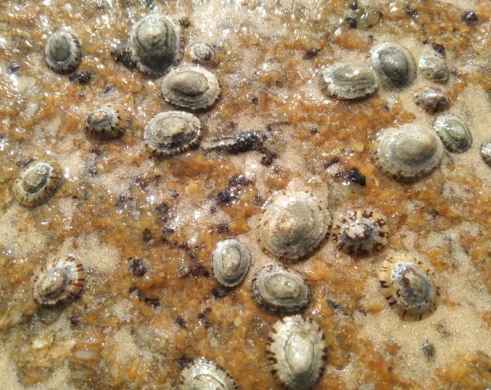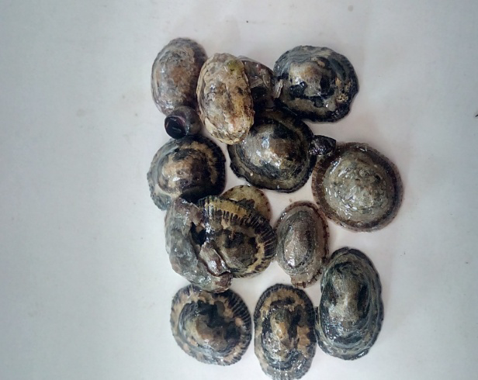
Figure1.Barnacle samples collected from Chinnavilai Beach (Kanyakumari District), Tamil Nadu, India
2.3 Screening of Actinomycetes
The tested ATCC reference strains (Staphylococcusaureus ATCC25923, Klebsiella pneumonia ATCC BAA-1705,Pseudomonasaeruginosa ATCC 27853,AcinetobacterbaumanniiATCC 19606,Enterobacteraerogenes ATCC35029 represent WHO – designed critical priority pathogens.
2.4Morphological characterization
Macroscopically the actinomycetes isolates were differentiated by their colony characters like size, shape, and color. Cultural characterization of isolated strains was examined by the visible observation of 6thdayold cultures grown on an AIM medium. Micromorphology spore chain morphology and sporulation of the colonies were observed under a magnifying lens and colony morphology was noted concerning aerial and substrate mycelium, color, branching the nature of the colony under a light microscope by cover slip method (Kawato and Sinobu,1979) and observed under incubation for 7,14 and 21days of intervals.
2.5. Antibacterial assay by agar plug method
The isolates were subjected to secondary screening using the agar plug method. They were fully streaked on AIM media and allowed to incubate for 5-9 days. Next, Luria broth was inoculated with five pathogens, namely MRSA, Enterbacteraerogens, Actinetobacterbaumannii, Klebsiella pneumonia, and Pseudomonas aeruginosa, and swabbed onto Muller Hinton agar medium separately using a sterile swab. A well cutter was then used to make a well, which was placed over the pathogens swabbed Muller Hinton agar plates. The plates were then incubated at 37ºC for 24 hours, following which the diameter of the zone of inhibition was measured to the nearest whole millimeter.
3. Results
Actinomycetes were grown on isolation media, where good growth was observed, and individual colonies were identified based on morphological characteristics of substrate and aerial mycelium. Four isolates with distinct features including differences in aerial and substrate mycelium as well as coloration were selected for further analysis. The isolates were named as BAR1-BAR4. To further study the selected strains, we viewed them under a microscope, as shown in Table 1 and Figure 2.
3.1 Morphological characterization of BAR strains
Morphological differences were observed in BAR1-BAR4.regarding size, shape, color, aerial mycelium, substrate mycelium pigmentation, metabolic exudation, branching, and nature of colony under a light microscope.
Table 1.Morphological characterization of BAR strains
Strains |  | Aerial Mycelium | Substrate  Mycelium |  | Pigmentation | Metabolic Exudation
BAR1 | Sandal |  |  | Brown | Present | Absent
BAR2 | Blue with white dots |  |  | White | Present | Absent
BAR3 | Gray |  |  | Sandal | Present | Absent
BAR4 | Sandal |  |  | Grey | Absent | Absent

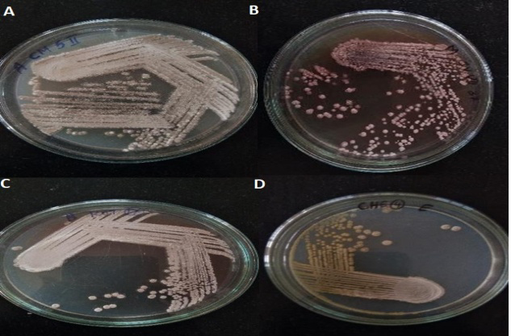
Figure 2. Isolation of actinomycetes strains (A) BAR1, (B) BAR2, (C) BAR3 and (D) BAR4
3.2Micromorphology
The isolated strains BAR1-BAR4 exhibit different morphological patterns, including rectus flexibilis (RF), straight, flexous, fascicled, monoverticillate, retinaculum apertum (RA), and biverticillate with spiral (Table 2)
TABLE 2.Micromorphology of isolated strains from barnacles
Strains | BAR1 | BAR2 | BAR3 | BAR4
Morphology | Spiral | Spiral | Spiral | RF

3.3 Antagonistic activity of Actinomycetes
Antimicrobialtests with five human pathogens, S.aureus,P.aeruginosa,A.baumanni,K.pneumonia,andE. aerogenes revealed that strains (BAR1–BAR4). Among all stains,BAR2has highly significant antimicrobial properties against the clinical isolates(Table3 and Figure 3)
Table 3.Secondary screening of selected marine actinomycetes against the human pathogenic bacteria
Isolated strains from marine barnacles | Human pathogens
Isolated strains from marine barnacles | S. aureus  (mm) | P. aeruginosa  (mm) | - baumanni  (mm) | K. pneumonia  (mm) | E.aerogenes  (mm)
BAR1 | 15 | 4 | 8
BAR2 | 25 |  | 18 | 12 | 10
BAR3 | 16 | -- | -- | -- | --
BAR4 | 3 | -- | 6 | -- | --
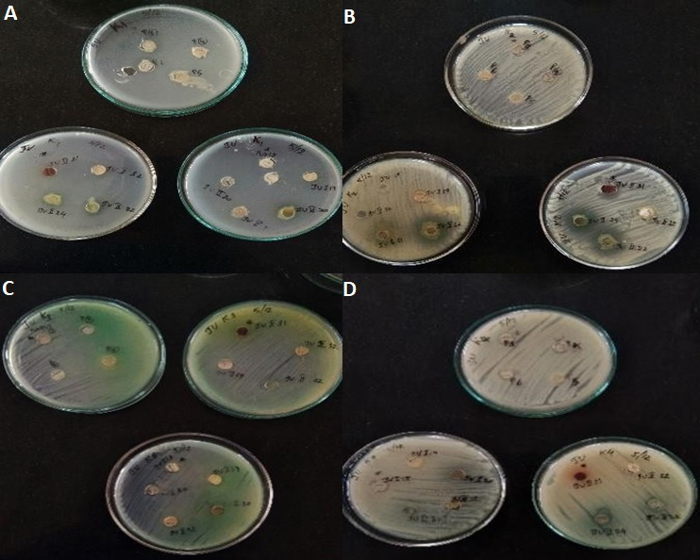
Figure 3. Antimicrobial activity of actinomycetes strains (A) BAR1, (B) BAR2, (C) BAR3and (D)BAR4
4.Discussion
The ocean is just as vast as the land when it comes to finding new antimicrobial compounds. Bacterial resistance to multiple drugs has become a common issue in the medical field. Actinomycetes, a type of marine microorganism, have developed with a high amount of diversity in their DNA and metabolism(Jensen, 2010).Barnacles are a source of many novel actinomycetesspecies that produce antimicrobial compounds. Marine actinomycetes have been found to contain molecules with potent anti-MRSA activity and efficacy against other bacterial pathogens(Hugeset al.,2008; McArthuret al., 2008).Actinomycetes is a source of discovery for novel secondary metabolites. Numerous novel metabolites have been isolated in recent years(Lam,2006).Actinomycetes are organisms that are known for their ability to produce antibiotics. Many antibiotics have been discovered from actinomycetes.The tissue of marine barnacles contains numerous symbiotic microorganisms (Changy,2011). The marine samples collected from all over the Indian coast produce alarge number of novels. The marine microorganism is the primary source for discovering both structural and bioactive compounds. In this study, actinomycetes were isolated and screened for their ability to produce antibiotics using selective AIM and cultivation conditions. A total of 17 different actinomycete isolates were collected from barnacles, and among these, BAR2 demonstrated significant antimicrobial activity with a high zone of inhibition. Four strains were then selected for their activity against human pathogens. Morphological characterization was noted by examining the structure, color, and character of the selected strains. The color of the aerial and substrate was observed to be white, grey, ash, and greenish-white pink color. Micromorphological characteristics such as spiral, rectus, and RF were noted under a light microscope. The selected actinomycetes strain BAR2 demonstrated pronounced antimicrobial activity, particularly against MRSA, with a 25mm zone of inhibition. This level of activity substantially exceeds previously reported inhibition zone for marine actinomycetes against staphylococcus aureus(8-11mm),highlighting the superior antibacterial potential of BAR2,In addition to its efficacy against gram positive pathogens BAR2 also exhibited activity against pseudomonas aeruginosa WHO-designed critical priority pathogens associated with high morbidity and mortality due to multidrug resistant in clinical settings. Collectively, the identification of four bioactive isolates from total of seventeen barnacle –derived actinomycetes underscores the effectiveness of Barnacles as promising bioprospecting targets for the discovery of novel antibiotics. Actinobacterial isolates exhibiting activity against a broad spectrum of pathogens are valuable indicators for the production of bioactive secondary metabolites with therapeutic potential.
5. Conclusion
The objective of the current study is to identify actinomycetes from the sea environment and test them for the synthesis of secondary metabolites. Actinomycetes were obtained from barnacles, out of 17 isolates from marine barnacles, four strains were selected for antimicrobial testing. One isolate exhibited strong activity against all human infections and was selected for further research. The actinomycetes isolate BAR2 has the potential to be a source of unique antibacterial compounds against human pathogenic pathogens. Therefore, the study suggests that extensive research on the antibacterial diversity of the abundant actinomycetes could provide valuable insights into the pharmaceutical industry. Activity against WHO priority pathogens underscores the public health potential of barnacle derived actinomycetes to combat the global antimicrobial resistance Crisis.
Disclaimer (Artificial intelligence)

Author(s) hereby declare that NO generative AI technologies such as Large Language Models (ChatGPT, COPILOT, etc.) and text-to-image generators have been used during the writing or editing of this manuscript.

References
- Adeyemo,OM,Onilude,AA&Babatola LJ2020,Effects of production parameters and inhibitory activity of antimicrobial compounds produced by co-cultured strains of Streptomyces xinghaiensis-OY62andS.rimosus OG95,J King Saud University –Sci,vol.32,pp.294-301.
- Bhatnagar, I., & Kim, S. K. (2010). Immense essence of excellence: marine microbial bioactive compounds. Marine drugs, 8(10), 2673-2701.
- Brown, E. D., & Wright, G. D. (2016). Antibacterial drug discovery in the resistance era. Nature, 529(7586), 336-343.
- Bentley ,S.D.,K.F.,Cerdeno-Tarraga,A.M.,Challis,G.L.,Thomas, N.R.,James,K.D.,Harris, D.E.,Quail,M.A.,Kieser,H.,Harper, D., et al.Complete genome sequence of the model actinomycetes streptomycescoelicolor A3(2).Nature 2002,417,141-147.
- Cao, L., Yun, W., Tang, S., Zhang, P., Mao, P., Jing, X., ... & Lou, K. (2009). Biodiversity and enzyme screening of actinomycetes from Hami lake. Wei sheng wuxuebao= ActamicrobiologicaSinica, 49(3), 287-293.
- Crawford, D. L., Lynch, J. M., Whipps, J. M., &Ousley, M. A. (1993). Isolation and characterization of actinomycete antagonists of a fungal root pathogen. Applied and environmental microbiology, 59(11), 3899-3905.
- Dhani,H.K.,Khalil,M.I.,&EI Haji,R.(2025).The Antimicrobial potential of Actinomycetes isolated from marine soil in Tyre city Beach,Lebanon.Applied Microbiology,5(1),27
- Edwards, C. (1993). Isolation properties and potential applications of thermophilic actinomycetes. Applied Biochemistry and Biotechnology, 42, 161-179.
- Gobalakrishnan,R&Sivakumar ,K 2017, Systematic characterization of potential cellulolytic marine actinobacteria Actinoalloteichus sp.MHA15,Biotechnol Rep,vol.13pp.30-36.
- Hong CM, Bacteria Encyclopedia of Earth eds . Sidney Draggan and CJ . Clever land, national council for science and environment , Washington DC, 2010.
- Hong, K., Gao, A. H., Xie, Q. Y., Gao, H., Zhuang, L., Lin, H. P., ... &Ruan, J. S. (2009). Actinomycetes for marine drug discovery isolated from mangrove soils and plants in China. Marine drugs, 7(1), 24-44.
- ImadaC,Koseki N, Kamatas M, Kobayashi T, Hamada –Sato N. Isoloation and characterization and antimicrobial activity of the bioactive metabolites in streptomycetes isolates . microbiology 2007,76,421-428.
- Jan, R.V.Biodiversity of Actinomycetes Associated with Caribbean sponges of Puerto, Rico, and their metabolic profiles.;University of North Carolina Wilmington:Wilmington ,NC,USA,2010.
- Jagannathan ,SV,Manemann,EM,Rowe,SE,Callender,MC&Soto,W 2021 , Marine Actinomycetes, New sources of Biotechnological Products, Mar,Drug, vol.19,pp.365.
- Lowy, F. D. (1998). Staphylococcus aureus infections. New England journal of medicine, 339(8), 520-532.
- Manoharan,A,Gunasekaran,NL,Desingu,K,Varatharaj,G,Kuppusamy,P
- & Veluchamy,B 2020,GCMS chemoprofiling of antibacterial proficient actinomycetes from mangrove sediments of coromandel coastline, pichavaram,TamilNadu,South India,Plant Arch,vol.20,pp.3747-3753.
- Mondal,H.,&Thomas,J. (2022).A review on the recent advance and application of vaccines against fish pathogen in aquaculture 30(4),1971-2000.
- Pan, C., Hassan, S.S.U.,Ishaq,M., Yan,S.and Jin,H.,2025.Marine actinomycetes : a hidden treasure trove for antibacterial discovery. Frontiers in Mainescience,12,p.1558320.
- Romankova, A. G., Zurabova, E. R., Fursenko, M. V., Sukharevich, V. I., &Pronina, M. I. (1971). Selection of strains of some antibiotic producing Actinomycetes during repeated passages in submerged cultures. Antibiotiki, 16(7), 579-583.
- Schmitt, S., Tsai, P., Bell, J., Fromont, J., Ilan, M., Lindquist, N., ... & Taylor, M. W. (2012). Assessing the complex sponge microbiota: core, variable and species-specific bacterial communities in marine barnacles. The ISME Journal, 6(3), 564-576
- Vining, L. C. (1992). Secondary metabolism, inventive evolution and biochemical diversity-a review. Gene, 115(1-2), 135-140.
- Valliappan,K.; Sun,W.;Li,Z.Marine actinobacteria associated with marine organism and their potential in producing pharmaceutical natural products .Appl.Microbiol.Biotechnol.2014,98,7365-7377.
- Wu, H., Xie, L., Wang, G., Dai, S., Chen, M., & Li, X. (2011). A method to type the potential angucycline producers in actinomycetes isolated from marine barnacles. Antonie van Leeuwenhoek, 99, 807-815.

